**S****imulation of OSL and TLD dosemeter response for the development of new extremity dosemeters**

H. Hoedlmoser*1, J. Brönner1, V. Bandalo1, F. Wahl2 and M. B. Greiter1

1Individual Monitoring Service, Helmholtz Zentrum München – German Research Center for Environmental Health (GmbH), Otto-Hahn-Ring 6, München 81739, Germany

2Dosimetrics GmbH

Otto-Hahn-Ring 6

81739 München, Germany

*Corresponding author: Herbert.Hoedlmoser@helmholtz-muenchen.de

**The individual monitoring service at the Helmholtz Zentrum München is currently developing a new eye lens dosemeter to be integrated in radiation protection glasses and a new ring dosemeter using a new BeOSL detector element for extremity dosimetry developed by Dosimetrics. In the design process for the new eye lens dosemeter, MCNP6 Monte Carlo simulations were used to model the energy and angular response of new dosemeters before ordering the expensive tools for injection molding. This study describes the simulation of the dosemeter and detector, the involved calculations do obtain the response in terms of the radiation protection quantity *Hp*(3). Simulations were carried out also for existing whole body dosemeters and TLD rings in order to verify the MC tools. With the final dosemeter prototypes becoming available earlier this year, all MC models could be verified and show very good agreement with experimental data.**

# Introduction

The individual monitoring service (IMS) at the Helmholtz Zentrum München (HMGU) is the largest dosimetry service in Germany and monitors approximately 160 000 customers per month by means of OSL-, film- and TLD- dosemeters. For whole body dosimetry the IMS is currently transitioning its customers from film dosimetry to the new BeOSL system described in [1] and [2]. While the number of customers with BeOSL whole body dosemeters has already increased to close to 60 000 per month there are no BeOSL options available yet for extremity dosimetry. The IMS is currently supplying 10 000 customers per month with extremity dosemeters such as photon and beta rings using TLD systems which are approaching the end of their product cycle. Recently the supplier of BeOSL technology, the HMGU spinoff Dosimetrics, has introduced a new detector element for extremity dosimetry, the so-called EzClip, which can be used with the standard BeOSL readout infrastructure. The IMS is planning to introduce this detector element in in a modified version of its photon ring dosemeter.

Additionally, a new eye lens dosemeter is currently being developed by the IMS, as the dose limit for the lens of the eye will be lowered to 20 mSv per year in 2019 with the introduction of new radiation protection legislation in Germany, leading to mandatory eye lens dose monitoring for some customers.

Both ring dosemeters and eye lens dosemeters use injection molded single use plastic parts to enclose the detector element. As the tools for injection molding are rather expensive, it is necessary to verify new dosemeter designs for their compatibility with IEC [3] standards before committing the costs for new injection molding tools. At the IMS, Monte Carlo methods have been applied to predict the energy and angular response for photon radiation of new dosemeter designs for extremity dosimetry. This study shows how to set up the Monte Carlo models using known intrinsic detector response functions from literature, how to verify them with existing dosemeter designs and how to test them with new geometries and designs. The objective of the simulation is to derive the energy and angular response for the new dosemeter designs in terms of the operational radiation protection quantities, i.e. in terms of *Hp*(0.07) for ring dosemeters and in terms *Hp*(3) for eye lens dosemeters.

# Materials and Methods

## Monte Carlo Simulations

The radiation transport code MCNP6 [4] was used to model simplified photon irradiaton geometries on calibration phantoms according to ISO 4037 [5]. An example for the irradiation geometry is shown in Figure 1 for the case of ring dosemeters on the ISO rod phantom. The modeled photon sources created monoenergetic photons in a parallel beam incident on the calibration phantom in 50 cm distance from the source. Electron transport was only switched on inside the dosemeter (plastic enclosure, filters and crystals). Scoring volume (or tally volume in the MCNP6 nomenclature) was the volume occupied by the detector crystal, either BeO or LiF: Mg,Cu,P. The energy deposition inside the detector was scored by means of *F8 tallies. Simulation runs of 1E9 photons each were run for 25 different photon energies in the range from 10 keV to 1.25 MeV.

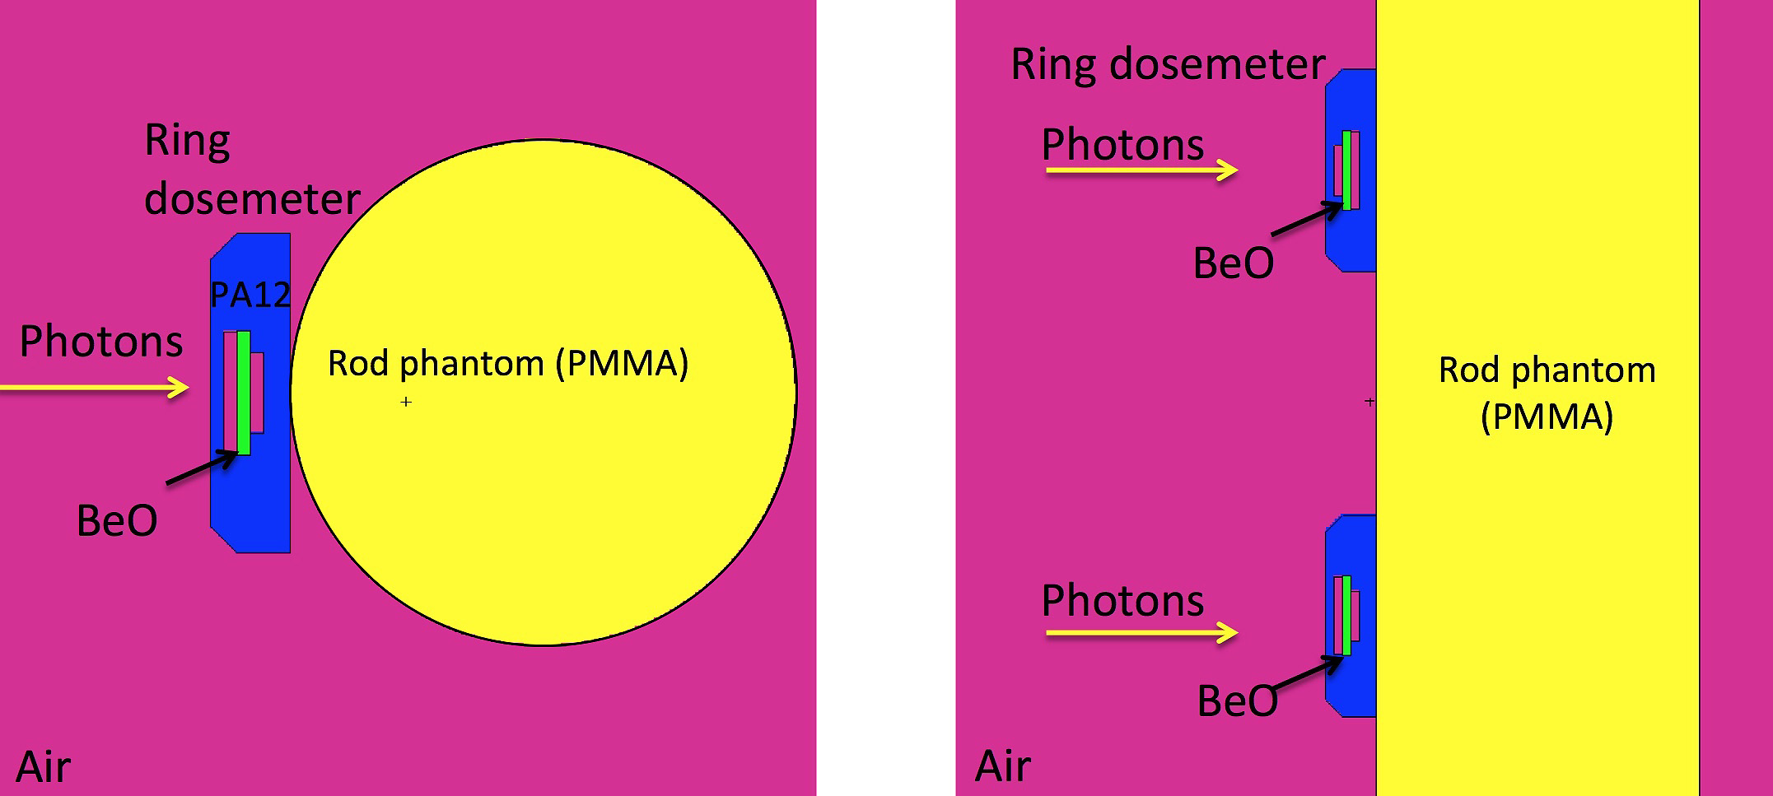

Figure 1 Top and side views of the model geometry for BeOSL ring dosemeters consisting of PMMA rod phantom and two ring dosemeters made from polyamide containing BeO detectors. Two different orientations of the detector element inside the ring are shown.

## Calculation of dosemeter response from MC results

The Monte Carlo models deliver the energy deposited in the detector crystal per simulated photon as a function of photon energy and of angle of incidence. The deposited energy mainly depends on the used materials (Z effective and density) and the geometry (thickness of the detector enclosure). However, the detector crystals cannot fully translate the deposited energy into a measurable light signal either by optical stimulation (OSL) in BeO or thermal stimulation (TLD) in LiF. Due to effects related to ionization density of incident photons and secondary electrons and local saturation effects along the ionization tracks, the fraction of deposited energy converted into OSL or TLD signals depends on photon energy. Therefore the simulated energy deposition needs to be scaled with the intrinsic OSL or TLD efficiency of the crystals. For BeO detectors this function was taken from Jahn et. al. [6] and for LiF:Mg,Cu,P from Horowitz et. al. [7]. The resulting detector response per simulated photon can be expressed as response in terms of photon fluence if the total number of simulated photons and the beam diameter are taken into account, as well as the attenuation of the simulated parallel beam in 50 cm of air. Air attenuation of the beam is significant only for the lower photon energies < 40 keV and can simply be taken into account using tabulated attenuation coefficients from [8]. In a further step, the fluence response of the detector needs to be converted into a response based on the relevant operational dose quantity, i.e. based on *Hp*(0.07) or *Hp*(3). This was achieved by means of fluence to air kerma (*Ka*) conversion coefficients from [9] and the latest conversion coefficients from *Ka* to *Hp*(0.07) or *Hp*(3) from ISO 4037 draft [5]. All data analysis and plotting was performed by means of macros written in root [10],[11], which were also handling the energy interpolation for all above mentioned efficiency, attenuation and conversion functions. Efficiency scaled energy depositions were then divided by the actual dose values and the resulting response curves normalized to the response at 662 keV (S-Cs) at 0° incidence.

## Detectors and readout technology

*BeOSL technology*

The new BeO detector element for extremity dosimetry, developed by Dosimetrics, the so called EzClip, contains the same 4.7x4.7x0.5 mm3 BeO chip used inside the BeOSL whole body dosemeter badge described in [1] and [2]. The operating principle of the BeOSL dosemeters is optically stimulated luminescence (OSL), i.e. stimulation of the crystal with blue light resulting in a dose proportional emission of luminescence light, which is analysed by means of photo sensors as described in [2]. The only difference for the new detector for extremity dosimetry is, the BeO chip, shown in Figure 2, is encased in a plastic housing, which is inscribed by a 2D code to identify the element. As depicted in Figure 2, this detector element can be placed in the readout carrier, which in turn fits into a badge called EzCase, that is identical to the standard whole body dosemeter, regarding its outside dimensions. Consequently, the detector element can be evaluated using the identical read out infrastructure used for the whole body system, which includes readers, erasers, and robotic manipulation tables as described in [1].

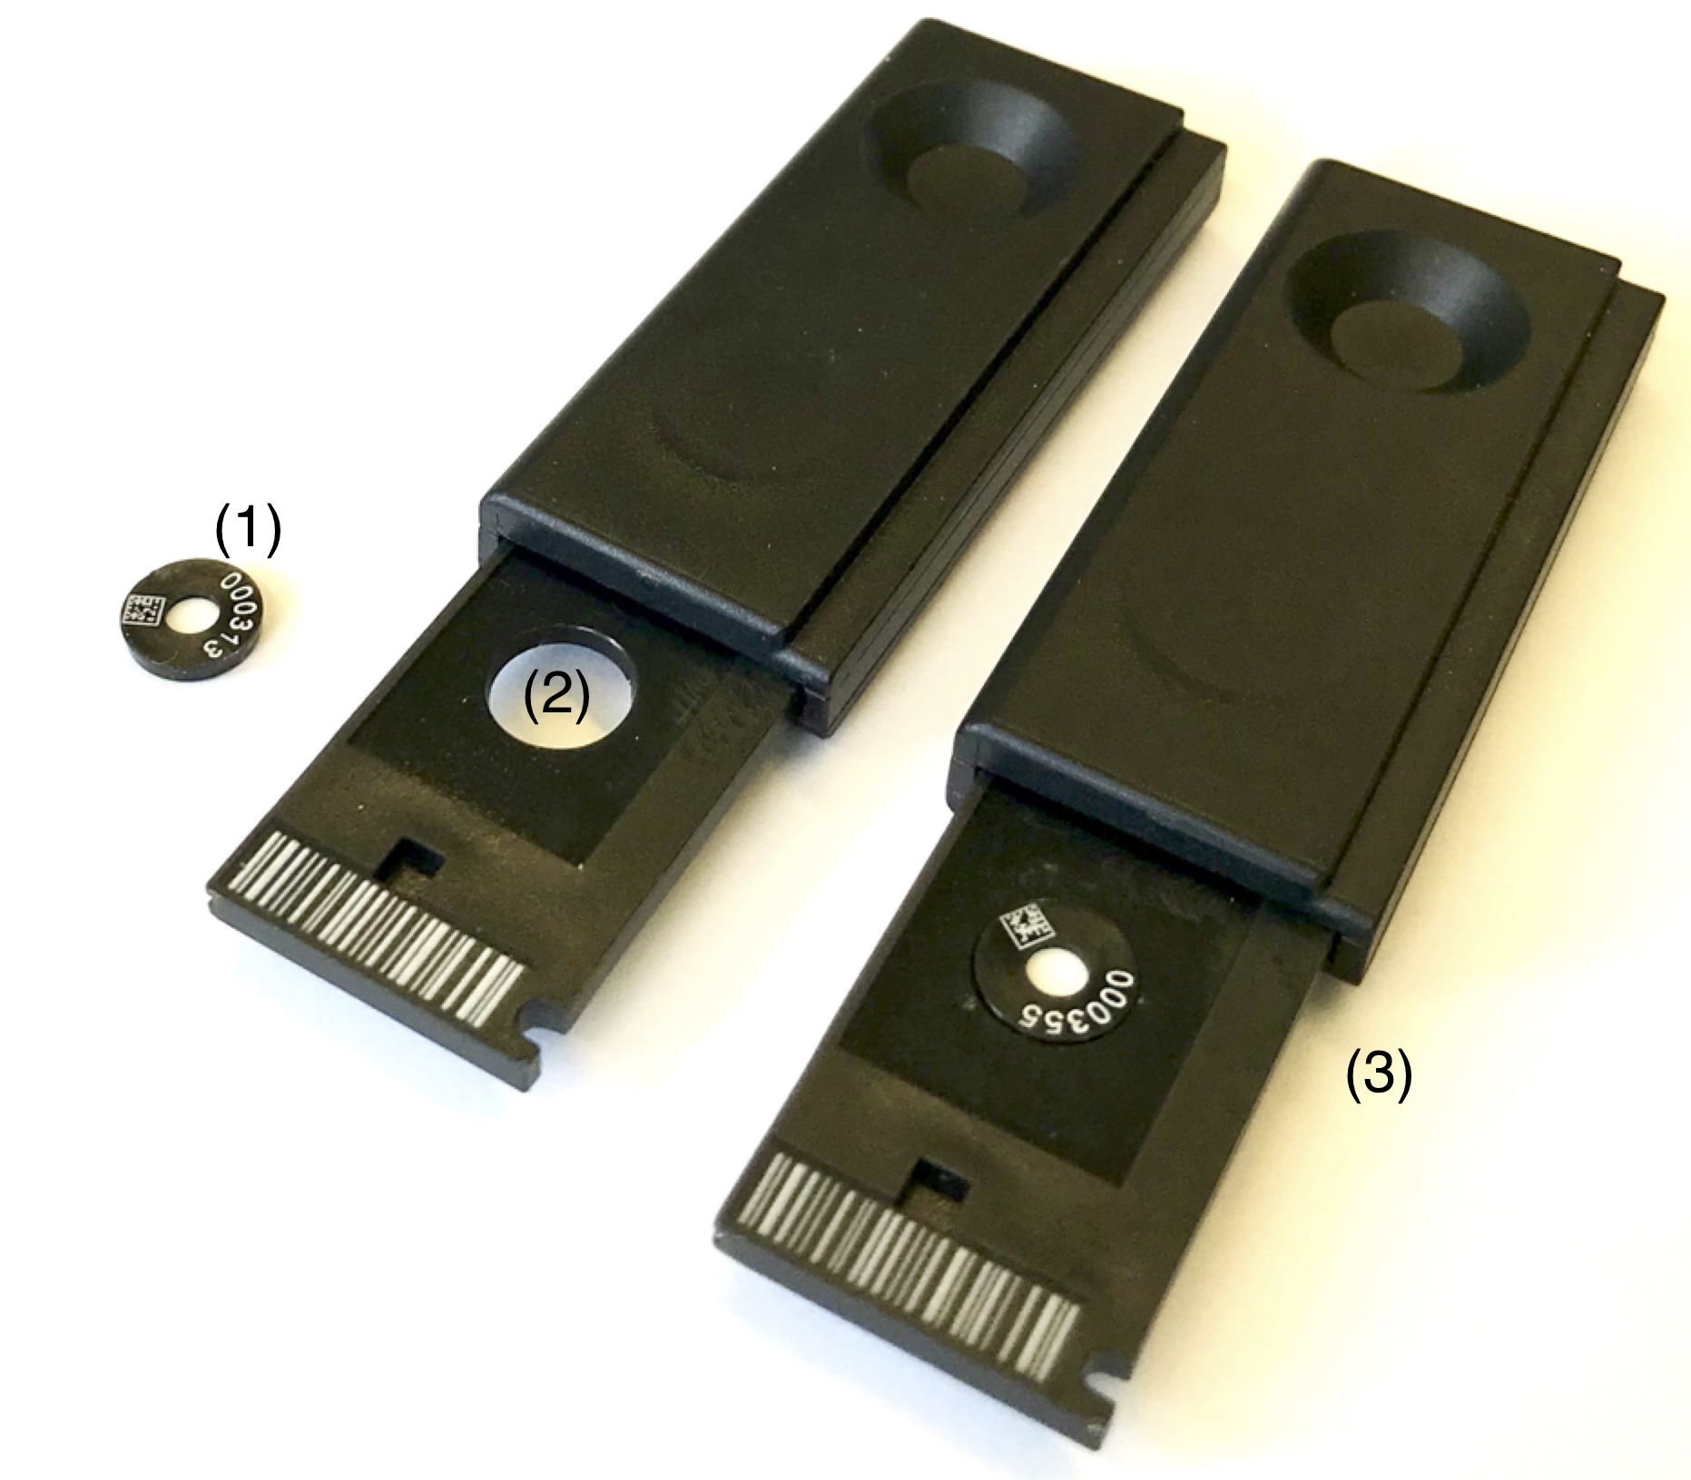

Figure 2 New BeOSL detector element for extremity dosimetry: (1) EzClip and readout badge EzCase without (2) and with (3) EzClip inside.

*TLD technology*

Circular LiF:Mg,Cu,P (MCP-N, natural isotope mixture for Li) TLD detectors (∅ = 4,9 mm x 0,9 mm) were briefly considered for use in a new eye lens dosemeter as an intermediate solution before the new BeO OSL detectors became available. They can be read out with the Harshaw H5500 readers used by the IMS for ring dosimetry.

## Eye lens and ring dosemeters

Figures in this paragraph depict the dosemeters and corresponding MC models used in this study. Figure 3 shows the BeOSL whole body dosemeter, which contains two BeO detectors with different filters to measure *Hp*(10) in one case and *Hp*(0.07) in the other. This dosemeter was the only BeOSL dosemeter available at the IMS at the start of the MC study and it served to test and benchmark the MC models.

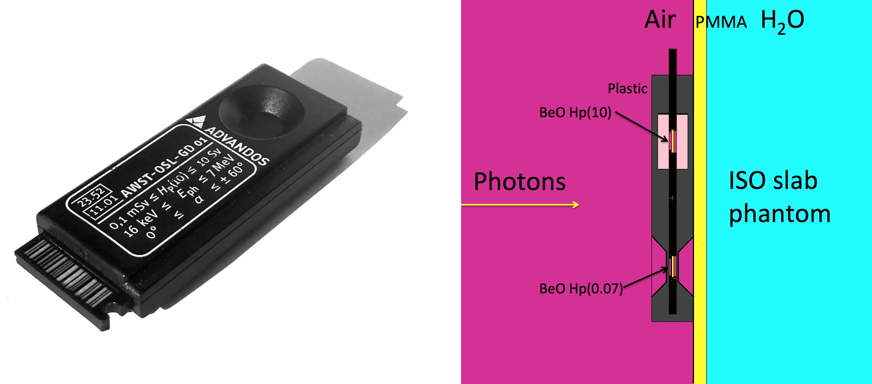

Figure 3. Left: BeOSL whole body dosemeter. Right: MC simulation geometry showing both *Hp*(0.07) and *Hp*(10) elements. This dosemeter was used to verify the MC simulation.

The dosemeter shown in Figure 4 is a TLD ring with an MCP-N detector. This dosemeter has been in use for several years in ring dosimetry (albeit with TLD-100 material). It was used in a case study to investigate, if the body of the ring, with the ring straps removed, could serve as an eye lens dosemeter. The ring is made from polyamide and uses a 0.35 mm thin cover to measure *Hp*(0.07) for low photon energies, therefore if used as an eye lens dosemeter it needs to be turned 180° to measure photon radiation through the thicker backside cover of the ring body and thus better approximate *Hp*(3). This is why the ring is mounted backwards on the phantom both in the irradiation tests and in the MC model.

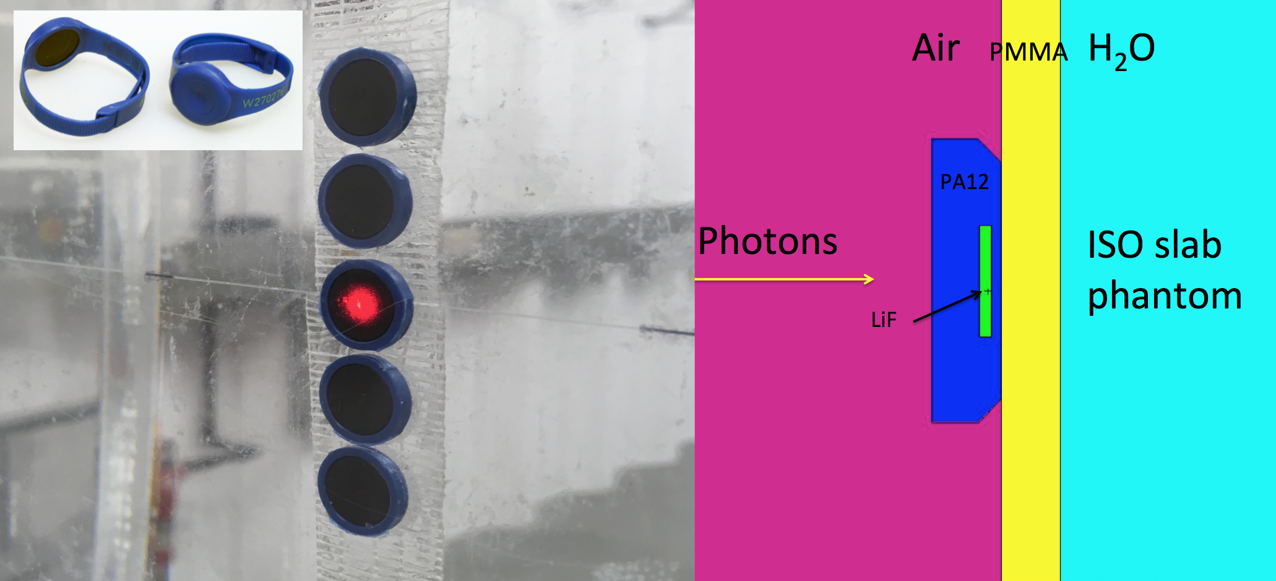

Figure 4 Left insert: TLD ring dosemeter. Left: Straps removed and mounted backwards on ISO phantom for irradiatons in *Hp*(3). Right: MC simulation geometry.

Figure 5 shows a new eye lens dosemeter. Here the design was developed as a compromise between the requirements due to the new operational quantity *Hp*(3) and practical requirements such as space constraints for the use as a dosemeter to be integrated in radiation protection glasses. The quantity *Hp*(3) demands a 2.5-3 mm thick plastic cover over for the detector. However, the dosemeter should ideally have identical response for forward (0°) and backward (180°) irradiation, as backscatter from the head contributes significantly to eye lens dose. This would require a 5-6 mm thick design, which is incompatible with space constraints behind radiation protection glasses. Therefore a design with a total thickness of 3.5 mm and a symmetrical cover of approximately 1.2 mm on both sides of the detector was chosen. The results of the MC simulations presented below confirmed, that this thickness is sufficient for an eye lens dosemeter, which is only intended for use with photon radiation, mostly in interventional radiology. The decision to implement this design by means of injection molding forms was taken based on the predictions of the MC results below.

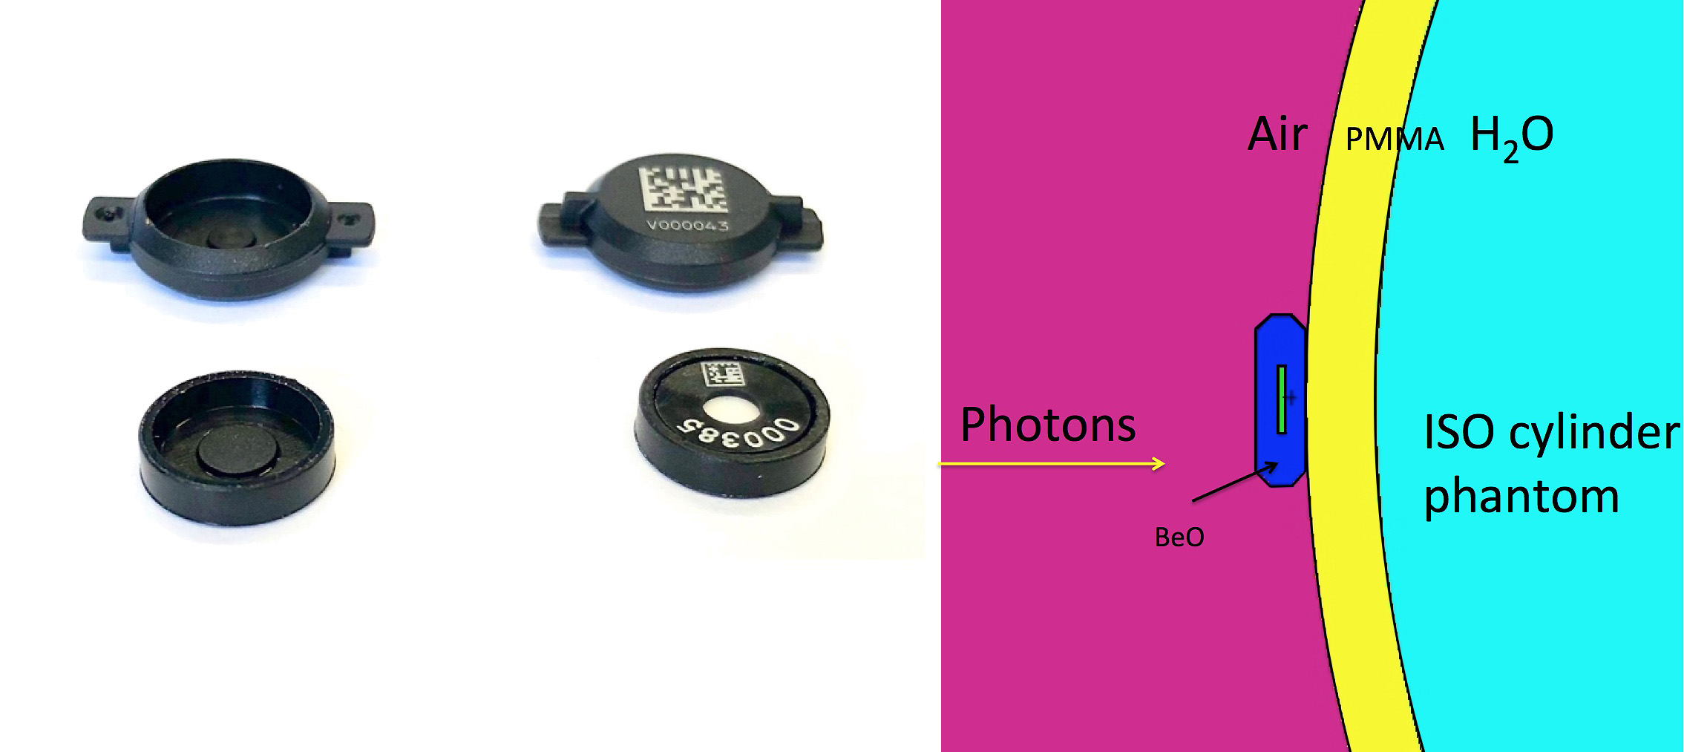

Figure 5 Left: BeOSL eye lens dosemeter with detector element. Right: simulated irradiation geometry on the ISO cylinder phantom. This dosemeter design was only approved and realized based on the predictions of the MC model.

The ring dosemeter design shown in Figure 6 is a slightly modified version of the plastic enclosure of the TLD Ring shown in the insert in Figure 4. Only the insides have been modified to accommodate the EzClip and the cover of the detector is slightly thicker than in the TLD version. These new rings are at the prototype stage and first measurements for a limited number of different photon radiation qualities are available for comparison with the MC model.

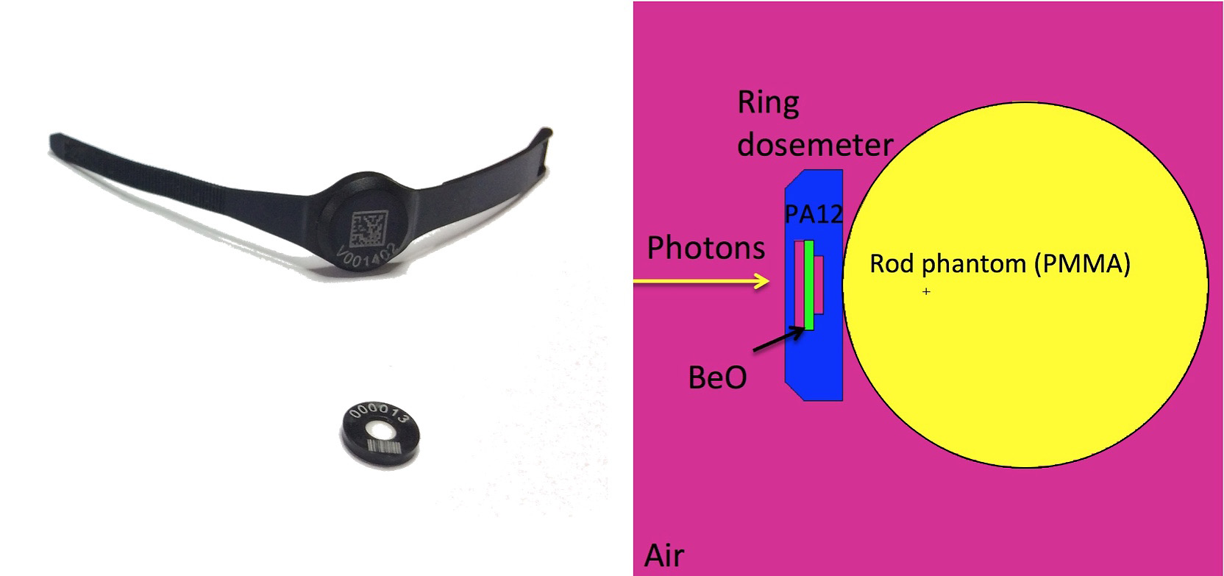

Figure 6 Left: BeOSL ring dosemeter with detector element. Right: simulated irradiation geometry on the ISO rod phantom

## Irradiations

All irradiations used for the experimental verifications of the MC models have been carried out in the secondary standard irradiation facilities of the IMS. The facilities are described in references [12] and [13]. Calibration procedures in these labs are in accordance with the recommendations of the ISO 4037 [5] series. For the evaluation of the energy and angular response, irradiations with doses of approximately 3 mSv *Hp*(3) or *Hp*(0.07) have been carried out with N-series radiation qualities and S-Cs. ISO phantoms used were the rod phantom for the rings, the slab phantom for the whole body dosemeter, and the cylinder phantom and in some cases the slab phantom for the eye lens dosemeters. Response curves were normalized to the response at 662 keV (S-Cs) at 0° incidence. Usually five to ten dosemeters were irradiated and evaluated for each radiation quality and angle of incidence. In the following presentation of results, the standard deviation was used to obtain error bars for the data points.

# Results

## Whole body dosemeter response

For the well-characterized whole body dosemeter a rich experimental database exists from the type testing stage, which could be used to compare to the MC simulated energy response obtained by means of the model geometry shown in Figure 3. These initial results at the beginning of the MC study agree very well with the experimental data as compared in Figure 7. Therefore it was decided to use the MC tool in the design process for the new eye lens dosemeters.

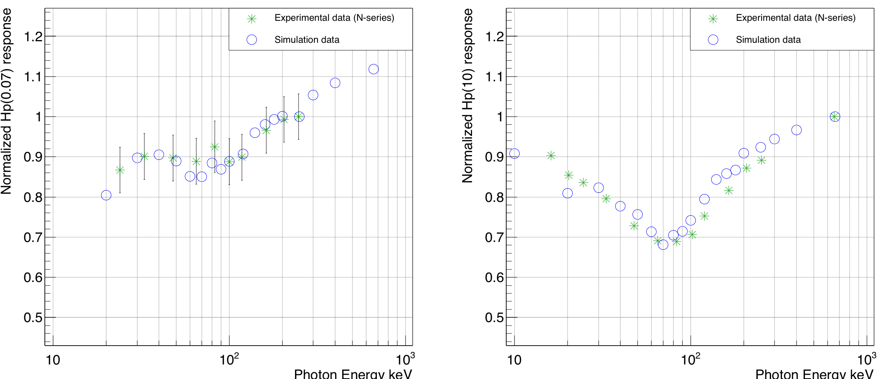

Figure 7 Simulated vs experimental result for the whole body dosemeter. Left is the response of the Hp(0.07) element of the whole body dosemeter and on the right side the Hp(10) element response. Please observe that for the two elements different reference energies have been chosen in the type testing phase: N-300 is the reference point for the Hp(0.07) element and S-Cs for the Hp(10) element.

## TLD eye lens case study

A further verification of the MC method could be easily obtained by means of the TLD system, which provided a test with a completely different detector material. As stated above, the existing rings were used in 180° irradiations (Figure 4) to test their *Hp*(3) response and compare it against the simulated response. The results are shown in Figure 8 and they demonstrate the validity of the MC method for the TLD system as the curves align very well for both 0° and 60° photon incidence. Still, the use of the TLDs was not pursued any further, as the BeOSL detector element became available and as there were some problems with the achievable coefficient of variation due to non-optimized temperature profiles for the MCP-N material in the readout software used at the IMS. (The software uses temperature profiles optimized either for TLD-100 material in photon rings and others optimized for thin film MCP-Ns material in beta rings.)

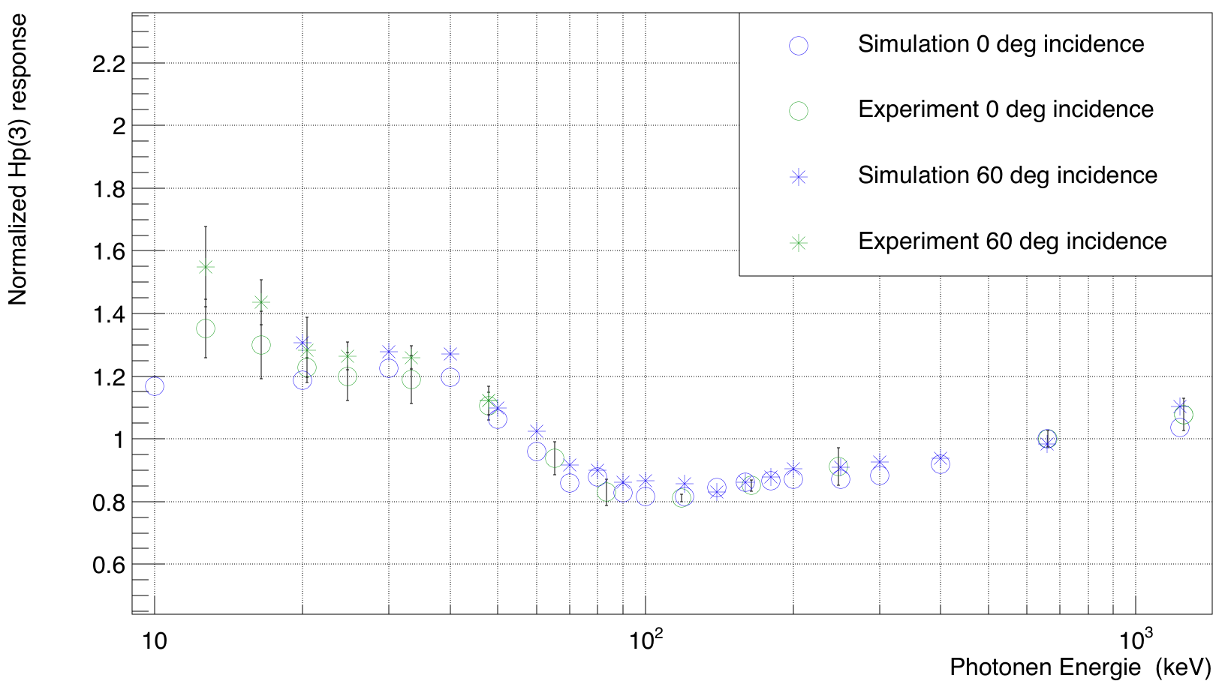

Figure 8 *Hp*(3) response of the TLD ring body with a LiF MCP-N detector element under backward irradiation. Simulated and experimental response curve line up very well for 0° and 60° photon incidence.

## BeOSL ring

First prototypes oft the BeOSL ring and the EzClip became available by Dosimetrics soon after the start of the MC study and provided a further possibility to test the MC method. Here the MC method was also used to investigate, if the orientation of the new not fully symmetric detector element would influence the *Hp*(0.07) response. The BeOSL EzClip is optically stimulated from one side and the emitted light is read out from the other side. Due to the space taken up by the code on the plastic enclosure, the readout side is covered by more plastic than the stimulation side. While the MC simulation cannot access the effect of this asymmetry on light stimulation and emission, it could be shown that the orientation of the chip in the ring during irradiation does not affect the energy deposition as a function of incident photon energy significantly. The orientation could therefore be chosen to optimize the logistics of scanning the detector code after unpacking the ring. The first measured results almost perfectly follow the simulated curves.

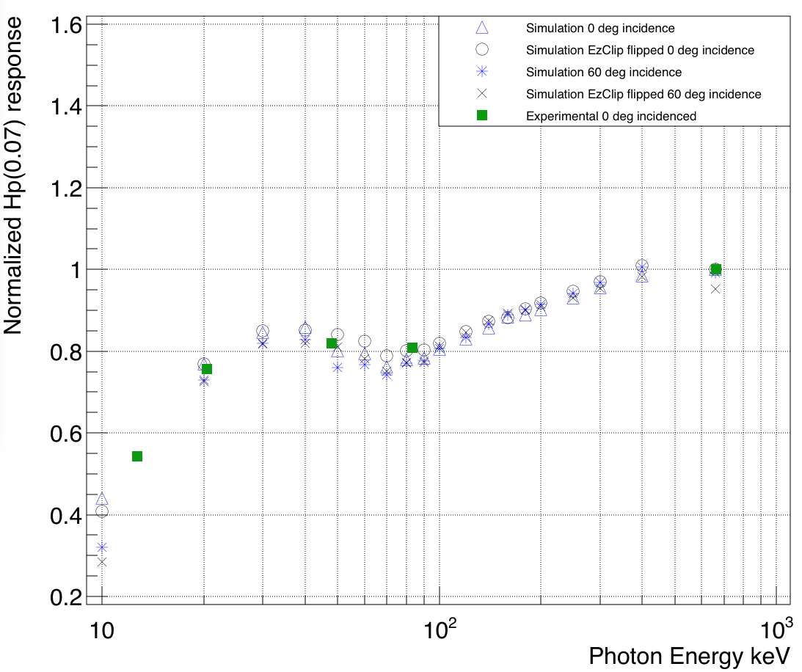

Figure 9 Simulated energy response at 0° and 60° photon incidence for the new BeOSL ring in comparison to 5 measured points with prototypes. The orientation of the detector element inside the ring does not influence the shape of the response curve significantly. For the geometry see Figure 1.

## BeOSL eye lens dosemeter

The design of the eye lens dosemeter as shown in Figure 5 was first developed following constraints imposed by the necessity to integrate and attach it to the frame of radiation protection glasses. The MC was then used to predict the energy response for the chosen design and to help with the choice of the plastic material to be used. Figure 10 shows a comparison for the simulated angular and energy response for three possible materials. As the response was almost ideal for photon energies > 20 keV, the tools for injection molding were ordered and prototypes were created for materials PA 12 (polyamide variant) and POM (polyoxymethylene). The material PA 12 was chosen due to its better mechanical performance in the opening process of the dosemeter. The satisfactory experimental verification of the MC results by means of irradiations with the final product, first available in summer 2018, is shown in Figure 11. In the same Figure two additional simulation runs were included with the actual photon spectra for N-15 and N-25 [14] as photon sources. This served to verify that the use of monoenergetic photon sources does not limit the comparability to experimental results, which were always based on irradiations with N-series qualities.

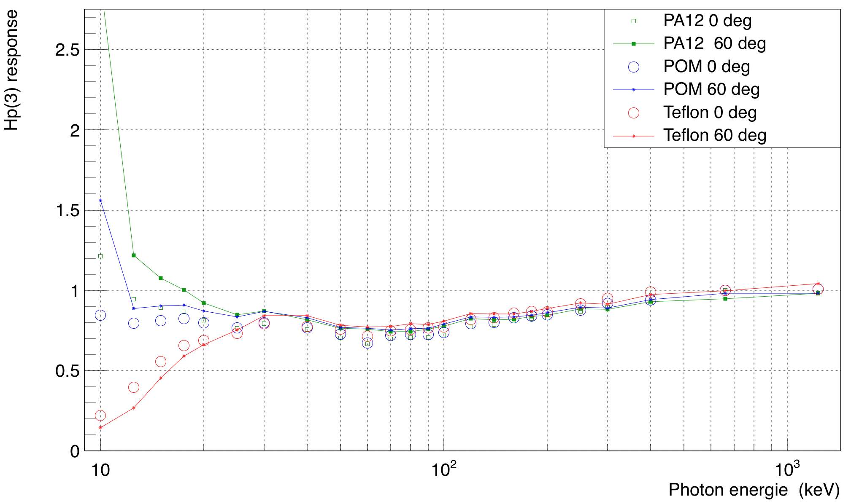

Figure 10 MC simulation of the energy response for 0° and 60° angle of incidence of the new BeOSL eye lens dosemeter.

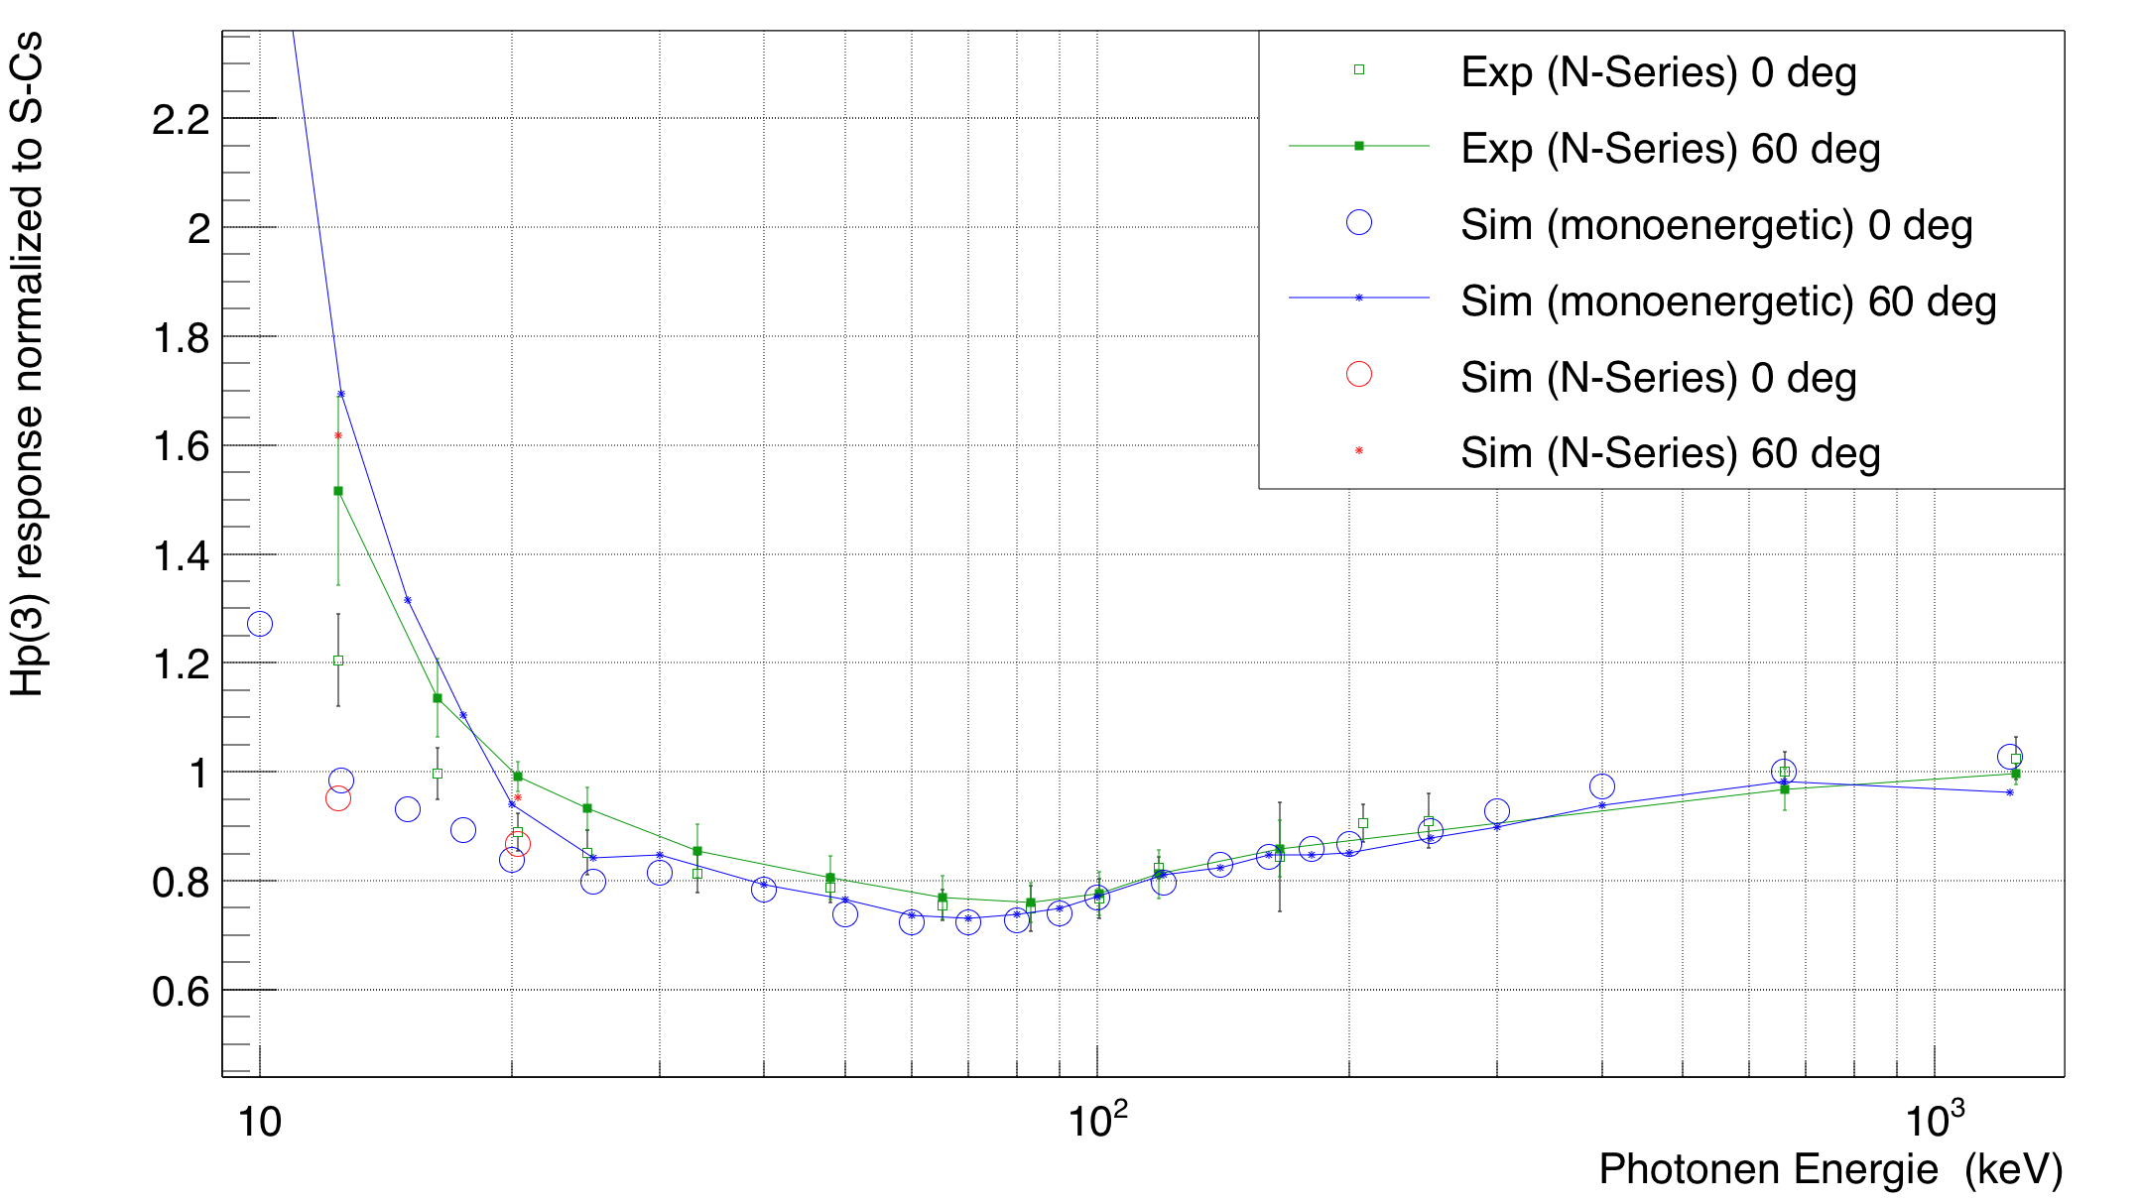

Figure 11 MC simulation and experimental data for the energy response of the new BeOSL eye lens dosemeter at 0° and 60° angle of incidence. Two simulation runs are included, which used N-series spectra instead of monoenergetic photon sources.

# Limitations of the MC method

Taking the example of the simulated and experimental response functions for the eye lens dosemeter in Figure 11, it is obvious that discrepancies between simulation and experiment are somewhat larger for the lowest photon energies.

The average relative difference between simulation and experiment for 0° incidence for energies < 25 keV is approximately 10%, whereas the average relative difference for energies >25 keV is 2%. The latter number is very good, considering that the coefficient of variation for BeOSL dosemeters is in the order of 2.5%. The somewhat larger discrepancies in the lower energy range can be understood by taking a look at uncertainties in the calculation of the simulated response. Whereas the MCNP6 results for the energy deposition in the detector exhibit very low statistical uncertainty of the order of 1% to 2%, larger uncertainties are introduced when calculating the response by means of OSL efficiency functions, fluence air attenuation and conversion factors from fluence to *Ka* and from *Ka* to *Hp*(3) as described in 0. Many of the energy points used in Figure 11 such as 12.5 keV, 15 keV, 17.5 keV and 25 keV require energy interpolation of the conversion and correction data and some of these functions vary strongly with energy in the low energy range and provide data only at 10 keV, 20 keV and 30 keV, making the interpolation problematic. For example, the relative discrepancy between simulated and experimental response at 25 keV changes from -15% to -6.4% if switching from linear interpolation to cubic spline interpolation in these calculations. In conclusion, while uncertainties and deviations from experiment are larger for the lower photon energies, the results are still good enough to indicate conformity with IEC requirements down to approximately 15 keV in the case of the eye lens dosemeter.

# Discussion and conclusion

In the comparisons for various dosemeter types presented above excellent agreement between MC models and experimental data was found. The major objective of the MC models was to predict if a certain dosemeter design would be able to produce a response function fulfilling the requirements of the IEC standards, i.e. a response between 0.71 and 1.67 over the full operational range of photon energies and for angles of incidence up to 60°. In the presentation of results no comparison with the IEC limits has been given, as all response functions were normalized to the response at 662 keV (S-Cs) 0°. The IMS however, has an additional degree of freedom in fulfilling the IEC requirements by choosing an appropriate system calibration and thereby scaling the response curve over full energy range. For the example of the new eye lens (Figure 11) the system calibration was derived by normalizing the response function to the response at N-150, 0° instead of S-Cs, i.e. the response at N-150 = 1 and the resulting response curve closely approaches unity over the full relevant photon energy range from 20 keV up to 200 keV. IEC requirements can be fulfilled down to 15 keV with this system calibration.

Due to the favorable intrinsic response function of the BeOSL detectors, fulfilling IEC limits is easily achieved by all investigated designs. The new eye lens dosemeter is currently undergoing a systematic radiological characterization and type-testing phase. A dedicated publication about the features and performance of the new dosemeter is currently in preparation.

In summary the MC simulation has served as a valuable tool to provide fast feedback on new designs or to help with the evaluation of different materials or even different detector options.

# References

1. T. Haninger, H. Hödlmoser, M. Figel, D. König-Meier, J. Henniger, M. Sommer, A. Jahn, G. Ledtermann, and R. Eßer, Properties of the BeOSL Dosimetry System in the Framework of a Large-scale Personal Monitoring Service, Radiat Prot Dosimetry first published online September 29, 2015 doi:10.1093/rpd/ncv425
2. M. Sommer, A. Jahn, J. Henninger, A new personal dosimetry system for *Hp*(10) and *Hp*(0.07) photon dose based on OSL-dosimetry of beryllium oxide. Radiat. Meas. 46, 1818–1821 (2011).
3. IEC 62387, Radiation protection instrumentation - Dosimetry systems with integrating passive detectors for individual, workplace and environmental monitoring of photon and beta radiation, 45B/906/CDV:2018-06 -62387 Ed.2.0
4. T. Goorley, et al., "Initial MCNP6 Release Overview", Nuclear Technology, 180, pp 298-315 (Dec 2012)
5. E DIN ISO 4037-1 to 3 (VDE 0412-4037-1 to 3):2017
6. A. Jahn, M. Sommer, J. Henninger, OSL efficiency for BeO OSL dosimeters, Rad Meas. Vol 71, 104-117, (2014).
7. Y. Horowitz, P. Olko, The effects of ionisation density on the thermoluminescence response (efficiency) of LiF:Mg,Ti and LiF:Mg,Cu, Radiation Protection Dosimetry, Vol. 109, p 331–348, (2004) <https://doi.org/10.1093/rpd/nch310>
8. NIST, <https://physics.nist.gov/PhysRefData/XrayMassCoef/ComTab/air.html>
9. ICRU Report 47, Measurement of Dose Equivalents from External Photon and Electron Radiations, (1992).
10. I. Antcheva et al, ROOT — A C++ framework for petabyte data storage, statistical analysis and visualization, Computer Physics Communications, Vol. 180, p 2499-2512, (2009).
11. <https://root.cern.ch>
12. V. Bandalo, J. Brönner, M. B. Greiter, H. Hoedlmoser, A Fully Automated Secondary Standard X-Ray Calibration Facility for Personal Dosemeters, Rad. Prot. Dosimetry, doi:10.1093/rpd/ncy187 (2018).
13. M. B. Greiter, J. Denk, and H. Hoedlmoser, Secondary Standard Calibration, Measurement and Irradiation Capabilities of the Individual Monitoring Service at the Helmholtz Zentrum München: Aspects of Uncertainty and Automation, Rad. Prot. Dosimetry. doi:10.1093/rpd/ncv537 (2016)
14. U. Ankerhold, Catalogue of X-ray spectra and their characteristic data –ISO and DIN radiation qualities, therapy and diagnostic radiation qualities, unfiltered X-ray spectra, PTB Report PTB-Dos-34, ISBN 3-89701-513-7 (2000).