**SUPPLEMENTAL MATERIAL**

**Long-Term Exposure to Traffic-Related Air Pollution, Traffic Noise and Incident Hypertension: An Analysis in the European Study of Cohorts for Air Pollution Effects (ESCAPE)**

Kateryna B Fuks, Gudrun Weinmayr, Xavier Basagaña, Olena Gruzieva, Regina Hampel, Bente Oftedal, Mette Sørensen, Kathrin, Wolf, Geir Aamodt, Gunn Marit Aasvang, Inmaculada Aguilera,Thomas Becker, Rob Beelen, Bert Brunekreef, Barbara Caracciolo, Josef Cyrys, Roberto Elosua, Kirsten Thorup Eriksen, Maria Foraster, Laura Fratiglioni, Agneta Hilding, Danny Houthuijs, Michal Korek, Nino Künzli, Jaume Marrugat, Mark Nieuwenhuijsen, Claes-Göran Östenson, Johanna Penell, Göran Pershagen, Ole Raaschou-Nielsen, Wim JR Swart, Annette Peters, Barbara Hoffmann

**Table of Contents**

Cohort acronyms: Page 2

Cohort-specific sensitivity analyses Page 3

Tables: Table S1 – Table S8 Page 4 – 12

Figures: Figure S1 – Figure S8 Page 13 – 23

**Cohort acronyms**

HUBRO = Oslo Health Study

SDPP = Stockholm diabetes preventive program

SNAC-K = the Swedish National study of Aging and Care in Kungsholmen

DCH = the Diet, Cancer and Health Cohort

HNR = the Heinz Nixdorf Risk Factors, Evaluation of Coronary Calcification, and Lifestyle study

KORA = the Cooperative Health Research in the Region of Augsburg

REGICOR = Registre Gironí del Cor – Girona’s heart registry

**Cohort-specific sensitivity analyses**

We performed the following sensitivity analyses: (i) adding a random intercept to account for area-level clustering; (ii) including additional covariates for fruit and vegetable consumption, where available; (iii) excluding participants who changed their residence during the follow-up period; (iv) adjusting for short-term air pollution and meteorology at the time of follow-up examination to account for short-term effects; (v) defining alternative outcomes: measured hypertension as systolic BP ≥ 160 mmHg or diastolic BP ≥ 95 mmHg or current intake of BPLM (to reduce false positive hypertensive cases) and measured hypertension as systolic BP ≥130 mmHg or diastolic BP ≥85 mmHg or current intake of BPLM (to include prehypertension).

**Tables**

**Table S1**

Description of baseline characteristics of cohorts included in the analysis of incident measured hypertension. Missing values for exposure, prevalent hypertension and blood pressure lowering medication intake, and covariates excluded.

| Parameter | SDPP | SNAC-K | HNR | KORA | REGICOR |
| --- | --- | --- | --- | --- | --- |
| N | 4,196 | 457 | 1,759 | 3,250 | 1,234 |
| Systolic blood pressure (mmHg; mean ± SD) | 116.6 ± 10.1 | 121.8 ± 9.4 | 119.8 ± 12.2 | 119.2 ± 11.2 | 115.9 ± 11.4 |
| Diastolic blood pressure (mmHg; mean ± SD) | 73.4 ± 7.2 | 74.9 ± 7.2 | 76.2 ± 7.4 | 75.8 ± 7.5 | 74.4 ± 7.6 |
| Self-reported hypertension at baseline (%) | Not available | 1.8% | 11.2% | 14.4% | 9.1% |
| Men (%) | 39.0% | 40.0% | 42.3% | 43.1% | 42.1% |
| Age (years; mean ± SD) | 46.8 ± 5.0 | 67.5 ± 8.5 | 56.9 ± 7.2 | 45.7 ± 12.3 | 51.5 ± 10.3 |
| Body mass index [kg/m²; mean ± SD) | 25.0 ± 3.5 | 24.9 ± 3.3 | 26.5 ± 3.9 | 26.0 ± 4.1 | 25.6 ± 3.8 |
| Area unemployment (%; mean ± SD) | 21.3 ± 2.9 | 2.1 ± 0.2 | 12.3 ± 3.4 | 27.2 ± 18.4 | 7.6 ± 2.7 |
| Current smoker (%) | 25.6% | 12.9% | 26.0% | 25.7% | 23.2% |
| Any environmental tobacco smoke exposure (%) | Not available | 65.4% | 37.5% | 43.6% | Not available |
| High alcohol consumption* (%) | 48.1% | 62.6% | 22.1% | 44.4% | 38.5% |
| Low education† (%) | 23.8% | 12.0% | 7.6% | 7.9% | 24.6% |
| Employed (%) | 93.3% | 43.8% | 51.6% | 68.6% | 73.7% |
| Type 2 diabetes mellitus (%) | 0.0% | 3.9% | 6.0% | 1.9% | 7.8% |
| Coronary heart disease ‡ (%) | 0.2% | 4.2% | 4.3% | 4.0% | 0.7% |

Abbreviations: SD = standard deviation

* *More than 6 drinks/week*

*† Primary school or less.*

*‡ Defined as personal history of myocardial infarction or angina pectoris.*

**Table S2.** Description of baseline characteristics of cohorts, included in the analysis of incident self-reported hypertension. Missing values for exposure, prevalent hypertension and blood pressure lowering medication intake, and covariates excluded.

| Parameter | HUBRO | SDPP | SNAC-K | DCH | HNR | KORA | REGICOR |
| --- | --- | --- | --- | --- | --- | --- | --- |
| N | 4,462 | 4,211 | 1,094 | 24,181 | 2,205 | 3,402 | 1,337 |
| Systolic blood pressure (mmHg; mean ± SD) | 121.6 ± 9.7 | 116.6 ± 10.1 | 138.8 ± 18.6 | 136.8 ± 18.8 | 127.1 ± 18.4 | 123.6 ± 16.0 | 119.3 ± 15.3 |
| Diastolic blood pressure (mmHg; mean ± SD) | 71.1 ± 8.3 | 73.4 ± 7.2 | 81.2 ± 10.0 | 81.7 ± 9.9 | 79.3 ± 10.0 | 78.1 ± 9.7 | 75.6 ± 9.1 |
| Measured hypertension at baseline (%) | 0.0%§ | 0.0%§ | 58.5% | 44.8% | 31.4% | 19.3% | 16.1% |
| Men (%) | 38.8% | 39.1% | 41.4% | 47.0% | 47.5% | 46.8% | 44.9% |
| Age (years; mean ± SD) | 44.6 ± 11.7 | 46.8 ± 5.0 | 69.8 ± 9.1 | 56.6 ± 4.3 | 58.1 ± 7.6 | 46.8 ± 12.4 | 52.8 ± 11.0 |
| Body mass index [kg/m²; mean ± SD) | 24.8 ± 3.6 | 25.0 ± 3.5 | 25.4 ± 3.6 | 25.6 ± 3.8 | 26.8 ± 4.0 | 26.1 ± 3.9 | 25.8 ± 3.8 |
| Area unemployment (%; mean ± SD) | 1.8 ± 0.8 | 21.3 ± 2.9 | 2.1 ± 0.2 | 2.3 ± 0.9 | 12.3 ± 3.4 | 27.5 ± 18.5 | 7.7 ± 2.8 |
| Current smoker (%) | 24.5% | 25.5% | 12.4% | 35.0% | 24.8% | 24.7% | 23.4% |
| Any environmental tobacco smoke exposure (%) | 22.4% | Not available | 66.1% | 81.4% | 36.9% | 43.2% | Not available |
| High alcohol consumption* (%) | 6.7% | 48.1% | 63.6% | 62.9% | 23.0% | 46.7% | 40.2% |
| Low education† (%) | 11.6% | 23.8% | 17.3% | 28.0% | 8.6% | 8.3% | 26.6% |
| Employed (%) | 87.0% | 93.3% | 35.2% | 18.3% | 48.1% | 67.9% | 70.1% |
| Type 2 diabetes mellitus (%) | 1.6% | 0.0% | 5.1% | 1.3% | 8.0% | 1.7% | 8.7% |
| Coronary heart disease ‡ (%) | 0.8% | 0.2% | 3.8% | 2.4% | 6.2% | 3.3% | 1.4% |

Abbreviations: SD = standard deviation

* *More than 6 drinks/week*

*† Primary school or less.*

*‡ Defined as personal history of myocardial infarction or angina pectoris.*

§ *The definition of measured hypertension at baseline was used to exclude prevalent cases in SDPP and HUBRO, because the self-reported hypertension at baseline was not available.*

**Table S3.** Cross-tabulation of incident self-reported and measured hypertension and of self-reported hypertension and blood pressure lowering medication in cohorts.

|  |  |  |  |  |  |  |  |  |  |
| --- | --- | --- | --- | --- | --- | --- | --- | --- | --- |
| **Cohort** | **Incident self-reported hypertension** | **Incident measured hypertension** | | | | **Incident blood pressure lowering medication intake** | | | |
| *Yes (%)* | *No (%)* | *Agreement (%)* | *Total* | *Yes (%)* | *No (%)* | *Agreement (%)* | *Total* |
| HUBRO | *Yes (%)* | Not available |  |  |  | 208 (4.5%) | 206 (4.5%) |  |  |
|  | *No (%)* |  |  |  |  | 37 (0.8%) | 4,158 (90.2%) | 4,366 (94.7%) | 4,609 |
| SDPP | *Yes (%)* | 568 (13.2%) | 63 (1.5%) |  |  | 370 (8.5%) | 269 (6.2%) |  |  |
|  | *No (%)* | 1,202 (28.0%) | 2,466 (57.4%) | 3,034 (70.6%) | 4,299 | 13 (0.3%) | 3,714 (85.1%) | 3,727 (85.4%) | 4,366 |
| SNAC-K | *Yes (%)* | 53 (8.3%) | 1 (0.2%) |  |  | 319 (20.2%) | 21 (1.3%) |  |  |
|  | *No (%)* | 194 (30.2%) | 394 (61.4%) | 447 (69.6%) | 642 | 1 (0.1%) | 1,241 (78.4%) | 1,560 (98.6%) | 1,582 |
| DCH | *Yes (%)* | Not available |  |  |  | 2,270 (9.5%) | 0 (0%) |  |  |
|  | *No (%)* |  |  |  |  | 894 (3.7%) | 20,856 (86.8%) | 23126 (96.3%) | 24,020 |
| HNR | *Yes (%)* | 179 (11.3%) | 340 (21.4%) |  |  | 310 (14.4%) | 121 (5.6%) |  |  |
|  | *No (%)* | 39 (2.5%) | 1,033 64.9%) | 1,212 (76.2%) | 1,591 | 128 (5.9%) | 1,594 (74.0%) | 1,904 (88.4%) | 2,153 |
| KORA | *Yes (%)* | 308 (11.2%) | 213 (7.8%) |  |  | 407 (12.3%) | 472 (14.2%) |  |  |
|  | *No (%)* | 212 (7.7%) | 2,015 73.3%) | 2,323 (84.5%) | 2,748 | 105 (3.2%) | 2,332 (70.3%) | 2,460 (74.2%) | 3,316 |
| REGICOR | *Yes (%)* | 88 (6.3%) | 46 (3.3%) |  |  | 133 (8.2%) | 113 (7.0%) |  |  |
|  | *No (%)* | 174 (12.4%) | 1,092 78.0%) | 1,180 (84.3%) | 1,400 | 47 (2.9%) | 1,327 (81.9%) | 1,460 (90.1%) | 1,620 |

**Table S4.** Description of exposure in cohorts included in the analysis of measured incidence of hypertension [mean ± standard deviation (5–95 percentile range, if not indicated otherwise]. Missing values for exposure, prevalent hypertension and blood pressure lowering medication intake, and covariates excluded.

| Exposure | SDPP | SNAC-K | HNR | KORA | REGICOR |
| --- | --- | --- | --- | --- | --- |
| PM25 [µg/m³] | 6.6 ± 1.2 (4.5–8.5) | 7.9 ± 1.3 (5.7–10.2) | 18.4 ± 1.0 (16.7–20.2) | 13.6 ± 0.9 (12.5–15.2) | 15.0 ± 1.6 (12.2–17.7) |
| PMcoarse [µg/m³] | 6.2 ± 2.4 (0.7–8.6) | 8.6 ± 4.7 (0.9–18.3) | 10.1 ± 1.6 (7.9–12.4) | 6.2 ± 1.0 (4.8–8.2) | 15.2 ± 2.4 (12.7–20.2) |
| PM25abs [µg/m³] | 0.5 ± 0.1 (0.4–0.7) | 0.8 ± 0.2 (0.5–1.1) | 1.6 ± 0.4 (1.2–2.2) | 1.7 ± 0.2 (1.4–2.0) | 2.3 ± 0.7 (1.3–3.4) |
| PM10 [µg/m³] | 13.5 ± 3.2 (6.0–16.7) | 16.5 ± 6.0 (6.2–28.4) | 27.7 ± 1.8 (25.1–31.1) | 20.3 ± 2.4 (16.5–24.2) | 32.2 ± 4.0 (26.9–40.4) |
| NO2 [µg/m³] | 8.3 ± 1.6 (6.1–11.2) | 17.2 ± 4.9 (8.7–24.9) | 30.0 ± 5.0 (23.2–38.5) | 18.6 ± 3.8 (13.7–25.4) | 37.0 ± 13.0 (12.4–56.0) |
| NOx [µg/m³] | 14.2 ± 3.0 (11.8–19.5) | 33.6 ± 12.6 (15.4–59.3) | 50.1 ± 11.8 (33.1–71.4) | 32.3 ± 7.1 (23.7–45.5) | 65.9 ± 27.8 (21.7–112.2) |
| NO [µg/m³] | 5.9 ± 2.0 (3.6–8.9) | 16.3 ± 8.3 (5.2–35.4) | 20.1 ± 7.7 (8.9–34.3) | 13.7 ± 3.8 (9.0–20.7) | 28.9 ± 15.3 (8.2–57.6) |
| Traffic intensity at the nearest road  [10³ vehicles/day] | 0.8 ± 1.6 (0.5–2.5) | 3.6 ± 6.5 (0.5–23.0) | Not available | 1.5 ± 3.2 (0.5–7.5) | 4.6 ± 6.8 (0.2–21.0) |
| Traffic load on major road fragments within 100 m [106 vehicles×m/day] | 0.1 ± 0.4 (0.0–0.9) | 1.9 ± 2.4 (0.0–5.2) | 1.0 ± 2.3 (0.0–4.1) | 0.4 ± 1.0 (0.0–2.4) | 1.6 ± 2.3 (0.0–6.0) |
| Lden [dB], median (interquartile range) | Not available | 66.5 (9.0) | 51.9 (13.4) | 53.7 (8.1) | 66.6 (6.3) |

**Table S5.** Description of exposure in cohorts included in the analysis of self-reported incidence of hypertension [mean ± standard deviation (5–95 percentile range), if not indicated otherwise]. Missing values for exposure, prevalent hypertension and blood pressure lowering medication intake, and covariates excluded.

| Exposure | HUBRO | SDPP | SNAC-K | DCH | HNR | KORA | REGICOR |
| --- | --- | --- | --- | --- | --- | --- | --- |
| PM25 [µg/m³] | 9.0 ± 1.3 (6.7–11.0) | 6.6 ± 1.2 (4.5–8.5) | 7.9 ± 1.3 (5.9–10.2) | 11.3 ± 0.9 (9.7–12.6) | 18.4 ± 1.1 (16.8–20.3) | 13.6 ± 0.9 (12.5–15.2) | 15.0 ± 1.7 (12.2–18.0) |
| PMcoarse [µg/m³] | 4.0 ± 2.0 (3.2–8.8) | 6.2 ± 2.4 (0.7–8.6) | 8.7 ± 4.8 (0.9–18.6) | 5.6 ± 1.0 (4.1–7.4) | 10.1 ± 1.6 (7.9–12.4) | 6.2 ± 1.0 (4.9–8.2) | 15.2 ± 2.4 (12.7–20.0) |
| PM25abs [µg/m³] | 1.2 ± 0.3 (0.8–1.7) | 0.5 ± 0.1 (0.4–0.7) | 0.8 ± 0.2 (0.5–1.1) | 1.1 ± 0.2 (0.8–1.5) | 1.6 ± 0.4 (1.2–2.2) | 1.7 ± 0.2 (1.4–2.0) | 2.3 ± 0.7 (1.2–3.4) |
| PM10 [µg/m³] | 13.7 ± 3.1 (9.3–19.1) | 13.5 ± 3.2 (6.0–16.7) | 16.6 ± 6.0 (6.2–28.8) | 17.0 ± 1.9 (13.9–20.3) | 27.8 ± 1.9 (25.2–31.4) | 20.3 ± 2.4 (16.5–24.2) | 32.3 ± 4.0 (26.7–40.4) |
| NO2 [µg/m³] | 20.5 ± 7.6 (10.9–35.5) | 8.3 ± 1.6 (6.1–11.2) | 17.4 ± 4.8 (8.9–25.3) | 16.0 ± 7.0 (8.0–29.8) | 30.2 ± 5.0 (23.4–38.6) | 18.5 ± 3.8 (13.7–25.4) | 37.0 ± 13.3 (12.0–56.2) |
| NOx [µg/m³] | 37.8 ± 14.6 (21.7–67.9) | 14.2 ± 3.0 (11.8–19.5) | 33.7 ± 12.4 (15.4–59.1) | 26.0 ± 18.3 (6.9–64.8) | 50.6 ± 11.8 (33.5–71.8) | 32.3 ± 7.1 (23.7–45.5) | 66.1 ± 28.3 (18.7–113.6) |
| NO [µg/m³] | 17.2 ± 8.1 (8.8–34.9) | 5.9 ± 2.0 (3.6–8.9) | 16.2 ± 8.2 (4.9–34.5) | 10.0 ± 11.6 (-1.1–36.2) | 20.4 ± 7.8 (9.1–34.2) | 13.7 ± 3.8 (8.9–20.7) | 29.1 ± 15.6 (6.6–58.4) |
| Traffic intensity at the nearest road  [10³ vehicles/day] | 2.4 ± 5.3 (0.5–10.0) | 0.8 ± 1.6 (0.5–2.5) | 3.6 ± 7.6 (0.5–23.0) | 2.8 ± 7.0 (0.2–16.0) | Not available | 1.5 ± 3.2 (0.5–7.8) | 4.8 ± 7.1 (0.2–22.0) |
| Traffic load on major road fragments within 100 m [106 vehicles×m/day] | 0.8 ± 1.8 (0.0–3.8) | 0.1 ± 0.4 (0.0–0.9) | 2.2 ± 3.2 (0.0–5.6) | 1.2 ± 2.3 (0.0–5.3) | 1.0 ± 2.3 (0.0–4.2) | 0.4 ± 1.0 (0.0–2.4) | 1.7 ± 2.3 (0.0–6.0) |
| Lden [dB] , median (interquartile range) | 55.3 (10.0) | Not available | 66.5 (9.0) | 57.6 (9.3) | 52.1 (14.0) | 53.7 (7.9) | 66.7 (6.1) |

**Table S6.** Correlation coefficient of exposures assigned to residential locations of all cohort participants, at baseline (Spearman’s ρ).

| Exposures | HUBRO | SDPP | SNAC-K | DCH | HNR | KORA | REGICOR |
| --- | --- | --- | --- | --- | --- | --- | --- |
| PM2.5 × PM2.5abs. | 0.47 | 0.93 | 0.98 | 0.48 | 0.89 | 0.42 | 0.80 |
| PM2.5 × PMcoarse | 0.14 | 0.32 | 0.71 | 0.62 | 0.68 | 0.26 | 0.33 |
| PM2.5 × PM10 | 0.71 | 0.32 | 0.70 | 0.72 | 0.88 | 0.37 | 0.71 |
| PM2.5 × NO2 | 0.40 | 0.63 | 0.82 | 0.64 | 0.65 | 0.35 | 0.67 |
| PM2.5 × traffic load | 0.22 | 0.13 | 0.57 | 0.35 | 0.21 | 0.24 | 0.35 |
| PM2.5 × traffic noise | 0.30 | Not available | 0.61 | 0.30 | 0.30 | 0.35 | 0.66 |
| PM2.5abs. × PMcoarse | 0.21 | 0.42 | 0.79 | 0.60 | 0.73 | 0.83 | 0.25 |
| PM2.5abs. × PM10 | 0.21 | 0.41 | 0.78 | 0.69 | 0.90 | 0.66 | 0.78 |
| PM2.5abs. × NO2 | 0.78 | 0.79 | 0.85 | 0.71 | 0.63 | 0.66 | 0.90 |
| PM2.5abs. × traffic load | 0.34 | 0.21 | 0.59 | 0.50 | 0.41 | 0.43 | 0.39 |
| PM2.5abs. × traffic noise | 0.34 | Not available | 0.66 | 0.45 | 0.48 | 0.46 | 0.77 |
| PM10 × PMcoarse | 0.38 | 1.00 | 1.00 | 0.64 | 0.69 | 0.77 | 0.44 |
| PM10 × NO2 | 0.28 | 0.45 | 0.71 | 0.81 | 0.54 | 0.68 | 0.79 |
| PM10 × traffic load | 0.38 | 0.16 | 0.48 | 0.51 | 0.21 | 0.26 | 0.53 |
| PM10 × traffic noise | 0.29 | Not available | 0.58 | 0.43 | 0.31 | 0.29 | 0.72 |
| NO2 × traffic load | 0.47 | 0.23 | 0.50 | 0.65 | 0.54 | 0.36 | 0.37 |
| NO2 × traffic noise | 0.47 | Not available | 0.64 | 0.62 | 0.36 | 0.43 | 0.66 |
| Traffic load × traffic noise | 0.59 | Not available | 0.63 | 0.58 | 0.60 | 0.48 | 0.45 |

**Table S7.** Pooled estimates of association of air pollutants with incident self-reported hypertension in the subset of cohorts* with available measured hypertension†. Estimates are adjusted for age, sex, education, economic activity, body mass index, smoking status, pack-years of smoking, environmental tobacco smoking, total alcohol consumption, wine consumption, physical activity, family history of hypertension, and area-level socio-economic status.

|  |  |  |  |
| --- | --- | --- | --- |
| **Exposure** | **Relative risk (95% confidence interval)** | **I2** | **pheterogeneity** |
| PM2.5 [5 µg/m³] | 1.24 (1.05, 1.46) | 0.00 | 0.98 |
| PMcoarse [5 µg/m³] | 1.05 (0.94, 1.16) | 30.76 | 0.22 |
| PM10 [10 µg/m³] | 1.03 (0.93, 1.15) | 0.00 | 0.62 |
| PM2.5 absorbance [10-5 m-1] | 1.17 (1.03, 1.33) | 0.00 | 0.73 |
| NO2 [10 µg/m³] | 1.05 (0.98, 1.13) | 0.00 | 0.91 |
| NOx [20 µg/m³] | 1.03 (0.95, 1.12) | 19.96 | 0.29 |
| Traffic load [4×106 vehicles×m/day] | 1.08 (1.01, 1.17) | 0.00 | 0.98 |
| Traffic intensity [5,000 vehicles/day] † | 1.00 (0.94, 1.07) | 45.81 | 0.14 |
| Lden [per 10 dB] ‡ | 1.03 (1.01, 1.06) | 0.00 | 0.90 |

*\* SNAC-K, SDPP, HNR, KORA, REGICOR; Npopulation under risk = 12,249; Nincident hypertension cases = 2,467.*

*† HNR excluded due to missing traffic intensity data.*

*‡ SDPP excluded due to missing noise data.*

**Table S8.** Pooled estimates of the association of air pollution, traffic indicators and road traffic noise with alternative definitions of hypertension*. Estimates are adjusted for age, sex, education, economic activity, body mass index, smoking status, pack-years of smoking, environmental tobacco smoking, total alcohol consumption, wine consumption, physical activity, family history of hypertension, and area-level socio-economic status.

| **Outcome and exposure** | **Relative risk (95% confidence interval)** | **I2** | **Pheterogeneity** |
| --- | --- | --- | --- |
| *Incident measured hypertension, low blood pressure cutoff (systolic BP ≥130 mmHg or diastolic BP ≥85 mmHg or current intake of BPLM).* |  |  |  |
| PM2.5 [5 µg/m³] | 1.01 (0.90, 1.14) | 4.11 | 0.38 |
| PMcoarse [5 µg/m³] | 1.02 (0.95, 1.10) | 25.91 | 0.25 |
| PM10 [10 µg/m³] | 1.04 (0.94, 1.16) | 23.48 | 0.26 |
| PM2.5 absorbance [10-5 m-1] | 1.06 (0.96, 1.18) | 0.00 | 0.55 |
| NO2 [10 µg/m³] | 1.00 (0.94, 1.07) | 0.00 | 0.88 |
| NOx [20 µg/m³] | 0.99 (0.94, 1.05) | 0.00 | 0.57 |
| Traffic load [4×106 vehicles×m/day] | 1.06 (0.94, 1.19) | 44.18 | 0.13 |
| Traffic intensity [5,000 vehicles/day] *†* | 0.99 (0.93, 1.04) | 25.20 | 0.26 |
| Lden [per 10 dB] *‡* | 1.01 (0.96, 1.06) | 0.00 | 0.79 |
| *Incident measured hypertension, high blood pressure cutoff (systolic BP ≥ 160 mmHg or diastolic BP ≥ 95 mmHg or current intake of BPLM)* |  |  |  |
| PM2.5 [5 µg/m³] | 1.09 (0.95, 1.26) | 0.00 | 0.81 |
| PMcoarse [5 µg/m³] | 1.02 (0.91, 1.14) | 48.81 | 0.10 |
| PM10 [10 µg/m³] | 0.99 (0.88, 1.12) | 25.90 | 0.25 |
| PM2.5 absorbance [10-5 m-1] | 1.08 (0.96, 1.20) | 0.00 | 0.50 |
| NO2 [10 µg/m³] | 1.02 (0.95, 1.08) | 0.00 | 0.52 |
| NOx [20 µg/m³] | 1.01 (0.95, 1.07) | 0.00 | 0.64 |
| Traffic load [4×106 vehicles×m/day] | 1.06 (0.98, 1.15) | 0.00 | 0.89 |
| Traffic intensity [5,000 vehicles/day] *†* | 0.96 (0.91, 1.01) | 0.00 | 0.90 |
| Lden [per 10 dB] *‡* | 0.99 (0.94, 1.05) | 0.00 | 0.42 |

*\* SNAC-K, SDPP, HNR, KORA, REGICOR; Npopulation under risk = 12,249; Nincident hypertension cases = 2,467.*

*† HNR excluded due to missing traffic intensity data.*

*‡ SDPP excluded due to missing noise data.*

**Figures**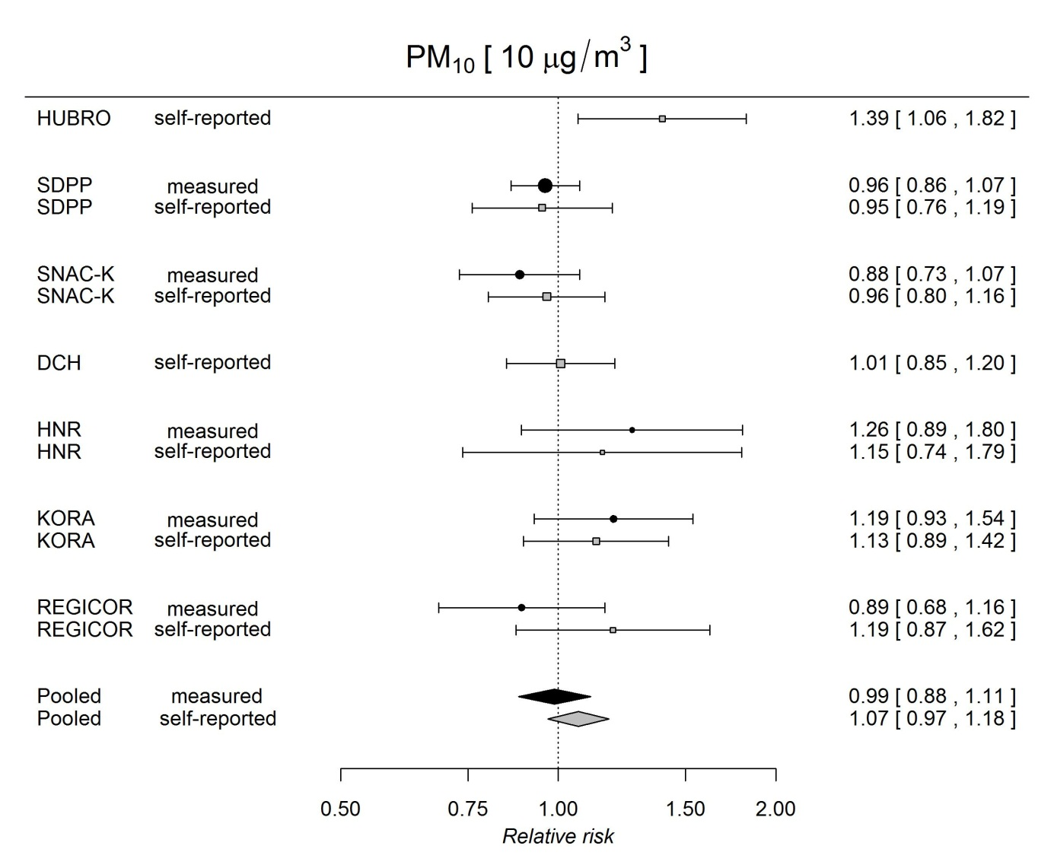

**Figure S1.** Random-effects meta-analysis of the association of PM10 at baseline with measured and self-reported incidence of hypertension at follow-up. Estimates adjusted for age, sex, education, economic activity, body mass index, smoking status, pack-years of smoking, environmental tobacco smoking, total alcohol consumption, wine consumption, physical activity, family history of hypertension, and area-level socio-economic status.

**Legend:** Filled marks = incident measured hypertension as outcome; open marks = incident self-reported hypertension. Relative risk (with 95% confidence interval) per given increase in exposure concentration is presented.

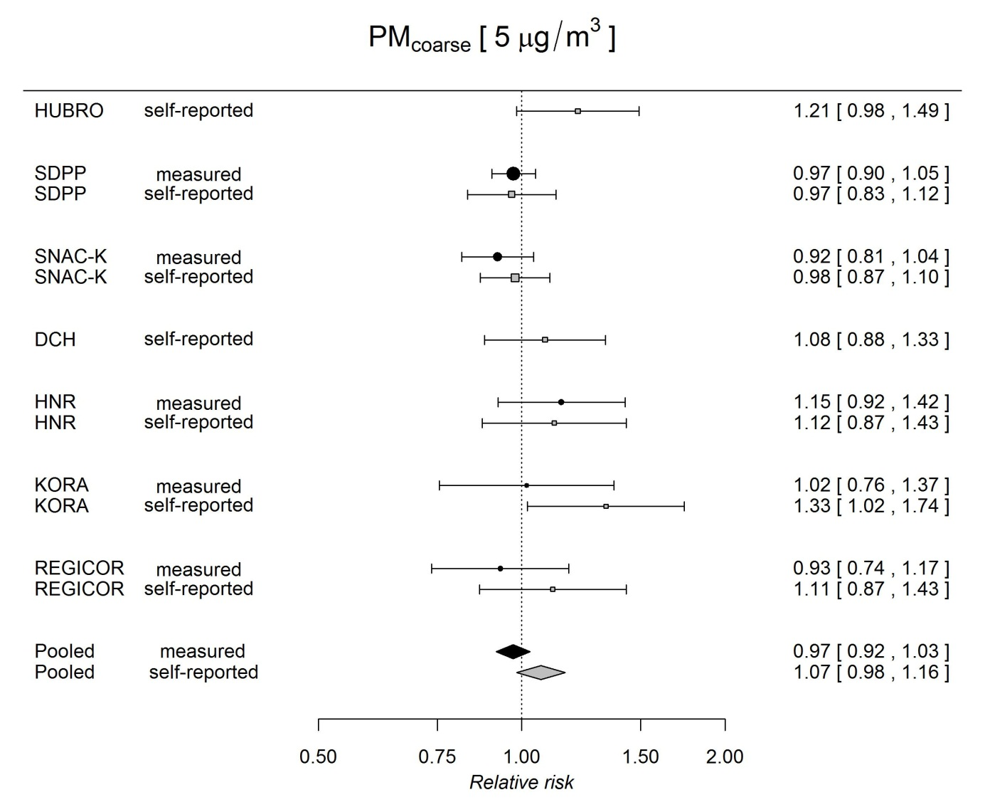

**Figure S2.** Random-effects meta-analysis of the association of PMcoarse at baseline with measured and self-reported incidence of hypertension at follow-up. Estimates adjusted for age, sex, education, economic activity, body mass index, smoking status, pack-years of smoking, environmental tobacco smoking, total alcohol consumption, wine consumption, physical activity, family history of hypertension, and area-level socio-economic status.

**Legend:** Filled marks = incident measured hypertension as outcome; open marks = incident self-reported hypertension. Relative risk (with 95% confidence interval) per given increase in exposure concentration is presented.

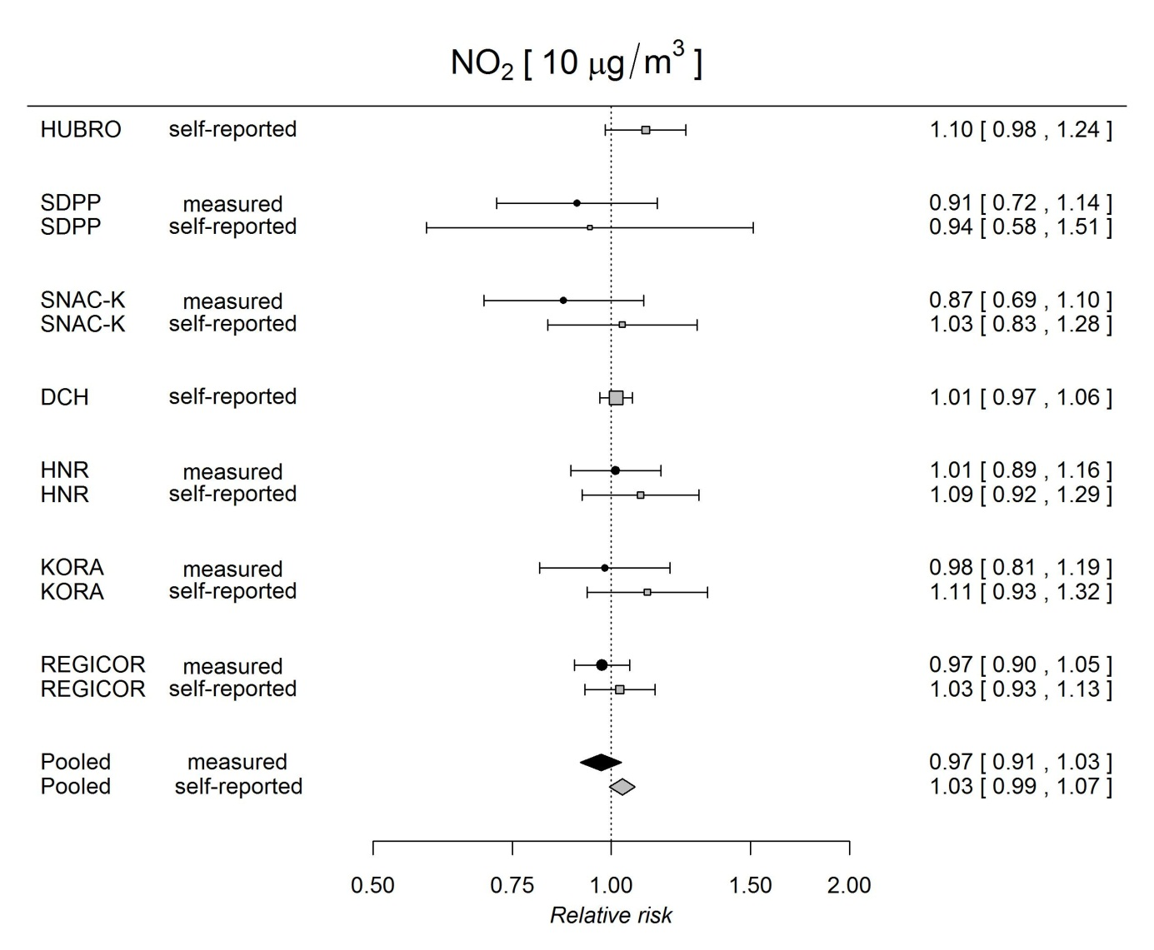

**Figure S3.** Random-effects meta-analysis of the association of NO2 at baseline with measured and self-reported incidence of hypertension at follow-up. Estimates adjusted for age, sex, education, economic activity, body mass index, smoking status, pack-years of smoking, environmental tobacco smoking, total alcohol consumption, wine consumption, physical activity, family history of hypertension, and area-level socio-economic status.

**Legend:** Filled marks = incident measured hypertension as outcome; open marks = incident self-reported hypertension. Relative risk (with 95% confidence interval) per given increase in exposure concentration is presented.

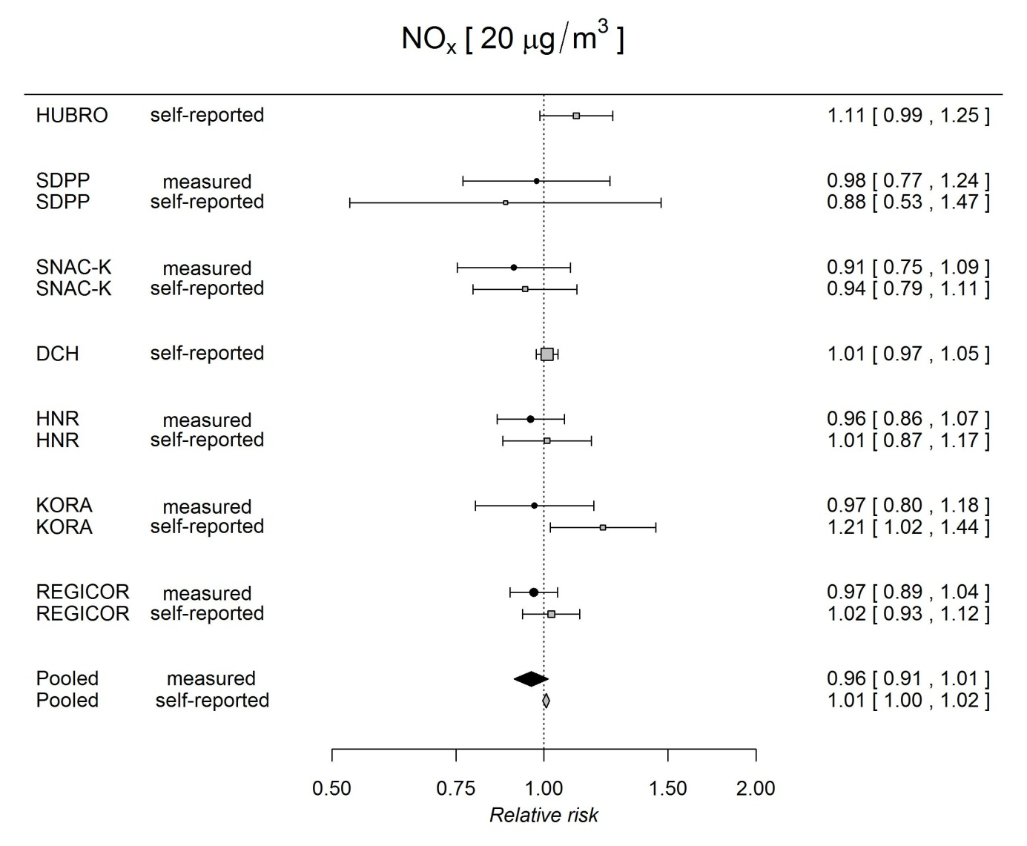**Figure S4.** Random-effects meta-analysis of the association of NOx at baseline with measured and self-reported incidence of hypertension at follow-up. Estimates adjusted for age, sex, education, economic activity, body mass index, smoking status, pack-years of smoking, environmental tobacco smoking, total alcohol consumption, wine consumption, physical activity, family history of hypertension, and area-level socio-economic status.

**Legend:** Filled marks = incident measured hypertension as outcome; open marks = incident self-reported hypertension. Relative risk (with 95% confidence interval) per given increase in exposure concentration is presented.

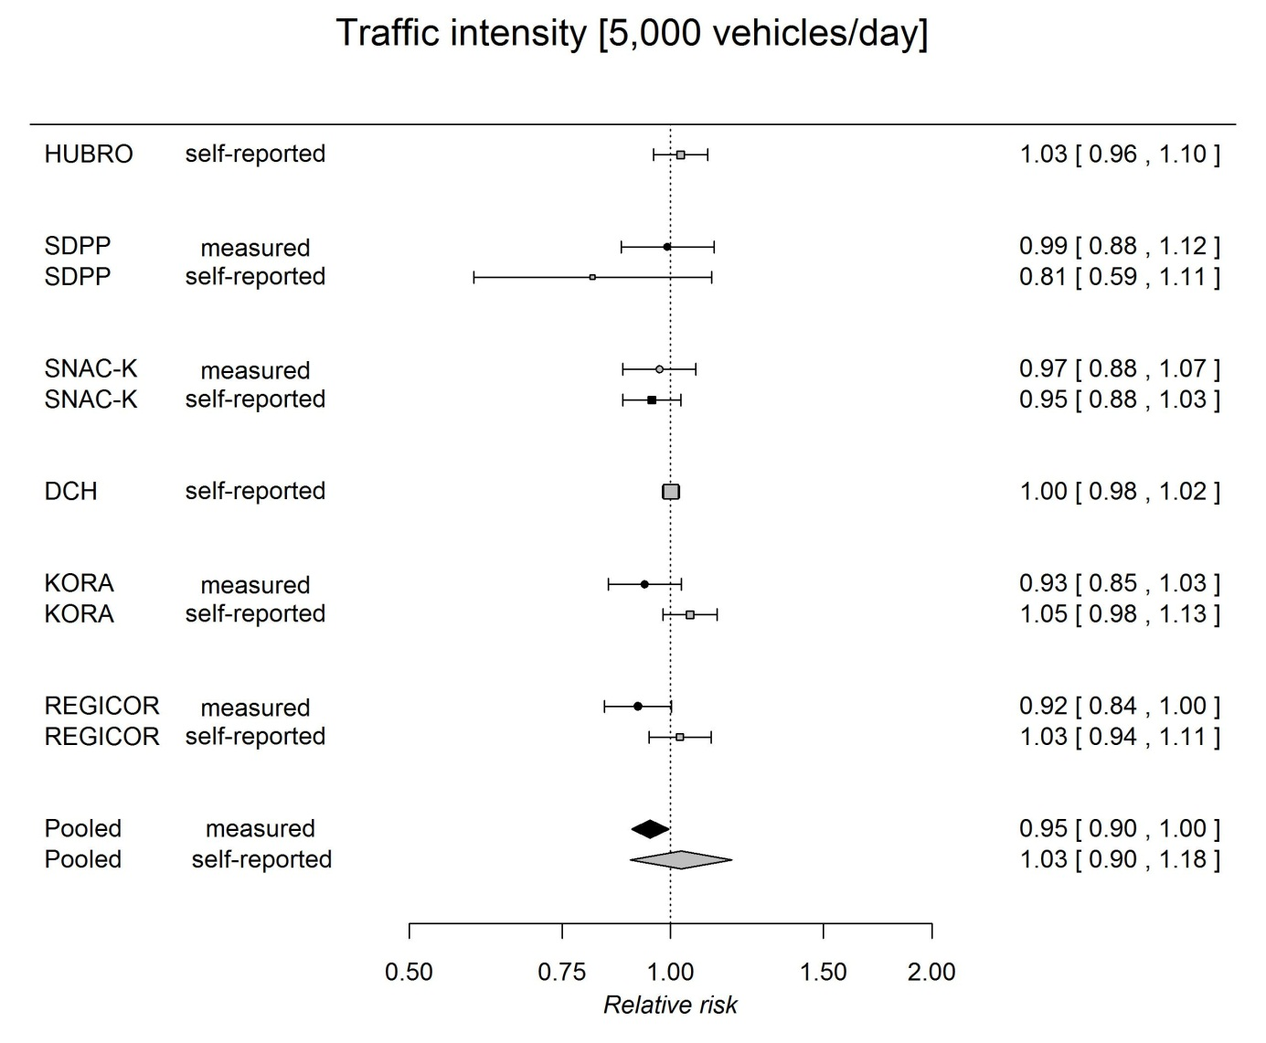**Figure S5.** Random-effects meta-analysis of the association of traffic intensity at the nearest road at baseline with measured and self-reported incidence of hypertension at follow-up. Estimates adjusted for age, sex, education, economic activity, body mass index, smoking status, pack-years of smoking, environmental tobacco smoking, total alcohol consumption, wine consumption, physical activity, family history of hypertension, and area-level socio-economic status.

**Legend:** Filled marks = incident measured hypertension as outcome; open marks = incident self-reported hypertension. Relative risk (with 95% confidence interval) per given increase in exposure concentration is presented.

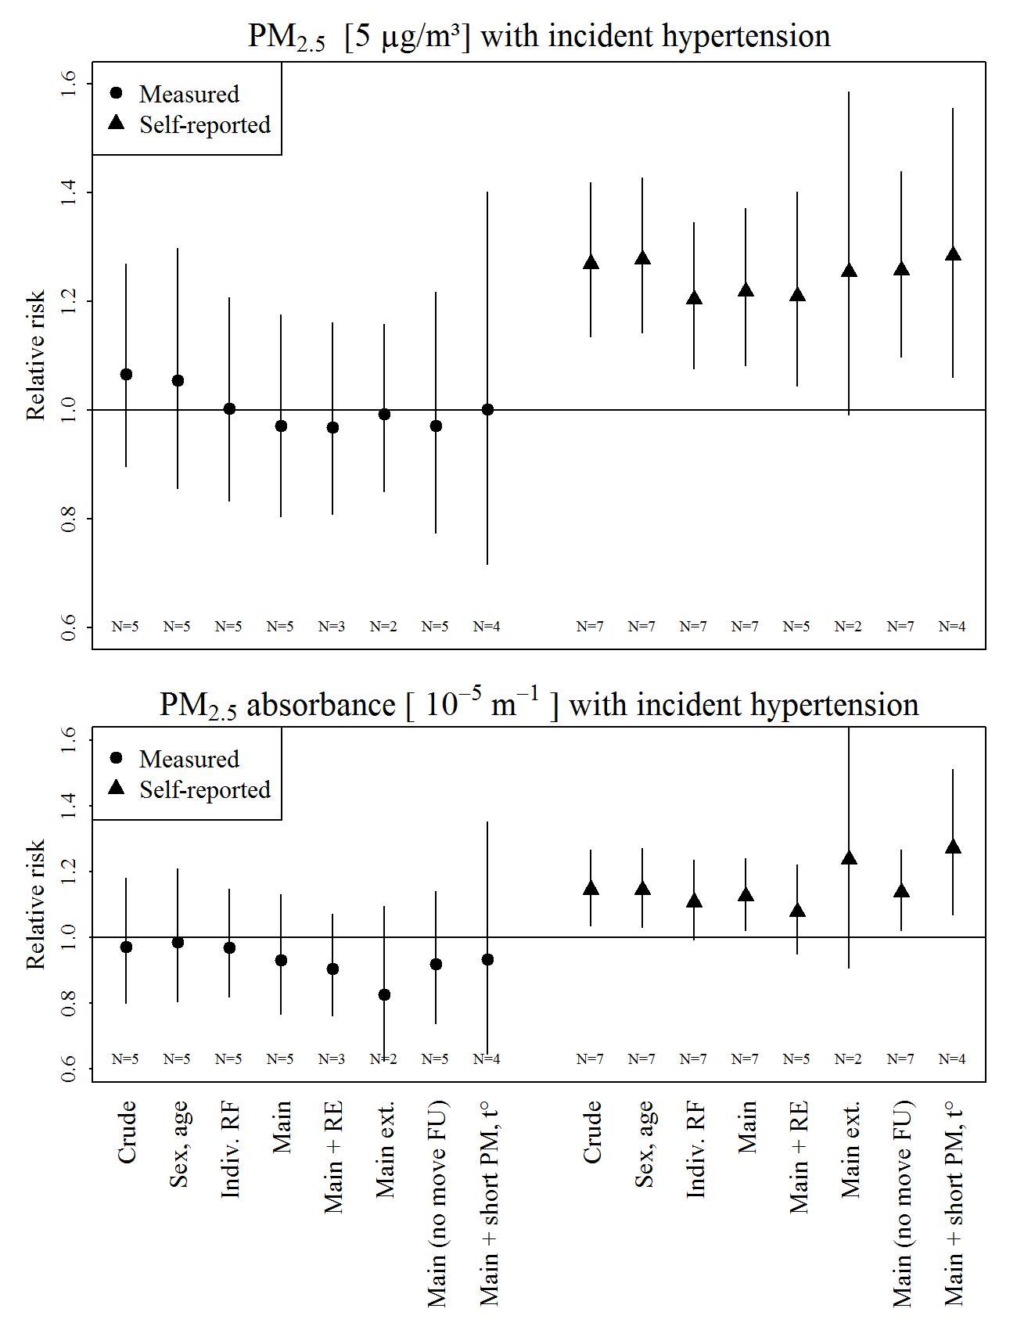

**Figure S6.** Association of PM2.5 and PM2.5 absorbance with incident hypertension, using different model specifications /sensitivity analysis).

**Legend:** Measured = incident measured hypertension as outcome; self-report = incident self-reported hypertension as outcome. N = number of studies in the meta-analysis.

Adjustment models:  
Crude = only exposure in the model. Cohorts included with self-reported hypertension: HUBRO, DCH, SDPP, SNAC-K, HNR, KORA, REGICOR. Cohorts included with measured hypertension: SDPP, SNAC-K, HNR, KORA, REGICOR.

Sex, age = adjusted for sex and age. Cohorts included with self-reported hypertension: HUBRO, DCH, SDPP, SNAC-K, HNR, KORA, REGICOR. Cohorts included with measured hypertension: SDPP, SNAC-K, HNR, KORA, REGICOR.

Indiv. RF = adjusted for individual risk factors, namely, for age, sex, education, economic activity, body mass index, smoking status, pack-years of smoking, environmental tobacco smoking, total alcohol consumption, wine consumption (if available separately; in this case, wine was excluded from total alcohol consumption), physical activity, family history of hypertension (if available). Cohorts included with self-reported hypertension: HUBRO, DCH, SDPP, SNAC-K, HNR, KORA, REGICOR. Cohorts included with measured hypertension: SDPP, SNAC-K, HNR, KORA, REGICOR.

Main = adjusted for individual risk factors and area-level socio-economic status. Cohorts included with self-reported hypertension: HUBRO, DCH, SDPP, SNAC-K, HNR, KORA, REGICOR. Cohorts included with measured hypertension: SDPP, SNAC-K, HNR, KORA, REGICOR.

Main + RE = main adjustment model with random intercept for area. Cohorts included with self-reported hypertension: HUBRO, DCH, SDPP, KORA, REGICOR. Cohorts included with measured hypertension: SDPP, KORA, REGICOR.

Main ext. = main adjustment model, additionally adjusted for salt, fruit and vegetable consumption. Cohorts included with self-reported hypertension: SDPP, KORA. Cohorts included with measured hypertension: SDPP, KORA.

Main (no move FU) = main adjustment model, participants with address change during follow-up excluded. Cohorts included with self-reported hypertension: HUBRO, DCH, SDPP, SNAC-K, HNR, KORA, REGICOR. Cohorts included with measured hypertension: SDPP, SNAC-K, HNR, KORA, REGICOR.

Main + short-term PM, t° = main model adjusted for short-term PM2.5 and ambient temperature (5-day mean). Cohorts included with self-reported hypertension: SDPP, SNAC-K, HNR, KORA. Cohorts included with measured hypertension: SDPP, SNAC-K, HNR, KORA.

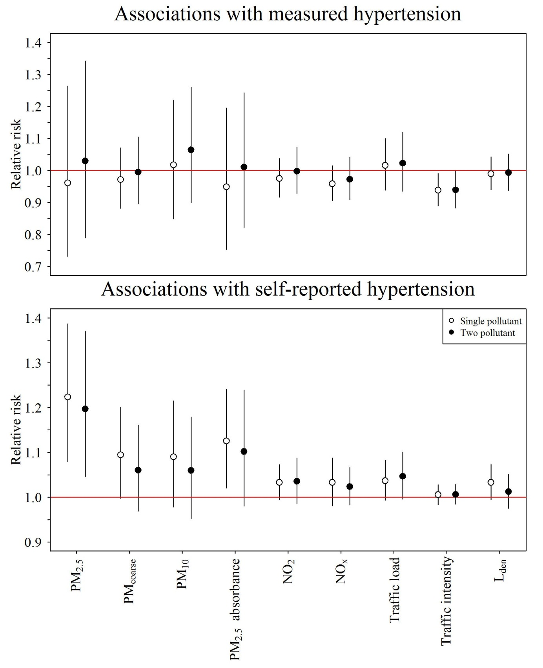

**Figure S7.** Meta-analysis estimates of the association of air pollution, traffic indicators and Lden with incident hypertension, analysed with single- and two-pollutant models.

**Legend:** Single pollutant = model with only one pollutant included (PM2.5, PMcoarse, PM10, PM2.5 absorbance, NO2, NOx, traffic indicators or Lden, respectively);

Two pollutant = adjusted for Lden (with PM2.5, PMcoarse, PM10, PM2.5 absorbance, NO2, NOx, or traffic indicators as main exposures) or for PM2.5 (with Lden as main exposure). Cohorts included with self-reported hypertension: HUBRO, DCH, SNAC-K, HNR, KORA, REGICOR. Cohorts included with measured hypertension: SNAC-K, HNR, KORA, REGICOR.

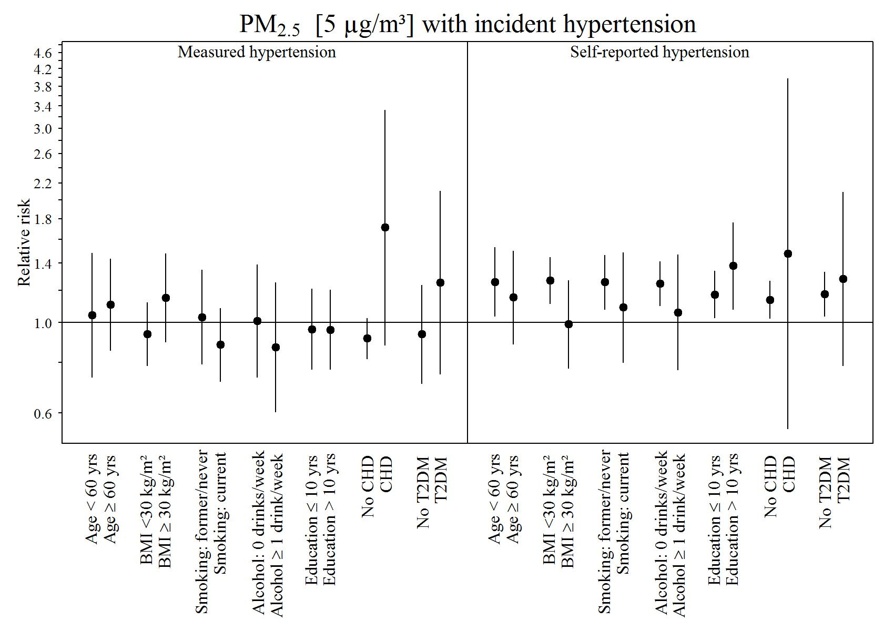

**Figure S8.** Meta-analysis estimates of the association of PM2.5 with incident hypertension (measured and self-reported), estimated in subgroups using product terms exposure×effect modifier.

**Legend:** BMI = body mass index; CHD = coronary heart disease; T2DM = type 2 diabetes mellitus.Cohorts included with self-reported hypertension: HUBRO, DCH, SDPP, SNAC-K, HNR, KORA, REGICOR. Cohorts included with measured hypertension: SDPP, SNAC-K, HNR, KORA, REGICOR.