Title: How accurately do maize crop models simulate the interactions of atmospheric CO2 concentration levels with limited water supply on water use and yield ?

Article Type: SI: Advance in crop modelling

Keywords: Zea mays, atmospheric carbon dioxide concentration, multi-model ensemble, water use, stomatal conductance, grain number

Corresponding Author: Dr. Jean-louis Durand, Ph. D. HDR

First Author: Jean-louis Durand, Ph. D. HDR

Order of Authors: Jean-louis Durand, Ph. D. HDR; Kenel Delusca; Ken Boote; Jon Lizaso; Remy Manderscheid; Hans J Weigel; Alex C Ruane; Cynthia Rosenzweig; Jim Jones; Laj Ahuja; Saseendran Anapalli; Christian Baron; Bruno Basso; Patrick Bertuzzi; Christian Biernath; Delphine Deryng; Franck Ewert; Thomas Gaiser; Sebastian Gayler; Florian Heinlein; Kurt C Kersebaum; Soo-Hyung Kim; Christoph Müller; Claas Nendel; Albert Olioso; Eckart Priesack; Julian Ramirez Villegas; Dominique Ripoche; Edmund R Rötter; Sabine I Seidel; Amit Srivastava; Fulu Tao; Dennis Timlin; Tracy Twine; Enli Wang; Heidi Webber; Zhigan Zhao

1

1. **Title** How accurately do maize crop models simulate the interactions of atmospheric
2. CO2 concentration levels with limited water supply on water use and yield?

3

1. **Authors:** Jean-Louis Durand (1); Kenel Delusca (1); Ken Boote (2); Jon Lizaso (3); Remy
2. Manderscheid (4); Hans Johachim. Weigel (4); Alex C Ruane (5); Cynthia Rosenzweig (5);
3. Jim Jones (2); Laj Ahuja (6); Saseendran Anapalli (6); Bruno Basso (7); Christian Baron
4. (8); Patrick Bertuzzi (9); Christian Biernath (10); Delphine Deryng (11); Franck Ewert
5. (12); Thomas Gaiser (12); Sebastian Gayler (13); Florian Heinlein (10); Kurt Christian
6. Kersebaum (14); Soo-Hyung Kim (15); Christoph Müller (16); Claas Nendel (14); Albert
7. Olioso (17), Eckart Priesack (10); Julian Ramirez Villegas (18); Dominique Ripoche (9);
8. Edmund. R. Rötter (19); Sabine I Seidel (12) Amit Srivastava (12); Fulu Tao (19, 20);
9. Dennis Timlin (21); Tracy Twine (23); Enli Wang (23); Heidi Webber (12); Zhigan Zhao

13 (24).

14

1. **Affiliations** (1) INRA; URP3F, France; (2) University of Florida, Gainesville, United
2. States of America; (3) Technical University of Madrid-CEIGRAM; (4) Thünen Institute,
3. Braunschweig, Germany; (5) NASA Goddard Institute for Space Studies, New York
4. City, United States of America; (6) CPSRU, USDA-ARS, Stoneville, Mississippi, USA; (7)
5. Department of Geological Sciences, Michigan State University, Michigan, USA; (8)
6. CIRAD, UMR TETIS, Montpellier, France; (9) INRA, Agroclim, France; (10) Institute
7. of Biochemical Plant Pathology, Helmholtz Zentrum München, Neuherberg, Germany;
8. (11) Computation Institute, University of Chicago, USA; (12) Institute of Crop Science
9. and Resource Conservation (INRES), University of Bonn, Germany; (13) Institute of
10. Soil Science and Land Evaluation, Section Biogeophysics, University of Hohenheim,
11. Stuttgart, Germany; (14) Institute of Landscape Systems Analysis, Leibniz-Centre for
12. Agricultural Landscape Research (ZALF), Müncheberg, Germany; (15) School of
13. Environmental and Forest Sciences, University of Washington, Seattle, USA; (16)
14. Potsdam Institute for Climate Impact Research, Potsdam, Germany; (17) INRA
15. EMMAH, Avignon, France; (18) School of Earth and Environment, University of Leeds,
16. Leeds, UK, CGIAR Research Program on Climate Change, Agriculture and Food
17. Security (CCAFS), Cali, Colombia International Center for Tropical Agriculture (CIAT),
18. Cali, Colombia; (19) Natural Resources Institute, Luke, Finland; (20) Institute of
19. Geographical Sciences and Natural Resources Research, Chinese Academy of Sciences,
20. Beijing, China; (21) Crop Systems and Global Change Laboratory, USDA/ARS,
21. Beltsville; USA, (22) Department of Soil, Water, & Climate, University of Minnesota,
22. Minnesota, USA; (23) CSIRO, Land and Water, Black Mountain, Australia; (24) China
23. Agricultural University, Beijing, China.

12

13 **Corresponding Author:** Jean-Louis Durand. [jean-louis.durand@lusignan.inra.fr](mailto:jean-louis.durand@lusignan.inra.fr)

14

15 **Abstract**

16

1. This study assesses the ability of 21 crop models to capture the impact of elevated CO2
2. concentration ([CO2]) on maize yield and water use as measured in a 2-year Free Air
3. Carbon dioxide Enrichment experiment conducted at the Thünen Institute in
4. Braunschweig, Germany (Manderscheid *et al.* 2014). Data for ambient [CO2] and irrigated
5. treatments were provided to the 21 models for calibrating plant traits, including weather,
6. soil and management data as well as yield, grain number, above ground biomass, leaf area
7. index, nitrogen concentration in biomass and grain, water use and soil water content.
8. Models differed in their representation of carbon assimilation and evapotranspiration
9. processes. The models reproduced the absence of yield response to elevated [CO2] under
10. well-watered conditions, as well as the impact of water deficit at ambient [CO2], with 50
11. % of models within a range of +/- 1 Mg.ha-1 around the mean. The bias of the median of
12. the 21 models was less than 1 Mg.ha-1. However under water deficit in one of the two
13. years, the models captured only 30% of the exceptionally high [CO2] enhancement on
14. yield observed. Furthermore the ensemble of models was unable to simulate the very low
15. soil water content at anthesis and the increase of soil water and grain number brought
16. about by the elevated [CO2] under dry conditions. Overall, we found models with explicit
17. stomatal control on transpiration tended to perform better. Our results highlight the
18. need for model improvement with respect to simulating transpirational water use and its
19. impact on water status during the kernel-set phase.
20. **Keywords.**
21. *Zea mays,* atmospheric carbon dioxide concentration, multi-model ensemble, water use, stomatal
22. conductance, grain number

13

1. **Highlights.**
2. • Simulations using a 21-model ensemble may overestimate the impact of soil water
3. deficit.
4. • Under water deficit, the simulated impact of elevated [CO2] on maize yield may be
5. significantly underestimated.
6. • The largest uncertainty between models comes from the simulation of the soil and crop
7. water balance.
8. • Stomatal conductance should be better parameterized and simulated for predicting the
9. impact of [CO2] on yield under water deficits.

23

# Introduction

1. Given population growth and changes in dietary habits, global maize demands are
2. expected to increase (Pingali, 2001). Water deficits, air temperature and atmospheric CO2
3. concentrations ([CO2]) are expected to rise significantly by 2050 and beyond (IPCC
4. 2013). For instance, [CO2] of approximately 540 parts per million (ppm) is projected for
5. 2050 to 2100 under the radiative concentration pathways (RCP) 8.5 or 4.5 scenarios,
6. respectively (Van Vurren *et al*., 2011). Projections of maize production remain unclear
7. partly due to the large uncertainty in the response of C4 crops to elevated [CO2] and
8. interaction with water and temperature stresses ( Markelz *et al.* 2011, Deryng *et al*., 2016,
9. ); a better mechanistic understanding of the underlying processes as they are affected by
10. climate change can reduce that uncertainty. Mechanistic crop models are valuable tools to
11. both integrate the complex interactions of climate variables and to make reliable
12. estimates of projected impacts of rising [CO2] on crop yields and resource use. During
13. the last few decades, the models have evolved from cropping system models to
14. agricultural production system models and are used in a large variety of domains or
15. sectors like food security (Matthews *et al.* 2013), agricultural policy assessment (Bryan et
16. al., 2011; Van Ittersum and Cassman, 2013; Gutzler et al., 2015), plant breeding
17. (Banterng et al., 2004; Boote et al., 2011, Heinemann et al., 2015), climate change impacts
18. assessment (Kapetanaki and Rosenzweig, 1997; Kassie et al., 2015; Southworth et al.,
19. 2000; Ringem et al., 2008; Tao et al., 2009; Sultan et al 2013, Deryng et al., 2014;
20. Rosenzweig et al., 2014, Nendel *et al.*2014) and adaptation design (Tao and Zhang, 2010).
21. The various crop models use different coding and parameterizations in their simulation
22. of [CO2] effects on key crop processes and yield under climate scenarios (White et al.,
23. 2011; Kersebaum and Nendel, 2014; Deryng et al., 2016). These approaches may provide
24. useful insights on the direction and magnitude of the impacts of expected climate change
25. effects and scenarios on important crops, such as maize.
26. Nevertheless, the uncertainty due to the way models simulate maize growth responses to
27. increasing [CO2] concentrations precludes more precise projections of maize production
28. and related food security scenarios (Leakey et al., 2012; Deryng et al., 2016). Crop plants
29. respond to [CO2] *via* its impact on stomatal conductance. For wheat, Yin (2013)
30. suggested that many crop models, for which parameters were identified with growth
31. chamber experiments, tend to overestimate the beneficial effects of elevated [CO2] on
32. productivity. The knowledge and testing of [CO2] effects to simulate the reduced
33. transpiration rate using maize models is even more rudimentary.
34. A previous intercomparison study of multiple maize models, based on experimental data
35. at four sites in France, Brazil, USA, and Tanzania, showed large variability in simulated
36. yield responses to different levels of [CO2] and under non-limiting water conditions
37. (Bassu et al., 2014). In that study, models that explicitly considered effects of doubled
38. [CO2] between 360 and 720 ppm on carbon assimilation and transpiration *via* stomatal
39. conductance resulted in yield increase of 0 to 19%. The study also revealed that the
40. simulated crop water use through evapotranspiration exhibited even higher variability
41. among models. These modeling uncertainties can partly be explained by the different
42. formalisms used in the models to represent the CO2 fertilization effect, often based on
43. empirical functions (Yin, 2013) or developed and/or calibrated using data from
44. experiments that failed to represent open-field responses (Long et al., 2005, 2006;
45. Ainsworth et al., 2008). Furthermore, the development of these models’ parameters were
46. made using a very limited number of data, thus reducing their reliability. For that reason,
47. complex interactions between water, temperature, radiation and [CO2] have not been
48. investigated fully. We believe that gathering the experience of many years of
49. improvement of models and their embedded formalisms and parameters may provide
50. insight into these complex interactions and may advance our capacities for a more certain
51. projection of climate change on maize yield. This approach may be implemented by
52. cross-comparing model results with open-field Free Air CO2 Enrichment (FACE) data,
53. as FACE experiments provide more realistic production conditions (O’Leary et al., 2015,
54. Boote et al., 1996, Tubiello and Ewert, 2012). In this way, possible sources of model
55. discrepancies can be examined, hints on specific weaknesses extracted, and overall model
56. ability to simulate response to varying [CO2] conditions enhanced.
57. While the response of C3 crops to CO2 fertilization is comparatively better documented
58. and analyzed in the scientific community, the response of C4 crops to elevated [CO2] is
59. much smaller and is also less documented in chamber and FACE experiments. The
60. effect is expected to be small due to the C4 photosynthesis pathway in which CO2 is pre-
61. fixed by PEP-Carboxylase and substrate saturation of that carboxylase occurs at about
62. 400 ppm *i.e.* the current ambient [CO2]. Two papers on FACE-experiments on C4 crops
63. report very little yield sensitivity under good water supply, but show greater response,
64. near 20% yield increase under dry conditions. This effect of CO2 on C4 crops is
65. illustrated by the results of Manderscheid *et al.* (2014) and Manderscheid *et al.* (2015),
66. who conducted a maize-FACE experiment in Braunschweig, Germany, in 2007 and
67. 2008. The experiment evaluated two [CO2] levels at two water regimes. Under dry
68. conditions only, significant effects on maize yields were observed in 1 of 2 years with a
69. very large [CO2]-induced increase in yields of 40% and with the same total crop water use
70. as the ambient [CO2] levels. That experiment provided results of an unusually positive
71. CO2 fertilization effect of 550 ppm [CO2] on maize yields under water limited conditions.
72. The data of that experiment are therefore valuable for evaluating the variability of maize
73. models to simulate such considerable impacts.
74. The objectives of this study were:
75. (i) to test the ability of multiple maize models to simulate the yield response to
76. the different [CO2] levels and water regimes of the two year FACE
77. experiment (Manderscheid *et al.* 2014), notably the strong response to [CO2]
78. under water limitation,
    1. (ii) to test the degree to which the models could correctly simulate the measured
    2. low soil water contents, and the complex relationships between CO2 and crop
    3. water relations,
    4. (iii) to compare simulated responses of relevant variables among groups of
    5. models, using as grouping criteria, contrasting approaches to compute such
    6. variables, to gain insight into the possible reasons for model variability,
    7. (iv) to highlight potential model improvements for enhancing their abilities to
    8. simulate the response of maize plant growth to the increasing [CO2 ].

9

1. This study is the second phase of the Maize pilot of the Agricultural Model
2. Intercomparison and Improvement Project (AgMIP), which is a major international
3. research effort that brings together climate, crop and economic modelling communities
4. with cutting-edge information technology to conduct model intercomparisons and
5. improvements, and to coordinate multi-assessments of future climate impacts and
6. adaptation on the agri-food sector (Bassu et al., 2014; Rosenzweig et al., 2013).

16

# 17 Materials and Methods

18

1. Here we: 1) briefly describe the conditions and design of the field experiment, 2)
2. present the data supplied to the 21 individual modelling groups to perform this work,
3. and 3) provide a short overview of the CO2 response mechanisms used in the
4. participating models.

23

1. *Field Experimentation Background*
2. The underlying data of the presented simulations originate from a FACE-experiment
3. performed on a 10-ha research field site at the Thünen Institute, Braunschweig, Germany
4. (N 52°18’, E 10°26’, 79 m a.s.l.) in two consecutive growing seasons 2007 and 2008. The
5. FACE-experiment is described in detail by Manderscheid *et al.* (2014). Additional details
6. on sap flow in plants and crop microclimate are given in Manderscheid *et al.* (2015). To
7. test the interactions of [CO2] levels and water availability on *Zea mays* L. cv. ‘Romario’
8. growth, a modified 2 x 2 factorial experiment with three replications was set up in a fully
9. randomized design. Sarlangue *et al.*(2007) measured approximately 1595 growing degree
10. days for the cultivar ‘Romario’ from emergence to physiological maturity. The texture of
11. the Luvisol soil is characterized by 6-7% clay, 24-32% silt and 61-70% sand (0-40cm soil
12. depth) with an increasing sand fraction with soil depth (40-60 cm). The maximum
13. rooting depth (i.e. depth of root water uptake) is limited to 60 cm.
14. The FACE system used a modified set up with 6 circular rings (diameters: 20 m) installed
15. following Weigel *et al.* (2005). The factors controlled included (a) two levels of [CO2]
16. concentrations: AMBIENT (387 ppm) and (b) FACE (550 ppm) and two levels of water
17. supply: IRR and DRY giving four treatments in total: IRR_AMBIENT, IRR_FACE,
18. DRY_AMBIENT, DRY FACE. IRR comprised non-limiting water conditions by rainfall
19. and drip irrigation as required. DRY comprised operation of rain shelter from mid July to
20. exclude most of heavy daily rainfalls (>10 mm). Atmospheric CO2 enrichment started in
21. early June of both years, when leaf area index (LAI) exceeded 0.5 m2 m-2. Pest control
22. and fertilisation were performed based on best farmers practice. The applied total
23. irrigation amounts and total fertilizer applications are presented in Table 1.
24. Daily air temperature, relative humidity, global radiation and precipitation were measured
25. in a nearby weather station. Soil water content was measured 20 (2007) and 25 (2008)
26. times per growth period using TDR probes down to 60 cm depth. Total aboveground
27. dry matter, grain yield, LAI, and grain number were measured four and five times during
28. the season in 2007 and 2008, respectively.

26

1 *Simulation Protocol*

2

1. The 21 modellers involved in this work were provided with basic information on the
2. experimental field conditions (physical and chemical soil properties and initial conditions,
3. weather data, maximum rooting depth), management of the different treatments (tillage,
4. fertilizer application, nitrogen fertilization, CO2 enrichment; Table 1), and essential
5. information on measurements (development stages and dates: sowing, anthesis and
6. physiological maturity, harvest) and limited cultivar information from the seed company
7. (approx. degree days from emergence to maturity). Modellers were asked to calibrate and
8. run their models based on the provided information for the treatments IRR_AMBIENT
9. for 2007 and 2008. Subsequently they applied their models to simulate all treatments of
10. both years (see Table 1).
11. *Evaluation of Simulation Results*

14

1. The simulation results of the individual models and multi-model ensemble were
2. compared to the respective measured values and evaluated by means of absolute and
3. relative (response ratios) graphical representations using boxplots and time series
4. analysis. Additionally, a number of statistical tools were used to evaluate the ability of
5. the models to simulate the measured plant growth and soil water dynamics of the FACE
6. experiment.
7. *Nash-Sutcliffe-Efficiency*
8. The Nash-Sutcliffe efficiency (NSE) is related to the RMSE and defined by Nash and
9. Sutcliffe (1970) (Eq 1).

24 (1)

1. Where *mi* and *si* are the measured and simulated values, and is the measured mean.
2. The NSE values are dimensionless and can take values from –∞ to 1.0. A NSE value of
3. 1.0 is given for a perfect match of simulation and measurement, if NSE ≥ 0, the model is
4. better than when the observed mean is used as a predictor, while negative values indicate
5. that the observed means is a better estimate.

6

1. *Root Mean Square Error*
2. Deviations from the measurements are estimated by the root mean square error (RMSE,
3. Eq. 2) in total values and units with respect to the observed variable:

10 (2)

1. *Key Characteristics of the Participating models*.
2. The main characteristics of the participating maize and agroecosystem models
3. can be found in Bassu *et al.* (2014) and in the individual model documentations. Eleven
4. models consider the [CO2] effects on maize growth through the primary modification of
5. daily biomass accumulation using either coefficients for the radiation use efficiency
6. (RUE) or transpiration efficiency (TE) or both simultaneously. Ten more mechanistic
7. maize models used algorithms based on biochemical photosynthesis processes (Table 2).
8. Six models specifically used routines to compute the grain number, all based on the
9. growth rate of the above ground biomass during a short period from anthesis to
10. beginning grain growth. Finally, 15 models included an explicit impact of [CO2] on leaf
11. (or canopy) stomatal resistance and hence transpiration rate, although 6 did not (Table2).

22

# Results

1. *General agreement with experimental data.*
   1. The median simulated date of anthesis was similar for all treatments and 3 days
   2. earlier than the measured values (Table1), within a range of 4 and 6 days for 50 % of
   3. models in 2007 and 2008, respectively.
   4. For the 21 models used here, the median RMSEs of yield, AGB at anthesis, AGB
   5. at harvest and soil plant available water in the 60 cm soil layer (SPAW) were 1.8, 1.5 and
   6. 2.1 Mg.ha-1 and 81 mm, respectively. As expected, the RMSEs of the model ensemble,
   7. computed with the median of the 21 model’s results, and for the same variables were
   8. much smaller except for crop water use (Table 3).
   9. Models exhibited an especially high variability for water use and that was also reflected in
   10. the variability of ET/ET° and SPAW. For the latter, the Nash-Suttclife coefficient varied
   11. between 0.74 and -35, with a median value of -0.39 for the 21 models. The main
   12. discrepancies between simulations of observations came from a very variable estimate of
   13. the initial soil water content in the 60 rooting depth, on sowing date, *i.e.* 30 days before
   14. the first data measured in the experiment.
   15. *Interactions of water deficit and CO2 on crop yield and water use*
   16. The response of simulations to the various crop treatment conditions was analysed as
   17. followed. First we compared the models and the results at ambient CO2 and well-
   18. watered conditions. Secondly, we studied the impact of water deficit at AMBIENT CO2
   19. and finally, we analysed the impact of [CO2], first under well-watered conditions then
   20. during the drought of 2008.
   21. *At Ambient [CO2] and optimal water conditions*
   22. The models were calibrated on the IRR AMBIENT treatments observations for 2007
   23. and 2008. Not surprisingly, the median of model simulations were close to observations,
2. showing a slight overestimation only of yields in 2007 and slight underestimate in 2008.
3. 50 % of models varied within a 1.8 and 1.4 Mg.ha-1 interval around the median in 2007
4. and 2008, respectively (Fig 1). The median of the 9 models having an explicit function
5. for kernel number was also close to the observations (Fig 2), *i.e.* approximately 4200
6. grains.m-2. 50 % of models were within 600 grains m-2 in 2007 but that range nearly
7. doubled in 2008 up to 1165 grains m-2. The above ground biomass (AGB) was also
8. rather well simulated in 2007 and 2008 although the median of models slightly
9. underestimated the observed value (Fig 3). The inter model range for 50 % of models
10. was similar both years and close to 1.6 Mg.ha-1, *i.e.* also similar to the range found for
11. yields. Finally, the median of simulated ET/ET° ratio did not differ largely between two
12. years at approximately 0.8 on average, with 50 % of models ranging within an interval
13. close to 0.2 around that median values (Fig 4).
14. *Impact of drought at AMBIENT [CO2]*
15. In 2007 the water deficit treatment had no impact on simulated yields so that the
16. AMBIENT DRY treatment could be considered as a replicate of the AMBIENT IRR
17. treatment. This was fully consistent with the observations (Fig 1). The same could be
18. concluded for simulated kernel numbers (Fig 2), AGB (Fig 3) and ET/ET° (Fig 4). The
19. inter-model variability for the 2007 AMBIENT DRY treatments was also similar to IRR
20. treatments for the same variables. In the following, the drought response will then only
21. be considered for the year 2008, and the 2007 AMBIENT DRY will be considered a
22. mere replicate of the AMBIENT IRR treatment.
23. In 2008 however, a significant impact of water limitation was simulated. Indeed drought
24. reduced the median of 21 simulated values of ET/ET° from 0.75 to 0.58 (Fig 4).
25. Interestingly, the variability of that variable also diminished under DRY conditions in
26. 2008. In that year, the simulated SPAW was close or higher than 53 mm (Fig S1), half of
27. the field capacity, in the AMBIENT IRR treatment whereas it remained lower than 40
28. mm for most of the growing season in the AMBIENT DRY plots, even declining down
29. to 12 mm approximately at the date of anthesis. The 21 models’ median simulated LAI
30. (Fig S2) in the second experimental year followed the general trend of the data except at
31. the end of the growth cycle where simulated results of the DRY treatment declined
32. much less rapidly than in the experiment. In 2008 the simulated impact of drought on
33. AGB at ambient [CO2] in the DRY treatment was very clear (Fig 3), the median of 21
34. models decreasing from 20.3 down to 14.5 Mg.ha-1. Simulations also exhibited an impact
35. of water deficit on the grain number (Fig 2), the median of the 9 relevant models
36. decreasing to 3250 grains m-2 instead of 4100 in the IRR treatment. The inter-model
37. variability also increased, models varying within a range of 1800 grains m-2. These
38. features were consistent with a simulated drought–induced decline in yield to
39. approximately 6.1 Mg.ha-1 instead of 10.8 Mg.ha-1 in the control (Fig1). As for the IRR
40. treatment, these simulated data generally were slightly lower than the measured yields.
41. The variability between models increased in comparison to the range found in the three
42. other IRR treatments (including the DRY AMBIENT in 2007). 50 % of models
43. simulated values within 2.86 Mg.ha-1 instead of 1.6 Mg.ha-1 in the IRR treatments on
44. average.
45. *Impact of CO2 in irrigated conditions*
46. As in the experiment in the treatments receiving sufficient water (including the DRY
47. treatments of 2007), there was no impact of [CO2] level on yields (Fig 5) or AGB (Fig 6).
48. There was no impact of [CO2] on ET/ET° (Fig 4) in the same situations and no
49. significant impact on the simulated water consumptions exhibited either (Table 1).
50. However, the 21 models’ medians of SPAW tended to be higher for the FACE treatment
51. (Fig S1 for 2008, 2007 not shown).
52. *Impact of [CO2] in water restricted conditions.*
53. When water deficit had an impact (DRY treatments in 2008), models were able to
54. simulate a compensating impact of [CO2] but with less intensity than the one measured

6 (Fig 5 ).

1. At 550 ppm, the median simulated yield was 7.4 instead of 6.2 MG.ha-1 at ambient
2. concentration, i.e. a 19 % increase for the median of the model ensemble. However,
3. because of the variability of the relative [CO2] increase between models, the median
4. increase of the 21 models was 10 % only. This [CO2] positive impact on yield under
5. water deficit was less than half the measured increase, between 7 and 9.8 Mg.ha-1 i.e., 40
6. % with 550 ppm compared to the ambient [CO2] (Fig 5).
7. The median simulated increase in grain number under high [CO2] was negligible
8. under well-watered conditions (Fig 2), including the non-irrigated plots in 2007, and 13.0
9. % for the dry treatment in 2008, again, less than the experimental result, where the grain
10. number was increased by 25 % with 550 ppm [CO2]. The median decrease of SPAW in
11. response to raising [CO2] in the water limited treatment of 2008 was also less than the
12. one measured (Fig S1), with no impact on total water use (Table 1) or ET/ET° (Fig 4) of
13. the crop. However, the median simulated ET /ET° during the period of flowering, *I.e.*

20 +/- 5 days around anthesis, among all models rose from 0.63 up to 0.88 at 550 ppm

1. [CO2] (Table 4), indicating a more severe water deficit at ambient [CO2] than at elevated
2. [CO2] during that particular phase, in line with the maximum soil water deficit as
3. expressed by SPAW.
   1. For the 6 models that simulated grain number, simulated growth rates of AGB
   2. between 5 days before and 5 days after flowering was computed. On average, models
   3. generally showed no [CO2] effect on that variable. Even at low water availability in 2008,
   4. the difference between the two [CO2] regimes *i.e.* at ambient and elevated [CO2],
   5. respectively was not significant (156 and 176 Kg.ha-1.day-1, respectively, Table 4).
   6. Finally, the median of the ensemble model’s simulation of AGB increased by 11
   7. % in the 2008 DRY FACE treatment, which was considerably less than the 24 %
   8. observed in the experiment (Fig 6).

9

10 **Discussion.**

11

1. *Yields and primary productivity.*
2. As previously reported in other work, the simulated maize yield was not increased
3. by elevated CO2 under well-watered conditions (Ghannoum *et al.* 2000, Leakey *et al.*2006,
4. Twine *et al.* 2013). For the 2008 season which exhibited significant water deficit;
5. however, simulations were able to simulate a significant increase in yield with CO2
6. enrichment, although less than observed in the same season. The measured impact of
7. CO2 was more than three times as large as the simulated one, considering the median of
8. the 21 models. This is one of the highest experimental impacts of [CO2] increase on
9. maize recorded in the literature (Kimball *et al.*2002, Leakey *et al.* 2006; Long *et al.* 2007,
10. Meng *et al.* 2014). Because no impact was found for the simulations of the 2008
11. experiment and in the 2007 wet treatments, and because the measured CO2 impacts were
12. not significant either, we concentrated the analysis of modeling of CO2 impact on the dry
13. treatment of 2008 only. It is under such conditions where model uncertainty (both
14. precision and accuracy) may seriously challenge our capacity to understand climate
15. change impacts and assess the effectiveness of long term adaptation options to climate
16. change.
17. As analysed by Manderscheid *et al.* (2014), and further documented in their later
18. paper (Manderscheid *et al.* 2015), the reasons for the dramatic increase of yield under 550
19. ppm [CO2] as compared to the ambient concentration resulted from a reduction of
20. transpiration rates at early stages of the crop cycle, enabling plants to conserve soil water
21. when water was still non limiting. During the time period –5 and + 5 days of anthesis,
22. the actual difference in SPAW between the two [CO2] levels in the dry and well-watered
23. situation was approximately 18 mm. That was approximately five times more than the
24. difference simulated by the models in general. Such higher SPAW under 550 ppm [CO2]
25. which brought about a much less stressful situation condition during kernel set and grain
26. formation for the high [CO2] treatment were, in general, not captured correctly by the
27. models. This cumulative water-saving effect appears to occur primarily because the
28. simulated CO2 effect to reduce transpiration appears to be too weak in most of these
29. maize models. Another causal factor is that the models on the whole also predicted ET
30. to be too high compared to measured (Table 1 and Figure S1), which would make this
31. [CO2] effect even more critical. Later, in August, the larger leaf area of the crop in the
32. elevated [CO2] treatment compensated the CO2-induced decline in transpiration rate so
33. that the water use from the beginning of June until harvest was similar in both
34. treatments. Models were able to partially represent that complex kinetics, although
35. missed the precise magnitude. This suggests that the response functions parameterized in
36. some of the models may simulate interactions at the process level correctly. In the field,
37. the decrease of the intensity of the transpiration rate induced by an increase in [CO2] was
38. almost exactly compensated by (i) the availability of more soil water at the time where
39. ETo was highest and (ii) an increase in green leaf area. FACE treatments generally bring
40. about a hotter and drier local microclimate (Twine et al 2013, Manderscheid *et al.* 2015,
41. Webber *et al.* 2016), resulting in very similar quantities of water use in both CO2
42. treatments until the end of the growth cycle. Under ambient [CO2] at the end of July, the
43. observed fraction of SPAW reached levels lower than the 0.5 ratio of water holding
44. capacity, which is often interpreted as a threshold for crop productivity (Allen *et al.*
45. 2006). The saved water that was observed in the root zone provided a much higher
46. SPAW and enabled the crop grown at 550 ppm [CO2] to maintain a better water status,
47. longer green leaf area duration and hence to harvest more energy and therefore produce
48. more biomass. Again, all this could be followed in the kinetics of simulated variables,
49. showing that the ensemble of models actually reproduced some of the impacts. What the
50. models did not take into account was (i) the consequence of the altered water regime of
51. plants on the microclimate (Twine *et al.* 2013, Manderscheid *et al.* 2015, Webber *et al.*
52. 2016) and (ii) the absorption of light by the rainout shelters. But even if considered, these
53. factors could not account for the full difference observed, all together. More important,
54. was the impact of [CO2] level on the timing of the maximum water stress 3 days after the
55. anthesis date, coincided with a very sensitive phase of kernel set in maize to plant water
56. status (Turc *et al.* 2016).
57. The simulated timing of the maximum stress for the crop was fairly precise, with
58. only 3 days difference. Therefore the drought relief effect of prior water conservation
59. (partial stomatal closure induced by the elevated [CO2]) would have impacted yield if the
60. water conservation had been enough. Indeed, ensemble models simulated the ambient
61. situation fairly well (Fig S1) but largely underestimated the impact of CO2. . Model
62. algorithms to reflect the effect on stomata resistance are mainly based on findings for C3
63. crops (e.g. Yu *et al.*2001; Nendel *et al.* 2009, but see Markelz *et al.* 2011). However, Akita
64. and Moss (1972) showed that the response curve of the stomatal resistance to increasing
65. CO2 was much steeper for C4 than for C3 crops. This could be an indication that the
66. main reason for a lesser impact of [CO2] in the simulation was an insufficient reduction
67. in plant transpiration in the early part of the season leading up to anthesis.
68. These data alone, based on one season of water use estimated by soil water
69. balance, are not sufficient to verify the magnitude of reduction of transpiration under
70. elevated [CO2]. Additional testing of transpiration and evapotranspiration of maize
71. models under elevated [CO2] is needed, and present evidence indicates that the maize
72. models are not sufficiently reducing transpiration with elevated [CO2]. In the prior
73. sensitivity evaluation of maize models to CO2 by Bassu *et al.*(2014), the median simulated
74. reduction in transpiration was 8 % for a doubling of [CO2] from 360 to 720 ppm. By
75. comparison, an 18 % reduction in transpiration was reported for maize grown at 720
76. versus 360 ppm [CO2] in two studies on maize conducted in sunlit, controlled-
77. environment chambers (Allen et al., 2011; Kim *et al.* 2006, Chun et al., 2011,). We
78. propose that if the maize models were updated to reflect this greater observed reduction
79. in transpiration, that the model simulations of water conservation during the pre-anthesis
80. phase would have been substantial, both improving the simulated soil water balance and
81. giving a larger benefit of elevated [CO2] for the water-stressed treatment in 2008.
82. Some consistency to that statement is given by the comparison of two groups of models:
83. those which have an explicit impact of [CO2] on the stomatal conductance and those
84. which do not (Table 3.) For those models with explicit stomatal conductance, the
85. seasonal water use was less and the mean RMSE for yield was significantly less,
86. sustaining the hypothesis that a more mechanistical approach for the response of crop
87. transpiration to [CO2] is better. The RMSE for yield of the ensemble model made of the
88. models with explicit stomatal conductance response was 0.7, *i.e.* even less than for the
89. other ensemble, which did not differ from the median value of the models’ RMSE of 2.3
90. for yield.
    1. Although the main source of uncertainty in this study comes from the variability
    2. in water use, the grain number issue must be considered as well as shown by the
    3. experiment itself. It may be expected that once the water economy of the crop is
    4. improved, the setting of kernel number (sink strength) could be the next to be improved,
    5. because occurrence of water deficits at the critical timing of kernel number determination
    6. should have caused more [CO2] effect on kernel number, but did not do so because the
    7. water conservation effect (transpiration reduction) was insufficient. Indeed, models with
    8. explicit grain number did not perform significantly better than those without simulating
    9. grain number (Table 3). Lack of significance might be due to the insufficient number of
    10. models in the first category (6), given the minimum number of maize crop models in an
    11. ensemble able to securely match the actual yields was found to be close to 10 in a
    12. previous study (Bassu *et al.* 2014). But above all, improved models also improve the
    13. ensemble of models (Martre et al 2016). Also, the routines used to take this effect into
    14. account might not be relevant. In all 6 models able to compute a grain number, the
    15. process is based on the AGB growth rate around anthesis. But that variable averaged –
    16. /+ 5 days around anthesis for the DRY treatment in 2008 did not differ between both
    17. [CO2] treatments (Table 4). Indeed recent findings by Turc *et al.* (2016) suggest that direct
    18. hydraulic influence on silk elongation set (i.e., affecting anthesis-silking-interval) might
    19. cause the decrease in grain number. The follow-on or feed-forward effect was that
    20. reduced kernel number on the ambient [CO2] treatment actually caused sink limitation
    21. later during grain-filling when rains were received. Evidence for this sink limitation is
    22. provided by Manderscheid *et al.* (unpublished data) who observed less carbohydrate
    23. remobilization from the ambient treatment than observed for the elevated CO2 treatment
    24. for the 2008 dry case. This interaction of water stress timing with kernel number set is
    25. what makes the CO2 impact larger for this experiment.

26

# Conclusions

1. In this study, CO2 affected maize yield primarily through crop water balance.
2. The coincidence of prior water conservation under elevated CO2 and because most
3. severe water stress occurred at anthesis can explain the particularly high impact of CO2 in
4. the data set and therefore, models missing this critical point in crop phenology cannot
5. adequately simulate the high impact of CO2 for this situation, regardless of the CO2
6. impact algorithm implemented in the model. This poses a great challenge to regional
7. applications of maize models in climate change impact assessments, since the accurate
8. reproduction of sowing dates (which determines the subsequent simulation of
9. phenology) at the regional scale is already very difficult. Probabilistic approaches to cover
10. a satisfying representation of phenology could overcome this problem and prepare the
11. way for making full use of improved CO2 impact algorithms.
12. Crop transpiration/water balance and kernel number set (sink strength) are the modules
13. that require special attention. More robust functions and good input data are required for
14. making these model adjustments

16

1. Figure Captions
2. Figure 1. Inter model variability for yield in 2007 and 2008 under dry or wet conditions,
3. at ambient or elevated [CO2]. The box includes 50 % of models, the error bars include 90
4. % of models. The plain horizontal line in the boxes indicates the median and the dotted
5. line indicates the mean. The triangles indicate the experimental means. Dots show
6. outliers.

23

1. Figure 2. Inter model variability for kernel number in 2007 and 2008 under dry or wet
2. conditions, at ambient or elevated [CO2]. The box includes 50 % of models, the error
3. bars include 90 % of models. The plain horizontal line in the boxes indicates the median
4. and the dotted line indicates the means. The triangles indicate the experimental means.
5. Dots show outliers.

3

1. Figure 3. Inter model variability for above ground biomass (AGB) in 2007 and 2008
2. under dry or wet conditions, at ambient or elevated [CO2]. The box includes 50 % of
3. models, the error bars include 90 % of models. The plain horizontal line in the boxes
4. indicates the median and the dotted line indicates the means. The triangles indicate the
5. experimental means. Dots show outliers.

9

1. Figure 4. Inter model variability for ratio of ET/ET° over the whole growing season in
2. 2007 and 2008 under dry or wet conditions, at ambient or elevated [CO2]. The box
3. includes 50 % of models, the error bars include 90 % of models. The plain horizontal
4. line in the boxes indicates the median and the dotted line indicates the mean. Dots show
5. outliers.

15

1. Figure 5. Simulated relative increase of maize yield at 550 ppm *versus* the ambient air
2. [CO2] in 2007 and 2008 for irrigated and dry plots: ((FACE – AMBIENT)/AMBIENT).
3. Triangles are from average measured yields.

19

1. Figure 6: Simulated relative increase of maize Above Ground Biomass at 550 ppm *versus*
2. the ambient air [CO2] in 2007 and 2008 for irrigated and dry plots: ((FACE-
3. AMBIENT)/AMBIENT).

23

1. Figure S1: Simulated and experimental time course of the plant available water in the 0-
2. 60 cm soil layer in 2008. Circles: Dry plots, Triangles: irrigated plots. Black: ambient
3. [CO2]. White: elevated [CO2]. Small symbols are the ensemble means of simulated values.
4. The bars indicate +/- standard error of the means (n =21). Large symbols indicate the
5. measured water soil content in the 60 cm layer.

3

1. FigureS2: Simulated and experimental time course of the green leaf area in 2008. Circles:
2. Dry plots, Triangles: irrigated plots. Black: ambient [CO2]. White: elevated [CO2]. Small
3. symbols are the ensemble means of simulated values. The bars indicate +/- standard
4. error of the means (n =21). Large symbols show the measured values of LAI.

8

# Acknowledgements:

* 1. JLD, KD, PB, DR and AO acknowledge support from the metaprogram Adaptation of
  2. Agriculture and Forests to Climate Change (AAFCC) of the French National Institute
  3. for Agricultural Research (INRA).

5

# References

1. Akita, S., and D. N. Moss. 1973. Photosynthetic responses to CO2 and light by
2. maize and wheat leaves adjusted for constant stomatal apertures. Crop Sci. 13:234-237.

9 doi:10.2135/cropsci1973.0011183X001300020025x

1. Allen, R.G., Pereira, L.S., Raes, D., Smith, M., 2006. Crop evapotranspiration:
2. guidelines for computing crop requirements. *Irrigation and Drainage Paper* No. 56, FAO,
3. Rome.
4. Allen, L. H., Jr., Kakani, V. G., Vu, J. C. V. Boote, K.J., 2011. Elevated CO2
5. increases water use efficiency by sustaining photosynthesis of water-limited maize and
6. sorghum. J. Plant Physiol. 168, 1909-1918.
7. Ainsworth, E. A., Long, S. P., 2005. What have we learned from 15 years of free
8. air CO2 enrichment (FACE)? A meta-analytic review of the responses of photosynthesis,
9. canopy properties and plant production to rising CO2. New Phyto., 165, 351-372.
10. Banterng, P., Patanothai, A., Pannangpetch, K., Jogloy, S., &Hoogenboom, G.,
11. 2004. Determination and evaluation of genetic coefficients of peanut lines for breeding
12. applications. Eur Journal Agron. 21, 297-310.
13. Bassu, S., Brisson, N., Durand, J.-L., Boote, K., Lizaso, J., Jones, J.W.,
14. Rosenzweig, C., Ruane, A.C., Adam, M., Baron, C., Basso, B., Biernath, C., Boogaard, H.,
15. Conijn, S., Corbeels, M., Deryng, D., De Sanctis, G., Gayler, S., Grassini, P., Hatfield, J.,
16. Hoek, S., Izaurralde, C., Jongschaap, R., Kemanian, A.R., Kersebaum, K.C., Kim, S.-H.,
17. Kumar, N.S., Makowski, D., Müller, C., Nendel, C., Priesack, E., Pravia, M.V., Sau, F.,
18. Shcherbak, I., Tao, F., Teixeira, E., Timlin, D. Waha, K, 2014.. How do various maize
19. crop models vary in their responses to climate change factors?. Glob. Ch. Biol. 20, 2301-

3 2320.

1. Berry, J. A., Farquhar, G. D., 1978. The CO2 concentrating function of C4
2. photosynthesis: a biochemical model. In Proceedings of the 4th International Congress
3. on Photosynthesis (pp. 119-131). Bioch. Soc. London.
4. Boote, K.J., Ibrahim, A.M.H., Lafitte, R., McCulley, R., Messina, C., Murray, S.C.,
5. Specht, J.E., Taylor, S., Westgate, M.E., Glasener, K., Bijl, C.G., Giese, J.H., 2011.
6. ‘Position statement on crop adaptation to climate change’, Crop Sci., 51, 2337–2343.
7. Bryan, B. A., Crossman, N. D., King, D., Meyer, W. S., 2011. Landscape futures
8. analysis: assessing the impacts of environmental targets under alternative spatial policy
9. options and future scenarios. Env. Mod. & Soft. 26, 83-91.
10. Chun J.A., Wang Q., Timlin D., Fleisher D., Reddy V.R., 2011. Effect of elevated
11. carbon dioxide and water stress on gas exchange and water use efficiency in corn. Ag.

15 For. Met. 151, 378–384.

1. Deryng, D., Elliott, J., Folberth, C., Mueller, C., Pugh, T.A.M., Boote, K.J.,
2. Conway, D., Ruane, A.C., Gerten, D., Jones, J.W., Khabarov, N., Olin, S., Schaphoff, S.,
3. Schmid, E., Yang, H., Rosenzweig, C., 2016. “Regional disparities in the beneficial
4. effects of rising CO2 emissions on crop water productivity”, Nat. Clim. Ch. 6, 786-790.
5. Eitzinger, J., Thaler, S., Schmid, E, Strauss, F. , Ferrise, R. , Moriondo, M., Bindi
6. M., Palosuo, T.,. Rötter, R, Kersebaum, K. C., Olesen, J. E., Patil, R. H., Şaylan, L.
7. Çaldağ, B. Çaylak, O., 2013. Sensitivities of crop models to extreme weather conditions
8. during flowering period demonstrated for maize and winter wheat in Austria. The J. of

24 Ag. Sci. 151, pp 813-835.

* 1. Ghannoum, O., Caemmerer, S. V., Ziska, L. H., & Conroy, J. P. 2000. The
  2. growth response of C4 plants to rising atmospheric CO2 partial pressure: a
  3. reassessment. Plant, Cell Environ. 23, 931-942.
  4. Gutzler, C., Helming, K., Balla, D., Dannowski, R., Deumlich, D., Glemnitz, M.,
  5. Knierim, A., Mirschel, W., Nendel, C., Paul, C., Sieber, S., Stachow, U., Starick, A.,
  6. Wieland, R., Wurbs, A., Zander P., 2015. Agricultural land use changes – a scenario-
  7. based sustainability impact assessment for Brandenburg, Germany. Ecol. Indic. 48, 505–

8 517.

9 Heinemann, A. B., Barrios-Perez, C., Ramirez-Villegas, J., Arango-Londoño, D.,

1. Bonilla-Findji, O., Medeiros, J. C., & Jarvis, A., 2015. Variation and impact of drought-
2. stress patterns across upland rice target population of environments in Brazil. J. Exp.

12 Bot. 66, 3625-3638.

1. Hussain, M. Z., VanLoocke, A., Siebers, M. H., RuizVera, U. M., Cody Markelz,
2. R. J., Leakey, A. D., Ord D.R., Bernacchi, C. J., 2013. Future carbon dioxide
3. concentration decreases canopy evapotranspiration and soil water depletion by
4. field‐ grown maize. Glob. Ch. Biol. 19, 1572-1584.
5. Van Ittersum, M. K., Cassman, K. G., 2013. Yield gap analysis—rationale,
6. methods and applications—introduction to the Special Issue. Field Crops Res. 143, 1-3.
7. Kersebaum, K.C., Nendel C., 2014.: Site-specific impacts of climate change on
8. wheat production across regions of Germany using different CO2 response functions.

21 Eur. J. Agron. 52, 22–32.

1. Kim S.-H., Sicher R.C., Bae H., Gitz D.C., Baker J.T., Timlin D.J., Reddy V.R.
2. (2006) Canopy photosynthesis, evapotranspiration, leaf nitrogen, and transcription
3. profiles of maize in response to CO2 enrichment. Glob. Ch. Biol. 12, 588-600.

25

* 1. Kimball B.A., Kobayashi K., Bindi M., 2002. Responses of agricultural crops to
  2. free-air CO2 enrichment. Adv. Agron. 77, 293-368.
  3. Leakey A.D.B., Bishop K.A., Ainsworth E.A., 2012. A multi-biome gap in
  4. understanding of crop and ecosystem responses to elevated CO2. Curr. Op. Plant

5 Biol.15, 228-236.

1. Long S.P., Ainsworth E.A., Leakey A.D.B., Nosberger J., Ort D.R., 2006. Food
2. for thought: lower than expected crop yield stimulation with rising CO2 concentrations.

8 Science 312, 1918-1921.

9 Manderscheid, R., Erbs, M., Weigel, H. J., 2014. Interactive effects of free-air

1. CO2 enrichment and drought stress on maize growth. Eur. J. of Agron. 52, 11-21.
2. Manderscheid, R., Erbs, M., Burkart, S., Wittich, K. P., Löpmeier, F. J., Weigel,
3. H. J., 2015. Effects of free air carbon dioxide enrichment on sap flow and canopy
4. microclimate of maize grown under different water supply. J. Agron. and Crop Sci. 202,

14 255-268.

1. Markelz, R. C., Strellner, R. S., & Leakey, A. D. 2011. Impairment of C4
2. photosynthesis by drought is exacerbated by limiting nitrogen and ameliorated by
3. elevated [CO2] in maize. J. Exp. Bot., 1-12.
4. Matthews, R. B., Rivington, M., Muhammed, S., Newton, A. C., Hallett, P. D.,
5. 2013. Adapting crops and cropping systems to future climates to ensure food security:
6. The role of crop modelling. Glob. Food Sec., 2(1), 24-28.
7. Meng, F., Zhang, J., Yao, F., & Hao, C., 2014. Interactive effects of elevated CO2
8. concentration and irrigation on photosynthetic parameters and yield of maize in
9. northeast China. PLoS ONE 9, e98318. doi:10.1371/journal.pone.0098318.
10. Nendel, C., Kersebaum, K.C., Mirschel, W., Manderscheid, R., Weigel, H.-J.,
11. Wenkel, K.-O. (2009): Testing different CO2 response algorithms against a FACE crop
12. rotation experiment. - NJAS.57 (1): 17-25
    1. O'Leary, G. J., Christy, B., Nuttall, J., Huth, N., Cammarano, D., Stöckle, C.,
    2. Basso, B., Shcherbak, I., Fitzgerald, G., Luo, Q., Farre-Codina, I., Palta, J. Asseng, S.,
    3. 2015. Response of wheat growth, grain yield and water use to elevated CO2 under a Free-
    4. Air CO2 Enrichment (FACE) experiment and modelling in a semi-arid environment.

5 Glob. Change Biol. 21; 2670–2686.

1. Pingali, P. L., 2001. CIMMYT 1999/2000 World maize facts and trends. Meeting
2. world maize needs: Technological opportunities and priorities for the public sector.
3. Rosenzweig, C., Elliott, J., Deryng, D., Ruane, A. C., Müller, C., Arneth, A.,
4. Jones, J. W., 2013. Assessing agricultural risks of climate change in the 21st century in a
5. global gridded crop model intercomparison. PNAS. 111, 3268–3273.
6. Stocker, T. F., Qin, D., Plattner, G. K., Tignor, M., Allen, S. K., Boschung, J.,
7. Midgley, B. M., 2013. IPCC, 2013: climate change 2013: the physical science basis.
8. Contribution of working group I to the fifth assessment report of the intergovernmental
9. panel on climate change.
10. Sultan, B., Roudier, P., Quirion, P., Alhassane, A., Müller, B., Dingkuhn, M.,
11. Ciais, P., Guimberteau, M., S. B. Traoré, S.,B., Baron, C., 2013. Assessing climate change
12. impacts on sorghum and millet yields in the Sudanian and Sahelian savannas of West
13. Africa. Env. Res. Let. 8, 014040.
14. Zao, F., Yokozawa, M., Zhang,Z. 2009. Modelling the impacts of weather and
15. climate variability on crop productivity over a large area: A new process-based model
16. development, optimization and uncertainty analysis. Agric. For. Meteorol. 149, 831–850.
17. Tao F., Zhang, Z., 2010. Adaptation of maize production to climate change in
18. North China Plain: Quantify the relative contributions of adaptation options. Eur. J.

24 Agron. 33, 103–116

1. Tubiello, F. N., &Ewert, F., 2002. Simulating the effects of elevated CO2 on
2. crops: approaches and applications for climate change. Eur. J. Agron. 18, 57-74.
   1. Turc, O., Bouteillé M., Fuad-Hassan A., Welcker C., Tardieu F., 2016. The
   2. growth of vegetative and reproductive structures (leaves and silks) respond similarly to
   3. hydraulic cues in maize. New Phytol. DOI: 10.1111/nph.14053
   4. Twine, T. E., Bryant, J. J., T Richter, K., Bernacchi, C. J., McConnaughay, K. D.,
   5. Morris, S. J., Leakey, A. D., 2013. Impacts of elevated CO2 concentration on the
   6. productivity and surface energy budget of the soybean and maize agroecosystem in the
   7. Midwest USA. Glo. Change Bio. 19, 2838-2852.
   8. Van Vuuren, D, Edmonds J, Kainuma M, Riahi K, Thomson A, Hibbard K,
   9. Hurtt G, Kram T, Krey V, Lamarque J-F, Masui T, Meinshausen M, Nakicenovic N,
   10. Smith S, and Rose S. 2011, The representative concentration pathways: an overview,

11 Climatic Change, 109, 5-31, doi: 10.1007/s10584-011-0148-z.

1. Webber, H., Gaiser, T., Oomen, R., Teixeira, E., Zhao, G., Wallach, D.,
2. Zimmermann A., Ewert, F., 2016. Uncertainty in future irrigation water demand and risk
3. of crop failure for maize in Europe. Env. Res. Let. 11, 074007. doi:10.1088/1748-

15 9326/11/7/074007.

1. Yin, X., 2013. Improving ecophysiological simulation models to predict the
2. impact of elevated atmospheric CO2 concentration on crop productivity. Ann. Bot. 112,

18 465-475.

Fig 1

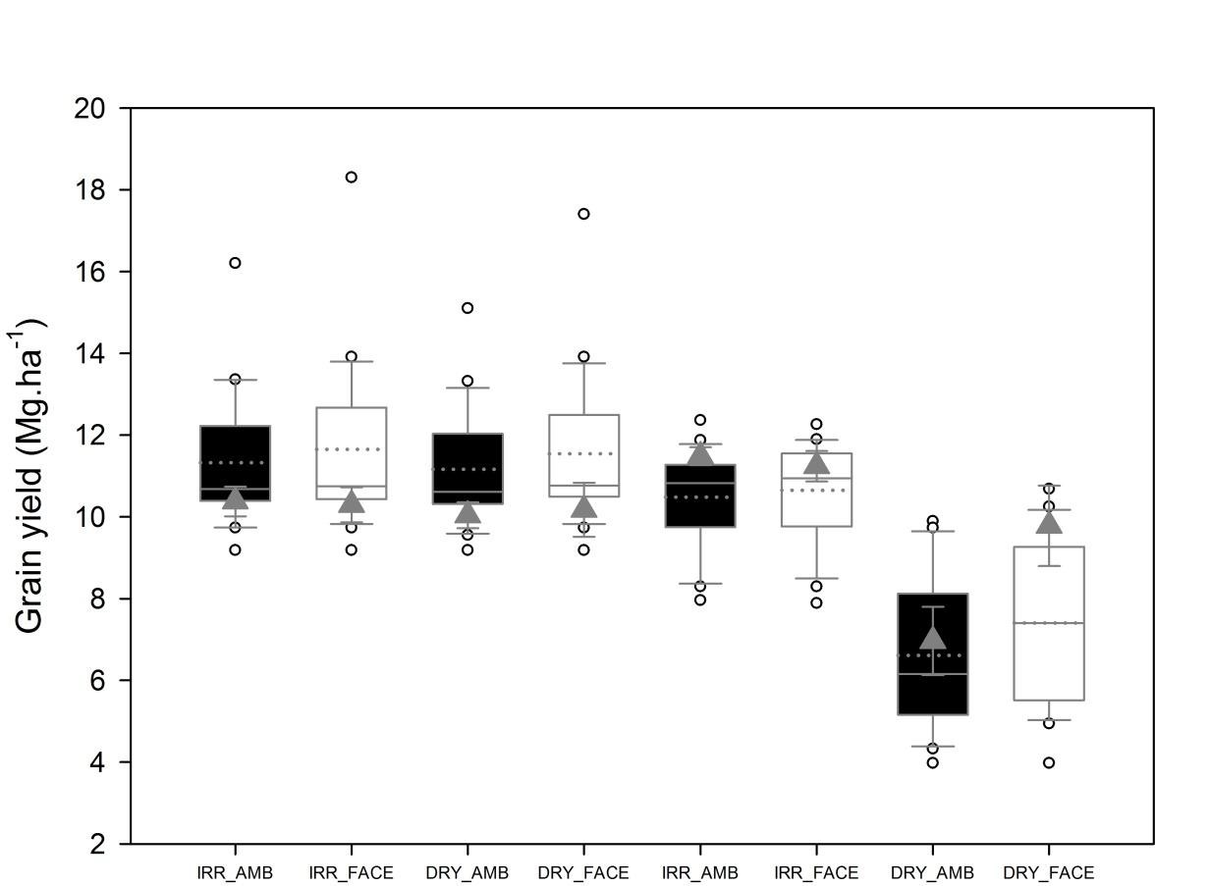

Fig 2

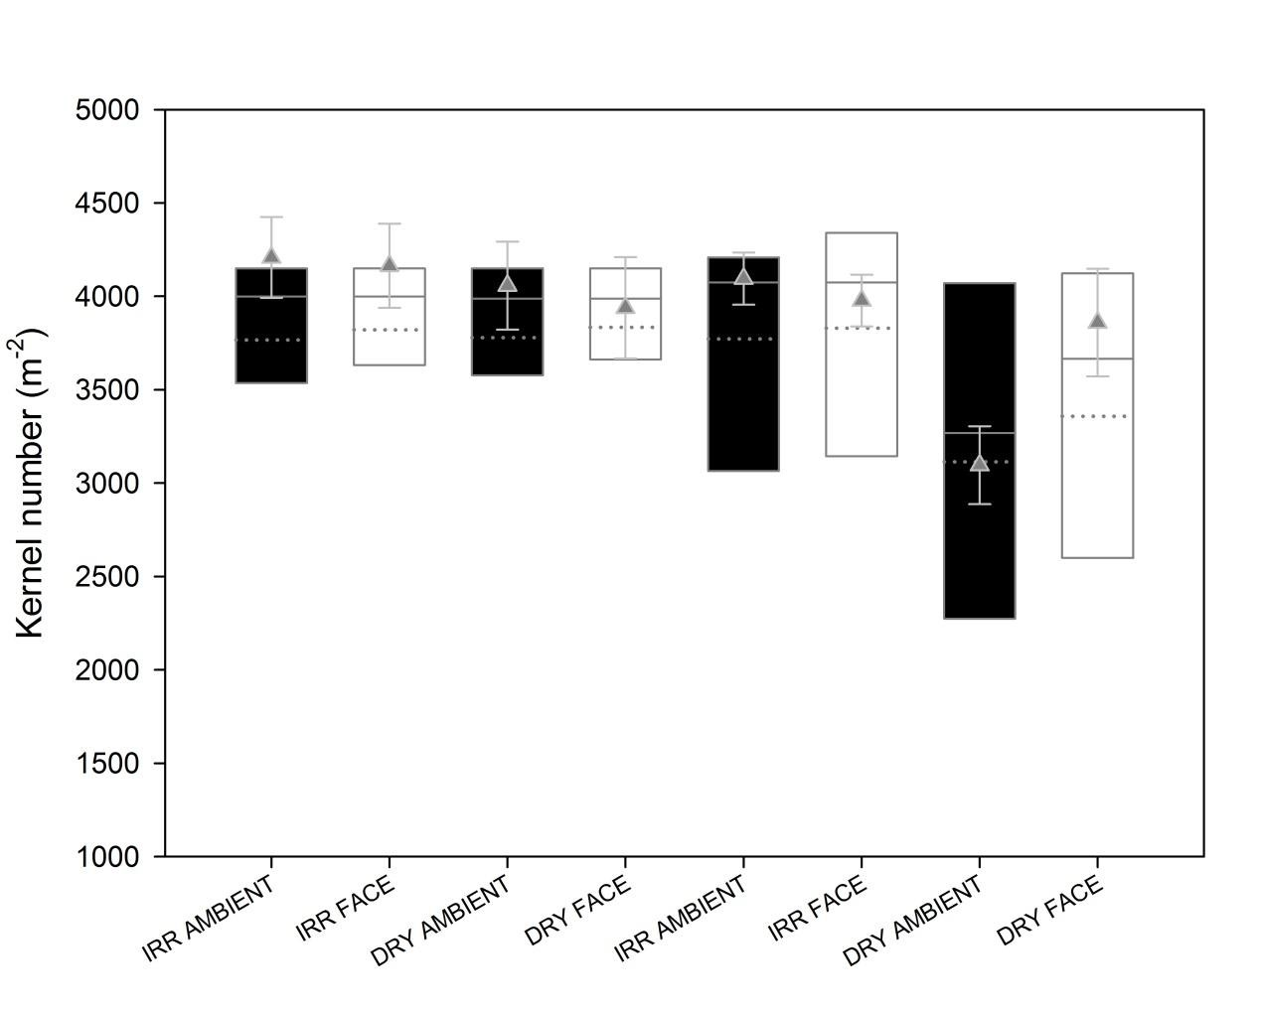

Fig 3

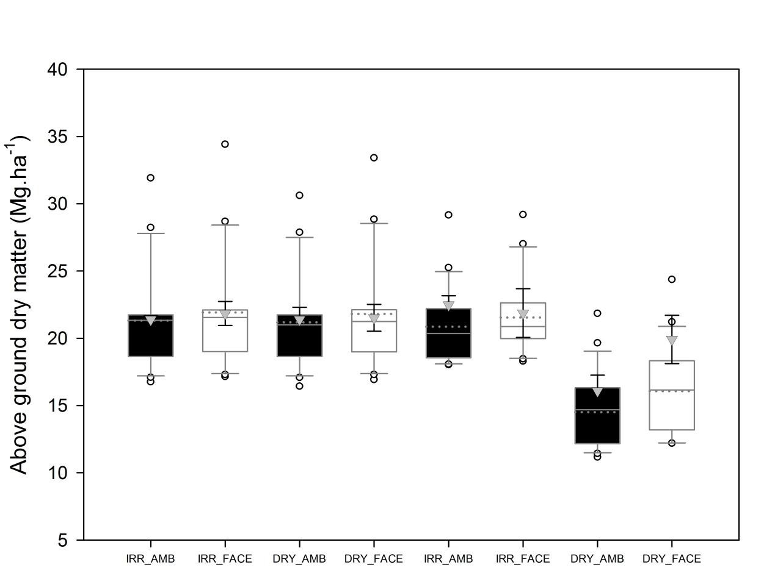

Fig 4

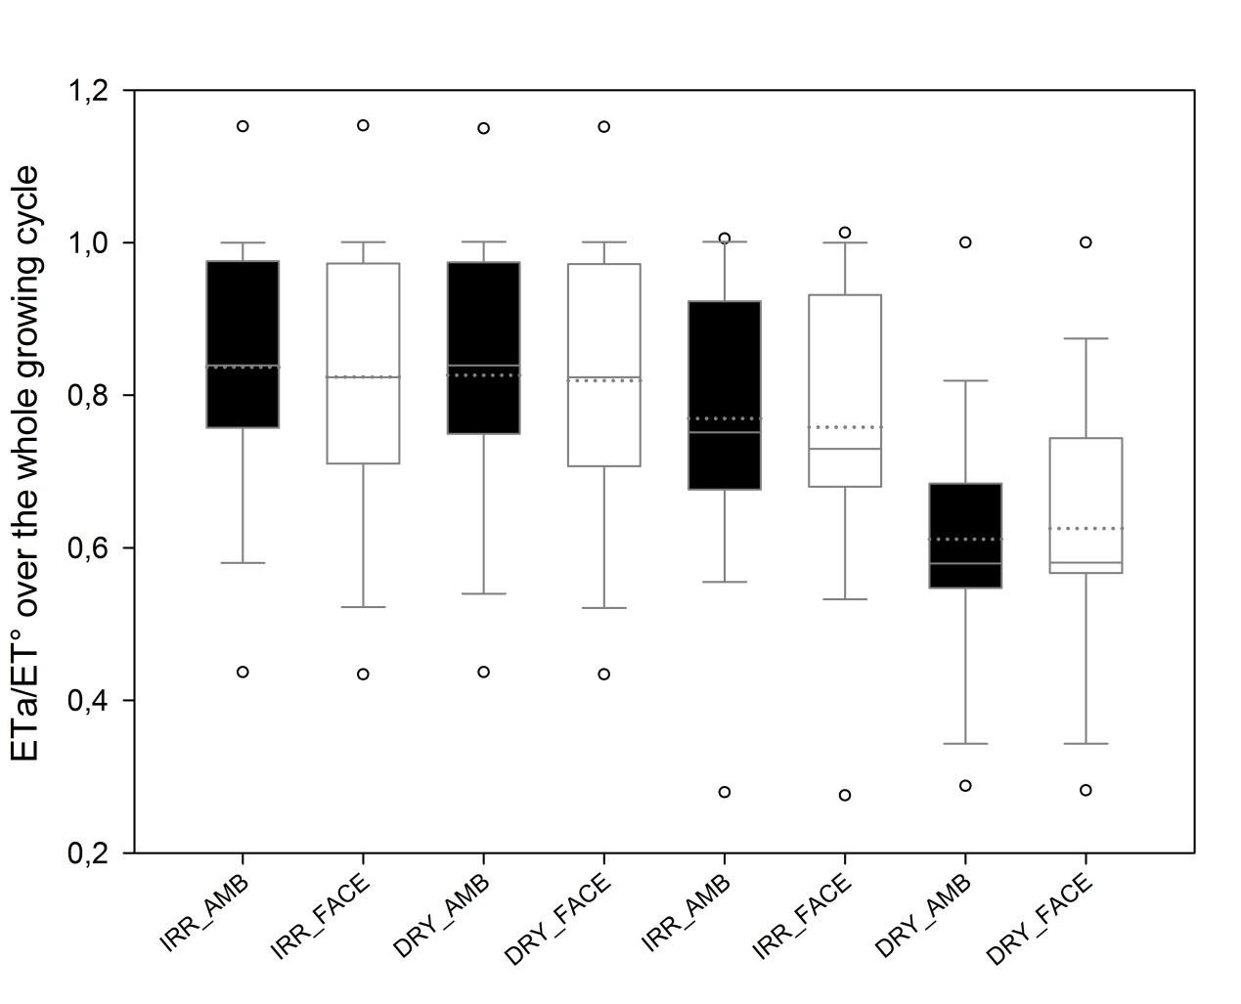

Fig 5

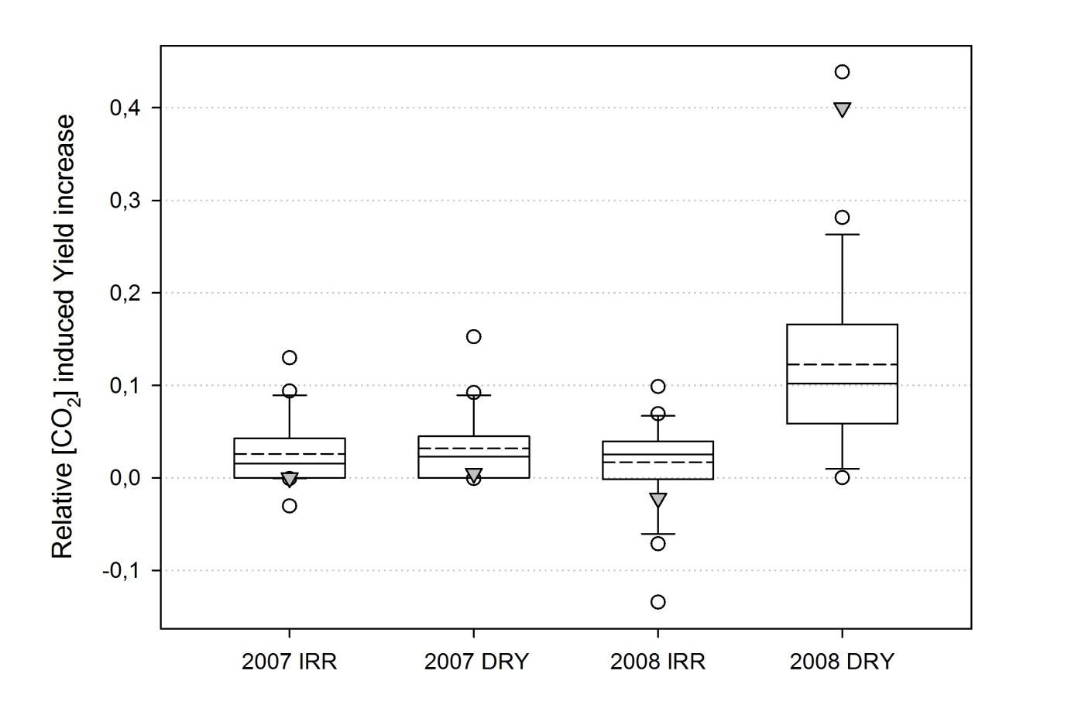

Fig 6

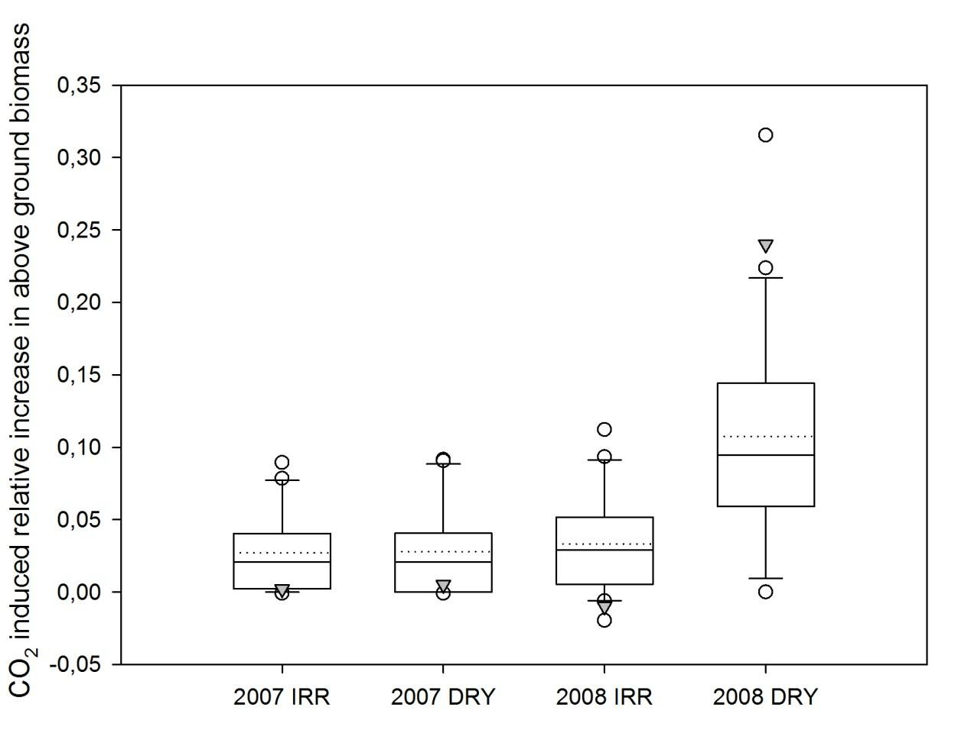

Table1 Total irrigation and fertilization amounts for the individual treatments, as well as averaged [CO2] concentrations. Dates of anthesis and observed total water use (estimated from soil water content measurements). Underlined and bold figures were provided to modellers. After

Manderscheid *et al.* (2014). The last column shows the median of models’simulations. Figure in brackets are one standard deviation, n=3 for measurements and n=21 for simulations.

|  |  |  |  |  |  |  |  |
| --- | --- | --- | --- | --- | --- | --- | --- |
|  | | **Irrigation**  **[mm]** | **Atm.**  **CO2** | **Nitrogen**  **fertilization** | **Date of**  **anthesis** | **Water**  **use** | **Water use**  **simulations** |
|  | **[ppm]** | **[kg N/ha]** |  | **measured (mm)** | **(mm)** |
| **2007** | **AMBIENT/IRRIGATED** | **34** | **387** | **173** | **18 July** | **320 (6)** | 391 (69) |
|  | **AMBIENT/DRY** | *0* | *387* | *173* | 18 July | 277 (5) | 376 (72) |
|  | **FACE/IRRIGATED** | *34* | *550* | *173* | 18 July | 327 (1) | 364 (70) |
|  | **FACE/DRY** | *0* | *550* | *173* | 18 July | 277 (7) | 364 (74) |
| **2008** | **AMBIENT/IRRIGATED** | **119** | **387** | **198** | **25 July** | **300 (1)** | 392 (63) |
|  | **AMBIENT/DRY** | *20* | *387* | *198* | 25 July | 198 (5) | 284 (68) |
|  | **FACE/IRRIGATED** | *94* | *550* | *198* | 25 July | 273 (0) | 360( 49) |
|  | **FACE/DRY** | *20* | *550* | *198* | 25 July | 201 (5) | 284 (51) |

Table 2. Traits of the 21 models in terms of biomass production, stomatal conductance and grain number simulation. More information on models can be found in Bassu *et al.* 2014 and in individual model’s papers.

|  |  |  |  |
| --- | --- | --- | --- |
|  | ***RUE or leaf photosynthesis (Lp)*** | ***Stomatal conductance1*** | ***Grain number*** |
| Agro-IBIS | Lp | Yes | No |
| APSIM | RUE | No | Yes |
| CERES-Maize | RUE | Yes | Yes |
| Daisy | Lp | No | No |
| EXPERT-N-Ceres | RUE | No | Yes |
| EXPERT-N-Spass | Lp | Yes | No |
| EXPERT-N-Sucros | Lp | No | No |
| GLAM | RUE | Yes | No |
| HERMES | Lp | Yes | No |
| IXIM | Lp | Yes | Yes |
| LP | Lp | Yes | No |
| MAIZSIM | Lp | Yes | No |
| MCWLA | Lp | Yes | No |
| Monica | Lp | Yes | No |
| PEGASUS | RUE | Yes | No |
| RZWQM2 | RUE | Yes | Yes |
| SALUS | RUE | Yes | No |
| SARRA-H | RUE | No | No |
| SIMPLACE<1> | RUE | No | No |
| SIMPLACE<2> | RUE | Yes | No |
| STICS | RUE | Yes | Yes |

1 Only models identifying an independent stomatal conductance variable responding to CO considered.

2

were

Table 3. Mean RMSEs for yield, above ground biomass at anthesis, above-ground biomass at harvest and crop water use simulations depending on (i) the way the biomass production is formalized (RUE: based on the simulation of radiation use efficiency of biomass production or based on a leaf photosynthesis response to light and [CO2]) and (ii) whether an explicit stomatal conductance function is used to simulate the response of crop transpiration to [CO2] or not and

(iii) whether the grain number is computed or not. In each cell the left hand side figure is the median of individual model’s RMSE and the right hand side figure is the RMSE for the model ensemble of each category. The superscript **HS** indicates a highly significant difference between the category of models.

|  |  |  |  |  |  |
| --- | --- | --- | --- | --- | --- |
|  | ***Number of models in category*** | ***Yield RMSE***  ***(Mg.ha-1)*** | ***Above Ground Biomass at anthesis RMSE***  ***(Mg.ha-1)*** | ***Above Ground Biomass at harvest RMSE (Mg.ha-1)*** | ***Total water use RMSE (mm)*** |
| **RUE** | 11 | 1.8/1.6 | 1.5/0.6 | 2.1/1.6 | 95/83 |
| **Leaf photosynthesis** | 10 | 1.8/1.2 | 1.2/0.9 | 1.8/1.0 | 57/66 |
| **Response of Stomatal conductance to [CO2]** | 15 | 1.4/0.7 | 1.3/0.4 | 2.0/1.2 | 78/72 |
| **No response of stomatal conductance to [CO2]** | 6 | 2.4**HS**/2.3 | 1.9/1.0 | 2.3/1.6 | 121/123 |
| **With Grain simulation** | 6 | 1.5/0.8 | 1.2/0.4 | 1.5/1.6 | 86/87 |
| **No grain simulation** | 15 | 1.8/1.1 | 1.5/0.9 | 2.1/1.9 | 81/83 |
| **All models** | 21 | 1.8/1.0 | 1.5/0.6 | 2.1/1.2 | 81/82 |

**Table 4** Median values for 21 models of the impact of CO2 on soil water content, biomass growth rate and ET/ET° in the DRY treatment in 2008.

# Median fraction of total plant available water in the 0-60 cm soil horizon during the growth cycle

**Median rate of above ground dry matter increase around anthesis (20-30 July, Kg.ha-1.day-1)**

**Median ratio ET/ET° at anthesis (25 July)**

**AMBIENT** 0.39 156 0.63

**FACE** 0.40 176 0.88