**Supplementary material**

**Troponin I and Cardiovascular Risk Prediction in the General Population**

**The BiomarCaRE Consortium**

Stefan Blankenberg*1, 2, Veikko Salomaa*3, Nataliya Makarova*1, 2, Francisco Ojeda1, Philipp Wild4, 5, 6, Karl J Lackner7, Torben Jørgensen8, 9, Barbara Thorand10, Annette Peters10,11, Matthias Nauck12, 13, Astrid Petersmann12, 13, Erkki Vartiainen14, Giovanni Veronesi15, Paolo Brambilla16, Simona Costanzo17, Licia Iacoviello17, Gerard Linden18, John Yarnell19, Christopher C Patterson19, Brendan M Everett20, Paul M Ridker20, Jukka Kontto3, Renate B Schnabel1, 2, Wolfgang Koenig11, 21, 22, Frank Kee**18, Tanja Zeller**1, 2, Kari Kuulasmaa**3, for the BiomarCaRE Inverstigators

¹University Heart Center Hamburg, Clinic for General and Interventional Cardiology, Hamburg, Germany

²German Center for Cardiovascular Research (DZHK e.V.), partner site Hamburg, Lübeck, Kiel

Hamburg, Germany

³National Institute for Health and Welfare, Helsinki, Finland

4University Medical Center of the Johannes Gutenberg-University Mainz, Department of Medicine II, Preventive Cardiology and Preventive Medicine, Mainz, Germany

5University Medical Center of the Johannes Gutenberg-University Mainz, Center for Thrombosis and Haemostasis (CTH), Mainz, Germany

6German Center for Cardiovascular Research (DZHK), Partner Site Rhein-Main, Mainz, Germany

7University Medical Center Mainz, Institute for Clinical Chemistry and Laboratory Medicine, Mainz, Germany

8Department of Public Health, Faculty of Health and Medical Science, University of Copenhagen, Denmark

9 Research Centre for Prevention and Health, Capital Region, Denmark

10Helmholtz Zentrum München, German Research Center for Environmental Health, Institute of Epidemiology II, München, Germany

11German Center for Cardiovascular Research (DZHK e.V.), partner site Munich Heart Alliance, München, Germany

12University Medicine Greifswald, Institute for Clinical Chemistry and Laboratory Medicine, Greifswald, Germany

13German Center for Cardiovascular Research (DZHK e.V.), partner site Greifswald, Germany

14Chronic Disease Epidemiology and Prevention Unit, Department of Chronic Disease Prevention, National Institute for Health and Welfare, Helsinki, Finland

15Research Centre in Epidemiology and Preventive Medicine, Department of Clinical and Experimental Medicine, University of Insubria, Varese, Italy

16University of Milano Bicocca, Department of Laboratory Medicine, Hospital of Desio, Desio (MB), Italy

17 IRCCS Istituto Neurologico Mediterraneo Neuromed, Department of Epidemiology and Prevention, Laboratory of Molecular and Nutritional Epidemiology, Pozzilli, Isernia, Italy

18Queens University of Belfast, UK Clinical Research Collaboration Centre of Excellence for Public Health, Belfast, Northern Ireland

19Queens University of Belfast, Centre for Public Health Belfast, Northern Ireland

20Brigham and Women's Hospital, Cardiovascular and Preventive Medicine Divisions, Boston, USA

21University of Ulm Medical Centre, Department of Internal Medicine II-Cardiology, Germany

22German Heart Centre Munich, Technical University of Munich, München, Germany

* Authors contributed equally as first author of the manuscript

** Authors contributed equally as last author of the manuscript

**Box S1**

Overview and description of contributing studies

**BiomarCaRE cohorts**

|  |  |  |
| --- | --- | --- |
| **Study/cohort Reference** | **Country** | **Study/cohort full name and short description** |
| MONICA Brianza Study1 | Italy | The MONICA-Brianza Cohort Study is a prospective observational study of three cohorts of 25-64 years old residents in Brianza, a highly-industrialized area located between Milan and the Swiss border, Northern Italy. Gender- and ten-year age stratified samples were randomly drawn in 1986, 1990 and 1993, and cardiovascular risk factors were investigated at baseline following the procedures of the WHO MONICA Project. The overall participation rate was 69%. For all subjects whole blood and serum samples were stored in a biobank. The protocol was approved by the Monza Hospital Ethical Committee. Study participants were followed up for first coronary or stroke events, fatal and non-fatal, up to the end of 2008, for a median of 15 years. http://epimed.uninsubria.eu. |
| Caerphilly Prospective Study2 | United Kingdom | The Caerphilly cohort is a prospective population based cohort from Wales. Men aged 56-70 years in 1989-93 were selected from the general population of Caerphilly in South Wales (population 40000) based on their date of birth from electronical registers and private census. Phase 3 (N=2171) was collected in 1989-93 and re-examined ten years later in 2002-2004 (Phase 5) taking repeated measurements of several risk factors and biomarkers. For current analysis only Phase 3 was used. Follow-up for deaths was performed by the Office of National Statistics and for non-fatal cardiovascular events using data linkage of hospital and GP records with validation by a study medical committee. Follow-up has been completed to February 2012. <http://www.thl.fi/publications/morgam/cohorts/full/uk/unk-caea.htm> |
| FINRISK 19973 | Finland | The FINRISK study is a series of population-based cardiovascular risk factor surveys carried out every five years in five (or six in 2002) districts of Finland, including North Karelia, Northern Savo (former Kuopio), Southwestern Finland, Oulu Province, Lapland province (in 2002 only) and the region of Helsinki and Vantaa. A stratified random sample was drawn for each survey from the national population register; the age-range was 25-74 years. All individuals enrolled in the study received a physical examination, a self-administered questionnaire, and a blood sample was drawn. In 1997, altogether 11500 individuals were invited and 8444 (73%) participated in the clinical examination. During follow-up the National Hospital Discharge Register, the National Causes of Death Register and the National Drug Reimbursement Register were used to identify endpoints. At the moment, the follow-up extends until Dec. 31st, 2010, i.e., 14 years for the FINRISK 1997 cohort. The Coordinating Ethics Committee of the Helsinki and Uusimaa Hospital District approved the study, which followed the declaration of Helsinki. All subjects gave written informed consent. <http://www.thl.fi/publications/morgam/cohorts/full/finland/fin-fina.htm> |
| Gutenberg Health Study (GHS)4 | Germany | The Gutenberg Health Study (GHS) is designed as a community-based, prospective, observational, single-center cohort study in the Rhine-Main area of Western Germany. The sample was drawn randomly from the governmental local registry offices in the city of Mainz and the district of Mainz-Bingen. The sample was stratified 1:1 for sex and residence (urban and rural) and in equal strata for decades of age. Individuals between 35 and 74 years of age were enrolled. Exclusion criteria were insufficient knowledge of the German language and physical or psychological inability to participate in the examinations at the study center. Baseline examination of 15000 study participants was performed between 2007 and 2012. A 2.5 year follow-up conducted as a telephone interview started in 2009. Since 2012, the 5-year follow up has been achieved through record linkage, including a second visit at the study center with extensive medical examination and re-sampling of the biomaterial which is ongoing. <http://www.gutenberghealthstudy.org/> |
| DanMONICA Study, RCPH5 | Denmark | The DanMONICA cohorts from the Research Center for Prevention and Health are three prospective population based cohorts from 11 municipalities from the western part of the suburbs of Copenhagen, Denmark. Random sampling was based on the national population register, stratified by sex and year of birth. Cohort 1 and 3 consists of men and women aged 30-70 years and cohort 2 consists of men and women aged 30-60. Cohort 1 was collected in 1982-1984 (N=4052). Cohort 2 (N=1504) was examined in 1986-1987 and cohort 3 (N=2026) was examined in 1991-1992. Follow up is achieved through linkage to the National Cause of Death Register and National Hospital Discharge Register, with endpoint diagnosis based on MORGAM criteria and validation described in6 Follow up for the cohorts 1, 2, and 3 is completed to December 31st 2010. http://www.thl.fi/publications/morgam/cohorts/full/denmark/den-gloa.htm |
| Kooperative Gesundheits-forschung in der Region Augsburg (KORA)7 | Germany | The WHO Multinational Monitoring of Trends and Determinants in Cardiovascular Diseases (MONICA)/ Cooperative Health Research in the Region of Augsburg (KORA) cohorts comprise all respondents from representative sample surveys from the city of Augsburg and the less urban Landkreis Augsburg and Landkreis Aichach-Friedberg regions in Bavaria, Southern Germany. List of municipalities and population registers were used as sampling frames for the first and the second stage of two-stage sampling, respectively. The second stage of sampling was stratified by sex and ten-year age group. The Survey 3 (S3) baseline examination (1994-1995) was carried out as part of the WHO MONICA project and consists of 4 856 men and women aged 25-74 years with a response rate of 75%. The Survey 4 (S4) baseline examination was carried out in 1999-2001 and includes 4261 participants (response rate: 66%). The S4 study and morbidity and mortality follow-ups were conducted within the frame of KORA.8 The BiomarCaRE project includes n=4692 and n=4221 participants from S3 and S4, respectively, Coronary events were identified through the MONICA/KORA Augsburg coronary event registry9. Coronary deaths were validated by autopsy reports, death certificates, and chart review from the last treating physician. Self-reported cases of incident stroke were validated by medical records. Mortality follow-up until 2009 was conducted through national death registers. http://www.thl.fi/publications/morgam/cohorts/full/germany/ger-auga.htm |
| Moli-Sani Project10 | Italy | The cohort of the Moli-Sani Project was recruited in the Molise region from city hall registries by a multistage sampling. First, townships were sampled in major areas by cluster sampling; then, within each township, participants aged 35 years or over were selected by simple random sampling. Exclusion criteria were pregnancy at the time of recruitment, lack of in understanding, current multiple trauma or coma, or refusal to sign the informed consent. A total of 24 325 men (47%) and women (53%) over the age of 35 were examined at baseline from 2005 to 2010. Participation was 70%. The cohort was followed-up for a median of 4.2 years (maximum 6.5 years) at December 2011 and will be followed-up every 5 years.10 Follow up is achieved through record linkage to national mortality registries and hospital discharge registers, validation of events was achieved through hospital record linkage and doctors medical records using updated MORGAM criteria. <http://www.moli-sani.org/> |
| Prospective Epidemiological Study of Myocardial Infarction (PRIME) Belfast11 | United Kingdom | The PRIME study examined the classic and putative cardiovascular risk factors to explain the large difference in heart disease incidence between Ireland and France. The study includes four cohorts of men aged 50-59; from Belfast, Northern Ireland (N=2745) and Lille (N=2633), Toulouse (N=2610) and Strasbourg (N=2612) in France. For the current analysis only the Belfast cohort was used. Baseline examinations took place in 1990-1993 and targeted cohorts which had broadly similar social class structures to the background population, initially sampling from industries and various employment groups, employment groups with more than 10% of their workforce of foreign origin were excluded. Follow up until 2004 (Toulouse, Strasbourg and Lille) and until 2012 (Belfast) was achieved through annual follow up questionnaires with verification against national death registers, medical records, hospital discharge diagnoses. Endpoints were validated by expert medical committee. http://www.thl.fi/publications/morgam/cohorts/full/uk/unk-bela.htm; http://www.thl.fi/publications/morgam/cohorts/full/france/fra-lila.htm; http://www.thl.fi/publications/morgam/cohorts/full/france/fra-stra.htm; http://www.thl.fi/publications/morgam/cohorts/full/france/fra-toua.htm |
| Scottish Heart Health Extended Cohort (SHHEC)12 | United Kingdom | The Scottish Heart Health Extended Cohort combines data from random surveys of men and women aged 40-59 across Scottish districts in 1984-87; and surveys of those aged 25-64 in Edinburgh and North Glasgow in 1986, following the same protocol of the WHO MONICA Project, repeated in North Glasgow in 1989, 1992 and 1995.12 Follow-up by record linkage extends through 2009. The ASSIGN cardiovascular risk score used in Scotland is based on SHHEC data.13 Of the original 18107, complete data on 16000 were transferred to Helsinki in 2000 for the MORGAM collaboration and available serum and plasma to the biomarker laboratory in Mainz/ Hamburg some years later, first for use in the MORGAM biomarker study (funded by the MRC London) and then for BiomarCaRE. SHHEC has hosted two previous collaborative MORGAM/ BiomarCaRE papers14, 15, a fuller cohort description is found in the latter. Principal Investigator: Professor Hugh Tunstall-Pedoe; Co-Principal Investigator: Professor Mark Woodward. Consultants: Professor Jill Belch, Professor Allan Struthers.  <http://www.thl.fi/publications/morgam/cohorts/full/uk/unk-sco.htm> |
| Study of Health in Pomerania (SHIP)16 | Germany | The SHIP study is an established population-based project conducted in Northeast Germany. The study aims to assess prevalence and incidence of common risk factors, subclinical disorders and clinical diseases and to investigate associations and interactions among them using comprehensive medical assessments. The first SHIP cohort was recruited between 1997 and 2001 and included 4308 individuals at baseline (SHIP-0, 20-70 years, response 68.8%), 3,300 after five years (SHIP-1) and 2333 after 11 years (SHIP-2). In parallel to SHIP-2, baseline examinations of a second, independent cohort (SHIP-TREND) were conducted in 4420 participants (20-79 years, response 50.3%). For the current analysis only SHIP-0 was used. SHIP is one of the population-based projects with very comprehensive examinations including interviews, cardio-metabolic ultrasound exams, cardiopulmonary exercise tests and whole-body magnetic resonance imaging in a general population setting. In addition to the examination follow-ups, information on fatal and non-fatal disease is collected on a regular basis. Mortality follow-ups are conducted semi-annually by record linkage with data bases of the regional population registry. Causes of death are defined from the official death documents provided by regional health authorities. Active follow-ups for non-fatal diseases are performed biannually and by interviews during follow-up examinations every five years. Self-reported information is validated by GP’s and using databases of the regional Association of SHI Physicians. http://www.medizin.uni-greifswald.de/cm/fv/ship.html http://www.medizin.uni-greifswald.de/cm/fv/ship.html |
| **Non BiomarCaRE Trial** | | |
| Justification for the Use of statins in Prevention: an Intervention Trial Evaluating Rosuvastatin (JUPITER)17 |  | The JUPITER trial was a randomized, double-blind, placebo-controlled trial of rosuvastatin 20 mg daily among men and women without cardiovascular disease or diabetes and LDL-C < 130 mg/dL and high-sensitivity C-reactive protein ≥2 mg/L. In total, 12956 participants from JUPITER had samples successfully analysed for hsTnI.18 |

**2. Definition of endpoints**

*Cardiovascular death* was defined as a death due to cardiovascular causes during the follow-up using an end-point definition similar to that of the European Society of Cardiology (ESC) described by Conroy et al.19 The definition includes definite or possible myocardial infarction or coronary death, unclassifiable coronary death, stroke and the following codes of the International Classification of Diseases (ICD-10) as the underlying cause of death: I10-I15, I44-I51, I70-I73 (see MORGAM Manual).19

*Cardiovascular disease event* as an endpoint was defined as the first fatal or non-fatal coronary heart disease event or likely cerebral infarction.

The coronary event included:

* acute definite or possible myocardial infarction or coronary death
* unstable angina pectoris
* cardiac revascularization
* unclassifiable death.

“Unclassifiable” death refers to death with insufficient evidence of coronary origin and no competing cause. For further details of the definition, see MORGAM Derived Variable CVD3 19

In the Caerphilly study this end-point included only definite myocardial infarction and no strokes. In the MONICA/KORA Augsburg study cardiac revascularization was not followed up. In the MONICA/KORA Augsburg and MONICA Brianza studies unstable angina pectoris was not assessed as an outcome but it is largely included in the category “possible myocardial infarction” of the WHO MONICA classification used in these studies. Likewise, the PRIME Belfast study did not include possible myocardial infarction, but this is largely compensated by unstable angina pectoris which was assessed.

*Total mortality* as an endpoint was defined as death due to any cause during the follow-up time. The follow-up starts at the date of baseline examinations.

Details of the follow-up and diagnostic procedures of each participating study have been published elsewhere.20

**3. Measuring and definition of phenotypes in Gutenberg Health Study**

To understand intermediate cardiovascular phenotype correlates of troponin concentrations we examined relations of carotid plaque burden, renal function and left ventricular mass in relation to troponin in the population-based Gutenberg Health Study of middle-aged individuals.

To get an understanding of renal function we estimated glomerular filtration rate (eGFR) using the currently recommended formula that adjusts for age and sex.21

For ultrasound measurements, we used an iE33 ultrasound system (Royal Philips Electronics, Amsterdam, and the Netherlands) with an S5-1 sector array transducer for echocardiographic measurements and an 11 to 3-MHz linear-array transducer for carotid ultrasound.

Carotid plaque burden is commonly used as an indicator of early atherosclerosis and has been associated with cardiovascular risk.22 Carotid plaques were defined as protrusions into the lumen of ≥1.5 mm, and screening for plaques was performed for common, internal, and external carotid arteries.23

Echocardiographic left ventricular mass (LVM) in the Gutenberg Health Study was determined according to the following formula: LVM=0.8 x (1.04 [(left ventricular inner end-diastolic diameter+interventricular septal thickness+posterior wall thickness)3-left ventricular inner end-diastolic diameter3])+0.6.4

**4. Statistical methods**

Initial descriptive associations between baseline variables and troponin I were assessed using linear mixed models with the cubic root of troponin I as the dependent variable. Associations between systolic blood pressure, estimated glomerular filtration rate (eGFR) and troponin I were tested in the BiomarCaRE cohort. Associations between carotid plaque, left ventricular mass (LVM) and troponin I were examined in the Gutenberg Health Study. To measure a standardized association between troponin I and each of covariates mentioned above we used a partial correlation coefficient.24 Cohorts were used as a grouping variable in the linear mixed models. All models included a random intercept, with age incorporated to reflect both a fixed and random effects. First, the baseline variable of interest was entered into the model in a linear fashion and then, if the variable under consideration was continuous, a quadratic term was included to test for nonlinearities. After that an interaction with sex was added (retaining the quadratic term if its *P*-value was less than .05). For those variables available only in the Gutenberg Health Study, linear models were used instead of linear mixed models, since only one cohort was involved. To visualize the baseline associations an effect plot of the model that included linear, quadratic terms and sex interactions was produced using the methods of Fox25.

Survival curves for cardiovascular disease events, cardiovascular mortality and total mortality were computed according to fifth of the troponin distribution. The upper quintile was 5.9 ng/L. Hence, it was rounded to the nearest integer and troponin I was dichotomized using 6 ng/L as a cut-off. Quintiles were computed in the overall BiomarCaRE cohort using linear quantile mixed models26, 27 with troponin I as the dependent variable. This method allows for the estimation of quantiles as a function of covariates while allowing for correlations between individuals belonging to the same cluster. The models considered contained no predictors, just an intercept, fixed and random. The latter was allowed to vary between cohorts.

Sex- and cohort-stratified Cox proportional hazards models for cardiovascular disease events, cardiovascular mortality and total mortality were computed using the individual level data from the available cohorts. For these analyses troponin I was used after applying the cubic root transformation, using 6 ng/L as a cut-off, and categorized based on quintiles as defined in the overall BiomarCaRE cohort. The Cox models for all three investigated events were adjusted for the SCORE19, 28 variables (systolic blood pressure, total cholesterol, smoking status, sex as strata and age as time scale). Additional models exchanging troponin I with CRP, NT-proBNP and eGFR were also computed. CRP and NT-proBNP were log-transformed for these analyses. All available follow-up length was used in the computation of the Cox models described above. To examine the short term association of troponin I, used as a continuous variable, with time-to-event we recomputed the models described above after censoring the follow-up time at 1, 5 and 10 years.

The C-index29, 30 and the net reclassification improvement (NRI)31, 32 were used to quantify the added predictive value of troponin I beyond that from a model including the variables in SCORE. This was repeated exchanging troponin I by CRP, NT-proBNP and eGFR. For these analyses, the ten year event probabilities were computed using a Weibull curve fitted over age and adjusted by the linear predictor of the estimated Cox model. For the computation of C-indices and NRI the follow-up times were censored at ten years. Ten-fold cross validation was used to control for the over-optimism of calculating performance measures on the same dataset from which the models were computed. The risk categories used for the NRI analysis were < 1%, 1 to < 5%, 5 to < 10%, and ≥ 10%28. A version of NRI appropriate for survival analyses was computed using the Kaplan-Meier32 approach and CIs were estimated via bootstrapping with 1,000 bootstrap samples. The overall NRI does not represent a proportion and is therefore reported as a decimal number between -2 and 2 rather than a percentage, as recommended by Maarten et al.33 Differences in C-statistics (with 95% CIs) after the addition of troponin I to the model consisting of cardiovascular risk factors were computed using the method described by Antolini et al.34 Cox regressions, C-indices and NRIs described above were also computed for the following age groups: < 45, 45-54, 55-64, ≥ 65 years at baseline.

To assess the calibration of the models, we used an extension of the Hosmer–Lemeshow test for survival analyses proposed by Demler et al.35 Tenths of the risk distribution were used.

A two-sided *P*-value of < 0.05 was considered statistically significant. All statistical methods were implemented in R statistical software version 3.2.136 (www.R-project.org).

**5. Funding and acknowledgements of cohorts**

Caerphilly Prospective Study (CaPs). This study was supported by a Project Grant from the British Heart Foundation (PG/09/002/26056).

The FINRISK surveys were mainly funded by budgetary funds of THL. Additional funding has been obtained from numerous non-profit foundations. Dr. Salomaa (PI) has been supported by the Finnish Foundation for Cardiovascular Research and the Academy of Finland (grant number 139635).

The Gutenberg Health Study is funded through the government of Rheinland-Pfalz (No. AZ 961-386261/733), the research program “Wissen schafft Zukunft” and the “Schwerpunkt Vaskuläre Prävention” of the University Medical Center Mainz and its contract with Boehringer Ingelheim and PHILIPS medical systems, including an unrestricted grant for the Gutenberg Health Study. This project was further supported by the MAIFOR program of the University Medical Center Mainz and the National Genome Network “NGFNplus” by the federal Ministry of Education and Research, Germany (No. 01GS0833 and 01GS0831, projects A3/D1).

The DanMONICA cohorts at the Research Centre for Prevention and Health were established over a period of ten years and have been funded by numerous sources which have been acknowledged, where appropriate, in the original articles.

The Moli-Sani Project was partially supported by research grants from Pfizer Foundation (Rome, Italy), the Italian Ministry of University and Research (MIUR, Rome, Italy)–Programma Triennale di Ricerca, Decreto n.1588 and Instrumentation Laboratory, Milan, Italy.

The follow-up activities for the MONICA Brianza Study were funded by the Regione Lombardia Health Administration (grants 31737/1997, 17155/2004 and 10800/2009) as part of the Osservatorio Epidemiologico Cardiovascolare Regionale Lombardo. Key personnel: Ferrario MM and Cesana G (study PIs); F Gianfagna; G Veronesi; P Brambilla and S. Signorini (bio-banking activities).

Prospective Epidemiological Study of Myocardial Infarction PRIME Belfast Study: We thank the following organizations which allowed the recruitment of the PRIME subjects: the Health screening centres organized by the Social Security of Lille (Institut Pasteur), Strasbourg, Toulouse and Tourcoing; Occupational Medicine Services of Haute- Garonne, of the Urban Community of Strasbourg; the Association Inter-entreprises des Services Médicaux du Travail de Lille et environs; the Comité pour le Développement de la Médecine du Travail; the Mutuelle Générale des PTT du Bas-Rhin; the Laboratoire d’Analyses de l’Institut de Chimie Biologique de la Faculté de Médecine de Strasbourg; the Department of Health (NI) and the Northern Ireland Chest Heart and Stroke Association. We also thank the members of the event validation Committees: Pr L. Guize, Dr C. Morrison, Dr M-T. Guillanneuf, Pr M. Giroud; and the Alliance Partnership Programme for its financial support. The PRIME Study was supported by grants from INSERM, and the Merck, Sharp and Dohme-Chibret Laboratory. PRIME Belfast received funding from HSC Research and Development Office and the Medical Research Council London [G0601463, No 80983: Serum Biomarkers in the MORGAM Populations].

The Scottish Heart Health Extended Cohort (SHHEC) was funded by the Scottish Health Department Chief Scientist Organization; British Heart Foundation; FP Fleming Trust.

The Study of Health in Pomerania (SHIP) is part of the Community Medicine Research net (CMR) of the University of Greifswald, Germany, which is funded by the Ministry of Cultural Affairs and the Social Ministry of the Federal State of Mecklenburg-West Pomerania. The CMR encompasses several research projects which share data from several population-based projects [http://community-medicine.de](https://ex2k7.qub.ac.uk/OWA/redir.aspx?C=DjaCEmcttEeAM9Q7e342WwsOemrPltBIAaGIxNopT3bPhlFahxdKpYPY70Ud1nsEUmW7TmUMEfs.&URL=http%3a%2f%2fcommunity-medicine.de)). The SHIP study is funded by the Federal Ministry of Education and Research (BMBF) under grant agreement No. 01ZZ9603, 01ZZ0103). Data and samples were provided by the Study of Health in Pomerania (SHIP) of the Forschungsverbund Community Medicine of the University of Greifswald.

JUPITER was funded by AstraZeneca, who collected the trial data and monitored the study sites but had no role in the conduct of these analyses or in drafting this report.

The KORA research platform and the KORA Augsburg studies are financed by the Helmholtz Zentrum München, German Research Center for Environmental Health, which is funded by the German Federal Ministry of Science and Research (Berlin, Germany) and by the State of Bavaria. Furthermore, KORA research was supported within the Munich Center of Health Sciences (MC Health), Ludwig-Maximilians University München, as part of LMUinnovative.

**6. References**

1. Gianfagna F, Veronesi G, Guasti L, Chambless LE, Brambilla P, Corrao G, Mancia G, Cesana G, Ferrario MM. Do apolipoproteins improve coronary risk prediction in subjects with metabolic syndrome? Insights from the North Italian Brianza cohort study. Atherosclerosis 2014;**236**(1):175-181.

2. Yarnell J, Baker IA, Sweetnam PM, Bainton D, O'Brien JR, Whitehead PJ, Elwood PC. Fibrinogen, viscosity, and white blood cell count are major risk factors for ischemic heart disease. The Caerphilly and Speedwell collaborative heart disease studies. Circulation 1991;**83**(3):836-844.

3. Borodulin K, Vartiainen E, Peltonen M, Jousilahti P, Juolevi A, Laatikainen T, Männistö S, Salomaa V, Sundvall J, Puska P. Forty-year trends in cardiovascular risk factors in Finland. The European Journal of Public Health 2015;**25**(3):539-546.

4. Wild PS, Sinning CR, Roth A, Wilde S, Schnabel RB, Lubos E, Zeller T, Keller T, Lackner KJ, Blettner M. Distribution and Categorization of Left Ventricular Measurements in the General Population: Results from the Population-Based Gutenberg-Heart Study. Circulation: Cardiovascular Imaging 2010:CIRCIMAGING. 109.911933.

5. Osler M, Linneberg A, Glümer C, Jørgensen T. The cohorts at the Research Centre for Prevention and Health, formerly ‘The Glostrup Population Studies’. International journal of epidemiology 2011;**40**(3):602-610.

6. Lynge E, Sandegaard JL, Rebolj M. The Danish National Patient Register. Scand J Public Health 2011;**39**(7 Suppl):30-3.

7. Löwel H, Döring A, Schneider A, Heier M, Thorand B, Meisinger C. The MONICA Augsburg surveys--basis for prospective cohort studies. Gesundheitswesen 2005;**67**:S13-8.

8. Holle R, Happich M, Löwel H, Wichmann H. KORA--a research platform for population based health research. Gesundheitswesen 2005;**67**:S19-25.

9. Lowel H, Lewis M, Hormann A, Keil U. Case finding, data quality aspects and comparability of myocardial infarction registers: results of a south German register study. J Clin Epidemiol 1991;**44**(3):249-60.

10. Di Castelnuovo A, De Curtis A, Costanzo S, Persichillo M, Olivieri M, Zito F, Donati MB, de Gaetano G, Iacoviello L. Association of D-dimer levels with all-cause mortality in a healthy adult population: findings from the MOLI-SANI study. haematologica 2013;**98**(9):1476-1480.

11. Yarnell J. The PRIME study: classical risk factors do not explain the severalfold differences in risk of coronary heart disease between France and Northern Ireland. Prospective Epidemiological Study of Myocardial Infarction. Qjm 1998;**91**(10):667-676.

12. Tunstall-Pedoe H. *MONICA, monograph and multimedia sourcebook: world's largest study of heart disease, stroke, risk factors, and population trends 1979-2002*: World Health Organization; 2003.

13. Woodward M, Brindle P, Tunstall-Pedoe H. Adding social deprivation and family history to cardiovascular risk assessment: the ASSIGN score from the Scottish Heart Health Extended Cohort (SHHEC). Heart 2007;**93**(2):172-176.

14. Zeller T, Tunstall-Pedoe H, Saarela O, Ojeda F, Schnabel RB, Tuovinen T, Woodward M, Struthers A, Hughes M, Kee F. High population prevalence of cardiac troponin I measured by a high-sensitivity assay and cardiovascular risk estimation: the MORGAM Biomarker Project Scottish Cohort. European heart journal 2014;**35**(5):271-281.

15. Tunstall-Pedoe H, Woodward M, Hughes M, Anderson A, Kennedy G, Belch J, Kuulasmaa K. Prime mover or fellow traveller: 25-hydroxy vitamin D's seasonal variation, cardiovascular disease, and death in the Scottish Heart Health Extended Cohort (SHHEC). Int J Epidemiol 2015:1-11.

16. Völzke H, Alte D, Schmidt CO, Radke D, Lorbeer R, Friedrich N, Aumann N, Lau K, Piontek M, Born G. Cohort profile: the study of health in Pomerania. International journal of epidemiology 2010:dyp394.

17. Ridker PM, Danielson E, Fonseca F, Genest J, Gotto Jr AM, Kastelein J, Koenig W, Libby P, Lorenzatti AJ, MacFadyen JG. Rosuvastatin to prevent vascular events in men and women with elevated C-reactive protein. New England Journal of Medicine 2008;**359**(21):2195.

18. Everett BM, Zeller T, Glynn RJ, Ridker PM, Blankenberg S. High Sensitivity Cardiac Troponin I and B-Type Natriuretic Peptide as Predictors of Vascular Events in Primary Prevention: Impact of Statin Therapy. Circulation 2015:CIRCULATIONAHA. 114.014522.

19. Conroy R, Pyörälä K, Fitzgerald Ae, Sans S, Menotti A, De Backer G, De Bacquer Dr, Ducimetiere P, Jousilahti P, Keil U. Estimation of ten-year risk of fatal cardiovascular disease in Europe: the SCORE project. European heart journal 2003;**24**(11):987-1003.

20. Kulathinal S, Niemela M, Niiranen T, Saarela O, Palosaari T, Tapanainen H, Kuulasmaa K. contributors from Participating Centres, for the MORGAM Project. Description of MORGAM Cohorts. MORGAM Project. e-publications [Internet]. 2005-; (2). URN:NBN:fi-fe20051214. Available from URL:<http://www.thl.fi/publications/morgam/manual/contents.htm>. Accessed July 28, 2015.

21. Levey AS, Stevens LA, Schmid CH, Zhang YL, Castro AF, Feldman HI, Kusek JW, Eggers P, Van Lente F, Greene T. A new equation to estimate glomerular filtration rate. Annals of internal medicine 2009;**150**(9):604-612.

22. Sinning C, Keller T, Zeller T, Ojeda F, Schluter M, Schnabel R, Lubos E, Bickel C, Lackner KJ, Diemert P, Munzel T, Blankenberg S, Wild PS. Association of high-sensitivity assayed troponin I with cardiovascular phenotypes in the general population: the population-based Gutenberg health study. Clin Res Cardiol 2014;**103**(3):211-22.

23. Touboul P-J, Hennerici M, Meairs S, Adams H, Amarenco P, Bornstein N, Csiba L, Desvarieux M, Ebrahim S, Fatar M. Mannheim carotid intima-media thickness consensus (2004–2006). Cerebrovascular diseases 2007;**23**(1):75-80.

24. Lipsitz SR, Leong T, Ibrahim J, Lipshultz S. A partial correlation coefficient and coefficient of determination for multivariate normal repeated measures data. Journal of the Royal Statistical Society: Series D (The Statistician) 2001;**50**(1):87-95.

25. Fox J. Effect displays in R for generalised linear models. Journal of Statistical Software 2003;**8**(15):1-27.

26. Geraci M, Bottai M. Linear quantile mixed models. Statistics and Computing 2014;**24**(3):461-479.

27. Geraci M. Linear quantile mixed models: the lqmm package for Laplace quantile regression. Journal of statistical Software 2014;**57**(13):1-29.

28. Perk J, De Backer G, Gohlke H, Graham I, Reiner Ž, Verschuren M, Albus C, Benlian P, Boysen G, Cifkova R. European Guidelines on cardiovascular disease prevention in clinical practice (version 2012). European heart journal 2012;**33**(13):1635-1701.

29. Harrell FE, Califf RM, Pryor DB, Lee KL, Rosati RA. Evaluating the yield of medical tests. Jama 1982;**247**(18):2543-2546.

30. Harrell FE, Lee KL, Mark DB. Tutorial in biostatistics multivariable prognostic models: issues in developing models, evaluating assumptions and adequacy, and measuring and reducing errors. Statistics in medicine 1996;**15**:361-387.

31. Pencina MJ, D'Agostino RB, Vasan RS. Evaluating the added predictive ability of a new marker: from area under the ROC curve to reclassification and beyond. Statistics in medicine 2008;**27**(2):157-172.

32. Pencina MJ, D'Agostino RB, Steyerberg EW. Extensions of net reclassification improvement calculations to measure usefulness of new biomarkers. Statistics in medicine 2011;**30**(1):11-21.

33. Maarten JG, Leening MD, Vedder MM, Witteman JCM, Pencina M, EW S. Net reclassification improvement: computation, interpretation, and controversies: a literature review and clinician's guide. Annals of internal medicine 2014;**160**(2):122-131.

34. Antolini L, Nam B-H, D'Agostino RB. Inference on correlated discrimination measures in survival analysis: a nonparametric approach. Communications in Statistics-Theory and Methods 2004;**33**(9):2117-2135.

35. Demler OV, Paynter NP, Cook NR. Tests of calibration and goodness‐of‐fit in the survival setting. Statistics in medicine 2015;**34**(10):1659-1680.

36. R Development Core Team. A language and environment for statistical computing. R Foundation for Statistical Computing, Vienna, Austria. In; 2008.

**7. Tables**

**Table S1**

Baseline characteristics of the study population according to each cohort (for meanings and units of the numbers in the table, see Table 1 of the main paper)

|  |  |  |  |  |  |  |  |  |  |  |
| --- | --- | --- | --- | --- | --- | --- | --- | --- | --- | --- |
| **Characteristics** | **Brianza**  **N=4932** | **Caerphilly**  **N=2171** | **FINRISK**  **N=8444** | **GHS**  **N=15010** | **Glostrup**  **N=7582** | **KORA**  **N=8913** | **Moli-Sani**  **N=24325** | **PRIME/**  **Belfast N=2745** | **SHHEC N=16000** | **SHIP**  **N=3871** |
| Years of examinations | 1986-1994 | 1989-  1994 | 1997 | 2007-2012 | 1982-1992 | 1994-  2001 | 2005-  2010 | 1991-  1994 | 1984-  1995 | 1997-  2001 |
| Men | 2432  (49.3) | 2171  (100) | 4253  (50.4) | 7584  (50.5) | 3837  (50.6) | 4427  (49.7) | 11702  (48.1) | 2745  (100) | 8069  (50.4) | 1884  (48.7) |
| Women | 2500  (50.7) | 0  (0) | 4191  (49.6) | 7426  (49.5) | 3745  (49.4) | 4486  (50.3) | 12623  (51.9) | 0  (0) | 7931  (49.6) | 1987  (51.3) |
| Age at baseline | 46.7  (36.9, 56.0) | 62.4  (58.5,  66.1) | 48.7  (37.4, 59.6) | 55.6  (46.1, 65.0) | 50.0  (39.9, 60.2) | 50.5  (37.7, 61.9) | 54.6  (45.8, 64.4) | 54.7  (52.3, 57.3) | 49.8  (43.2, 55.9) | 50.0  (36.0, 63.0) |
| **Cardiovascular risk factors** | | | | | | | | | | |
| Daily smoker | 1479  (30.0) | 542  (34.1) | 1810  (21.9) | 2697  (18.0) | 3393  (44.8) | 2008  (22.5) | 4949  (20.6) | 643  (23.4) | 6142  (38.4) | 1165  (30.2) |
| Diabetes | 129  (2.7) | 129  (5.9) | 488  (5.8) | 1030  (6.9) | 186  (2.5) | 459  (5.1) | 1576  (6.5) | 71  (2.6) | 278  (1.7) | 309  (8.0) |
| Hypertension | 1429  (29.3) | 1249  (62.0) | 3491  (41.9) | 6997  (46.7) | 1516  (20.6) | 3202  (36.0) | 13357  (55.2) | 972  (35.4) | 5149  (32.2) | 1865  (48.3) |
| Body-mass-index | 24.9  (22.5, 27.8) | 26.6  (24.4, 28.9) | 26.2  (23.6, 29.2) | 26.6  (23.9, 30.0) | 24.4  (22.1, 27.1) | 26.5  (23.9, 29.6) | 27.5  (24.7, 30.8) | 26  (24.0, 28.1) | 25.4  (23.1, 28.1) | 26.8  (23.8, 30.1) |
| Systolic blood pressure | 128.0  (116.0, 141.0) | 144.0  (130.0, 158.0) | 134.0  (121.0, 149.0) | 131.5  (120.5, 144.0) | 122.0  (111.0, 134.5) | 130.0  (118.0, 144.0) | 138.5  (125.5, 153.5) | 131.0  (120.0, 146.0) | 129.0  (118.0, 143.0) | 134.5  (121.0, 149.0) |
| Total cholesterol | 5.5  (4.7, 6.2) | 6.2  (5.5, 6.9) | 5.4  (4.8, 6.2) | 5.7  (5.0, 6.4) | 5.8  (5.0, 6.6) | 5.8  (5.1, 6.6) | 5.5  (4.8, 6.2) | 5.8  (5.2, 6.5) | 6.2  (5.4, 7.1) | 5.7  (4.9, 6.5) |
| HDL cholesterol | 1.4  (1.2, 1.7) |  | 1.4  (1.1, 1.6) | 1.4  (1.2, 1.7) | 1.4  (1.2, 1.7) | 1.4  (1.1, 1.7) | 1.4  (1.2, 1.7) | 1.2  (1.0, 1.4) | 1.4  (1.2, 1.7) | 1.4  (1.1, 1.7) |
| **Medication** | | | | | | | | | | |
| Anti-hypertensive | 527  (10.7) | 453  (22.3) | 1134  (13.9) | 4434 (29.6) | 495  (6.8) | 1295  (14.5) | 6894  (28.8) | 273  (9.9) | 1201  (7.5) | 976  (25.3) |
| **Troponin** | | | | | | | | | | |
| Troponin I | 1.8  (0.9, 2.8) | 6.0  (4.7, 8.1) | 3.1  (2.1, 4.9) | 3.8  (2.4, 5.4) | 2.8  (1.8, 4.3) | 1.9  (1.2, 3.1) | 2.2  (1.4, 3.5) | 5.3  (4.1, 6.8) | 4.0  (1.9, 6.1) | 1.8  (0.7, 3.8) |
| **Other biomarkers** | | | | | | | | | | |
| CRP, mg/l | 1.4 (0.7, 3.0) | 2.5  (1.3, 5.0) | 1.2  (0.6, 2.5) | 1.6  (0.7, 3.2) | 1.2  (0.6, 2.8) | 1.3  (0.6, 3.0) | 1.6  (0.8, 3.3) | 1.7  (0.8, 3.3) | 1.4  (0.7, 3.1) | 1.4  (0.7, 3.1) |
| NT-proBNP, pg/ml | 39.3 (20.5, 71.8) |  | 47.6 (24.7, 88.5) | 61.9 (28.5, 124.4) |  | 49.2 (26.0, 90.5) | 50.2 (26.5, 94.2) | 34.4 (19.0, 62.6) | 52.3 (28.1, 97.6) | 55.0 (28.0, 108.0) |
| eGFR (ml/min/1.73m2) | 92.1 (75.3, 103.1) | 87.0  (76.6, 93.9) | 89.5 (77.3, 101.1) | 89.2 (79.2, 98.1) | 98.6 (86.1, 109.6) | 101.2 (91.1, 111.2) | 94.3 (83.9, 103.0) | 84.8 (73.5, 96.7) | 95.9 (84.1, 104.6) | 101.0 (88.6, 113.4) |
| **Endpoint** | |  |  |  |  |  |  |  |  |  |
| Cardiovascular mortality | 167  (3.4) | 470  (21.6) | 422  (5.0) |  | 1002  (13.3) | 331  (3.7) | 151  (0.6) | 149  (5.4) | 1786  (11.2) | 38  (1.0) |
| Cardiovascular  disease | 393  (8.0) | 583  (26.9) | 964  (11.4) |  | 1326  (17.5) | 525  (5.9) | 473  (1.9) | 505  (18.4) | 2953  (18.5) |  |
| Total  mortality | 595  (12.1) | 1302  (60.0) | 1045  (12.4) | 391  (2.6) | 2506  (33.1) | 911  (10.2) | 575  (2.4) | 550  (20.0) | 4310  (26.9) | 503  (13.0) |

**Table S2**

Troponin intra-assay and inter-assay coefficients of variation by cohort in the BiomarCaRE project

|  |  |  |
| --- | --- | --- |
| **Study/cohort** | **Intra assay variation (%)** | **Inter assay variation (%)** |
| MONICA Brianza Study | 6.13 | 5.56 |
| Caerphilly Prospective Study | 3.32 | 4.78 |
| FINRISK 1997 | 2.36 | 4.80 |
| Gutenberg Health Study (GHS) | 2.60 | 5.40 |
| DanMONICA studies; RCPH | 4.71 | 5.00 |
| Moli-Sani Project | 7.52 | 6.25 |
| Prospective Epidemiological Study of Myocardial Infarction (PRIME) Belfast | 2.14 | 4.30 |
| Scottish Heart Health Extended Cohort (SHHEC) | 4.26 | 6.29 |
| Study of Health in Pomerania (SHIP) | 2.68 | 3.45 |
| Kooperative Gesundheits-forschung in der Region Augsburg (KORA) | 4.50 | 3.50 |

**Table S3**

Baseline characteristics of the study population according to troponin I availability

|  |  |  |  |  |
| --- | --- | --- | --- | --- |
| Characteristics |  | | Troponin available | Troponin missing |
| Number of individuals, No. | |  | 74738 | 19255 |
| Years of baseline examinations, range in years | |  | 1982−2012 | 1982−2012 |
| Men, No. (%) | |  | 38736 (51.8) | 10368 (53 .8) |
| Women, No. (%) | |  | 36002 (48.2) | 8887 (46.2) |
| Age at baseline examination, y | |  | 51.6 (42.4, 60.4) | 54.2 (44.8, 63.2) |
| Cardiovascular risk factors | |  |  |  |
| Daily smoker, No. (%) | |  | 20269 (27.4) | 4559 (24.0) |
| Diabetes, No. (%) | |  | 3557 (4.8) | 1098 (5.7) |
| Hypertension*, No. (%) | |  | 30881 (41.6) | 8346 (43.8) |
| Body-mass-index, kg/m² | |  | 26.2 (23.6, 29.3) | 26.4 (23.7, 29.6) |
| Systolic blood pressure, mmHg | |  | 132.0 (120.0, 147.5) | 131.5 (120.0, 145.0) |
| Total cholesterol, mmol/L | |  | 5.7 (5.0, 6.5) | 5.7 (5.0, 6.5) |
| HDL cholesterol, mmol/L | |  | 1.4 (1.2, 1.7) | 1.4 (1.1, 1.7) |
| LDL cholesterol, mmol/L | |  | 3.5 (2.9, 4.2) | 3.6 (3.0, 4.2) |
| Medication | |  |  |  |
| Antihypertensive, No. (%) | |  | 13326 (18.1) | 4356 (22.9) |
| Lipid lowering, No. (%) | |  | 2715 (6.3) | 1517 (12.7) |
| Endpoints | |  |  |  |
| Cardiovascular mortality, No. (%) | |  | 3626 (5.1) | 890 (10.6) |
| Cardiovascular disease, No. (%) | |  | 6357 (9.5) | 1365 (16.3) |
| Total mortality, No. (%) | |  | 10284 (13.8) | 2404 (12.5) |

Baseline characteristics are presented as absolute and relative frequencies for categorical variables, and quartiles for continuous variables as well as ranges in years for years of baseline examinations.

Troponin I measured by a high-sensitivity assay. HDL stands for high density lipoprotein. LDL stands for low density lipoprotein.

*Hypertension was defined as individuals take antihypertensive medication and/or have RR > 140 mmHg.

**Table S4**

Changes in C-statistics for ten-year risk prediction by endpoints after omitting selected variables from established risk scores. The analyses for CRP, NT-proBNP and eGFR were performed in a smaller group.

|  |  |  |  |
| --- | --- | --- | --- |
|  | **C-index**  **(95% CI)** | **C-index difference**  **(95% CI)** | ***P-*value** |
| **ESC SCORE of**  **cardiovascular mortality** | **0.84 (0.82, 0.86)** |  |  |
| without Systolic blood pressure | 0.84 (0.82, 0.85) | -0.007 (-0.010, -0.004) | <0.001 |
| without Smoking | 0.83 (0.81, 0.85) | -0.010 (-0.014, -0.007) | <0.001 |
| without Total cholesterol | 0.84 (0.82, 0.86) | -0.001 (-0.002, 0.000) | 0.17 |
| ESC SCORE with Troponin I | 0.85 (0.83, 0.87) | 0.007 (0.005, 0.009) | <0.001 |
| ESC SCORE with CRP (N=62713) | 0.85 (0.83, 0.87) | 0.007 (0.004, 0.009) | <0.001 |
| ESC SCORE with NT-proBNP (N=50041) | 0.86 (0.84, 0.88) | 0.017 (0.012, 0.023) | <0.001 |
| ESC SCORE with eGFR (N=49410) | 0.85 (0.82, 0.87) | 0.001 (0.000, 0.002) | 0.031 |
| **ESC SCORE of**  **cardiovascular disease** | **0.80 (0.79, 0.81)** |  |  |
| without Systolic blood pressure | 0.79 (0.78, 0.81) | -0.007 (-0.009, -0.005) | <0.001 |
| without Smoking | 0.79 (0.78, 0.80) | -0.009 (-0.011, -0.006) | <0.001 |
| without Total cholesterol | 0.80 (0.78, 0.81) | -0.005 (-0.007, -0.003) | <0.001 |
| ESC SCORE + Troponin I | 0.80 (0.79, 0.82) | 0.004 (0.003, 0.005) | <0.001 |
| ESC SCORE with CRP (N=58919) | 0.81 (0.80, 0.83) | 0.006 (0.004, 0.008) | <0.001 |
| ESC SCORE with NT-proBNP (N=46566) | 0.82 (0.80, 0.83) | 0.008 (0.005, 0.011) | <0.001 |
| ESC SCORE with eGFR (N=45960) | 0.81 (0.80, 0.83) | 0.000 (0.000, 0.001) | 0.31 |
| **ESC SCORE of**  **total mortality** | **0.80 (0.79, 0.81)** |  |  |
| without Systolic blood pressure | 0.80 (0.79, 0.81) | -0.002 (-0.003, -0.001) | <0.001 |
| without Smoking | 0.79 (0.78, 0.80) | -0.011 (-0.014, -0.009) | <0.001 |
| without Total cholesterol | 0.80 (0.79, 0.81) | 0.000 (0.000, 0.000) | <0.001 |
| ESC SCORE + Troponin I | 0.81 (0.80, 0.82) | 0.003 (0.002, 0.004) | <0.001 |
| ESC SCORE with CRP (N=66684) | 0.81 (0.80, 0.82) | 0.006 (0.004, 0.007) | <0.001 |
| ESC SCORE with NT-proBNP (N=53975) | 0.81 (0.80, 0.82) | 0.010 (0.008, 0.012) | <0.001 |
| ESC SCORE with eGFR (N=53344) | 0.80 (0.79, 0.82) | 0.000 (0.000, 0.000) | 0.14 |

**Table S5**

Hazard ratios, C-statistics and net reclassification analyses of troponin > 6 for endpoints

|  |  |  |  |  |  |  |  |
| --- | --- | --- | --- | --- | --- | --- | --- |
|  | **HR**  **(95% CI)** | **HR**  ***P-*value** | **C-index**  **base model**  **(95% CI)** | **C-index**  **base model and TnI**  **(95% CI)** | **C-index difference to base model**  **(95% CI)** | ***P-*value**  **C-index difference** | **NRI**  **(95% CI)** |
| Cardiovascular mortality | 1.87  (1.72, 2.03) | < 0.001 | 0.84  (0.82, 0.86) | 0.85  (0.83, 0.87) | 0.010  (0.007, 0.012) | < 0.001 | 0.0743  (0.0487, 0.0999) |
| Cardiovascular disease | 1.51  (1.41, 1.61) | < 0.001 | 0.80  (0.79, 0.81) | 0.81  (0.79, 0.82) | 0.006  (0.004, 0.007) | < 0.001 | 0.0185  (0.0061, 0.0309) |
| Total mortality | 1.42  (1.35, 1.49) | < 0.001 | 0.80  (0.79, 0.81) | 0.81  (0.80, 0.82) | 0.003  (0.003, 0.004) | < 0.001 | 0.0095  (0.0018, 0.0172) |

**8. Figures**

**Figure S1**

Timeline by baseline survey year and cohort



Many of BiomarCaRE cohorts combined cohorts from several surveys in the same population, conducted at different periods. Cohort descriptions with detailed survey periods are reported in the BOX S1.

**Figure S2**

Distribution of serum troponin I concentrations in the overall study populationᵃ

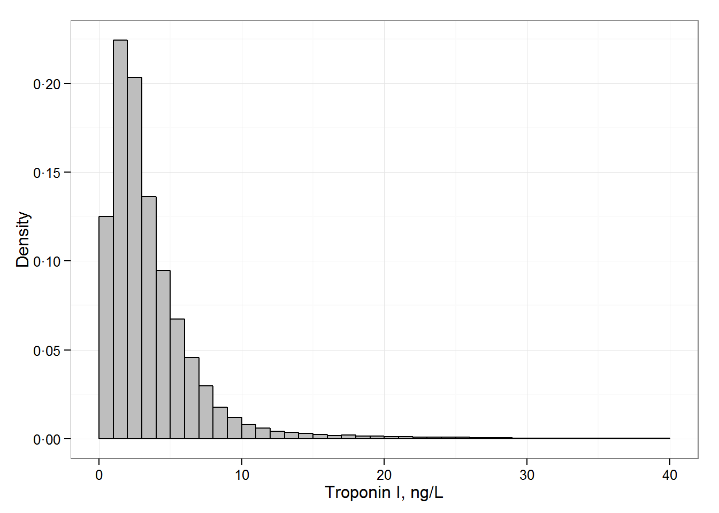

ᵃDensity histogram of troponin I in all cohorts (x-axis truncated, 641 values above 40 ng/L are not shown).

**Figure S3**

Distribution of troponin I serum concentrations by cohort in the BiomarCaRE projectᵃ

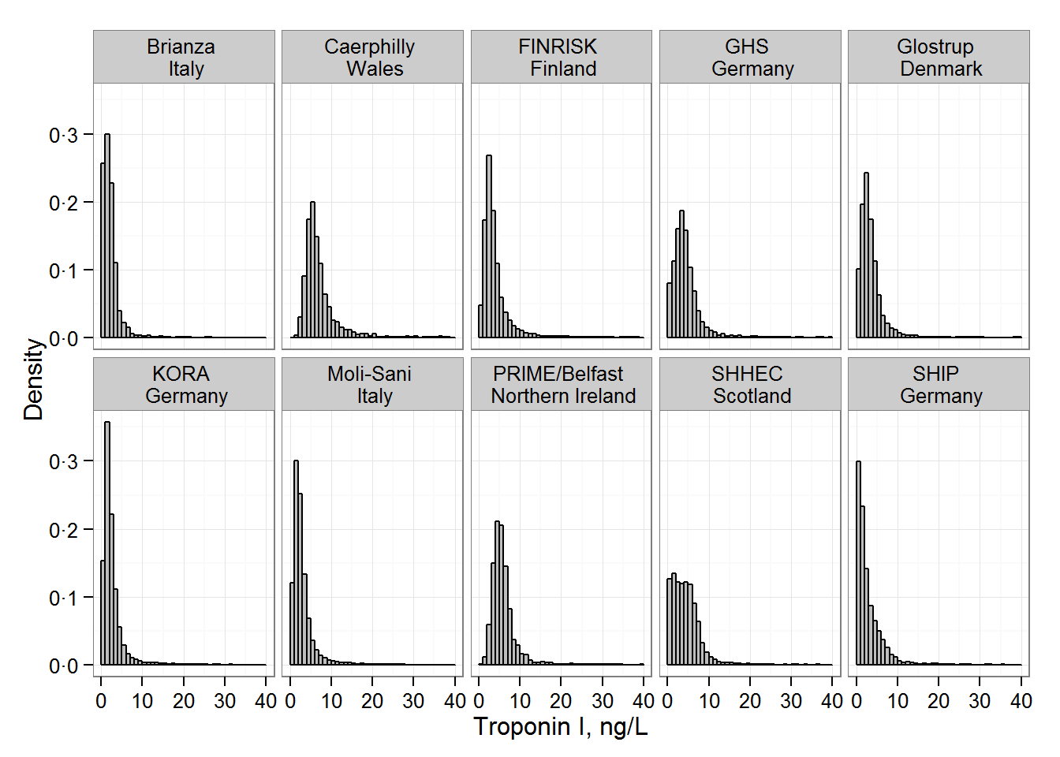

ᵃDensity histogram of troponin I on each study (x-axis truncated, 641 values above 40 ng/L are not shown).

**Figure S4**

Baseline associations between troponin I levels and risk factors and phenotypes stratified by sex

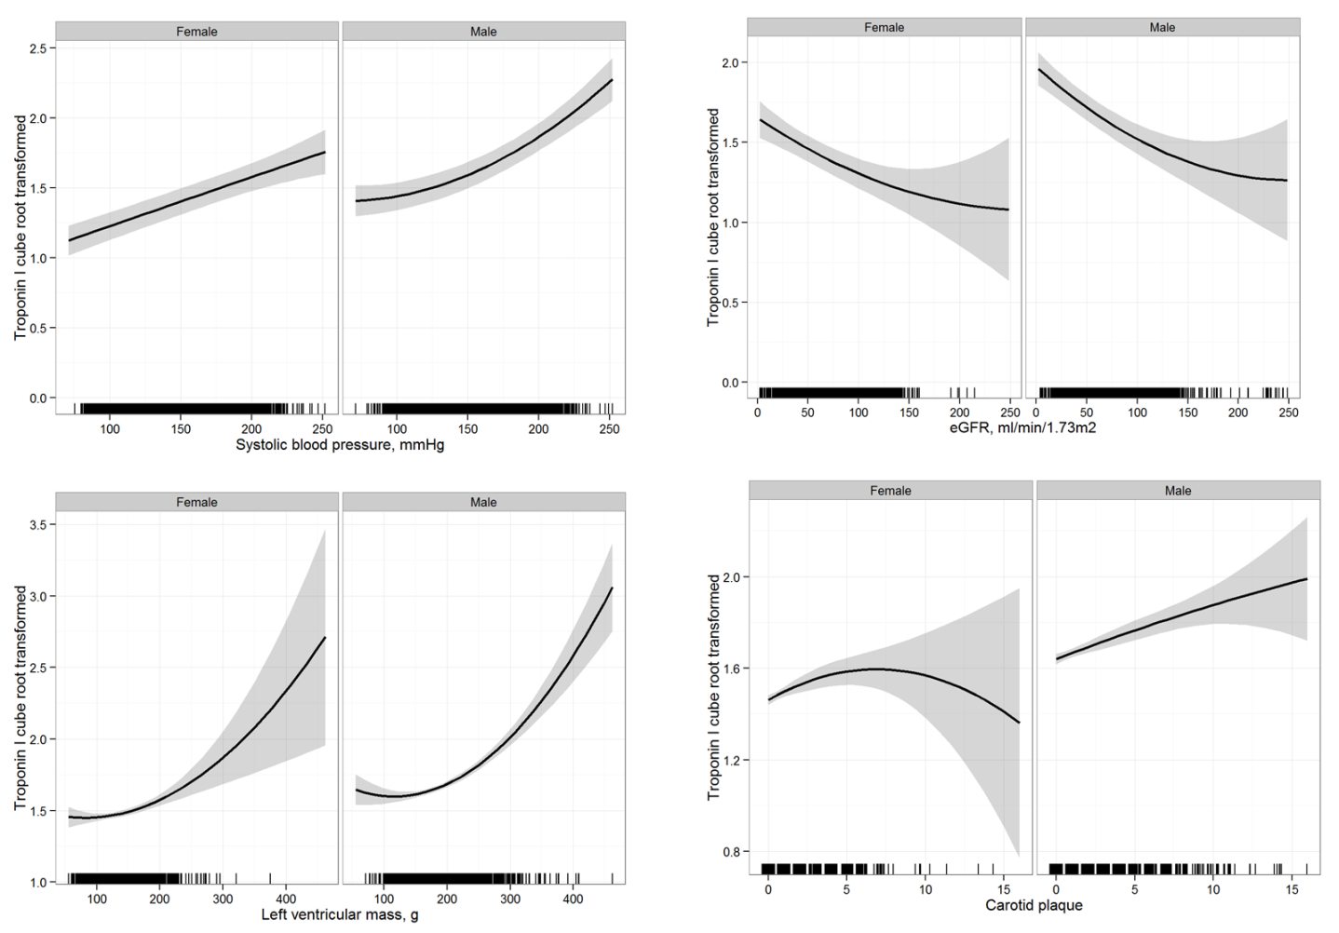

Associations between systolic blood pressure, eGFR and troponin I have been examined in the BiomarCaRE cohort. Associations between carotid plaque, left ventricular mass and troponin I have been examined in the Gutenberg Health Study. The grey shaded area on every figure depicts pointwise 95% confidence intervals. The units of Troponin I before the cube root transformation are ng/L.

**Figure S4**

(continued) Regression coefficients for baseline associations

|  |  |  |  |  |  |
| --- | --- | --- | --- | --- | --- |
| **Characteristics** | **Coefficient (linear)** | | ***P-*value (coefficient)** | ***P-*value (quadratic)** | ***P-*value**  **sex interaction** |
| Male | 0.213 | < 0.001 | |  |  |
| Examination age, years | -0.005 | 0.0040 | | < 0.001 | < 0.001 |
| BMI, kg/m² | 0.015 | < 0.001 | | 0.011 | < 0.001 |
| Systolic BP, mmHg | 0.004 | < 0.001 | | < 0.001 | 0.0010 |
| Total cholesterol, mmol/L | 0.056 | < 0.001 | | < 0.001 | < 0.001 |
| Diabetes | 0.106 | < 0.001 | |  | 0.048 |
| eGFR, mL/min for 1.73m² | -0.003 | < 0.001 | | 0.0075 | 0.020 |
| Carotid plaque | 0.023 | < 0.001 | | 0.37 | 0.74 |
| Left ventricular mass, g | 0.002 | < 0.001 | | < 0.001 | 0.57 |

**Figure S4**

(continued) Partial correlations adjusted for age with exception of age

|  |  |  |
| --- | --- | --- |
| **Characteristics** | **Females** | **Males** |
| Examination age | 0.07 | 0.09 |
| BMI | 0.06 | 0.06 |
| Systolic BP | 0.07 | 0.08 |
| Total cholesterol | 0.04 | 0.04 |
| eGFR | 0.02 | 0.04 |
| Carotid plaque | 0.10 | 0.11 |
| Left ventricular mass | 0.13 | 0.24 |

**Figure S5**

Hazard ratios of cubic root transformed troponin I (i.e. the HR given is not per SD) measured in subgroups of the study population

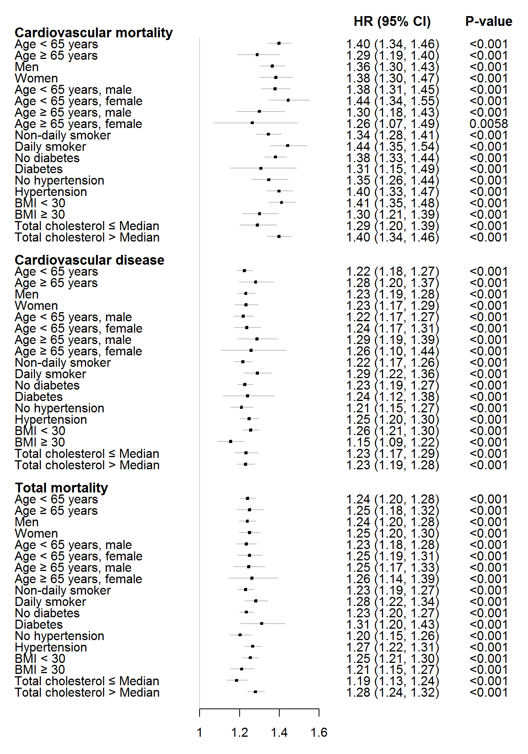

**Figure S6**

Hazard ratios of continuous cubic root transformed troponin I according to each cohort

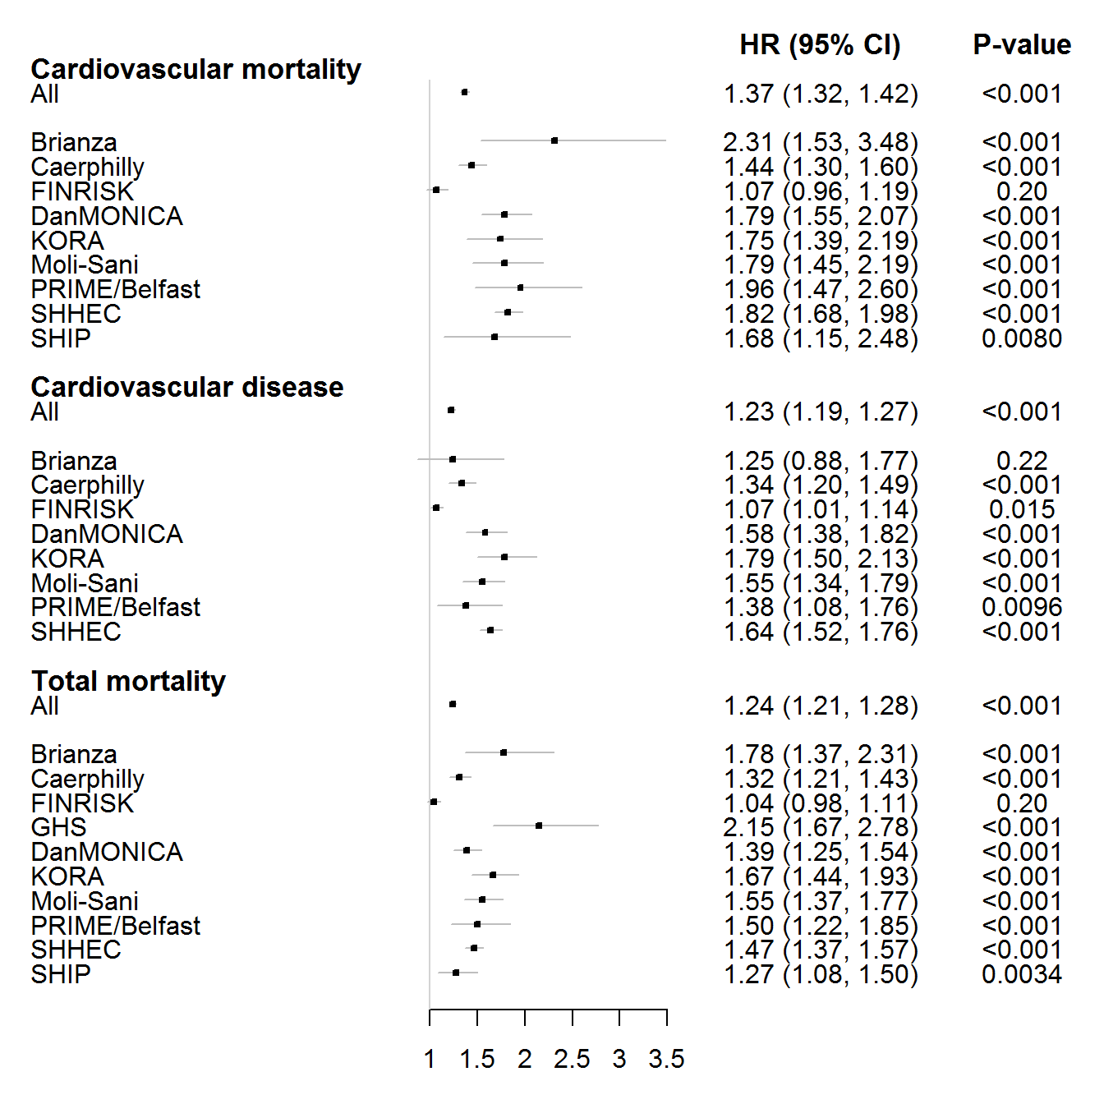

Hazard ratios of cubic root transformed troponin I per cohort. Models are adjusted for the variables used in the ESC SCORE (cardiovascular mortality, total mortality) and ACC/AHA score (cardiovascular disease). Age is used as the time scale. The models are stratified by sex (except for those cohorts consisting only of men). The overall model was additionally stratified by cohort.

**Figure S7** C-statistics by biomarker including troponin I, C-reactive Protein (CRP), N-terminal pro-B-type natriuretic peptide (NT-proBNP) and estimated glomerular filtration rate (eGFR). Follow-up time was censored at 1, 5 and 10 years.

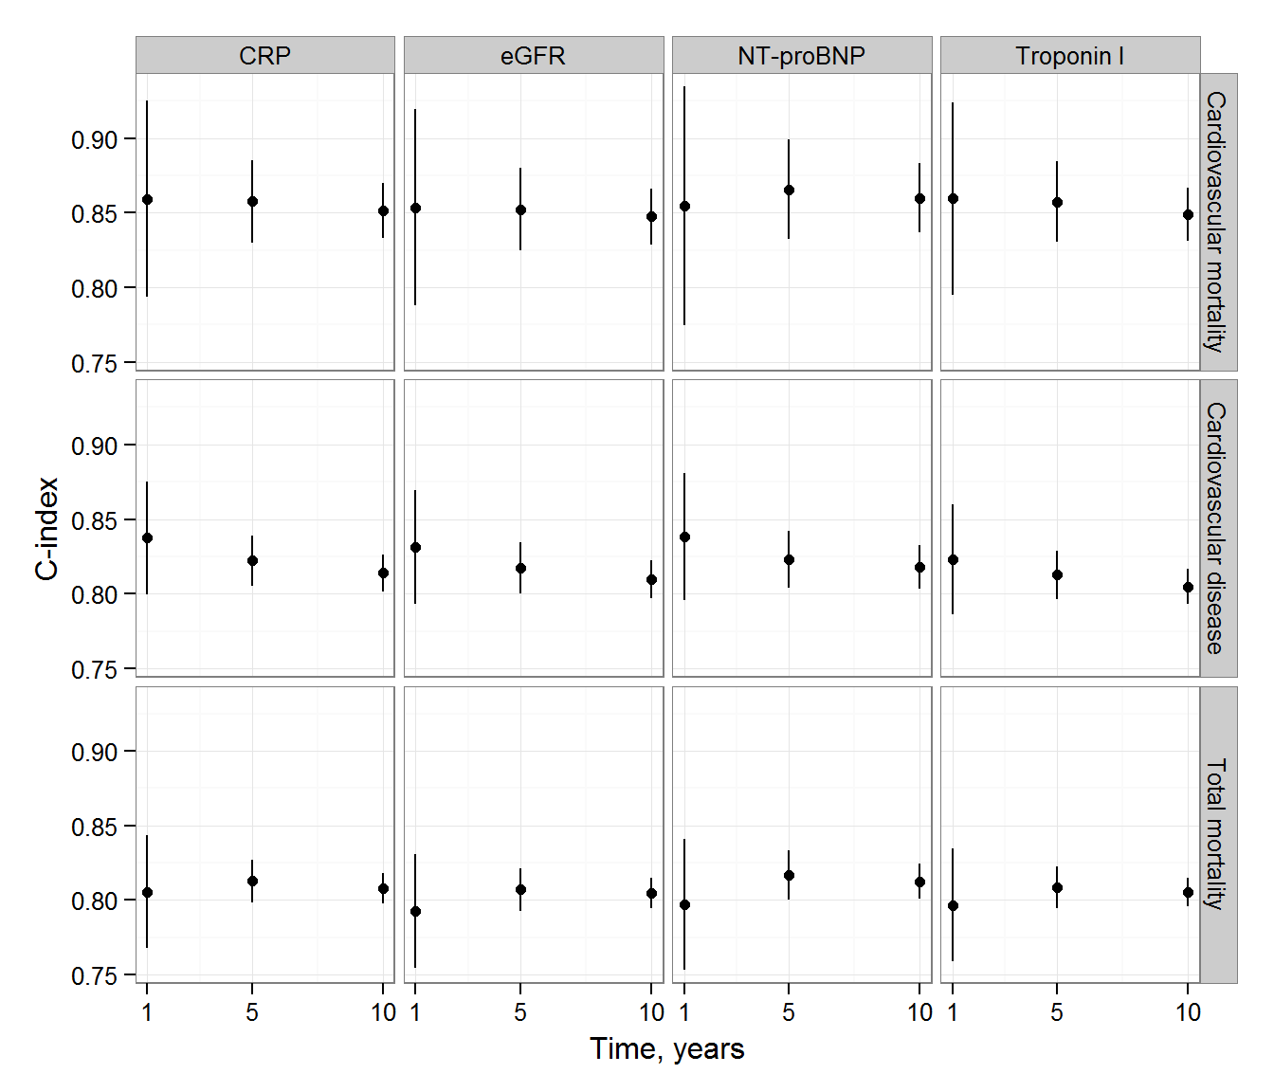

**Figure S8**

Calibration plots for analyzed endpoint of cardiovascular mortality, cardiovascular disease and total mortality

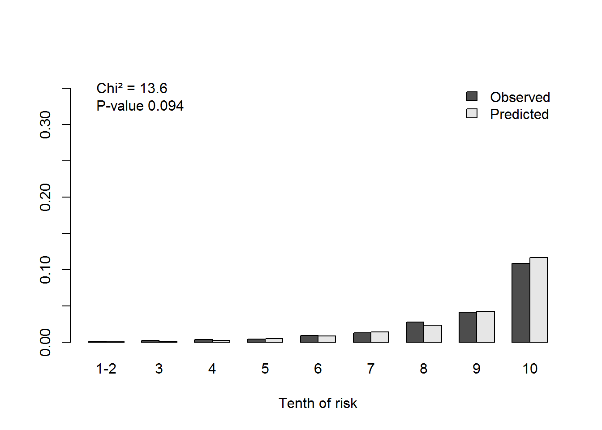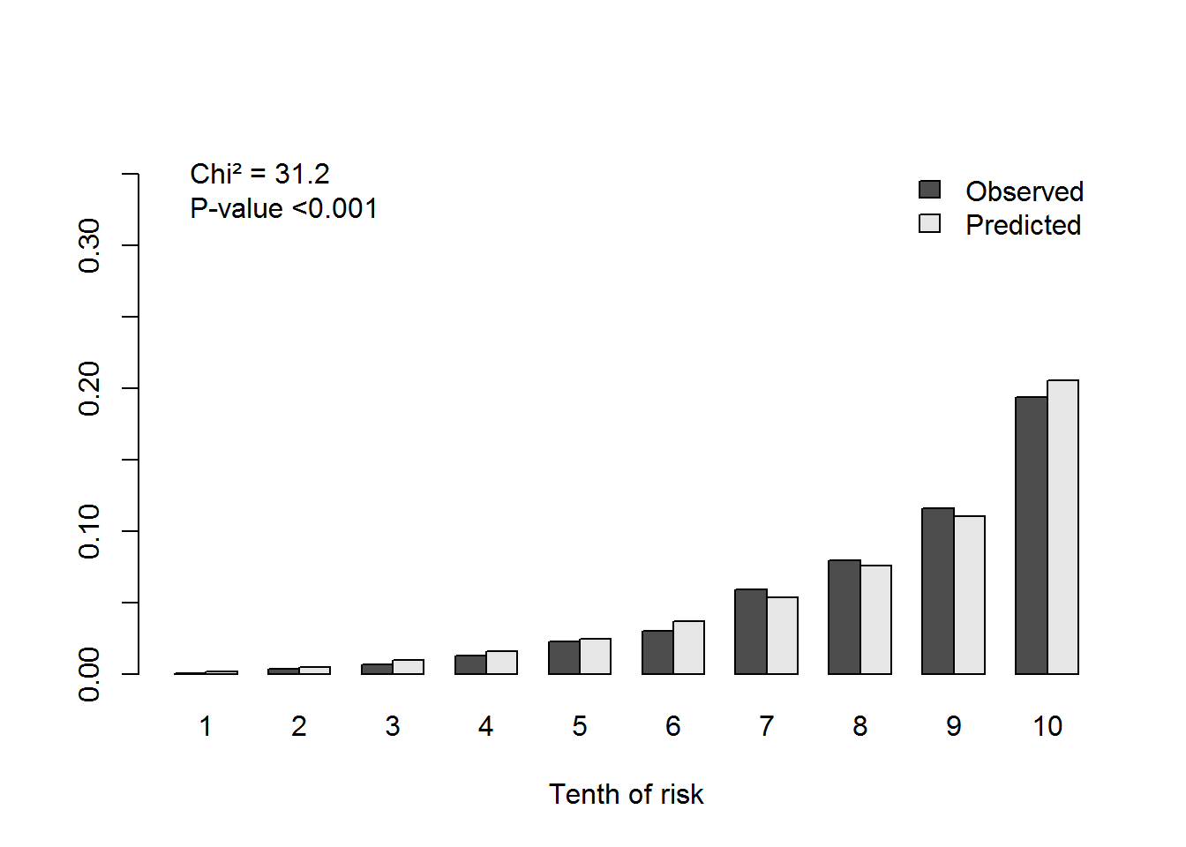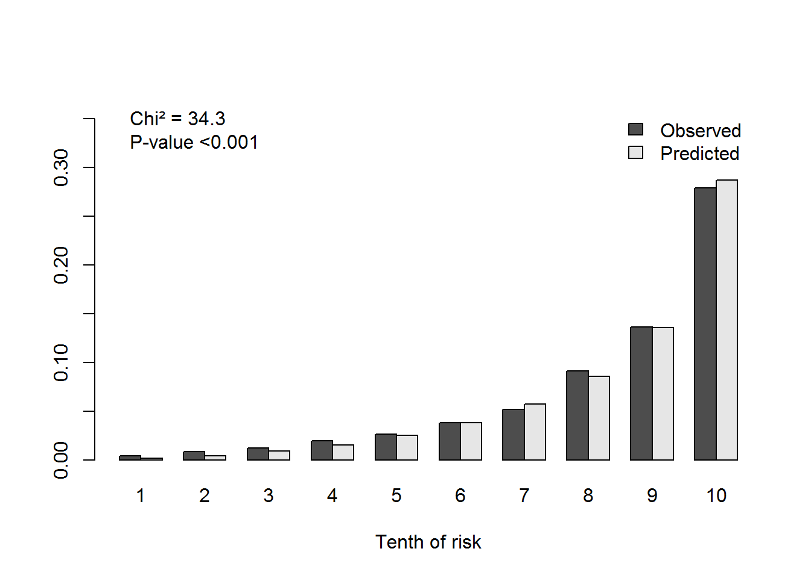

The x-axis refers to deciles of predicted risk. Each bar in the graph represents the average observed and predicted risk. If a category contained less than five events, it was merged with an adjacent category.