**Supporting Information**

**Molecular Characterization of Particulate Organic Matter in Full Scale Anaerobic Digesters: An NMR Spectroscopy Study**

Sepehr Shakeri Yektaa*, Mattias Hedenströmb, Bo H. Svenssona, Ingrid Sundgrena, Mårten Darioa, Alex Enrich-Prasta, Norbert Hertkornc, Annika Björna

*aDepartment of Thematic Studies-Environmental Change and Biogas Research Center, Linköping University, 581 83 Linköping, Sweden*

*bDepartment of Chemistry, Umeå University, 901 87 Umeå, Sweden*

*cHelmholtz Center Munich, German Research Center for Environmental Health, Research Unit Analytical Biogeochemistry, 85764 Neuherberg, Germany*

*\*Corresponding author: E-mail: sepehr.shakeri.yekta@liu.se, Phone: +46 13282294, Fax: +46 13133630.*

**Table S1**

Integral values for alkyl, O-alkyl, anomeric, aromatic and carbonyl C (% of total integrals) together with alkyl to O-alkyl ratios, based on 13C CP-MAS NMR spectra of substrate and digestate particulate organic matter (POM). The ranges of integral values are presented for spectra from duplicate or triplicate samples. Carbon (C) and nitrogen (N) contents of POM (% of weight) are provided together with computed C:N ratio. Analytical uncertainties of 3% and 5% were considered based on C and N measurements in multiple reference sludge samples.

|  |  |  |  |  |  |  |  |  |  |  |
| --- | --- | --- | --- | --- | --- | --- | --- | --- | --- | --- |
| Sample  name | Number of samples | Alkyl  0 – 47 ppm | O-alkyl  47 – 90 ppm | Anomertic  90 – 108 ppm | Aromatic,  108 – 167 ppm | Carbonyl  167 – 220 ppm | Alkyl to O-alkyl ratio | N | C | C:N |
| CDAW1-S1 | 2 | 16 | 59 – 61 | 11 – 12 | 5 – 7 | 7 | 0.3 | 3 | 43 | 14 |
| CDAW1-S2 | 2 | 11 | 63 | 13 | 9.0 | 4 – 5 | 0.2 | 1.2 | 43 | 36 |
| CDAW1-S3 | 2 | 8 – 9 | 62 | 13 | 13 | 4 | 0.1 | 0.6 | 44 | 73 |
| CDAW1-D | 2 | 11 – 15 | 55 – 56 | 11 – 12 | 13 – 16 | 5 – 6 | 0.2 – 0.3 | 1.9 | 44 | 23 |
| CDAW1-PD | 2 | 14 – 15 | 53 – 54 | 11 | 14 – 15 | 6 – 7 | 0.3 | 2.1 | 45 | 21 |
| CDAW2-S | 1 | 8.0 | 67 | 14 | 9.0 | 2 | 0.1 | 1 | 43 | 43 |
| CDAW2-D | 3 | 17 – 23 | 46 – 51 | 9 – 11 | 15 | 7 – 8 | 0.3 – 0.5 | 3.7 | 46 | 12 |
| CDAW2-PD | 3 | 19 – 24 | 43 – 47 | 9 – 10 | 17 | 7 – 8 | 0.4 – 0.6 | 4.4 | 47 | 11 |
| CDAW3-S1 | 2 | 25 – 27 | 46 – 48 | 9 – 10 | 9 – 10 | 7 – 8 | 0.5 – 0.6 | 3.8 | 51 | 13 |
| CDAW3-S2 | 1 | 16 | 54 | 11 | 12 | 7 | 0.3 | 2.8 | 43 | 15 |
| CDAW3-D1 | 2 | 19 | 48 | 9 – 10 | 15 – 16 | 7 | 0.4 | 3.3 | 45 | 14 |
| CDAW3-D2 | 2 | 20 | 48 | 10 | 15 | 7 | 0.4 | 3.5 | 46 | 13 |
| CDFW1-S | 1 | 22 | 53 | 10 | 8.0 | 7.0 | 0.4 | 2.7 | 45 | 17 |
| CDFW1-D | 1 | 38 | 34 | 5.0 | 11 | 12 | 1.1 | 7.5 | 50 | 6.7 |
| CDFW1-PD | 1 | 37 | 33 | 5.0 | 13 | 12 | 1.1 | 7.3 | 48 | 6.6 |
| CDFW2-S | 3 | 38 – 39 | 36 – 38 | 6 – 7 | 8 – 9 | 10 | 0.9 – 1.1 | 4.5 | 54 | 12 |
| CDFW2-D | 3 | 30 – 35 | 40 – 41 | 7 – 8 | 11 – 13 | 8 – 9 | 0.7 – 0.9 | 5.2 | 42 | 8.1 |
| CDFW2-PD | 3 | 29 – 33 | 40 – 42 | 7 – 8 | 11 – 13 | 8 – 10 | 0.7 – 0.8 | 4.9 | 40 | 8.2 |
| CDFW3-S | 3 | 19 – 22 | 51 – 53 | 10 – 11 | 9 – 10 | 8 – 7 | 0.4 | 2.6 | 47 | 18 |
| CDFW3-D | 3 | 34 – 37 | 33 – 36 | 5 – 6 | 12 – 14 | 11 – 12 | 0.9 – 1.1 | 6.9 | 50 | 7.3 |
| CDFW3-PD | 3 | 35 – 38 | 32 – 34 | 5 – 6 | 13 – 14 | 11 – 12 | 1.1 – 1.2 | 7.1 | 50 | 7.0 |
| CDFW4-S | 3 | 16 – 18 | 53 – 57 | 11 – 12 | 10 – 11 | 6 – 7 | 0.3 | 2.2 | 47 | 21 |
| CDFW4-D | 3 | 21 – 22 | 44 – 45 | 8 – 9 | 17 – 18 | 7 – 8 | 0.5 | 3.1 | 41 | 13 |

**Table S2**

Overall characteristics of samples from anaerobic digestion plants, analyzed by Eurofins Environment Testing Sweden AB. Total carbohydrate values represent the sum of xylose, mannose, glucose, galactose, and arabinose concentrations in each sample. TS stands for total solid, representing the dry weight of the samples. VS stands for volatile solid, ww for wet weight, and AU for analytical uncertainty (% of reported values).

|  |  |  |  |  |  |  |  |
| --- | --- | --- | --- | --- | --- | --- | --- |
| Sample  name | TS  (%ww) | VS  (%TS) | Kjeldahl N  (mg/gTS) | Ammonium N  (mg/gTS) | Total protein  (mg/gTS) | Total carbohydrate  (mg/gTS) | Protein to  carbohydrate ratio |
| CDAW1-S1 | 7,1 | 97 | 38 | 5,5 | 203 | 569 | 0,4 |
| CDAW1-D | 10 | 88 | 45 | 24 | 131 | 428 | 0,3 |
| CDAW1-PD | 7,7 | 86 | 49 | 30 | 122 | 363 | 0,3 |
| CDAW2-S | 37 | 96 | 12 | 1 | 65 | 647 | 0,1 |
| CDAW2-D | 6,3 | 72 | 89 | 52 | 228 | 192 | 1,2 |
| CDAW2-PD | 6,3 | 78 | 76 | 38 | 238 | 185 | 1,3 |
| CDAW3-S1 | 5,3 | 78 | 91 | 53 | 236 | 193 | 1,2 |
| CDAW3-S2 | 47 | 90 | 30 | 5 | 157 | 480 | 0,3 |
| CDAW3-D1 | 8,9 | 81 | 61 | 22 | 239 | 220 | 1,1 |
| CDAW3-D2 | 7,7 | 73 | 81 | 44 | 227 | 210 | 1,1 |
| CDFW1-S | 14 | 91 | 38 | 6,1 | 198 | 355 | 0,6 |
| CDFW1-D | 4,8 | 74 | 146 | 63 | 521 | 84 | 6,2 |
| CDFW1-PD | 4,3 | 72 | 133 | 84 | 305 | 71 | 4,3 |
| CDFW2-S | 6 | 82 | 72 | 33 | 244 | 61 | 4,0 |
| CDFW2-D | 3,3 | 67 | 164 | 109 | 341 | 118 | 2,9 |
| CDFW2-PD | 3,9 | 67 | 159 | 97 | 385 | 114 | 3,4 |
| CDFW3-S | 10 | 89 | 28 | 5 | 144 | 342 | 0,4 |
| CDFW3-D | 4,3 | 70 | 102 | 56 | 291 | 98 | 3,0 |
| CDFW3-PD | 4,0 | 70 | 95 | 63 | 203 | 72 | 2,8 |
| CDFW4-S | 29 | 88 | 31 | 4,1 | 165 | 404 | 0,4 |
| CDFW4-D | 12 | 62 | 66 | 32 | 208 | 126 | 1,7 |
| AU (%) | 10 | 10 | 10 | 20 | 20 | 15 | - |

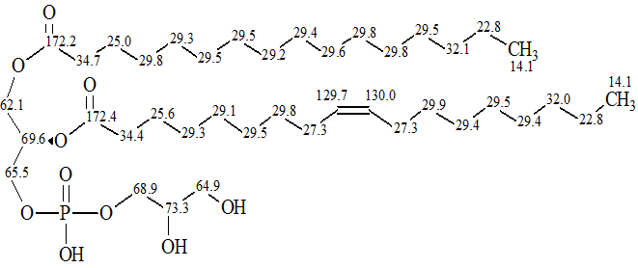

**Fig. S1.** Simulated 13C chemical shifts (in ppm) of 1-Palmitoyl-2-oleoyl-sn-glycero-3-phosphoglycerol dissolved in DMSO-*d6*, using ACD/spectrus software.

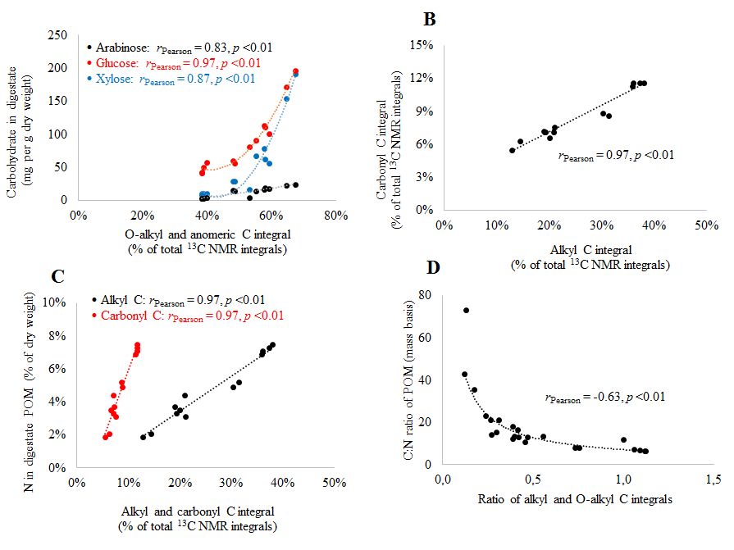

**Fig. S2.** A) Total concentrations of arabinose, glucose and xylose in the digestate samples versus sum of O-alkyl and anomeric C integrals of solid-state 13C CP-MAS NMR spectra, representing the relative abundances of O-alkyl and anomeric C in digestate particulate organic matter (POM). B) Solid-state 13C CP-MAS NMR integrals of alkyl C versus integrals of carbonyl C. C) Nitrogen contents of the POM versus solid-state 13C CP-MAS NMR integrals of alkyl C and carbonyl C. D) The C:N ratios of all POM samples versus alkyl:O-alkyl C ratios of solid-state 13C CP-MAS NMR spectra.

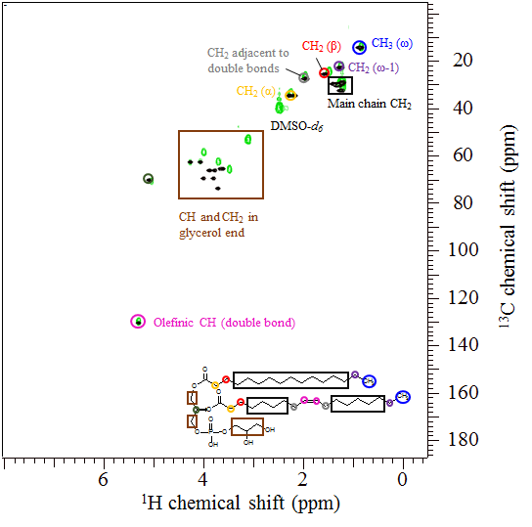

**Fig. S3.** Experimental (green) 1H,13C HSQC NMR spectrum of 1-Palmitoyl-2-oleoyl-sn-glycero-3-phosphoglycerol (POPG) dissolved in DMSO-*d6* together with the modeled spectrum (black) based on its chemical structure. The peak assignments to subunits include CH3(ω) at δH/C:0.9/14.4 ppm, main-chain CH2 at δH/C:1.1-1.5/26.5-32.5 ppm, CH2(ω-1) at δH/C:1.3/22.5 ppm, CH2(β) at δH/C:1.5/24.8 ppm, CH2 adjacent to double bonds at δH/C:2.0/27.0 ppm, CH2(α) at δH/C:2.2/33.8 ppm, and CH in double bonds at δH/C:5.3/129.8 ppm, as well as CH and CH2 in glycerol subunits at δH/C:3.5-5.5/50-80 ppm.

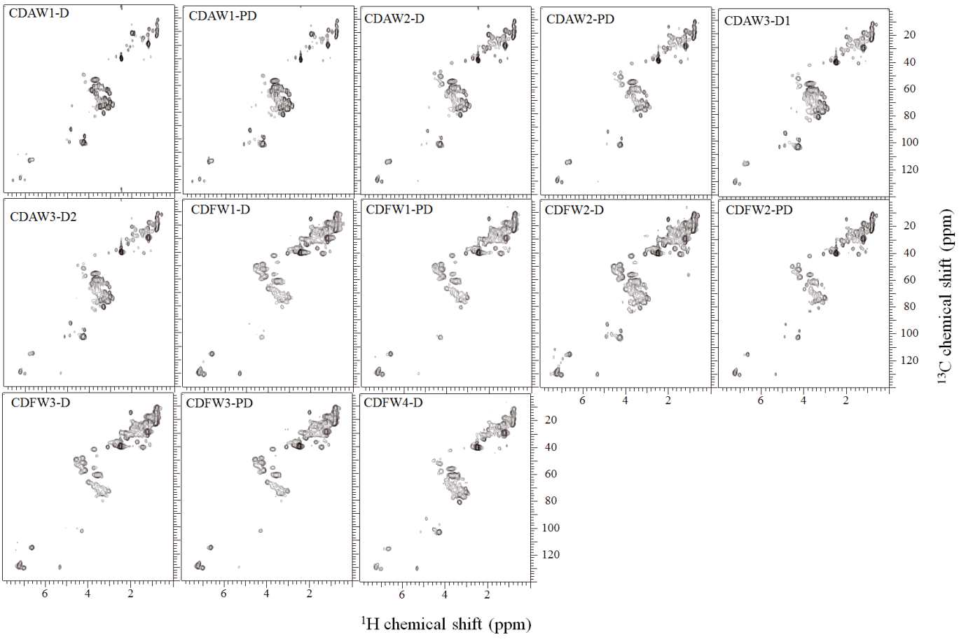

**Fig. S4.** 1H,13C HSQC NMR spectra of digestate particulate organic matter samples.

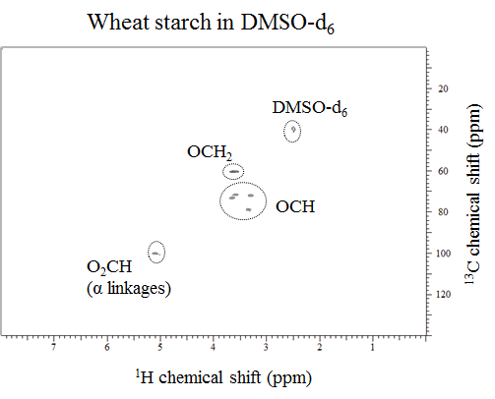

**Fig. S5.** 1H,13C HSQC NMR spectrum obtained from wheat starch dissolved in DMSO-*d6*.

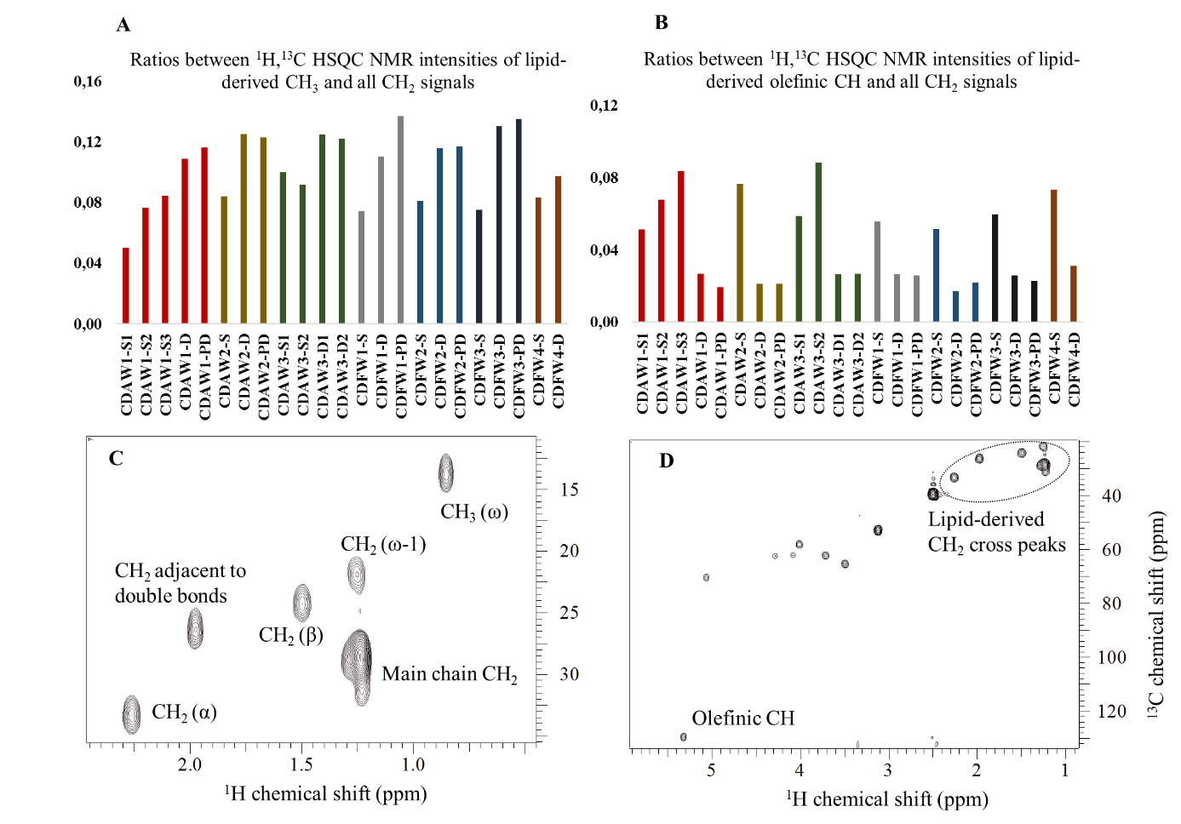

**Fig. S6.** Ratios between signal intensities of lipid-derived CH3 and CH2 in1H,13C HSQC NMR spectra. B) Ratios between signal intensities of olefinic CH and lipid-derived CH2 units in1H,13C HSQC NMR spectra. C) Cross peaks used to calculate lipid-derived CH3 and CH2 ratios. D) Cross peaks used to calculate ratios of olefinic CH and lipid-derived CH2 units.