Supporting Information

Upgrading coagulation with hollow-fibre nanofiltration for improved organic matter removal during surface water treatment

Stephan J. Köhler1, *, Elin Lavonen1,Alexander Keucken2,3, Philippe Schmitt-Kopplin4,5,Tom Spanjer6 and Kenneth Persson3,7

1 Department of Aquatic Sciences and Assessment, Swedish University of Agricultural Sciences, Box 7050, Uppsala, Sweden

2 Vatten & Miljö i Väst AB (VIVAB), Box 110, SE-311 22 Falkenberg, Sweden.

3 Water Resources Engineering, Faculty of Engineering, Lund technical University, Box 118, SE-221 00 Lund, Sweden

4 Analytical BioGeoChemistry, German Research Center for Environmental Health, Helmholtz Zentrum München, 85764, Neuherberg, Germany

5 Chair of Analytical Food Chemistry, Technische Universität München, 85354, Freising-Weihenstephan, Germany 6 Pentair X-Flow B.V., P.O. 739, 7500 AS Enschede, The Netherlands.

7 Sydvatten AB, Skeppsgatan 19, SE 211 19 Malmö, Sweden

Nr of Figures:8

Nr of Tables:1

Nr of Pages: 10

Tables

Figures

**Appendix**

Background section

Mälaren has been used as a drinking water source since 1850. Some one hundred years ago the intake was moved away from the city shores eastwards. Nowadays, Görväln DWTP is one of the three large DWTP in Stockholm and produces around 40 Million m3 of drinking water annually. In the 1960’s, the lake faced large problems with eutrophication due to input of phosphorous (P) and nitrogen (N) from wastewater treatment plants and agriculture (Ericsson et al. 1984). Most of the major eutrophication problems have been tackled and both N and P have decreased substantially. Görväln DWTP has its raw water intake in the eastern part of the lake close to the outlet to the Baltic Sea. At that point two water masses, one from the northeast with rather alkaline (1.9-2.4 mM), turbid water (2-16 FNU) with terrestrially derived DOC, and one with less alkaline (0.7mM), less turbid (1.5-7 FNU), translucent water with a larger fraction of algal derived DOC from the western basin mix. The average retention time of the whole lake is 2.8 years (Kohler et al. 2013). During that time DOC is processed in the lake and new, algal DOC is produced internally. This algal derived DOC has a lower SUVA and varies even with respect to other characteristics, higher freshness index (β:α), less dissolved iron, less color per DOC , and is harder to remove with the conventional coagulation technique that is currently employed at Görväln DWTP. Both water sources are affected by significant amounts of waste water effluents from a number of medium size towns (50 000-200 000) situated around the lake which potentially may pose problems with nutrients, algal blooms, as well as occurrence of bacteria, micropollutants and medical products. In addition to this, Mälaren is trafficked by sport boats and occasionally also smaller oil tankers. Water quality in Mälaren is due to its sheer size very good but as a whole the situation may be described as fragile.

The varying contribution of water masses from these two basins cause DOC to fluctuate over time. Platinum color measured in the raw water has varied between 15 and 50 mg Pt /l between 1935 and 2015, indicating an approximate historic range in TOC of between 5 to 11 mg L-1 over that period (Johansson et al. 2010). Switching between two different water intake depths dampens some of the larger fluctuations in DOC concentration and quality. For example, during 2011-2014 80% of the [DOC] and Pt color values are between 6.8 and 8.6 mg C L-1and 17 and 38 mg Pt L-1 respectively. Furthermore, for turbidity, 80% of the values are between 1 and 3.5 FNU. Over the last 15 years, DOC concentrations in the surface water of the basin where the raw water intake is located have varied between 5 and 14 mg/l. In the year 2000, after a long period of intensive rainfall, DOC concentrations in the surface water peaked at around 14 mg C L-1in the autumn and declined only slowly over the following months. This historic peak in TOC has triggered a number of studies (Weyhenmeyer et al. 2004, Temnerud and Weyhenmeyer 2008) (Johansson et al. 2010) on the vulnerability of the WTPs using Mälaren as raw water source. The use of nanofiltration for removal of DOC is one part of the initiated activities.

Given the high pH (7.3-7.6) and alkalinity (60-80 mg L-1) in the incoming raw water, a significant fraction of the coagulant dose (AlDOS) in the current WTP train is used to decrease the pH to the optimal pH of Al2(SO4)3 coagulation of around 6.5, as no acid is added for this purpose.

Membrane section

The outer layer of the membrane exhibits a very open porous structure, to ensure mechanical strength of the membrane combined with a very low hydraulic resistance. According to the membrane supplier, this patented interior employs corrugated plates along the length of the insert that subdivides the fibre bundles into segments. This subdivision provides an optimized flow distribution and assures the lowest pressure drop possible and thus minimizes power consumption. Membrane interior and the outer casing of the modules are made of PVC ensuring identical expansion and contraction as a result of seasonal temperature changes of the water to be treated. The membranes are potted in a resin at both ends, to provide an absolute barrier between the feed and permeate sides of the module.

The membrane can withstand exposure times of >150,000 ppm hours NaOCl at pH around 11 without any significant loss in permeability and >100,000 ppm hours before any loss in retention is observed (De Grooth 2015).

The hydraulic load of the pilot plant with respect to flux and recovery rates could be adjusted mechanically by replaceable orifice plates in the recirculation, concentrate (NF-C) and permeate lines (NF-P). The membrane module was operated in cross-flow mode in combination with continuous, flow proportional retentate outlet and intermittent forward flushing. Instead of automatically hydraulic cleanings, regular chemical enhanced forward flushing was applied by recirculating cleaning solutions (NaOH, pH:~12, NaOCl, 200 ppm) on the lumen side of the membrane with a soak time of 120 minutes. Enhanced chemical backwashing was applied manually on a regular basis after 40 to 50 days of continuous filtration.

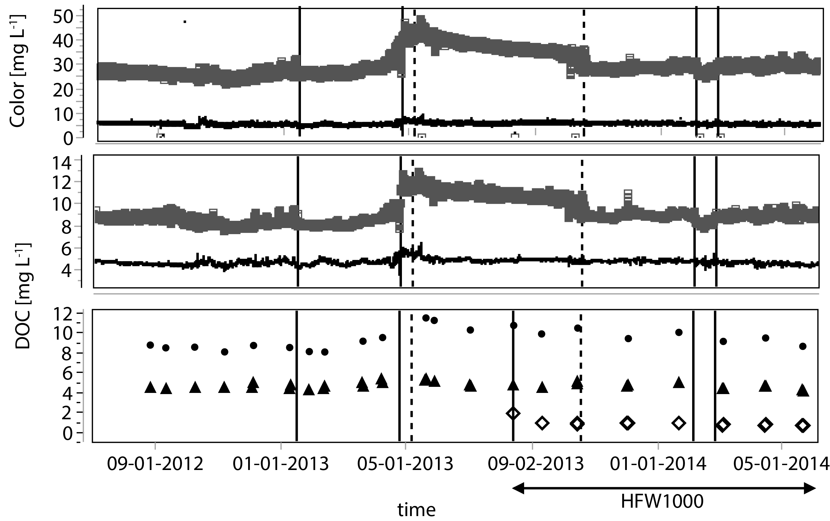

Figure A. 1: a: S:can modelled modeled platinum color (mg L-1) , b: Time series of S:can modelled DOC (mg L-1) in the raw water (grey), sand filter (black), including measured DOC in raw water (black circles), sand filter (black triangels ) and nanofilter permeate (white diamonds for the full pilot study period starting in September 2012 to July 2014. The HFW 1000 was installed in August 2013. Vertical black lines indicate change of intake depth and hyphenated vertical lines changes in the NF pilot setup. The black horizontal arrow in the lowest panel indicates the nine months experimental period of the HW 1000 nanofilter pilot.

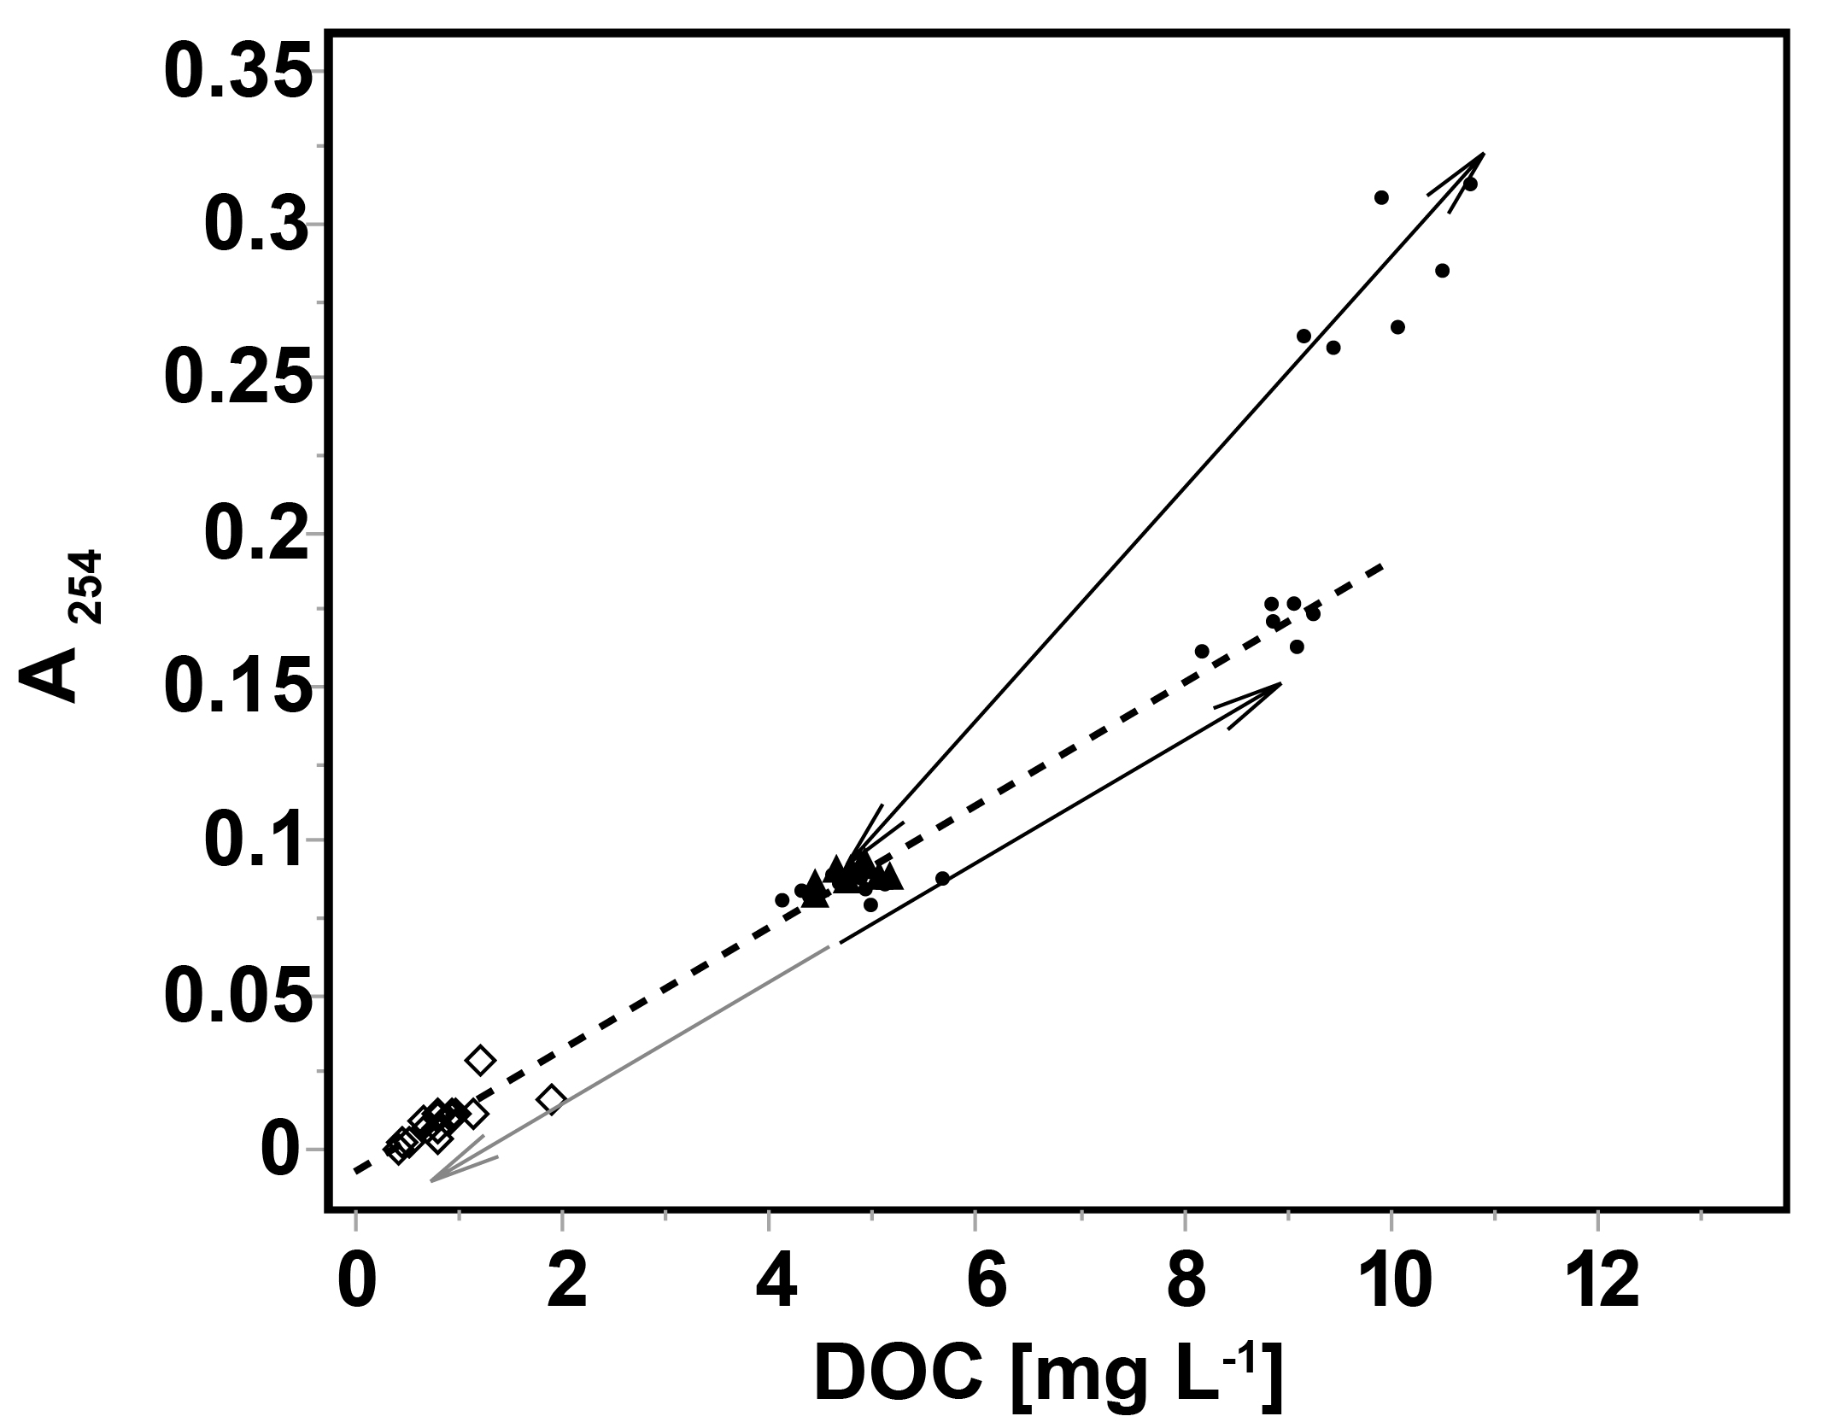

Figure A. 2: A254 against DOC for all different sampling points. The black hyphenated line indicates the linear relationship (A254 = -0.0073 + 0.0198*DOC, r2 = 0.99) between A254 and DOC after coagulation. The grey arrows indicate either the concurrent removal (NF-P) or increase (NF-C) in A254 with DOC (lower two arrows) during NF. In contrast during coagulation a preferential removal of A254 is observed (upper arrow).

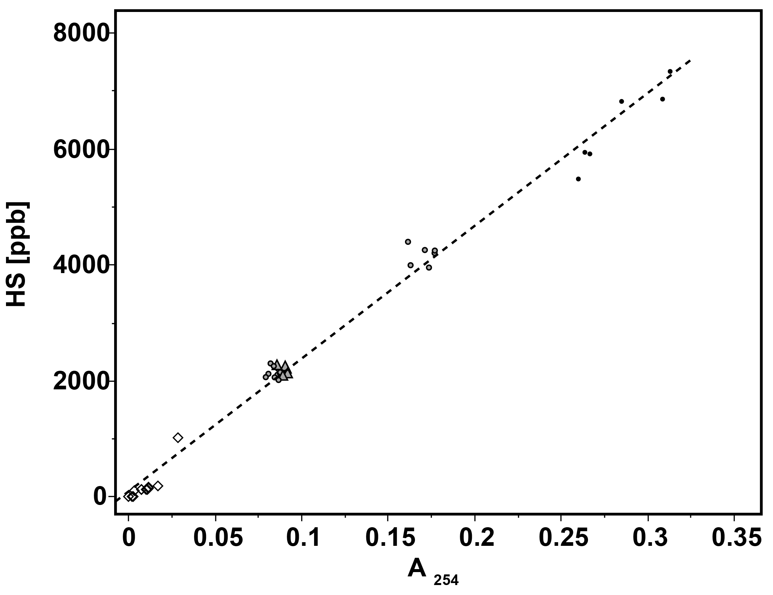

Figure A. 3*:* Amount of HS [ppb] quantified from LC-OCD against measured A254 for all samples. Thehyphenated line is the regression curveHS [ppb] = 100 + 22900*A254; r2 = 0.99.

|  |  |
| --- | --- |
|  |  |
|  |  |
|  |  |
|  |  |
| Figure A. 4: Typical EEMs for RAW, SF, NF-P and nanofilter permeate followed by active carbon filter water (CF2) displaying data from 2013-08-14 after installation of a fresh active carbon filter (left: raw and processed waters (Raw, SF, NF, CF2 from top to bottom) and right: the removed fraction of FDOM calculated from differential EEMs displaying the amount of FDOM that has been removed during the different treatment steps (Raw-SF, SF-NF, NF-CF2 from top to bottom) | |

|  |  |
| --- | --- |
|  |  |
|  | |

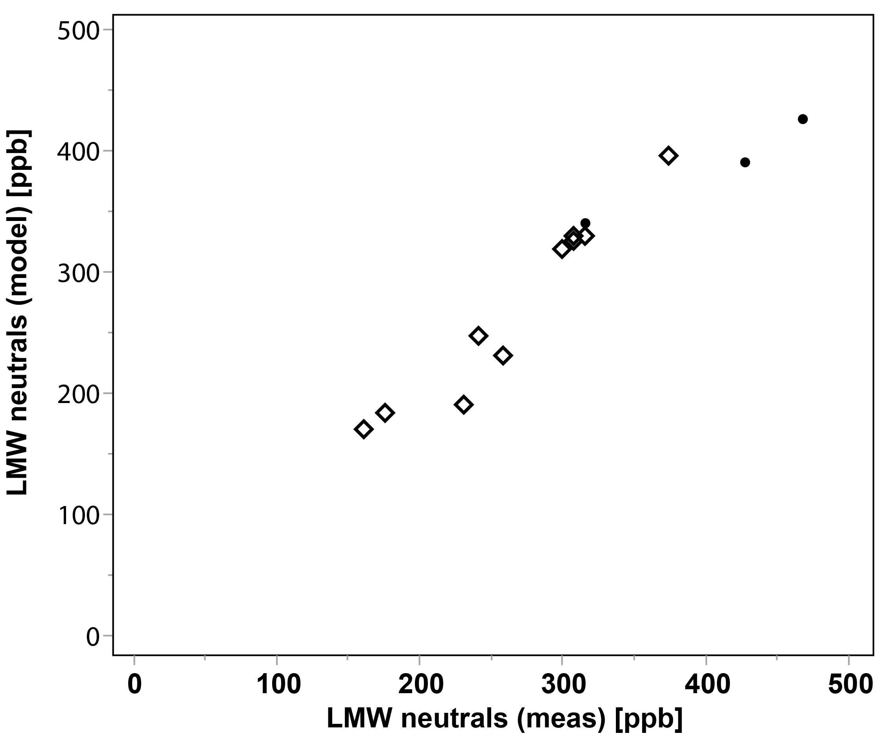

Figure A. 5*:* Predicted concentration of low molecular weight (LMW) neutrals from fluorescence derived parameters humification index (HIX) and freshness index (β:α) for the nanofiltration permeate (LMW = -16 + 1450*HIX – 1050*β:α; n = 13; p< 0.01)

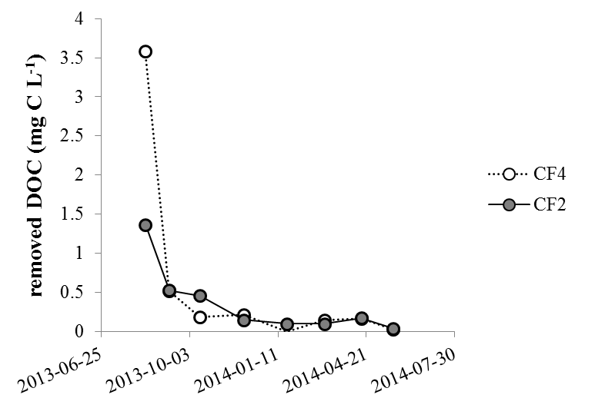

Figure A. 6*:* Removed DOC over time after change in GAC filter in CF2 and CF4 indicating similar low removal of DOC after just a few months despite different feed DOC concentration.

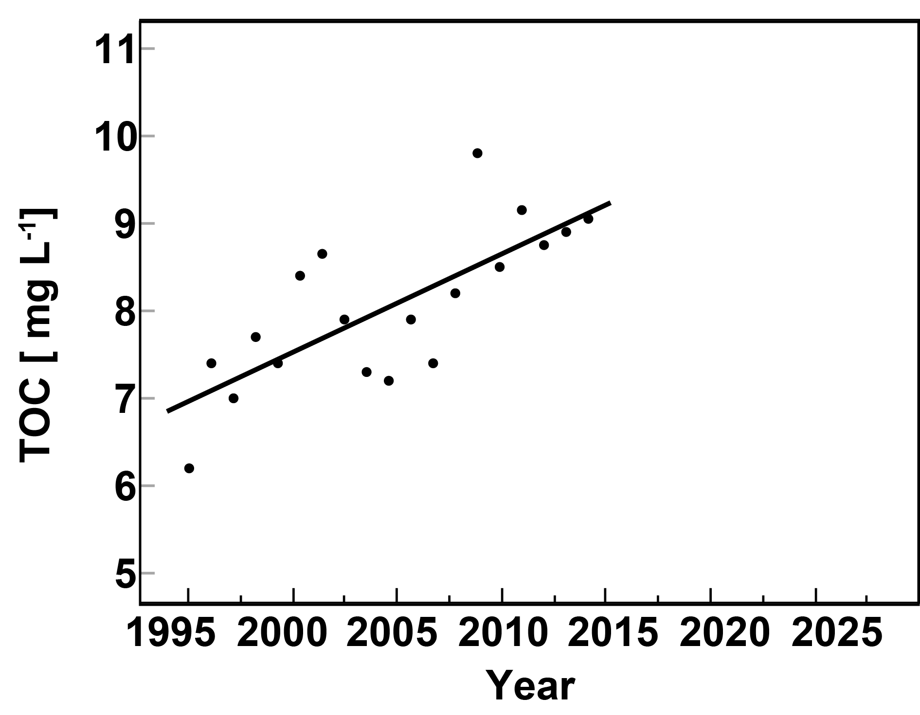

Figure A. 7*:* Change in median annual (n=12) TOC concentration during the period 1996 to 2014. The red line describes the change in TOC over time with a slope of 0.12 mg L-1 year-1 r2 = 0.56 and p < 0.001.

Table A. 1: Median and standard deviation of the different DOC fractions obtained from LC-OCD [ppb] for the period August 2013 to July 2014.

|  |  |  |  |  |  |  |  |
| --- | --- | --- | --- | --- | --- | --- | --- |
|  | Full-scale | | | | Pilot scale | | |
| code | RAW | SF | CF | DW | CF4 | NF-P | CF2 |
| biopoly | 245±61 | 138±24 | 142±32 | 149±37 | 135±25 | 9±4 | 10±6 |
| HS | 6510±572 | 2235±159 | 2181±195 | 2198±208 | 2149±452 | 159±20 | 140±65 |
| build | 1260±117 | 1164±104 | 1173±92 | 1170±90 | 1110±247 | 140±29 | 123±48 |
| LMW neutrals | 835±142 | 664±83 | 678±106 | 652±116 | 605±163 | 188±36 | 146±52 |
| LMW acids | 42±35 | 0±17 | 0±4 | 0±6 | 0±8 | 0±0 | 0±38 |
| LMW | 878±176 | 664±100 | 678±110 | 652±122 | 605±171 | 188±36 | 146±90 |
| DOC | 8740±655 | 4242±185 | 4167±167 | 4403±151 | 4084±823 | 487±72 | 410±161 |

References

De Grooth, J. (2015) A Tale Of Two Charges: Zwitterionic Polyelect rolyte Multilayer Membranes. Ph.D., Twente University, Twente.

Ericsson, P., Hajdu, S. and Willén, E. (1984) Vattenkvaliteten i Görväln. En dynamisk Mälarfjärd. Vattenkemi och växtplankton i ett fyrtioårigt perspektiv (in Swedish). Vatten 40, 193-211.

Johansson, L., Temnerud, J., Abrahamsson, J. and Kleja, D.B. (2010) Variation in organic matter and water color in Lake Mälaren during the past 70 years. *Ambio* 39(2), 116-125.

Kohler, S.J., Kothawala, D., Futter, M.N., Liungman, O. and Tranvik, L. (2013) In-Lake Processes Offset Increased Terrestrial Inputs of Dissolved Organic Carbon and Color to Lakes. *Plos One* 8(8).

Weyhenmeyer, G.A., Willen, E. and Sonesten, L. (2004) Effects of an extreme precipitation event on water chemistry and phytoplankton in the Swedish Lake Malaren. *Boreal Environment Research* 9(5), 409-420.

Temnerud, J. and Weyhenmeyer, G.A. (2008) Abrupt changes in air temperature and precipitation: do they matter for water chemistry? *Global Biogeochemical Cycles* 22(2), GB2008.