*Supplementary Material*

**Limited efficiency of wet scrubbers in reducing the environmental impact of ship emitted particles**

*Lukas Anders1,2, Martin Bauer1, Seongho Jeong3, Marco Schmidt1,2, Haseeb Hakkim1,2, Aleksandrs Kalamašņikovs1,2, Ellen Iva Rosewig1,2, Julian Schade3, Robert Irsig4, Sven Ehlert4, Jan Bendl3, Mohammad Reza Saraji-Bozorgzad1,3,4, Barbara Giocastro3, Uwe Käfer1†, Uwe Etzien5, Bert Buchholz5, Thomas Adam3, Martin Sklorz1,2, Thorsten Streibel1,2, Hendryk Czech1, Johannes Passig1,2* and Ralf Zimmermann1,2*

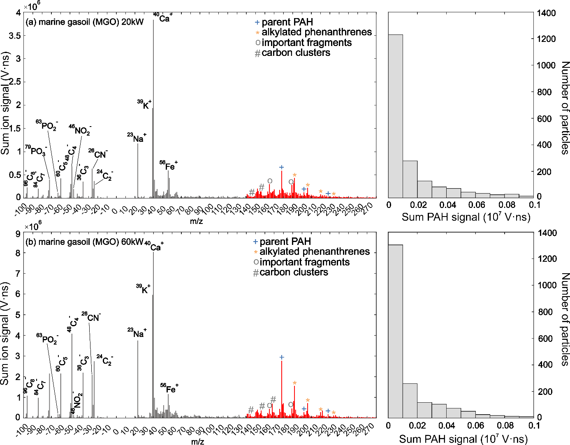

**Fig. S1** The summed mass spectra (n=2000) for marine gas oil combustion (a) at 20 kW load and (b) at 60 kW load show that vanadium signals, typically markers for bunker fuels, are nearly absent, while Fe⁺ remains pronounced due to resonant ionization. The elemental carbon (EC) signatures are more prominent compared to heavy fuel oil emissions (Fig. 1), where OC is relatively strong. The PAH pattern is dominated by phenanthrene and its alkylated derivatives, with masses lower than those observed in heavy fuel oil combustion.

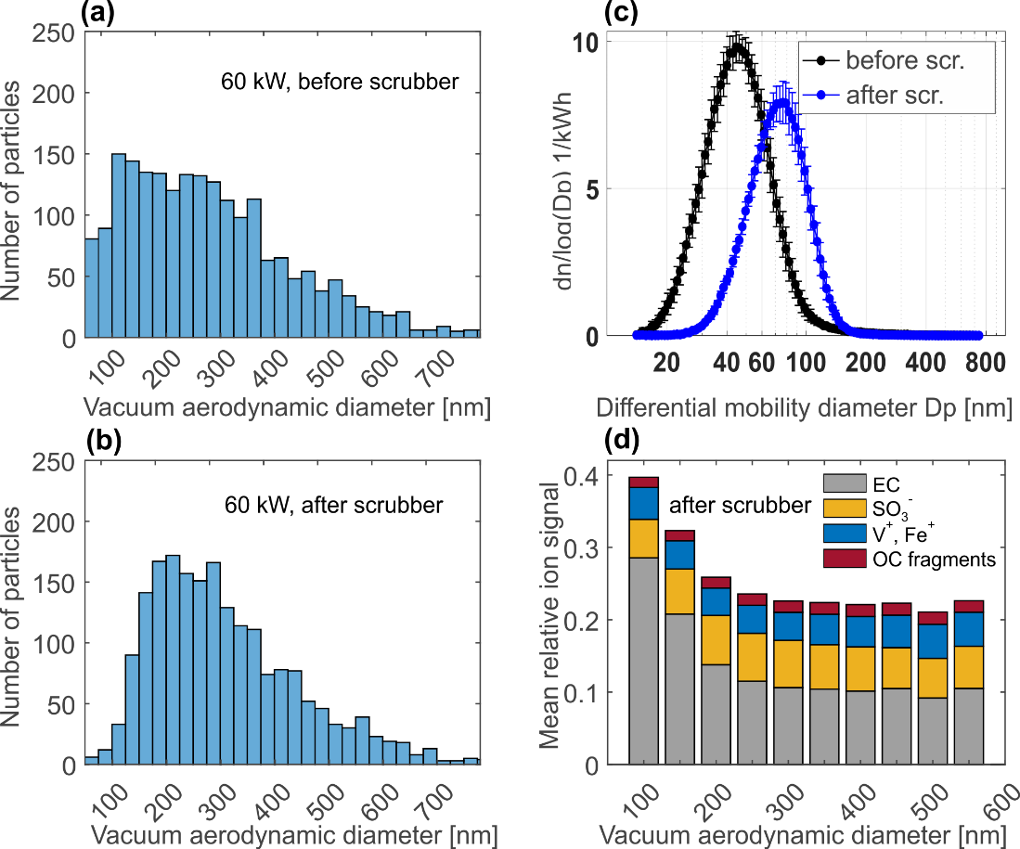

**Fig. S2** The size distributions (n=2,000) measured by the optical detection unit of the single-particle mass spectrometer (a) before the scrubber, and (b) after, are influenced by the Mie scattering efficiency, which decreases sharply for particles smaller than approximately 150 nm. In comparison with the size distribution measured using a scanning mobility particle sizer (c), it is evident that the instrument primarily detects the largest fraction of emitted particles. However, these larger particles contribute substantially to the overall particle mass and are capable of long-range transport. (d) The size-resolved composition of particles at a 60 kW engine load reveals a higher fraction of elemental carbon (EC) in the smaller particles. Combined with the more efficient removal of very small particles (see Panel (c)), this explains the stronger decrease in EC compared to other aerosol components, as observed in both the SPMS data (Fig. 1) and bulk aerosol measurements (Jeong et al. 2023). (EC: sum of anions C2-–C5-, OC fragments: sum of cations at m/z=43, 55, 57, 59). Due to an error in the single-particle size data, a similar plot for the measurements prior to the scrubber is not available. Panel (c) modified from (Jeong et al. 2023).

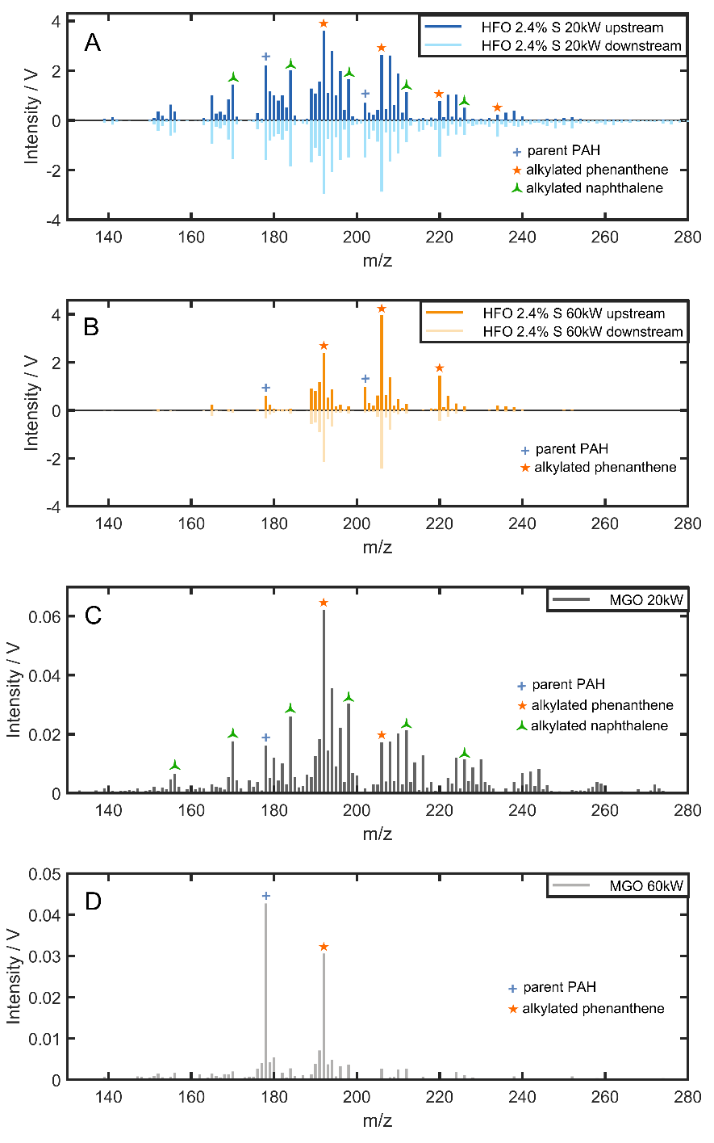

**Fig. S3** Thermodesorption/REMPI mass spectra of heavy fuel oil (HFO) and marine gas oil (MGO) exhaust particle emissions at different engine loads before and after scrubber, sampled on quartz fibre filters and analyzed using a total carbon analyzer (DRI Model 2001A OC/EC Carbon Analyzer) coupled to a Time of-Flight mass spectrometer with REMPI ionization at 266 nm wavelength that is selective for polycyclic aromatic hydrocarbons. The components were thermally desorbed from the filter, using the protocol Improve_A and a small amount was directed into the MS for ionization before oxidization. Only the signals obtained during the first two temperature steps ware used. Consistent with the single-particle measurements (Fig. 1), the spectra reveal a comparable PAH distribution, showing virtually no scrubber effect at 20 kW and a moderate reduction in PAH signals induced by the scrubber at 60 kW.