# Spatial sampling of weather data for regional crop yield simulations

Lenny G.J. van Bussel1,2\*, Frank Ewert1, Gang Zhao1, Holger Hoffmann1, Andreas Enders1, Daniel Wallach3, Senthold Asseng4, Guillermo A. Baigorria5, Bruno Basso6, Christian Biernath7, Davide Cammarano4,‡ , James Chryssanthacopoulos8, Julie Constantin3, Joshua Elliott9, Michael Glotter9, Florian Heinlein7, Kurt-Christian Kersebaum10, Christian Klein7, Claas Nendel10, Eckart Priesack7, Hélène Raynal3, Consuelo C. Romero5, Reimund P. Rötter11, Xenia Specka10 and Fulu Tao11

1 Crop Science Group, Institute of Crop Science and Resource Conservation (INRES), University of Bonn, Katzenburgweg 5, D-53115 Bonn, Germany

2 Plant Production Systems, Wageningen University, P.O. Box 430, NL-6700 AK Wageningen, The Netherlands

3 INRA, UMR 1248 AGIR & UR0875 MIA-T, F-31326 Auzeville, France

4 Agricultural & Biological Engineering Department, University of Florida, Gainesville, FL 32611, U.S.A.

5 School of Natural Resources & Department of Agronomy and Horticulture, University of Nebraska-Lincoln, Lincoln, NE 68583, U.S.A.

6 Dept. of Geological Sciences, Michigan State University, East Lansing, MI 48824, U.S.A.

7 Helmholtz Zentrum München, German Research Center for Environmental Health, Institute of Soil Ecology, D-85764 Neuherberg, Germany

8 Center for Climate Systems Research, Columbia University, 2880 Broadway, New York, NY 10025, U.S.A.

9 Computation Institute and Dept. of Geophysical Sciences, University of Chicago, Chicago, IL, 60637, U.S.A.

10 Institute of Landscape Systems Analysis, Leibniz Centre for Agricultural Landscape Research, 15374 Müncheberg, Germany

11 Plant Production Research, MTT Agrifood Research Finland, FI-50100 Mikkeli, Finland

‡ Current address: The James Hutton Institute, Invergowrie, Dundee, DD2 5DA, Scotland

\*Corresponding author ([Lenny.vanBussel@wur.nl](mailto:Lenny.vanBussel@wur.nl); phone number: +31 317-483073)

# Abstract

Field-scale crop models are increasingly applied at spatio-temporal scales that range from regions to the globe and from decades up to 100 years. Sufficiently detailed data to capture the prevailing spatio-temporal heterogeneity in weather, soil, and management conditions as needed by crop models are rarely available. Effective sampling may overcome the problem of missing data but has rarely been investigated. In this study the effect of sampling weather data has been evaluated for simulating yields of winter wheat in a region in Germany over a 30-year period (1982-2011) using 12 process-based crop models. A stratified sampling was applied to compare the effect of different sizes of spatially sampled weather data (10, 30, 50, 100, 500, 1000 and full coverage of 34,078 sampling points) on simulated wheat yields. Stratified sampling was further compared with random sampling. Possible interactions between sample size and crop model were evaluated.

The results showed differences in simulated yields among crop models but all models reproduced well the pattern of the stratification. Importantly, the regional mean of simulated yields based on full coverage could already be reproduced by a small sample of 10 points. This was also true for reproducing the temporal variability in simulated yields but more sampling points (about 100) were required to accurately reproduce spatial yield variability. The number of sampling points can be smaller when a stratified sampling is applied as compared to a random sampling. However, differences between crop models were observed including some interaction between the effect of sampling on simulated yields and the model used. We concluded that stratified sampling can considerably reduce the number of required simulations. But, differences between crop models must be considered as the choice for a specific model can have larger effects on simulated yields than the sampling strategy. Assessing the impact of sampling soil and crop management data for regional simulations of crop yields is still needed.

**Keywords:** regional crop simulations, winter wheat, upscaling, stratified sampling, yield estimates

# 1. Introduction

Crop models have originally been developed to study crop growth at the field scale for a single growing season, assuming homogeneous weather, soil and management. They were meant to be applied with location-specific data, such as daily weather data from a nearby weather station and a common local sowing date. With the increasing use of crop models in impact assessment studies of e.g. climate change (see e.g. [Alcamo et al., 2007](#_ENREF_1); [Berg et al., 2013](#_ENREF_9); [Franck et al., 2011](#_ENREF_20); [Gerten et al., 2011](#_ENREF_22); [Rosenzweig et al., 2013](#_ENREF_37); [Tao and Zhang, 2011](#_ENREF_42); [Zhao et al., 2013b](#_ENREF_52)) crop models are however increasingly applied for large areas at spatial scales that range from regions within a country to the globe with time scales ranging from decades up to 100 years.

At spatio-temporal scales exceeding field size or comprising more than one year, assuming homogeneous conditions for weather, soil and crop management will increasingly be invalid with further coarsening the spatio-temporal scales. For example, weather conditions can show considerable heterogeneity over space and time ([Daly, 2006](#_ENREF_13); [Hansen and Jones, 2000](#_ENREF_23)) due to elevation gradients or coastal effects. Sources that could provide sufficiently detailed data to capture the prevailing spatio-temporal heterogeneity in weather, soil, and management conditions in a region or over time, such as weather stations, are rarely available ([Nonhebel, 1994](#_ENREF_32)). And even if such detailed data and high performance computing infrastructures are available, the computing time will still constrain large area model applications at high resolution ([Zhao et al., 2013a](#_ENREF_51)). Thus, to overcome the problem of missing data and/or computational limitations, several scaling methods have been proposed for large area crop model applications. Scaling methods that can be distinguished include data extrapolation, data aggregation, data modelling, e.g. data interpolation, and stratified sampling ([Ewert et al., 2011](#_ENREF_19)). Data extrapolation uses one or few locations within a region to represent the entire region of interest. In contrast, data interpolation tries to derive detailed or high resolution data using the limited known data combined with physical information, in order to capture some of the prevailing heterogeneity within the region of interest. Previous studies found however that considerable errors could be introduced, when using interpolated or modelled weather data ([Baron et al., 2005](#_ENREF_7); [Van Wart et al., 2013a](#_ENREF_46)) or by using monthly instead of daily weather data ([Nonhebel, 1994](#_ENREF_32); [Van Bussel et al., 2011b](#_ENREF_44)).

Despite the increasing use of crop models for large areas, studies that test the error in model outputs due to the use of scaling methods are scarce. Previous studies that assessed these errors, mainly focussed on the effects of data aggregation on model simulations ([Angulo et al., 2013](#_ENREF_4); [Baron et al., 2005](#_ENREF_7); [De Wit et al., 2005](#_ENREF_14); [Easterling et al., 1998](#_ENREF_16); [Olesen et al., 2000](#_ENREF_33); [Van Bussel et al., 2011a](#_ENREF_43); [Wassenaar et al., 1999](#_ENREF_49)). But, although large area crop estimates have also been obtained by extrapolating point-based crop model simulations from the field scale to a larger region, see e.g. Rosenzweig and Parry ([1994](#_ENREF_38)), Wolf and Van Diepen ([1995](#_ENREF_50)), Alexandrov et al., 2002 ([2002](#_ENREF_2)), and Van Wart et al. ([2013b](#_ENREF_47)), the magnitude of errors resulting from applying such a scaling method is currently unknown. Better understanding of errors from extrapolation also concurs with the approach of using downscaled climate projections from weather generators (see e.g. Semenov and Barrow ([1997](#_ENREF_39)) and Jones and Thornton ([2013](#_ENREF_25))).

Recently, the relationship between the number of sampling points in a region and the simulation error has been studied for a region in Germany, the Free State of Thuringia ([Nendel et al., 2013](#_ENREF_31)). It was shown that the use of one representative soil and one weather station was insufficient to reproduce the observed mean yield in the region of interest. Including more detailed soil information and weather stations improved the simulation accuracy. However, several points remained unclear such as the relationship between the number of sampling points and simulation error. It remains also unclear to which extent such findings apply to other regions and other crops and how independent the results are from the specific crop model used. The latter deserves particular attention as recent studies have pointed to considerable differences among models in simulating crop yields ([Angulo et al., 2013](#_ENREF_4); [Asseng et al., 2013](#_ENREF_5); [Palosuo et al., 2011](#_ENREF_34); [Rosenzweig et al., 2013](#_ENREF_37)) which may also affect conclusions on effective sampling for regional crop model application.

Hence, in this study we aimed to evaluate the effects of the spatial sampling of weather data on simulations of winter wheat yield in two production systems, potential and water-limited, for one region in Germany over a 30-year period (1982-2011). We explored (i) which effects the different sizes of spatially sampled weather data have on simulated wheat yields, comparing samples sizes of 10, 30, 50, 100, 500, 1000 and a full coverage of 34,078 points per region, (ii) the advantage of a stratified as compared to a random sampling, and (iii) to which extent results are consistent across a range of crop models differing in structure and detail.

# 2. Methods and Materials

## 2.1. Study area

The study area was the state of North Rhine-Westphalia (NRW) in Germany, (Fig. 1a). NRW has a size of about 34,080 km2 and shows a considerable heterogeneity in altitude (Fig. 1b, data from the German Meteorological Service) and hence in spatial variability in weather conditions (Fig. 1c-f, Table 1). The region also experienced temporal variability in weather conditions (Fig. 2a). In the 30-year period 1982 to 2011 average yearly minimum temperature varied from 4 to 6.5°C, average yearly maximum temperature from 8 to 10.5°C, the yearly global solar radiation sum from 3500 to 4500 MJ m-2, and the yearly precipitation sum showed the largest temporal variation from 750 to 1150 mm. Observed actual yields (Fig. 2b) varied in the time period 1999 to 2011 from 6.3 to approximately 8 t DM ha-1. Although the districts cannot be easily attributed to the high or low altitude regions, observed actual yields (averaged over the time period 1999 to 2011) tended to be lower in the higher altitude regions as compared to lower altitude regions.

#### Figure 1a. The state (Bundesland, area approximately 34,000 km2) of North Rhine-Westphalia (left panel), the regional districts for which yield data are available (right panel); b. altitude (m); c. 30-year period mean maximum temperature (°C); d. 30-year period mean minimum temperature (°C); e. 30-year period mean yearly precipitation sum (mm); f. 30-year period mean radiation (MJ m-2 d-1); g. 12-year period mean actual farmers yields (t DM ha-1), observed zero yields, indicating crop failure by e.g. frost, have been removed.

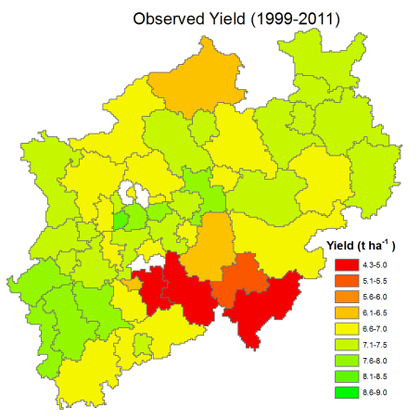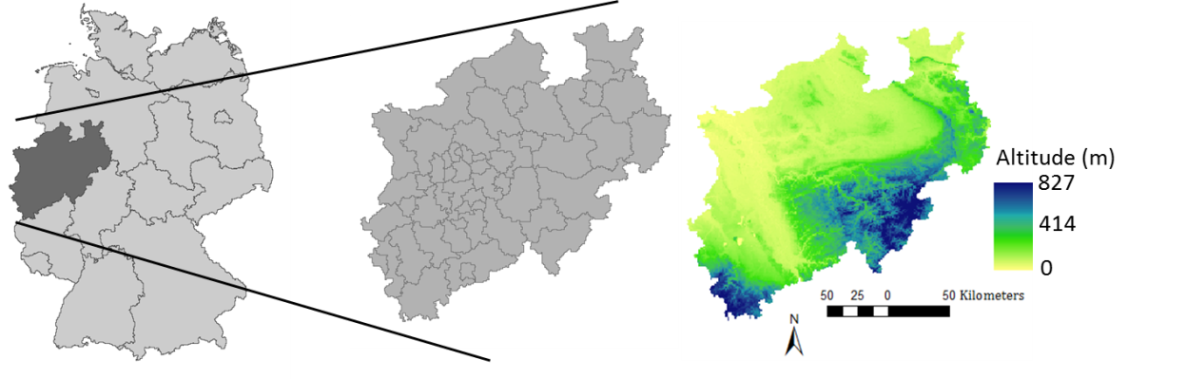

a)

b)

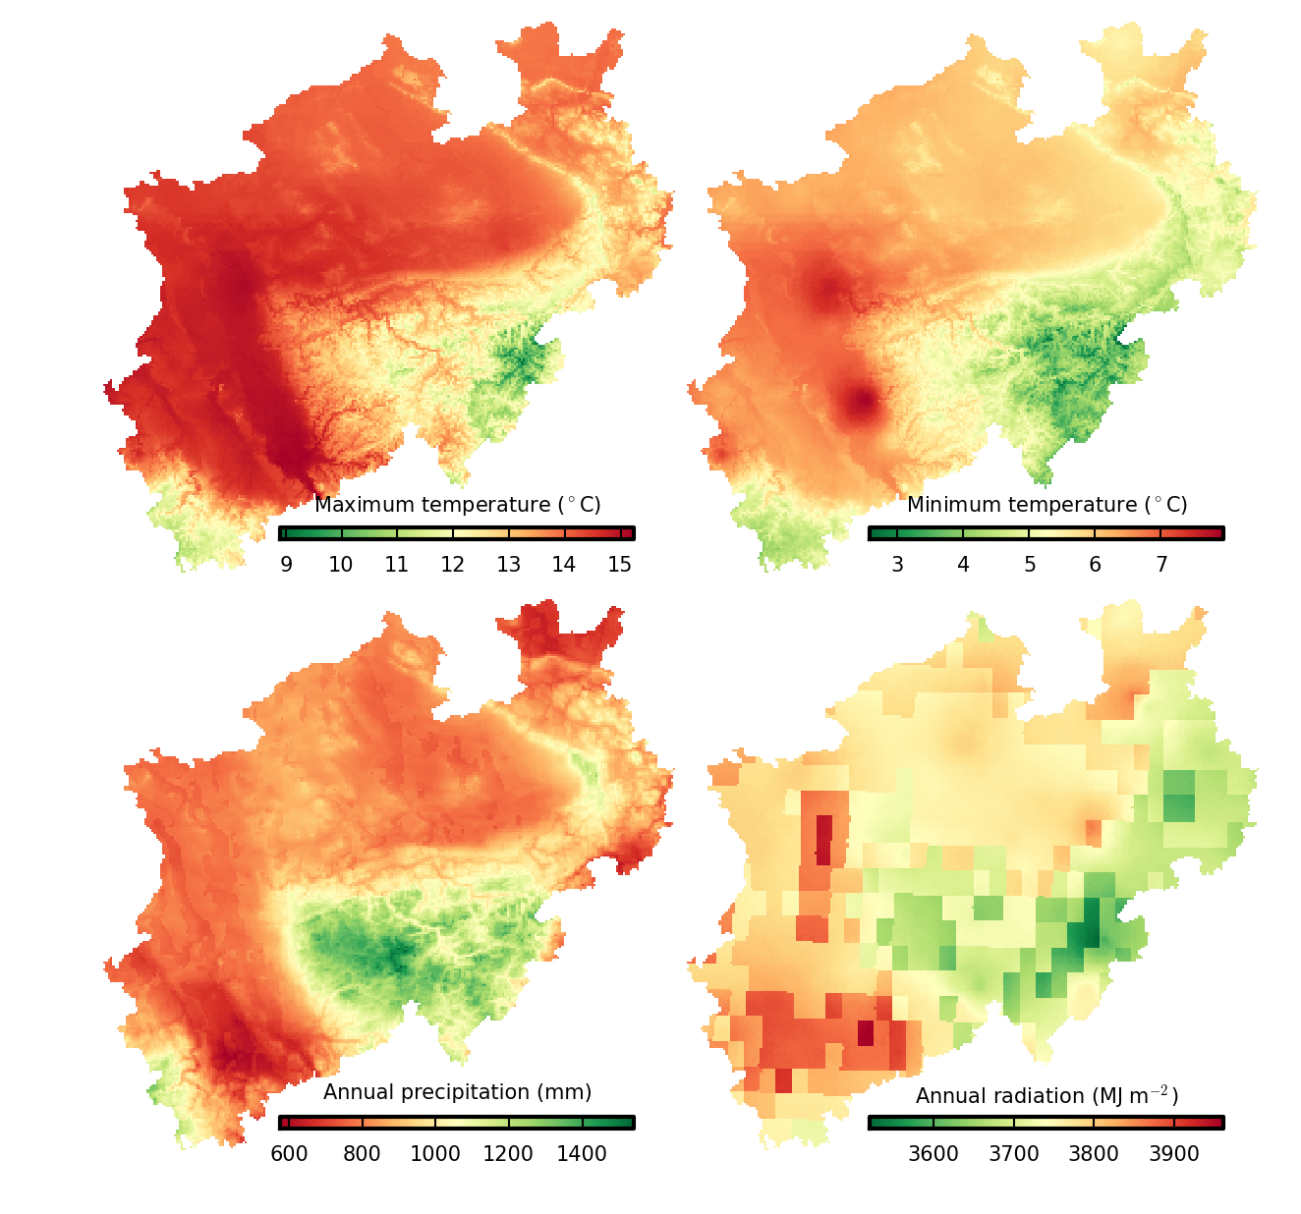

c)

d)

e)

f)

g)

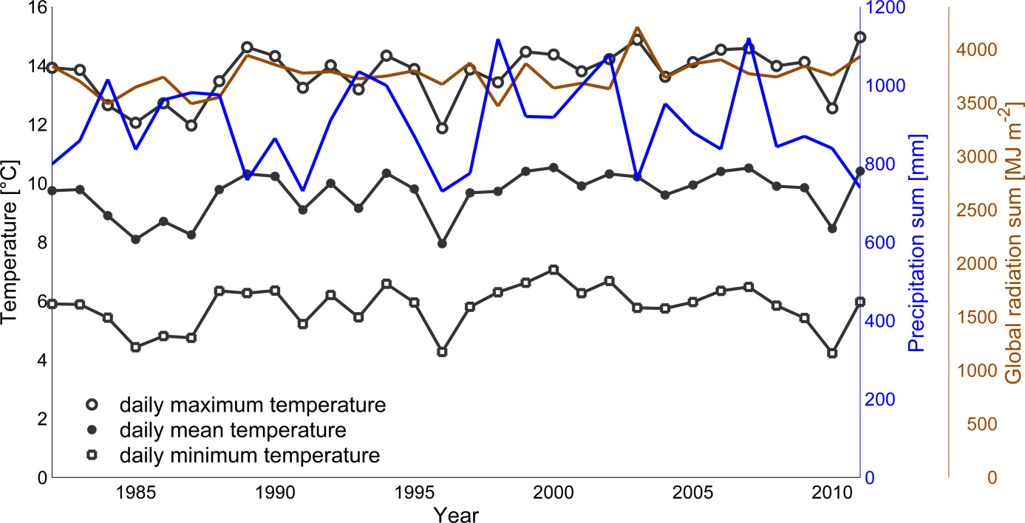

a)

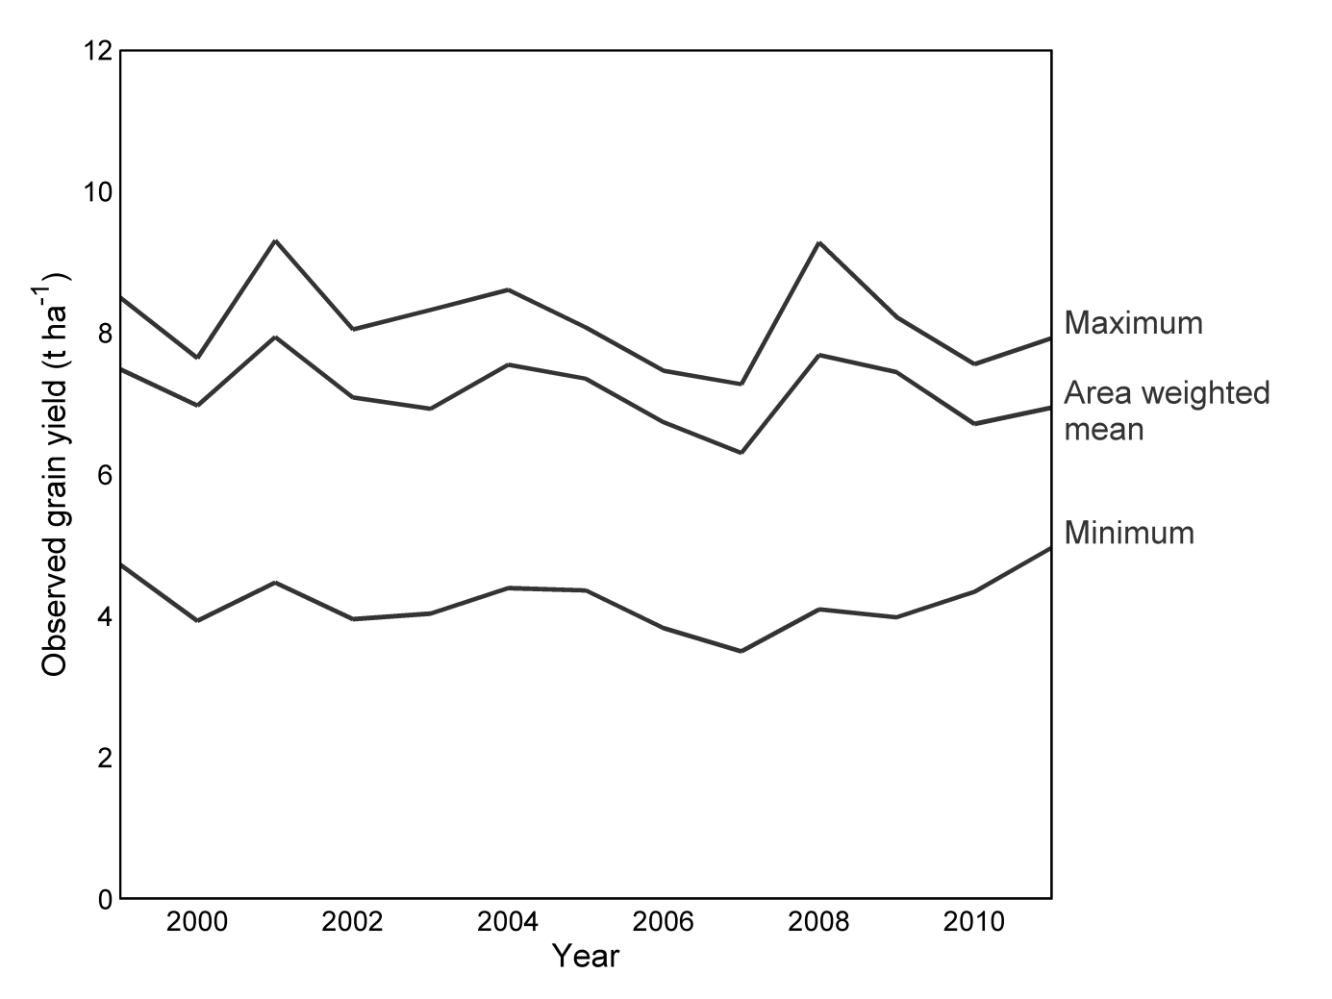Figure 2a. Temporal variation in weather conditions, per year averaged over the whole of North Rhine-Westphalia; b. temporal variation in the yearly mean actual farmers yields (t DM ha-1), the mean is area weighted using the area per district (Fig 1g).

b)

#### Table 1. Mean weather conditions within the most important period of the winter wheat growing season (March till July), based on a 30-year period (1982 – 2011)

|  |  |  |
| --- | --- | --- |
| Variable | Lower altitudes (0 - 100 m) | Higher altitudes (100 - >800 m) |
| Precipitation (mm) | 250 - 330 | 330 - 550 |
| Minimum temperature (°C) | 9 | 6 |
| Maximum temperature (°C) | 18 | 15 |
| Solar radiation (m-2 d-1) | 15.8 | 14.9 |

## 2.2. Available input data

### 2.2.1. Weather data

Time series of daily weather data with 1 km resolution were created for the 30-year period (1982 to 2011). For this purpose, daily minimum and maximum temperatures and sunshine duration from about 280 weather stations (about 800 locations with precipitation measurements) located within the region as well as monthly mean values at a 1 km resolution were obtained from the German Meteorological Service ([DWD](#_ENREF_15)). To derive daily time series for minimum and maximum temperature and sunshine duration at the 1 km resolution, the monthly grids were combined with the daily weather station data of the nearest station. The Ångström–Prescott formula ([Prescott, 1940](#_ENREF_35)) was applied to calculate the daily solar radiation from sunshine hours. Data from the Satellite Application Facility on Climate Monitoring (CM SAF; [www.cmsaf.eu](http://www.cmsaf.eu), resolution approximately 7 km × 11 km) were used to derive location-specific a and b coefficients for the Ångström–Prescott formula. Due to the limited availability of consistent measurements, wind speed was represented by one value per day for whole NRW. This value was based on the mean of all wind speed stations measurements, converted to wind speeds of 2 m above ground ([Allen et al., 1998, Eq. 47](#_ENREF_3)). Daily relative humidity has been calculated with help of Allen et al. ([1998, Eqs. 10 and 11](#_ENREF_3)): actual vapour pressure by assuming and saturated vapour pressure by assuming . Daily precipitation data at 1 km resolution were directly obtained from DWD for the years 1982 till 2009. The other years were calculated as above described for the other variables.

### 2.2.2. Soil, crop management and actual yield data

As the focus in this study was only on the effect of sampling weather data we used for the simulations only one soil type (sandy loam), which is common in NRW (Table 2). For crop management we used, in accordance with farmers’ practices in NRW, a sowing date of 1st of October, a harvest date of 1st of August, and a winter wheat cultivar with daylength and vernalization responsiveness. Information on actual farmers yields was available per district (NUTS 3 level) for the time period 1999 to 2011 ([Regionaldatenbank Deutschland, 2013](#_ENREF_36)) (Fig. 1g). Generally, farmers in NRW apply sufficient fertilizer but hardly any irrigation to their winter wheat crop (EUROSTAT, 2011). Therefore the mean observed actual yields (Fig. 1g) can be considered as benchmark for simulated water-limited yields. However as occurrence of pests, diseases, and weeds are not considered by the crop models which may have affected the observed actual yields, we did not quantitatively evaluate the performance of crop models with these observed data.

#### Table 2a. Soil properties of the used soil type

|  |  |  |  |  |  |
| --- | --- | --- | --- | --- | --- |
| Layer | Thickness (dm) | Volumetric water contents (m3 H2O m-3 soil) at | | | |
| Air dryness | Wilting point | Field capacity | Saturation |
| layer 1a | 3 | 0.085 | 0.17 | 0.36 | 0.45 |
| layer 1b | 9 | 0.085 | 0.17 | 0.36 | 0.45 |
| layer 2 | 8 | 0.065 | 0.13 | 0.37 | 0.44 |
| layer 3 | 3 | 0.005 | 0.01 | 0.04 | 0.11 |

#### Table 2b. Initial soil conditions

|  |  |  |  |
| --- | --- | --- | --- |
| Layer | Initial soil water per layer | Initial soil nitrate and ammonium for layer (kg ha-1) | Soil organic carbon pools (g C 100g-1) |
| layer 1a | 50% of FC | 30 | 2.76 |
| layer 1b | 50% of FC | 20 | 0.38 |
| layer 2 | 50% of FC | 5 | 0.27 |
| layer 3 | 50% of FC | 1 | 0.25 |

## 2.3. Crop models

The 12 utilized models in this study were: MONICA (v.1.2.5) ([Nendel et al., 2011](#_ENREF_30)), APSIM (v.7.5) ([Keating et al., 2003](#_ENREF_26)) and DSSAT-CERES-Wheat (v. 4.5.1.23) ([Jones et al., 2003](#_ENREF_24)) run for large areas in parallel (hence pAPSIM and pDSSAT-CERES-Wheat) within the parallel System for Integrating Impacts Models and Sectors (pSIMS; ([Elliott et al., 2014](#_ENREF_17))), HERMES (v.4.26) ([Kersebaum et al., 2007](#_ENREF_27)), MCWLA (v.2.0) ([Tao et al., 2009](#_ENREF_41)), NWheat (v.1.55) ([Asseng et al., 1998](#_ENREF_6)), SALUS (v.1.0) ([Basso et al., 2010](#_ENREF_8)), LINTUL2 ([Spitters and Schapendonk, 1990](#_ENREF_40)) implemented in SIMPLACE<LINTUL2> ([Gaiser et al., 2013](#_ENREF_21)), SPASS implemented in the model system ExpertN ([Biernath et al., 2011](#_ENREF_11)), STICS (v.8.3) ([Brisson et al., 2008](#_ENREF_12)) implemented in the RECORD platform ([Bergez et al., 2013](#_ENREF_10)), DSSAT-CERES-Wheat (v.4.5.0.0) ([Jones et al., 2003](#_ENREF_24)), and DSSAT-CropSim-Wheat (v.4.5.0.0)([Jones et al., 2003](#_ENREF_24)). Within these models different representations of processes important for crop growth are used and they differ with respect to the inclusion of soil processes. All models run with a daily time step. Detailed model descriptions are given in Table 3, based on Asseng et al. ([2013](#_ENREF_5)). Since data that can be used to calibrate models for large area application are often hardly available, only limited calibration was applied, using the general information on crop phenology and grain yield (see section 2.2.2.).

The models were used with one exception to simulate potential and water-limited yields. The definitions from Evans and Fisher ([1999](#_ENREF_18)) and Van Ittersum and Rabbinge ([1997](#_ENREF_45)) were applied: potential yield is the yield of a crop cultivar when grown without water and nutrient limitations and biotic stress effectively controlled; water-limited yield is similarly defined, but crop growth might be limited by water supply.

#### Table 3. Applied crop growth models and their used model approaches, following the approach of Asseng et al. ([2013](#_ENREF_5))

|  |  |  |  |  |  |  |  |  |  |
| --- | --- | --- | --- | --- | --- | --- | --- | --- | --- |
| Model | Leaf area/ light interception a | Light utilization b | Yield formation c | Phenology d | Root distribution over depth e | Type of water stress f | Water dynamics g | Evapo-transpiration h | No. cultivar parameters |
| MONICA | s | RUE | Prt | T/DL/V/O | EXP | E | C | PM | 15 |
| pAPSIM | S | RUE | Prt/Gn/B | T/DL/V/O | O | E | C | TE | 7 |
| pDSSAT-CERES-Wheat | S | RUE | Gn | T/DL/V | EXP | E/S | C | PM | 7 |
| HERMES | D | P-R | Prt | T/DL/V/O | EXP | E/S | C | **PM**/TW/PT | 6 |
| MCWLA | S | P-R | HI/B | T/DL/V | EXP | E | R | PM | 7 |
| Nwheat | S | RUE | Prt | T/DL/V | EXP | S | C | PT | 7 |
| SALUS | S | RUE | Prt/HI | T/DL/V | EXP | E | C | PT | 18 |
| SIMPLACE<LINTUL2> | S | RUE | Prt/B | T,/DL | LIN | E | C | P | 4 |
| ExpertN | D | P-R | Gn/Prt | T/DL/V | EXP | E/S | R | PM | 5 |
| STICS | S | RUE | Prt/Gn/B | T/DL/V/O | SIG | E/S | C | **P**/PT/SW | 13 |
| DSSAT-CropSim-Wheat | S | RUE | Gn | T/DL/V | EXP | E/S | C | PM | 7 |
| DSSAT-CERES-Wheat | S | RUE | Gn | T/DL/V | EXP | E/S | C | PM | 7 |

a S, simple approach (e.g. LAI); D, detailed approach (e.g. canopy layers)

b RUE, radiation use efficiency approach; P-R, gross photosynthesis – respiration

c HI, fixed harvest index; B, total (above-ground) biomass; Gn, number of grains; Prt, partitioning during reproductive stages

d T, temperature; DL, photoperiod (day length); V, vernalization; O, other water/nutrient stress effects considered

e LIN, linear, EXP, exponential, SIG, sigmoidal; O, other approaches

f E, actual to potential evapotranspiration ratio; S, soil available water in root zone

g C, capacity approach; R, Richards approach, V

h PT, Priestly-Taylor; PM, Penman-Monteith; TW, Turc-Wendling, P, Penman; SW, Shuttleworth and Wallace (restrictive model); TE, Transpiration efficiency approach (“bold” indicates approach used during the study)

## 2.4. Sampling strategy

We applied all crop models for each 1 km resolution gridcell that is located within NRW (see Fig. 3a for a simplified representation of the approach). We assumed that simulations for these 34,078 points and the derived statistics resemble field-based simulations and provided us with the ‘true’ values of the NRW potential and water-limited yields. We first applied the ‘stratified sampling’ to evaluate the effect of sampling size on yield simulations. This involved the following steps:

1. The region was divided into environmental zones with similar conditions (i.e. the strata or zones). The stratification (Fig. 4) was taken from the global environmental stratification (GEnS) by Metzger et al. ([2013](#_ENREF_29)). It uses four variables to delineate relatively homogeneous environmental strata, i.e. temperature seasonality, potential evapotranspiration (PET) seasonality, growing degree-days with a base temperature of 0 °C, and an aridity index (the ratio between annual precipitation and PET).
2. Sampling locations (gridcells with 1 km resolution) were randomly selected within each zone, each sampling location was considered to be representative for the entire zone. The number of selected sampling locations per zone was proportional to the area of the zone.
3. The models were run for each selected sampling location and the output data were compared for different sample sizes (Fig. 3b).

Figure 3. Graphic overview of the applied scaling method a) Simulation for each 1 km resolution gridcells and subsequently aggregation of output data; b) Stratified sampling and subsequently aggregation of output data.

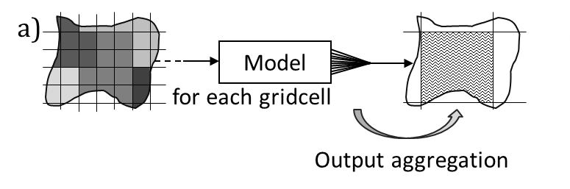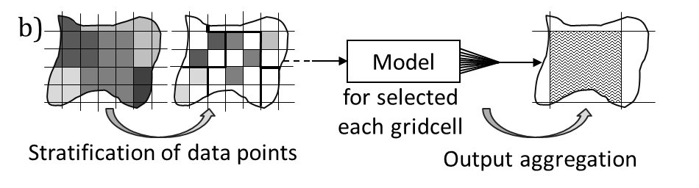

## 2.5. Assessment of required sampling size

The aim of stratified sampling is to improve the representativeness of the samples by reducing sampling error. It uses a weighted mean of sub-populations rather than the arithmetic mean of a typical random sample from the whole population. The performance of the sampling can be indicated by the changes of the mean squared error when enlarging the sample size *s*. The is equal to the sum of the variance and squared bias of the sampled simulated yields ([Wackerly et al., 2008](#_ENREF_48)). Because we did not consider model errors, but only sampling problems, we could assume that when we sampled a point, we got exactly the correct value for this point. This implies that we could set the bias term to 0.

The expected mean squared error () for the whole study area for a certain sampling size was calculated as follows:

(Eq. 1)

in which is the number of sampling points, the number of zones, the variance of the simulated yields of the selected sampling points in zone , and

with the area for zone and the area for the whole study area. Per sampling point first the mean yield over the 30-year simulation period has been calculated. For interpretation reasons we converted into the expected rooted mean squared error with help of: .

A relatively small stable indicates that the sample size is large enough to represent the prevailing variability within the region and consequently, the sample is likely to be an accurate reflection of the ‘true’ simulated yield (mean and distribution) for the whole region. In order to find the adequate sample size to represent the prevailing variability in weather conditions in NRW, we conducted a stratified sampling of the simulated yields with varying sample size (10 to 1000 sampling points with 10 as increment). Figure 4 indicates the spatial allocation of 50, 100, 500 and 1000 sampling points.

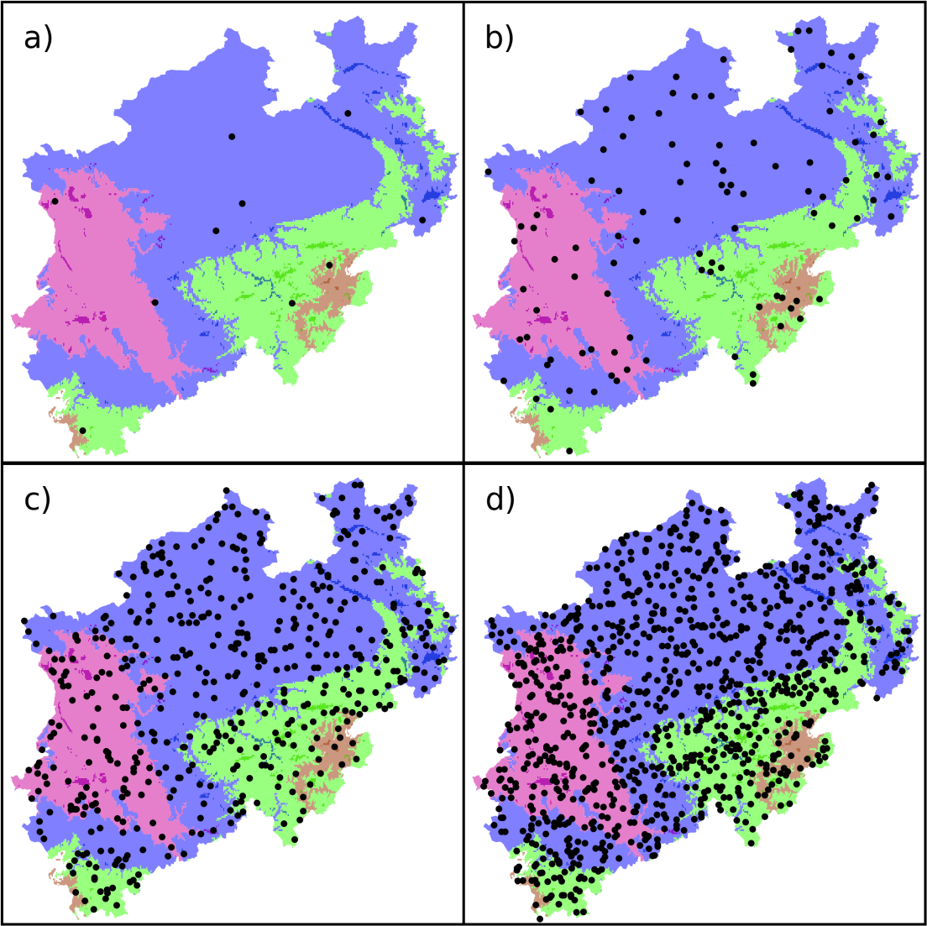

#### Figure 4. Spatial allocation of the distinct sampling sizes: a) 10, b) 100, c) 500, and d) 1000 within the zones. The colours indicate the different GEnS strata or zones for North Rhine-Westphalia.

## 2.6. Effect of stratified sampling as compared to random sampling

To test the effectiveness of the stratification, the sampling of NRW was repeated by selecting sampling points randomly, without considering the zones. Both sampling methods (random and stratified) were conducted 10,000 times for four sample sizes (5, 10, 30, and 50). Probability density functions of the simulated yields per sample were estimated using Gaussian kernels.

# 3. Results

## 3.1. Variability in climate input data after sampling

The spatial pattern of the climate zones aligned well with the spatial pattern of the altitude of NRW (Fig. 1b and Fig. 4). The zones also reflected the spatial pattern of the weather variables which are used as input for the crop models (Fig. 1c-f). To assess the ability of the randomly stratified selected subset of sampling points to reflect the weather conditions resulting from all sampling points within a zone, the ranges in resulting temperature conditions were plotted for two randomly selected years (Fig. 5). The randomly selected subset of sampling points reflected the range in temperature conditions resulting from all sampling points within the zone well, with only slightly less higher and lower minimum and maximum temperatures.

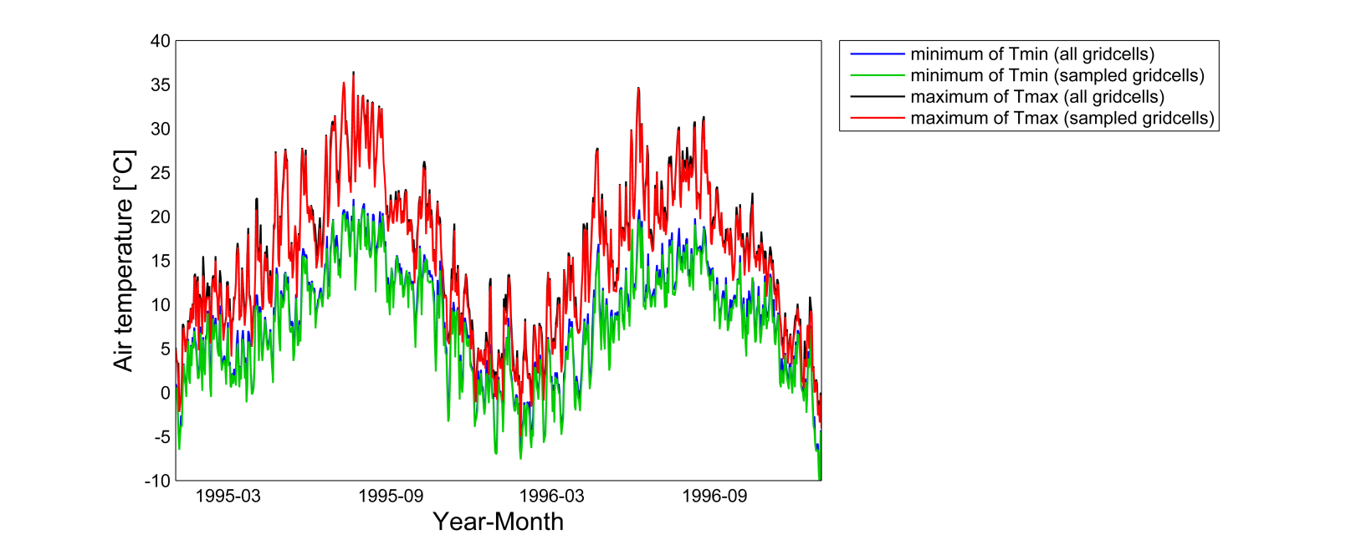Figure 5. Range in minimum and maximum temperature in pink zone of Fig. 4 based on full coverage of sampling points (n = 5057) and based on sampled subset (n = 9), for the years 1995 and 1996.

## 3.2. Comparison of simulated yields among models

### 3.2.1 Spatial patterns of the simulated yields

Distinct spatial patterns were detectable for simulated crop yields and all models reproduced the pattern of the climate zones and weather data. However, yield differences among zones varied depending on the crop model (Fig. 6). While some models simulated higher yields in regions with higher altitudes and lower yields in regions with lower altitudes, other models simulated the opposite spatial pattern, the latter being slightly more in line with the spatial pattern of the observed actual farmer yields. In general, the models simulated hardly any water-stress (i.e. water-limited yield was approximately equal to potential yield). Besides contrasting spatial patterns, the 30-year mean water-limited yields for NRW (Fig. 7, violin plots with sampling size 34,078) simulated by the models varied from 6.2 t DM ha-1 to over 10 t DM ha-1. Not only the means, but also the range in simulated water-limited yields differed: 8 models gave a range of approximately 0.5 t DM ha-1 (based on the 25th and 75th percentiles of the simulated 30-year mean water-limited yields at the 1 km resolution), while for 2 models the 25th and 75th percentiles of simulated 30-year mean differed more than 1.5 DM ha-1.

If we assume that observed actual farmers yields are representative for the whole region, including for locations where no observations were available, the area-weighted mean winter wheat observed actual yield for NRW is 7.2 t DM ha-1 for the period 1999 – 2011 (Fig. 1g). In developed countries with intensive, high input agriculture, farmers often produce approximately 80% of their potential production (Cassman, 1999). Van Wart et al. (2013b) showed that this is indeed a valid assumption for rainfed winter wheat in Germany. Based on this 80% threshold and the mean observed actual yield, the long-term mean water-limited yield for NRW can be estimated at approximately 9 t DM ha-1. The majority of the models (8 out of 12) simulated a 30-year mean water-limited yield between 8 and 10.3 t DM ha-1, this corresponds with relative yield gaps (i.e. the mean observed actual yield divided by water-limited yields) of 90-70%. Two models simulated lower 30-year mean water-limited yields than the mean observed actual yield in NRW.

#### D:\Bonn\AgMIP\scaling exercise\paper\Lennys_figure_folder\Figures 13-6-2014\fig1.png Figure 6. Spatial pattern of simulated yields (t DM ha-1), mean of 30-year period.

### 3.2.2. Temporal patterns of the simulated yields

The simulated temporal variability (Fig. 8) of yields was considerably larger in comparison with the simulated spatial variability (Fig. 6). The range of simulated water-limited yields across years was approximately 1 to 2 t DM ha-1 for 2 models (based on all sampling points), which was in agreement with the temporal variability of the observed actual yields (Fig. 8). Other models (3 out of 12) simulated an interannual variability of more than 4 t DM ha-1.

The interannual variability pattern was rather similar among the models (Fig. 8). For example for the year 2004, a year with rather average weather conditions, 11 out of 12 models simulated a higher water-limited yield in comparison with their model specific long-term water-limited yield. However, in a few other years there was less consensus, e.g. for the year 2003, that was characterized by high summer temperatures and drought, 5 models simulated a higher water-limited yield in comparison with their model specific long-term water-limited yield, while 7 models simulated a lower water-limited yield which was also observed.

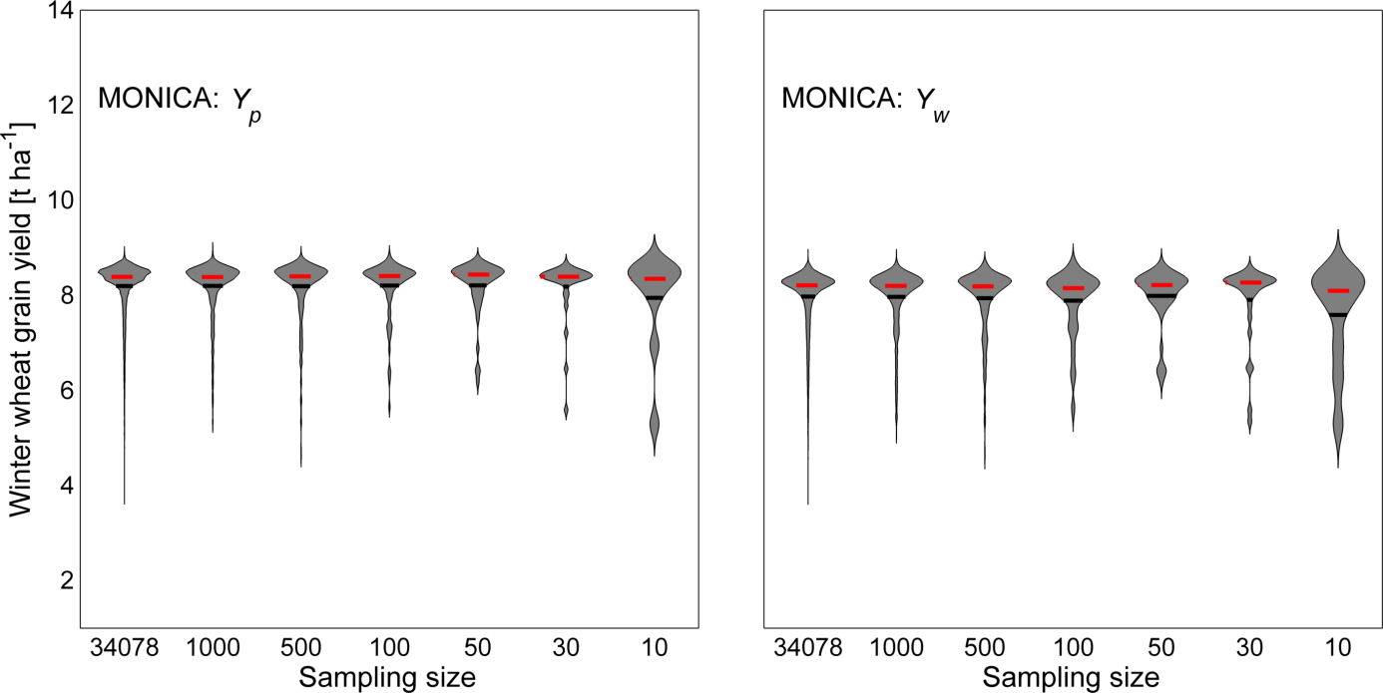

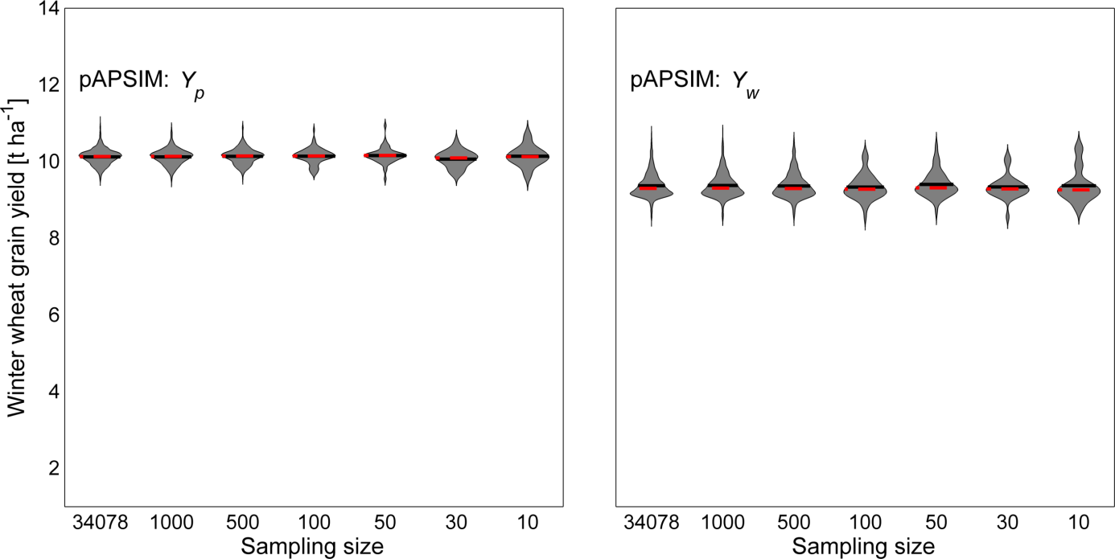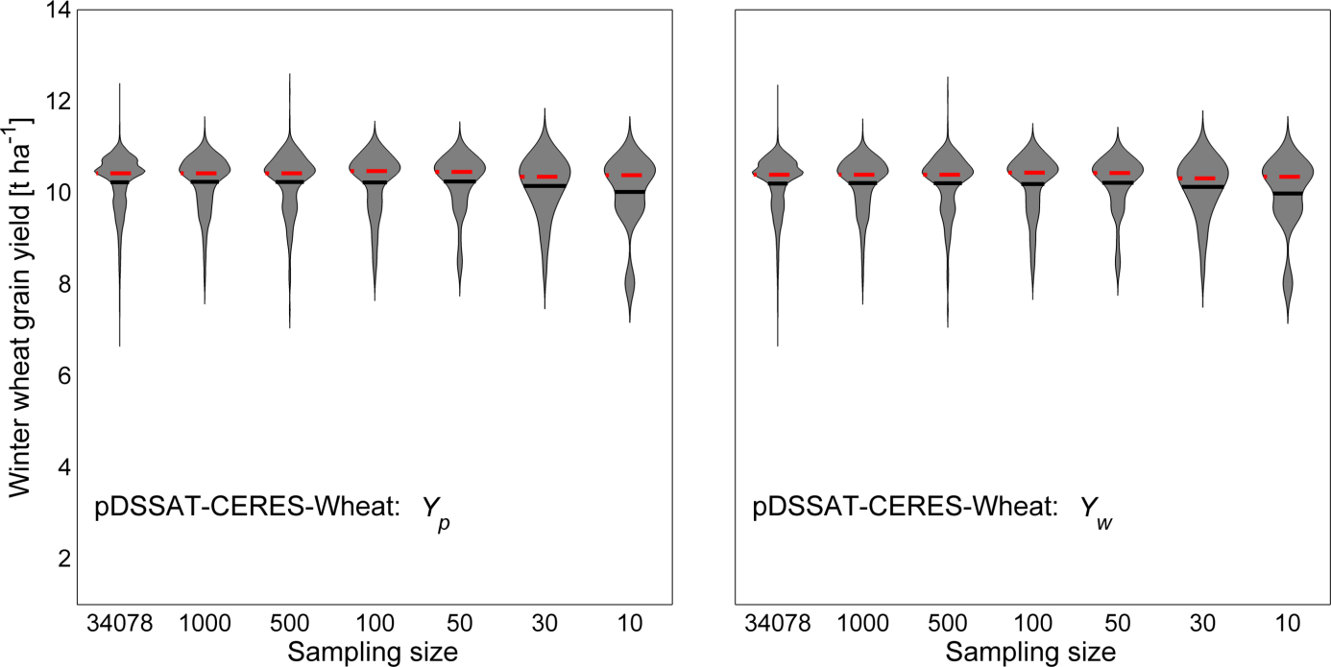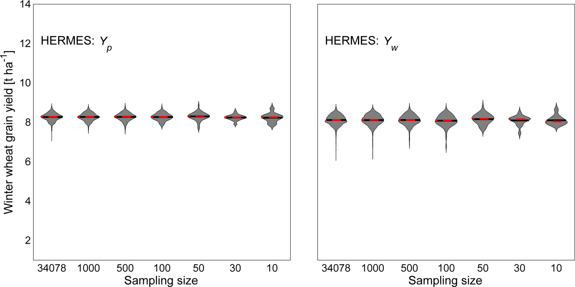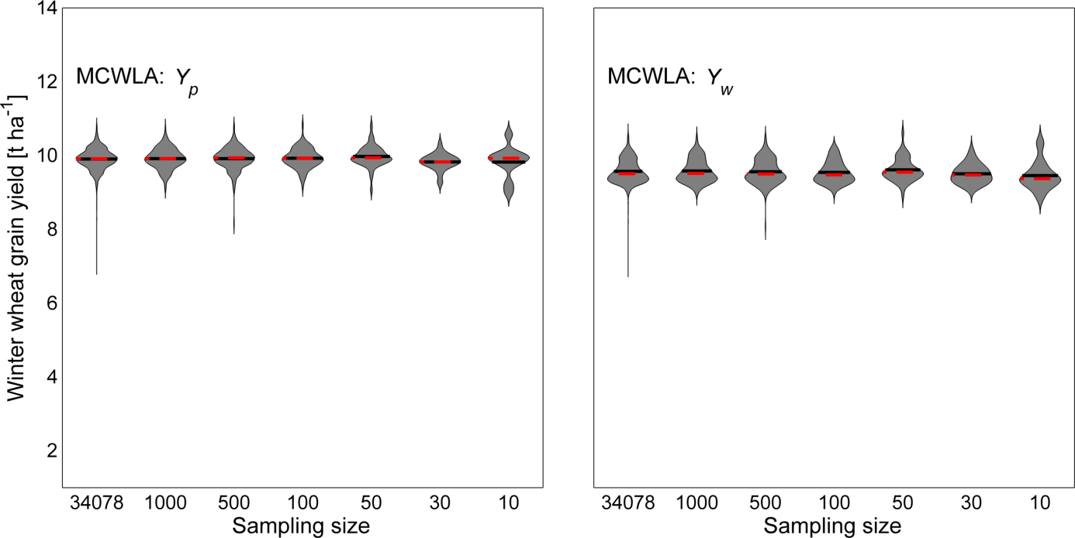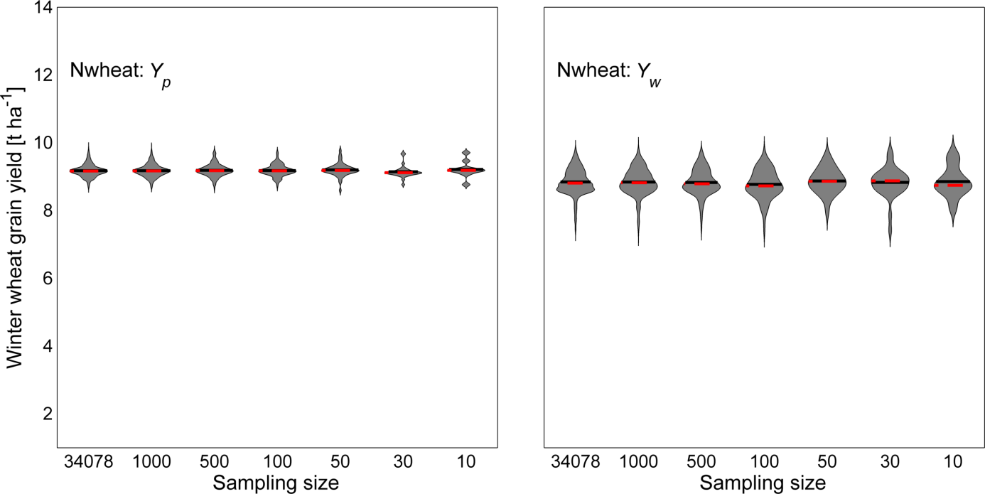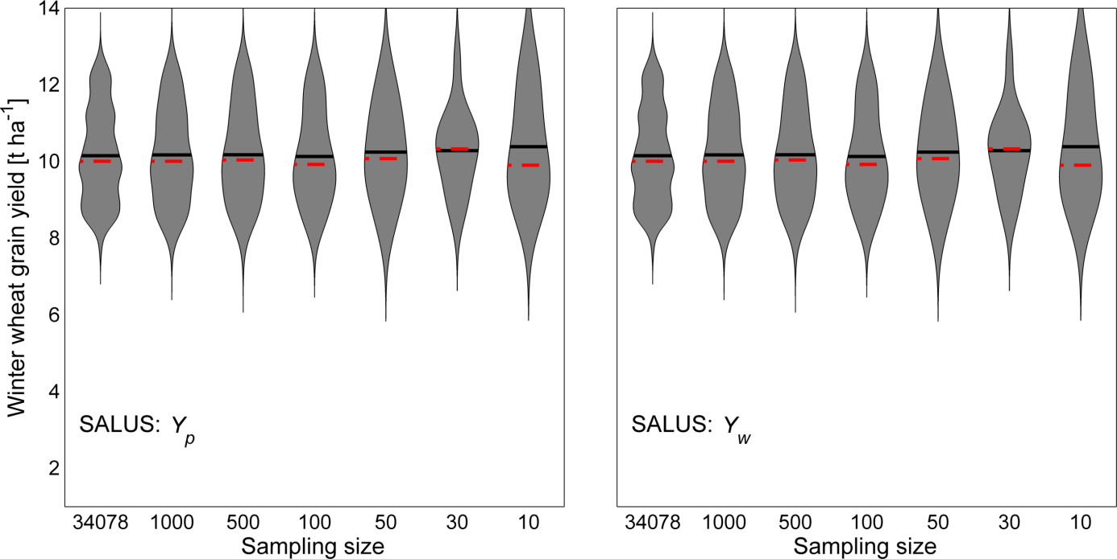

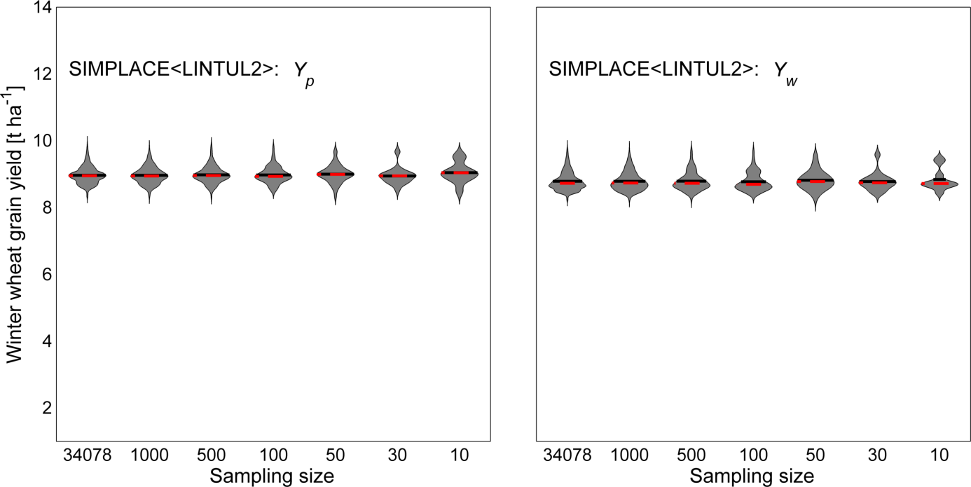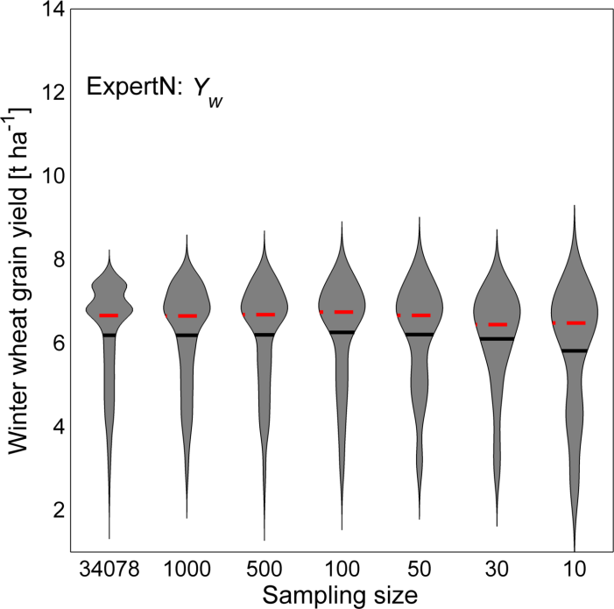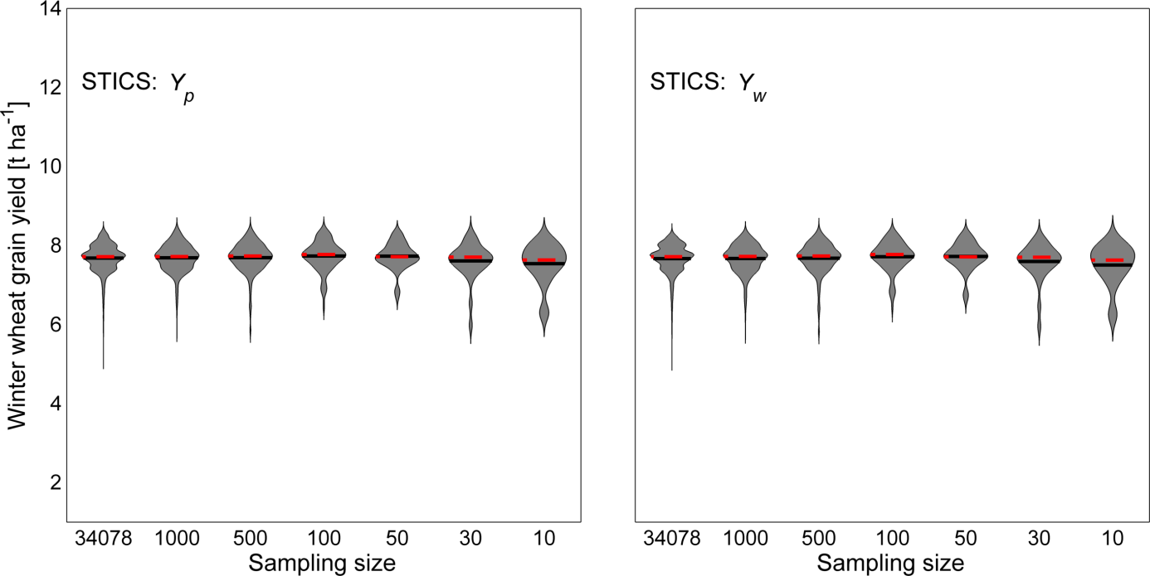

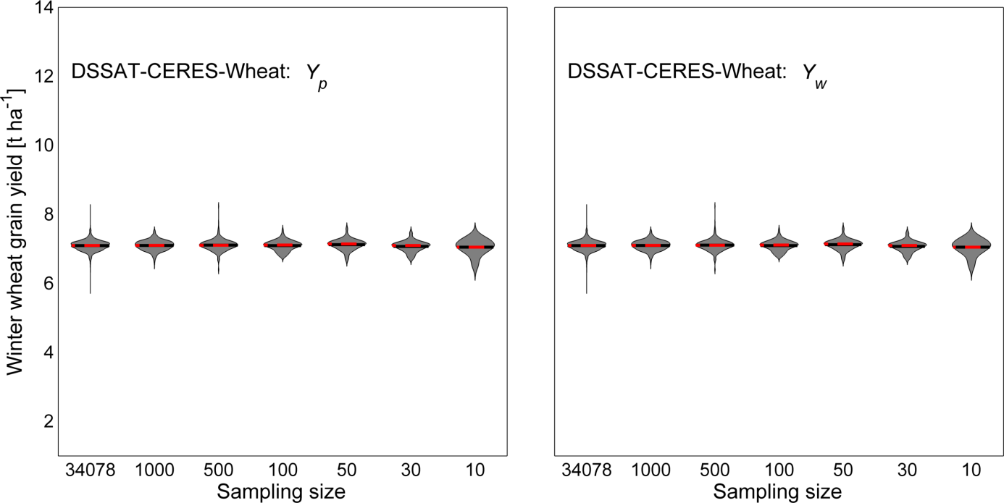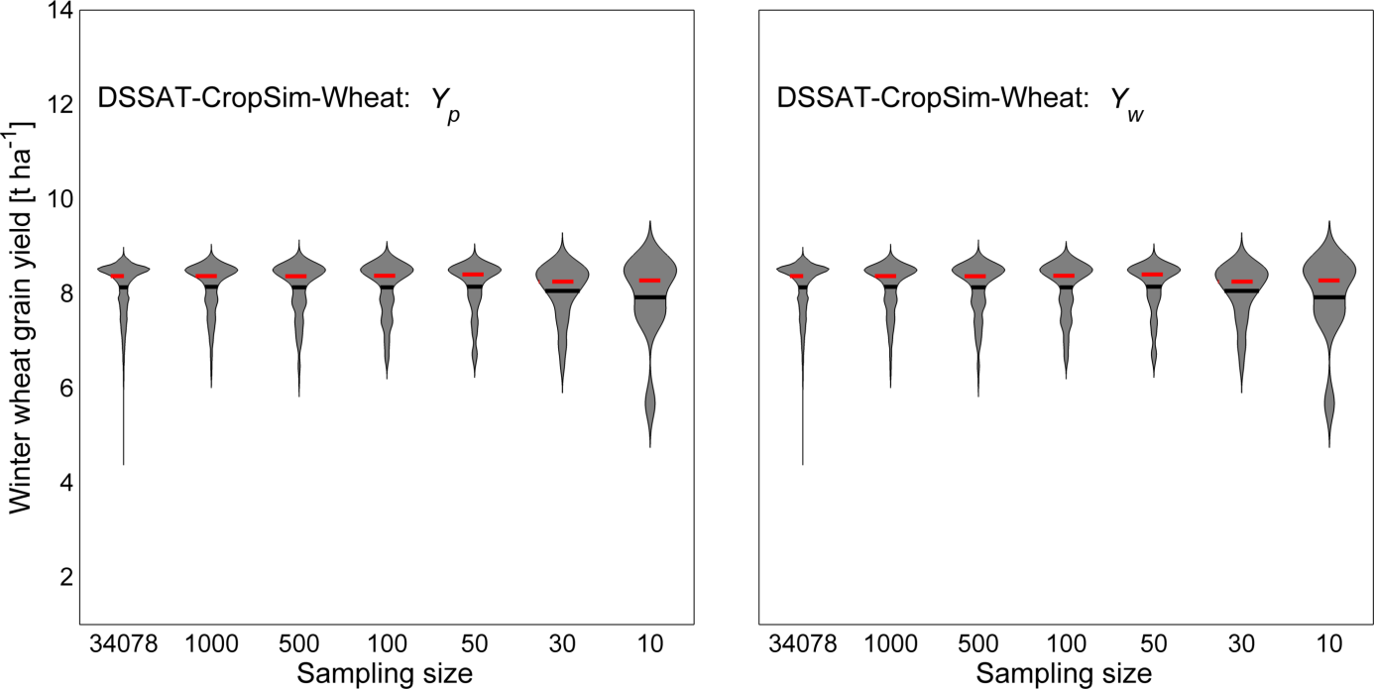Figure 7. Comparison of simulated yields per model, aggregated for whole North Rhine-Westphalia and over the 30-year period, for 7 different sampling sizes, based on stratified sampling (Yp is potential yield, Yw is water-limited yield) in violin plots. A violin plot is a boxplot combined with a kernel density plot, which shows the probability density function; the horizontal black lines in the violin plots represent the mean value of the frequency distribution, the dashed red line the median value; the shape of the graphs represent the distribution of the values.

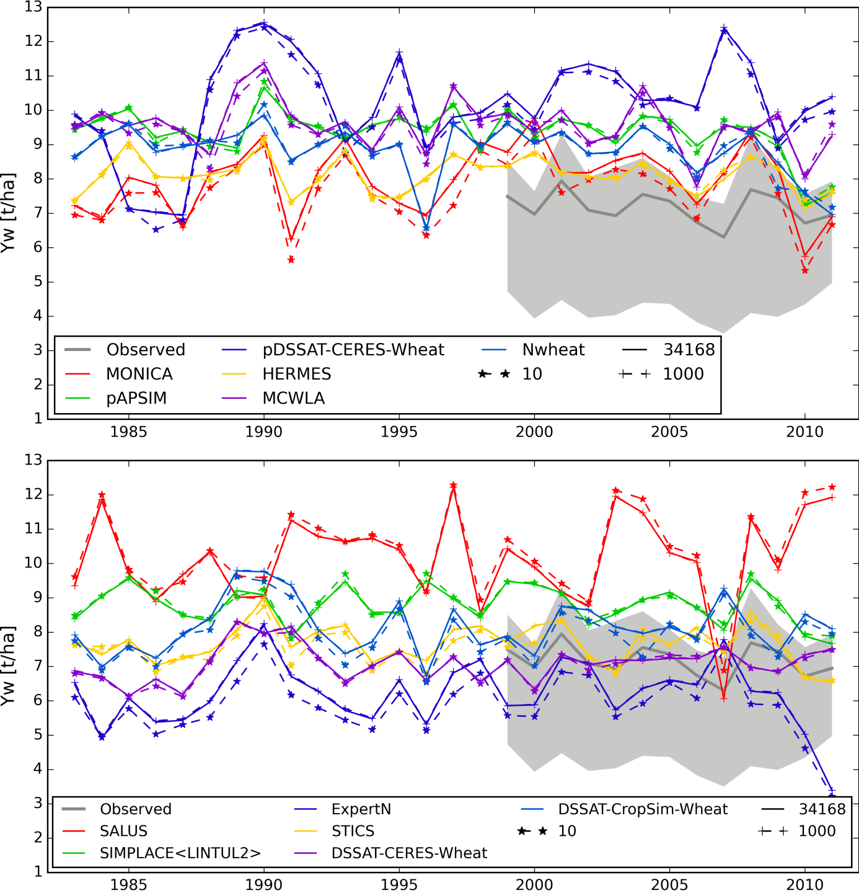

Figure 8. Temporal patterns of simulated yields per model, aggregated for the whole North Rhine-Westphalia, for 3 different sampling sizes: all gridcells (‒‒‒ ) , 1000 (‒+‒+) and 10 (‒⋆‒⋆) stratified sampled gridcells. The grey band indicates the observed farmer’s yields (minimum, maximum, and mean (solid grey line)).

## 3.3. Sampling strategy

### 3.3.1. Effects of sampling size on simulated yields

Median and mean of the simulated yields (aggregated for NRW and the 30-year period) were hardly affected by the number of chosen sampling points: decreasing the sampling points from 34,078 to 10 resulted in a change of maximally 0.34 t DM ha-1 of the simulated 30-year mean water-limited yield of NRW (Fig. 7). Even simulations based on the lowest sample size (10 sampling points) still resulted in a fairly similar distribution of the simulated yields, in comparison with simulations based on the highest available level of detail in the input data (simulations based on full coverage of 34,078 sampling points). This was consistent for all models and independent of the production condition. For some crop models the frequency distribution of the simulated yields changed as a result of a different sampling size, especially the occurrence of lower yields decreased with a decreasing number of sampling points. See Appendix A for the exact values for each model. The temporal variability in simulated yields was also hardly affected by the chosen sampling size (Fig. 8). Importantly, differences among the means and distributions of the simulated yields by the various models were much larger than the effect of sample size: the simulated 30-year mean water-limited yields (based on all 34,078 sampling points) of the lowest and highest yield simulating model differ up to 4 t DM ha-1, while decreasing the sampling points from 34,078 to 10 changed the simulated 30-year mean water-limited yields with 0.14 t DM ha-1 (averaged over all models).

### 3.3.2. Minimum sampling size for yield simulation

To quantify the minimum sampling size that is required to obtain accurate simulated yields, as compared to results based on full coverage of 34,078 sampling points, the weighted mean squared error (Eq. 1) was estimated for each model (Table 4). All models showed a high at low sampling sizes, dropped when the sampling sizes increased and for most models the were relatively stable and small with a sampling size of approximately 100 points (Table 4, 8 out of 12 models reached < 1 [t ha-1]2 × 10-3 for water-limited conditions). For the other models dropped below 1 [t ha-1]2 × 10-3 at 500 sampling points. These results aligned with distribution shown in the violin plots (Fig. 7): some models showed a larger range in simulated yields than others and consequently more sampling points will be required to get a similar accuracy in simulated yield. Nevertheless, despite a relatively unstable when the sampling size is less than 100, even simulations based on the lowest sampling size (10) gave relatively low values for every model; the is at most 0.2 t DM ha-1 for water-limited conditions.

#### Table 4. Expected mean squared error () (Eq. 1) for different sampling sizes () per model

|  |  |  |  |  |  |
| --- | --- | --- | --- | --- | --- |
| Crop model |  |  |  |  |  |
| for potential production conditions ([t ha-1]2 × 10-3) | | | | |
| MONICA | 7.620 | 0.985 | 0.717 | 0.187 | 0.077 |
| pAPSIM | 5.512 | 0.678 | 0.373 | 0.071 | 0.038 |
| pDSSAT-CERES-Wheat | 4.615 | 1.447 | 1.119 | 0.218 | 0.100 |
| HERMES | 1.929 | 0.391 | 0.173 | 0.042 | 0.020 |
| MCWLA | 6.089 | 0.836 | 0.448 | 0.125 | 0.053 |
| Nwheat | 3.126 | 0.357 | 0.143 | 0.033 | 0.018 |
| SALUS | 32.545 | 6.125 | 2.747 | 0.648 | 0.351 |
| SIMPLACE<LINTUL2> | 3.734 | 0.508 | 0.220 | 0.051 | 0.028 |
| STICS | 3.645 | 0.907 | 0.578 | 0.124 | 0.061 |
| DSSAT-CERES-Wheat | 1.582 | 0.291 | 0.177 | 0.046 | 0.019 |
| DSSAT-CropSim-Wheat | 5.549 | 1.005 | 0.829 | 0.149 | 0.073 |
|  | for water-limited production conditions ([t ha-1]2 × 10-3) | | | | |
| MONICA | 38.703 | 3.236 | 3.468 | 0.513 | 0.265 |
| pAPSIM | 8.028 | 1.187 | 0.569 | 0.095 | 0.049 |
| pDSSAT-CERES-Wheat | 5.185 | 1.381 | 1.095 | 0.211 | 0.097 |
| HERMES | 1.407 | 0.500 | 0.453 | 0.063 | 0.043 |
| MCWLA | 2.899 | 0.914 | 0.350 | 0.110 | 0.048 |
| Nwheat | 5.819 | 1.223 | 0.820 | 0.135 | 0.076 |
| SALUS | 32.545 | 6.125 | 2.747 | 0.648 | 0.351 |
| SIMPLACE<LINTUL2> | 2.306 | 0.468 | 0.183 | 0.042 | 0.024 |
| ExpertN | 8.684 | 4.931 | 2.602 | 0.494 | 0.266 |
| STICS | 2.687 | 0.908 | 0.545 | 0.120 | 0.059 |
| DSSAT-CERES-Wheat | 1.582 | 0.291 | 0.177 | 0.046 | 0.019 |
| DSSAT-CropSim-Wheat | 5.549 | 1.005 | 0.829 | 0.149 | 0.073 |

### 3.3.3. Stratified versus random sampling

To test the effectiveness of the stratification, we sampled the model results using a random and stratified distribution of the sampling locations, for four sampling sizes. The probability density functions of the samples look differently for the random and stratified sampling (Fig. 9). Compared to random sampling, simulations based on stratified sampling converged faster around the simulated mean yield based on all sampling points if the sample size decreases. These differences indicated that the stratified sampling method is more efficient than the random one, especially with a sample size of 10. Also here, differences among models were observed. The probability density functions showed that different models produced different spatial patterns in simulated yields, since the differences in the probability density functions for random and stratified sampling were not the same for the models.

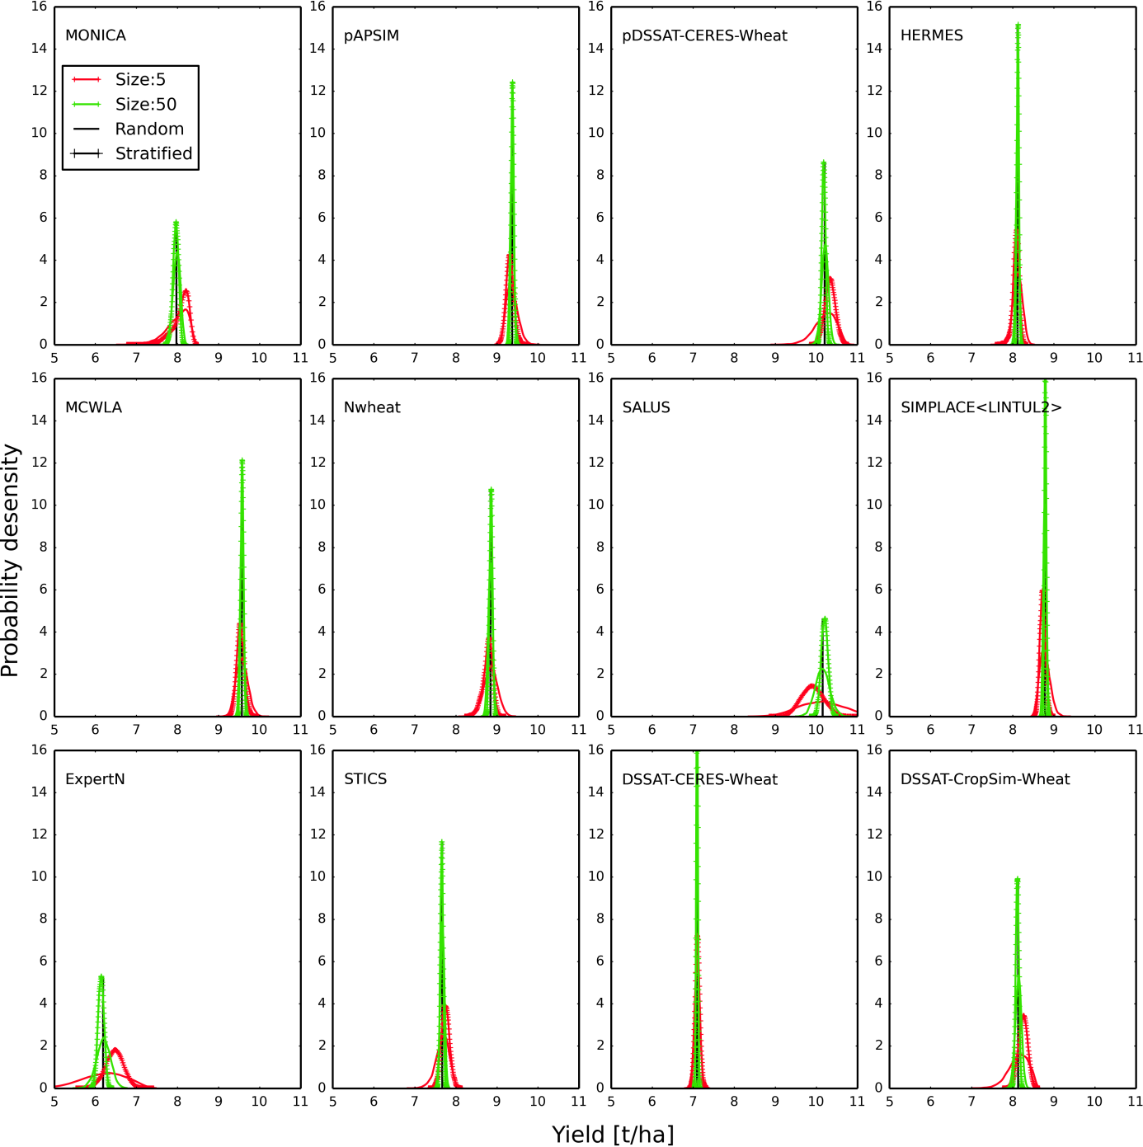Figure 9. Probability density function of simulated water-limited yields based on random and stratified sampled gridcells, the black solid vertical lines indicate the simulated mean water-limited yield based on all gridcells (> 34,000).

# 4. Discussion

## 4.1. Stratified sampling to simulate regional crop yields

Accurate simulations of crop yields at the level of administrative regions such as North Rhine-Westphalia (NRW) are essential to assess for example the impact of climate variability on regional crop productivity. The availability of accurate input data normally decreases if the intended spatial extent for the model application increases. This requires methods to process input data ([Ewert et al., 2011](#_ENREF_19)) in order to obtain regional estimates of crop yields. Processing input data, often referred to as upscaling methods, may have implications for model outcomes ([Baron et al., 2005](#_ENREF_7); [Easterling et al., 1998](#_ENREF_16); [Mearns et al., 2001](#_ENREF_28); [Nonhebel, 1994](#_ENREF_32); [Van Bussel et al., 2011b](#_ENREF_44); [Van Wart et al., 2013a](#_ENREF_46)), but despite the increasing number of studies with crop simulations for large areas, little is known about the errors related to the scaling methods. The present study used a high-resolution weather data set from a state in Germany, North Rhine-Westphalia, in combination with 12 crop models to test the magnitude of error on simulated regional wheat yields due to the sampling of weather data. Although previous studies ([Baron et al., 2005](#_ENREF_7); [Van Wart et al., 2013a](#_ENREF_46)) showed that model outcomes can show considerable errors if applied with interpolated weather data, we assumed that due to the extensive weather station network in NRW, these errors will be relatively low in the created gridded weather database. It might be that certain assumptions, e.g. calculating saturated vapour pressure by assuming have influenced the quality of the developed weather database. Testing the quality of the weather data was however not the focus of this study. We aimed to assess to what extent the spatial and temporal patterns of the simulated yields could be represented by a distinct chosen number of sampling points. It is to our knowledge the first systematic study on analysing the effect of sampling size, sampling methods and their possible interaction with crop models.

We found that for all the crop models a stratified sampling of 10 points was sufficient to reproduce the simulated 30-year mean yield within a 34,078 km2 region (Fig. 7). This has obviously a positive implication for the computing time required to run a crop model across such a large area. In addition, such a huge decrease in output data will make further data processing and analysis of results easier or even possible. To obtain also an accurate spatial distribution of the simulated yields, for the majority of the models (8 out of 12) approximately 100 sampling points were required (Table 4). For models that showed a relatively large range in simulated yields, a larger number of sampling points was required to reproduce the spatial distribution in simulated yields. This result is in line with previous research that showed for models simulating a higher variability in yields, the use of aggregated input data will result in higher deviations from the mean for these models as compared to models with a lower variability in simulated yields ([Hansen and Jones, 2000](#_ENREF_23)). The probability density functions (Fig. 9) showed that if possible, stratified sampling is preferred above random sampling, since stratified sampling clearly increased the effectiveness of the sampling.

## 4.2. Implications for regional crop simulations

The aim of the presented study was not to compare the simulated yields by the different crop models with observed actual yields or to compare crop models among each other, but to assess the effect of spatial sampling of weather data on regional crop yield simulations. Therefore we performed only a limited calibration, which mimicked nevertheless the common practice in crop simulations for large areas with respect to their calibration. Although not the aim, we cannot ignore the striking result that possible errors in regional crop simulations seem to be more caused by the different model approaches than by scaling issues with respect to weather data availability. This large range in model results has recently been shown by Angulo et al. ([2013](#_ENREF_4)), Asseng et al. ([2013](#_ENREF_5)) and Rosenzweig et al. ([2013](#_ENREF_37)), and justifies the efforts of programs such as AgMIP ([www.agmip.org](http://www.agmip.org)) and MACSUR ([www.macsur.org](http://www.macsur.org)) towards research on model improvement. It showed that, besides a deeper understanding of errors due to scaling issues, improvement of crop models, among other testing if a model is suited to simulate crop growth and yield in a certain region, is essential in order to obtain accurate yield estimates at scales that extent from fields to the region and beyond.

In our study we had data at our disposal from about 280 weather stations from the German Weather Service. However, these data were only available through contract and freely available weather data for the region of NRW from the weather service is restricted to only six weather stations. In all large environmental strata of NRW at least one of these six weather stations is located. The results of our study indicate that it is likely that the mean regional yield can be simulated relative accurately with help of the data from these six weather stations, but that the spatial variability in simulated yields might be less accurate. Crop simulations for large areas are often applied in regions which have considerable less data available than Germany, such as Sub-Saharan Africa. This study showed that especially the spatial distribution of simulations in such areas should be assessed with care if they were derived from few single points only. Our results provided insights how the minimum number of sampling points can be assessed to provide acceptable simulations for a region. Stratified sampling is certainly a way to reduce the required number of sampling points. This applies to sampling the spatial heterogeneity but may also apply to temporal variability if long time series are not available.

## 4.3. Future research

Results of the present study are valid primarily for the studied region and selected time period. They are however in line with conclusions from an earlier study where 14 weather stations were sufficient to reproduce well observed yields within another state in Germany, the Free State of Thuringia ([Nendel et al., 2013](#_ENREF_31)). This leaves the question open however to which extent a more advanced model calibration as done in Nendel at al. ([2013](#_ENREF_31)) affects results obtained in our study, particularly the obtained differences among models and their responsiveness to the sampling of weather data.

In the present study, we have used only one soil type and we did not consider known variations in management ([see e.g. Van Bussel et al., 2011a; showing that sowing dates can vary considerable within a region](#_ENREF_43)). The effect of sampling soils and management could exceed the effects of sampling weather data which may particularly be the case in regions with less favourable growing conditions, e.g. where severe water limitations for crop growth can be expected, since rainfall is especially variable over space and thus timing of sowing and soil conditions are of great importance for affecting water-limited yields. Therefore, further efforts are required to expand the present study to also analyse the effects of sampling soil types and crop management.

# 5. Conclusions

Errors in large area crop simulations can result from the choice of weather input data. If only a limited number of weather stations is available within a region, this study showed that, despite a relatively accurate spatial mean, the spatial distribution in simulated yields can be prone to error. We have shown that to increase effectiveness of sampling, stratified sampling is preferred above random sampling. But most importantly, this study showed that the effect of model choice on the outcomes of regional crop simulations is far larger than the effects of the sampling and that models respond differently to sampling. Efforts are therefore required to improve crop models for regional applications. Further work is also needed to extend the present study to investigate the effects of sampling soil type and crop management.

# Acknowledgements

We thank the AgMIP research community for their contributions to this effort, Marc Metzger (Centre for the Study of Environmental Change and Sustainability, School of Geosciences, University of Edinburgh, United Kingdom) for providing the stratification data, and DWD for providing the weather data.

LGJvB and FE acknowledge partial funding from MACSUR FACCE JPI, FE acknowledges support from DFG under the CRC TR 32 (TRR 32/2 2011 3009725 ) and PAK Multi-scale modelling. FT and RPR received financial support from FACCE MACSUR project funded through the Finnish Ministry of Agriculture and Forestry (MMM). CB was funded through the Helmholtz project "REKLIM - Regional Climate Change: Causes and Effects" Topic 9: "Climate Change and Air Quality", CK was funded by "REKLIM - Regional Climate Change: Causes and Effects" Topic 4: "The land surface in the climate system", FH was funded by the German Research Foundation (Deutsche Forschungsgemeinschaft, DFG) under the Grants FOR1695.

# Author contributions

LGJvB, FE, GZ, HH, DW designed the study set up; AE, LGJvB prepared the input data; GZ, HH, AE, JC, HR, CK, CB, FH, EP, FT, RPR, DC, SA, JE, MG, CN, K-CK, XS, BB, GAB, CCR run crop models; LGJvB, FE, GZ, HH analysed the results and wrote the manuscript. All authors commented on previous versions of the manuscript.

# References

Alcamo, J., Dronin, N., Endejan, M., Golubev, G. and Kirilenko, A., 2007. A new assessment of climate change impacts on food production shortfalls and water availability in Russia. Global Environ. Chang., 17(3-4): 429-444.

Alexandrov, V., Eitzinger, J., Cajic, V. and Oberforster, M., 2002. Potential impact of climate change on selected agricultural crops in north-eastern Austria. Global Change Biol., 8(4): 372-389.

Allen, R.G., Pereira, L.S. and Raes, D., 1998. Crop evapotranspiration: guidelines for computing crop water requirements. FAO irrigation and drainage paper 56. FAO, Rome.

Angulo, C. et al., 2013. Characteristic ‘fingerprints’ of crop model responses to weather input data at different spatial resolutions. European Journal of Agronomy, 49(0): 104-114.

Asseng, S. et al., 2013. Uncertainty in simulating wheat yields under climate change. Nature Climate Change, 3(9): 827-832.

Asseng, S. et al., 1998. Performance of the APSIM-wheat model in Western Australia. Field Crop Res., 57(2): 163-179.

Baron, C. et al., 2005. From GCM grid cell to agricultural plot: scale issues affecting modelling of climate impact. Phil. Trans. R. Soc. Lond. B, 360(1463): 2095-2108.

Basso, B., Cammarano, D., Troccoli, A., Chen, D. and Ritchie, J.T., 2010. Long-term wheat response to nitrogen in a rainfed Mediterranean environment: Field data and simulation analysis. European Journal of Agronomy, 33(2): 132-138.

Berg, A., de Noblet-Ducoudré, N., Sultan, B., Lengaigne, M. and Guimberteau, M., 2013. Projections of climate change impacts on potential C4 crop productivity over tropical regions. Agr. Forest Meteorol., 170(0): 89-102.

Bergez, J.E. et al., 2013. An open platform to build, evaluate and simulate integrated models of farming and agro-ecosystems. Environ. Modell. Softw., 39(0): 39-49.

Biernath, C. et al., 2011. Evaluating the ability of four crop models to predict different environmental impacts on spring wheat grown in open-top chambers. European Journal of Agronomy, 35(2): 71-82.

Brisson, N., Launay, M., Mary, B. and Beaudoin, N., 2008. Conceptual basis, formalisations and parameterization of the STICS crop model.

Daly, C., 2006. Guidelines for assessing the suitability of spatial climate data sets. International Journal of Climatology, 26(6): 707-721.

De Wit, A.J.W., Boogaard, H.L. and Van Diepen, C.A., 2005. Spatial resolution of precipitation and radiation: the effect on regional crop yield forecasts. Agr. Forest Meteorol., 135(1-4): 156-168.

DWD, <https://werdis.dwd.de/werdis/start_js_JSP.do>.

Easterling, W.E., Weiss, A., Hays, C.J. and Mearns, L.O., 1998. Spatial scales of climate information for simulating wheat and maize productivity: the case of the US Great Plains. Agr. Forest Meteorol., 90(1-2): 51-63.

Elliott, J. et al., 2014. The parallel system for integrating impact models and sectors (pSIMS). Environ. Modell. Softw., 62: 509-516.

Evans, L.T. and Fisher, R.A., 1999. Yield potential: Its definition, measurement, and significance. Crop Science, 39(6): 1544-1551.

Ewert, F. et al., 2011. Scale changes and model linking methods for integrated assessment of agri-environmental systems. Agriculture, Ecosystems and Environment, 142(1-2): 6-17.

Franck, S., von Bloh, W., Müller, C., Bondeau, A. and Sakschewski, B., 2011. Harvesting the sun: New estimations of the maximum population of planet Earth. Ecol. Model., 222(12): 2019-2026.

Gaiser, T. et al., 2013. Modeling biopore effects on root growth and biomass production on soils with pronounced sub-soil clay accumulation. Ecol. Model., 256(0): 6-15.

Gerten, D. et al., 2011. Global water availability and requirements for future food production. Journal of Hydrometeorology.

Hansen, J.W. and Jones, J.W., 2000. Scaling-up crop models for climate variability applications. Agr. Syst., 65(1): 43-72.

Jones, J.W. et al., 2003. The DSSAT cropping system model. European Journal of Agronomy, 18(3–4): 235-265.

Jones, P.G. and Thornton, P.K., 2013. Generating downscaled weather data from a suite of climate models for agricultural modelling applications. Agr. Syst., 114(0): 1-5.

Keating, B.A. et al., 2003. An overview of APSIM, a model designed for farming systems simulation. European Journal of Agronomy, 18(3–4): 267-288.

Kersebaum, K., Hecker, J.-M., Mirschel, W., Wegehenkel, M. and Kersebaum, K., 2007. Modelling nitrogen dynamics in soil–crop systems with HERMES, Modelling water and nutrient dynamics in soil–crop systems. Springer Netherlands, pp. 147-160.

Mearns, L.O., Easterling, W.E., Hays, C.J. and Marx, D., 2001. Comparison of agricultural impacts of climate change calculated from high and low resolution climate change scenarios: Part II. Accounting for adaptation and CO2 direct effects. Climatic Change, 51(2): 173-197.

Metzger, M.J. et al., 2013. A high-resolution bioclimate map of the world: a unifying framework for global biodiversity research and monitoring. Global Ecol. Biogeogr.: n/a-n/a.

Nendel, C. et al., 2011. The MONICA model: Testing predictability for crop growth, soil moisture and nitrogen dynamics. Ecol. Model., 222(9): 1614-1625.

Nendel, C. et al., 2013. Simulating regional winter wheat yields using input data of different spatial resolution. Field Crop Res., 145(0): 67-77.

Nonhebel, S., 1994. The effects of use of average instead of daily weather data in crop growth simulation models. Agr. Syst., 44(4): 377-396.

Olesen, J.E., Bocher, P.K. and Jensen, T., 2000. Comparison of scales of climate and soil data for aggregating simulated yields of winter wheat in Denmark. Agriculture, Ecosystems & Environment, 82(1-3): 213-228.

Palosuo, T. et al., 2011. Simulation of winter wheat yield and its variability in different climates of Europe. A comparison of eight crop growth models. European Journal of Agronomy, 35(3): 103-114.

Prescott, J.A., 1940. Evaporation from a water surface in relation to solar radiation. Trans. R. Soc. Aust., 64: 114-125.

Regionaldatenbank Deutschland, 2013. Statistische Ämter des Bundes und der Länder.

Rosenzweig, C. et al., 2013. Assessing agricultural risks of climate change in the 21st century in a global gridded crop model intercomparison. Proceedings of the National Academy of Sciences.

Rosenzweig, C. and Parry, M.L., 1994. Potential impact of climate change on world food supply. Nature, 367(6459): 133-138.

Semenov, M. and Barrow, E., 1997. Use of a stochastic weather generator in the development of climate change scenarios. 35(4): 397-414.

Spitters, C.J.T. and Schapendonk, A.H.C.M., 1990. Evaluation of breeding strategies for drought tolerance in potato by means of crop growth simulation. Plant Soil, 123(2): 193-203.

Tao, F., Yokozawa, M. and Zhang, Z., 2009. Modelling the impacts of weather and climate variability on crop productivity over a large area: A new process-based model development, optimization, and uncertainties analysis. Agr. Forest Meteorol., 149(5): 831-850.

Tao, F. and Zhang, Z., 2011. Impacts of climate change as a function of global mean temperature: Maize productivity and water use in China. Climatic Change, 105(3-4): 409-432.

Van Bussel, L.G.J., Ewert, F. and Leffelaar, P.A., 2011a. Effects of data aggregation on simulations of crop phenology. Agriculture, Ecosystems & Environment, 142(1-2): 75-84.

Van Bussel, L.G.J., Müller, C., Van Keulen, H., Ewert, F. and Leffelaar, P.A., 2011b. The effect of temporal aggregation of weather input data on crop growth models' results. Agr. Forest Meteorol., 151(5): 607-619.

Van Ittersum, M.K. and Rabbinge, R., 1997. Concepts in production ecology for analysis and quantification of agricultural input-output combinations. Field Crop Res., 52(3): 197-208.

Van Wart, J., Grassini, P. and Cassman, K.G., 2013a. Impact of derived global weather data on simulated crop yields. Global Change Biol., 19(12): 3822-3834.

Van Wart, J., Kersebaum, K.C., Peng, S., Milner, M. and Cassman, K.G., 2013b. Estimating crop yield potential at regional to national scales. Field Crop Res., 143(0): 34-43.

Wackerly, D.D., Mendenhall, W. and Scheaffer, R.L., 2008. Mathematical statistics with applications. Thomson Higher Education, Belmont.

Wassenaar, T., Lagacherie, P., Legros, J.-P. and Rounsevell, M.D.A., 1999. Modelling wheat yield responses to soil and climate variability at the regional scale. Climate Res., 11: 209-220.

Wolf, J. and Van Diepen, C.A., 1995. Effects of climate change on grain maize yield potential in the european community. Climatic Change, 29(3): 299-331.

Zhao, G. et al., 2013a. Large-scale, high-resolution agricultural systems modeling using a hybrid approach combining grid computing and parallel processing. Environ. Modell. Softw., 41(0): 231-238.

Zhao, G. et al., 2013b. Impact of agricultural management practices on soil organic carbon: simulation of Australian wheat systems. Global Change Biol., 19(5): 1585-1597.

Table S1a Mean, median, maximum and minimum simulated potential yield (t/ha) for different sampling sizes for different sampling sizes () per model

|  |  |  |  |  |  |  |  |  |  |  |  |  |
| --- | --- | --- | --- | --- | --- | --- | --- | --- | --- | --- | --- | --- |
| Model | Mean potential yield (t/ha) | | | Median potential yield (t/ha) | | | Maximum potential yield (t/ha) | | | Minimum potential yield (t/ha) | | |
|  |  |  |  |  |  |  |  |  |  |  |  |
| MONICA | 7.9 | 8.2 | 8.2 | 8.4 | 8.4 | 8.4 | 8.6 | 8.8 | 8.9 | 5.3 | 5.7 | 3.7 |
| pAPSIM | 10.1 | 10.1 | 10.1 | 10.1 | 10.1 | 10.1 | 10.7 | 10.8 | 11.1 | 9.7 | 9.7 | 9.4 |
| pDSSAT-CERES-Wheat | 10.0 | 10.2 | 10.2 | 10.4 | 10.5 | 10.4 | 10.8 | 11.0 | 12.2 | 8.0 | 8.2 | 6.8 |
| HERMES | 8.2 | 8.3 | 8.3 | 8.3 | 8.3 | 8.3 | 8.7 | 8.7 | 8.9 | 7.9 | 7.8 | 7.1 |
| MCWLA | 9.8 | 9.9 | 9.9 | 9.9 | 9.9 | 9.9 | 10.6 | 10.8 | 10.9 | 9.0 | 9.2 | 6.9 |
| Nwheat | 9.2 | 9.2 | 9.2 | 9.2 | 9.2 | 9.2 | 9.7 | 9.7 | 10.0 | 8.8 | 8.7 | 8.6 |
| SALUS | 10.4 | 10.1 | 10.2 | 9.9 | 9.9 | 10.0 | 12.8 | 12.6 | 13.3 | 8.7 | 8.0 | 7.4 |
| SIMPLACE <LINTUL2> | 9.0 | 9.0 | 9.0 | 9.0 | 8.9 | 9.0 | 9.6 | 9.8 | 10.0 | 8.5 | 8.5 | 8.2 |
| ExpertN | NaN | NaN | NaN | NaN | NaN | NaN | NaN | NaN | NaN | NaN | NaN | NaN |
| STICS | 7.5 | 7.7 | 7.7 | 7.6 | 7.8 | 7.7 | 8.1 | 8.4 | 8.5 | 6.3 | 6.5 | 5.0 |
| DSSAT-CropSim-Wheat | 7.9 | 8.1 | 8.1 | 8.3 | 8.4 | 8.4 | 8.6 | 8.7 | 8.9 | 5.7 | 6.6 | 4.5 |
| DSSAT-CERES-Wheat | 7.0 | 7.1 | 7.1 | 7.1 | 7.1 | 7.1 | 7.3 | 7.5 | 8.2 | 6.5 | 6.8 | 5.8 |

Table S1b Mean, median, maximum and minimum simulated water-limited yield (t/ha) for different sampling sizes for different sampling sizes () per model

|  |  |  |  |  |  |  |  |  |  |  |  |  |
| --- | --- | --- | --- | --- | --- | --- | --- | --- | --- | --- | --- | --- |
| Model | Mean water-limited yield (t/ha) | | | Median water-limited yield (t/ha) | | | Maximum water-limited yield (t/ha) | | | Minimum water-limited yield (t/ha) | | |
|  |  |  |  |  |  |  |  |  |  |  |  |
| MONICA | 7.6 | 7.9 | 8.0 | 8.1 | 8.2 | 8.2 | 8.5 | 8.7 | 8.9 | 5.3 | 5.5 | 3.7 |
| pAPSIM | 9.4 | 9.3 | 9.4 | 9.3 | 9.3 | 9.3 | 10.3 | 10.3 | 10.8 | 8.8 | 8.5 | 8.4 |
| pDSSAT-CERES-Wheat | 10.0 | 10.2 | 10.2 | 10.4 | 10.4 | 10.4 | 10.8 | 11.0 | 12.2 | 8.0 | 8.2 | 6.8 |
| HERMES | 8.1 | 8.1 | 8.1 | 8.0 | 8.1 | 8.1 | 8.6 | 8.6 | 8.8 | 7.9 | 6.8 | 6.2 |
| MCWLA | 9.5 | 9.5 | 9.6 | 9.4 | 9.5 | 9.5 | 10.3 | 10.2 | 10.7 | 8.9 | 9.0 | 6.8 |
| Nwheat | 8.9 | 8.8 | 8.8 | 8.7 | 8.7 | 8.8 | 9.7 | 9.7 | 9.9 | 8.1 | 7.4 | 7.2 |
| SALUS | 10.4 | 10.1 | 10.2 | 9.9 | 9.9 | 10.0 | 12.8 | 12.6 | 13.3 | 8.7 | 8.0 | 7.4 |
| SIMPLACE LINTUL2> | 8.8 | 8.8 | 8.8 | 8.7 | 8.7 | 8.7 | 9.5 | 9.7 | 9.9 | 8.4 | 8.4 | 8.1 |
| ExpertN | 5.8 | 6.3 | 6.2 | 6.5 | 6.7 | 6.7 | 7.4 | 7.7 | 7.9 | 2.7 | 2.7 | 1.7 |
| STICS | 7.5 | 7.7 | 7.7 | 7.6 | 7.8 | 7.7 | 8.1 | 8.3 | 8.4 | 6.3 | 6.4 | 5.0 |
| DSSAT-CropSim-Wheat | 7.9 | 8.1 | 8.1 | 8.3 | 8.4 | 8.4 | 8.6 | 8.7 | 8.9 | 5.7 | 6.6 | 4.5 |
| DSSAT-CERES-Wheat | 7.1 | 7.1 | 7.1 | 7.1 | 7.1 | 7.1 | 7.3 | 7.5 | 8.2 | 6.5 | 6.8 | 5.8 |