**SUPPLEMENTARY INFORMATION**

**Supplement for Materials and Methods**

*Oil-Red-O staining*

Anonymised frozen skin biopsies were sectioned and fixed in 4% Paraformaldehyde (Sigma-Aldrich, Dorset, UK) for 10 min. Slides were placed in 100% Propylene Glycol (Amresco, Solon, OH, USA) for 1 min, followed by a rinse with distilled water. The sections were stained with 0,7% Oil Red O (Sigma-Aldrich) solution for 7 minutes than rinsed with 85% Propylene Glycol solution. A counter staining for nuclei was done with methylene green. Finally, the slides were covered using Mount Quick Aqueous mounting medium (Bio Optica Milano, Italy).

*Raman spectroscopy*

Skin biopsies were obtained from abdominal reconstruction surgery. Approximately 1 cm2 skin samples were treated with either squalene, linoleic-, oleic-, palmitic- or stearic acid on 4 mL volume Franz diffusion cells using phosphate buffer saline solution to avoid skin drying. In all cases the treatment duration was 24 h and the treated area was 66.5 mm2. Tissue samples of the treated areas were frozen and sectioned onto aluminium coated slides. Raman spectra of each section were obtained with a DXR Raman microscope (Thermo Fisher Scientific, Waltham, MA, USA) equipped with a 532nm diode laser. Instrument operation and the evaluation of measurements were done by the OMNIC Dispersive Raman 8.2 software (Thermo Fisher Scientific). In all mapping measurements 24 spectra were collected, the spectral resolution was approximately 2 cm-1, and the spectral window ranged from 200 to 3200 cm-1. The individual spectra of each fatty acid were used as a reference when comparing the treated vs untreated samples.

*SZ95 sebocyte cell culture and treatment*

The immortalized human sebaceous gland cell line SZ95 (1) was cultured at 37°C in a humidified atmosphere containing 5% (v/v) CO2, in Sebomed medium (Biochrom, Berlin, Germany) supplemented with 10% Fetal Bovine Serum (FBS, Biowest, Rue de la Caille, France), 1 mM CaCl2 solution, 1% penicillin/streptomycin (Sigma-Aldrich, Dorset, UK) and 5 µg/ml Epidermal Growth Factor (EGF) (Sigma-Aldrich). Cells were kept in culture until reaching approximately 80% confluence. Prior to supernatant collection the used medium was replaced with Sebomed medium containing 0.5% FBS, 1 mM CaCl2 solution, with or without 1% penicillin/streptomycin, lacking EGF. 24 h supernatant was collected and filtered using 0.2 µm syringe filters (Sarstedt, Nümbrecht, Germany) and used for experiments. In each in vitro experiment Sebomed medium containing 0.5% FBS, 1 mM CaCl2 solution, with or without 1% penicillin/streptomycin, lacking EGF was used as a control treatment of monocytes or macrophages.

For lipid depletion of SZ95 sebocyte supernatant Cleanascite lipid clarification reagent (Biotech Support Group, Monmouth Junction, NJ, USA) was used according to the manufacturer’s instructions. Lipids; squalene, linoleic acid, oleic acid, palmitic acid and stearic acid (Sigma-Aldrich) dissolved in Ethanol:DMSO (1:1); were replaced individually subsequent to lipid depletion in a concentration of 150µM. Replacement concentrations were determined by preliminary ELISA and flow cytometry data. (Supplement Figure 1a,c). Ethanol:DMSO (1:1) was used as a vehicle control.

*P. acnes strains*

Strain *P. acnes 889* (*P. acnes*) was obtained from the Department of Microbiology, University of Debrecen, Hungary. *P. acnes* bacteria were cultured on pre-reduced Columbia agar base (Oxoid, Basingstoke, UK) supplemented with 5% cattle blood, vitamin K1, and hemin, incubated at 37°C for 72 h under anaerobic conditions (Ruskinn Concept 400 Anaerobic Workstation, Pencoed, UK). The 72 h culture of the bacteria was dissolved in suspension medium broth and the suspension was adjusted to 0.5 McFarland standard turbidity. This resulted in 105-106 colony forming units (CFU)/ml. Cells were then centrifuged at 3500 rpm for 5 min and the supernatant was discarded. After a washing step in phosphate-buffered saline (Lonza, Verviers, Belgium) cells were harvested in 1 ml RPMI1640 medium (Sigma-Aldrich) lacking antibiotic/antimicotic solution and used for experiments.

*Macrophage culturing and differentiation*

Monocytes were isolated from PBMCs of healthy donors using the CD14 microbeads (Miltenyi Biotech, Vienna, Austria) following the manufacturer’s protocol. 1x106 monocytes were plated in a 24-well plate in RPMI 1640 (Sigma-Aldrich) supplemented with 10% of FBS (Biochrom) and with or without 1% antibiotics (Invitrogen, Carlsbad, CA, USA); and were treated with 40% or 80% of SZ95 sebocyte supernatant (collected as previously described). An appropriate concentration of Sebomed medium containing 0.5% FBS, 1 mM CaCl2 solution, with or without 1% penicillin/streptomycin, lacking EGF was used as control. Monocytes were differentiated in the presence of SZ95 sebocyte supernatant or Sebomed medium for 5 days at 37°C in a humidified atmosphere containing 5% (v/v) CO2 and were used for experiments. For further differentiation and activation IL-4 (20ng/ml), IFN-G (20ng/ml) or *P. acnes* was used (1:50). Results presented are obtained with 80% SZ95 sebocyte supernatant supplementation after confirming dose dependence and an optimal dose as detailed in Supplement Figure 1b.

*Immunohistochemistry*

Frozen sections were fixed in acetone for 10 min and incubated in 5% normal goat serum diluted in Serum-Free Protein Block (SFPB) (Dako, Glostrup, Denmark). Factor XIII-A was detected by rabbit affinity purified anti-human FXIII-A antibody (Affinity Biologicals, Ancaster, Ontario, Canada) for 2 h at room temperature. This procedure was followed by visualization using DyLight 488 horse anti-sheep IgG antibody for 45 min (Vector Laboratories Ltd, Cambridgeshire, UK). For co-expression, the detection of FXIII-A was sequentially combined with different reference markers using monoclonal anti-human antibodies against CD antigens [CD206, CD209 (Abcam, Cambridge, UK), CD163 (Enzo Life Sciences, Farmingdale, NY, USA)]. Following a 10 min incubation with normal horse serum containing SFPB, the second primaries’ specific binding was visualized by DyLight 594 goat anti-rabbit/mouse IgG antibody (Vector Laboratories Ltd). Slides were washed in PBS and mounted with Vectashield Mounting Medium with DAPI (Vector Laboratories Ltd) to counterstain nuclei. For negative controls, the appropriate non-immune control sera (rabbit IgG from Vector Laboratories Ltd, mouse IgG1 or mouse IgG2b from BD Pharmingen, Heidelberg, Germany) were used in place of primary antibodies followed by the same procedure as above. Images were acquired with an Axioplan microscope (Carl Zeiss, Oberkochen, Germany) equipped with selective filters and connected to a CCD IMAC camera (Sony, Tokyo, Japan) and ISIS fluorescent imaging system (MetaSystems, Altlussheim, Germany). For antibody specifications see Supplement table 1.

*Flow cytometry*

For flow cytometric analysis macrophages were collected and washed with PBS (5 min, 1500 rpm) and were resuspended in staining buffer (PBS containing 1% BSA (Amresco). Cells were stained for surface markers CD206, CD209 using phycoerythrin (PE) conjugated mAbs (BD Bioscienses, New Jersey, NJ, USA) for 30 min at 4°C; PE conjugated IgG1κ (BD Bioscienses) was used as isotype control. The stained cells were subsequently washed in staining buffer (5 min, 1500 rpm) and were fixed with 4% PFA for 20 minutes at RT. Data was collected by flow cytometric analysis using FACSCalibur (BD Bioscienses) and was analysed with Flowing Software (Cell Imaging Core, Turku, Finland). For antibody specifications see Supplement table 1.

*Western blotting*

Cells were collected at 12 h following *P. acnes* treatment and were washed in PBS and lysed in RIPA buffer containing a phosphatise-protease inhibitor mix (Sigma-Aldrich). After centrifugation (12000 rpm, 20 min, 4°C) supernatant was collected, protein concentration was determined using BCA Protein Assay Kit (Thermo Fisher Scientific). Proteins were separated by electrophoresis using a 6% or 12% polyacrylamide gel and transferred to nitrocellulose membrane (Bio-Rad Laboratories, Hercules, CA, USA). After blocking, membranes were probed with anti-IL-1B (R&D Systems, MN, USA), anti–FXIII-A (Acris Antibodies, Herford, Germany) and anti-β-actin (Cell Signalling, Danvers, MA, USA). The Ag–Ab complexes were labelled with appropriate HRP-conjugated secondary antibodies (Bio-Rad Laboratories) and visualized by Immobilon Western HRP Substrate kit (Millipore, Bedford, MA, USA). For antibody specifications see Supplement table 1.

*ELISA*

Supernatants from macrophages cultured in the presence of SZ95 sebocyte supernatant or appropriate controls were collected at 24 h after *P. acnes 889* treatment and were stored at −20°C until they were analysed for IL-6, TNF-A and IL-1B using the appropriate ELISA Duosets (R&D Systems) according to the manufacturer’s instructions. For the analyses of CXCL8 and IL-4, supernatants from SZ95 sebocytes were collected at 12 h, 24 h and 36 h at approximately 80% confluence and were stored at −20°C until they were used for measurements with specific ELISA Duosets (R&D Systems) according to the manufacturer’s instructions.

*Phagocytosis assay*

For FITC staining of *P. acnes,* bacteria were collected and washed in PBS and resuspended in 1 ml 0.1 M sodium bicarbonate buffer pH 9. 1 µl of 10 mg/ml FITC (Sigma-Aldrich) was used for labelling 108 bacteria at 4°C for 1 h. Finally, cells were washed in PBS twice and used for phagocytosis. Macrophages were incubated with FITC-labelled *P. acnes* for 2 h at 37°C, with or without lipid depletion and replacement, to allow bacteria uptake. The process of phagocytosis was stopped by adding ice-cold PBS. Cells were then collected and washed twice with cold PBS by centrifugation for 5 min at 1500 rpm. Cells were fixed with 4% PFA for 20 min at RT, data was collected by flow cytometric analysis using FACSCalibur (BD Bioscienses) and was analysed with Flowing Software (Cell Imaging Core).

*Statistics*

All data are presented as mean ± SD. We made at least three biologic replicates for all experiments. Unpaired t-test, one-way ANOVA statistic test and Tukey post-hoc test were used in the analysis of ELISA data. Differences by p<0.05 values were considered statistically significant.

**Supplement Table 1**

Antibodies and their used dilutions in the study.

|  |  |  |  |  |  |
| --- | --- | --- | --- | --- | --- |
| **Antibodies used for immunofluorescence** | | | | | |
| **Antigen** | **Manufacturer** | **Clone** | **Isotype** | **Dilution** | **Detection** |
| FXIII-A | Affinity Biologicals | - | APIgG | 1:100 | Horse anti-sheep DyLight 488 |
| CD206 | Abcam | 15-2 | IgG | 1:100 | Goat anti-mouse DyLight 594 |
| CD209 | Abcam | 5D7 | - | 1:100 | Goat anti-mouse DyLight 594 |
| CD163 | Enzo Life Sciences | K20-T | IgG | 1:100 | Goat anti-rabbit DyLight 594 |
| **Antibodies used for flow cytometry** | | | | | |
| **Antigen** | **Manufacturer** | **Clone** | **Isotype** | **Dilution** | **Detection** |
| CD206 | BD Pharmingen | 19.2 | IgG1,κ | 1:100 | PE-conjugated |
| CD209 | BD Pharmingen | DCN46 | IgG2b,κ | 1:100 | PE-conjugated |
| **Antibodies used for Western blotting** | | | | | |
| **Antigen** | **Manufacturer** | **Clone** | **Isotype** | **Dilution** | **Detection** |
| FXIII-A | Acris Antibodies | - | - | 1:200 | Goat anti-rabbit HRP |

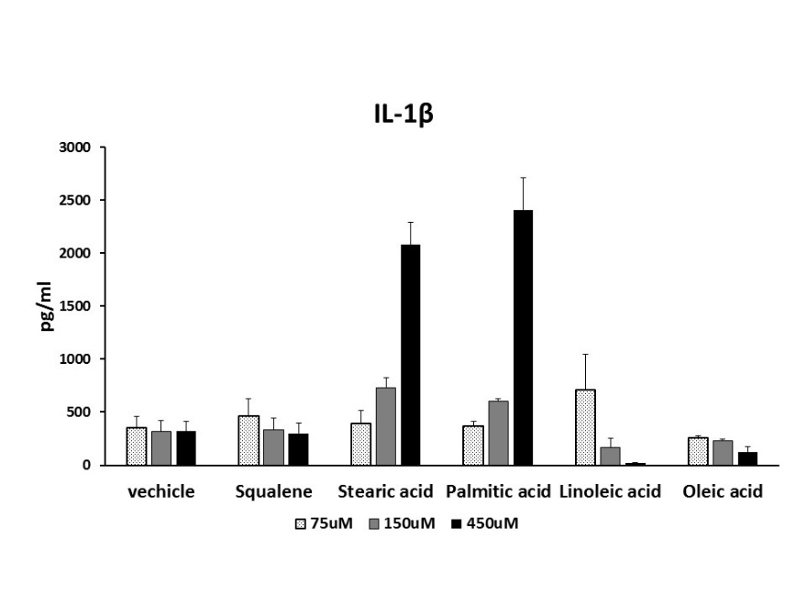**Supplement Figure 1**

**IL-1B**

**a,**

Increasing concentration of lipids (squalene, stearic- palmitic- linoleic- oleic acids) were used to determine the optimal replacement concentrations. IL-1B levels produced by *in vitro* cultured macrophages as described in Materials and Methods were measured by ELISA according to the manufacturer’s instructions. Ethanol:DMSO (1:1) was used as a vehicle control. (n=3)

**b,**

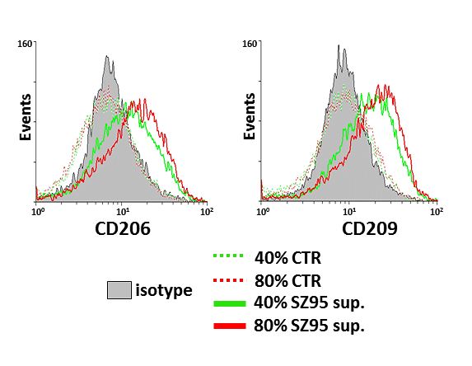

CD206 and CD209 cell surface protein level expressions determined by flow cytometry revealed a dose dependence on the amount of the SZ95 sebocyte supernatant used for supplementation (in 40% - green line and in 80% - red line) of the culturing medium. Based on these results, for all subsequent experiments an 80% SZ95 sebocyte supernatant supplementation to the culturing medium was adopted.

**Supplement Figure 2**

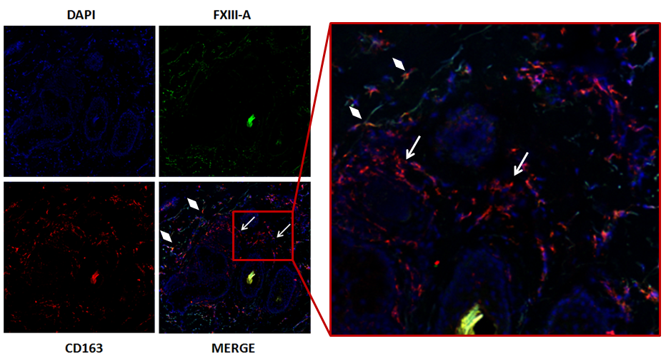

CD163 positive macrophages accumulate in the vicinity of the sebaceous glands, showing a characteristic distribution, by lining up almost exclusively parallel with the basal cell layers. Magnification 100x. Digital magnification of the parallelly lined up macrophages are highlighted with red dashed lines.

**Supplement Figure 2. Classically activated macrophages (CD163+/FXIII-) could only be detected under pathological conditions**

Immunohistochemical staining of acne samples revealed that classically activated macrophages accumulate in a well-defined focus of acne lesions (white arrows). Note that dual positive CD163+/FXIII-A+ alternatively activated macrophages are also detected on the periphery of the sebaceous glands (white rhombuses). Magnification 100x and 200x.

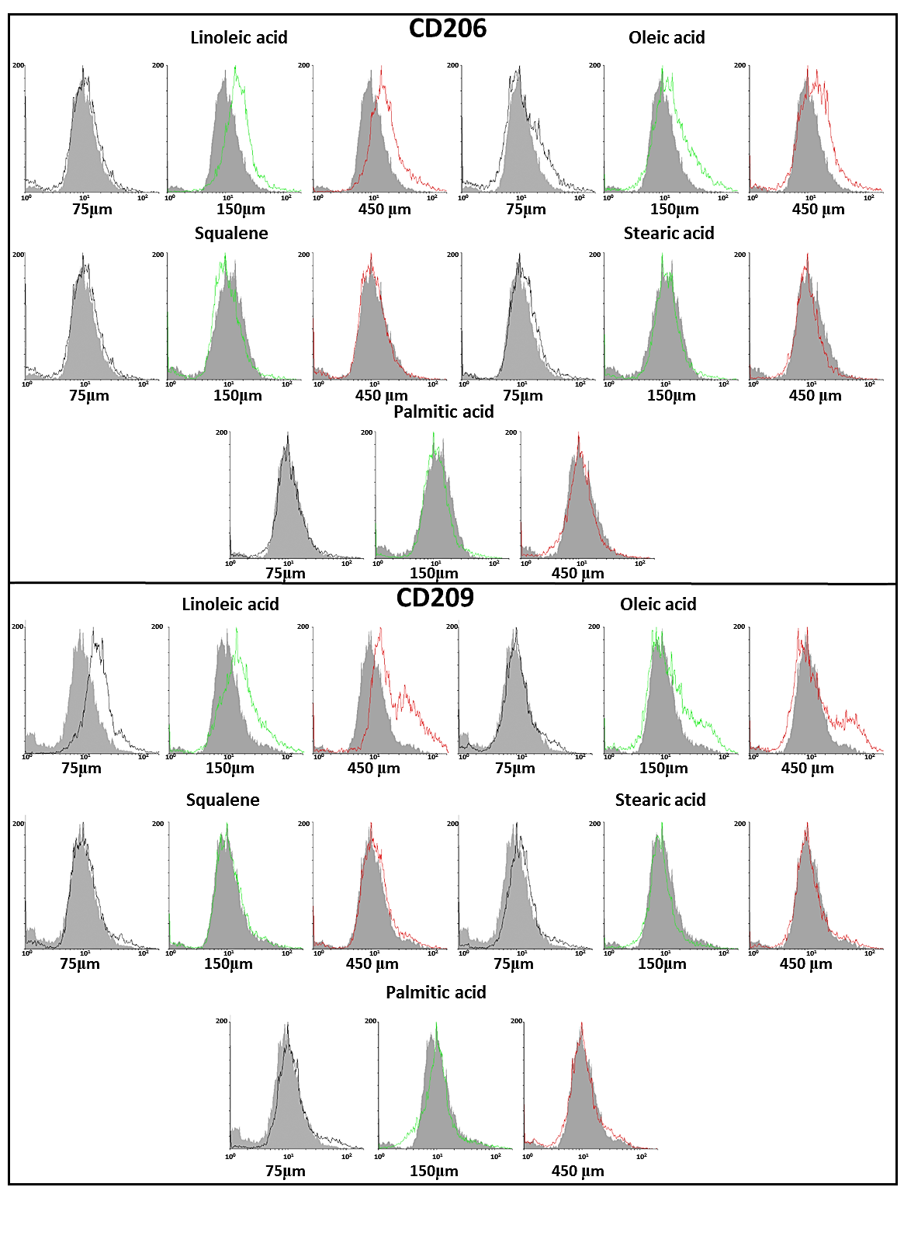

**Supplement Figure 3**

Flow cytometry measurements were carried out to detect CD206 and CD209 cell surface protein expression levels of *in vitro* differentiated macrophages treated with increasing concentration of lipids to determine the optimal replacement concentrations. Ethanol:DMSO (1:1) was used as a vehicle control (grey histograms). One representative experiment of three performed is shown.

**Supplement Figure 4**

CD163 positive macrophages accumulate in the vicinity of the sebaceous glands, showing a characteristic distribution, by lining up almost exclusively parallel with the basal cell layers. Magnification 100x. Digital magnification of the parallelly lined up macrophages are highlighted with red dashed lines.

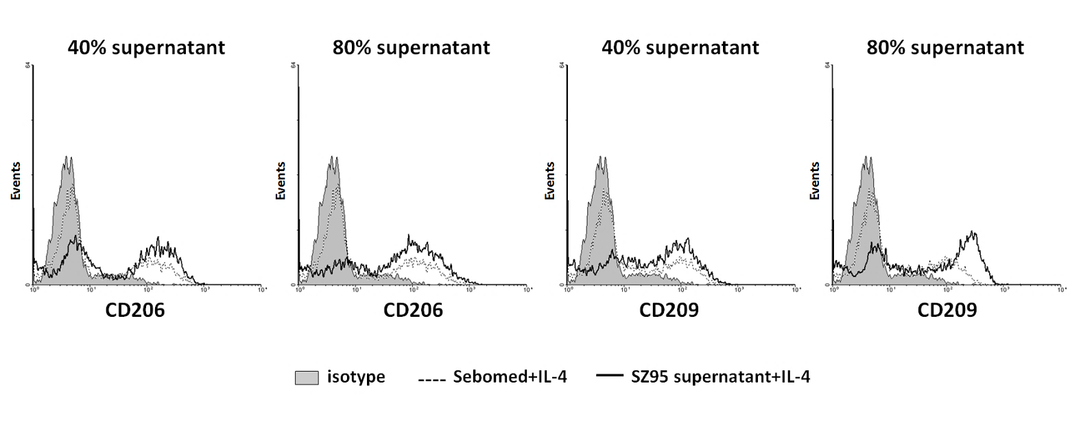

**Supplement Figure 4. SZ95 sebocyte supernatant further enhances the effect of IL-4 on the markers of alternative macrophage activation**

CD206 and CD209 cell surface protein expression were determined by flow cytometry on IL-4 activated macrophages that were differentiated *in vitro* in the presence of SZ95 sebocyte supernatant in different concentrations (40% and 80%) as described in Materials and Methods (solid black line) or culture medium (control, dotted line). One representative experiment of five performed is shown.

**Supplement Figure 5**

CD163 positive macrophages accumulate in the vicinity of the sebaceous glands, showing a characteristic distribution, by lining up almost exclusively parallel with the basal cell layers. Magnification 100x. Digital magnification of the parallelly lined up macrophages are highlighted with red dashed lines.

**a,**

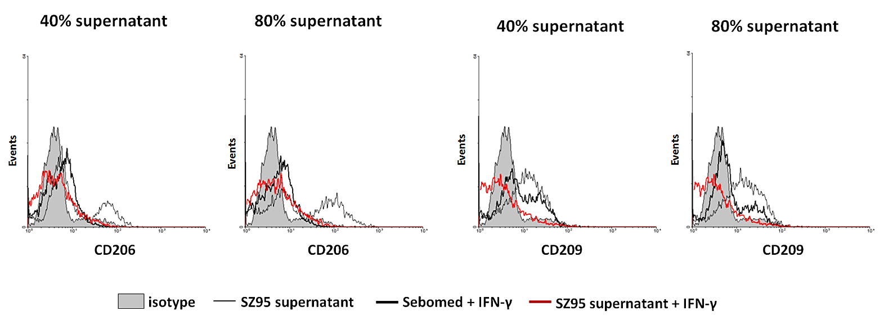

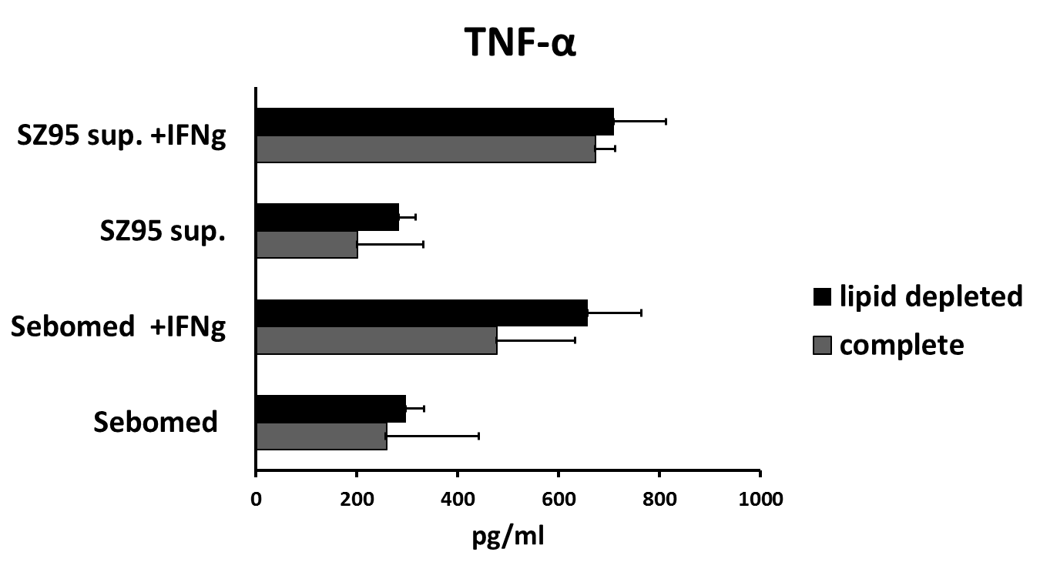**b,**

**TNF-A**

**Supplement Figure 5. Macrophages conserve their potential to differentiate along the classical pathway**

Flow cytometry data displays that SZ95 sebocyte supernatant could not relieve the down regulation of the measured markers due to co-treatment with IFN-G (red line) in macrophages. One representative experiment of three performed is shown (a). This was further confirmed by TNF-A ELISA measurements, where monocytes were differentiated in the presence of either complete (grey bar) or lipid depleted (black bar) SZ95 sebocyte supernatant administered together with IFN-G. Mean ± SD of samples assayed in duplicate is depicted (n=3) (b).

**References**

1. Zouboulis C C, Seltmann H, Neitzel H, et al. Establishment and characterization of an immortalized human sebaceous gland cell line (SZ95). J Invest Dermatol 1999: 113: 1011-1020.