**Supplementary Information**

**Impact of Volatile and Semi-volatile Organic Compounds from Farming Environments on Allergy-Related Cellular Processes**

Exposure and Health

Nadine Gawlitta, Elias J. Zimmermann, Jürgen Orasche, Anja Huber, Jeroen Buters, Sebastiano Di Bucchianico, Sebastian Oeder, Thomas Gröger1*, Ralf Zimmermann

1Joint Mass Spectrometry Centre (JMSC), Cooperation Group Comprehensive Molecular Analytics, Helmholtz Zentrum München, Neuherberg, Germany

*corresponding author: [thomas.groeger@helmholtz-muenchen.de](mailto:thomas.groeger@helmholtz-muenchen.de)

*Table S1: Characteristics of the shed and the animals for the four different sheds in which sampling was conducted.*

|  |  |  |  |  |  |  |  |
| --- | --- | --- | --- | --- | --- | --- | --- |
| Sheds | Sampling times | No. of animals | Race | Sex | Shed size (m2) | Fodder | Litter |
| *Cow A* | 14.11.-20.11.2018  06.12.-17.12.2018 | 53 | Brown-Suisse; Holstein-Friesian | female | 722 | silage (corn, grass), hay, concentrate (soy and rape shred, straw, hay) | sawdust |
| *Cow B* | 14.02.-20.02.2019  12.08.-19.08.2020 | 75 | Simmental Cattle | female | 600 | silage (60 % corn, 40 % grass) and straw | straw |
| *Sheep A* | 26.02.-04.03.2019 | 350 | Merino | female (200) and lambs (150) | 324 | hay and concentrate (hay, herbs, grass) | straw and hay |
| *Sheep B* | 05.03.-10.03.2019 | 160 | Crossbreed of Merino and mountain sheep | female (130) and lambs (30) | 350 | silage and hay | straw and feed remains |

*Table S2: Internal standard (ISTDs) and derivatization standard (DSTD) used for the analysis of PM samples. 1ISTDs used for normalization of PM samples with Matlab (Version 2013b).*

|  |  |
| --- | --- |
| ISTD | DSTD |
| Acenaphthylene-D8 | Fumaric Acid-D2 |
| Acenaphthene-D10 | Adipic Acid-D10 |
| Biphenyl-D10 | P-Nitrophenol-D4 |
| Fluorene-D10 | Glycerol-D8 |
| Anthracene-D10 | Levoglucosane 13C6 |
| Phenanthrene-D10 | Vanillin 13C6 |
| Fluoranthene-D10 | Palmitic Acid-D31 |
| Pyrene-D10 | Dodecanol-D25 |
| Benz[a]anthracene-D12 | Cholesterol-D6 |
| Chrysene-D12 |  |
| Benz[b]fluoranthene-D12 |  |
| Benz[k]fluoranthene-D121 |  |
| Benz[e]pyrene-D121 |  |
| Benz[a]pyrene-D121 |  |
| Perylene-D121 |  |
| Indeno[1,2,3-cd]pyrene-D12 |  |
| Dibenz[a,h]anthracene-D141 |  |
| Benz[ghi]perylene-D121 |  |
| Coronene-D12 |  |
| n-Hexadecane-D34 |  |
| n-Docosane-D46 |  |
| n-Tetracosane-D50 |  |
| n-Triacontane-D621 |  |
| Benz[a]anthracene-7,10-dione-D10 |  |
| 9,10-Anthraquinone 13C6 |  |

*Table S3: Flow parameters of GCxGC analysis. Helium was used as carrier gas.*

|  |  |  |
| --- | --- | --- |
| Column flow [mL min-1] | Split flow [mL min-1] | t [s] |
| 0.1 | 10 | 1200 |
| 1 | 100 | 90 |
| 2.6 | 0 | 600 |

*Table S4: Injection temperature profile of GCxGC analysis.*

|  |  |  |
| --- | --- | --- |
| T rate [°C s-1] | T [°C] | t [s] |
| - | 70 | 40 |
| 2 | 300 | 1350 |
| - | 250 | 3495 |

*Table S5: Column setup of* *GCxGC analysis.*

|  |  |  |
| --- | --- | --- |
| Column setup | Type | Length [m] |
| Pre-column | BPX5 (0.25 mm i.d. x 0.25 µm df) | 1.7 |
| 1st Dimension | BPX50 (0.25 mm i.d. x 0.25 µm df) | 58 |
| 2nd Dimension | BPX1 (0.1 mm i.d. x 0.1 µm df) | 1.4 |

*Table S6: GC oven temperature profile of GCxGC analysis.* *The secondary oven was used with a temperature offset of 5 °C relative to the GC oven temperature. The modulator temperature offset was 15 °C relative to the secondary oven temperature. The modulation time was set to 3 s.*

|  |  |  |
| --- | --- | --- |
| T rate [°C min-1] | T [°C] | Holding time [min] |
| - | 40 | 5 |
| 5 | 330 | - |
| - | 330 | 20 |

*Table S7: Mass spectral parameters of GCxGC-ToFMS analysis.*

|  |  |
| --- | --- |
| MS Parameters | Settings |
| Transferline temperature | 300 °C |
| Acquisition rate | 100 Hz |
| Acquisition range | 29 – 750 m/z |
| Electron ionization | 70 eV |
| Ion source temperature | 250 °C |

*Table S8: Preprocessing of PM samples with Leco ChromaTOF (Version 4.50.8.0 optimized for Pegasus).*

|  |  |  |  |
| --- | --- | --- | --- |
| Baseline Correction |  | |  |
| Baseline Offset | 1 | | auto no. of data points for smoothing |
| S/N | 1 | |  |
| GCxGC Parameters | **1st dimension** | | **2nd dimension** |
| Peak Width [s] | 18 | | 0.2 |
| Match required to combine Peaks | - | | 800 |
| Subpeak | min. S/N | | 50 |
|  | |  | |
| Library Search Settings | |  | |
| Identity/Search Mode | | normal/forward | |
| No. of Hits | | 10 | |
| Molecular Weight Min./Max. | | 40/650 | |
| Mass Threshold | | 10 | |
| Similarity Match Min. | | 700 | |
| Library | | NIST, internal libraries | |
| Mass for Area Calculation | | DTIC | |
| Classification | | exclusion of column bleed | |
| References | | internal standard (Table S1) | |
| Export | | .csv-files | |

*Table S9: Data processing of PM samples with OpenChrom (Lablicate, Edition 1.4.0.202002200817).*

|  |  |
| --- | --- |
| Retention Time Prefilter |  |
| Column 1 [s] | 12 |
| Column 2 [s] | 0.8 |
| Retention Time Filter |  |
| Column 1 [s] | 6 |
| Column 2 [s] | 0.3 |
| Penalty Factor | 5 |
| Penalty Max. | 26 |
| Match Factor Min. | 75 |
| MS Comparator | cosine |
| Classification Matching | false |
| Statistical Evaluation |  |
| Replacement of empty values by | small random |
| Exclusion of values with | one or none value |
| Transformation | 10 Log (x) |
| Centering | mean |
| Scaling | Pareto |
| ANOVA | p ≤ 0.001 |

*Table S10: Sorbent material (Merck, Germany) of the thermal desorption glass tubes. Each glass tube consisted of three layers of sorbents, which were separated by glass wool. Thermal desorption of sorbent layers was done in reverse order.*

|  |  |  |
| --- | --- | --- |
| Sorbent sampling order in direction of airflow | Sorbent | Weight [mg] |
| 1 | Carbotrap® B (20-40 mesh) | 60 |
| 2 | Carbotrap® Y (20-40 mesh) | 60 |
| 3 | Carboxen® 569 (20-45 mesh) | 60 |

*Table S11: GC oven temperature program for gas phase analysis.*

|  |  |  |
| --- | --- | --- |
| T rate [°C min-1] | T [°C] | Holding time [min] |
| - | 50 | 4 |
| 20 | 70 | - |
| 10 | 260 | 11 |

Mass spectrometer was operated at 35-500 m/z and a scan rate of 3.3 Hz.

*Table S12: Data processing of gas phase samples with OpenChrom (Lablicate Edition 1.4.0.202011271422).*

|  |  |
| --- | --- |
| OpenChrom Settings |  |
| Baseline Detector | SNIP |
| Chromatogram Filter | Baseline |
| Peak Detection | First derivative |
| Peak Integrator | Trapezoid |
| Peak Identification | NIST Library (Match factor 70) |
| Data Conversion | .ocb-files |

*Table S13: Endotoxin measurements of the total cow shed extract and the smaller fractions of cow shed A and B as well as sheep shed A and B.*

|  |  |  |  |
| --- | --- | --- | --- |
| Shed extract | Extract Concentration [µg mL-1] | Endotoxin [EU mL-1] | Corresponding amount in [ng mL-1]  (According to manufacturer: 0.1 EU ml = 0.01 ng mL-1) |
| Cow shed A (total) | 1 | 0.0214 | 0.0021 |
| Cow shed A (total) | 5 | 0.0204 | 0.0020 |
| Cow shed A (total) | 20 | 0.0224 | 0.0022 |
| Cow shed A (total) | 100 | 0.0211 | 0.0021 |
| Cow shed A (total) | 1000 | 0.0194 | 0.0019 |
| Cow shed A (small) | 500 | 0.0476 | 0.0048 |
| Cow shed B (small) | 500 | 0.0034 | 0.0003 |
| Sheep shed A (small) | 500 | 0.0000 | 0.0000 |
| Sheep shed B (small) | 500 | 0.0000 | 0.0000 |

*Table S14: Gene names and corresponding Taqman assays used.*

|  |  |  |
| --- | --- | --- |
| Gene | Name | Taqman Assay –  product number |
| *CXCL8* | Interleukin 8 | Hs00174103_m1 |
| *HMOX1* | Heme oxigenase 1 | Hs01110250_m1 |
| *CYP1A1* | Cytochrome P450 superfamily | Hs00153120_m1 |
| *TNFAIP3* | A20, Tumor necrosis factor, alpha- induced protein 3 | Hs00234713_m1 |
| *HSP1A1* | Heat shock 70 kDa protein 1 | Hs00359163_s1 |
| *XDH* | Xanthine dehydrogenase | Hs00166010_m1 |
| *PELI2* | Protein pellino homolog 2 | Hs00222029_m1 |
| *TLR2* | Toll-like receptor 2 | Hs02621280_s1 |
| *GAPDH* | Glycerldehyde 3-phophate dehydrogenas | Hs2758991_g1 |
| *GUSB* | Beta-glucuronidase | Hs00939627_m1 |

*Table S15: Identification of substances found in clusters II to IV after ANOVA-PCA.* *As cluster V and VI consist of 83 components, which were only visible in one cow shed as well as in one sheep shed, we decided to not focus on these clusters any further.*

|  |  |  |
| --- | --- | --- |
| Cluster No. | Substance | Sample origin |
| II | Pyrene | Cow shed A and B, sheep shed A |
| II | 7-oxo-2-oxa-7-thiatricyclodecan-4-ol | Cow shed A and B, sheep shed A |
| II | Hexanedioic acid, bis(2-ethylhexyl)ester | Cow shed A and B, sheep shed A |
| II | Neral/Ketone/Aldehyde | Cow shed A and B, sheep shed A |
| III | Alkane | Cow shed A and B, sheep shed B |
| III | Alkane | Cow shed A and B, sheep shed B |
| III | Alkane | Cow shed A and B, sheep shed B |
| III | Alkane | Cow shed A and B, sheep shed B |
| III | Octadecanoic acid, methyl ester | Cow shed A and B, sheep shed B |
| III | Alkane | Cow shed A and B, sheep shed B |
| III | Hexadecanoic acid, ethyl ester | Cow shed A and B, sheep shed B |
| III | Hexadecanoic acid, methyl ester | Cow shed A and B, sheep shed B |
| IV | PAH | Cow shed B, sheep shed A |
| IV | PAH | Cow shed B, sheep shed A |

*Table S16: PAH content of the different sheds. PAHs were only listed when present in at least 2 out of 3 samples. Average areas of the samples are usually calculated for n=3. #Average areas calculated for n=2.*

|  |  |  |  |  |
| --- | --- | --- | --- | --- |
| *PAHs // Area found in* | *Cow Shed A* | *Cow Shed B* | *Sheep Shed A* | *Sheep Shed B* |
| Fluoranthene | - | 934952 | 321130 | #186861 |
| Pyrene | #161484 | 1287727 | 395004 | - |
| Benzo[a]anthracene | - | 1828012 | #442393 | - |
| Chrysene | 427573 | 2884696 | 803426 | 375573 |
| Benz(b)fluoranthene | - | 1859265 | #437967 | - |
| Benz(k)fluoranthene | #232265 | 2541927 | 502686 | 154138 |
| Benz(e)pyrene | 228931 | 2874130 | 687368 | #80109 |
| Benz(a)pyrene | - | 2839158 | - | - |
| Perylene | - | 461583 | #157934 | - |
| Benz(g,h,i)perylene | - | 1869258 | #604271 | - |
| Indeno(1,2,3-c,d)pyrene | - | 1784210 | #544603 | - |

*Table S17: Identification of compounds found in cluster I after ANOVA-PCA. Coloration equals coloration of the loadings plot in Fig. 2. Red: Key components identified. Black: Components seen as less significant due to the comments listed below.*

|  |  |  |  |
| --- | --- | --- | --- |
| RT1 [s] | RT2 [s] | Library match  (NIST similarity > 700) | Comment |
| 1847.5 | 1.72 | Bicyclo[3.1.1]heptan-2-one,6,6-dimethyl-,(1R)- | Highly abundant in ambient air |
| 1856.5 | 1.79 | Carane, 4,5-epoxy-,trans | Highly abundant in ambient air |
| 1865.5 | 1.87 | 1H,4H-Pyrazolo[3,4-b]pyran-5-carbonitrile, 6-amino-4-(3,4-dichlorophenyl)-3-propyl- | Highly abundant in ambient air |
| 1880.5 | 1.78 | Bicyclo[4.1.0]heptan-3-one,4,4,7-trimethyl-,[1R-(1a,4a,6a)]- | Highly abundant in ambient air |
| 1946.5 | 1.64 | 1-Piperidinecarboxaldehyde | Not confirmed by day-to-day measurements |
| 1967.5 | 1.93 | 4-Methoxy-3-(trimethylsilyl)methyl-1-undecene | Not confirmed by day-to-day measurements |
| 2072.5 | 1.70 | inconclusive | inconclusive |
| 2251.0 | 1.94 | 3-(5-Methylfuryl)-N-furamidopropionamide | Highly abundant in ambient air |
| 2347.0 | 1.85 | inconclusive | Highly abundant in ambient air |
| 3019.0 | 1.75 | 9-Octadecenoic acid(Z)-,hexyl ester // 9-Octadecen-12-ynoic acid, methyl ester | Not confirmed by day-to-day measurements |
| 3088.0 | 2.51 | 10-Heneicosene (c,t) | Found in blank samples |
| 3200.5 | 2.02 | 2-Hexanone, 5-methyl-5-phenyl- | Not confirmed by day-to-day measurements |
| 3319.0 | 2.53 | Nonadecanoic acid (1TMS) | Not confirmed by day-to-day measurements |
| 3326.5 | **2.03** | **Doconexent** | **significant** |
| 3356.5 | **2.40** | **2-Nonadecanone** | **significant** |
| 3374.5 | 2.15 | Carbonic acid, hexadecyl phenyl ester | Contamination |
| 3394.0 | **2.04** | **trans-Dehydroandrosterone, trifluoracetate** | **significant** |
| 3574.0 | **2.48** | **Cholest-5-en-3-ol(3a)-, tetradecanoate** | **significant** |
| 3631.0 | 2.24 | Dodecanamide | Highly abundant in ambient air |
| 3857.5 | 2.72 | 28-Nor-17a(H)-hopane | Not confirmed by day-to-day measurements |

*Table S18: Summary of the 4 significantly different compounds from cow to sheep shed. Average retention times, similarity and probability from the six cow shed samples as resulted by NIST library are given.*

|  |  |  |  |  |
| --- | --- | --- | --- | --- |
| RT1 [s] | RT2 [s] | NIST Hit | Similarity | Probability |
| 3325.6 | 2.04 | Docosahexanoic acid  (-methyl ester) | 749  (752) | 915  (3748) |
| 3356.5 | 2.40 | 2-Nonadecanone | 795 | 4143 |
| 3393.5 | 2.04 | Prasterone-3-sulfate //  Prasterone acetate | 813 //  833 | 767 //  1643 |
| 3574 | 2.48 | Cholesta-3,5-diene //  Cholest-5-en-3-ol (3α), tetradecanoate | 801 //  806 | 1196 //  2010 |

*Table S19: Summary of VOCs found to be the 20 highest abundant in either one or two of the cow sheds analyzed. VOCs had to be in at least four out of seven individual measurements, unknowns, standards and substances found in blank measurements were excluded. SCFAs and Terpenes can be found in Table 2 of the main manuscript. a belongs to the 20 most abundant peaks of cow shed A. b belongs to the 20 most abundant peaks of cow shed B. a,b belongs to the 20 most abundant peaks of both cow sheds.*

|  |  |
| --- | --- |
| *VOCs* | *Origin* |
| *Air Pollutants* |  |
| Benzenea | anthropogenic combustion aerosol |
| Benzene, 1,3,5-trimethylb | anthropogenic combustion aerosol |
| Benzoic acida | anthropogenic combustion aerosol |
| Benzoic acid, 4-methyl-a | anthropogenic combustion aerosol |
| Tolueneb | anthropogenic combustion aerosol |
| p-Xyleneb | anthropogenic combustion aerosol |
| *Others* |  |
| 1-Butanola | produced by gut microbiome // mammalian metabolite |
| 2,3-Butanedionea | produced during malolactic fermentation // saccharomyces cerevisiae metabolite and an Escherichia coli metabolite |
| 2-Undecene, (Z)-b | alkene |
| Acetamidea | results from the formal condensation of acetic acid with ammonia // primary used as solvent and plasticizer |
| p-Cresolb | metabolite of aromatic amino acid metabolism produced by intestinal microflora in humans and animals // uremic toxin // human metabolite and Escherichia coli metabolite |
| Ethyl acetatea | acetate ester formed between acetic acid and ethanol // Saccharomyces cerevisiae metabolite |
| Formamide, N,N-dimethyl-a,b | polar aprotic solvent |
| n-Propyl acetateb | obtained from formal condensation of acetic acid and propanol // plant metabolite |

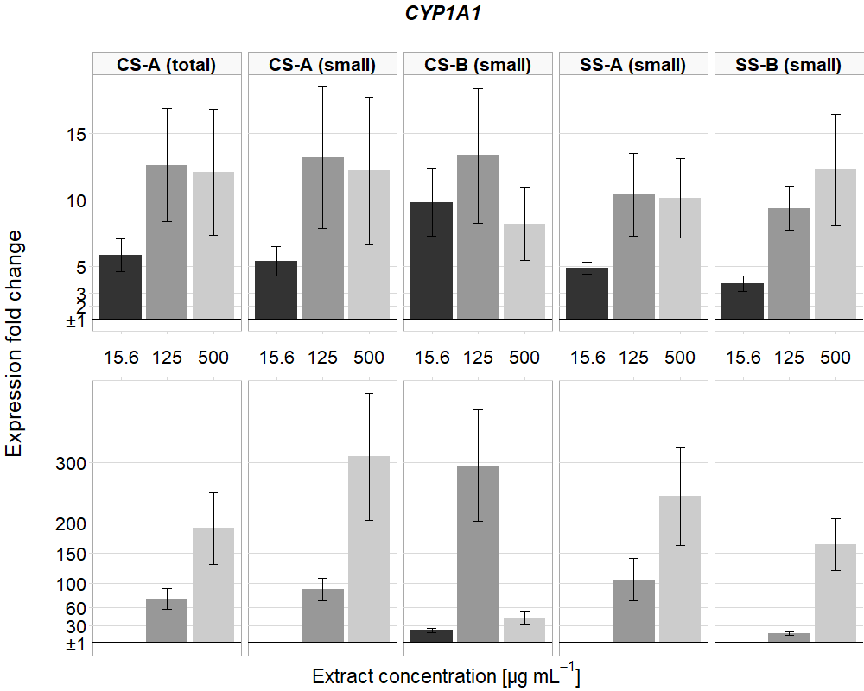

**Fig. S1** Gene expression of *CYP1A1* for all samples and all concentrations tested. Mean and standard error of mean (n=3) of every sample are depicted

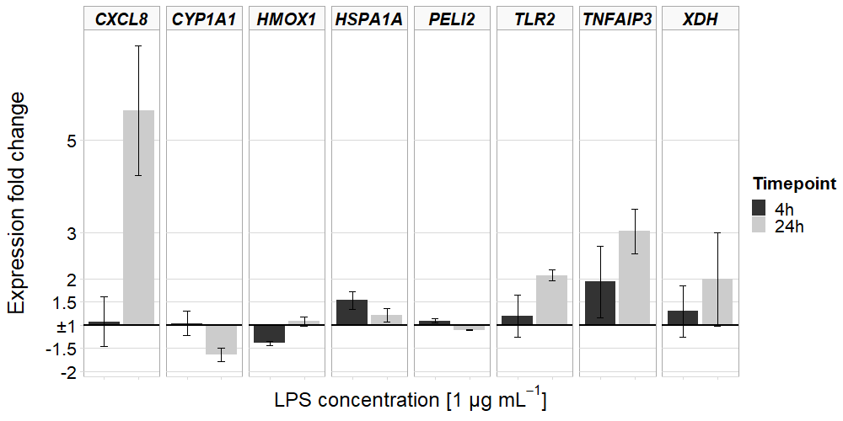

**Fig. S2** Gene expression regulation for *CXCL8*, *CYP1A1*, *HMOX1*, *HSPA1A*, *PELI2*, *TLR2*, *TNFAIP3* and *XDH* by LPS after 4 h and 24 h

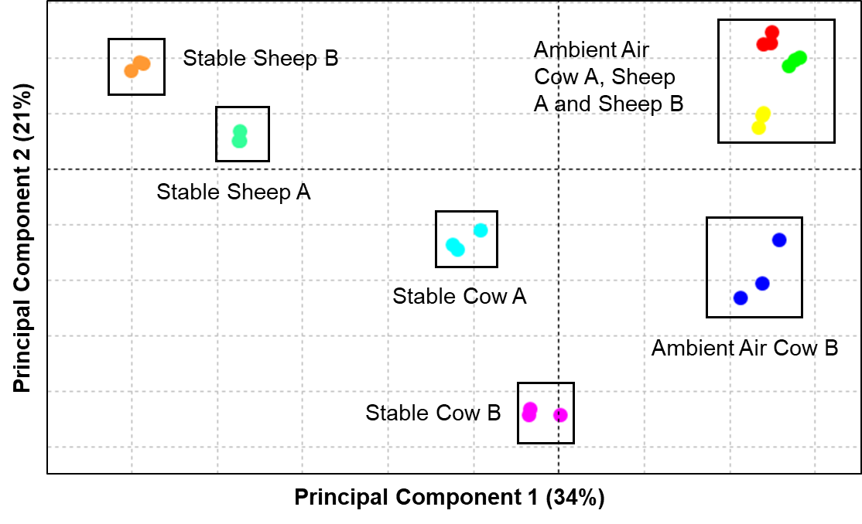

**Fig. S3** ANOVA-PCA of the different sheds including the ambient air samples. Red: Ambient Air Sheep B; Green: Ambient Air Cow A; Yellow: Ambient Air Sheep A

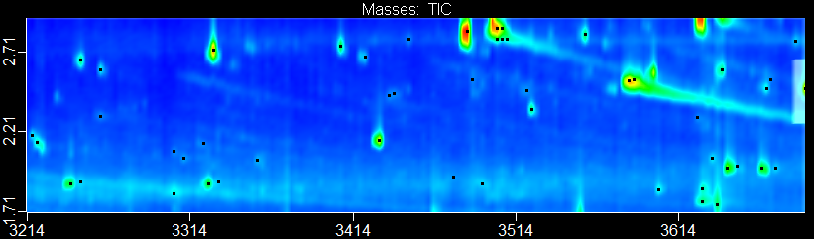

**3214**

**3314**

**3414**

**3514**

**3614**

**1.7**

**2.2**

**2.7**

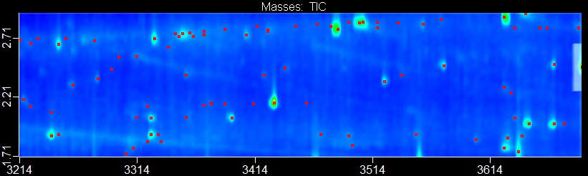

**1.7**

**2.2**

**2.7**

1

2

3

4

Retention time [s]

Retention time [s]

**a**

**b**

**Fig. S4** Chromatographic region of the four significant peaks found in cow sheds (**a**) compared to sheep sheds (**b**). Retention time first dimension: 3200-3700 s. Retention time second dimension: 1.7-2.7 s. Key components numbered from 1 to 4

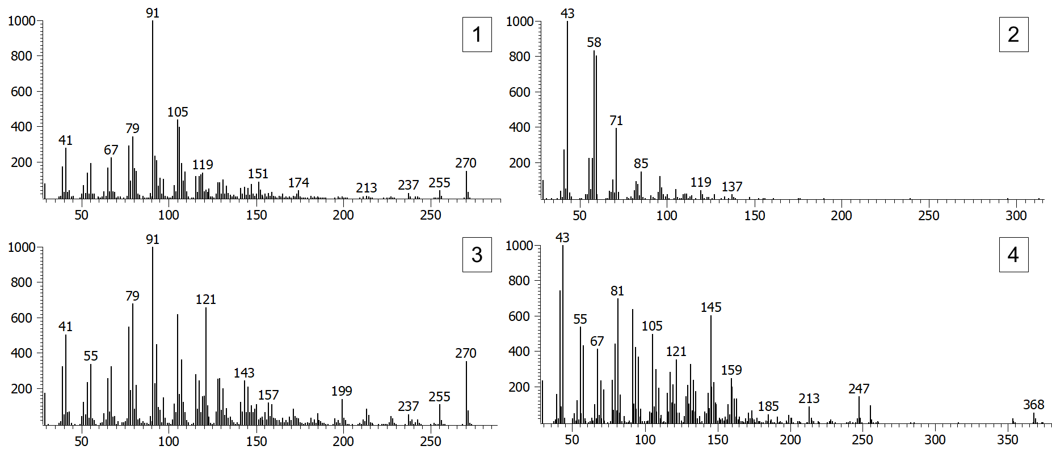

**Fig. S5** Exemplary mass spectra (peak true) of the four key components identified in cow shed A. **1** Docosahexaenoic acid **2** 2-Nonadecanone **3** Dehydroisoandrosterone sulfate **4** Cholesta-3,5-diene

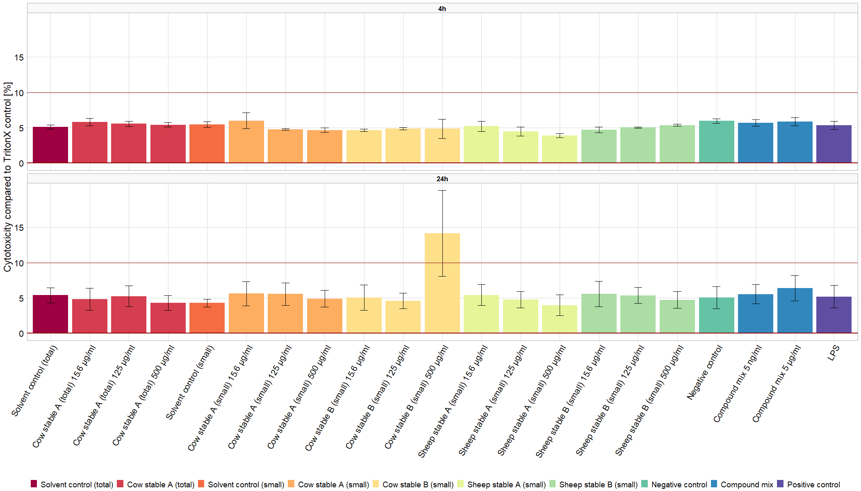

**Fig. S6** LDH plots after exposure to different shed extracts and standard materials after 4 h and 24 h

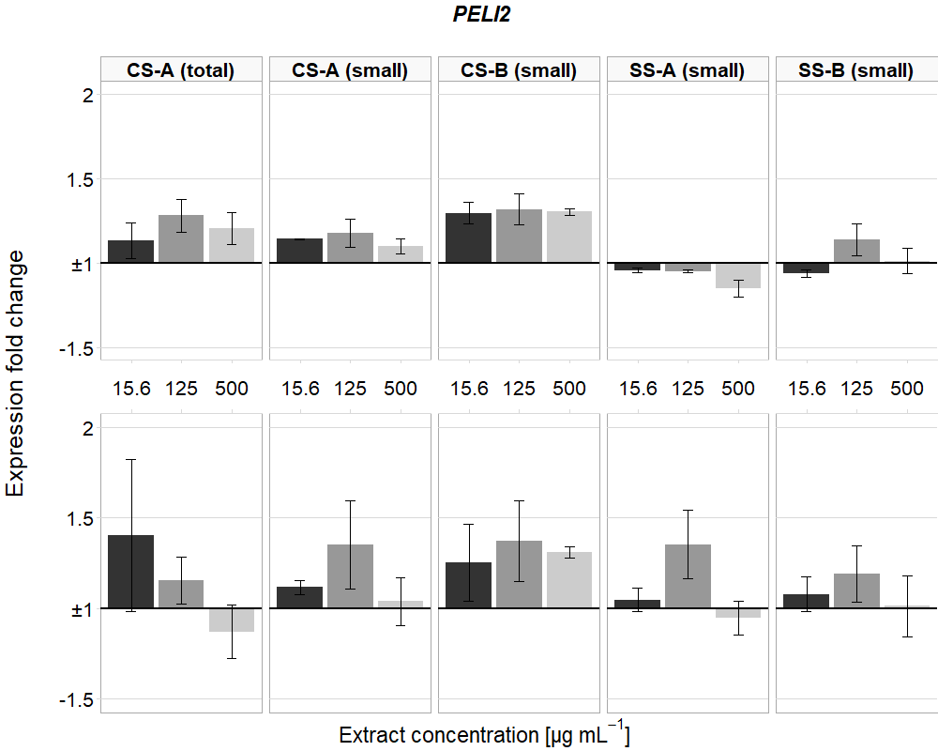

**Fig. S7** Gene expression of *PELI2* for all samples and all concentrations tested. Mean and standard error of mean (n=3) of every sample are depicted