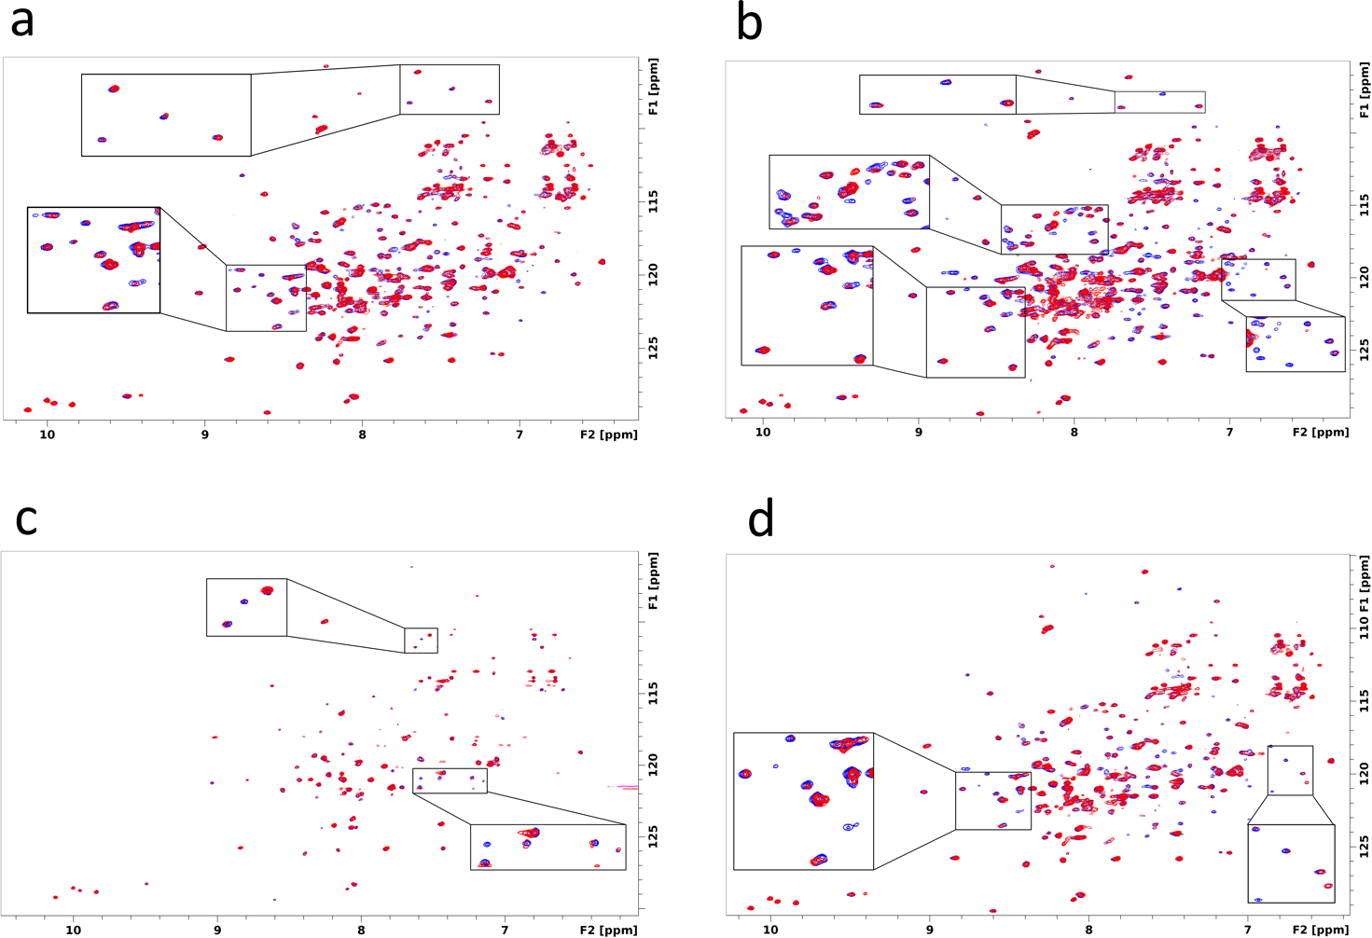

**Figure S1.** **NMR spectra.** 1H-15N 2D HSQC spectra of the 2H,15N-labeled TcPEX5 (blue) superimposed with spectra after addition of hit compound (a) 1, (b) 3, (c) 4 and (d) 5 at 1:1 molar ratio (red). Regions of significant difference are highlighted.