**Supplement**

**Environmental risk factors of incident distal sensorimotor polyneuropathy: Results from the prospective population-based KORA F4/FF4 study**

Christian Herdera,b,c,*,**, Siqi Zhangd,**, Kathrin Wolfd, Haifa Maalmia,b,   
Gidon J. Bönhofa,b,c, Wolfgang Rathmannb,e, Lars Schwettmannf,g, Barbara Thorandd,h,   
Michael Rodena,b,c, Alexandra Schneiderd, Dan Zieglera,b,c,***, Annette Petersd,h,***

a Institute for Clinical Diabetology, German Diabetes Center, Leibniz Center for Diabetes Research at Heinrich Heine University Düsseldorf, Düsseldorf, Germany

b German Center for Diabetes Research (DZD), Partner Düsseldorf, München-Neuherberg, Germany

c Department of Endocrinology and Diabetology, Medical Faculty and University Hospital Düsseldorf, Heinrich Heine University Düsseldorf, Düsseldorf, Germany

d Institute of Epidemiology, Helmholtz Zentrum München, German Research Center for Environmental Health, Neuherberg, Germany

e Institute for Biometrics and Epidemiology, German Diabetes Center, Leibniz Center for Diabetes Research at Heinrich Heine University Düsseldorf, Düsseldorf, Germany

f Institute of Health Economics and Health Care Management, Helmholtz Zentrum München, German Research Center for Environmental Health, Neuherberg, Germany

g Department of Economics, Martin Luther University Halle-Wittenberg, Halle (Saale), Germany

h German Center for Diabetes Research (DZD), Partner Neuherberg, München-Neuherberg, Germany

**Table A.1.** Cumulative Risk Index (95% CI) of incident DSPN associated with PNC, mean temperature of warm season, night-time average traffic noise, and NDVI in a 100 m buffer from multi-exposure models among all participants, non-obese participants, and obese participants (main model).

|  |  |  |  |  |  |
| --- | --- | --- | --- | --- | --- |
|  | **Exposures** | **All (*n* = 423)** | **Non-obese (n=306)** | **Obese (n=117)** | ***P*diff** |
| Two-exposure | PNC + T | 1.33 (1.06, 1.67)* | 1.33 (1.02, 1.75)* | 1.42 (0.90, 2.24) | 0.82 |
|  | T + Noise | 1.22 (0.94, 1.58) | 1.15 (0.84, 1.56) | 1.34 (0.84, 2.13) | 0.59 |
|  | T + NDVI | 1.20 (0.92, 1.56) | 1.14 (0.86, 1.52) | 1.40 (0.84, 2.33) | 0.49 |
|  | PNC + Noise | 1.15 (0.99, 1.33)† | 1.01 (0.83, 1.23) | 1.40 (1.14, 1.74)** | 0.02 |
|  | PNC + NDVI | 1.13 (0.97, 1.33) | 1.01 (0.85, 1.20) | 1.52 (1.15, 1.99)** | 0.01 |
|  | Noise + NDVI | 1.09 (0.90, 1.33) | 0.90 (0.73, 1.12) | 1.48 (1.06, 2.07)* | 0.02 |
| Three-exposure | PNC + T + Noise | 1.38 (1.05, 1.80)* | 1.26 (0.91, 1.75) | 1.69 (0.97, 2.96)† | 0.37 |
|  | PNC + T + NDVI | 1.35 (1.03, 1.76)* | 1.26 (0.93, 1.70) | 1.74 (1.03, 2.95)* | 0.29 |
|  | T + Noise + NDVI | 1.29 (0.94, 1.78) | 1.09 (0.77, 1.55) | 1.76 (0.96, 3.20)† | 0.18 |
|  | PNC + Noise + NDVI | 1.15 (0.96, 1.38) | 0.95 (0.77, 1.18) | 1.60 (1.18, 2.19)** | 0.01 |
| Four-exposure | PNC + T + Noise + NDVI | 1.39 (1.02, 1.91)* | 1.18 (0.83, 1.67) | 2.01 (1.10, 3.67)* | 0.13 |

Note: The model (main model) was adjusted for age, sex, years of education, neighborhood socioeconomic status, smoking status, alcohol consumption, physical activity, height, and waist circumference. Effects were estimated for an IQR decrease in the mean temperature of warm season and NDVI in a 100 m buffer, and for an IQR increase in night-time average traffic noise and PNC.

DSPN=distal sensorimotor polyneuropathy, NDVI= Normalized Difference Vegetation Index, PNC=particle number concentration, T=temperature.

\*\**P* < 0.01; \**P* < 0.05; †*P* < 0.1

**Table A.2.** Step-wise exposure selection based on goodness of model fit among all participants.

|  |  |  |
| --- | --- | --- |
|  | **Exposures** | **BIC** |
| 1st exposure | PNC | 763.25 |
|  | T | 764.15 |
|  | Noise | 764.68 |
|  | NDVI | 764.73 |
| 2nd exposure | PNC + T | 767.99 |
|  | PNC + Noise | 769.26 |
|  | PNC + NDVI | 769.30 |
| 3rd exposure | PNC + T + Noise | 773.89 |
|  | PNC + T + NDVI | 774.01 |
| Four exposures | PNC + T + Noise + NDVI | 779.91 |

Note: When selecting the second exposure, the first exposure with the lowest BIC (PNC) was forced into the model; when selecting the third exposure, the combination of first and second exposures with the lowest BIC (PNC + T) was forced into the model.

BIC=Bayesian information criterion, NDVI= Normalized Difference Vegetation Index, PNC=particle number concentration, T=temperature.

**Table A.3.** Risk ratios (95% confidence intervals) of incident DSPN for an IQR change in exposures stratified by obesity (extended model).

|  |  |  |  |  |  |
| --- | --- | --- | --- | --- | --- |
|  | **Exposure** | **IQR** | **Non-obese (n=306)** | **Obese (n=117)** | ***P*interaction** |
| Temperature | Annual mean temperature | 0.67 °C | 1.19 (0.95, 1.51) | 0.97 (0.72, 1.32) | 0.27 |
|  | Mean temperature of warm season | 0.75 °C | 1.21 (0.98, 1.50)† | 0.99 (0.74, 1.32) | 0.25 |
|  | Mean temperature of cold season | 0.58 °C | 1.15 (0.91, 1.45) | 0.95 (0.70, 1.28) | 0.30 |
| Greenness | NDVI_100 m | 0.11 | 0.93 (0.79, 1.09) | 1.30 (0.98, 1.73)† | 0.03 |
|  | NDVI_300 m | 0.11 | 0.89 (0.74, 1.07) | 1.14 (0.88, 1.48) | 0.10 |
|  | NDVI_500 m | 0.11 | 0.82 (0.67, 1.01)† | 1.10 (0.81, 1.48) | 0.08 |
|  | NDVI_1000 m | 0.11 | 0.78 (0.63, 0.98)* | 0.99 (0.72, 1.36) | 0.17 |
| Noise | Daily average traffic noise | 7.4 dB(A) | 0.95 (0.79, 1.13) | 1.20 (0.98, 1.47)† | 0.07 |
|  | Night-time average traffic noise | 7.2 dB(A) | 0.96 (0.80, 1.14) | 1.24 (1.01, 1.52)* | 0.05 |
| Air pollutant | PNC | 2.0×103/cm3 | 1.06 (0.91, 1.24) | 1.28 (1.07, 1.54)** | 0.09 |
|  | PM10 | 2.1 μg/m3 | 0.91 (0.72, 1.14) | 1.14 (0.90, 1.45) | 0.13 |
|  | PMcoarse | 1.4 μg/m3 | 0.84 (0.68, 1.05) | 1.22 (0.93, 1.60) | 0.02 |
|  | PM2.5 | 1.5 μg/m3 | 0.89 (0.72, 1.09) | 1.10 (0.78, 1.55) | 0.25 |
|  | PM2.5abs | 0.3×10-5/m | 0.89 (0.69, 1.15) | 0.98 (0.71, 1.35) | 0.61 |
|  | NO2 | 6.8 μg/m3 | 0.88 (0.69, 1.13) | 1.16 (0.86, 1.57) | 0.10 |
|  | NOx | 8.6 μg/m3 | 1.00 (0.84, 1.19) | 1.23 (0.96, 1.58) | 0.13 |
|  | O3 | 3.5 μg/m3 | 0.91 (0.75, 1.10) | 1.03 (0.79, 1.36) | 0.44 |

Note: The model (extended model) was adjusted for age, sex, years of education, neighborhood socioeconomic status, smoking status, alcohol consumption, physical activity, height, waist circumference, levels of total cholesterol, HbA1c and uric acid, history of cardiovascular disease, estimated glomerular filtration rate, neurological conditions that might cause nerve damage, use of lipid-lowering medication, and use of NSAIDs.

Effects were estimated for an IQR decrease in metrics of air temperature and greenness, and for an IQR increase in metrics of traffic noise and air pollution.

DSPN=distal sensorimotor polyneuropathy, IQR=interquartile range, NDVI= Normalized Difference Vegetation Index, NO2=nitrogen dioxide, NOx=nitrogen oxides, O3=ozone, PM=particulate matter, PNC=particle number concentration, SD=standard deviation.

\*\**P* < 0.01; \**P* < 0.05; †*P* < 0.1

**Table A.4.** Step-wise exposure selection based on goodness of model fit with interaction between exposures and obesity status.

|  |  |  |
| --- | --- | --- |
|  | **Exposures** | **BIC** |
| 1st exposure | NDVI | 773.18 |
|  | PNC | 773.72 |
|  | Noise | 774.44 |
|  | T | 775.23 |
| 2nd exposure | NDVI + PNC | 783.09 |
|  | NDVI + Noise | 783.96 |
|  | NDVI + T | 784.02 |
| 3rd exposure | NDVI + PNC + T | 793.49 |
|  | NDVI + PNC + Noise | 794.13 |
| Four exposures | NDVI + PNC + T + Noise | 804.51 |

Note: When selecting the second exposure, the first exposure with the lowest BIC (NDVI) was forced into the model; when selecting the third exposure, the combination of first and second exposures with the lowest BIC (NDVI + PNC) was forced into the model.

BIC=Bayesian information criterion, NDVI= Normalized Difference Vegetation Index, PNC=particle number concentration, T=temperature.

**Table A.5.** Cumulative Risk Index (95% CI) of incident DSPN associated with PNC, mean temperature of warm season, night-time average traffic noise, and NDVI in a 100 m buffer from multi-exposure models among all participants, non-obese participants, and obese participants (extended model).

|  |  |  |  |  |  |
| --- | --- | --- | --- | --- | --- |
|  | **Exposures** | **All (*n* = 423)** | **Non-obese (n=306)** | **Obese (n=117)** | ***P*diff** |
| Two-exposure | PNC + T | 1.35 (1.07, 1.69)* | 1.33 (1.01, 1.77)* | 1.46 (0.93, 2.28)† | 0.74 |
|  | T + Noise | 1.25 (0.96, 1.63)† | 1.17 (0.85, 1.60) | 1.42 (0.90, 2.24) | 0.48 |
|  | T + NDVI | 1.19 (0.92, 1.55) | 1.12 (0.83, 1.50) | 1.42 (0.87, 2.33) | 0.41 |
|  | PNC + Noise | 1.16 (0.99, 1.35) | 1.02 (0.84, 1.25) | 1.41 (1.13, 1.76)** | 0.03 |
|  | PNC + NDVI | 1.13 (0.96, 1.32) | 1.00 (0.84, 1.21) | 1.49 (1.14, 1.93)** | 0.02 |
|  | Noise + NDVI | 1.09 (0.90, 1.33) | 0.91 (0.73, 1.14) | 1.47 (1.06, 2.03)* | 0.02 |
| Three-exposure | PNC + T + Noise | 1.41 (1.07, 1.86)* | 1.28 (0.92, 1.79) | 1.80 (1.06, 3.06)* | 0.29 |
|  | PNC + T + NDVI | 1.35 (1.03, 1.77)* | 1.24 (0.91, 1.71) | 1.78 (1.07, 2.96)* | 0.24 |
|  | T + Noise + NDVI | 1.31 (0.95, 1.81) | 1.10 (0.76, 1.58) | 1.84 (1.01, 3.36)* | 0.15 |
|  | PNC + Noise + NDVI | 1.15 (0.96, 1.39) | 0.96 (0.77, 1.20) | 1.59 (1.17, 2.14)** | 0.01 |
| Four-exposure | PNC + T + Noise + NDVI | 1.42 (1.03, 1.95)* | 1.19 (0.83, 1.71) | 2.10 (1.16, 3.81)* | 0.11 |

Note: The model (extended model) was adjusted for age, sex, years of education, neighborhood socioeconomic status, smoking status, alcohol consumption, physical activity, height, and waist circumference, levels of total cholesterol, HbA1c, uric acid, history of cardiovascular disease, estimated glomerular filtration rate, neurological conditions that might cause nerve damage, use of lipid-lowering medication, and use of NSAIDs.

Effects were estimated for an IQR decrease in the mean temperature of warm season and NDVI in a 100 m buffer, and for an IQR increase in night-time average traffic noise and PNC.

DSPN=distal sensorimotor polyneuropathy, NDVI= Normalized Difference Vegetation Index, PNC=particle number concentration, T=temperature.

\*\**P* < 0.01; \**P* < 0.05; †*P* < 0.1

**Table A.6.** Risk ratios (95% confidence intervals) of incident DSPN for an IQR change in exposures among non-movers and stratified by obesity.

|  |  |  |  |  |  |
| --- | --- | --- | --- | --- | --- |
|  | **Exposure** | **All (n=397)** | **Non-obese (n=289)** | **Obese (n=108)** | ***P*interaction** |
| Temperature | Annual mean temperature | 1.09 (0.89, 1.33) | 1.17 (0.92, 1.48) | 0.96 (0.70, 1.32) | 0.31 |
|  | Mean temperature of warm season | 1.11 (0.92, 1.35) | 1.18 (0.95, 1.47) | 0.99 (0.73, 1.34) | 0.31 |
|  | Mean temperature of cold season | 1.05 (0.86, 1.27) | 1.12 (0.88, 1.42) | 0.92 (0.68, 1.25) | 0.31 |
| Greenness | NDVI_100 m | 1.03 (0.89, 1.21) | 0.95 (0.81, 1.11) | 1.27 (0.93, 1.73) | 0.09 |
|  | NDVI_300 m | 0.98 (0.83, 1.16) | 0.93 (0.77, 1.11) | 1.13 (0.87, 1.47) | 0.18 |
|  | NDVI_500 m | 0.94 (0.77, 1.13) | 0.86 (0.70, 1.06) | 1.12 (0.83, 1.51) | 0.12 |
|  | NDVI_1000 m | 0.89 (0.73, 1.09) | 0.83 (0.67, 1.04) | 1.02 (0.73, 1.43) | 0.24 |
| Noise | Daily average traffic noise | 1.01 (0.88, 1.17) | 0.93 (0.78, 1.11) | 1.16 (0.94, 1.43) | 0.10 |
|  | Night-time average traffic noise | 1.03 (0.89, 1.19) | 0.93 (0.78, 1.11) | 1.19 (0.96, 1.48)† | 0.08 |
| Air pollutant | PNC | 1.13 (0.99, 1.29) | 1.07 (0.91, 1.25) | 1.26 (1.02, 1.56)* | 0.18 |
|  | PM10 | 1.02 (0.84, 1.23) | 0.92 (0.73, 1.16) | 1.17 (0.91, 1.51) | 0.13 |
|  | PMcoarse | 0.96 (0.78, 1.18) | 0.85 (0.68, 1.06) | 1.24 (0.92, 1.68) | 0.02 |
|  | PM2.5 | 0.95 (0.78, 1.17) | 0.90 (0.73, 1.12) | 1.08 (0.76, 1.54) | 0.33 |
|  | PM2.5abs | 0.96 (0.75, 1.22) | 0.92 (0.71, 1.20) | 1.01 (0.72, 1.43) | 0.59 |
|  | NO2 | 1.02 (0.80, 1.30) | 0.92 (0.71, 1.20) | 1.21 (0.88, 1.67) | 0.10 |
|  | NOx | 1.07 (0.91, 1.27) | 1.01 (0.84, 1.21) | 1.20 (0.92, 1.56) | 0.22 |
|  | O3 | 0.95 (0.81, 1.11) | 0.91 (0.75, 1.09) | 1.02 (0.77, 1.35) | 0.50 |

Note: The model (main model) was adjusted for age, sex, years of education, neighborhood socioeconomic status, smoking status, alcohol consumption, physical activity, height, and waist circumference.

Effects were estimated for an IQR decrease in metrics of air temperature and greenness, and for an IQR increase in metrics of traffic noise and air pollution.IQR values were the same as the ones in the main analysis.

DSPN=distal sensorimotor polyneuropathy, IQR=interquartile range, NDVI= Normalized Difference Vegetation Index, NO2=nitrogen dioxide, NOx=nitrogen oxides, O3=ozone, PM=particulate matter, PNC=particle number concentration, SD=standard deviation.

\**P* < 0.05; †*P* < 0.1

**Table A.7.** Risk ratios (95% confidence intervals) of incident DSPN for an IQR decrease in air temperature indices and NDVI assessed in 2014 among all participants and stratified by obesity.

|  |  |  |  |  |  |  |
| --- | --- | --- | --- | --- | --- | --- |
|  | **Exposure** | **IQR** | **All (*n* = 423)** | **Non-obese (n=306)** | **Obese (n=117)** | ***P*interaction** |
| Temperature | Annual mean temperature | 0.54°C | 1.00 (0.84, 1.19) | 1.11 (0.91, 1.35) | 0.82 (0.61, 1.10) | 0.08 |
|  | Mean temperature of warm season | 0.73°C | 1.02 (0.84, 1.24) | 1.12 (0.90, 1.39) | 0.84 (0.61, 1.17) | 0.12 |
|  | Mean temperature of cold season | 0.46°C | 0.97 (0.82, 1.16) | 1.11 (0.89, 1.37) | 0.77 (0.57, 1.05)† | 0.06 |
| Greenness | NDVI_100 m | 0.08 | 1.05 (0.92, 1.20) | 0.95 (0.81, 1.11) | 1.24 (0.97, 1.58)† | 0.05 |
|  | NDVI_300 m | 0.09 | 0.99 (0.82, 1.20) | 0.88 (0.70, 1.10) | 1.19 (0.91, 1.57) | 0.05 |
|  | NDVI_500 m | 0.10 | 0.96 (0.77, 1.19) | 0.84 (0.66, 1.07) | 1.21 (0.88, 1.65) | 0.03 |
|  | NDVI_1000 m | 0.10 | 0.86 (0.67, 1.10) | 0.76 (0.58, 0.99)* | 1.07 (0.76, 1.51) | 0.06 |

Note: The model (main model) was adjusted for age, sex, years of education, neighborhood socioeconomic status, smoking status, alcohol consumption, physical activity, height, and waist circumference.

DSPN=distal sensorimotor polyneuropathy, IQR=interquartile range, NDVI= Normalized Difference Vegetation Index.

\**P* < 0.05; †*P* < 0.1

**Table A.8.** P value for the interaction term between two exposures in the two-exposure model among all, non-obese, and obese participants.

|  |  |  |  |  |  |  |  |  |  |  |  |
| --- | --- | --- | --- | --- | --- | --- | --- | --- | --- | --- | --- |
|  | **All (*n* = 423)** | | |  | **Non-obese (n=306)** | | |  | **Obese (n=117)** | | |
| **Exposure** | **NDVI** | **Noise** | **PNC** |  | **NDVI** | **Noise** | **PNC** |  | **NDVI** | **Noise** | **PNC** |
| Temperature | 0.64 | 0.20 | 0.13 |  | 0.89 | 0.64 | 0.15 |  | 0.89 | 0.61 | 0.53 |
| NDVI |  | 0.41 | 0.72 |  |  | 0.22 | 0.61 |  |  | 0.68 | 0.55 |
| Noise |  |  | 0.32 |  |  |  | 0.11 |  |  |  | 0.88 |

**Table A.9.** Absolute standardised mean differences before and after inverse-probability weighting for each covariate in the main model.

|  |  |  |
| --- | --- | --- |
| **Covariate** | **Unweighted** | **Weighted** |
| Age | 0.650 | 0.039 |
| Sex | 0.024 | 0.016 |
| Years of education | 0.186 | 0.021 |
| Smoking status_former smoker | 0.008 | 0.007 |
| Smoking status_never smoker | 0.004 | 0.005 |
| Alcohol consumption | 0.038 | 0.033 |
| Physical activity_medium | 0.145 | 0.030 |
| Physical activity_high | 0.240 | 0.008 |
| Height | 0.027 | 0.006 |
| Waist circumference | 0.392 | 0.020 |
| Low neighbourhood SES | 0.006 | 0.012 |

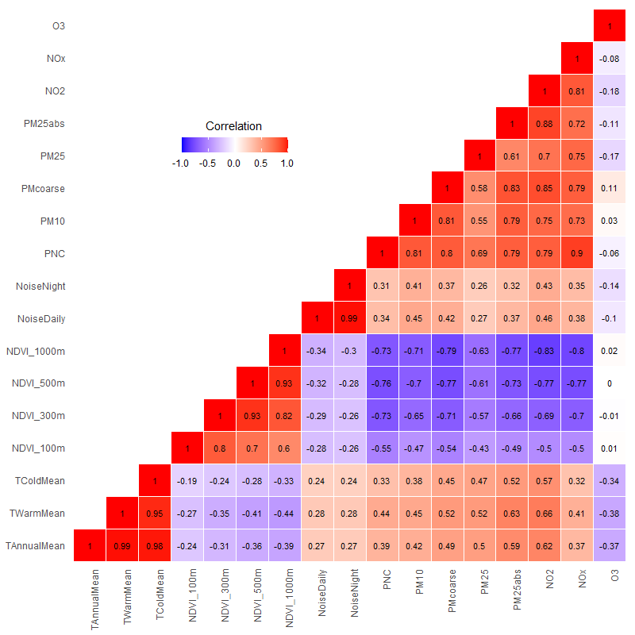

**Figure A.1**. Spearman correlation coefficients of the environmental exposures.

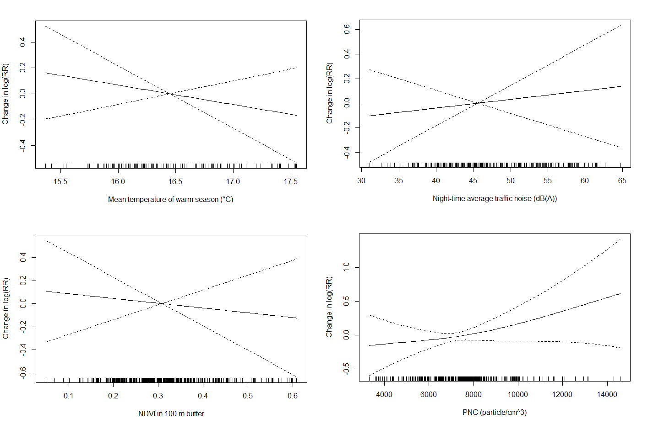

**Figure A.2**. Exposure-response functions between representative exposures and incident DSPN.