**Figure S1: ACSL4LPC-KO induces distinct changes in hepatic lipid profile**

(a) ACSL4LPC-KO lead to an accumulation of 16:0 LPC both on SD and WD. No difference was observed in LPCh 18:0, LPCh 18:1 or LPCh 18:2. (b) ACSL4LPC-KO mice show an accumulation of LPE 16:0, LPE 18:0 and LPE 20:4 both on SD and WD.

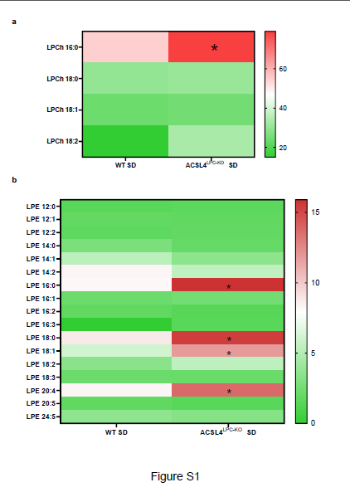

**Figure S2: Extended immunogenic profiling did not reveal any changes in immune cell populations in ACSL4LPC-KO mice**

(a-b) ACSL4LPC-KO mice and WT mice did not show differences in the presence of CD8+or CD4+ T-cells

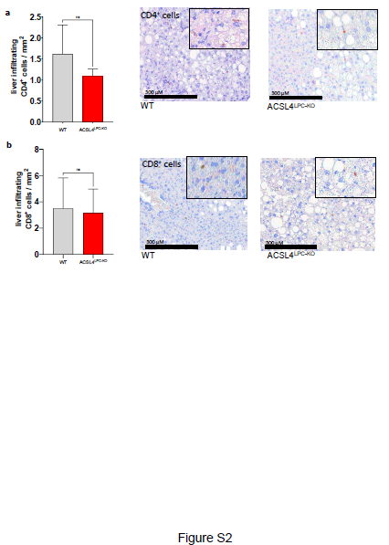

**Figure S3: Primer sequences**

The primer sequences used for qPCR in whole liver tissue are presented as sense and antisense primers.

