**Metabolic tumor constitution is superior to tumor regression grading for evaluating response to neoadjuvant therapy of esophageal adenocarcinoma patients**

A Buck, VM Prade *et al. J Pathol* DOI: 10.1002/path.5828

**Supplementary Figures S1–S4**

**Supplementary Table S1**

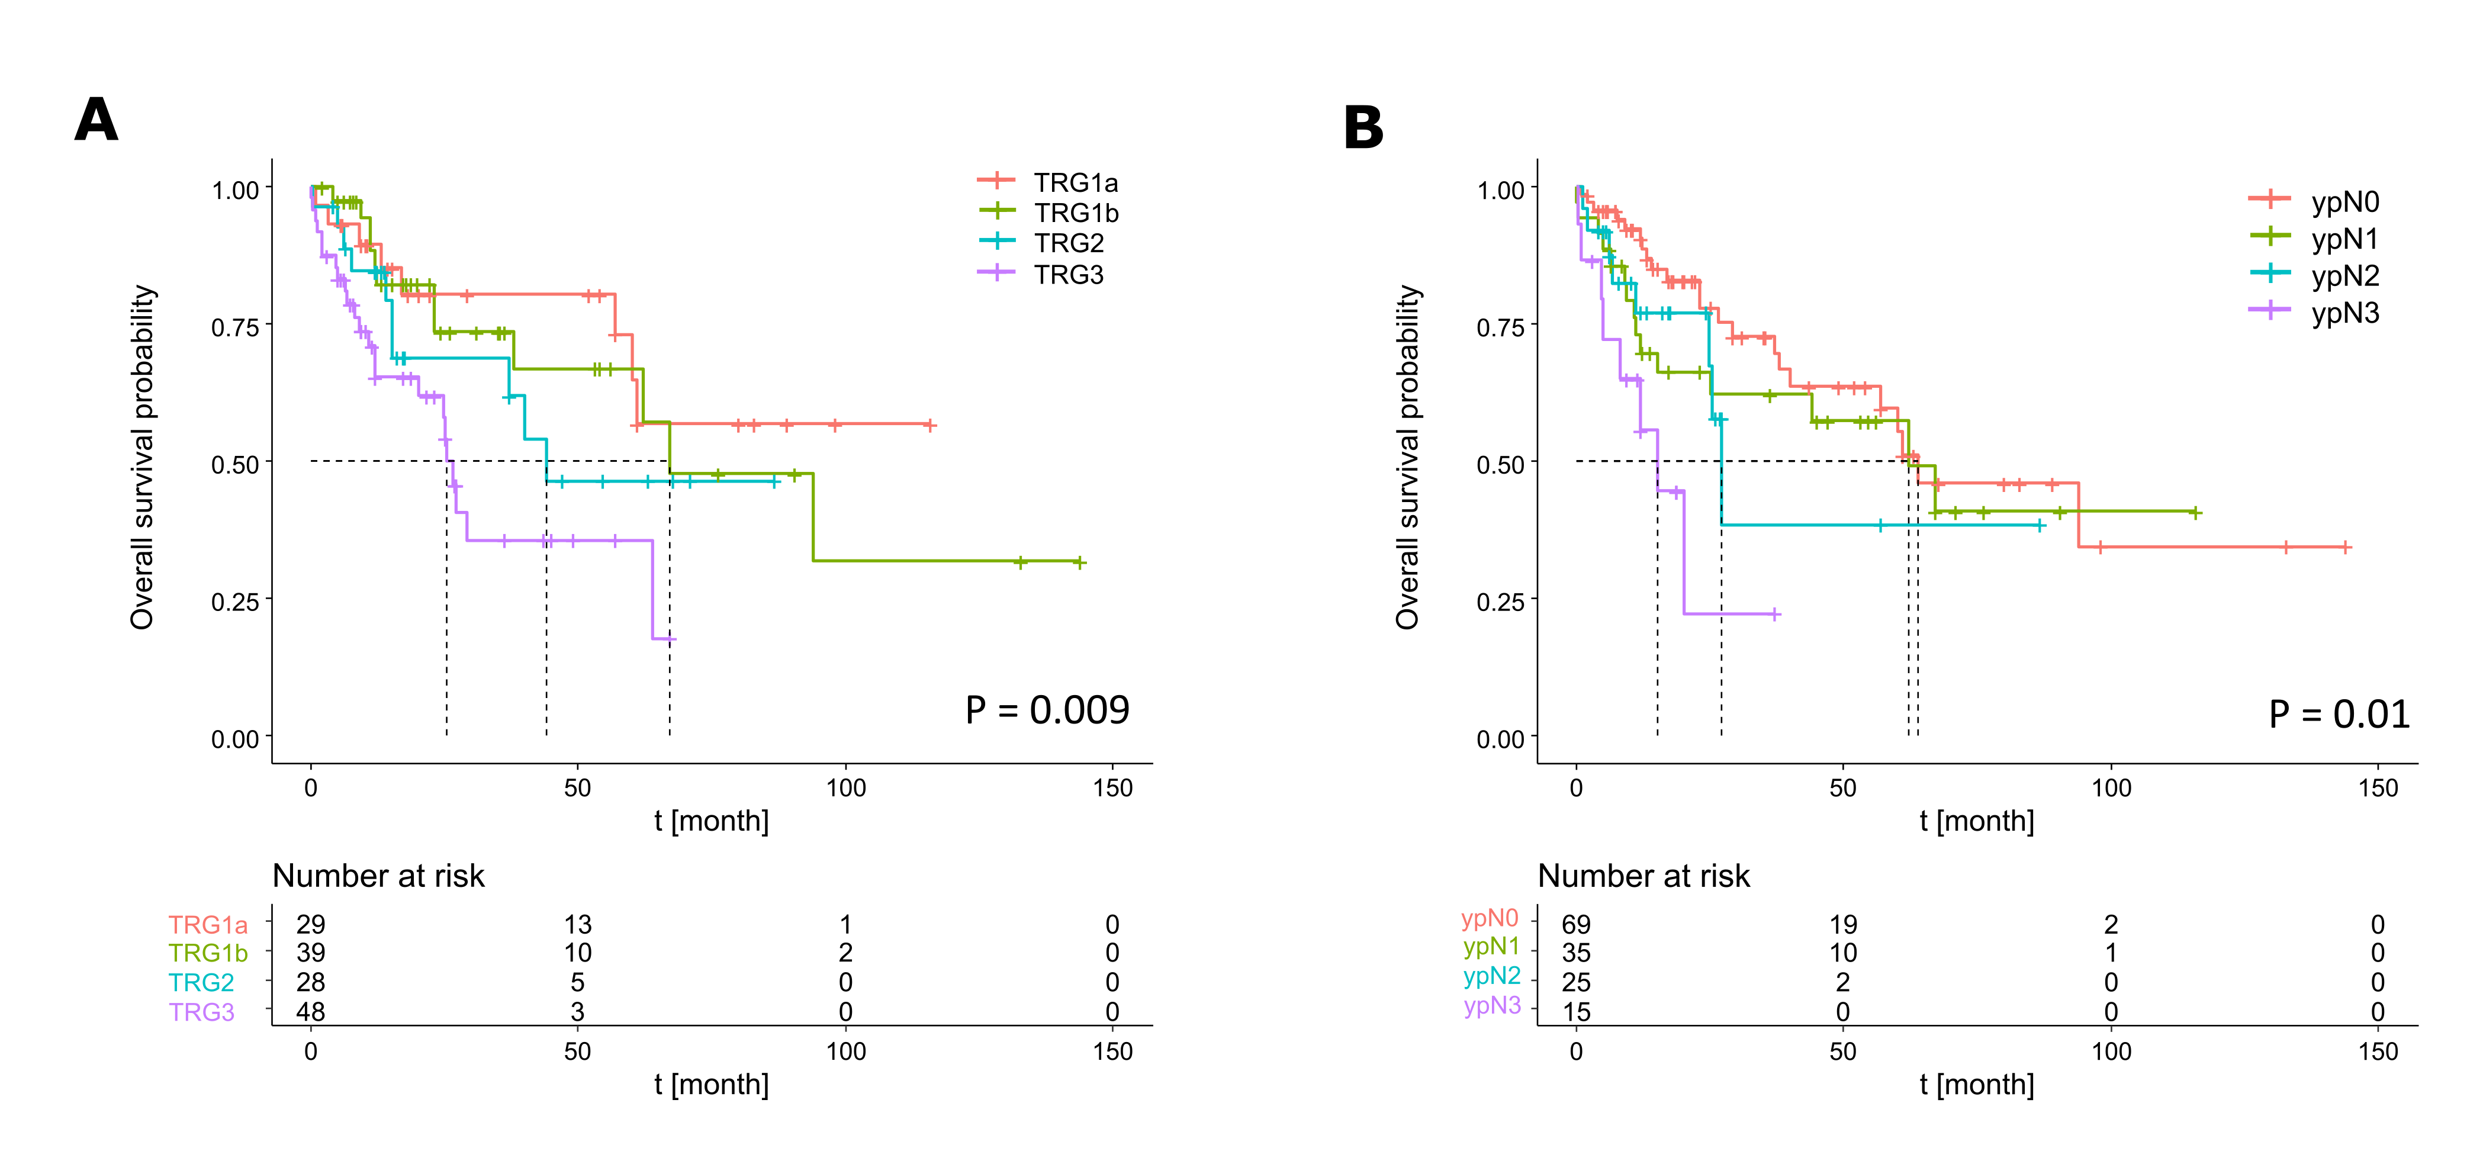

**Figure S1.** Overall survival according to tumor regression grade and lymph node status. Overall survival stratified by (A) TRG and (B) ypN category in patients treated with neoadjuvant therapy following surgery. Differences in overall survival were determined by Kaplan–Meier survival estimates using a log-rank test. *P* values less than 0.05 were considered significant.

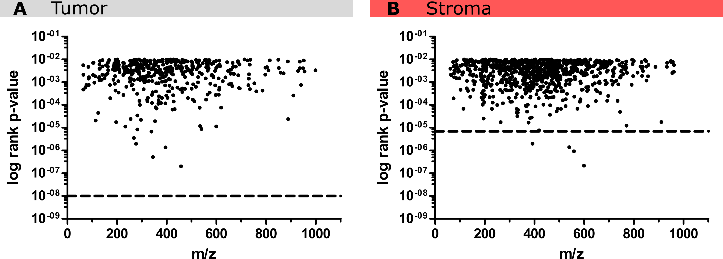

**Figure S2.** Significance values of individual metabolites compared with the performance of the classifiers. (A) The tumor classifier (dashed line, *p*= 10−8) is higher in significance compared with its individual metabolites used for patient stratification. (B) Most stroma metabolites also show a lower significance than the classifier (dashed line, *p*= 7 × 10−6). It is shown that four molecular ions at *m/z* 599.1444 (feature importance: 0.0003; *p =*2.178E-07), *m/z* 559.0366 (feature importance: 0.0007; *p =*9.215E-07), *m/z* 540.0678 (feature importance: 0.0002; *p =*1.385E-06), and *m/z* 392.0282 (feature importance: 0.0034; *p =*1.978E-06) are of higher significance but do not contribute to optimum patient stratification due to a low importance of classifier features. The stroma classifier was trained with the same threshold that was used for the classification of tumor tissue regions.

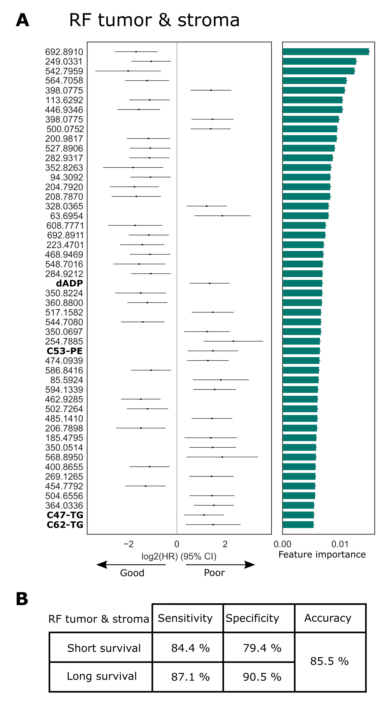

**Figure S3.** Random forest (RF) classifier including metabolites from both tissue compartments, tumor and stroma, results in risk stratification of patients after neoadjuvant treatment. (A) Forest plots of log2 hazard ratios with 95% confidence intervals obtained for the classification to separate patients into metabolic responding groups. The plot is ordered according to the importance of individual tumor and stroma metabolite features. (B) Diagnostic performance summarizing the sensitivity, specificity, and accuracy of the combined classification approach. *P* values less than 0.05 were considered significant.

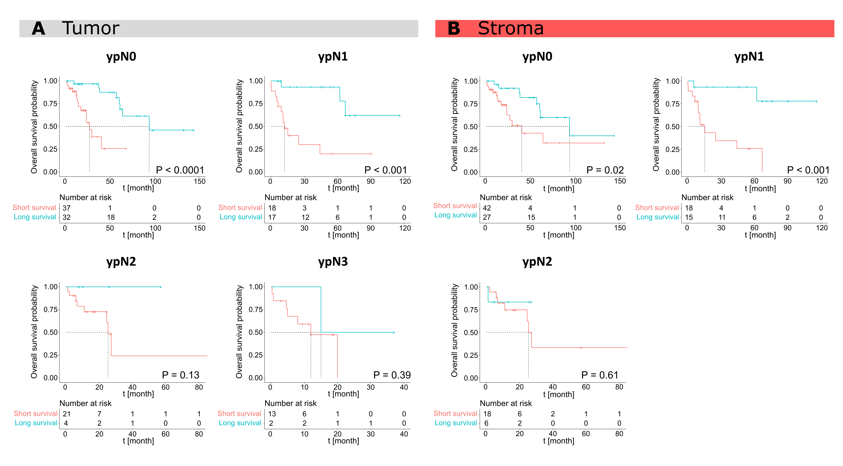

**Figure S4.** Tumor and stroma random forest classifiers applied to subgroups of the ypN enable patient stratification. (A) Tumor and (B) stroma classifiers stratified patients significantly within ypN0 and ypN1, while classification in ypN2 and ypN3 was not significant. In the stroma, the ypN3 category could not be further stratified with the classifiers using Kaplan–Meier analysis. *P* values less than 0.05 were considered significant.

**Table S1.** Clinicopathological variables of 144 patients with EAC who underwent neoadjuvant chemoradiotherapy followed by esophagectomy and 64 patients with primary resected EAC

|  |  |  |  |  |
| --- | --- | --- | --- | --- |
|  |  | **Neoadjuvant EAC** |  | **Primary resected EAC** |
| **Variables** |  | ***n* (%)** |  | ***n* (%)** |
| Depth of invasion [(y)pT] | T0 | 29 (20.1%) |  | 0 |
|  | T1 | 24 (16.7%) |  | 0 |
|  | T2 | 27 (18.7%) |  | 0 |
|  | T3 | 60 (41.7%) |  | 62 (96.9%) |
|  | T4 | 4 (2.8%) |  | 2 (3.1%) |
| Lymph node status [(y)pN] | N0 | 69 (47.9%) |  | 20 (31.3%) |
|  | N1 | 35 (24.3%) |  | 13 (20.3%) |
|  | N2 | 25 (17.4%) |  | 18 (28.1%) |
|  | N3 | 15 (10.4%) |  | 13 (20.3%) |
| Distant metastases | Absent | 126 (87.5%) |  | 64 (100%) |
|  | Present | 18 (12.5%) |  | 0 (0%) |
| Resection status | R0 | 118 (81.9%) |  | 58 (90.6%) |
|  | R1 | 21 (14.6%) |  | 6 (9.4%) |
|  | Rx | 5 (3.5%) |  | – |
| TRG (Becker) | 1a | 29 (20.2%) |  | – |
|  | 1b | 39 (27.1%) |  | – |
|  | 2 | 28 (19.4%) |  | – |
|  | 3 | 48 (33.3%) |  | – |