# Time-resolved Phosphoproteomic Analysis Elucidates Hepatic 11,12-Epoxyeicosatrienoic Acid Signaling Pathways

Marco Rahma, Juliane Merl-Phama, Jerzy Adamskib,c, Stefanie M. Haucka#

aResearch Unit Protein Science, Helmholtz Zentrum München, German Research Center for Environmental Health GmbH, Ingolstädter Landstraße 1, D-85764 Neuherberg, Germany

bResearch Unit Molecular Endocrinology and Metabolism, Helmholtz Zentrum München, German Research Center for Environmental Health GmbH, Ingolstädter Landstraße 1, D-85764 Neuherberg, Germany

cDepartment of Biochemistry, Yong Loo Lin School of Medicine, National University of Singapore, Singapore

#Corresponding Author:

Stefanie Hauck

Research Unit Protein Science, Helmholtz Zentrum München

Ingolstädter Landstraße 1, D-85764 Neuherberg

Mail: [hauck@helmholtz-muenchen.de](mailto:hauck@helmholtz-muenchen.de)

# Keywords

Lipid Signaling, AKT/mTOR/p70S6K pathway, Eicosanoids, LC-MS/MS, TiO2

# Highlights

* LC-MS/MS-based phosphoproteomics deciphers 11,12-EET signaling networks
* 11,12-EET affects proteins involved in processes like RNA splicing and translation regulation
* 11,12-EET acutely activates the hepatic mTOR/p70S6K signaling pathway
* DNA damage response signaling is modulated by 11,12-EET treatment

# Abstract

Epoxyeicosatrienoic acids (EETs) are potent lipid mediators with well-established effects in vascular tissues. Recent studies indicated an emerging role of these eicosanoids in metabolic diseases and the EET signaling pathway was shown to be involved in hepatic insulin sensitivity. However, compared to vascular tissues, there is only limited knowledge about the underlying signaling pathways in the liver. Therefore, we employed an LC-MS/MS-based time-resolved phosphoproteomics approach to characterize 11,12-EET-mediated signaling events in the liver cell line Hepa 1-6.

11,12-EET treatment resulted in the time-dependent regulation of phosphopeptides involved in processes as yet unknown to be affected by EETs, including RNA processing, splicing and translation regulation. Pathway analysis combined with western blot-based validation revealed enhanced AKT/mTOR/p70S6K signaling as demonstrated by increased acute phosphorylation of AKT (Ser473) and p70S6K (Thr389). In addition, 11,12-EET treatment led to differential regulation of phosphopeptides including important mediators of the DNA damage response and we observed a prolonged induction of the etoposide-induced DNA damage marker γH2AX in response to 11,12-EET.

In summary, our findings extend current knowledge of 11,12-EET signaling events and emphasize the importance of the AKT/mTOR/p70S6K pathway in hepatic 11,12-EET signaling. Based on the results presented in this study, we furthermore propose a novel role of EET signaling in the regulation of the DNA damage response.

# 1. Introduction

Epoxyeicosatrienoic acids (EETs) are potent bioactive lipids generated from arachidonic acid by the action of cytochrome P450 epoxygenases [1]. While primarily attracting attention for their vasodilatory effects based on the hyperpolarization of smooth muscle cells [2], EETs potently stimulate angiogenesis, trigger anti-inflammatory responses and show anti-apoptotic and mitogenic effects [3]–[7]. This diversity of physiological responses suggests a variety of signaling mechanisms underlying the respective mode of actions. Most of these mechanisms seem to depend on cell type and physiological context and are thought to involve both intra- and extracellular signaling molecules [8].

In this regard, EETs were shown to increase phosphorylation of extracellular signal-regulated kinases (ERK)1/2 and p38 mitogen activated protein (MAP) kinase [9] and to transactivate epidermal growth factor (EGF) receptor [10]. In addition, EETs were found to stimulate protein tyrosine kinases and phosphatases [9] and to activate protein kinase A (PKA) by increasing cAMP [11]; [12]. Latter was associated with the binding of a membrane protein, although the identity of this putative EET receptor is still unknown.

While these observations primarily originate from tissues like the vasculature and kidney, an additional important role of EETs in hepatic insulin resistance and diabetes has begun to emerge in recent years, making the EET degrading soluble epoxide hydrolase (sEH) a promising drug target for cardiovascular and metabolic diseases [13]; [14].

In order to pharmacologically exploit the hepatic EET pathway and assess potential side effects and adversity, it is important to gain a deeper understanding of the molecular mechanisms which are involved in hepatic EET-mediated effects. Therefore, investigations addressing EET signaling in the liver are of great interest. So far, studies employing pharmacological inhibition or gene knockout of the EET degrading enzyme sEH have indirectly suggested the involvement of EETs in the stimulation of insulin secretion and improvement of insulin sensitivity and glucose homeostasis [15]; [16].Likewise, epoxygenase overexpression in a mouse model of insulin resistance restored hepatic intracellular signaling as measured by PI3-kinase expression and phosphorylation of AKT, AMPK and ERK1/2 [17]. Similarly, studies using direct EET treatment in hepatocytes showed that EETs act as enhancers of hepatic insulin signaling by increasing AKT phosphorylation in different experimental models of insulin resistance [18]; [19].

These studies employed targeted approaches to focus on individual components of EET signaling. In contrast, cellular signaling via protein phosphorylation is comprised of complex and tightly regulated networks which are involved in the control of crucial cellular functions like apoptosis, transcription, protein degradation, cytoskeletal regulation and cell cycle checkpoints. Dysregulation of these networks is a common characteristic of many complex diseases like diabetes and cancer [20]; [21]; [22].

In recent years, LC-MS/MS-based phosphoproteomics in conjunction with specific enrichment strategies like metal oxide affinity chromatography (MOAC) emerged as a powerful tool for the analysis of these phosphorylation-based signaling networks [23]. Despite facing limitations like reduced ionization efficiency of phosphopeptides, the lability of the phosphoester bond during fragmentation and the incomplete coverage of the phosphoproteome due to sample complexity and physicochemical properties of phosphopeptides [24]; [25], phosphoproteomics enables the simultaneous non-targeted identification and quantification of up to tens of thousands of phosphorylated peptides within a single MS experiment [26]–[30]. These characteristics led to the successful application of phosphoproteomics in the study of complex disease biology and the identification of targets for the development of precise pharmacological therapies [31]; [32]; [33].

In contrast, the comprehensive unbiased characterization of EET-induced cellular protein phosphorylation has not been performed before.Especially in light of the emergence of the EET pathway as a pharmacological target, phosphoproteomics shows great potential to advance the understanding of the underlying complex signaling networks and to identify additional more specific targets for pharmacological intervention within the EET pathway.

Therefore, this study aimed to characterize mechanisms of short-term EET signaling in the liver cell line Hepa 1‑6 by using mass spectrometry-based quantitative phosphoproteomics. With this approach, we identified patterns of time-resolved dynamics in phosphosite regulation and associated biological processes. In conjunction with bioinformatic tools, the technique further enabled us to map regulated phosphosites to enriched consensus sequence motifs and to reveal cellular pathways affected by EET treatment.

Since we previously identified EETs as positive modulators of AKT phosphorylation [19], we moreover complement our phosphoproteomics dataset with the targeted analysis of other components of the insulin signaling pathway by western blotting. Altogether, this study further elucidates EET signaling mechanisms and the influence of EETs on the hepatic insulin signaling pathway up-and downstream of AKT.

# 2. Materials and Methods

## 2.1 Cell Culture

Hepa 1-6 cells were obtained from ATCC (ATCC CRL-1830) and cultured in a humidified incubator at 37° C and 5 % CO2 according to the instructions given by ATCC. Cells were grown in Dulbecco’s Modified Eagle Medium (DMEM, gibco 41966-029) complemented with fetal bovine serum (FBS, gibco 10500-064) to a final concentration of 10 % (v/v), 100 U/ml penicillin and 100 µg/ml streptomycin (gibco 15140-122). Cultures were tested for mycoplasma using a PCR test kit (PanReac AppliChem A3744). Detailed conditions and performance of treatment with test compounds and cell lysis are described in the respective sections.

## **2.2 Phosphoproteomic Analysis**

### 2.2.1 Treatment with 11,12-Epoxyeicosatrienoic Acid

For phosphoproteomic analysis, Hepa 1-6 cells were individually seeded in 10 cm dishes at a density of 1.6x106 cells/dish and allowed to attach for at least 24 h. Prior to stimulation with test compounds, cells were washed twice with phosphate buffered saline (PBS, gibco 14190-094) and serum-starved overnight in serum-free DMEM supplemented with 100 U/ml penicillin and 100 µg/ml streptomycin. Serum starvation did not affect cell viability, but slightly reduced growth rates (data not shown).Stock solutions of 11,12-Epoxyeicosatrienoic Acid (11,12-EET, Cayman 50511) were prepared in DMSO and diluted in serum-free DMEM to a final concentration of 1 µM right before treatment was performed for 5, 15 and 30 minutes in four biological replicates. Equal volumes of DMSO served as a solvent control for every time-point.

### 2.2.2 Cell Lysis

Immediately after treatment, cells were quickly washed twice with ice-cold PBS and harvested by scraping in pre-chilled lysis buffer (8 M Urea, 50 mM NH4HCO3, 1 mM Na3VO4) supplemented with 1 tablet of Complete Mini EDTA-free Protease Inhibitor Cocktail/10 ml (Roche 11836170001) and Phosphatase Inhibitor Cocktail 2 and 3 (1:100 (v/v), Sigma-Aldrich)). Cell debris was removed by centrifugation at 20,000 g for 15 min at 4 °C and an aliquot was taken for determination of protein concentration by BCA assay (Pierce, Thermo Fisher Scientific, 23227). Remaining lysates were snap-frozen in liquid nitrogen and stored at -80 °C until further use.

### 2.2.3 Protein Digestion and Desalting

400 µg of protein lysates were reduced with dithiothreitol (DTT, Merck 111474) at a final concentration of 5mM for 1 h at 37 °C (shaking). Afterwards, solutions were cooled to room temperature (RT) and cysteine residues were alkylated with iodoacetamide (IAA, Merck 804744) at a final concentration of 10 mM by incubation for 30 min in the dark. Unreacted IAA was quenched for 30 min at RT (shaking) by the addition of DTT to a final concentration of 5 mM.

Protein digestion was performed with 4 µg Lys-C (1:100 (w/w), Wako Chemicals, Neuss) for 4 h at 37 °C. Afterwards, sample solutions were diluted with 50 mM NH4HCO3 to reduce urea concentration to < 2 M and tryptic digestion (4 µg, 1:100, Promega) was performed overnight at 37 °C.

For the identification of phosphopeptides before enrichment, a 10 µg aliquot of the digest was desalted with Pierce C18 spin columns (Thermo Fisher Scientific, 89870) according to the manufacturer’s instructions. Briefly, samples were acidified with sample buffer (2 % (v/v) trifluoroacetic acid (TFA)/20 % (v/v) acetonitrile (ACN)) to a final concentration of 1 % (v/v) TFA/5 % (v/v) ACN and loaded onto previously conditioned (2x 200 µl ACN (50 % (v/v))) and equilibrated (2x 200 µl TFA (0.5 % (v/v))/ACN (5 % (v/v))) columns. Sample flow-through was recovered and reloaded onto columns, followed by three washing steps with 200 µl TFA (0.5 % (v/v))/ACN (5 % (v/v)) and elution with 2x 20 µl TFA (0.1 % (v/v))/ACN (70 % (v/v)). For all steps, centrifugation was performed at 1,500 g for 1 minute at RT. Eluates were evaporated almost to dryness in a vacuum concentrator (Concentrator plus, Eppendorf) and resuspended in 50 µl TFA (0.5 % (v/v))/ACN (2 % (v/v)) of which 5 µl were subjected to analysis by LC-MS/MS.

The remaining part of each digest was quenched with TFA to a final concentration of 1 % (v/v) and centrifuged at 2,500 g for 5 min at RT. The supernatant was desalted by solid-phase extraction using Sep-Pak C18 cartridges (Sep-Pak tC18, 1 cc Vac (100 mg), Waters), which were previously conditioned (2 ml ACN (100 % (v/v))) and equilibrated (2x 1 ml 0.6 % (v/v) acetic acid). After sample loading, columns were washed twice with 2x 1 ml 0.6 % (v/v) acetic acid and peptides were eluted twice with 350 µl ACN (80 % (v/v))/acetic acid (0.6 % (v/v)) and evaporated almost to dryness (Concentrator plus, Eppendorf).

### 2.2.4 Phosphopeptide Enrichment

Desalted and concentrated eluates were dissolved in 100 µl loading buffer (80 % (v/v) ACN/6 % (v/v) TFA) and enriched by titanium dioxide (TiO2) chromatography adapted from [34]; [35] with the following modifications:

TiO2 microcolumns were prepared in 20 µl GELoader tips (Eppendorf) plugged with a C8 disk, washed with 20 µl methanol and packed with 500 µg TiO2 (Sachtopore NP, 5µm, 300Å (SNX030S005), Sachtleben Chemie) bead slurry (10 mg/ml in 30 % (v/v) ACN/0.1 % (v/v) TFA). After equilibration with 50 µl loading buffer, the samples were loaded in two steps (50 µl each) and the microcolumns were successively washed with 50 µl loading buffer and 50 µl washing buffer (50 % ACN (v/v)/0.1 % (v/v) TFA).

Enriched phosphopeptides were eluted with 30 µl NH4OH (10 % (v/v)) into 30 µl 20 % formic acid (FA), followed by a second elution with 3 µl 80 % (v/v) ACN/2 % (v/v) FA. All processing steps were performed by centrifugation of the microcolumns at appropriate speed. Samples were further acidified with FA to pH 2 and subjected to analysis by LC-MS/MS.

### 2.2.5 LC-MS/MS Analysis

Analysis of enriched phosphopeptides was performed on an Ultimate 3000 nano Rapid Separation LC (RSLC) system (Dionex, Sunnyvale, CA) coupled to a Q-Exactive HF mass spectrometer (Thermo Fisher Scientific), equipped with a nano-ESI source.

An injection volume of 16 µl was automatically delivered to a nano trap column (5 mm x 300 μm i.d., packed with 5 μm Acclaim PepMap100 C18 resin, 100 Å pore size (LC Packings, Sunnyvale)) and loaded at a flow rate of 30 µl/min using 0.1 % TFA (v/v) in HPLC-grade water for 5 min. Afterwards, peptides were separated on a reversed phase analytical column (Acquity UPLC M-Class HSS T3 Column, 250 mm × 75 μm i.d., 1.8 μm, 100 Å pore size, Waters) at a constant temperature of 40 °C and eluted with a nonlinear gradient at 250 nl/min flow rate. The gradient was linearly ramped from 7-27 % ACN for 90 min, from 27-41 % ACN for 5 min and from 41-85 % ACN for 5 min and kept isocratic at 85 % ACN for 5 min. The eluent concentration was set back to 5 % ACN within 2 min and equilibrated under this condition for 18 min (all buffers included 0.1 % (v/v) FA).

Mass spectrometric (MS) data was acquired in data-dependent mode on a Q-Exactive HF equipped with a nano-ESI source with spray voltage set to 1.90 kV and capillary temperature of 275 °C.

Full Scan spectra were acquired in positive mode with a resolution of 60,000 at m/z 200 within a mass range of 300-1500 m/z and an AGC target of 3x106 with a maximum ion injection time of 50 ms. Internal calibration was performed with a lock mass of 371.10124 m/z. Based on their intensity in the MS full scan, up to ten precursor ions with charge states 2-8 were isolated within a window of 1.6 m/z and fragmented in the HCD cell with a normalized collision energy of 28 % if they exceeded a minimal ion count of 1x104.

Resulting fragment ions were analyzed with a resolution of 15,000 at m/z 200 and an AGC target of 1x105 with a maximum ion injection time of 150 ms. Analyzed precursor ions were dynamically excluded for 30s.

For the non-enriched samples, the gradient and mass spectrometric method was slightly modified to meet the needs of the differing sample constitution and abundance:

The LC gradient was linearly ramped from 7-27 %ACN for 80 min, from 27-41 % ACN for 15 min and from 41-85 % ACN for 5 min, followed by an isocratic step at 85 % ACN for 5 min. Within 2 min, the ACN content was reduced to 5 % and kept isocratic for further 18 min (all buffers included 0.1 % (v/v) FA).

Conditions for MS full scans were the same as for the analysis of enriched phosphopeptides, whereas the intensity threshold for fragmentation was set to 2x104 and the maximum ion injection time for fragment ion scans was reduced to 50 ms.

### 2.2.6 Raw Data Processing and Normalization

Mass spectrometric raw data was processed with Progenesis QI for proteomics (Version 3.0, Nonlinear Dynamics, Waters) to perform label-free quantification with pairwise normalization as described in [36]. Reference samples were automatically selected by the software, followed by automatic alignment of data from chromatographic runs with manual adjustment. Features with single or more than seven charges were excluded from further analysis and normalization to all proteins was performed to correct for systematic experimental variation between samples. All processing steps were performed separately for the phospho-enriched and non-enriched fraction of samples.

After alignment and peak picking, MS/MS data were exported in Mascot generic format (mgf) and analyzed with Proteome Discoverer (Version 2.1.1.21, Thermo Fisher Scientific) using the Sequest HT search engine. Spectra were searched against Swiss-Prot mouse database (Release 2017_02) with a precursor mass tolerance of 10 ppm and a fragment mass tolerance of 0.02 Da. Deamidation (N,Q), oxidation (M) and phosphorylation (S,T,Y) were selected as dynamic modifications and carbamidomethylation (C) as static modification. Two missed cleavages were allowed and proteolytic specificity was set to trypsin. Peptide-spectrum matches (PSM) were filtered to < 1 % False Discovery Rate (FDR) based on Percolator q-value, search engine rank 1 and posterior error probability < 0.01. For the confident localization of phosphosites, ptmRS node (Version 2.0, 1.4.5504.43149, run in phosphoRS mode) was implemented in Proteome Discoverer and an Isoform Confidence Probability Filter > 95 % was applied to phospho-PSMs. Filtered identifications were assigned to features in Progenesis QI for proteomics and peptide quantification was performed based on the sum of abundances of phosphopeptide ions with identical sequence and phosphorylation site.

The mass spectrometry proteomics data have been deposited to the ProteomeXchange Consortium via the PRIDE [37] partner repository with the dataset identifier PXD015245

Normalization of phosphopeptide abundances was performed by calculating pairwise normalization factors as described in [36]. Briefly, both the TiO2-enriched and non-enriched datasets were separately normalized in Progenesis QI based on the “Normalize to all proteins” method and abundances of phosphopeptide ions with identical sequence and phosphorylation sites were summed up separately for both datasets. Phosphopeptides identified in both datasets were used for the calculation of abundance ratios between non-enriched vs. TiO2-enriched sample pairs and the ratios were subsequently normalized to one biological sample. Phosphopeptides were removed from the set of shared peptides if they contained methionine and/or if variance between biological samples exceeded 1.5 times the interquartile range of normalized abundance ratios. Finally, the median of all remaining normalized phosphopeptide abundance ratios was calculated for every biological sample pair and used for normalization of all phosphopeptide abundances in the TiO2-enriched dataset.

### 2.2.7 Bioinformatic Analyses

Graphical Proteomics Data Explorer (GProX) was used to identify similar dynamics between regulated phosphopeptides. Ratios of phosphopeptides regulated at least once during the time-course experiment (p < 0.05) were standardized and unsupervised fuzzy c-means (FCM) clustering was performed. FCM is a soft partitioning method which represents an extension of the k-means approach [38]. K-means clustering assigns data points to distinct clusters based on similarities of members within one cluster. Within this hard clustering approach, objects can only belong to one single cluster. In contrast, the soft partitioning algorithm in FCM assigns data points to multiple clusters based on membership values which represent the gradual affiliation to the respective clusters.

Phosphopeptides were filtered to exceed a membership value of 0.5 and classified into six clusters based on 100 iterations.

GO-Terms representing Biological Processes were assigned to the respective identifications based on Swissprot entries (Mus musculus, 2019_01) and significant enrichment of GO-Terms within clusters was identified using binomial statistical testing including Benjamini-Hochberg p-value adjustment (threshold p < 0.05). All non-regulated identifications served as background for enrichment testing (n = 5333).

The extraction of potentially overrepresented peptide sequence patterns surrounding the phosphorylated residues identified by mass spectrometry was performed with motif-x (motif extractor), a software tool that uses an iterative algorithm which builds successive motifs through comparison to a dynamic statistical background [39].

Significantly upregulated phosphopeptides (p < 0.05) were centered on the phosphorylated amino acid and extended to a total number of 13 characters. IPI Mouse Proteome was used as background. Extracted motifs were required to occur at least 20 times and to meet a significance threshold < 10-6.

Significantly enriched canonical pathways and their potential upstream regulators were identified with the web-based Ingenuity Pathway Analysis (IPA) software application (Version: 46901286, Qiagen). IPA makes use of the manually curated Ingenuity Knowledge Base content to link phosphopeptides to pathways and regulators.

A list of phosphopeptides showing significant regulation (p < 0.05) at least once during the time-course of the experiment was uploaded and “core analysis” was performed. The User Dataset was chosen as a reference set and both direct and indirect relationships in all species were considered for analysis.

## 2.3 Western Blotting

Hepa 1-6 cells were seeded in 6-well plates at a density of 2.5x105 cells/well or 10 cm dishes at a density of 1.6x106 cells/dish, attached for 24 h and serum-starved overnight (see Section 2.2.1 for details). Treatment was performed as described in the respective sections. After treatment, cells were washed twice with ice-cold PBS and harvested by scraping in pre-cooled RIPA lysis buffer (50 mM TRIS-HCl pH 7.5, 150 mM NaCl, 0.1 % SDS, 0.5 % sodium deoxycholate, 1 % NP-40) supplemented with phosphatase inhibitor cocktails 2 and 3 (1:50 (v/v), Sigma-Aldrich)) and Complete Protease Inhibitor Cocktail (1:25 (v/v) dilution from 1 tablet in 2 ml; Roche 4693116001). Lysates were incubated on ice for 15 min and centrifuged at 10,000 g for 10 min at 4 °C to remove cellular debris. Afterwards, samples were snap-frozen and stored at ‑80 °C until further use. For the investigation of γH2AX response, lysates were additionally sonicated on ice before centrifugation (5x5s at 40 % amplitude (EpiShear Probe Sonicator, Active Motif)). BCA assay was used for protein quantification (Pierce, Thermo Fisher Scientific, 23227) and 20-25 µg of protein was heated in 1x Laemmli buffer (50 mM Tris (pH 6.8), 1 % SDS, 10 % glycerol, 50 mM β-mercaptoethanol and bromophenol blue) at 80 °C for 5 min.

Proteins were separated via SDS-PAGE (4–15 % Mini-PROTEAN TGX™ Precast Protein Gels, 4561083, Bio-Rad) at 100-200 V and transferred onto polyvinylidene difluoride (PVDF) membranes in a wet tank blot system (Bio-Rad, 1703930) at 100 V for 40-45 min. Membranes were blocked in 5 % (w/v) blocking grade nonfat dry milk (Bio-Rad, 1706404) in TBS-T (20 mM TRIS-HCl, 150 mM NaCl, 2 mM EDTA, 0.1 % (v/v) Tween-20) for 1 h at RT and subsequently washed two times in TBS-T for 10-15 min. Incubation with primary antibodies was performed in 5 % (w/v) bovine serum albumin (BSA) in TBS-T overnight at 4 °C.

Table 1 shows primary antibodies used for the analysis of phosphorylation status of selected proteins.

Table 1: Targets, manufacturer and dilution of primary antibodies for the detection of phosphorylated proteins

|  |  |  |  |  |
| --- | --- | --- | --- | --- |
| **Antibody target** | **Site** | **Manufacturer** | **Product no.** | **Dilution** |
| p-mTOR | Ser2448 | Cell Signaling Technologies | #5536 | 1:1,000 |
| p-p70S6K | Thr389 | Cell Signaling Technologies | #9205 | 1:750 |
| p-AKT | Ser473 | Cell Signaling Technologies | #4060 | 1:1,000 |
| ß-ACTIN | - | Sigma Aldrich | A5441 | 1:25,000 |
| p-RPS6 | Ser235/236 | Cell Signaling Technologies | #2211 | 1:1,000 |
| p-4EBP1 | Ser65 | Cell Signaling Technologies | #9451 | 1:1,000 |
|  | Thr37/46 | Cell Signaling Technologies | #2855 | 1:1,000 |
| γH2AX | Ser139 | Cell Signaling Technologies | #9718 | 1:1000 |

The next day, membranes were washed three times with TBS-T followed by the addition of peroxidase-conjugated secondary antibodies (goat anti-rabbit IgG (111–036–045)/goat anti-mouse IgG (115–036–062) Jackson ImmunoResearch) diluted 1:10,000 in 5 % (w/v) BSA/TBS-T for 1 h at RT. Afterwards, membranes were washed three times with TBS-T and chemiluminescence was detected using ECL Select Detection Reagent (GE Healthcare, RPN2235) on a Fusion FX7 Imager (Vilber Lourmat).

After detection, membranes were washed two times in TBS-T to remove remaining detection reagent and antibodies were stripped off in 2 % sodium dodecyl sulfate (SDS), 100 mM ß-mercaptoethanol and 67.5 mM TRIS (pH 6.7) at 50 °C for 30 min. Stripped membranes were subsequently washed five times in TBS-T and blocked in 5 % (w/v) blocking grade nonfat dry milk in TBS-T for 1 h at RT. Non-phosphorylated proteins were detected by incubation with specific primary antibodies and chemiluminescent imaging as described before.

Primary antibodies used for the detection of total protein abundance are listed in Table 2.

Table 2: Targets, manufacturer and dilution of primary antibodies for the detection of total protein abundance

|  |  |  |  |
| --- | --- | --- | --- |
| **Antibody target** | **Manufacturer** | **Product no.** | **Dilution** |
| mTOR | Cell Signaling Technologies | #2983 | 1:4,000 |
| p70S6K | Cell Signaling Technologies | #2708 | 1:1,000 |
| AKT | Cell Signaling Technologies | #4691 | 1:1,000 |
| ß-ACTIN | Sigma Aldrich | A5441 | 1:25,000 |
| RPS6 | Cell Signaling Technologies | #2217 | 1:100,000 |
| 4EBP1 | Cell Signaling Technologies | #9452 | 1:1,000 |
| GAPDH | Millipore | MAB374 | 1:10,000 |
| Histone H3 | abcam | ab1791 | 1:10,000 |

## 2.4 Statistics

For the investigation of statistically significant effects of treatments on phosphopeptide abundance (11,12-EET vs. DMSO for every time-point), unpaired two-tailed student’s t-test was performed assuming equal variance. Null hypotheses were rejected at a significance level of p < 0.05.

Correction of p-values for multiple hypothesis testing was performed with Significance Analysis of Microarrays (SAM), which was developed to select statistically significantly regulated genes from microarray analyses [40] based on the method for FDR and q-value estimation by Storey *et al.* [41]. Two class unpaired t-statistics were applied and the delta parameter was adjusted to obtain a median FDR < 10 %. All phosphopeptides with a q-value below 10 % were considered statistically significant.

# 3. Results

## 3.1 Characteristics and Regulation of Identified Phosphopeptides

In order to investigate EET-induced time-dependent regulation of the phosphoproteome in liver cells, we treated Hepa1-6 cells with 1 µM 11,12-EET or a solvent control (DMSO) for 5, 15 and 30 minutes and subsequently analyzed phosphopeptides by an LC-MS/MS-based shotgun phosphoproteomics method. The substoichiometric nature of phosphorylated proteins within the proteome necessitated the purification of phosphopeptides from tryptic digests prior to mass spectrometric analysis [25] and was performed with TiO2 affinity chromatography. This approach yielded very specific enrichment as depicted by the high average fraction of phosphopeptides (85.0 %) identified among samples. With our MS intensity-based label-free quantification approach, we identified and quantified 6708 phosphopeptides harboring 6297 distinct phosphosites on 2278 phosphoproteins covering all experimental conditions. The majority of phosphorylation events were found on serine (92.4 %), followed by threonine (7.1 %) and tyrosine (0.5 %) residues (Figure 1A). Identified phosphopeptides were mostly phosphorylated on a single residue which applied for 80.6 %. Doubly and triply phosphorylated peptides represented 17.2 % and 2.3 % of all phosphopeptides, respectively (Figure 1B).

To identify significant regulation of phosphopeptides at different time-points in this dataset, we performed an unpaired Student’s t-test (p < 0.05). The extent of regulation after 11,12-EET stimulation is depicted in volcano plots (Figure 1D) and is complemented by Figure 1C which gives a tabular overview on the number of time-dependently regulated phosphopeptides (fold change ≥ 1.5, p < 0.05). We observed an increase in regulated phosphopeptides over time ranging from 199 peptides after 5 minutes to 313 peptides after 15 minutes which was followed by a decrease to 177 significantly regulated phosphopeptides after 30 minutes, suggesting a transient response in phosphorylation to 11,12-EET treatment. Since t-tests were performed for thousands of phosphopeptides in our dataset, correction for multiple hypothesis testing was additionally employed using Significance Analysis of Microarrays (SAM) [40]. SAM plots in Figure 1E show the time-course of regulated phosphopeptides following adjustment of the median FDR < 10 %. All phosphopeptides with their respective fold change, p-values and FDR are listed in Supplementary Table 1.

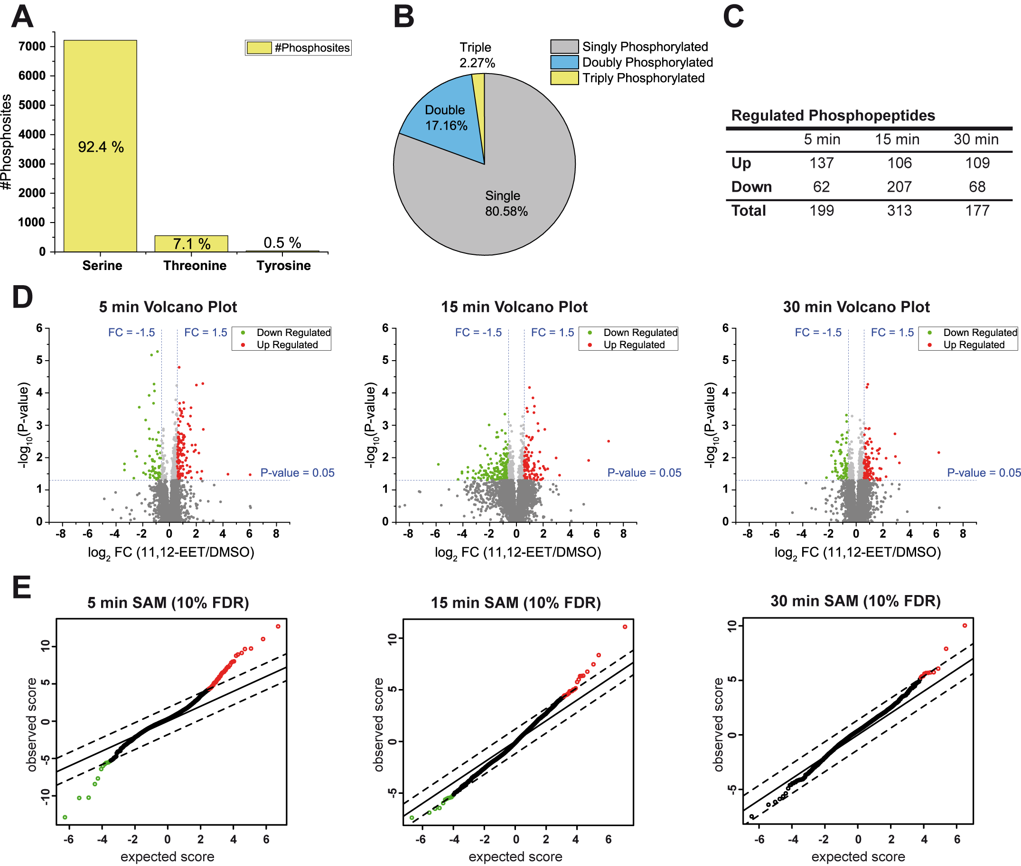

Figure 1: Characteristics and Regulation of Identified Phosphopeptides A) Bar graph representing quantity and ratio of phospho-serine, -threonine and -tyrosine among phosphosites identified from LC-MS/MS. B) Pie chart depicting the ratio of mono- di- and triply phosphorylated peptides identified from LC-MS/MS. C) Numbers of differentially regulated phosphopeptides (fold change ≥ 1.5 (up- and downregulation), p < 0.05) for every time-point of 11,12-EET treatment. D) Volcano plots depicting significance of regulation versus fold change for phosphopeptides after 11,12-EET treatment compared to DMSO control for every time-point. Horizontal dashed blue line represents p-value cutoff < 0.05 and vertical dashed blue lines illustrate the cutoffs for fold change ≥ 1.5. Upregulated phosphopeptides exceeding the cutoffs for fold change and significance are shown in red and downregulated are colored in green. E) Scatter plot from Significance Analysis of Microarrays (SAM) for every time-point after adjustment of false discovery rate (FDR) < 10 %. Red color indicates significantly upregulated phosphopeptides, downregulated phosphopetides are shown in green.

## 3.2 Time-resolved Dynamics of Phosphoproteome and Enrichment of Biological Processes

We next determined common patterns of temporal regulation between significantly changed phosphopeptides (p < 0.05). For this purpose, we employed fuzzy c-means clustering and assigned phosphopeptides to six clusters with distinct temporal profiles (phosphopeptides assigned to clusters are listed in Supplementary Table 1). Based on the progression of phosphopeptide ratios, we could classify clusters showing immediate regulation after 5 minutes (cluster 5 & cluster 6), intermediate/early-to-intermediate regulation (cluster 2 & cluster 3) and constant or long-term regulation (cluster 1 & cluster 4) (Figure 2A).

In order to characterize *Biological Processes* belonging to proteins contained in each cluster, we additionally analyzed the specific enrichment of associated GO-Terms (Figure 2B). Since this study aims to identify short-term signaling events in response to 11,12-EET stimulation, clusters containing phosphopeptides which show a direct increase in phosphorylation are of special interest (cluster 1, 3 and 6). It can be expected that these profiles represent the most proximal stages of signal transduction events and contain proteins which mediate early responses to phosphorylation after 11,12-EET treatment. Strikingly, phosphopeptides reflecting an immediate and transient increase in phosphorylation (cluster 6) showed significant enrichment of RNA-related processes like *mRNA processing*, *regulation of* *mRNA stability*, *RNA splicing* and *mRNA export from nucleus*. In addition, we identified enrichment of processes (*cellular response to rapamycin* and *response to amino acid starvation*) that are associated with the mammalian target of rapamycin (mTOR) signaling pathway [42]; [43] in cluster 6. Other processes specifically enriched in this cluster were related to the cell cycle (*positive regulation of cyclin-dependent protein kinase activity*), myosin-light-chain-phosphatase activity, protein ubiquitination and proteasomal degradation.

Clusters 1 and 3 showed a more sustained up-regulation of phosphopeptides during the course of the experiment. GO-Terms reflecting these trends were associated with eicosanoid metabolism (*prostaglandin metabolic process*) and transcription (*regulation of nucleic acid-templated transcription*) (cluster 1) and included *cellular response to gamma radiation* and vasculature-related processes (*coronary vasculature development*, *positive regulation of* v*ascular associated smooth muscle cell migration*) (cluster 3).

On the contrary, phosphopetides which matched to temporal profiles of sustained down-regulation at later time-points (cluster 4) were associated with GO-Terms like *response to cAMP* and endothelial cell proliferation, whereas terms linked to apoptosis, cell adhesion and lipid metabolism were specifically enriched in a cluster reflecting a more transient decrease in phosphorylation (cluster 5). *Biological Processes* associated with intermediately down-regulated phosphopeptides (cluster 2) showed only weak enrichment and the related GO-Terms were shared with other temporal profiles, which impeded an evaluation of specific processes represented by proteins contained in this cluster.

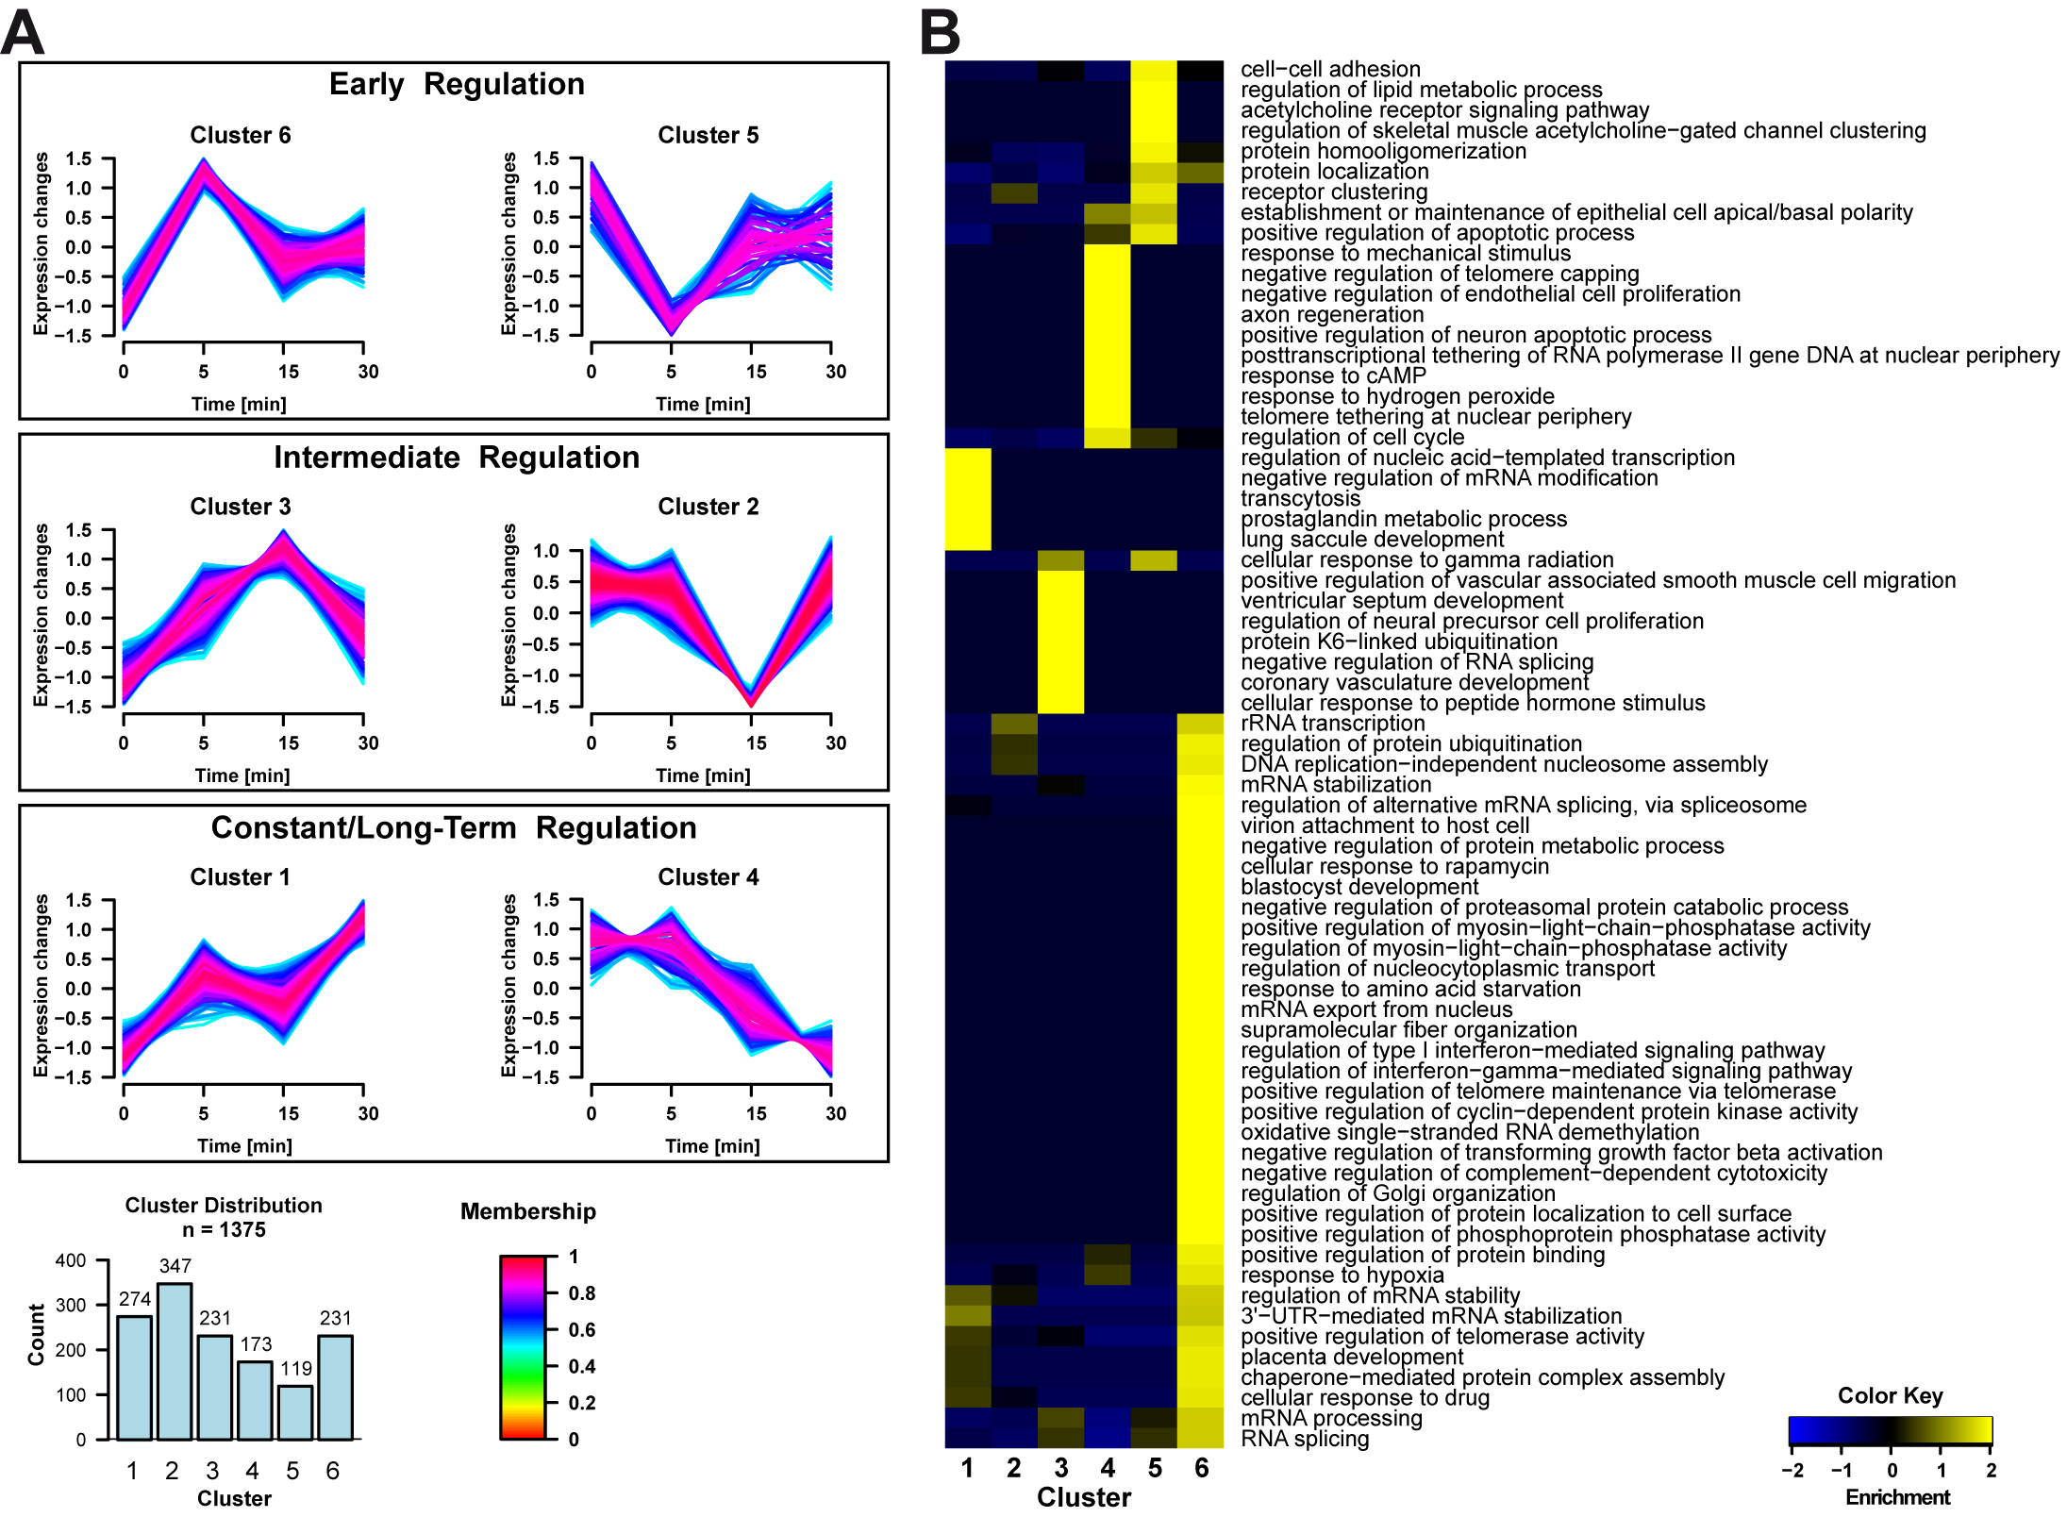

Figure 2: Temporal Patterns of Regulation and Associated GO-Terms for Biological Processes A) Fuzzy c-means clustering was performed for all phosphopeptides significantly regulated (p < 0.05) at least once in the time-course of stimulation. Phosphopeptides were grouped to six clusters reflecting early, intermediate and long-term regulation. Assignments of phosphopeptides to clusters were accepted when a membership value of 0.5 was exceeded. B) Enrichment analysis of GO-Terms for Biological Processes overrepresented in the clusters from A). Binomial statistical testing was performed against a background of all non-regulated identifications (n = 5333) and a p-value threshold < 0.05 was applied after Benjamini-Hochberg adjustment. GO-Terms had to occur at least three times to be included in the analysis.

## 3.3 Discovery of 11,12-EET Signaling Pathways, Upstream Regulators and Phosphorylated Sequence Motifs

Following the identification of temporal regulatory patterns of phosphopeptides and associated *Biological Processes*, we subsequently investigated signaling pathways potentially underlying the detected processes from Section 3.2. For this purpose, we performed Ingenuity Pathway Analysis (IPA) with abundance ratio data from all phosphopeptides significantly regulated (p < 0.05) at least once during the time-course of 11,12-EET treatment (Figure 3A, Supplementary Table 2).

The analysis revealed that the *DNA Double-Strand Break Repair by Homologous Recombination* (HR) pathway was most significantly enriched (p = 6.61x10-3) based on the regulated identifications from our dataset. This pathway included proteins involved in the mediation of HR and DNA repair, DNA end joining and the modulation of chromatin constitution in DNA repair synthesis like Breast cancer type 1 susceptibility protein (BRCA1), Transcriptional regulator ATRX and DNA ligase 1 (LIG1) [44]; [45]; [46]. In addition, the DNA damage response (DDR) kinase ataxia-telangiectasia mutated (ATM) was identified with a significant decrease in Ser1987 phosphorylation after 15 minutes. Strikingly, all three proteins of the MRE11-RAD50-NBS1 (MRN) complex were detected in our dataset with significantly regulated phosphopeptides. The MRN complex acts as a sensor of DNA damage and initiator of the DDR and DNA repair processes like homologous recombination (HR) [47]. In this regard, especially the significantly increased (1.40-fold regulation after 5min) Ser648 phosphorylation site on MRE11 is of interest, as it was shown to influence the DDR [48]. Additionally, *Cell Cycle: G2/M DNA Damage Checkpoint Regulation* (p = 4.37x10-2) was identified as another pathway associated to the maintenance of genome stability and DNA repair. Within this signaling network, ataxia telangiectasia and Rad3-related (ATR) kinase emerged significantly stronger phosphorylated at Ser431 by 11,12-EET treatment after 5 minutes. We also observed downregulation of Ser312 within tumor protein p53 and several phosphopeptides from topoisomerases TOP2A and TOP2B. In addition, we identified a decrease in Ser53 on Cyclin B1 (CCNB1) and increased levels of a peptide doubly phosphorylated at Ser161 and Ser163 on E3 ubiquitin-protein ligase MDM2.

Apart from these DNA damage and repair associated pathways, IPA additionally resulted in enrichment of signaling networks which take part in the regulation of vascular tone and signaling in cardiovascular tissues, including *Nitric Oxide Signaling in the Cardiovascular System* (p = 1.45x10-2) and *Hypoxia Signaling in the Cardiovascular System* (p = 2.57x10-2), potentially reflecting the role of EETs in vascular tissues [2].

EETs were previously shown to increase the phosphorylation of AKT in liver cells [18]; [19]. In light of these findings, we identified the enrichment of the AKT downstream network *p70S6K Signaling* (p = 4.68x10-2) in our analysis [49]. This pathway included functional phosphorylation sites on the p70S6K target RPS6 (Ser235/236/240) [50], which were significantly upregulated at all time-points of 11,12-EET treatment (1.43-/1.53-/1.76-fold after 5/15/30 min).

Additionally, the *P2Y Purigenic Receptor Signaling Pathway* (p = 4.68x10-2) represented a G-protein coupled receptor network involving targets like RAF1 (Ser244), CREB-binding protein (CREBBP) (Ser120) and the regulatory subunit of cAMP-dependent protein kinase type I-alpha (PRKAR1A). PRKAR1A was phosphorylated in the linker region of the enzyme on Ser77/83 residues which were suggested to exert a regulatory function on PRKAR1A [51].

Our analysis furthermore included the enrichment of pathways related to the activation of transcription (*TR/RXR Activation* (p = 2.57x10-2), *PPARα/RXRα Activation* (p = 2.75x10-2)), *Estrogen Receptor Signaling* (p = 1.78x10-2) and Androgen Signaling (p = 1.45x10-2).

To further drive the discovery of central kinases implicated in the phosphorylation of proteins within enriched pathways from IPA core analysis and EET signaling in general, we additionally made use of the prediction of Upstream Regulators in IPA. Figure 3B depicts the results of predicted regulators, restricted to the term “kinases”: Casein kinase II subunit alpha (CSNK2A1) was most significantly enriched (p = 4.54x10-9) among kinase regulators and yielded a positive z-Score of activation at all time-points, with the strongest activation predicted after 5 minutes (z-Score = 3.842).

In line with the enrichment of Canonical Pathways associated with DNA damage repair in Ingenuity core analysis (Figure 3A), predicted upstream kinase regulators encompass the DDR kinases ATM and ATR. Both kinases were predicted to be activated after 5 minutes as indicated by positive z-Scores (2.954 for ATM and 1.942 for ATR), followed by a predicted inactivation of ATR for all other time-points. ATM was also assigned a negative z-Score at 15 minutes (-2.006) followed by a slightly positive value at 30 minutes (0.379). Similarly, pathway enrichment analysis suggested the involvement of 11,12-EET signaling in the regulation of cell cycle checkpoints. Fitting to this observation, Cyclin-dependent kinase 4 (CDK4) was identified as an upstream regulator together with Cyclin-dependent kinases 1 and 2 (CDK1/CDK2), although the latter kinases were not identified with a significant p-value.

The predicted activation of RPS6KB2 (z-Score = 1.103) is in good correlation to the enrichment of p70S6K Signaling in Canonical Pathway analysis and can be directly connected to increased phosphorylation levels of the RPS6KB2 target RPS6 on Ser235/236/240. Interestingly, although without significant p-value of overlap, the kinase AKT1 was predicted to be activated (z-Score = 2.451) after 5 minutes. Since AKT acts as one of several upstream activators of p70S6K [49], this finding indicates a connection to the observed enrichment of the p70S6K signaling network in our dataset.

In addition, we found the receptor tyrosine-protein kinase ERBB2, a member of the epidermal growth factor receptor family [52], predicted in an activated state at 5 minutes (z-Score = 1.798) and members of the p38 mitogen-activated protein kinase (MAPK11/MAPK14) and c-Jun N-terminal kinase 3 (MAPK10) predicted to be inactivated at the intermediate and late time-points, although these observations did not reach statistical significance.

We next performed motif-X analysis to determine overrepresented peptide sequence patterns among all significantly upregulated phosphopeptides (p < 0.05). We used this procedure as a complementary approach to gain insight into kinases participating in 11,12-EET signaling by identifying their consensus motifs of phosphorylation. We identified three groups of sequence motifs which could be subdivided into basophilic motifs containing mainly arginine residues in the surrounding of the phosphorylation site, proline-directed sequence patterns and motifs involving acidic amino acids (Figure 3C).

Among basophilic motifs, we observed the RxRxxS motif, which was shown to represent the minimum consensus sequence required for phosphorylation by AKT, RSK and p70S6K. While all three kinases preferentially phosphorylate sequence motifs containing basic residues at n-3 and n-5 position to the phosphorylated residue, RSK and p70S6K were shown to better tolerate lysine residues in these positions than AKT [53]. In addition, we identified the cAMP-dependent protein kinase minimal consensus motif RRxS [54] and the RxxSP motif, which was described to be targeted by serine/arginine protein kinases (SRPK) implicated in splicing [55]. On the contrary, the sequence pattern RSxS corresponds closely to a target sequence required for high affinity 14-3-3 binding (RSxSxP) [56].

The proline-containing SP and PxSP motifs were previously shown to be phosphorylated by members of the proline-directed kinases like the MAP kinase family (ERK1/ERK2) and cyclin-dependent kinases (CDKs) [57] [58].

We furthermore observed sequence patterns mainly consisting of the acidic amino acids glutamate and aspartate, which were predominantly enriched in the C-terminal part of the peptide sequences downstream of the phosphorylation site. These included sequences described to be consensus motifs for Casein kinase II (SDxD, SExE, SDxE and general C-terminal localization of acidic residues) [59]; [60]. These observations are in line with the results from the Upstream Regulator analysis, which suggested a role for Casein kinase II in 11,12-EET signaling.

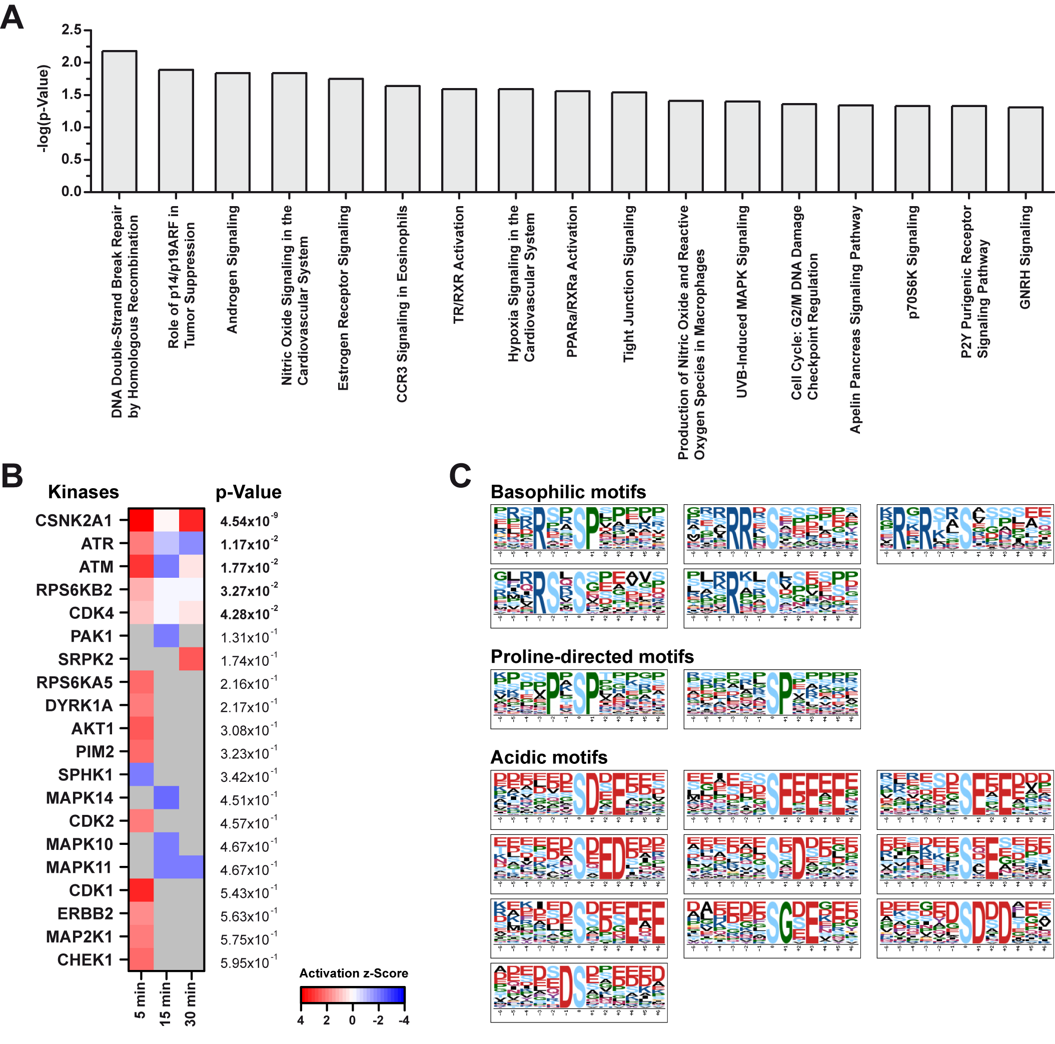

Figure 3: Characterization of the 11,12-EET Signaling Network A) Phosphopeptides differentially regulated at least once in the time-course of 11,12-EET treatment (p < 0.05) were subjected to IPA “Core Analysis” and Canonical Pathways with their respective p-value of enrichment are shown (p-value threshold < 0.05). B) Heatmap representing the predicted activation of Upstream Regulators restricted to “kinases” associated with the regulation of phosphopeptides from IPA “Core Analysis” from A). C) Identification of overrepresented peptide sequences from significantly upregulated phosphopeptides (p < 0.05) using Motif-x. Peptides were centered on the phosphorylated amino acid residue and extended to a total number of 13 characters. IPI Mouse Proteome was used as background. Extracted motifs were required to occur at least 20 times and to meet a significance threshold < 10-6.

## 3.4 11,12-EET Increases Phosphorylation within AKT and p70S6K Signaling

The results from our phosphoproteomics dataset so far showed accumulating signs of an involvement of the p70S6K network in 11,12-EET signaling. Ingenuity pathway analysis and upstream regulator identification suggested an enrichment of p70S6K signaling and the kinases AKT1 and RPS6KB2. We furthermore discovered the overrepresented RxRxxS motif which is a consensus sequence for phosphorylation by these kinases [53]. In addition, there were several significantly regulated phosphopeptides found in our dataset which give rise to the assumption that these kinases could play a role in 11,12-EET Signaling in liver cells: We observed significant upregulation of Ser235/236/240 (1.43-/1.53-/1.76-fold) on RPS6 at all time-points investigated and a 1.97-fold increase in phosphorylation of Ser184 on AKT1S1. We also identified a slight but significant upregulation of EIF4EBP1 on Ser67/Thr69. Now, we wanted to further explore the acute short-term effect of 11,12-EET treatment on the AKT/p70S6K signaling network in liver cells by western blot-based testing (Figure 4).

We observed a direct increase in the phosphorylation of Akt (Ser473) after short-term 11,12-EET treatment of the liver cell line Hepa1-6 for 5 minutes and 15 minutes. Afterwards, the signal diminished to a level even below DMSO control after 30 minutes. In addition, as suggested by IPA analysis of the phosphoproteomics results, we noticed a strong increase in the activating phosphorylation site Thr389 on p70S6K after 5 minutes and (albeit to a lesser extent) after 15 minutes, whereas the signal was almost indistinguishable from the control treatment after 30 minutes. Similarly, 11,12-EET treatment slightly enhanced the phosphorylation of the p70S6K target RPS6 at Ser235/236 after 5 and 15 minutes, whereas there was no effect visible at the latest time-point. We additionally investigated the phosphorylation status of another p70S6K target, mTOR [61], and observed a small and transient increase in Ser2448 phosphorylation on this protein. In contrast, 11,12-EET treatment did not seem to affect the phosphorylation of 4EBP1 (Ser64, Thr36/45).

The differential phosphorylation of p70S6K substantiates the direct involvement of this kinase in short term 11,12-EET signaling in the liver cell line Hepa 1-6 as suggested by bioinformatics tools.

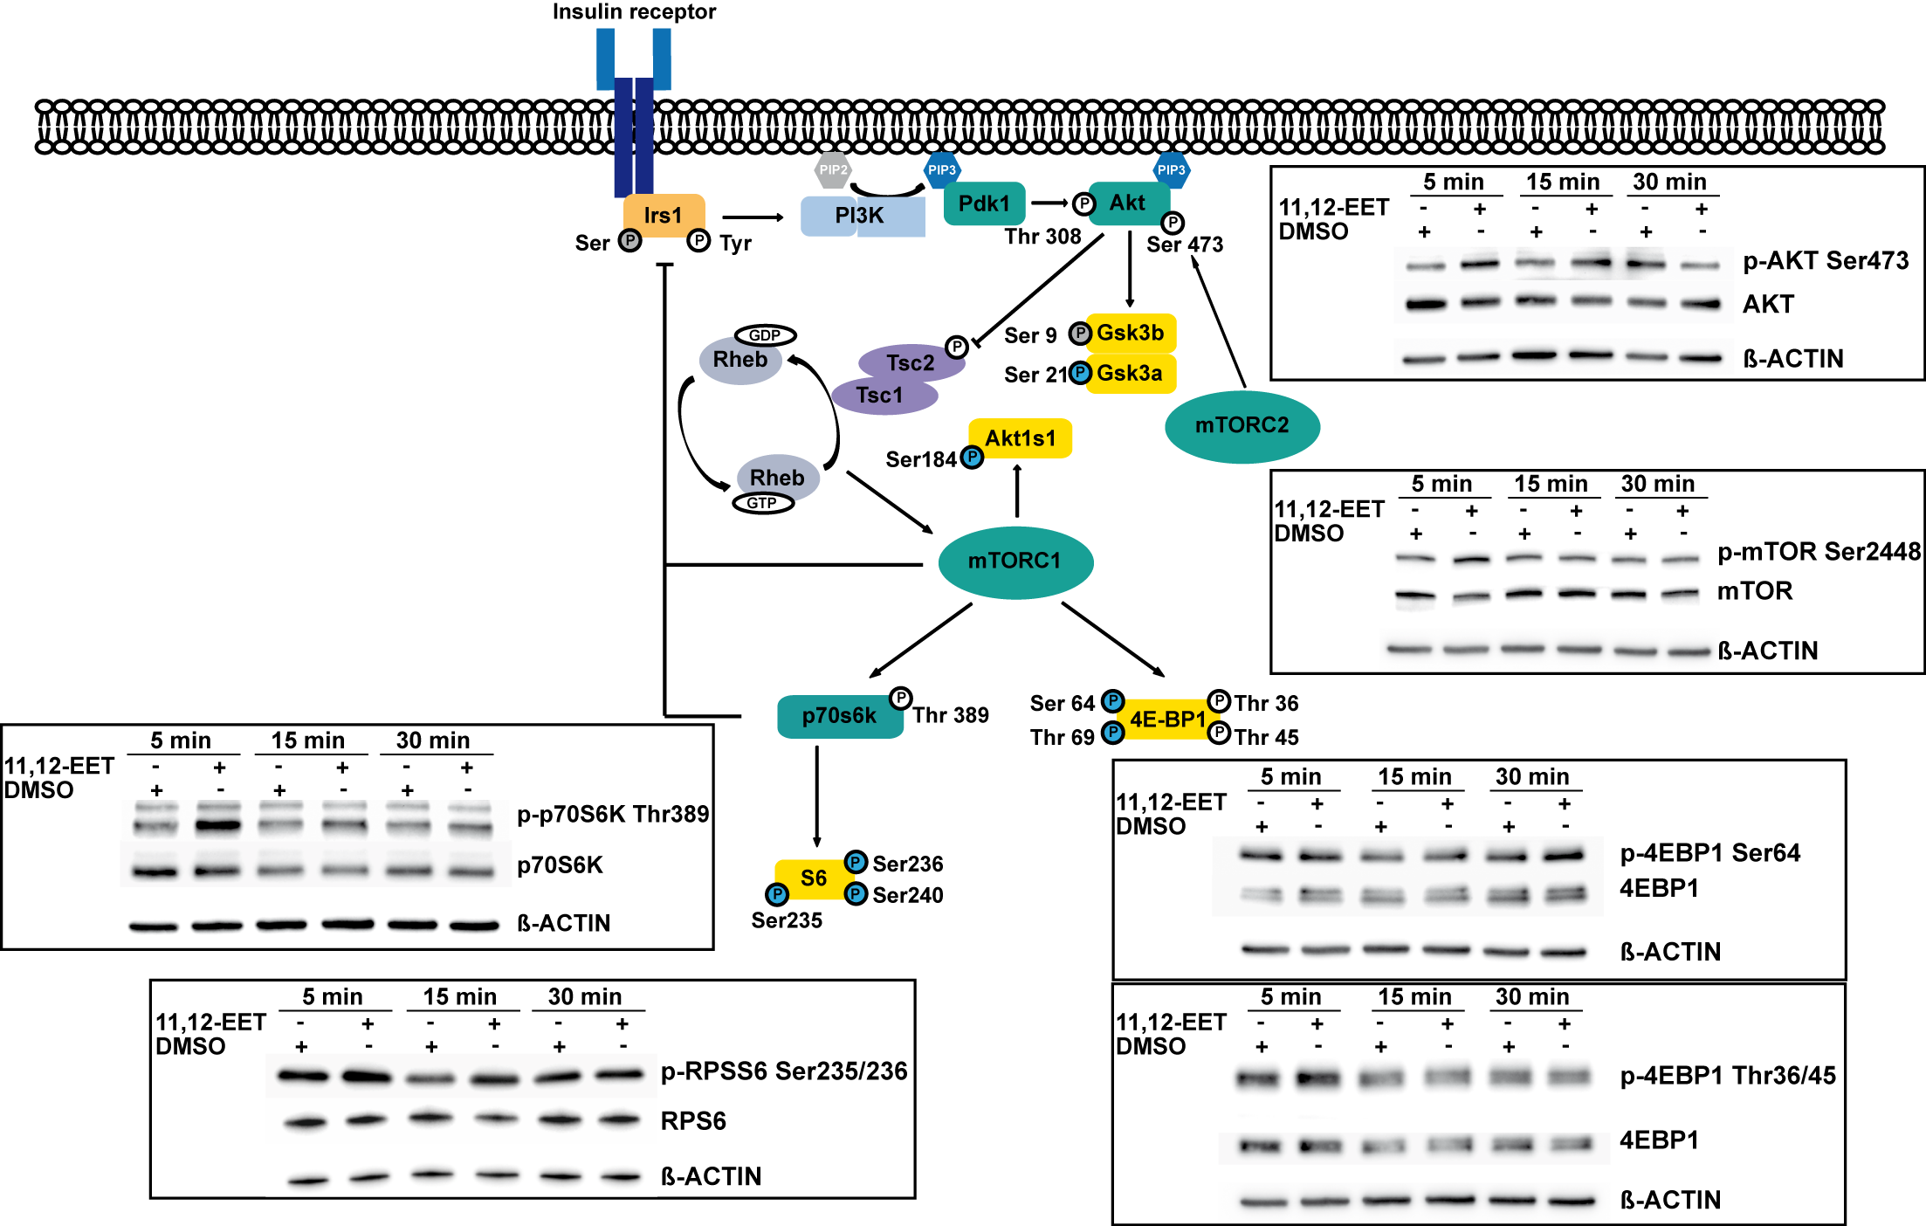

Figure 4: Western Blot Validation of 11,12-EET-induced Modulation of AKT and p70S6K Signaling Hepa 1-6 cells were starved overnight and stimulated with 1 µM 11,12-EET or DMSO (control) for 5, 15 and 30 minutes. Immunoblots were performed for p-AKT (Ser473), p-p70S6K (Thr389) and other phosphoproteins of the insulin signaling pathway including RPS6 (Ser235/236), mTOR (Ser2448) and EIF4EBP1 (Ser64 and Thr36/45). Blots show signal intensity after 11,12-EET and DMSO control treatment for every time-point. Core components of the PI3K/AKT pathway are illustrated for visualization of analyzed proteins in the context of insulin signaling. Phosphosites found upregulated in our dataset are shown in blue, while sites identified without regulation are colored in grey. White color indicates sites not found in our dataset.

The Thr389 site on p70S6K is known to be phosphorylated by mTOR complex 1 (mTORC1) and Ser473 on AKT was shown to be a target of mTOR complex 2 (mTORC2) [62] [63]. We therefore hypothesized that 11,12-EET exerted an activating effect on both mTORC1 and mTORC2 and that mTOR signaling was responsible for the observed upregulation in phosphorylation. However, for AKT several other kinases have been implicated in Ser473 phosphorylation as well [64]–[68].

In order to test our hypothesis, we utilized the mTOR inhibitor Torin1 (250 nM) and reanalyzed the phosphorylation status of AKT (Ser473) and p70S6K (Thr389) after 11,12-EET treatment. Insulin, a well-known inducer of mTOR activity, was included in the analysis to test the efficacy of mTOR inhibition. After short-term (10 min) treatment with both 11,12-EET and insulin, we observed an increase in phosphorylation on both phosphosites (Figure 5A). In contrast, 11,12-EET treatment failed to increase phosphorylation levels after pretreatment with Torin1. These results strongly suggest that the observed 11,12-EET-induced phosphorylation of AKT and p70S6K is dependent on mTOR activity.

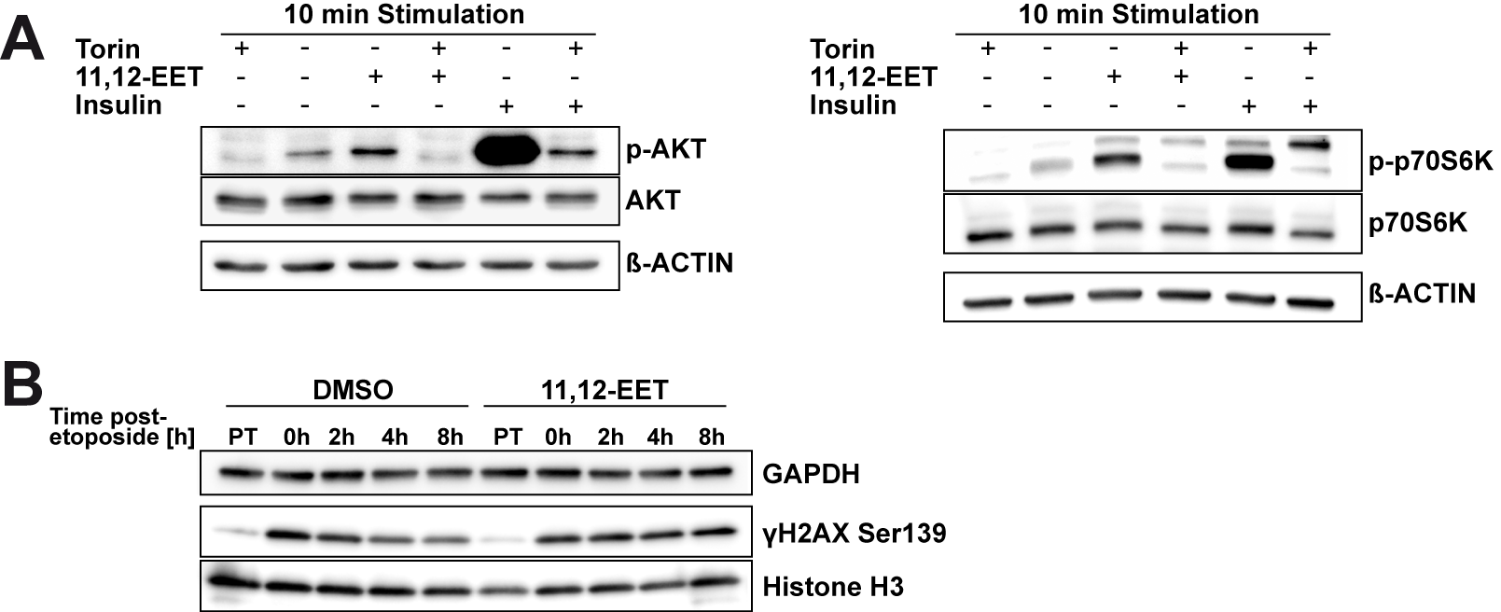

Figure 5: Analysis of mTOR-dependent Phosphorylation of AKT (Ser473)/p70S6K (Thr389) Mediated by 11,12-EET and γH2AX Time-course after Etoposide Treatment in Response to 11,12-EET or DMSO Pretreatment A) Hepa 1-6 cells were pretreated with the mTOR inhibitor Torin1 (250 nM) or DMSO control for one hour before treatment with 11,12-EET (1 µM), insulin (1 nM) or DMSO (control) was performed for 10 minutes. Immunoblots for p-AKT (Ser473) and p-p70S6K (Thr389) show signal intensity after treatment with the compounds as indicated. B) Pretreatment (PT) with DMSO or 1 µM 11,12-EET was performed for one hour followed by induction of γH2AX Ser139 phosphorylation by one hour etoposide (20 µM) treatment (0h). Cells were washed and the γH2AX response was followed-up for eight hours (2h-8h). Immunoblots show signal intensity for γH2AX (Ser139), GAPDH (loading control) and Histone H3 (nuclear loading control).

IPA pathway analysis revealed the enrichment of a DNA double strand break repair-related pathway in our dataset (section 3.3), which was based on the significant regulation of several functional phosphosites on proteins involved in the response to DNA damage. We therefore investigated a possible effect of 11,12-EET treatment on the DNA damage response (DDR) by monitoring the time-course of phosphorylation of the DNA damage marker γH2AX after induction of DNA strand breaks with etoposide (Figure 5B).

Treatment with etoposide induced an increase in γH2AX following both DMSO and 11,12-EET pretreatment (Figure 5B; 0h). In DMSO pretreated samples, γH2AX intensity subsequently faded over the time-course of follow up (Figure 5B; 0h-8h, DMSO). In contrast, γH2AX intensity remained elevated for up to eight hours following etoposide treatment in 11,12-EET pretreated samples (Figure 5B; 0h-8h; 11,12-EET). In one out of the three replicates under investigation, we observed a time-dependent decrease in histone H3 nuclear loading control intensity simultaneously with γH2AX in DMSO pretreated samples, while the GAPDH control remained unchanged (Supplementary Figure S1). However, we do not expect a primary effect on histone abundance or cellular protein content in general, since this phenomenon did not occur in other replicates and GAPDH content remained stable over the time-course of investigation. It is of additional note that 11,12-EET pretreatment alone did not induce γH2AX compared to the DMSO control pretreatment (Figure 5B; PT). These results indicate an influence of 11,12-EET treatment on the kinetics of the DNA damage response marker yH2AX following the induction of strand breaks and substantiate a potential association between 11,12-EET Signaling and the DNA damage response.

# 4. Discussion

EETs act as paracrine and autocrine lipid mediators which modulate cellular signal transmission via protein phosphorylation in different cell types [6]; [8]; [9]. In this study, we employed time-resolved LC-MS/MS-based phosphoproteomics for the comprehensive identification of signaling mediators and pathways involved in acute short-term EET signal transmission in liver cells.

Our TiO2-based metal oxide affinity chromatography (MOAC) approach enabled the specific enrichment of phosphopeptides from complex cell lysates. TiO2-MOAC was reported to have a tendency towards enrichment of monophosphorylated peptides compared to other enrichment strategies like immobilized metal affinity chromatography (IMAC) [69]; [70]; [71]; [72]. Similarly, monophosphorylated peptides accounted for >80 % of all phosphopeptides in this study. It was previously discussed that the high affinity of TiO2 towards multiply phosphorylated peptides could favor the more efficient elution of monophosphorylated peptides from the material. In addition, suppressed ionization of multiply phosphorylated peptides was described during mass spectrometric detection. Considering the inherent bias of data-dependent acquisition methods towards more abundant peptide species, these factors altogether potentially result in the underrepresentation of multiply phosphorylated peptides in this experimental setting [70]; [73].

When analyzing the distribution of phosphosites among amino acids, we identified >90 % of phosphosites on serine and ~7 % on threonine residues. This observation closely represents original estimates of phosphoamino acid distributions in whole cells [74]. Although the observed ratio of tyrosine sites is one order of magnitude higher than originally estimated (0.5 %), these ratios compare well to generally accepted numbers obtained from more recent mass spectrometric investigations [21]; [27]; [75]; [76].

EET signaling mechanisms are well studied in the context of vascular tissues, where they are involved in processes like angiogenesis and proliferation [77]; [78]. Given the increasing emergence of the EET pathway as a drug target in metabolic diseases [13], we aimed to reveal EET signaling events in liver cells. Previous *in vivo* studies in Ephx2-/- knockout mice indicated increased insulin signaling in the liver after pharmacological inhibition or knockout (KO) of the hydrolase [16]. Since Ephx2 is capable of hydrolyzing a range of other lipid epoxides apart from EETs [79], and Ephx2-KO was also shown to increase insulin secretion [15], these effects could not be unequivocally attributed to the direct and sole action of EETs. Other studies investigating the hepatic phosphorylation of AKT in response to longer-term (40-60 min) EET treatment showed that maximum effects required EET pretreatment and were insulin-dependent [19]. Similarly, the modulation of insulin signaling in hepatocytes necessitated prolonged EET pretreatment at exceptionally high doses of 30 µM in combination with insulin co-treatment [18]. Due to the extended (pre-)treatment and insulin-dependence, the potential existence of secondary effects responsible for these observations could not be excluded.

In contrast, the fast response in the stimulation of AKT phosphorylation within 5 minutes of acute short-term EET treatment observed in this study points towards a direct EET-mediated mode of activation in liver cells, similar to findings of direct acute AKT phosphorylation following EET treatment in other tissues [80]; [81]. Our results furthermore point towards an extended EET signaling network generated around AKT and p70S6K. We confirmed an increase of the activating Thr389 phosphosite on p70S6K [63] and validated the mTORC-dependence of AKT phosphorylation, which both reflect the EET-dependent activation of the AKT/mTOR/S6K1 network. Increased phosphorylation of other target proteins within this pathway corroborates the relevance of the AKT/mTOR/S6K1 axis in EET signal transduction in liver cells. In line with this, EETs were previously shown to activate the PI3K/AKT/mTOR/S6K1 pathway in endothelial cells in the context of angiogenesis [80], and it seems very likely that the same signaling pathways are utilized by EETs in liver cells as well. The immediate phosphorylation of target proteins potentially supports the action through a transmembrane receptor signaling mechanism. In this regard, several lines of evidence proposed the involvement of a specific transmembrane receptor in EET signaling; although EETs were also shown to transactivate the epidermal growth factor receptor [10]; [11]; [12]; [82].

The PI3K/AKT/mTOR pathway is typically implicated in the regulation of cell proliferation, survival and metabolism and concomitant with these effects exerts downstream actions on the regulation of translation and RNA splicing [83]–[87]. Interestingly, we identified an overrepresentation of proteins involved in RNA stability, splicing and processing with a time-course of phosphorylation closely reflecting that of the validated targets within this pathway. This finding could connect EETs to previously unidentified functions in RNA processing, splicing and translation regulation with PI3K/AKT/mTOR acting as a potential candidate pathway for the mediation of these effects.

Pathway analysis of regulated phosphopeptides and western blot experiments conducted within this study suggest a new role for EETs in the modulation of DNA damage response signaling. EETs contain an electrophilic epoxide structure which is prone to react with nucleophilic biological macromolecules like proteins and DNA [88]. A recent study conducted by Funk *et al.* [89] demonstrated the capability of 11,12-EET to form DNA adducts *in vitro*. However, the authors concluded that the potency of adduct formation was 40-times lower compared to another endogenous DNA-reactive epoxide (leukotriene A4 (LTA4)) and the concentration range of DNA adduct formation was considered not to be physiologically relevant. In addition, the intracellular fate of EETs is thought to be tightly regulated. EETs are hydrolyzed intracellularly to their corresponding diols by sEH, incorporated into phospholipids and bound by fatty acid binding proteins [90]. Therefore, it is questionable if considerable amounts of free EETs indeed reach the nucleus to directly interact with DNA. Similarly, when investigating the kinetics of γH2AX formation, we did not observe a direct induction of this DNA damage marker after incubation with 11,12-EET alone.

However, EETs prolonged the induction of γH2AX in our experiments, which raises the question whether EETs also influence the execution of DNA repair processes downstream of γH2AX and potentially modulate genome stability and the frequency of mutations. Interestingly, recent studies found that activation of growth factor signaling via AKT or the mTOR/S6K pathway impairs the DNA damage response and results in increased genome instability through mechanisms involving different effectors [91]; [92]. On the contrary, the inhibition of mTOR signaling was shown to increase the γH2AX response and downregulate the checkpoint kinase CHK1 [93].

Future studies in this field will clarify in which way EETs affect the DNA damage signaling network and whether the observed γH2AX prolongation elicits downstream functional outcomes.

EETs are arachidonic acid metabolites generated by the action of CYP epoxygenases [1]. In the context of arachidonic acid metabolism, EETs were shown to negatively regulate the formation of prostaglandin E2 (PGE2) [94]. Our dataset revealed strong and persistent phosphorylation of cytosolic prostaglandin E2 synthase (PTGES3) at both Ser148 and Ser151 in response to 11,12-EET treatment. Although the reduction of PGE2 was previously described as a competitive inhibition of upstream Prostaglandin G/H synthases primarily mediated by 14,15-EET [94], these findings could point to an alternative stage of regulation of prostaglandin metabolism by EETs. The Ser151 site contains several acidic residues downstream of the phosphorylation site and thereby fulfills the consensus motif for CKII phosphorylation, which was also overrepresented in our motif analysis. The activation of CKII by EET treatment has not been described before and the increased phosphorylation of this site on PTGES3 further suggests the involvement of this kinase in EET signaling.

One of the most well-known effects of EETs is the regulation of vascular tone by hyperpolarization of vascular smooth muscle cells, which is regarded to primarily occur through the activation of BKCa channels [95]; [96]; [97]. In addition to this mechanism, it was shown that EETs modulate the RhoA-ROCK-MLCK pathway in endothelial cells and reduce Ca2+ sensitivity in bronchi [98]; [99]; pathways that are known to also regulate contraction of smooth muscles by altering the phosphorylation status of myosin light chain (MLC) and its interaction with actin [100]. In this context, myosin light chain phosphatase (MLCP) induces smooth muscle relaxation by dephosphorylating MLC [101] and the Myosin Phosphatase Target Subunit 1 (MYPT1/PPP1R12A) negatively regulates MLCP activity after phosphorylation at Thr694 and Thr852 [102].

Here, we identified downregulation (1.72-fold) of the inhibitory Thr694 site of MYPT1 after 5 minutes which was at the border of significance (p = 0.089) and additionally identified strong persistent upregulation of a doubly phosphorylated peptide at Ser861/870. Although the functional relevance of the upregulated sites is currently unknown, phosphorylation of these sites was shown to be increased after short-term growth hormone (GH) stimulation [103]. In light of these findings, the influence of EETs on MYPT1 and the subsequent regulation of MLC phosphorylation could generate a new layer of complexity of the EET-mediated impact on vascular smooth muscle cell contraction.

# 5. Conclusion

In this study, we applied an LC-MS/MS-based phosphoproteomics approach to investigate 11,12-EET signaling in liver cells. Our findings substantiate a strong role of the mTOR/p70S6K pathway in hepatic EET signaling and demonstrate the mTOR-dependence of 11,12-EET-mediated AKT phosphorylation. In addition, we discovered the regulation of phosphopeptides potentially associating the action of EETs to processes like RNA processing, translation regulation, prostaglandin metabolism and the regulation of smooth muscle action. Especially the investigation of the detailed role of EETs in novel pathways identified in this work like the DNA damage response creates an important topic of future studies.

# Conflict of Interests

The authors have no conflict of interests to declare.

# Funding

This work was supported by intramural funding of Helmholtz Zentrum München – German Research Center for Environmental Health (GmbH), Germany, which is funded by the German Federal Ministry of Education and Research (BMBF) and the State of Bavaria.

References

[1] Oliw EH; Oates JA: Oxygenation of arachidonic acid by hepatic microsomes of the rabbit. *Biochimica et Biophysica Acta (BBA) - Lipids and Lipid Metabolism* (**1981**), 666 (3), pp. 327–340. DOI: 10.1016/0005-2760(81)90291-5.

[2] Campbell WB; Gebremedhin D; Pratt PF; Harder DR: Identification of Epoxyeicosatrienoic Acids as Endothelium-Derived Hyperpolarizing Factors. *Circulation Research* (**1996**), 78 (3), pp. 415–423. DOI: 10.1161/01.RES.78.3.415.

[3] Michaelis UR; Fisslthaler B; Medhora M; Harder D; Fleming I; Busse R: Cytochrome P450 2C9-derived epoxyeicosatrienoic acids induce angiogenesis via cross-talk with the epidermal growth factor receptor (EGFR). *FASEB journal : official publication of the Federation of American Societies for Experimental Biology* (**2003**), 17 (6), pp. 770–772. DOI: 10.1096/fj.02-0640fje.

[4] Michaelis UR; Fisslthaler B; Barbosa-Sicard E; Falck JR; Fleming I; Busse R: Cytochrome P450 epoxygenases 2C8 and 2C9 are implicated in hypoxia-induced endothelial cell migration and angiogenesis. *Journal of cell science* (**2005**), 118 (Pt 23), pp. 5489–5498. DOI: 10.1242/jcs.02674.

[5] Node K: Anti-inflammatory Properties of Cytochrome P450 Epoxygenase-Derived Eicosanoids. *Science* (**1999**), 285 (5431), pp. 1276–1279. DOI: 10.1126/science.285.5431.1276.

[6] Chen J; Falck JR; Reddy KM; Capdevila J; Harris RC: Epoxyeicosatrienoic Acids and Their Sulfonimide Derivatives Stimulate Tyrosine Phosphorylation and Induce Mitogenesis in Renal Epithelial Cells. *J. Biol. Chem.* (**1998**), 273 (44), pp. 29254–29261. DOI: 10.1074/jbc.273.44.29254.

[7] Chen J; Capdevila J; Harris RC: Cytochrome P450 Epoxygenase Metabolism of Arachidonic Acid Inhibits Apoptosis. *Molecular and Cellular Biology* (**2001**), 21 (18), pp. 6322–6331. DOI: 10.1128/MCB.21.18.6322-6331.2001.

[8] Spector AA; Norris AW: Action of epoxyeicosatrienoic acids on cellular function. *American journal of physiology. Cell physiology* (**2007**), 292 (3), p. C996-1012. DOI: 10.1152/ajpcell.00402.2006.

[9] Fleming I; Fisslthaler B; Michaelis R; Kiss L; Popp R; Busse R: The coronary endothelium-derived hyperpolarizing factor (EDHF) stimulates multiple signalling pathways and proliferation in vascular cells. *Pfl�gers Archiv European Journal of Physiology* (**2001**), 442 (4), pp. 511–518. DOI: 10.1007/s004240100565.

[10] Chen J; Capdevila J; Harris RC: Heparin-binding EGF-like growth factor mediates the biological effects of P450 arachidonate epoxygenase metabolites in epithelial cells. *Proceedings of the National Academy of Sciences of the United States of America* (**2002**), 99 (9), pp. 6029–6034. DOI: 10.1073/pnas.092671899.

[11] Wong PY; Lai P; Shen S; Belosludtsev YY; Falck J: Post-receptor signal transduction and regulation of 14(R),15(S)-epoxyeicosatrienoic acid (14,15-EET) binding in U-937 cells. *Journal of Lipid Mediators and Cell Signalling* (**1997**), 16 (3), pp. 155–169. DOI: 10.1016/S0929-7855(97)00005-9.

[12] Wong PY; Lai P; Falck J: Mechanism and signal transduction of 14 (R), 15 (S)-epoxyeicosatrienoic acid (14,15-EET) binding in guinea pig monocytes. *Prostaglandins & other lipid mediators* (**2000**), 62 (4), pp. 321–333. DOI: 10.1016/S0090-6980(00)00079-4.

[13] He J; Wang C; Zhu Y; Ai D: Soluble epoxide hydrolase: A potential target for metabolic diseases. *Journal of diabetes* (**2016**), 8 (3), pp. 305–313. DOI: 10.1111/1753-0407.12358.

[14] Luther JM; Brown NJ: Epoxyeicosatrienoic acids and glucose homeostasis in mice and men. *Prostaglandins & other lipid mediators* (**2016**), 125, pp. 2–7. DOI: 10.1016/j.prostaglandins.2016.07.010.

[15] Luo P; Chang H; Zhou Y; Zhang S; Hwang SH; Morisseau C *et al.*: Inhibition or deletion of soluble epoxide hydrolase prevents hyperglycemia, promotes insulin secretion, and reduces islet apoptosis. *The Journal of pharmacology and experimental therapeutics* (**2010**), 334 (2), pp. 430–438. DOI: 10.1124/jpet.110.167544.

[16] Luria A; Bettaieb A; Xi Y; Shieh G; Liu H; Inoue H *et al.*: Soluble epoxide hydrolase deficiency alters pancreatic islet size and improves glucose homeostasis in a model of insulin resistance. *Proceedings of the National Academy of Sciences of the United States of America* (**2011**), 108 (22), pp. 9038–9043. DOI: 10.1073/pnas.1103482108.

[17] Xu X; Zhao CX; Wang L; Tu L; Fang X; Zheng C *et al.*: Increased CYP2J3 expression reduces insulin resistance in fructose-treated rats and db/db mice. *Diabetes* (**2010**), 59 (4), pp. 997–1005. DOI: 10.2337/db09-1241.

[18] Skepner JE; Shelly LD; Ji C; Reidich B; Luo Y: Chronic treatment with epoxyeicosatrienoic acids modulates insulin signaling and prevents insulin resistance in hepatocytes. *Prostaglandins & other lipid mediators* (**2011**), 94 (1-2), pp. 3–8. DOI: 10.1016/j.prostaglandins.2010.10.002.

[19] Schäfer A; Neschen S; Kahle M; Sarioglu H; Gaisbauer T; Imhof A *et al.*: The Epoxyeicosatrienoic Acid Pathway Enhances Hepatic Insulin Signaling and is Repressed in Insulin-Resistant Mouse Liver. *Molecular & cellular proteomics : MCP* (**2015**), 14 (10), pp. 2764–2774. DOI: 10.1074/mcp.M115.049064.

[20] Hunter T: Signaling—2000 and Beyond. *Cell* (**2000**), 100 (1), pp. 113–127. DOI: 10.1016/S0092-8674(00)81688-8.

[21] Olsen JV; Blagoev B; Gnad F; Macek B; Kumar C; Mortensen P; Mann M: Global, in vivo, and site-specific phosphorylation dynamics in signaling networks. *Cell* (**2006**), 127 (3), pp. 635–648. DOI: 10.1016/j.cell.2006.09.026.

[22] Brognard J; Hunter T: Protein kinase signaling networks in cancer. *Current opinion in genetics & development* (**2011**), 21 (1), pp. 4–11. DOI: 10.1016/j.gde.2010.10.012.

[23] Jünger MA; Aebersold R: Mass spectrometry-driven phosphoproteomics: patterning the systems biology mosaic. *Wiley interdisciplinary reviews. Developmental biology* (**2014**), 3 (1), pp. 83–112. DOI: 10.1002/wdev.121.

[24] Engholm-Keller K; Larsen MR: Technologies and challenges in large-scale phosphoproteomics. *Proteomics* (**2013**), 13 (6), pp. 910–931. DOI: 10.1002/pmic.201200484.

[25] Solari FA; Dell'Aica M; Sickmann A; Zahedi RP: Why phosphoproteomics is still a challenge. *Molecular bioSystems* (**2015**), 11 (6), pp. 1487–1493. DOI: 10.1039/C5MB00024F.

[26] Krüger M; Kratchmarova I; Blagoev B; Tseng Y; Kahn CR; Mann M: Dissection of the insulin signaling pathway via quantitative phosphoproteomics. *Proceedings of the National Academy of Sciences of the United States of America* (**2008**), 105 (7), pp. 2451–2456. DOI: 10.1073/pnas.0711713105.

[27] Verano-Braga T; Schwämmle V; Sylvester M; Passos-Silva DG; Peluso AAB; Etelvino GM *et al.*: Time-resolved quantitative phosphoproteomics: new insights into Angiotensin-(1-7) signaling networks in human endothelial cells. *Journal of proteome research* (**2012**), 11 (6), pp. 3370–3381. DOI: 10.1021/pr3001755.

[28] Kettenbach AN; Sano H; Keller SR; Lienhard GE; Gerber SA: SPECHT - single-stage phosphopeptide enrichment and stable-isotope chemical tagging: quantitative phosphoproteomics of insulin action in muscle. *Journal of proteomics* (**2015**), 114, pp. 48–60. DOI: 10.1016/j.jprot.2014.11.001.

[29] Kubiniok P; Lavoie H; Therrien M; Thibault P: Time-resolved Phosphoproteome Analysis of Paradoxical RAF Activation Reveals Novel Targets of ERK. *Molecular & cellular proteomics : MCP* (**2017**), 16 (4), pp. 663–679. DOI: 10.1074/mcp.M116.065128.

[30] Humphrey SJ; Karayel O; James DE; Mann M: High-throughput and high-sensitivity phosphoproteomics with the EasyPhos platform. *Nature protocols* (**2018**), 13 (9), pp. 1897–1916. DOI: 10.1038/s41596-018-0014-9.

[31] Francavilla C; Lupia M; Tsafou K; Villa A; Kowalczyk K; Rakownikow Jersie-Christensen R *et al.*: Phosphoproteomics of Primary Cells Reveals Druggable Kinase Signatures in Ovarian Cancer. *Cell reports* (**2017**), 18 (13), pp. 3242–3256. DOI: 10.1016/j.celrep.2017.03.015.

[32] Dwivedi P; Muench DE; Wagner M; Azam M; Grimes HL; Greis KD: Phospho serine and threonine analysis of normal and mutated granulocyte colony stimulating factor receptors. *Scientific data* (**2019**), 6 (1), p. 21. DOI: 10.1038/s41597-019-0015-8.

[33] Dwivedi P; Muench DE; Wagner M; Azam M; Grimes HL; Greis KD: Time resolved quantitative phospho-tyrosine analysis reveals Bruton's Tyrosine kinase mediated signaling downstream of the mutated granulocyte-colony stimulating factor receptors. *Leukemia* (**2019**), 33 (1), pp. 75–87. DOI: 10.1038/s41375-018-0188-8.

[34] Thingholm TE; Jørgensen TJD; Jensen ON; Larsen MR: Highly selective enrichment of phosphorylated peptides using titanium dioxide. *Nature protocols* (**2006**), 1 (4), pp. 1929–1935. DOI: 10.1038/nprot.2006.185.

[35] Zhou H; Ye M; Dong J; Corradini E; Cristobal A; Heck AJR *et al.*: Robust phosphoproteome enrichment using monodisperse microsphere-based immobilized titanium (IV) ion affinity chromatography. *Nature protocols* (**2013**), 8 (3), pp. 461–480. DOI: 10.1038/nprot.2013.010.

[36] Kauko O; Laajala TD; Jumppanen M; Hintsanen P; Suni V; Haapaniemi P *et al.*: Label-free quantitative phosphoproteomics with novel pairwise abundance normalization reveals synergistic RAS and CIP2A signaling. *Scientific reports* (**2015**), 5, p. 13099. DOI: 10.1038/srep13099.

[37] Perez-Riverol Y; Csordas A; Bai J; Bernal-Llinares M; Hewapathirana S; Kundu DJ *et al.*: The PRIDE database and related tools and resources in 2019: improving support for quantification data. *Nucleic acids research* (**2019**), 47 (D1), pp. D442-D450. DOI: 10.1093/nar/gky1106.

[38] Futschik ME; Carlisle B: Noise-robust soft clustering of gene expression time-course data. *Journal of bioinformatics and computational biology* (**2005**), 3 (4), pp. 965–988.

[39] Chou MF; Schwartz D: Biological sequence motif discovery using motif-x. *Current protocols in bioinformatics* (**2011**), Chapter 13, pp. Unit 13.15–24. DOI: 10.1002/0471250953.bi1315s35.

[40] Tusher VG; Tibshirani R; Chu G: Significance analysis of microarrays applied to the ionizing radiation response. *Proceedings of the National Academy of Sciences of the United States of America* (**2001**), 98 (9), pp. 5116–5121. DOI: 10.1073/pnas.091062498.

[41] Storey JD: A direct approach to false discovery rates. *Journal of the Royal Statistical Society: Series B (Statistical Methodology)* (**2002**), 64 (3), pp. 479–498. DOI: 10.1111/1467-9868.00346.

[42] Demetriades C; Doumpas N; Teleman AA: Regulation of TORC1 in response to amino acid starvation via lysosomal recruitment of TSC2. *Cell* (**2014**), 156 (4), pp. 786–799. DOI: 10.1016/j.cell.2014.01.024.

[43] Sabers CJ; Martin MM; Brunn GJ; Williams JM; Dumont FJ; Wiederrecht G; Abraham RT: Isolation of a Protein Target of the FKBP12-Rapamycin Complex in Mammalian Cells. *J. Biol. Chem.* (**1995**), 270 (2), pp. 815–822. DOI: 10.1074/jbc.270.2.815.

[44] Zhao W; Steinfeld JB; Liang F; Chen X; Maranon DG; Jian Ma C *et al.*: BRCA1-BARD1 promotes RAD51-mediated homologous DNA pairing. *Nature* (**2017**), 550 (7676), pp. 360–365. DOI: 10.1038/nature24060.

[45] Juhász S; Elbakry A; Mathes A; Löbrich M: ATRX Promotes DNA Repair Synthesis and Sister Chromatid Exchange during Homologous Recombination. *Molecular cell* (**2018**), 71 (1), p. 11-24.e7. DOI: 10.1016/j.molcel.2018.05.014.

[46] Ellenberger T; Tomkinson AE: Eukaryotic DNA ligases: structural and functional insights. *Annual review of biochemistry* (**2008**), 77, pp. 313–338. DOI: 10.1146/annurev.biochem.77.061306.123941.

[47] Lamarche BJ; Orazio NI; Weitzman MD: The MRN complex in double-strand break repair and telomere maintenance. *FEBS letters* (**2010**), 584 (17), pp. 3682–3695. DOI: 10.1016/j.febslet.2010.07.029.

[48] Li Z; Li J; Kong Y; Yan S; Ahmad N; Liu X: Plk1 Phosphorylation of Mre11 Antagonizes the DNA Damage Response. *Cancer research* (**2017**), 77 (12), pp. 3169–3180. DOI: 10.1158/0008-5472.CAN-16-2787.

[49] Manning BD; Cantley LC: AKT/PKB signaling: navigating downstream. *Cell* (**2007**), 129 (7), pp. 1261–1274. DOI: 10.1016/j.cell.2007.06.009.

[50] Pende M; Um SH; Mieulet V; Sticker M; Goss VL; Mestan J *et al.*: S6K1-/-/S6K2-/- Mice Exhibit Perinatal Lethality and Rapamycin-Sensitive 5'-Terminal Oligopyrimidine mRNA Translation and Reveal a Mitogen-Activated Protein Kinase-Dependent S6 Kinase Pathway. *Molecular and Cellular Biology* (**2004**), 24 (8), pp. 3112–3124. DOI: 10.1128/MCB.24.8.3112-3124.2004.

[51] Haushalter KJ; Casteel DE; Raffeiner A; Stefan E; Patel HH; Taylor SS: Phosphorylation of protein kinase A (PKA) regulatory subunit RIα by protein kinase G (PKG) primes PKA for catalytic activity in cells. *The Journal of biological chemistry* (**2018**), 293 (12), pp. 4411–4421. DOI: 10.1074/jbc.M117.809988.

[52] Moasser MM: The oncogene HER2: its signaling and transforming functions and its role in human cancer pathogenesis. *Oncogene* (**2007**), 26 (45), pp. 6469–6487. DOI: 10.1038/sj.onc.1210477.

[53] Alessi DR; Barry Caudwell F; Andjelkovic M; Hemmings BA; Cohen P: Molecular basis for the substrate specificity of protein kinase B; comparison with MAPKAP kinase-1 and p70 S6 kinase. *FEBS letters* (**1996**), 399 (3), pp. 333–338. DOI: 10.1016/S0014-5793(96)01370-1.

[54] Kemp BE; Graves DJ; Benjamini E; Krebs EG: Role of multiple basic residues in determining the substrate specificity of cyclic AMP-dependent protein kinase. *Journal of Biological Chemistry* (**1977**), 252 (14), pp. 4888–4894. Available online at http://www.jbc.org/content/252/14/4888.short.

[55] Lipp JJ; Marvin MC; Shokat KM; Guthrie C: SR protein kinases promote splicing of nonconsensus introns. *Nature structural & molecular biology* (**2015**), 22 (8), pp. 611–617. DOI: 10.1038/nsmb.3057.

[56] Muslin AJ; Tanner J; Allen PM; Shaw AS: Interaction of 14-3-3 with Signaling Proteins Is Mediated by the Recognition of Phosphoserine. *Cell* (**1996**), 84 (6), pp. 889–897. DOI: 10.1016/S0092-8674(00)81067-3.

[57] Songyang Z; Lu KP; Kwon YT; Tsai LH; Filhol O; Cochet C *et al.*: A structural basis for substrate specificities of protein Ser/Thr kinases: primary sequence preference of casein kinases I and II, NIMA, phosphorylase kinase, calmodulin-dependent kinase II, CDK5, and Erk1. *Molecular and Cellular Biology* (**1996**), 16 (11), pp. 6486–6493.

[58] Errico A; Deshmukh K; Tanaka Y; Pozniakovsky A; Hunt T: Identification of substrates for cyclin dependent kinases. *Advances in enzyme regulation* (**2010**), 50 (1), pp. 375–399. DOI: 10.1016/j.advenzreg.2009.12.001.

[59] Bian Y; Ye M; Wang C; Cheng K; Song C; Dong M *et al.*: Global screening of CK2 kinase substrates by an integrated phosphoproteomics workflow. *Scientific reports* (**2013**), 3, p. 3460. DOI: 10.1038/srep03460.

[60] Meggio F; Pinna LA: One-thousand-and-one substrates of protein kinase CK2? *FASEB journal : official publication of the Federation of American Societies for Experimental Biology* (**2003**), 17 (3), pp. 349–368. DOI: 10.1096/fj.02-0473rev.

[61] Chiang GG; Abraham RT: Phosphorylation of mammalian target of rapamycin (mTOR) at Ser-2448 is mediated by p70S6 kinase. *The Journal of biological chemistry* (**2005**), 280 (27), pp. 25485–25490. DOI: 10.1074/jbc.M501707200.

[62] Sarbassov DD; Guertin DA; Ali SM; Sabatini DM: Phosphorylation and regulation of Akt/PKB by the rictor-mTOR complex. *Science (New York, N.Y.)* (**2005**), 307 (5712), pp. 1098–1101. DOI: 10.1126/science.1106148.

[63] Kim D; Sarbassov DD; Ali SM; King JE; Latek RR; Erdjument-Bromage H *et al.*: mTOR Interacts with Raptor to Form a Nutrient-Sensitive Complex that Signals to the Cell Growth Machinery. *Cell* (**2002**), 110 (2), pp. 163–175. DOI: 10.1016/S0092-8674(02)00808-5.

[64] Persad S; Attwell S; Gray V; Mawji N; Deng JT; Leung D *et al.*: Regulation of protein kinase B/Akt-serine 473 phosphorylation by integrin-linked kinase: critical roles for kinase activity and amino acids arginine 211 and serine 343. *The Journal of biological chemistry* (**2001**), 276 (29), pp. 27462–27469. DOI: 10.1074/jbc.M102940200.

[65] Tsuchiya A; Kanno T; Nishizaki T: PI3 kinase directly phosphorylates Akt1/2 at Ser473/474 in the insulin signal transduction pathway. *The Journal of endocrinology* (**2014**), 220 (1), pp. 49–59. DOI: 10.1530/JOE-13-0172.

[66] Partovian C; Simons M: Regulation of protein kinase B/Akt activity and Ser473 phosphorylation by protein kinase Calpha in endothelial cells. *Cellular signalling* (**2004**), 16 (8), pp. 951–957. DOI: 10.1016/j.cellsig.2004.01.008.

[67] Toker A; Newton AC: Akt/Protein Kinase B Is Regulated by Autophosphorylation at the Hypothetical PDK-2 Site. *J. Biol. Chem.* (**2000**), 275 (12), pp. 8271–8274. DOI: 10.1074/jbc.275.12.8271.

[68] Bozulic L; Surucu B; Hynx D; Hemmings BA: PKBalpha/Akt1 acts downstream of DNA-PK in the DNA double-strand break response and promotes survival. *Molecular cell* (**2008**), 30 (2), pp. 203–213. DOI: 10.1016/j.molcel.2008.02.024.

[69] Bodenmiller B; Mueller LN; Mueller M; Domon B; Aebersold R: Reproducible isolation of distinct, overlapping segments of the phosphoproteome. *Nature methods* (**2007**), 4 (3), pp. 231–237. DOI: 10.1038/nmeth1005.

[70] Thingholm TE; Jensen ON; Robinson PJ; Larsen MR: SIMAC (sequential elution from IMAC), a phosphoproteomics strategy for the rapid separation of monophosphorylated from multiply phosphorylated peptides. *Molecular & cellular proteomics : MCP* (**2008**), 7 (4), pp. 661–671. DOI: 10.1074/mcp.M700362-MCP200.

[71] Ficarro SB; McCleland ML; Stukenberg PT; Burke DJ; Ross MM; Shabanowitz J *et al.*: Phosphoproteome analysis by mass spectrometry and its application to Saccharomyces cerevisiae. *Nature biotechnology* (**2002**), 20 (3), pp. 301–305. DOI: 10.1038/nbt0302-301.

[72] Jensen SS; Larsen MR: Evaluation of the impact of some experimental procedures on different phosphopeptide enrichment techniques. *Rapid communications in mass spectrometry : RCM* (**2007**), 21 (22), pp. 3635–3645. DOI: 10.1002/rcm.3254.

[73] Ruprecht B; Koch H; Medard G; Mundt M; Kuster B; Lemeer S: Comprehensive and reproducible phosphopeptide enrichment using iron immobilized metal ion affinity chromatography (Fe-IMAC) columns. *Molecular & cellular proteomics : MCP* (**2015**), 14 (1), pp. 205–215. DOI: 10.1074/mcp.M114.043109.

[74] Hunter T; Sefton BM: Transforming gene product of Rous sarcoma virus phosphorylates tyrosine. *Proc Natl Acad Sci USA* (**1980**), 77 (3), pp. 1311–1315. DOI: 10.1073/pnas.77.3.1311.

[75] Nagano K; Shinkawa T; Mutoh H; Kondoh O; Morimoto S; Inomata N *et al.*: Phosphoproteomic analysis of distinct tumor cell lines in response to nocodazole treatment. *Proteomics* (**2009**), 9 (10), pp. 2861–2874. DOI: 10.1002/pmic.200800667.

[76] Zhang H; Sun J; Ye J; Ashraf U; Chen Z; Zhu B *et al.*: Quantitative Label-Free Phosphoproteomics Reveals Differentially Regulated Protein Phosphorylation Involved in West Nile Virus-Induced Host Inflammatory Response. *Journal of proteome research* (**2015**), 14 (12), pp. 5157–5168. DOI: 10.1021/acs.jproteome.5b00424.

[77] Michaelis UR; Fleming I: From endothelium-derived hyperpolarizing factor (EDHF) to angiogenesis: Epoxyeicosatrienoic acids (EETs) and cell signaling. *Pharmacology & therapeutics* (**2006**), 111 (3), pp. 584–595. DOI: 10.1016/j.pharmthera.2005.11.003.

[78] Fleming I: Epoxyeicosatrienoic acids, cell signaling and angiogenesis. *Prostaglandins & other lipid mediators* (**2007**), 82 (1-4), pp. 60–67. DOI: 10.1016/j.prostaglandins.2006.05.003.

[79] Morisseau C; Inceoglu B; Schmelzer K; Tsai H; Jinks SL; Hegedus CM; Hammock BD: Naturally occurring monoepoxides of eicosapentaenoic acid and docosahexaenoic acid are bioactive antihyperalgesic lipids. *J. Lipid Res.* (**2010**), 51 (12), pp. 3481–3490. DOI: 10.1194/jlr.M006007.

[80] Zhang B; Cao H; Rao GN: Fibroblast growth factor-2 is a downstream mediator of phosphatidylinositol 3-kinase-Akt signaling in 14,15-epoxyeicosatrienoic acid-induced angiogenesis. *The Journal of biological chemistry* (**2006**), 281 (2), pp. 905–914. DOI: 10.1074/jbc.M503945200.

[81] Dhanasekaran A; Gruenloh SK; Buonaccorsi JN; Zhang R; Gross GJ; Falck JR *et al.*: Multiple antiapoptotic targets of the PI3K/Akt survival pathway are activated by epoxyeicosatrienoic acids to protect cardiomyocytes from hypoxia/anoxia. *American journal of physiology. Heart and circulatory physiology* (**2008**), 294 (2), p. H724-35. DOI: 10.1152/ajpheart.00979.2007.

[82] Chen Y; Falck JR; Manthati VL; Jat JL; Campbell WB: 20-Iodo-14,15-epoxyeicosa-8(Z)-enoyl-3-azidophenylsulfonamide: photoaffinity labeling of a 14,15-epoxyeicosatrienoic acid receptor. *Biochemistry* (**2011**), 50 (18), pp. 3840–3848. DOI: 10.1021/bi102070w.

[83] Saxton RA; Sabatini DM: mTOR Signaling in Growth, Metabolism, and Disease. *Cell* (**2017**), 168 (6), pp. 960–976. DOI: 10.1016/j.cell.2017.02.004.

[84] Ma XM; Blenis J: Molecular mechanisms of mTOR-mediated translational control. *Nature reviews. Molecular cell biology* (**2009**), 10 (5), pp. 307–318. DOI: 10.1038/nrm2672.

[85] Blaustein M; Pelisch F; Tanos T; Muñoz MJ; Wengier D; Quadrana L *et al.*: Concerted regulation of nuclear and cytoplasmic activities of SR proteins by AKT. *Nature structural & molecular biology* (**2005**), 12 (12), pp. 1037–1044. DOI: 10.1038/nsmb1020.

[86] Patel NA; Kaneko S; Apostolatos HS; Bae SS; Watson JE; Davidowitz K *et al.*: Molecular and genetic studies imply Akt-mediated signaling promotes protein kinase CbetaII alternative splicing via phosphorylation of serine/arginine-rich splicing factor SRp40. *The Journal of biological chemistry* (**2005**), 280 (14), pp. 14302–14309. DOI: 10.1074/jbc.M411485200.

[87] Zhou Z; Qiu J; Liu W; Zhou Y; Plocinik RM; Li H *et al.*: The Akt-SRPK-SR axis constitutes a major pathway in transducing EGF signaling to regulate alternative splicing in the nucleus. *Molecular cell* (**2012**), 47 (3), pp. 422–433. DOI: 10.1016/j.molcel.2012.05.014.

[88] Scott Obach R; Kalgutkar AS (**2010**): Reactive Electrophiles and Metabolic Activation. In : Comprehensive Toxicology: Elsevier, pp. 309–347.

[89] Funk DJ; Sorg BL; Kopka K; Schmeiser HH: Epoxyeicosatrienoic acids (EETs) form adducts with DNA in vitro. *Prostaglandins & other lipid mediators* (**2016**), 123, pp. 63–67. DOI: 10.1016/j.prostaglandins.2016.04.006.

[90] Spector AA; Fang X; Snyder GD; Weintraub NL: Epoxyeicosatrienoic acids (EETs). Metabolism and biochemical function. *Progress in Lipid Research* (**2004**), 43 (1), pp. 55–90. DOI: 10.1016/S0163-7827(03)00049-3.

[91] Xie X; Hu H; Tong X; Li L; Liu X; Chen M *et al.*: The mTOR-S6K pathway links growth signalling to DNA damage response by targeting RNF168. *Nature cell biology* (**2018**), 20 (3), pp. 320–331. DOI: 10.1038/s41556-017-0033-8.

[92] Piscitello D; Varshney D; Lilla S; Vizioli MG; Reid C; Gorbunova V *et al.*: AKT overactivation can suppress DNA repair via p70S6 kinase-dependent downregulation of MRE11. *Oncogene* (**2018**), 37 (4), pp. 427–438. DOI: 10.1038/onc.2017.340.

[93] Zhou X; Liu W; Hu X; Dorrance A; Garzon R; Houghton PJ; Shen C: Regulation of CHK1 by mTOR contributes to the evasion of DNA damage barrier of cancer cells. *Scientific reports* (**2017**), 7 (1), p. 1535. DOI: 10.1038/s41598-017-01729-w.

[94] Fang X; Moore SA; Stoll LL; Rich G; Kaduce TL; Weintraub NL; Spector AA: 14,15-Epoxyeicosatrienoic acid inhibits prostaglandin E2 production in vascular smooth muscle cells. *The American journal of physiology* (**1998**), 275 (6), p. H2113-21. DOI: 10.1152/ajpheart.1998.275.6.H2113.

[95] Li P; Campbell WB: Epoxyeicosatrienoic Acids Activate K + Channels in Coronary Smooth Muscle Through a Guanine Nucleotide Binding Protein. *Circulation Research* (**1997**), 80 (6), pp. 877–884. DOI: 10.1161/01.RES.80.6.877.

[96] Li P; Zhang DX; Ge Z; Campbell WB: Role of ADP-ribose in 11,12-EET-induced activation of K(Ca) channels in coronary arterial smooth muscle cells. *American journal of physiology. Heart and circulatory physiology* (**2002**), 282 (4), p. H1229-36. DOI: 10.1152/ajpheart.00736.2001.

[97] Dimitropoulou C; West L; Field MB; White RE; Reddy LM; Falck JR; Imig JD: Protein phosphatase 2A and Ca2+-activated K+ channels contribute to 11,12-epoxyeicosatrienoic acid analog mediated mesenteric arterial relaxation. *Prostaglandins & other lipid mediators* (**2007**), 83 (1-2), pp. 50–61. DOI: 10.1016/j.prostaglandins.2006.09.008.

[98] Morin C; Sirois M; Echave V; Gomes MM; Rousseau E: EET displays anti-inflammatory effects in TNF-alpha stimulated human bronchi: putative role of CPI-17. *American journal of respiratory cell and molecular biology* (**2008**), 38 (2), pp. 192–201. DOI: 10.1165/rcmb.2007-0232OC.

[99] Dong R; Hu D; Yang Y; Chen Z; Fu M; Wang DW *et al.*: EETs reduces LPS-induced hyperpermeability by targeting GRP78 mediated Src activation and subsequent Rho/ROCK signaling pathway. *Oncotarget* (**2017**), 8 (31), pp. 50958–50971. DOI: 10.18632/oncotarget.17331.

[100] Cole WC; Welsh DG: Role of myosin light chain kinase and myosin light chain phosphatase in the resistance arterial myogenic response to intravascular pressure. *Archives of biochemistry and biophysics* (**2011**), 510 (2), pp. 160–173. DOI: 10.1016/j.abb.2011.02.024.

[101] Grassie ME; Moffat LD; Walsh MP; MacDonald JA: The myosin phosphatase targeting protein (MYPT) family: a regulated mechanism for achieving substrate specificity of the catalytic subunit of protein phosphatase type 1δ. *Archives of biochemistry and biophysics* (**2011**), 510 (2), pp. 147–159. DOI: 10.1016/j.abb.2011.01.018.

[102] Khromov A; Choudhury N; Stevenson AS; Somlyo AV; Eto M: Phosphorylation-dependent autoinhibition of myosin light chain phosphatase accounts for Ca2+ sensitization force of smooth muscle contraction. *The Journal of biological chemistry* (**2009**), 284 (32), pp. 21569–21579. DOI: 10.1074/jbc.M109.019729.

[103] Ray BN; Kweon HK; Argetsinger LS; Fingar DC; Andrews PC; Carter-Su C: Research resource: identification of novel growth hormone-regulated phosphorylation sites by quantitative phosphoproteomics. *Molecular endocrinology (Baltimore, Md.)* (**2012**), 26 (6), pp. 1056–1073. DOI: 10.1210/me.2011-1258.