**Supplemental Figure S1.** Example of iron species chromatogram from a cerebrospinal fluid (CSF) with indication of peaks for Inorganic Fe (inorg. Fe), Fe-Transferrin (Fe-Tf), and Fe-Ferritin (Fe-Fer).

**Supplemental Figure S2.** Regression analysis investigating the association between baseline iron (Fe) species and risk of developing any dementia (left panels) or Alzheimer's dementia (AD – right panels). The solid line indicates hazard ratio (HR) and the shaded areas the 95% confidence intervals. Dashed line represents regression analysis assuming a linear model. Analyses are adjusted for age, sex, educational attainment, smoking status, and selenate. Black line represents null risk (HR=1). Black vertical lines represent individual values of Fe species.

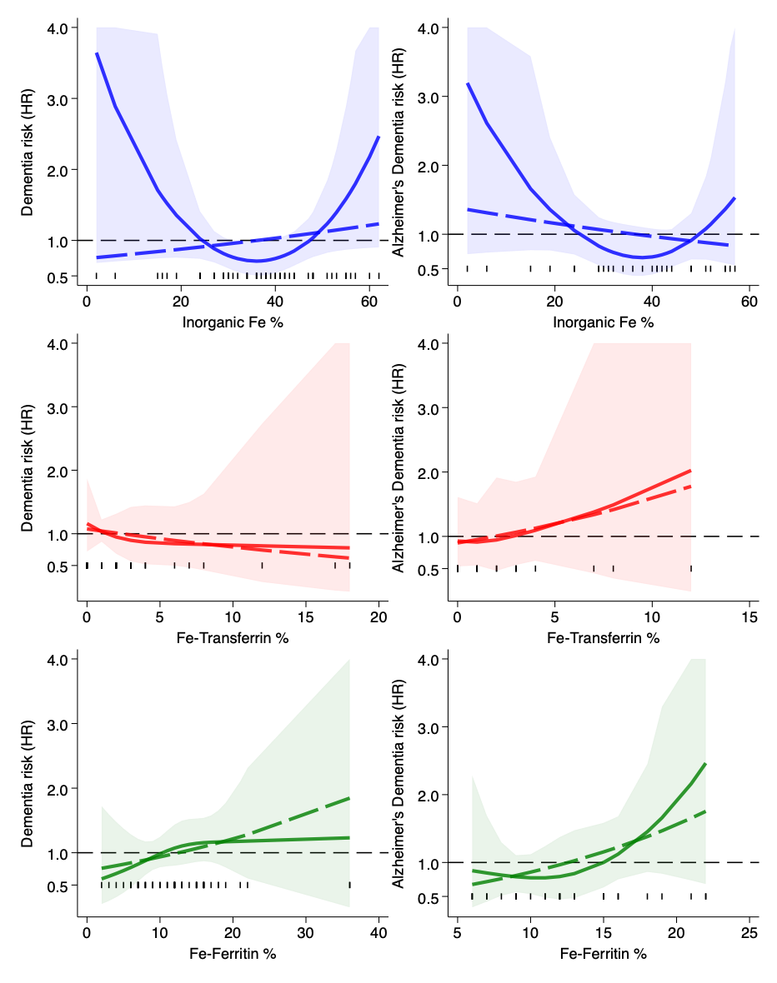

**Supplemental Figure S3.** Regression analyses investigating the association between baseline iron (Fe) species and risk of developing any dementia (left panels) or Alzheimer's dementia (AD – right panels). The solid line indicates hazard ratio (HR) and the shaded areas the 95% confidence intervals. Dashed line represents regression analysis assuming a linear model. Analyses are adjusted for age, sex, educational attainment, smoking status, and selenoprotein P. Black line represents null risk (HR=1). Black vertical lines represent individual values of Fe species.

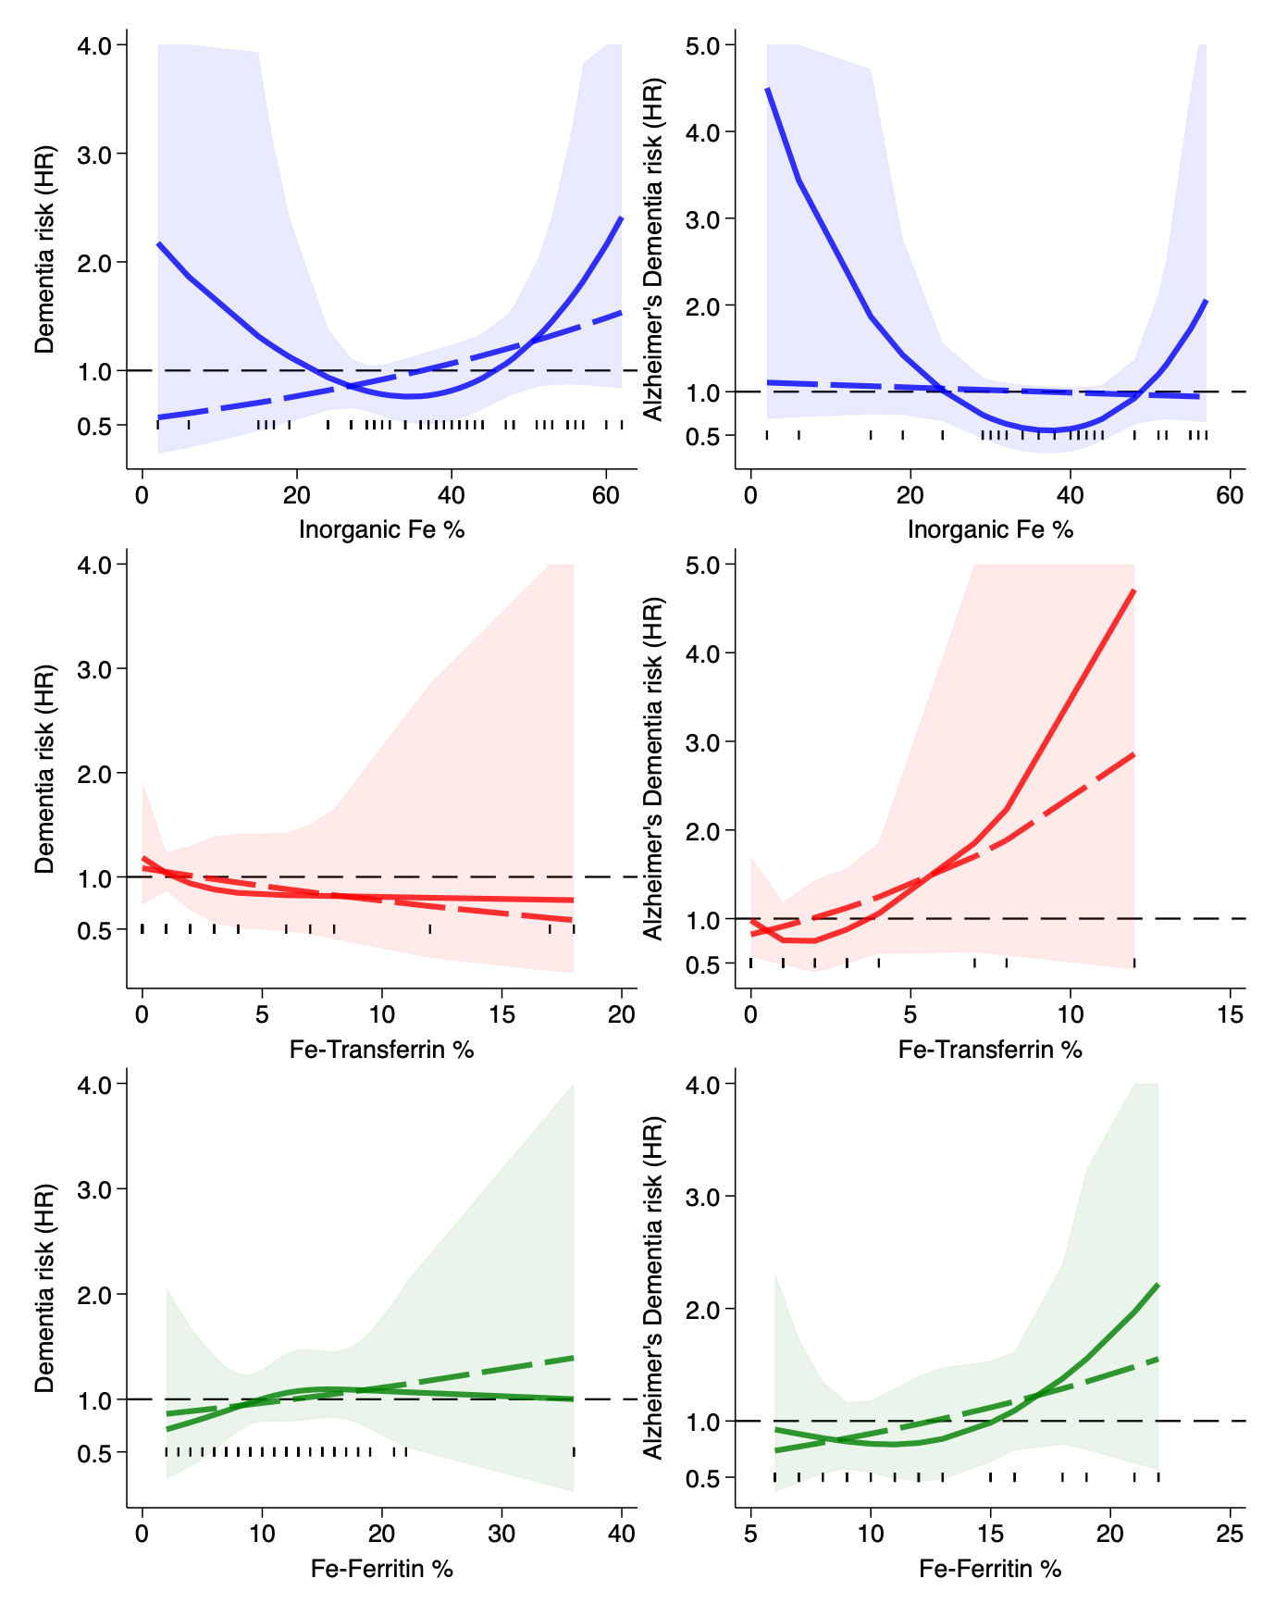

**Supplemental Figure S4.** Regression analyses investigating the association between baseline iron (Fe) species and risk of developing any type of dementia (left panels) or Alzheimer's dementia (AD – right panels). The solid line indicates hazard ratio (HR) and the shaded areas the 95% confidence intervals. Dashed line represents regression analysis assuming a linear model. Analyses are adjusted for age, sex, educational attainment, smoking status, and amyloid β1-42 levels. Black line represents null risk (HR=1). Black vertical lines represent individual values of Fe species.

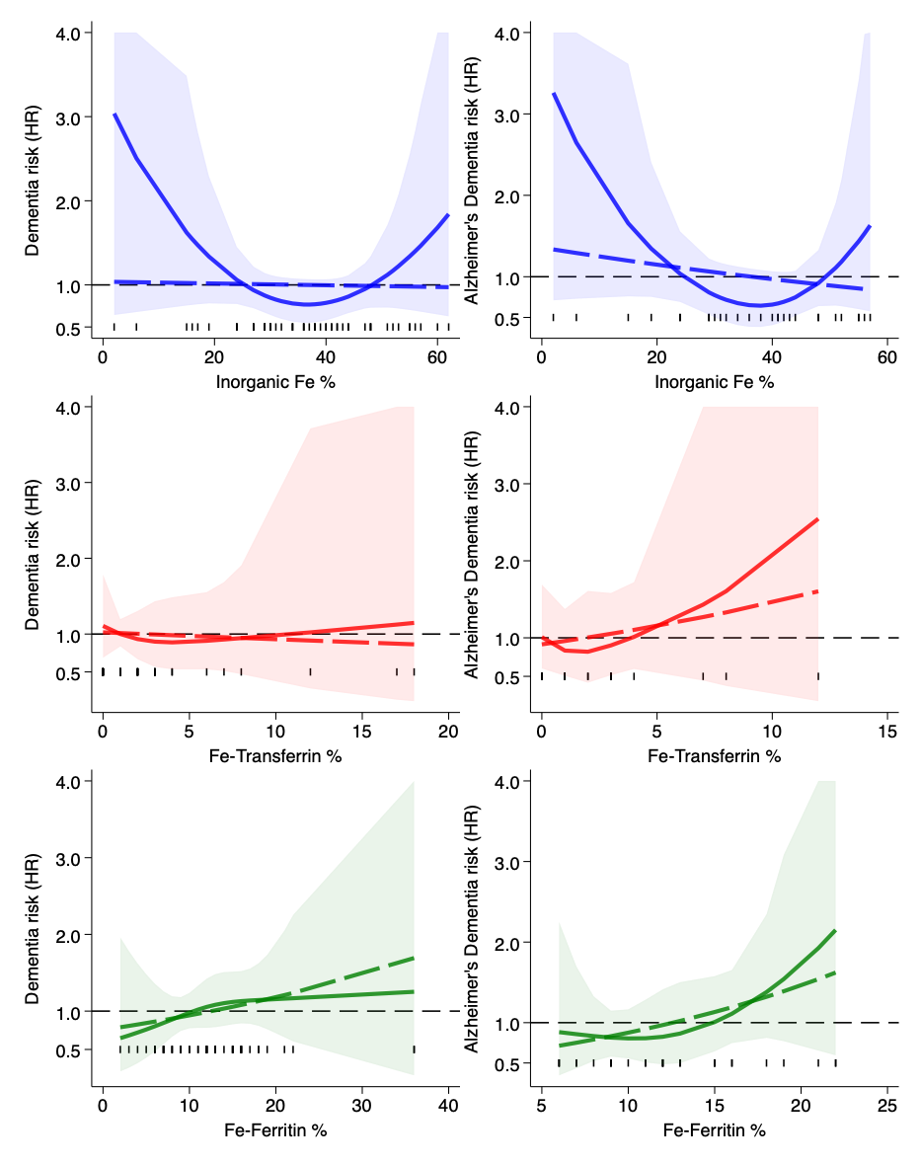

**Supplemental Figure S5.** Regression analyses investigating the association between baseline iron (Fe) species and risk of developing any type of dementia (left panels) or Alzheimer's dementia (AD – right panels). The solid line indicates hazard ratio (HR) and the shaded areas the 95% confidence intervals. Dashed line represents regression analysis assuming a linear model. Analyses are adjusted for age, sex, educational attainment, smoking status, and total tau levels. Black line represents null risk (HR=1). Black vertical lines represent individual values of Fe species.

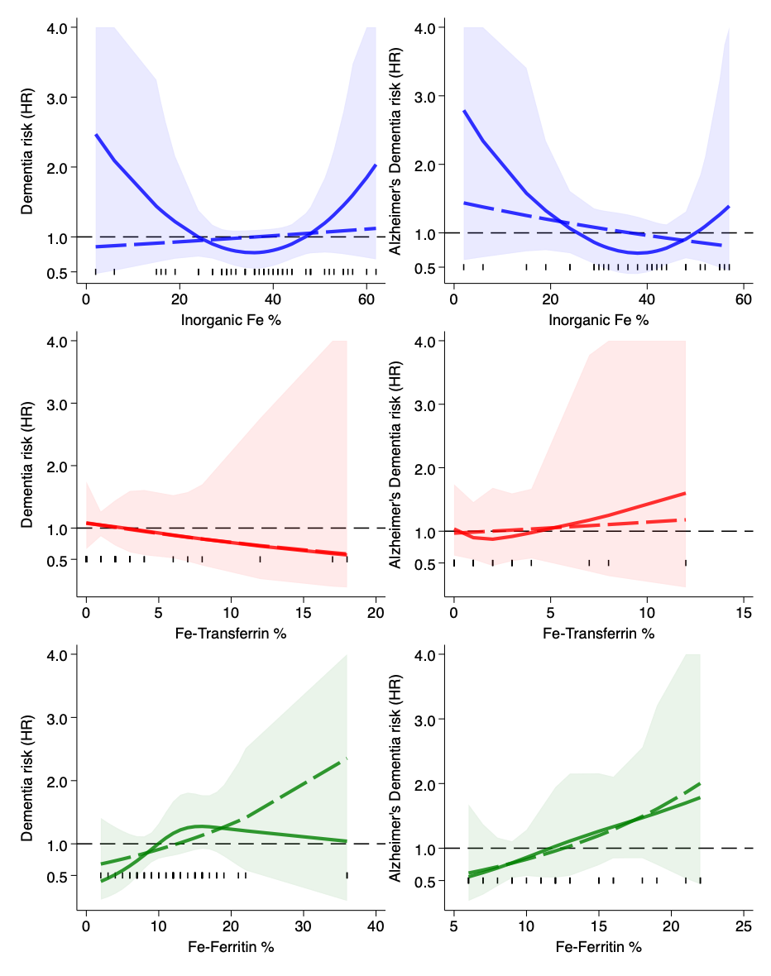

**Supplemental Figure S6.** Regression analyses investigating the association between baseline iron (Fe) species and risk of developing any type of dementia (left panels) or Alzheimer's dementia (AD – right panels). The solid line indicates hazard ratio (HR) and the shaded areas the 95% confidence intervals. Dashed line represents regression analysis assuming a linear model. Analyses are adjusted for age, sex, educational attainment, smoking status, and phosphorylated tau levels. Black line represents null risk (HR=1). Black vertical lines represent individual values of Fe species.

