Interpretive Summary: **Targeted assessment of the metabolome in skeletal muscle and in serum of dairy cows supplemented with conjugated linoleic acid during early lactation.** By Sadri et al. In view of the significance of conjugated linoleic acids (CLA) that was proposed on muscle metabolism in humans and laboratory animals, the effect of a dietary CLA supplement during early lactation on the metabolome was profiled in muscle and serum on d 21 and 70 after calving by means of a targeted metabolomic approach in dairy cows. Besides other significantly changed metabolites, CLA supplementation mainly led to changes in muscle and serum glycerophospholipids and sphingolipids concentrations, reflecting the phospholipid compositional changes in muscle associated with alteration of insulin sensitivity.

**RUNNING HEAD:** MUSCLE AND SERUM METABOLOME IN CLA-FED Dairy COWS

**Targeted assessment of the metabolome in skeletal muscle and in serum of dairy cows supplemented with conjugated linoleic acid during early lactation**

**H. Sadri,1* Y. Yang,2 C. Prehn,3 J. Adamski,3,4,5,6 J. Rehage,7 S. Dänicke,8 M. H. Ghaffari,2 and H. Sauerwein2†**

1Department of Clinical Science, Faculty of Veterinary Medicine, University of Tabriz, Tabriz 5166616471, Iran

2Institute of Animal Science, Physiology Unit, University of Bonn, 53115 Bonn, Germany

3Research Unit Molecular Endocrinology and Metabolism, Genome Analysis Center, Helmholtz Zentrum München, German Research Center for Environmental Health, Neuherberg, Germany

4Lehrstuhl für Experimentelle Genetik, Technische Universität München, Freising-Weihenstephan 85350, Germany

5German Center for Diabetes Research (DZD), München-Neuherberg 85764, Germany

6Department of Biochemistry, Yong Loo Lin School of Medicine, National University of Singapore, 8 Medical Drive, Singapore 117597, Singapore

7University for Veterinary Medicine, Foundation, Clinic for Cattle, 30173 Hannover, Germany

8Institute of Animal Nutrition, Friedrich-Loeffler-Institute (FLI), 38116 Braunschweig, Germany

*H. Sadri was a visiting scientist at the Institute of Animal Science, Physiology and Hygiene Unit, University of Bonn, 53115 Bonn, Germany, at the time the research was done.

†Corresponding author: [sauerwein@uni-bonn.de](mailto:sauerwein@uni-bonn.de)

**ABSTRACT**

In the dairy cow, late gestation and early lactation are characterized by a complexity of metabolic processes required for the homeorhetic adaptation to the needs of fetal growth and milk production. Skeletal muscle plays an important role in this adaptation. The objective of this study was to characterize the metabolome in skeletal muscle (*M. semitendinosus*) and in serum of dairy cows in the context of the physiological changes occurring in early lactation and to test the effects of dietary supplementation (from d 1 in milk onwards) with conjugated linoleic acids (sCLA; 100 g/d; supplying 7.6 g of *cis*-9,*trans*-11 CLA and 7.6 g of *trans*-10,*cis*-12 CLA per cow/d; n = 11) compared with control fat-supplemented cows (CTR; n = 10). The metabolome was characterized in skeletal muscle samples collected on d 21 and 70 after calving in conjunction with their serum counterpart using a targeted metabolomics approach (AbsoluteIDQ p180 kit; Biocrates Life Sciences AG, Innsbruck, Austria). Thereby 188 metabolites from 6 different compound classes (acylcarnitines, amino acids, biogenic amines, glycerophospholipids, sphingolipids, and hexoses) were quantified in both sample types. In both groups, dry matter intake increased after calving. It was lower in sCLA than in CTR on d 21, which resulted in reduced calculated net energy and metabolizable protein balances. On d 21, the concentrations of dopamine, Ala, and hexoses in the skeletal muscle were higher in sCLA than in CTR. On d 21, the changed metabolites in serum were mainly long-chain (>C24) di-acyl phosphatidylcholine PC (PC aa) and acyl alkyl phosphatidylcholine (PC ae), along with lysophosphatidylcholine acyl (lysoPC a) C26:1 that were all lower in sCLA than in CTR. Supplementation with CLA affected the muscle concentrations of 22 metabolites on d 70 including 10 long-chain (>C22) sphingomyelin (SM), hydroxysphingomyeline [(SM (OH)], PC aa, and PC ae along with 9 long-chain (>C16) lysoPC a and 3 metabolites related to amino acids (spermine, citrulline, and Asp). On d 70, the concentrations of lysoPC a C18:2 and C26:0 in serum were higher in the sCLA cows than in the CTR cows. Regardless of treatment, the concentrations of Ile, Leu, Phe, Lys, His, Met, Trp, and hydroxybutyrylcarnitine (C4-OH) decreased, whereas those of ornithine, Gln, and trans-4-hydroxyproline (t4-OH-Pro) increased from d 21 to d 70 in muscle. The significantly changed metabolites in serum with time of lactation were 28 long-chain (> C30) PC ae and PC aa, 7 long-chain (> C16) SM and SM (OH), along with lysoPC a C20:3 that were all increased. In conclusion, besides other significantly changed metabolites, CLA supplementation mainly led to changes in muscle and serum concentrations of glycerophospholipids and sphingolipids that might reflect the phospholipid compositional changes in muscle. The metabolome changes observed in sCLA on d 21 seem to be, at least in part, due to the lower DMI in these cows. The changes in the muscle concentrations of AA from d 21 to d 70, which coincided with the steady energy and MP balances, might reflect a shift of protein synthesis/degradation balance towards synthesis.

**Key Words:** conjugated linoleic acids, metabolomics, skeletal muscle, dairy cow

**INTRODUCTION**

Reduced feed intake during the last days of gestation and increased nutrient demand for milk synthesis at the onset of lactation commonly result in a negative nutrient balance (Drackley, 1999), which might compromise the ability of dairy cows for adapting to the physiological needs of pregnancy and lactation. Adaptive failure during this crucial period might impair animal health and performance (Drackley, 1999; Sundrum, 2015). Most of the approaches to help cows through this critical phase focused on understanding the regulation of energy metabolism and the main target tissues were liver and adipose tissue; consequently, less attention has been paid to the metabolic and regulatory role of skeletal muscle in the adaptation to early lactation. Skeletal muscle, the largest internal organ in mammals, plays important role in regulating the systemic metabolic homeostasis (Baskin et al., 2015). Muscle protein mobilization seems to start ante partum, even before the onset of lipid mobilization (van der Drift et al., 2012), to overcome negative nutrient balance by providing AA for milk protein synthesis, direct oxidation, hepatic gluconeogenesis, as well as for the immune system (Plaizier et al., 2000; Kuhla et al., 2011; Sadri et al., 2016). Moreover, the oxidative capacity of skeletal muscle for fatty acids (**FA**) released from adipose tissue lipolysis might also contribute to reducing the metabolic load of FA on the liver (Kuhla et al., 2011; Schäff et al., 2013), although the quantitative contribution of skeletal muscle to FA metabolism in dairy cows in early lactation is unknown.

In recent decades, dietary supplementation with CLA has gained special attention in human and animal nutrition due to the many bioactive health-related properties of CLA. Supplementation with *trans*-10, *cis*-12 CLA has evolved as a dietary strategy used in dairy cows especially in early lactation for reducing milk fat content while improving energy balance to counteract the physiological negative energy balance (Sippel et al., 2009; Schlegel et al., 2012; Qin et al., 2018). In most animal feeding trials applying CLA, the consideration of skeletal muscle was limited to the assessment of the CLA tissue concentrations (e.g., (Enser et al., 1999; De La Torre et al., 2006; Pinelli-Saavedra et al., 2019). However, in view of reports attributing CLA a role in modulating muscle metabolism in humans and in laboratory animals (Lehnen et al., 2015; Kim et al., 2016a,b), analogous effects in dairy cows are of interest. In human studies, characterizing the muscle metabolome is considered as a promising tool for understanding the metabolic processes related to the energetic status, glucose, and FA metabolism (Fazelzadeh et al., 2016; Xiang et al., 2017; Starnes et al., 2017); however, the studies performed in cattle to explore the metabolome in skeletal muscle are mostly limited to beef animals and meat (Goldansaz et al., 2017), whereas there is only one paper dealing with dairy cows until now (Sadri et al., 2020). Using a targeted metabolomics approach, we tested the hypothesis that dietary supplementation with CLA would alter the lactation-related metabolomic signatures in skeletal muscle and in blood serum of dairy cows. Thus, the objective of this study was to characterize the skeletal muscle metabolome in conjunction with their serum counterpart in the context of the physiological changes occurring during early lactation in dairy cows as influenced by a rumen-protected CLA supplement.

**MATERIAL AND METHODS**

***Animals, Treatment, and Experimental Design***

The experimental procedures performed in this study were in accordance with the European Community regulations on the protection of experimental animals and the guidelines of the LAVES (Lower Saxony State Office for Consumer Protection and Food Safety, Germany, File Number 33.14.42502-04-071/07). The basic set-up of the study together with performance data has been described in detail previously (Pappritz et al., 2011). In the current study, a subset of animals and samples from this study were used. In brief, one d after calving, 21 multiparous Holstein cows were allocated to either a control (**CTR**; n = 10) group or a supplemental CLA (**sCLA**; n = 11) group. Cows were fed with a partial mixed ration (PMR) for ad libitum intake, according to the recommendations of the German Society of Nutrition Physiology (GfE, 2001). The PMR (6.8 MJ of NEL/kg of DM) consisted of 37.8% corn silage, 25.2% grass silage, and 37% concentrate (on a DM basis). From DIM 1 throughout the observation period, the fat supplements were given with 4 kg of additional concentrate (8.8 MJ of NEL/kg of DM) consisting of the same components as the concentrate used in the PMR. The animals in the sCLA group received a diet supplemented with rumen-protected CLA (Lutrell Pure, BASF SE, Ludwigshafen, Germany; 100 g per cow/d), providing 7.6 g of *cis*-9, *trans*-11 CLA and 7.6 g of *trans*-10, *cis*-12 CLA per day and cow (Pappritz et al., 2011). The CTR cows were fed a diet that included 100 g/d of rumen-protected control fat supplement (Silafat, BASF SE) in which CLA was substituted by stearic acid (C18:0) to form an isoenergetic control diet.

***Blood and Muscle Tissue Sampling***

Blood samples were collected via puncture of the jugular vein using evacuated tubes on d 1, 21, and 70 after parturition after the morning milking before cows had access to fresh feed and before collecting the muscle biopsies (see below). The centrifugation (at 4 °C and 3,000 × *g* for 10 min) of plasma (heparin and EDTA) and serum was performed after sampling, and the samples were stored at -80 °C for further analysis.

Muscle tissue samples were collected on d 21 and 70 after parturition under aseptic conditions from the *M. semitendinosus* of the left or right hind limb about 10 cm ventrally of the *Tuber ischiadicum*. At the biopsy site, the skin was shaved, washed, dried with paper towels, degreased with medical alcohol, and disinfected with iodine. Biopsies were taken by means of the Magnum Biopsy System (penetration depth 22 mm) using 12G Magnum Biopsy Needles which were introduced through a 11G Bard TrueGuide coaxial needle (Bard GmbH, Karlsruhe, Germany). Thereafter, the skin wound was covered by Aluminium spray (aniMedica GmbH a LIVISTO company, Senden-Bösensell, Germany). For pain management, a sacral epidural anaesthesia (7-8 mL Procain 2%; Pracasel 2%, Selectavet, Weyarn-Holzolling, Germany) was applied and the biopsy site infiltrated subcutaneously with 5 mL Procain 2%. For analgesia, ketoprofen (3 mg/kg BW IM; Romefen PR10%, CEVA Tiergesundheit GmbH, Düsseldorf, Germany) was administered for two consecutive days. Tissue samples were snap-frozen in liquid nitrogen and stored at –80 °C until analysis. The muscle samples collected from one sCLA animal (DIM 21 and 70) and two CTR animals (DIM 70) had been expended for other analyses and the amount of tissue remaining was insufficient for a reliable analysis.

***Analysis of NEFA, Glucose, and Insulin in Blood Samples***

Glucose was assayed in NaF-EDTA plasma; for quantification of NEFA and insulin, heparinized plasma was used. The plasma concentrations of glucose and NEFA were determined by an automatic analyzer (Cobas Mira Plus System from Roche Diagnostica Ltd, Basel, Switzerland) using commercial test kits (Glucose: Glucose Hexokinase Fluid 5+1, MTI Diagnostics GmbH, Idstein, Germany; NEFA: HR(2) R1+R2 Set, WAKO Chemicals GmbH, Neuss, Germany). The concentrations of insulin in plasma were measured using a commercially available antibody radioimmunoassay (DSL-1600, Diagnostic Systems Laboratories, Inc., TX). The intra- and inter-assay coefficients of variation were 6.3% and 8.8%, respectively (Saremi et al., 2014).

***Metabolite Profiling***

The metabolome was characterized in muscle and serum samples by a targeted quantitative metabolomics approach employing a commercially available Kit (Absolute*IDQ* p180 Kit; Biocrates Life Sciences AG, Innsbruck, Austria). The metabolite panel consists of 188 different metabolites including free carnitine, 40 acylcarnitines (Cx:y), 21 amino acids (19 proteinogenic amino acids, citrulline, and ornithine), 21 biogenic amines, hexose (H1; the sum of hexoses – about 90–95% glucose), 90 glycerophospholipids [14 lysophosphatidylcholines (lysoPC) and 76 phosphatidylcholines (PC diacyl (aa) and acyl-alkyl (ae)], and 15 sphingolipids (SMx:y). Thecomplete list of the metabolites is given in Supplemental Table S1. The abbreviations, written as Cx:y, are used to describe the total number of carbons and double bonds of all chains, respectively. Sample preparation and all analyses were performed in the Helmholtz Zentrum München (GmbH), German Research Center for Environmental Health, Genome Analysis Center. In the case of serum, 10 µL of the thawed sample were directly applied to the assay. In the case of muscle, 25 mg of frozen sample were homogenized and extracted using homogenization tubes containing ceramic beads with a diameter of 1.4 mm and a Precellys 24 homogenizer equipped with an integrated cooling unit (PEQLAB Biotechnology GmbH, Darmstadt, Germany). Three μL of a dry ice-cooled mixture of ethanol/phosphate buffer (85/15, vol/vol) were added to each milligram of frozen muscle tissue. After centrifugation, 10 µL of the homogenate supernatant were applied to the well plate of the p180 kit. The detailed description of the tissue preparation, the assay procedures of the Absolute*IDQ* p180 Kit, as well as the metabolite nomenclature have been described in detail elsewhere (Zukunft et al., 2013, 2018). Sample handling was performed using a Hamilton Microlab STARTM robot (Hamilton Bonaduz AG, Bonaduz, Switzerland) and an Ultravap nitrogen evaporator (Porvair Sciences, Leatherhead, UK) along with standard laboratory equipment. Mass spectrometric analyses were conducted using an API 4000 triple quadrupole instrument (Sciex Deutschland GmbH, Darmstadt, Germany) equipped with a 1200 Series HPLC (Agilent Technologies Deutschland GmbH, Böblingen, Germany) and an HTC PAL autosampler (CTC Analytics, Zwingen, Switzerland) controlled by the software Analyst 1.6.1 (Sciex Deutschland GmbH, Darmstadt, Germany). Data evaluation for quantification of muscle and serum metabolite concentrations and quality assessment was performed with the software MultiQuant 3.0.1 (Sciex Deutschland GmbH) and the Met*IDQ* software package (Biocrates Life Sciences AG), which is an integral part of the Absolute*IDQ* p180 Kit. Internal standards were used as a reference to calculate the metabolite concentrations. The concentrations in muscle tissue samples are given in picomoles per milligram of tissue and the concentrations of the serum samples are given in micromoles per liter.

***Calculations and*** ***Statistical Analyses***

The diet used for the experimental cows was evaluated by the NittanyCow Dairy Ration Evaluator (Mifflinburg, PA) to calculate postpartum net energy (NEL) and metabolizable protein (MP) balances for each cow according to the National Research Council (NRC) model (NRC, 2001). The NEL balance was calculated with the following formula: NEB = (DMI × NEL diet) - [(0.08 × BW0.75) + (0.0929 × fat + 0.0563 × protein + 0.0395 × lactose) × milk yield)]. In the case of MP balance, the supply of the different protein fractions and AA balances was estimated using actual DMI, milk yield, milk composition, BCS, and BW of the cows as explained in detail elsewhere (Yang et al., 2020). Feed efficiency was calculated as the ratio between 4% fat-corrected milk (kg) and DMI, where fat corrected milk (4%) = 0.4 × kg milk + 15 × kg milk × fat content. Statistical analysis of the data for DMI, NEL, and MP balances, feed efficiency, and blood parameters were analyzed using repeated measures in the MIXED procedure of SAS software (version 9.3; SAS Institute Inc., Cary, NC). The model included treatment, time, and interaction of treatment × time as fixed effects and cow as random effect. The first-order autoregressive covariance structure (AR1) was determined as the most appropriate covariance structure for all repeated statements according to the information criteria of Akaike and Bayes. The Tukey-Kramer adjustment was applied to account for multiple comparisons. The data were tested for normality before analysis using the UNIVARIATE procedure and were log-transformed (base 10) when data were not normally distributed. The threshold of significance was set at *P* ≤ 0.05, and trends were declared at 0.05 < *P* ≤ 0.10.

The statistical analysis of the muscle and serum metabolite data was carried out using the web-based metabolomics data processing tool MetaboAnalyst 4.0 (Chong et al., 2018). According to the “80% rule” proposed by Bijlsma et al. (2006), metabolites with more than 20% of missing values (i.e., values lower than the limit of detection; Supplemental Table S2) were not considered for the statistical analysis. A total of 178 (94.7%) and 185 (98.4%) metabolites yielded useful measurements for the statistical evaluation in serum and muscle samples, respectively. Thus, only 10 and 3 metabolites, respectively, in serum and muscle were not considered for the statistical analysis. In case of missing values within those metabolites considered for the statistical analysis, the Bayesian PCA (BPCA) method offered by MetaboAnalyst was used to estimate the values of missing data. The metabolite data were generalized log-transformed and Pareto-scaled to correct for heteroskedasticity, to reduce the skewness of the data, and to reduce mask effects (van den Berg et al., 2006). Volcano plots were created to provide an overview of the significantly affected metabolites. Volcano plots display the size of the biological effect (fold-change) versus the statistical significance of the result. Important metabolites were identified by the volcano plot based on the fold change threshold of 1.5 on the x-axis and t-tests threshold (*P*-value) of 0.05 on the y-axis. The metabolites determined through the use of a volcano plot were then analyzed using estimation methods and are presented as mean-difference estimation plots (Claridge-Chang and Assam, 2016). Effect size was measured using Hedges’ *g* (Greenland et al., 2016) and was referred to as either ‘trivial’ (*g* < 0.2), ‘small’ (0.2 < *g* < 0.5), ‘moderate’ (0.5 < *g* < 0.8) or ‘large’ (*g* > 0.8) as per standard practice. To estimate precision, 95% confidence intervals for mean differences were calculated by bootstrap methods (resampled 5,000 times, bias-corrected, and accelerated). The Mann-Whitney U test was used to calculate *P*-values for pro forma reporting exclusively (Crichton, 2000).

**RESULTS**

***Blood Parameters, DMI, Calculated NEL, and MP Balances, and Feed Efficiency***

The time courses of the plasma NEFA, glucose, and insulin concentrations are presented in Figure 1. Plasma NEFA concentrations did not differ between the groups but decreased in both groups postpartum (*P* < 0.01). The plasma concentrations of glucose were affected by time (*P* < 0.01), and the overall treatment effect was significant (*P* = 0.04). The mean concentrations of glucose across all time-points in sCLA were greater than in CTR. Plasma insulin concentrations were affected by CLA supplementation (*P* = 0.02) and decreased (*P* < 0.01) with time of lactation in both groups but to a greater extent in CTR than in sCLA, resulting in lower (*P* < 0.05) insulin concentrations on d 21 and 70 in CTR than in sCLA.

Dry matter intake, and calculated NEL balance and feed efficiency are presented in Figure 1. Postpartum DMI was 21.2 ± 0.24 kg/d (mean ± SEM) and 22.3 ± 0.24 kg/d in the sCLA and CTR groups, respectively. The DMI increased (*P* < 0.01) in both groups postpartum, and an interaction of treatment × time was observed (*P* < 0.01). The DMI on d 21 was greater in CTR than in sCLA (*P* < 0.01). The effect of CLA on calculated energy balance depended on time in lactation (*P* = 0.02). The NEL balance was estimated to be about -8.09 ± 1.54 MCal/d (mean ± SEM) and -3.74 ± 1.86 MCal/d on d 1 in sCLA and CTR, respectively. The sCLA group was estimated to be still deficient in NEL intake on d 21 (-7.45 ± 1.24 MCal/d), whereas the animals of the CTR group reached a steady NEL balance. Both sCLA and CTR groups were in a steady energy balance on d 70. The effect of CLA on MP balance was dependent on time in lactation (*P* = 0.02). The MP balance was estimated to be about -201 ± 89 g/d (mean ± SEM) and -429 ± 74 g/d on d 1 in CTR and sCLA, respectively. The animals of the sCLA groups were estimated to be still deficient in MP intake on d 21 (-72 ± 56 g/d), whereas the CTR group had a positive calculated MP intake balance on d 21 (377 ±104 g/d). Both groups had a positive calculated MP intake balance on d 70 (212 ± 72.9 and 173 ± 51 g/d, respectively). The calculated feed efficiency was not affected by treatment or time, but a treatment × time interaction was observed (*P* = 0.05). The calculated feed efficiency on d 21 was slightly greater in sCLA than in CTR, but it did not reach the level of significance after correction for multiple comparisons.

***Muscle and Serum Metabolome***

The univariate analysis with volcano plot was carried out to obtain a preliminary overview of the muscle (Figures 2 and 4) and serum (Figures 3 and 5) metabolites that are contributing most to discriminating sCLA and CTR cows on d 21 and 70.

The muscle concentrations of dopamine, Ala, and hexoses (H1) were greater (effect size, *g* ≥ 0.99; *P* ≤ 0.04) in sCLA than in CTR on d 21 (Figure 2). On d 21, the serum concentrations of carnosine (*g* = 1.68; *P* < 0.01) were greater in the sCLA cows as compared with the CTR cows, whereas those of methionine sulfoxide (Met-SO; *g* = -1.24; *P* < 0.01), PC aa C24:0, C40:1, C40:2, C42:0, C42:1, C42:2, C42:4 (*g* ≤ -1.04; *P* ≤ 0.02), and PC ae C38:1, C38:2, C40:1, C40:3, C40:4, C42:0, C44:6, C42:1, C42:2, C42:3, C42:4, C42:5, C44:3, C44:4, C44:5 (*g* ≥ -0.96; *P* ≤ 0.02), as well as LysoPC a C26:1 showed a reverse change (*g* = -1.01; *P* = 0.02; Figure 3).

On d 70, the muscle concentrations of spermine, citrulline, and Asp (*g* ≥ 0.88; *P* ≤ 0.02), and SM C24:0, C26:1 (*g* ≥ 0.88; *P* ≤ 0.05), and hydroxysphingomyeline [SM (OH)] C22:1, C24:1 (*g* ≥ 2.06; *P* < 0.01), and PC aa C26:0, C32:0, C30:0, C28:1 (*g* ≥ 0.88; *P* ≤ 0.05), and PC ae C34:0, C30:1 (*g* ≥ 0.84; *P* ≤ 0.03), as well as lysPC a C18:2, C20:3, C26:1, C28:0, C28:1, C20:4, C16:1, C18:1, C26:0 (*g* ≥ 0.96; *P* ≤ 0.05, except for C20:4: *g* = 0.80; *P* = 0.09) were greater in the sCLA cows as compared with the CTR cows (Figure 4). The serum concentrations of lysoPC a C18:2 and C26:0 (*g* ≥ 1.11; *P* ≤ 0.02) were greater in sCLA than in CTR on d 70 (Figure 5).

The univariate analysis with volcano plot was also carried out to identify those metabolites that differed (1.5-fold change and *P* < 0.05) in muscle (Supplemental Figure S1) and serum (Supplemental Figure S2) across the time-points (regardless of treatment). The muscle concentrations of Ile, Leu, Phe, Lys, His, Met, Trp, and hydroxybutyrylcarnitine (C4-OH) decreased from d 21 to d 70, whereas those of ornithine, Gln, and trans-4-hydroxyproline (t4-OH-Pro) increased. The serum concentrations of PC ae C30:0, C30:1, C32:2, C34:0, C34:2, C34:3, C36:0, C36:2, C36:3, C36:4, C36:5, C38:0, C38:3, C38:4, C38:5, PC aa C32:2, C32:3, C34:4, C36:0, C36:2, C36:3, C38:0, C38:1, C38:3, C40:3, C40:4, C42:4, C42:5, SM C16:1, C18:1, C20:2, C24:0, C26:0, SM (OH) C16:1, C24:1, lysoPC a C20:3, and serotonin increased from d 21 to d 70, whereas those of acetylcarnitine (C2) showed a reverse change.

**DISCUSSION**

In the current study, sample preparation and all analyses were performed almost 4 years after collecting the samples (with no previous thawing and freezing cycle). Thus, the absolute concentrations in these samples might vary due to the storage period, though the relative concentrations and the differences between groups would remain largely unchanged. The current data demonstrate that glycerophospholipids, including PC (a principal phospholipid circulating in the blood) in particular, underwent a shift in their serum and muscle concentrations of the sCLA cows when compared with those of the CTR cows in early lactation. In serum of the sCLA cows, 23 unequivocally identified phospholipids (22 PC and 1 lysPC) on d 21 after calving were less abundant than in the CTR cows. Phosphatidylcholines can be synthesized in the body through phosphorylation of choline, obtained from dietary sources or by the degradation of existing choline-containing lipids, mediated by phosphatidylethanolamine N-methyltransferase (PEMT) in the liver (Reo et al., 2002) as well as in the mammary gland (Robinson et al., 1987). In ruminants, dietary choline is extensively degraded in the rumen (Neill, 1979; Sharma, and Erdman, 1989) and thus endogenous synthesis via the PEMT pathway is regarded as a critical source of choline (Baldi and Pinotti, 2006). It is known that the *de novo* synthesis of choline is carried out from ethanolamine when S-adenosylmethionine as a methyl-group donor is adequately supplied (Zeisel and Blusztajn, 1994). In the sCLA cows, the concentrations of serum PC on d 21 were decreased, without change in the levels of other phospholipids (except lysoPC a C26:1). Due to the reduced decreased DMI in the sCLA cows over the first days of lactation and possibly the related lower supply of dietary precursors such as methionine, we, therefore, reasoned that choline biosynthesis could be decreased or the use of PC as a substrate for energy metabolism could be increased during this period, or a combination of both. Interestingly, the relationship reversed on d 70: the concentrations of the 19 identified phospholipids [6 PC, 9 lysPC, 2 SM, and 2 SM (OH)] in muscle and of serum lysoPC a C18:2 and C26:0 were elevated in the sCLA cows as compared to the CTR cows. The PC derived from hepatic PEMT activity might have a small contribution to total PC in ruminants (Robinson et al., 1987; Artegoitia et al., 2014). Unlike rodents and humans, where almost all PEMT activity occurs in the liver (Reo et al., 2002), the majority (about 82%) of endogenous choline synthesis via the PEMT activity appears to be supplied by extrahepatic tissues in sheep, with skeletal muscle contributing around 60% of this activity (Robinson et al., 1987). The mechanism yielding increased muscle and serum phospholipids in the sCLA cows on d 70 remains to be clarified; however, CLA have been demonstrated to influence several proteins involved in diverse metabolic processes linked to skeletal muscle anabolism, inflammation, and carbohydrate and lipid metabolism (Lehnen et al., 2015; Kim et al., 2016a,b). Thus, though speculative, CLA might have affected key proteins involved in phospholipid synthesis, augmenting the content of muscle PC, lysoPC, and SM. Besides PC and SM, 9 lysoPC a (C16:1, C18:1, C18:2, C20:0, C20:4, C26:1, C28:0, and C28:1) in the muscle and 2 lysoPC a (C18:2, C26:0) in the serum of the sCLA cows were increased on d 70. Lysophosphatidcholines, with structural and signaling roles, are a class of biomolecule that are primarily originating from cleaving of cell membrane-derived PC via the action of phospholipase A2 (van der Veen et al., 2017).

An interesting finding of the present study was the increased muscle dopamine concentrations on d 21 in cows supplemented with CLA. Dopamine, with multiple central and peripheral physiological effects, mediates its action via β-adrenergic receptors in skeletal muscle (Schubert et al., 1976; Smith et al., 2004). It has been shown that muscle cells respond to dopamine through increases in cAMP concentrations, which could be blocked by a β-adrenergic antagonist (Schubert et al., 1976). Thus, it seems possible that the greater dopamine content in the muscle of the sCLA cows would augment the cAMP concentrations in muscle via β-adrenergic receptors. The β-adrenergic action and cAMP have been implicated as negative regulators of insulin action, which consequently decrease glycogen synthase activity and insulin-stimulated glucose uptake in skeletal muscle (Smith et al., 2004). Lowering the activity of glycogen synthase activity could cause an intracellular accumulation of glucose-6-phosphate, which appears to decrease insulin-stimulated glucose transport into the muscle (Lee et al., 1997; Laurent et al., 2000). In the current study, the greater muscle dopamine coincided with the greater muscle hexoses (H1 – about 90–95% glucose) concentrations, proposing the presence of insulin resistance in the muscle of the sCLA cows. As reported previously from this animal experiment, CLA supplementation was associated with a mitigation of the postpartum increase of circulating adiponectin (an adipokine that promotes insulin sensitivity) in the cows of the present study (Singh et al., 2014), further indicating decreased insulin sensitivity. In support of this, there was also a slight and transient increase of both glucose and insulin in the circulation of sCLA cows, and as shown in the companion study by Saremi et al. (2014) resulting in decreased values of a surrogate index for insulin sensitivity that is calculated from glucose, insulin, and NEFA concentrations.

In the current study, the concentrations of Ala in muscle were higher in the sCLA cows as compared with the CTR cows on d 21. Besides Gln, Ala predominates among the AA released from muscle proteolysis in transferring both amino groups and carbon atoms [in particular from branched-chain amino acids (BCAA)] to the liver where the nitrogen enters the urea cycle and the pyruvate is used for gluconeogenesis (Frayn, 2010). The reduced DMI in the sCLA cows over the first days of lactation and the related lower calculated NEL and MP balances were associated with the 1.7-fold greater abundance of F-box only protein 32 (*FBXO32*; also called *atrogin-1*) on d 21. Atrogin-1 is one of the specific markers of muscle wasting (Foletta et al., 2011) and its up-regulation might be related to an upregulation of the ubiquitin-proteasome system (the main proteolytic pathway in muscle) and consequent stimulation of protein degradation in the muscle. In addition, the mRNA for the α-polypeptide subunit of the branched-chain α-keto acid dehydrogenase E1 component was elevated in sCLA (Yang et al., 2020), likely suggesting a relatively high oxidative potential of the muscle in the sCLA cows on d 21. Taken together, the greater muscle concentrations of Ala in the sCLA cows on d 21 might be due to stimulation of muscle proteolysis and catabolism of released AA, in particular BCAA, in response to the CLA supplementation or to the decreased DMI and the related lower calculated NEL and MP balances during early lactation, or to a combination of both.

In the current study, we cannot determine whether or not the observations were independent of lower feed intake in the sCLA cows over the first 21 days of lactation. In a study reported by Hötger et al. (2013), cows supplemented with CLA tended to lower DMI as compared with control cows. Nevertheless, other studies about the effects of dietary supplemented CLA on the feed intake of dairy cows during the first weeks of lactation have yielded mostly consistent results, and in contrast to our findings, no influence on DMI was observed (Moore et al., 2004; Castañeda-Gutiérrez et al., 2005; Piamphon et al., 2009). The mechanisms behind the CLA-related transitory depression in DMI in the current study is not clear, but but was apparently not related to compromised palatability of the CLA-containing concentrate since all cows consumed the concentrate feed as allocated.

The concentrations of free AA in muscle reflect the balance between various processes: the inward transport from the circulation and the outward release into the bloodstream, the incorporation into protein (synthesis), the release from protein degradation, and the loss by transamination and degradation (Frayn, 2010). In addition, in muscle wasting states, increased muscle protein breakdown is associated with raising intracellular concentrations of essential AA, such as Leu, Ile, Val, Phe, and Met (Holecek and Micuda, 2017; de Vasconcelos et al., 2019). Thus, in the current study, the decrease in muscle concentrations of Ile, Leu, Phe, Lys, His, Met, Trp, and C4-OH (mainly derived from the ketone body β-hydroxybutyrate) from d 21 to d 70, which coincided with the steady energy and MP balance on d 70 might reflect that the balance of protein synthesis/degradation was shifted towards synthesis. This is supported by the increased muscle Gln on d 70, which has been positively associated with muscle protein synthesis (Millward et al., 1989; Wu et al., 2011).

In the current study, phosphatidylcholines were the main metabolites in serum increasing in the course of lactation, which is in agreement with a previous report in dairy cows (Artegoitia et al., 2014). Phosphatidylcholine is a main component of all cell membranes and lipoprotein classes, reaching up to 60 to 80% of total phospholipids (Cole et al., 2012). The concentrations of lipoproteins, in particular of high-density lipoprotein (HDL), in the circulation increase with time of lactation in dairy cows (Raphael et al., 1973). Thus, the increased concentrations of PC from d 21 to d 70 after calving might have resulted from changes in type and level of lipoproteins in the circulation that occur during lactation (Artegoitia et al., 2014).

**CONCLUSIONS**

This study presents the analysis of the metabolomes in muscle and serum of dairy cows receiving a dietary supplemented with CLA during early lactation. For unknown reasons, supplementation of the diet with CLA was associated with a reduction in DMI over the first days of lactation and consequently a reduced calculated NEL and MP balance. The CLA supplementation mainly led to changes in muscle and serum glycerophospholipids and sphingolipids concentrations, reflecting the phospholipid compositional changes in muscle. The decreased long-chain PC in sCLA cows on d 21 might be due to the reduced DMI in these cows over the first days of lactation and the related lower supply of dietary precursors for choline biosynthesis or, to the use of PC as a substrate for energy metabolism during this period. The changes observed in the muscle AA concentrations with time of lactation (regardless of treatment), which coincided with the steady energy and MP balance, might reflect a shift of protein synthesis/degradation balance towards synthesis.

**ACKNOWLEDGMENTS**

The animal experiment was performed in frame of a project funded by the Deutsche Forschungsgemeinschaft (DFG, Berlin, Germany. Germany; PAK 286/1, SA 432/10-1); the metabolomics analyses were supported by Evonik Nutrition & Care GmbH (Hanau, Germany). We thank Iris Gockel-Bohner (Institute of Animal Science, Physiology and Hygiene Unit, University of Bonn) for her help during sampling of the cows. Y. Yang was recipient of a scholarship from the China Scholarship Council (CSC).

**REFERENCES**

Artegoitia, V. M., J. L. Middleton, F. M. Harte, S. R. Campagna, and M. J. de Veth. 2014. Choline and choline metabolite patterns and associations in blood and milk during lactation in dairy cows. PLoS One. 26;9(8):e103412. doi: 10.1371/journal.pone.0103412.

Baldi, A., and L. Pinotti. 2006. Choline metabolism in high-producing dairy cows: metabolic and nutritional basis. Can. J. Anim. Sci. 86:207–212.

Baskin, K. K., B. R. Winders, and E. N. Olson. 2015. Muscle as a "mediator" of systemic metabolism. Cell Metab. 21:237–248.

Bijlsma, S., I. Bobeldijk, E. R. Verheij, R. Ramaker, S. Kochhar, I. A. Macdonald, B. van Ommen, and A. K. Smilde. 2006. Large-scale human metabolomics studies: a strategy for data (pre-) processing and validation. Anal. Chem. 15:567–574.

Castañeda-Gutiérrez, E., T. R. Overton, W. R. Butler, and D. E. Bauman. 2005. Dietary supplements of two doses of calcium salts of conjugated linoleic acid during the transition period and early lactation. J. Dairy Sci. 88:1078–1089.

Chong, J., O. Soufan, C. Li, I. Caraus, S. Z. Li, G. Bourque, D. S. Wishart, and J. G. Xia. 2018. MetaboAnalyst 4.0: Towards more transparent and integrative metabolomics analysis. Nucleic Acids Res. 46(W1):W486–W494.

Claridge-Chang, A., and P. N. Assam. 2016. Estimation statistics should replace significance testing. Nat. Methods. 13:108–109.

Cole, L. K., J. E. Vance, and D. E. Vance. 2012. Phosphatidylcholine biosynthesis and lipoprotein metabolism. Biochim. Biophys. Acta. 1821:754–761.

Crichton, N. 2000. Information point: Mann-Whitney test. J. Clin. Nurs. 9:583.

De La Torre, A., D. Gruffat, D. Durand, D. Micol, A. Peyron, V. Scislowski, and D. Bauchart. 2006. Factors influencing proportion and composition of CLA in beef. Meat Sci. 73:258–268.

de Vasconcelos, D. A. A., P. Giesbertz, D. R. de Souza, K. F. Vitzel, P. Abreu, G. N. Marzuca-Nassr, M. A. S. Fortes, G. M. Murata, S. M. Hirabara, R. Curi, H. Daniel, and T. C. Pithon-Curi. 2019. Oral L-glutamine pretreatment attenuates skeletal muscle atrophy induced by 24-h fasting in mice. J. Nutr. Biochem. 70:202–214.

Drackley, J. K. 1999. Biology of dairy cows during the transition period: The final frontier? J. Dairy Sci. 82:2259–2273.

Enser, M., N. Scollan, N. Choi, E. Kurt, K. Hallett, and J. Wood. 1999. Effect of dietary lipid on the content of conjugated linoleic acid (CLA) in beef muscle. Anim. Sci. 69:143–146.

Fazelzadeh, P., R. W. Hangelbroek, M. Tieland, L. C. P. G. M. de Groot, L. B. Verdijk, L. C. van Loon, A. K. Smilde, R. D. A. M. Alves, J. Vervoort, M. Müller, J. P. M. van Duynhoven, and M. V. Boekschoten. 2016. The muscle metabolome differs between healthy and frail older adults. J. Proteome Res. 15:499–509.

Foletta, V. C., L. J. White, A. E. Larsen, B. Léger, and A. P. Russell. 2011. The role and regulation of MAFbx/atrogin-1 and MuRF1 in skeletal muscle atrophy. Pflugers Arch. 461:325–335.

Frayn, K. N. 2010. Metabolic Regulation: A Human Perspective. 3rd ed. Blackwell Science, Oxford, UK.

GfE (German Society of Nutrition Physiology). 2001 Ausschuss für Bedarfsnormen der Gesellschaft für Ernährungsphysiologie. Nr. 8. Empfehlungen zur Energie- und Nährstoffversorgung der Milchkühe und Aufzuchtrinder (Recommendations of Energy and Nutrient Supply for Dairy Cows and Breeding Cattle). DLG-Verlag, Frankfurt am Main, Germany.

Goldansaz, S. A., A. C. Guo, T. Sajed, M. A. Steele, G. S. Plastow, and D. S. Wishart. 2017. Livestock metabolomics and the livestock metabolome: A systematic review. PLoS One. 22;12(5):e0177675. doi: 10.1371/journal.pone.0177675.

Greenland, S., S. J. Senn, K. J. Rothman, J. B. Carlin, C. Poole, S. N. Goodman, and D. G. Altman. 2016. Statistical tests, P values, confidence intervals, and power: A guide to misinterpretations. Eur. J. Epidemiol. 31:337–350.

Holecek, M., and S. Micuda. 2017. Amino acid concentrations and protein metabolism of two types of rat skeletal muscle in postprandial state and after brief starvation. Physiol. Res. 66:959–967.

Hötger, K., H. M. Hammon, C. Weber, S. Görs, A. Tröscher, R. M. Bruckmaier, and C. C. Metges. 2013. Supplementation of conjugated linoleic acid in dairy cows reduces endogenous glucose production during early lactation. J. Dairy Sci. 96:2258–2270.

Kim, Y., J. Kim, K. Whang, and Y. Park. 2016a. Impact of conjugated linoleic acid (CLA) on skeletal muscle metabolism. Lipids. 51:159–178.

Kim, Y., K. Daeyoung, D. J. Good, and Y. Park. 2016b. Conjugated linoleic acid (CLA) influences muscle metabolism via stimulating mitochondrial biogenesis signaling in adult-onset inactivity induced obese mice. Eur. J. Lipid Sci. Technol. 118:1305–1316.

Kuhla, B., G. Nürnberg, D. Albrecht, S. Görs, H. M. Hammon, and C. C. Metges. 2011. Involvement of skeletal muscle protein, glycogen, and fat metabolism in the adaptation on early lactation dairy cows. J. Proteome Res. 10:4252–4262.

Laurent, D., R. S. Hundal, A. Dresner, T. B. Price, S. M. Vogel, K. F. Petersen, and G. I. Shulman. 2000. Mechanism of muscle glycogen autoregulation in humans. Am. J. Physiol. Endocrinol. Metab. 278:E663–E668.

Lee, A. D., P. A. Hansen, J. Schluter, E. A. Gulve, J. Gao, and J. O. Holloszy. 1997. Effects of epinephrine on insulin-stimulated glucose uptake and GLUT-4 phosphorylation in muscle. Am. J. Physiol. Cell Physiol. 273:C1082–C1087.

Lehnen, T. E., M. R. da Silva, A. Camacho, A. Marcadenti, and A. M. Lehnen. 2015. A review on effects of conjugated linoleic fatty acid (CLA) upon body composition and energetic metabolism. J. Int. Soc. Sports Nutr. 12:36.

Millward, D. J., M. M. Jepson, and A. Omer. 1989. Muscle glutamine concentration and protein turnover in vivo in malnutrition and in endotoxemia. Metabolism. 38:6–13.

Moore, C. E., H. C. Hafliger, O. B. Mendivil, S. R. Sanders, D. E. Bauman, and L. H. Baumgard. 2004. Increasing amounts of conjugated linoleic acid (CLA) progressively reduces milk fat synthesis immediately postpartum. J. Dairy Sci. 87:1886–1895.

Neill, A. R., D. W. Grime, A. M. Snoswell, A. J. Northrop, D. B. Lindsay, and R. M. Dawson. 1979. The low availability of dietary choline for the nutrition of the sheep. Biochem. J. 180:559–565.

NRC. 2001. Nutrient Requirements of Dairy Cattle. 7th rev. ed. Natl. Acad. Sci., Washington, DC.

Pappritz, J., P. Lebzien, U. Meyer, G. Jahreis, R. Kramer, G. Flachowsky, and S. Dänicke. 2011. Duodenal availability of conjugated linoleic acids after supplementation to dairy cow diets. Eur. J. Lipid Sci. Technol. 113:1443–1455.

Piamphon, N., C. Wachirapakorn, M. Wanapat, and C. Navanukraw. 2009. Effects of protected conjugated linoleic acid supplementation on milk fatty acid in dairy cows. Asian-Australas. J. Anim. Sci. 22:49–56.

Pinelli-Saavedra, A., H. González-Ríos, J. Luis Dávila-Ramírez, T. Yamileth Islava-Lagarda, and I. Rebeca Esquerra-Brauer. 2019. Dietary conjugated linoleic acid (CLA) has comparable effects to ractopamine on the growth performance, meat quality and fatty acid profiles of loin muscles of finishing pigs under commercial husbandry. Ital. J. Anim. Sci. 18:713–722.

Plaizier, J. C., J. P. Walton, A. Martin, T. Duffield, R. Bagg, P. Dick, and B. W. McBride. 2000. Short communication: Effects of monensin on 3-methylhistidine excretion in transition dairy cows. J. Dairy Sci. 83:2810–2812.

Qin, N., A. R. Bayat, E. Trevisi, A. Minuti, P. Kairenius, S. Viitala, M. Mutikainen, H. Leskinen, K. Elo, T. Kokkonen, and J. Vilkki. 2018. Dietary supplement of conjugated linoleic acids or polyunsaturated fatty acids suppressed the mobilization of body fat reserves in dairy cows at early lactation through different pathways. J. Dairy Sci. 101:7954–7970.

Raphael, B. C., P. S. Dimick, and D. L. Puppione. 1973. Lipid characterization of bovine serum lipoproteins throughout gestation and lactation. J. Dairy Sci. 56:1025–1032.

Reo, N. V., M. Adinehzadeh, and B. D. Foy. 2002. Kinetic analyses of liver phosphatidylcholine and phosphatidylethanolamine biosynthesis using C NMR spectroscopy BBA-Mol. Cell Biol. L. 1580:171–188.

Robinson, B. S., A. M. Snoswell, W. B. Runciman, and T. R. Kuchel. 1987. Choline biosynthesis in sheep. Evidence for extra- hepatic synthesis. Biochem. J. 244:367–373.

Sadri, H., F. Giallongo, A. N. Hristov, J. Werner, C. H. Lang, C. Parys, B. Saremi, and H. Sauerwein. 2016. Effects of slow-release urea and rumen-protected Met and His on mammalian target of rapamycin (mTOR) signaling and ubiquitin proteasome-related gene expression in skeletal muscle of dairy cows. J. Dairy Sci. 99:6702–6713.

Sadri, H., M. H. Ghaffari, K. Schuh, G. Dusel, C. Koch, C. Prehn, J. Adamski, and H. Sauerwein. 2020. Metabolome profiling in skeletal muscle to characterize metabolic alterations in over-conditioned cows during the periparturient period. J. Dairy Sci. 103:3730–3744.

Saremi, B., S. Winand, P. Friedrichs, A. Kinoshita, J. Rehage, and S. Dänicke. 2014. Longitudinal profiling of the tissue-specific expression of genes related with insulin sensitivity in dairy cows during lactation focusing on different fat depots. PLoS One 2014;9:e86211.

Schäff, C., S. Börner, S. Hacke, U. Kautzsch, H. Sauerwein, S. K. Spachmann, M. Schweigel-Röntgen, H. M. Hammon, and B. Kuhla. 2013. Increased muscle fatty acid oxidation in dairy cows with intensive body fat mobilization during early lactation. J. Dairy Sci. 96:6449–6460.

Schlegel, G., R. Ringseis, W. Windisch, F. J. Schwarz, and K. Eder. 2012. Effects of a rumen-protected mixture of conjugated linoleic acids on hepatic expression of genes involved in lipid metabolism in dairy cows. J. Dairy Sci. 95:3905–3918.

Schubert, D., H. Tarikas, and M. LaCorbiere. 1976. Neurotransmitter regulation of adenosine 3’,5’-monophosphate in clonal nerve, glia, and muscle cell lines. Science. 102:471–472.

Sharma, B: K., and R. A. Erdman. 1989. In vitro degradation of choline from selected foodstuffs and choline supplements. J. Dairy Sci. 72:2772–2776.

Singh, S. P., S. Häussler, J. F. Heinz, B. Saremi, B. Mielenz, J. Rehage, S. Dänicke, M. Mielenz, and H. Sauerwein. 2014. Supplementation with conjugated linoleic acids extends the adiponectin deficit during early lactation in dairy cows. Gen. Comp. Endocrinol. 198:13–21.

Sippel, M. A., R. S. Spratt, and J. P. Cant. 2009. Milk production responses of primiparous and multiparous dairy cows to dose of conjugated linoleic acid consumed in rumen inert form. Can. J. Anim. Sci. 89:393–399.

Smith, J. L., J. S. Ju, B. M. Saha, B. A. Racette, and J. S. Fisher. 2004. Levodopa with carbidopa diminishes glycogen concentration, glycogen synthase activity, and insulin-stimulated glucose transport in rat skeletal muscle. J. Appl. Physiol. 97:2339–2346.

Starnes, J. W., T. L. Parry, S. K. O'Neal, J. R. Bain, M. J. Muehlbauer, A. Honcoop, A. Ilaiwy, P. M. Christopher, C. Patterson, and M. S. Willis. 2017. Exercise-induced alterations in skeletal muscle, heart, liver, and serum metabolome identified by non-targeted metabolomics analysis. Metabolites. 7:40.

Sundrum, A., 2015. Metabolic disorders in the transition period indicate that the dairy cows’ ability to adapt is overstressed. Animals (Basel). 5:978–1020.

van den Berg, R. A., H. C. J. Hoefsloot, J. A. Westerhuis, A. K. Smilde, and M. J. van der Werf. 2006. Centering, scaling, and transformations: Improving the biological information content of metabolomics data. BMC Genomics. 7:142.

van der Drift, S. G. A., M. Houweling, J. T. Schonewille, A. G. M. Tielens, and R. Jorritsma. 2012. Protein and fat mobilization and associations with serum beta-hydroxybutyrate concentrations in dairy cows. J. Dairy Sci. 95:4911–4920.

van der Veen, J. N., J. P. Kennelly, S. Wan, J. E. Vance, D. E. Vance, and R. L. Jacobs. 2017. The critical role of phosphatidylcholine and phosphatidylethanolamine metabolism in health and disease. Biochim. Biophys. Acta Biomembr. 1859:1558–1572.

Wu, G., F. W. Bazer, G. A. Johnson, D. A. Knabe, R. C. Burghardt, T. E. Spencer, X. L. Li, and J. J. Wang. 2011. Triennial Growth Symposium: important roles for L-glutamine in swine nutrition and production. J. Anim. Sci. 89:2017–2030.

Xiang, L., H. Zhang, J. Wei, X. Y. Tian, H. Luan, S. Li, H. Zhao, G. Cao, A. C. K. Chung, C. Yang, Y. Huang, and Z. Cai. 2017. Metabolomics studies on db/db diabetic mice in skeletal muscle reveal effective clearance of overloaded intermediates by exercise. Anal. Chim. Acta. 1037:130–139.

Yang, Y., H. Sadri, C. Prehn, J. Adamski, J. Rehage, S. Dänicke, D. von Soosten, C. C. Metges, M. H. Ghaffari, and H. Sauerwein. 2020. Proteasome activity and expression of mammalian target of rapamycin signaling factors in skeletal muscle of dairy cows supplemented with conjugated linoleic acids during early lactation. J. Dairy Sci. 103:2829–2846.

Zeisel, S. H., M-H. Mar, J. C. Howe, and J. M. Holden. 2003. Concentrations of cholinecontaining compounds and betaine in common foods. J. Nutr. 133:1302–1307.

Zukunft, S., C. Prehn, C. Röhring, G. Möller, M. Hrabe de Angelis, J. Adamski, and J. Tokarz. 2018. High-throughput extraction and quantification method for targeted metabolomics in murine tissues. Metabolomics. 14:18.

Zukunft, S., M. Sorgenfrei, C. Prehn, G. Möller, and J. Adamski. 2013. Targeted metabolomics of dried blood spot extracts. Chromatographia. 76:1295–1305.

**Legend of the Figures**

**Figure 1.** Time course of the circulating concentrations of non-esterified fatty acids (NEFA), glucose, and insulin, of dry matter intake (DMI), NEL balance, and feed efficiency (4% fat-corrected milk/DMI) in dairy cows during early lactation. Supplementation with CLA (sCLA) or control fat (CTR) was initiated at d 1 of lactation. Different letters indicate differences (*P* < 0.05) between the time points in the control (CTR) (a-b) and in the sCLA (A-B) group. Asterisks indicate differences (*P* < 0.01) between sCLA and CTR at a given time point. Data are presented as means ± SEM. Data for NEFA, glucose, insulin, and dry matter intake are from Saremi et al. (2014) and Yang et al. (2020).

**Figure 2.** Volcano plot visualizing muscle metabolites in dairy cows on d 21 after calving. Supplementation with CLA (sCLA; n = 10) or control fat (CTR; n = 10) was initiated at d 1 of lactation. The x-axis represents the mean of log2 fold-change (FC) value, and the y-axis corresponds to the negative logarithm of the *P*-values. Each circle represents a single metabolite. The horizontal line represents the level of significance for the t-tests performed (0.05), and the vertical lines display the threshold set for fold change (1.5). The pink circles show metabolites that were significantly changed by the CLA supplementation and the gray circles show metabolites that were not significantly changed. Effect size, shown as Hedges’*g* between sCLA and CTR cows, is shown in the Gardner–Altman estimation plots of muscle metabolites. Both groups are plotted on the left axes; the mean difference is plotted on floating axes on the right as a bootstrap sampling distribution. The mean difference is depicted as a dot. Ala = alanine; H1 = hexose (sum of hexoses – about 90–95% glucose).

**Figure 3.** Volcano plot visualizing serum metabolites in dairy cows on d 21 after calving. Supplementation with CLA (sCLA; n = 11) or control fat (CTR; n = 10) was initiated at d 1 of lactation. The x-axis represents the mean of log2 fold-change (FC) value, and the y-axis corresponds to the negative logarithm of the *P*-values. Each circle represents a single metabolite. The horizontal line represents the level of significance for the t-tests performed (0.05), and the vertical lines display the threshold set for fold change (1.5). The pink circles show metabolites that were significantly changed by the CLA supplementation and the gray circles show metabolites that were not significantly changed. Effect size, shown as Hedges’*g* between sCLA and CTR cows, is shown in the Gardner–Altman estimation plots of muscle metabolites. Both groups are plotted on the left axes; the mean difference is plotted on floating axes on the right as a bootstrap sampling distribution. The mean difference is depicted as a dot. Met = methionine; Met-SO = methionine sulfoxide; PC aa = di-acyl phosphatidylcholine; PC ae = acyl alkyl phosphatidylcholine.

**Figure 4.** Volcano plot visualizing muscle metabolites in dairy cows on d 70 after calving. Supplementation with CLA (sCLA; n = 10) or control fat (CTR; n = 8) was initiated at d 1 of lactation. The x-axis represents the mean of log2 fold-change (FC) value, and the y-axis corresponds to the negative logarithm of the *P*-values. Each circle represents a single metabolite. The horizontal line represents the level of significance for the t-tests performed (0.05), and the vertical lines display the threshold set for fold change (1.5). The pink circles show metabolites that were significantly changed by the CLA supplementation and the gray circles show metabolites that were not significantly changed. Effect size, shown as Hedges’*g* between sCLA and CTR cows, is shown in the Gardner–Altman estimation plots of muscle metabolites. Both groups are plotted on the left axes; the mean difference is plotted on floating axes on the right as a bootstrap sampling distribution. The mean difference is depicted as a dot. Asp = aspartate; Cit = citrulline; LysoPC a = lysophosphatidylcholine acyl; PC aa = di-acyl phosphatidylcholine; PC ae = acyl alkyl phosphatidylcholine; SM = sphingomyeline; SM (OH) = hydroxysphingomyeline.

**Figure 5.** Volcano plot visualizing serum metabolites in dairy cows on d 70 after calving. Supplementation with CLA (sCLA; n = 11) or control fat (CTR; n = 10) was initiated at d 1 of lactation. The x-axis represents the mean of log2 fold-change (FC) value, and the y-axis corresponds to the negative logarithm of the *P*-values. Each circle represents a single metabolite. The horizontal line represents the level of significance for the t-tests performed (0.05), and the vertical lines display the threshold set for fold change (1.5). The pink circles show metabolites that were significantly changed by the CLA supplementation and the gray circles show metabolites that were not significantly changed. Effect size, shown as Hedges’*g* between sCLA and CTR cows, is shown in the Gardner–Altman estimation plots of muscle metabolites. Both groups are plotted on the left axes; the mean difference is plotted on floating axes on the right as a bootstrap sampling distribution. The mean difference is depicted as a dot. LysoPC a = lysophosphatidylcholine acyl.



**Figure 1.**

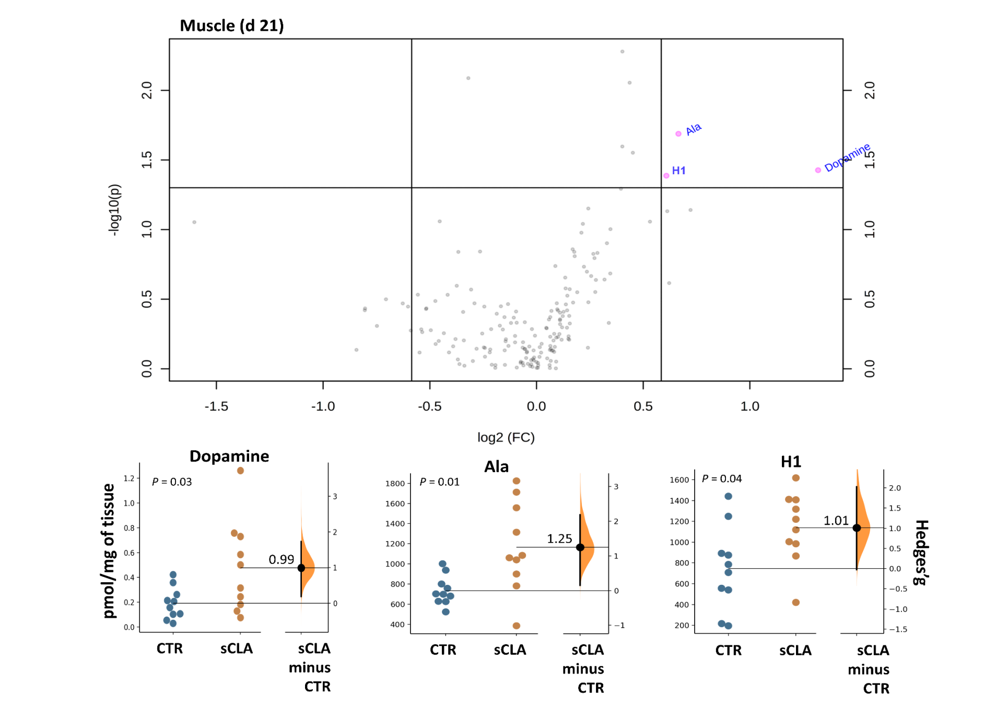

**Figure 2.**

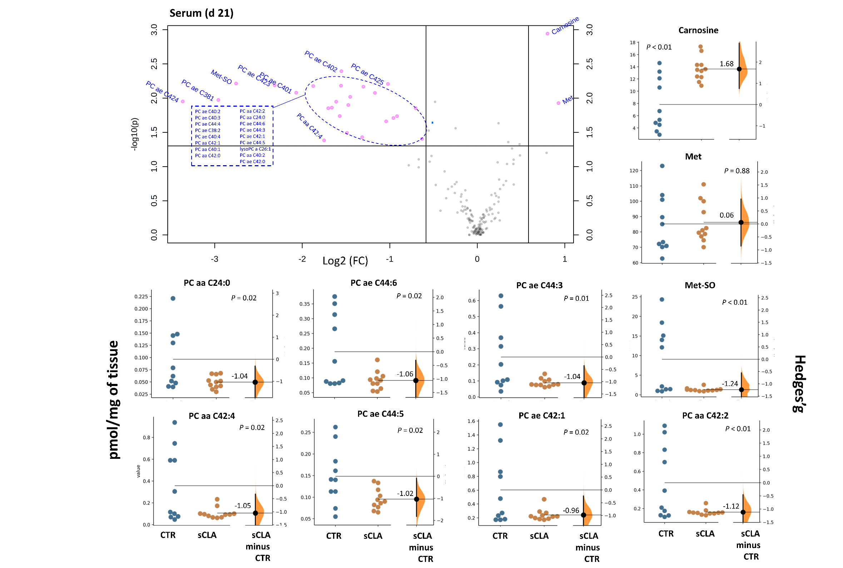

**µM**

**Figure 2.**

**Figure 3.**

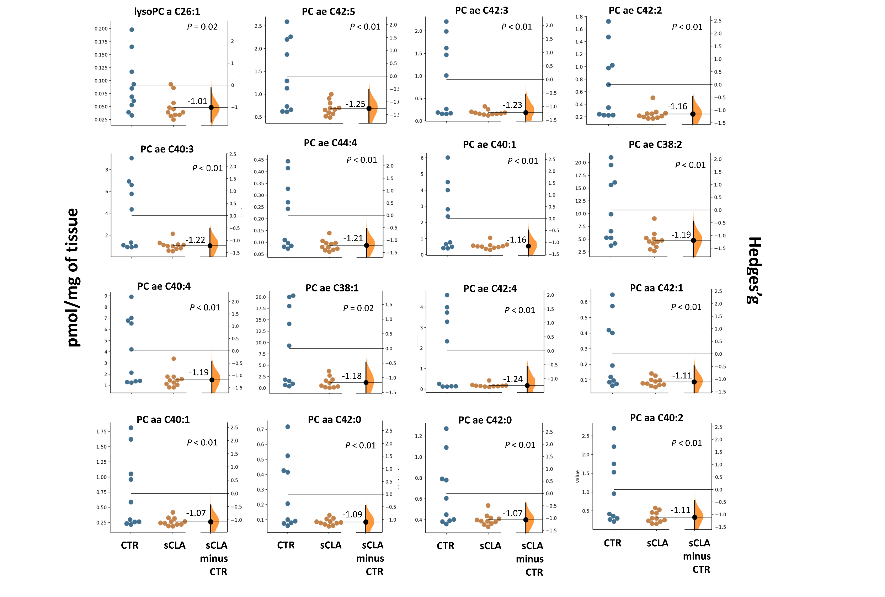

**µM**

**Figure 2 (Continued).**

**Figure 3 (continued).**

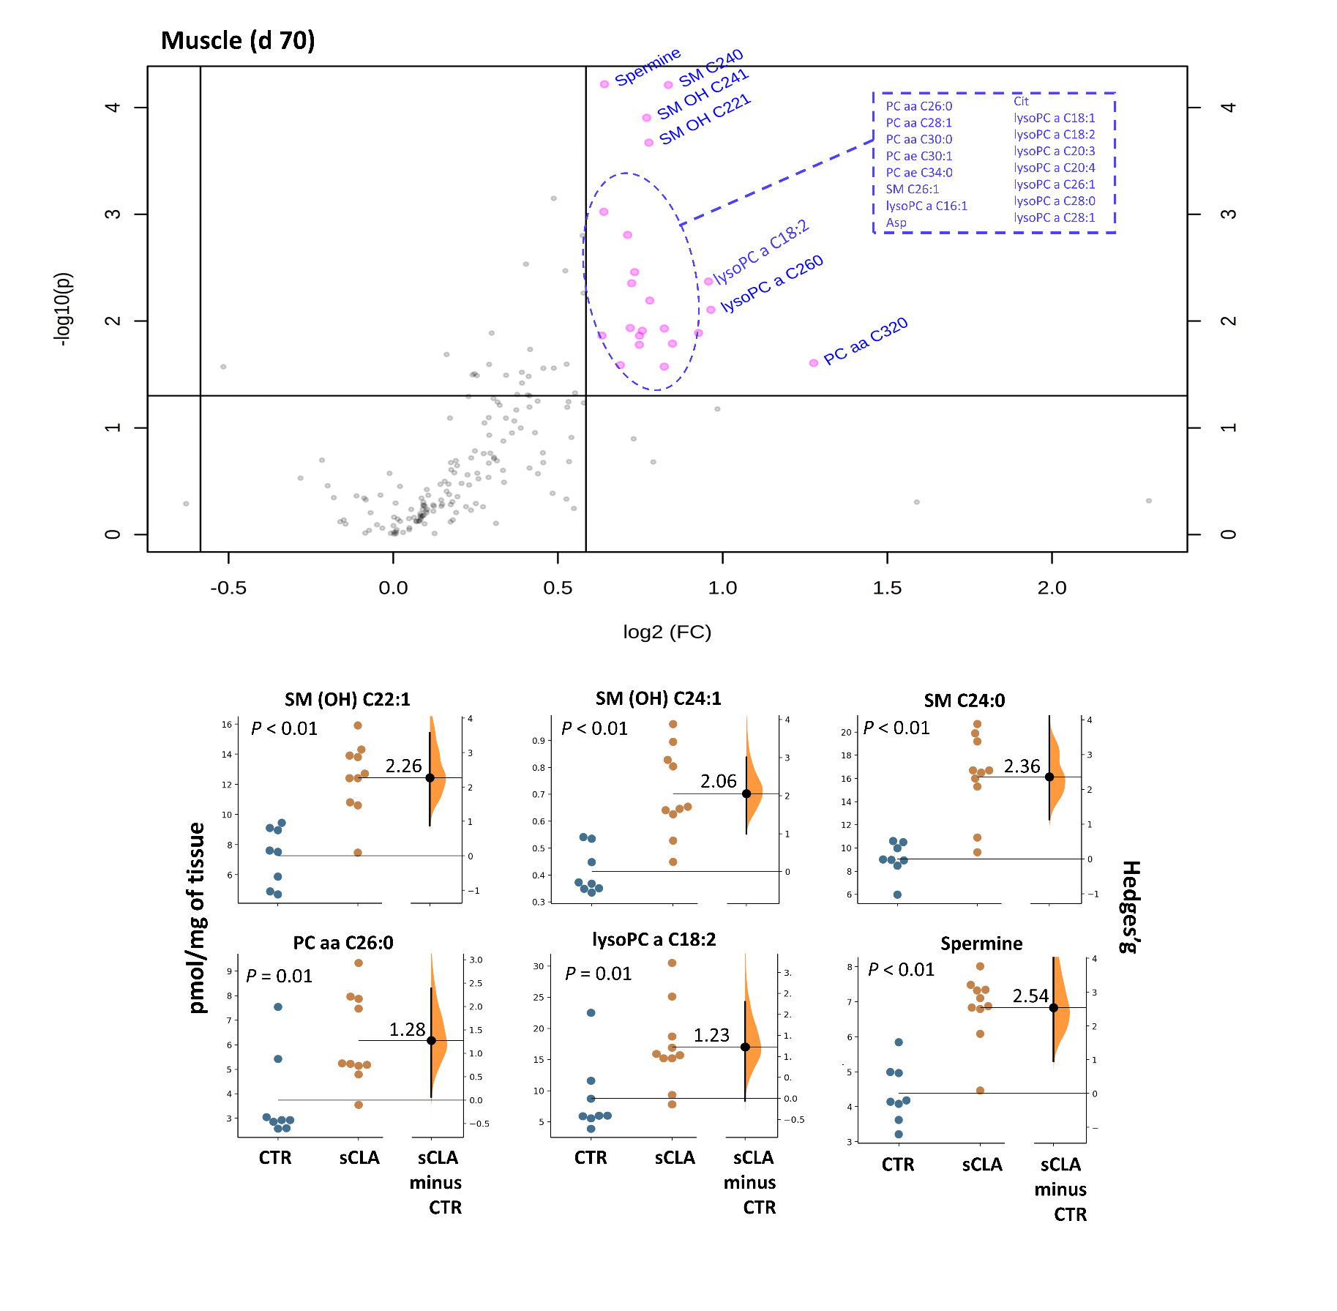**Figure 4.**

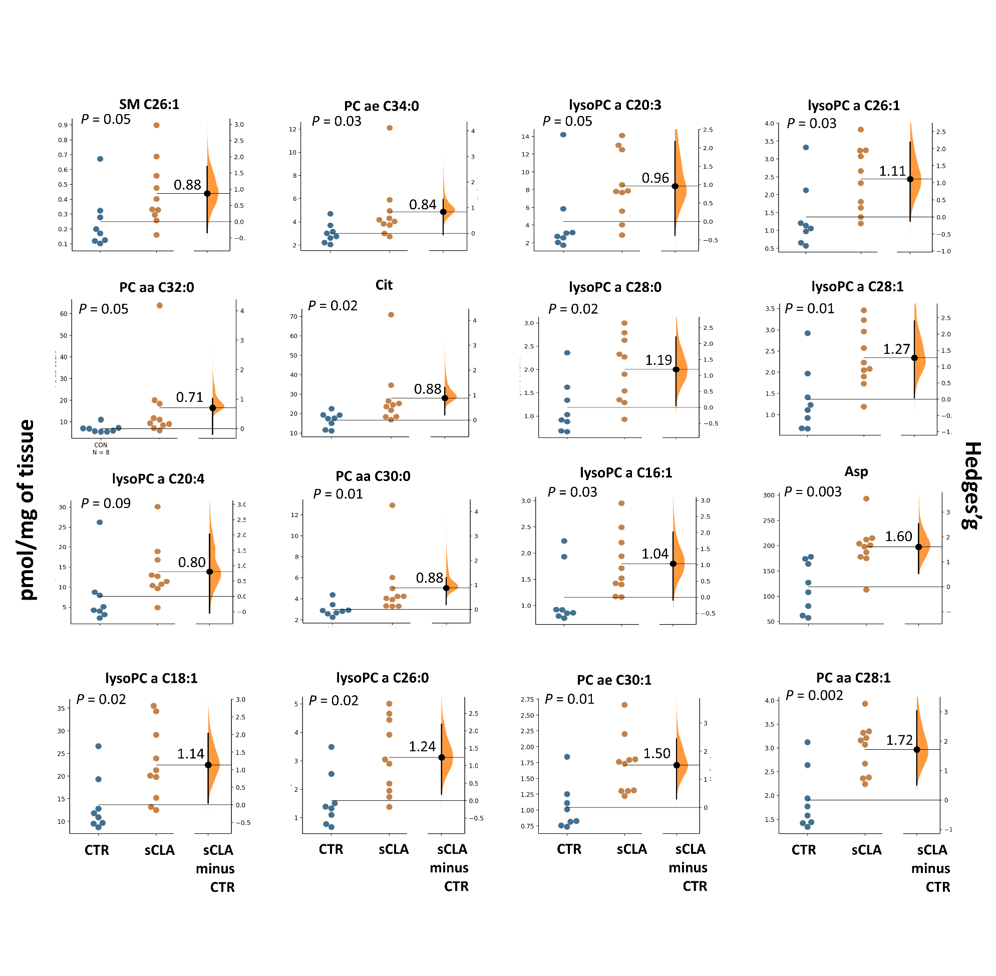

**Figure 4 (Continued).**

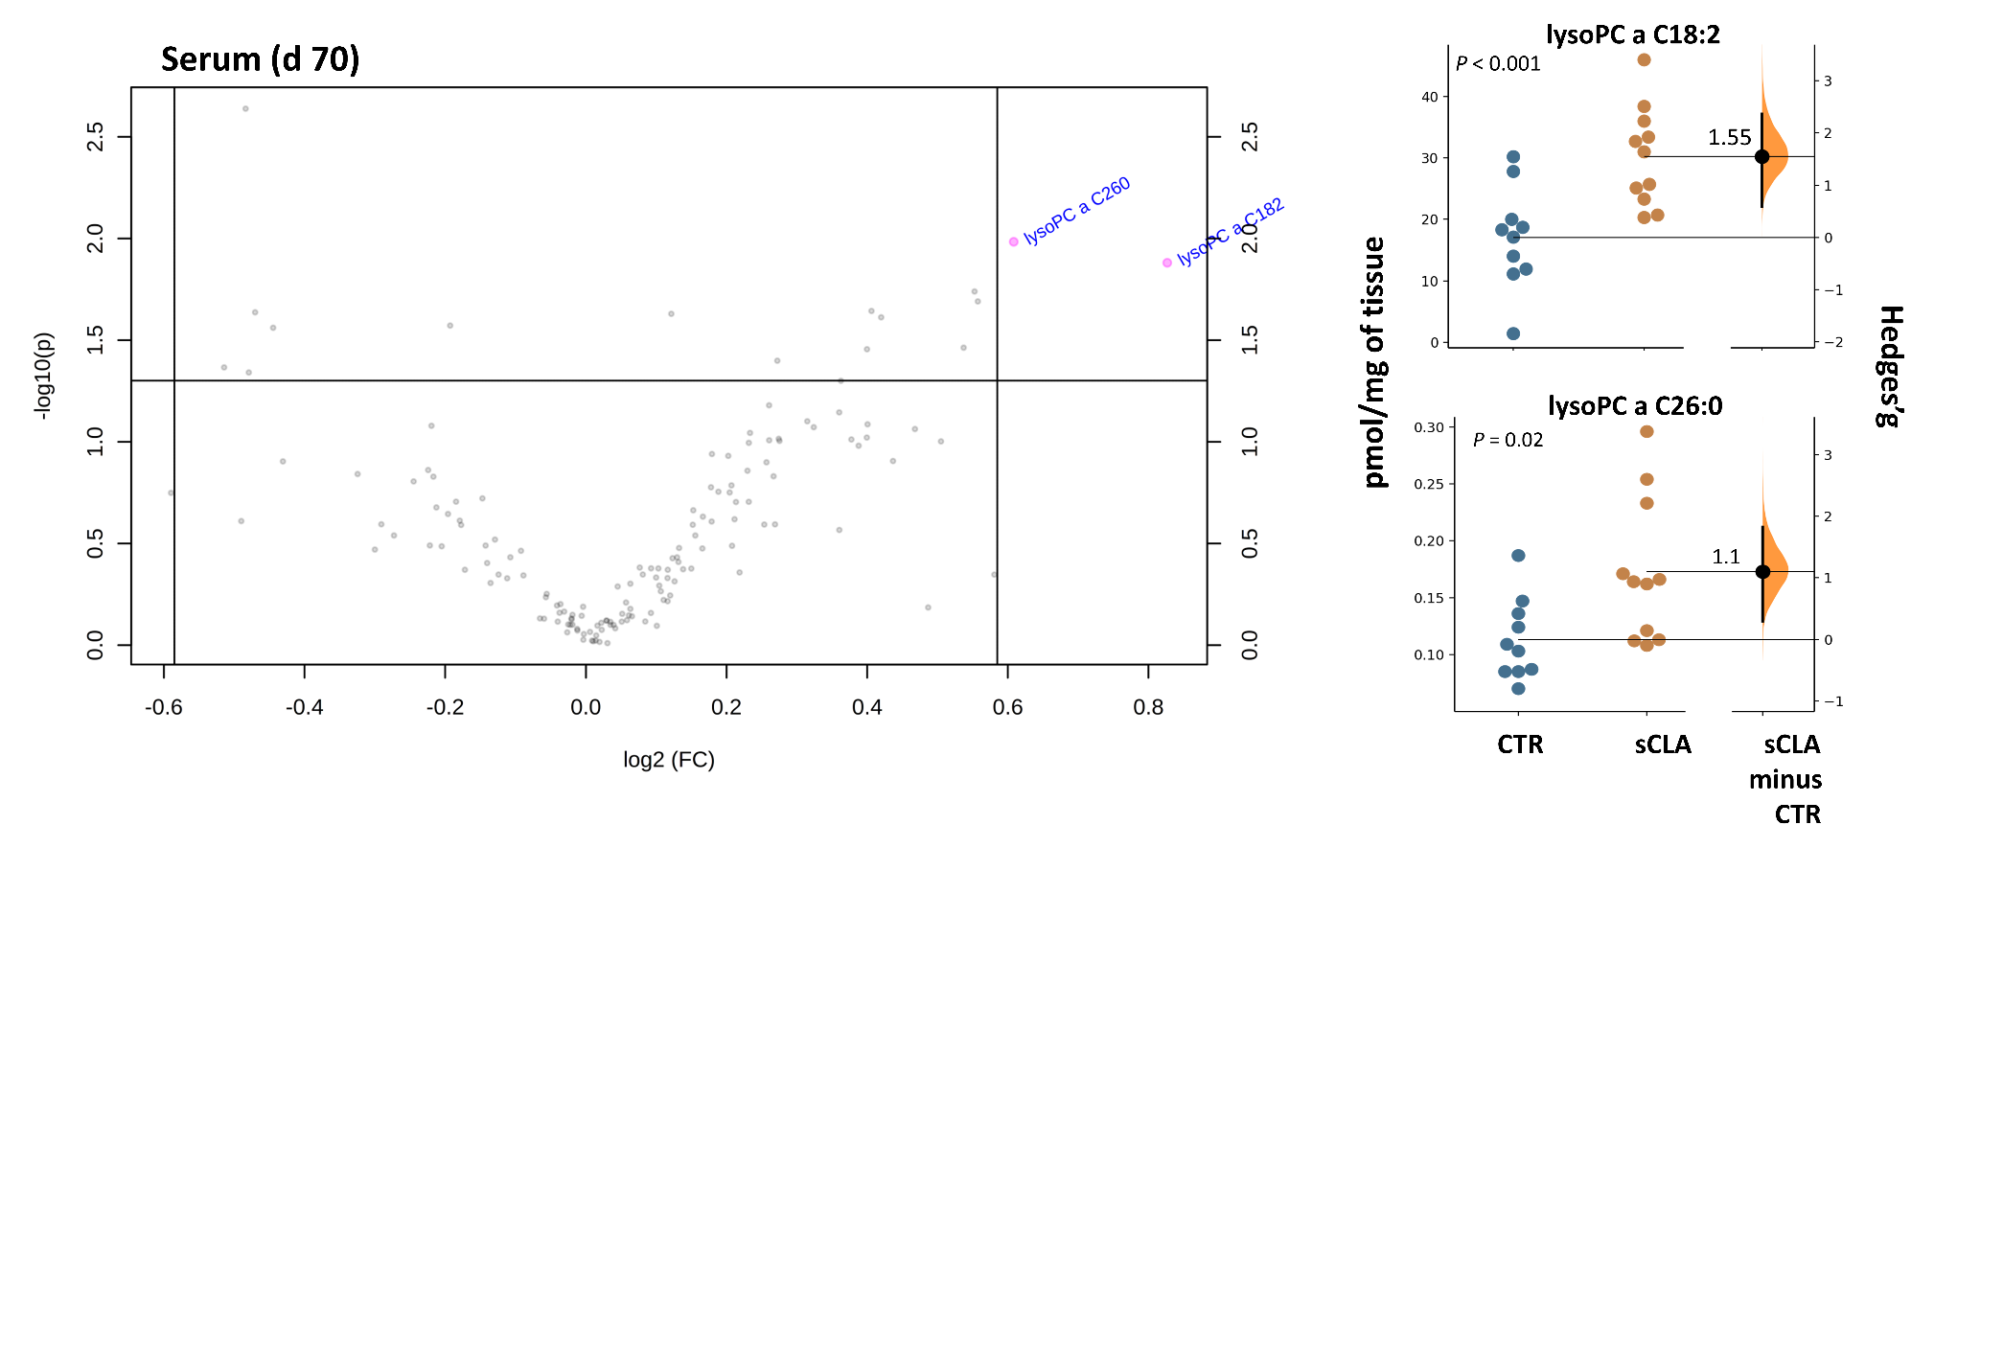

**µM**

**Figure 5.**

**Supplemental Table S1.** List of metabolites measured with the Absolute-IDQ p180 Kit.

|  |  |
| --- | --- |
| **Compound class** | **Metabolites** |
| Acylcarnitines | Carnitine (C0), Acetylcarnitine (C2), Propionylcarnitine (C3), Propenoylcarnitine (C3:1), Hydroxypropionylcarnitine (C3-OH), Butyrylcarnitine (C4), Butenylcarnitine (C4:1), Hydroxybutyrylcarnitine (C4- OH (C3-DC)), Valerylcarnitine (C5), Tiglylcarnitine (C5:1), Glutaconylcarnitine (C5:1-DC), Glutarylcarnitine (Hydroxyhexanoylcarnitine) (C5-DC (C6-OH)), Methylglutarylcarnitine (C5-M-DC), Hydroxyvalerylcarnitine (Methylmalonylcarnitine) (C5-OH (C3-DC-M)), Hexanoylcarnitine (Fumarylcarnitine) (C6 (C4:1-DC)), Hexenoylcarnitine (C6:1), Pimelylcarnitine (C7-DC), Octanoylcarnitine (C8), Nonaylcarnitine (C9), Decanoylcarnitine (C10), Decenoylcarnitine (C10:1), Decadienylcarnitine (C10:2), Dodecanoylcarnitine (C12), Dodecenoylcarnitine (C12:1), Dodecanedioylcarnitine (C12-DC), Tetradecanoylcarnitine (C14), Tetradecenoylcarnitine (C14:1), Hydroxytetradecenoylcarnitine (C14:1-OH), Tetradecadienylcarnitine (C14:2), Hydroxytetradecadienylcarnitine (C14:2- OH), Hexadecanoylcarnitine (C16), Hexadecenoylcarnitine (C16:1), Hydroxyhexadecenoylcarnitine (C16:1-OH), Hexadecadienylcarnitine (C16:2), Hydroxyhexadecadienylcarnitine (C16:2-OH), Hydroxyhexadecanoylcarnitine (C16-OH), Octadecanoylcarnitine (C18), Octadecenoylcarnitine (C18:1), Hydroxyoctadecenoylcarnitine (C18:1-OH), Octadecadienylcarnitine (C18:2) |
| Amino acids | Alanine (Ala), Arginine (Arg), Asparagine (Asn), Aspartate (Asp), Citrulline (Cit), Glutamine (Gln), Glutamate (Glu), Glycine (Gly), Histidine (His), Isoleucine (Ile), Leucine (Leu), Lysine (Lys), Methionine (Met), Ornithine (Orn), Phenylalanine (Phe), Proline (Pro), Serine (Ser), Threonine (Thr), Tryptophan (Trp), Tyrosine (Tyr), Valine (Val) |
| Biogenic amines | Acetylornithine (Ac-Orn), Asymmetric dimethylarginine (ADMA), Symmetric dimethylarginine (SDMA), alpha-Aminoadipic acid (alpha-AAA), Carnosine (Carnosine), Creatinine (Creatinine), Histamine (Histamine), Kynurenine (Kynurenine), Methioninesulfoxide (Met-SO), Nitrotyrosine (Nitro-Tyr), cis-4- Hydroxyproline (cis-OH-Pro), trans-4-Hydroxyproline (trans-OH-Pro), Phenylethylamine (PEA), Putrescine, Sarcosine, Serotonin, Spermidine, Spermine, Taurine, Dopamine, DOPA |
| Glycerophospholipids | Lyso-PC lysoPC a C14:0, lysoPC a C16:0, lysoPC a C16:1, lysoPC a C17:0, lysoPC a C18:0, lysoPC a C18:1, lysoPC a C18:2, lysoPC a C20:3, lysoPC a C20:4, lysoPC a C24:0, lysoPC a C26:0, lysoPC a C26:1, lysoPC a C28:0, lysoPC a C28:1 Diacyl-PC PC aa C24:0, PC aa C26:0, PC aa C28:1, PC aa C30:0, PC aa C30:2, PC aa C32:0, PC aa C32:1, PC aa C32:2, PC aa C32:3, PC aa C34:1, PC aa C34:2, PC aa C34:3, PC aa C34:4, PC aa C36:0, PC aa C36:1, PC aa C36:2, PC aa C36:3, PC aa C36:4, PC aa C36:5, PC aa C36:6, PC aa C38:0, PC aa C38:1, PC aa C38:3, PC aa C38:4, PC aa C38:5, PC aa C38:6, PC aa C40:1, PC aa C40:2, PC aa C40:3, PC aa C40:4, PC aa C40:5, PC aa C40:6, PC aa C42:0, PC aa C42:1, PC aa C42:2, PC aa C42:4, PC aa C42:5, PC aa C42:6 Acyl-alkyl-PC PC ae C30:0, PC ae C30:1, PC ae C30:2, PC ae C32:1, PC ae C32:2, PC ae C34:0, PC ae C34:1, PC ae C34:2, PC ae C34:3, PC ae C36:0, PC ae C36:1, PC ae C36:2, PC ae C36:3, PC ae C36:4, PC ae C36:5, PC ae C38:0, PC ae C38:1, PC ae C38:2, PC ae C38:3, PC ae C38:4, PC ae C38:5, PC ae C38:6, PC ae C40:1, PC ae C40:2, PC ae C40:3, PC ae C40:4, PC ae C40:5, PC ae C40:6, PC ae C42:0, PC ae C42:1, PC ae C42:2, PC ae C42:3, PC ae C42:4, PC ae C42:5, PC ae C44:3, PC ae C44:4, PC ae C44:5, PC ae C44:6 |
| Sphingolipids | SM (OH) C14:1, SM (OH) C16:1, SM (OH) C22:1, SM (OH) C22:2, SM (OH) C24:1, SM C16:0, SM C16:1, SM C18:0, SM C18:1, SM C20:2, SM C22:3, SM C24:0, SM C24:1, SM C26:0, SM C26:1 |
| Hexoses | Sum of hexoses (H1) |

|  |  |
| --- | --- |
| **Supplemental Table S2.** List of metabolites with more than 20% of missing values (i.e., values lower than the limit of detection) that were not considered for the statistical analysis. | |
| Serum | Muscle |
| Decenoylcarnitine (C10:1) | c4-OH-Pro (*cis*-4-Hydroxyproline) |
| Dodecenoylcarnitine (C12:1) | Nitrotyrosine (Nitro-Tyr) |
| Dodecanedioylcarnitine (C12-DC) | Sarcosine |
| Dihydroxyphenylalanine (DOPA) |  |
| Dopamine |  |
| Histamine |  |
| Phenylethylamine (PEA) |  |
| c4-OH-Pro (*cis*-4-Hydroxyproline) |  |
| Nitrotyrosine (Nitro-Tyr) |  |
| Sarcosine |  |



**Supplemental Figure S1.** Volcano plot visualizing muscle metabolites that were affected by time of lactation (d 21 versus d 70; regardless of treatment) in dairy cows. The x-axis represents the mean of log2 fold-change (FC) value, and the y-axis corresponds to the negative logarithm of the *P*-values. Each circle represents a single metabolite. The horizontal line represents the level of significance for the t-tests performed (0.05), and the vertical lines display the threshold set for fold change (1.5). The pink circles show metabolites that were significantly changed between two-time points and the gray circles show metabolites that were not significantly changed. C4- OH (C3-DC) = hydroxybutyrylcarnitine; Gln = gluthamine; His = histidine; Ile= isoleucine; Leu = leucine; Lys =lysine; Met = methionine; Orn = ornithine; Phe = phenylalanine; t4-OH-Pro = trans-4-hydroxyproline; Trp = tryptophan.

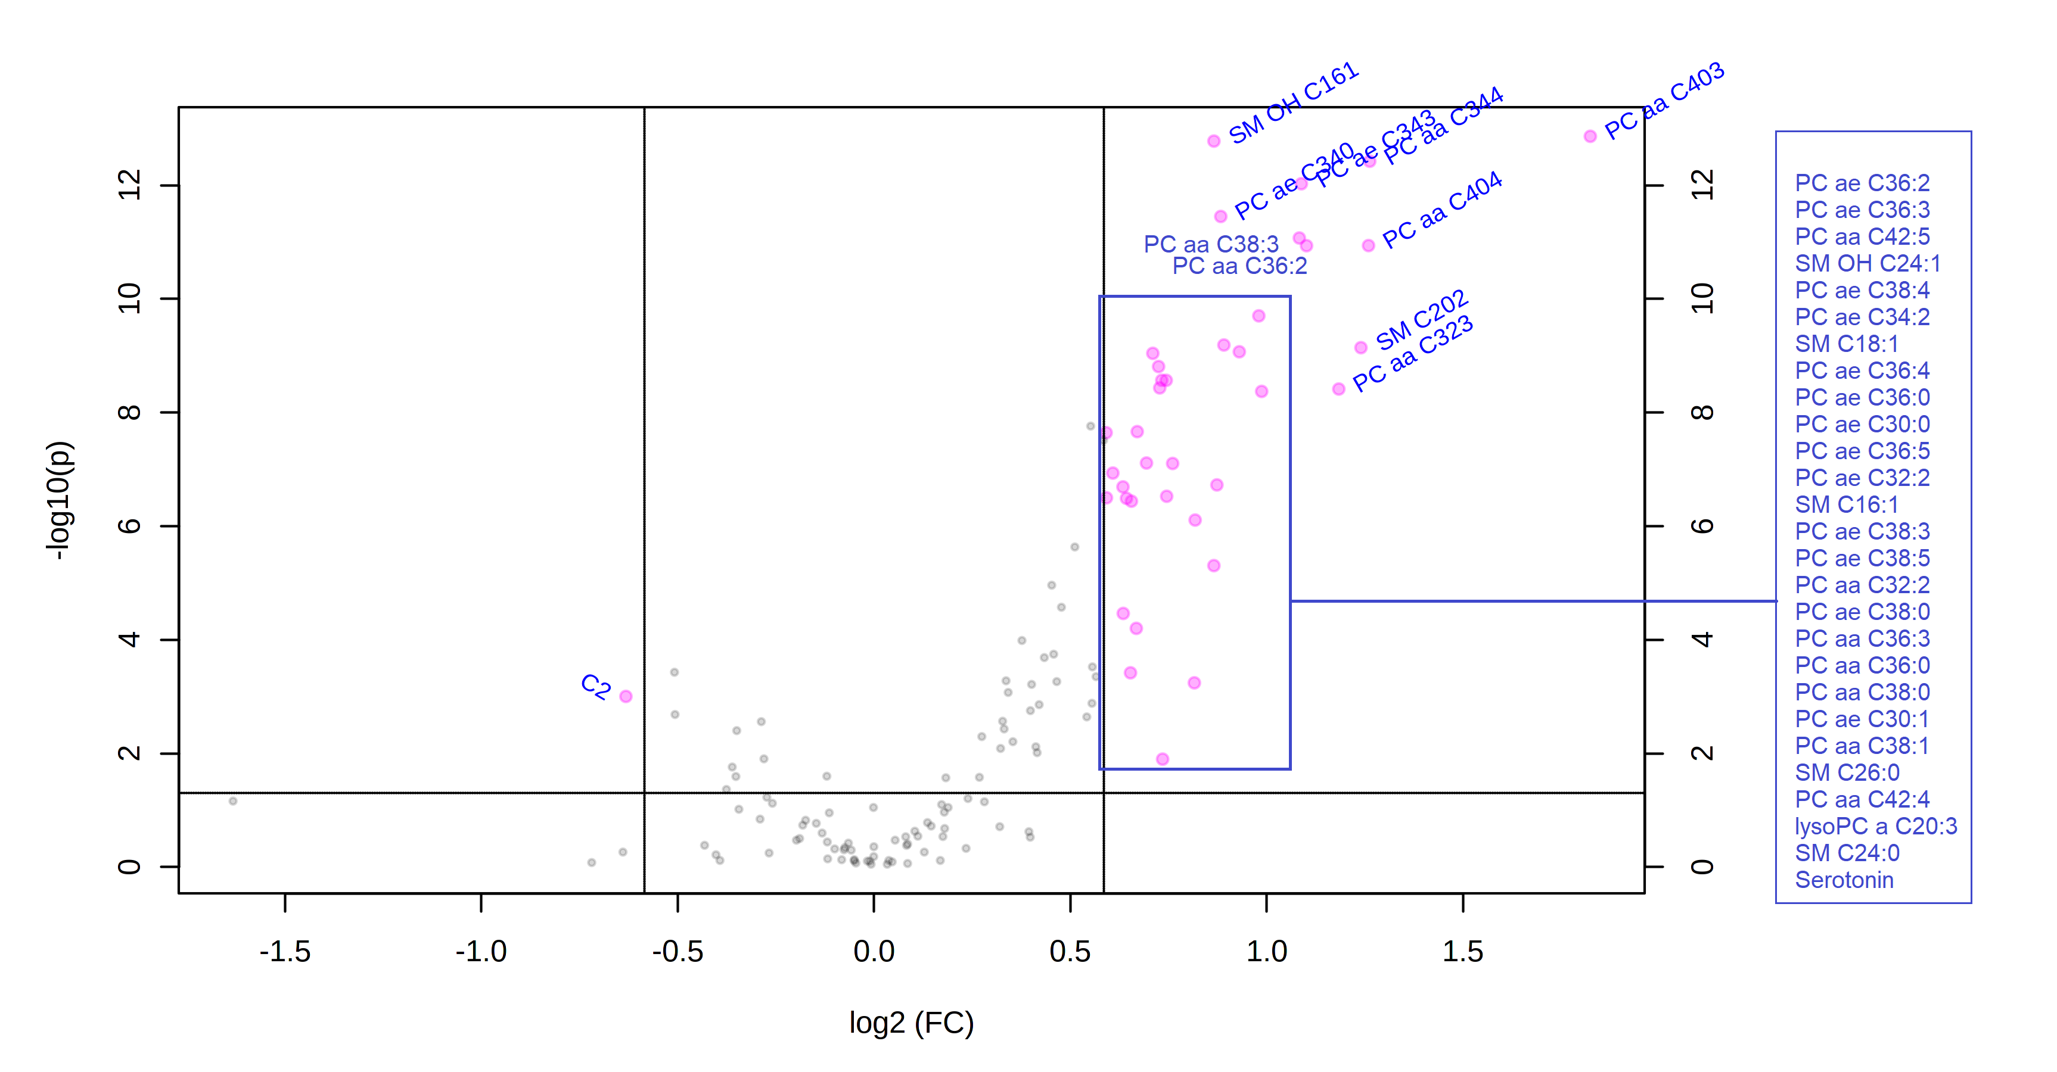

**Supplemental Figure S2.** Volcano plot visualizing serum metabolites that were affected by time of lactation (d 21 versus d 70; regardless of treatment) in dairy cows. The x-axis represents the mean of log2 fold-change (FC) value, and the y-axis corresponds to the negative logarithm of the *P*-values. Each circle represents a single metabolite. The horizontal line represents the level of significance for the t-tests performed (0.05), and the vertical lines display the threshold set for fold change (1.5). The pink circles show metabolites that were significantly changed between two-time points and the gray circles show metabolites that were not significantly changed. C2 = acetylcarnitine; lysoPC = lysophosphatidcholine; PC aa = di-acyl phosphatidylcholine; PC ae = acyl alkyl phosphatidylcholine; SM (OH) = hydroxysphingomyeline; SM = sphingomyeline.