**Supplementary material**

**Supplementary Table 1.** Enzymatic activities of the mitochondrial respiratory chain in fibroblasts from Patient 1 and 2.1.

|  |  |  |  |
| --- | --- | --- | --- |
| **Enzyme activities**1 | **Fibroblasts** | | |
| **Patient 1** | **Patient 2.1** | **Control range** |
| Complex I+III | 21.6 | 1.1 | 15-42 |
| Complex II | 31.5 | 40.9 | 22-35 |
| Complex II+III | 17.6 | 27.6 | 11-20 |
| Complex III | ND | 34.9 | 25-48 |
| Complex IV | 34.9 | 35.5 | 33-57 |
| Citrate synthetase (CS) | 34 | 43.5 | 41-62 |
|  |  | | |
| **Enzyme activities**2 | **Patient 1** | **Patient 2.1** | **Control range** |
| Complex I+III / CS | 0.64 | 0.03 | 0.24-0.85 |
| Complex II / CS | 0.93 | 0.94 | 0.53-0.75 |
| Complex II+III / CS | 0.52 | 0.63 | 0.25-0.42 |
| Complex III / CS | ND | 0.80 | 0.49-1.06 |
| Complex IV / CS | 1.03 | 0.82 | 0.84-1.15 |

1 nmol min-1 mg-1 protein; 2 nmol min-1 mg-1 protein enzyme activity expressed in percentage respect to CS activity.

**Supplementary Table 2.** Oligonucleotides used in this study.

|  |  |  |
| --- | --- | --- |
| **Variant** | **Forward Primer** | **Reverse Primer** |
| **RT-PCR** |  |  |
| c.1453-1G>C | GGAATAGAACCCTCGCTTGC | CAAATGCCACCTGAAGCTCT |
| c.1918C>G | TCATACTTTCCGCAGTGACCT | TTCATTTGCCTTCACTGGTGT |
| c.710del | AGCTGAACCTCATATACCGTGT | GTGTCTTAGCAGCTCCAGTATTT |
| c.902C>T | AGCTGAACCTCATATACCGTGT | TGGCTTTCATTTCACGTAAAACC |
| **Minigene** | CTGGGCCTGCTCATCCTCT | CAGTGCCAAGGTCTGAAGGT |
| **CLONING** |  |  |
| c.1453-1G>C | CTTCTCGAGCCAGTTGAGGGTAGGGTGTT | GTTAGGATCCAGCCAACATGCAACATGAGC |
| c.1918C>G | CTTCTCGAGCATCCTGAGGCAAGCAGTTT | GTTAGGATCCGGCTTTCCTGACTTGCATGA |
| c.902C>T | CTTCTCGAGCCTTTTCCTGAGGCGTAGATG | GTTAGGATCCCCACGCCCAGCTAATTGTTT |

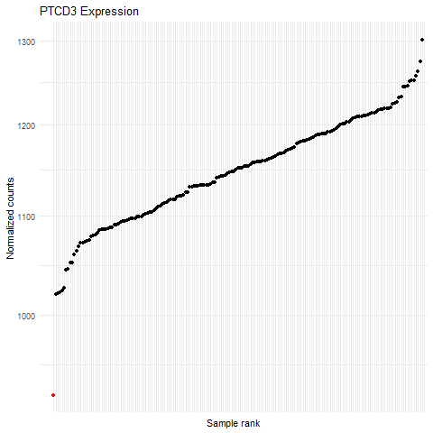

**Supplementary figure 1.** Expression Rank plot showing RNAseq analysis of *PTCD3*. Red dot indicates P1.