**T-cell engager antibodies enable T cells to control HBV infection and to target HBsAg-positive hepatoma in mice**

**- Supplementary Information –**

Oliver Quitt1,#, Shanshan Luo1,8,#, Marten Meyer2, Zhe Xie1,Forough Golsaz-Shirazi3, Eva Loffredo-Verde1, Julia Festag1, Jan Hendrik Bockmann1,5,6, Lili Zhao1, Daniela Stadler1, Wen-Min Chou1, Raindy Tedjokusumo1, Jochen Martin Wettengel1, Chunkyu Ko1, Elfriede Nößner1, Nadja Bulbuc2, Fazel Shokri3, Sandra Lüttgau4, Mathias Heikenwälder1, Felix Bohne1, Gerhard Moldenhauer4, Frank Momburg2, Ulrike Protzer1,5,*

# both authors contributed equally to the work; *corresponding author

1Institute of Virology, School of Medicine, Technical University of Munich / Helmholtz Zentrum München, Munich, Germany

2Antigen Presentation and T/NK Cell Activation Group, Clinical Cooperation Unit Applied Tumor Immunity, German Cancer Research Centre, Heidelberg, Germany

3Department of Immunology, School of Public Health, Tehran University of Medical Sciences, Tehran, Iran

4Department of Translational Immunology, German Cancer Research Centre, Heidelberg, Germany

5German Center for Infection Research (DZIF), Munich and Hamburg partner sites, Germany

6Department of Internal Medicine, University Medical Center Hamburg-Eppendorf, Hamburg, Germany

7Current address:Institute of Hematology, Union Hospital, Tongji Medical College, Huazhong University of Science and Technology, Wuhan, China

Remark: No additional investigators contributed to the study

**Table of content**

Supplementary Material and Methods 3

Structure and generation of BiMAb recognizing HBVenv 4

Structure and generation of FabMAb recognizing HBVenv 5

Production and purification of bsAbs. 6

SDS-polyacrylamide gel electrophoresis and Western blot analysis 6

ELISA for analysis of HBsAg-binding and pharmacokinetics. 6

ELISA HBsAg genotype panel 7

Confocal microscopy to study binding of bsAbs to HBVenv on membranes 8

Flow cytometry to study binding of bsAbs to T cells 9

Flow cytometry to study binding of bsAbs to infected HepG2 NTCP cells 9

Flow cytometry after activation of PBMC on coated HBsAg or Huh7S cells 9

T-cell proliferation and activation 10

T-cell subset quantification 10

Analysis of cytokine secretion 11

Intracellular cytokine staining 11

Co-culture with infected HepG2-NTCP cells 12

Transwell assay 13

Intracellular HBVcore-staining for flow cytometry 13

Quantification of viral replication 14

Animal experiments 15

Immunohistochemistry of murine liver 15

Pharmacokinetics of bsAbs in vivo 16

Therapeutic efficiency of BiMAb in vivo 16

RNA extraction from tumor tissue and qPCR 17

Southern blot analyses 17

Statistical analyses 18

Supplementary figures and figure legends 19

Supplementary tables 39

Supplementary References 40

.

# Supplementary Material and Methods

Structure and generation of BiMAb recognizing HBVenv

As HBV-specific binders, scFv C81 and the Fab-fragment of monoclonal antibody   
5F92, 3 were used that both recognize the a-determinant of HBV S protein that is contained in all HBVenv proteins. BiMAb (Fig. 1Ai) consist of two copies of HBVenv-specific scFv C81 connected to the N-termini of a IgG1 Fc domain via a (G4S)3 linker. The Fc domain is instrumental for efficient secretion of BiMAb from producer cells. For recruitment of T cells, CD3- or CD28-specific scFv were fused to the C‑termini of the Fc domain. The CD3-specific scFv was generated from the variable domains of the monoclonal antibody OKT34, and the CD28-specific scFv is derived from the antibody 9.35. Homodimerization through the IgG1 hinge domain results in tetravalent constructs with two binding sites each for HBVenv and CD3 or CD28, respectively, and a molecular weight of ~170 kD. To avoid aberrant disulfide formation in the absence of Ig light chains Cys220 was mutated to Ser. In order to reduce antibody-dependent and complement-dependent cytotoxicity mediated by Fcγ receptor (FcγR) binding, amino acid variations E233P, L234A, L235A, G236del, K322A, A327G, P329A, A330S and P331S were introduced into the Fc domain.

BiMAb were cloned by joining the following 5 fragments possessing unique restriction sites in pBluescript KS II+ (Stratagene, San Diego, USA) and then subcloning the complete constructs into the expression vector pcDNA3.1(–) (Invitrogen, Karlsruhe, Germany) as a 5’ XhoI–NotI 3’ insert. Fragment 1, Endoplasmic reticulum (ER) leader sequence and C8 anti-HBsAg scFv1 flanked by XhoI (5’, ctcgagaccATG) and EcoRI sites (3’, coding GNS); fragment 2, glycine-serine linker GNS(G4S)3AS flanked by EcoRI (5’, coding GNS) and NheI (3’, coding AS) sites; fragment 3, the Fc portion of human IgG1 (GenBank accession no. BC078670) containing the mutations C220S, E233P, L234A, L235A, G236del, N297Q, K322A, A327G, P329A, A330S, and P331S introduced by PCR mutagenesis and flanked by NheI (coding AS) and BamHI (coding DP) sites; fragment 4, a StrepTag II sequence DPGWSHPQFEKSR flanked by BamHI (5’, coding DP) and XbaI (3’, coding SR); fragment 5, a scFv antibody derived from anti-CD3 OKT3 (VH–(G4S)3-VL; GenBank accession nos. A22261 and A22259) or anti-CD28 9.3 (VH–(G4S)3-VL; GenBank accession nos. AJ459795 and AJ459794) flanked by XbaI (5’, coding SR), or SpeI in case of 9.3 scFv (5’, coding SS after ligation to XbaI), followed by a short Gly4 linker, and flanked by a NotI site after the stop codon.

Structure and generation of FabMAb recognizing HBVenv

FabMAb (Fig. 1Aii) is composed of an HBVenv-specific, chimeric Fab-fragment consisting of the human IgG CH1 and murine variable domains derived from antibody 5F9 connected to a CD3- or CD28-specific single chain variable fragment (scFv) by a glycine-serine (G4S)3 linker. FabMAb have a relatively small protein size of ~78 kD and display monovalent binding to both antigens. To enable efficient purification under neutral pH conditions, FabMAb were equipped with a C-terminal His-tag and BiMAb with a Strep-tag II between the Fc domain and the C-terminal scFvs.

FabMAbαCD3 was cloned by exchanging CD22 heavy and light chains in the construct pcDNA3.1_CD22xOKT3(VHCD22_huCH1γ_(G4S)3_VHOKT3_(G4S)3_VκOKT3_10xHis_P2A_VLCD22_huCH1κ), with the variable domains of the HBVenv-specific murine antibody 5F9. For this, variable heavy and light chain sequences were amplified from cDNA of hybridoma 5F9 via PCR and inserted into pcDNA3.1_CD22xOKT3. Through insertion of a P2A site, this construct expresses VH and V chains in an equimolar ratio. To construct FabMAbαCD28, we exchanged the scFv OKT3 (αCD3) for scFv 9.3 (αCD28).

## Production and purification of bsAbs.

BiMAb were produced by Proteros Biostructures, Martinsried, Germany. Plasmid constructs were expressed in HEK293 cells, followed by combinational purification with protein A affinity chromatography and size exclusion chromatography (SEC). FabMAb were ordered from InVivo Biotech Services, Henningsdorf/Berlin, Germany. Constructs were expressed in HEK293 cells, followed by combinational purification with metal chelate affinity chromatography and SEC.

## SDS-polyacrylamide gel electrophoresis and Western blot analysis

To analyze the purity and integrity of the bsAbs, 2.5 µg of each construct were separated on a 12.5% SDS-PAGE under reducing and non-reducing conditions, followed by staining with Coomassie CCB R250 (Roth, Karlsruhe, Germany). For Western blot analysis 100 ng of purified bsAbs were separated by PAGE and transferred to a polyvinylidene fluoride membrane (Millipore/Merck, Darmstadt, Germany) at 20 V for 1 hour. The membrane was blocked with 5% dry skimmed milk in phosphate-buffered saline containing 1% Tween-20 (PBST, Roth) for 1 hour at room temperature (RT), followed by overnight incubation at 4 °C with goat anti human IgG peroxidase (Sigma-Aldrich, Taufkirchen, Germany). Membranes were washed and incubated with Amersham ECL Prime Western Blotting Detection Reagent (GE, Boston, USA). Protein bands were visualized using an ECL Chemocam (Intas, Göttingen, Germany).

## ELISA for analysis of HBsAg-binding and pharmacokinetics.

96-well MaxiSorp plates (ThermoFisher Scientific, Darmstadt, Germany) were coated with 1 µg/ml HBsAg purified from patient serum (kindly provided by Roche Diagnostics, Penzberg, Germany) in PBS overnight at 4 °C. Plates were washed with PBS/0.5% tween (PBST) and blocked with 200 µl assay diluent (PBS containing 1% bovine serum albumin (BSA), Roth) for 1 hour at RT. After washing with PBST, a dilution series of BiMAb or FabMAb (1000, 316.2, 100, 31.62, 10, 3.162, 1, 0.316, 0.1, 0.031, 0.01, 0.003 nM) was applied in 100 µl assay diluent and incubated for 1.5 hours at RT. Plates were washed and polyclonal horseradish peroxidase (HRP) coupled goat anti human IgG antibodies (Sigma Aldrich) diluted 1:1000 was added for one hour at RT to detect bsAbs bound to HBsAg. The ELISA was developed by addition of 100 µl stabilized chromogen TMB (Life Technologies, Carlsbad, USA). The reaction was stopped with 100 µl 2N sulfuric acid (Roth). Optical density was measured at 450 nm and background at 560 nm with an infinite F200 reader (Tecan, Männedorf, Switzerland). Data were fitted with Prism (GraphPad Sofware) in order to calculate EC50 values by non-linear regression.

## ELISA HBsAg genotype panel

Serum HBsAg from a genotype panel (Paul-Ehrlich-Institut, Langen, Germany) was captured with HBVenv-specific antibodies (Murex HBsAg Version 3, DiaSorin, Saluggia, Italy). After addition of 25 µl sample diluent provided with the Murex assay kit, 1 IU (FabMAb analysis) or 5 IU (BiMAb analysis) HBsAg from the genotype panel were added to the assay stripes in 75 µl assay diluent and incubated for 1 hour at 37 °C. 50 nM FabMAb or 100 nM BiMAb were added in 25 µl assay diluent, followed by incubation for 30 min at 37 °C. Antibodies were detected with an anti-6x His-Tag antibody HRP-conjugate (Invitrogen) diluted 1:500 (FabMAb analysis) and a StrepMAb classic-HRP (Iba Lifescience, Göttingen, Germany) diluted 1:4000 (BiMAb analysis) in 25 µl assay diluent. After incubation for 30 min at 37 °C and washing, development and OD measurement was performed as mentioned above.

## Confocal microscopy to study binding of bsAbs to HBVenv on membranes

0.7x106 Huh7 cells were seeded in a 6-well plate and transfected with 5 µg mCherry-S plasmid DNA (kindly provided by Volker Bruss, German Research Centre for Eviromental Health, Germany) using FuGene HD (Promega, Walldorf, Germany) according to the manufacturer’s protocol. After 48 hours, cells were trypsinized and blocked for 1 hour in PBS containing 5% BSA. Cells were washed, resusbended in 200 μl assay diluent containing 50 nM of bsAbs and incubated for 1.5 hours. Cells were washed and incubated for 45 min in 200 μl of Alexa Fluor 647 goat anti-human IgG (ThermoFisher Scientific), 1:500 diluted in assay diluent, and an Alexa 488 coupled wheat germ agglutinine (ThermoFisher), 1:400 diluted in assay diluent. Cells were washed 3 times, resuspended in PBS containing 4% paraformaldehyde (ChemCruz/Santa Cruz Biotechnology, Dallas, USA) and incubated for 15 min. Finally, cells were resuspended in 100 μl mounting solution Fluoromount-G® (Southern Biotech), transferred to slides and stored overnight in the dark at 4 °C. Analysis was performed using a Fluoview FV10i fluorescence microscope (Olympus, Shinjuku, Japan). Pictures were taken with a 60x special water phase contrast objective lens NA1.2 (corresponds to UPLSAPO60XW) at room temperature. Cells were embedded in Mounting solution Fluoromount-G®. The used fluorochromes were mcherry, Alexa Fluor 647, Alexa 488 and 4′,6-Diamidin-2-phenylindol. The scanning device (camera) were 2 galvano-meter mirrors incorporated in the Fluoview FV10i fluorescence microscope. The acquisition software FV10i SW 02.01.01.07 (Olympus). Pictures of Alexa Fluor 647 channel were post-processed in Adobe Photoshop CS3 using picture, mode, grey scale and picture, mode, brightness/contrast (2x 150 brightness, 100 contrast).

## Flow cytometry to study binding of bsAbs to T cells

2.5x105 PBMC were washed with PBS containing 0.1% BSA (FACS buffer) and incubated in this buffer containing a dilution series of FabMAb (1000, 316.2, 100, 31.62, 10, 3.162, 1, 0.316, 0.1, 0.031) for 30 min at 4 °C. After 3 washing steps with 200 µl FACS puffer, cells were stained with a cocktail containing an anti-CD8 PB (clone DK25, Dako/Agilent, Santa Clara, USA) 1:50, anti-CD4 FITC (clone RPA-T4, BD, Heidelberg, Germany) 1:5 and anti-human IgG PE (clone G18-145, BD) 1:25 in 50 µl FACS buffer for 30 min at 4 °C in the dark. PBMC were washed 3 times, stained with 10 µl propidium iodide (BD), and analyzed on a CytoFlexS (Beckman Coulter, Brea, USA).

## Flow cytometry to study binding of bsAbs to infected HepG2 NTCP cells

For binding of BiMAb to HBV infected HepG2NTCP cells (MOI 1000), 5 µg of purified BiMAb was incubated with infected HepG2 NTCP cells in 50 µl for 30 min on ice. After washing, cells were incubated with Alexa-Fluor® 647 labelled goat anti-human IgG (1:400, 50 µl/sample) for 30 min on ice. Following additional washing, samples were analyzed on a CytoFlexS (Beckman Coulter).

## Flow cytometry after activation of PBMC on coated HBsAg or Huh7S cells

96-well cell culture plates were coated with 5 µg/ml HBsAg (kindly provided by Roche, Penzberg, Germany) in PBS overnight at 37 °C. Control wells were incubated with PBS only. As target cells, 4x105 Huh7S cells (a cell line stably transfected with HBV S, genotype D) or parental Huh7 as control cells per well were seeded. The next day, plates were washed once with PBS and 1x105 freshly isolated PBMC per well were added in 100 µl RPMI1640 (supplemented with 10% fetal bovine serum, 50 U/ml penicillin/streptomycin, 2 mM L-glutamine, 1% sodium pyruvate and 1% MEM non-essential amino acids; all from Life Technologies). BsAbs were diluted in DMEM (same supplements as RPMI1640) and subsequently added to the PBMC. Unless otherwise indicated, co-culture was maintained for 72 hours, before supernatants and T cells were analyzed. For killing assays, cells were seeded in 96-well E-plates (ACEA Biosciences, San Diego, USA) one day prior to start of PBMC co-cultures. Cell viability was measured for 96 hours employing an xCELLigence real-time cell analyzer SP device (ACEA Biosciences).

## T-cell proliferation and activation

PBMC were stained using the cell trace violet proliferation kit (ThermoFischer scientific) prior to start of co-cultures. After 72 hours of co-culture, cells were harvested and washed with 200 µl FACS buffer, followed by staining with a 50 µl mix containing 1:20 dilutions of anti-CD4 PE-eFlour 610 (clone RPA-T4, ThermoFisher), anti-CD8 APC (clone SK1, BD), anti-LAMP1 Alexa Flour 488 (clone H4A3, ThermoFisher), anti-CD25 PE (clone M-A251, BD), as well as near-infrared live/dead (ThermoFisher) 1:1000 in FACS buffer for 30 min at 4 °C in the dark. Cells were washed 3 times with 200 µl FACS buffer and analyzed by flow cytometry on a CytoFlexS.

## T-cell subset quantification

Subsets of CD8+ T cells were defined employing the markers CD45RA and CCR7 according to Sallusto et al. 19996. Cells were harvested after 72 hours of culture on coated HBsAg in the presence of 3 nM FabMAb or BiMAb CD3/CD28 combinations. After washing with FACS buffer, cells were stained with anti‑CD3 AF700 (clone UCHT1, BD) 1:50, anti-CD4 FITC (RPA-T4, BD) 1:5, anti-CD8 PB (clone SK1, BioLegend, San Diego, USA) 1:50, anti-CD45RA APC (clone HI100, BioLegend) 1:20, anti-CCR7 BV650 (clone G043H7, BioLegend) 1:20, and Aqua live/dead (ThermoFisher) 1:1000 in 50 µl FACS buffer for 30 min at 4 °C in the dark. Cells were washed three times and analyzed on a CytoFlexS.

## Analysis of cytokine secretion

Supernatants of PBMC cultures collected after stimulation were analyzed by the human IFNγ uncoated ELISA kit (ThermoFisher), the human IL‑2 uncoated ELISA kit (ThermoFisher) or the BD OptEIA human TNFα ELISA set (BD), according to the manufacture’s protocol. ELISAs were performed on MaxiSorp plates. For in-depth analysis, cytokines and chemokines in supernatants were measured using the multiplex bead array system Bio-Plexhuman Cytokine Group I Panel 17-Plex, with added single kits for human RANTES (CCL5), human IP-10 (CXCL10), following the manufacturer’s recommendations. Data were acquired using the Luminex100 machine with BioPlex Manager 6.1 software. Standard curves were fitted using the logistic-5PL regression type.

## Intracellular cytokine staining

PBMC were treated with 0.2 µg/ml Brefeldin A (Sigma-Aldrich) 4 hours prior to harvest and stored at 4° C if needed. After washing with 200 µl FACS buffer, cells were stained with anti-CD4 PE-eFlour 610 1:20, anti-CD8 APC 1:20 and near-infrared live/dead 1:1000 in 50 µl FACS buffer for 30 min at 4 °C in the dark. Cells were washed with FACS buffer, resuspended in 100 µl Cytofix/Cytoperm (BD) and incubated for 20 min in the dark. After washing with Perm/Wash (BD) cells were stained with a cocktail containing anti-TNFα eFlour 450 (clone Mab11, ThermoFisher), anti-IL‑2 FITC (clone MQ1-17H12, BD), anti‑IFNγ AF700 (clone B27, BD) and anti-grzB PE (clone GB11, ThermoFisher), 1:40 in FACS buffer for 30 min at 4 °C in the dark. After washing, cells were analyzed on a CytoFlexS.

## Co-culture with infected HepG2-NTCP cells

2x105 HepG2-NTCP K7 cells7 per well were seeded in 24-well cell culture plates in 500 µl DMEM. When cells had reached a confluency of ~90%, the medium was replaced by differentiation medium containing 2.5% dimethyl sulfoxide (DMSO) (Sigma-Aldrich). After differentiation for two days, cells were infected by addition of HBV medium supplied with 2.5% DMSO and 4% polyethylene glycol at indicated MOI for 24 hours. Fresh differentiation medium was added and cells were cultured for 8 days. Medium was exchanged again 2 days prior to the start of the co-culture. 10 days after infection, cell culture medium was collected and 5x105 freshly isolated PBMC were added in 250 µl RPMI1640 mixed with 250 µl DMEM containing bsAbs. To prevent de-differentiation of HepG2-NTCP cells, the co-culture was supplied with 1% DMSO. Fresh medium containing bsAbs was supplied every two days for a total duration of 10 days, and supernatants were stored at -20 °C for parallel analysis at the end of the experiment. At the end of the experiment, a cell titer blue assay (Promega) was performed and cellular DNA was extracted employing a NucleoSpin® tissue kit (Macherey-Nagel, Düren, Germany), both according to the manufacturer’s protocol. For viability measurements using the xCELLigence device, 1.2x106 cells per well were seeded in a 6-well cell culture plate, followed by HBV-infection as described above. 7 days post infection, cells were trypsinized and 4x105 cells per well were transferred to a 96-well E-plate. On the following day, a co-culture with PBMC was performed as described above in the presence of 1% DMSO.

## Transwell assay

To analyze the cytokine-mediated antiviral effect of pro-inflammatory cytokines (e.g. IFNγ and TNFα) that are released upon T-cell activation, a transwell system was established employing Corning transwell polyester membrane cell culture inserts (Corning, New York, USA) with 0.4 µm pore size (Sigma). Huh7 or Huh7S cells (1.6x105/well) were seeded in the inlet and cultured overnight to reach a confluency of ~90%. After discarding the old medium, cells were co-cultured with PBMC (5x105/well) in the presence or absence of BiMAb (3 nM of BiMAbαCD3 and BiMAbαCD28 combination) or FabMAb (3 nM of FabMAbαCD3 and FabMAbαCD28 combination) for 24 hours. Subsequently, the inlets were transferred to 12-well cell cultures, in which HBV-infected, differentiated HepaRG cells (MOI 100) were cultivated as described before8, 9. After 1 week of co-culture, pro-inflammatory cytokines and viral parameters in the supernatant, as well as intracellular HBV cccDNA and total HBV-DNA were quantified.

## Intracellular HBVcore-staining for flow cytometry

Infected HepG2-NTCP were washed once with PBS and incubated with a 1:1 mixture of trypsin and Versene solution (0.02%, both ThermoFisher) for 30 minutes at 37 °C. Trypsin was inactivated by addition of DMEM containing 10% FCS and cells were passed through a 100 µM cell strainer (Corning) and transferred to a 96-well V-bottom plate. All following incubation steps were performed at 4 °C in the dark. Cells were washed once with FACS buffer and stained with fixable viability dye eFlour 780 (ebioscience) diluted 1:5000 in 50 µl FACS buffer for 30 minutes. After washing with FACS buffer, cells were permeabilized with 100 µl permeabilization solution (FoxP3 Staining kit, eBioscience) for 1 hour. Cells were washed twice with permeabilization buffer (FoxP3 Staining kit, eBioscience) and stained with rabbit anti-HBc antiserum Ad48 diluted 1:2000 in 50 µl permeabilization buffer for 30 minutes. After washing with permeabilization buffer, cells were stained with a F(ab’)2 donkey anti-rabbit IgG PE (555416, BD) diluted 1:10 in 50 µl permeabilization buffer for 30 min. After washing with permeabilization buffer, cells were resuspended in 200 µl FACS buffer and analyzed on a CytoFlexS.

## Quantification of viral replication

To define the antiviral effect of redirected T cells on HBV-infected hepatocytes, the viral parameters HBsAg, HBeAg, total HBV-DNA and HBV cccDNA were quantified. HBsAg and HBeAg levels were quantified on an ArchitectTM platform after 1:5 dilution of samples with the Architect HBsAg Manual Diluent using the quantitative HBsAg test (Abbott Laboratories, Wiesbaden, Germany) or the HBeAg BEP III test (Diasorin, Saluggia, Italy). DNA was extracted employing a NucleoSpin® tissue kit (Macherey-Nagel) according to manufacturer´s instruction and total HBV- and cccDNA levels were analyzed by quantitative real time PCR (qPCR) performed on a LightCycler® 480 instrument (Roche Diagnostics, Mannheim, Germany). To ensure specific detection of cccDNA, isolated intracellular DNA was subjected to T5 exonuclease digestion (New England Biolabs, Ipswich, USA) prior to PCR as described7-9. In brief, DNA was eluted in 100 µl buffer. The rcDNA was quantified by RT-PCR on a LightCycler® 480 Instrument II(Roche Diagnostics) using the Light Cycler 480 SYBR Green I Master Mix (Roche Diagnostics) with 4 µl genomic DNA, 0.5 µl of each primer (20 nM) in total reaction volume of 10 µl. In case of cccDNA, 4 µl of T5 digested DNA was employed. Specificity was tested by melting curve analysis. Samples from the transwell experiment were calculated via relative quantification using the cellular prion protein (PRP) gene and then normalized to the HBV only group. Samples from HepG2 NTCP cultures were calculated via absolute quantification using plasmid standards containing the HBV sequence and then normalized to controls without Ab. For detailed information about primer sequences see CTAT table.

## Animal experiments

Rag2/IL2Rγc-/- mice (Balb/c background), HBVtg HBV1.3xfs mice (HBVQ9 genotype D, serotype ayw13, C57BL/6 background) and C57BL/6 mice were used. Animal experiments were conducted in strict accordance to the German regulations of the Society for Laboratory Animal Science (GV-SOLAS) and the European Health Law of the Federation of Laboratory Animal Science Associations (FELASA). Experiments were approved by the local Animal Care and Use Committee of Upper Bavaria (permission number: 55.2-1-54-2532-57-14) and followed the 3R rules. Mice were kept in a specific-pathogen-free (SPF) facility under appropriate biosafety level following institutional guidelines and received humane care.

## Immunohistochemistry of murine liver

To evaluate whether BiMAb specifically target HBs on the cell surface of hepatocytes *in vivo*, two different doses of BiMAbαCD3 or BiMAbαCD28 (50 µg and 100 µg/mouse in 200 µl PBS) were intravenously injected into HBV1.3xfs or C57BL/6 control mice. 2 hours after injection, mice were sacrificed, followed by collection of the liver. Specific binding of BiMAb to hepatocytes was examined by immunohistochemistry. Livers were fixed in 4% buffered formalin for 48 hours, dehydrated and embedded in paraffin before serial 2 µm-thin sections were prepared. Hematoxylin-Eosin (HE) staining was performed on deparaffinized sections with Eosin and Mayer´s Haemalaun according to standard protocols. For detection of bsAbs, liver sections were stained using HRP-coupled goat-anti-human antiserum on a Leica Bond MAX system (Leica Biosystems, Nussloch, Germany). For analysis, tissue slides were scanned using a SCN 400 slide scanner (Leica Biosystems). Positive cells were quantified from at least three tissue areas adding up to ≥10 mm2 using the integrated Tissue AI software (Leica Biosystems).

## Pharmacokinetics of bsAbs in vivo

C57BL/6 mice got injected with 200 µl PBS containing 50 µg of BiMAbαCD3 or FabMAbαCD28. 3 mice each were injected intravenously (i.v.), intraperitoneally (i.p.), or subcutaneously (s.c.). 3 mice injected with PBS served as negative control. Serum was collected after 1, 6, 12, 24, 48 and 72 hours. To determine FabMAb concentrations in mouse sera, MaxiSorp plates were coated with HBsAg and blocked as described. A dilution series of sera (1:20-1:160) was added and incubated for 1.5 hours at RT. As standard, a dilution series of FabMAb was employed. Bound FabMAb that had been contained in mouse sera were detected by goat anti-human Fab HRP (Sigma-Aldrich/Merck). BiMAb concentrations in sera were quantified using the ArchitectTM anti-HBs assay (Abott Laboratories).

## Therapeutic efficiency of BiMAb in vivo

To evaluate the therapeutic efficiency of BiMAb *in vivo*, we selected 28 Rag2/IL2Ryc-/- mice with comparable age and gender distribution. On day 0, Huh7 and Huh7S cells (2x106 cells/mouse) were injected subcutaneously into the left (Huh7) and the right flank (Huh7S) of each animal. Freshly isolated PBMC (1x106 / well) were stimulated on 24-well plates coated with anti-human CD3 (5 µg/ml) (MAB core facility, German Research Centre for Environmental health) and anti-human CD28 (0.005 µg/ml) (eBioscience) in the presence of IL-2 (350 IU/ml) (Novartis, Basel, Switzerland) for 3 days. Subsequently, cells were maintained in culture medium containing 180 IU/ml of IL-2 for 7 days. On day 14, when tumours were well established, 2x107 PBMC / mouse were i.p. and a combination of BiMAbαCD3 and BiMAbαCD28 (100 µg/mouse) or PBS were i.v. injected. Injection of antibodies was repeated on day 16, 18 and 20. Mice were sacrificed on day 23. Tumour size was measured using a calliper and tumour tissue was collected for immunohistochemistry and mRNA extraction to analyse T-cell infiltration and activation via qPCR. Serum was collected to quantify HBsAg levels.

## RNA extraction from tumor tissue and qPCR

Tumor tissues were taken from BiMAb treated or non-treated mice, cut into four parts, and directly frozen in liquid nitrogen for further use. RNA was extracted with the “NucleoSpin® Tissue” RNA kit (Macherey Nagel) from frozen tumor tissues (all samples were frozen and thawed one time) and used for cDNA synthetization with the Superscript III kit (ThermoFisher Scientific) (20 µl reaction volume). The concentration of all the cDNA samples was quantified by Nano-drop 1 (ThermoFisher Scientific) and normalized with H2O. Human CD4+, CD8+, TNFα, IFNγ and IL-2 mRNAs were quantified by RT-PCR on a LightCycler® 480 Instrument II(Roche Diagnostics) using the Light Cycler 480 SYBR Green I Master Mix with 1 µl cDNA, 0.5 µl of each primer (20 nM) in total reaction volume of 10 µl. Results were normalized to expression of glyceraldehyde 3-phosphate dehydrogenase (GAPDH). Analysis was performed with the LightCycler 480 SW software. For primer sequences, see CTAT table. qPCR conditions are listed in Supplementary table 1.

## Southern blot analyses

For Southern blot analysis, cells were lysed and lysates were treated with DNase I (Roche) and RNase (Applichem, Darmstadt, Germany) for 3 hours at 37 °C. Cytoplasmic HBV capsids were precipitated with polyethylene glycol (PEG8000) and digested using sodium dodecyl sulfate and proteinase K for 3 hours at 37 °C. Subsequently, capsid-associated DNA was purified by phenol–chloroform extraction, followed by ethanol precipitation. This DNA was separated through a 1.3% agarose gel, transferred to a nylon membrane and UV cross-linked. The membrane was hybridized with a digoxigenin-labelled HBV-specific DNA probe at 65 °C overnight and HBV rcDNA was visualized using the DIG Luminescent Detection kit (Roche).

Statistical analyses

All statistical analysis was performed with Prism 5.01.336 (GraphPad Software Inc., San Diego, CA, USA). Data sets were analyzed for Gaussian distribution with D’Agostino-Pearson omnibus test. Depending on the result parametric student T test or non-parametric Mann-Whitney test was employed. P-values <0.05 were considered significant. P-values are only shown if they are significant. EC50was calculated using non-linear regression log(agonist) vs. response variable slope with a robust fit. IC50 was calculated with non-linear regression log(inhibitor) vs. response variable slope with a robust fit.

Supplementary figures and figure legends

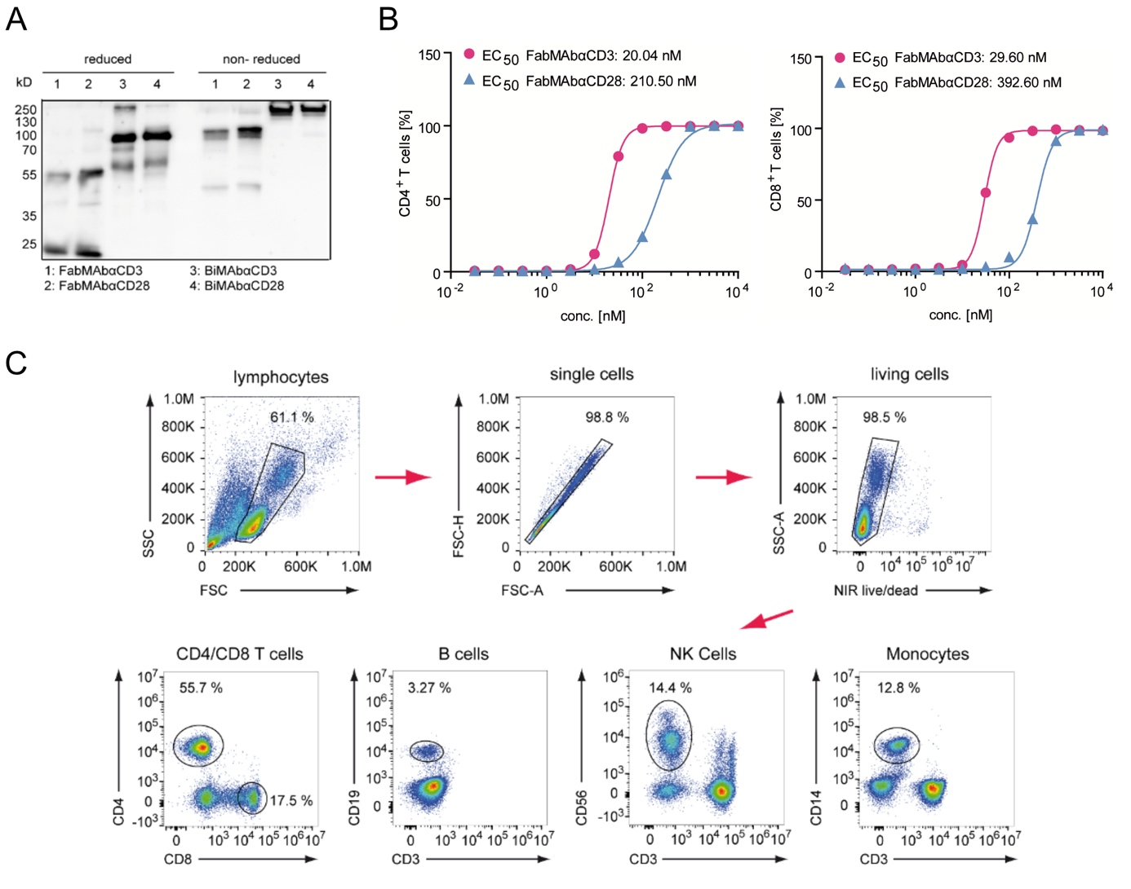

**Supplementary Fig. 1. Purified T-cell engager antibodies bind effector cells specifically. (A)** Western blot of bsAbs under reducing and non-reducing conditions. 100 ng of the respective antibody were separated by a 12.5% polyacrylamide SDS-gel and transferred to a polyvinylidene fluoride membrane. BsAbs were detected with polyclonal goat anti human IgG antibodies. **(B)** Non-linear regression analysis of the percentage of IgG positive CD8+ (top) and CD4+ (bottom) T cells after incubation with a half-logarithmic dilution series of FabMAb ranging from 1000-0.03162 nM determined by flow cytometry. Single values of a representative experiment are shown. EC50 values were calculated with the Prism software using non-linear regression log(agonist) vs. response variable slope with a robust fit. **(C)** Gating strategy for the detection of CD4+ and CD8+ T cells, B cells, NK cells and monocytes. PBMC were gated for lymphocytes, which were further gated on single cells and living cells. Living cells were gated for CD4 or CD8 expression to distinguish T cells and CD3 as well as CD19, CD56 and CD14 to separate B cells, NK cells and monocytes.

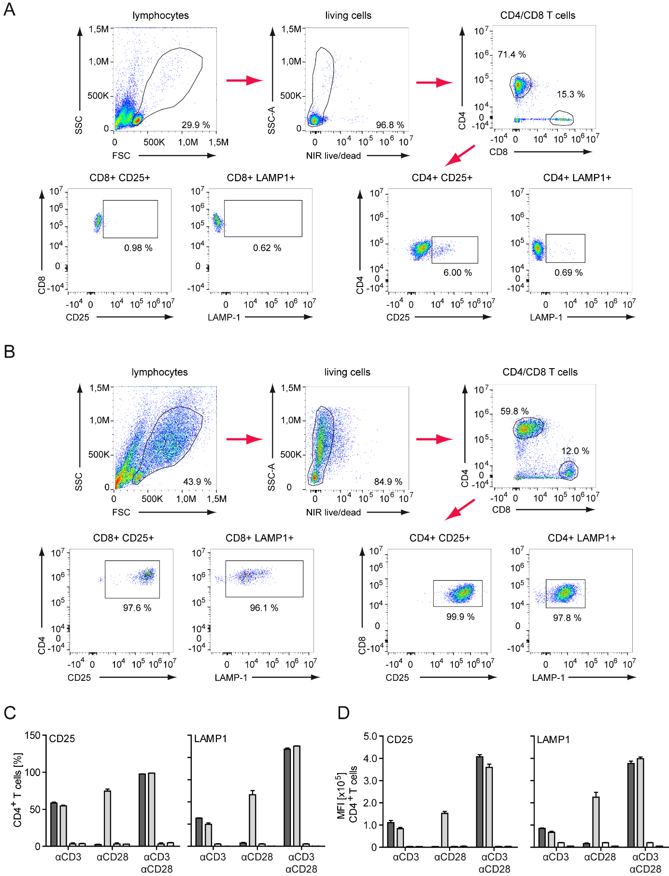

**Supplementary Fig. 2. HBVenv-binding T-cell engager antibodies induce upregulation of CD25 and LAMP-1 on CD8+ and CD4+ T cells.** Gating strategy for the detection of CD25 and LAMP-1 expressing CD4+ and CD8+ T cells. PBMC were cultured for 72 hours on plates **(A)** with or **(B)** without HBsAg coated in the presence of 3 nM FabMAbαCD3 and FabMAbαCD28 in a 1:1 ratio. Flow cytometry dot plots were first gated for lymphocytes, and in a second step for living cells. Living cells were gated for CD4 or CD8 expression to identify T cell subsets, and further gated on CD25 and LAMP-1. **(C,D)** Quantification of CD25+ and LAMP‑1+-positive CD4+ T cellsgiven as **(C)** percentage of the parental population or **(D)** MFI.

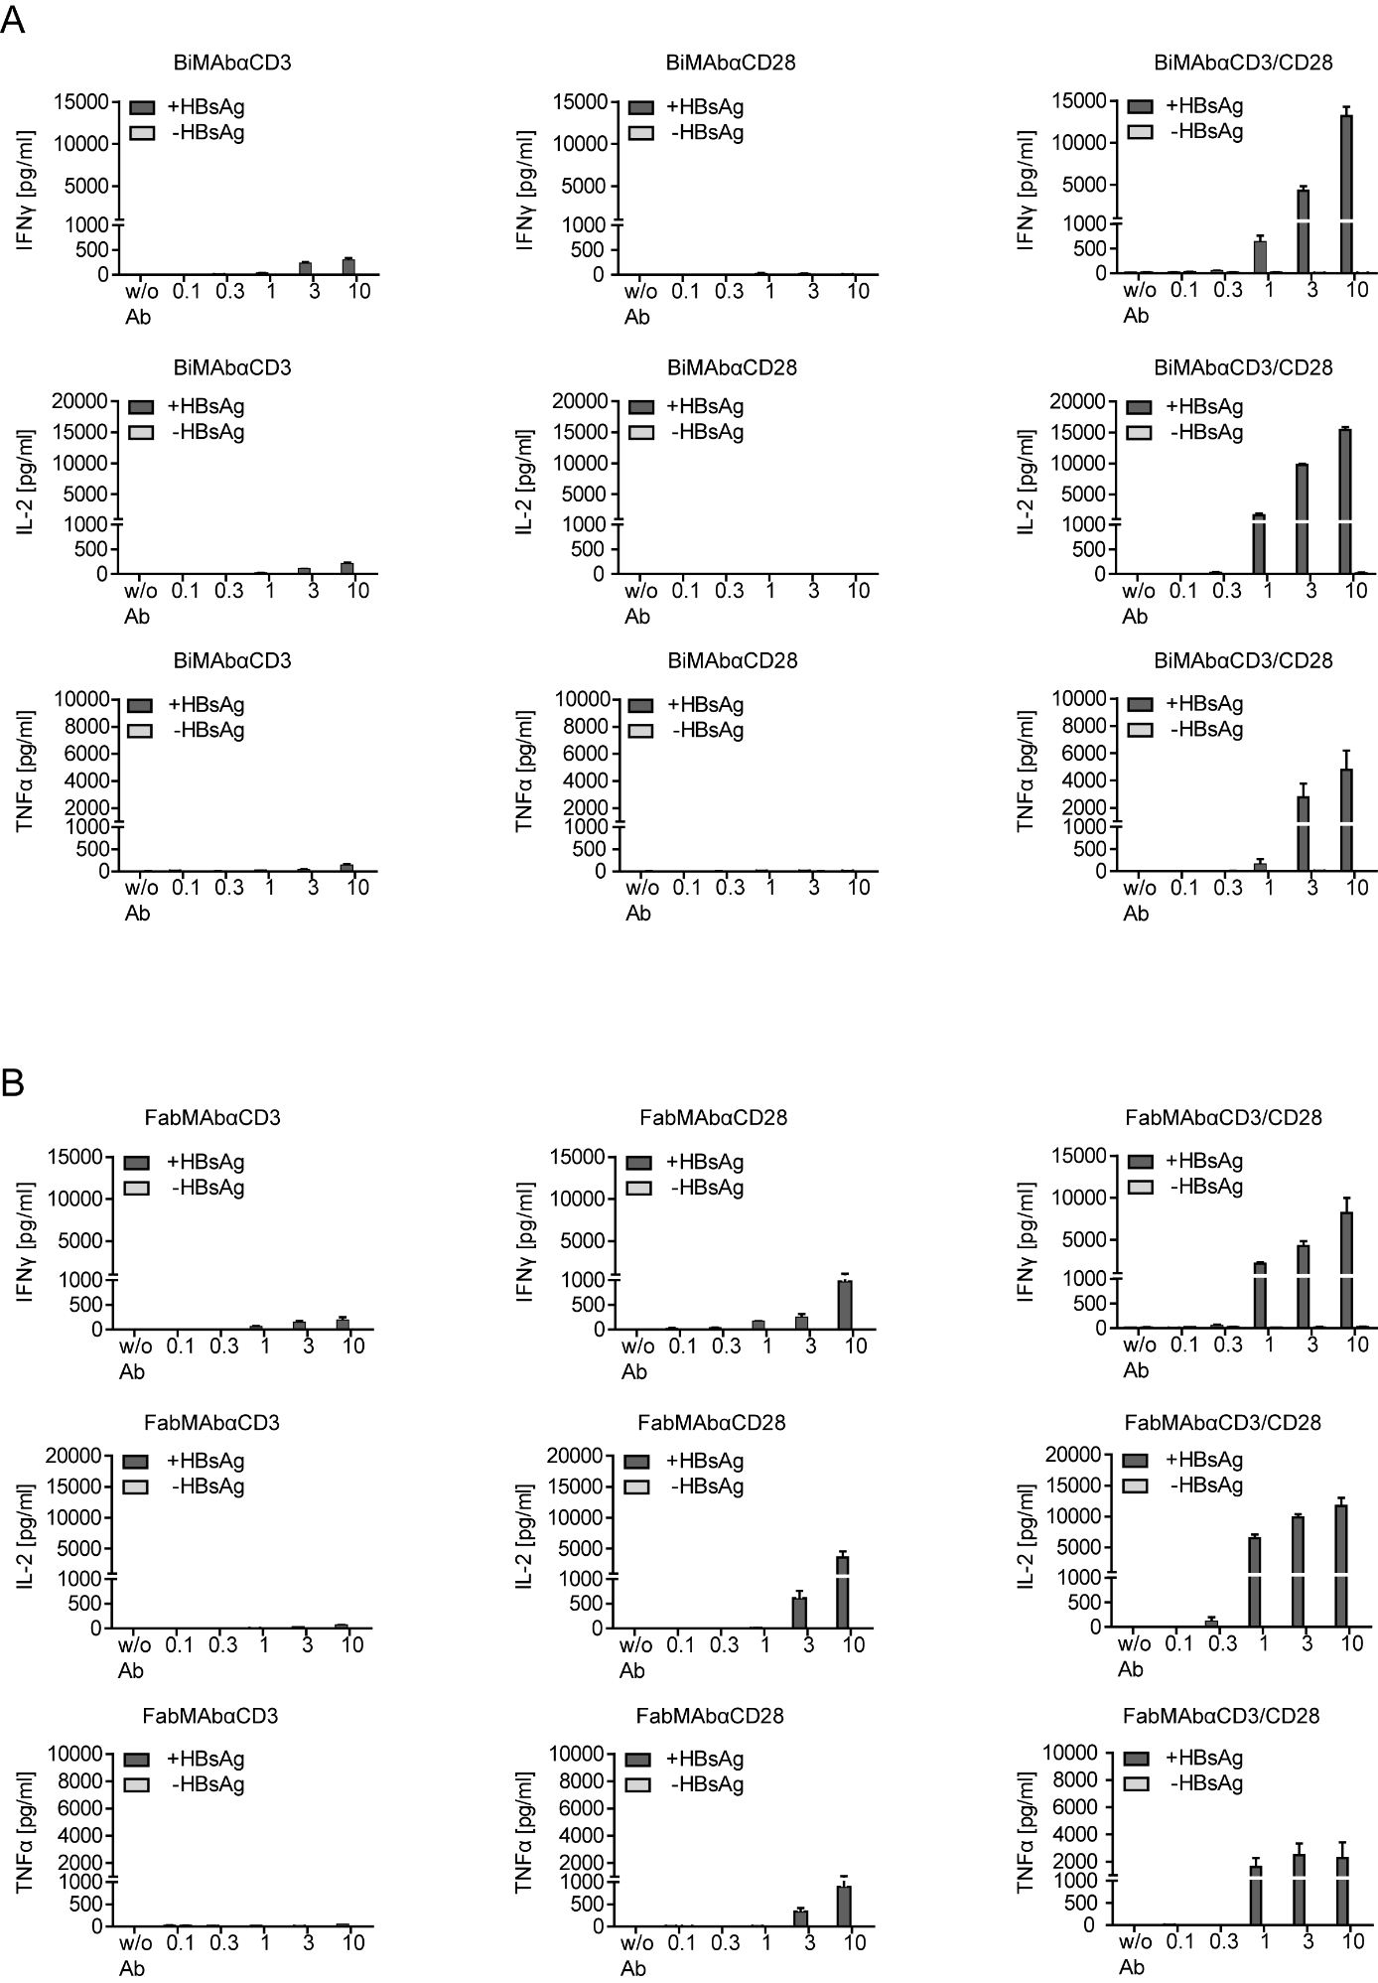

**Supplementary Fig. 3. HBVenv-binding T-cell engager antibodies activate T cells to secrete IFNγ, IL-2 and TNFα when cultured on recombinant HBsAg.** PBMC were cultured for 72 hours on plated with (+) or without (-)HBsAg coated in the presence of the indicated concentration of **(A)** BiMAb or **(B)** FabMAb. Cytokines were quantified in the supernatant by ELISA. Treatment was performed with CD3-specific constructs (left), CD28-specific constructs (middle) or the combination of both constructs in a 1:1 ratio (right). Data are presented as mean values ± SD of triplicate co-cultures (*n* = 3).

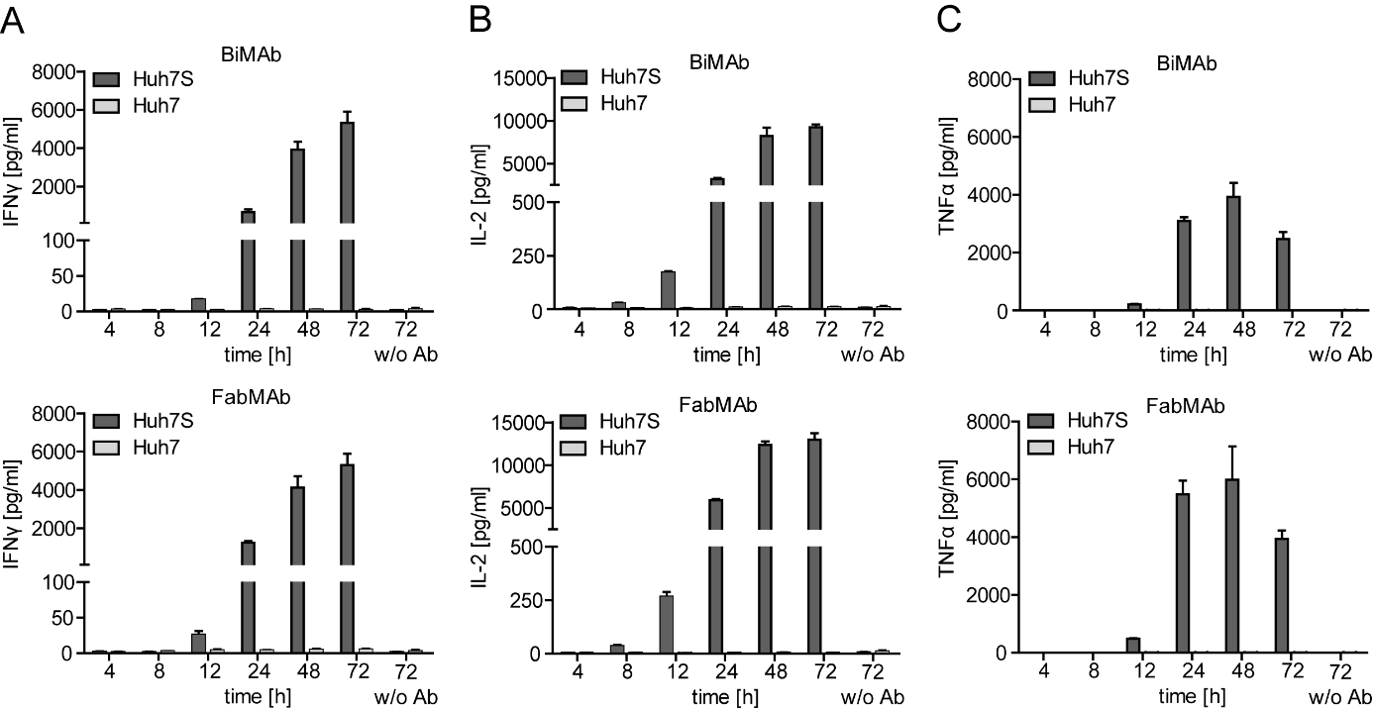

**Supplementary Fig. 4. HBVenv-binding T-cell engager antibodies activate T cells to secret IFNγ, IL-2 and TNFα in co-cultures with transgenic target cells.** PBMC were cultured with HBVenv-expressing Huh7S or parental Huh7 cells as control in the presence of 3 nM of of CD3- and CD28-targeting BiMAb (top) or FabMAb (bottom) in a 1:1 ratio. Levels of **(A)** IFNγ, **(B)** IL-2, and **(C)** TNFα in the supernatant was quantified by ELISA at indicated time points. Data are presented as mean values ± SD of triplicate co-cultures (*n* = 3).

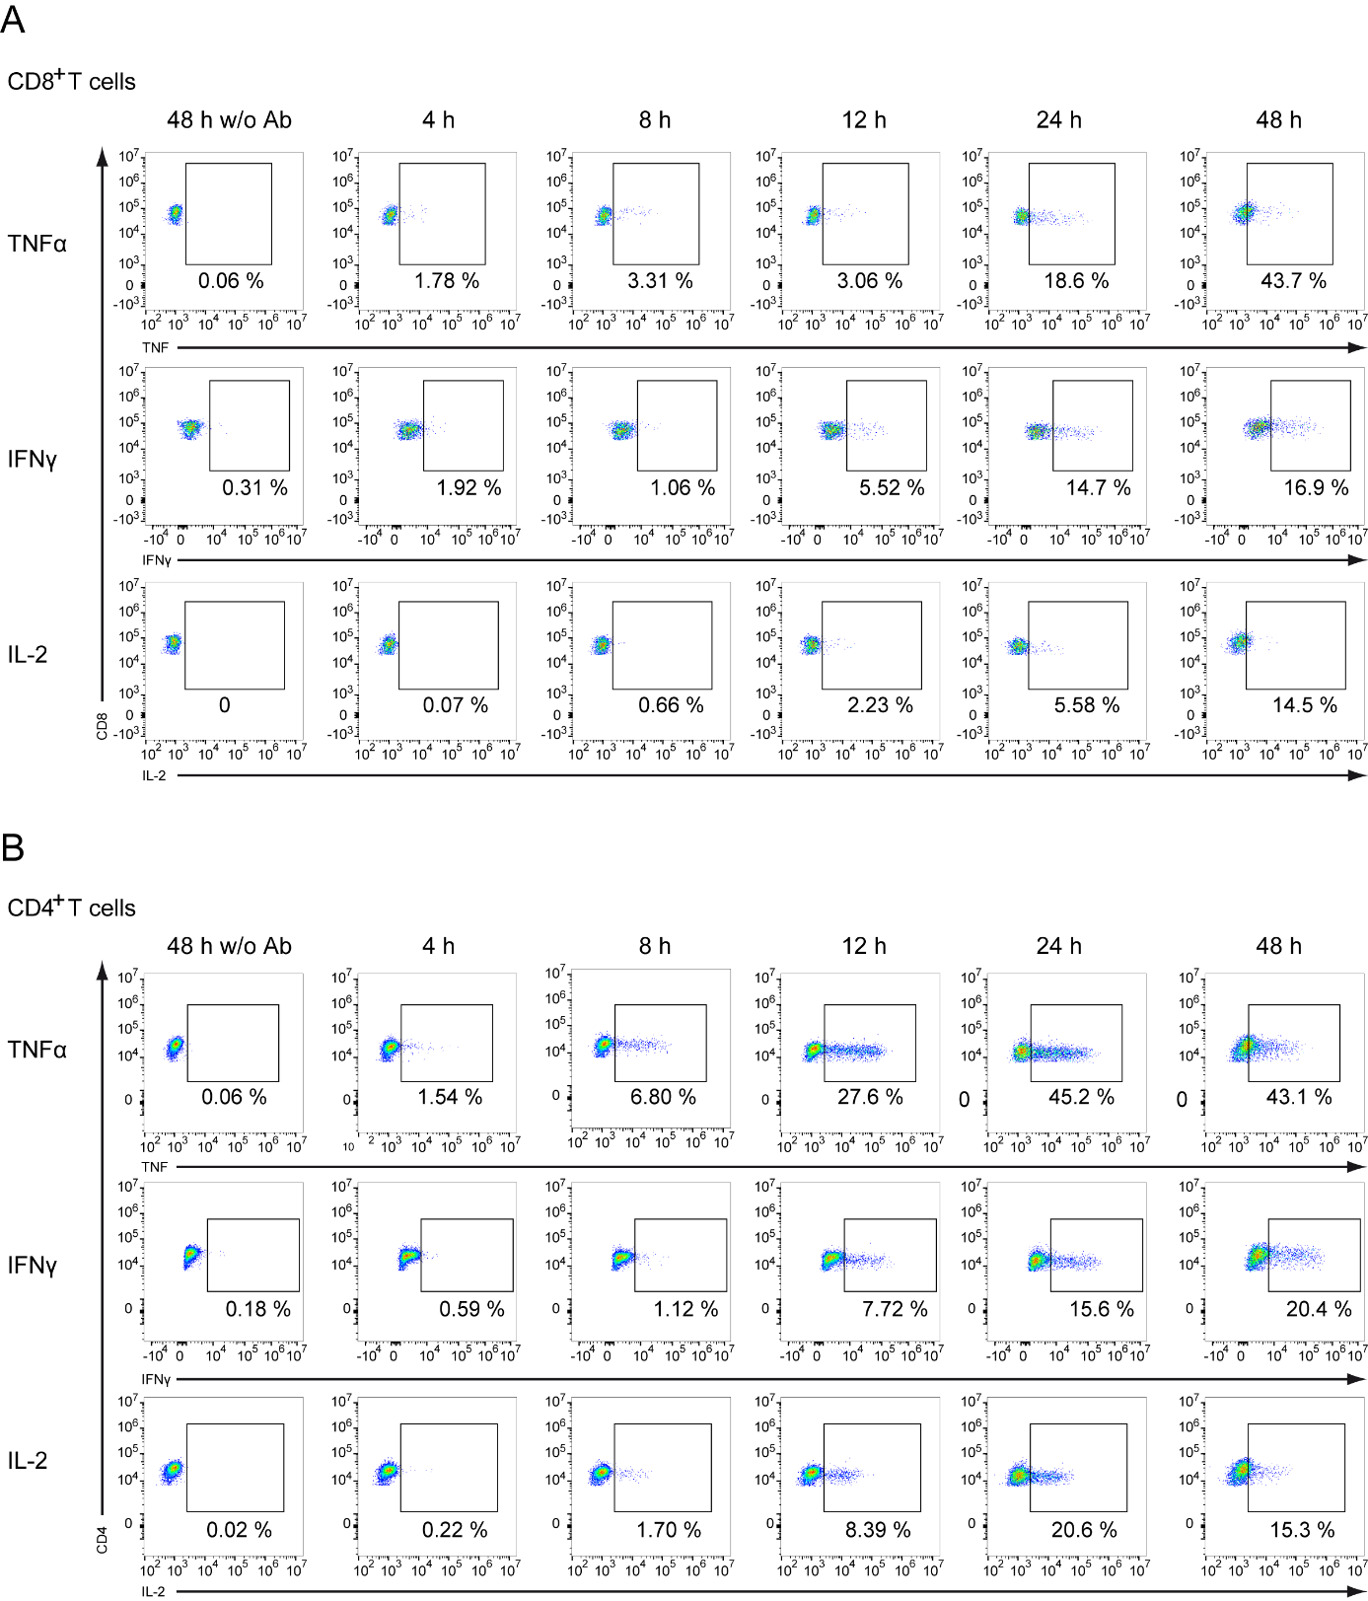

**Supplementary Fig. 5. HBVenv-binding T-cell engager antibodies activate T cells to upregulate cytokine expression.** PBMC were cultured with HBVenv-expressing Huh7S or parental Huh7 control cells in the presence of 3 nM of CD3- and CD28-targeting FabMAb for 48 hours in a 1:1 ratio. PBMC were harvested at indicated time points and the expression of TNFα (top), IFNγ (middle) and IL-2 (bottom) was determined by intracellular cytokine staining. Exemplary FACS blots for **(A)** CD8+ T cells and **(B)** CD4+ T cells are shown.

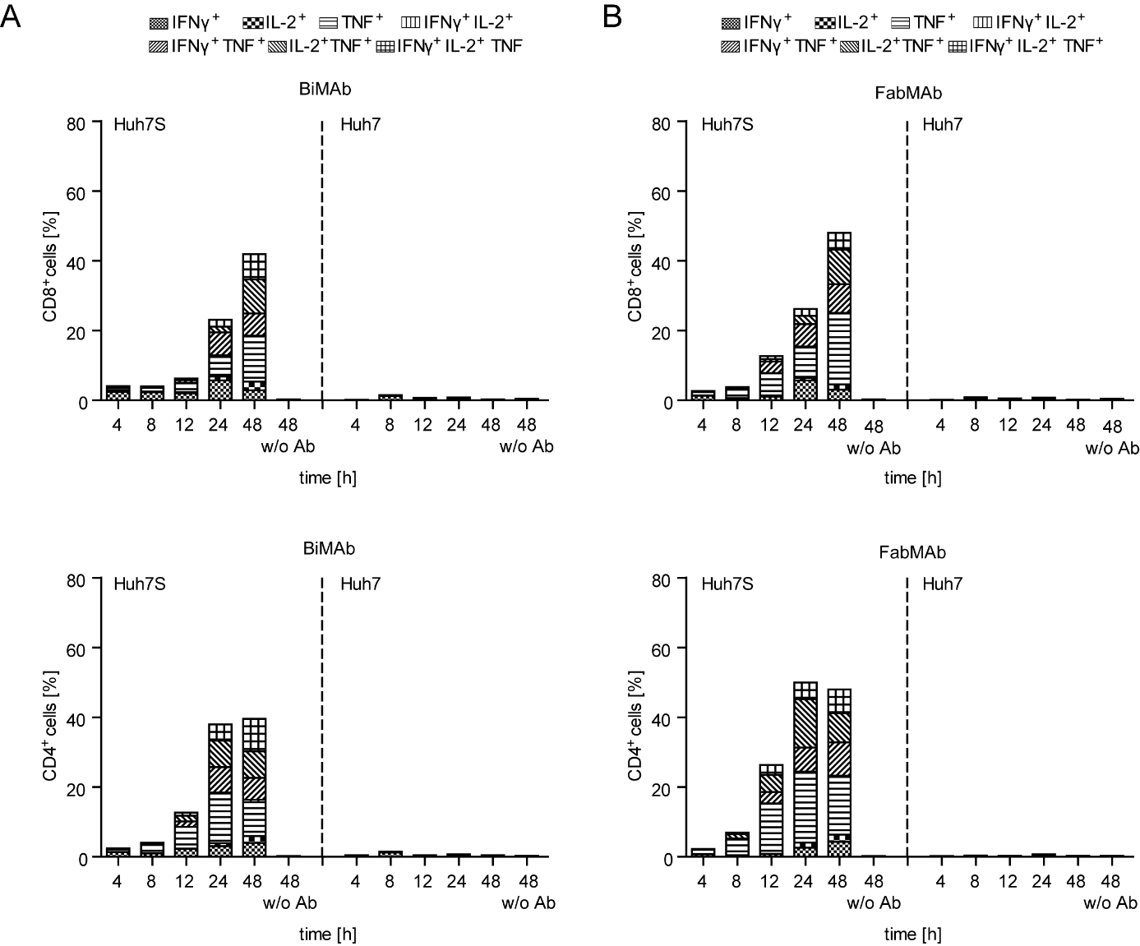

**Supplementary Fig. 6.** **HBVenv-binding T-cell engager antibodies induce polyfunctional T cells.** PBMC were cultured with HBVenv-expressing Huh7S or parental Huh7 control cells in the presence of 3 nM of of CD3- and CD28-targeting **(A)** BiMAb or **(B)** FabMAb in a 1:1 ratio for 48 hours. To determine polyfunctionality of T cells, intracellular cytokine staining of IFNγ, IL-2, and TNFα was performed in CD8+ (top) and CD4+ (bottom) T cells after co-culture with Huh7S (left) and Huh7 (right) cells in the presence of bsAbs at indicated time points. Shaded areas indicate the cytokine combinations detected in the respective proportion of T cells. Data are presented as mean values of triplicate co-cultures (*n* = 3).

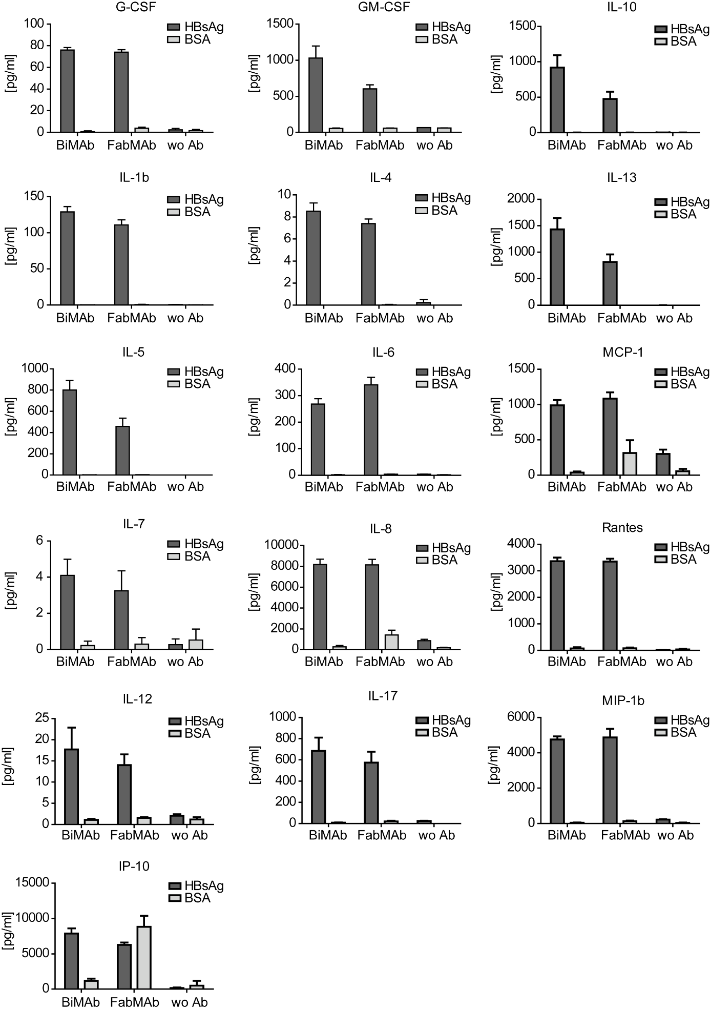

**Supplementary Fig. 7.** **HBVenv-binding T-cell engager antibodies activate T cells to secrete a variety of cytokines and chemokines.** PBMC were cultured for 72 hours on plates coated with HBsAg or BSA in the presence 3 nM of CD3- and CD28-targeting BiMAb, FabMAb in a 1:1 ratio or without bsAb (w/o Ab). Luminex assay determined the levels of G-CSF, GM-CSF, IL-1b, IL-4, IL-5, IL-6, IL-7, IL-8, IL-10, IL-12(p70), IL-13, IL-17, MCP-1(MCAF), MIP-1b, Rantes and IP-10 in the supernatant employing Luminex100 machine with BioPlex Manager 6.1 software.

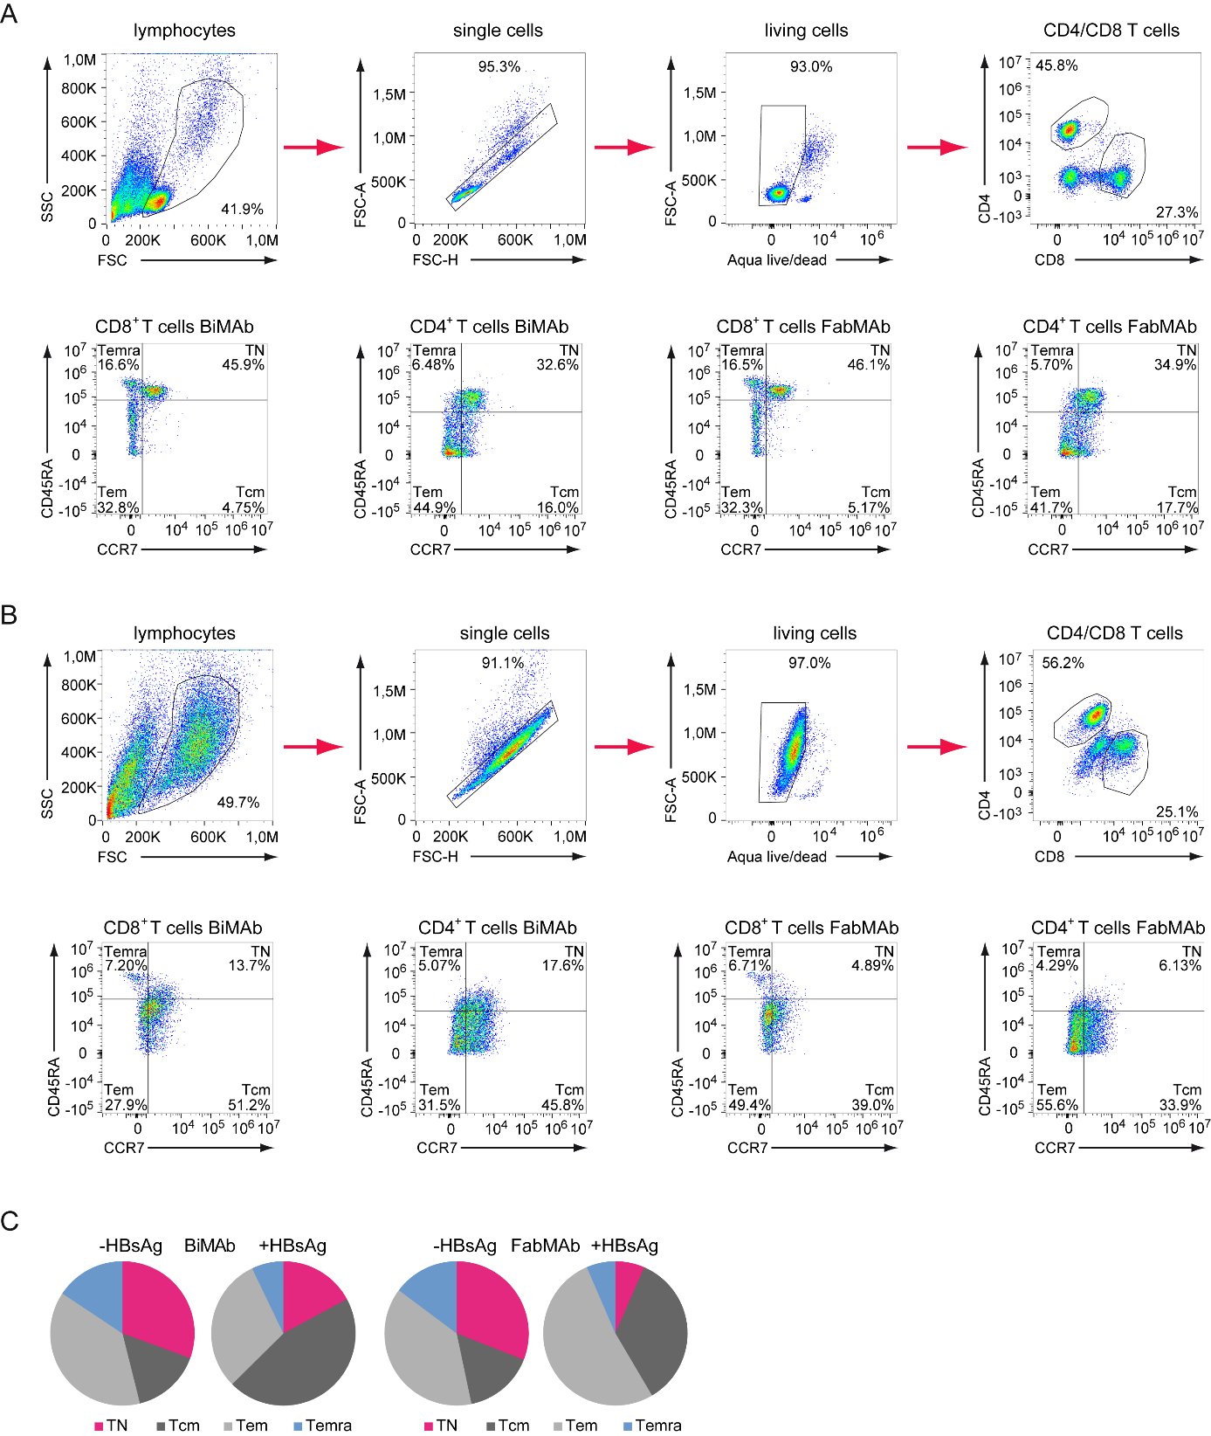

**Supplementary Fig. 8.** **HBVenv-binding T-cell engager antibodies induce the differentiation from naïve into effector T cells.** Gating strategy for the detection of CCR7 and CD45RA on CD8+ and CD4+ T cells. PBMC were cultured for 72 hours on plates **(A)** with or **(B)** without HBsAg coated in the presence of 3 nM FabMAbαCD3 and FabMAbαCD28 in a 1:1 ratio. PBMC were gated for lymphocytes, which were further gated on living cells and CD8 and CD4 expression. CD8+ and CD4+ T cells were then gated for CCR7 and CD45RA. Exemplary FACS blots are shown. **(C)** Percentage of naïve (TN), central memory (Tcm), effector memory (Tem) and effector memory cells re-expressing CD45RA (Temra) was determined after flow cytometry staining of CD45RA and CCR7. Data are presented as mean values of triplicate co-cultures (*n* = 3). 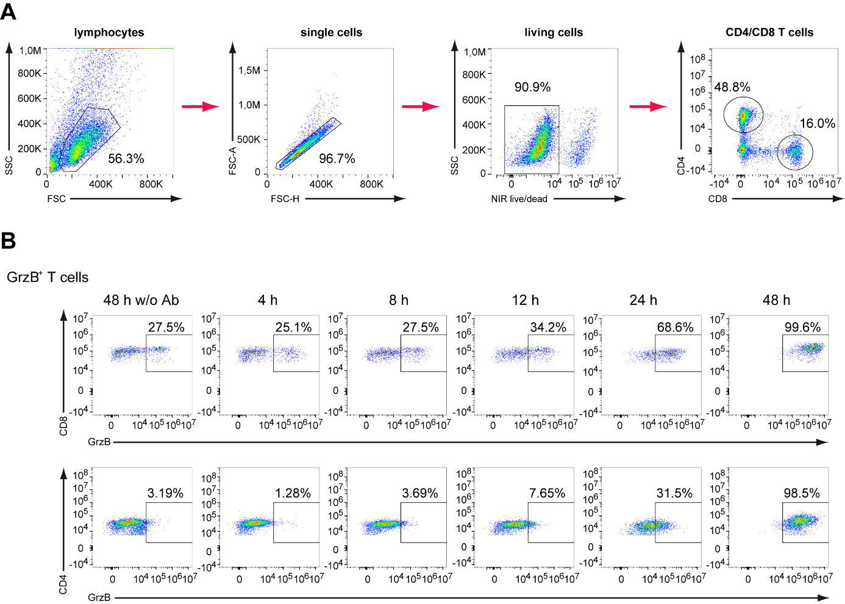

**Supplementary Fig. 9.** **HBVenv-binding T-cell engager antibodies induce the the expression of GrzB on CD8+ and CD4+ T cells.** PBMC were cultured with HBVenv-expressing Huh7S or parental Huh7 control cells in the presence of 3 nM of CD3- and CD28-targeting BiMAb or FabMAb for 72 hours in a 1:1 ratio. PBMC were harvested and the expression of GrzB was determined by intracellular cytokine staining. **(A)** PBMC were gated for lymphocytes, which were further gated on single cells and living cells, and finally CD8 and CD4 expression. **(B)** Production of GrzB by CD8+ (top) and CD4+ (bottom) T cells at indicated time points Exemplary FACS blots are shown.

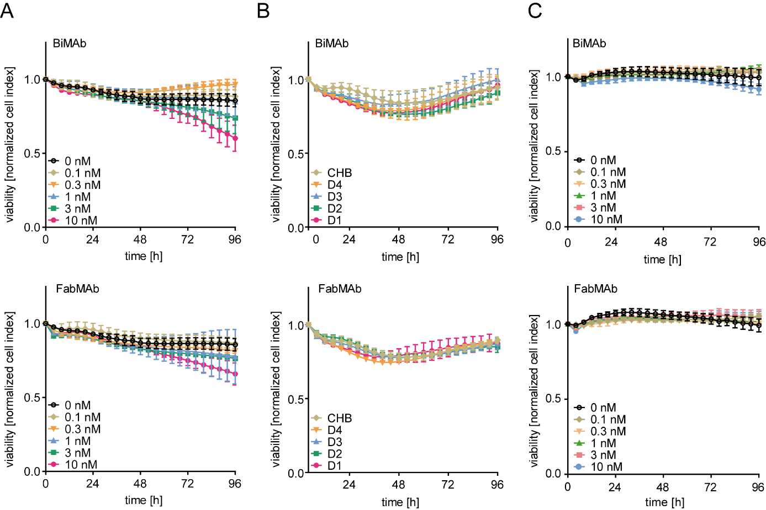

**Supplementary Fig. 10. Parental Huh7 cells slowly lose viability in the presence of high doses of T-cell engager antibodies.** HBVenv-negative Huh7 cells in co-culture with various PBMC preparations. **(A)** PBMC from a healthy individual and a dilution series of BiMAb (top) or FabMAb (bottom). **(B)** PBMC from 4 different healthy donors (D1-D4) and from a chronically infected patient (CHB) and BiMAb (top) or FabMAb (bottom) at 3nM concentratuin. Target cell viability was determined over 96 hours in real-time employing an xCELLigence real-time cell analyzer. **(C)** Viability of non-infected HepG2 NTCP cells was monitored over 96 hours employing an xCELLigence real-time cell analyzer. Cells were cultured with PBMC and the indicated concentration of CD3- and CD28-targeting BiMAb (top) or FabMAb (bottom) in a 1:1 ratio. Data are presented as mean ± SD of triplicate cell-cultures (*n* = 3).

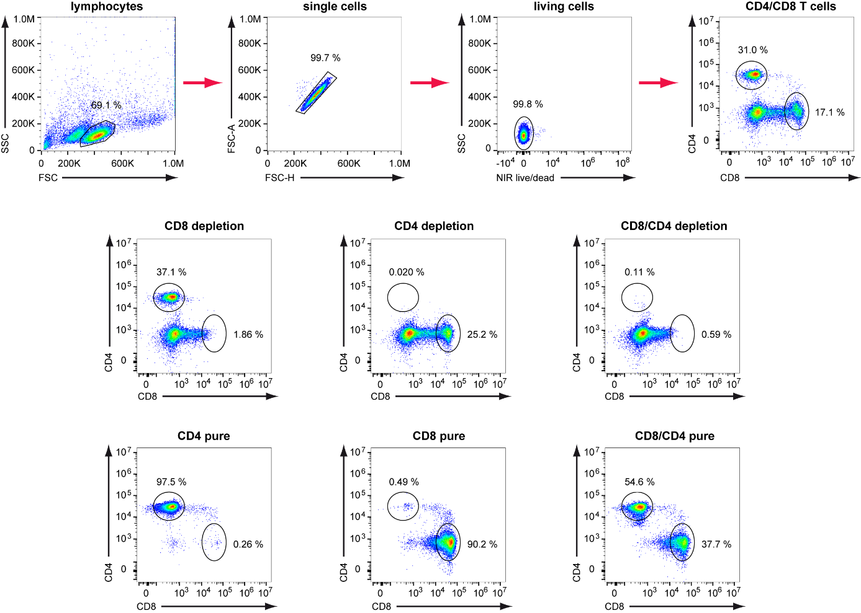

**Supplementary Fig. 11. CD8+ and CD4+ T cells are efficiently depleted and can be isolated by magnetic associated cell sorting (MACS).** Gating strategy to analyze the efficiency of T-cell depletion and isolation by MACS. Top panel: PBMC were gated for lymphocytes, which were further gated for single cells and living cells. Living cells were gated for CD4 or CD8 expression to distinguish T cells. Middle panel: CD8+ (left), CD4+ (middle) and both subsets (right) are successfully depleted by MACS. Bottom panel: CD8+ (left), CD4+ (middle) and both subsets (right) are successfully purified by MACS. Exemplary FACS blots are shown.

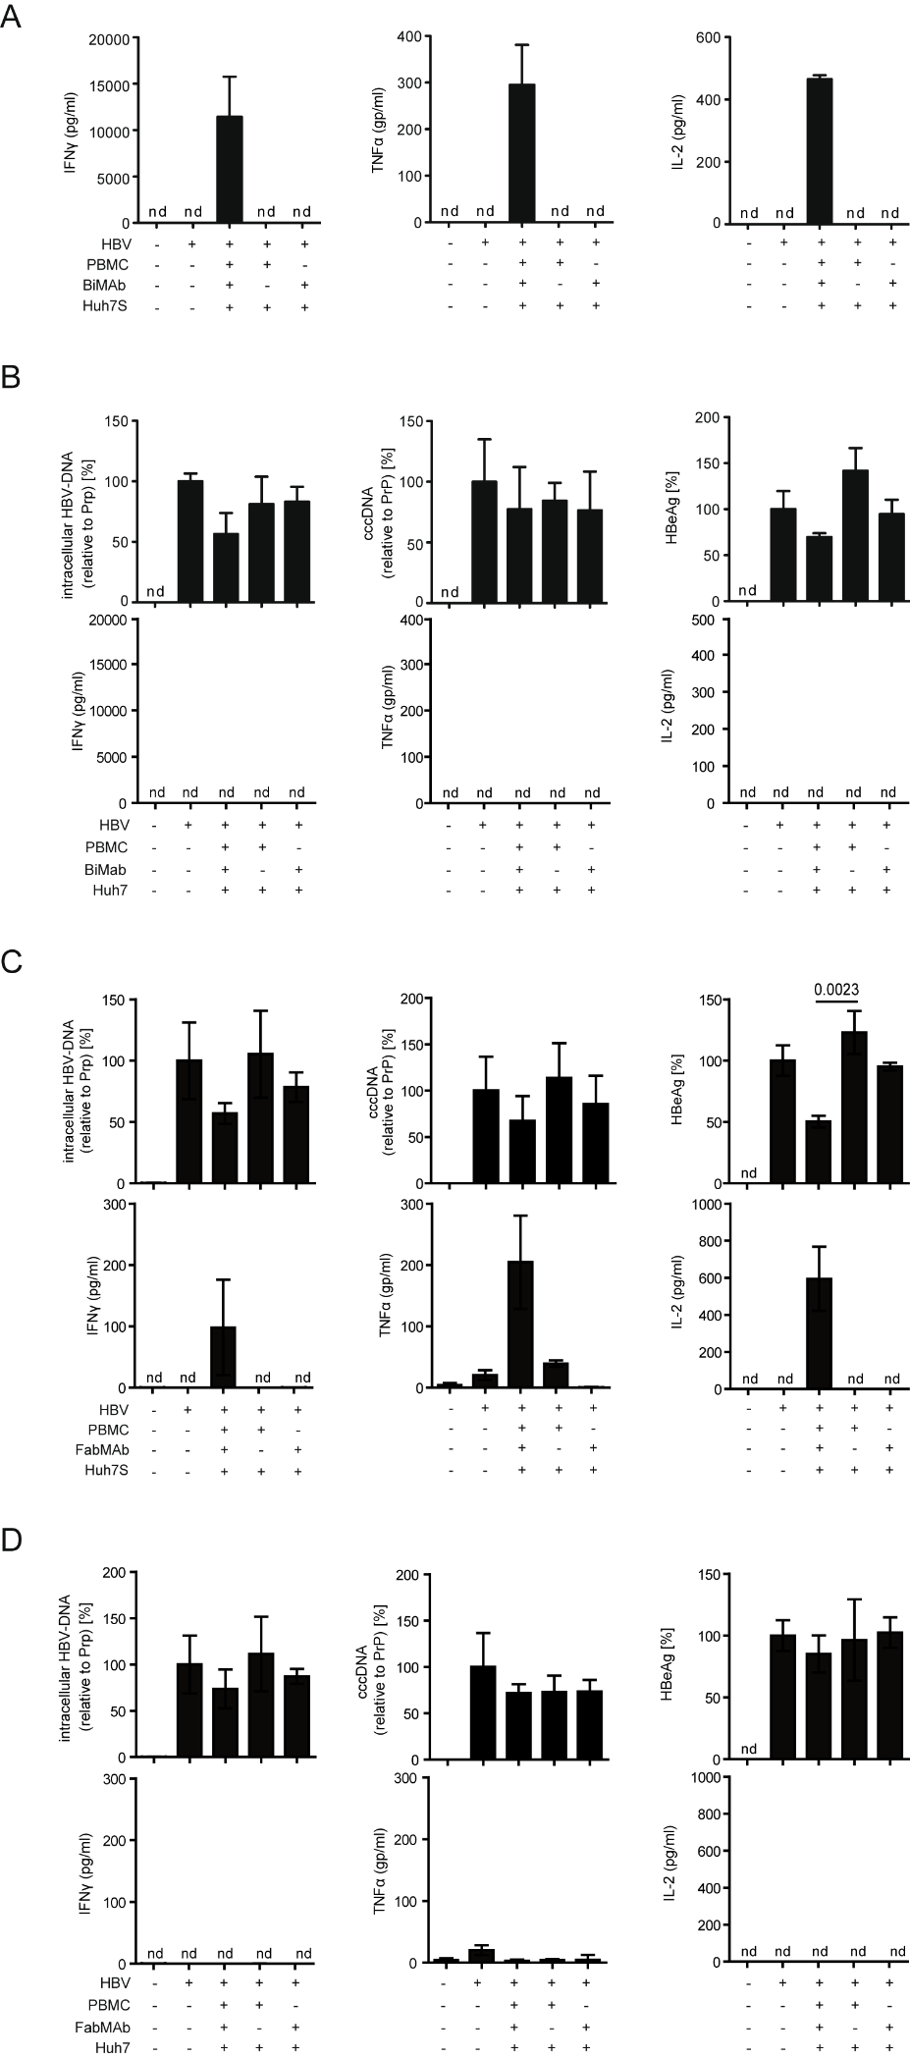

**Supplementary Fig. 12. T cells elicit cytokine-mediated antiviral effects only in the presence of HBVenv.** HepaRG cells were cultivated on the bottom of a well and infected with HBV before a transwell system with a co-culture of PBMC and **(A)** BiMAb and HBVenv-positive Huh7S cells **(B)** BiMAb and parental Huh7 cells, **(C)** FabMAb and HBVenv-positive Huh7S cells and **(D)** FabMAb and parental Huh7 cells for 7 days were added. BsAbs were applied as a combination of CD3- and CD28- specific constructs in a 1:1 ratio at a concentration of 3 nM. Activated T cells had no direct contact to the infected HepaRG cells but secreted cytokines could pass the inlet membrane and act on target cells. **(B-D)** Upper panel:levels oftotalintracellular HBV-DNA (left), HBV cccDNA (middle) in infected HepaRG cells were determined by qPCR relative to the cellular prion protein (PRP) gene, and levels of HBeAg (right) in the supernatant secreted from day 0-7 are indicated. **(A-D)** Lower panel: levels of indicated cytokines were measured by ELISA. Data are presented as mean values ± SD of triplicate co-cultures (*n* = 3). nd=not detectable.

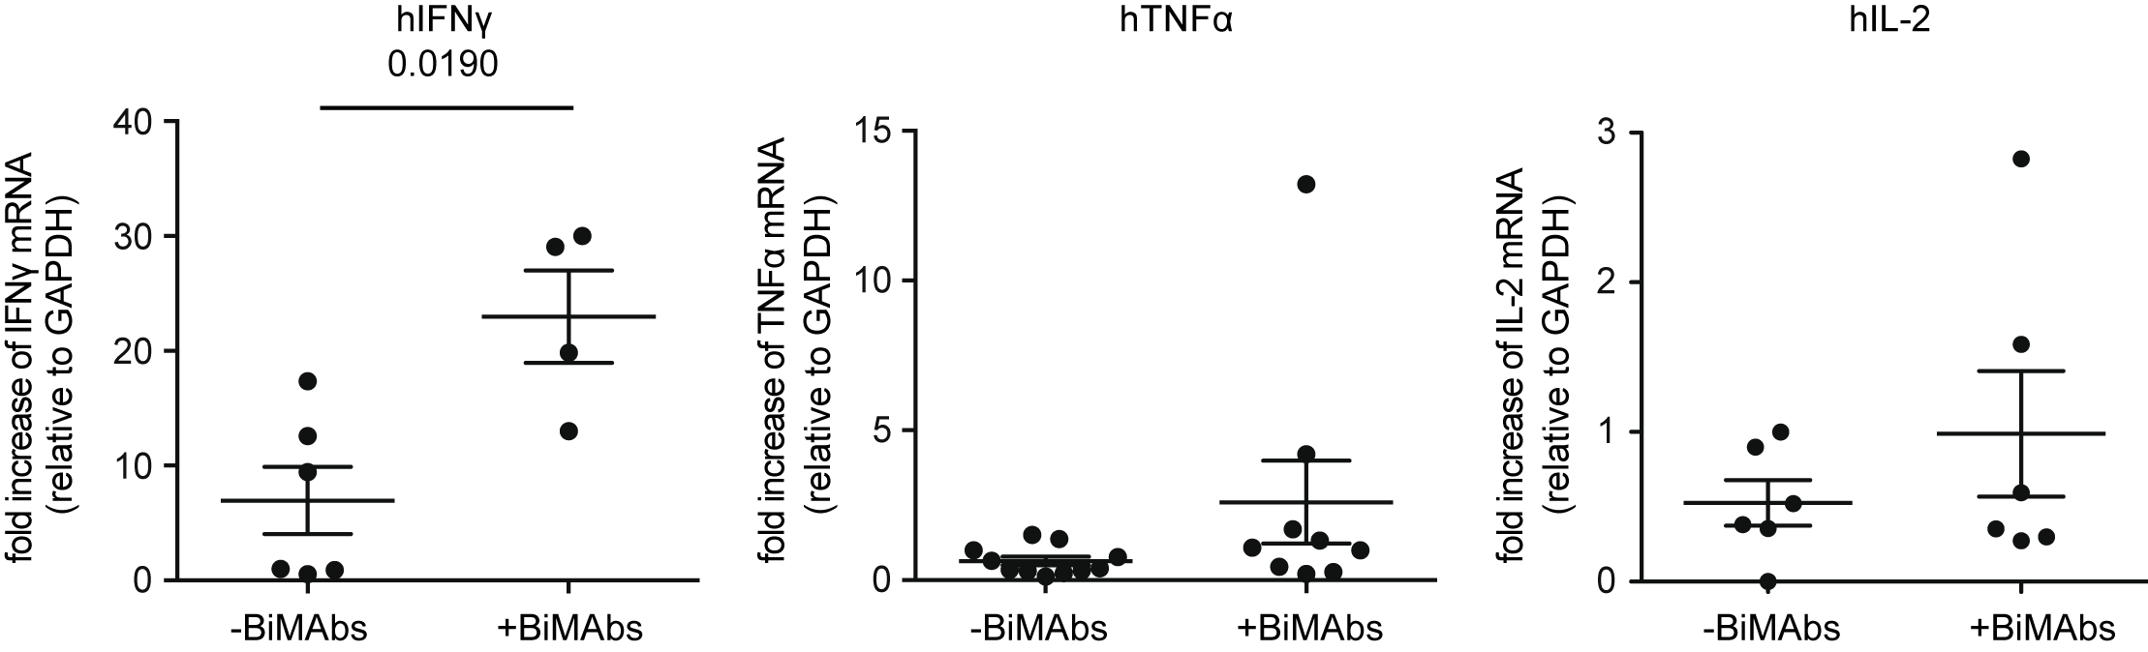

**Supplementary Fig. 13 The expression of pro-inflammatory cytokines is increased in HBVenv-expressing tumors.** Fold increase of hIFNγ (left), hTNFα (middle), and hIL-2 (right) mRNA in HBVenv-positive tumors after 10-day treatment with BiMAb. mRNA was only extracted from detectable tumors and samples without detectable GAPDH mRNA were excluded from the analysis. Data represent mean ± SD.p-values were calculated using Mann-Withney u test.

# Supplementary tables

**Supplementary Table 1: qPCR conditions for human CD4+, CD8+, IFNγ, IL-2 and TNFα**

|  |  |  |  |  |  |
| --- | --- | --- | --- | --- | --- |
|  | **T [°C]** | **t [sec]** | **Ramp [°C/sec]** | **Acquisition mode** | **Cycles** |
| **Denaturation** | 95 | 300 | 4.4 |  | 1 |
| **Amplification** | 95 | 25 | 4.4 |  | 40 |
|  | 60 | 20 | 2.2 |  |
|  | 72 | 40 | 4.4 |  |
| **Melting** | 95 | 1 | 4.4 |  | 1 |
|  | 65 | 60 | 2.2 |  |
|  | 95 |  | 0.11 | continuous: 5/°C |
| **Cooling** | 40 | 30 | 2.2 |  | 1 |

Supplementary References

1. Bohne F, Chmielewski M, Ebert G, Wiegmann K, Kurschner T, Schulze A, et al. T cells redirected against hepatitis B virus surface proteins eliminate infected hepatocytes. Gastroenterology 2008;134:239-247.

2. Golsaz Shirazi F, Mohammadi H, Amiri MM, Singethan K, Xia Y, Bayat AA, et al. Monoclonal antibodies to various epitopes of hepatitis B surface antigen inhibit hepatitis B virus infection. J Gastroenterol Hepatol 2014;29:1083-1091.

3. Golsaz-Shirazi F, Mohammadi H, Amiri MM, Khoshnoodi J, Kardar GA, Jeddi-Tehrani M, et al. Localization of immunodominant epitopes within the "a" determinant of hepatitis B surface antigen using monoclonal antibodies. Arch Virol 2016;161:2765-2772.

4. Kung P, Goldstein G, Reinherz EL, Schlossman SF. Monoclonal antibodies defining distinctive human T cell surface antigens. Science 1979;206:347-349.

5. Baroja ML, Lorre K, Van Vaeck F, Ceuppens JL. The anti-T cell monoclonal antibody 9.3 (anti-CD28) provides a helper signal and bypasses the need for accessory cells in T cell activation with immobilized anti-CD3 and mitogens. Cell Immunol 1989;120:205-217.

6. Sallusto F, Lenig D, Förster R, Lipp M, Lanzavecchia A. Two subsets of memory T lymphocytes with distinct homing potentials and effector functions. Nature 1999;402:34-38.

7. Ko C, Chakraborty A, Chou WM, Hasreiter J, Wettengel JM, Stadler D, et al. Hepatitis B virus genome recycling and de novo secondary infection events maintain stable cccDNA levels. J Hepatol 2018;69:1231-1241.

8. Xia Y, Stadler D, Ko C, Protzer U: Analyses of HBV cccDNA Quantification and Modification. In: Guo H, Cuconati A, eds. Hepatitis B Virus: Methods and Protocols. New York, NY: Springer New York, 2017; 59-72.

9. **Xia Y, Stadler D**, Lucifora J, Reisinger F, Webb D, Hosel M, et al. Interferon-gamma and Tumor Necrosis Factor-alpha Produced by T Cells Reduce the HBV Persistence Form, cccDNA, Without Cytolysis. Gastroenterology 2016;150:194-205.