*Supplemental material*

*Food-cue reactivity task*

High versus low caloric food images showed higher activity in the striatum, insula and parts of the prefrontal cortex (see supplementary table 1 and figure 1) (p<0.05 FWE corrected). Overall, fasted compared to sated state showed a stronger activation in the striatum (see supplementary table 1) (p<0.05 FWE corrected). In addition, there was a significant effect of age group with stronger activation in visual processing areas and putamen in younger adults in comparison to elderly participants (see supplementary table 1) (p<0.05 FWE corrected). There was no main effect of BMI group and no significant 2-way interactions between BMI group, age group and state of hunger. The country site (dummy coded with two regressors) and sex (female/male) were included in the design matrix as covariates of no interest.

Supplementary table 1: GLM analysis for high minus low caloric food images

|  |  |  |  |  |  |  |
| --- | --- | --- | --- | --- | --- | --- |
| **Brain regions** | **Hemi** | **MNI Coordinates** | | | **Peak- t** | **pFWE** |
| **x** | **y** | **z** |
| **Main effect high versus low caloric** | | | | | | |
| Caudate | R | 8 | 8 | 8 | 5.06 | 0.008 |
| Caudate | L | -8 | 4 | 12 | 4.27 | 0.008 |
| ACC/Frontal Medial Orbital | L | -4 | 48 | 0 | 4.05 | 0.001 |
| Insula | L | -36 | 16 | -12 | 3.96 | 0.013SVC |
| **Fasted > Sated** | | | | | | |
| Putamen | R | 28 | 0 | 4 | 4.95 | 0.014 |
| Caudate | R | 12 | 20 | 4 | 3.37 | 0.014 |
| Putamen/Pallidum | L | -16 | 8 | 0 | 3.91 | 0.016SVC |
| **Sated >Fasted** | | | | | | |
| No differential activation |  |  |  |  |  |  |
| **Young adult > elderly adult** | | | | | | |
| Calcarine | R | 20 | -96 | 0 | 5.02 | 0.006 |
| Occipital Mid | R | 36 | -88 | 4 | 4.86 | 0.006 |
| Occipital Inf | L | -40 | -64 | -8 | 4.53 | 0.017 |
| Fusiform | L | -36 | -48 | -24 | 3.47 | 0.017 |
| Putamen | L | -32 | -12 | -8 | 4.46 | 0.002SVC |
| Putamen | R | 28 | -8 | 8 | 3.89 | 0.016SVC |
| **Elderly adult > young adult** | | | | | | |
| No differential activation |  |  |  |  |  |  |

Hemi = Hemisphere, L = left, R = right, p value FWE corrected using whole-brain cluster correction; SVC, pFWE small volume correction.

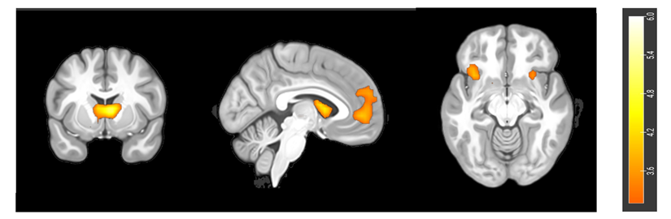

Supplementary Figure 1: Brain activation for high minus low caloric food contrast (GLM analysis). Color maps correspond to t-values (p<0.001 uncorrected for display).

***gPPI using task-based seed regions***

The gPPI analyses using the seeds (left caudate, right caudate, left insula, left ACC) based on the results of the FCR task showed that the right caudate exhibited a stronger functional connectivity with the right insula during sated compared to fasted state (x=44,y=4, z=0, t=3.89, p=0.022, pFWE<0.05, SVC corrected). A stronger connectivity between the right caudate and the left middle frontal cortex was found in elderly compared to normal adult participants (x=-48, y=28, z=32, t=5.05, p=0.006, pFWE<0.05). The left caudate nucleus showed an increased connectivity in the sated in comparison to the fasted state with a neighboring region in the caudate (x=-16, y=4, z=-20, p=0.006, SVC corrected), the right insula (x=48, y=8, z=-4, p=0.021, pFWE<0.05, SVC corrected), and the right lateral hypothalamus (x=8, y=-4, z=-8, p=0.008, pFWE<0.05, SVC corrected). The left insula as seed region exhibited increased connectivity in the sated opposed to the fasted state in the right DLPFC (x=32, y=40, z=40, p=0.010, SVC corrected). Regarding the left ACC as seed region, no significant FC were found.