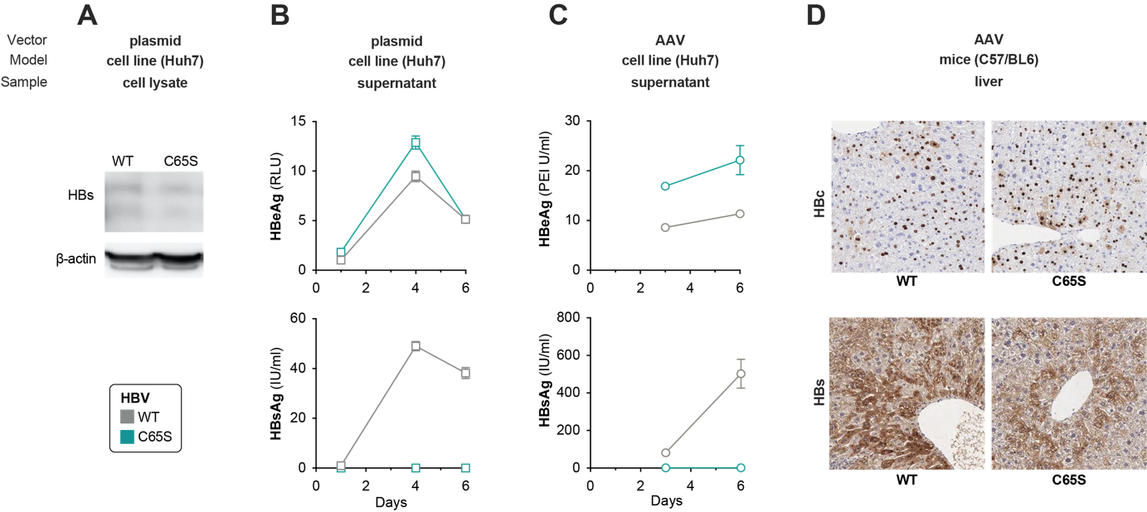

**Supplementary Figure S1. Development of a model for chronic hepatitis B expressing secretion-defective HBsAg.** The C65S mutation was inserted into an Adeno-Associated Virus (AAV) production plasmid containing a 1.3-overlength genome of HBV genotype. (**A**) The AAV-HBV production plasmids expressing wildtype (WT) or C65S-mutant HBV (C65S) were transfected into Huh7 cells, and 3 days later HBs expression analyzed from cell lysates using western blot and β-actin serving as control (**B/C**). Secretion of HBeAg (upper row) and HBsAg (lower row) was evaluated in supernatant of Huh7 cells that were (**B**) transfected with the AAV-HBV production plasmid or (**C**) transduced with AAV-HBV vectors carrying WT or C65S HBV. (**D**) AAV-HBV vectors were injected intravenously into C57/BL6 mice (109 genome equivalents per mouse) and HBc and HBs expression analyzed by immunohistochemical stainings of liver sections.