**A patient-centric approach to quality control and dosimetry**

**in CT including CBCT**

H. de las Heras1,2, F. Schöfer1, H. Schöfer1, R. M. Sánchez3, C. Zervides4,5, K. Mair6, Q. Al-Zoubi7, B. Renger8, T. de las Heras Gala1, H. Schlattl2

**Author affiliations**

1 Quality Assurance in Radiological Technologies (QUART) GmbH, Kirchenweg 7, 85604 Zorneding, Germany

2 Helmholtz Zentrum München, Ingolstädter Landstr. 1, 85764 Neuherberg, Germany

3 Instituto de Investigación Sanitaria del Hospital Clínico San Carlos (IdISSC). C/ Profesor Martín Lagos s/n, 28040 Madrid, Spain

4 Zervides Radiation Protection Services, 5A Onisilou Street, 3075 Limassol, Cyprus

5 University of Nicosia Medical School, 93 Agiou Nikolaou Street, Engomi, 2408 Nicosia, Cyprus

6 Strahlentheraptie Süd, Robert-Weixler-Straße 50, 87439 Kempten, Germany

7 AIKAmed, Wasfi Al-Tal St. 217, 11953 Amman, Jordan

8 University Hospital Rechts der Isar, Ismaninger Str. 22, 81675 Munich, Germany

**A patient-centric approach to quality control and dosimetry**

**in CT including CBCT**

**Abstract**

One measurement and an algebraic formula are used to calculate the incident air kerma (*K*a,i) at the skin after any CT examination, including cone-beam CT (CBCT) and multi-slice CT (MSCT).

Empty scans were performed with x-ray CBCT systems (dental, C-arm and linac guidance scanners) as well as two MSCT scanners. The accumulated *K*a,i at the flat panel (in CBCT) or the maximum incident air kerma at the isocentre (in MSCT) were measured using a solid-state probe. The average *K*a,i(skin), at the skin of a hypothetical patient, was calculated using the proposed formula. Additional measurements of dose at the isocentre (DFOV) and kerma-area product (KAP), as well as *K*a,i(skin) from thermoluminiscence dosimeters (TLDs) and size-specific dose estimates are presented for comparison.

The *K*a,i(skin) for the standard head size in the dental scanner, the C-arm (high dose head protocol) and the linac (head protocol) were respectively 3.33±0.19 mGy, 15.15±0.76 mGy and 3.23±0.16 mGy. For the first MSCT, the calculated *K*a,i(skin) was 13.1±0.7 mGy and the TLDs provided a *K*a,i(skin) between 10.3±1.1 mGy and 13.8±1.4 mGy.

Estimation of patient air kerma in tomography with an uncertainty below 7 % is thus feasible using an empty scan and conventional measurement tools. The provided equations and website can be applied to a standard size for the sake of quality control or to several sizes for the definition of diagnostic reference levels (DRLs). The obtained incident air kerma can be directly compared to the *K*a,i from other x-ray modalities as recommended by ICRU and IAEA.

Keywords: CT, CBCT, quality control, patient dosimetry, air kerma, DRLs, radiation monitoring systems

# Introduction

There is currently a large amount of dosimetry quantities that have been developed to account for the peculiarities of different imaging modalities[1]. However, the International Atomic Energy Agency (IAEA) agrees that incident air kerma (IAK or “*K*a,i” as recommended by the International Commission on Radiation Units and Measurements[2], ICRU) is the simplest quantity to measure exposure for projection modalities in x-ray radiology (Reference 1, Section 22.2.1). The ICRU recommends “incident air kerma and entrance surface air kerma (*K*a,i and *K*a,e) for a specified series of patients or a specified phantom for the establishment and use of diagnostic reference levels (DRLs) in medical x-ray imaging for simple examinations”2. The International Commission on Radiological Protection (ICRP) recognizes the crucial role of *K*a,i to assess the peak skin dose during interventional procedures[3],[4].

One practical solution to achieve a “patient-centric approach” and satisfy the above needs is to use the *Ka,i* at the skin in all x-ray modalities, not only for quality control (considering a standard patient size) but also for radiation dose monitoring (depending on patient size) and for defining DRLs (for a specified series of patients or a specified phantom). Although this is common for projection (2D) modalities[5],[6] it requires a standard methodology for tomography applications, including multi-slice computed tomography (MSCT) and cone-beam CT (CBCT).

Up to now, methods to measure or estimate *K*a,i in x-ray tomography either require many measurements and heavy phantoms[7],[8] (using film, TLD or OSL dosimeters) or are based on Monte Carlo simulations[9],[10]. None of these are practical to strengthen motivation for radiation protection, enable frequent tests or improve standardization. Instead, the CT dose index (CTDI) has been established for the technical characterization of MSCT devices. However, the CTDI does not represent an actual patient exposure[11] (thus it is not patient-centric) and it has turned impractical for large cone-beam angles like the ones used in CBCT scanners[12].

The purpose of this work is to demonstrate a methodology to calculate personalized air kerma in tomography (PAKT) using one solid-state dosimeter and a simple algebraic formula. The formula has been additionally implemented in a website for ease of application (<https://quart.shinyapps.io/PAKT/>). This PAKT methodology is indeed a pact among radiation protection officers, regulators, scientists, industry and general public within our group to agree on at least one quantity that can serve for direct comparisons and discussions in rigorous terms. For comparison to this methodology we also present measurements of the kerma-area product (KAP) and dose at the isocentre (DFOV), respectively recommended by the British[13] and German[14] guidelines for dental CBCT. These two measures have also been adopted by the recent guidelines for quality control in all kinds of CBCT, written in collaboration by the European Federation of Organisations of Medical Physics (EFOMP), the IAEA and the European Society for Therapeutic Radiology and Oncology (ESTRO)[15]. In the case of MSCT, we present comparative measurements of absorbed dose by thermoluminiscence dosimeters (TLDs) and we discuss the equivalence of the PAKT to size-specific dose estimates (SSDE)20.

# Materials and methods

In the following we present the formulas for the calculation of *Ka,i* following the PAKT methodology. The details of the calculations for each modality can be found in the appendix.

## The PAKT formula

The main idea of the PAKT method is to obtain the accumulated kerma area product of the beam portion that traverses the patient (*KAPpatient*) during the scan and derive the *Ka,i* at the surface of the patient or phantom as

where the exposed area is the product of the patient perimeter *P* and the collimation of the x-ray beam (i.e. the beam length in the craniocaudal or “z” direction). The obtained *K*a,i is thus the average of the actual *K*a,i received along that perimeter during the scan.

To measure the KAP in the case of CBCT devices, a dosimeter probe is attached to the center of the flat-panel detector. In the case of MSCT, the probe is placed at the isocentre (**Figure 1**).

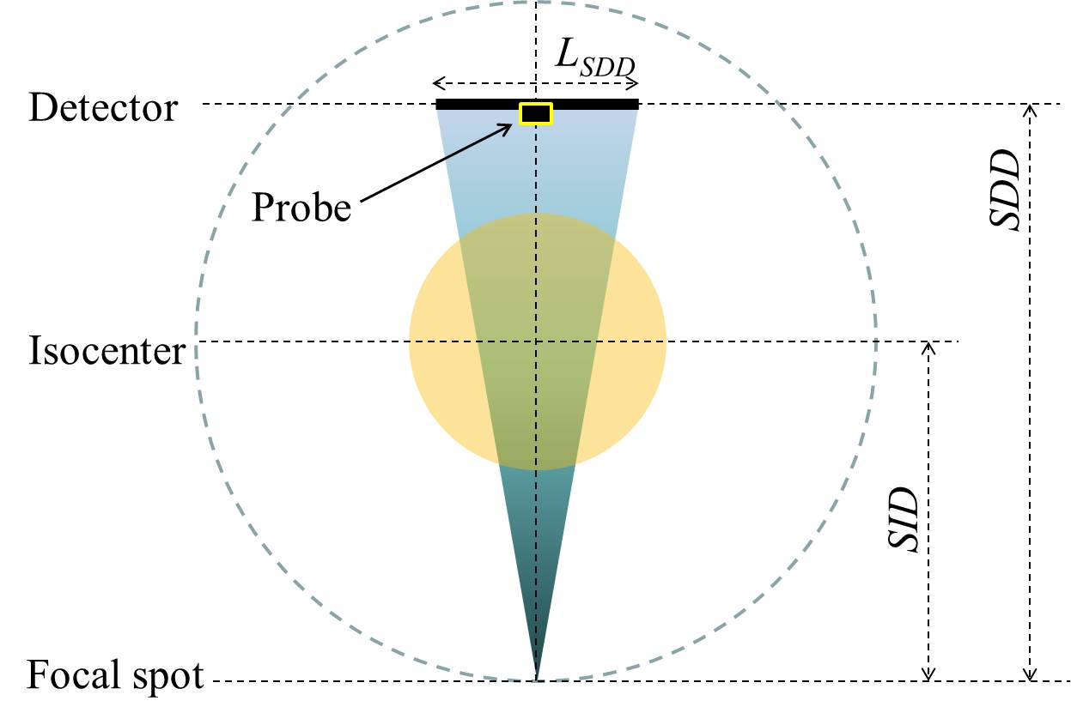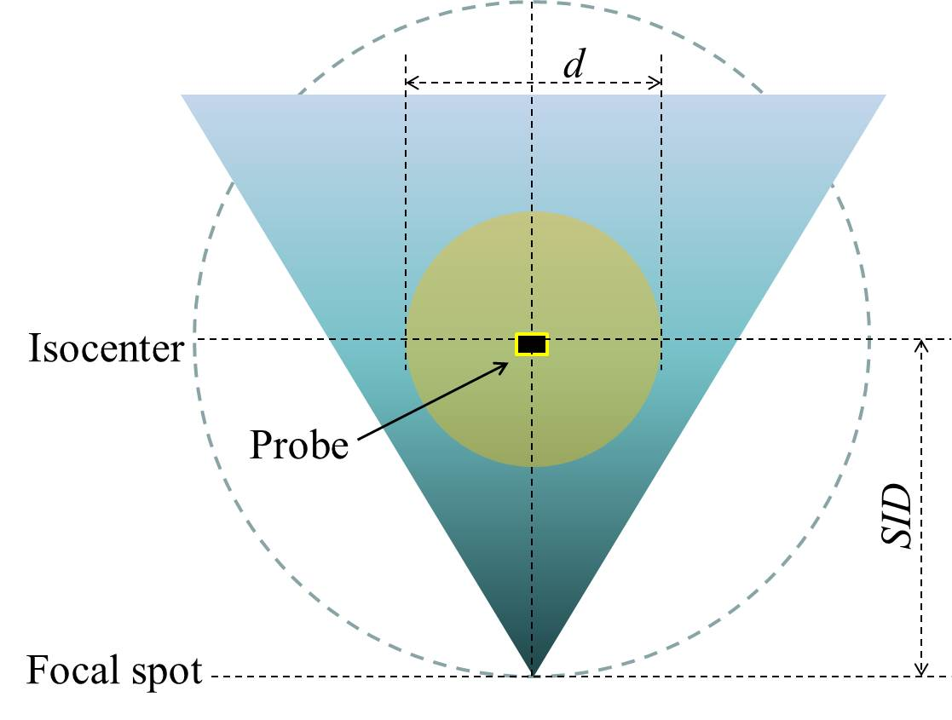

Figure 1. Definitions and position of the probe for the typical geometry of CBCT (left) and MSCT devices (right); *d* is the effective diameter of the patient or phantom. For clarity, the drawings are not to scale.

The resulting formula for the CBCT geometry is (see Appendix, equation [5])

[1]

where *Kai(SDD)* is the accumulated measurement of the probe at the flat panel during a whole scan, *LSDD* is the width of the beam at the flat panel (in the direction of the rotation plane), *P* is the patient perimeter, *SDD* is the source-detector distance, *SID* is the source-isocenter distance and *b* is a correction factor that is lower than 1 in the presence of a bow-tie filter. This correction factor is particularly relevant in dental scanners because the SID is small (see appendix). The specific case of devices with a large field of view or with an asymmetric geometry is explained in detail in the appendix.

In the case of MSCT, the formula is (see appendix, equation [6])

[2]

where is the maximum kerma rate measured at the isocentre (corresponding to the x-ray tube irradiating the probe perpendicularly), *t* is the scan time and *P* is the patient perimeter. The bow-tie factor *b* is particularly relevant for large patients (see appendix). For scans involving tube current modulation, see the discussion (section 4.3).

## Data acquisition

Measurements were acquired in one CBCT system of each kind: a dental system (CBCT, The Yoshida Dental MFG. Co., LTD, Sumida-ku Tokyo, Japan) a C-arm (biplane C-arm Allura FD20/10, Philips Healthcare, Amsterdam, The Netherlands) and a guidance system in a radiotherapy linac (TrueBeam OBI, Varian Medical Systems, Palo Alto, CA, USA), as well as two MSCT devices (Supria 16, Hitachi, Ltd. Tokyo, Japan and Sensation 64, Siemens Healthcare, Munich, Germany). A solid-state probe (dido2000k, QUART GmbH, Zorneding, Germany) was used to measure the incident air kerma (without backscatter). All measurements were performed using clinical protocols. In the case of CBCT devices, the probe was attached to the flat panel (**Figure 2**). In the case of the conventional MSCT scanners, the probe was placed at the isocentre (**Figure 3** **left**) to measure the maximum air kerma rate during the tube rotation.

The measurement of air kerma at the flat panel in CBCT devices was used to calculate the dose at the isocentre (DFOV), described in the DIN 6868-16114 and recommended in the EFOMP-ESTRO-IAEA guidelines for quality control of CBCT15. It is defined as , where *LSDD* and *LFOV* are the lengths of the x-ray field at the SDD and the length of the field of view at the isocentre in the plane of rotation. This quantity is the same as the CTDIfree-in-air for symmetric geometries (**Figure 1**). For asymmetric geometries (see figure in appendix) the DFOV reflects the fact that less dose is delivered for the same size of the field of view, whereas the CTDIfree in air does not reflect this fact.

In the case of a CT beam covering the whole probe, the measurement of the actual collimation of the beam is irrelevant. Since the active surface of the probe used in this work is 1x1 cm2, in the case of beam collimations *smaller* than 1 cm in the z-direction the probe provides the dose-length product instead of a point dose. In this case, it was necessary to additionally measure the beam collimation at the isocentre. An electronic x-ray ruler (QUART nonius, QUART GmbH, Zorneding, Germany) was placed next to the probe and aligned with the laser positioning lights for this purpose (**Figure 3**, left).

For a qualitative comparison to the results in CBCT systems, direct measurements of KAP were performed with an ionisation chamber or “KAP meter” (VacuDAP Bluetooth, VACUTEC Meßtechnik GmbH, Dresden, Germany) attached to the tube casing (**Figure 4**). The reading of the KAP meter was corrected with the corresponding factors provided by the manufacturer. Since the KAP meter provides the value of KAP exiting the meter, a simultaneous measurement of *Ka*,i at the flat panel was required for the comparison. The difference between both *K*a,i measurements (with and without the KAP meter) shows the air kerma decrease generated by attenuation within the KAP meter.

In the case of MSCT, direct measurements of absorbed dose on the surface of a phantom (QUART DVTkp, QUART GmbH, Zorneding, Germany) during a scan were performed using LiF TLDs (Mirion Technologies, Irvine, CA, USA), as shown in **Figure 3 right**. The phantom is described in the standard DIN 6868-15[16] and consists of a PMMA module of 4 cm-thickness and 16 cm-diameter, which is the standard diameter for an adult head or a paediatric body. It has inserts of polyvinyl chloride (PVC), representing bone, and air. Since the TLD measurements include backscatter (approximately 35 % according to the literature[17],[18]) and also include transmitted radiation through the phantom during the scan (approximately an additional 10 %), a factor of 45 % was subtracted from the actual TLD results to compare them to the calculated values of *Ka,i*. In addition, the displayed values of CTDIvol (required for the SSDE formalism) and dose-length product (DLP) were noted for a qualitative comparison.

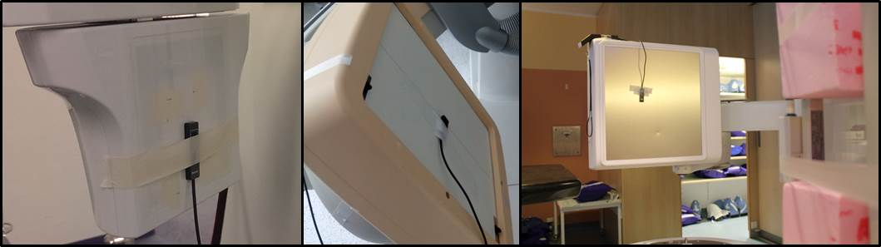

Figure 2. Position of the probe to measure *K*a,i at the detector in the dental (left), C-arm (middle) and linac guidance scanner (right).

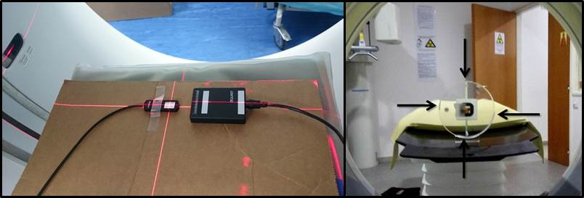

Figure 3. Left: Position and alignment of the probe and the electronic ruler for the measurements in a MSCT scanner. Right: Set-up of the phantom with attached TLDs (the arrows indicate the position of the four TLDs over the surface of the phantom).

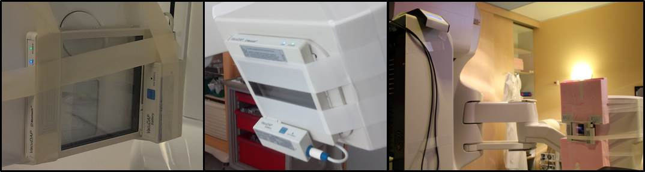

Figure 4. Position of the KAP meter in the dental (left), the C-arm (middle) and linac guidance scanner (right).

The exposure parameters set for each one of the available protocols are shown in **Tables 1** and **2**.

Table 1. Parameters for the data acquisition in the CBCT devices.

|  |  |  |  |  |  |  |  |  |  |  |
| --- | --- | --- | --- | --- | --- | --- | --- | --- | --- | --- |
| Equipment | Dental | C-arm |  |  |  | Linac |  |  |  |  |
| Protocol | Head | High dose | Low dose | Stent | Stent High Resolution | Head  (half) | Head  (full) | Pelvis | Spotlight | Thorax |
| Trajectory | full | 240° | 240° | 240° | 240° | half | full | full | half | full |
| Fan | full | full | full | full | full | full | full | half | full | half |
| KVp | 82 | 120 | 120 | 80 | 80 | 100 | 100 | 125 | 125 | 125 |
| mAs | 72.45 | 250 | 250 | 260 | 260 | 150 | 270 | 1080 | 750 | 270 |
| SID (cm) | 37.7 | 81 | 81 | 81 | 81 | 100 | 100 | 100 | 100 | 100 |
| SDD (cm) | 59 | 120 | 120 | 120 | 120 | 150 | 150 | 150 | 150 | 150 |
| LFOV (cm) | 5.7 | 25.48 | 25.48 | 25.48 | 12.99 | 26.20 | 26.20 | 46.50 | 26.20 | 46.50 |
| LSDD (cm) | 7.2 | 37.74 | 37.74 | 37.74 | 19.25 | 38.12 | 38.12 | 37.59 | 38.12 | 37.59 |
| Detector range (cm) | 9.9 | 29.66 | 29.66 | 29.66 | 15.13 | 26.92 | 26.92 | 25.46 | 26.92 | 25.46 |

Table 2. Parameters for the data acquisition in the MSCT scanners.

|  |  |  |  |  |  |  |  |  |
| --- | --- | --- | --- | --- | --- | --- | --- | --- |
| Equipment | Protocol | KVp | mA | SID (cm) | SDD (cm) | Time (s) | mAsref  **(mAs)** | Nominal collimation (cm) |

|  |  |  |  |  |  |  |  |  |
| --- | --- | --- | --- | --- | --- | --- | --- | --- |
| MSCT 1 | head | 120 | 120 | 57 | 104 | 3.518 | 422 | 1.25 |
| MSCT 2 | head | 120 | 320 | 57 | 104 | 0.5057 | 162 | 0.75 |

## Estimation of personalized air kerma in tomography (PAKT)

The procedure to estimate the incident air kerma for any patient undergoing a MSCT or CBCT examination in one specific device is exemplified in the following.

The *Ka,i*(skin) was first calculated assuming a standard patient head, with a perimeter of following equations [1] and [2]. In the case of a specific patient, it is necessary to measure the perimeter of the scanned body part (using measure tape or using the DICOM tools on one reconstructed axial slice after the scan) and calculate the corresponding *Ka,i*(skin) for the measured perimeter using either equation [1] or [2]. However, the actual value of the *Ka,i*(skin) depends linearly on the value of the specific tube current-time product (*mAs*). As this value may differ from the value used in the reference measurement (*mAsref*), the actual value must be taken into account for the final estimation of the personalized value of the patient air kerma as follows.

The PAKT formula for a specific patient in a CBCT device is

, [3]

where *mAs* is the value of the tube current multiplied by the exposure time for that specific patient scan. For details about cases involving tube current modulation, helical scans and scans of several body parts see the discussion (section 4.3).

In the case of MSCT, the PAKT formula for a specific patient is, similarly,

[4]

Alternatively, to avoid the use of these formulas in the practice, graphs including standard patient sizes and the possible values of the mAs can be generated at the acceptance test. The website mentioned above easily generates such graphs; an example is presented in the next section. One reference measurement (one graph) is required for each combination of kilovoltage and filter used in clinical practice.

# Results

The results from the measurements in the CBCT and MSCT devices are shown in Tables 3 and 4.

Table 3. Measurements of *K*a,i at the detector and KAP in the CBCT devices.

|  |  |  |  |  |  |  |  |  |  |  |
| --- | --- | --- | --- | --- | --- | --- | --- | --- | --- | --- |
|  | Dental | C-arm |  |  |  | Linac |  |  |  |  |
|  | Head | High dose | Low dose | Stent | Stent High Resolution | Head  (half) | Head  (full) | Pelvis | Spotlight | Thorax |
| *K*a,i(SDD) (mGy)  ± 5 % | 11.69 | 19.54 | 9.85 | 41.51 | 40.23 | 1.97 | 4.15 | 30.10 | 20.90 | 7.52 |
| Time (s)  ± 0.001 | 11.551 | 20.714 | 10.41 | 20.716 | 20.717 | 28.683 | 60.527 | 60.527 | 33.821 | 60.526 |
| In presence of the KAP meter: |  |  |  |  |  |  |  |  |  |  |
| KAP  (mGy cm2)  ± 6 % | 765 | 17578 | 8820 | 38021 | 8885 | 1273 | 2294 | 15304 | 11658 | 3802 |
| *K*a,i(SDD) (mGy)  ± 5 % | 10.26 | 17.62 | 8.83 | 36.78 | 35.21 | 2.10 | 3.78 | 27.46 | 19.07 | 6.87 |
| Time (s)  ± 0.001 | 11.557 | 20.715 | 10.41 | 20.717 | 20.717 | 33.82 | 60.527 | 60.528 | 33.822 | 60.526 |
| Decrease in kerma rate (%) | -12.3 | -9.8 | -10.3 | -11.4 | -12.5 | -9.4 | -9.0 | -8.8 | -8.8 | -8.8 |

Table 4. Measurements performed at the MSCT devices. The TLD results include 45 % due to backscatter and transmission through the phantom.

|  |  |  |  |  |  |  |  |
| --- | --- | --- | --- | --- | --- | --- | --- |
| Measurement device | Electronic x-ray ruler | Solid-state probe | | TLDs | | | |
| Parameter | Beam collimation (cm) | Maximum air kerma rate  (mGy / s) | Maximum air kerma-length product rate (mGy cm /s) | Top (mGy) | Left (mGy) | Right (mGy) | Bottom (mGy) |
| MSCT 1 | > 1 | 10.71 |  | 25.07 | 23.41 | 22.27 | 18.66 |
| MSCT 2 | 0.84 |  | 48.46 |  |  |  |  |

A plot of one measurement of the air kerma-length product rate () during the scan in MSCT 2 and a screenshot of the software used to measure the corresponding beam collimation are shown in **Figure 5**.

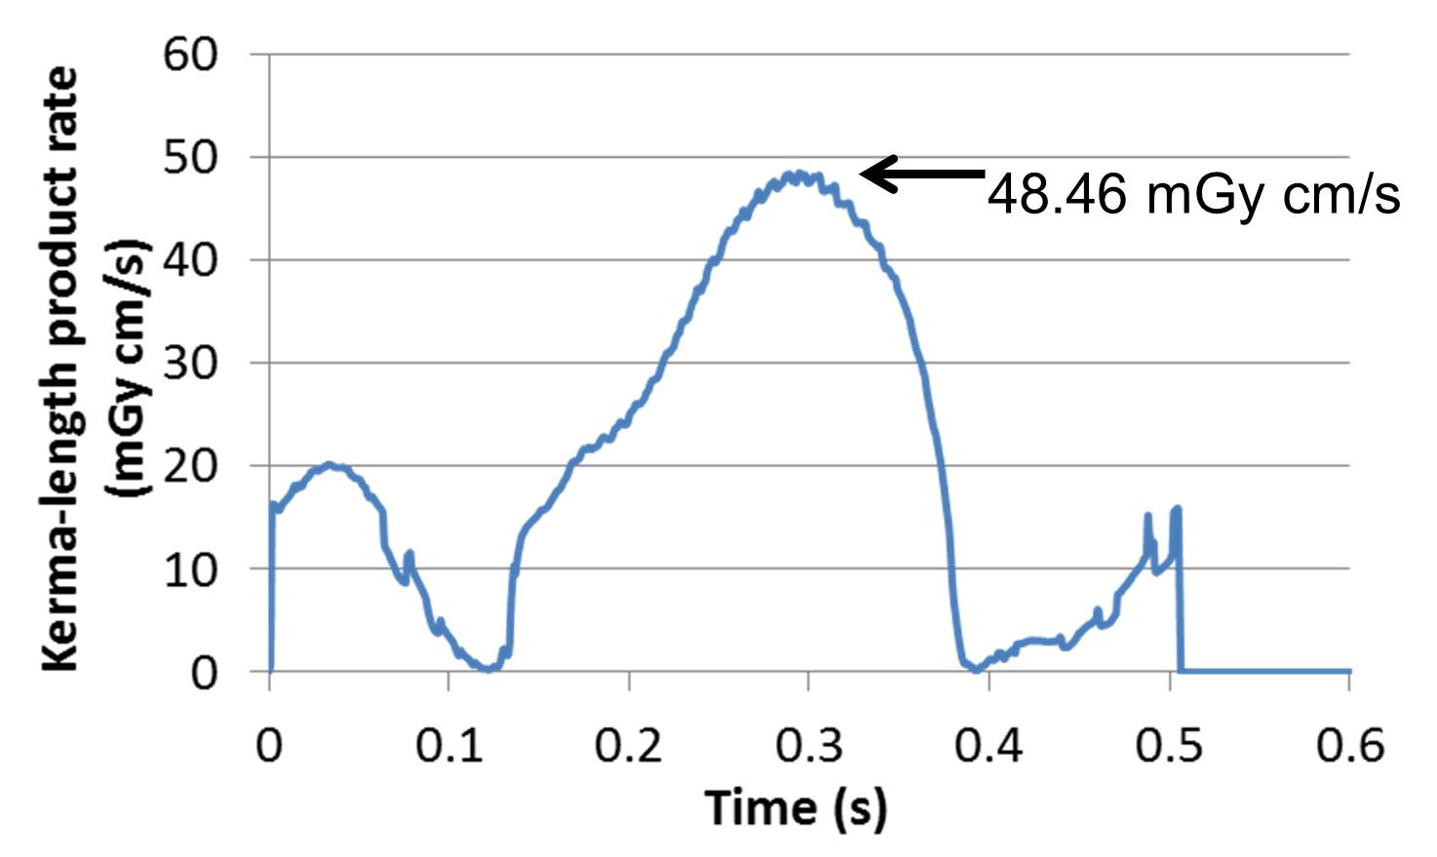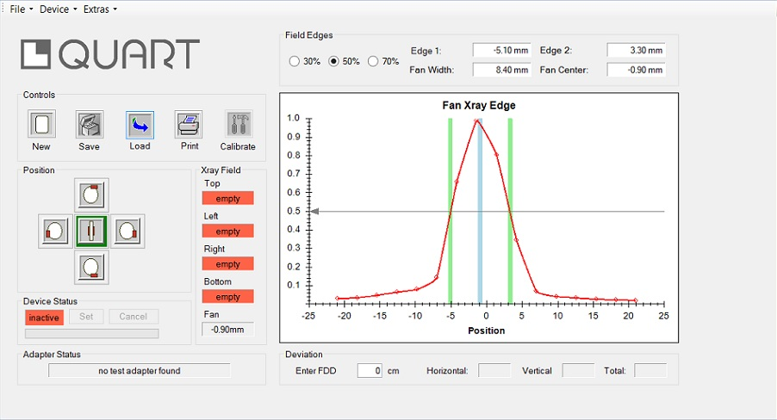

Figure 5. Left: Reading of during the scan in MSCT 2. The maximum value of this curve corresponds to the x-ray beam hitting the probe perpendicularly. Right: Screenshot of the measurement of beam-collimation: the software shows that the effective collimation is 8.40 mm (full width at half maximum of the beam profile).

The results for the CBCT devices and the MSCT devices are shown in **Tables 5** and **6**.

Table 5. Results for the CBCT devices; the incident air kerma at the isocentre (DFOV) as required in the German standard10, the KAP as required in the British standard9 and the incident air kerma at the skin *Ka,i*(skin) for the standard 16 cm-diameter head, calculated as suggested in this work.

|  |  |  |  |  |  |  |  |  |  |  |
| --- | --- | --- | --- | --- | --- | --- | --- | --- | --- | --- |
|  | Dental | C-arm |  |  |  | Linac |  |  |  |  |
|  | Head | High dose | Low dose | Stent | Stent High Resolution | Head  (half) | Head  (full) | Pelvis | Spotlight | Thorax |
| DFOV (mGy) | 23.1 | 41.6 | 21.0 | 88.4 | 85.7 | 4.2 | 8.8 | 35.4 | 44.2 | 8.8 |
| ± | 1.4 | 2.1 | 1.1 | 4.5 | 4.3 | 0.3 | 0.5 | 2.1 | 2.7 | 0.5 |
| KAP  (mGy cm^2) | 850 | 19688 | 9925 | 43213 | 10192 | 1518 | 2727 | 18142 | 13824 | 4507 |
| ± | 57 | 1318 | 665 | 2896 | 683 | 100 | 180 | 1199 | 914 | 298 |
| ***K*a,i(skin) (mGy)** | 2.85 | 15.15 | 7.63 | 32.18 | 24.59 | 1.53 | 3.23 | 15.50 | 16.27 | 3.87 |
| ± | 0.17 | 0.76 | 0.38 | 1.61 | 1.33 | 0.08 | 0.16 | 0.95 | 0.82 | 0.24 |

**Table 6. Results for the MSCT devices**. The incident air kerma at the skin *Ka,i*(skin), calculated as suggested in this work, and the SSDE are shown for a standard 16 cm-diameter head.

|  |  |  |  |  |  |  |  |  |
| --- | --- | --- | --- | --- | --- | --- | --- | --- |
|  | *K*a,i (skin) (mGy) | Top  TLD  (mGy) | Left  TLD  (mGy) | Right  TLD  (mGy) | Bottom  TLD  (mGy) | SSDE  (mGy) | CTDIvol  (mGy) | DLP  (mGy cm) |
| MSCT 1 | 13.1 | 13.8 | 12.9 | 12.3 | 10.3 | 59 | 28.80 | 351.4 |
| ± | 0.7 | 1.4 | 1.3 | 1.2 | 1.0 | - | - | - |
| MSCT 2 | 10.2 |  |  |  |  | 112 | 54.38 | 20.14 |
| ± | 0.6 |  |  |  |  | - | - | - |

The graphical comparison of PAKT to the TLD measurements is shown in **Figure 6**.

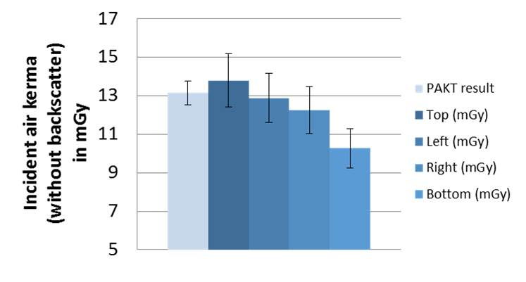

Figure 6. Comparison of the *K*a,i calculated by the PAKT methodology (left column) and by the TLD measurements (dark columns).

The behavior of the different dose quantities with respect to the geometry of the CBCT devices (symmetric or asymmetric, also called “full fan” or “half fan”) or to the size of the field of view is shown in **Figure 7** and **Figure 8**. These graphs show that whenever the beam size is larger than the size of the examined body part, neither the KAP nor the DFOV correlate with the actual *Ka,i*(skin). For this reason the KAP and the DFOV are recommended only as quality control measures in the EFOMP-ESTRO-IAEA guideline for CBCT15.

In the case of MSCT, it is appropriate to compare the PAKT methodology to the SSDE formalism, which provides factors to convert the CTDIvol into a measure of patient dose20. Applying such factors to the paediatric, adult and large patient sizes, the corresponding SSDE for the MSCT 1 are 59, 33 and 15.8 mGy and for the MSCT 2 are 112, 62 and 30 mGy. For the data acquired in the MSCT 2, the PAKT and the SSDE results are shown in **Figure 9a** and **Figure 9b** for comparison. The PAKT curves are the same for every patient size, which is a consequence of the bow-tie filter.

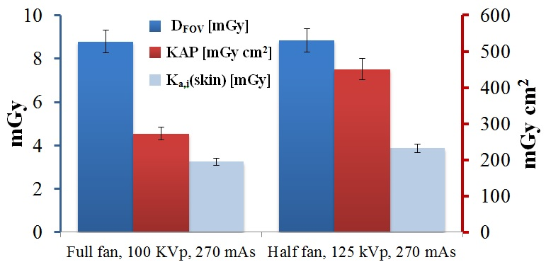

Figure 7. Dose at the isocentre (DFOV), *Ka,i*(skin) for the reference head size (left axis) and KAP (right axis) for two scans, performed in the CBCT of the linac, corresponding to a full fan (left) and a half fan (right).

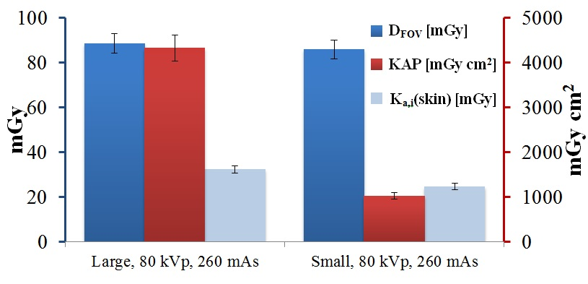

Figure 8. Dose at the isocenter (DFOV), *Ka,i*(skin) for the reference head size (left axis) and KAP (right axis) for two scans, performed in the C-arm, corresponding to a large field of view (left) and a small field of view (right).

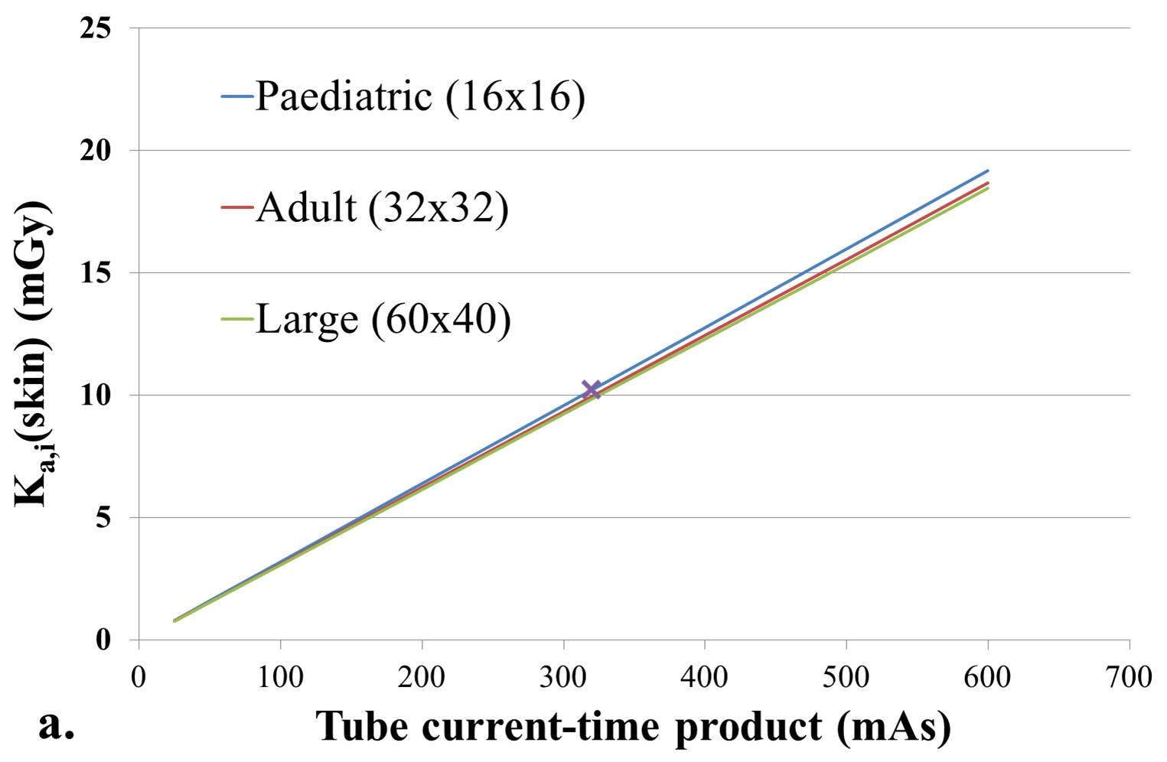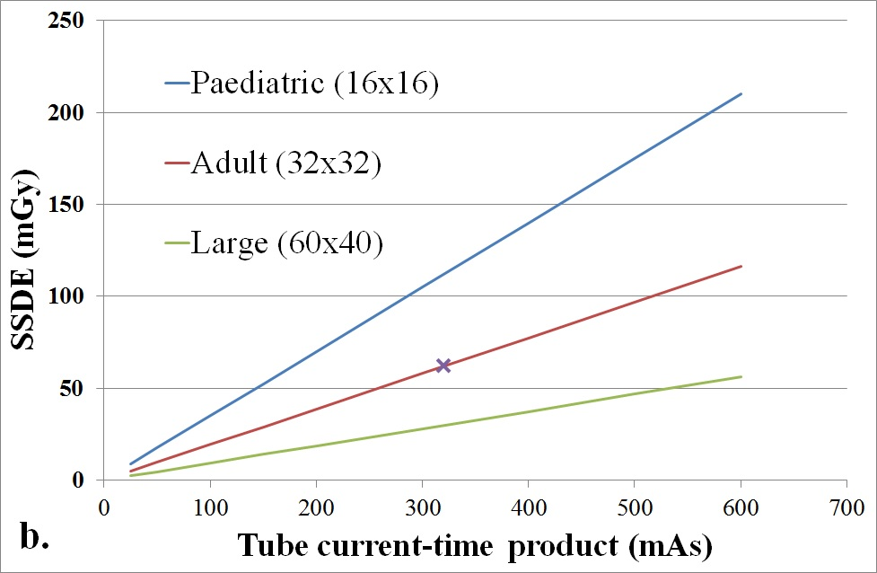

Figure 9. Results obtained for three patient sizes for the MSCT 2 of this work using the PAKT (left) and the SSDE (right) formalisms. All lines were extrapolated from the reference value (cross), obtained at 320 mAs.

# Discussion

The methodology for estimations of personalized air kerma in tomography (PAKT) has been described and exemplified with one device of each kind (dental CBCT, C-arm for guided surgery, linac guidance scanner and two conventional MSCT scanners). The method requires one measurement for each desired protocol (using a solid-state probe) and one geometric calculation summarized in one formula. The results from the formula are reasonable in the light of the comparisons to the conventional KAP and the standard DFOV (**Figures 7** and **8**) and the measurements using TLDs (**Figure 6**) at the surface of a phantom.

The PAKT does not provide an estimate of an overall exposure of the patient but of an average point dose (air kerma at the skin without backscatter). This makes the method robust against slight deviations of the patient from the isocentre as long as the patient remains within the field of view.

The suggested PAKT methodology proposes 1) a patient-centric approach for quality control that is applicable to all CBCT and MSCT devices, 2) the possibility to compare the results of incident air kerma within all x-ray modalities and 3) the availability of clear exposure information to the skin for any patient undergoing any kind of x-ray tomography scan. These three advantages are discussed in more detail below.

## A patient-centric approach for quality control

In 2D imaging modalities, a standard measurement of Ka,i at the imaging detector is compared to a given threshold to define the acceptance conditions. A simple calculation using the inverse square law provides the Ka,i(skin) for a given patient, so that this method easily becomes “patient-centric”. In 3D modalities, on the contrary, conventional measures for quality control, like CTDI or DLP, do not represent an actual exposure. The *K*a,i(skin) obtained by the PAKT equations for a standard patient size, as presented in this work, does provide a patient-centric measure for 3D modalities; we have shown that it can be used to define thresholds and intervals for acceptance and constancy tests for any kind of CT device (including CBCT and MSCT).

For the sake of a patient-centric approach to quality control, the reference results of *Ka,i*(skin) shown in this work can be directly used. Specific tolerances for acceptance and constancy tests should be refined by extensive data acquisition and always be accompanied by corresponding evaluations of image quality.

The kerma-area product, recommended in the British standard HPE-CRCE-010 9 for dental CBCT, is a very practical, as well as patient-centric measure for QC reports in dental CBCT because, in these devices, the whole beam traverses the patient. However, in the case of the large cone-beams used in C-arms and linacs, this measurement does not correlate with the actual patient exposure because a large part of the beam does not contribute to the patient exposure. This is particularly striking in the comparison between symmetric and asymmetric geometries. Asymmetric geometries (also called “half fan”) use almost one half of the beam width used in the corresponding symmetric geometry (see **Figure 10**). In the cases depicted in **Figure 7**, the KAP increases because of the increase in kerma rate, but we can see in the actual *Ka,i(skin)* that this increase is mostly counteracted by the use of a half fan geometry.

Using the PAKT is also patient-centric when comparing different fields of view as shown in **Figure 8**. If we concluded from **Figure 8** that the protocol with a small field of view decreases the patient exposure by a factor of four because the KAP decreases from 4000 to 1000 mGy cm2 we would be very wrong. The actual incident air kerma decreases from 32 mGy to 24 mGy, which means a decrease by a factor of only 1.3. Indeed the KAP is much more complex than the *K*a,i and its meaning is more difficult to explain and understand1. Apart from that, we have shown in Table 3 that the KAP meters decrease the intensity of the x-ray beam by between 9 % (125 kVp) to 13 % (80 kVp). This fact, together with the necessary pressure correction and the cumbersome set-up in linacs (**Figure 4**), makes the KAP less practical for patient dose estimations.

## Universal comparison of exposure in all x-ray modalities

The suggested PAKT enables a direct comparison between the patient air kerma received in MSCT and CBCT. For example, the *Ka,i(skin)* in the MSCT 2 for the reference size was 10.2 mGy, which is three times larger than the *Ka,i(skin)* in the dental CBCT for that same size (**Tables 5** and **6**). In comparison to this measure, the recent ICRP publication 1295 has suggested the measurement of the dose inside a large phantom. Although this procedure is certainly valuable to include the scatter radiation resulting from big cone beams, the required tool is heavy and the method leaves out small CBCT devices like the ones employed in dental applications. For routine quality control and for patient dose information, the PAKT method avoids the use of phantoms and it is applicable to all CBCT and MSCT devices. These facts may encourage clinics worldwide to regularly perform the tests. For the same reason, enforcement of such tests becomes easier for regulation agencies in all parts of the world.

The CTDI weighted (CTDIw) and the CTDIvol are important to calculate organ dose with scanner-independent organ dose conversion coefficients[19]. The CTDIvol is also used to calculate the size-specific dose estimates (SSDE) described in the AAPM report 204[20]. However, the CTDIvol and the corresponding SSDE (**Figure 9b**) are specific for MSCT; their values cannot be compared to dose measurements performed with other imaging modalities. On the contrary, the Ka,i obtained with the PAKT formalism (**Figure 9a**) enables a direct comparison to measurements from mammography, radiography, fluoroscopy and tomosynthesis systems3.

Such a comparison and an extensive database could help regulators and clinics to produce statistics about the use of dose in x-ray radiology using the simplest parameter of all: incident air kerma. This comparison may be particularly interesting for radiation dose monitoring systems[21],[22], which are recently being designed and installed world-wide.

## Information for personalized patient reports

Following the described PAKT, the reference measurement at a given radiation quality provides all data required to immediately estimate the corresponding *K*a,i(skin) for any patient examination at that radiation quality. The perimeter of the scanned body part and the value of the mAs corresponding to one rotation are needed to produce the personalized estimation. Both data can be noted during the examination or recovered from the DICOM data. In the case of tube current modulation, the value of the average mAs can be used without incurring significant errors (as stated in ref 1, section 22.5.3.3). In the case of helical scans (as opposed to axial), the dose is distributed over a helix instead of a cylinder, but the PAKT result is the same for the irradiated region. If several body parts with different perimeters are scanned, it is necessary to calculate and use the average of the perimeters involved, correspondingly weighted by the scanned length of each body part. Alternatively, the result for each body part can be calculated separately.

## Assumptions of the PAKT method

The PAKT assumes a circular shape of the irradiated object, which means that the result is an average over the whole irradiated surface. The result is thus exactly correct for the standard, circular phantoms but it is just an approximation for most body sections of a specific patient. In the case of dental scanners, where the distance to the patient is small, the shape of the head is almost a circle, thus the approximation is acceptable. In the case of body scans, due to the large distance from the focal spot to the patient, the effect of a non-circular shape of the body is negligible. While other approaches are searching to produce detailed skin maps[23], where the regions of larger and lower exposure are shown, the described PAKT limits its result to a single figure.

In the cases of the beam being larger at isocentre than the patient section, we have approximated the width of the beam by the patient width to calculate the KAP. This introduces a systematic error that generates an underestimation of the *K*a,i(skin). Since the final uncertainty in the results is much larger (between 5 and 6.3 %) this systematic error is negligible.

The bow-tie correction factor has been calculated following descriptions of beam intensity for a 120 kV-beam measured by two independent and consistent references25,26 (see appendix) for a scanner of the same type as the one used in this work. However, the slight difference between intensity and kerma due to beam hardening within the bow-tie filter and different models of bow-tie filters within different manufacturers have not been considered.

The shape of the beam in the studied C-arm and the dental CBCT is collimated to the size of the detector. As the shape of the beam in the CBCT used in the linac has been found to have a bell shape like the ones shown in Scandurra et al[24], the position of the probe on the flat panel is critical in the linac devices (it should be placed in the middle of the beam, not in the edges). These figures are usually provided by the manufacturers and they should be validated as part of the quality control procedures for the device, for instance using a film, fluorescent screen or an electronic x-ray ruler like the one used in this work.

# Conclusion

Estimation of patient air kerma in tomography (PAKT) with an uncertainty below 7 % has been shown to be feasible with a single measurement performed at the acceptance test of the device. The method avoids the need of phantoms or Monte Carlo approximations and it is applicable to any CBCT or MSCT device. The provided equations and the website can be applied to a standard size for the sake of quality control or to several sizes for the definition of DRLs. The application to a specific patient after a specific examination requires the perimeter of the scanned section and the specific mAs value. The obtained incident air kerma can be directly compared to measurements from other x-ray modalities for the same body region and to the thresholds for tissue reactions. This information could be added to the patient report and to radiation dose monitoring systems.

# Appendix – Derivation of the formulas for *Ka,i*

As mentioned above, the formulas required to apply the PAKT methodology are implemented in the public website <https://quart.shinyapps.io/PAKT/>. The equations running in the background of that website are described in detail in this appendix.

The *K*a,i(skin)is obtained dividing the KAP of the beam that traverses the patient by the exposed area,

Where P is the perimeter of the scanned body part and *CSSD* is the collimation (cranio-caudal dimension) of the beam at the surface of the patient. This *CSSD* can be obtained from the measurement of the beam collimation at a known distance from the focal spot. In CBCT devices the beam collimation is known at the detector; in MSCT scanners the beam collimation is measurable at the isocenter. For this reason, each case is described separately in the following.

## The case of cone-beam CT

In CBCT devices the collimation of the beam at the source-detector distance (*CSDD*) in the cranio-caudal dimension is a comfortable parameter because it coincides with the size of the detector itself. The collimation of the beam at the skin of the patient is thus

,

where SSD is the distance from the source (focal spot) to the skin of the patient, and SDD is the source-detector distance.

The distance SSD is estimated as SSD = SID – r, where SID is the source-isocenter distance and r is the radius of the object (patient or phantom), calculated in practice as r = P / 2π (being P the perimeter of the irradiated body part).

In CBCT we can exactly know where the beam hits the detector, so the exposed area is calculated as

In CBCT systems where the whole beam traverses the patient (like most dental devices), the KAP of the beam is obtained directly from the measurement at the detector, *K*a,i(SDD),

where *CSDD* and *LSDD* are the dimensions of the beam at the imaging detector and *b* is the bow-tie factor, which is lower than 1 in the presence of a bow-tie filter (see section 6.3). The length *LSDD* corresponds to the irradiated length of the flat panel in the plane of rotation. Thus we have

, [5]

where we have indicated that the length of the field of view at isocentre (*LFOV*) is smaller than the diameter of the irradiated section of the patient (*d*), as it is usual in dental CBCT. If this is not the case, for example in head scans using CBCT guidance systems of linacs and CBCT protocols of C-arms with a large field of view (e.g. *LFOV > d*) , we must consider only the part of the beam that irradiates the patient (because the rest of the beam does not contribute to the exposure).

In the case of symmetric cone beams, the projection of the beam (*LSDD* of equation [5]) is substituted by the projection of *d* at the imaging detector, . Thus

.

In the case of asymmetric geometries (also called “half fan”), like the protocols *pelvis* and *thorax* of the CBCT in the linac of this work, the part of *d* that is covered by the beam in one projection (*d´* in **Figure 10**) is equal to one half of the patient diameter plus the asymmetric part of the beam. This asymmetric part is a fraction *f* of the length of the field of view at isocentre ), thus . Therefore, for this asymmetric case, the width *LSDD* of equation [5] is substituted by the projection of *d´* and we get

Indeed this is a generalized version of the equation for the symmetric case, because then the “asymmetric” part of the beam is one half of the patient diameter, , and then the factor in brackets equals 1. In the case of the CBCT in the linac of this work, .

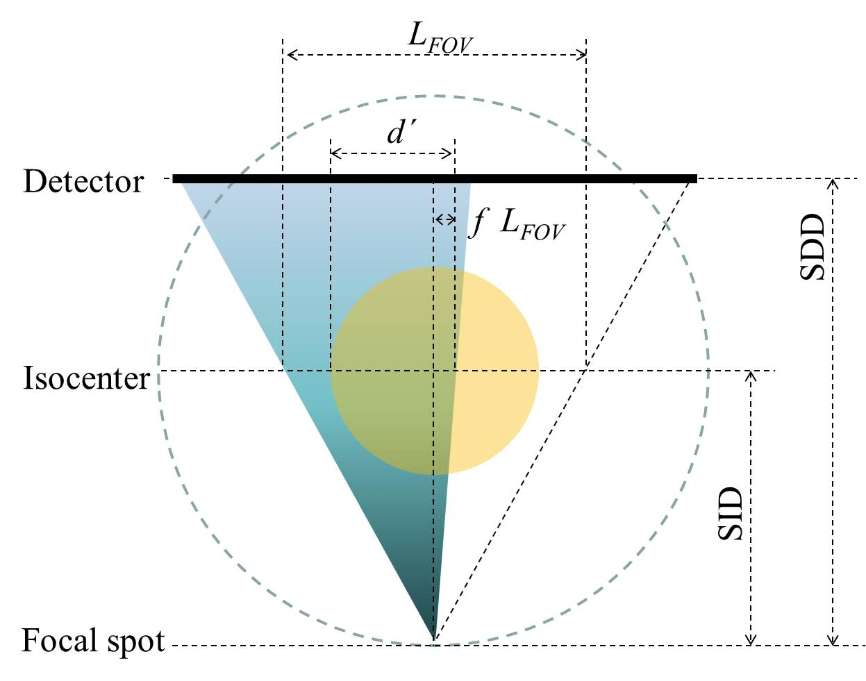

Figure 10. Sketch of a CBCT that uses an asymmetric geometry, also called “half fan” geometry. The portion of the patient diameter that is traversed by the cone beam in one projection is indicated by *d´*. This *d´* is equal to a half of the patient diameter plus a certain fraction *f* of the length of the field of view at isocentre *LFOV*. Drawing not to scale.

## The case of multi-slice CT

In this case, the kerma-area product is estimated at the isocentre (**Figure 1** right) with the set-up shown in **Figure 3** left. However, we do not need to know the real width of the beam in the lateral dimension, since the edges of the beam never hit the patient. Instead, we approximate the beam width at isocenter by the patient width (whose center is also assumed to be at isocentre). This approximation underestimates the KAP by 1 % for a typical SID of 50 cm.

As explained above, to obtain the KAP, the reading of is multiplied by the width of the phantom or the irradiated body part (*d* in **Figure 1 right**) and the rotation time *t,*

where the correction factor *b* is necessary to account for the bow-tie filter (see section 6.3).

To obtain the exposed area, it is necessary to know the beam collimation at the position of the exposed area (the skin). The collimation at the isocentre CSID can be measured using an electronic x-ray ruler as shown in **Figure 3** left. The corresponding collimation CSSD at the source-skin distance (for example 8 cm above the isocentre in the case of the standard head phantom) is calculated with the intercept theorems. Thus we have

where *SID* is the source-isocenter distance. Both required measurements (max and *CSID*) can be acquired simultaneously with the set-up shown in Figure **3** left. In total, since , we have

, *CSID* < 1 cm

If *CSID* is larger than or equal to the length of the probe (1 cm in the case of the probe of this work), then the measurement from the probe is a punctual kerma rate (), which must be multiplied by *t*, by *d* and by *CSID* to obtain the KAP, so that

, *CSID* ≥ 1 cm. [6]

If the probe has a different size in the cranio-caudal direction, the equations are the same but the conditions change to include that specific size. Note that the *K*a,i is independent of the beam width in the z direction (just as the *K*a,i is independent of the beam size in projection radiography).

## The bow-tie factor b

The PAKT formulas have been developed in the assumption that the beam intensity is constant along the whole beam section. Under this assumption, the heel effect in the axial direction cancels itself but the intensity modulation in the transversal direction, produced by the bow-tie filter that is present in MSCT scanners and most CBCT scanners, needs to be corrected by the factor *b*. Otherwise the Ka,i would be overestimated.

To obtain the bow-tie factor *b* we have used the intensity curves published by Li et al[25],, which are consistent with independent curves published by Boone[26]. The factor *b* was calculated as

where is the integral of the relative intensity curve up to the fan angle *αmax*(measured from the central ray to the border of the patient) and is the same integral assuming no bow-tie filter (constant intensity). To facilitate the calculation of this factor the intensity curve for 120 kV (shown in Fig. 10 of reference 25) was divided in 5 linear segments that provide the following formulas:

where the angle depends on the patient size as .

As an example, Table 7 shows the detailed calculation of *b* for the devices shown in this work.

**Table 7. Calculation of the bow-tie factor *b* for the devices used in this work.**

|  |  |  |  |  |  |  |
| --- | --- | --- | --- | --- | --- | --- |
|  | CBCT | | | MSCT | | |
|  | Dental | C-arm | Linac | Paediatric  or head | Adult | Large |
| Diameter, d (cm) | 16 | 16 | 16 | 16 | 32 | 50 |
| Radius, r (cm) | 8 | 8 | 8 | 8 | 16 | 25 |
| Source-isocenter distance, SID (cm) | 37.7 | 81 | 100 | 57 | 57 | 57 |
| Perimeter, P (cm) | 50.3 | 50.3 | 50.3 | 50.3 | 100.5 | 157.1 |
| Fan angle αmax (degrees) | 12.0 | 5.6 | 4.6 | 8.0 | 15.7 | 23.7 |
| **Bow-tie factor, b** | **0.86** | **0.99** | **1.00** | **0.95** | **0.77** | **0.59** |
| ± | 0.03 | 0.04 | 0.04 | 0.04 | 0.03 | 0.02 |

Table 7 shows that the factor *b* is especially relevant for dental CBCT scanners and for adult and large patients in MSCT scanners.

**Acknowledgements**

We wish to thank Marcus Hohlweg and Anna Lehnert (VacuTec, Germany) for lending us the KAP meter and Ricardo Weigel (QUART GmbH, Germany) for lending us the electronic x-ray ruler, the dosemeter and the phantom. We also especially thank our reviewers for the hint about the bow-tie correction, as well as Florian Wagner (Helmholtz Zentrum München, Germany), Armin Baumgartner (Baumgartner & Rath, Germany), Attoui Abderrazak (Active Radsys, Italy), Jaime Martín (Hospital de San Chinarro, Spain), Javier Pifarré (Hospital de Majadahonda, Spain), Jesús García (Tecnasa, Spain) and Wolfgang Andersson (ACBA GmbH, Germany) for fruitful discussions and for their help during (conclusive and inconclusive) data acquisition sessions.

**References**

1. Dance DR, Christofides S, Maidment ADA, McLean ID, Ng KH, editors 2014 Diagnostic radiology physics: A handbook for teachers and students. Vienna: International Atomic Energy Agency (IAEA). See Chapter 22.
2. ICRU 2005 Patient dosimetry for X rays used in medical imaging. ICRU Report 74. J. ICRU 5, 1–113.
3. ICRP 2000 International Commission on Radiological Protection. Avoidance of Radiation Injuries from Interventional Procedures. ICRP Publication 85. Ann. ICRP 30(2). Oxford: Pergamon Press.
4. Miller D L, Balter S, Noonan P. T. and Georgia J D 2002 Minimizing radiation-induced skin injury in interventional radiology procedures Radiology 225, 329–336.
5. Båth M, Söderman C and Svalkvist A 2014 A simple method to retrospectively estimate patient dose-area product for chest tomosynthesis examinations performed using VolumeRAD. Med Phys. 41 10 101905.
6. Brady S L and Kaufman R A 2015 Estimating pediatric entrance skin dose from digital radiography examination using

   DICOM metadata: A quality assurance tool Med Phys 42 2489.
7. ICRP, 2015. Radiological Protection in Cone Beam Computed Tomography (CBCT). ICRP Publication 129. Ann. ICRP 44(1).
8. Ding GX and Malcolm AW 2013 An optically stimulated luminescence dosimeter for measuring patient exposure from imaging guidance procedures Phys Med Biol 58 17 5885-97.
9. Cros M, Geleijns J, Joemai R M and Salvadó M 2016 Perfusion CT of the Brain and Liver and of Lung Tumors: Use of Monte Carlo Simulation for Patient Dose Estimation for Examinations With a Cone-Beam 320-MDCT Scanner. [AJR Am J Roentgenol.](http://www.ncbi.nlm.nih.gov/pubmed/26700344" \o "AJR. American journal of roentgenology.)  206 1 129-35.
10. Montanari D et al 2014 Comprehensive evaluations of cone-beam CT dose in image-guided radiation therapy via GPU-based Monte Carlo simulations Phys Med Biol 59 5 1239-53.
11. McCollough CH, Leng S, Yu L, Cody DD, Boone JM, McNitt-Gray MF 2011 CT dose index and patient dose: they are not the same thing. Radiology 259 2 311-6.
12. Sykes JR, Lindsay R, Iball G and Thwaites DI 2013 Dosimetry of CBCT: methods, doses and clinical consequences. Journal of Physics: Conference Series 444 012017.
13. Health Protection Agency. HPA-CRCE-010 : Guidance on the safe use of dental cone beam CT equipment. Chilton, UK: Health Protection Agency ; 2010.
14. Deutsches Institut für Normung. DIN 6868-161: Image quality assurance in X-ray departments - Part 161: RöV acceptance testing of dental radiographic equipment for digital cone beam computed tomography. English translation of DIN 6868-161:2013-01. Berlin: Deutsches Institut für Normung; 2016. Original and English translation available at <https://www.beuth.de/en/standard/din-6868-161/164214522>.
15. de las Heras Gala H et al 2017 Quality control in cone-beam computed tomography (CBCT) EFOMP-ESTRO-IAEA protocol

    (summary report). Phys Med 39 67-72. The guideline is available at https://www.efomp.org/index.php?r=fc&id=protocols.
16. Deutsches Institut für Normung. DIN 6868-15 2015-06. Image quality assurance in X-ray departments - Part 15: RöV constancy testing of X-ray installations for dental radiographic equipment for digital cone-beam computed tomography. Berlin. Deutsches Institut für Normung; 2015.
17. Dance DR, Christofides S, Maidment ADA, McLean ID, Ng KH, editors. Diagnostic radiology physics: A handbook for teachers and students. Vienna: International Atomic Energy Agency (IAEA); 2014. See page 203 and factors on page 576.
18. Petoussi-Henss N, Zankl M, Drexler G, Panzer W and Regulla D 1998 Calculation of backscatter factors for diagnostic radiology using Monte Carlo methods. Phys Med Biol 43 8.
19. Turner AC et al 2010 The feasibility of a scanner-independent technique to estimate organ dose from MDCT scans: using CTDIvol to account for differences between scanners Med Phys 37 4 1816-25.
20. Boone JM et al 2011. AAPM report No 204: Sie-specific dose estimates (SSDE) in pediatric and adult body CT examinations. Report of AAPM Task group 204.
21. Applegate K E 2015 Protection of patients in diagnostic and interventional medical imaging: collaboration is the key.

    Health Phys 108 2 221-3.
22. De Bondt T, Mulkens T, Zanca F, Pyfferoen L, Casselman JW, Parizel PM 2017 Benchmarking pediatric cranial CT protocols using a dose tracking software system: a multicenter study. Eur Radiol 27 2 841-850.
23. Rana V. K, Rudin S and Bednarek D R 2016 A tracking system to calculate patient skin dose in real-time during neurointerventional procedures using a biplane x-ray imaging system Med Phys 43 5131.
24. Scandurra D and Lawford C E 2014 A dosimetry technique for measuring kilovoltage cone-beam CT dose on a linear accelerator using radiotherapy equipment JACMP 15 4.
25. Li X, Shi JQ, Zhang D, et al. 2015 A new technique to characterize CT scanner bow-tie filter attenuation and applications in human cadaver dosimetry simulations. Med Phys 42 11 6274-6282. See Figure 10.
26. Boone JM 2010 Method for evaluating bow tie filter angle-dependent attenuation in CT: Theory and simulation results. Med. Phys. 37 1, 40–48. See Figure 4.