Supplementary Information for

# Soft Ultrasound Priors in Optoacoustic Reconstruction: Improving Clinical Vascular Imaging

Hong Yang, Dominik Jüstel, Jaya Prakash, Angelos Karlas, Anne Helfen, Max Masthoff, Moritz Wildgruber, Vasilis Ntziachristos *

*Correspondence should be addressed to V.N. (v.ntziachristos@tum.de).

This SI file includes:

Supplementary Figure S1. SSIM of reconstructed images from noise-distorted input image.

Supplementary Table I. SSIM with different k1 and k2 with ground truth image degraded by noise.

**1. Structural similarity index**

Because of the limited-view detection geometry of a handheld OPUS system, the boundary of a structure cannot be resolved in the reconstructed image in locations where the normal at the boundary does not intersect the transducer array. Due to this information loss, the reconstructed images suffer from blurred boundaries and stripe/streak artefacts [1, 2], which can be well quantified by the structural similarity (SSIM) index.

SSIM is an objective image quality metric and commonly used to estimate the perceived quality of digital images by measuring the similarity between two images. It is a standard tool in image processing [3]. Comparing to other image quality metrics, such as mean squared error (MSE) and peak signal-to-noise ratio (PSNR), SSIM is a full-reference method and puts more emphasis on the comparison of the structures in a distorted image and in the reference image [3]. A distortion-free or ground truth image is necessary for the calculation of SSIM. The SSIM is calculated as

where and are, respectively, the mean and variance of the reconstructed image , and and are, respectively, the mean and variance of the reference (ground truth) image . The variable is the covariance of and , while and stabilize division by a weak denominator: and , where L stands for the dynamic range of the reference image. As mentioned in [3], the values of and are somewhat arbitrary, but the SSIM is considered to be insensitive to those two constants. We set and throughout the paper and in the following demonstrate this insensitivity for our images.

We select 5 combinations of the parameters (,) with different orders of magnitude and ratios and use them to evaluate the SSIM of the same images. The model matrix **M** used in the forward simulation is based on the experimental setup introduced in Section 3.4 and the SSIM is calculated with (,) equals to (0.1,0.3), (0.01,0.03), (0.001, 0.003), (0.01,0.01) and (0.03,0.01) for the reconstructed images using standard or prior-integrated reconstruction, respectively.

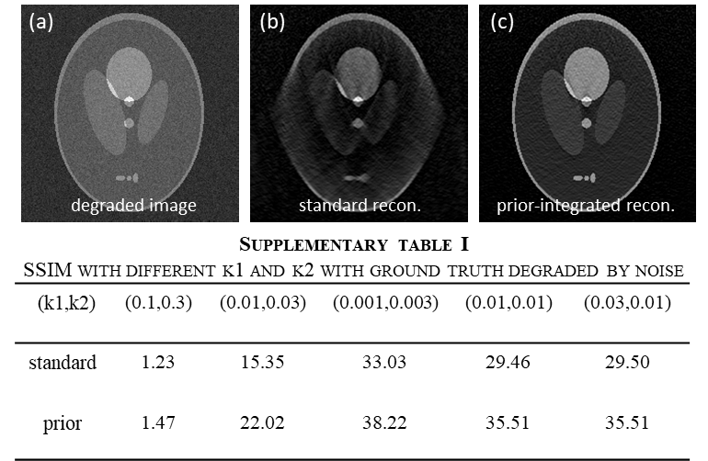

**Fig. S1** SSIM of reconstructed images from noise-distorted input image. **(a)** degraded noisy image. Its corresponding recovered image with **(b)** standard and **(c)** prior-integrated reconstruction.

In conclusion, the selection of and affects the SSIM values but does not affect the comparison between standard and prior-integrated reconstruction under different cases. In order to facilitate the comparison across studies, We kept these values of and to be 0.01 and 0.03, the same as in Ref. [3].

**References**

[1] X. L. Deán-Ben, L. Ding, and D. Razansky, “Dynamic particle enhancement in limited-view optoacoustic tomography,” *arXiv preprint arXiv:1512.03289*, 2015.

[2] A. Buehler, A. Rosenthal, T. Jetzfellner, A. Dima, D. Razansky, and V. Ntziachristos, “Model‐based optoacoustic inversions with incomplete projection data,” *Medical physics,* vol. 38, no. 3, pp. 1694-1704, 2011.

[3] Z. Wang, A. C. Bovik, H. R. Sheikh, and E. P. Simoncelli, “Image quality assessment: from error visibility to structural similarity,” *IEEE transactions on image processing,* vol. 13, no. 4, pp. 600-612, 2004.