*APPENDICES*

### Appendix Table I. Differences in Key Baseline Characteristics by Treatment Group in Patients Analyzed and Excluded from this Study (N = 404)

|  |  |  |  |  |  |  |  |  |  |  |
| --- | --- | --- | --- | --- | --- | --- | --- | --- | --- | --- |
|  | Total Sample | | | By Treatment Group | | | | | | |
|  | Analyzed  (N = 331) | Excluded  (N = 73) | p-value1 | Analyzed  (N = 331) | | | | Excluded  (N = 73) | | |
|  |  |  |  | Collaborative care | Usual care | p-value2 | Collaborative care | | Usual care | p-value2 |
| Age (years) | 52.9 | 52.1 | 0.47 | 52.46 | 53.29 | 0.1873 | 50.41 | | 53.39 | 0.9364 |
| Female sex, % | 59.8 |  | 0.57 | 55.0 | 65.0 | 0.6056 | 53.0 | | 59.0 | 0.9121 |
| BMI, kg/m2 | 26.7 | 27.0 | 0.66 | 26.70 | 26.69 | 0.9536 | 27.80 | | 26.36 | 0.7027 |
| Blood Pressure Medication, % | 48.9 | 52.1 | 0.63 | 48.0 | 50.0 | 0.9943 | 50.0 | | 54.0 | 0.9595 |
| Duration of Diabetes (years) | 9.4 | 9.7 | 0.75 | 8.84 | 10.00 | 0.3813 | 9.43 | | 9.94 | 0.5928 |
| OHA Medication, % | 93.4 | 90.4 | 0.38 | 95.0 | 92.0 | 0.0381 | 88.0 | | 93.0 | 0.1484 |
| Current tobacco Use,% | 2.0 | 1.2 | 0.038 | 0.91 | 1.51 | 0.1771 | 5.48 | | 1.37 | < 0.001 |
| Antidepressants, % | 4.5 | 5.5 | 0.73 | 7.0 | 2.0 | < 0.001 | 3.0 | | 7.0 | 0.4419 |
| Insulin, % | 32.6 | 39.7 | 0.28 | 31.0 | 34.0 | 0.7592 | 47.0 | | 34.0 | 0.7375 |

*Abbreviations: OHA = Oral Hypoglycemic Agent; BMI = Body Mass Index*

All data presented are unadjusted. Percentages may not match weighted and unweighted characteristics presented in the main manuscript.

1 p-value compares differences between the total analyzed and excluded sample

2 p-value compares differences between the collaborative care and usual care group within analysis stratum

**Appendix Table II. Adjusted Differences in Means of Additional, Single-Measure Composite Treatment Targets Between Collaborative Care and Usual Care**

|  |  |  |  |  |  |  |  |  |  |
| --- | --- | --- | --- | --- | --- | --- | --- | --- | --- |
|  | Collaborative Care Group (%) (N=192) | Usual Care Group (%) (N = 202) | Risk Ratios at 12 months (95% CI) | Collaborative Care Group (%) (N = 164) | Usual Care Group (%) (N = 167) | Risk Ratios at 36 months (95% CI) | Collaborative Care Group (%) (N = 152) | Usual Care Group (%) (N = 162) | Risk Ratios at 36 months (95% CI) |
| Improvements since baseline in composite indicators, % |  |  |  |  |  |  |  |  |  |
| ≥0.5-percentage point reduction in HbA1c or HbA1c <7% | 28.7 [22.3, 35.2] | 20.9 [15.3, 26.6] | 1.38 [1.00, 1.89] | 16.1 [10.3, 21.9] | 13.8 [8.5, 19.0] | 1.15 [0.69, 1.94] | 4.4 [1.0, 7.7] | 6.4 [2.6, 10.2] | 0.68 [0.26, 1.77] |
| ≥5-mm Hg reduction in SBP or SBP <130 mmHg | 59.6 [52.6, 66.6] | 57.9 [51.0, 64.7] | 1.00 [0.87, 1.16] | 45.2 [37.5, 52.9] | 52.3 [44.7, 60.0] | 0.87 [0.70, 1.08] | 33.7 [26.1, 41.3] | 32.0 [24.7, 39.3] | 1.01 [0.74, 1.38] |
| ≥10-mg/dL reduction in LDL or LDL-C <100 mg/dL (<70 with history of CVD) | 59.8 [52.8, 66.8] | 54.4 [47.5, 61.3] | 0.98 [0.84, 1.15] | 40.8 [33.2, 48.4] | 43.2 [35.6, 50.7] | 0.91 [0.72, 1.15] | 28.4 [21.2, 35.7] | 24.7 [18.0, 31.4] | 1.08 [0.76, 1.53] |

*Abbreviations: LDL = Low-Density Lipoprotein; HbA1c = Hemoglobin A1C; SBP = Systolic Blood Pressure*

### Appendix Table III: Effect of Collaborative Care on Primary Outcome at 36 Months by Socioeconomic and Clinical Characteristics

|  |  |  |
| --- | --- | --- |
|  | Risk Ratio (95% CI) | p-value* |
| Age (years) |  |  |
| ≤49 | 0.94 [0.72, 1.22] | 0.38 |
| ≥ 50 | 0.93 [0.77, 1.13] |
| Sex |  |  |
| Male | 1.05 [0.83, 1.33] | 0.37 |
| Female | 0.85 [0.70, 1.04] |
| Level of Education |  |  |
| More than secondary | 1.10 [-0.52, 0.71] | 0.68 |
| Primary or Secondary | 0.90 [-0.45, 0.25] |
| No education | 0.78 [0.32, 1.88] |
| Household Income |  |  |
| < 10000 INR | 1.04 [0.60, 1.78] | 0.76 |
| ≥10000 INR | 0.89 [0.63, 1.25] |
| Duration of diabetes |  |  |
| ≤ 8 years | 0.84 [0.55, 1.30] | 0.56 |
| > 8 years | 1.00 [0.68, 1.48] |
| Site |  |  |
| MDRF (private) | 0.91 [0.74, 1.12] | -- |
| AIIMS (public) | 0.78 [0.57, 1.09] |
| EDC (private)† | 0.00 [0.00, 0.00] |
| DIACON (private) | 1.18 [0.86, 1.61] |

*p-value tests heterogeneity across levels of each socio-economic and clinical risk factor

†Numerator equal to 0.00

**Appendix Table IV. Common Effect Outcome at 12-, 24-, and 36-Month Follow-Up**

|  |  |  |  |  |
| --- | --- | --- | --- | --- |
|  | Collaborative Care | | Usual Care | |
|  | Common Effect | 95% CI | Common Effect | 95% CI |
| 12 months -Post-intervention | -0.2250 | (-0.3303, -0.1197) | 0.00 (reference) | N/A |
| 24 months -Post-intervention | -0.1118 | (-0.2254 0.0018) | 0.00 (reference) | N/A |
| 36 months-Post-intervention | 0.0434 | (-0.0880, 0.1749) | 0.00 (reference) | N/A |

### Appendix Figure I. INDEPENDENT Participant Eligibility and Collaborative Care Components

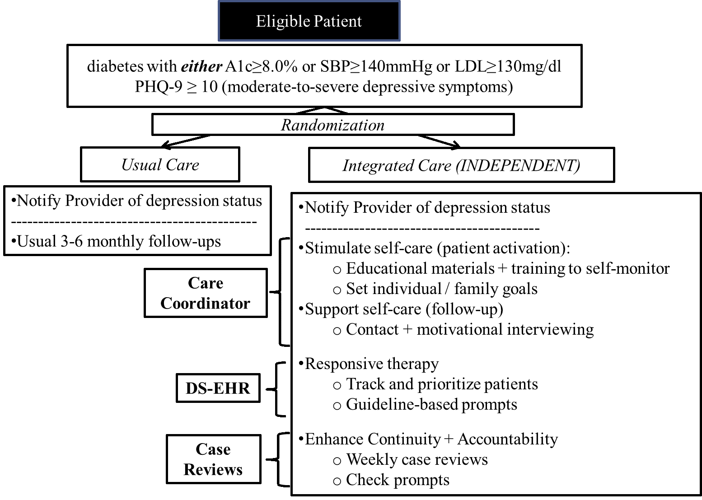

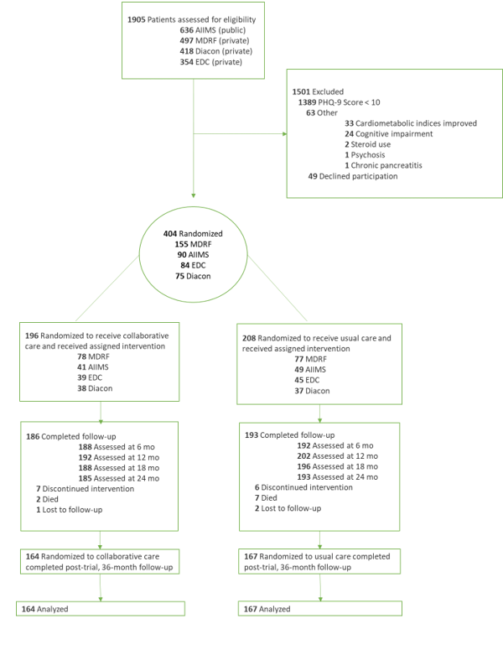Appendix Figure II: Participant Diagram