**Appendix A**

**Fig. A.1.** Sample Distribution of the Weighted Polyepigenetic Glucocorticoid Exposure Score of the Fetus at Birth (N=814).

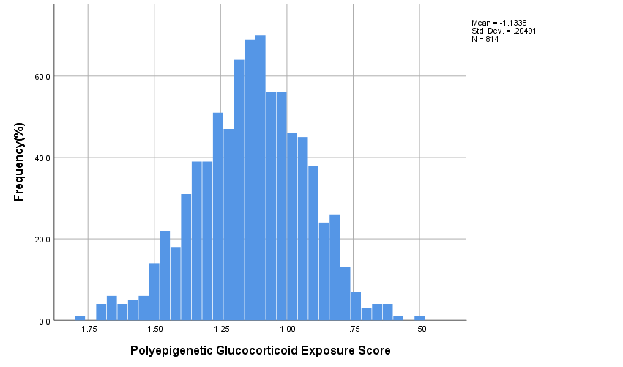

**Fig. A.2.** Scatter Plot with a Smoothing Line (Loess Fit) of the Association Between the Fetal Polyepigenetic Glucocorticoid Exposure Score at Birth and the Number of Days the Child Had Spent in Inpatient or Outpatient Treatment for Mental or Behavioral Disorder as the Primary Diagnosis (N=99).

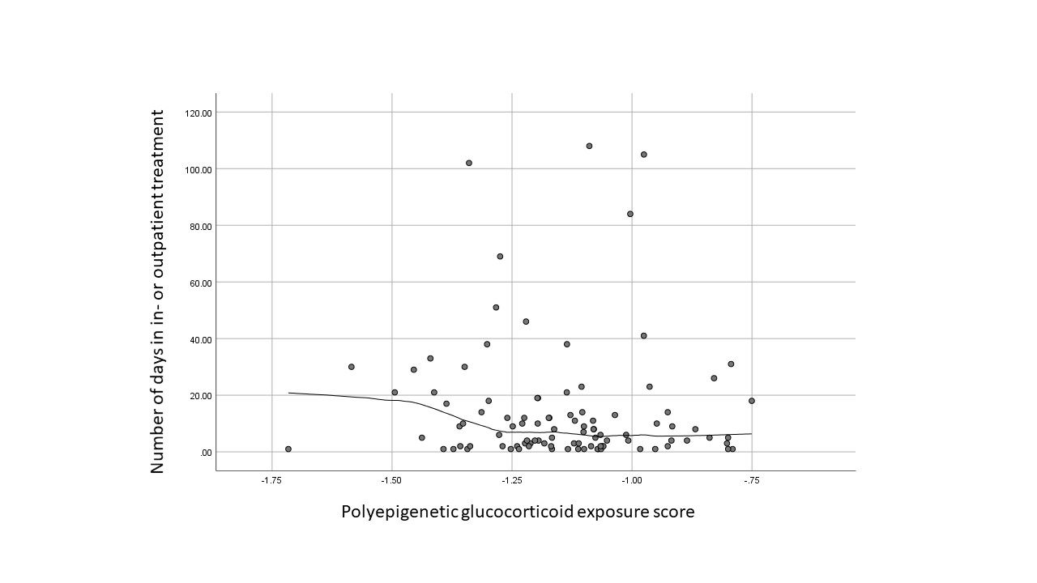

|  |  |  |  |  |  |
| --- | --- | --- | --- | --- | --- |
| **Table A.1.** Frequency of Broad Category Diagnoses of Mental and Behavioral Disorders and Their Comorbidity in the Total Sample of Children Who Had Been in Any Inpatient Treatment or Outpatient Treatment in Public Specialized Medical Care with Mental or Behavioral Disorder as the Primary Diagnosis, and in Children Who Had Spent Less than the Median Number and the Median Number or More Days in the Treatment. | | | | | |
|  |  |  | Number of days in treatment | |  |
| Broad category diagnoses | ICD-10 Diagnostic Code | Total Sample with any mental or behavioral disorder diagnosis  (N=99) | 1-6 days (below median) (N=49) | 7-108 days (at or above median) (N=50) | P |
|  |  | N(%) | N(%) | N(%) |  |
| Non-Affective Psychosis | F2 | 0 | 0 | 0 | NA |
| Mood Disorders | F3 | 1 (1%) | 0 | 1 (2%) | 0.32 |
| Neurotic, Stress-Related, and Somatoform Disorders | F4 | 1 (1%) | 1 (2%) | 0 | 0.31 |
| Behavioral syndromes associated with physiological disturbances and physical factors | F5 | 11 (11.1%) | 9 (18.4%) | 2 (4%) | 0.023 |
|  | F6 | 0 | 0 | 0 | NA |
| Mental Retardation | F7 | 2 (2%) | 1 (2%) | 1(2%) | 0.988 |
| Psychological Development  Disorders | F8 | 64 (64.6%) | 23 (46.9%) | 41 (82%) | <0.001 |
| Behavioral and Emotional Disorders | F9 (F90-F98) | 49 (49.5%) | 19 (38.8%) | 30 (60%) | 0.035 |
| Unspecified Mental Disorder | F99 | 0 | 0 | 0 | NA |
| Number of Broad Category Diagnoses | F2 – F9 |  |  |  | <0.001 |
| 1 |  | 75 (75.8%) | 46 (93.9%) | 29 (58%) |  |
| 2 |  | 20 (20.2%) | 2 (4.1%) | 18 (36%) |  |
| 3 |  | 4 (4%) | 1 (2%) | 3 (6%) |  |
| Abbreviations: ICD-10, International Statistical Classification of Diseases and Related Health Problems, Tenth revision. P refers to p-values derived from the Chi-square test when comparing the children who had spent 7 or more days and less than 7 days in any inpatient treatment or outpatient treatment in public specialized medical care with any mental or behavioral disorder as the primary diagnosis. | | | | | |

|  |  |  |  |  |  |
| --- | --- | --- | --- | --- | --- |
| **Table A.2.** Association Between the Child- and Mother-related Covariates and the Fetal Polyepigenetic Glucocorticoid Exposure Score at Birth | | | | | |
| Covariate | Fetal Polyepigenetic Glucocorticoid Exposure Score at Birth | | | | |
| Unstandardized Beta | Standard Error | 95% Confidence Interval | | p |
| **Child** |  | | | | |
| Sex (boy vs. girl) | 0.03 | 0.04 | -0.04 | 0.11 | 0.42 |
| Birth year (year) | 0.003 | 0.02 | -0.04 | 0.05 | 0.89 |
| Gestational age at birth (weeks) | -0.02 | 0.01 | -0.04 | 0.007 | 0.15 |
| **Mother** |  | | | | |
| Age at delivery (year) | 0.001 | 0.003 | -0.006 | 0.007 | 0.81 |
| Education (tertiary vs secondary or less) | 0.03 | 0.04 | -0.05 | 0.11 | 0.45 |
| Smoking during pregnancy (yes vs. no) | -0.16 | 0.09 | -0.35 | 0.02 | 0.086 |
| Any cardiometabolic condition during pregnancy (yes vs. no) | 0.06 | 0.05 | -0.03 | 0.15 | 0.19 |
| Lifetime diagnosis of any mental disorder (yes vs. no) | 0.08 | 0.05 | -0.02 | 0.18 | 0.13 |
| Any cardiometabolic condition refers to hypertensive disorders, gestational diabetes mellitus, type 1 diabetes, and pre-pregnancy overweight/obesity [body mass index ≥25 kg/m2]).  Lifetime diagnosis of any mental disorder refers to any International Classification of Diseases-9: 290-319 and International Statistical Classification of Diseases and Related Health Problems-10: F00-F99 diagnosis codes. | | | | | |