**Human neutrophil peptide 1 limits hypercholesterolemia-induced atherosclerosis by increasing hepatic LDL clearance**

Nicole Paulin1*, Yvonne Döring1*, Sander Kooijman2,3, Xavier Blanchet1, Joana R. Viola1,4, Renske de Jong1,4, Manuela Mandl1, Jeffrey Hendrikse1,4, Maximilian Schiener1, Philipp von Hundelshausen1, Anja Vogt5, Christian Weber1,6, Khalil Bdeir7, Susanna M. Hofmann5,8,9, Patrick C.N. Rensen2,3, Maik Drechsler1,4,6#, Oliver Soehnlein1,4,6#

Running title: HNP1 limits atherosclerosis

* and # denote equal contribution

1Institute for Cardiovascular Prevention (IPEK), LMU Munich, Munich, 80336, Germany

2Department of Medicine, Division of Endocrinology, Leiden University Medical Center, 2300 RC Leiden, the Netherlands

3Einthoven Laboratory for Vascular Medicine, Leiden University Medical Center, 2300 RC Leiden, the Netherlands

4Department of Pathology, AMC, 1105 AZ, Amsterdam, the Netherlands

5Medizinische Klinik und Poliklinik IV, Klinikum der LMU München, Munich, 80336, Germany

6DZHK, partner site Munich Heart Alliance, Munich, 80336, Germany

7Department of Pathology and Laboratory Medicine, University of Pennsylvania, Philadelphia, PA, 19104, USA.

8Institute for Diabetes and Regeneration, Helmholtz Center Munich

9German Center for Diabetes Research (DZD) München-Neuherberg, Germany

Contact information:

Oliver Soehnlein

Institute for Cardiovascular Prevention

Ludwig-Maximilians-University Munich

Pettenkoferstr. 9, 80336 Munich

Phone: +49-(0)89-4400-54667

Email: oliver.soehnlein@gmail.com

**- Data supplement -**

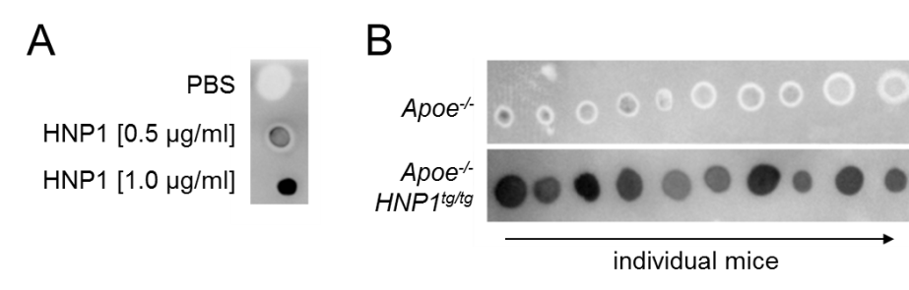

**Figure S1: HNP1 plasma levels in *Apoe-/-* and *Apoe-/-HNP1tg/tg* mice.** *Apoe-/-* or *Apoe-/-HNP1tg/tg* mice were fed a high fat diet for four weeks. Recombinant HNP1 (A) or plasma (B) were spotted on a nitrocellulose membrane and probed with an antibody to HNP1. Each dot in (B) corresponds to a mouse in figure 1.

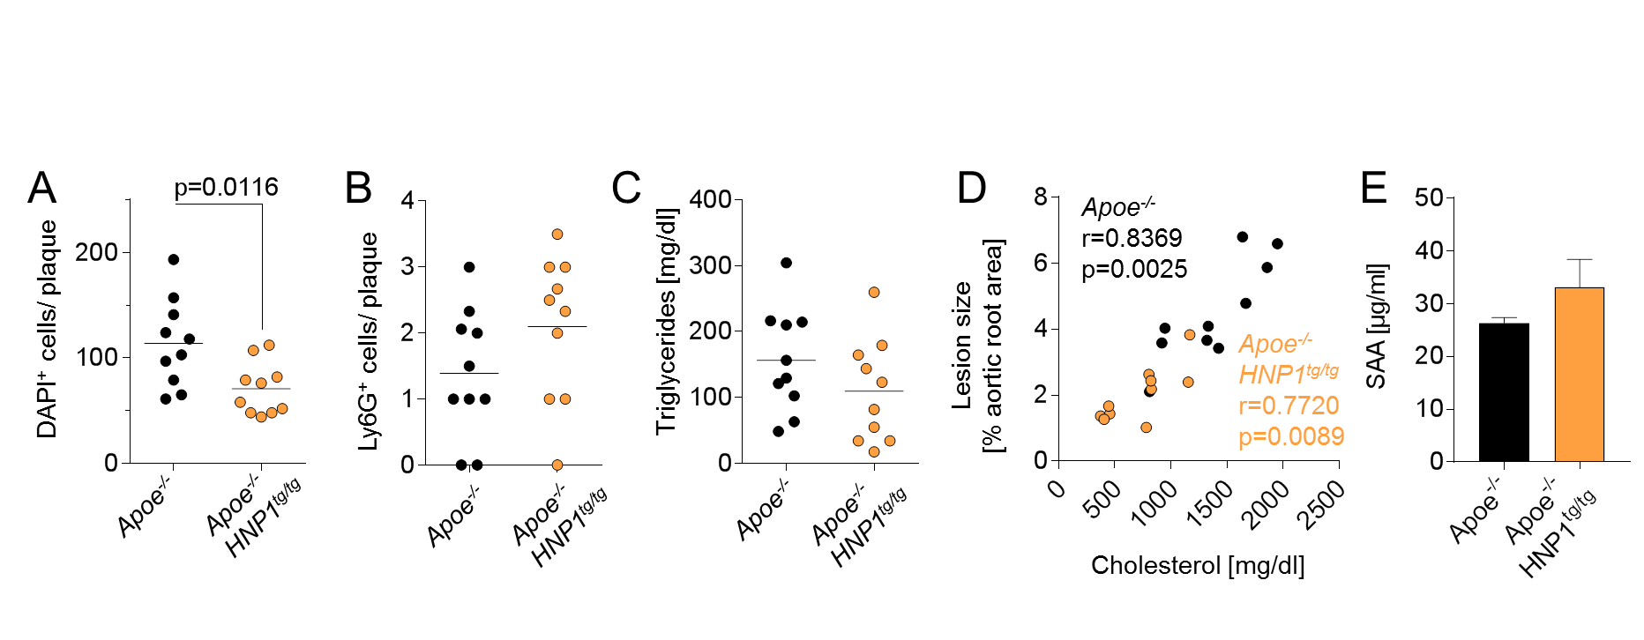

**Figure S2:** **Transgenic expression of HNP1 does not affect lesional neutrophil accumulation and plasma triglyceride levels.** *Apoe-/-* and *Apoe-/-HNP1tg/tg* mice were fed a high-fat diet for 4 weeks. **(A)** Quantification of DAPI+ cells. **(B)** Quantification of lesional neutrophils following Ly6G staining. **(C)** Plasma triglyceride levels. **(D)** Pearson correlation of plasma cholesterol levels and lesion size in aortic root sections. **(E)** Plasma concentration of serum amyloid A (SAA). Data were analyzed with unpaired t-test in (A-C) and (E). n=10.

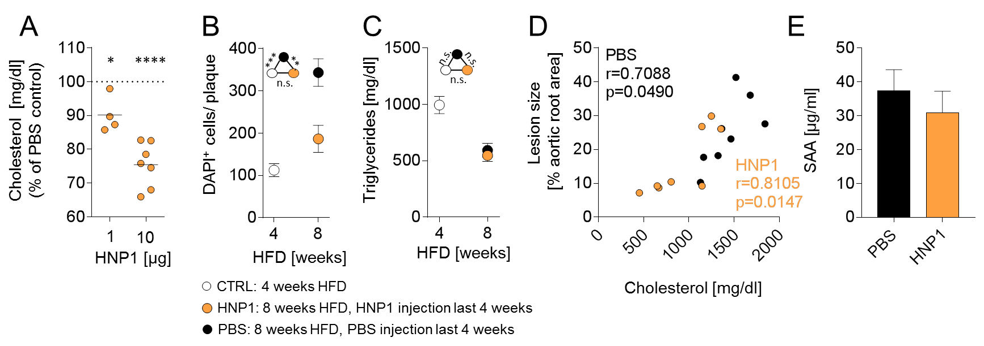

**Figure S3: Treatment with HNP1 reduces atherosclerosis. (A)** *Apoe-/-* mice were fed a high fat diet for four weeks. Mice were injected with a single dose of HNP1 (1 or 10 µg, i.v.) or PBS and plasma was collected after 24 hours. Subsequently plasma cholesterol levels were quantified. PBS-treated mice were set to 100%. Data were analyzed by one way-ANOVA. *p<0.05, ****p<0.0001 vs PBS-treated mice according to Bonferroni multiple comparison test. **(B-E)** *Apoe-/-* mice were fed a high fat diet for four weeks after which the baseline group was harvested. Two additional groups were fed a high fat diet for 8 weeks and received either PBS (every other day) or HNP1 (10 µg, every other day, i.v.) during the last four weeks of high fat diet feeding. **(B)** Enumeration of lesional cells following DAPI staining. **(C)** Quantification of plasma triglyceride levels. Data in B and C are presented as mean±SEM and were analyzed by one-way ANOVA. n=8-11 per group. **p<0.01, ***p<0.001 according to Bonferroni multiple comparison test, n.s. not significant. **(D)** Pearson correlation of plasma cholesterol levels and lesion area in aortic root sections. **(E)** Plasma concentration of serum amyloid A (SAA). Data were analyzed with unpaired t-test.

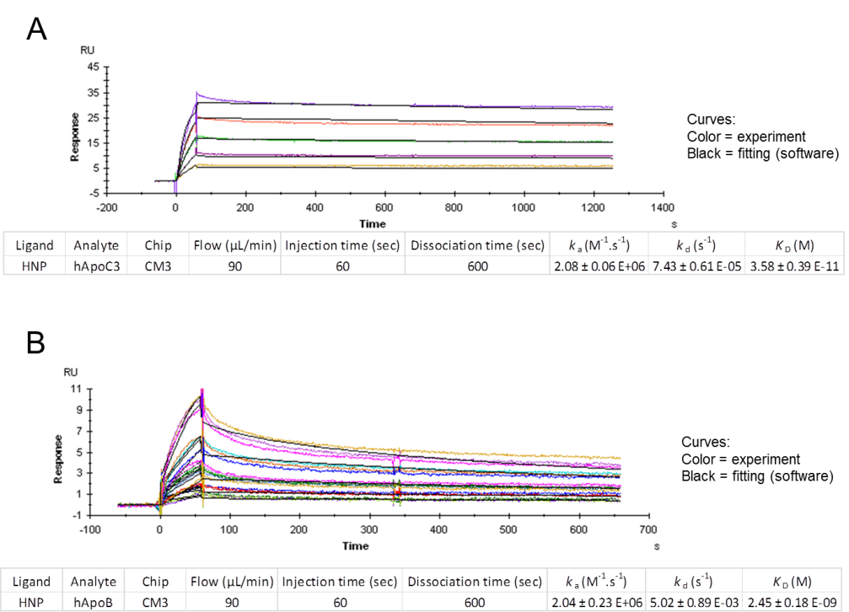

**Figure S4: Kinetic studies for interaction of HNP1 to human apolipoproteins.** Examples of sensograms of human ApoC3 (A) or ApoB (B) binding to HNP1. Analytes were perfused at concentrations from 62.5 to 1000 ng/ml over the chip for 1 minute at 90 µl/min followed by a dissociation phase of 10 or 20 minutes. Sensograms were normalized from the baseline signal and kinetic constants were determined using BIACORE X100 evaluation 2.0 software.

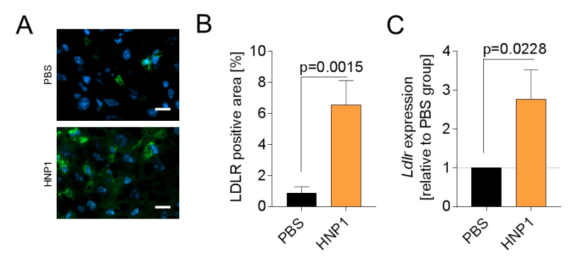

**Figure S5: HNP1 treatment enhances LDLR expression in the liver.** *Apoe-/-* mice were fed a high fat diet for eight weeks. During the last four weeks mice were injected with PBS (every other day, i.v.) or HNP1 (10 µg, every other day, i.v.). Displayed is the protein (A/B) and mRNA expression of LDLR (C). n=8 per group. Data were analyzed by unpaired t-test.

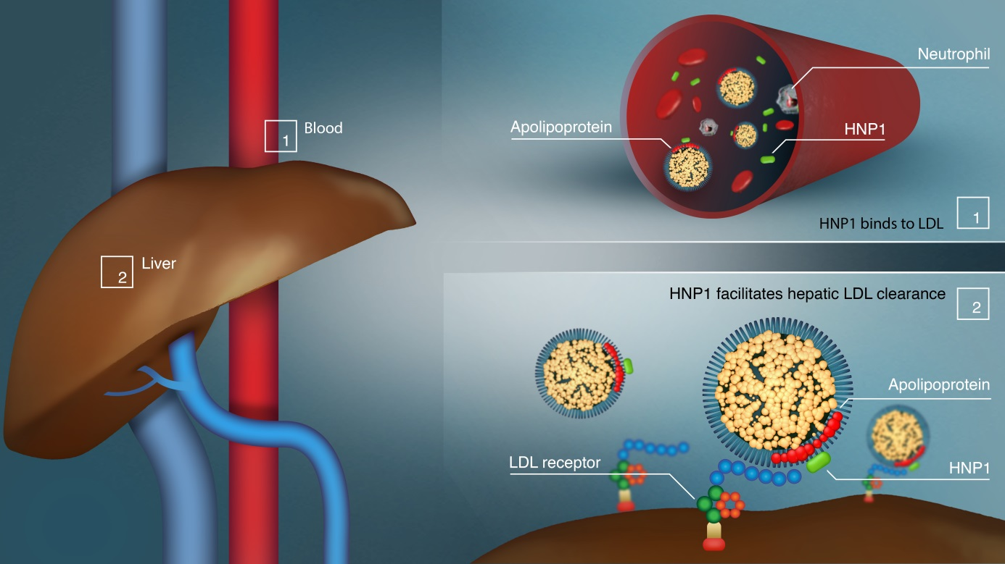

**Figure S6: Summary of proposed mechanism.**

|  |  |  |  |  |  |
| --- | --- | --- | --- | --- | --- |
|  | WBC | platelets | lymphocytes | monocytes | neutrophils |
| *Apoe-/-* | 5.7x109/l  ±1.4x109/l | 1486x109/l  ±132.2x109/l | 3.2x109/l  ±0.9x109/l | 0.4x109/l  ±0.2x109/l | 2.0x109/l  ±0.8x109/l |
|  |  |  |  |  |  |
| *Apoe-/-*  *HNP1tg/tg* | 6.6x109/l  ±2.9x109/l | 1319x109/l  ±192.1x109/l | 4.4x109/l  ±2.2x109/l | 0.4x109/l  ±0.2x109/l | 2.0x109/l  ±1.0x109/l |
|  |  |  |  |  |  |
| p-value | 0.5037 | 0.0818 | 0.2150 | 0.5071 | 0.9971 |

**Table S1: Transgenic expression of HNP1 does not affect blood cell counts.** *Apoe-/-* and *Apoe-/-HNP1tg/tg* mice were fed a high-fat diet for 4 weeks. Indicated blood cells were quantified by flow cytometry. Data were analyzed with unpaired t-test, n = 10.

|  |  |  |  |  |  |
| --- | --- | --- | --- | --- | --- |
|  | WBC | platelets | lymphocytes | monocytes | neutrophils |
| *Apoe-/-*  *baseline* | 4.8x109/l  ±1.2x109/l | 797.1x109/l  ±365.3x109/l | 2.5x109/l  ±0.5x109/l | 0.2x109/l  ±0.1x109/l | 2.0x109/l  ±0.9x109/l |
|  |  |  |  |  |  |
| *Apoe-/-*  *PBS treatment* | 4.2x109/l  ±2.1x109/l | 861.2x109/l  ±465.0x109/l | 2.4x109/l  ±0.8x109/l | 0.1x109/l  ±0.1x109/l | 1.7x109/l  ±1.3x109/l |
|  |  |  |  |  |  |
| *Apoe-/-*  *HNP1 treatment* | 4.4x109/l  ±2.2x109/l | 958x109/l  ±451.8x109/l | 2.1x109/l  ±1.1x109/l | 0.1x109/l  ±0.1x109/l | 2.2x109/l  ±1.8x109/l |

**Table S2: HNP1 treatment does not affect blood cell counts.** *Apoe-/-* mice were fed a high fat diet for four weeks after which the baseline group was harvested. Two additional groups were fed a high fat diet for 8 weeks and received either PBS (every other day) or HNP1 (10 µg, every other day, i.v.) during the last four weeks of high fat diet feeding. Indicated blood cells were quantified by flow cytometry. n = 8-11 per group.