Supplementary Figure
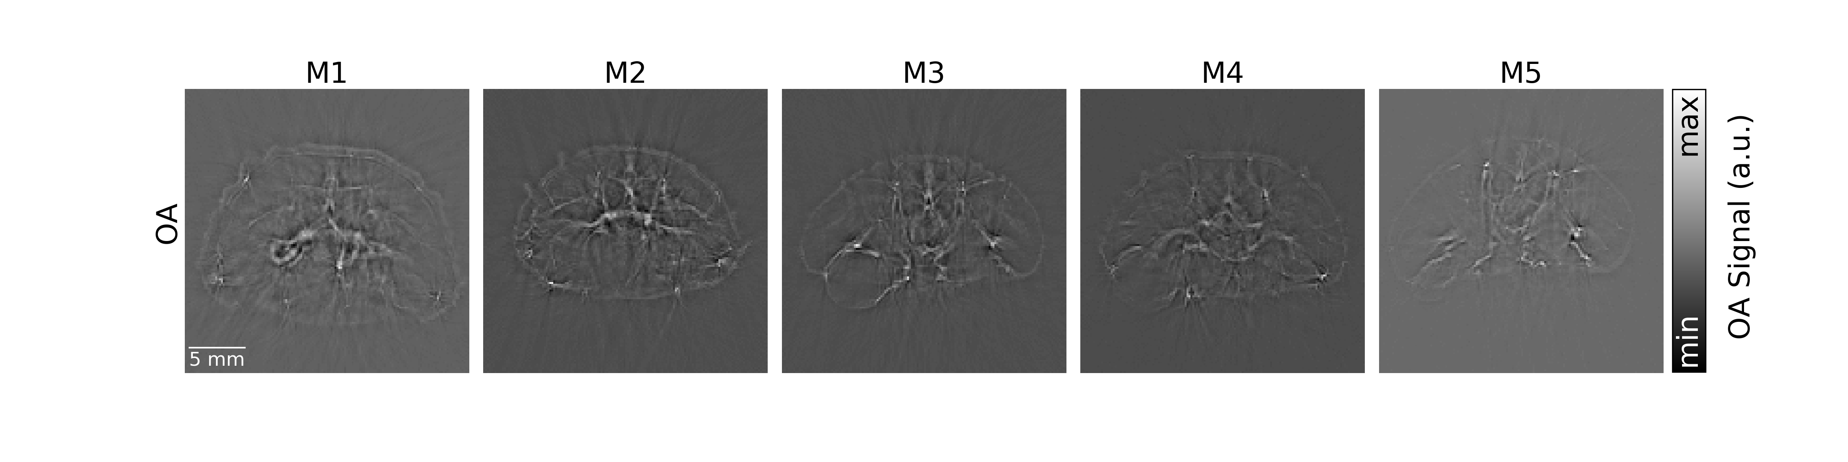
Supplementary Figure 1: Cross-sectional OA images without Frangi filter. The same OA images with Frangi filter are shown in Fig. 3 in manuscript.

