*Supplementary information of*

**Secondary organic aerosols produced from photochemical oxidation of secondarily evaporated biomass burning organic gases: chemical composition, toxicity, optical properties, and climate effect**

Zheng Fang a, Chunlin Li a, Quanfu He a, **Hendryk Czech b,c, Thomas Gröger c,** Jianqiang Zeng d, Hua fang d, Shaoxuan Xiao d, Michal Pardo a, Elena Hartner b,c, Daphne Meidan a, Xinming Wang d, **Ralf Zimmermann b,c, Alexander Laskin e,f,** Yinon Rudich a,*

a Department of Earth and Planetary Sciences, Weizmann Institute of Science, Rehovot 76100, Israel

b Joint Mass Spectrometry Centre, Chair of Analytical Chemistry, Institute of Chemistry, University of Rostock, 18059 Rostock, Germany

c Joint Mass Spectrometry Centre, Comprehensive Molecular Analytics, Helmholtz Zentrum München, 81379 München, Germany

d State Key Laboratory of Organic Geochemistry and Guangdong Key Laboratory of Environment Protection and Resources Utilization, Guangzhou Institute of Geochemistry, Chinese Academy of Sciences, Guangzhou 510640, China

e Department of Chemistry, f Department of Earth, Atmospheric and Planetary Sciences, Purdue University, West Lafayette, IN 47907, USA

**\*Correspondence to:**Yinon Rudich (yinon.rudich@weizmann.ac.il)

This supporting information file contains 7 texts, 1 table, and 13 figures as follows:

* Text S1. Data processing of results obtained from thermal desorption - two-dimensional gas chromatography time-of-flight mass spectrometry (TD-GC×GC-TOF MS).
* Text S2: The extraction efficiency of chromophores in SOA by solvents.
* Text S3. Lung cell viability test after exposure to the water extracts of the 10.6-days SOA
* Text S4. The method to measure DTT consumption rate
* Text S5: The method to evaluate aerosol direct forcing effect.
* Text S6: Considerations and definitions in the core-shell model.
* Text S7: Calculation of integrated Eabs during a typical BB event.
* Table S1. The comparison between SSA values of BBOA obtained in this study and those found in the literature.
* Figure S1: The experimental setup.
* Figure S2: The morphology of 0.7-days SOA measured by atomic force microscopy (AFM).
* Figure S3: Size-resolved SOA chemical composition from AMS.
* Figure S4: The AMS mass spectra for 5.5-days and 10.6-days SOA.
* Figure S5: Individual contribution of the most abundant semivolatile compounds found on SOA and their changes during aging.
* Figure S6: Pseudo-chromatogram of significant peaks in SOA of each photochemical age.
* Figure S7: Hierarchical clustering of significant peaks.
* Figure S8: Flow cytometry histograms of PI dye from A549 and Calu-3 human lung epithelial cells.
* Figure S9: Duplicate measurements of absorbance plots of the 10.6-days SOA by DTT assay.
* Figure S10: Comparison between refractive indices (RI) of SOA in this study and those in the literature.
* Figure S11: Comparison between the absorbance of the soluble SOA when using methanol or water as the solvent.
* Figure S12: MAC and MSC of SOA versus aerosol diameter and wavelength.
* Figure S13: The extrapolated SFE values between 450 nm and 600 nm.

Text S1. Data processing of results obtained from TD-GC×GC-TOF MS.

Basic post-processing was also done with a vendor specific ChromaTOF software (LECO, St. Joseph, MI, USA). Raw chromatograms were first exported in NetCDF format and then imported to the ChromaTOF. An S/N threshold of 2500 was applied for peak detection. Peaks contributing to column bleed and paraffins were excluded from further processing. Alignments of peaks were performed by building in a “statistical compare function”. Peak area was calculated as the “deconvoluted total ion current”. Deconvoluted spectra were feed to NIST MS Search V2.3. Further recognition was done for peaks which were found in SOA of all photochemical ages. Hits with a minimum similarity of 700 were considered for further evaluation of the identity of the peak. Other criteria include retention time in two dimensions of GC, spectra probability, and reasonability of the structure. The mean background signal was subtracted for all peaks. In each of triplicate measurements, peaks were normalized to the total signal of all peaks.

One-way Analysis of Variance (ANOVA) was performed on the three samples with relative peak areas as input. Heat map and clustering were performed with Matlab build-in "clustergram" function (bioinformatics toolbox 4.3.1) based on hierarchical clustering on row-wise normalized data (multiple of the standard deviation) with Euclidean distance metric and average linkage function.

Text S2. The extraction efficiency of chromophores in SOA by solvents

Recent studies have reported that when a suitable organic solvent (e.g., methanol, dichloromethane, acetonitrile) is used for specific OA formed from combustion or pyrolysis, the *k* values measured by the solvent extraction agree well with online measurements such as the photoacoustic spectrometer, BBCES system or albedometer (Cheng et al., 2020; Li et al., 2020; Li et al., 2021). Cheng et al. (2020) found that the discrepancy between the solvent extraction method and online measurements is linked to the efficiency of solvent extraction, and the less absorbing BrC exhibit a higher agreement between the two methods. Our SOA exhibit less absorption than the least absorbing BrC obtained in previous studies (Cheng et al., 2020; Li et al., 2020; Li et al., 2021), so they were assumed to be fully extracted by the methanol after two extractions. Compared with methanol, water has less extraction efficiency of chromophores, which is observed both in the literature (Zhang et al., 2013; Huang et al., 2018; Cao et al., 2021) and in this study (see Fig. S9).

Text S3. Lung cell viability test after exposure to the water extracts of the 10.6-days SOA

The human lung carcinogenic cell line A549 (ATCC® CCL-185™) was grown in RPMI (Gibco, Thermo Fisher Scientific, MA, US) supplemented with 10% fetal bovine serum (FBS) and 5 μg mL-1 penicillin/streptomycin (Biological Industries). The human lung adenocarcinoma cell line Calu-3 (ATCC® HTB-55™) was grown in Eagle's Minimum Essential Medium (Sigma-Aldrich) supplemented with 10% FBS, 1%, pyruvate, 1% glutamine and 5 μg mL-1 penicillin/streptomycin (Biological Industries), both cell lines were grown at 37 °C in a humidified atmosphere consisting of 95% air and 5% CO2.

Both A549 and Calu-3 cells (passages 2-30) were exposed to the 10.6-days SOA extracts in serum-free medium with salts/glucose; the medium comprised of 50 mM HEPES, 100 mM NaCl, 5 mM KCl, 2 mM CaCl2, and 5 mM glucose (pH 7.2 prior to use to maintain osmolarity). The cells were exposed to the SOA extracts at 0.25 mg L-1, and 25 mg L-1 and to blank extracts, which underwent the same procedures as the extracts but with water and were used as controls. Cell death was measured after exposure for 24 h.

The DNA-intercalating dye propidium iodide (PI), which is excluded by viable cells, was used. Flow cytometry (Amnis® CellStream® Flow Cytometer, Luminex, US) was used to evaluate cell viability using the following fluorescence settings: excitation wavelength at 488 nm and emission wavelength at 610 nm. Data were collected from 10,000 cells.

The equivalent environmental concentration of SOA (Cequivalent, μg m-3) is assessed based on the method first developed by Pardo et al. (2021). Here we add the consideration of penetration rate of particles to human body (P), and get the following equation:

E1

where Ccell is the concentration of SOA water extracts used in our experiments. Vblood is the blood volume of a human body, and is set to 4.5 L. Vair is the total inhaled volume for 24 hours. The tidal volume and rate of human breath were assumed to be 0.5 L each time and 12 times per minute, respectively, thus Vair is set to 8.64 m3. The P value of 0.64 is acquired from Park et al. (2021). As a result, the doses of 0.25 mg L-1×24 h and 25 mg L-1×24 h in SOA solution are converted to exposures of 2×102 μg m-3×24 h and 2×104 μg m-3×24 h to airborne aerosols. For more accurate estimation, the exact values of P for size-specific SOA, the distribution of SOA in different organs, and metabolic rates of SOA in human body are needed. Here we only provide a basic estimation for preliminary understanding.

Text S4. The method to measure DTT consumption rate

The DTT consumption rate was conducted manually following the method developed in the literature (Cho et al., 2005; Lin et al., 2019) with minor modifications. First, 0.5 ml of aerosol extract solution (93 mg L-1), 4 ml of sodium phosphate buffer (1 mM, pH =7.4, with trace metal brought by the impurity removed by the Chelex resin), and 0.5 ml of DTT solution (1 mM) were added to an incubation vial. The incubation vial was kept at 37 °C by a dry bath incubator (DBN, MRC). Every 5 minutes, 0.6 ml of the solution in the incubation vial is withdrawn and mixed with 1.8 ml of Tris base solution (0.4 M), 0.7 ml of TCA solution (10 w/v%), and 0.5 ml of DTNB solution (1 mM). The residual DTT in the incubation vial and the added DTNB react to form 2-nitro-5-thiobenzoic, which has a light absorption peak at 412 nm and can be characterized by UV-Vis spectroscopy (model USB 650, Ocean Optics). The blank tests were done based on a clean filter with the same procedures. Compared to the blank group, the incubation solution in the experimental group contains undissolved particles. By interpolating the time series of measured absorbance at 412 nm to time = 0, the incubation solution in the experimental group didn't show significant (*p*<0.01) higher absorbance than that in the blank group, suggesting that the undissolved particles had neglectable contribution to its absorbance at 412 nm. The consumption rate of DTT by the SOA solution was calculated according to the background-corrected decay rate of the light absorption versus time (Fig. S7).

Text S5. The method to evaluate aerosol direct forcing effect

The direct forcing effect of aerosols can be evaluated by the equation (Bond and Bergstrom, 2006):

E2

where SFE is the energy added to the Earth's atmosphere by a unit mass of aerosols (W g-1 nm-1). S(*λ*) is the 1 nm-resolved solar irradiance (W m-2 nm-1) measured by Thuillier et al. (2003). *τ*atm is the atmospheric transmission, Fc is the cloud fraction, *a*s is the Earth's albedo below the suspended aerosol. With *n* and *k* values measured in this study, the diameter and wavelength-dependent MAC, MSC and the backscatter fraction (*β*) values were calculated based on the Mie code (Bohren and Huffman, 1983). In Equation S2, parameters like *τ*atm and Fc can be influenced by specific meteorological condition, but they do not determine whether SFE is positive or negative; in order to explore the effect of other factors on the direct forcing effect, *τ*atm and Fc are set as 0.79 and 0.6, respectively (Bond and Bergstrom, 2006). The MSC, MAC, *β* of aerosol and the surface albedo will eventually determine whether the aerosol has a warming (SFE > 0) or cooling effect (SFE< 0) under specific conditions.

Text S6. BC coated by OA: considerations and definitions in the core-shell model

Optical properties of BC coated by SOA are calculated based on the Mie theory code (Bohren and Huffman, 1983). Recently, the complex refractive index of BC was reviewed by Liu et al. (2019) and the recommended range of *n* and *k* were 1.50-1.86 and 0.68-1.00, respectively; in this study, the middle value of the suggested range, namely 1.68 + 0.84i, was used to represent the optical properties of BC across the wavelength range of 313-450 nm. The density of BC was set to be 1.8 g cm-3 (Bond and Bergstrom, 2006; Liu et al., 2019). For Fig. 8&9 and their relevant discussions, we simply treat each BC core as a single sphere, and attempt to explore the sensitivity of SFE towards the BC core diameter and the OA/BC mass ratio (denoted as RBC). For the BC core in the BB plume, a unimodal size distribution with peak diameter ranging from 60-140 nm has been reported (Sahu et al., 2012; Lee et al., 2017; McClure et al., 2020), so the diameter range of less than 400 nm should cover the atmospherically relevant sizes of most BC. Besides, aerosols with diameters smaller than 50 nm could scatter light not only through the Mie scattering but also by the Rayleigh scattering, and therefore are not considered in this study. As to the RBC, previous ambient observations suggested that the majority of aerosols have RBC values of below 20 (Cappa et al., 2012; Liu et al., 2017; Wang et al., 2017; Taylor et al., 2020; Fierce et al., 2020).

The enhancement ratios of BC absorption (Eabs) and scattering (Esca) are calculated as:

E3

E4

where *q*abs (unitless) and *q*sca (unitless) are the wavelength-dependent absorption coefficient and scattering coefficient given by the Mie theory code, respectively; for easier comparison, they are averaged across a wavelength range of 313-450 nm. D is the diameter.

Text S7. Integrated Eabs during a typical BB event

The BC core is assumed to have a lognormal size distribution with a median diameter of 140 nm and a standard deviation of 0.35 (Kondo et al., 2011; Sahu et al., 2012).

For the thinly coated BC, the real lensing effect should be smaller than theoretical calculations because ambient BC often exists as a fractal-like rather than perfectly spherical structure (Adler et al., 2010; Liu et al., 2017; Fierce et al., 2020). As the coating becomes thicker, the fractal BC core will gradually transform into a spherical morphology (Peng et al., 2016). Therefore, the following correction was applied (Liu et al., 2017; Fierce et al., 2020):

E5

E6

where Eabs,cor is the corrected Eabs, Fin is the internally mixed fraction determined by RBC. For coated BC with RBC larger than 3, no correction was applied.

The heterogeneity of RBC among aerosols was acquired from the "Ambient biomass burning" case in Fig. 2 of Liu et al. (2017). The distribution of RBC was first fitted with a normal distribution equation, then their probabilities were computed for RBC between 0.5 and 20 (step length of 0.5). It is assumed that the distribution of RBC applies to all sizes of BC core. The integrated RBC is 8.94 in this case.

First, Eabs,cor was obtained from the Mie theory code and Equations S5 & S6. Next, for the BC core of each size (1 nm to 400 nm, at 1-nm intervals), the integrated Eabs,cor was calculated according to the distribution of RBC. Finally, the MACBC of each size was timed by its corresponding Eabs,cor, and was then further integrated according to the size distribution of the BC core.

With the method illustrated above, across wavelengths of 313-450 nm, the integrated MAC of the BC core was calculated to be 9.14 m2 g-1; the integrated MAC of BC that are coated by 0.7-days, 5.5-days and 10.6-days SOA were 17.63, 17.81 and 18.53 m2 g-1, respectively.

**Table S1.** The comparison between SSA values of BBOA obtained in this study and those found in the literature.

|  |  |  |  |  |  |
| --- | --- | --- | --- | --- | --- |
| BBOA source | Fresh/aged | Diameter (nm) | Wavelength (nm) | SSA value | |
| Reference | In this study |
| Duff smoldering | Fresh | ~70 | 405 | 0.95-0.98a | 0.71-0.84 |
| Peat smoldering | Fresh | ~120 | 375 | 0.852 ± 0.005b | 0.90-0.95 |
| Fresh | ~120 | 405 | 0.946 ± 0.002b | 0.91-0.95 |
| Wood tar | Fresh | 250 | 330 | 0.80 ± 0.08c | 0.93-0.96 |
| Fresh | 250 | 405 | 0.94 ± 0.02c | 0.97-0.98 |
|  | Aged with NO3 | 250 | 330 | 0.72 ± 0.01c | 0.93-0.96 |
|  | Aged with NO3 | 250 | 405 | 0.87 ± 0.01c | 0.97-0.98 |
|  | Aged with OH | 150 | 375 | 0.949 ± 0.003d | 0.94-0.97 |
|  | Aged with OH | 150 | 405 | 0.974 ± 0.003d | 0.93-0.96 |
|  | Aged with OH + NOx | 150 | 375 | 0.874 ± 0.007d | 0.94-0.97 |
|  | Aged with OH + NOx | 150 | 405 | 0.906 ± 0.007d | 0.93-0.96 |
| Tropical fire | Aged in the ambient atmosphere | ~150 | 550 | 0.85 ± 0.05e | >0.93f |

a Chakrabarty et al., 2010; b Sumlin et al., 2017; c Li et al., 2019; d Li et al., 2020; e Magi et al., 2009, 2011; f extrapolated from the measured wavelengths.



Figure S1. The experimental setup.

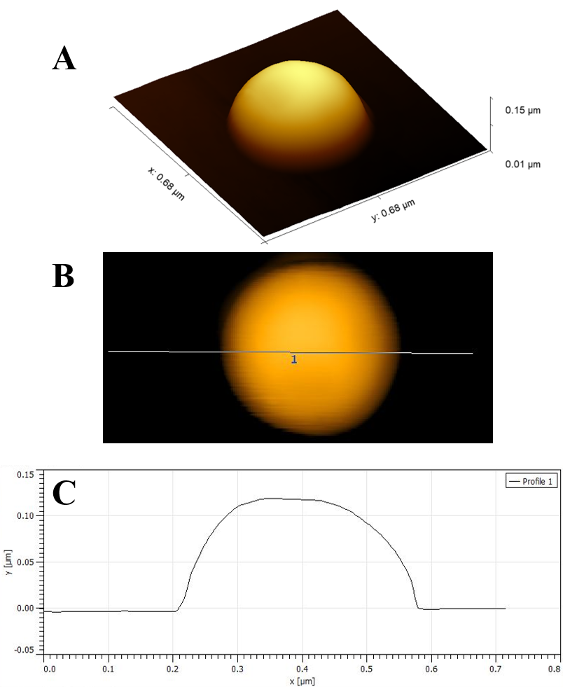

Figure S2. Representative atomic force microscope (AFM) image of 0.7-days SOA: (A) 3D perspective view (B) plan-view with position of cross-section profile given in (C).



Figure S3. Chemical composition of SOA as a function of diameter: (A) OHexp = 0.7 days; (B) OHexp = 5.5 days; and (C) OHexp = 10.6 days. After converting the aerodynamic diameter in the AMS to the mobility diameter, bins 1-5 correspond to particles with mobility diameters in the range of 162.1-185.5, 185.5-211.5, 211.5-240.3, 240.3-272.5, 272.5-308.8 nm, respectively.



Figure S4. AMS spectra of SOA produced under: (a) 5.5-days equivalent OHexp, and (b) 10.6-days equivalent OHexp. Total signal of each spectrum is normalized to be 1.0.

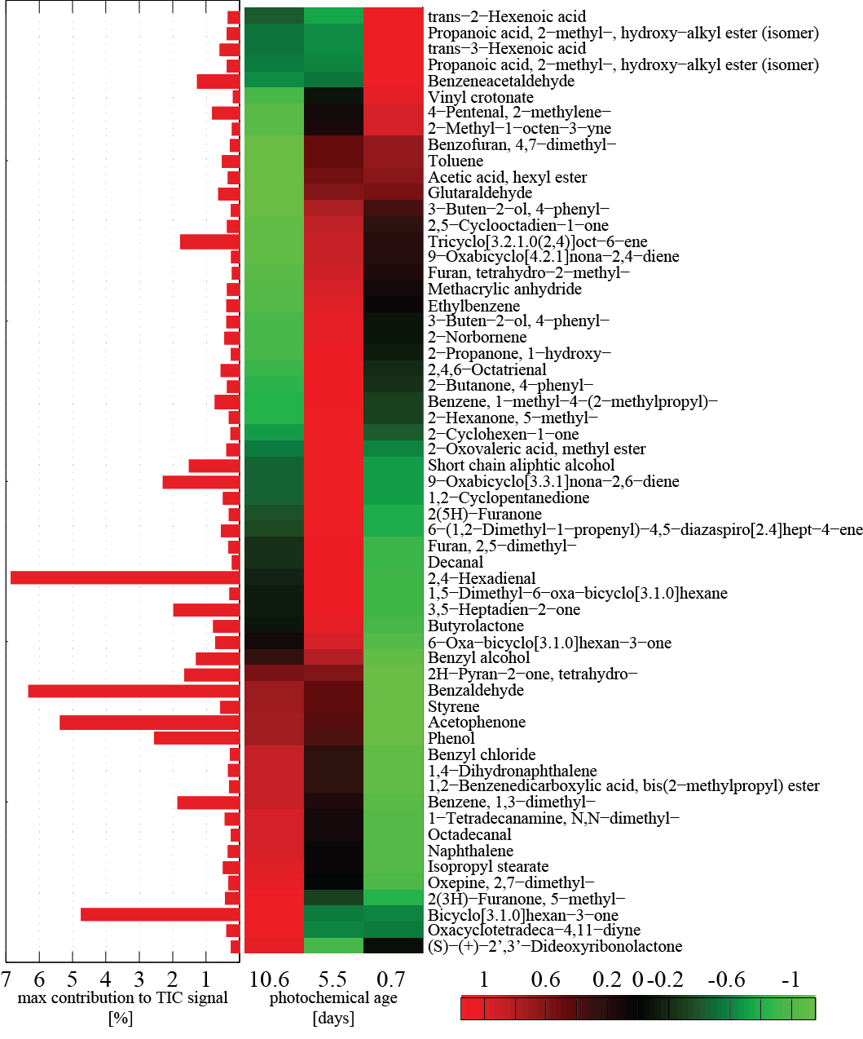

Figure S5. Individual contribution of the most abundant semivolatile compounds found in SOA and their variation during aging. The bar graph gives the individual contribution in percent of the total signal (highest contribution during aging). The heat map reflects the normalized change in abundance. Values for the individual ages were first averaged from triplicates, and then normalized to the standard derivations for different photochemical ages. Positive numbers (red) mean high abundance in specific sample, while negative numbers (green) indicate low abundance.

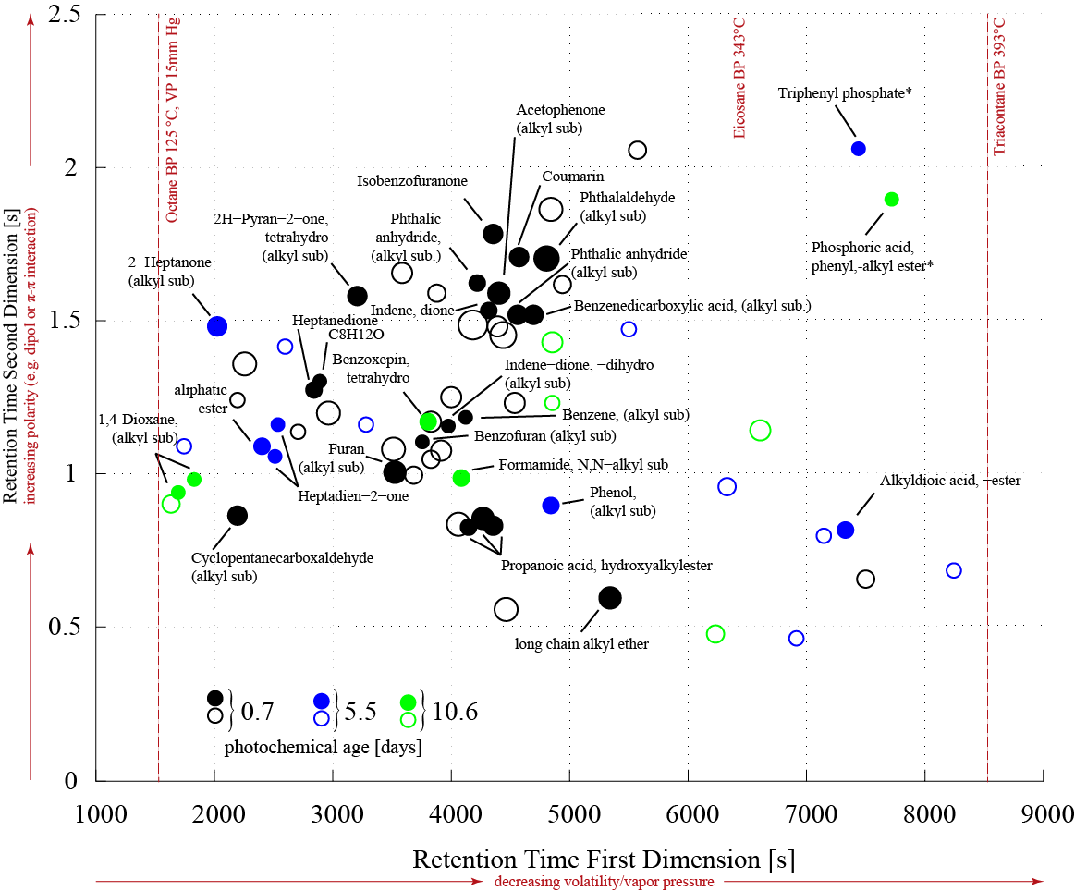

Figure S6. Pseudo-chromatogram of significant peaks (*p*<0.05, ANOVA test) in SOA with reference to the photochemical age. Sizes of the bubbles is proportional to -log10(*p*). Identity of peaks marked with empty cycles could not be unambiguously determined based on chromatographic and spectrometric data (NIST similarity < 700 or missing of characteristic spectral features). Assignment to photochemical ages was done based on the hierarchical clustering (See Fig. S6). Dashed red lines indicate the boiling point (BP) and vapor pressure (VP) of corresponding *n*-alkanes for comparison. Compounds known as plasticizers are marked by asterisks. More significant peaks were found in the 0.7-days SOA than 5.5-days and 10.6-days SOA. This might be due to that, specific characteristic compounds in more aged samples were less volatile and/or thermal fragile due to the oxidation process, and were thus out of the application range of TD-GC×GC-TOF MS.

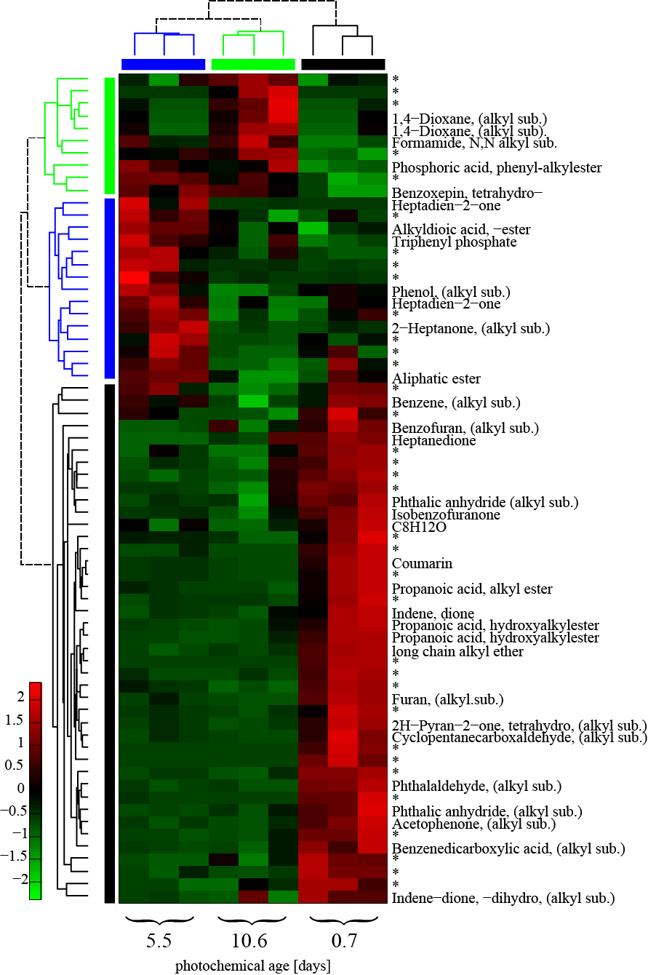

Figure S7. Hierarchical clustering of significant peaks (*p*<0.05, ANOVA test). Compounds indicated with asterisks could be not unambiguously identified. Each row was normalized to multiple of the standard derivation for each compound. Positive numbers (red) mean high abundance in specific sample, while negative numbers (green) indicate low abundance. The applied statistics allows an discrimination of the photochemical age based on the semivolatile compounds in SOA.



**Figure S8.** Flow cytometry histograms of PI dye from (a) A549 and (b) Calu-3 human lung epithelial cells. Cells were exposed to the water extracts of the 10.6-days SOA at concentrations of 25, 0.25 mg/L for 24 hours. Each experiment was performed in triplicates. Blank treated cells represents cells that underwent the same procedure as the SOA extracts and they serve as the control. “Untreated cells” (UT) represents cells that were not treated with SOA extracts, “Unstained cells” (US) represents cells that were not stained with PI dye. The differences between US and UT is a reference for the impact of the dye.



Figure S9. Duplicate measurements of absorbance plots of the 10.6-days SOA by DTT assay.



**Figure S10.** (a) The real parts of the RI of SOA retrieved by BBCES in this study and compared with literature values. (b) The imaginary parts of the RI of SOA measured by methanol extraction in this study and in the literature.



Figure S11. Comparison between the absorbance of the soluble SOA when using methanol or water as the solvent. When water was used, the measurements suffer from relatively large noise-to-signal ratios at 370-409 nm, therefore the data in this range was interpolated from the neighboring data. The shaded area represents the uncertainty.



Figure S12. The MAC of SOA with equivalent OHexp of (a) 0.7 day, (b) 5.5 days, and (c) 10.6 days. The MSC of SOA with equivalent OHexp of (d) 0.7 day, (e) 5.5 days, and (f) 10.6 days.



Figure S13. The extrapolated SFE versus aerosol diameter and wavelength for (a) 0.7-days SOA, (b) 5.5-days SOA, and (c) 10.6-days SOA with a surface albedo = 0.19; the integrated extrapolated SFE across 450-600 nm against surface albedo and aerosol diameter for (e) 0.7-days SOA, (f) 5.5-days SOA, and (g) 10.6-days SOA. The color bars are consistent with Fig. 5 in the main text for easier comparisons. In figure (a-c), since all the SFE values are minus, the contours labelling SFE=0 cannot be shown.

References

Adler, G., Riziq, A.A., Erlick, C., Rudich, Y., 2010. Effect of intrinsic organic carbon on the optical properties of fresh diesel soot. Proc. Natl. Acad. Sci. 107, 6699-6704. https://doi.org/10.1073/pnas.0903311106

Bohren, C.F., Huffman, D.R., 1983. Absorption and scattering of light by small particles. John Wiley & Sons.

Bond, T.C., Bergstrom, R.W., 2006. Light absorption by carbonaceous particles: An investigative review. Aerosol Sci. Technol. 40, 27-67. https://doi.org/10.1080/02786820500421521

Cao, T., Li, M., Zou, C., Fan, X., Song, J., Jia, W., Yu, C., Yu, Z., Peng, P., 2021. Chemical composition, optical properties, and oxidative potential of water- and methanol-soluble organic compounds emitted from the combustion of biomass materials and coal. Atmos. Chem. Phys. Discuss. 2021, 1-47. https://doi.org/10.5194/acp-2021-159

Cappa, C.D., Onasch, T.B., Massoli, P., Worsnop, D.R., Bates, T.S., Cross, E.S., Davidovits, P., Hakala, J., Hayden, K.L., Jobson, B.T., Kolesar, K.R., Lack, D.A., Lerner, B.M., Li, S.-M., Mellon, D., Nuaaman, I., Olfert, J.S., Petaja, T., Quinn, P.K., Song, C., Subramanian, R., Williams, E.J., Zaveri, R.A., 2012. Radiative absorption enhancements due to the mixing state of atmospheric black carbon. Science (80-. ). 337, 1078-1081. https://doi.org/10.1126/science.1223447

Chakrabarty, R.K., Gyawali, M., Yatavelli, R.L.N., Pandey, A., Watts, A.C., Knue, J., Chen, L.W.A., Pattison, R.R., Tsibart, A., Samburova, V., Moosmüller, H., 2016. Brown carbon aerosols from burning of boreal peatlands: microphysical properties, emission factors, and implications for direct radiative forcing. Atmos. Chem. Phys. 16, 3033-3040. https://doi.org/10.5194/acp-16-3033-2016

Chakrabarty, R.K., Moosmuller, H., Chen, L.-W., Lewis, K., Arnott, W.P., Mazzoleni, C., Dubey, M.K., Wold, C.E., Hao, W.M., Kreidenweis, S.M., 2010. Brown carbon in tar balls from smoldering biomass combustion. Atmos. Chem. Phys. https://doi.org/10.5194/acp-10-6363-2010

Cheng, Z., Atwi, K., Hajj, O. El, Ijeli, I., Fischer, D. Al, Smith, G., Saleh, R., 2020. Discrepancies between brown carbon light-absorption properties retrieved from online and offline measurements. Aerosol Sci. Technol. 1-15. https://doi.org/10.1080/02786826.2020.1820940

Cho, A.K., Sioutas, C., Miguel, A.H., Kumagai, Y., Schmitz, D.A., Singh, M., Eiguren-Fernandez, A., Froines, J.R., 2005. Redox activity of airborne particulate matter at different sites in the Los Angeles Basin. Environ. Res. 99, 40-47. https://doi.org/10.1016/j.envres.2005.01.003

Dingle, J.H., Zimmerman, S., Frie, A.L., Min, J., Jung, H., Bahreini, R., 2019. Complex refractive index, single scattering albedo, and mass absorption coefficient of secondary organic aerosols generated from oxidation of biogenic and anthropogenic precursors. Aerosol Sci. Technol. 53, 449-463. https://doi.org/10.1080/02786826.2019.1571680

Fierce, L., Onasch, T.B., Cappa, C.D., Mazzoleni, C., China, S., Bhandari, J., Davidovits, P., Fischer, D. Al, Helgestad, T., Lambe, A.T., Sedlacek, A.J., Smith, G.D., Wolff, L., 2020. Radiative absorption enhancements by black carbon controlled by particle-to-particle heterogeneity in composition. Proc. Natl. Acad. Sci. 201919723. https://doi.org/10.1073/pnas.1919723117

Flores, J.M., Zhao, D.F., Segev, L., Schlag, P., Kiendler-Scharr, A., Fuchs, H., Watne, Å.K., Bluvshtein, N., Mentel, T.F., Hallquist, M., 2014. Evolution of the complex refractive index in the UV spectral region in ageing secondary organic aerosol. Atmos. Chem. Phys. 14. https://doi.org/10.5194/acp-14-5793-2014

He, Q., Bluvshtein, N., Segev, L., Meidan, D., Flores, J.M., Brown, S.S., Brune, W., Rudich, Y., 2018. Evolution of the complex refractive index of secondary organic aerosols during atmospheric aging. Environ. Sci. Technol. 52, 3456-3465. https://doi.org/10.1021/acs.est.7b05742

Huang, R.J., Yang, L., Cao, J.J., Chen, Y., Chen, Q., Li, Y.J., Duan, J., Zhu, C.S., Dai, W.T., Wang, K., Lin, C.S., Ni, H.Y., Corbin, J.C., Wu, Y.F., Zhang, R.J., Tie, X.X., Hoffmann, T., O’Dowd, C., Dusek, U., 2018. Brown carbon aerosol in urban Xi’an, northwest China: The composition and light absorption properties. Environ. Sci. Technol. 52, 6825-6833. https://doi.org/10.1021/acs.est.8b02386

Kondo, Y., Matsui, H., Moteki, N., Sahu, L., Takegawa, N., Kajino, M., Zhao, Y., Cubison, M.J., Jimenez, J.L., Vay, S., Diskin, G.S., Anderson, B., Wisthaler, A., Mikoviny, T., Fuelberg, H.E., Blake, D.R., Huey, G., Weinheimer, A.J., Knapp, D.J., Brune, W.H., 2011. Emissions of black carbon, organic, and inorganic aerosols from biomass burning in North America and Asia in 2008. J. Geophys. Res. 116. https://doi.org/10.1029/2010jd015152

Lambe, A.T., Cappa, C.D., Massoli, P., Onasch, T.B., Forestieri, S.D., Martin, A.T., Cummings, M.J., Croasdale, D.R., Brune, W.H., Worsnop, D.R., Davidovits, P., 2013. Relationship between oxidation level and optical properties of secondary organic aerosol. Environ. Sci. Technol. 47, 6349-6357. https://doi.org/10.1021/es401043j

Lee, H.H., Bar-Or, R.Z., Wang, C., 2017. Biomass burning aerosols and the low-visibility events in Southeast Asia. Atmos. Chem. Phys. 17, 965-980. https://doi.org/10.5194/acp-17-965-2017

Li, C., He, Q., Hettiyadura, A.P.S., Käfer, U., Shmul, G., Meidan, D., Zimmermann, R., Brown, S.S., George, C., Laskin, A., Rudich, Y., 2020. Formation of secondary brown carbon in biomass burning aerosol proxies through NO3 radical reactions. Environ. Sci. Technol. 54, 1395–1405. https://doi.org/10.1021/acs.est.9b05641

Li, C., He, Q., Schade, J., Passig, J., Zimmermann, R., Meidan, D., Laskin, A., Rudich, Y., 2019. Dynamic changes in optical and chemical properties of tar ball aerosols by atmospheric photochemical aging. Atmos. Chem. Phys. 19, 139-163. https://doi.org/10.5194/acp-19-139-2019

Li, C., Windwer, E., Fang, Z., Nissenbaum, D., Rudich, Y., 2021. Correcting micro-aethalometer absorption measurements for brown carbon aerosol. Sci. Total Environ. 146143. https://doi.org/10.1016/j.scitotenv.2021.146143

Li, X., Xiao, M., Xu, X., Zhou, J., Yang, K., Wang, Z., Zhang, W., Hopke, P.K., Zhao, W., 2020. Light absorption properties of organic aerosol from wood pyrolysis: Measurement method comparison and radiative implications. Environ. Sci. Technol. 54, 7156-7164. https://doi.org/10.1021/acs.est.0c01475

Lin, M., Yu, J.Z., 2019. Dithiothreitol (DTT) concentration effect and its implications on the applicability of DTT assay to evaluate the oxidative potential of atmospheric aerosol samples. Environ. Pollut. 251, 938-944. https://doi.org/10.1016/j.envpol.2019.05.074

Liu, D.T., Whitehead, J., Alfarra, M.R., Reyes-Villegas, E., Spracklen, D. V, Reddington, C.L., Kong, S.F., Williams, P.I., Ting, Y.C., Haslett, S., Taylor, J.W., Flynn, M.J., Morgan, W.T., McFiggans, G., Coe, H., Allan, J.D., 2017. Black-carbon absorption enhancement in the atmosphere determined by particle mixing state. Nat. Geosci. 10, 184-U132. https://doi.org/10.1038/ngeo2901

Liu, F., Yon, J., Fuentes, A., Lobo, P., Smallwood, G.J., Corbin, J.C., 2019. Review of recent literature on the light absorption properties of black carbon: Refractive index, mass absorption cross section, and absorption function. Aerosol Sci. Technol. 1-27. https://doi.org/10.1080/02786826.2019.1676878

Liu, P.F., Abdelmalki, N., Hung, H.M., Wang, Y., Brune, W.H., Martin, S.T., 2015. Ultraviolet and visible complex refractive indices of secondary organic material produced by photooxidation of the aromatic compounds toluene and m-xylene. Atmos. Chem. Phys. 15, 1435-1446. https://doi.org/10.5194/acp-15-1435-2015

Magi, B.I., 2011. Corrigendum to “Chemical apportionment of southern African aerosol mass and optical depth” published in Atmos. Chem. Phys., 9, 7643-7655, 2009. Atmos. Chem. Phys. 11, 4777-4778. https://doi.org/10.5194/acp-11-4777-2011

Magi, B.I., 2009. Chemical apportionment of southern African aerosol mass and optical depth. Atmos. Chem. Phys. 9, 7643-7655. https://doi.org/10.5194/acp-9-7643-2009

McClure, C.D., Lim, C.Y., Hagan, D.H., Kroll, J.H., Cappa, C.D., 2020. Biomass-burning-derived particles from a wide variety of fuels - Part 1: Properties of primary particles. Atmos. Chem. Phys. 20, 1531-1547. https://doi.org/10.5194/acp-20-1531-2020

Pardo, M., Li, C., Fang, Z., Levin-Zaidman, S., Dezorella, N., Czech, H., Martens, P., Käfer, U., Gröger, T., Rüger, C.P., Friederici, L., Zimmermann, R., Rudich, Y., 2021. Toxicity of water- and organic-soluble wood tar fractions from biomass burning in lung epithelial cells. Chem. Res. Toxicol. 34, 1588-1603. https://doi.org/10.1021/acs.chemrestox.1c00020

Park, J., Kwon, O., Yoon, C., Park, M., 2021. Estimates of particulate matter inhalation doses during three-dimensional printing. Indoor Air-International J. Indoor Air Qual. Clim. 31, 392-404. https://doi.org/10.1111/ina.12736

Peng, J.F., Hu, M., Guo, S., Du, Z.F., Zheng, J., Shang, D.J., Zamora, M.L., Zeng, L.M., Shao, M., Wu, Y.S., Zheng, J., Wang, Y., Glen, C.R., Collins, D.R., Molina, M.J., Zhang, R.Y., 2016. Markedly enhanced absorption and direct radiative forcing of black carbon under polluted urban environments. Proc. Natl. Acad. Sci. U. S. A. 113, 4266-4271. https://doi.org/10.1073/pnas.1602310113

Romonosky, D.E., Ali, N.N., Saiduddin, M.N., Wu, M., Lee, H.J., Aiona, P.K., Nizkorodov, S.A., 2016. Effective absorption cross sections and photolysis rates of anthropogenic and biogenic secondary organic aerosols. Atmos. Environ. 130, 172-179. https://doi.org/10.1016/j.atmosenv.2015.10.019

Sahu, L.K., Kondo, Y., Moteki, N., Takegawa, N., Zhao, Y., Cubison, M.J., Jimenez, J.L., Vay, S., Diskin, G.S., Wisthaler, A., 2012. Emission characteristics of black carbon in anthropogenic and biomass burning plumes over California during ARCTAS‐CARB 2008. J. Geophys. Res. Atmos. 117. https://doi.org/10.1029/2011JD017401

Sumlin, B.J., Pandey, A., Walker, M.J., Pattison, R.S., Williams, B.J., Chakrabarty, R.K., 2017. Atmospheric photooxidation diminishes light absorption by primary brown carbon aerosol from biomass burning. Environ. Sci. Technol. Lett. https://doi.org/10.1021/acs.estlett.7b00393

Taylor, J.W., Wu, H., Szpek, K., Bower, K., Crawford, I., Flynn, M.J., Williams, P.I., Dorsey, J., Langridge, J.M., Cotterell, M.I., Fox, C., Davies, N.W., Haywood, J.M., Coe, H., 2020. Absorption closure in highly aged biomass burning smoke. Atmos. Chem. Phys. 20, 11201-11221. https://doi.org/10.5194/acp-20-11201-2020

Thuillier, G., Hersé, M., Labs, D., Foujols, T., Peetermans, W., Gillotay, D., Simon, P.C., Mandel, H., 2003. The solar spectral irradiance from 200 to 2400 nm as measured by the SOLSPEC spectrometer from the Atlas and Eureca missions. Sol. Phys. 214, 1-22. https://doi.org/10.1023/A:1024048429145

Wang, J.F., Zhang, Q., Chen, M.D., Collier, S., Zhou, S., Ge, X.L., Xu, J.Z., Shi, J.S., Xie, C.H., Hu, J.L., Ge, S., Sun, Y.L., Coe, H., 2017. First chemical characterization of refractory black carbon aerosols and associated coatings over the Tibetan Plateau (4730 m a.s.l). Environ. Sci. Technol. 51, 14072-14082. https://doi.org/10.1021/acs.est.7b03973

Xie, M., Chen, X., Hays, M.D., Lewandowski, M., Offenberg, J., Kleindienst, T.E., Holder, A.L., 2017. Light absorption of secondary organic aerosol: Composition and contribution of nitroaromatic compounds. Environ. Sci. Technol. 51, 11607-11616. https://doi.org/10.1021/acs.est.7b03263

Zhang, X., Lin, Y.-H., Surratt, J.D., Weber, R.J., 2013. Sources, composition and absorption Ångström exponent of light-absorbing organic components in aerosol extracts from the Los Angeles Basin. Environ. Sci. Technol. 47, 3685-3693. https://doi.org/10.1021/es305047b