**SUPPLEMENTAL MATERIAL**

**Long-term exposure to air pollution, road traffic noise, residential greenness, and prevalent and incident metabolic syndrome: Results from the population-based KORA F4/FF4 cohort in Augsburg, Germany**

Stephan Voss*abc, Alexandra Schneiderc, Cornelia Huthc, Kathrin Wolfc, Iana Markevychcde, Lars Schwettmannf, Wolfgang Rathmanng, Annette Petersc, Susanne Breitnerac

*aInstitute for Medical Information Processing, Biometry and Epidemiology – IBE, LMU Munich, Munich, Germany*

*b Pettenkofer School of Public Health, Munich, Germany*

*c Institute of Epidemiology, Helmholtz Zentrum München GmbH – German Research Center for Environmental Health, Neuherberg, Germany*

*d Institute and Clinic for Occupational, Social and Environmental Medicine, LMU Munich, Munich, Germany*

*e Institute of Psychology, Jagiellonian University, Cracow, Poland*

*f Helmholtz Zentrum München – German Research Center for Environmental Health (GmbH), Institute of Health Economics and Health Care Management, Neuherberg, Germany*

*g Institute for Biometrics and Epidemiology, German Diabetes Center, Leibniz Center for Diabetes Research at Heinrich Heine University, Duesseldorf*

*\*Corresponding author:*

*LMU Munich*

*Institute for Medical Information Processing, Biometry and Epidemiology*

*Marchioninistr. 17*

*81377 Munich, Germany*

*E-mail: svoss@ibe.med.uni-muenchen.de*

**Supplemental Table 1:** **Description and Spearman correlation coefficients of annual air pollution concentrations, road traffic noise and residential greenness estimated at residence for the population used for the cross-sectional analysis prevalent MetS (F4) and for the longitudinal analysis of incident MetS (FF4)**

|  |  |  |  |  |  |  |  |  |  |  |  |  |  |  |  |
| --- | --- | --- | --- | --- | --- | --- | --- | --- | --- | --- | --- | --- | --- | --- | --- |
| **Exposure** | **Survey** | **Min** | **Median** | **Mean**  **+/- SD** | **IQR** | **Max** | **PM10** | **PM2.5** | **PMcoarse** | **PM2.5 abs** | **PNC** | **NO2** | **O3** | **Road traffic noise** | **Greenness** |
| **PM10 (µg/m3)** | F4 | 12.3 | 16.3 | 16.6  +/- 1.5 | 2.1 | 22.3 | 1 |  |  |  |  |  |  |  |  |
|  | FF4 | 13.9 | 16.1 | 16.4  +/- 1.4 | 2.0 | 22.3 | 1 |  |  |  |  |  |  |  |  |
| **PM2.5 (µg/m3)** | F4 | 8.2 | 11.9 | 11.8  +/- 1.0 | 1.4 | 14.4 | 0.52 | 1 |  |  |  |  |  |  |  |
|  | FF4 | 8.3 | 11.8 | 11.7  +/- 1.0 | 1.4 | 14.1 | 0.53 | 1 |  |  |  |  |  |  |  |
| **PMcoarse (µg/m3)** | F4 | 2.5 | 4.9 | 5.0  +/- 1.0 | 1.3 | 8.8 | 0.78 | 0.58 | 1 |  |  |  |  |  |  |
|  | FF4 | 2.5 | 4.8 | 4.8  +/- 1.0 | 1.3 | 8.5 | 0.77 | 0.56 | 1 |  |  |  |  |  |  |
| **PM2.5abs (10-5/m)** | F4 | 0.8 | 1.2 | 1.2  +/- 0.2 | 0.3 | 1.8 | 0.77 | 0.62 | 0.81 | 1 |  |  |  |  |  |
|  | FF4 | 0.8 | 1.2 | 1.2  +/- 0.2 | 0.3 | 1.7 | 0.78 | 0.60 | 0.80 | 1 |  |  |  |  |  |
| **PNC (103/cm³)** | F4 | 3.2 | 7.3 | 7.3  +/- 1.8 | 2.0 | 15.7 | 0.81 | 0.65 | 0.76 | 0.77 | 1 |  |  |  |  |
|  | FF4 | 3.3 | 7.1 | 7.1  +/-1.8 | 2.0 | 15.6 | 0.79 | 0.67 | 0.73 | 0.76 | 1 |  |  |  |  |
| **NO2 (µg/m3)** | F4 | 6.9 | 13.8 | 14.2  +/- 4.5 | 6.9 | 27.5 | 0.72 | 0.72 | 0.84 | 0.86 | 0.77 | 1 |  |  |  |
|  | FF4 | 6.9 | 13.2 | 13.7  +/- 4.3 | 6.3 | 27.5 | 0.71 | 0.73 | 0.81 | 0.85 | 0.77 | 1 |  |  |  |
| **O3 (µg/m3)** | F4 | 32.1 | 39.2 | 39.1  +/- 2.4 | 3.4 | 46.2 | 0.04 | -0.19 | 0.11 | -0.12 | -0.04 | -0.18 | 1 |  |  |
|  | FF4 | 32.1 | 39.2 | 39.1  +/- 2.3 | 3.4 | 45.8 | 0.10 | -0.15 | 0.20 | -0.05 | -0.02 | -0.12 | 1 |  |  |
| **Road traffic noise (dB)** | F4 | 22.3 | 53.7 | 54.6  +/- 6.7 | 8.1 | 76.2 | 0.49 | 0.34 | 0.45 | 0.42 | 0.41 | 0.48 | -0.10 | 1 |  |
|  | FF4 | 23.3 | 53.4 | 54.1  +/- 6.4 | 8.0 | 74.1 | 0.47 | 0.33 | 0.43 | 0.43 | 0.38 | 0.47 | -0.06 | 1 |  |
| **Greenness (NDVI)** | F4 | 0.1 | 0.3 | 0.3  +/- 0.1 | 0.1 | 0.6 | -0.67 | -0.64 | -0.72 | -0.73 | -0.73 | -0.80 | 0.07 | -0.33 | 1 |
|  | FF4 | 0.1 | 0.3 | 0.3  +/- 0.1 | 0.1 | 0.5 | -0.70 | -0.64 | -0.82 | -0.79 | -0.71 | -0.81 | 0.00 | -0.38 | 1 |

**Supplemental Table 2: Model performance of LUR models for PM10, PM2.5, PMcoarse, PM2.5abs, PNC, No2, and O3**

|  |  |  |  |  |  |
| --- | --- | --- | --- | --- | --- |
| **Pollutant** | **R2** | **Adj R2** | **LOOCV R2** | **LOOCV Adj R2** | **Moran’s I (p value)** |
| **PM10** | **0.91** | **0.87** | **0.78** | **0.76** | **-0.18 (0.15)** |
| **PM2.5** | **0.84** | **0.79** | **0.70** | **0.69** | **-0.12 (0.49)** |
| **PMcoarse** | **0.75** | **0.68** | **0.57** | **0.55** | **-0.11 (0.60)** |
| **PM2.5abs** | **0.93** | **0.89** | **0.84** | **0.83** | **-0.14 (0.37)** |
| **PNC** | **0.92** | **0.89** | **0.83** | **0.82** | **-0.05 (0.99)** |
| **NO2** | **0.95** | **0.94** | **0.90** | **0.89** | **-0.10 (0.64)** |
| **O3** | **0.92** | **0.88** | **0.82** | **0.81** | **-0.10 (0.61)** |

**Supplemental Table 3: Results for single criteria of the metabolic syndrome in the cross-sectional analysis using the main model. Odds ratios per increase in interquartile range of the exposure variable (N = 2,883)**

|  |  |  |  |  |  |  |  |  |  |  |
| --- | --- | --- | --- | --- | --- | --- | --- | --- | --- | --- |
| **Exposure** | **HDLa** | | **Blood pressureb** | | **Waistc** | | **Glucosed** | | **Triglyceridese** | |
|  | OR (95% CI) | P | OR (95% CI) | P | OR (95% CI) | P | OR (95% CI) | P | OR (95% CI) | p |
| **PM10 (µg/m3)** | 1.08 (0.95; 1.23) | 0.25 | 1.11 (0.98; 1.24) | 0.09 | 1.06 (0.94; 1.19) | 0.36 | 1.11 (0.99; 1.25) | 0.07 | 1.06 (0.94; 1.20) | 0.31 |
| **PM2.5 (µg/m3)** | 1.11 (0.97; 1.27) | 0.12 | 1.08 (0.96; 1.21) | 0.19 | 1.08 (0.96; 1.22) | 0.18 | 1.07 (0.95; 1.20) | 0.29 | 1.10 (0.97; 1.24) | 0.13 |
| **PMcoarse (µg/m3)** | 1.02 (0,90; 1.16) | 0.74 | 1.09 (0.98; 1.22) | 0.11 | 0.98 (0.87; 1.09) | 0.69 | 1.10 (0.98; 1.23) | 0.11 | 1.09 (0.97; 1.22) | 0.17 |
| **PM2.5abs (10-5/m)** | 1.18 (1.02; 1.36) | 0.02 | 1.10 (0.97; 1.25) | 0.15 | 1.01 (0.89; 1.15) | 0.86 | 1.11 (0.97; 1.26) | 0.12 | 1.16 (1.02; 1.33) | 0.02 |
| **PNC (103/cm³)** | 1.01 (0.92; 1.12) | 0.77 | 1.04 (0.95; 1.14) | 0.35 | 1.03 (0.94; 1.13) | 0.52 | 1.02 (0.93; 1.12) | 0.67 | 1.02 (0.93; 1.12) | 0.65 |
| **NO2 (µg/m3)** | 1.12 (0.97 1.30) | 0.13 | 1.05 (0.92; 1.20) | 0.47 | 1.04 (0.91; 1.19) | 0.53 | 1.10 (0.96; 1.25) | 0.16 | 1.15 (1.01; 1.32) | 0.04 |
| **O3 (µg/m3)** | 0.96 (0.84; 1.10) | 0.58 | 1.10 (0.97; 1.24) | 0.13 | 0.91 (0.81; 1.03) | 0.14 | 1.01 (0.89; 1.14) | 0.88 | 0.98 (0.87; 1.11) | 0.79 |
| **Road traffic noise (dB)** | 1.00 (0.90; 1.12) | 0.95 | 1.09 (0.99; 1.21) | 0.09 | 1.05 (0.94; 1.16) | 0.38 | 1.04 (0.94; 1.15) | 0.47 | 0.99 (0.90; 1.10) | 0.91 |
| **Greenness (NDVI)** | 0.92 (0.81; 1.04) | 0.16 | 0.97 (0.87; 1.08) | 0.56 | 0.96 (0.86; 1.07) | 0.47 | 1.02 (0.91; 1.14) | 0.71 | 0.86 (0.77; 0.97) | 0.01 |

a HDL levels < 40 men / < 50 women or intake of fibrates

b Diastolic blood pressure >= 85 mmHg and/or systolic blood pressure >= 130 mmHg or intake of antihypertensiva with prehistory of hypertension

c waist circumference >= 94 cm men/ >= 80 cm women

d fasting glucose >= 100 mg/dl or intake of glucose lowering medication

e Triglyceride levels >= 150 or intake of fibrates

**Supplemental Table 4: Results for single criteria of the metabolic syndrome in the longitudinal analysis using the main model. Odds ratios per increase in interquartile range of the exposure variable**

|  |  |  |  |  |  |  |  |  |  |  |
| --- | --- | --- | --- | --- | --- | --- | --- | --- | --- | --- |
|  | **HDLa** | | **Blood pressureb** | | **Waistc** | | **Glucosed** | | **Triglyceridese** | |
| **Exposure** | N = 1,421 | | N = 946 | | N = 595 | | N = 1,200 | | N = 1,339 | |
|  | OR (95% CI) | P | OR (95% CI) | P | OR (95% CI) | P | OR (95% CI) | P | OR (95% CI) | p |
| **PM10 (µg/m3)** | 1.13 (0.71; 1.81) | 0.61 | 0.94 (0.75; 1.17) | 0.57 | 0.92 (0.76; 1.10) | 0.35 | 0.90 (0.77; 1.05) | 0.17 | 1.10 (0.86; 1.41) | 0.44 |
| **PM2.5 (µg/m3)** | 1.12 (0.66; 1.91) | 0.66 | 1.11 (0.89; 1.39) | 0.37 | 1.04 (0.86; 1.25) | 0.69 | 0.95 (0.81; 1.11) | 0.51 | 1.20 (0.95; 1.52) | 0.12 |
| **PMcoarse (µg/m3)** | 0.77 (0.50; 1.21) | 0.26 | 0.92 (0.75; 1.13) | 0.44 | 0.92 (0.77; 1.09) | 0.32 | 0.88 (0.75; 1.03) | 0.11 | 1.03 (0.81; 1.31) | 0.79 |
| **PM2.5abs (10-5/m)** | 0.90 (0.54; 1.51) | 0.69 | 0.93 (0.73; 1.18) | 0.55 | 0.88 (0.71; 1.07) | 0.20 | 0.99 (0.83; 1.17) | 0.87 | 1.12 (0.87; 1.44) | 0.39 |
| **PNC (103/cm³)** | 1.02 (0.73; 1.41) | 0.92 | 1.05 (0.89; 1.23) | 0.60 | 0.98 (0.84; 1.14) | 0.77 | 0.97 (0.86; 1.10) | 0.64 | 1.09 (0.90; 1.31) | 0.37 |
| **NO2 (µg/m3)** | 0.94 (0.52; 1.70) | 0.85 | 0.95 (0.76; 1.19) | 0.68 | 0.93 (0.77; 1.12) | 0.44 | 0.94 (0.79; 1.10) | 0.43 | 0.99 (0.77; 1.28) | 0.95 |
| **O3 (µg/m3)** | 0.83 (0.52; 1.32) | 0.44 | 1.10 (0.88; 1.37) | 0.41 | 1.13 (0.93; 1.36) | 0.22 | 0.94 (0.80; 1.11) | 0.48 | 0.96 (0.75; 1.23) | 0.75 |
| **Road traffic noise (dB)** | 1.08 (0.68; 1.72) | 0.73 | 0.88 (0.72; 1.07) | 0.19 | 0.97 (0.83; 1.15) | 0.75 | 0.99 (0.86; 1.14) | 0.85 | 1.06 (0.86; 1.30) | 0.60 |
| **Greenness (NDVI)** | 0.80 (0.52; 1.23) | 0.31 | 0.82 (0.68; 0.99) | 0.03 | 0.89 (0.76; 1.04) | 0.14 | 0.84 (0.73; 0.97) | 0.02 | 0.72 (0.59; 0.88) | <0.01 |

a HDL levels < 40 men / < 50 women or intake of fibrates

b Diastolic blood pressure >= 85 mmHg and/or systolic blood pressure >= 130 mmHg or intake of antihypertensiva with prehistory of hypertension

c waist circumference >= 94 cm men/ >= 80 cm women

d fasting glucose >= 100 mg/dl or intake of glucose lowering medicaments

e Triglyceride levels >= 150 or intake of fibrates

**Supplemental Table 5: Association between exposure variables and prevalent metabolic syndrome per effect modifier using the main model. Odds ratios per increase in interquartile range of the exposure variable**

|  |  |  |  |  |  |  |  |  |  |  |  |  |  |  |  |  |  |  |
| --- | --- | --- | --- | --- | --- | --- | --- | --- | --- | --- | --- | --- | --- | --- | --- | --- | --- | --- |
|  | **PM10** | | **PM2.5** | | **PMcoarse** | | **PM2.5abs** | | **PNC** | | **NO2** | | **O3** | | **Noise** | | **Greenness** | |
| OR (95% CI) | **p** | OR (95% CI) | **p** | OR (95% CI) | **p** | OR (95% CI) | **p** | OR (95% CI) | **p** | OR (95% CI) | **p** | OR (95% CI) | **p** | OR (95% CI) | **p** | OR (95% CI) | **p** |
| **sex** |  |  |  |  |  |  |  |  |  |  |  |  |  |  |  |  |  |  |
| male | 1.14(0.97; 1.34) | 0.94 | 1.20(1.02; 1.41) | 0.38 | 1.17(1.01; 1.37) | 0.56 | 1.23(1.04; 1.47) | 0.34 | 1.02(0.90; 1.15) | 0.70 | 1.15(0.97; 1.38) | 0.75 | 0.99(0.84; 1.17) | 0.73 | 1.08(0.94; 1.23) | 0.67 | 0.92(0.79; 1.07) | 0.61 |
| female | 1.15(0.98; 1.36) |  | 1.09(0.91; 1.28) |  | 1.10(0.93; 1.29) |  | 1.09(0.91; 1.31) |  | 1.06(0.93; 1.20) |  | 1.11(0.92; 1.34) |  | 1.04(0.87; 1.23) |  | 1.03(0.89; 1.20) |  | 0.97(0.83; 1.14) |  |
| **age** |  |  |  |  |  |  |  |  |  |  |  |  |  |  |  |  |  |  |
| <=65 | 1.14(1.00; 1.31) | 0.93 | 1.18(1.03; 1.36) | 0.39 | 1.12(0.98; 1.27) | 0.72 | 1.20(1.03; 1.40) | 0.70 | 1.04(0.93; 1.15) | 0.99 | 1.16(1.00; 1.36) | 0.69 | 1.00(0.87; 1.16) | 0.93 | 1.06(0.94; 1.20) | 0.63 | 0.89(0.77; 1.01) | 0.17 |
| >65 | 1.15(0.94; 1.41) |  | 1.05(0.85; 1.38) |  | 1.19(0.98; 1.45) |  | 1.12(0.90; 1.40) |  | 1.04(0.89; 1.22) |  | 1.09(0.88; 1.36) |  | 1.01(0.82; 1.24) |  | 1.07(0.89; 1.27) |  | 1.06(0.88; 1.28) |  |
| **pa** |  |  |  |  |  |  |  |  |  |  |  |  |  |  |  |  |  |  |
| <1h/w | 1.12(0.96; 1.32) | 0.68 | 1.25(1.05; 1.48) | 0.16 | 1.15(1.98; 1.34) | 0.90 | 1.20(1.01; 1.44) | 0.62 | 1.09(0.96; 1.23) | 0.29 | 1.14(0.95; 1.37) | 0.91 | 1.04(0.88; 1.24) | 0.65 | 1.02(0.89; 1.18) | 0.51 | 0.91(0.77; 1.06) | 0.48 |
| >=1h/w | 1.17(1.00; 1.38) |  | 1.05(0.90; 1.24) |  | 1.13(0.96; 1.32) |  | 1.13(0.95; 1.37) |  | 0.99(0.87; 1.12) |  | 1.12(0.94; 1.34) |  | 0.99(0.84; 1.16) |  | 1.09(0.94; 1.25) |  | 0.98(0.84; 1.15) |  |
| **smoking** |  |  |  |  |  |  |  |  |  |  |  |  |  |  |  |  |  |  |
| Nonsmok | 1.14(1.01; 1.30) | 0.90 | 1.14(1.01; 1.29) | 0.92 | 1.14(1.01; 1.28) | 0.90 | 1.14(0.99; 1.31) | 0.43 | 1.03(0.93; 1.13) | 0.65 | 1.14(0.99; 1.31) | 0.91 | 1.01(0.89; 1.15) | 0.96 | 1.06(0.95; 1.19) | 0.77 | 0.97(0.86; 1.09) | 0.35 |
| Smok | 1.17(0.88; 1.54) |  | 1.16(0.85; 1.58) |  | 1.16(0.87; 1.54) |  | 1.31(0.95; 1.80) |  | 1.09(0.87; 1.36) |  | 1.11(0.80; 1.55) |  | 1.00(0.73; 1.38) |  | 1.02(0.81; 1.29) |  | 0.83(0.62; 1.12) |  |
| **diabetes** |  |  |  |  |  |  |  |  |  |  |  |  |  |  |  |  |  |  |
| no | 1.17(1.03; 1.32) | 0.92 | 1.11(0.98; 1.27) | 0.30 | 1.16(1.03; 1.31) | 0.27 | 1.19(1.04; 1.37) | 0.69 | 1.04(0.95; 1.15) | 0.94 | 1.15(1.00; 1.33) | 0.56 | 1.00(0.88; 1.14) | 0.29 | 1.09(0.97; 1.21) | 0.94 | 0.93(0.82; 1.05) | 0.94 |
| yes | 1.13(0.67; 1.97) |  | 1.47(0.88; 2.43) |  | 0.86(0.51; 1.45) |  | 1.06(0.61; 1.87) |  | 1.03(0.68; 1.57) |  | 0.97(0.55; 1.72) |  | 0.73(0.42; 1.27) |  | 1.07(0.67; 1.69) |  | 0.95(0.65; 1.38) |  |
| **obesity** |  |  |  |  |  |  |  |  |  |  |  |  |  |  |  |  |  |  |
| <=BMI30 | 1.26(1.09; 1.46) | 0.10 | 1.18(1.02; 1.37) | 0.62 | 1.26(1.09; 1.45) | 0.09 | 1.24(1.05; 1.46) | 0.34 | 1.11(0.99; 1.24) | 0.13 | 1.22(1.04; 1.45) | 0.20 | 1.00(0.86; 1.17) | 0.48 | 1.12(0.98; 1.28) | 0.33 | 0.88(0.76; 1.01) | 0.11 |
| >BMI30 | 1.02(0.82; 1.26) |  | 1.10(0.89; 1.36) |  | 1.01(0.82; 1.25) |  | 1.08(0.86; 1.36) |  | 0.95(0.80; 1.12) |  | 1.02(0.80; 1.29) |  | 1.11(0.88; 1.38) |  | 1.00(0.84; 1.20) |  | 1.07(0.88; 1.31) |  |
| **living area area** |  |  |  |  |  |  |  |  |  |  |  |  |  |  |  |  |  |  |
| city | 1.19(1.01; 1.40) | 0.28 | 1.16(0.94; 1.43) | 0.87 | 1.16(0.94; 1.43) | 0.96 | 1.32(1.05; 1.66) | 0.62 | 1.04(0.90; 1.21) | 0.28 | 1.15(0.91; 1.46) | 0.95 | 0.97(0.79; 1.19) | 0.30 | 1.03(0.89; 1.20) | 0.82 | 0.83(0.68; 1.02) * | 0.04 |
| town | 1.21(0.97; 1.51) |  | 1.15(0.96; 1.38) |  | 1.27(1.03; 1.57) |  | 1.23(0.95; 1.59) |  | 1.08(0.92; 1.25) |  | 1.30(0.99; 1.72) |  | 1.03(0.85; 1.24) |  | 1.12(0.94; 1.34) |  | 0.96(0.78; 1.16) * |  |
| rural | 0.86(0.49; 1.50) |  | 1.19(0.87; 1.63) |  | 1.14(0.75; 1.76) |  | 1.13(0.63; 2.02) |  | 0.85(0.61; 1.19) |  | 1.18(0.58; 2.38) |  | 1.18(0.86; 1.63) |  | 1.00(0.79; 1.28) |  | 1.28(0.91; 1.82) * |  |

Abbreviations: pa, physical activity; <1h/w, <1hour per week, regularly; >=1h/w, >=1 hour per week, regularly; nonsmok, nonsmoker; smok, smoker

*Interaction term significant for p <0.05

**Supplemental Table 6: Sensitivity analysis for prevalent metabolic syndrome using the main model. Odds ratios per increase in interquartile range of the exposure variable**

|  |  |  |  |  |  |  |  |  |  |  |
| --- | --- | --- | --- | --- | --- | --- | --- | --- | --- | --- |
|  | **Main analysis** | | **Nonmovers only** | | **Adjusted % households with income <1250€** | | **Adjusted packyears** | | **Adjusted BMI** | |
| **Exposure** | **N = 2,883** | | **N = 2,241** | | **N = 2,883** | | **N = 2,807** | | **N = 2,880** | |
|  | OR (95% CI) | P | OR (95% CI) | P | OR (95% CI) | P | OR (95% CI) | P | OR (95% CI) | P |
| **PM10 (µg/m3)** | 1.15 (1.02; 1.29) | 0.02 | 1.15 (1.01; 1.30) | 0.03 | 1.12 (0.99; 1.28) | 0.04 | 1.13 (1.01; 1.28) | 0.04 | 1.19 (1.05; 1.35) | 0.01 |
| **PM2.5 (µg/m3)** | 1.14 (1.02; 1.28) | 0.02 | 1.11 (0.98; 1.27) | 0.10 | 1.12 (0.98; 1.27) | 0.10 | 1.12 (1.00; 1.26) | 0.05 | 1.15 (1.01; 1.31) | 0.03 |
| **PMcoarse (µg/m3)** | 1.14 (1.02; 1.27) | 0.02 | 1.11 (0.98; 1.26) | 0.10 | 1.12 (0.97; 1.28) | 0.11 | 1.11 (0.99; 1.24) | 0.07 | 1.20 (1.06; 1.36) | <0.01 |
| **PM2.5abs (10-5/m)** | 1.17 (1.03; 1.32) | 0.02 | 1.15 (1.00; 1.32) | 0.05 | 1.15 (0.98; 1.35) | 0.09 | 1.15 (1.01; 1.31) | 0.03 | 1.22 (1.06; 1.40) | 0.01 |
| **PNC (103/cm³)** | 1.04 (0.95; 1.13) | 0.42 | 1.03 (0.93; 1.14) | 0.55 | 1.00 (0.91; 1.11) | 0.95 | 1.02 (0.94; 1.12) | 0.60 | 1.06 (0.96; 1.17) | 0.21 |
| **NO2 (µg/m3)** | 1.13 (0.99; 1.29) | 0.06 | 1.10 (0.96; 1.27) | 0.17 | 1.09 (0.92; 1.30) | 0.32 | 1.12 (0.98; 1.28) | 0.10 | 1.17 (1.02; 1.35) | 0.03 |
| **O3 (µg/m3)** | 1.01 (0.90; 1.14) | 0.83 | 1.04 (0.91; 1.19) | 0.57 | 1.04 (0.92; 1.17) | 0.56 | 1.00 (0.89; 1.13) | 0.99 | 1.06 (0.93; 1.20) | 0.43 |
| **Road traffic noise (dB)** | 1.06 (0.95; 1.17) | 0.29 | 1.05 (0.93; 1.17) | 0.44 | 1.03 (0.93; 1.15) | 0.54 | 1.04 (0.94; 1.15) | 0.44 | 1.09 (0.98; 1.22) | 0.11 |
| **Greenness (NDVI)** | 0.95 (0.84; 1.06) | 0.32 | 0.98 (0.87; 1.11) | 0.73 | 1.00 (0.87; 1.14) | 0.95 | 1.94 (0.84; 1.05) | 0.25 | 0.94 (0.83; 1.06) | 0.35 |

**Supplemental Table 7: Sensitivity analysis for incident metabolic syndrome (prevalent metabolic syndrome for “Adjusted prevalent MetS (F4)”) in the longitudinal analysis using the main model. Odds ratios per increase in interquartile range of the exposure variable**

|  |  |  |  |  |  |  |  |  |  |  |  |  |  |  |
| --- | --- | --- | --- | --- | --- | --- | --- | --- | --- | --- | --- | --- | --- | --- |
|  | **Main analysis** | | **Nonmovers only** | | **Adjusted % households with income <1250€** | | **Adjusted packyears** | | **Mixed-effects model with random intercept** | | **Adjusted BMI** | | **Adjusted prevalent MetS (F4)** | |
| **Exposure** | **N = 1,192** | | **N = 900** | | **N = 1,192** | | **N = 1,147** | | **N = 1,192** | | **N = 1,192** | | **N = 1,741** | |
| OR (95% CI) | P | OR (95% CI) | P | OR (95% CI) | P | OR (95% CI) | P | OR (95% CI) | P | OR (95% CI) | P | OR (95% CI) | P |
| **PM10 (µg/m3)** | 0.96 (0.78; 1.18) | 0.69 | 0.98 (0.78; 1.23) | 0.86 | 0.97 (0.78; 1.20) | 0.75 | 0.98 (0.80; 1.20) | 0.85 | 0.99 0.78; 1.24) | 0.91 | 1.00 (0.81; 1.23) | 1.00 | 0.92 (0.79; 1.07) | 0.30 |
| **PM2.5 (µg/m3)** | 0.98 (0.80; 1.20) | 0.86 | 0.95 (0.76; 1.18) | 0.62 | 0.99 (0.79; 1.24) | 0.94 | 1.03 (0.84; 1.26) | 0.79 | 1.00 (0.80; 1.25) | 0.99 | 1.03 (0.84; 1.26) | 0.78 | 0.98 (0.84; 1.15) | 0.85 |
| **PMcoarse (µg/m3)** | 0.93 (0.77; 1.13) | 0.47 | 0.92 (0.74; 1.15) | 0.47 | 0.92 (0.72; 1.17) | 0.49 | 0.95 (0.78; 1.15) | 0.58 | 0.99 (0.79; 1.25) | 0.52 | 0.99 (0.81; 1.20) | 0.90 | 0.91 (0.78; 1.05) | 0.18 |
| **PM2.5abs (10-5/m)** | 0.89 (0.71; 1.11) | 0.29 | 0.93 (0.73; 1.19) | 0.58 | 0.86 (0.66; 1.12) | 0.27 | 0.91 (0.73; 1.14) | 0.41 | 0.90 (0.69; 1.18) | 0.46 | 0.95 (0.76; 1.19) | 0.64 | 0.92 (0.78; 1.08) | 0.29 |
| **PNC (103/cm³)** | 1.01 (0.87; 1.17) | 0.93 | 0.99 (0.84; 1.17) | 0.92 | 1.02 (0.87; 1.20) | 0.83 | 1.01 (0.88; 1.17) | 0.86 | 1.02 (0.86; 1.22) | 0.82 | 1.03 (0.88; 1.21) | 0.72 | 1.01 (0.90; 1.13) | 0.91 |
| **NO2 (µg/m3)** | 0.91 (0.73; 1.12) | 0.37 | 0.95 (0.75; 1.20) | 0.65 | 0.88 (0.66; 1.16) | 0.35 | 0.92 (0.75; 1.14) | 0.46 | 0.90 (0.70; 1.17) | 0.44 | 0.95 (0.76; 1.18) | 0.62 | 0.92 (0.78; 1.09) | 0.35 |
| **O3 (µg/m3)** | 1.18 (0.97; 1.45) | 0.10 | 1.15 (0.92; 1.44) | 0.22 | 1.18 (0.96; 1.45) | 0.11 | 1.21 (0.98; 1.49) | 0.08 | 1.17 (0.94; 1.47) | 0.17 | 1.32 (1.06; 1.63) | 0.01 | 1.05 (0.90; 1.22) | 0.56 |
| **Road traffic noise (dB)** | 0.88 (0.74; 1.06) | 0.18 | 0.85 (0.69; 1.04) | 0.12 | 0.88 (0.73; 1.06) | 0.19 | 0.92 (0.76; 1.10) | 0.35 | 0.99 (0.81; 1.20) | 0.28 | 0.95 (0.80; 1.13) | 0.59 | 0.87 (0.77; 0.99) | 0.04 |
| **Greenness (NDVI)** | 0.86 (0.71; 1.03) | 0.09 | 0.83 (0.68; 1.02) | 0.08 | 0.79 (0.64; 0.97) | 0.02 | 0.83 (0.70; 1.00) | 0.05 | 0.77 (0.60; 0.99) | 0.04 | 0.85 (0.70; 1.03) | 0.09 | 1.00 (0.87; 1.15) | 0.99 |

**Supplemental Figure 1: Results of effect modification analysis for sex, age physical activity, smoking status, diabetes, obesity, and living area as effect modifiers for the longitudinal analysis at KORA FF4. Odds ratios per increase in interquartile range for prevalent metabolic syndrome using the main model**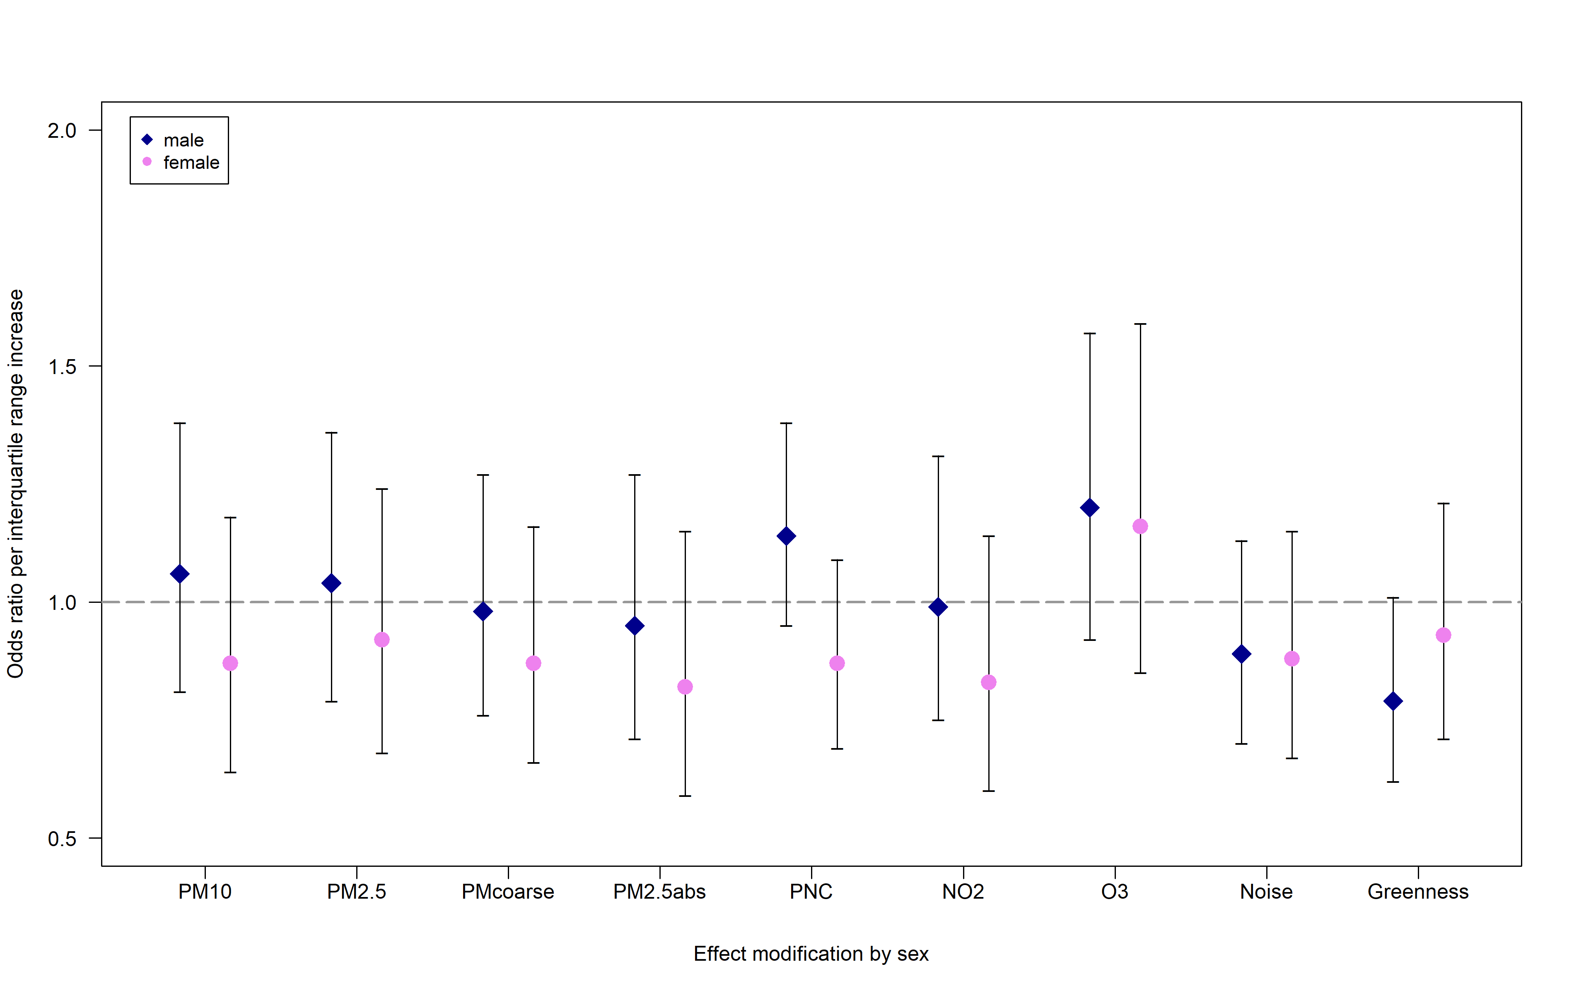

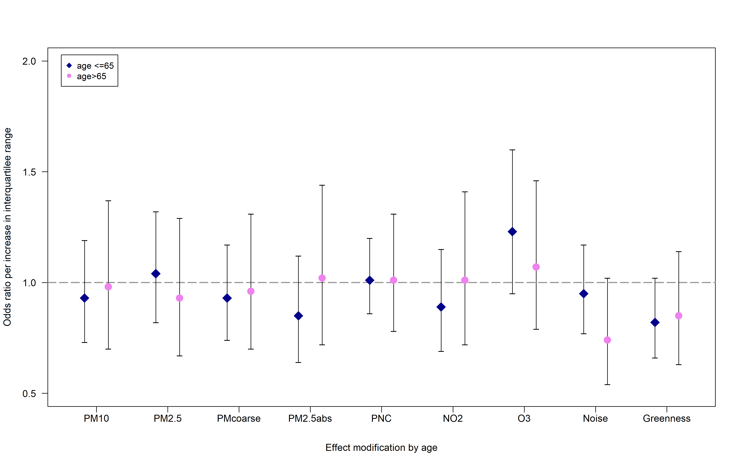

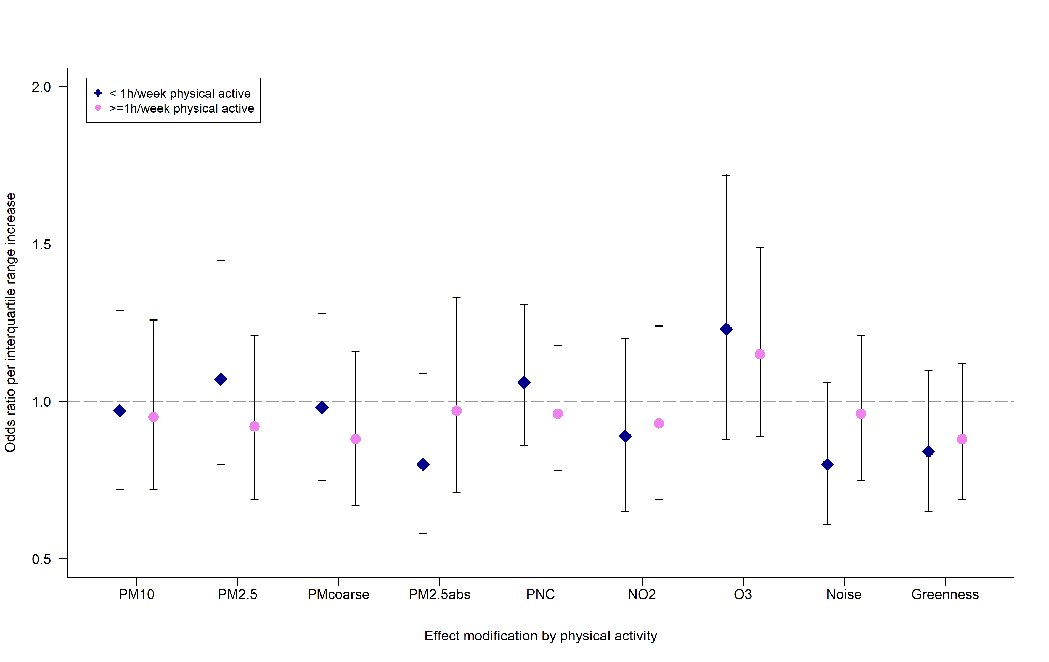

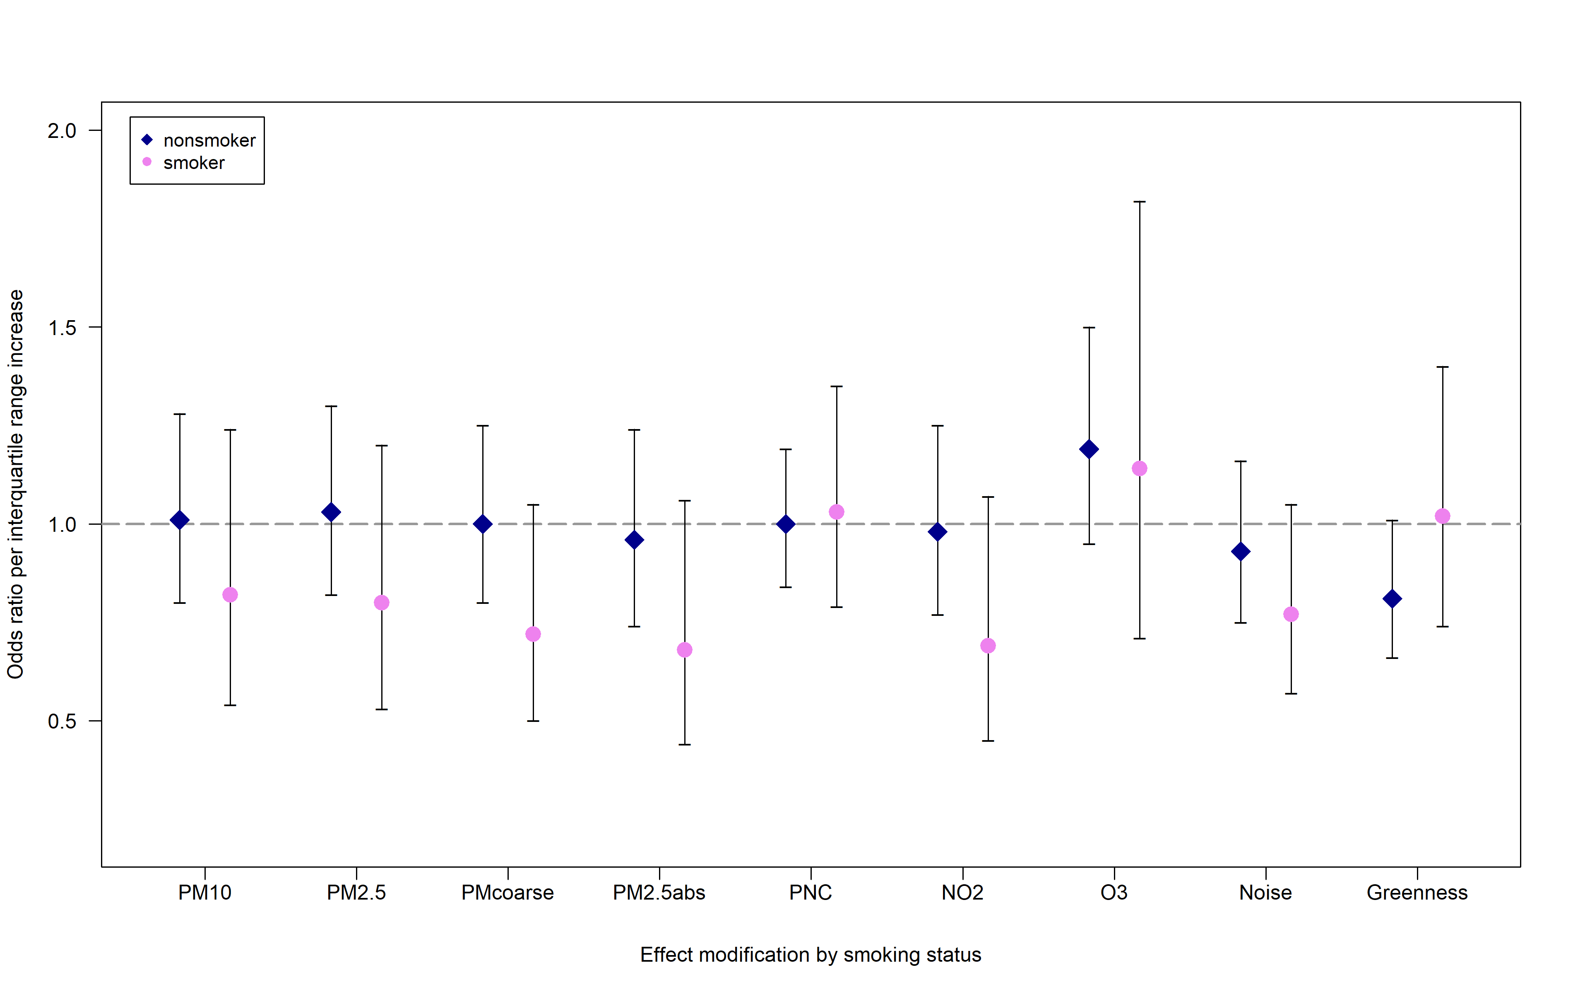

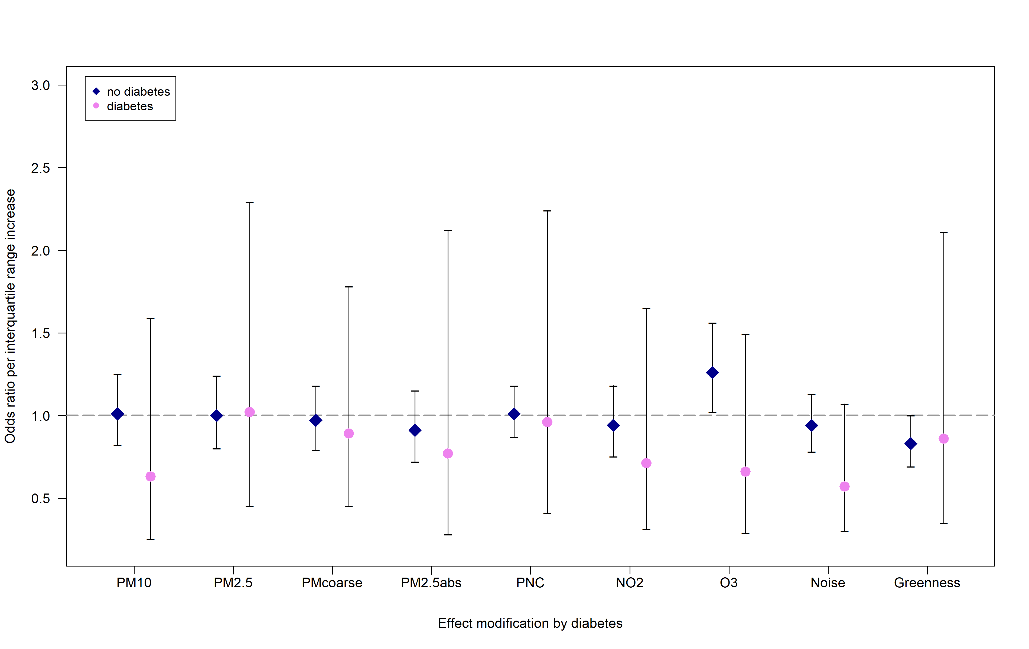

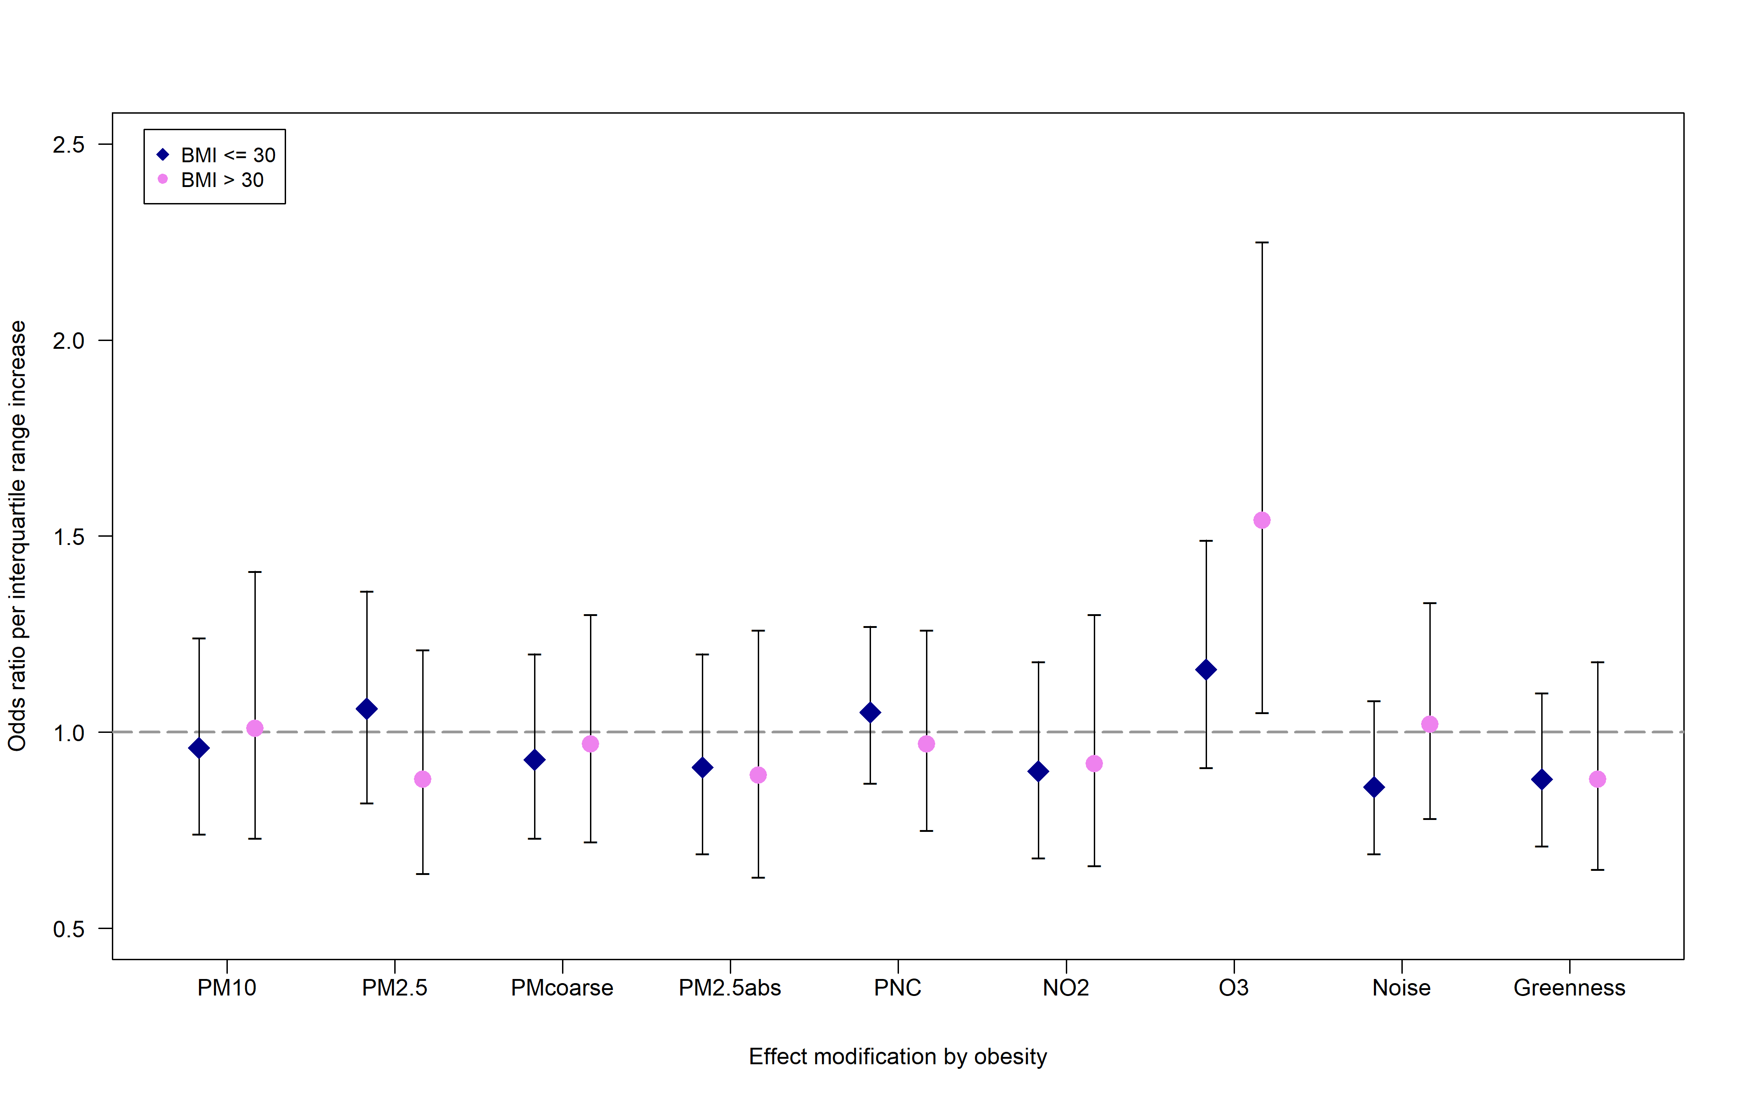

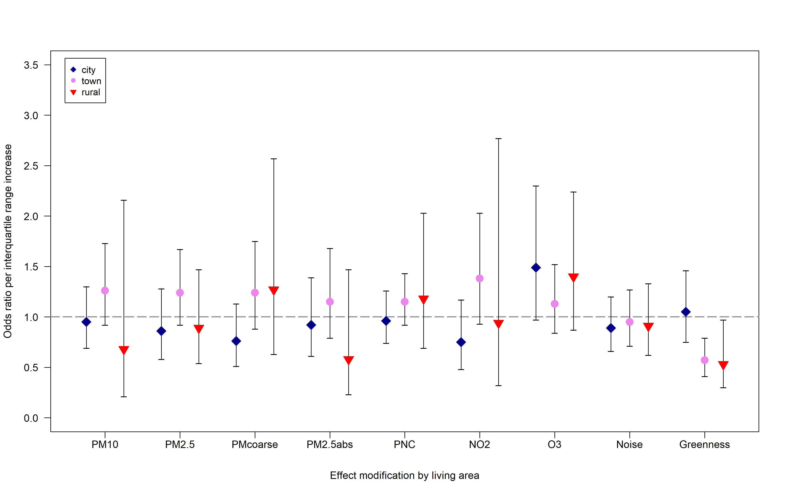

**Supplemental Figure 2: Results of effect modification analysis of PM2.5abs, PM2.5 and residential greenspace for the cross-sectional analysis at KORA F4. Odds ratios per interquartile range increase in exposure for prevalent metabolic syndrome using the main model**

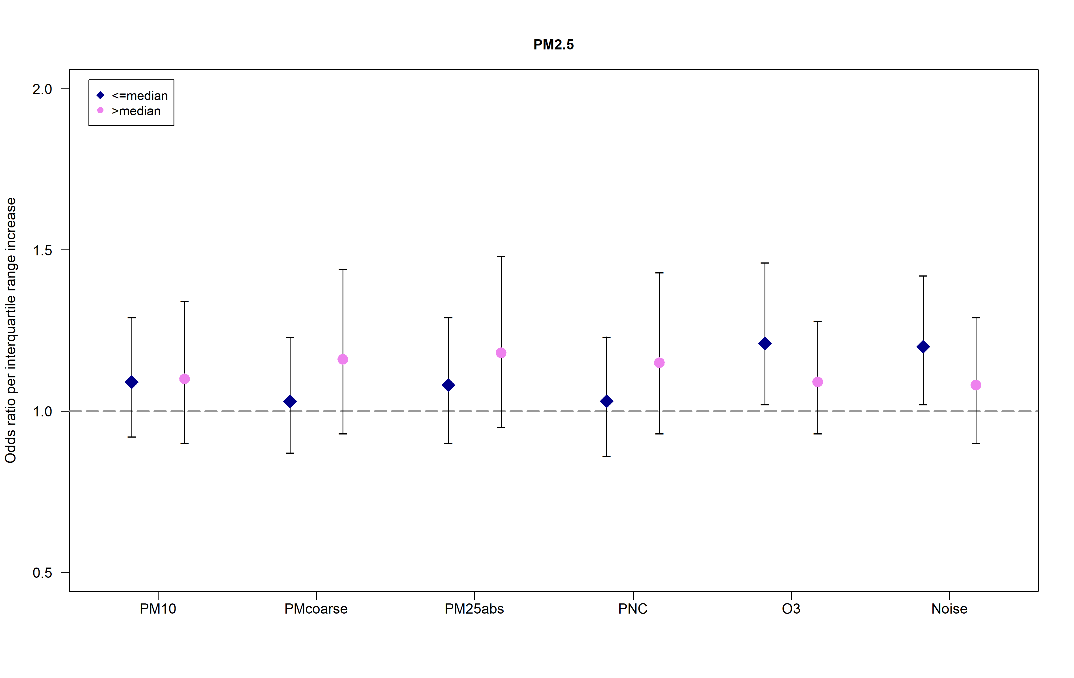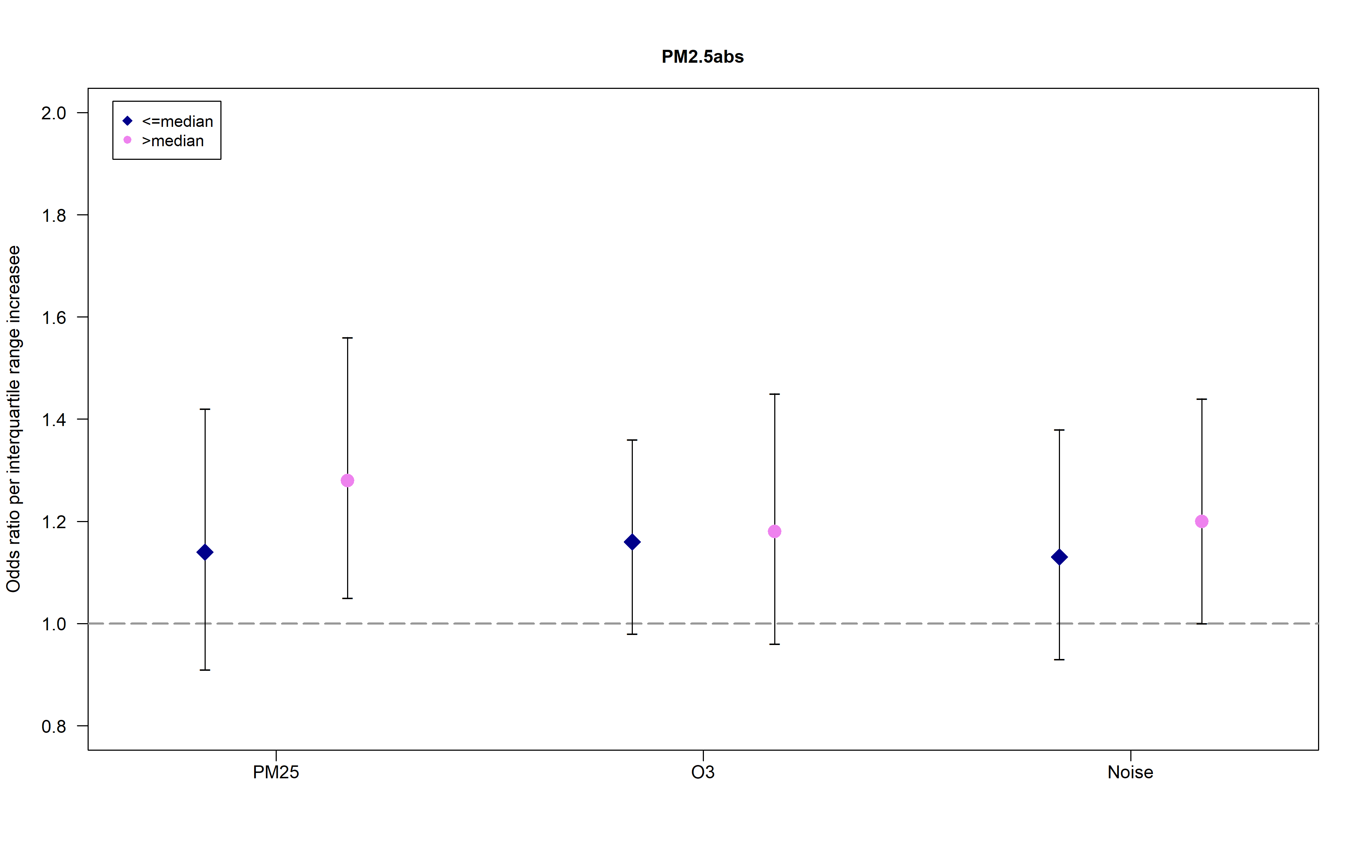

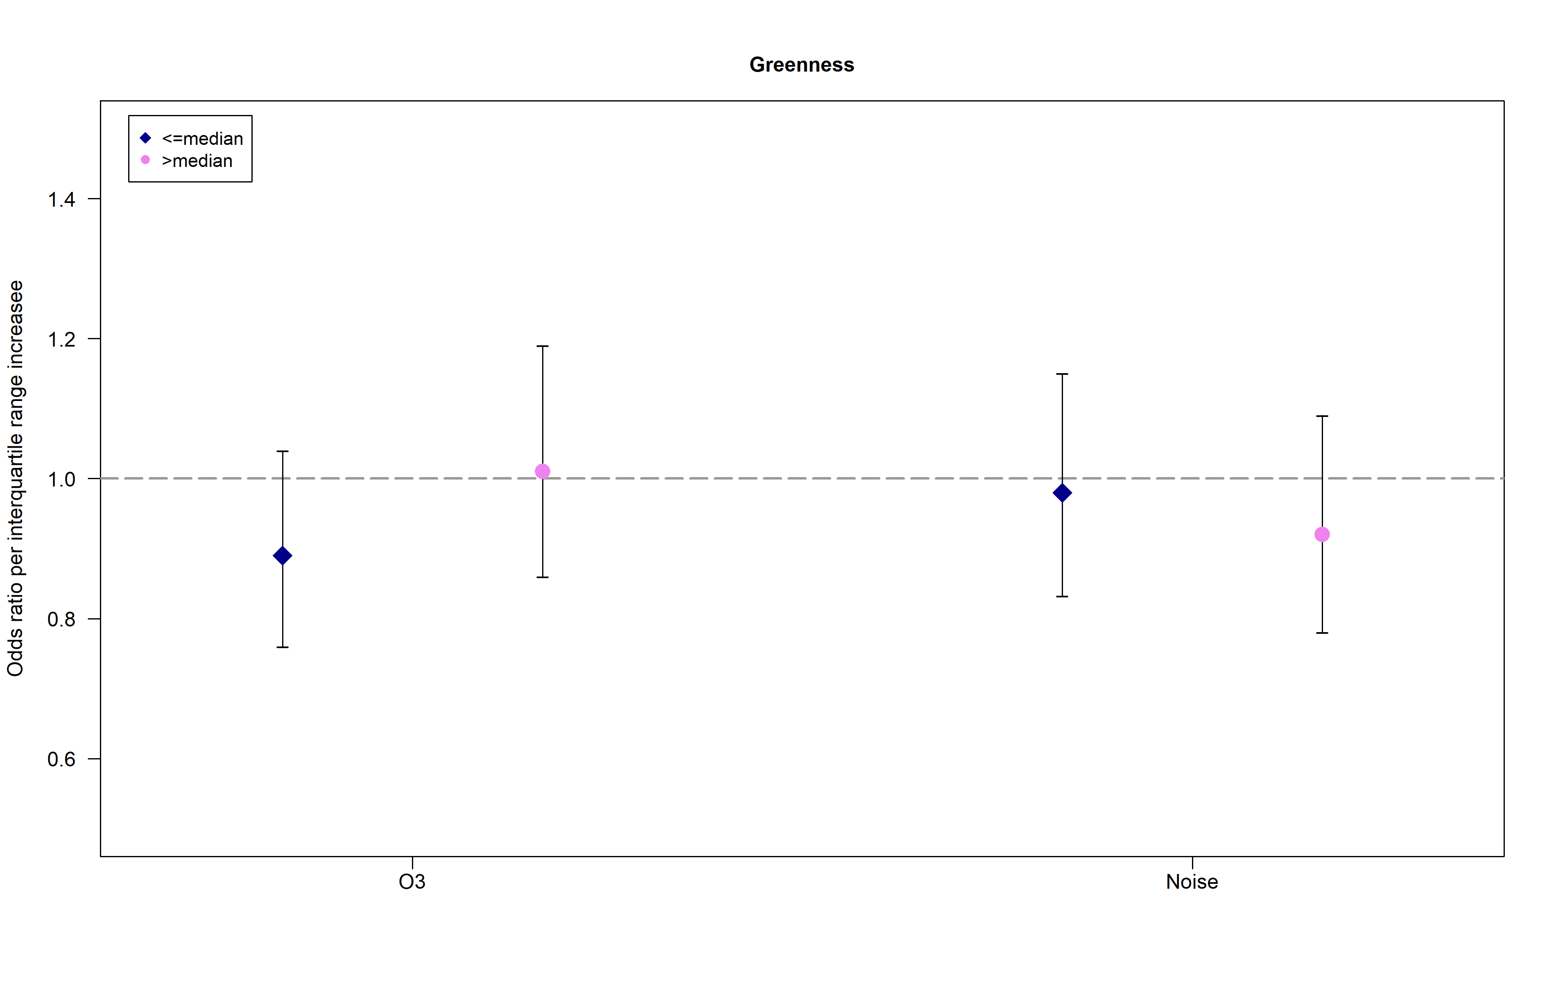

**Supplemental Figure 3: Dose-response functions in the cross-sectional analysis for prevalent MetS using Generalized Additive Models and the Main Model**

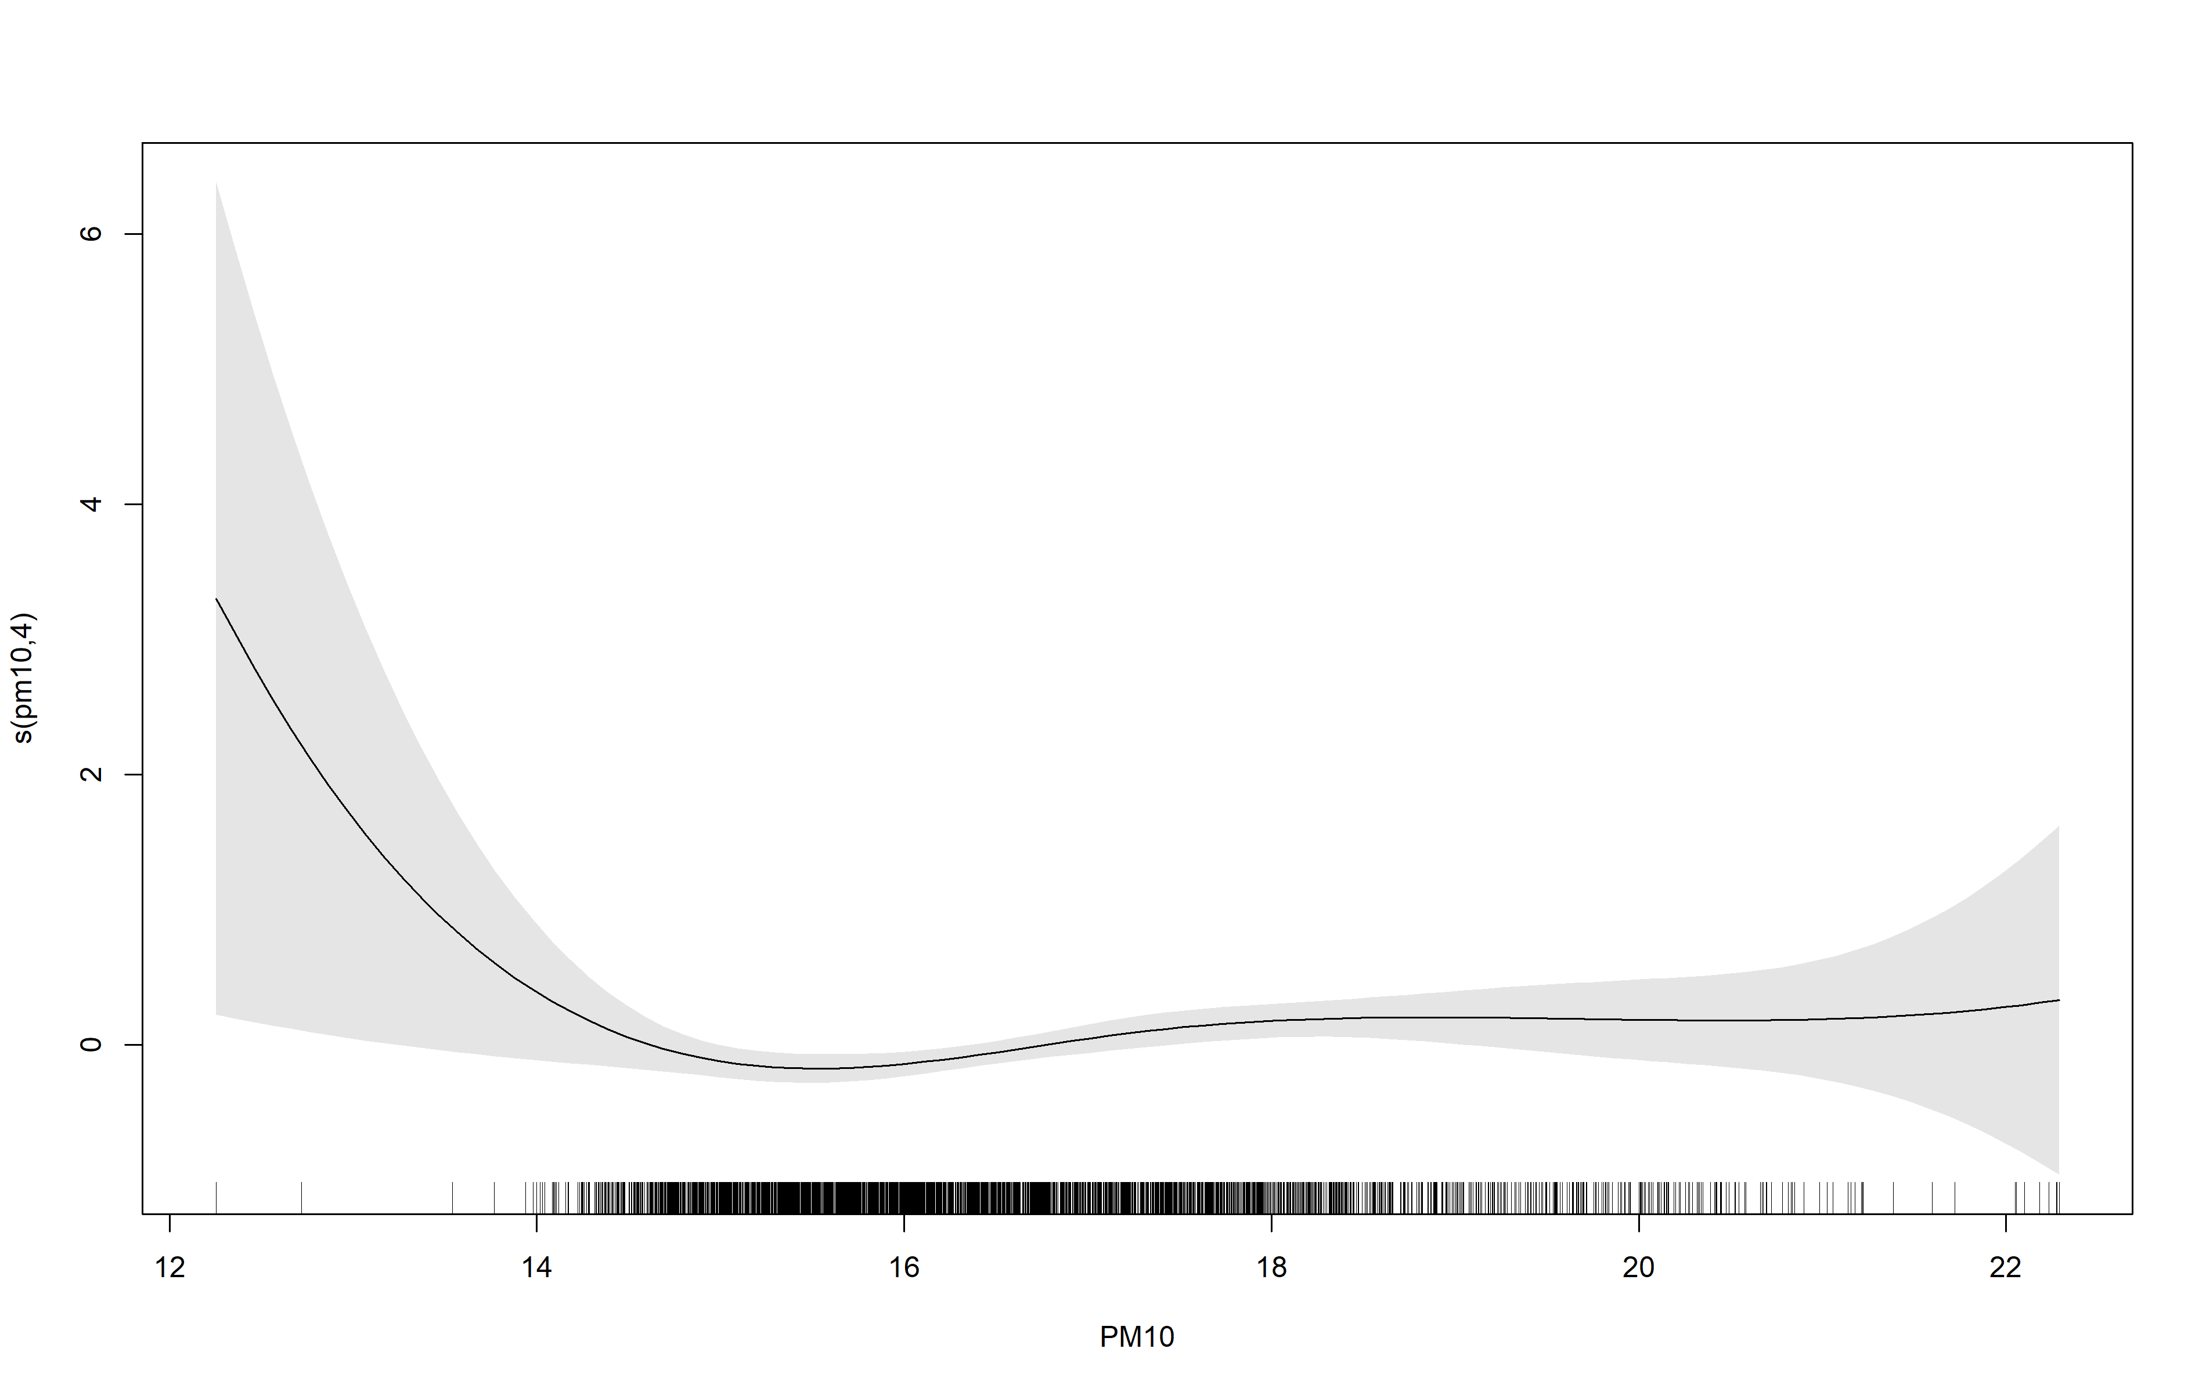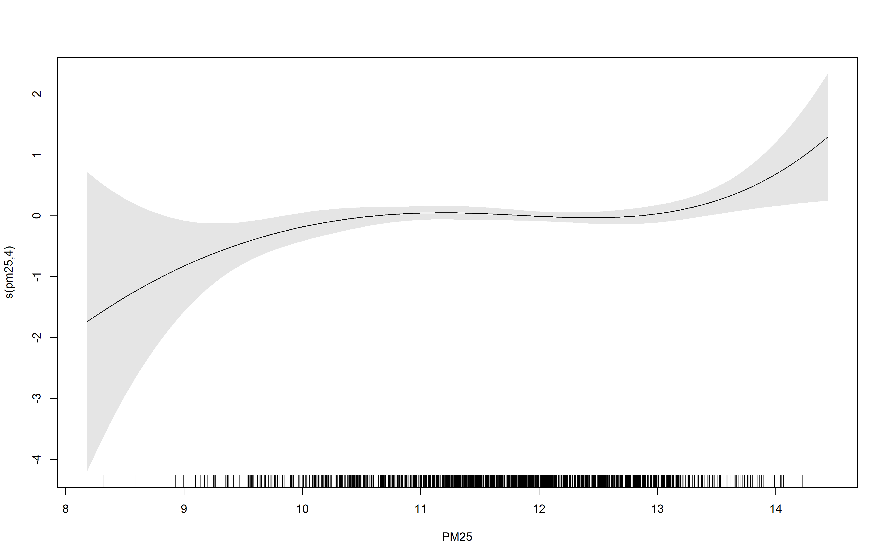

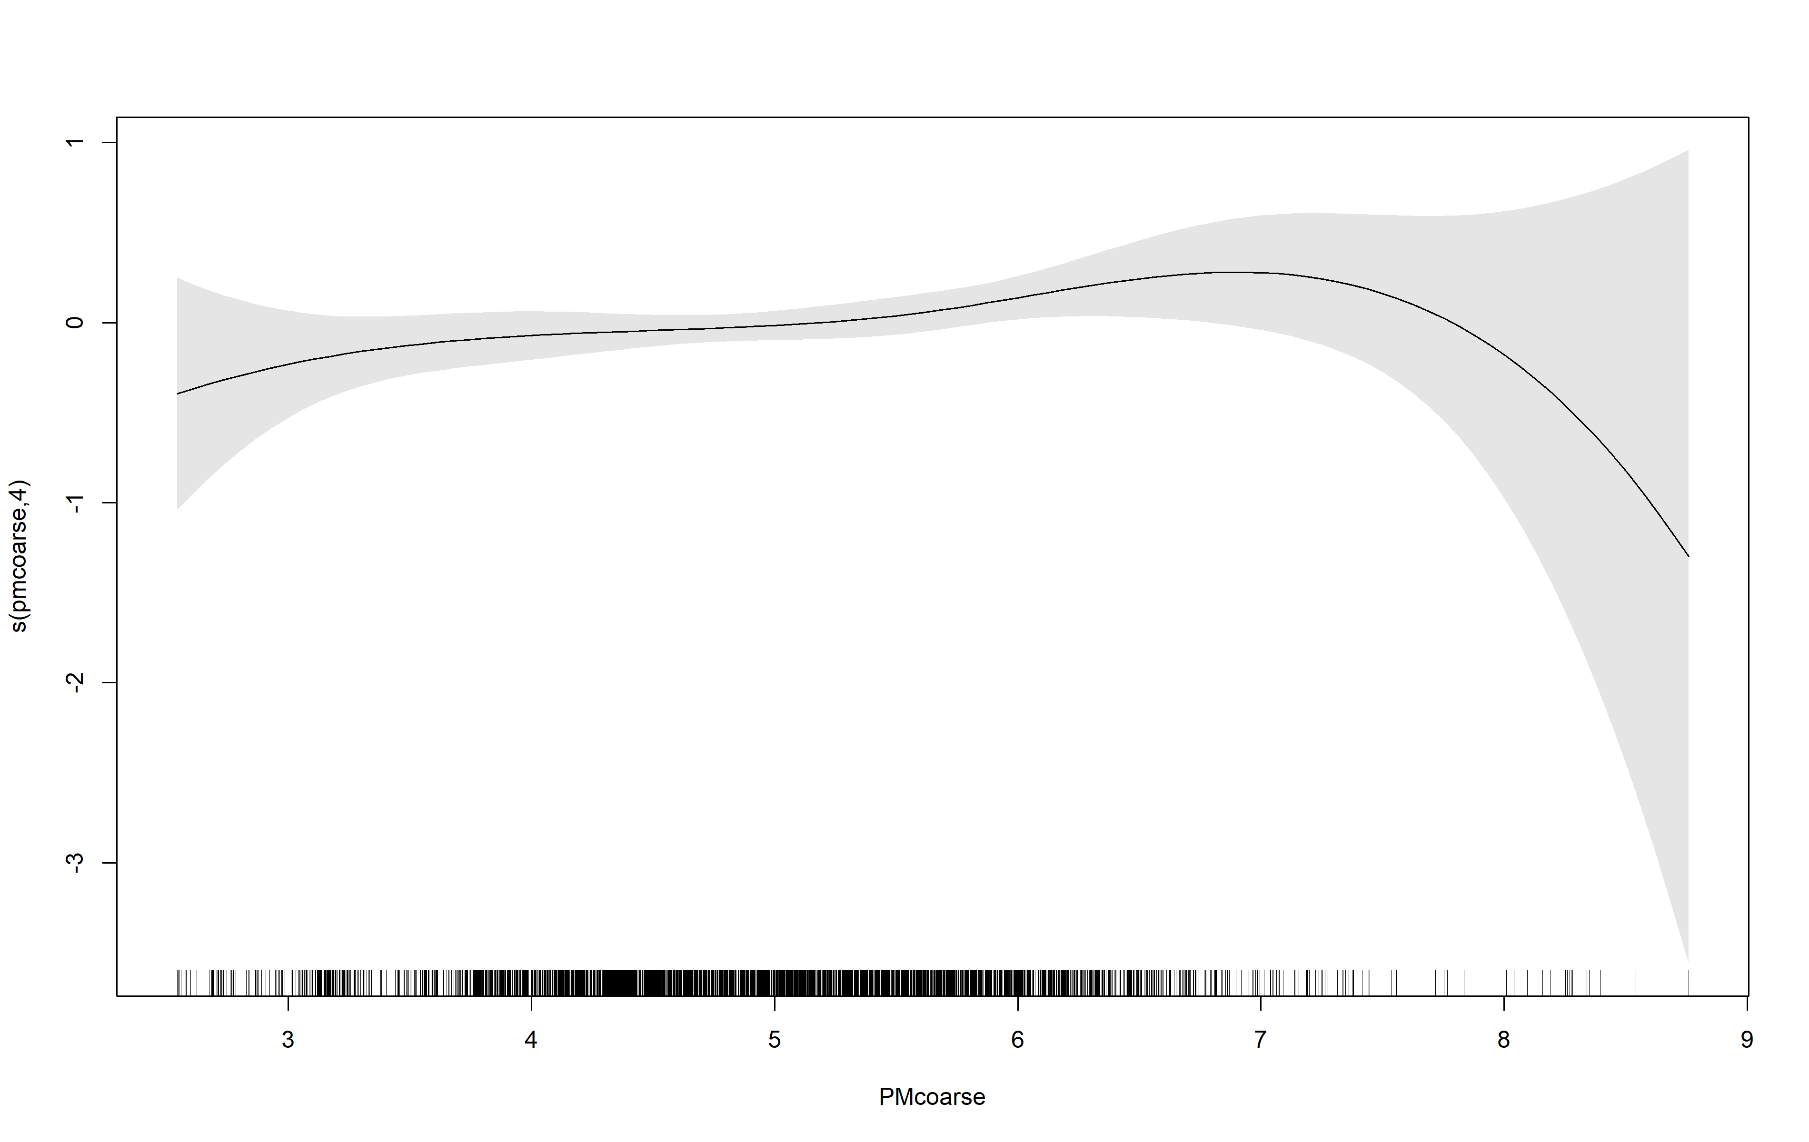

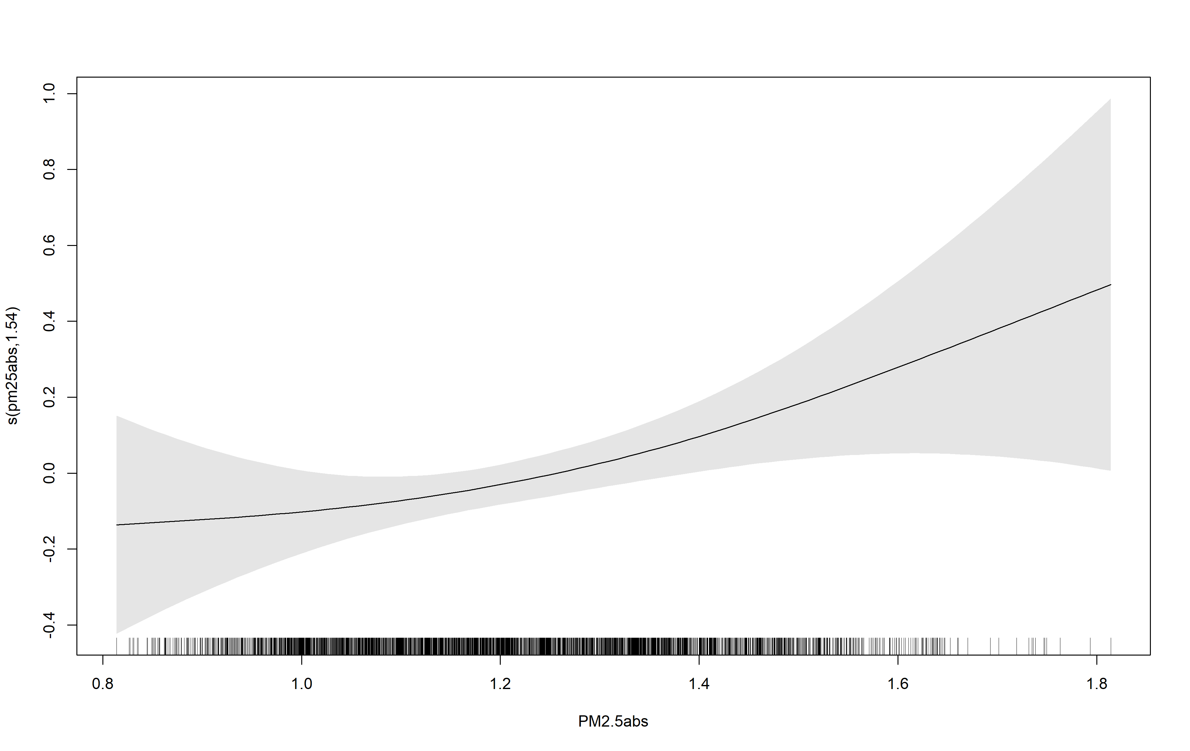

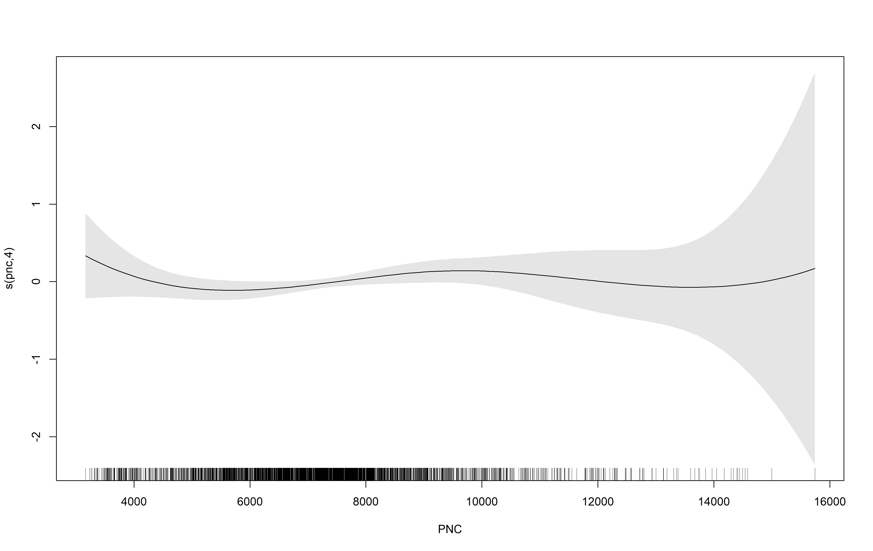

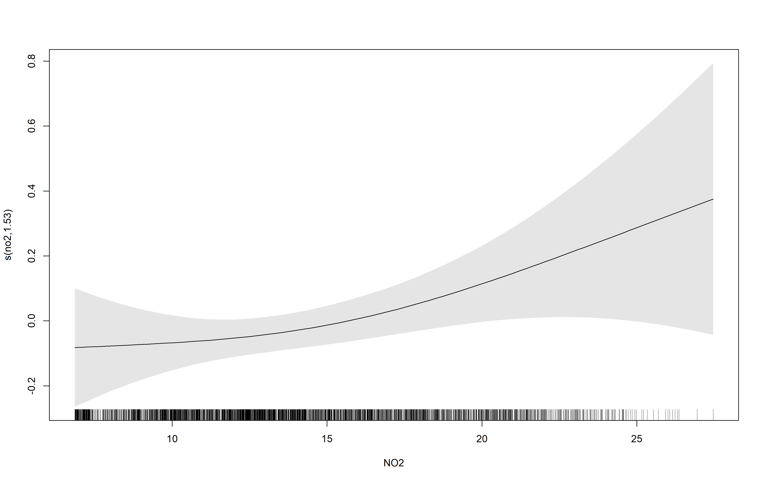

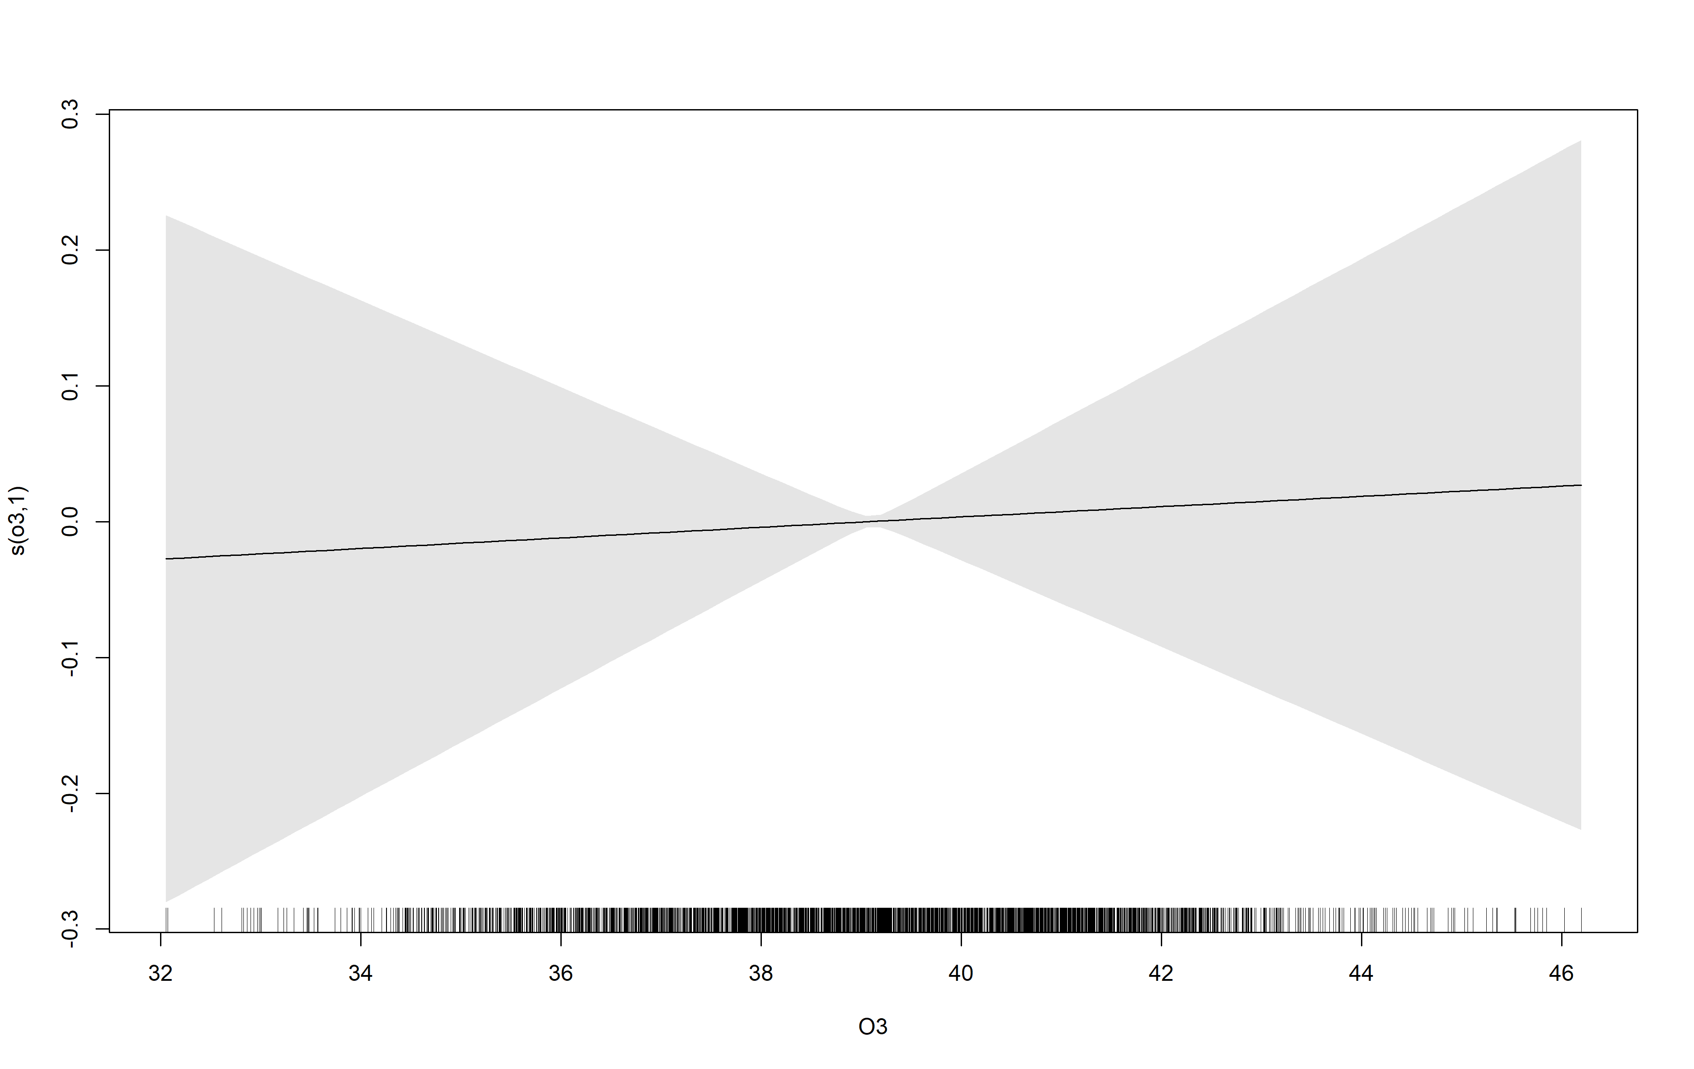

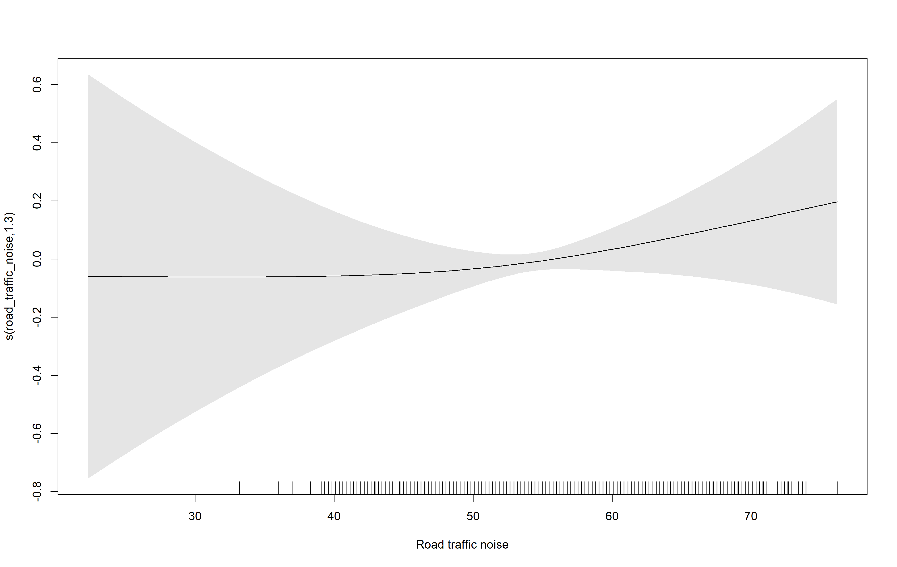

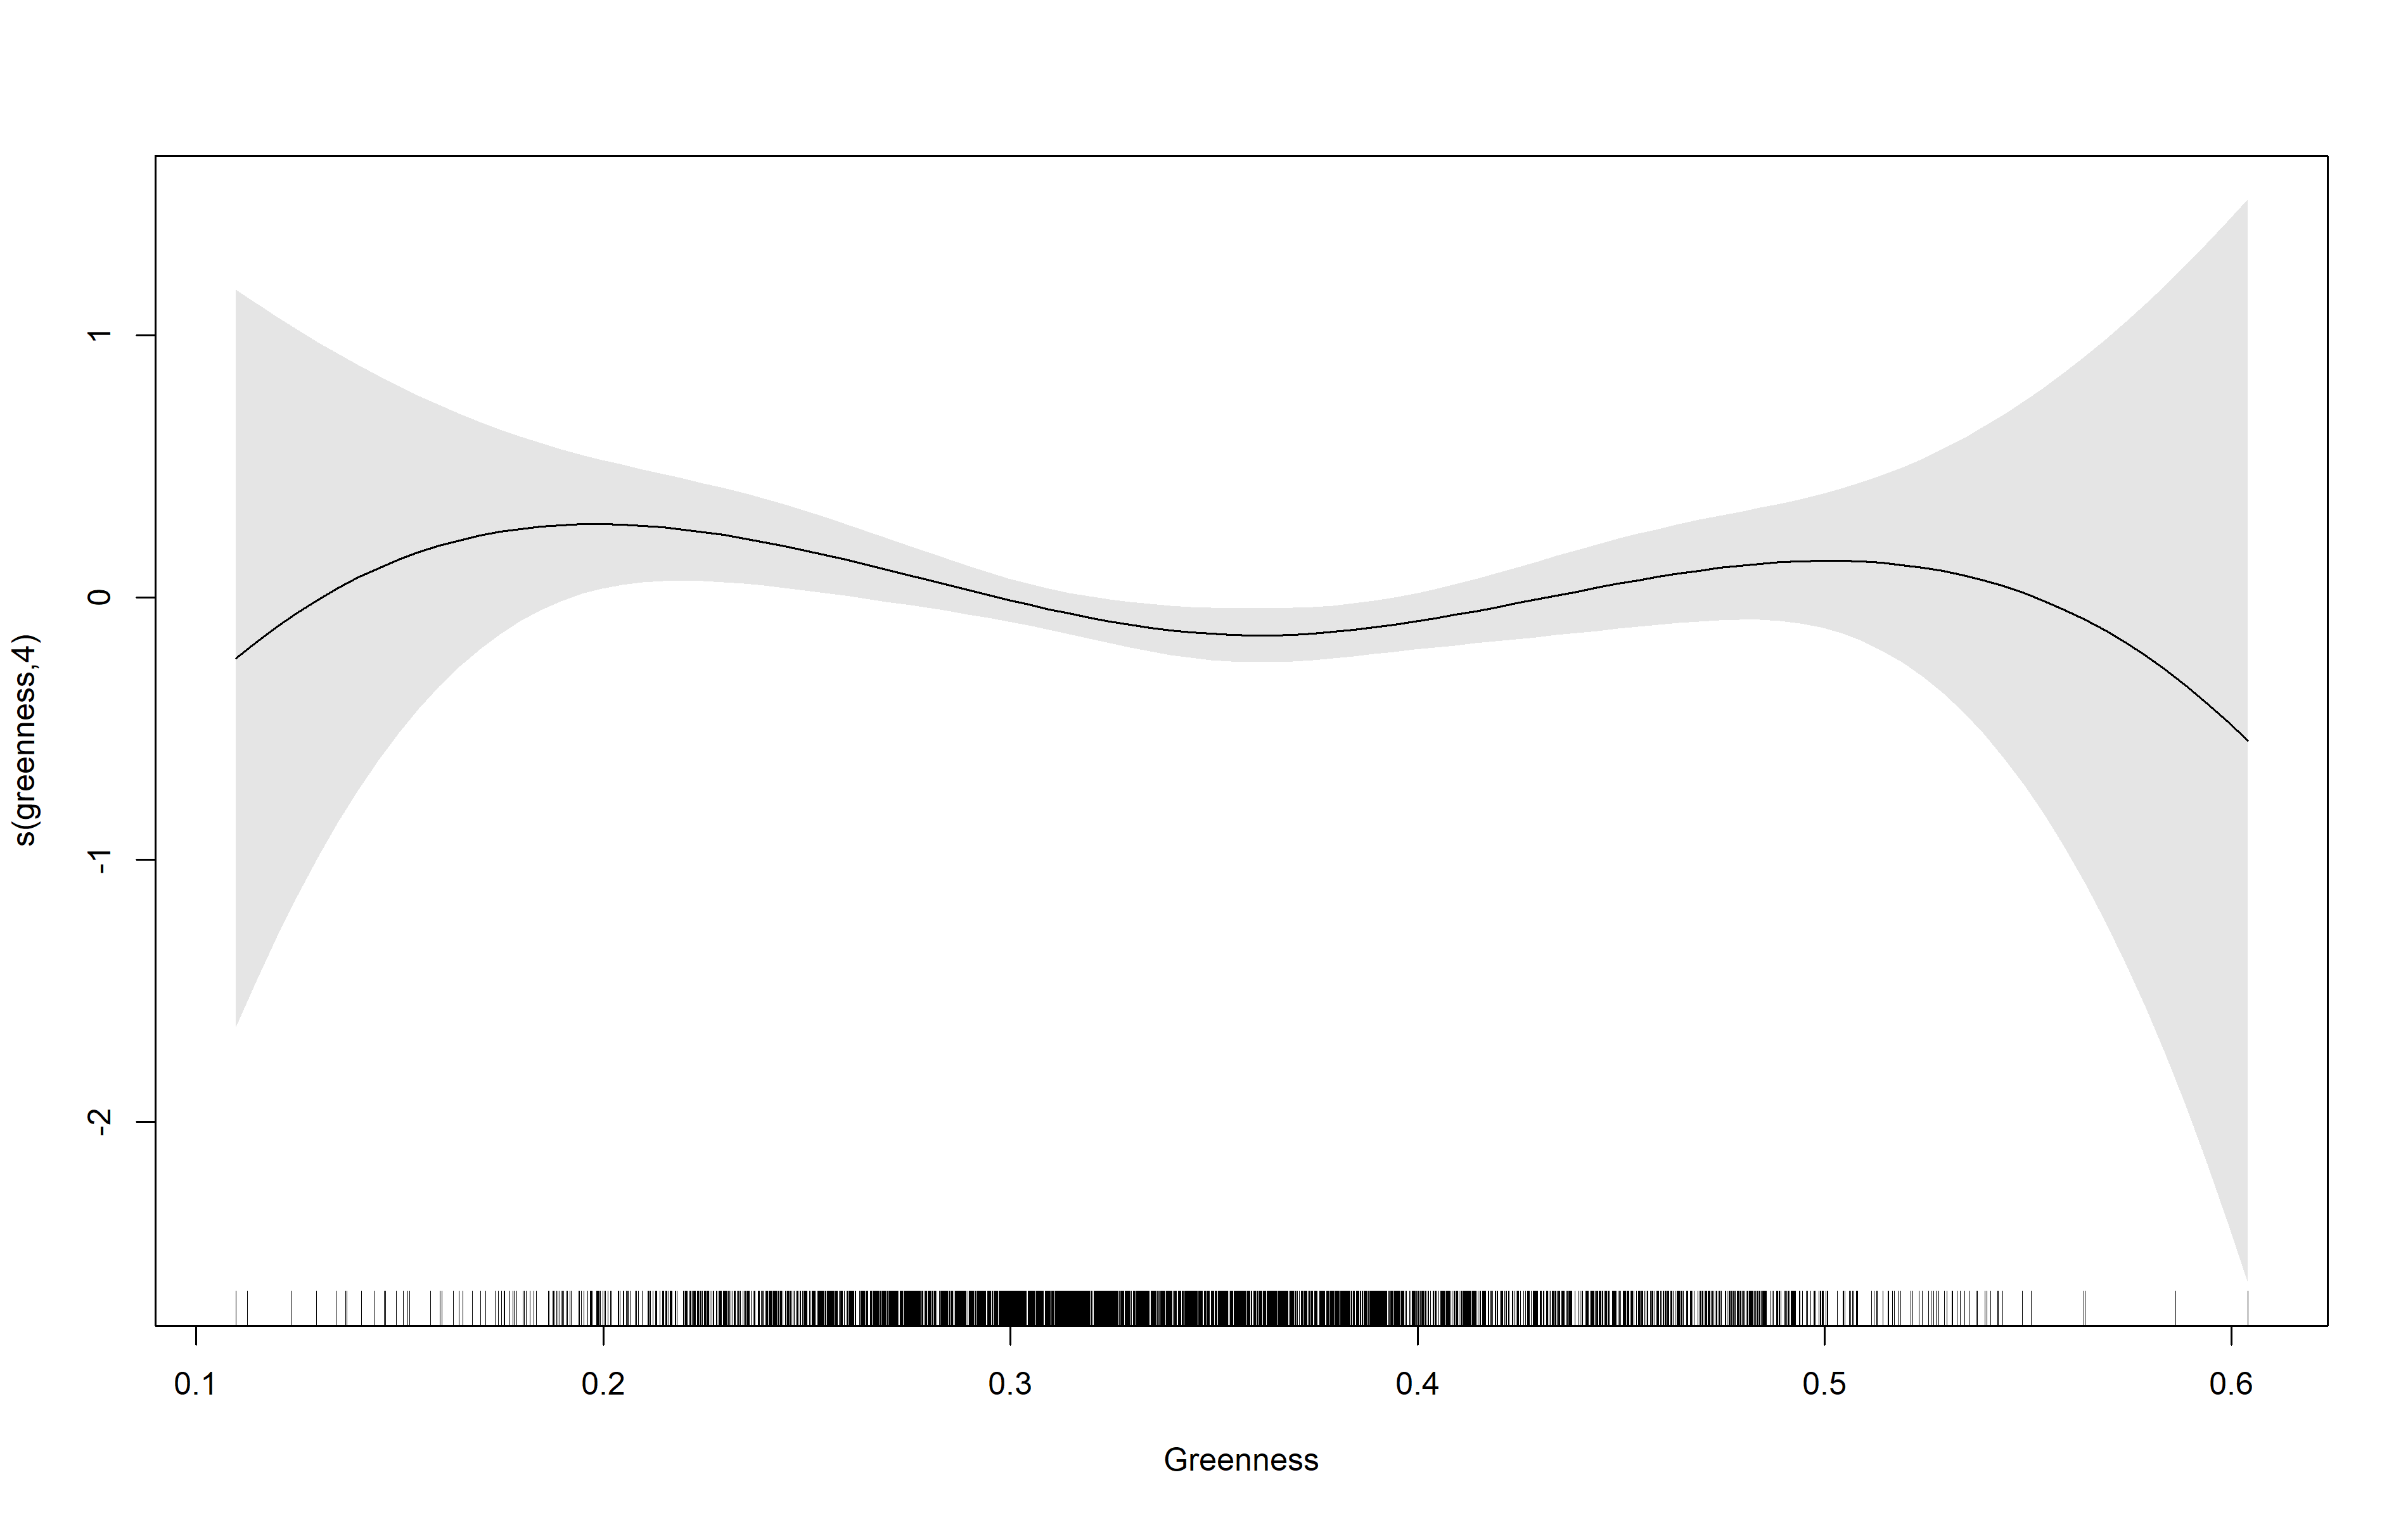

**Supplemental Figure 4: Dose-response functions in the longitudinal analysis for incident MetS using Generalized Additive Mixed Models and the Main Model**

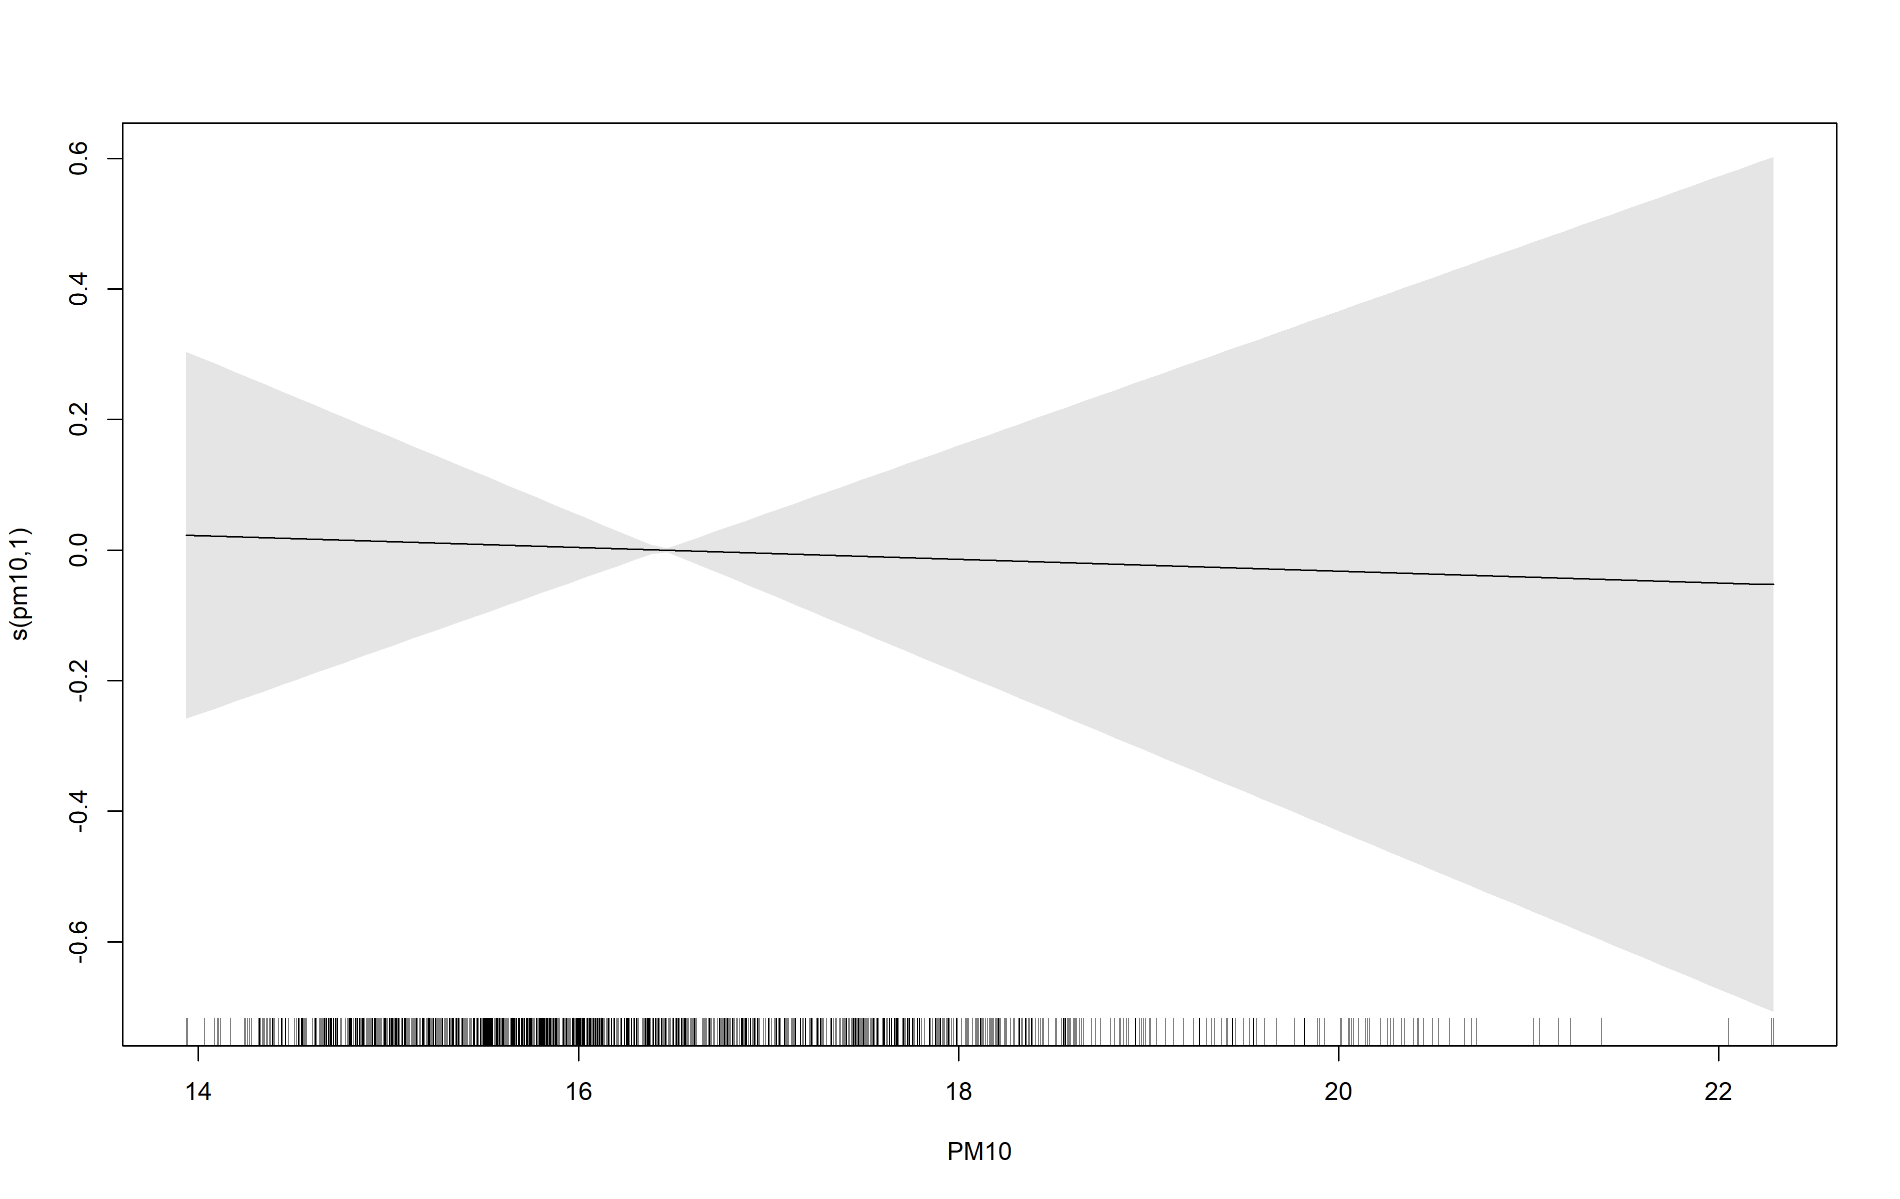

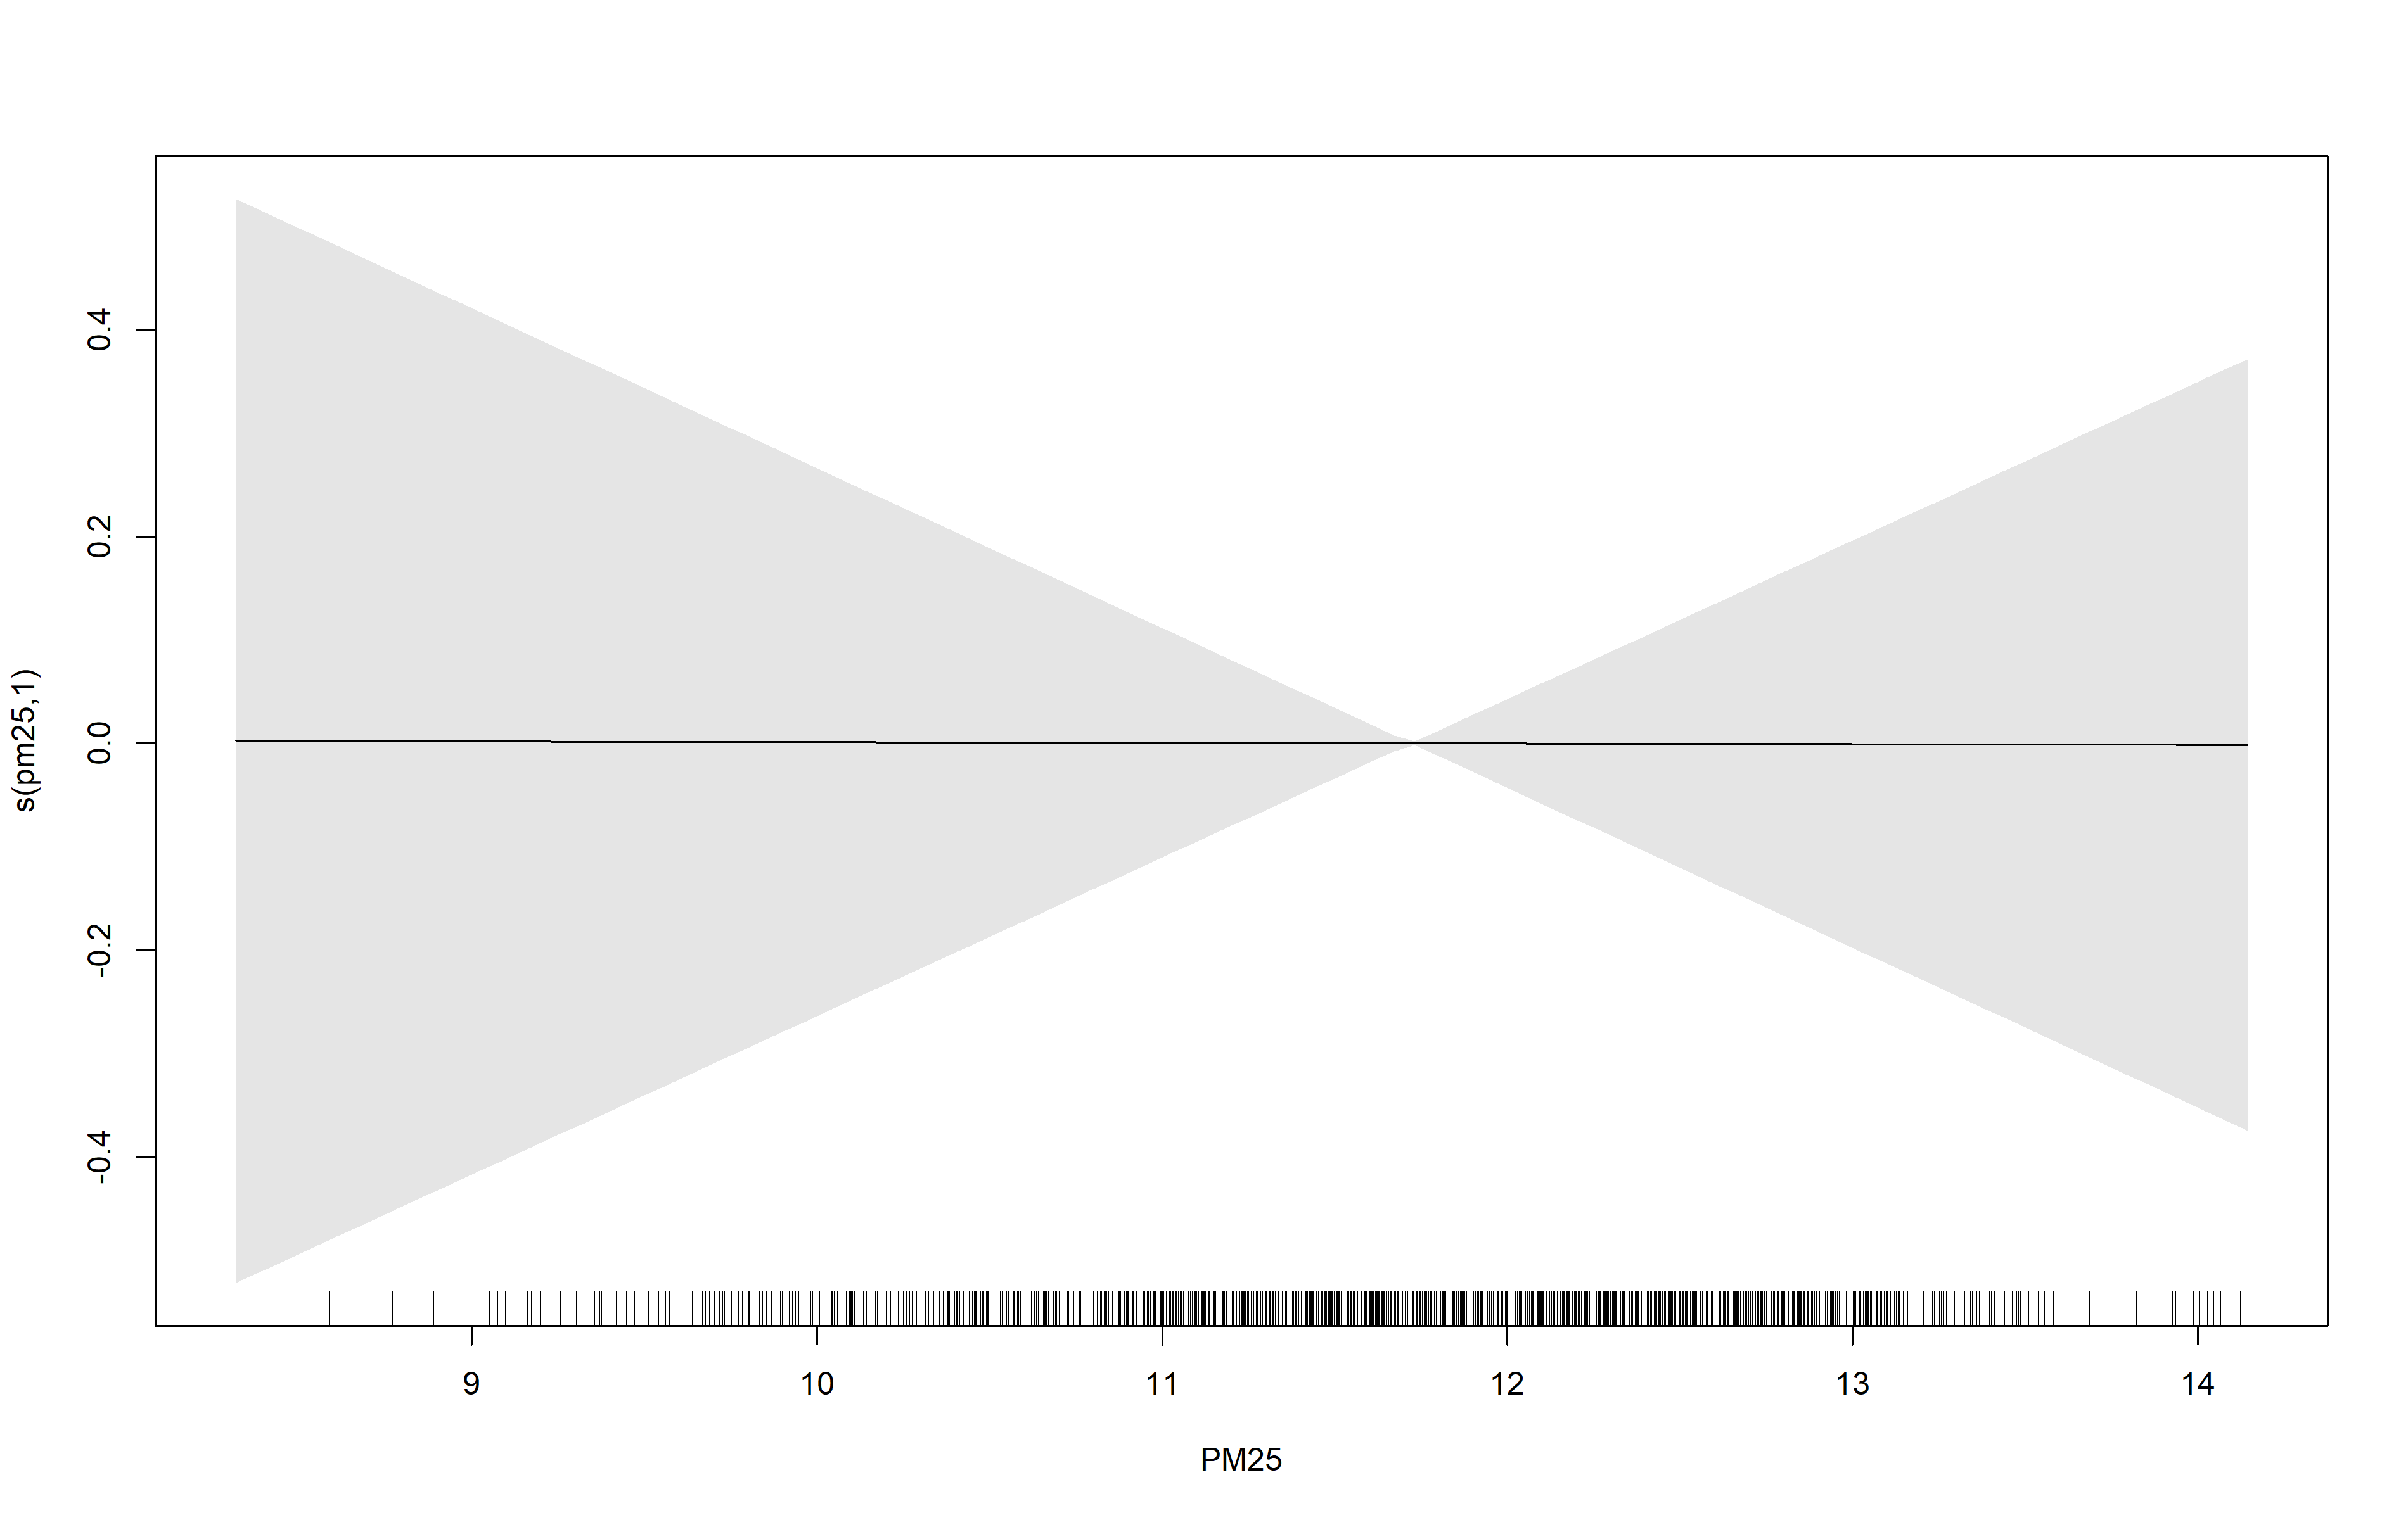

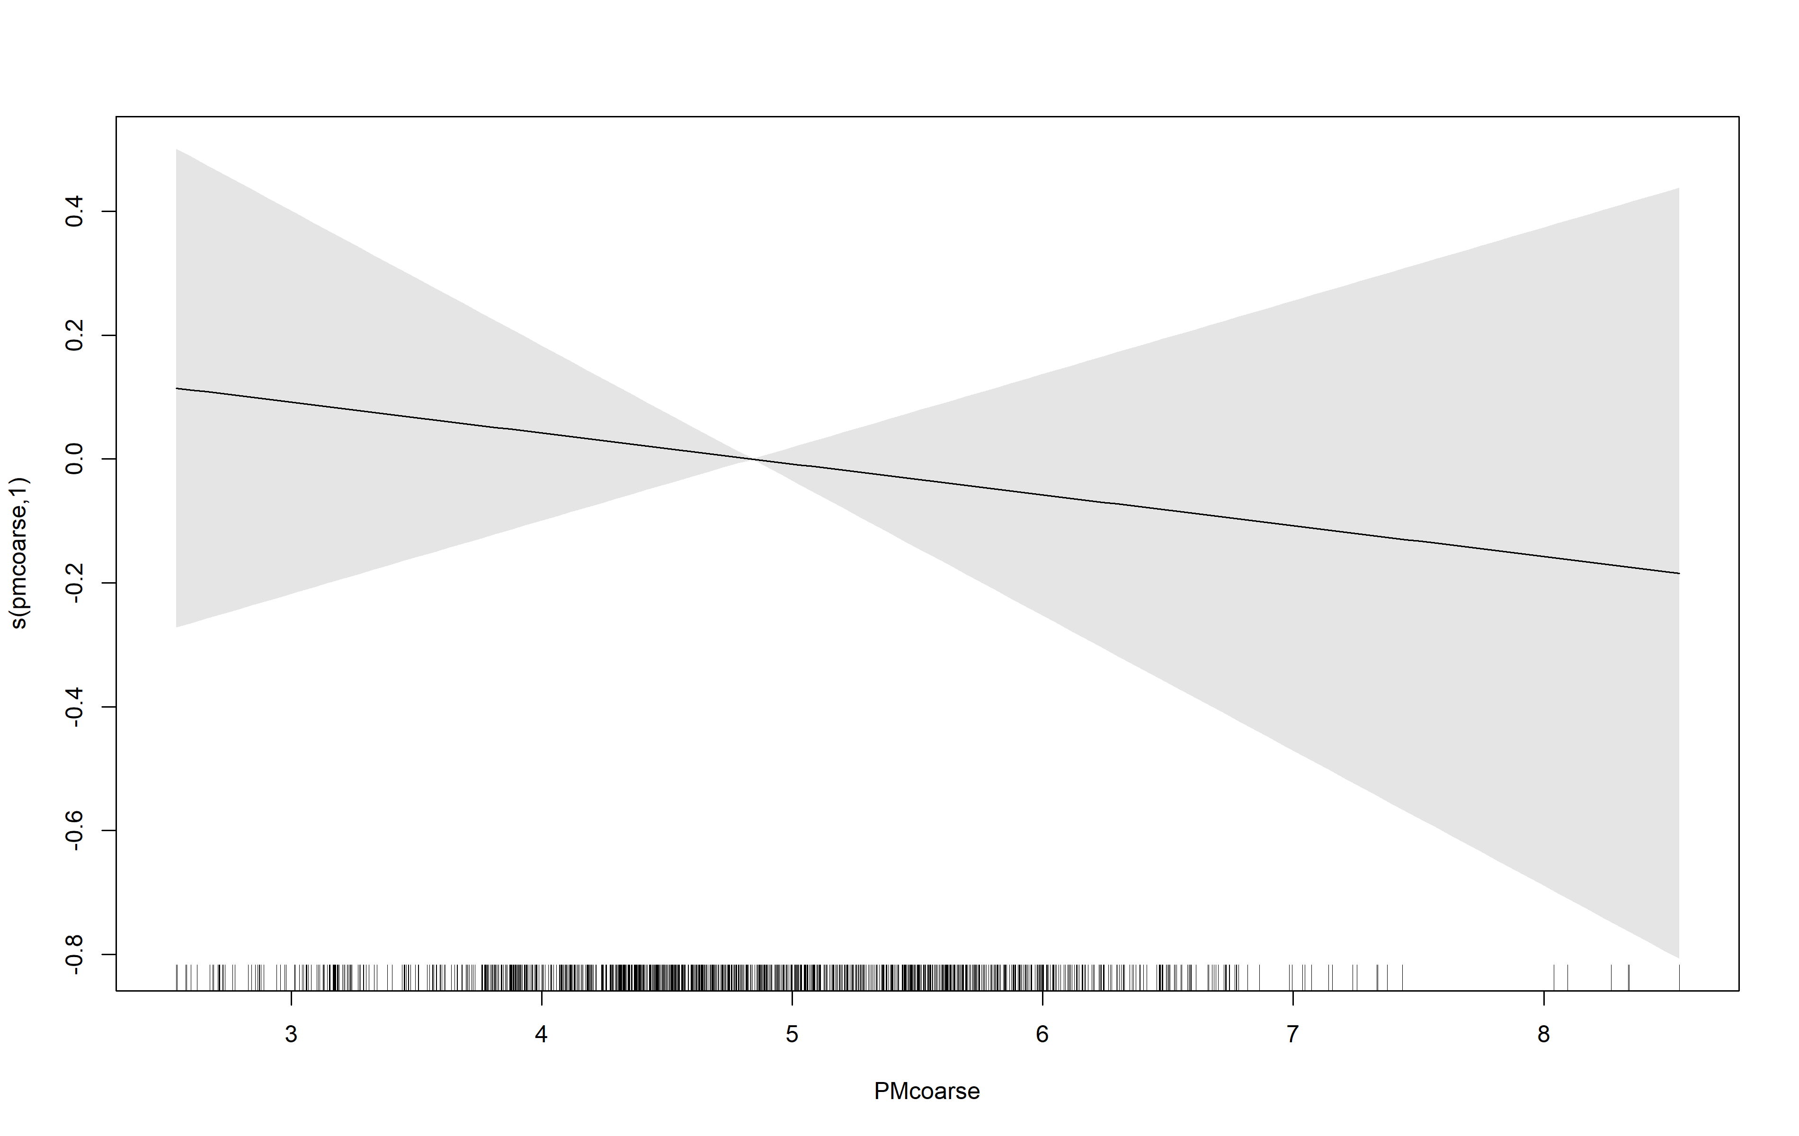

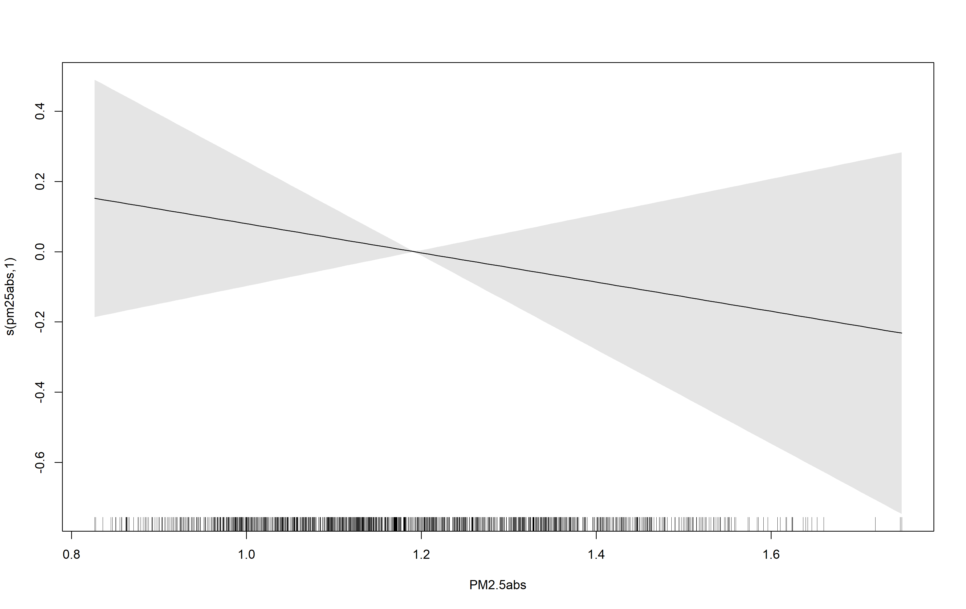

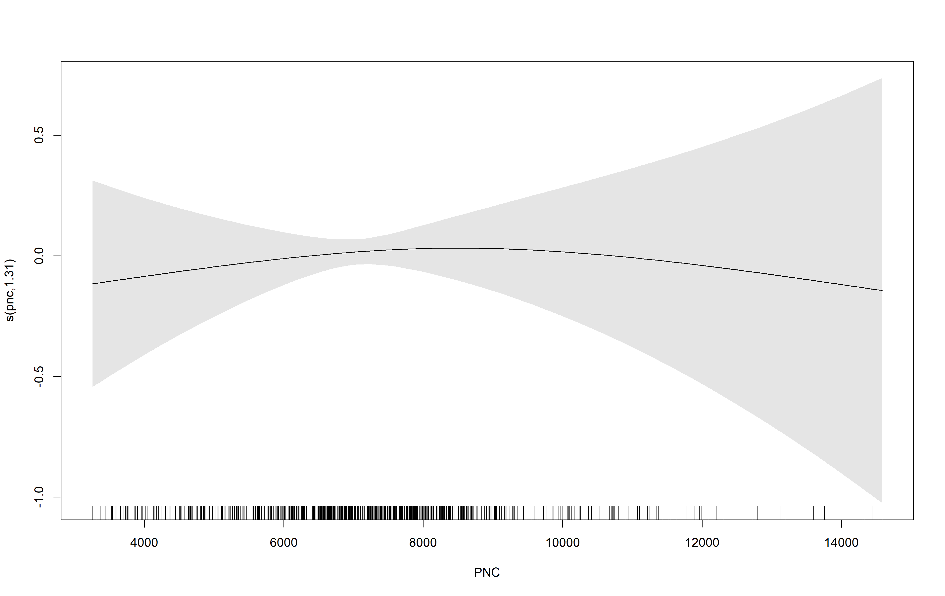

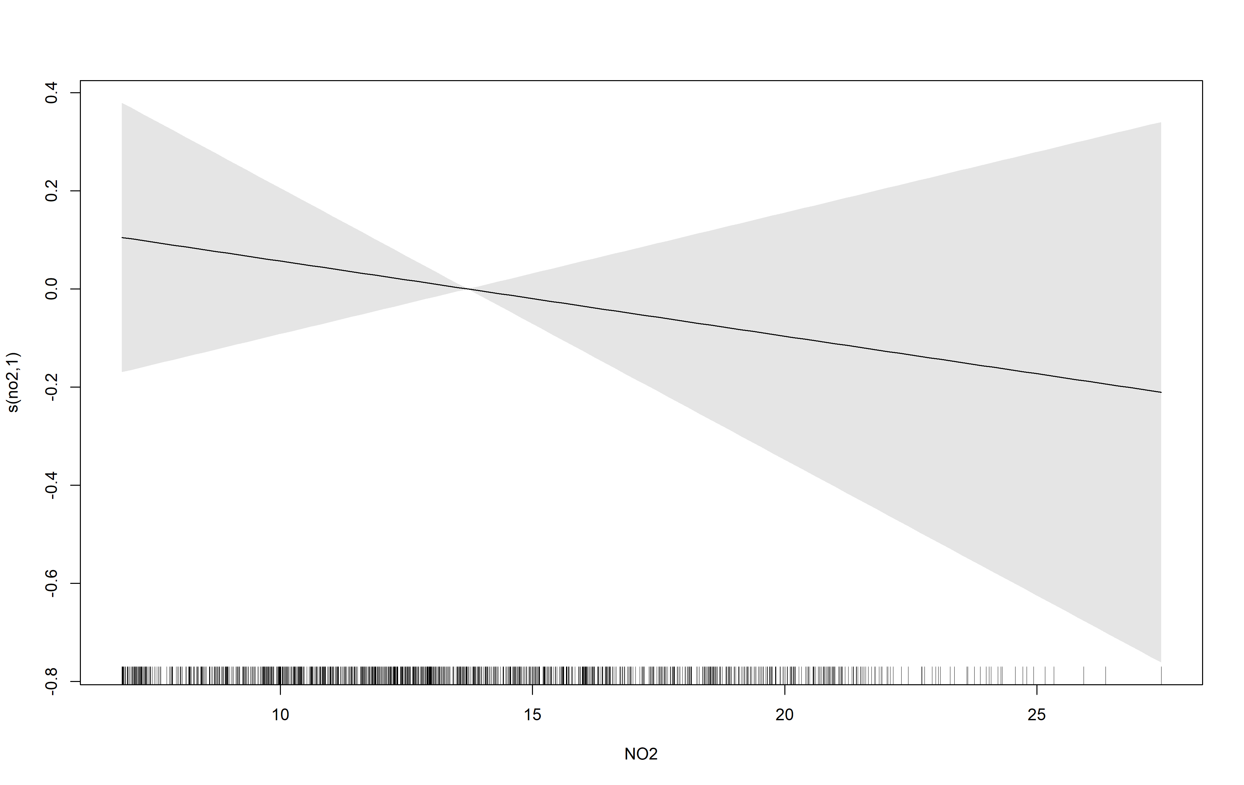

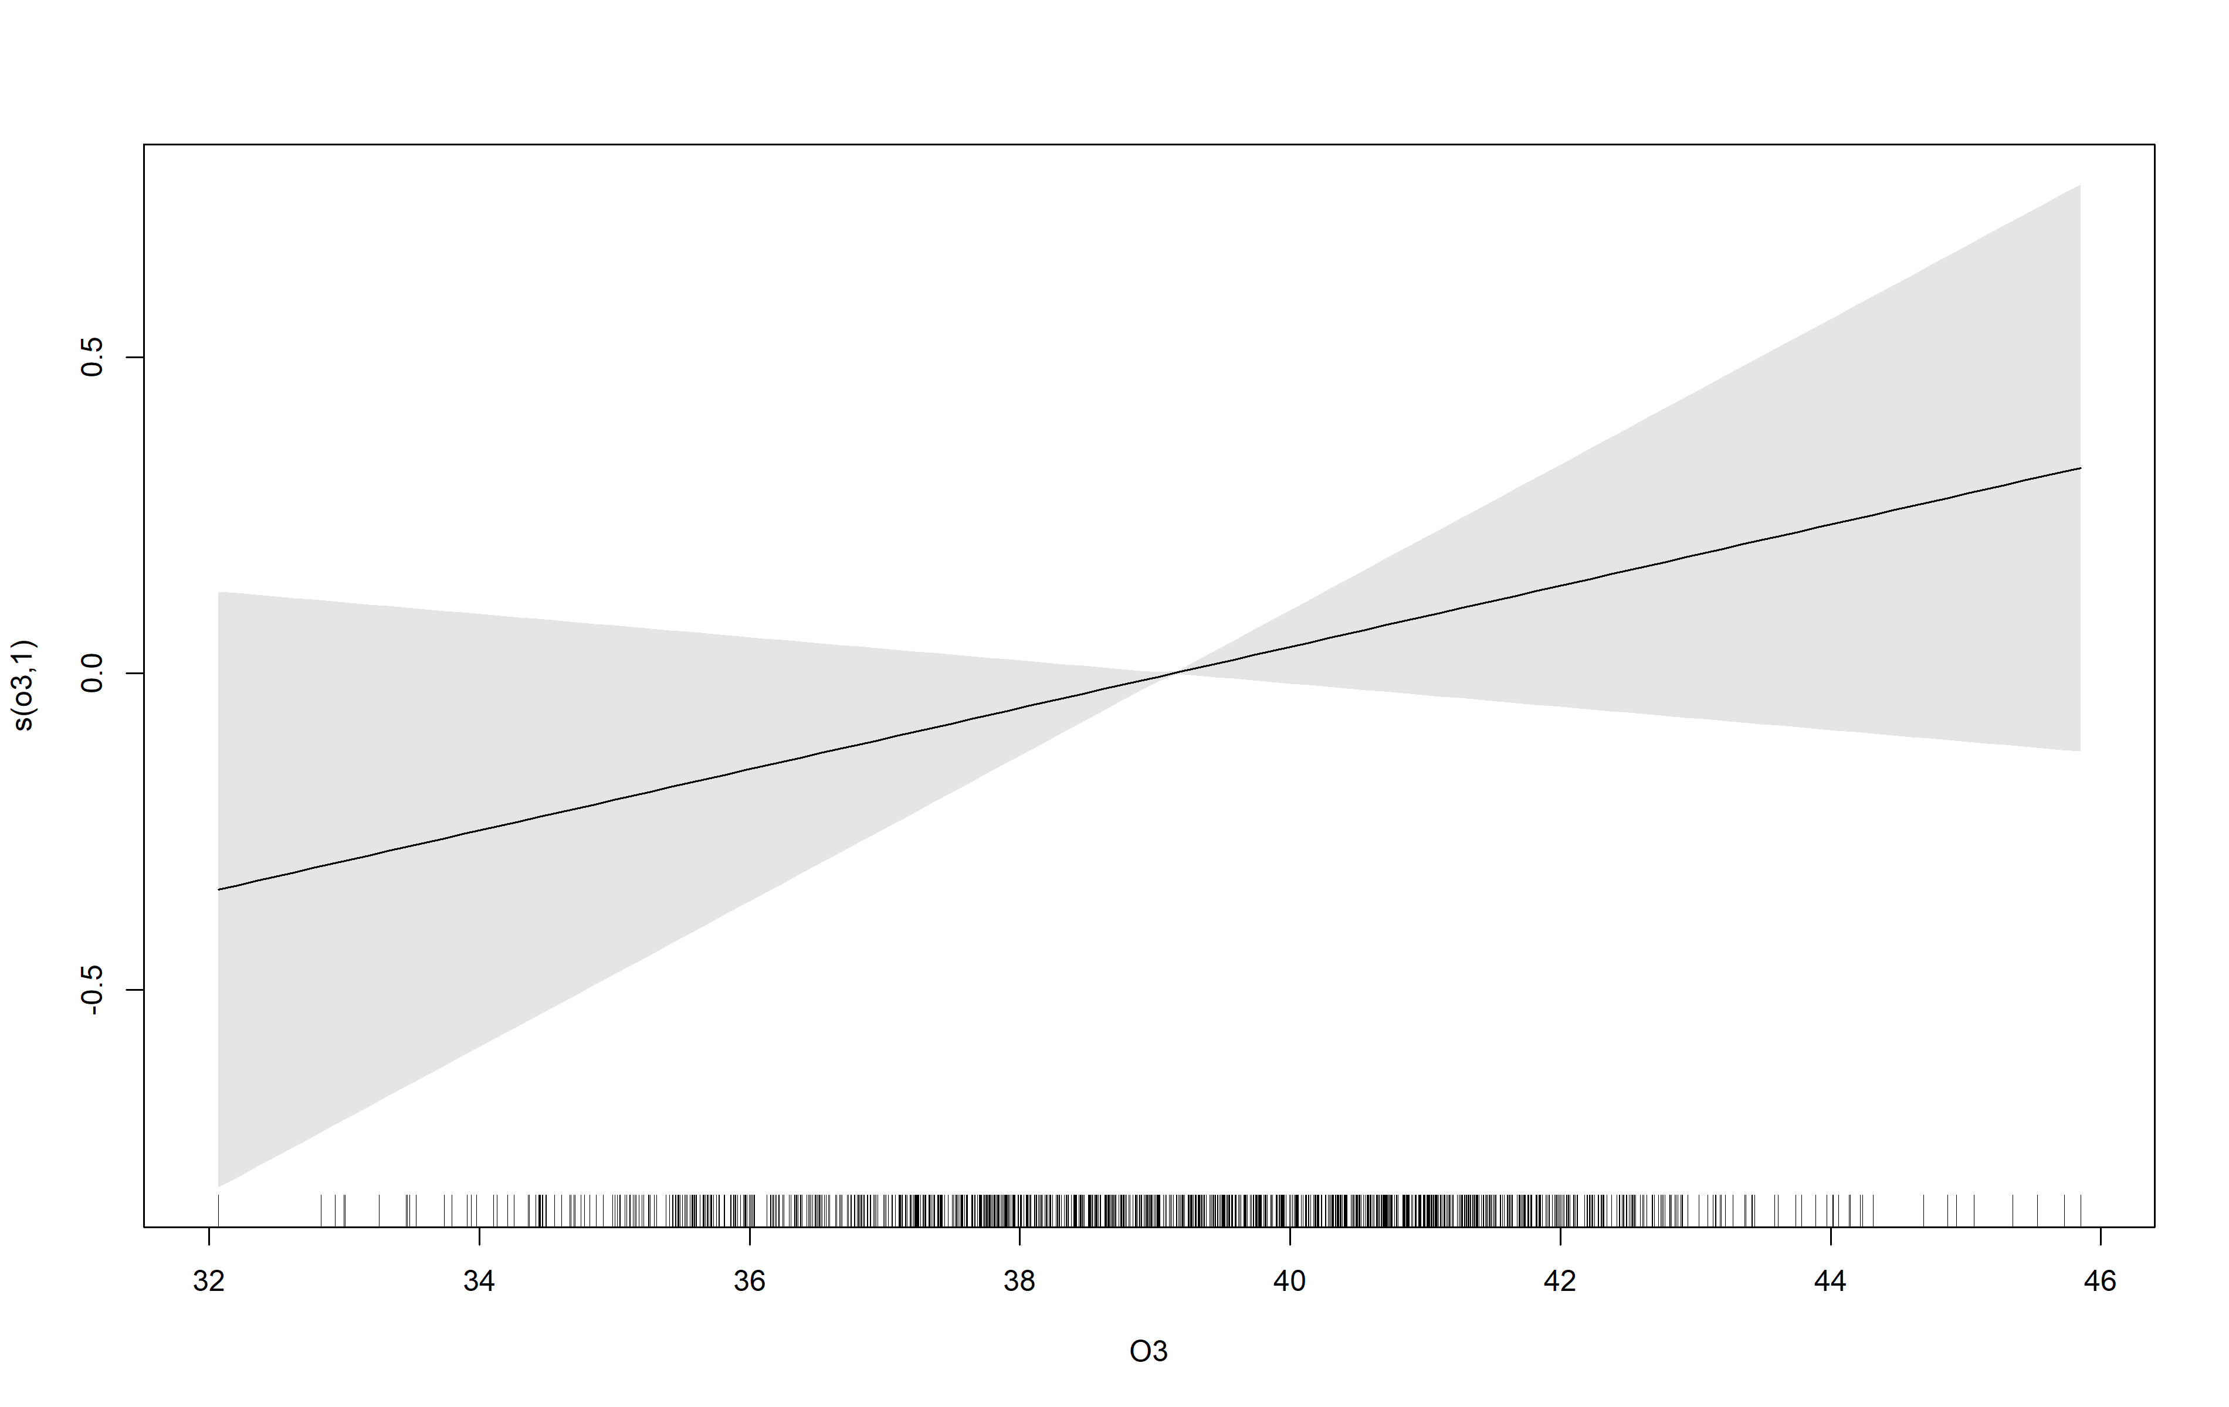

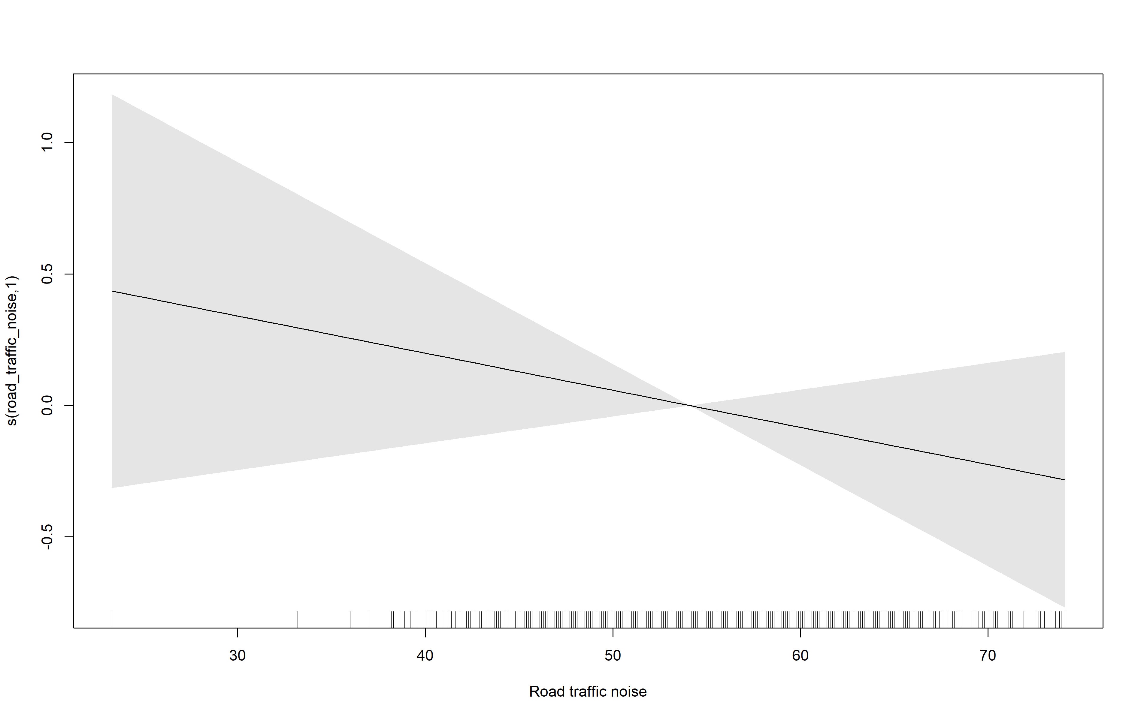

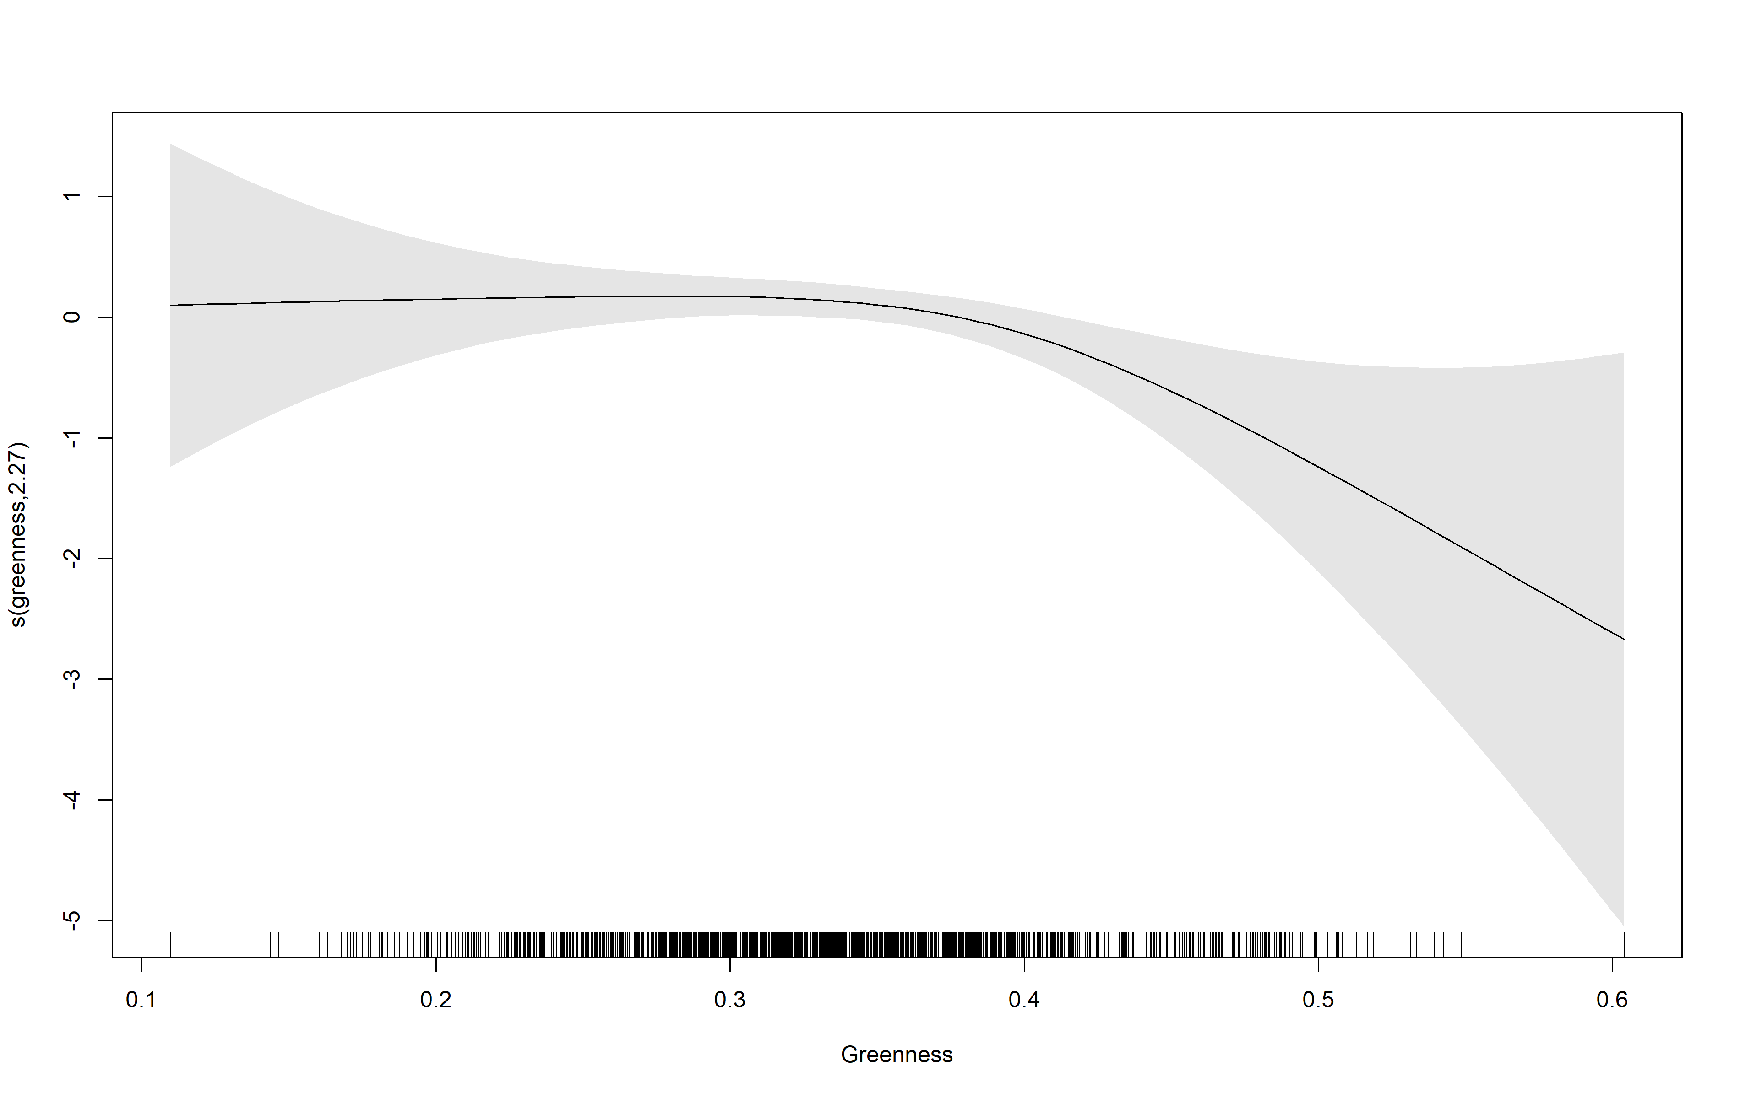

**Supplemental Figure 5: Proposed directed acyclic graph (DAG) demonstrating the assumed causal relationships between the exposure (green circle), outcome (blue circle with black border), and other variables of interest. DAG was built at [www.dagitty.net](http://www.dagitty.net)**

