**Supporting Information**

***Chemical proxies of glacier-derived and marine organic matter reveal low mixing in summer-stratified Arctic fjords***

Fabian Moye1,2, Jana K. Geuer2,3, Claudia Burau2, Mourad Harir4,5, Philippe Schmitt-Kopplin4,5, Boris P. Koch2,6, Tilmann Harder1,2, Jan Tebben2

1Marine Chemistry, Faculty of Biology and Chemistry, University of Bremen, James Watt Str. 1, 28359 Bremen, Germany.

2Department of Ecological Chemistry, Alfred Wegener Institute, Helmholtz Zentrum für Polar- und Meeresforschung, Am Handelshafen 12, 27570 Bremerhaven, Germany.

3Max Planck Institute for Marine Microbiology, Celsiusstraße 1, 28359 Bremen, Germany.

4Research Unit Analytical BioGeoChemistry, Helmholtz Munich, Ingolstaedter Landstrasse 1, 85764, Neuherberg, Germany

5Chair of Analytical Food Chemistry, Technische Universität München, Maximus-von-Imhof-Forum 2, 85354 Freising, Germany

6University of Applied Sciences, An der Karlstadt 8, 27568 Bremerhaven, Germany

Corresponding author: Jan Tebben ([jan.tebben@awi.de](mailto:jan.tebben@awi.de))

# Contents of this file

Text S1.1. to S1.8.

Figures S1 to S17

Tables S1 to S4

# Introduction

This supporting information contains the description of DOM extraction (**S1.1.**), dissolved organic carbon (DOC) measurement (**S1.2.**), measurement of nutrients (**S1.3.**), water mass definitions (**S1.4.** and **Table S1.**), detailed description of the FT-Orbitrap-MS (**S1.5**) and FT-ICR-MS measurements (**S1.6.**), followed by details to the molecular formula annotation (**S1.7**) as well as detailed formulation of the mixing model (**S1.8**). Additional graphic details are given for the instrument comparison, an overview of the oceanographic conditions and further details of the mixing model. Oceanographic conditions and chemical properties of the samples determined by FT-ICR-MS and FT-Orbitrap-MS are given in **Table S2 – S3**. Used R-packages are listed in **Table S4**. Detailed data of the mixing experiment are given in **Table S5**.

**Text S1.1. DOM extraction**

Water samples collected with a 24 Niskin bottle CTD rosette were vacuum filtered (<200 mbar) across 0.7 µm GF/F (Whatman), acidified with HCl to pH 2 and 500 mL of filtrate extracted with 200 mg PPL resin (Dittmar et al. 2008). Washed and dried (N2, purity grade 5.5) cartridges were stored at -20°C until elution at the home laboratory with 1000 µL methanol. The samples were weighed and stored at -18°C until measurement.

**Text S1.2. DOC concentration**

High-temperature catalytic oxidation and subsequent non-dispersive infrared spectroscopy and chemiluminescence detection (TOC-LCPH/CPN, Shimadzu, Germany) was used to determine concentrations of DOC and total dissolved nitrogen (TDN) in the water samples. On each day of analysis, samples were thawed and subsequently homogenized thoroughly. 6.5 mL per sample were acidified with 1 mol L‑1 HCl (Suprapur®, Sigma-Aldrich) in the autosampler and sparged with oxygen to remove inorganic carbon. 50 µL of sample was injected on the catalyst (680°C) in triplicate yielding average concentrations. Additional injections were performed if the standard variation or the coefficient of variation exceeded 1 %, respectively. A potassium hydrogen phthalate standard, ultrapure water and a deep-sea reference sample (Hansell Laboratory, University of Miami, USA) were measured after every batch of six samples. The limit of quantification (LOQ) was 7 µmol L‑1 for DOC and 11 µmol L‑1 for TDN and the accuracy of the method was ±5 %.

**Text S1.3. Nutrients**

Nutrient measurements (silicate, nitrate, nitrite, phosphate) were described elsewhere (Seifert et al. 2019). In short, nutrient samples collected with 50 mL LDPE bottles were analyzed in the home laboratory with a spectrophotometric autoanalyzer (QuAAtro39, SEAL Analytical) by a slightly modified standard procedure (Kattner and Becker 1991).

**Text S1.4. Water mass definitions**

Water masses definitions were used as defined by (Geuer 2020) and are summarized in **Table S1**.

## Text S1.5. Detailed FT-Orbitrap-MS measurements

Injections were automated with split-sampler injection (20 µL) into the sample loop. Samples were delivered to the electrospray ionization (ESI) source at 10 µL min‑1 using a UHPLC (Vanquish, Thermo Fisher Scientific, Bremen, Germany) and a push solvent (50/50 v/v ultrapure water, methanol). A small number of samples were insufficient for analysis on both platforms; they were measured by FT-ICR MS. Negative Ion Calibration Solution (Pierce, Thermo Fisher Scientific) was used for the calibration of the instrument. 1.5 mL combusted brown glass vials (Thermo Fisher Scientific) were used. The last 5 µL / 0.5 min of the run were not used for the data analysis to avoid mixing effects of the sample with the push solvent. Each run was followed by a wash-sequence at the flowrate of 200 µL min‑1 (90 % methanol for 0.5 min, re-equilibration at 50/50 v/v methanol, ultrapure water for 0.5 min). A low-flow ESI needle was used. The spray voltage for all experiments was -2.8 kV. Capillary temperature was set to 250°C and the sheath gas was set to 12 and the auxiliary gas to 3 (arbitrary units). MS measurements were performed using electrospray ionization in negative mode. Full MS mode with a resolution of 280 000 (*m/z* 200), a scan range of *m/z* 150 to 1500 and 10 microscans was used. The ion optics and ESI source settings were tuned to maximize the intensity of the peak at *m/z* 400. Each scan was internally calibrated with nine lock masses (339.10854, 369.11911, 411.12967, 469.13515, 541.15628, 595.20323, 611.19814, 651.22944, 693.24001). For the mixing experiment the tuning resulted in a spray voltage of -2.5 kV and the capillary temperature was set to 280°C, the sheath gas to 13 and the auxiliar gas at 3 (arbitrary units). Each scan averaged five microscans and the scan range was set to *m/z* 150 to 1875. Scans of the mixing experiment were recalibrated post-acquisition with an inhouse script. The Xcalibur software package (Thermo Electron Corporation) was used to export the exact mass lists, intensity, noise level and resolution to individual peak lists.

## Text S1.6. FT-ICR-MS measurements

FT-ICR-MS measurements were done on a Bruker Solarix 12 T (Bruker Daltonics GmbH, Germany) at the Helmholtz Munich, Research Unit Analytical Biogeochemistry, Germany as described in Wünsch et al. (2018). Briefly, an Apollo II electrospray ionization (ESI) source was used in negative mode and the mass range set to *m/z* 100 to *m/z* 1000 with a mass resolution of 375 000 at *m/z* 400. 300 scans were at 4 Mega words were collected for each spectrum. Spectra were externally calibrated using an arginine cluster and internally using marine DOM molecular formulas.

**Text S1.7. Molecular formula characteristics**

The Nominal Oxidation State of Carbon (NOSC) for each neutral molecular formula was calculated according to LaRowe and Van Cappellen (2011)

The Aromaticity Index (AI) was calculated as (Koch and Dittmar 2006; Koch and Dittmar 2016):

The index of degradation (IDEG) was calculated according to Flerus et al. (2012) if all 10 molecular formulas were present in the sample (: absolute intensity, NEG: with age negative correlating molecular formulas, POS: with age positive correlating molecular formulas):

**Text S1.8. Detailed mixing model**

The 2-endmember model was used as described by Seidel et al. (2015), given as the freshwater fraction

The organic freshwater fraction () then is calculated as

With, . From this the specific properties (p) were modeled as:

The respective salinity of the mixing experiment was calculated as follows:

For example, the N/C mixing model was calculated for the laboratory mixing experiment as:

With freshwater weighted average: 0.0031 and marine weighted average: 0.0101 and the f as the mixing rate (representative of in the laboratory) between the two endmembers (0 %, 25 %, 50 %, 75 %,100 %) and extrapolated for the complete salinity range. Aromaticity and nominal mass were modeled accordingly.

The mixing of the molecular properties in Scoresby Sund determined by FT-ICR-MS were as followed: The aromatic index (AI) decreased from an average of 0.0249 in the GMW to a minimal value of 0.0131 in the marine water (highest salinity). N/C increased from 0.0064 to 0.0114 and the nominal mass from 385 to 402.

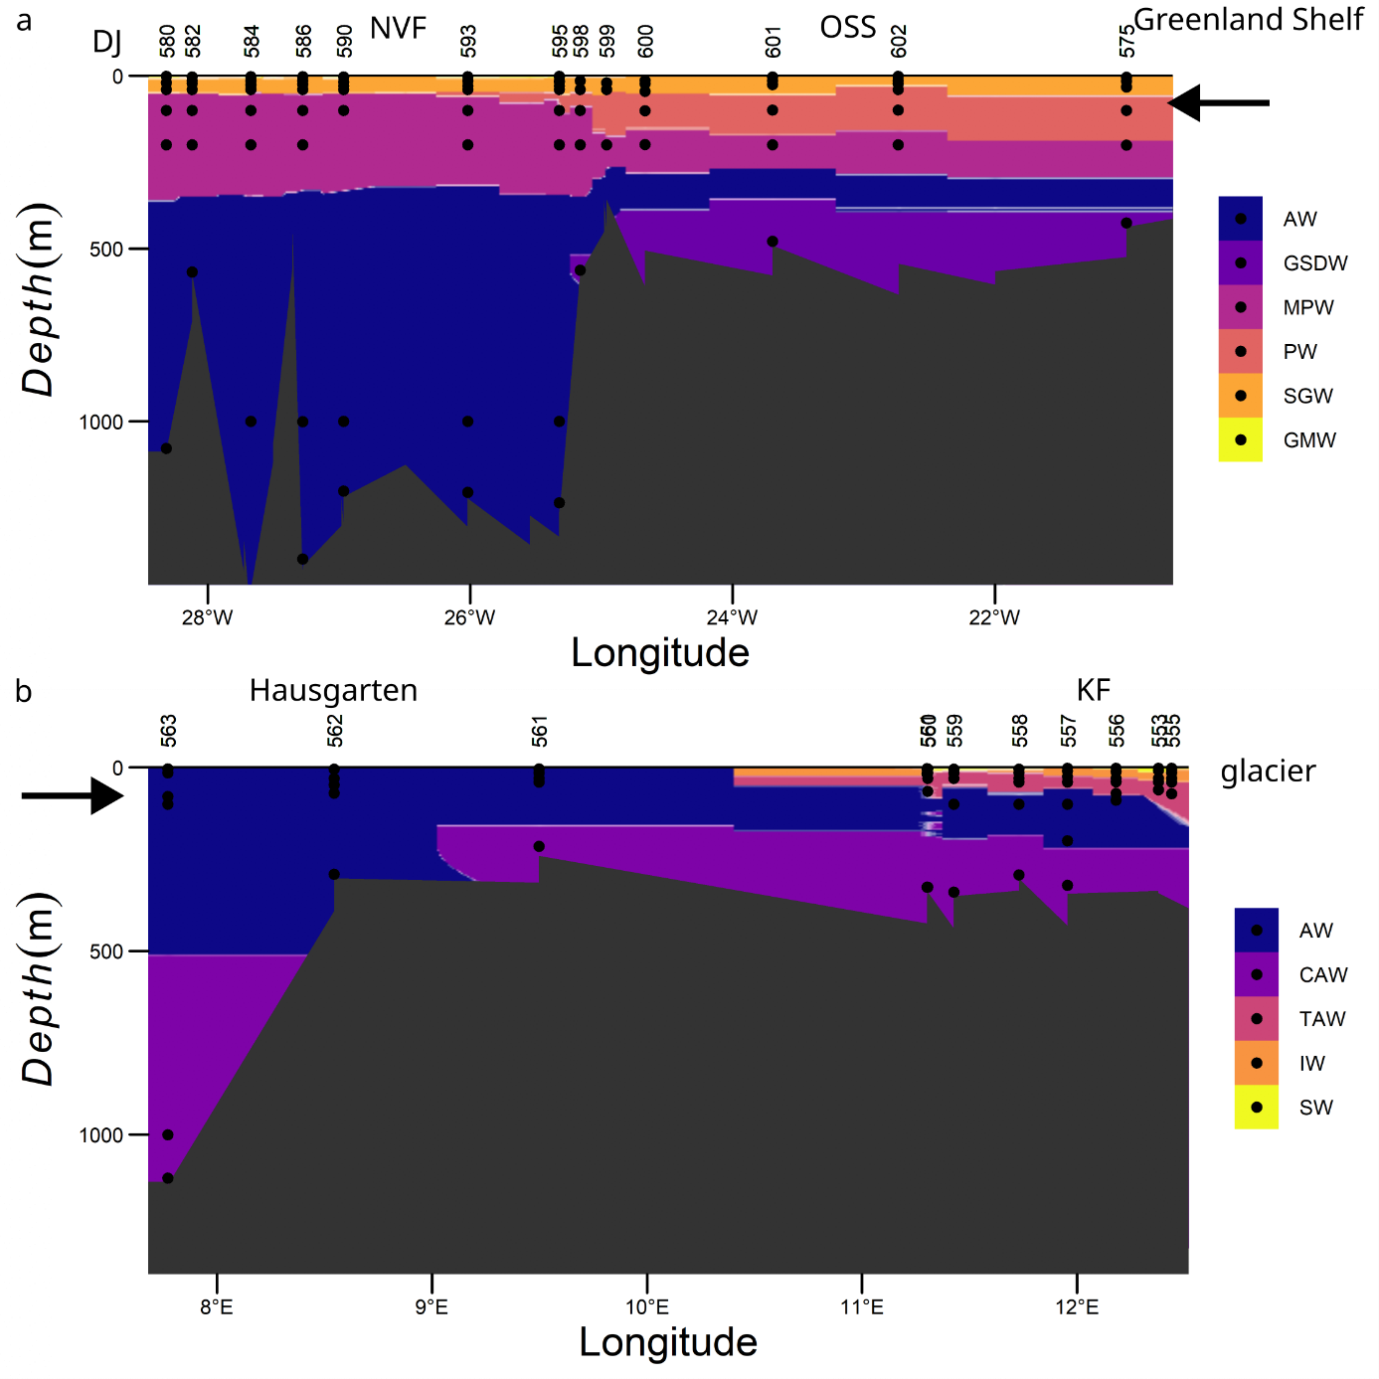

**Figure S1**. Distribution of water masses (definition see Table S1 and Geuer (2020)) in (**a**) Scoresby Sund and (**b**) Kongsfjorden with origin of SPE-DOM samples (black dots). GMW: glacial meltwater, SGW: surface glacial water, SW: surface water, IW: intermediate water, PW: polar water, TAW: transformed Atlantic water, MPW: modified polar water, AW: Atlantic water, GSDW: Greenland Sea deep water, CAW: cold Atlantic water. DJ: Daugaard-Jensen glacier, NVF: Nordvestfjord, OSS: Outer Scoresby Sund, KF: Kongsfjorden. CTD data were interpolated with k-nearest neighbor classifier (k: 5, kernel: gaussian). Only water mass with highest probability was retained. Black arrows indicate inflowing marine water.

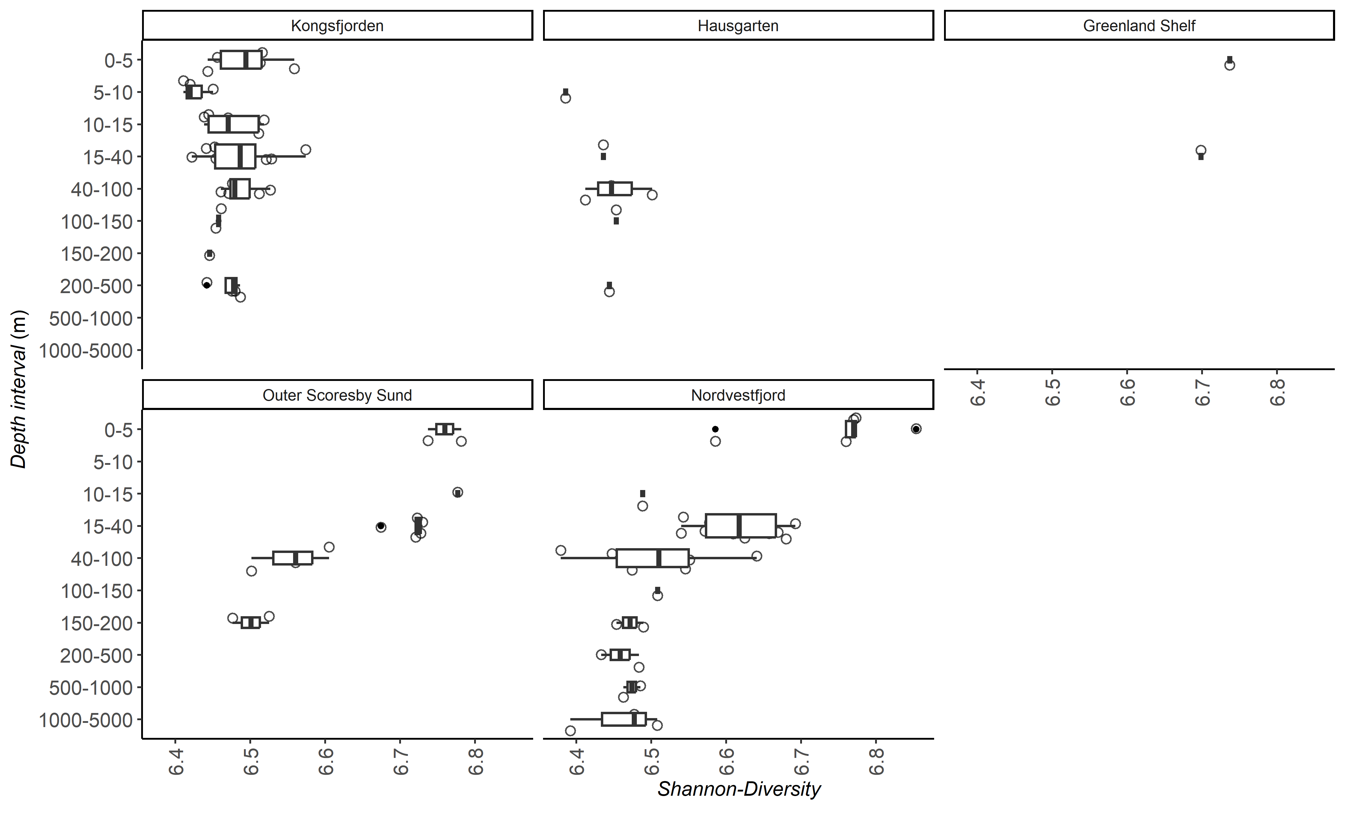

**Figure S2**: Molecular diversity measured by the Shannon diversity index calculated from FT-Orbitrap-MS data in DOM samples of Kongsfjorden, Greenland Strait and Scoresby Sund. At depth intervals with insufficient samples to calculate a boxplot only the median is shown. Samples are marked as open and outliers as filled circles.

**Figure S3**. Screeplot of the first 20 components of the Principal Component Analysis (PCA) for left: FT-ICR-MS and right: FT-Orbitrap-MS. Most variance is explained in the first two components.



**Figure S4**. PC1 and PC2 of FT-Orbitrap-MS (**a**, **c**, **e**, **f**) and FT-ICR-MS (**b**, **d**) data plotted onto the cross sections of the fjord of (**a** – **c**) Scoresby Sund with NVF: Nordvestfjord, OSS: Outer Scoresby Sund, GS: Greenland shelf and (**d** – **f**) Kongsfjorden (KF) and Hausgarten. PC1 had no clear trend for Kongsfjorden and PC2 respective for Scoresby Sund. Background color and contour lines of the respective PC axis were added to guide the eye.

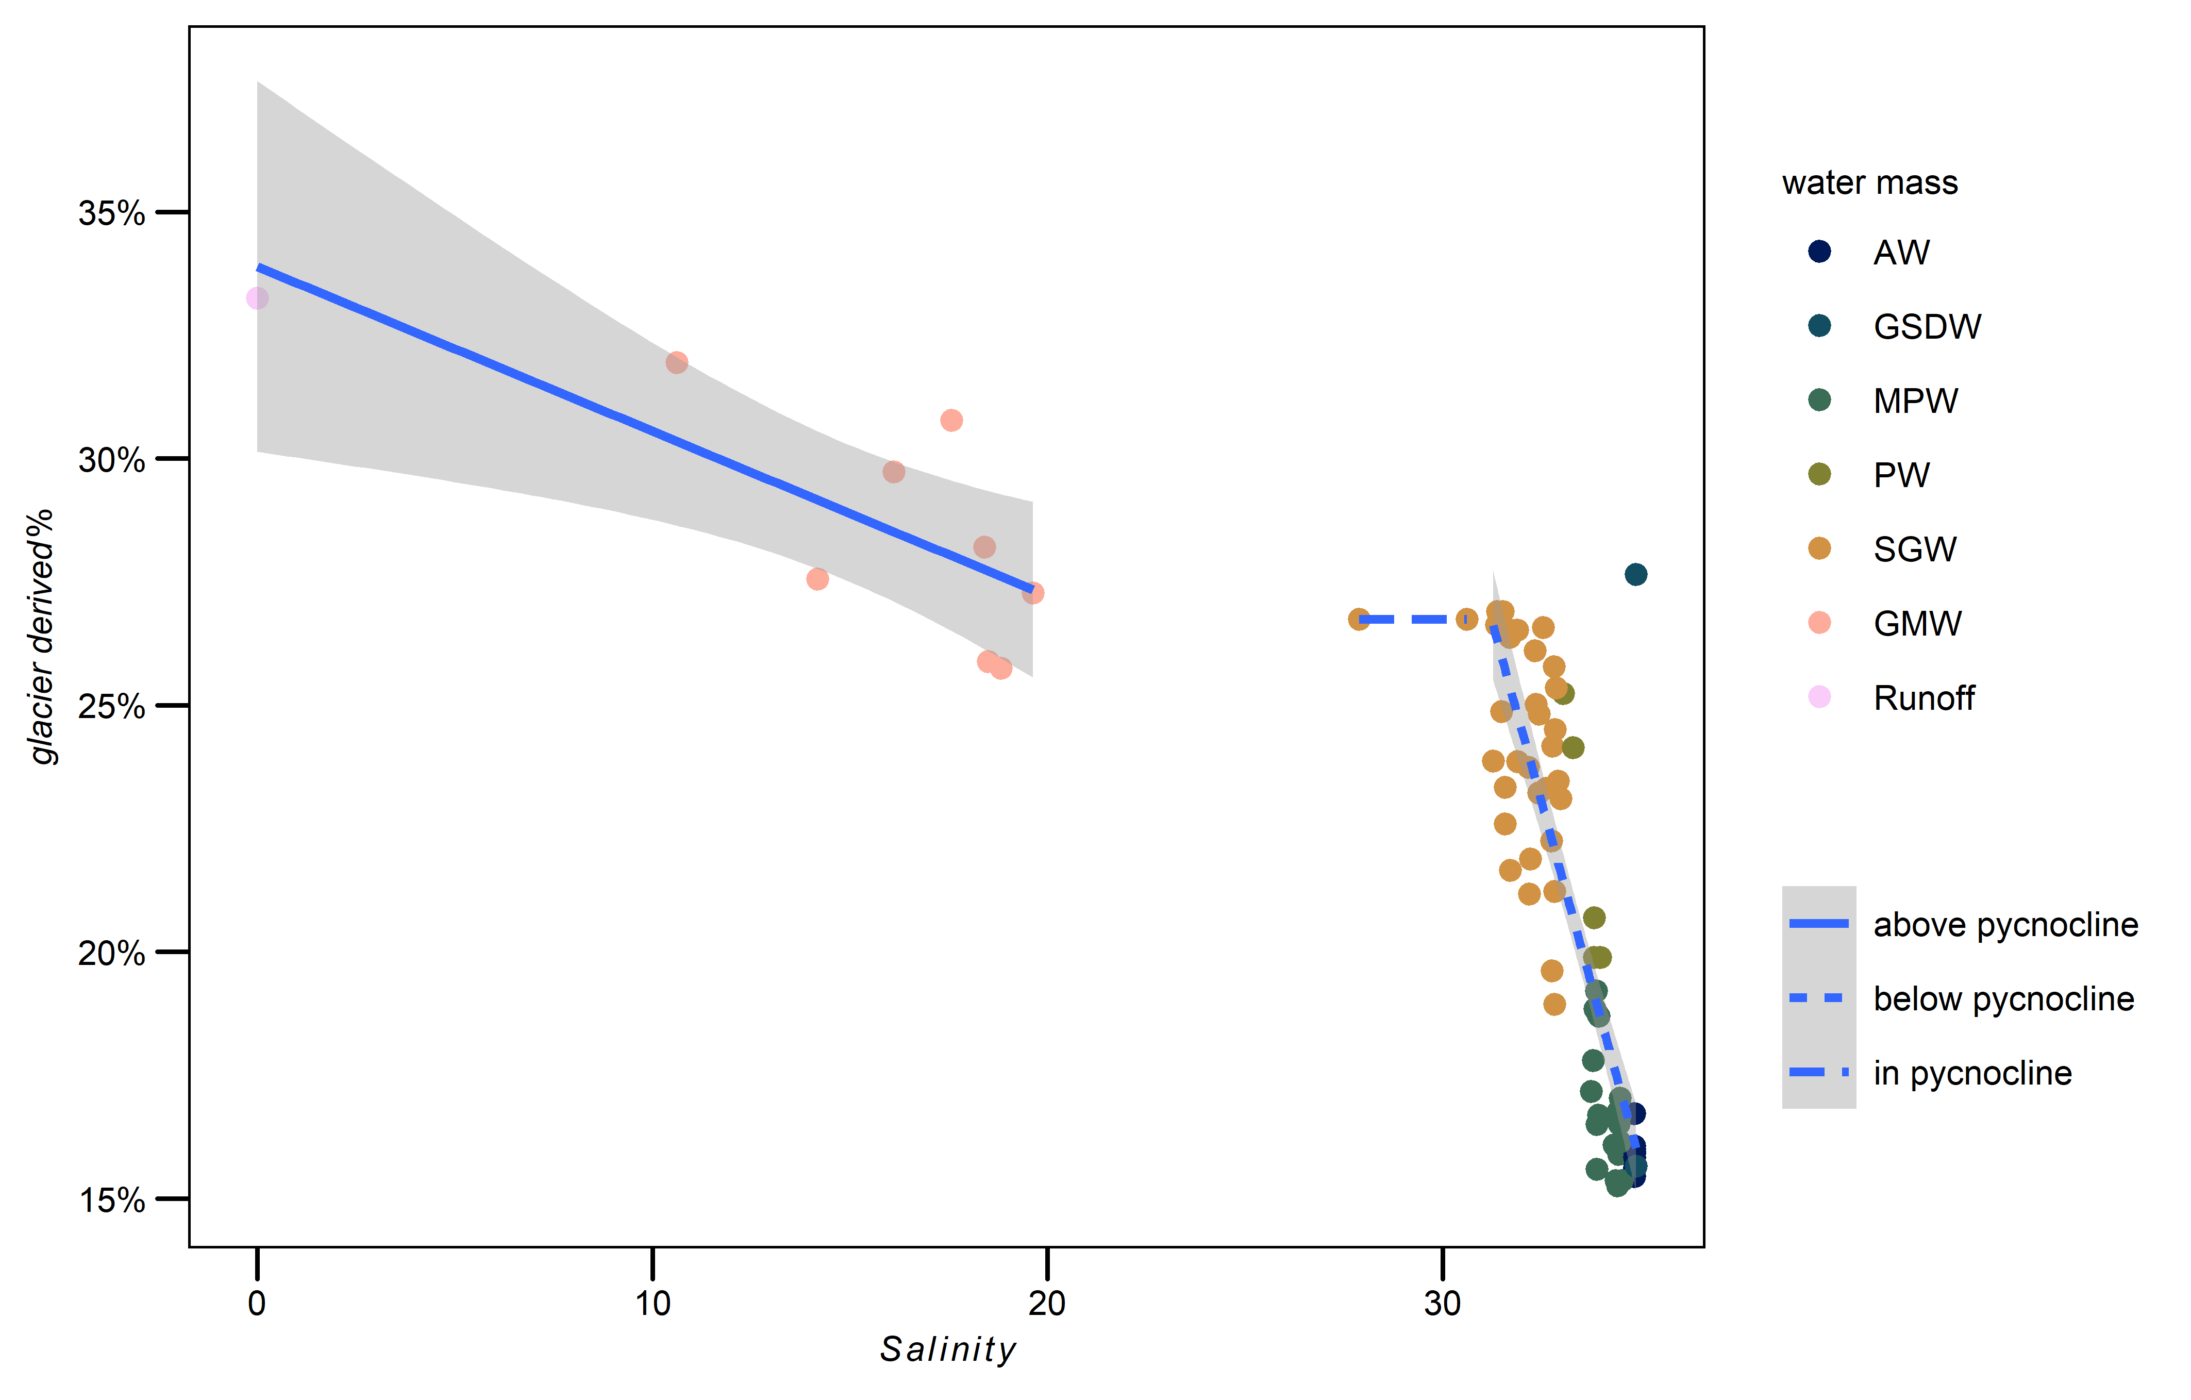

**Figure S5.** Percentage of absolute intensity of glacier derived molecular formulas (**Figure 3, 4**, PC1 loading value > 0.5) detected on FT-ICR-MS in Nordvestfjord and Outer Scoresby Sund. Linear mixing above the pycnocline () was not significant, but below the pycnocline ()). In the pycnocline, a linear model could not be established due to insufficient sample size. AW: Atlantic water, GSDW: Greenland Sea deep water, MPW: mixed Polar water, PW: Polar water, SGW: surface glacial water, GMW: glacial meltwater.

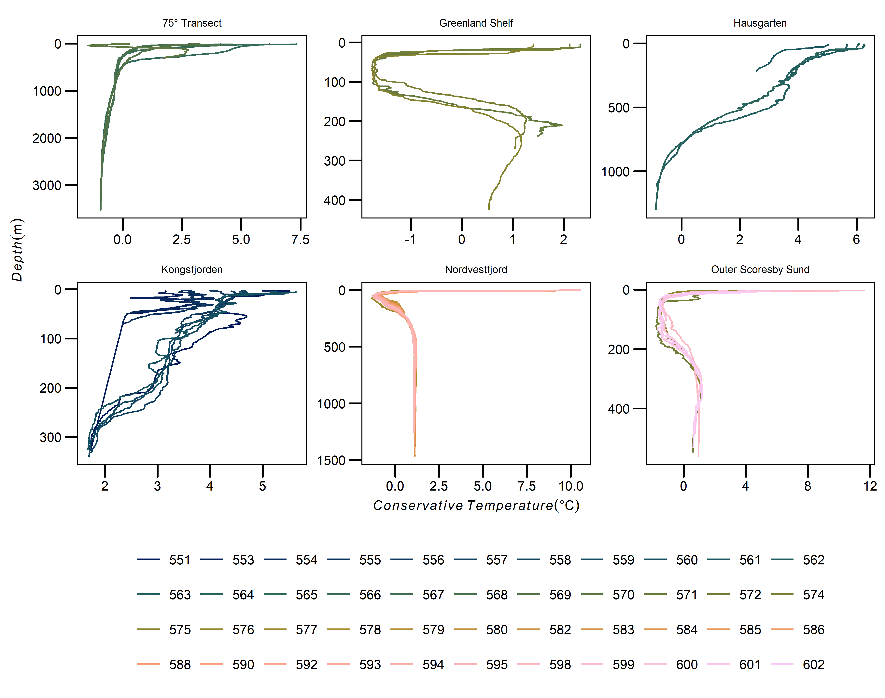

**Figure S6**: Conservative temperature profiles (CTD-data, Friedrichs et al. (2017)) by station and province (some provinces had more CTD cast than SPE-DOM sample stations).

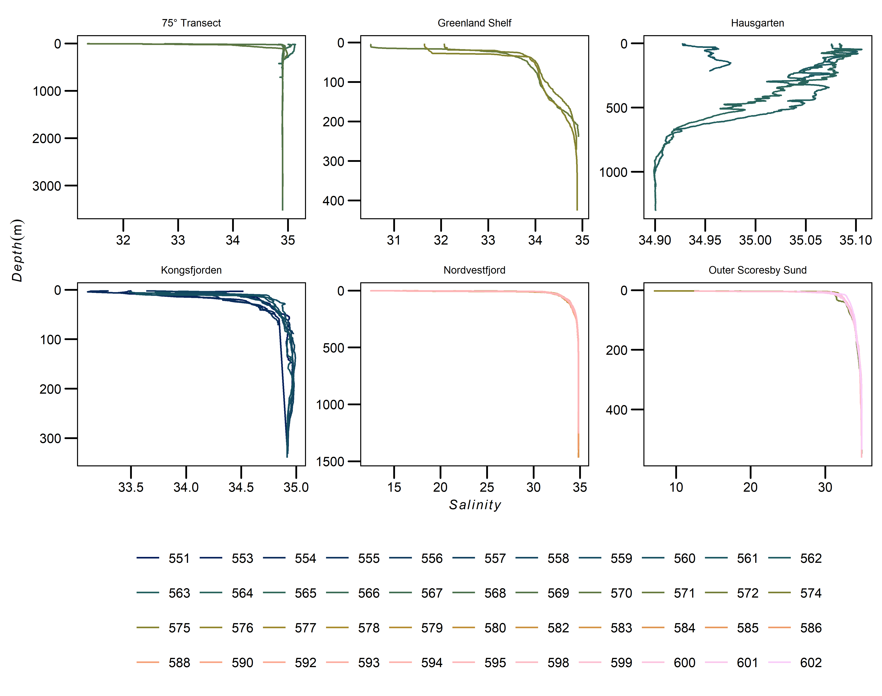

**Figure S7**: Salinity profiles (CTD-data, Friedrichs et al. (2017)) by station and province (some provinces had more CTD cast than SPE-DOM sample stations).

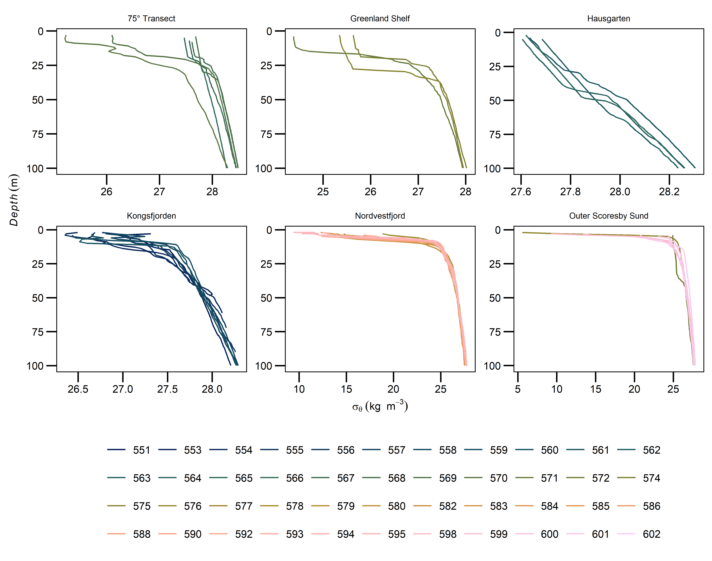

**Figure S8**: Potential density () profiles (CTD-data, Friedrichs et al. (2017)) of the first 100 m for each province and station (some provinces had more CTD cast than SPE-DOM sample stations).

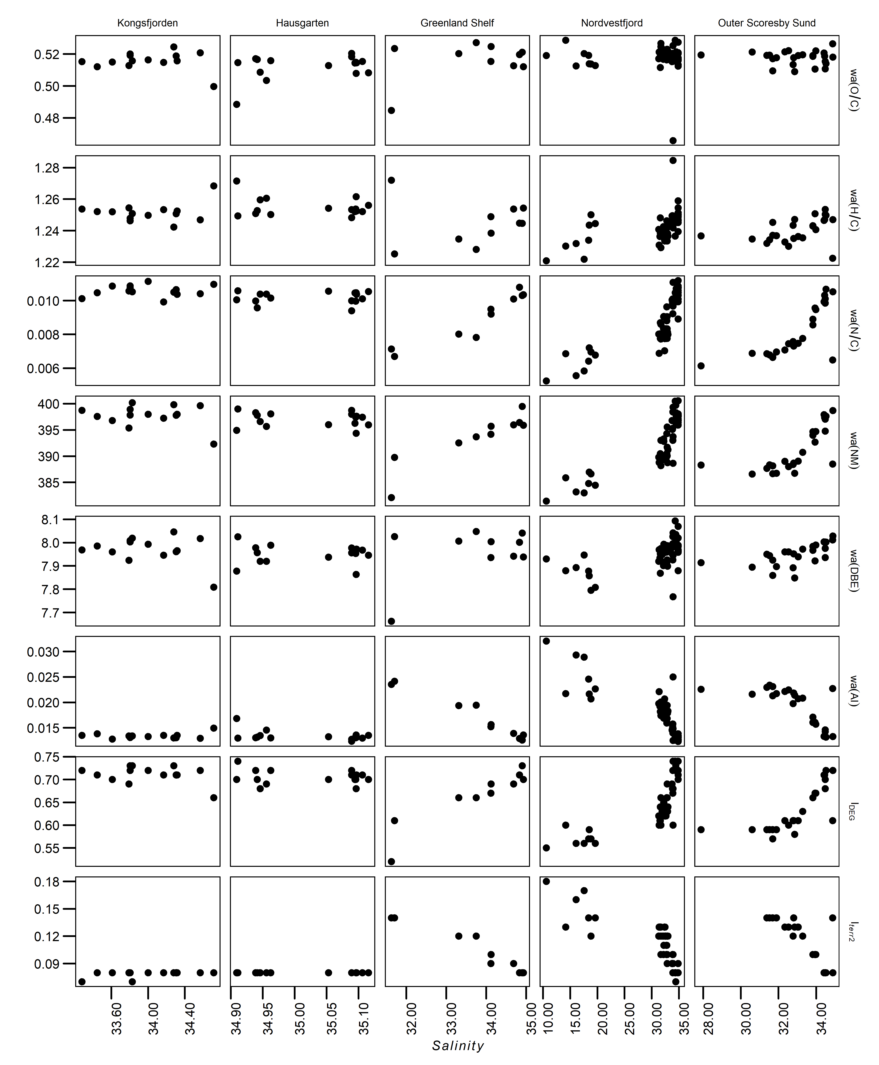

**Figure S9**: FT-ICR-MS formula characteristics correlation to salinity for all provinces except 75° N Transect (2 samples). Weighted average (weight: absolute intensity) of molecular O/C ratio, H/C ratio, N/C ratio, nominal mass (nm), double bond equivalents (DBE) and aromaticity index (AI); Degradation index (*IDEG*); terrestrial index 2 (*Iterr2*). Samples with insufficient Iterr2 (FT-ICR-MS: 12)formulas were removed. Note different axis ranges.

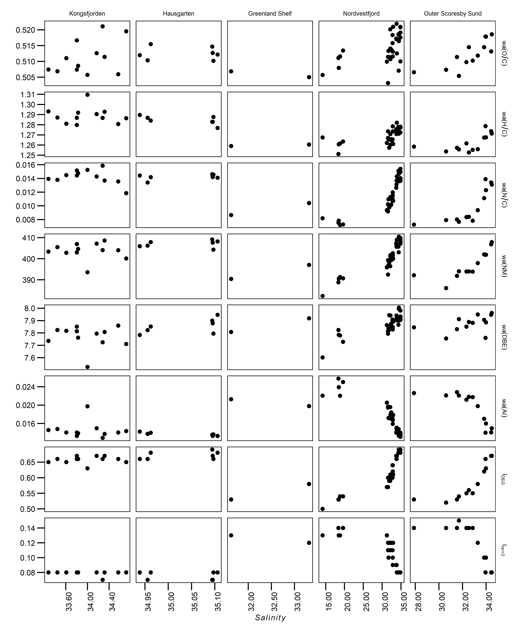

**Figure S10**: FT-Orbitrap-MS formula characteristics correlation to salinity for all provinces. Weighted average (weight: absolute intensity) of molecular O/C ratio, H/C ratio, N/C ratio, nominal mass (nm), double bond equivalents (DBE) and aromaticity index (AI); Degradation index (*IDEG*); terrestrial index 2 (*Iterr2*). Samples with insufficient Iterr2 (FT-Orbitrap-MS: 7)formulas were removed. Note different axis ranges.

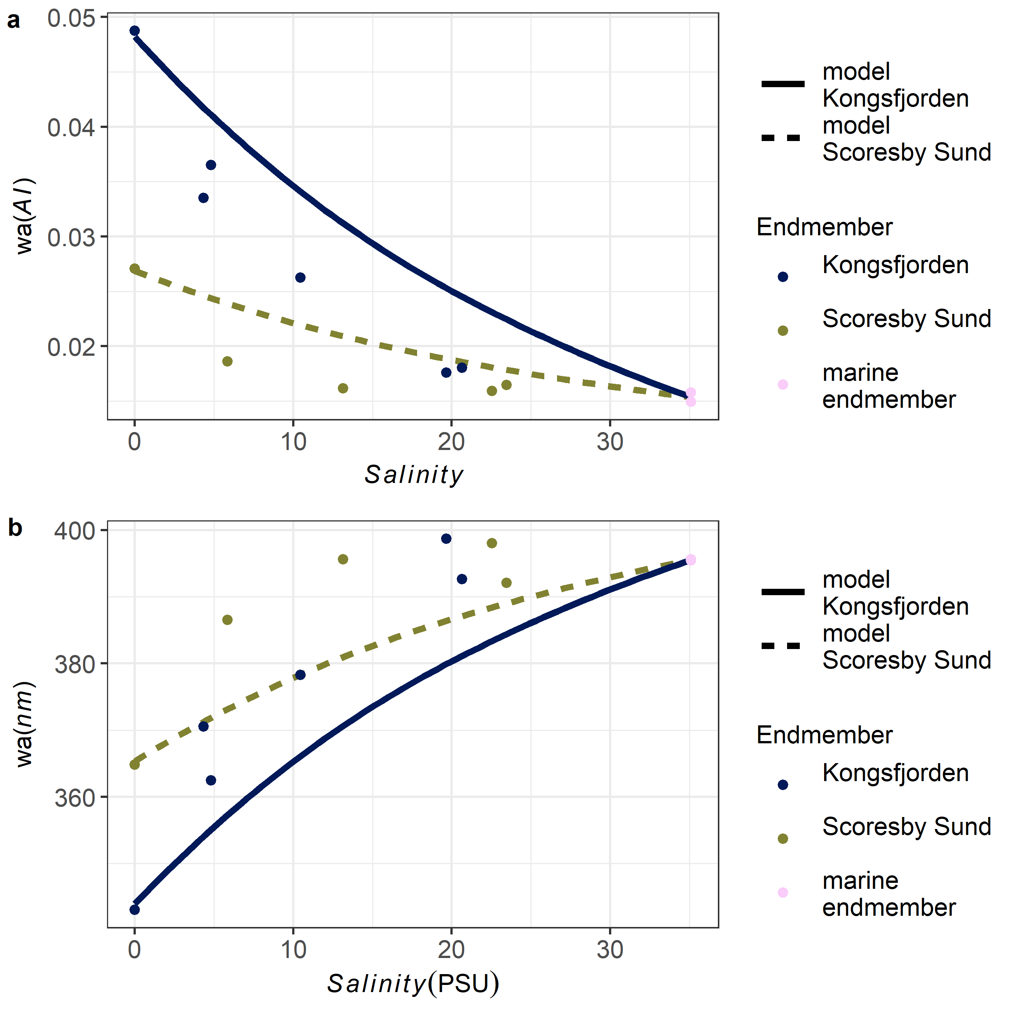

**Figure S11**. The endmember mixing experiment in the lab showed the validity of the model (for calculations of salinity see **S1.5**). The two different models depend on the two separate samples used as glacial endmembers (Kongsfjorden: blue, solid line; Scoresby Sund: green, dashed line). AI (**a**) and nominal mass (**b**) had respective deviations (for calculation of salinity, see **S1.5.**). The respective RMSE were: AI, Kongsfjorden: 0.0065, Scoresby Sund: 0.0034; nominal mass, Kongsfjorden: 13, Scoresby Sund: 10.

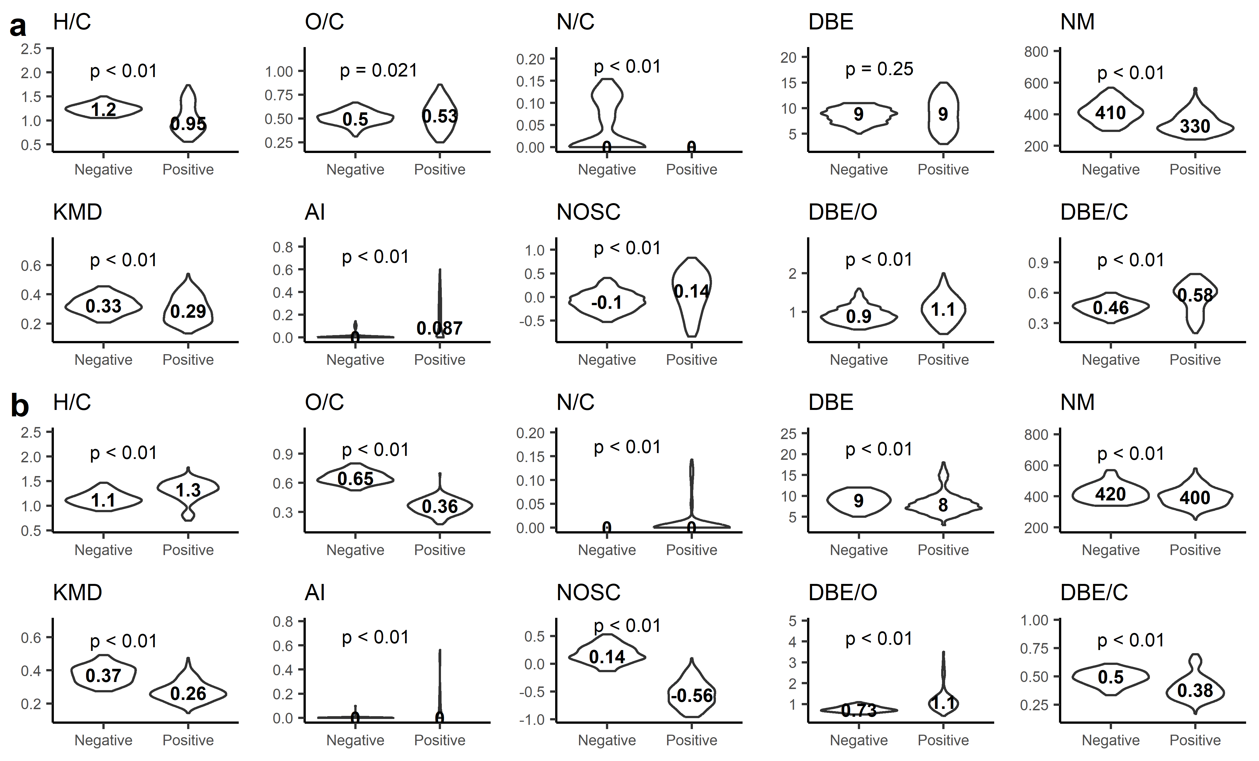

**Figure S12**: Violin plots representing the characteristics of the selected molecular formulas (|PC|>0.5, cf. **Figure 3**) detected by FT-ICR-MS for (**a**) PC1 and (**b**) PC2 (values: median; for FT-Orbitrap-MS data see **S4**). The p-value resulted from the group comparison (negative vs positive) with the Mann – Whitney test. “*Negative*” represents molecular formulas with a loading of less than -0.5 along PC and “*Positive*” a loading of more than 0.5 along the PC. DBE = double bound equivalent, KMD = Kendrick mass defect, NM = nominal mass, AI = Aromaticity Index, NOSC = nominal oxidation state of carbon.

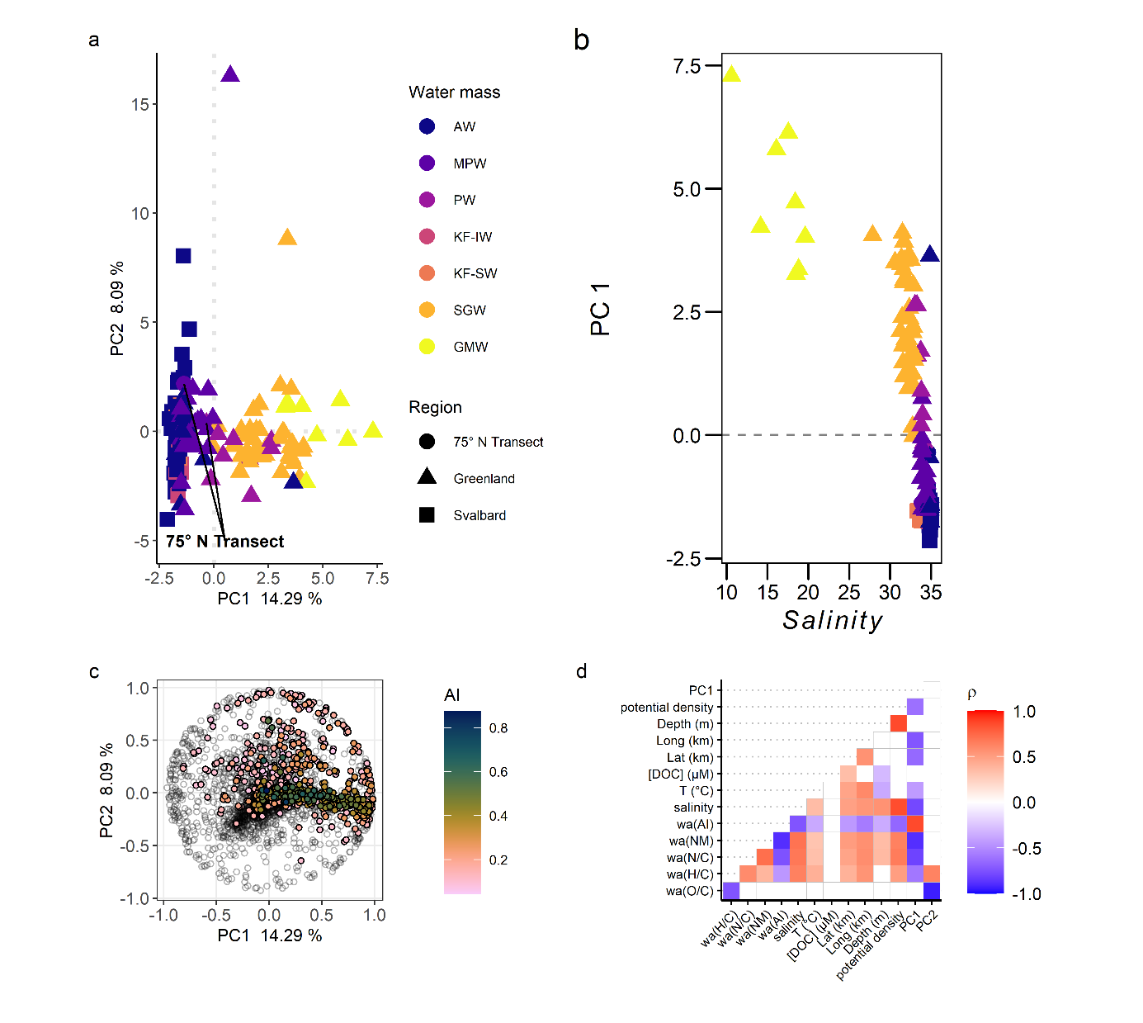

**Figure S13** Principal Component Analysis of (**a**) FT-Orbitrap-MS molecular formulas based on relative m/z intensities (equal to sum of 1 per spectrum). The shape of the marker indicates regions (triangles: Greenland Shelf, Outer Scoresby Sund, Nordvestfjord (combined as Greenland), circles: 75°N transect, squares: AWI Hausgarten, Kongsfjorden (combined as Svalbard). (**a**) water mass, (**b**) PC1 correlation to salinity, (**c**) respective loading plot () to score plot (**a**). The color scale indicates the respective unsaturation (aromaticity index, AI) for molecular formulas with an AI > 0, while molecular formulas with AI = 0 are represented in the background. (**d**) Spearman rank correlation between PCs and metavariables. Correlations with p≥0.01 are blank (p-values corrected by Holm-Bonferroni). GMW: glacial meltwater, SGW: surface glacial water, Kf-SW: Kongsfjorden surface water, Kf-IW: Kongsfjorden intermediate water, PW: polar water, MPW: modified polar water, AW: Atlantic water.

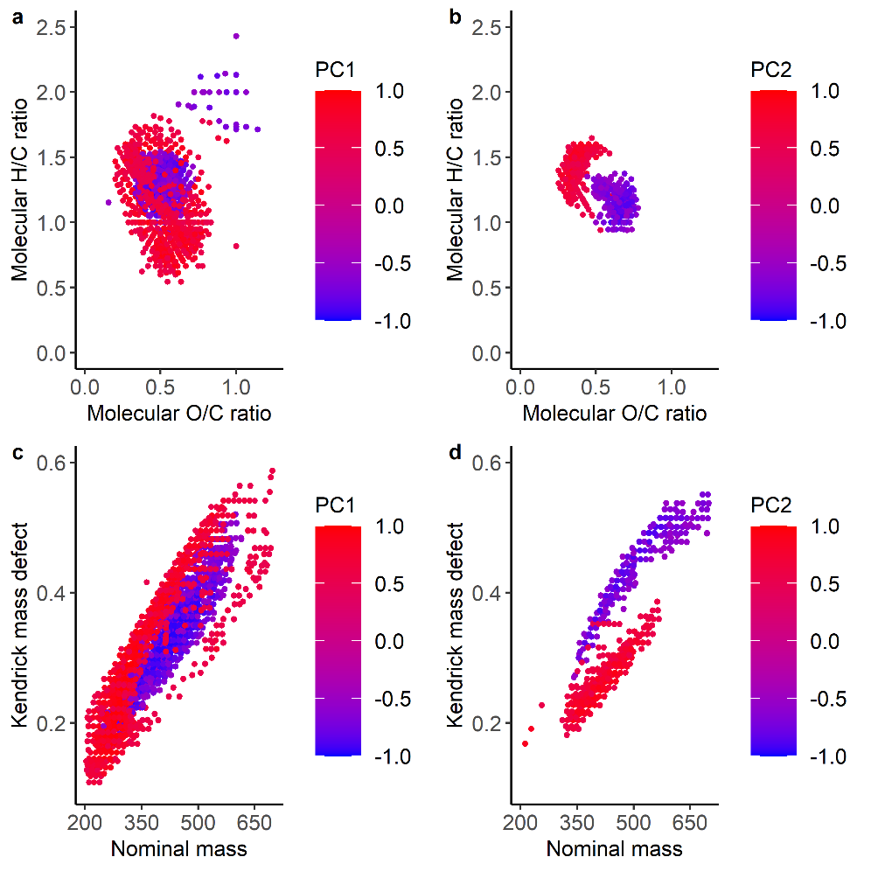

**Figure S14**. (**a**, **b**) Van-Krevelen diagram (Kim et al., 2003) and (**c**, **d**) Kendrick mass defect (Hughey et al. 2001; Kendrick 1963) for molecular formulas generated by FT-Orbitrap-MS that have a PC1 (a, c) > 0.5 or < -0.5 or a PC2 (**b**, **d**) > 0.5 or < -0.5. The color scale representants the value of PC loading (low = blue, high =red).

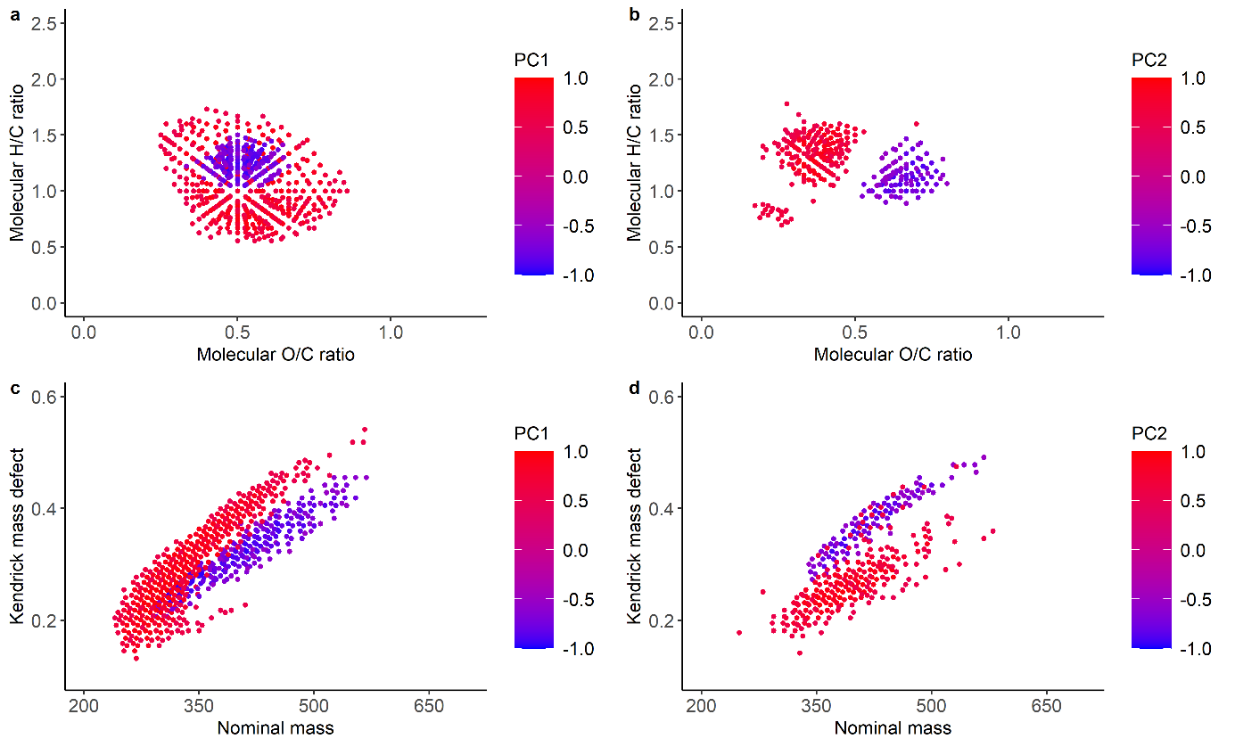

**Figure S15. (a, b)** Van-Krevelen diagram (Kim et al. 2003) and (**c, d**) Kendrick mass defect (Hughey et al. 2001; Kendrick 1963) for molecular formulas generated with FT-ICR-MS that had a PC1 (a,c) > 0.5 or < -0.5 or a PC2 (b, d) > 0.5 or < -0.5. The color scale represents the value of the PC loading (low: blue; high: red)

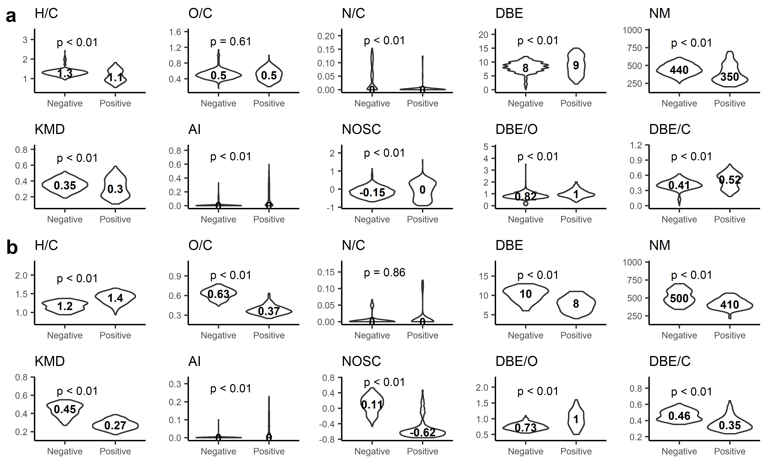**Figure S16**. Violinplots representing the characteristics of the selected molecular formulas (|PC|>0.5, Figure S4) of the FT-Orbitrap-MS data for PC1 (**a**) and PC2 (**b**; median in bold). The p-value was the result of the group (negative vs positive) comparison with the Mann – Whitney test. “*Negative*” rep-resented molecular formulae with a loading of less than -0.5 along PC1 and “*Positive*” a loading of more than 0.5 along PC1. DBE = double bound equivalent, KMD = Kendrick mass defect, NM = nominal mass, AI = Aromaticity Index, NOSC = nominal oxidation state of carbon.

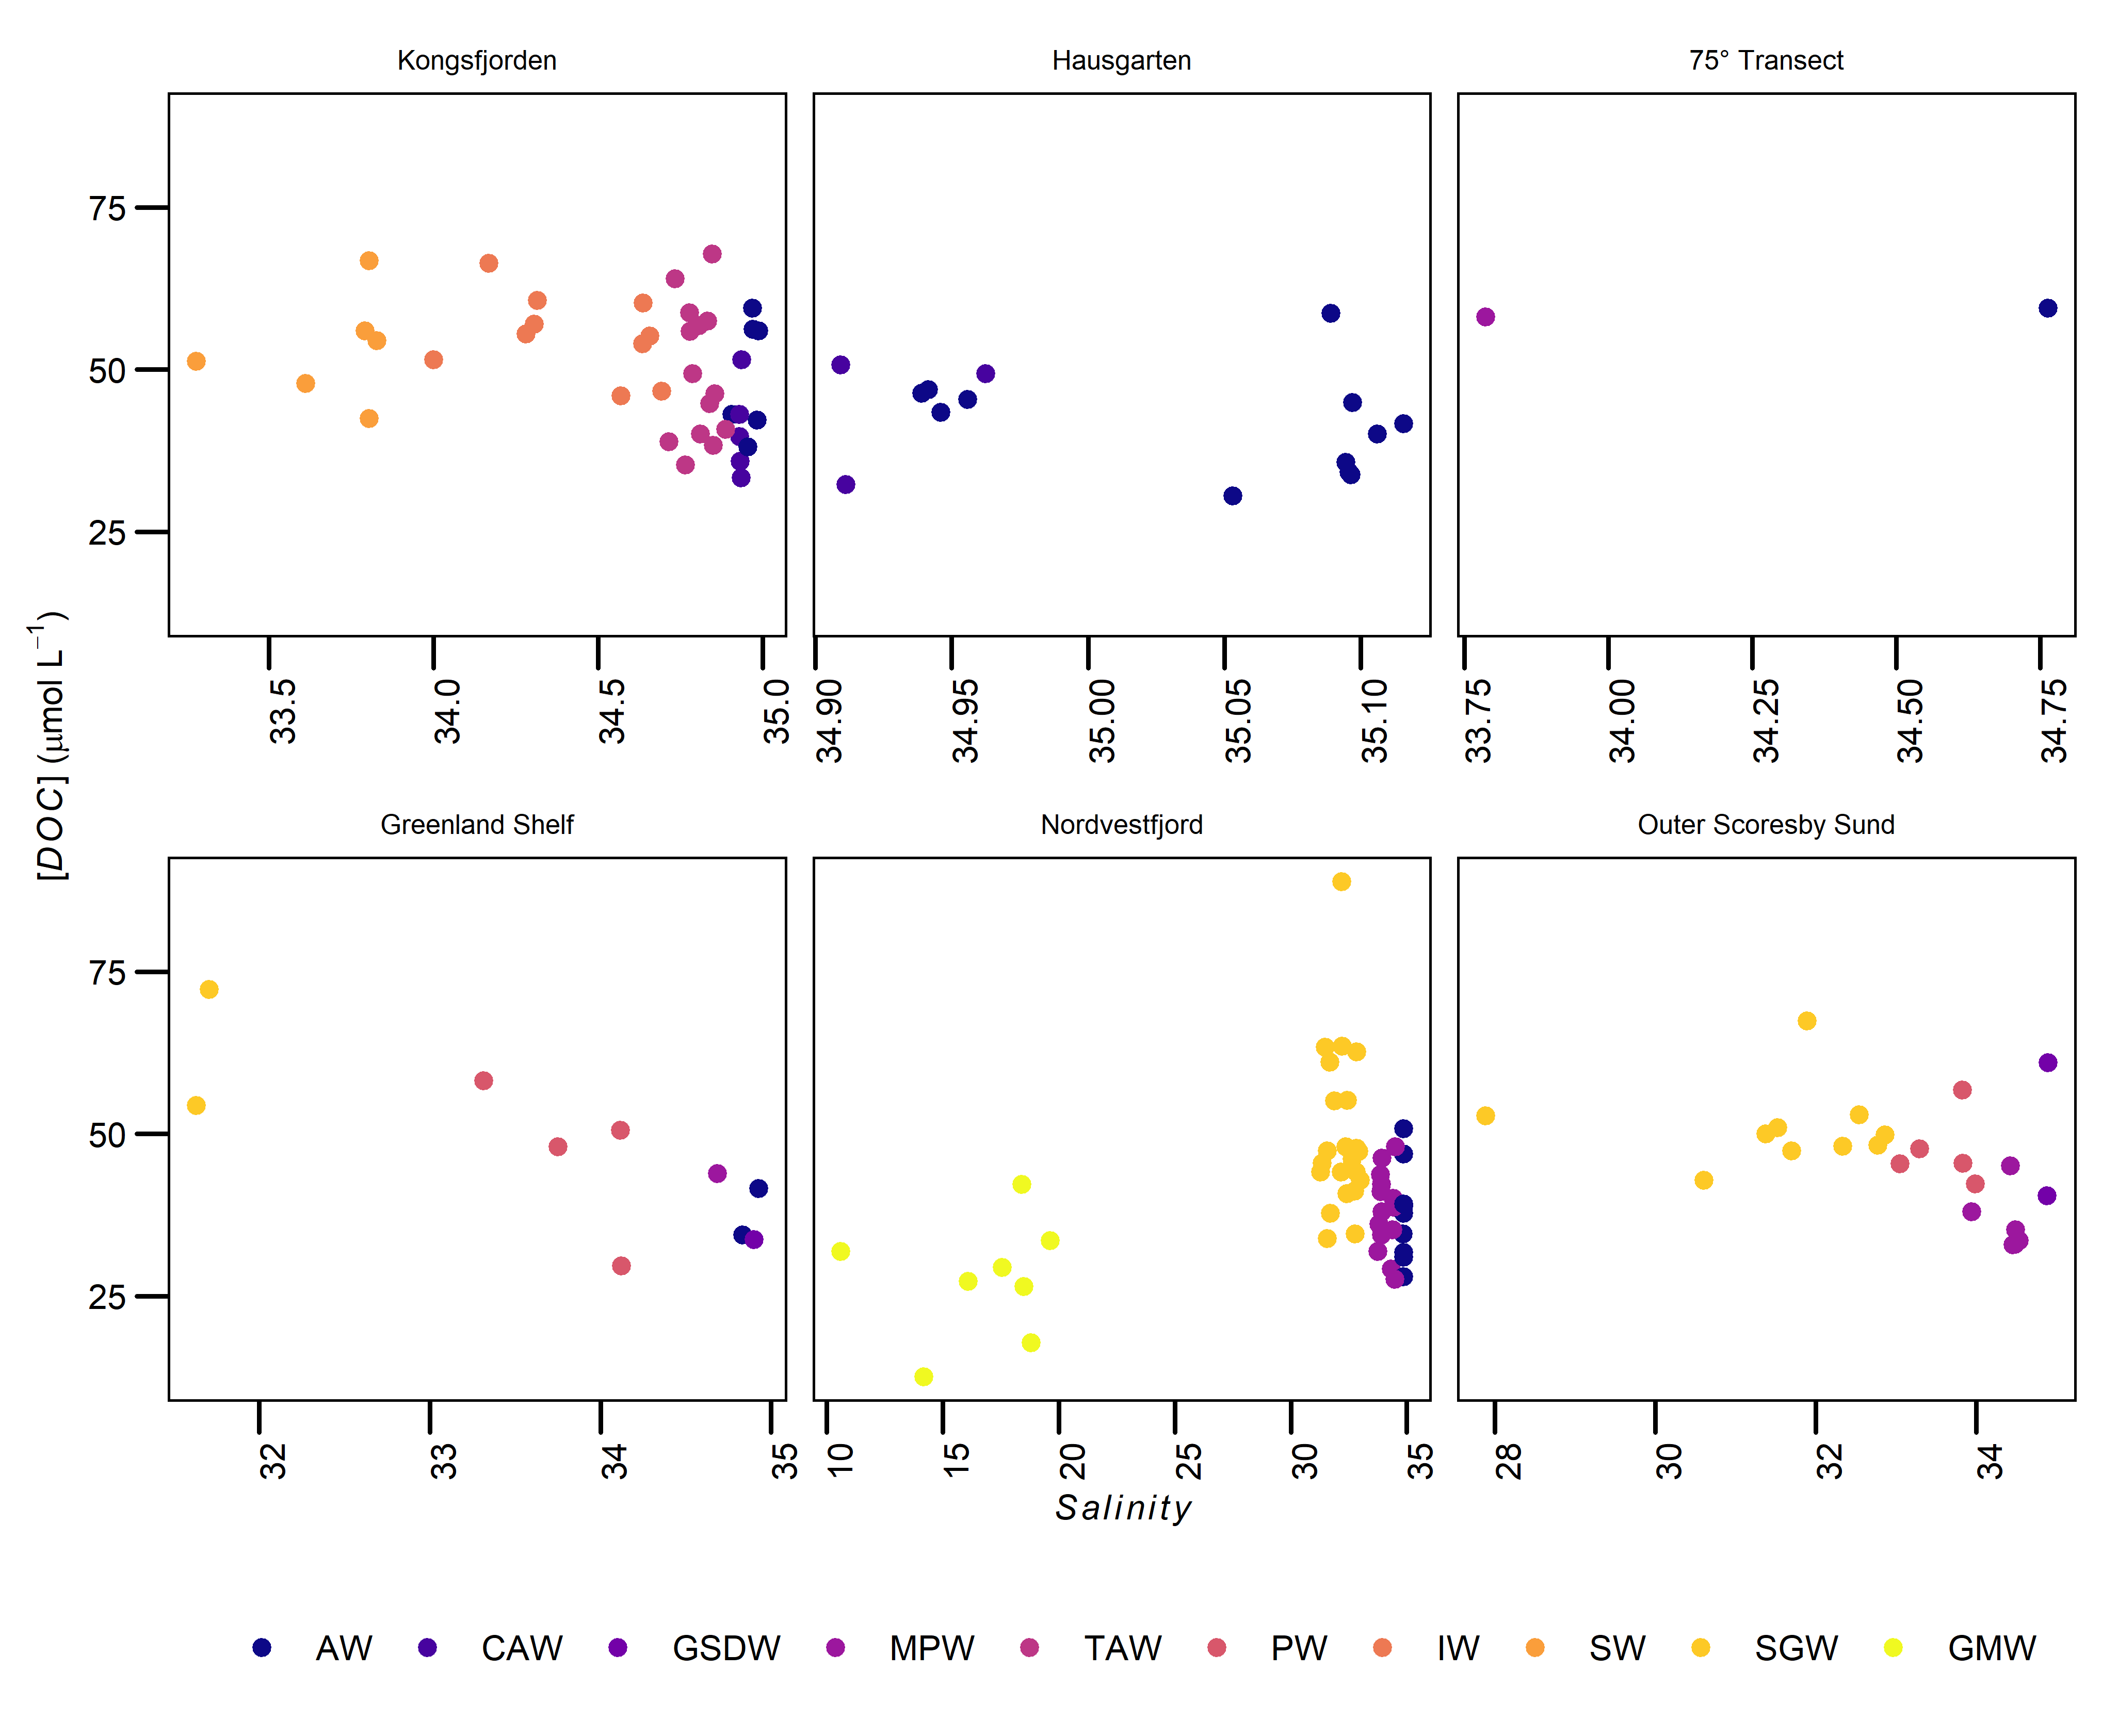

**Figure S17.** DOC concentration by province by salinity and water mass (GMW: glacial meltwater, SGW: surface glacial water, SW: surface water, IW: intermediate water, PW: polar water, TAW: transformed Atlantic water, MPW: modified polar water, AW: Atlantic water, GSDW: Greenland Sea deep water, CAW: cold Atlantic water.; for definition of water mass see Table S1). Note different x-axis ranges.

**Table S1.** Water mass definition following Geuer (2020) by temperature (T) and salinity (S) range. Agglomerated water masses to simplify discussions are abbreviated in the column “WM”.

|  |  |  |  |  |  |  |
| --- | --- | --- | --- | --- | --- | --- |
| **Region** | **Water mass** | **Abbr.** | **WM** | **T (°C)** | **S** | **Reference** |
| Svalbard | Surface water | SW | KF-SW | 1.0 – 7.0 | 30.0 – 34.0 | (Tverberg et al. 2019) |
| Intermediate water | IW | AW | 1.0 – 7.0 | 34.0 – 34.7 | (Tverberg et al. 2019) |
| Transformed Atlantic water | TAW | AW | 1.0 – 7.0 | 34.7 – 34.9 | (Tverberg et al. 2019) |
| Atlantic water | AW | AW | 3.0 - 7.0 | 34.9 – 35.2 | (Tverberg et al. 2019) |
| Cold Atlantic water | CAW | AW | < 3.0 | > 34.9 | (Tverberg et al. 2019) |
| Greenland | Glacial meltwater | GMW | GMW |  | < 20 | (Geuer 2020) |
| Surface glacial water | SGW | SGW |  | 25.0 – 33.0 | (Seifert et al. 2019) |
| Modified polar water | MPW | MPW | -1 – 1 | 33.0 – 34.7 | (Seifert et al. 2019) |
| Polar water | PW | PW | < -1 | 33.0 – 34.2 | (Seifert et al. 2019) |
| Atlantic water | AW | AW | > 1 | > 34.6 | (Seifert et al. 2019) |
| Greenland Sea deep water | GSDW | AW | < 1 | > 34.8 | (Seifert et al. 2019) |
| 75° Transect | Atlantic water | AW | AW | > 1 | > 35.65 | (Geuer 2020) |
| Modified Polar water | MPW | MPW | > -1 | < 34 | (Geuer 2020) |

**Table S2.** Oceanographic water mass properties (salinity, temperature, DOC concentration, extraction efficiency) and chemical properties measured with FT-ICR-MS (Shannon diversity index, terrestrial Index (Iterr2), Index of degradation (IDEG), H/C, O/C, N/C ratio and aromaticity index (AI), number of annotated molecular formulas (#mf), number of samples (#n)). NA: not available.

|  |  |  |  |  |  |  |  |  |  |  |  |  |  |  |
| --- | --- | --- | --- | --- | --- | --- | --- | --- | --- | --- | --- | --- | --- | --- |
| Water massa | Sb | T  (°C)b | [DOC]  (µmol L‑1)b | extr. eff. (%)b | Hb | I*terr2*b | *I*DEGb | wa (H/C)c | wa (O/C)c | wa (N/C)c | wa (DBE)c | wa (AI)c | #mfb | #n |
| AW | 34.91 (0.10) (0.013) | 3.0 (1.7) (0.2) | 42.0 (13.6) (1.8) | 58.4 (21.0) (2.7) | 6.28 (0.05) (0.01) | 0.08 (0.01) (0.00) | 0.71 (0.02) (0.00) | 1.250 (0.139) (0.001) | 0.516 (0.091) (0.000) | 0.010 (0.031) (0.000) | 7.980 (1.670) (0.007) | 0.013 (0.044) (0.000) | 1117 (93) (12) | 59 |
| KF-IW | 34.43 (0.24) (0.077) | 4.3 (0.5) (0.1) | 55.3 (6.3) (2.0) | 50.9 (4.7) (1.5) | 6.35 (0.02) (0.01) | 0.08 (0.00) (0.00) | 0.72 (0.01) (0.00) | 1.250 (0.142) (0.001) | 0.519 (0.092) (0.001) | 0.010 (0.031) (0.000) | 7.990 (1.710) (0.015) | 0.013 (0.044) (0.000) | 1237 (46) (15) | 10 |
| KF-SW | 33.65 (0.22) (0.082) | 4.2 (1.0) (0.4) | 45.6 (21.5) (8.1) | 44.8 (21.0) (8.0) | 6.31 (0.05) (0.02) | 0.08 (0.00) (0.00) | 0.71 (0.01) (0.001) | 1.250 (0.140) (0.002) | 0.516 (0.09) (0.001) | 0.011 (0.031) (0.000) | 7.980 (1.690) (0.019) | 0.013 (0.044) (0.000) | 1159 (108) (41) | 7 |
| MPW | 34.19 (0.32) (0.067) | -0.08 (0.5) (0.1) | 38.7 (7.0) (1.5) | 77.2 (17.2) (3.7) | 6.28 (0.04) (0.01) | 0.09 (0.01) (0.00) | 0.70 (0.03) (0.01) | 1.250 (0.140) (0.001) | 0.516 (0.092) (0.001) | 0.010 (0.030) (0.000) | 7.980 (1.680) (0.011) | 0.014 (0.046) (0.000) | 1100 (93) (20) | 22 |
| PW | 33.70 (0.39) (0.13) | -1.5 (0.2) (0.07) | 47.1 (8.4) (2.8) | 73.2 (18.5) (6.2) | 6.37 (0.04) (0.01) | 0.11 (0.01) (0.00) | 0.66 (0.02) (0.01) | 1.240 (0.153) (0.001) | 0.521 (0.095) (0.001) | 0.009 (0.028) (0.000) | 7.980 (1.780) (0.017) | 0.018 (0.056) (0.001) | 1219 (69) (23) | 9 |

**Table S2.** Continued.

|  |  |  |  |  |  |  |  |  |  |  |  |  |  |  |
| --- | --- | --- | --- | --- | --- | --- | --- | --- | --- | --- | --- | --- | --- | --- |
| Water massa | Sb | T  (°C)b | [DOC]  (µmol L‑1)b | extr. eff. (%)b | Hb | I*terr2*b | *I*DEGb | wa(H/C)c | wa(O/C)c | wa(N/C)c | wa(DBE)c | wa(AI)c | #mfb | #n |
| SGW | 32.00 (0.93) (0.15) | -0.2 (1.4) (0.2) | 49.5 (13.8) (2.3) | 68.2 (18.3) (3.1) | 6.38 (0.04) (0.01) | 0.12 (0.01) (0.00) | 0.62 (0.03) (0.01) | 1.240 (0.16) (0.001) | 0.518 (0.096) (0.000) | 0.008 (0.027) (0.000) | 7.930 (1.820) (0.009) | 0.020 (0.061) (0.000) | 1215 (79) (13) | 36 |
| GMW | 16.73 (3.02) (1.07) | 8.2 (2.1) (0.8) | 27.7 (9.2) (3.3) | 83.1 (30.1) (10.6) | 6.43 (0.02) (0.01) | 0.15 (0.02) (0.01) | 0.57 (0.02) (0.01) | 1.240 (0.176) (0.002) | 0.517 (0.099) (0.001) | 0.006 (0.025) (0.000) | 7.870 (1.910) (0.019) | 0.025 (0.073) (0.001) | 1262 (27) (10)s | 8 |
| G-Rf | NA | NA | 24.0 | NA | 6.74 | NA | 0.53 | 1.240 (0.256) (0.006) | 0.509 (0.113) (0.003) | 0.001 (0.010) (0.000) | 7.890 (2.690) (0.067) | 0.039 (0.094) (0.002) | 1615 | 1 |
| Kf-Rf | NA | NA | 17.0 | NA | 6.65 | NA | 0.35 | 1.270 (0.256) (0.006) | 0.485 (0.118) (0.003) | 0.004 (0.022) (0.001) | 7.320 (2.690) (0.060) | 0.050 (0.106) (0.003) | 1430 | 1 |

*Note*. awater mass: GMW: glacial meltwater, SGW: surface glacial water, Kf-SW: Kongsfjorden surface water, Kf-IW: Kongsfjorden intermediate water, PW: polar water, MPW: modified polar water, AW: Atlantic water, G-Rf: Scoresby Sund runoff, Kf-Rf: Kongsfjorden runoff. baverage with standard deviation and standard error of mean of all samples. cweighted average (wa) with weighted standard deviation (weight: absolute intensity) and weighted standard error of mean of all molecular formulas of the respective water mass.

**Table S3:** Chemical properties measured with FT-Orbitrap-MS (Shannon diversity index, terrestrial Index (Iterr2), Index of degradation (IDEG), H/C, O/C, N/C ratio and aromaticity index (AI), number of annotated molecular formulas (#mf), number of samples (#Nobs)). NA: not available.

|  |  |  |  |  |  |  |  |  |  |  |
| --- | --- | --- | --- | --- | --- | --- | --- | --- | --- | --- |
| Water mass  a | H  b | I*terr2*  b | *I*DEG  b | wa(H/C)  c | wa(O/C)  c | wa(N/C)  c | wa(DBE)  c | wa(AI)  c | #mf  b | #Nobs. |
| AW | 6.47 (0.04) (0.01) | 0.08 (0.00) (0.00) | 0.67 (0.01) (0.00) | 1.250 (0.139) (0.001) | 0.516 (0.091) (0.000) | 0.0103 (0.031) (0.000) | 7.980 (1.670) (0.007) | 0.013 (0.044) (0.000) | 1849 (56) (9) | 36 |
| KF-IW | 6.47 (0.04) (0.01) | 0.08 (0.00) (0.00) | 0.66 (0.01) (0.01) | 1.250 (0.142) (0.001) | 0.519 (0.092) (0.001) | 0.0104 (0.031) (0.000) | 7.990 (1.710) (0.015) | 0.013 (0.044) (0.000) | 1871 (120) (40) | 9 |
| KF-SW | 6.49 (0.05) (0.02) | 0.08 (0.00) (0.00) | 0.66 (0.01) (0.00) | 1.250 (0.140) (0.002) | 0.516 (0.09) (0.001) | 0.0106 (0.031) (0.000) | 7.980 (1.690) (0.019) | 0.013 (0.044) (0.000) | 1845 (54) (22) | 6 |
| MPW | 6.49 (0.04) (0.01) | 0.08 (0.01) (0.00) | 0.67 (0.01) (0.00) | 1.250 (0.140) (0.001) | 0.516 (0.092) (0.001) | 0.0101 (0.03) (0.000) | 7.980 (1.680) (0.011) | 0.014 (0.046) (0.000) | 1838 (77) (23) | 11 |
| PW | 6.65 (0.08) (0.04) | 0.11 (0.01) (0.0052) | 0.60 (0.03) (0.01) | 1.240 (0.153) (0.001) | 0.521 (0.095) (0.001) | 0.00852 (0.028) (0.000) | 7.980 (1.780) (0.017) | 0.018 (0.056) (0.001) | 1958 (34) (17) | 4 |
| SGW | 6.64 (0.11) (0.02) | 0.12 (0.02) (0.00) | 0.58 (0.04) (0.01) | 1.240 (0.160) (0.001) | 0.518 (0.096) (0.000) | 0.00775 (0.027) (0.000) | 7.930 (1.820) (0.009) | 0.020 (0.061) (0.000) | 1941 (105) (22) | 22 |
| GMW | 6.75 (0.10) (0.04) | 0.14 (0.01) (0.00) | 0.53 (0.02) (0.01) | 1.240 (0.176) (0.002) | 0.517 (0.099) (0.001) | 0.0064 (0.025) (0.000) | 7.870 (1.910) (0.019) | 0.025 (0.073) (0.001) | 1988 (59) (26) | 5 |

*Note*. awater mass: GMW: glacial meltwater , SGW: surface glacial water, Kf-SW: Kongsfjorden surface water, Kf-IW: Kongsfjorden intermediate water, PW: polar water, MPW: modified polar water, AW: Atlantic water. baverage with standard deviation and standard error of mean of all samples. cweighted average (wa) with weighted standard deviation (weight: absolute intensity) and weighted standard error of mean of all molecular formulas of the respective water mass.

**Table S4**. Used R-packages, respective versions, and citations.

|  |  |  |
| --- | --- | --- |
| package | version | citation |
| ume |  | (Leefmann et al. 2019) |
| data.table | 1.14.8 | (Dowle and Srinivasan 2023) |
| ggplot2 | 3.4.4 | (Wickham 2016) |
| ggthemes | 4.2.4 | (Arnold 2021) |
| ggformula | 0.10.4 | (Kaplan and Pruim 2023) |
| viridis | 0.6.4 | (Garnier et al. 2023) |
| scico | 1.5.0 | (Pedersen and Crameri 2023) |
| ggcorrplot | 0.1.4.1 | (Kassambara 2023a) |
| cowplot | 1.1.1 | (Wilke 2020) |
| ggpubr | 0.6.0 | (Kassambara 2023b) |
| scales | 1.2.1 | (Wickham and Seidel 2022) |
| gsw | 1.1-1 | (Kelley et al. 2017) |
| vegan | 2.6-4 | (Oksanen et al. 2022) |
| Hmisc | 5.1-1 | (Harrel 2023) |
| kknn | 1.3.1 | (Schliep and Hechenbichler 2016) |

**Table S5**: Detailed data of the mixing experiment. is the experimental mixing proportion of runoff SPE-DOM; Two marine samples (1077, 1085) from Hausgarten (Fram strait) were used as “true” marine endmember. The respective runoff sample is indicated by Gr (Scoresby Sund) and Kongsfjorden (Kf). The salinity value was measured for the marine samples, calculated for the mixing samples and assumed to be 0 for the runoff samples. described the freshwater ratio calculated from the salinity and the respective organic matter proportion originating from freshwater. The intensity weighted average of the N/C, the nominal mass (NM) and the aromaticity index (AI) were calculated from the measured molecular composition by FT-Orbitrap-MS and through theoretical conservative mixing for each fjord. Salinity, , and the respective modelled molecular properties were calculated according to S1.6.

|  |  |  |  |  |  |  |  |  |  |  |  |  |  |  |
| --- | --- | --- | --- | --- | --- | --- | --- | --- | --- | --- | --- | --- | --- | --- |
|  | Marine | Runoff | S |  |  | wa(N/C) | theo.  wa(N/C)  KF | theo.  wa(N/C)  Gr | wa(NM) | theo.  wa(NM)  KF | theo.  wa(NM)  Gr | wa(AI) | theo.  wa(AI)  KF | theo.  wa(AI)  Gr |
| 0% | 1077 | marine  sample | 35.1060 | 0% | 0% | 0.0100 | 0.0101 | 0.0101 | 395 | 396 | 396 | 0.015 | 0.015 | 0.015 |
| 0% | 1085 | marine  sample | 35.0944 | 0% | 0% | 0.0103 | 0.0101 | 0.0101 | 396 | 396 | 396 | 0.016 | 0.015 | 0.015 |
| 25% | 1085 | Gr | 23.4614 | 33% | 21% | 0.0048 | 0.0090 | 0.0086 | 392 | 384 | 389 | 0.016 | 0.022 | 0.018 |
| 25% | 1077 | Gr | 22.5480 | 36% | 23% | 0.0063 | 0.0089 | 0.0085 | 398 | 383 | 388 | 0.016 | 0.023 | 0.018 |
| 25% | 1085 | Kf | 20.6438 | 41% | 27% | 0.0085 | 0.0087 | 0.0082 | 393 | 381 | 387 | 0.018 | 0.025 | 0.019 |
| 25% | 1077 | Kf | 19.6532 | 44% | 30% | 0.0095 | 0.0086 | 0.0080 | 399 | 380 | 386 | 0.018 | 0.025 | 0.019 |
| 50% | 1077 | Gr | 13.1442 | 63% | 47% | 0.0045 | 0.0077 | 0.0068 | 396 | 371 | 381 | 0.016 | 0.031 | 0.021 |
| 50% | 1077 | Kf | 10.4519 | 70% | 56% | 0.0079 | 0.0073 | 0.0062 | 378 | 366 | 378 | 0.026 | 0.034 | 0.022 |
| 75% | 1077 | Gr | 5.8388 | 83% | 73% | 0.0021 | 0.0064 | 0.0050 | 387 | 357 | 373 | 0.019 | 0.040 | 0.024 |
| 75% | 1085 | Kf | 4.8075 | 86% | 77% | 0.0046 | 0.0062 | 0.0047 | 362 | 355 | 372 | 0.037 | 0.041 | 0.024 |
| 75% | 1077 | Kf | 4.3467 | 88% | 79% | 0.0051 | 0.0061 | 0.0046 | 371 | 354 | 371 | 0.034 | 0.042 | 0.025 |
| 100% | runoff  sample | Kf | 0.0000 | 100% | 100% | 0.0051 | 0.0051 | 0.0031 | 343 | 343 | 365 | 0.049 | 0.049 | 0.027 |
| 100% | runoff  sample | Gr | 0.0000 | 100% | 100% | 0.0031 | 0.0051 | 0.0031 | 365 | 343 | 365 | 0.027 | 0.049 | 0.027 |

Arnold, B. J. 2021. ggthemes: Extra Themes, Scales and Geoms for 'ggplot2'.

Dittmar, T., B. P. Koch, N. Hertkorn, and G. Kattner. 2008. A simple and efficient method for the solid-phase extraction of dissolved organic matter (SPE-DOM) from seawater. Limnology and Oceanography-Methods **6:** 230-235.

Dowle, M., and A. Srinivasan. 2023. data.table: Extension of `data.frame`.

Flerus, R. and others 2012. A molecular perspective on the ageing of marine dissolved organic matter. Biogeosciences **9:** 1935-1955.

Friedrichs, A., K. Schwalfenberg, B. P. Koch, and O. Zielinski. 2017. Physical oceanography during MARIA S. MERIAN cruise MSM56 (MECAF). PANGAEA.

Garnier, S., N. Ross, R. Rudis, A. P. Camargo, M. Sciaini, and C. Scherer. 2023. viridis(Lite) - Colorblind-Friendly Color Maps for R.

Geuer, J. K. 2020. Biogeochemistry of dissolved domoic acid in the ocean: Sources, distribution and function. Dissertation. University of Bremen.

Harrel, F. E. a. o. 2023. Hmisc: Harrell Miscellaneous.

Hughey, C. A., C. L. Hendrickson, R. P. Rodgers, A. G. Marshall, and K. Qian. 2001. Kendrick Mass Defect Spectrum:  A Compact Visual Analysis for Ultrahigh-Resolution Broadband Mass Spectra. Analytical Chemistry **73:** 4676-4681.

Kaplan, D., and R. Pruim. 2023. ggformula: Formula Interface to the Grammar of Graphics.

Kassambara, A. 2023a. ggcorrplot: Visualization of a Correlation Matrix using 'ggplot2', p. R package version 0.1.4.1.

Kassambara, A. 2023b. ggpubr: 'ggplot2' Based Publication Ready Plots.

Kattner, G., and H. Becker. 1991. Nutrients and organic nitrogenous compounds in the marginal ice zone of the Fram Strait. Journal of Marine Systems **2:** 385-394.

Kelley, D., C. Richards, and WG127 SCOR/IAPSO. 2017. gsw: Gibbs Sea Water Functions.

Kendrick, E. 1963. A mass scale based on CH2= 14.0000 for high resolution mass spectrometry of organic compounds. Analytical Chemistry **35:** 2146-2154.

Kim, S., R. W. Kramer, and P. G. Hatcher. 2003. Graphical method for analysis of ultrahigh-resolution broadband mass spectra of natural organic matter, the van Krevelen diagram. Anal Chem **75:** 5336-5344.

Koch, B. P., and T. Dittmar. 2006. From mass to structure: an aromaticity index for high-resolution mass data of natural organic matter. Rapid Communications in Mass Spectrometry **20:** 926-932.

---. 2016. From mass to structure: an aromaticity index for high-resolution mass data of natural organic matter (vol 20, pg 926, 2006). Rapid Communications in Mass Spectrometry **30:** 250-250.

LaRowe, D. E., and P. Van Cappellen. 2011. Degradation of natural organic matter: A thermodynamic analysis. Geochimica et Cosmochimica Acta **75:** 2030-2042.

Leefmann, T., S. Frickenhaus, and B. P. Koch. 2019. UltraMassExplorer: a browser-based application for the evaluation of high-resolution mass spectrometric data. Rapid Commun Mass Spectrom **33:** 193–202.

Oksanen, J. and others 2022. vegan: Community Ecology Package.

Pedersen, T. L., and F. Crameri. 2023. scico: Colour Palettes Based on the Scientific Colour-Maps.

Schliep, K., and K. Hechenbichler. 2016. kknn: Weighted k-Nearest Neighbors.

Seidel, M. and others 2015. Molecular-level changes of dissolved organic matter along the Amazon River-to-ocean continuum. Marine Chemistry **177:** 218-231.

Seifert, M. and others 2019. Influence of Glacial Meltwater on Summer Biogeochemical Cycles in Scoresby Sund, East Greenland. Frontiers in Marine Science **6**.

Tverberg, V. and others 2019. The Kongsfjorden Transect: Seasonal and Inter-annual Variability in Hydrography, p. 49-104. *In* H. Hop and C. Wiencke [eds.], The Ecosystem of Kongsfjorden, Svalbard. Springer International Publishing.

Wickham, H. 2016. ggplot2: Elegant Graphics for Data Analysis. Springer-Verlag New York.

Wickham, H., and D. Seidel. 2022. scales: Scale Functions for Visualization.

Wilke, C. O. 2020. cowplot: Streamlined Plot Theme and Plot Annotations for 'ggplot2', p. R package version 1.1.1.

Wünsch, U. J., E. Acar, B. P. Koch, K. R. Murphy, P. Schmitt-Kopplin, and C. A. Stedmon. 2018. The Molecular Fingerprint of Fluorescent Natural Organic Matter Offers Insight into Biogeochemical Sources and Diagenetic State. Analytical Chemistry **90:** 14188-14197.