# Appendix

Table S1: Technical features of GUAN instrumentation. Mobility particle size spectrometers follow the TROPOS design unless stated otherwise (Birmili et al., 2016).

|  |  |  |  |  |  |  |  |
| --- | --- | --- | --- | --- | --- | --- | --- |
| **NO.** | **Name** | **Type** | **Inlet height above ground** | **Particle mobility size spectrometer type** | **Size range** | **eBC instrument** | **eBC cut-off** |
| **1** | ANA | portable cabin | 4 m | MPSS | 10–800 nm | MAAP | PM1 |
| **2** | AUG | portable cabin | 4 m | TMPSS | 5–800 nm | Aethalometer  (Type 8100) | PM2.5 |
| **3** | BOS | portable cabin | 4 m | MPSS | 10–800 nm | MAAP | PM10 |
| **4** | DDN | portable cabin | 4 m | TMPSS | 5–800 nm | MAAP | PM1 |
| **5** | DDW | portable cabin | 4 m | MPSS | 10–800 nm | MAAP | PM1 |
| **6** | HPB | building | 12 m | MPSS | 10–800 nm | MAAP | PM10 |
| **7** | LAN | portable cabin | 14 m | MPSS (TSI 3936) | 10–600 nm | – | PM1 |
| **8** | LEI | building | 6 m | TDMPSS | 5–800 nm | MAAP | PM1 |
| **9** | LMI | portable cabin | 4 m | TDMPSS | 5–800 nm | MAAP | PM10 |
| **10** | LTR | portable cabin | 16 m | TDMPSS | 5–800 nm | MAAP | PM10 |
| **11** | LWE | portable cabin | 4 m | TDMPSS | 10–800 nm | MAAP | PM10 |
| **12** | MEL | portable cabin | 4 m | TMPSS | 5–800 nm | MAAP | PM10 |
| **13** | MST | portable cabin | 4 m | MPSS (TSI 3936) | 14–750 nm | – | PM10 |
| **14** | NEU | building | 6 m | MPSS | 10–800 nm | MAAP | PM10 |
| **15** | SCH | building | 6 m | MPSS | 10–800 nm | MAAP | PM10 |
| **16** | WAL | building | 6 m | MPSS | 10–800 nm | MAAP | PM10 |
| **17** | ZSF | building | 6 m | MPSS (TSI 3936) | 10–600 nm | MAAP | PM10 |

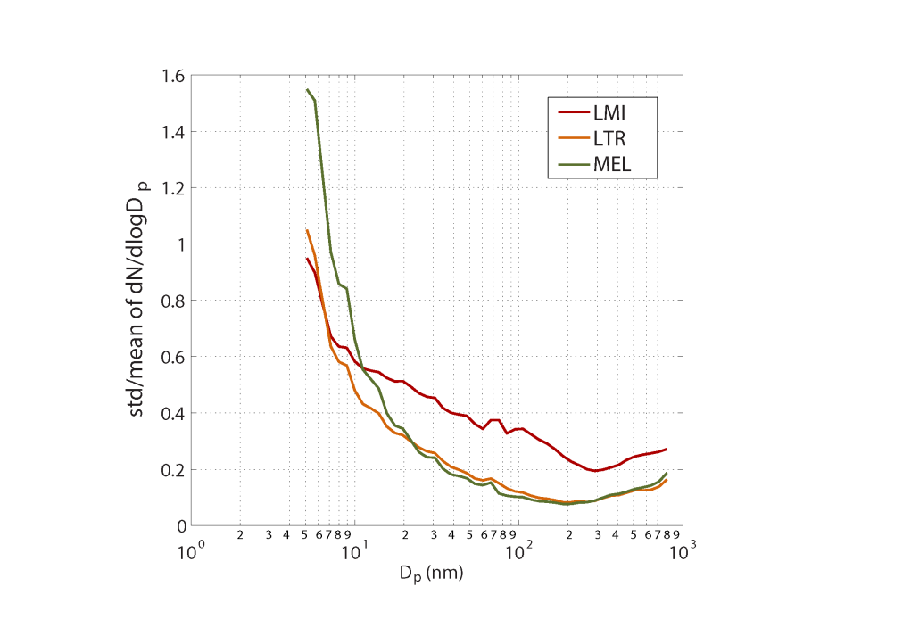

Figure S1: Two-hour variability of PNSD at LMI, LTR and MEL. Lower value indicates higher stability of d*N*/dlog*D*p.

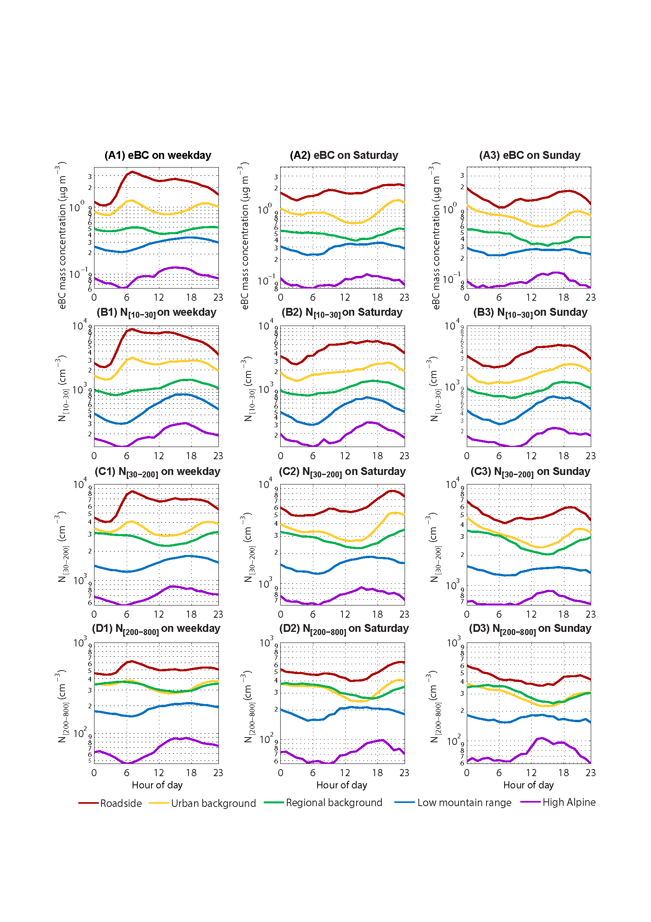

Figure S2: Diurnal cycles of particulate pollutant parameters on weekday and weekend for different site categories from 2009 to 2014.

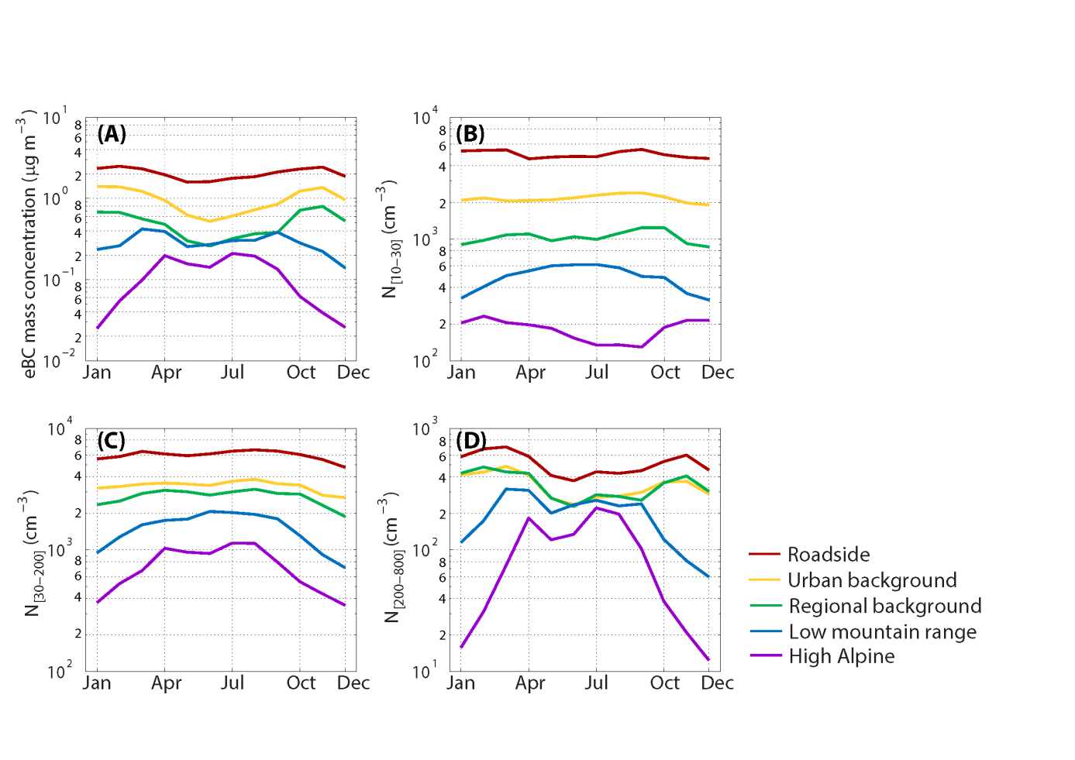

Figure S3: Annual cycles of particulate pollutant parameters for different site categories from 2009 to 2014.