**Supplementary Figure legends**

**Supplementary Figure 1. Metabolic effects of different high fat diets.** (**A**) Gain of body weight in mice fed with chow, HCHF1, HCHF2, LCHF1, and LCHF2 diet groups (n=13 for each group). (**B**) Absolute weight of fat mass in mice fed with different diets. (**C**) Plasma leptin levels in mice fed with different diets. (**D & E**) Absolute weight and percentage of lean mass in mice fed with different diets.

**Supplementary Figure 2.** Mediobasal hypothalamic lipid metabolites in chow, HCHF1, HCHF2, LCHF1, and LCHF2 diets fed mice (**A** - **M**) (n=5-6 for chow, n=8 for HCHF1, n=6 for HCHF2, n=6 for LCHF1, n=5 for LCHF2). Diet effects were analyzed by One-way ANOVA.

**Supplementary Figure 3.** Mediobasal hypothalamic sterols in chow, HCHF1, HCHF2, LCHF1, and LCHF2 diets fed mice (**A** - **M**) (n=6 for chow, n=8 for HCHF1, n=6 for HCHF2, n=6 for LCHF1, n=5 for LCHF2). The 5 diets effects were analyzed by One-way ANOVA.

**Supplementary Figure 4.** CML-ir is detectable in neurons but not in microglia, astrocytes, or endothelial cells. (**A**)Most of the NeuN-ir neurons contain CML-ir (colocalization is indicated by white arrowheads). (**B**) CML-ir is not present in iba1-ir microglia. (**C**) CML-ir is not present in GFAP-ir astrocytes. (**D**) CML-ir is not present in endothelial cells (visualized by RAGE expression). Scale bar: 30 um in A, C and D, 45 um in B.

**Supplementary Figure 5.** Carboxymethyl-lysine (CML)-modified proteins and methylglyoxal (MG-H1)-modified proteins are increased in the mediobasal hypothalami of HCHF diets-fed mice. (A) Carboxymethyl-lysine (CML)-modified proteins levels in HCHF1 and/or HCHF2 diet-fed mouse hypothalami are higher at 95, 55, 43KD. (B) Methylglyoxal (MG-H1)-modified proteins levels in HCHF1 and/or HCHF2 diet-fed mouse hypothalami are higher at 180, 95, 72, and/or 43KD.

**Supplementary Figure 6.** Neurons and astrocytes do not express RAGE. (**A**) RAGE is not expressed in NeuN-ir cells. (**B**) RAGE is not expressed in POMC neurons. (**C**) RAGE is not expressed in GFAP-ir astrocytes. Scale bar: 30um.

**Supplementary Figure 7.** Microglia, neurons, and astrocytes do not express ALCAM. (**A**) ALCAM is not expressed by iba1-ir microglia. (**B**) ALCAM is not expressed by NeuN-ir neurons. (**C**) ALCAM is not expressed by CML-ir neurons. (**D**) ALCAM is not expressed by GFAP-ir astrocytes. Scale bar: 120um in A, 30um in B-D.

**Supplementary Figure. 1**

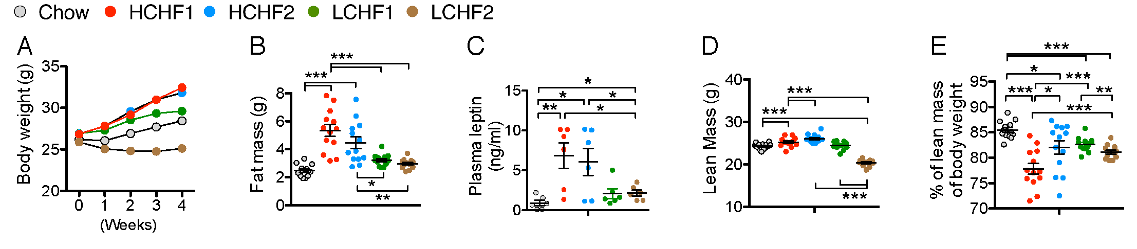

**Supplementary Figure. 2**

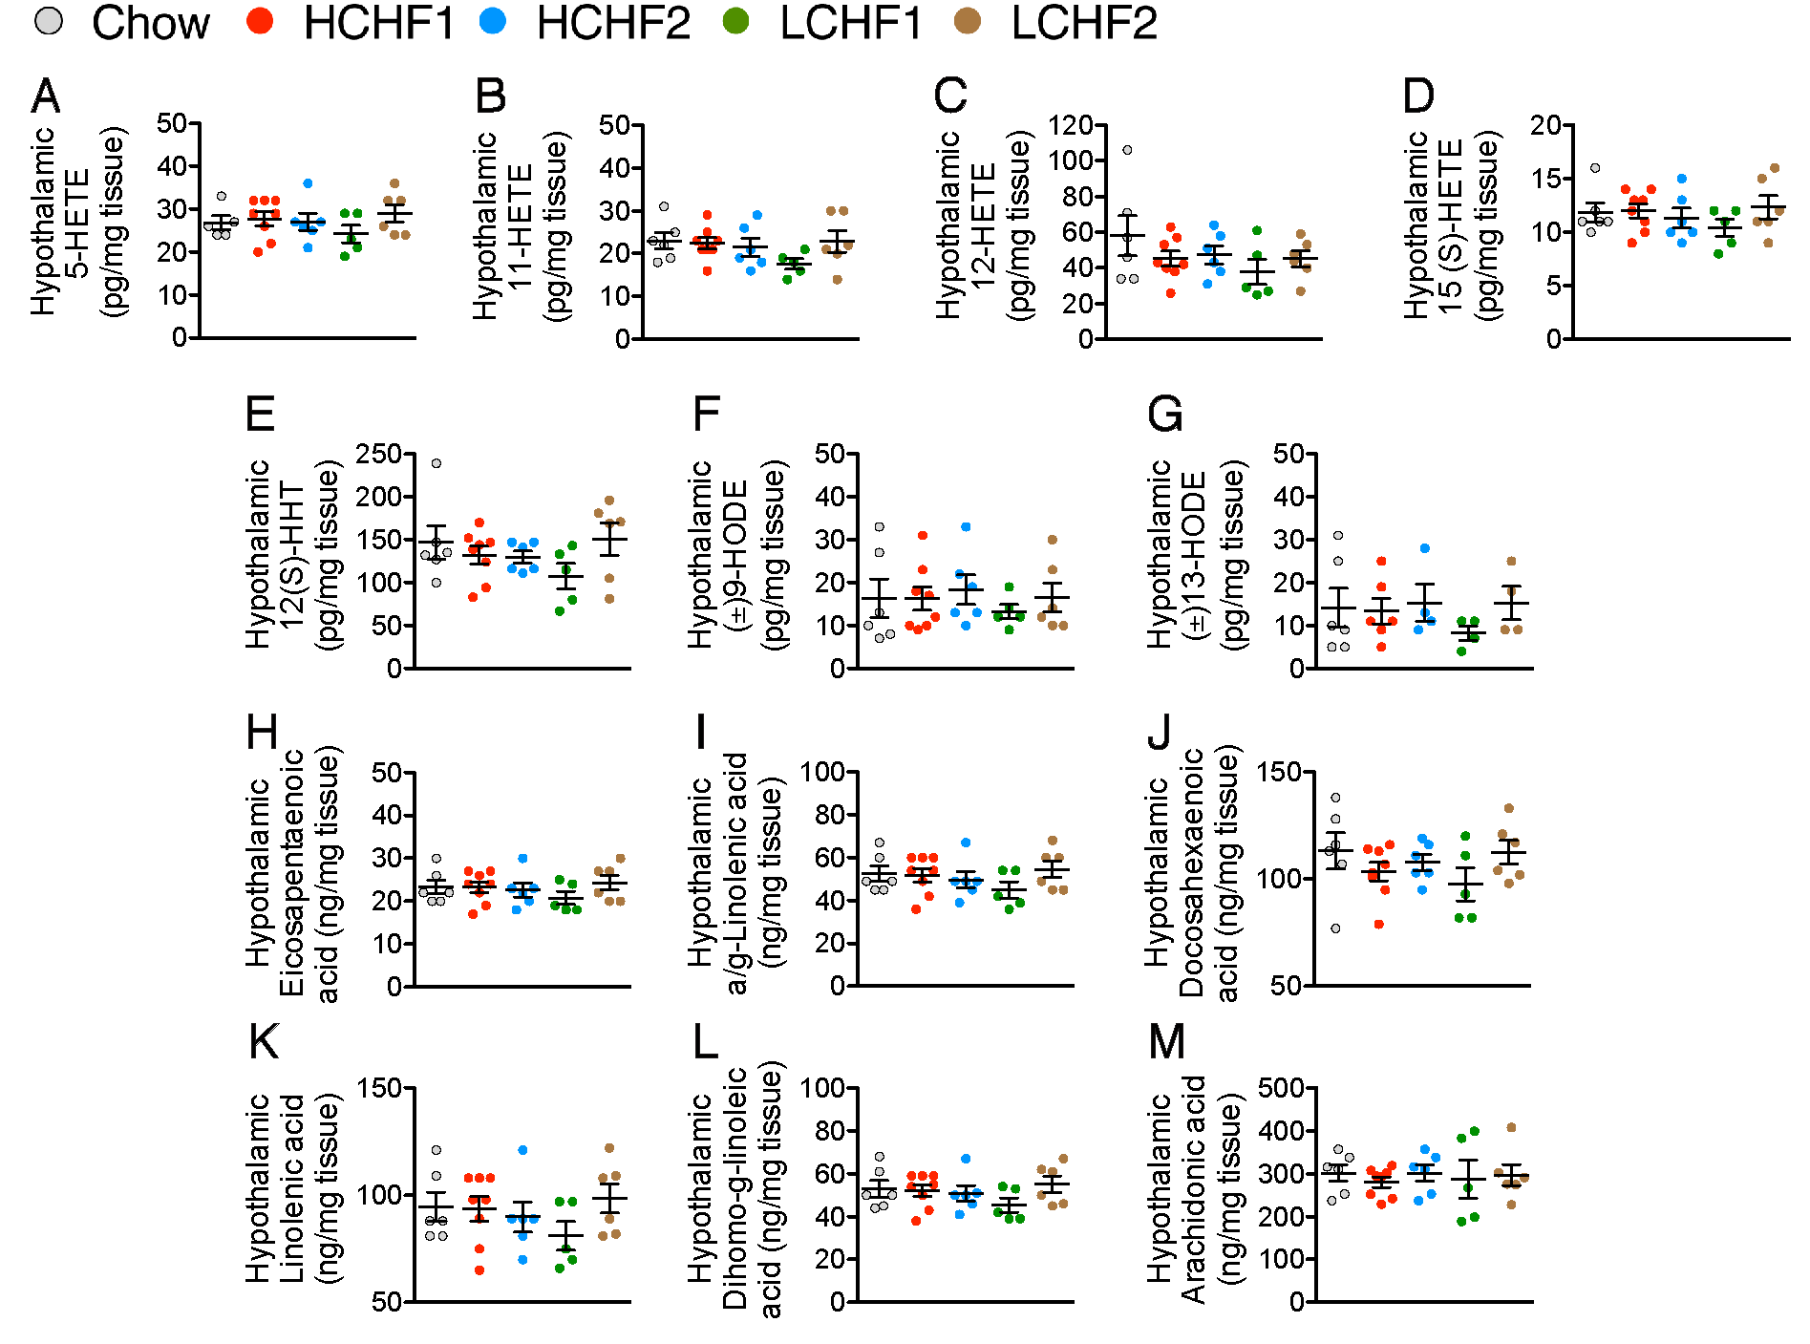

**Supplementary Figure. 3**

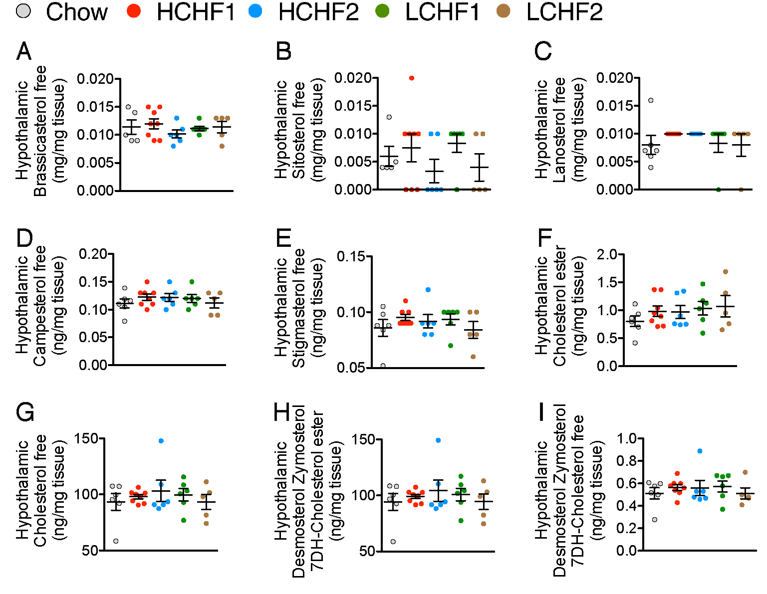

**Supplementary Figure. 4**

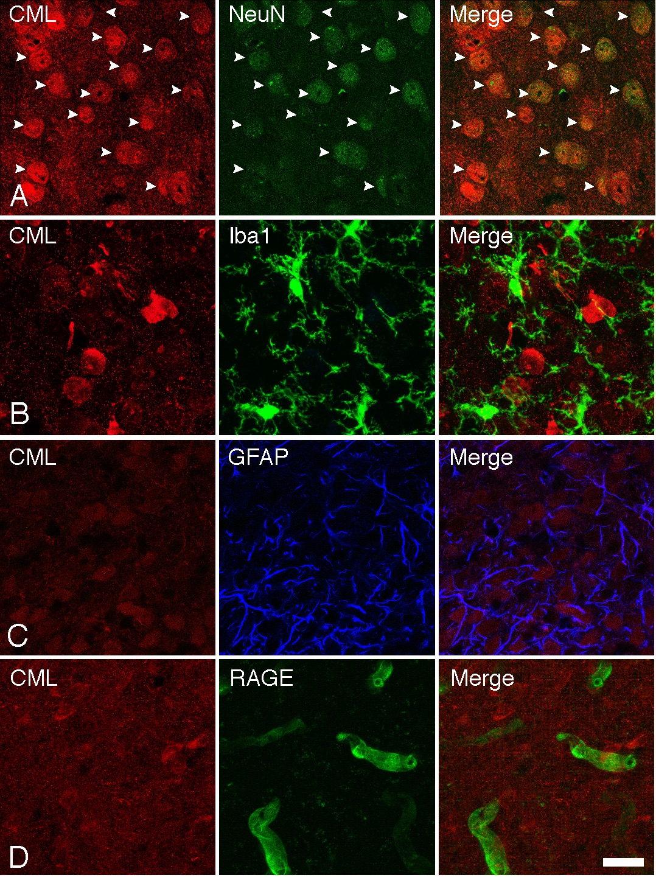

**Supplementary Figure. 5**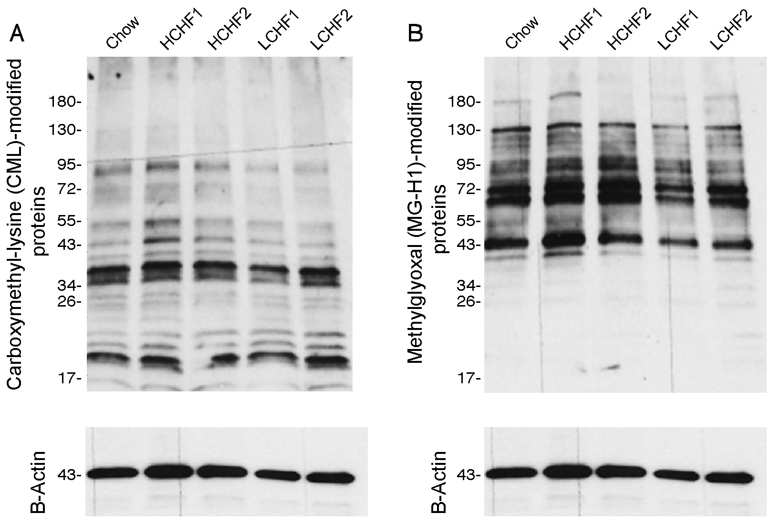

**Supplementary Figure. 6**

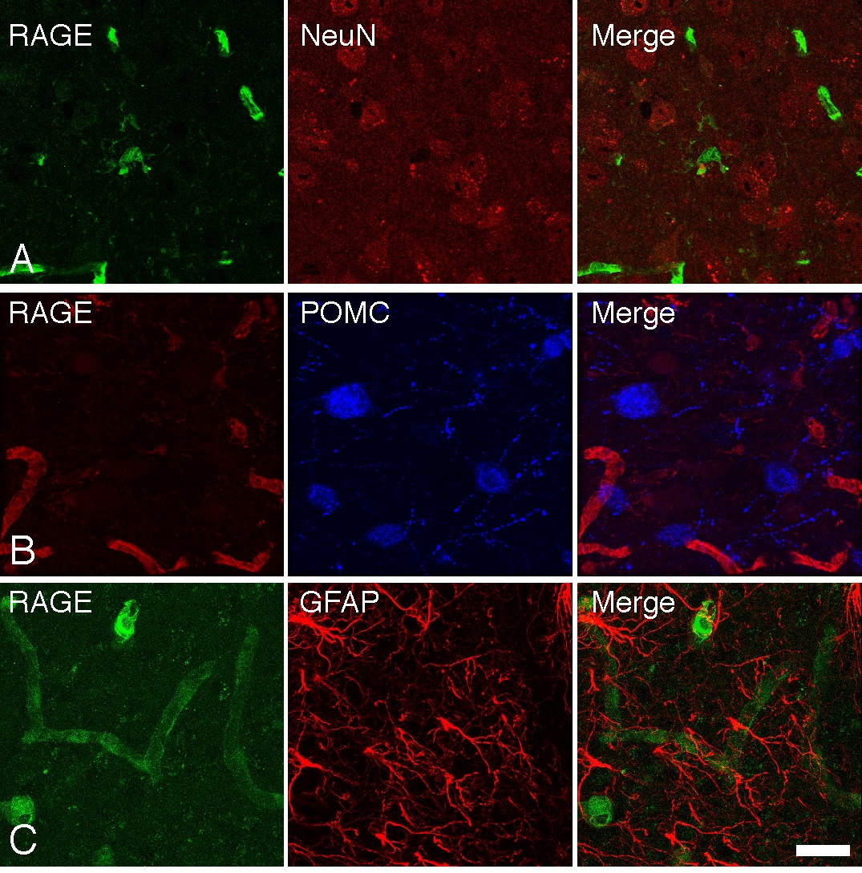

**Supplementary Figure. 7**

