**SUPPLEMENTARY DATA**

**Supplemental materials and methods**

**Chemicals and reagents.**

Carbonyl Iron (Carl Roth), BODIPY LDL-C (Thermo Fisher Scientific), TopFluor (Avanti Polar Lipids), Cholesteryl Oleate [Cholesteryl-1,2-3H(N)] (Perkin Elmer), Cholesterol [1,2-3H(N)] (Perkin Elmer), Cholesterol [4-14C] (American Radiolabeled Chemicals), dNTP set 100mM each (GE Healthcare), RNAsin (Promega), Ssofast Probe Supermix (BioRad) , Ssofast EvaGreen Supermix (BioRad), FBS Superior (Biochrom), Penicillin/Streptomycin (Biochrom), DMEM (Lonza), Hepatocyte Wash Medium (Thermo Fisher Scientific), Williams’ Medium E (Thermo Fisher Scientific), Insulin Solution from Bovine Pancreas (Sigma Aldrich), MEM Non Essential Amino Acids (Thermo Fisher Scientific), Sodium Pyruvate Solution (Sigma Aldrich), Oil-Red-O Solution (Sigma Aldrich), Horse Serum (Thermo Fisher Scientific), Deferiprone (Sigma Aldrich), Iron(II) chloride tetrahydrate (Sigma Aldrich), Holo Transferrin (Sigma Aldrich), Liberase TM (Sigma Aldrich), Triton X-100 (Carl Roth), Bovine Serum Albumin (Sigma Aldrich), Sudan IV (Carl Roth), Hematoxylin (Sigma Aldrich), MG132 (Sigma Aldrich), Cycloheximide (Sigma Aldrich).

**Human data.**

Human genome-wide association data with HDL-C, LDL-C, and total cholesterol was generated by the Global Lipids Genetics Consortium (GLGC) as previously described http://csg.sph.umich.edu/abecasis/public/lipids2013. The GLGC 2013 data set was published recentley.1 Plots used in *Figures 2* and *S4* were generated using LocusZoom.2 The sample size consists of 188,577 individuals of European ancestry and 7,898 of non-European-ancestry.1

The findings from the GLGC data were extended using a recessive model in additional six populations **(Table S1)**: (n = 24,058): (1) SAPHIR,3 (2) KORA F4,3 (3) KORA F3,4 (4) GCKD,5 (5) CoLaus,6 (6) SAPALDIA.7 The SNP rs1800562 was genotyped de-novo in SAPHIR and SAPALDIA using a TaqMan assay (ThermoFisher Scientific) on a QuantStudio 6 qPCR system. Imputed genome-wide SNP data was available for the other studies (imputation quality of rs1800562 in all studies was 1).Normalized whole-blood expression values form M1/M2 hallmark genes8 (identified by Martinez *et al*.) and genes regulated by oxidative stress (identified by Han *et al*.)9 in healthy controls (n = 6) and iron-high hemochromatosis type 1 subjects (HH1, serum ferritin > 1000 ng/ml) were extracted from the whole-blood transcriptome data set GSE121620 (GEO, Gene Expression Omnibus).

**Animal studies.**

All animals were maintained in the animal core facility of the Medical University of Innsbruck and handled in strict accordance with good animal practice as defined by the Austrian Authorities, and all animal work was approved by the Austrian Animal Care and Use Committee (Bundesministerium für Bildung, Wissenschaft und Forschung–BMBWF, approval number BMBWFW-66.011/0175-WF/V/3b/2017). Five weeks old littermates (background C57BL/6N) were fed a standard chow diet (Ssniff) prior to the start of experiments; only male mice were used throughout the study. *Hfe-/-* mice were obtained from Klaus Schümann10 and cross-bred with *ApoE-/-* mice to generate *ApoE-/-Hfe-/-* double-knockout animals. *ApoE-/-* and *ApoA1-/-* mice were obtained from Jackson Laboratories Germany. At the age of 4 weeks, animals were switched to a western-type diet supplemented with 25 g/kg (ironhi) or 5 mg/kg (ironlo) carbonyl iron, respectively. At indicated time points, animals were fasted for 4 h, anesthetized and blood samples were taken.

**Gene therapy.**

The recombinant murine PCSK9 adeno-associated virus was purchased from Vector BioLabs using a PCSK9 gain-of-function construct (AAV8-TBG-mPCSK9-D377Y). To deliver AAV, 5-week-old mice were given 2,5x1012 vector genome copies/kg of PCSK9 AAV or control virus (AAV8-TBG-eGFP) via single tail vein injection according to Goettsch *et al*.11 Three weeks later, animals were set on an ironlo/hi diet.

**Plasma cholesterol analysis.**

Serum cholesterol was measured using Cholesterol F.X. reagent (Global System); lipoprotein profiles were analyzed by fractionation of pooled serum using two Superose 6-columns in series (FPLC), followed by cholesterol measurement.

**Hepatic iron measurement.**

Total hepatic iron was quantified as described previously by our laboratory.12

**Atherosclerosis studies.**

For atherosclerosis studies, *ApoE*-/- and *ApoE-/-Hfe-/-* animals were fed an ironhi/lo western-type diet for 20 weeks, respectively. At study termination, animals were sacrificed by cervical dislocation, and atherosclerosis lesion area was quantified as described previously.13, 14

**[3H]-LDL-C turnover studies.**

[3H]-LDL-C was prepared according to Weisgraber *et al*.15 Briefly, cholesteryl oleate (American Radiolabeled Chemicals) was dried under a nitrogen stream and resolved in ethanol abs. The solution was gently mixed with LDL (Sigma Aldrich), supplemented with a protease inhibitor cocktail (Sigma Aldrich) under a N2 atmosphere at 37 °C for 24 h, followed by extensive centrifugation/washing cycles with PBS using an Amicon Ultra device (Merck) with a cutoff of 10,000 MWCO. The radioactive signal was quantified using a liquid scintillation counter. Wildtype and

*Hfe-/-* mice were fed an ironhi and ironlo diet for three weeks, respectively. Then, animals were injected i.v. with 200 µl of [3H]-LDL-C (2.7x105 CPM). At 4 h and 8 h, the tracer was measured in liver and serum using a liquid scintillation counter.

**In vivo LDL-C uptake in KCs.**

For flow cytometry quantification of LDL-C uptake in KCs in vivo, LDL was loaded with fluorescently labeled cholesterol according to the method described above. Therefore, LDL was incubated with 8.5 µM TopFluor cholesterol (Avanti Polar Lipids) for 24 h at 37°C under a N2 atmosphere, followed by extensive centrifugation/washing cycles with PBS using an Amicon Ultra device (Merck) with a cutoff of 10,000 MWCO. Fluorescence intensity was determined at 495 nm / 507 nm using a Tecan Infinite 200. To rule out potential aggregation of our LDL-C preparations, we heated BODIPY LDL-C at 85°C for 5 min and compared native BODIPY LDL-C with thermal fused particles using size-exclusion chromatography (*Figure S28*). Wildtype and Hfe-/- mice fed an ironhi or ironlo diet for three weeks were injected i.v. with 200 µl of fluorescent LDL (1 mg/ml). The animals were sacrificed after 1 h; the liver was digested with 40 ml Collagenase 1 solution (Thermo Fisher Scientific, 0.8 mg/ml) and the KCs were isolated and prepared for flow cytometry. KCs were stained for lineage (CD3 (clone 17A2), CD19 (6D5), CD49b (DX5), CD45 (30-F11), CD11b (M1/70), Gr-1 (RB6-8C5) and F4/80 (BM8) (Thermo Fisher Scientific) and analyzed in a Gallios flow cytometry device (Beckman Coulter). KCs were confirmed by additional staining with Clec4f (Life Technologies). Circulating monocytes were determined by the usage of CD45 (30-F11), (CD3 (clone 17A2), CD19 (6D5), CD49b (DX5), CD11b (M1/70), Gr-1 (RB6-8C5), CD115 (AFS98), SiglecF (E50-2440), Ly6C (RB6-8C5) and analyzed in a CytoFLEX flow cytometry device (Beckman Coulter).

**Macrophage-to-feces RCT Study**

Macrophage *in vivo* RCT study using J774 macrophages (ATCC) was performed as described13. J774 macrophages were grown in suspension using a CELLspin 500 (Integra Biosciences), radiolabeled with 2.5 μCi ml-1 [3H]-cholesterol and loaded with 40 μg ml-1 acetylated LDL (AcLDL) for 48 h. These foam cells were washed twice, equilibrated in medium with 0.2% bovine serum albumin for 6 h, centrifuged, and resuspended in PBS. [3H]-cholesterol–labeled and AcLDL-loaded J774 cells were injected i.p. Plasma samples were taken at 6, 24, and 48 h post-injection. Feces was collected continuously from 0 to 48 h and stored at 4°C before extraction of sterols. At study termination (48 h after injection), the mice were exsanguinated. Fecal cholesterol as well as bile acid extractions were performed as described. Radioactivity in plasma and in fecal lipid extracts was measured in a liquid scintillation counter, and is given as % CPM injected.

**KC depletion.**

For depletion of hepatic KCs, the mice were injected i.v. with 200 µl of clodronate-containing liposomes or control liposomes (www.clodoronateliposomes.com) on days 0 and 2.16, 17

**LDL-C uptake in primary murine hepatocytes.**

Primary murine hepatocytes were isolated as described.16 The cells were incubated with 2.5 µg/ml BODIPY LDL-C (Thermo Fisher Scientific). At indicated time points, the cells were detached using TrypLE Express (Thermo Fisher Scientific) and analyzed by flow cytometry. Flow cytometry measurements were performed using a Beckman-Coulter Gallios device and analyzed with the FlowJo software (FlowJo LLC). ΔMFI is defined as the difference in the signal intensity between an unstained control and a stained sample. Cell viability was assessed using DAPI (Thermo Fisher Scientific). Receptor-mediated endocytosis in Hfe-/- hepatocytes was blocked either by incubating cells at 4°C, or pharmacologically using dynasore, a cell permeable, dynamin GTPase-blocking small molecule.18

**KC co-culture studies with primary murine hepatocytes.**

For co-culture experiments, the immortalized murine Kupffer cell line Kup519 was loaded with BODIPY LDL-C for 20 h, then transferred to dishes containing freshly isolated primary murine hepatocytes. BODIPY cholesterol content in hepatocytes was visualized by immunohistochemistry and quantified at indicated time points using flow cytometry. To generate *Abca1* deficient Kup5 cells, a genetic knockout was achieved using the CRISPR/Cas9 technology.20 The lentiCRISPR v2 plasmid was a gift from Feng Zhang (Addgene plasmid # 52961). Singe guide RNAs for *Abca1* knockout were designed with the Broad Institute online tool.21 Following sgRNA was applied: Abca1 ACATGTCATCAACATAACAG. Lentiviral particles were produced according to Zufferey *et al*.22 by using lentiCRISPR v2 plasmid with the corresponding sgRNA insert, the packaging plasmid (psPAX2 plasmid was a gift from Didier Trono (Addgene plasmid # 12260) and envelope plasmid (pVSV-G plasmid was a gift from Connie Cepko (Addgene plasmid # 36399)). Thereafter, Kup5 cells were incubated with viral supernatant for 48 h, followed by antibiotic selection with 2 µg/mlPuromycin (Gibco).

**Cholesterol efflux from Kup5 cells.**

Experimental procedures were performed according to Demetz *et al*.,13 Tancevski *et al*.,14 and Duong *et al*.,23. Briefly, 5 x 105 Kup5 cells were seeded on a 6-well plate. Cells were then incubated with 5 µCi/ml [3H]-cholesterol for 24 h in DMEM containing 1% FBS. Then, cells were washed twice with PBS and equilibrated for 16-18 h in DMEM containing 0.2% fatty acid free BSA (Sigma Aldrich) and 1 µg/mlACAT-inhibitor (Lonza). Subsequently, cells were washed twice with PBS and incubated with DMEM supplemented with 10 µg/ml ApoA1, 0.3 mM cAMP and 1µg/mlACAT-inhibitor for 4 h. Supernatant was then collected, cells were washed twice with PBS and harvested in 1 ml 0.1 M NaOH. Both, supernatants and cell lysates were analyzed using a liquid scintillation counter (Perkin Elmer).

**Protein extraction and immunoblot analysis.**

Preparation of protein extracts and immunoblot analysis were performed as described.14 Anti-LDLr antibody was purchased from R&D systems, anti-Abca1 antibody from Abcam, and the anti-Actin antibody from Sigma Aldrich. Antibodies against ferroportin were from DAKO and Ferritin antibodies were produced previously in our laboratory.24 The chemiluminescent reaction was performed using Super Signal West Dura Reagent (Pierce), blots were visualized and analyzed by ChemiDoc device, using Image Lab software (BioRad).

**RNA isolation, reverse transcription, and TaqMan quantitative real-time PCR (qRT-PCR).**

Total RNA was extracted using PeqGold Trifast (VWR) according to the manufacturer's protocol and reverse transcribed with M-MLV Reverse Transcriptase (Thermo Fisher Scientific). The following primer sequences were used Tie2 forward TCTGGGTGGCCACTACCTAC, Tie2 reverse TGAAAGGCTTTTCCACCATC, YM2 forward CCACAGGAGCTGGATTCATT, YM2 reverse GGAAATCCCACAATGAGCTT, Arg1 forward GGTCTGTGGGGAAAGCCAATGAAG, Arg1 reverse GGAAATCCCACAATGAGCTT, IL12/23p40 forward GACCATCACTGTCAAAGAGTTTCTAGAT, IL12/23p40 reverse GGAAAGTCTTGTTTTTGAAATTTTTTAA, T-bet forward CCTGTTGTGGTCCAAGTTCAACCA, T-bet reverse ATCCACAAACATCCTGTAATGGCTTGT, T-bet probe ATCATCACTAAGCAAGGACGGCGAATGTTCC, CD3eps forward GGACAGTGGCTACTACGTCTGCTACAC, CD3eps reverse CCACACAGTACTCACACACTCGAGCT, Foxp3 forward AGGAGAAGCTGGGAGCTATGC, Foxp3 reverse TGGCTACGATGCAGCAAGAG , Foxp3 probe AGCGCCATCTTCCCAGCCAGG, GATA3 forward CTACCGGGTTCGGATGTAAGTC, GATA3 reverse GTTCACACACTCCCTGCCTTCT, IL6 forward TGTTCTCTGGGAAATCGTGGA, IL6 reverse AAGTGCATCATCGTTGTTCATACA, IL6 probe ATGAGAAAAGAGTTGTGCAATGGCAATTCTG, IL10 forward CCAGAGCCACATGCTCCTAGA, IL10 reverse TGGTCCTTTGTTTGAAAGAAAGTCT, IL10 probe TGCGGACTGCCTTCAGCCAGG, CD206 forward ATGCCAAGTGGGAAAATCTG, CD206 reverse TGTAGCAGTGGCCTGCATAG, TNFa forward TTCTATGGCCCAGACCCTCA, TNFa reverse TTGCTACGACGTGGGCTACA, TNFa probe CTCAGATCATCTTCTCAAAATTCGAGTGACAAGC, LDLr forward TCAGTCCCAGGCAGCGTAT, LDLr reverse CTTGATCTTGGCGGGTGTT, LDLr probe ACACCAAGGGCGTAAAGAGGAGGACACTGTTC, IFITM forward CCACAATCAACATGCCTGAG, IFITM reverse CCACCATCTTCCTGTCCCTA, IFIT forward CTGAGATGTCACTTCACATGGAA, IFIT reverse GTGCATCCCCAATGGGTTCT, NKp46 forward TCATCTGGGCCAAACCCAGCA, NKp46 reverse AGCACTCTGAGCCCCCTGACA, CD3eps forward GGA CAG TGG CTA CTA CGT CTG CTA CAC, CD3eps reverse CCA CAC AGT ACT CAC ACA CTC GAG CT, Hepcidin forward GGCAGACATTGCGATACCAAT, Hepcidin reverse TGCAACAGATACCACACTGGGAA, Hepcidin probe CCAACTTCCCCATCTGCATCTTCTGC, Beta-glucuronidase forward CTCATCTGGAATTTCGCCGA, Beta-glucuronidase reverse GGCGAGTGAAGATCCCCTTC, Beta-glucuronidase probe CGAACCAGTCACCGCTGAGAGTAATCG.

Real-time PCR reactions were performed on a CFX cycler and analyzed with CFX software (BioRad). Gene expression was normalized using ΔΔct calculations.

**Design of hemagglutinin (HA) tagged HFE constructs.**

For reconstitution of *Hfe-/-* hepatocytes with human wildtype *HFE* or the human variant bearing the *C282Y* missense mutation, we added a hemagglutinin (HA) tag after the N-terminal signaling sequence and a C-terminal Twin-Strep-tag to the human protein sequences of these two variants. The resulting protein sequences were subsequently optimized for mammalian expression with the codon optimization tool on the IDT homepage. The deduced nucleic acid sequence was supplemented with attB gateway overhangs and retrieved as gBlocks from IDT. These gBlocks were inserted into the pDONR207 (Thermo Fisher Scientific) donor plasmid using the BP Gateway reaction (Thermo Fisher Scientific) and transformed into chemo competent TOP10 (Thermo Fisher Scientific) bacteria. After validation by sequencing, pDONR207 plasmids with the correct insert were used in a LR Gateway reaction (Thermo Fisher Scientific) with the pCS-Dest (Addgene Plasmid #22423) expression vector. This reaction mix was, again, transformed into chemo competent TOP10 Bacteria and the resulting plasmids *pCS2-HA-HFE(282C)* and *pCS2-HA-HFE(282Y)* were sequence-verified.

**Genetic reconstitution of HFE in primary murine Hfe-/- hepatocytes.**

Primary hepatocytes of *Hfe-/-* mice were isolated as described, seeded onto glass cover slips (Menzel) and transfected with *pCS2-HA-HFE(C282C)*, or *pCS2-HA-HFE(C282Y)* by using the JetPEI-hepatocyte transfection system according to the manufacturer's protocol (Polyplus transfections), respectively. To differentiate both between endogenous non-functional Hfe of murine *Hfe-/-* hepatocytes and human HFE in immunofluorescence staining, a hemagglutinin (HA)-tag at the N-terminus of the expressed HFE protein was inserted into the cDNA cassette of both wildtype and missense *HFE*, serving as a highly specific binding site for the employed anti-HA antibody. Immunofluorescence staining was performed as previously described.25 Briefly, after 48 h, cells were fixed with 4% paraformaldehyde for 20 min at room temperature and blocked with blocking/staining solution (5% horse serum, 0.2% Triton X-100, 0.2% bovine serum albumin in phosphate buffered saline) for 30 min at room temperature, co-incubated with anti HA (1:1,000, Sigma Aldrich), and anti LDLr antibody (1:1,000 R&D systems) overnight at 4°C. Subsequently, cells were labeled with secondary antibodies (1:1,000, donkey anti rat Alexa Fluor 488 and rabbit anti goat Alexa Fluor 594, Thermo Fisher Scientific) for 2 h at room temperature. Finally, cover slips were mounted with fluorescence mounting medium (DAKO) containing DAPI (Thermo Fisher Scientific) for DNA staining. Analysis was performed on 13 different preparations from primary Hfe-/- hepatocytes either transfected with wildtype (10 preparations) or with C282Y mutant HFE (3 preparations). Cultured cells from different preparations were collected, immunostained, and randomized so that the experimenter (image acquisition and analysis) was blinded to the actual condition. Cultures were imaged using a high resolution (60x, 1.42 N.A.) objective on an Olympus microscope and image acquisition was performed on a cell-to-cell basis using exactly the same exposure time and camera settings. To this end the experimenter scanned the coverglass for green anti-HA/Alexa488 staining. Images were then acquired without prior observation of the red anti-LDLr/Alexa594 channel. Quantification of fluorescent intensity was performed by including the entire cells as outlined in Figure 3 and using MetaMorph software (Molecular Devices) as previously described25, 26. A background region was acquired in each image and background fluorescence was subtracted. Depending on the yield and transfection efficiency, between 2 and 29 cells were analyzed per experiment.

**Masson’s trichrome staining.**

Masson’s trichrome staining was carried out according to the manufacturer’s protocol (Abcam).

**Cytology and immunohistochemistry.**

Kup5 cells were seeded onto glass cover slips (Menzel) and incubated over night with 2.5 µl/ml BODIPY LDL-C (Thermo Fisher Scientific). Cells were fixed with a 4% paraformaldehyde (Sigma Aldrich) solution for 20 min at room temperature, blocked with 5% normal horse serum incubated with Alexa Fluor 594 Phalloidin for 1 h (Thermo Fisher Scientific) and mounted with fluorescence mounting medium (DAKO) containing DAPI (Thermo Fisher Scientific) to stain nuclei. Cells were imaged on a LSM 700 confocal microscope (Zeiss) and processed with Zen light software (Zeiss).27 Livers of wildtype mice were dissected and snap-frozen in Tissue Tek-OCT embedding compound (VWR) and stored at -80°C. Tissue sections of a thickness of 5 µm were desiccated, fixed with 4% paraformaldehyde for 20 min at room temperature, blocked with 5% normal goat serum at room temperature for 30 min and incubated with anti-LDLr (R&D Systems) as well as co-stained with Clec4f-antibody over night at 4°C (1:1,000 Thermo Fisher Scientific). Sections for ApoB staining (1:200 anti ApoB100 antibody, Abcam) were pre-incubated with 0.1% Triton X-100 (Carl Roth) at room temperature for 10 min. Then, samples were incubated with secondary antibodies (1:1,000 rabbit anti goat Alexa Fluor 488, donkey anti rat Alexa Fluor 594, Thermo Fisher Scientific) for 1 h. Finally, cover slips were mounted with fluorescence mounting medium (DAKO) containing DAPI (Thermo Fisher Scientific) for DNA staining. Afterwards, cells were imaged on an Olympus microscope using cellSens software (Olympus).

**Prussian Blue Staining**

Tissue sections (5 µm) were incubated for 1 minute with ammonium sulfide solution 20% (Sigma) and washed for 10 seconds with running tap water. Then, sections were incubated for 1 minute with 10% potassium hexacyanoferrate (Carl Roth) mixed with 0.5 M hydrochloric acid (Sigma Aldrich) and washed again with running tap water for 10 seconds. Microscope slides were dyed using nuclear fast red solution (Gatt-Koller) for 5 minutes. After an additional washing step (running tap water for 10 seconds), sections were incubated in 100% acetone for 10 minutes at 4°C, followed by 96% Ethanol for 2 minutes and afterwards ethanol absolute. Then, sections were drained in xylene for 2 minutes and mounted with mounting medium Entellan (Sigma Aldrich).

**Foam cell staining**

Tissue sections of a thickness of 5 µm were air dried for 1 h at room temperature. Once they were dry they were incubated first in 100% acetone for 10 minutes at 4°C, after that in 70% acetone for 30 seconds at 4°C and afterwards in 50% acetone for 30 seconds at 4°C. Microscope slides were washed in running tap water and additionally in PBS for 5 minutes. Samples were incubated in Bloxall (Blocking Solution Fa, Vector Laboratories) for 10 minutes at room temperature and washed with PBS for 5 minutes. Afterwards they were incubated for 30 minutes at 37°C in rat anti mouse CD68 (Bio Rad) antibody, diluted 1:400 in PBS/1% BSA. Microscope slides were washed in PBS for 30 minutes at room temperature and incubated with biotinylated rabbit anti rat (Vector Laboratories) diluted 1:200 in PBS/1% BSA for 30 minutes at 37°C. After an additional washing step with PBS for 30 minutes at room temperature, slides were stained with ExtrAvidin-Peroxidase (Sigma) diluted 1:200 in PBS/1% BSA at 37°C for 30 minutes and washed with PBS for 30 minutes at room temperature. After the addition of DAB (DAB Substrate Kit, Vector Laboratories) according to the manufacturer’s protocol, slides were washed with PBS for 20 minutes and then with distilled water. After the washing steps, slides were counterstained with filtered hematoxylin solution according to Mayer (Sigma) for 30 seconds. Afterwards they were washed with 70% ethanol for 10 seconds as well as 96% ethanol for 5 minutes. After incubation with xylene substitute (Sigma-Aldrich) for 5 minutes cells were mounted with mounting medium Roti-Histokitt II (Carl Roth).

**Oxidized LDL and ApoA-I measurements**

Measurements were carried out according to the manufacturer’s protocols (antibodies-online.com #ABIN415792 and Abcam #ab238260).

**HDL measurement**

ApoB containing lipoproteins in plasma were precipitated using Qantolip HDL (Technoclone) according to the manufacturer’s protocol. Afterwards, the cholesterol in the samples was measured.

**Determination of cytokines in murine plasma**

IL-6, TNFα, IL-1a, p-selectin, and ICAM1 (Magnetic Luminex Assay LXSAMSM-05) were measured according to the manufacturer’s protocols using a Luminex MAGPIX device (R&D Systems).

**Echocardiography**

Transthoracic echocardiography was performed using standard protocols for the assessment of heart function and morphometry as described previously.28, 29 Briefly, lightly anaesthetized mice (0.5% isoflurane and 99.5% O2) were placed on a temperature‐controlled warming pad (kept at 37.5°C). To conduct ultrasound examination, the Vevo 1100 imaging system and Visual Sonics Software Vevo Lab 1.7.1 (Visual Sonics, Toronto, Canada) were used. Measurements in parasternal longitudinal axis (PSLAX) were performed with a MS400 (18-38MHz) transducer. Aortic valve opening diameter and aortic valve leaflet thickness were determined in M-Mode. All measurements and analyses were performed in a blinded fashion from 3 consecutive cardiac cycles under stable conditions. The investigator was blinded to the treatment.

**Statistical analysis**

Statistical analysis was carried out with software GraphPad Prism 7 (GraphPad Software) and R programming suite (www.r-project.org). Signiﬁcance was determined either by Mann-Whitney *U* test (non-parametric distribution), or unpaired two-tailed Student’s T test, or by one-way/two-way ANOVA with Tukey post-hoc tests when more than two groups were compared (parametric distribution). In the box plots, the boundaries of the box represent the first quartile (bottom boundary) and third quartile (top boundary); the band represents the median; and the whiskers represent 1.5x of interquartile range (IRQ).

For the genetic association analysis in 6 epidemiological studies, linear models were calculated in each study separately, regressing the recessive coded genotype on total as well as LDL cholesterol, adjusted for age and sex. For the calculation of the P-values, the phenotypes were inverse normally transformed to ensure normal distribution. The single-study results were meta-analyzed using inverse variance weighted fixed effects. No heterogeneity between studies was observed (I2 index for heterogeneity = 0 for all models).

*P* < 0.05 was considered statistically signiﬁcant.

**Specific statistical data analyzed in main figures.**

*Figure 1B*: Values are depicted as median with interquartile range (boxes), whiskers represent 1.5x IRQ. 2-way ANOVA: treatment, F(1,16) = 15.5, *P* = 0.0012; genotype, F(1,16) = 6.1, *P* < 0.025; treatment X genotype, F(1,16) = 12.6, *P* = 0.003; Tukey’s post hoc test.

*Figure 1C*: Values are depicted as median with interquartile range (boxes), whiskers represent 1.5x IRQ. 2-way ANOVA: treatment, F(1,16) = 8.99, *P* = 0.0085; genotype, F(1,16) = 0.02386, *P* = 0.879; treatment X genotype, F(1,16) = 2.945, *P* = 0.105; Tukey’s post hoc test.

*Figure 3G*:Graphs show mean ± SD (unpaired Student’s t-test, two-tailed).

*Figure 4C*: Values are depicted as median with interquartile range (boxes). Whiskers represent 1.5x IRQ (data representative of three independent experiments).

*Figure 4D*: Values are depicted as median with interquartile range (boxes), whiskers represent 1.5x IRQ.

*Figure 4F*: Values are depicted as median with interquartile range (boxes). Whiskers represent 1.5x IRQ 2-way ANOVA: (F) treatment, F(1,16) = 0.05, *P* = ns; timepoint, F(3,16) = 62.4, *P* < 0.0001; treatment X time, F(3,16) = 0.7, *P* = ns (*n* = 3). (G) 2-way ANOVA: treatment, F(1,16) = 0.009, *P* = ns; timepoint, F(3,16) = 22.03, *P* < 0.0001; treatment X time, F(3,16) = 0.02, *P* = ns (n = 3).

*Figure 5E*: Values are depicted as median with interquartile range (boxes), whiskers represent 1.5x IRQ. 2-way ANOVA: treatment, F(1,16) = 166.2, *P* < 0.0001; timepoint, F(3,16) = 41.7, *P* < 0.0001; treatment X time, F(3,16) = 20.3, *P* < 0.0001; Tukey’s post hoc test (n = 3). (M) 2-way ANOVA: treatment, F(1,16) = 259.1, *P* < 0.0001; timepoint, F(3,16) = 25.2, *P* < 0.0001; treatment X time, F(3,16) = 10.0, *P* = 0.0006; Tukey’s post hoc test (n = 3).

*Figure 5G*: Values are depicted as median with interquartile range (boxes), whiskers represent 1.5x IRQ. 2-way ANOVA: diet, F(1,8) = 17.03, *P=* 0.003; genotype, F(1,8) = 0.06, *P* = 0.039; diet X genotype, F(1,7) = 0.0033, Tukey’s post hoc test (n = 3).

*Figure 6G*: Values are depicted as median with interquartile range (boxes), whiskers represent 1.5x IRQ. (n = 4). Unpaired Student’s t-test; two-tailed test was used.

*Figure 6H*: Values are depicted as median with interquartile range (boxes), whiskers represent 1.5x IRQ. 2-way ANOVA: genotype, F(1,8) = 15.3, *P=* 0.00453; Abca1 supplement, F(1,8) = 43.34, *P* = 0.0002; genotype X Abca1 supplement, F(1,8) = 15.3, *P*=0.0045, Tukey’s post hoc test (n = 3).

*Figure 6I*: Values are depicted as median with interquartile range (boxes), whiskers represent 1.5x IRQ. (n = 3). Unpaired Student’s t-test; two-tailed test was used.

*Figure 6J*: Values are depicted as median with interquartile range (boxes), whiskers represent 1.5x IRQ. ANOVA: F(2,6) = 14.2, *P* = 0.005; Tukey’s post hoc test (n = 3).

Figure 6K: Graphs show mean ± SEM, ANOVA: F(2,6) = 32.6, *P* = 0.0006; Tukey post hoc test (data representative of two independent experiments).

Figure 6M: Graphs show mean ± SEM. ANOVA: F(4,10) = 5.7, *P* = 0.012; Tukey post hoc test (data representative of two independent experiments).

**References:**

1. Willer CJ, Schmidt EM, Sengupta S, Peloso GM, Gustafsson S, Kanoni S, Ganna A, Chen J, Buchkovich ML, Mora S, Beckmann JS, Bragg-Gresham JL, Chang HY, Demirkan A, Den Hertog HM, Do R, Donnelly LA, Ehret GB, Esko T, Feitosa MF, Ferreira T, Fischer K, Fontanillas P, Fraser RM, Freitag DF, Gurdasani D, Heikkila K, Hypponen E, Isaacs A, Jackson AU, Johansson A, Johnson T, Kaakinen M, Kettunen J, Kleber ME, Li X, Luan J, Lyytikainen LP, Magnusson PKE, Mangino M, Mihailov E, Montasser ME, Muller-Nurasyid M, Nolte IM, O'Connell JR, Palmer CD, Perola M, Petersen AK, Sanna S, Saxena R, Service SK, Shah S, Shungin D, Sidore C, Song C, Strawbridge RJ, Surakka I, Tanaka T, Teslovich TM, Thorleifsson G, Van den Herik EG, Voight BF, Volcik KA, Waite LL, Wong A, Wu Y, Zhang W, Absher D, Asiki G, Barroso I, Been LF, Bolton JL, Bonnycastle LL, Brambilla P, Burnett MS, Cesana G, Dimitriou M, Doney ASF, Doring A, Elliott P, Epstein SE, Ingi Eyjolfsson G, Gigante B, Goodarzi MO, Grallert H, Gravito ML, Groves CJ, Hallmans G, Hartikainen AL, Hayward C, Hernandez D, Hicks AA, Holm H, Hung YJ, Illig T, Jones MR, Kaleebu P, Kastelein JJP, Khaw KT, Kim E, Klopp N, Komulainen P, Kumari M, Langenberg C, Lehtimaki T, Lin SY, Lindstrom J, Loos RJF, Mach F, McArdle WL, Meisinger C, Mitchell BD, Muller G, Nagaraja R, Narisu N, Nieminen TVM, Nsubuga RN, Olafsson I, Ong KK, Palotie A, Papamarkou T, Pomilla C, Pouta A, Rader DJ, Reilly MP, Ridker PM, Rivadeneira F, Rudan I, Ruokonen A, Samani N, Scharnagl H, Seeley J, Silander K, Stancakova A, Stirrups K, Swift AJ, Tiret L, Uitterlinden AG, van Pelt LJ, Vedantam S, Wainwright N, Wijmenga C, Wild SH, Willemsen G, Wilsgaard T, Wilson JF, Young EH, Zhao JH, Adair LS, Arveiler D, Assimes TL, Bandinelli S, Bennett F, Bochud M, Boehm BO, Boomsma DI, Borecki IB, Bornstein SR, Bovet P, Burnier M, Campbell H, Chakravarti A, Chambers JC, Chen YI, Collins FS, Cooper RS, Danesh J, Dedoussis G, de Faire U, Feranil AB, Ferrieres J, Ferrucci L, Freimer NB, Gieger C, Groop LC, Gudnason V, Gyllensten U, Hamsten A, Harris TB, Hingorani A, Hirschhorn JN, Hofman A, Hovingh GK, Hsiung CA, Humphries SE, Hunt SC, Hveem K, Iribarren C, Jarvelin MR, Jula A, Kahonen M, Kaprio J, Kesaniemi A, Kivimaki M, Kooner JS, Koudstaal PJ, Krauss RM, Kuh D, Kuusisto J, Kyvik KO, Laakso M, Lakka TA, Lind L, Lindgren CM, Martin NG, Marz W, McCarthy MI, McKenzie CA, Meneton P, Metspalu A, Moilanen L, Morris AD, Munroe PB, Njolstad I, Pedersen NL, Power C, Pramstaller PP, Price JF, Psaty BM, Quertermous T, Rauramaa R, Saleheen D, Salomaa V, Sanghera DK, Saramies J, Schwarz PEH, Sheu WH, Shuldiner AR, Siegbahn A, Spector TD, Stefansson K, Strachan DP, Tayo BO, Tremoli E, Tuomilehto J, Uusitupa M, van Duijn CM, Vollenweider P, Wallentin L, Wareham NJ, Whitfield JB, Wolffenbuttel BHR, Ordovas JM, Boerwinkle E, Palmer CNA, Thorsteinsdottir U, Chasman DI, Rotter JI, Franks PW, Ripatti S, Cupples LA, Sandhu MS, Rich SS, Boehnke M, Deloukas P, Kathiresan S, Mohlke KL, Ingelsson E, Abecasis GR, Global Lipids Genetics C. Discovery and refinement of loci associated with lipid levels. *Nat Genet* 2013;**45**:1274-1283.

2. Pruim RJ, Welch RP, Sanna S, Teslovich TM, Chines PS, Gliedt TP, Boehnke M, Abecasis GR, Willer CJ. LocusZoom: regional visualization of genome-wide association scan results. *Bioinformatics* 2010;**26**:2336-2337.

3. Kollerits B, Coassin S, Beckmann ND, Teumer A, Kiechl S, Döring A, Kavousi M, Hunt SC, Lamina C, Paulweber B, Kutalik Z, Nauck M, van Duijn CM, Heid IM, Willeit J, Brandstätter A, Adams TD, Mooser V, Aulchenko YS, Völzke H, Kronenberg F. Genetic evidence for a role of adiponutrin in the metabolism of apolipoprotein B-containing lipoproteins. *Hum Mol Genet* 2009;**18**:4669-4676.

4. Wichmann HE, Gieger C, Illig T; MONICA/KORA Study Group. KORA-gen--Resource for Population Genetics, Controls and a Broad Spectrum of Disease Phenotypes. *Gesundheitswesen* 2005;**67**:26-30.

5. Titze S, Schmid M, Kottgen A, Busch M, Floege J, Wanner C, Kronenberg F, Eckardt KU, investigators Gs. Disease burden and risk profile in referred patients with moderate chronic kidney disease: composition of the German Chronic Kidney Disease (GCKD) cohort. *Nephrol Dial Transplant* 2015;**30**:441-451.

6. Firmann M, Mayor V, Vidal PM, Bochud M, Pécoud A, Hayoz D, Paccaud F, Preisig M, Song KS, Yuan X, Danoff TM, Stirnadel HA, Waterworth D, Mooser V, Waeber G, Vollenweider P. The CoLaus study: a population-based study to investigate the epidemiology and genetic determinants of cardiovascular risk factors and metabolic syndrome. *BMC Cardiovasc Disord* 2008;**8**:6.

7. Downs SH, Schindler C, Liu LJ, Keidel D, Bayer-Oglesby L, Brutsche MH, Gerbase MW, Keller R, Kunzli N, Leuenberger P, Probst-Hensch NM, Tschopp JM, Zellweger JP, Rochat T, Schwartz J, Ackermann-Liebrich U; SAPALDIA Team. Reduced exposure to PM10 and attenuated age-related decline in lung function. *N Engl J Med* 2007;**357**:2338-2347.

8. Martinez FO, Gordon S, Locati M, Mantovani A. Transcriptional profiling of the human monocyte-to-macrophage differentiation and polarization: new molecules and patterns of gene expression. *J Immunol* 2006;**177**:7303-7311.

9. Han ES, Muller FL, Perez VI, Qi W, Liang H, Xi L, Fu C, Doyle E, Hickey M, Cornell J, Epstein CJ, Roberts LJ, Van Remmen H, Richardson A. The in vivo gene expression signature of oxidative stress. *Physiol Genomics* 2008;**34**:112-126.

10. Bahram S, Gilfillan S, Kuhn LC, Moret R, Schulze JB, Lebeau A, Schumann K. Experimental hemochromatosis due to MHC class I HFE deficiency: immune status and iron metabolism. *Proc Natl Acad Sci U S A* 1999;**96**:13312-13317.

11. Goettsch C, Hutcheson JD, Hagita S, Rogers MA, Creager MD, Pham T, Choi J, Mlynarchik AK, Pieper B, Kjolby M, Aikawa M, Aikawa E. A single injection of gain-of-function mutant PCSK9 adeno-associated virus vector induces cardiovascular calcification in mice with no genetic modification. *Atherosclerosis* 2016;**251**:109-118.

12. Sonnweber T, Ress C, Nairz M, Theurl I, Schroll A, Murphy AT, Wroblewski V, Witcher DR, Moser P, Ebenbichler CF, Kaser S, Weiss G. High-fat diet causes iron deficiency via hepcidin-independent reduction of duodenal iron absorption. *J Nutr Biochem* 2012;**23**:1600-1608.

13. Demetz E, Schroll A, Auer K, Heim C, Patsch JR, Eller P, Theurl M, Theurl I, Theurl M, Seifert M, Lener D, Stanzl U, Haschka D, Asshoff M, Dichtl S, Nairz M, Huber E, Stadlinger M, Moschen AR, Li X, Pallweber P, Scharnagl H, Stojakovic T, Marz W, Kleber ME, Garlaschelli K, Uboldi P, Catapano AL, Stellaard F, Rudling M, Kuba K, Imai Y, Arita M, Schuetz JD, Pramstaller PP, Tietge UJF, Trauner M, Norata GD, Claudel T, Hicks AA, Weiss G, Tancevski I. The arachidonic acid metabolome serves as a conserved regulator of cholesterol metabolism. *Cell Metab* 2014;**20**:787-798.

14. Tancevski I, Demetz E, Eller P, Duwensee K, Hoefer J, Heim C, Stanzl U, Wehinger A, Auer K, Karer R, Huber J, Schgoer W, Van Eck M, Vanhoutte J, Fievet C, Stellaard F, Rudling M, Patsch JR, Ritsch A. The liver-selective thyromimetic T-0681 influences reverse cholesterol transport and atherosclerosis development in mice. *PLoS One* 2010;**5**:e8722.

15. Weisgraber KH, Mahley RW, Assmann G. The rat arginine-rich apoprotein and its redistribution following injection of iodinated lipoproteins into normal and hypercholesterolemic rats. *Atherosclerosis* 1977;**28**:121-140.

16. Theurl M, Theurl I, Hochegger K, Obrist P, Subramaniam N, van Rooijen N, Schuemann K, Weiss G. Kupffer cells modulate iron homeostasis in mice via regulation of hepcidin expression. *J Mol Med* 2008;**86**:825-835.

17. Elsegood CL, Chan CW, Degli-Esposti MA, Wikstrom ME, Domenichini A, Lazarus K, van Rooijen N, Ganss R, Olynyk JK, Yeoh GC. Kupffer cell-monocyte communication is essential for initiating murine liver progenitor cell-mediated liver regeneration. *Hepatology* 2015;**62**:1272-1284.

18. Macia E, Ehrlich M, Massol R, Boucrot E, Brunner C, Kirchhausen T. Dynasore, a cell-permeable inhibitor of dynamin. *Dev Cell* 2006;**10**:839-850.

19. Kitani H, Sakuma C, Takenouchi T, Sato M, Yoshioka M, Yamanaka N. Establishment of c-myc-immortalized Kupffer cell line from a C57BL/6 mouse strain. *Results Immunol* 2014;**4**:68-74.

20. Sanjana NE, Shalem O, Zhang F. Improved vectors and genome-wide libraries for CRISPR screening. *Nat Methods* 2014;**11**:783-784.

21. Doench JG, Fusi N, Sullender M, Hegde M, Vaimberg EW, Donovan KF, Smith I, Tothova Z, Wilen C, Orchard R, Virgin HW, Listgarten J, Root DE. Optimized sgRNA design to maximize activity and minimize off-target effects of CRISPR-Cas9. *Nat Biotechnol* 2016;**34**:184-191.

22. Zufferey R, Dull T, Mandel RJ, Bukovsky A, Quiroz D, Naldini L, Trono D. Self-inactivating lentivirus vector for safe and efficient in vivo gene delivery. *J Virol* 1998;**72**:9873-9880.

23. Duong PT, Collins HL, Nickel M, Lund-Katz S, Rothblat GH, Phillips MC. Characterization of nascent HDL particles and microparticles formed by ABCA1-mediated efflux of cellular lipids to apoA-I. *J Lipid Res* 2006;**47**:832-843.

24. Zoller H, Koch RO, Theurl I, Obrist P, Pietrangelo A, Montosi G, Haile DJ, Vogel W, Weiss G. Expression of the duodenal iron transporters divalent-metal transporter 1 and ferroportin 1 in iron deficiency and iron overload. *Gastroenterology* 2001;**120**:1412-1419.

25. Obermair GJ, Szabo Z, Bourinet E, Flucher BE. Differential targeting of the L-type Ca2+ channel alpha 1C (CaV1.2) to synaptic and extrasynaptic compartments in hippocampal neurons. *Eur J Neurosci* 2004;**19**:2109-2122.

26. Obermair GJ, Schlick B, Di Biase V, Subramanyam P, Gebhart M, Baumgartner S, Flucher BE. Reciprocal interactions regulate targeting of calcium channel beta subunits and membrane expression of alpha1 subunits in cultured hippocampal neurons. *J Biol Chem* 2010;**285**:5776-5791.

27. Grander C, Adolph TE, Wieser V, Lowe P, Wrzosek L, Gyongyosi B, Ward DV, Grabherr F, Gerner RR, Pfister A, Enrich B, Ciocan D, Macheiner S, Mayr L, Drach M, Moser P, Moschen AR, Perlemuter G, Szabo G, Cassard AM, Tilg H. Recovery of ethanol-induced *Akkermansia muciniphila* depletion ameliorates alcoholic liver disease. *Gut* 2018;**67**:891-901.

28. Gollmann-Tepeköylü C, Lobenwein D, Theurl M, Primessnig U, Lener D, Kirchmair E, Mathes W, Graber M, Pölzl L, An A, Koziel K, Pechriggl E, Voelkl J, Paulus P, Schaden W, Grimm M, Kirchmair R, Holfeld J. Shock Wave Therapy Improves Cardiac Function in a Model of Chronic Ischemic Heart Failure: Evidence for a Mechanism Involving VEGF Signaling and the Extracellular Matrix. *J Am Heart Assoc* 2018;**7**:e010025.

29. Que X, Hung MY, Yeang C, Gonen A, Prohaska TA, Sun X, Diehl C, Määttä A, Gaddis DE, Bowden K, Pattison J, MacDonald JG, Ylä-Herttuala S, Mellon PL, Hedrick CC, Ley K, Miller YI, Glass CK, Peterson KL, Binder CJ, Tsimikas S, Witztum JL. Oxidized phospholipids are proinflammatory and proatherogenic in hypercholesterolaemic mice. *Nature* 2018;**558**:301-306.

**Authors’ contributions**

E.D., I.T., and G.W. conceived the study, E.D., P.T., R.H., C.V., D.H., C.H., K.A., D.L., L.B.Z., C.P.O., A.B., G.J.O.,C.A., S.C., C.L, J.K., V.P., M.A., A.S.,M.N., S.D., M.S, L.v.R., C.F., M.B.-P., N.B., L.V.d.S. ,S.S., H.Hi., C.G-T., J.Ho., J.Ha., J.H., S.M., J.G., G.F.V., R.P., P.M.,. M.I., P.M-V., N.M.P.-H., H.M., K.S., A.P., B.P., J.W., S.K., F.K., Ig.T., I.T., G.W. performed the experiments, analyzed and interpreted the data E.D., I.T. and G.W. wrote the paper.

**Supplemental figures**

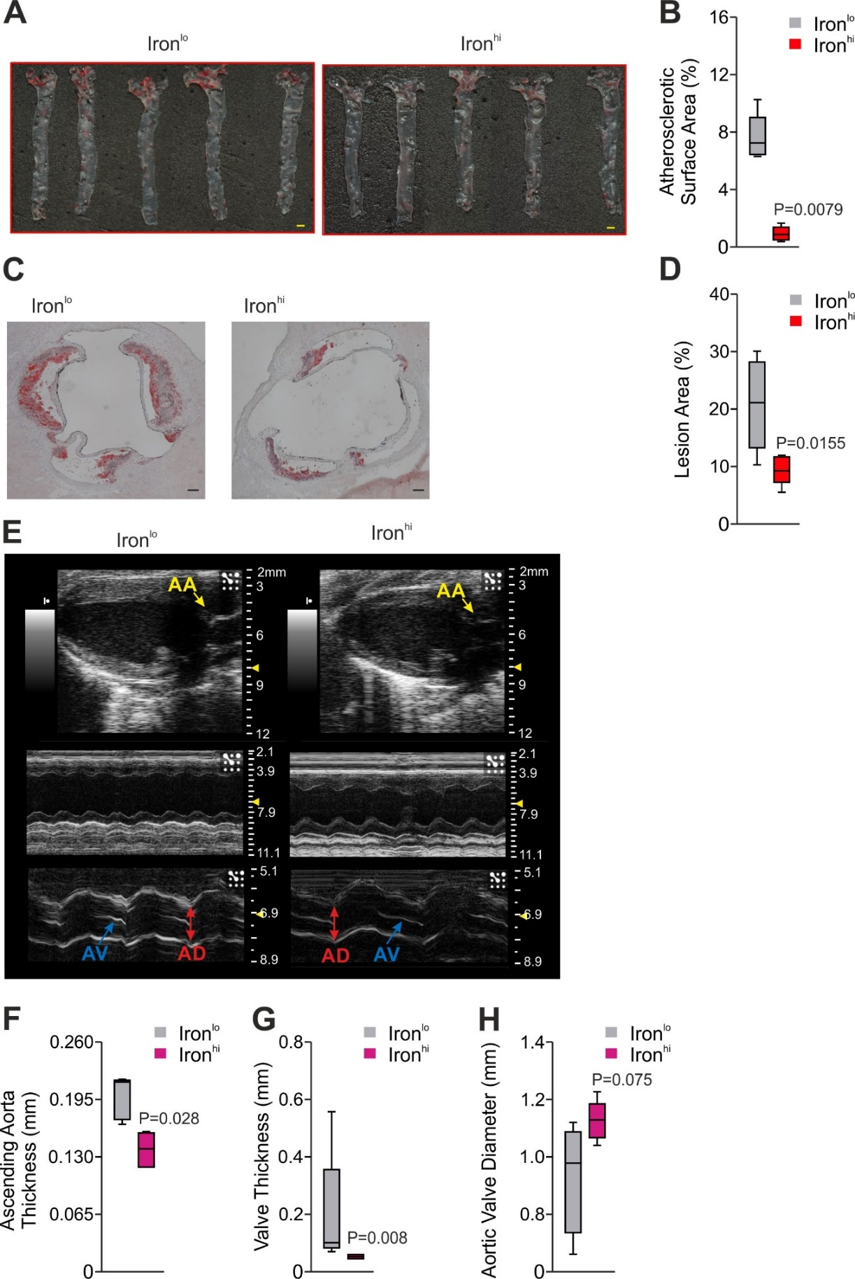

*Figure S1, related to Figure 1: ApoE-/-Hfe-/-* mice were fed a Western-type diet low or high in iron (ironlo, ironhi) for 10 weeks*.* (A) The atherosclerotic burden was visualized in thoracic aortas stained with Sudan IV (n = 5 per group). Scale bar = 1 mm.

(B) Statistical comparison of the atherosclerotic lesion size (Mann Whitney test, two-tailed). (C) Atherosclerotic burden in aortic sections stained with Oil-Red-O (n = 5 per group).

(D) Statistical comparison of the atherosclerotic lesion size (Unpaired Student’s T test; two-tailed).

(E) Representative images of transthoracic echocardiography of *ApoE-/-Hfe-/-* mice afterironlo or ironhi diet are shown. AA: ascending aorta, AV, AD: aortic valve diameter, AV: aortic valve.

Echocardiographic evaluation of thickness of the ascending aorta (F) aortic valve thickness (G), and aortic valve diameter (H) for the evaluation of atherosclerotic plaque burden within the aortic root (n = 4-5 per group). (F) Unpaired Student’s T test; two-tailed, (G) Mann Whitney test, two-tailed, (H) Unpaired Student’s T test; two-tailed.

Values are depicted as median with interquartile range (boxes), whiskers represent 1.5x IRQ.

*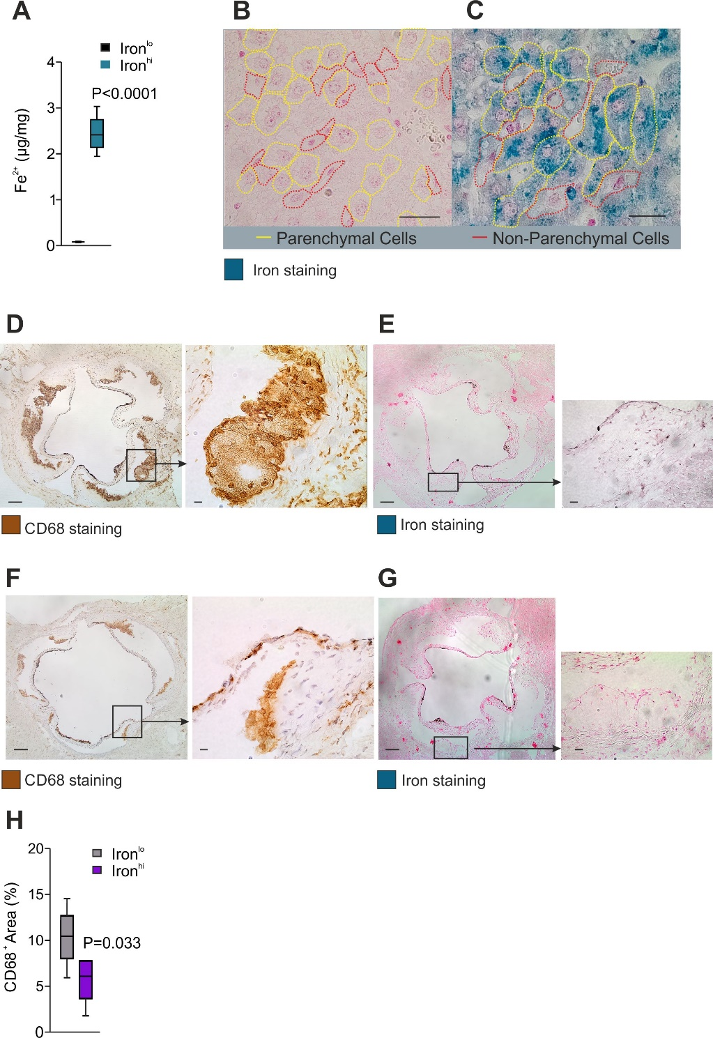Figure S2*, *related to Figure 1*: Storage of iron.

Liver and aortic root sections obtained from *ApoE-/-Hfe-/-*animals set on ironhi/lo for 10 weeks (n = 5). Histological iron staining in livers of animals on (A) ironlo and (B) ironhi diet, respectively. Scale bar = 100 µm. Parenchymal cells are contoured in yellow, non-parenchymal in red. (C) Hepatic iron measurement of respective animals (n=5 per group). Immunohistochemical staining of aortic roots using an anti-CD68 antibody to visualize foam cells in ironlo (D,E) and in ironhi (F,G) treated *ApoE-/-Hfe-/-*mice, respectively. (H) Statistical comparison of the CD68 positive area. Unpaired Student’s T test; two-tailed. Values are depicted as median with interquartile range (boxes). Whiskers represent 1.5x IRQ. Scale bars: 100 µm in overview, 10 µm in images at higher magnification.

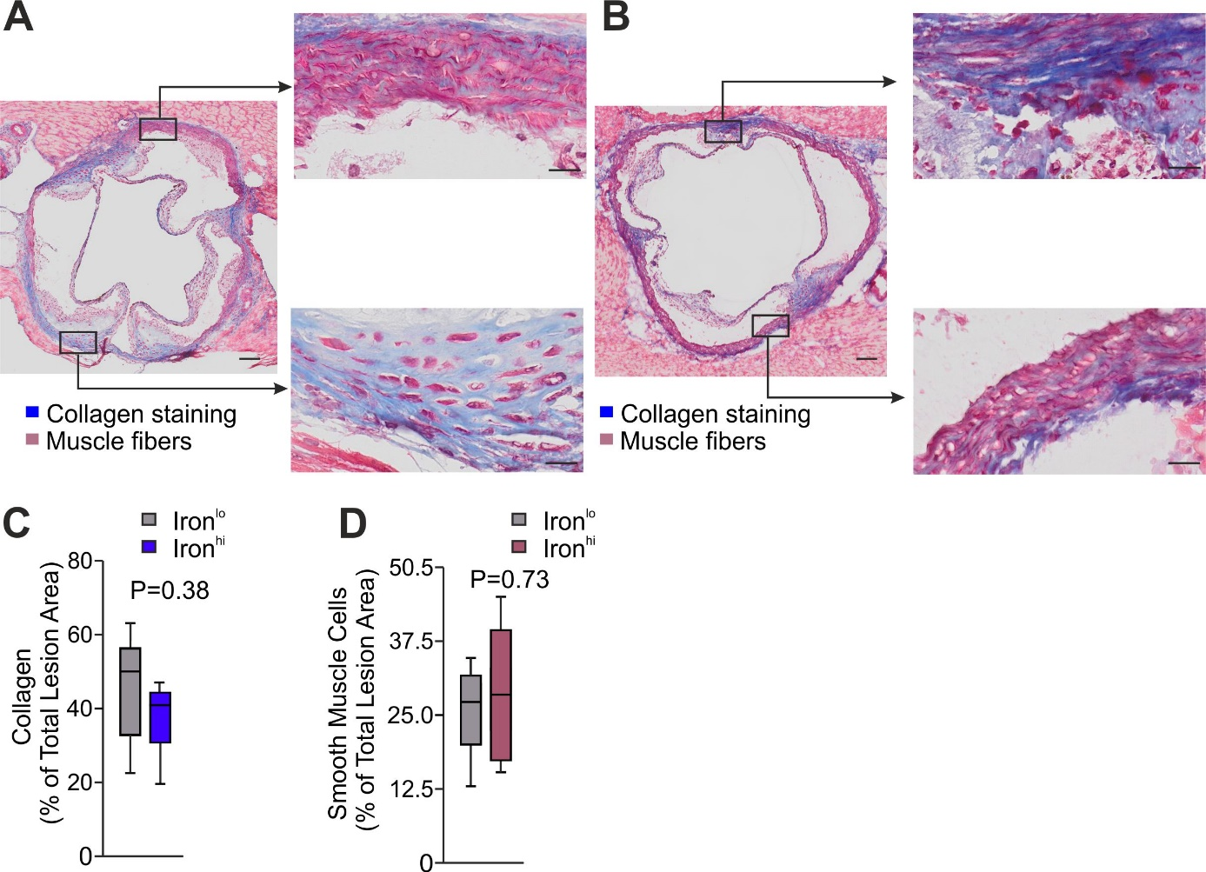

*Figure S3*, *related to Figure 1*: Masson’s trichrome staining of the aortic root of *Apoe-/ Hfe-/-*fed a (A) ironlo and (B**)** ironhi diet for 10 weeks. Statistical comparison of the (C) collagen and (D) smooth muscle positive area. (Unpaired Student’s T test; two-tailed). Values are depicted as median with interquartile range (boxes), whiskers represent 1.5x IRQ. Scale bars: 100 µm in overview, 10 µm in images at higher magnification.

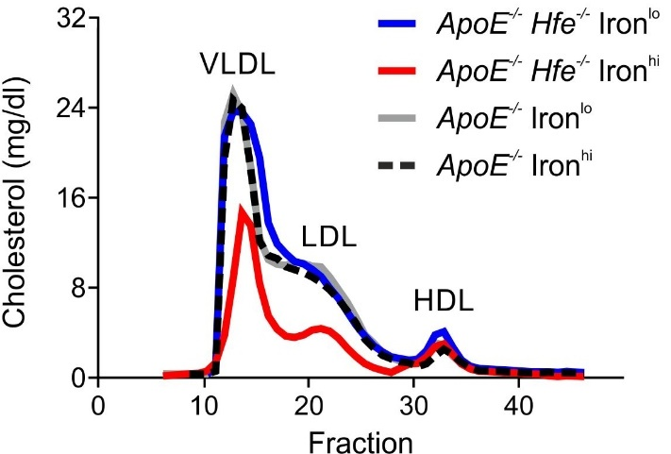

*Figure S4, related to Figure 1.* Long-term dietary supplementation with iron reduces plasma LDL-C levels

in *ApoE-/-Hfe-/-* mice.

Dietary supplementation with iron prevents from atherosclerosis in *ApoE-/-Hfe-/-* mice. The graph shows FPLC analysis of cholesterol fractions of plasma pooled from mice at 20 weeks of diet (n = 5 per group).

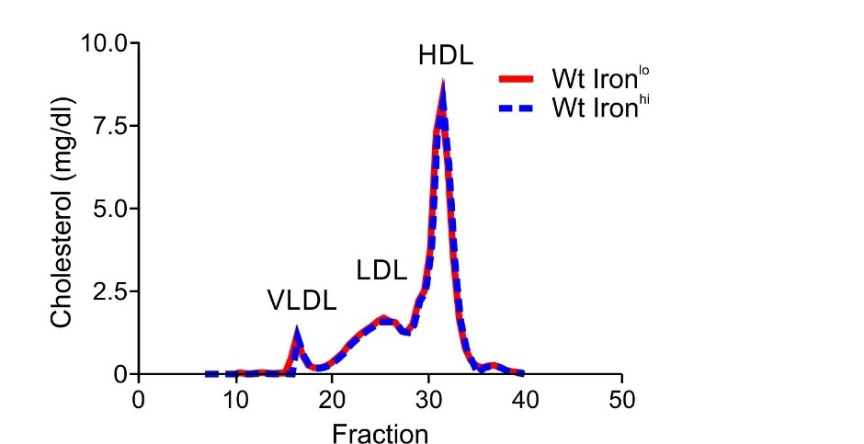

*Figure S5, related to Figure 1:* FPLC analysis of cholesterol fractions in plasma pooled from wildtype mice upon 10 weeks of western type diet high or low in iron.

The graph shows FPLC analysis of cholesterol fractions in plasma pooled from mice at 10 weeks of ironhi/lo diet (n = 5 per group).

*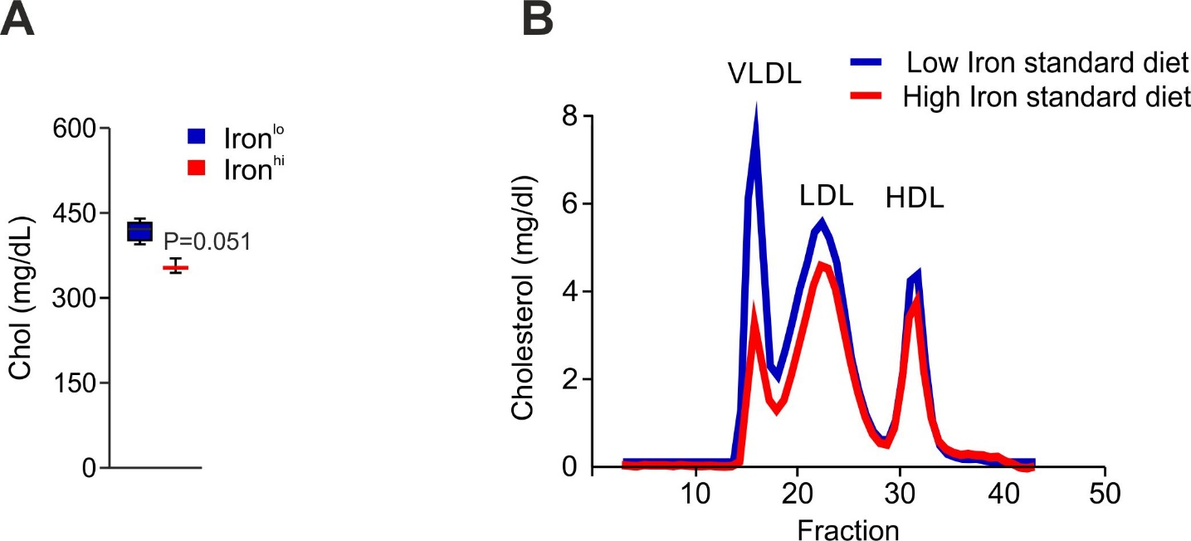Figure S6, related to Figure 1:* Dietary supplementation with iron prevents from atherosclerosis in *ApoE-/-Hfe-/-* mice

*ApoE-/-Hfe-/-* mice were set on a standard diet supplemented with 25 g/kg carbonyl iron or < 10 mg/kg iron for 6 weeks, respectively.

(A) Measurement of total cholesterol in plasma. (B) FPLC analysis of plasma pooled from animals (n = 3-4 per group). Values are depicted as median with interquartile range (boxes). Whiskers represent 1.5x IRQ (Unpaired Student’s T test; two-tailed).

*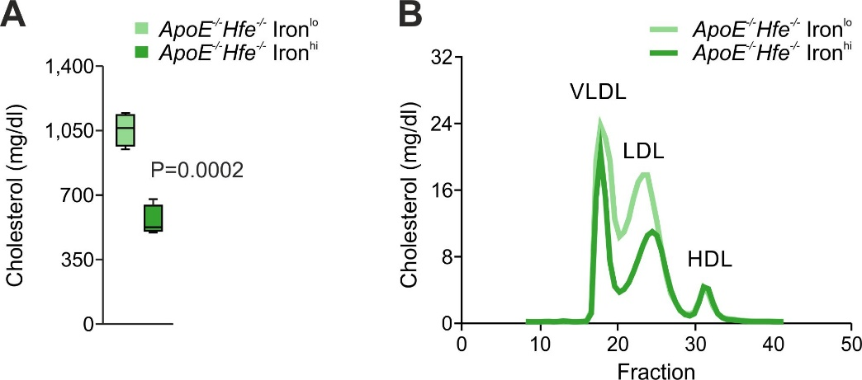Figure S7, related to Figure 1*: Dietary iron supplementation of *ApoE-/-Hfe-/-* mice rapidly leads to decreased levels of plasma cholesterol.  
(A) Cholesterol measurement and (B) FPLC analysis of plasma pooled from animals at 5 days of dietary iron supplementation (n = 5 per group). (A) Unpaired Student’s T test; two-tailed. Values are depicted as median with interquartile range (boxes), whiskers represent 1.5x IRQ.

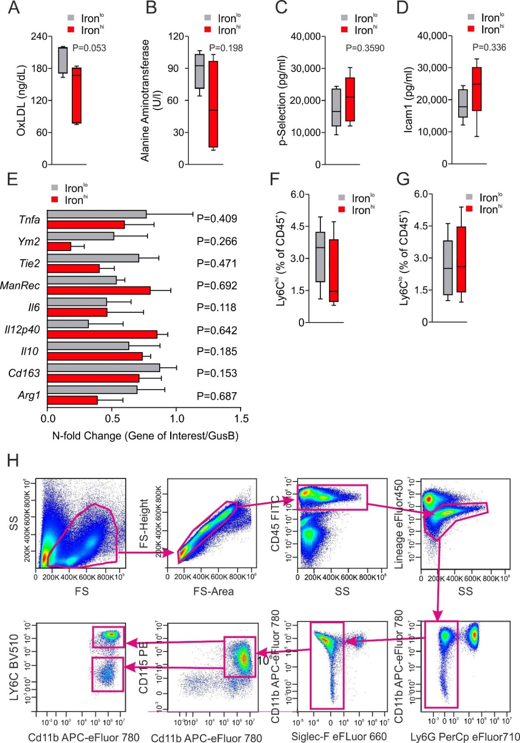

*Figure S8, related to Figure 1*: Markers of inflammation and macrophage polarization: Determination of (A) oxidized LDL (OxLDL), (B) alanine aminotransferase, (C) p-selectin, and (D) ICAM1 levels in plasma of *ApoE-/-Hfe-/-* animals set on ironhi/lo diet for 10 weeks. (E) Expression of M1/M2 foam cells polarization markers analyzed by qRT-PCR in the arotic roots of *ApoE-/-Hfe-/-* animals set on ironhi/lo diet for 20 week. (F-H) Quantification of circulating classical/inflammatory and non-classical circulating monocytes (Ly6Chi/lo) by flow cytometry in *ApoE-/-Hfe-/-* animals set on ironhi/lo diet for 3 weeks.

(A-D,F,G) Unpaired Student’s T test; two-tailed. Values are depicted as median with interquartile range (boxes), whiskers represent 1.5x IRQ. (E) Mean ± SEM.

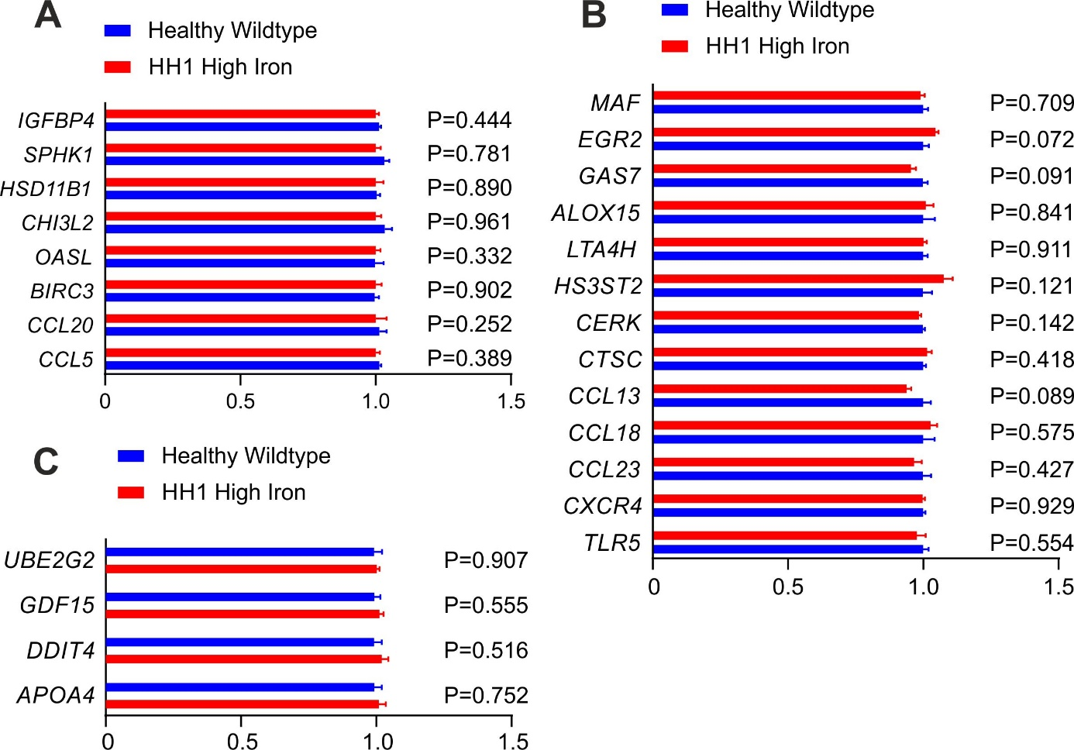

*Figure S9, related to Figure 1:* Gene expression data set of whole-blood transcriptome.

Gene expression of markers for (A) M1 and (B) M2 differentiation and for (C) oxidative stress in blood of healthy individuals and hemochromatosis type 1 patients with high serum ferritin levels (n = 6 per group, GSE121620 GEO data set). Expression was normalized to healthy controls. Significance was assessed with two-tailed T test.

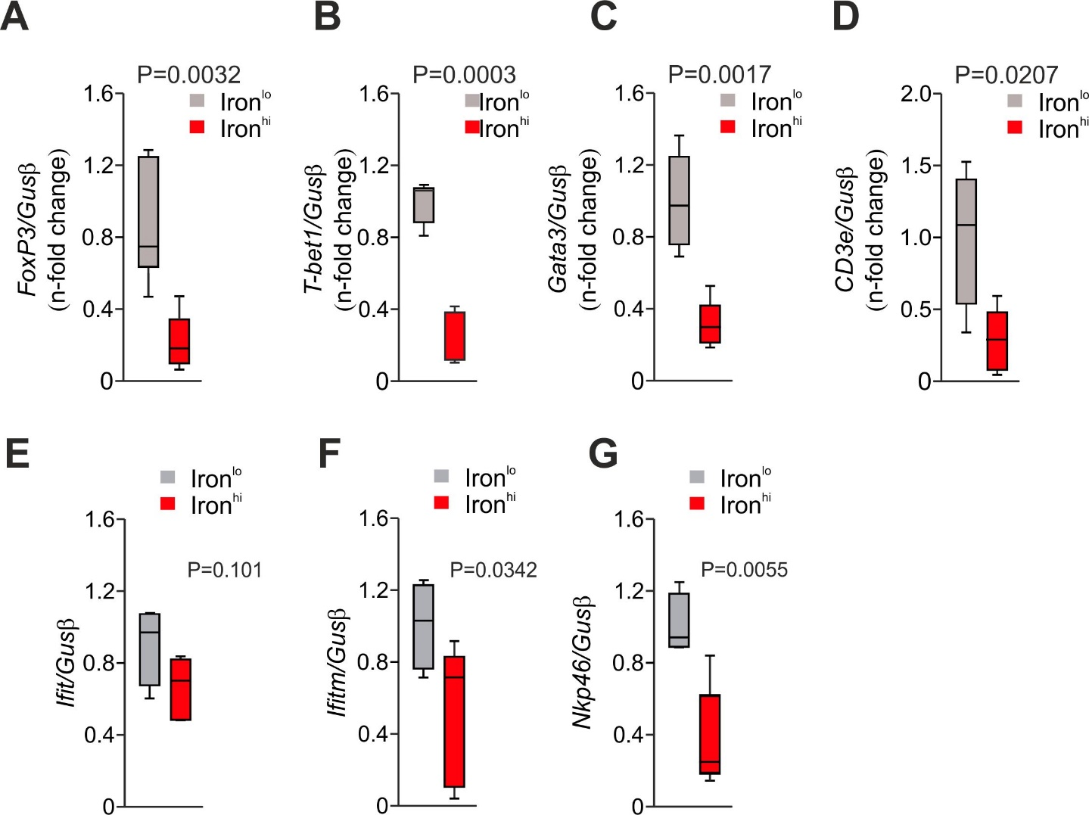

*Figure S10, related to Figure 1*: Transcriptional expression of genes involved in T-cell regulation.

QPCR- analysis of atherosclerotic lesion of (A) *FoxP3*, (B) *T-Bet1*, (C) *Gata3,* (D) *CD3epsilon*, (E) *Ifit*, (F) *Ifitm*, (G) *Nkp46* in *ApoE-/-Hfe-/-* set on ironhi/lo diet for 10 weeks. *Beta-Glucuronidase* (*Gus*) served as reference gene (n = 5 per group). Unpaired Student’s T test; two-tailed. Values are depicted as median with interquartile range (boxes), whiskers represent 1.5x IRQ.

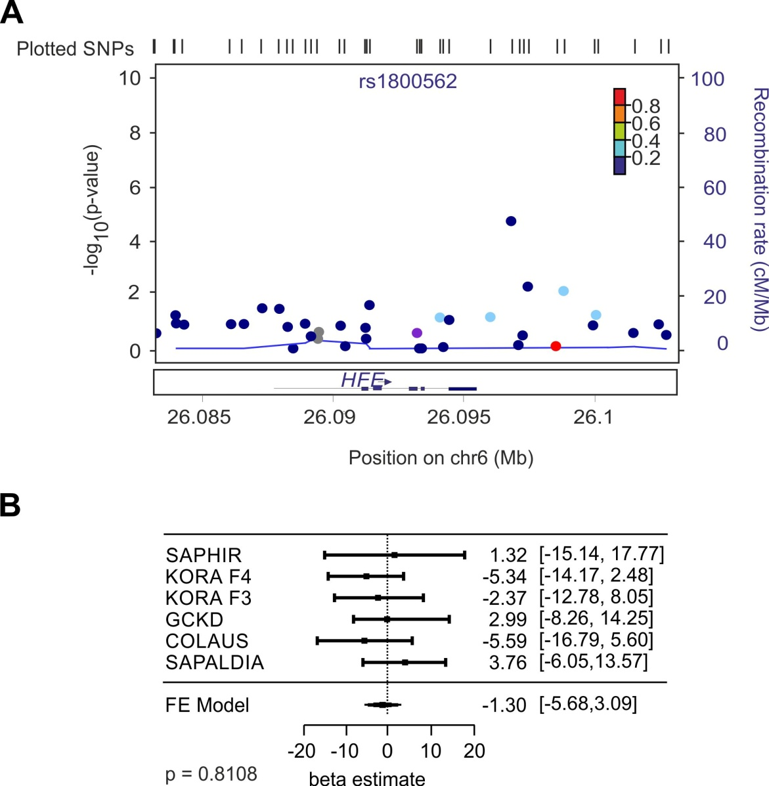*Figure S11 related to Figure 2*: (A) Locus plot for HDL-C centered on the *HFE* gene. The y-axis reports the -log10 *P-*values of each SNP from Willer *et al*. plotted against position on chromosome 6 using an additive genetic model; colors indicate amount of linkage disequilibrium between SNPs based on 1000 Genomes phase 3; the diamond indicates the identified lead SNP rs1800562 within *HFE*. Plot was generated using LocusZoom. (B) The association ofthe identified lead SNP rs1800562 in *HFE* with HDL-C was further analyzed in 6 epidemiological studies using a recessive model and including a total of 24,058 individuals*.* Estimates are derived from a recessive coded genotype (1: AA, 0: AG/GG), adjusting for age and sex and excluding participants taking lipid lowering drugs. Single-study results were meta-analyzed using inverse variance weighted fixed effects. The *P*-value was derived from the same model, but based on inverse normal transformed values of HDL-C to ensure normal distribution.

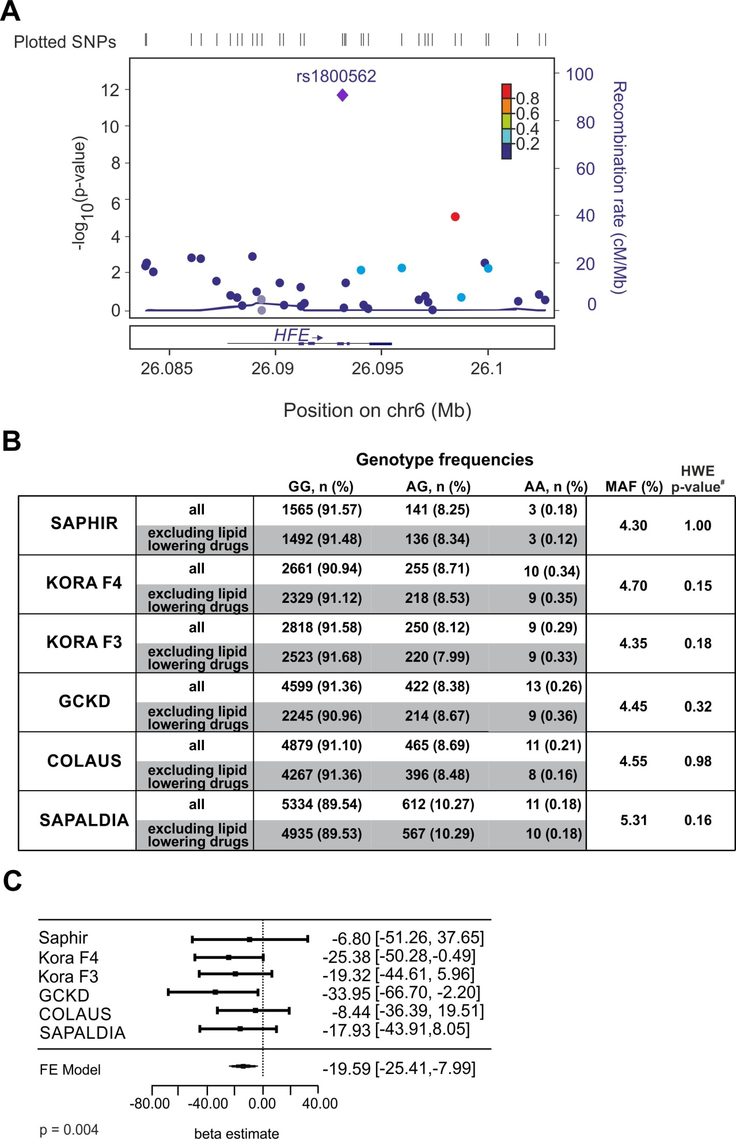

*Figure S12, related to Figure 2.* Identification of HFE as a regulator of plasma cholesterol in humans.

Common variants in the human *HFE* gene were evaluated in GWAS meta-analysis comprising >180,000 individuals of European ancestry. (A) Locus plot for GWA to total-C in the *HFE* gene, with *P*-values of -log10 plotted against position on chromosome 6; colors indicate amount of linkage disequilibrium between SNPs; the diamond indicates the identified lead SNP rs1800562 within *HFE*. Plot was generated using Locus Zoom.

(B) Allele frequency and genotype distribution of SNP rs1800562 in the analyzed epidemiological studies.

(C) Association of the SNP rs1800562 in *HFE* with plasma total cholesterol in 6 epidemiological studies, comprising a total of > 20,000 individuals. Estimates are derived from a linear regression model on total cholesterol, using recessive coded genotype (1: AA, 0: AG/GG), adjusting for age and sex and excluding participants taking lipid lowering drugs. Single-study results were meta-analyzed using inverse variance weighted fixed effects.

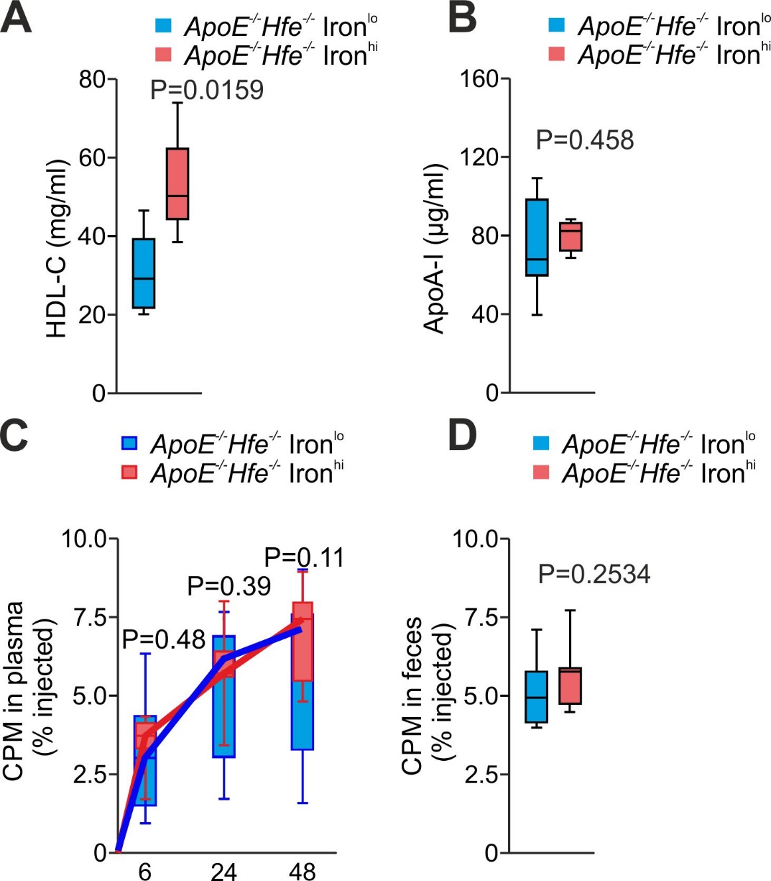

*Figure S13, related to Figure 2:* HDL composition and functionality in *ApoE-/-Hfe-/-* mice.

(A) HDL and (B) ApoA-I levels of *ApoE-/-Hfe-/* mice set on ironhi/lo diet for 10 weeks (n = 5 per group). (C) Plasma [3H]-cholesterol levels and (D) fecal [3H]-sterol levels (n = 8 per group). Unpaired Student’s T test; two-tailed. Values are depicted as median with interquartile range (boxes), whiskers represent 1.5x IRQ.

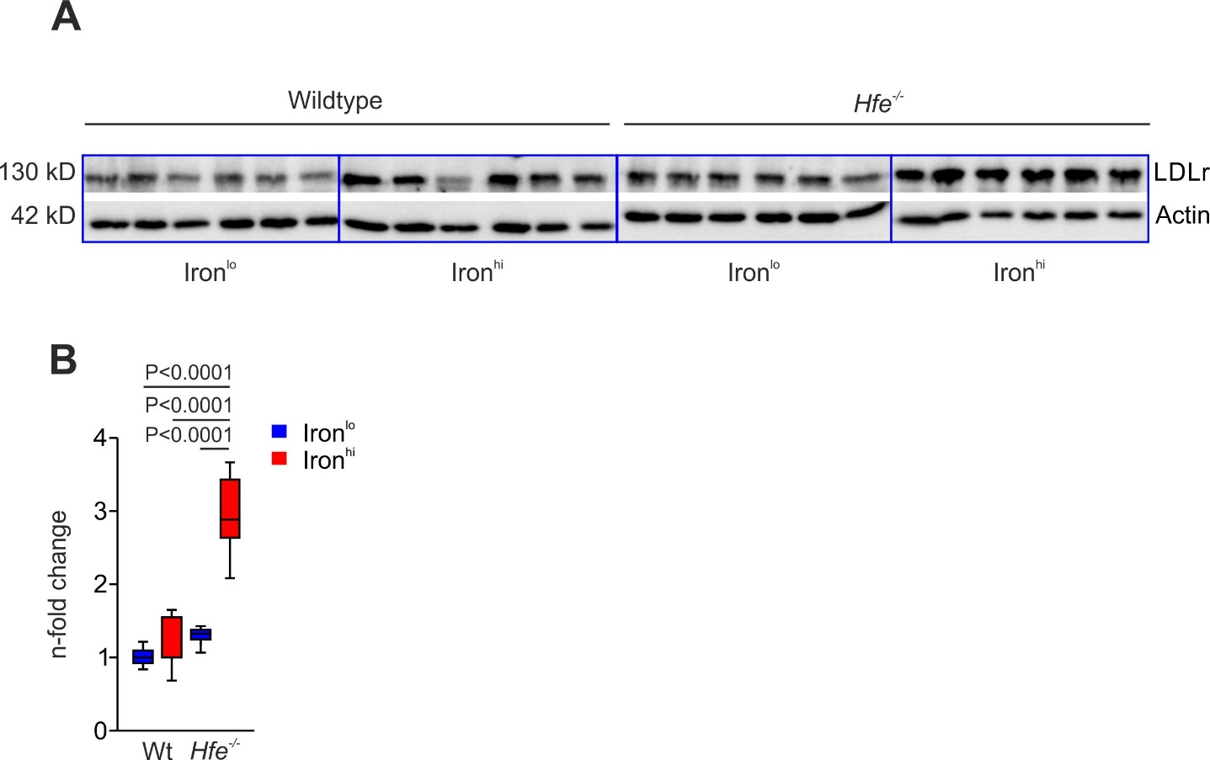

*Figure S14, related to Figure 4.* Iron upregulates LDLr in liver of Hfe-/- mice.  
(A) Immunoblot analysis of LDLr in livers of wildtype and *Hfe-/-* animals fed ironlo or ironhi diet for 3 weeks, respectively. Actin served as loading control. (B) Densitometric analysis of proteins. Values are depicted as median with interquartile range (boxes), whiskers represent 1.5x IRQ. Two-way ANOVA: diet F(1,20) = 49.77, *P* < 0.0001; genotype F(1,20) = 54.96, *P* < 0.0001; diet X genotype, F(1,20) = 27.86, *P* < 0.0001 (n = 6 per group).

*Figure S15 related to Figure 4:* Quantification of western blot analysis.

Immunoblot analysis of LDLr, of the iron storage protein ferritin and the iron exporter ferroportin levels in livers of wildtype and *Hfe-/-* animals fed ironlo or ironhi diet for 3 weeks, respectively. Actin served as loading control.

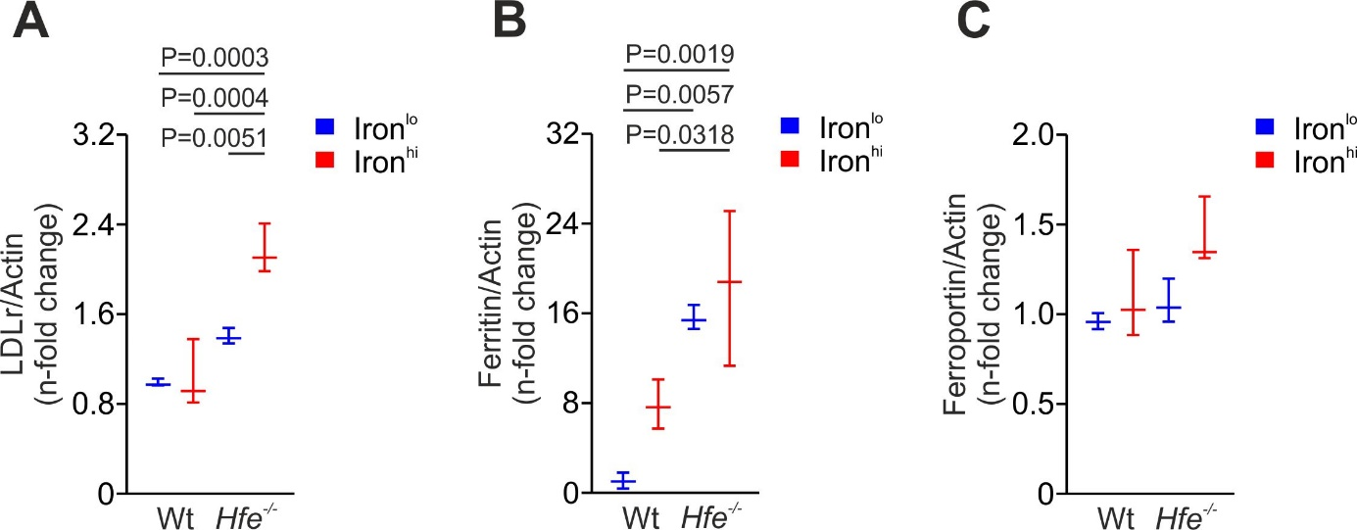Densitometric analysis of proteins levels of (A) LDLr, (B) ferritin, and (C) ferroportin. Values are depicted as median with interquartile range (boxes). Whiskers represent 1.5x IRQ, Two-way ANOVA: (A) diet, F(1,8) = 13.43, *P* = 0.0064; genotype, F(1,8) = 49.19, *P* = 0.0001; diet X genotype, F(1,8) = 10.77, *P* = 0.0112; (B) diet, F(1,8) = 5.106, *P* = 0.0537; genotype, F(1,8) = 34.89, *P* = 0.0004; diet X genotype, F(1,8) = 0.847, *P* = 0.3841; (C) diet, F(1,8) = 5.265, *P* = 0.0509; genotype, F(1,8) = 4.314, *P* = 0.0715; diet X genotype, F(1,8) = 1.949, *P* = 0.2003, Tukey's post hoc test was used.

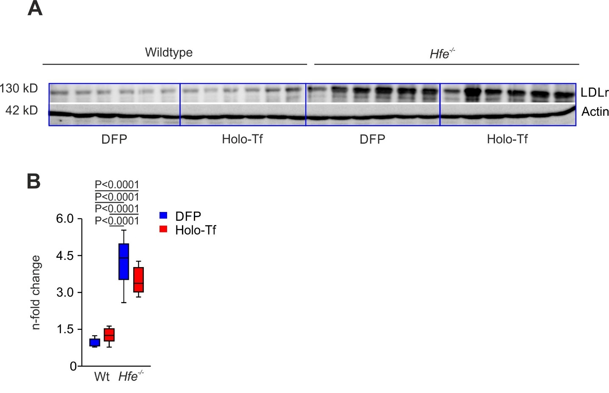

*Figure S16, related to Figure 4.* Iron metabolism does not affect LDLr expression in isolated hepatocytes.

(A) Immunoblot analysis of LDLr in primary murine hepatocytes of wildtype and *Hfe-/-* animals incubated with Deferiprone (DFP) and holo transferrin (holo-Tf), respectively. Actin served as loading control. (B) Densitometric analysis of LDLr levels relative to the loading control. Values are depicted as median with interquartile range (boxes), whiskers represent 1.5x IRQ. 2-way ANOVA: iron amount F(1, 20) = 0.88, *P* = 0.36; genotype, F(1, 20) = 121.6, *P* < 0.0001; iron amount X genotype, F(1,20) = 4.0, *P* = 0.059 (n = 6 per group).

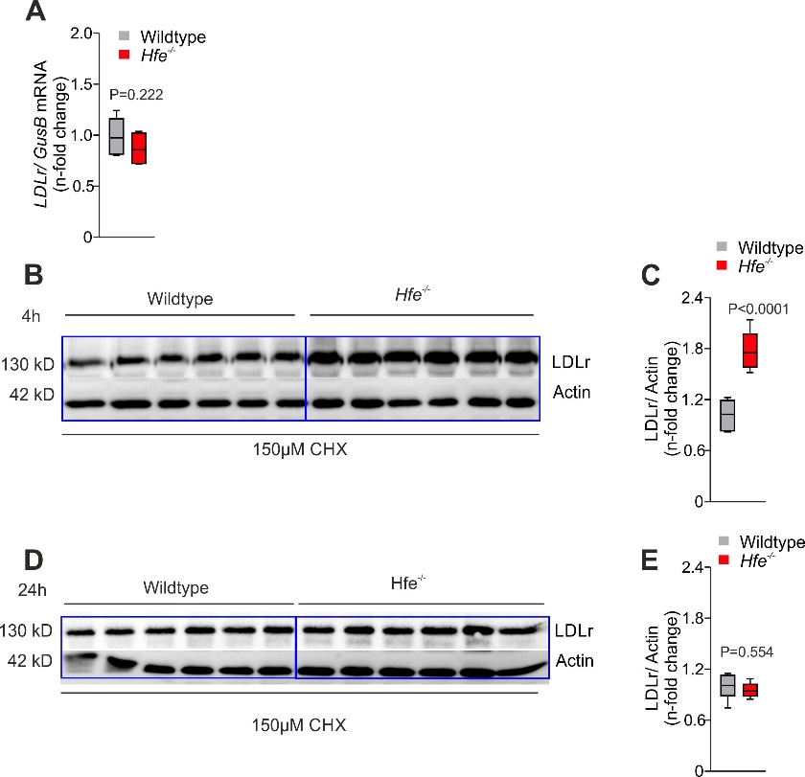

*Figure S17 related to Figure 4:* Regulation of Ldlr by Hfe.   
(A) RT-qPCR-analysis ofLdlr in cultured primary murine hepatocytes from wildtype or *Hfe-/-* mice. *Beta-Glucuronidase* (*Gus*) served as reference gene. (B) Immunoblot analysis of Ldlr levels in primary murine hepatocytes, isolated from wildtype and *Hfe-/-* mice, and incubated with 150 µM cycloheximide (CHX) for 4 h. Actin served as loading control. (C) Densitometric analysis of LDLr levels relative to the loading control. (D) Immunoblot analysis of Ldlr levels in primary murine hepatocytes, isolated from wildtype and *Hfe-/-* mice, respectively, and incubated with 150 µM cycloheximide (CHX) for 24 h. Actin served as loading control. (E) Densitometric analysis of LDLr levels relative to the loading control. Unpaired Student’s T test; two-tailed. Values are depicted as median with interquartile range (boxes), whiskers represent 1.5x IRQ.

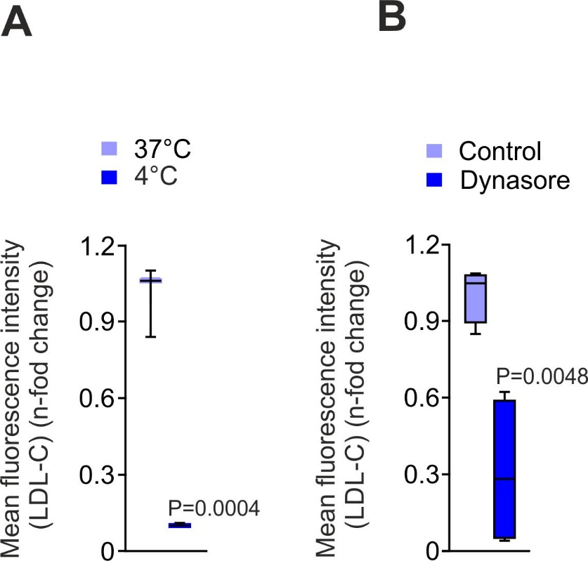

*Figure S18, related to Figure 4.* Inhibition of receptor mediated endocytosis in hepatocytes.

(A) Primary hepatocytes isolated from *Hfe-/-* mice were incubated with 5 µg/ml BODIPY LDL-C at 37°C or 4°C for 1h, respectively. LDL-C uptake in hepatocytes was determined using flow cytometry. Values are depicted as median with interquartile range (boxes). Whiskers represent 1.5x IRQ (n = 3).

(B) Primary hepatocytes isolated from *Hfe-/-* mice were incubated with 5 µg/ml BODIPY LDL-C and treated with 25 µM dynasore or vehicle (Control) for 1h, respectively. LDL-C uptake in hepatocytes was determined using flow cytometry. Values are depicted as median with interquartile range (boxes), whiskers represent 1.5x IRQ (n = 4). (Unpaired Student’s T test; two-tailed.).

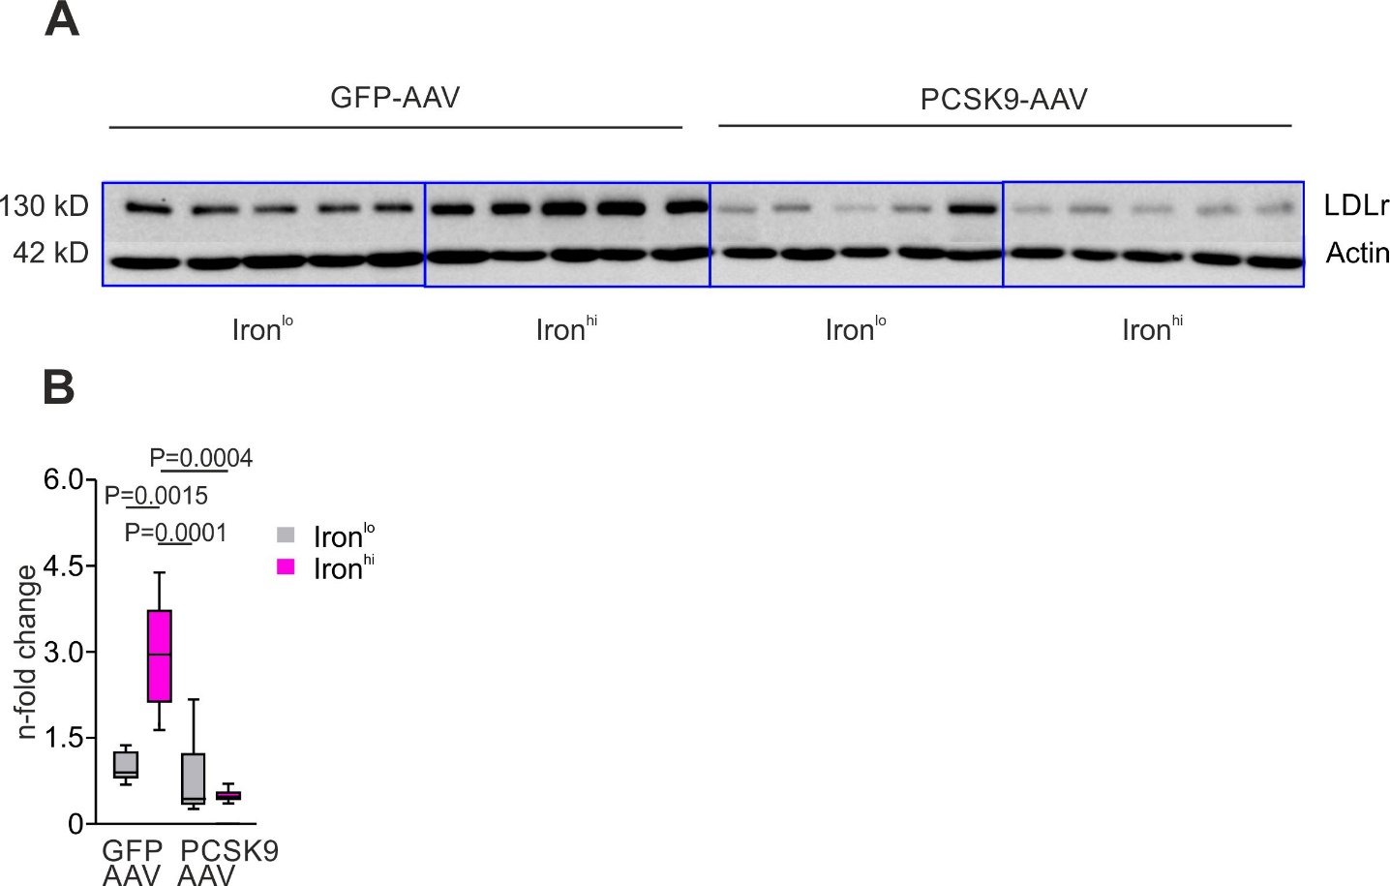

*Figure S19, related to Figure 4*. AAV-mediated overexpression of PCSK9 in the liver abolishes LDLr expression.

(A) Immunoblot analysis of hepatic LDLr levels in wildtype and *Hfe-/-* animals fed ironlo or ironhi diet for 12 weeks, and injected i.v. with 2.5 x 1012 genome copies per kg AAV8-TBG-eGFP, and AAV8-mPCSK9-D377Y respectively. Actin served as loading control. (B) Densitometric analysis of Ldlr levels relative to the loading control. Values are depicted as median with interquartile range (boxes), whiskers represent 1.5x IRQ. 2-way ANOVA: diet F(1,16) = 7.923, *P* = 0.0125; transduction F(1,16) = 21.16, *P* < 0.0003; transduction X genotype, F(1,16) = 13.82, *P* = 0.002 (n = 6 per group).

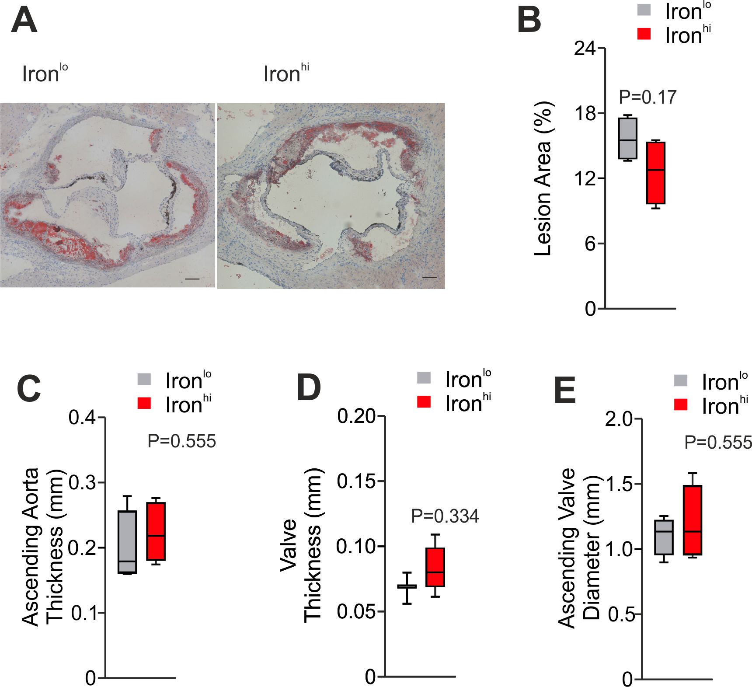

*Figure S20, related to Figure 4:* Formation of atherosclerosis plaques in animals infected with AAV-PCSK9.

(A) Oil Red-O staining of aortic roots of *ApoE-/-Hfe-/-* animals infected with AAV-PCSK9, and set on ironhi/lo for 10 weeks. (B) Statistical comparison of the lesion area. Echocardiographic evaluation of (C) thickness of the ascending aorta, (D) aortic valve thickness, and (E) aortic valve diameter for the evaluation of atherosclerotic plaque burden within the aortic root Unpaired Student’s T test; two-tailed. Values are depicted as median with interquartile range (boxes), whiskers represent 1.5x IRQ (n = 3-4 per group).

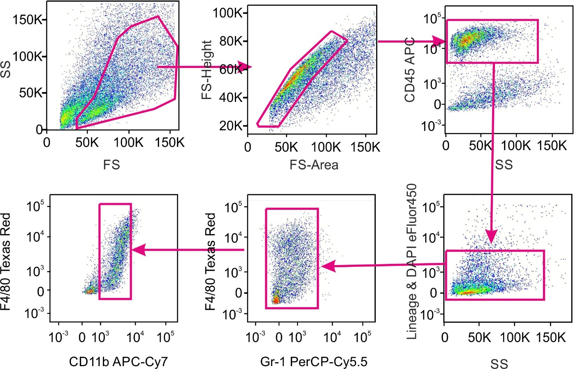

*Figure S21*:Gating strategy for FACS sorting of KC after liver perfusion.

Representative dot plots of the non-parenchymal fraction of perfused livers. KCs were defined as DAPI /lineage-, CD45+, Gr-1-, F4/80+, CD11bint cells.

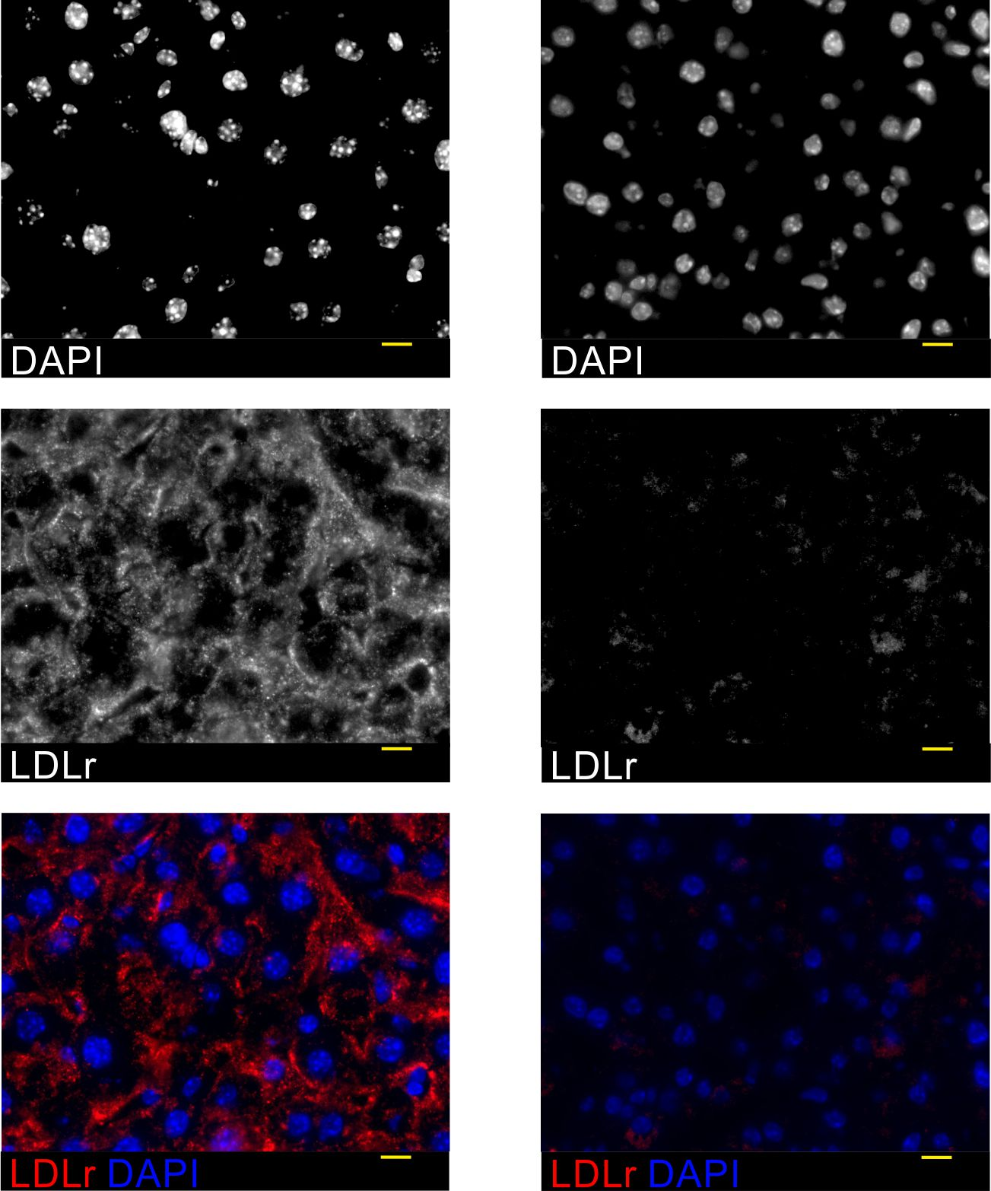

*Figure S22, related to Figure 5.* Specificity of the employed LDLr antibody.

Immunofluorescence analysis of liver sections from wildtype (left panels) and *LDLr-/-* (right panels) mice. (Red: LDLr AF594, blue: DAPI). Scale bar = 10 µm.

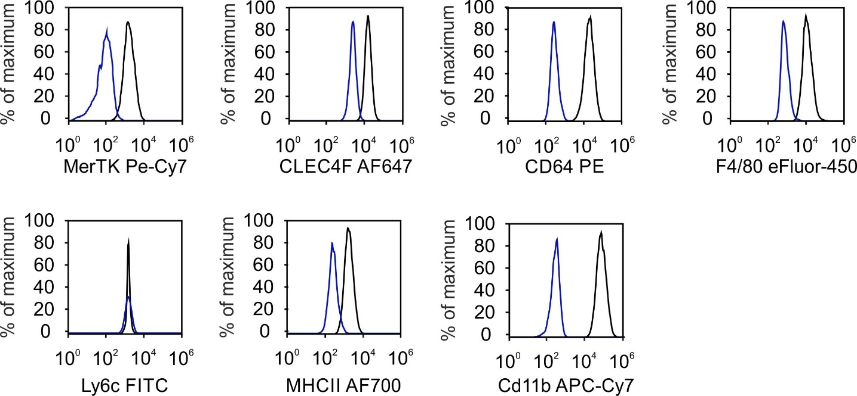

*Figure S23, related to Figure 5.* Expression of KC-specific surface markers in Kup5 cells analyzed by flow cytometry.

Representative histograms of Kup5 cells were adjusted to % of maximum. Unstained cells are depicted in blue, cells stained with the indicated antibody in black. Kup5 cells were found MerTkhigh, Clec4fhigh, CD64high, F4/80high, Ly6c-, MHCIIhigh and CD11bhigh. Results of one representative experiment out of 3 performed are shown.

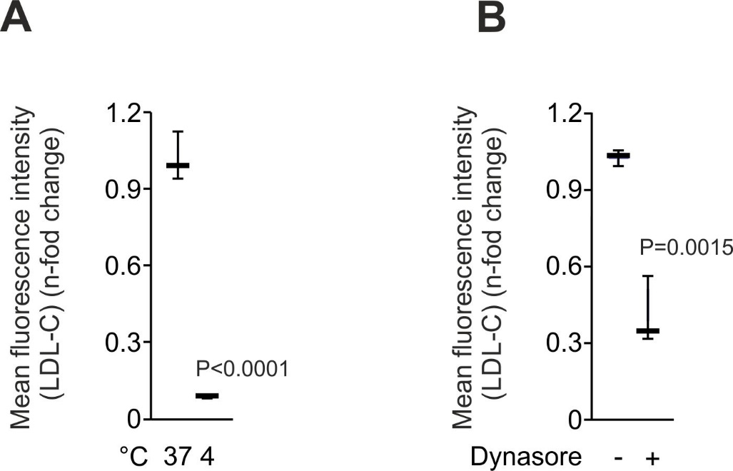

*Figure S24, related to Figure 5.* Inhibition of LDL receptor mediated endocytosis abolishes LDL-C uptake in Kup5 cells.

(A) Kup5 cells were incubated with 5 µg/ml BODIPY LDL-C and incubated at 37°C or 4°C for 1 h, respectively. LDL-C uptake in hepatocytes was determined using flow cytometry. Values are depicted as median with interquartile range (boxes). Whiskers represent 1.5x IRQ (n = 3).

(B) Kup5 cells were incubated with 5 µg/ml BODIPY LDL-C and treated with 25 µM dynasore or vehicle (Control) for 1 h, respectively. LDL-C uptake in hepatocytes was determined using flow cytometry. Values are depicted as median with interquartile range (boxes). Whiskers represent 1.5x IRQ (n = 3) (Unpaired Student’s T test; two-tailed.).

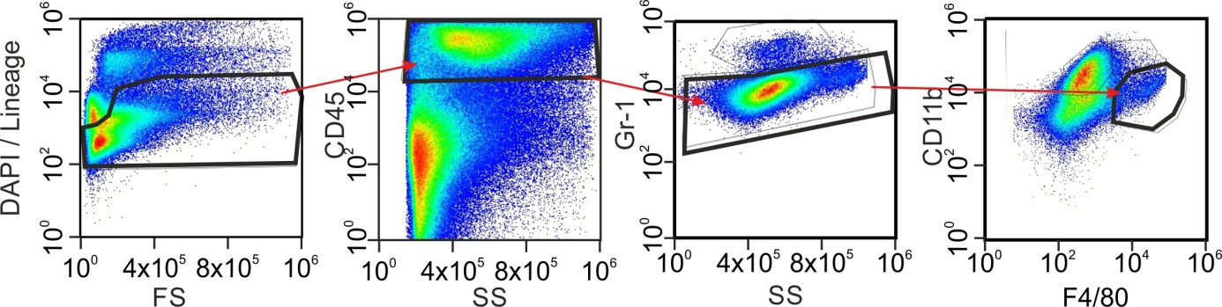

*Figure S25, related to Figure 5.* Gating strategy for identification of hepatic KC after liver perfusion by flow cytometry.

Representative dot plots of the non-parenchymal fraction of perfused livers. KCs are defend as: DAPI /lineage-, DAPI /lineage-, CD45+, Gr-1-, F4/80+, CD11bint.

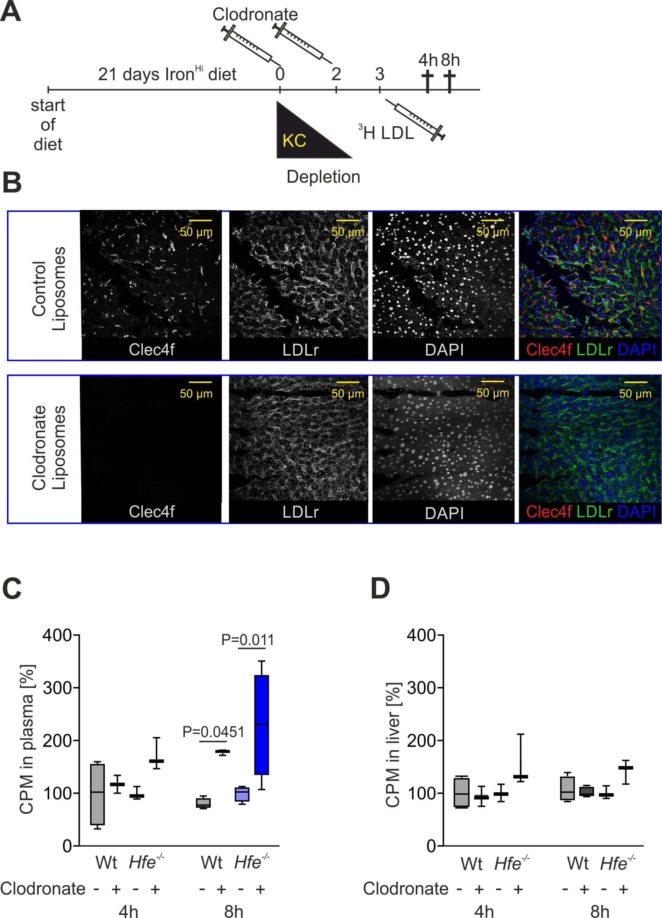

*Figure S26, related to Figure 5*: Depletion of KCs leads to LDL-C accumulation in plasma.

To evaluate KC-dependent cholesterol transport mechanisms *in vivo*, KC were depleted by the use of clodronate.

(A) Wildtype and *Hfe-/-* mice were set on ironhi diet for three weeks. Animals were then injected i.v. with 200 µl clodronate-containing or control liposomes at days 0 and 2, respectively. (B) Three days after clodronate treatment, KC depletion was verified by immunofluorescence staining of liver sections from wildtype mice (red: Clec4f AF594, green: LDLr AF488, blue: DAPI). Scale bar = 50 µm.

(C,D) On day three of liposomal clodronate or control treatment, animals were injected i.v. with [3H]-LDL-C. Mice were sacrificed at 4 h and 8 h post-injection, and tracer was measured in (C) plasma and (D) liver using a liquid scintillation counter. Values are depicted as median with interquartile range (boxes), whiskers represent 1.5x IRQ. (C) ANOVA F(3,9) = 2.21 *P* = ns; 8 h ANOVA F(3,13) = 8.22 *P* = 0.0025, Tukey’s post hoc test (n= 3-5). (D) 4 h ANOVA F(3, 9) = 2.525 *P* = 0.12; 8 h ANOVA F(3, 11) = 3.16 *P* = 0.068 (n = 3-5).

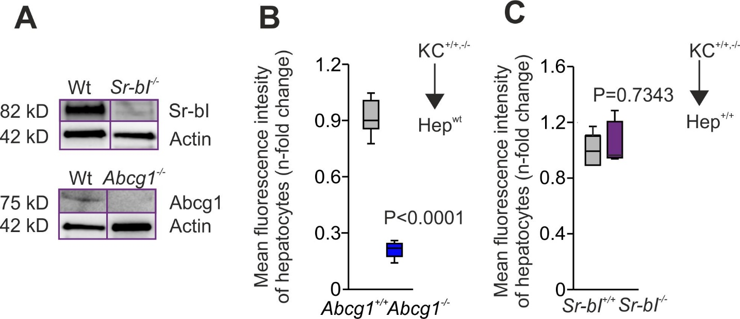

*Figure S27, related to Figure 6*: Transflux of cholesterol from wildtype, *Sr-bI-/-*, and *Abcg1-/-* Kup5 cells to primary murine hepatocytes. (A) Genetic knockout of *Sr-bI* and of the cholesterol efflux pump *Abca1* in Kup5 cells using the CRISPR/Cas9 technology was verified by immunoblot analysis. Actin served as loading control. BODIPY LDL-C derived cholesterol transfer from (B) wildtype *Abcg1-/-,* and (C) *Sr-bI-/-* Kup5 cells to primary murine hepatocytes after 24 h of co-culture was measured using flow cytometry. (n= 4)

**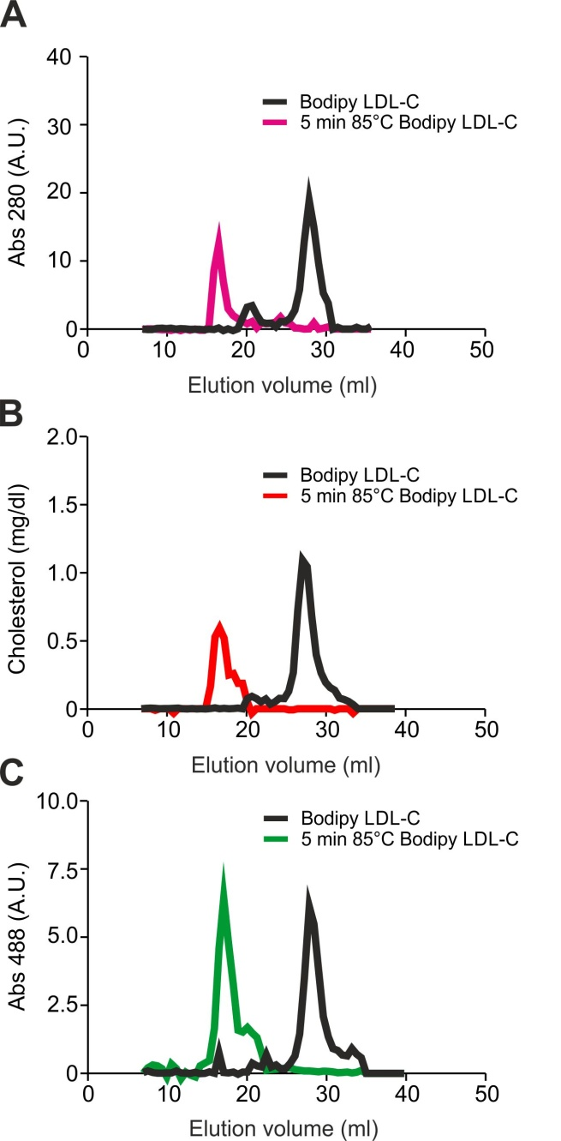***Figure S28, related to Methods (In vivo LDL-C uptake in KCs).* Analysis of aggregation of LDL particles.

To induce LDL particle aggregates, BODIPY LDL-C particles were heated at 85°C for 5 min (colored lines) and compared with native BODIPY LDL-C (black lines) using size-exclusion chromatography. (A) Protein, (B) cholesterol, and (C) fluorescent moieties are shown.

**SUPPLEMENTAL TABLES**

***Table S1, related to Figure 2*. Baseline Characteristics of Contributing Studies.**

|  |  |  |  |  |  |  |
| --- | --- | --- | --- | --- | --- | --- |
|  | **SAPHIR**  (n = 1709) | **KORA F4**  (n = 2926) | **KORA F3**  (n = 3077) | **GCKD**  (n = 5034) | **COLAUS**  (n = 5355) | **SAPALDIA**  (n = 5957) |
| Age (in years) | 51.33 ± 6.00  [47, 52, 55] | 56.15 ± 13.31  [44, 56, 67] | 57.32 ± 12.90  [46, 57, 67] | 60.08 ± 11.97  [53, 63, 70] | 53.47 ± 10.77  [44.4, 53.1, 62.0] | 52.17 ± 11.41  [43, 53, 61] |
| Women, n (%) | 628 (36.75%) | 1509 (51.57%) | 1577 (51.25%) | 2007 (39.87%) | 2867 (53.54%) | 3000 (50.36%) |
| Total cholesterol  (mg/dl) | 227.93 ± 39.74  [200, 225, 253] | 216.06 ± 39.71  [188, 214, 240] | 218.31 ± 39.87  [191, 216, 243] | 211.31 ± 53.09  [176, 207, 240] | 215.81 ± 39.68  [189.5, 212.7, 239.8] | 233.04 ± 43.56  [201, 232, 259] |
| LDL cholesterol  (mg/dl) | 145.74 ± 36.34  [120, 145, 169] | 136.09 ± 34.89  [111, 134, 158] | 128.01 ± 32.55  [105, 126, 148] | 118.42 ± 43.68  [89, 114, 143] | 129.23 ±35.63  [104.4, 127.6, 150.8] | 142.41 ± 39.66  [114, 140, 167] |
| HDL cholesterol  (mg/dl) | 59.56 ± 15.63  [48, 57.5, 69] | 55.91± 14.45 [45, 54, 65] | 58.85 ± 17.14 [47, 56, 69] | 52.03 ± 18.12  [39.37, 48.51, 61.44] | 63.18 ± 16.81  [50.27, 61.87, 73.47] | 58.02 ± 17.19  [45.17, 55.98, 67.95] |
| Lipid-lowering drugs, n (%) | 78 (4.56%) | 370 (12.65%) | 325 (10.56%) | 2566 (50.97%) | 684 (12.77%) | 445 (7.47%) |

Continuous variables are shown as mean +/- stdev and [25%,50%,75%]-Percentiles

n: sample size for which genotypes, phenotypes (TC, LDL-C, HDL-C) and covariates age and sex are available