**SUPPLEMENTAL MATERIAL**

**Long-term air pollution exposure and Parkinson’s Disease mortality in a large pooled European cohort: an ELAPSE study**

Thomas Cole-Hunter1, Jiawei Zhang1, Rina So1, Evangelia Samoli2, Shuo Liu1, Jie Chen3, Maciej Strak3,4, Kathrin Wolf5, Gudrun Weinmayr6, Sophia Rodopolou2, Elizabeth Remfry7, Kees de Hoogh8,9, Tom Bellander10,11, Jørgen Brandt12,13, Hans Concin14, Emanuel Zitt14,15, Daniela Fecht16, Francesco Forastiere17,18, John Gulliver16,19, Barbara Hoffmann20, Ulla A. Hvidtfeldt21, Karl-Heinz Jöckel22, Laust H. Mortensen23,24, Matthias Ketzel12,25, Diego Yacamán Méndez26,35, Karin Leander10, Petter Ljungman10,27, Elodie Faure28, Pei-Chen Lee28,29, Alexis Elbaz28, Patrik K.E. Magnusson30, Gabriele Nagel6, Göran Pershagen10,11, Annette Peters5,31, Debora Rizzuto32,33, Roel C. H. Vermeulen3,34, Sara Schramm22, Massimo Stafoggia10,17, Klea Katsouyanni2,18, Bert Brunekreef3, Gerard Hoek3, Youn-Hee Lim1, Zorana J. Andersen1*

1 Section of Environmental Health, Department of Public Health, University of Copenhagen, Copenhagen, Denmark

2 Department of Hygiene, Epidemiology and Medical Statistics, Medical School, National and Kapodistrian University of Athens, Athens, Greece

3 Institute for Risk Assessment Sciences, Utrecht University, Utrecht, The Netherlands

4 National Institute for Public Health and the Environment, Bilthoven, The Netherlands

5 Institute of Epidemiology, Helmholtz Zentrum München, Neuherberg, Germany

6 Institute of Epidemiology and Medical Biometry, Ulm University, Ulm, Germany

7 Wolfson Institute of Population Health, Queen Mary University of London, United Kingdom

8 Swiss Tropical and Public Health Institute, Basel, Switzerland

9 University of Basel, Basel, Switzerland

10 Institute of Environmental Medicine, Karolinska Institutet, Stockholm, Sweden

11 Centre for Occupational and Environmental Medicine, Region Stockholm, Stockholm, Sweden

12 Department of Environmental Science, Aarhus University, Roskilde, Denmark

13 iClimate, interdisciplinary Centre for Climate Change, Aarhus University, Roskilde, Denmark

14 Agency for Preventive and Social Medicine (aks), Bregenz, Austria

15 Department of Internal Medicine 3, LKH Feldkirch, Feldkirch, Austria

16 MRC Centre for Environment and Health, School of Public Health, Imperial College London, London, United Kingdom

17 Department of Epidemiology, Lazio Region Health Service / ASL Roma 1, Rome, Italy

18 MRC Centre for Environment and Health, Environmental Research Group, School of Public Health, Imperial College London, London, United Kingdom

19 Centre for Environmental Health and Sustainability & School of Geography, Geology and the Environment, University of Leicester, Leicester, United Kingdom

20 Institute for Occupational, Social and Environmental Medicine, Centre for Health and Society, Medical Faculty, Heinrich Heine University Düsseldorf, Germany

21 Danish Cancer Society Research Center, Copenhagen, Denmark

22 Institute for Medical Informatics, Biometry and Epidemiology, Medical Faculty, University of Duisburg-Essen, Essen, Germany

23 Section of Epidemiology, Department of Public Health, University of Copenhagen, Copenhagen, Denmark

24 Statistics Denmark, Copenhagen, Denmark

25 Global Centre for Clean Air Research (GCARE), University of Surrey, Guildford GU2 7XH, United Kingdom

26 Department of Global Public Health, Karolinska Institutet, Stockholm, Sweden

27 Department of Cardiology, Danderyd University Hospital, Stockholm, Sweden

28 University Paris-Saclay, UVSQ, Inserm, Gustave Roussy, "Exposome and Heredity" team, CESP UMR1018, 94805, Villejuif, France

29 Department of Public Health, National Cheng Kung University, Tainan, Taiwan

30 Department of Medical Epidemiology and Biostatistics, Karolinska Institutet, Stockholm, Sweden

31 Ludwig Maximilians Universität München, München, Germany

32 Department of Neurobiology, Care Sciences, and Society, Karolinska Institutet and Stockholm University, Stockholm, Sweden

33 Stockholm Gerontology Research Center, Stockholm, Sweden

34 Julius Center for Health Sciences and Primary Care, University Medical Center Utrecht, Utrecht University, Utrecht, The Netherlands

35 Centre for Epidemiology and Community Medicine, Region Stockholm, Stockholm, Sweden

**\*Correspondence** and requests for reprints should be addressed to Zorana J. Andersen, PhD, University of Copenhagen, Øster Farimagsgade 5, Copenhagen 1014, Denmark. E-mail: [zorana.andersen@sund.ku.dk](mailto:zorana.andersen@sund.ku.dk).

**SUPPLEMENTAL TABLES**

**Table S1. Overview of studies investigating the link between air pollution and Parkinson’s Disease**

|  |  |  |  |  |  |  |
| --- | --- | --- | --- | --- | --- | --- |
| Author, Year, Location | Cohort/Study | Population/  Sample | Incidence/ Mortality | Number of cases | Exposure  unit, Duration | Effect estimates |
| Cerza et al. 2018  Rome, Italy | Rome Longitudinal Study  *Administrative cohort* | 1,008,253  (44.0% men) | Incidence | 13,104 | PM2.5 (per 5μg/m3) PM10 (per 10μg/m3)  NO2 (per 10μg/m3)  NOx (per 20μg/m3)  O3 (per 10μg/m3)  *1 year* | 0.96 (0.92, 1.00)  0.98 (0.95, 1.01)  0.97 (0.96, 0.99)  0.97 (0.96, 0.98)  1.02 (1.00, 1.05)  *HR (95%CI)* |
| Chen et al. 2017  Taiwan | National Health Insurance Research Dataset (NHIRD)  *Nested case-control* | 5080  (48.2% men) | Incidence | 511 | PM10 (per 1 μg/m3)  NO2 (per 1 ppb)  NOx (per 1 ppb)  O3 (per 1 ppb)  *5 year* | 1.01 (1.00, 1.02)   * 1. (0.99, 1.03)   1.00 (0.99, 1.01)  1.01 (0.97, 1.04)  *OR (95%CI)* |
| Lee et al. 2016  Taiwan | National Health Insurance Research Dataset (NHIRD)    *Case-control* | Controls: 44,468  (51.3% men) | Incidence | 11,117 | PM10 [per IQR (20.51 ppb)]  NOx [per IQR (13.43 ppb)]  O3 [per IQR (4.38 ppb)]  1998-index | 0.93 (0.90, 0.96)  1.00 (0.98, 1.03)  1.00 (0.97, 1.03)  *OR (95%CI)* |
| Liu et al. 2016  USA | PAGE  *Nested case-control* | Controls: 3313  (73.5% men) | Incidence | 1556 | PM2.5 [per IQR (3.8 μg/m3)]  PM10 [per IQR (8.4 μg/m3)]  NO2 [per IQR (7.3 ppb)]  *1 year* | 1.02 (0.95, 1.10)  1.03 (0.97, 1.09)  1.01 (0.95, 1.11)  *OR (95%CI)* |
| Palacios et al. 2017  USA | Health Professionals Follow-up Study (HPFS)  *Prospective cohort* | 50,352  (100% men) | Incidence | 550 | PM2.5 (per 10μg/m3)  PM10 (per 10μg/m3)  *1 year* | 0.99 (0.97, 1.02)  0.98 (0.97, 1.00)  *HR (95%CI)* |
| Palacios et al. 2014  USA | Nurses’ Health Study  *Prospective cohort* | 111,769  (100% women) | Incidence | 508 | PM2.5 (per 10μg/m3)  PM10 (per 10μg/m3)  *1 year* | 1.08 (0.81, 1.45)  0.99 (0.84, 1.16)  *RR (95%CI)* |
| Rhew et al. 2021  North Carolina, USA | Healthcare Cost and Utilization Project’s (HCUP) State Inpatient Database (SID)  *Case-control* | Controls: (357,574 person-years)  (41.1% men) | Mortality Incidence | Cases: (1,665,073 person-years) | PM2.5 (≥ / < 10 μg/m3) | 1.13 (0.92, 1.31)  1.14 (0.81, 1.61)  *OR (95%CI)* |
| Ritz et al. 2016  Denmark | Danish National Hospital Register  *Case-control* | Controls: 1,800 (59.3% men) | Incidence | Cases: 1,696 | NO2 [per IQR (2.97 μg/m3)]  NOx [per IQR (7.10 μg/m3)]  1971-index date | 1.09 (1.03, 1.16)  1.06 (1.02, 1.11)  *OR (95%CI)* |
| Shi et al. 2020  USA | American Medicare Population  *Longitudinal cohort* | 63,038,019  (44.9% men) | Incidence | 1,033,669 | PM2.5 (per 5 µg/m3)  *1 year* | 1.13 (1.12, 1.14)  *HR (95%CI)* |
| Shin et al. 2018  Ontario, Canada | ONPHEC  *Retrospective administrative cohort* | 2,194,519 (46.6% men) | Incidence | 38,475 | PM2.5 [per IQR (9.8 µg/m3)] NO2 [per IQR (14.7 ppb)] O3 [per IQR (49.8 ppb)]  *5 year* | 1.04 (1.01, 1.07)  1.03 (1.00, 1.07)  1.04 (1.01, 1.07)  *HR (95%CI)* |
| Toro et al. 2019  Netherlands | *Case-control* | Controls: 854 (63.2% men) | Incidence | Cases: 436 | PM2.5 (per 5 μg/m3) PM10 (per 1 μg/m3)  NO2 (per 10 μg/m3)  NOx (per 20 μg/m3)  *1 year* | 0.80 (0.20, 3.17)  0.68 (0.15, 3.10)  0.86 (0.62, 1.19)  0.91 (0.65–1.28)  *OR (95%CI)* |
| Yu et al. 2021  Ningbo, China | *Prospective cohort* | 46,839  (41.7% men) | Incidence | 206 | PM2.5 [per IQR (8.2 μg/m3)]  PM10 [per IQR (10.8 μg/m3)]  NO2 [per IQR (11.7 μg/m3)]  *1 month* | 1.41 (1.14, 1.75)  1.24 (0.99, 1.56)  1.16 (0.89, 1.51)  *HR (95%CI)* |
| Yuchi et al. 2020  Vancouver, Canada | Medical Services Plan  *Administrative health database cohort* | 630,231  (47.3% men) | Incidence | 4201 | PM2.5 [per IQR (1.65 μg/m3)] BC [per IQR (1.02 μg/m3)]  NO2 [per IQR (9.03 ppb)]  *5 year* | 1.09 (1.02, 1.16)  1.03 (0.97, 1.08)  1.12 (1.05, 1.20)  *HR (95%CI)* |
| Zhao et al. 2021  Canada | 2001 Canadian Census Health and Environment Cohort (CanCHEC) | 3,209,100  (48.4% men) | Mortality | 8500 | O3 [per IQR (10.1 ppb)] | 1.09 (1.04–1.14)  *HR (95%CI)* |

**Table S2. Study characteristic of each sub-cohort with Parkinson’s disease mortality rates.**

|  |  |  |  |  |  |  |  |  |
| --- | --- | --- | --- | --- | --- | --- | --- | --- |
| **Cohort/sub-cohort** | **Population size\*** | **N#** | **Enrolment year** | **End of follow-up** | **Mean age at baseline** | **Mean age at end of follow-up** | **Deaths, N (rate)**φ | **Study area** |
|
| **Pooled Cohort** | 324,728 | 271,720 | / | / | 47.1 | 66.9 | 381 (7.1) | Seven cohorts in six countries |
| **CEANS** | 21,987 | 20,702 | / | / | 56.3 | 69.3 | 12 (4.5) | Stockholm county, Sweden |
| SDPP | 7,835 | 7,727 | 1992-1998 | 2011 | 47.1 | 63 | 0 (0.0) |
| SIXTY | 4,180 | 3,969 | 1997-1999 | 2014 | 60 | 75.5 | 3 (4.9) |
| SALT | 6,724 | 6,176 | 1998-2002 | 2011 | 57.8 | 68.2 | 1 (1.6) |
| SNACK | 3,248 | 2,830 | 2001-2004 | 2011 | 72.9 | 80.3 | 8 (38.1) |
| **DNC** | 28,433 | 25,171 | / | / | 53.5 | 70.8 | 27 (6.2) | Denmark-wide |
| 1993 | 19,664 | 17,043 | 1993 | 2013 | 56.2 | 74.9 | 27 (8.5) |
| 1999 | 8,769 | 8,128 | 1999 | 2013 | 47.9 | 62.4 | 0 (0.0) |
| **E3N** | 53,521 | 39,006 | 1989-1991 | 2011 | 53 | 69.7 | 29 (4.5) | France-wide |
| **EPIC-NL** | 36,905 | 32,872 | / | / | 49.5 | 66.1 | 17 (3.1) | Four cities, the Netherlands |
| Morgen | 20,711 | 18,302 | 1993-1997 | 2013 | 42.9 | 59.8 | 5 (1.6) |
| Prospect | 16,194 | 14,570 | 1993-1997 | 2013 | 57.7 | 74.1 | 12 (5.0) |
| **HNR** | 4,809 | 4,733 | 2000-2003 | 2015 | 59.7 | 71.7 | 8 (14.1) | Ruhr area, Germany |
| **KORA** | 8,823 | 4,853 | / | / | 49.4 | 63.7 | 4 (5.7) | Augsburg area, Germany |
| S3 | 4,566 | 2,572 | 1994-1995 | 2011 | 49.4 | 65 | 2 (5.0) |
| S4 | 4,257 | 2,281 | 1999-2001 | 2014 | 49.3 | 62.3 | 2 (6.8) |
| **VHM&PP** | 170,250 | 144,383 | 1985-2005 | 2014 | 42.1 | 65.2 | 284 (8.5) | Vorarlberg region, Austria |

*: Population size is the number of participants for which information was transferred to Utrecht University for construction of the pooled cohort.

#: N indicates the number of participants included in our model analysis (minus those excluded due to missing covariate information).

φ: Rate is crude mortality rate for the pooled cohort during the follow-up period, expressed in units of deaths per 100,000 participants per year.

Definition of abbreviation: ALRI, acute lower respiratory infection.

**Table S3. Pearson correlations between air pollutants for year 2010 exposure in the pooled cohort and sub-cohorts.**

|  |  |  |  |  |  |  |  |  |  |  |
| --- | --- | --- | --- | --- | --- | --- | --- | --- | --- | --- |
| **Pollutants** | **Cohort** | **NO2** | **PM2.5** | **BC** | **O3** | **Cohort** | **NO2** | **PM2.5** | **BC** | **O3** |
|  | **Pooled cohort** |  |  |  |  | **CEANS-SALT** |  |  |  |  |
| NO2 | 1 |  |  |  | 1 |  |  |  |
| PM2.5 | 0.59 | 1 |  |  | 0.67 | 1 |  |  |
| BC | 0.71 | 0.82 | 1 |  | 0.84 | 0.55 | 1 |  |
| O3 | -0.6 | -0.04 | 0 | 1 | -0.74 | -0.47 | -0.76 | 1 |
|  | **CEANS-SDPP** |  |  |  |  | **CEANS-SIXTY** |  |  |  |  |
| NO2 | 1 |  |  |  | 1 |  |  |  |
| PM2.5 | 0.6 | 1 |  |  | 0.69 | 1 |  |  |
| BC | 0.67 | 0.49 | 1 |  | 0.84 | 0.59 | 1 |  |
| O3 | -0.7 | -0.18 | -0.33 | 1 | -0.71 | -0.44 | -0.71 | 1 |
|  | **CEANS-SNACK** |  |  |  |  | **DNC-1999** |  |  |  |  |
| NO2 | 1 |  |  |  | 1 |  |  |  |
| PM2.5 | 0.75 | 1 |  |  | 0.61 | 1 |  |  |
| BC | 0.43 | 0.29 | 1 |  | 0.93 | 0.64 | 1 |  |
| O3 | -0.66 | -0.5 | -0.74 | 1 | -0.21 | -0.16 | -0.2 | 1 |
|  | **DNC-1993** |  |  |  |  | **EPIC-NL-Morgen** |  |  |  |  |
| NO2 | 1 |  |  |  | 1 |  |  |  |
| PM2.5 | 0.64 | 1 |  |  | 0.22 | 1 |  |  |
| BC | 0.92 | 0.7 | 1 |  | 0.84 | 0.41 | 1 |  |
| O3 | -0.42 | -0.32 | -0.42 | 1 | -0.78 | 0.15 | -0.55 | 1 |
|  | **E3N** |  |  |  |  | **HRN** |  |  |  |  |
| NO2 | 1 |  |  |  | 1 |  |  |  |
| PM2.5 | 0.81 | 1 |  |  | 0.65 | 1 |  |  |
| BC | 0.92 | 0.74 | 1 |  | 0.88 | 0.64 | 1 |  |
| O3 | -0.5 | -0.49 | -0.38 | 1 | -0.83 | -0.66 | -0.81 | 1 |
|  | **EPIC-NL-Prospect** |  |  |  |  | **KORA-S4** |  |  |  |  |
| NO2 | 1 |  |  |  | 1 |  |  |  |
| PM2.5 | 0.48 | 1 |  |  | 0.58 | 1 |  |  |
| BC | 0.91 | 0.41 | 1 |  | 0.73 | 0.54 | 1 |  |
| O3 | -0.86 | -0.43 | -0.84 | 1 | -0.73 | -0.37 | -0.71 | 1 |
|  | **KORA-S3** |  |  |  |  | **VHM&PP** |  |  |  |  |
| NO2 | 1 |  |  |  | 1 |  |  |  |
| PM2.5 | 0.52 | 1 |  |  | 0.65 | 1 |  |  |
| BC | 0.78 | 0.46 | 1 |  | 0.91 | 0.76 | 1 |  |
| O3 | -0.75 | -0.38 | -0.77 | 1 | -0.83 | -0.69 | -0.88 | 1 |

**Table S4. Associations between long-term air pollution exposure and Parkinson’s disease below various cut-off values in Model 3.**

|  |  |  |  |  |
| --- | --- | --- | --- | --- |
| **Pollutants** | **Cut-off levels** | **Number of participants** | **Number of deaths** | **HR (95%CI)** |
| **PM2.5** |  |  |  |  |
|  | All levels | 271,720 | 381 | 1.25 (1.01, 1.55) |
|  | < 25 µg/m3 | 271,692 | 381 | 1.25 (1.01, 1.56) |
|  | < 20 µg/m3 | 262,893 | 371 | 1.28 (1.02, 1.60) |
|  | < 15 µg/m3 | 106,014 | 135 | 1.42 (0.75, 2.68) |
| **NO2** |  |  |  |  |
|  | All levels | 271,720 | 381 | 1.13 (0.95, 1.34) |
|  | < 40 µg/m3 | 258,344 | 370 | 1.15 (0.95, 1.40) |
|  | < 30 µg/m3 | 214,921 | 329 | 1.38 (1.07, 1.77) |
|  | < 20 µg/m3 | 81,681 | 103 | 2.29 (1.10, 4.80) |
| **BC** |  |  |  |  |
|  | All levels | 271,720 | 381 | 1.12 (0.94, 1.34) |
|  | < 3 10-5m-1 | 271,115 | 380 | 1.11 (0.92, 1.33) |
|  | < 2.5 10-5m-1 | 267,060 | 376 | 1.12 (0.92, 1.37) |
|  | < 2 10-5m-1 | 243,603 | 345 | 1.31 (1.03, 1.67) |
|  | < 1.5 10-5m-1 | 106,969 | 114 | 1.52 (0.85, 2.73) |
| **O3** |  |  |  |  |
|  | All levels | 271,720 | 381 | 0.74 (0.58, 0.94) |
|  | < 120 µg/m3 | 271,720 | 381 | 0.74 (0.58, 0.94) |
|  | < 100 µg/m3 | 266,875 | 378 | 0.73 (0.56, 0.94) |

**Table S5. Effect modification on the association between year 2010 exposure and Parkinson’s disease mortality by baseline characteristics.**

|  |  |  |  |  |  |  |  |
| --- | --- | --- | --- | --- | --- | --- | --- |
| **Baseline characters** | **N** | **Deaths, N** | **NO2** | **PM2.5** | **BC** | **O3** | ***P* values** |
| **HR (95% CI)** | **HR (95% CI)** | **HR (95% CI)** | **HR (95% CI)** |
| Age, years |  |  |  |  |  |  | NO2: 0.70; PM2.5: 0.78; BC: 0.74; O3: 0.49 |
| < 65 | 245,488 | 182 | 1.08 (0.85, 1.38) | 1.21 (0.90, 1.62) | 1.08 (0.84, 1.38) | 0.70 (0.52, 0.95) |
| ≥ 65 | 26,232 | 199 | 1.15 (0.92, 1.43) | 1.28 (0.96, 1.72) | 1.14 (0.91, 1.43) | 0.79 (0.59, 1.06) |
| Sex |  |  |  |  |  |  | NO2: 0.09; PM2.5: 0.13; BC: 0.10; O3: 0.55 |
| Female | 186,766 | 104 | 1.04 (0.85, 1.27) | 1.12 (0.87, 1.46) | 1.03 (0.84, 1.27) | 0.76 (0.58, 0.99) |
| Male | 84,954 | 137 | 1.39 (1.03, 1.88) | 1.50 (1.09, 2.07) | 1.38 (1.02, 1.87) | 0.68 (0.48, 0.97) |
| Overweight |  |  |  |  |  |  | NO2: 0.74; PM2.5: 0.05*; BC: 0.11; O3: 0.71 |
| No | 160,976 | 197 | 1.15 (0.93, 1.42) | 1.48 (1.13, 1.95) | 1.24 (1.00, 1.53) | 0.75 (0.58, 0.99) |
| Yesφ | 110,744 | 184 | 1.10 (0.86, 1.40) | 1.04 (0.79, 1.38) | 0.97 (0.76, 1.25) | 0.72 (0.53, 0.96) |
| Smoking status |  |  |  |  |  |  | NO2: 0.71; PM2.5: 0.19; BC: 0.33; O3: 0.39 |
| Current smoker | 59,125 | 28 | 1.36 (0.85, 2.19) | 1.61 (0.85, 3.06) | 1.50 (0.96, 2.34) | 0.88 (0.48, 1.61) |
| Former smoker | 44,529 | 60 | 1.13 (0.81, 1.58) | 0.90 (0.57, 1.41) | 1.02 (0.73, 1.43) | 0.61 (0.42, 0.89) |
| Never smoker | 168,066 | 293 | 1.10 (0.91, 1.34) | 1.29 (1.02, 1.62) | 1.10 (0.91, 1.35) | 0.76 (0.59, 0.98) |
| Employment status |  |  |  |  |  |  | NO2: 0.98; PM2.5: 0.47; BC: 0.20; O3: 0.09 |
| Employed**†** | 185,768 | 63 | 1.12 (0.80, 1.59) | 1.45 (0.92, 2.29) | 1.36 (0.96, 1.92) | 0.98 (0.65, 1.48) |
| Others | 85,952 | 318 | 1.13 (0.94, 1.36) | 1.22 (0.97, 1.53) | 1.07 (0.89, 1.30) | 0.70 (0.55, 0.90) |

Results are presented as hazard ratio and 95% confidence interval [HR (95%CI)] for the following increases: 10 µg/m3 for NO2, 5 µg/m3 for PM2.5, 0.5 10-5 m-1 for BC and 10 µg/m3 for O3. BC was measured by the reflectance of PM2.5 filters from 2009 and 2010, expressed in absorbance units.

Effect modification analyses were conducted based on Model 3 and evaluated by introducing interaction terms. *P* values for whether there were statistical differences between strata were tested by the Wald test.

*: A statistically significant *P* value (at 5% level) for effect modification analyses.

φ: BMI ≥ 25 kg/m2 indicates overweight according to WHO categories.

**†:** Employed status includes employed and self-employed.

**Table S6. Associations between year 2010 exposure and back-extrapolated baseline year exposure and Parkinson’s disease mortality in Model 3 (N=271,695).**

|  |  |  |  |
| --- | --- | --- | --- |
|  | **Year 2010 exposure** | **Baseline year exposure** | |
| **(N=271,695)** | **Ratio method** | **Difference method** |
| **Parkinson’s disease (381 deaths)** | | |  |
| NO2 | 1.19 (1.01, 1.40) | 1.09 (0.99, 1.22) | 1.17 (1.00, 1.36) |
| PM2.5 | 1.30 (1.05, 1.60) | 1.09 (0.99, 1.20) | 1.15 (0.99, 1.35) |
| BC | 1.18 (1.00, 1.40) | 1.12 (1.00, 1.25) | 1.16 (1.00, 1.35) |
| O3 | 0.70 (0.56, 0.89) | 0.77 (0.64, 0.94) | 0.76 (0.62, 0.93) |

Results are presented as hazard ratio and 95% confidence interval [HR (95%CI)] for the following increments: 5 µg/m3 for PM2.5, 10 µg/m3 for NO2, 0.5 10-5 m-1 for BC and 10 µg/m3 for O3. BC was measured by the reflectance of PM2.5 filters from 2009 and 2010, expressed in absorbance units.

**Table S7. Associations between time-varying annual exposure and Parkinson’s disease mortality in three cohorts** **(CEANS, EPIC-NL, and VHM&PP; N=132,952) with available information based on Model 3.**

|  |  |  |  |
| --- | --- | --- | --- |
|  | **Year 2010 exposure** | **Time-varying exposure\*** | |
| **(N=132,952)** | **Ratio method** | **Difference method** |
| **Parkinson’s disease (197 deaths)** | | |  |
| NO2 | 1.33 (1.00, 1.76) | 1.31 (1.00, 1.71) | 1.38 (1.04, 1.82) |
| PM2.5 | 1.37 (1.01, 1.87) | 1.40 (1.08, 1.81) | 1.39 (1.06, 1.83) |
| BC | 1.18 (0.89, 1.58) | 1.11 (0.84, 1.47) | 1.17 (0.88, 1.56) |
| O3 | 0.76 (0.52, 1.13) | 0.84 (0.72, 0.99) | 0.84 (0.72, 0.98) |

* Time-varying analyses were additionally adjusted for calendar year of follow-up (strata one year) based on Model 3 to account for secular time trend in Parkinson’s disease mortality and air pollution.

Results are presented as hazard ratio and 95% confidence interval [HR (95%CI)] for the following increments: 5 µg/m3 for PM2.5, 10 µg/m3 for NO2, 0.5 10-5 m-1 for BC and 10 µg/m3 for O3. BC was measured by the reflectance of PM2.5 filters from 2009 and 2010, expressed in absorbance units.

**Table S8 Results for sensitivity analysis of associations between year 2010 exposure and Parkinson’s disease mortality in Model 3.**

|  |  |  |  |  |  |  |
| --- | --- | --- | --- | --- | --- | --- |
|  | **Number of participants** | **Number of deaths** | **HR (95%CI)** | | | |
| **NO2** | **PM2.5** | **BC** | **O3** |
| All cohorts | 271,720 | 381 | 1.13 (0.95, 1.34) | 1.25 (1.01, 1.55) | 1.12 (0.94, 1.34) | 0.74 (0.58, 0.94) |
| Exclude CEANS | 251,018 | 369 | 1.12 (0.94, 1.34) | 1.25 (1.01, 1.55) | 1.11 (0.92, 1.33) | 0.74 (0.58, 0.95) |
| Exclude DNC | 246,549 | 354 | 1.21 (1.01, 1.45) | 1.28 (1.03, 1.59) | 1.17 (0.97, 1.41) | 0.70 (0.54, 0.90) |
| Exclude E3N | 232,714 | 352 | 1.12 (0.92, 1.36) | 1.28 (1.02, 1.61) | 1.13 (0.92, 1.38) | 0.80 (0.60, 1.06) |
| Exclude EPIC-NL | 238,848 | 364 | 1.12 (0.93, 1.33) | 1.25 (1.00, 1.55) | 1.12 (0.93, 1.34) | 0.75 (0.58, 0.96) |
| Exclude HNR | 266,987 | 373 | 1.14 (0.95, 1.37) | 1.26 (1.01, 1.56) | 1.13 (0.94, 1.36) | 0.73 (0.57, 0.94) |
| Exclude KORA | 266,867 | 377 | 1.14 (0.96, 1.36) | 1.25 (1.01, 1.56) | 1.13 (0.95, 1.36) | 0.73 (0.57, 0.93) |
| Exclude VHM&PP | 127,337 | 97 | 1.01 (0.77, 1.32) | 1.03 (0.60, 1.75) | 1.06 (0.80, 1.40) | 0.72 (0.50, 1.04) |

Results are presented as hazard ratio and 95% confidence interval [HR (95%CI)] for the following increments: 5 µg/m3 for PM2.5, 10 µg/m3 for NO2, 0.5 10-5 m-1 for BC and 10 µg/m3 for O3.

**Table S9. Exposure distribution of PM2.5 composition in the pooled cohort**

|  |  |  |  |  |  |  |  |  |  |  |  |
| --- | --- | --- | --- | --- | --- | --- | --- | --- | --- | --- | --- |
| PM2.5 composition | Exposure Model | Mean | SD | IQR | Min | P5 | P25 | Median | P75 | P95 | Max |
| Cu | SLR | 3.7 | 2.7 | 3.8 | 0.0 | 0.0 | 1.5 | 3.7 | 5.3 | 7.6 | 42.4 |
| RF | 4.0 | 1.7 | 1.9 | 0.9 | 1.9 | 2.7 | 4.0 | 4.6 | 6.9 | 19.2 |
| Fe | SLR | 89.0 | 47.0 | 56.7 | 0.0 | 20.5 | 57.8 | 85.7 | 114.4 | 162.6 | 453.9 |
| RF | 83.7 | 34.5 | 31.2 | 21.0 | 44.0 | 62.6 | 74.3 | 93.8 | 158.7 | 311.8 |
| K | SLR | 176.9 | 51.0 | 69.4 | 31.8 | 87.5 | 141.3 | 177.9 | 210.7 | 257.0 | 321.4 |
| RF | 233.3 | 98.1 | 201.3 | 74.4 | 98.4 | 118.5 | 268.1 | 319.9 | 375.8 | 480.6 |
| Ni | SLR | 0.7 | 0.7 | 0.7 | 0.0 | 0.0 | 0.3 | 0.5 | 1.0 | 1.9 | 12.7 |
| RF | 0.8 | 0.6 | 0.9 | 0.1 | 0.2 | 0.3 | 0.5 | 1.1 | 1.9 | 3.8 |
| S | SLR | 644.0 | 146.5 | 226.2 | 299.0 | 430.9 | 537.2 | 619.3 | 763.4 | 897.4 | 1251.9 |
| RF | 684.7 | 144.1 | 180.1 | 484.2 | 524.2 | 607.4 | 632.9 | 787.5 | 935.0 | 1314.1 |
| Si | SLR | 95.5 | 20.6 | 22.7 | 37.5 | 68.6 | 81.9 | 93.0 | 104.6 | 133.0 | 255.3 |
| RF | 86.9 | 25.4 | 22.9 | 38.1 | 62.5 | 71.9 | 78.9 | 94.7 | 134.7 | 299.7 |
| V | SLR | 1.2 | 1.3 | 1.6 | 0.0 | 0.0 | 0.3 | 0.7 | 1.9 | 3.2 | 17.8 |
| RF | 1.1 | 1.1 | 1.3 | 0.3 | 0.3 | 0.3 | 0.4 | 1.6 | 3.5 | 7.3 |
| Zn | SLR | 16.9 | 11.8 | 11.2 | 0.0 | 3.1 | 10.5 | 15.4 | 21.7 | 32.5 | 145.4 |
| RF | 20.8 | 7.4 | 8.1 | 9.5 | 11.3 | 15.4 | 21.3 | 23.6 | 32.6 | 73.9 |

Definition of abbreviation: SLR, Supervised Linear Regression model; RF, Random Forest model; SD, standard deviation; IQR, interquartile range; P5 to P95 are percentiles.

Unit for pollutants: ng/m3

**Table S10. Truncation frequency (Truncation performed for model 3 population, N = 271,003)**

|  |  |  |  |
| --- | --- | --- | --- |
| **Pollutant** | **Exposure Model** | **N below zero (%)** | **N above maximum (%)** |
| Cu | SLR | 33,525 (12.4) | 2 (0.0) |
| RF | 0 (0.0) | 0 (0.0) |
| Fe | SLR | 1,587 (0.6) | 0 (0.0) |
| RF | 0 (0.0) | 0 (0.0) |
| K | SLR | 0 (0.0) | 0 (0.0) |
| RF | 0 (0.0) | 0 (0.0) |
| Ni | SLR | 37,467 (13.8) | 20 (0.0) |
| RF | 0 (0.0) | 0 (0.0) |
| S | SLR | 0 (0.0) | 0 (0.0) |
| RF | 0 (0.0) | 0 (0.0) |
| Si | SLR | 0 (0.0) | 0 (0.0) |
| RF | 0 (0.0) | 0 (0.0) |
| V | SLR | 46,163 (17.0) | 0 (0.0) |
| RF | 0 (0.0) | 0 (0.0) |
| Zn | SLR | 8,154 (3.0) | 240 (0.1) |
| RF | 0 (0.0) | 0 (0.0) |

Definition of abbreviation: SLR, Supervised Linear Regression model; RF, Random Forest model

**Table S11. Pearson correlations between PM2.5 compositions and PM2.5 mass in the pooled cohort.**

|  |  |  |  |  |  |  |  |  |  |  |  |  |  |  |  |  |  |  |
| --- | --- | --- | --- | --- | --- | --- | --- | --- | --- | --- | --- | --- | --- | --- | --- | --- | --- | --- |
| Cohort/Sub-cohort | Cu | | Fe | | K | | Ni | | S | | Si | | | V | | | Zn | |
| SLR | RF | SLR | RF | SLR | RF | SLR | RF | SLR | RF | SLR | RF | SLR | | RF | SLR | | RF |
| Average* | 0.41 | 0.45 | 0.45 | 0.41 | 0.28 | 0.43 | 0.24 | 0.12 | 0.46 | 0.31 | 0.37 | 0.20 | 0.17 | | -0.02 | 0.36 | | 0.39 |
| CEANS-SDPP | 0.10 | 0.53 | 0.29 | 0.31 | 0.22 | 0.47 | -0.06 | 0.07 | 0.39 | 0.16 | 0.25 | 0.01 | -0.09 | | 0.14 | -0.08 | | 0.40 |
| CEANS-SIXTY | 0.43 | 0.51 | 0.53 | 0.49 | 0.19 | 0.63 | 0.31 | 0.33 | 0.45 | 0.04 | 0.45 | 0.35 | 0.03 | | 0.03 | 0.40 | | 0.46 |
| CEANS-SALT | 0.46 | 0.49 | 0.52 | 0.49 | 0.15 | 0.57 | 0.28 | 0.33 | 0.43 | 0.03 | 0.44 | 0.37 | 0.06 | | 0.11 | 0.37 | | 0.43 |
| CEANS-SNACK | 0.46 | 0.46 | 0.49 | 0.51 | 0.31 | 0.43 | -0.01 | 0.41 | 0.38 | 0.14 | 0.43 | 0.26 | 0.38 | | -0.02 | 0.36 | | 0.48 |
| DNC-1993 | 0.42 | 0.42 | 0.42 | 0.38 | 0.17 | 0.41 | 0.32 | 0.29 | 0.43 | 0.44 | 0.38 | 0.23 | 0.23 | | 0.27 | 0.46 | | 0.26 |
| DNC-1999 | 0.33 | 0.33 | 0.31 | 0.27 | 0.11 | 0.37 | 0.23 | 0.18 | 0.31 | 0.37 | 0.23 | 0.14 | 0.12 | | 0.19 | 0.36 | | 0.14 |
| EPIC-NL-Morgen | 0.19 | 0.25 | 0.25 | 0.25 | 0.38 | 0.41 | 0.05 | -0.04 | 0.45 | 0.46 | 0.25 | 0.43 | -0.06 | | -0.41 | 0.38 | | 0.55 |
| EPIC-NL-Prospect | 0.41 | 0.34 | 0.39 | 0.34 | 0.55 | 0.46 | 0.06 | 0.37 | 0.62 | 0.58 | 0.34 | 0.25 | 0.27 | | 0.21 | 0.34 | | 0.30 |
| HNR | 0.47 | 0.47 | 0.49 | 0.63 | -0.22 | 0.49 | 0.33 | 0.48 | 0.49 | 0.28 | 0.39 | 0.32 | 0.30 | | 0.39 | 0.24 | | 0.57 |
| E3N | 0.70 | 0.62 | 0.74 | 0.56 | 0.26 | -0.22 | 0.50 | 0.07 | 0.43 | 0.40 | 0.54 | -0.01 | 0.29 | | 0.06 | 0.46 | | 0.57 |
| KORA-S3 | 0.30 | 0.29 | 0.38 | 0.33 | 0.44 | 0.47 | 0.19 | -0.30 | 0.36 | 0.27 | 0.27 | 0.23 | 0.07 | | -0.49 | 0.29 | | 0.13 |
| KORA-S4 | 0.36 | 0.46 | 0.44 | 0.45 | 0.35 | 0.45 | 0.32 | -0.24 | 0.38 | 0.27 | 0.40 | 0.37 | 0.00 | | -0.51 | 0.37 | | 0.17 |
| VHM&PP | 0.73 | 0.66 | 0.64 | 0.36 | 0.78 | 0.67 | 0.55 | -0.42 | 0.82 | 0.55 | 0.42 | -0.30 | 0.65 | | -0.27 | 0.71 | | 0.62 |

*Average of cohort-specific correlation.

**Table S12. Pearson correlations between PM2.5 compositions and NO2 in the pooled cohort.**

|  |  |  |  |  |  |  |  |  |  |  |  |  |  |  |  |  |  |  |
| --- | --- | --- | --- | --- | --- | --- | --- | --- | --- | --- | --- | --- | --- | --- | --- | --- | --- | --- |
| Cohort/Sub-cohort | Cu | | Fe | | K | | Ni | | S | | Si | | | V | | | Zn | |
| SLR | RF | SLR | RF | SLR | RF | SLR | RF | SLR | RF | SLR | RF | SLR | | RF | SLR | | RF |
| Average* | 0.72 | 0.77 | 0.80 | 0.75 | 0.10 | 0.37 | 0.43 | 0.28 | 0.45 | 0.20 | 0.69 | 0.40 | 0.31 | | 0.04 | 0.47 | | 0.52 |
| CEANS-SDPP | 0.23 | 0.79 | 0.83 | 0.66 | 0.16 | 0.8 | 0.22 | 0.12 | 0.2 | -0.34 | 0.73 | -0.01 | 0.04 | | -0.04 | 0.37 | | 0.62 |
| CEANS-SIXTY | 0.82 | 0.85 | 0.91 | 0.87 | -0.16 | 0.74 | 0.55 | 0.61 | 0.46 | -0.04 | 0.81 | 0.71 | 0.07 | | -0.04 | 0.63 | | 0.69 |
| CEANS-SALT | 0.84 | 0.85 | 0.91 | 0.88 | -0.23 | 0.71 | 0.51 | 0.63 | 0.46 | -0.03 | 0.81 | 0.73 | 0.08 | | 0.03 | 0.59 | | 0.68 |
| CEANS-SNACK | 0.79 | 0.83 | 0.82 | 0.87 | 0.27 | 0.7 | 0.06 | 0.65 | 0.44 | 0.33 | 0.73 | 0.55 | 0.61 | | -0.05 | 0.57 | | 0.72 |
| DNC-1993 | 0.61 | 0.61 | 0.62 | 0.54 | -0.12 | 0.41 | 0.39 | 0.27 | 0.37 | 0.24 | 0.49 | 0.21 | 0.24 | | 0.23 | 0.44 | | 0.38 |
| DNC-1999 | 0.41 | 0.4 | 0.4 | 0.33 | -0.11 | 0.29 | 0.24 | 0.13 | 0.21 | 0.17 | 0.28 | 0.12 | 0.11 | | 0.12 | 0.29 | | 0.22 |
| EPIC-NL-Morgen | 0.9 | 0.91 | 0.89 | 0.88 | -0.61 | -0.57 | 0.67 | 0.73 | 0.29 | -0.43 | 0.73 | 0.5 | 0.6 | | 0.54 | -0.01 | | -0.08 |
| EPIC-NL-Prospect | 0.86 | 0.89 | 0.89 | 0.89 | 0.02 | 0.64 | 0.37 | 0.16 | 0.43 | 0.53 | 0.83 | 0.75 | 0.32 | | -0.16 | 0.61 | | 0.7 |
| HNR | 0.8 | 0.79 | 0.82 | 0.77 | -0.05 | 0.26 | 0.19 | 0.53 | 0.47 | 0.34 | 0.56 | 0.41 | 0.22 | | 0.34 | 0.14 | | 0.49 |
| E3N | 0.84 | 0.79 | 0.87 | 0.78 | 0.24 | -0.23 | 0.6 | 0.24 | 0.54 | 0.47 | 0.74 | 0.23 | 0.42 | | 0.17 | 0.5 | | 0.59 |
| KORA-S3 | 0.76 | 0.73 | 0.78 | 0.74 | 0.61 | 0.31 | 0.56 | 0.09 | 0.63 | 0.39 | 0.69 | 0.59 | 0.31 | | -0.36 | 0.63 | | 0.48 |
| KORA-S4 | 0.71 | 0.74 | 0.78 | 0.76 | 0.61 | 0.09 | 0.56 | 0.1 | 0.66 | 0.35 | 0.72 | 0.61 | 0.29 | | -0.17 | 0.65 | | 0.57 |
| VHM&PP | 0.84 | 0.81 | 0.89 | 0.77 | 0.69 | 0.68 | 0.63 | -0.57 | 0.73 | 0.65 | 0.81 | -0.23 | 0.7 | | -0.14 | 0.76 | | 0.69 |

*Average of cohort-specific correlation

SUPPLEMENTAL FIGURES

Figure S1. Seven cohorts among six European countries included in the study (N=271,720).

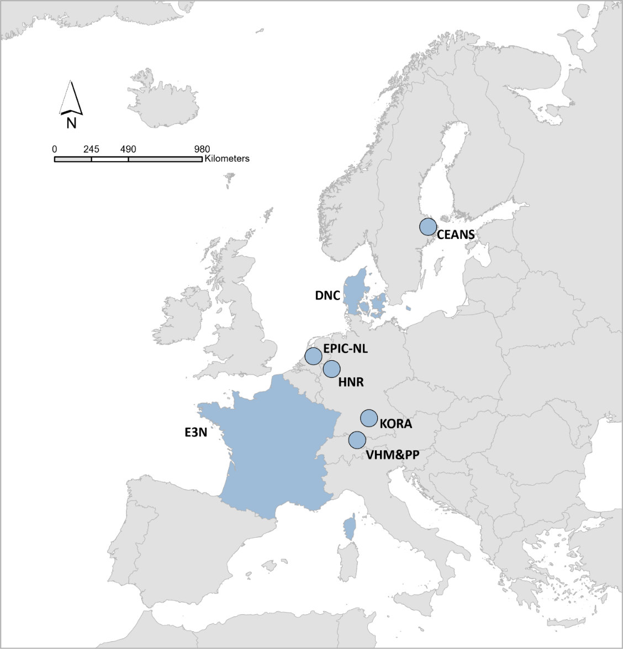

**Figure S2. Description of air pollutants by cohorts and sub-cohorts for the year 2010 and the baseline years (N=271,720).**

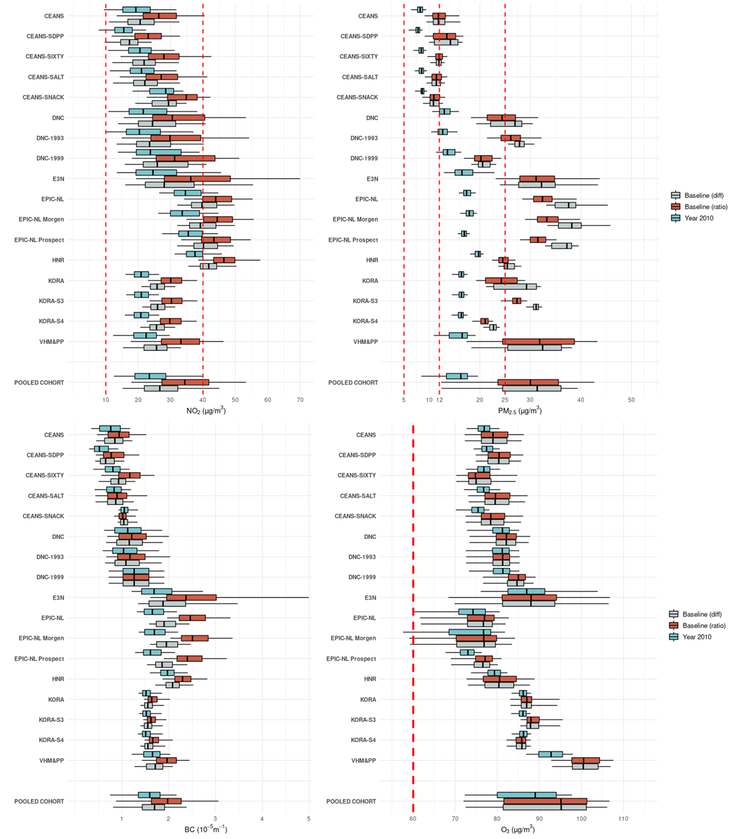

The bold lines in the middle of the box indicate the median values (the 50th percentiles). The lower and upper hinges correspond to the 25th and 75th percentiles. The lower and upper whiskers extend to the 5th and 95th percentiles. Red dotted dash lines represent different limited/guideline values in EU, U.S., and WHO guidelines (2021 version).

The number of participants for available baseline exposures, which were back-extrapolated using ratio and difference methods, was 271,720. For comparison, we restricted the same participants for 2010 exposure in this graph.

Definition of abbreviation: PM2.5, particulate matters with aerodynamic diameters of less than 2.5 μm; NO2, nitrogen dioxide; BC, black carbon (measured by the reflectance of PM2.5 filters from 2009 and 2010, expressed in absorbance units); O3, ozone.

**Figure S3. Pearson correlations between air pollutants composition estimated from supervised linear regression model in the pooled cohort.**

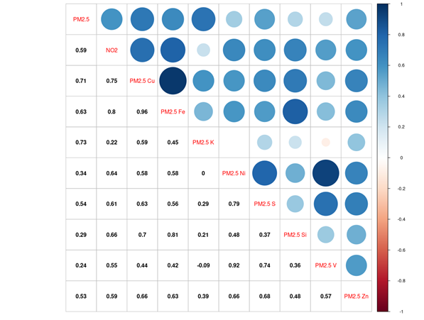

**Figure S4. Pearson correlations between air pollutants composition estimated from random forest model in the pooled cohort.**

