# Supplementary methods

***In vitro* interactive assay of islets and blood** Fresh mouse blood was collected from the retro-orbital sinus, anti-coagulated with heparin (3 U/ml) and diluted with four volumes PBS (1:5 dilution). Isolated porcine islets were perfused with diluted anticoagulated blood in Eppendorf tubes (1.5 ml) attached to a rocking apparatus (60 rpm, CERTOMAT® HK, BBraun), and placed in an incubator at 37°C to mimic blood ﬂow inside the tubes. About 2000 IEQ isolated porcine islets with a size larger than 70 µm were selected using a cell strainer (BD Falcon), collected in 5 µl PBS and agitated in 250 µl diluted mouse blood, incubated and rotated for one hour. Post incubation blood-islet clots were either snap frozen in O.C.T. medium (Sakura) and fixed for immunofluorescence staining (Supplementary Figure s5) or directly fixed in ice-cold acetone and airdried for staining with eosin/hematoxylin (0.5%) and then incubated with increasing concentrations of ethanol and mounted on coverslips (Supplementary Figure s6).

# Supplementary data

# 

Supplement Figure S1: Isolated porcine IEQ promoted human platelet aggregation (relevant to Figure 1). Aggregation was induced by 30 porcine IEQ (A), 30 IEQ pretreated with 100 ng/ml IL-1β (B) or 50 IEQ pretreated with IL-1β (C). Each line represents a separate experiment (n=4), recording time was 10 min. The maximum percentage of aggregation was quantified. IL-1β pretreatment promoted human PRP aggregation induced by porcine IEQ (D). 50 porcine IEQ were pretreated with 10 or 100 ng/ml IL-1β before platelet aggregometry (E). \**P*<0.05, \*\**P*<0.01, and \*\*\**P*<0.001 vs indicated comparator. PRP platelet rich plasma, IEQ islet equivalents.

Supplement Figure S2**:**  Representative microfluidic experiment with human pancreatic islets and GP6-/- blood versus WT blood. Thrombus formation with Bioflux device as described in Materials and Methods Section. The graphs represent clot areas plotted against time in experimental conditions described in the caption of the image. The table (**Table S1**) gives an overview on the kinetic data. WT=Wildtype mouse blood, GP6-/- = GPVI deficient mutant mouse blood

|  |  |  |  |  |
| --- | --- | --- | --- | --- |
|  | WT | WT with islets | GP6-/- | GP6-/- with islets |
| Aggregation slope | 5.5 | 132.3 | 3.7 | 131.5 |
| Time to maximum sec | 115 | 115 | 100 | 95 |
| Maximum clot area m2 | 392 | 9992 | 496 | 7932 |
| Disaggregation slope | -1,19 | -11.8 | -4.2 | -126.1 |

Addition of human pancreatic islets resulted in an increased aggregation slope and clot area compared to mouse blood alone. Similar to the profile calculated from pig islets and mouse blood, disaggregation slope from *GP6-/-* was about 10-fold higher compared to WT blood.



Supplement Figure S3**:** Cryosections from grafted liver either untreated (A,C ) or JAQ1-treated (B,D) C57BL/6N syngeneic islet recipients demonstrated similar degree of leukocyte accumulation. Livers were recovered 24 hr after transplantation and probed for insulin (green) and PSGL-1 (red) (A-B) or for CD11b (red) (C-D); scale bar=50 m.



Supplement Figure S4**:** Plasma insulin levels during intraperitoneal glucose tolerance test in human islets transplanted mice. Streptozotocin-induced diabetic NMRI nu/nu mice were transplanted with about 2,000 human islet equivalents by injection into the portal vein. JAQ1 is an antibody which is applied subcutaneously to render a mouse GPVI deficient. Transplanted mice were treated either with JAQ1 or isotypic antibody as control (Ctrl). At 120 days after human islet transplantation an intraperitoneal glucose tolerance test (2 g/kg glucose i.p.) was performed collecting plasma for determining glucose stimulated insulin release. Human insulin was measured by ELISA (DRG). Plasma insulin stimulated by glucose of JAQ1-treated mice was significantly lower compared to isotypic-treated control mice (5.3 ± 3.4 versus 13.8 ± 3.8 U/l, p=0.0005, n=10).



Supplement Figure S5**:** Cryosections from in vitro interactive assay of porcine islets and WT mouse blood, demonstrating thrombus formation induced by porcine islets (A) and the involvement of CD11b+ cells (B). Isolated porcine islets were incubated with diluted anticoagulated WT mouse blood for one hour, fixed and probed for insulin, GPIb or CD11b as indicated. scale bar=50 m.

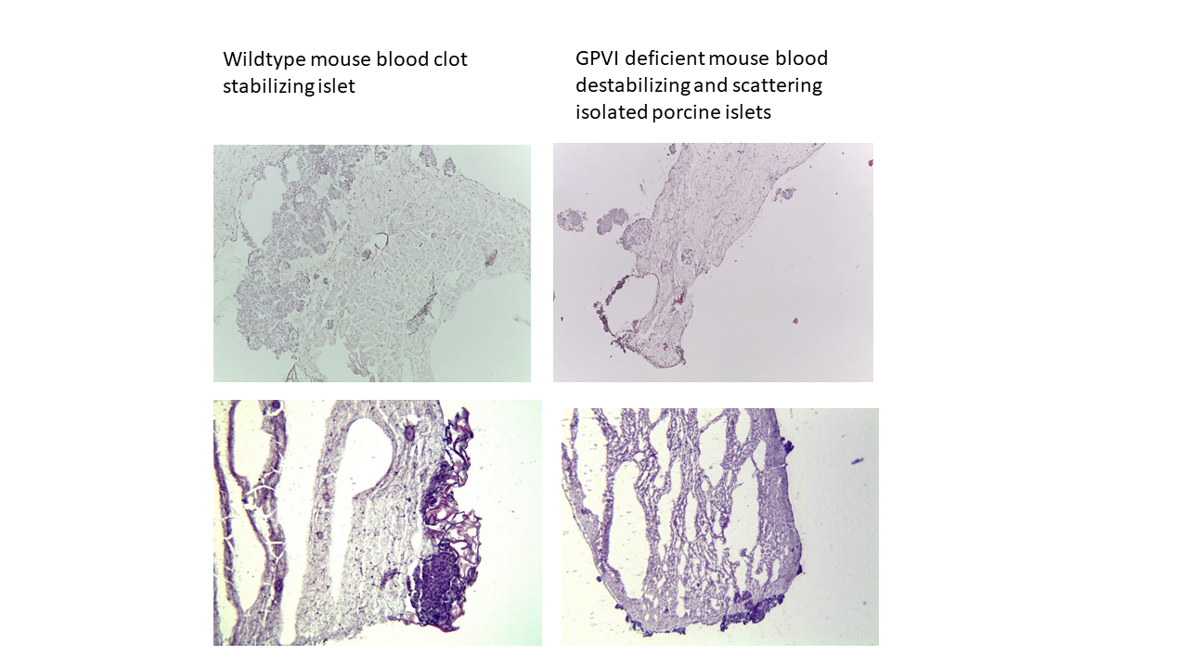

Supplement Figure S6**:** Eosin/hematoxylin (0.5%) staining of in vitro interactive assay of porcine islets and WT mouse blood. Isolated porcine islets were incubated with diluted anticoagulated WT mouse blood for one hour, fixed in ice-cold acetone and airdried. Eosin/hematoxylin (0.5%) staining was performed and followed by incubation with increasing concentrations of ethanol and mounted on coverslips. The figure shows representative images of compact porcine pancreatic islets in stabilized WT (left, magnification 100x) or in destabilized GP6 -/- blood clot (right, magnification 100x).

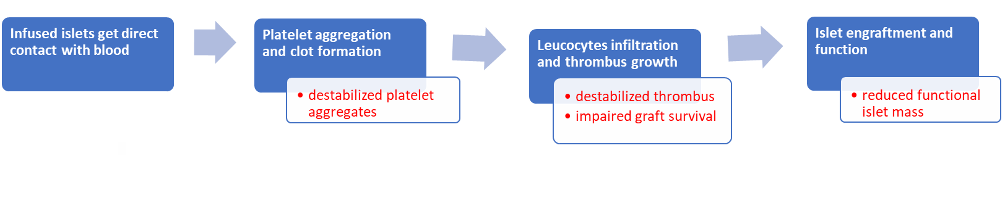

Supplement Figure S7**:** Graphical abstract of the thrombotic events after intraportal islet transplantation and the observed impact of GPVI deficiency as illustrated in red text in white boxes.