Pollen exposure weakens innate defense against respiratory viruses
Stefanie Gilles^{1,#,*}, PhD, Cornelia Blume^{2,3#}, PhD, Maria Wimmer^{1,4}, PhD, Athanasios Damialis¹, PhD, Laura Meulenbroek^{4,5}, PhD, Mehmet Gökkaya¹, MSc, Carolin Bergougnan, MSc¹, Selina Eisenbart¹, Nicklas Sundell⁶, PhD, Magnus Lindh⁶, PhD, Lars-Magnus Andersson⁶, PhD, Åslög Dahl⁷, PhD, Adam Chaker⁸, MD, Franziska Häring¹, MSc, Sabrina Wagner¹, PhD, Avidan U. Neumann¹, PhD, Cezmi A. Akdis^{9,10}, MD, Johan Garssen^{4,5}, MD, Johan Westin⁶, MD, Belinda van´t Land^{5,11}, PhD, Donna E. Davies^{2,3}, PhD, Claudia Traidl-Hoffmann^{1,10}, MD

¹ Chair and Institute of Environmental Medicine, UNIKA-T, Technical University of Munich and Helmholtz Zentrum München, Augsburg, Germany.
² University of Southampton, Faculty of Medicine, Academic Unit of Clinical and Experimental Sciences, Southampton, United Kingdom.
³ Southampton NIHR Respiratory Biomedical Research Unit, University Hospital Southampton, Southampton SO16 6YD, United Kingdom.
⁴ Utrecht University, Faculty of Science, Department of Pharmaceutical Sciences, Division of Pharmacology, Utrecht, The Netherlands.
⁵ Nutricia Research, Department of Immunology, Utrecht, The Netherlands.
⁶ Department of Infectious Diseases/Clinical Virology, University of Gothenburg, Gothenburg, Sweden.
⁷ Department of Biological and Environmental Sciences, Faculty of Sciences, University of Gothenburg, Gothenburg, Sweden.
⁸ ENT Department, Klinikum Rechts der Isar, Technical University of Munich, Munich, Germany.
⁹ Swiss Institute of Allergy and Asthma Research (SIAF), University Zurich, Davos, Switzerland.
¹⁰ Christine-Kühne-Center for Allergy Research and Education (CK-Care), Davos, Switzerland.
¹¹ The Wilhelmina Children’s Hospital, University Medical Center Utrecht, Laboratory of Translational Immunology, Utrecht, The Netherlands

*Address correspondence to:
Dr. Stefanie Gilles, Chair of Environmental Medicine, UNIKA-T, Technical University of Munich, Neusäßer Str. 47, D-86156 Augsburg, Germany; phone: ++40 +821 598412; fax: ++40 +821 598420; e-mail: stefanie.gilles@tum.de

# SG and CB contributed equally to this work

The authors state that they have no competing interests.

This file includes:

Materials and methods, detailed
Supplementary text
Supplementary figures and figure legends
References

Materials and Methods, detailed

Pollen and pollen extracts
Pollen grains from birch (Betula pendula) and timothy grass (Phleum pratense) were extracted from male flowers collected in spring/summer of 2014 in Munich and Augsburg as previously described¹. Ragweed (Ambrosia artemisiifolia) pollen used for the RSV mouse model was collected from plants grown in greenhouses. Aqueous pollen extracts (APEs) and a protein-free fraction thereof (APE<3kDa) were prepared as described in ². Briefly, 10mg of pollen were suspended in aqueous buffer (PBS for cell stimulations; 0.9% NaCl for nasal challenge) and incubated in a shaking water-bath for 30 minutes at 37°C, with vortexing every 10 minutes to prevent sedimentation of the pollen. The pollen grains were then pelleted by centrifugation (10 min, 1,000xg) and the supernatant was sterile-filtered (0.2µm pore-size filter) to remove residual pollen. For generating a protein-free extract, the total APE was ultra-filtered using 3 kilo Dalton (kDa) cutoff filters (Amicon Ultra, Millipore). Total protein concentrations of APEs were 100µg/mL (birch), 160µg/mL (timothy grass) and 750µg/mL (ragweed; by Bradford assay). The major allergen concentrations, as determined by ELISA, were 50µg/mL Bet v 1 (birch), 70µg/mL Phl p 5 (timothy grass) and 100µg/mL Amb a 1 (ragweed).

Human rhinovirus (RV) 16 propagation and titration
Human rhinovirus (HRV16; ATCC VR-283™, Teddington, UK) was amplified using H1 HeLa cells as previously described ^{3,4}. Infectivity of stocks and release of infective virions in cell culture supernatants was determined using a HeLa titration assay and 50% tissue culture infective dose assay (TCID₅₀/ml). Ultraviolet-irradiated virus controls (UV-RV16) were prepared by exposure of virus stocks to UV light at 1200 mJ/cm² on ice for 50 min.

RNA extraction from differentiated PBECs and RT-qPCR
Using standard phenol-chloroform extraction, RNA was isolated from cell lysates and reverse transcribed to cDNA using a Precision Reverse Transcription kit (PrimerDesign, Southampton, UK) according to the manufacturer’s instructions. cDNA was amplified by qPCR (cycling conditions 95 ºC 10 min, then 50 cycles of 95 ºC 15 s, 60 ºC 1 min) using Perfect Probe assays specific for IFN-β, IL-29, MDA-5 and RIG-I (PrimerDesign). Data were normalised to the geometric mean of the housekeeping genes (ubiquitin C and glyceraldehyde 3-phosphate dehydrogenase, probe-based duplex primer mix, PrimerDesign) and fold change in gene expression relative to controls (without pollen and RV16 stimulation) was determined using the ΔΔCt method.

Stimulation of HNEC monolayer cultures with viral mimics, pollen extracts and pollen
Passage 2 HNECs isolated from surgical biopsies (see methods in main manuscript) were seeded into tissue culture plates in complete airway epithelial cell growth medium (PromoCell, Heidelberg, Germany) until 80-90% confluent. One day prior to stimulation, medium was changed to complete medium without hydrocortisone. Control cells were incubated with medium (untreated) or treated cells with PolyIC (10µg/mL), High molecular weight PolyIC-LyoVec (10µg/mL), aqueous pollen extract (APE; corresponding to 10, 50 or 100µg total protein/mL or 5, 10 or 50µg of Bet v 1/mL), a protein-free, low MW fraction of aqueous pollen extract (APE<3kDa; at the same concentrations) or whole pollen grains (birch, timothy grass; corresponding to 1 and 5 µg/mL aqueous pollen extract) for 24h. The pollen grains were added drop-wise to the cell cultures from a freshly prepared pollen suspension. Sedimentation of the pollen grains onto the HNEC monolayer occurred within 5 minutes, as observed under the light microscope. After the stimulation, supernatants were recovered, centrifuged briefly to remove pollen grains and cell debris and subjected to ELISA or multiplex assay for detection of type III interferones and pro-inflammatory cytokines and chemokines.

Reagents, ELISA and multiplex kits
IFN-λ1 (IL-29) was measured using Human IL-29 (IFN lambda 1) ELISA Ready-SET-Go!® ELISA kit (eBioscience, San Diego, CA, USA); IFN-λ2 (IL-28A) and chemokines were detected by singleplex or multiplex using the MILLIPLEX MAP Human Cytokine/Chemokine Magnetic Bead Panel II (Millipore, Darmstadt, Germany); CCL5 release was determined using a Human RANTES Tissue Culture Kit (Mesoscale Discovery, Rockville, MD) according to the manufactures instructions. PolyIC and LyoVec-PolyIC were purchased at Invivogen, Toulouse, France. Inhibitors of PPAR-γ (GW-9662) and adenosine receptors (MRS-1754, SCH-442416) were purchased at Sigma Aldrich, Taufkirchen, Germany.

Nuclear translocation of transcription factors
HNEC submerged monolayer cultures were incubated with indicated stimulants for 5 min in hydrocortisone-free complete medium. The reaction was stopped by placing the cells on ice and washing twice with ice-cold PBS containing phosphatase inhibitors. Nuclear and cytoplasmic extracts were prepared from cells using the Nuclear Extract Kit (Active Motif, Carlsbad, CA, USA) following the manufacturer´s instructions. 10 µg of total proteins were subjected to SDS-PAGE and transferred to a nitrocellulose membrane by Western Blotting. Phosphorylated IRF-3 and -7 were probed with specific monoclonal antibodies (Phospho-IRF-3 (Ser396) Rabbit mAb; Phospho-IRF-7 (Ser477) Rabbit mAb, Cell Signaling Technology, Danvers, MA, USA) and secondary HRP-conjugated goat anti-rabbit antibody (Cell Signaling Technologies, Danvers, MA, USA), followed by chemiluminescence (ECL) detection on a ChemoCam imager (Intas, Goettingen, Germany). Intensity of the bands was quantitated using the ChemoStar software (Intas).

Gene expression analysis of murine lung tissue
Complementary DNA (cDNA) was prepared by reverse transcription of 0.5 µg of each total RNA using the RevertedAid H Minus First Strand cDNA synthesis kit (Fermentas GmbH/Germany). Quantitative real-time PCR (qPCR) was performed using specific primers and probes for each gene and using the Probes Master 480 (Roche). Reactions were analyzed using the LightCycler480 (Roche) at 50°C for 2 min, 94°C for 10 min and 45 cycles of 94°C for 15 s and 60°C for 15 s. For relative quantification, the expression levels relative to the housekeeping gene 18s RNA were determined. The CT (cycle threshold difference) between the target gene and 18s RNA was calculated for each sample and expressed as 2^{-ΔCt}.

RSV-specific real-time PCR
Viral load was determined in the bronchoalveolar lavage fluid by real-time PCR as described previously ⁵. In short, viral genomic RNA was isolated from the fluid using a MagnaPure LC total nucleic acid kit (Roche Diagnostics, Mannheim, Germany). The isolated viral RNA was reverse transcribed using a MultiScribe reverse transcriptase kit and random hexamers (Applied Biosystems, Foster City, CA), according to the manufacturer’s guidelines. Murine encephalomyocarditis virus (RNA) was used as an internal control. Samples were assayed in a 25 μl reaction mixture containing 10 μl of cDNA, TaqMan universal PCR master mix (Applied Biosystems, ABTI), primers (900 nM RSV-A primers), and fluorogenic probes (58.3 nM RSV-A probe) labeled with the 5’ reporter dye 6-carboxy-fluorescein (FAM) and the 3’ quencher dye 6-carboxy-tetramethyl-rhodamine (TAMRA). Amplification and detection were performed with an ABTI 7900 HT system for 2 min at 50oC, 10 min at 95°C, and 45 cycles of 15 sec at 95°C and 1 min at 60°C. Samples were controlled for the presence of possible inhibitors of the amplification reaction by the indicated internal control, signals of which had to range within a clear-cut interval. Sample cycle threshold values (Ct) were compared with a standard curve of RSV A2.

Re-stimulation of murine, lung-infiltrating cells
Isolated lung cells (1x10⁶) were co-cultured with RSV-infected D1 cells (2x10⁵ cells). D1 is a non-transformed, growth factor-dependent, myeloid dendritic cell line derived from C57BL/6 mice ⁶. D1 cells were grown in IMDM, 5% FCS, 1% penicillin/streptomycin and 50µM β-mercapto-ethanol and supplemented with 30% conditioned medium form GM-CSF producing R1 cells ⁷. Before adding them to lung cells, D1 cells were infected for 48 hours with RSV (multiplicity of infection, m. o. i. 2). Cell suspensions were stimulated for 6 h at 37°C, 5% CO₂ in 200 µl IMDM supplemented with 2 mM L-glutamine, 25 mM HEPES buffer, 5% FCS, penicillin/streptomycin, 50µM β-mercapto-ethanol and 50 U/ml recombinant IL-2 and 10 µg/ml Brefeldin A. For flow-cytometric analysis, cells were harvested, and T cells were identified by anti-CD3, anti-CD4, and anti-CD8. Fixed and permeabilized cells were then stained with anti-INF-γ, anti-IL-4 and anti-IL-13. Samples were acquired on a FACSCanto II flow cytometer and analyzed by FlowJo software.

Airborne pollen concentrations
Airborne pollen concentrations were monitored using Hirst-type volumetric pollen traps in Augsburg, Germany and Gothenburg, Sweden, as described by the European Aerobiology Society ⁸. So as to exclude uncommon long-distance pollen transport and pollen re-suspension phenomena, only the main birch pollen season was used. Its start and end were defined by 5% and 95% respectively of the total annual pollen sum ⁹.

Antiviral gene expression in nasal curettages
Total RNA was extracted from nasal curettages using RNeasy Mini Kit (Qiagen). RNA was treated with DNase and concentrations were determined on a BioDrop spectrophotometer (Harvard Bioscience). 150ng of each RNA was used as a template to synthesize cDNA using iScriptTM cDNA Synthesis Kit (Bio-Rad). Thermal cycling protocol was 25°C for 5 min, 46°C for 20 min and 95°C for 1 min. Per sample A set of antiviral and house-keeping genes were pre-amplified from 5µl cDNA using the SsoAdvancedTM PreAmp Supermix and PrimePCRTM PreAmp for IFNA1, INFB1, IL28A, IL29 and GAPDH (Bio-Rad). 18S and EF1A primer pairs were designed in our lab. Thermal cycling protocol was 95°C for 3 min, followed by 12 cycles of amplification at 95°C for 15 sec and 58°C for 4 min. 1µl of each pre-amplified sample was used to perform qPCR using the iTaq Universal SYBR Green Supermix (Bio-Rad) on a CFX384 Touch Real-Time PCR Detection System (Bio-Rad). Thermal cycling program was run at 95°C for 30 sec, followed by 40 cycles of amplification at 95°C for 5 sec and 60°C for 30 sec. Quantification cycle (Cq) values were determined by using automatic threshold. GAPDH, 18S and EF1A were used as reference genes. ΔΔCq Values were calculated to obtain relative gene expression.

Meteorological data
Data on average weekly outdoor temperature (degrees Celsius), vapor pressure (VP; hPa), relative humidity (RH, %), wind speed (meter/second) and precipitation (mm) for the study period were obtained from the Swedish Meteorological and Hydrological Institute (SMHI) obtained at the local weather station in Gothenburg (5 meters above the sea level, situated at Latitude: 57.7157N, Longitude: 11.9925E).

Statistics
(i) In vitro experiments, RSV mouse model, human pollen challenge study (unless stated otherwise in the legends): two-sided Mann Whitney test for simple comparisons between two groups; two-sided Wilcoxon test for pairwise comparisons between treatment and control groups; Friedman test for comparisons of multiple treatment groups with a single control group. (ii) Human cohorts: Relationships of symptoms with airborne pollen concentrations were investigated with simple linear regressions (GLM) and cross-correlations (time series analysis). In all analyses of symptoms, seven-day moving averages of normalized values were used, so as to eliminate periodicity effects (lower hospitalization rates over the weekends). All statistical tests were performed with Prism or Statistica.

Supplementary Text
Pollen diminish the epithelial response to rhinovirus infection.
Human primary bronchial epithelial cells (PBECs) were differentiated at the air-liquid interface, exposed to control medium or timothy grass pollen extract (Phl-APE) and infected with human rhinovirus (HRV16) for 24h. Exposure of infected PBECs to Phl-APE resulted in reduced mRNA levels of several anti-viral and pro-inflammatory response genes, as compared to only HRV16 infected cells (fig. S1). Levels of IFN-β and CCL-5 gene expression were significantly reduced (fig. S1, A-B; p<0.05), levels IRF-7 (p=0.06) and MDA-5 by trend (p=0.07) (fig. S1, C-D).

Birch pollen exposure diminishes the IFN-λ response in rhinovirus-infected, differentiated human nasal epithelial cells.
To study the kinetics of the IFN-λ response under combined exposure to pollen and rhinovirus, differentiated human nasal epithelial cells were infected with human rhinovirus (HRV16) and co-exposed to aqueous birch pollen extract (Bet-APE) or whole birch pollen grains (BP) for 24 and 48h. Basolateral supernatants were then analyzed for IL-29 by ELISA. Bet-APE and whole birch pollen grains significantly attenuated the IL-29 response of HRV-infected HNECs at both time-points (fig. S2). UV-irradiated HRV16 was used as stimulation control and did not induce IL-29 (data not shown).

Pollen modulate signaling of nasal epithelial cells to viral mimics.
To characterize in detail how pollen interfered with antiviral pathways, we carried out experiments using monocultures of primary human nasal epithelial cells (HNECs) stimulated with synthetic viral mimics. First we tested a TLR3 ligand, PolyIC, in the absence or presence of pollen grains. Whereas unstimulated HNECs did not release significant amounts of IFN-λs, PolyIC-stimulated cells showed a robust IFN-λ response (fig. S3, A). Mean IFN-λ levels in supernatants of PolyIC-stimulated cells were 774 ± 490 pg/mL (IL-28A) and 1159 ± 310 pg/mL (IL-29). Since defective IFN-λ responses have been described for atopic asthmatics, we compared IFN-λ responses in HNECs from atopic and non-atopic donors (fig. S3, B). Mean levels of IL-28A in PolyIC-stimulated HNECs were 1520 ± 316 pg/mL (non-atopic) and 971 ± 426 pg/mL (atopic donors); mean IL-29 levels 656 ± 94 pg/mL (non-atopic) and 727 ± 164 pg/mL (atopic donors). IFN-λ production did not differ significantly between cells of non-atopic and atopic donors (IL-28A: p=0.08; IL-29: p=0.96; atopic vs. non-atopic). Aqueous birch pollen extracts also significantly decreased both IL-28A and IL-29 production of cells transfected with the RIG-I/MDA-5 ligand (fig. S3, C). We also checked for the effect of pollen exposure on the pro-inflammatory chemokine response of HNECs to PolyIC stimulation. Pollen grains significantly decreased the release in several chemokines, such as G-CSF, CCL2, CCL3, CCL4, CCL5 and CXCL10, whereas they increased levels of IL-1β (fig. S3, D).

The PolyIC-induced IFN-λ response of HNECs is not mediated by known immune-modulatory substance in pollen.
We previously reported immune-modulatory effects, such as PPAR-γ dependent inhibition of IL-12 and blocking of nuclear translocation of NF-κB, by non-allergenic pollen substances ¹⁰. Two classes of PALMs were previously identified and discussed as potential PPAR-γ ligands, the phytoprostanes and the phyto-hydroxyoctodecadienoic/-hydroxyoctodecatrienoic acids (HODEs, HOTEs). We tested both phytoprostanes and HODE/HOTEs as candidate active substances because (i) the promoter regions of type I and III IFN genes contain PPAR-γ responsive elements (fig. S4, A) and (ii) PPAR-γ agonists were previously shown to inhibit IRF-3 translocation to the IFN-β promoter in LPS- and PolyIC-stimulated murine peritoneal macrophages ⁴. However, none of the tested lipid mediators had any significant effect on the PolyIC-induced IFN-λ secretion (fig. S4, B). A PPAR-γ antagonist, GW-9662, did not abolish the inhibitory effect of APE<3kDa on the IFN-λ response to PolyIC (fig. S4, C).
Since adenosine is a major constituent of APE<3kDa and can exert immune-modulatory effects on human dendritic cells ², we assessed whether the effect of pollen on the PolyIC-induced IFN-λ response of HNECs could be mediated in part by adenosine. At concentrations as contained in aqueous pollen extracts (1-10µM), did not have a pronounced effect on the PolyIC-induced IL-29 production of HNECs (fig. S4, D). However, in the presence of an A2a inhibitor, the IL-29 response to PolyIC stimulation was approximately 4-fold increased as compared to cells not treated with the inhibitor (fig. S4, E).

Supplementary figures and legends

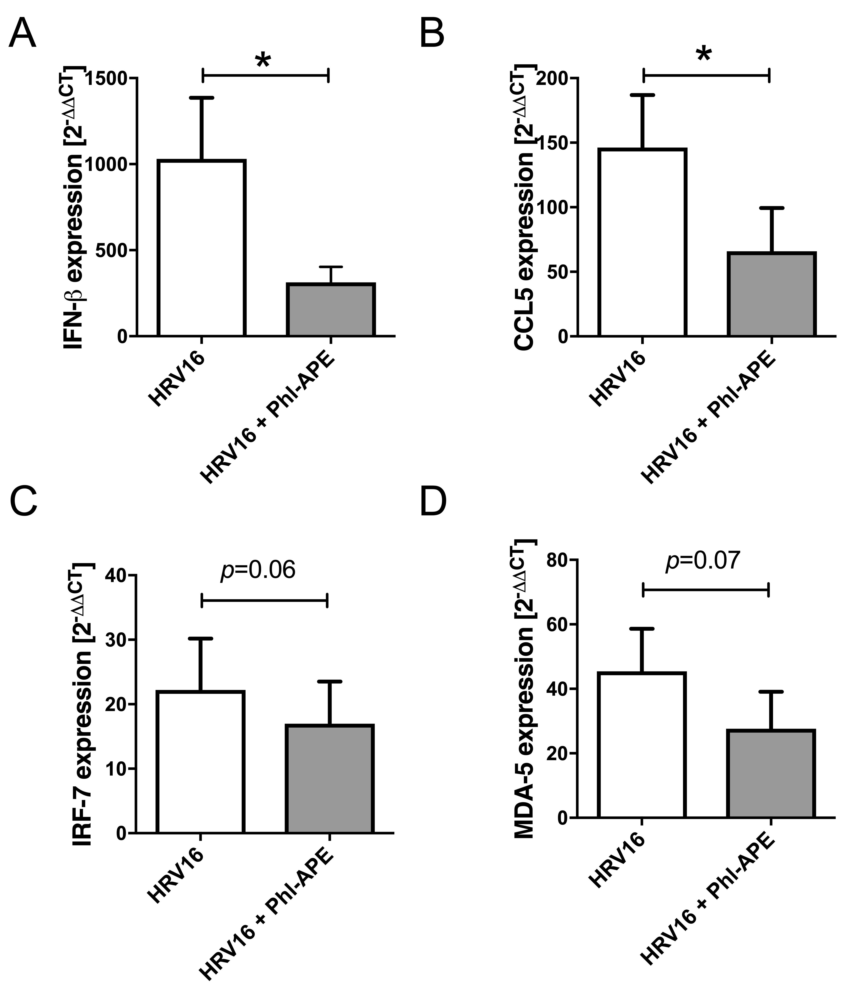
Figure S1: Expression of antiviral genes in virally infected human bronchial epithelial cells during exposure to pollen.
Human primary bronchial epithelial cells (PBECs) were differentiated at the air-liquid interface, exposed to control medium or timothy grass pollen extract (Phl-APE) and infected with human rhinovirus (HRV16) for 24h. Mean + SEM; *: p<0.05; n=5-6. Experiments were carried out with cultures of n independent donors.

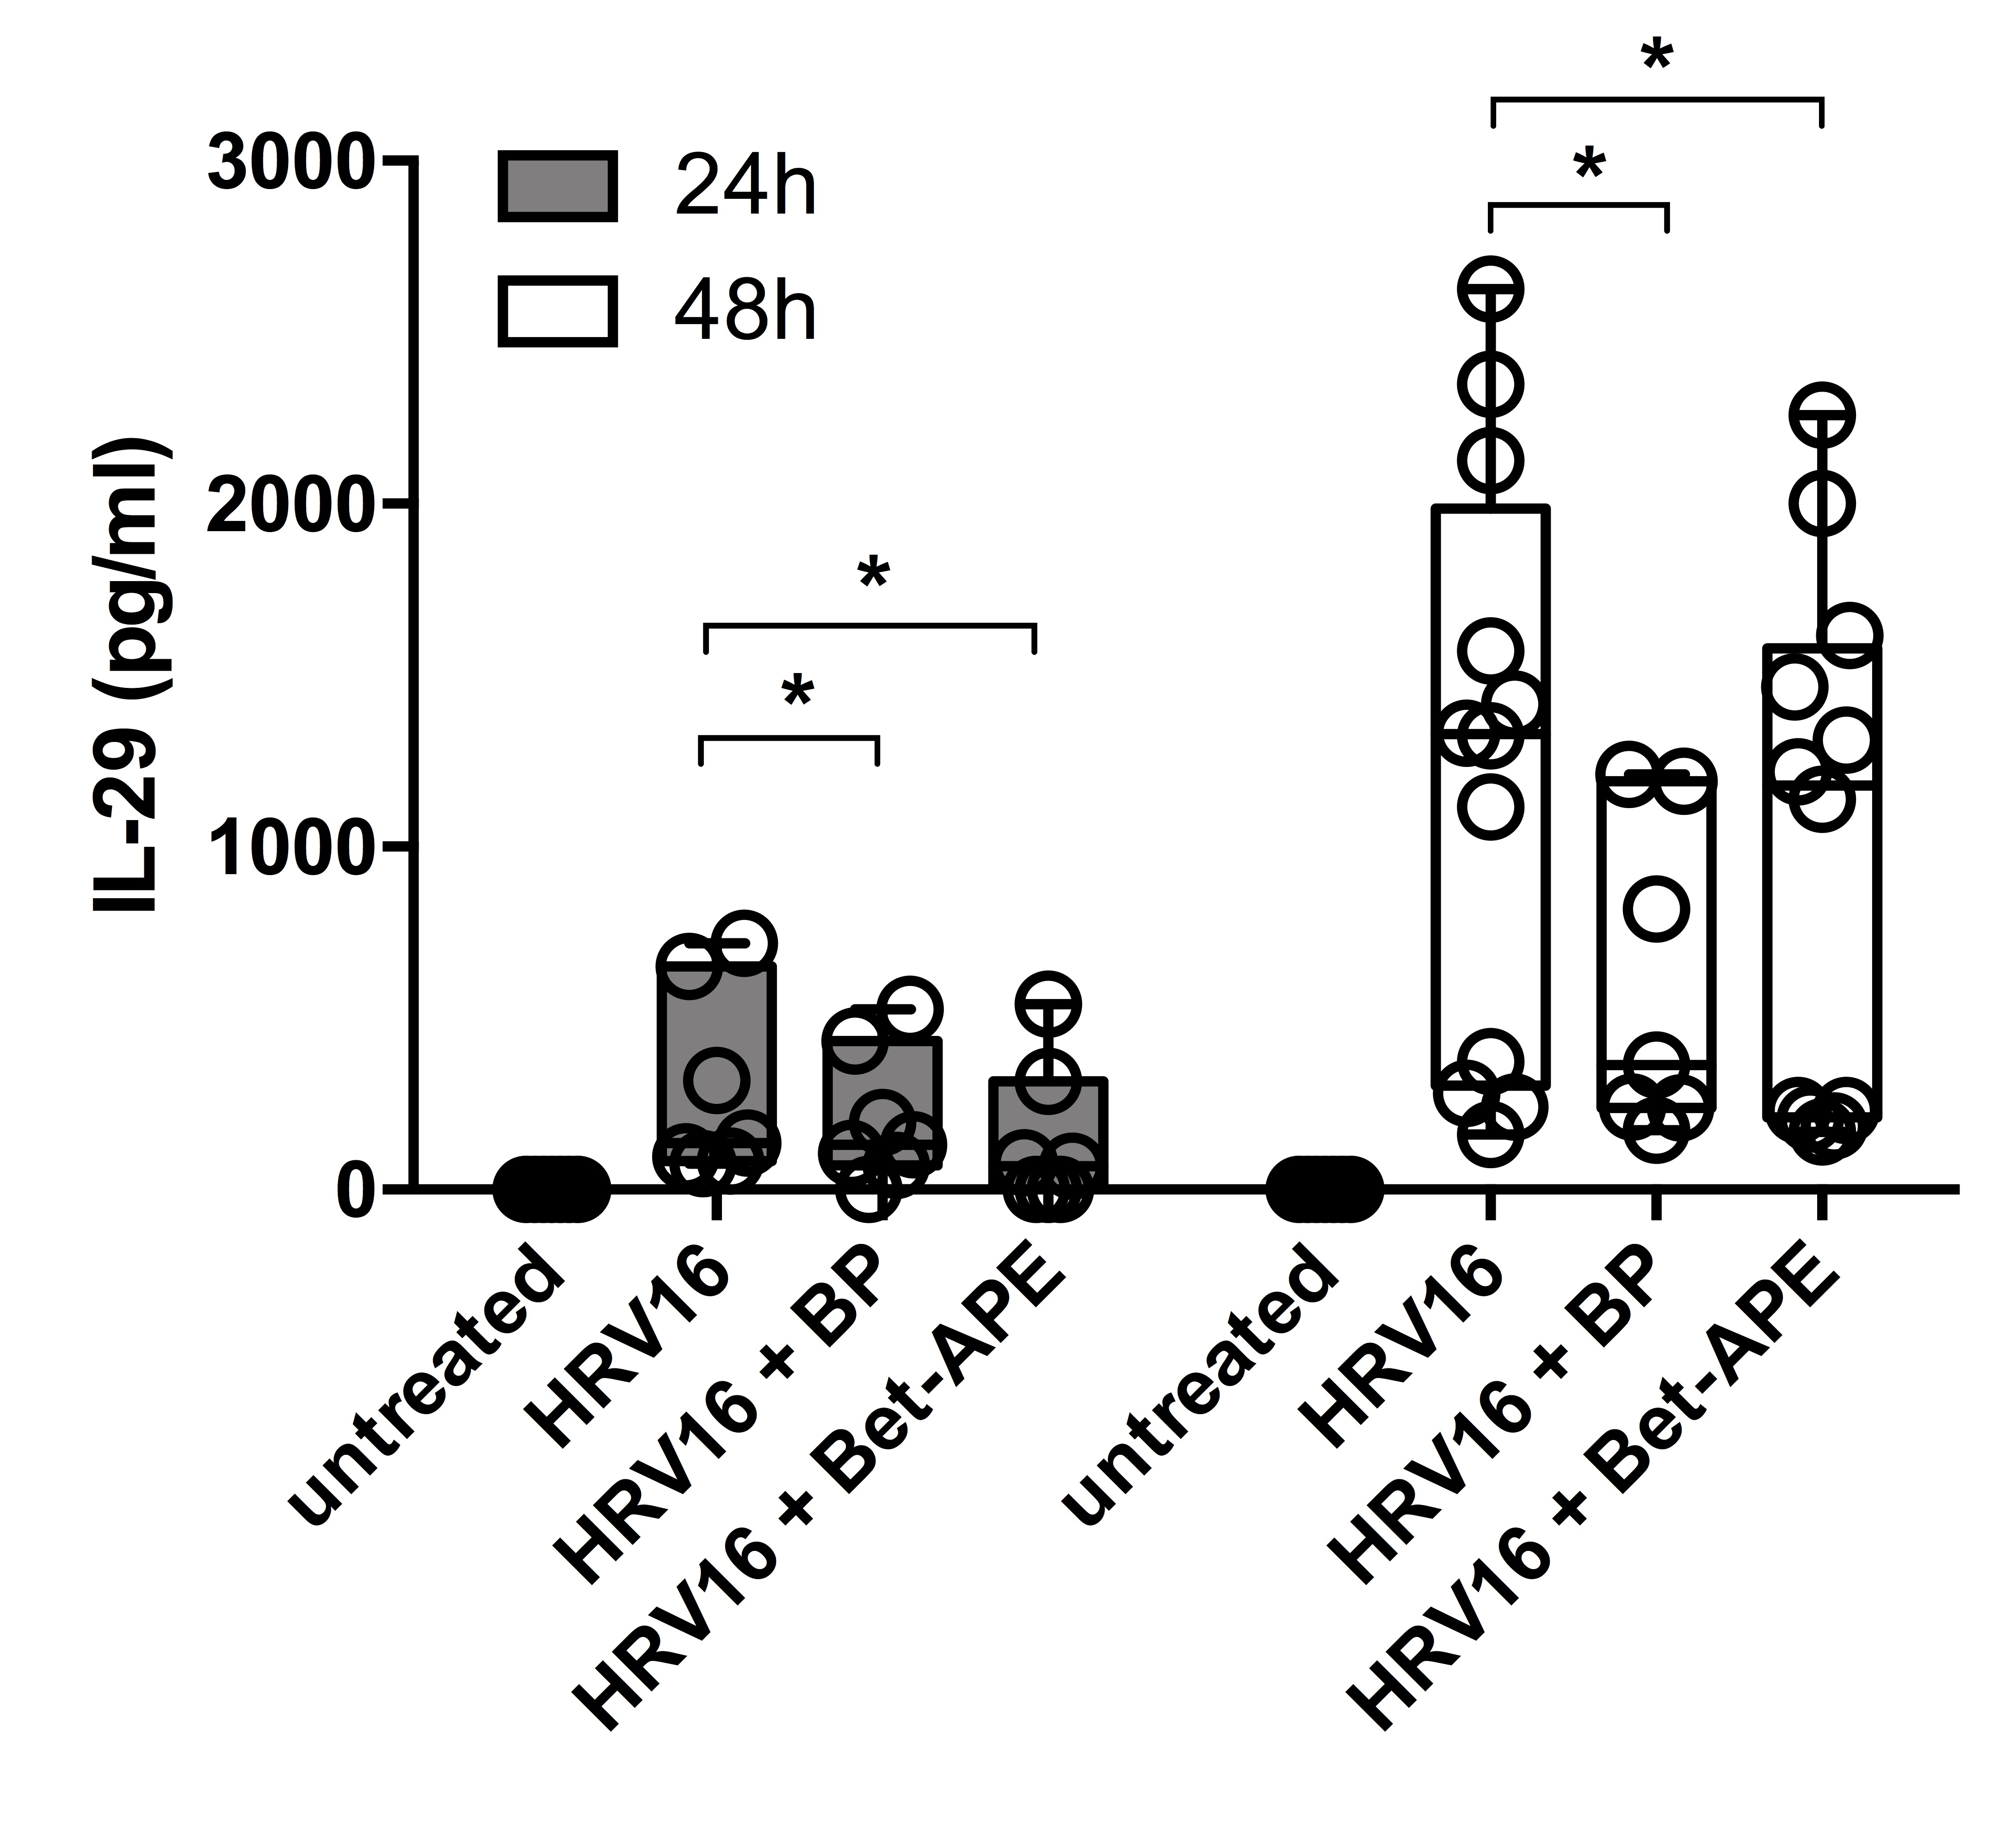
Figure S2: Time-course of the IL-29 response of human nasal epithelial cells to rhinovirus infection and birch pollen co-exposure.
Differentiated primary human nasal epithelial cells (HNECs) were either left untreated or infected with human rhinovirus (HRV16), either alone or under co-exposure with whole birch pollen grains (BP, 10µg/mL) or aqueous birch pollen extract (Bet-APE; 100µg/mL). Basolateral release of IL-29 was measured after 24h and 48h of incubation. UV-irradiated HRV16 was used as stimulation control and did not induce IL-29 (not shown). *: p<0.05; n=6-12. All experiments were carried out with cells of independent, non-atopic donors.
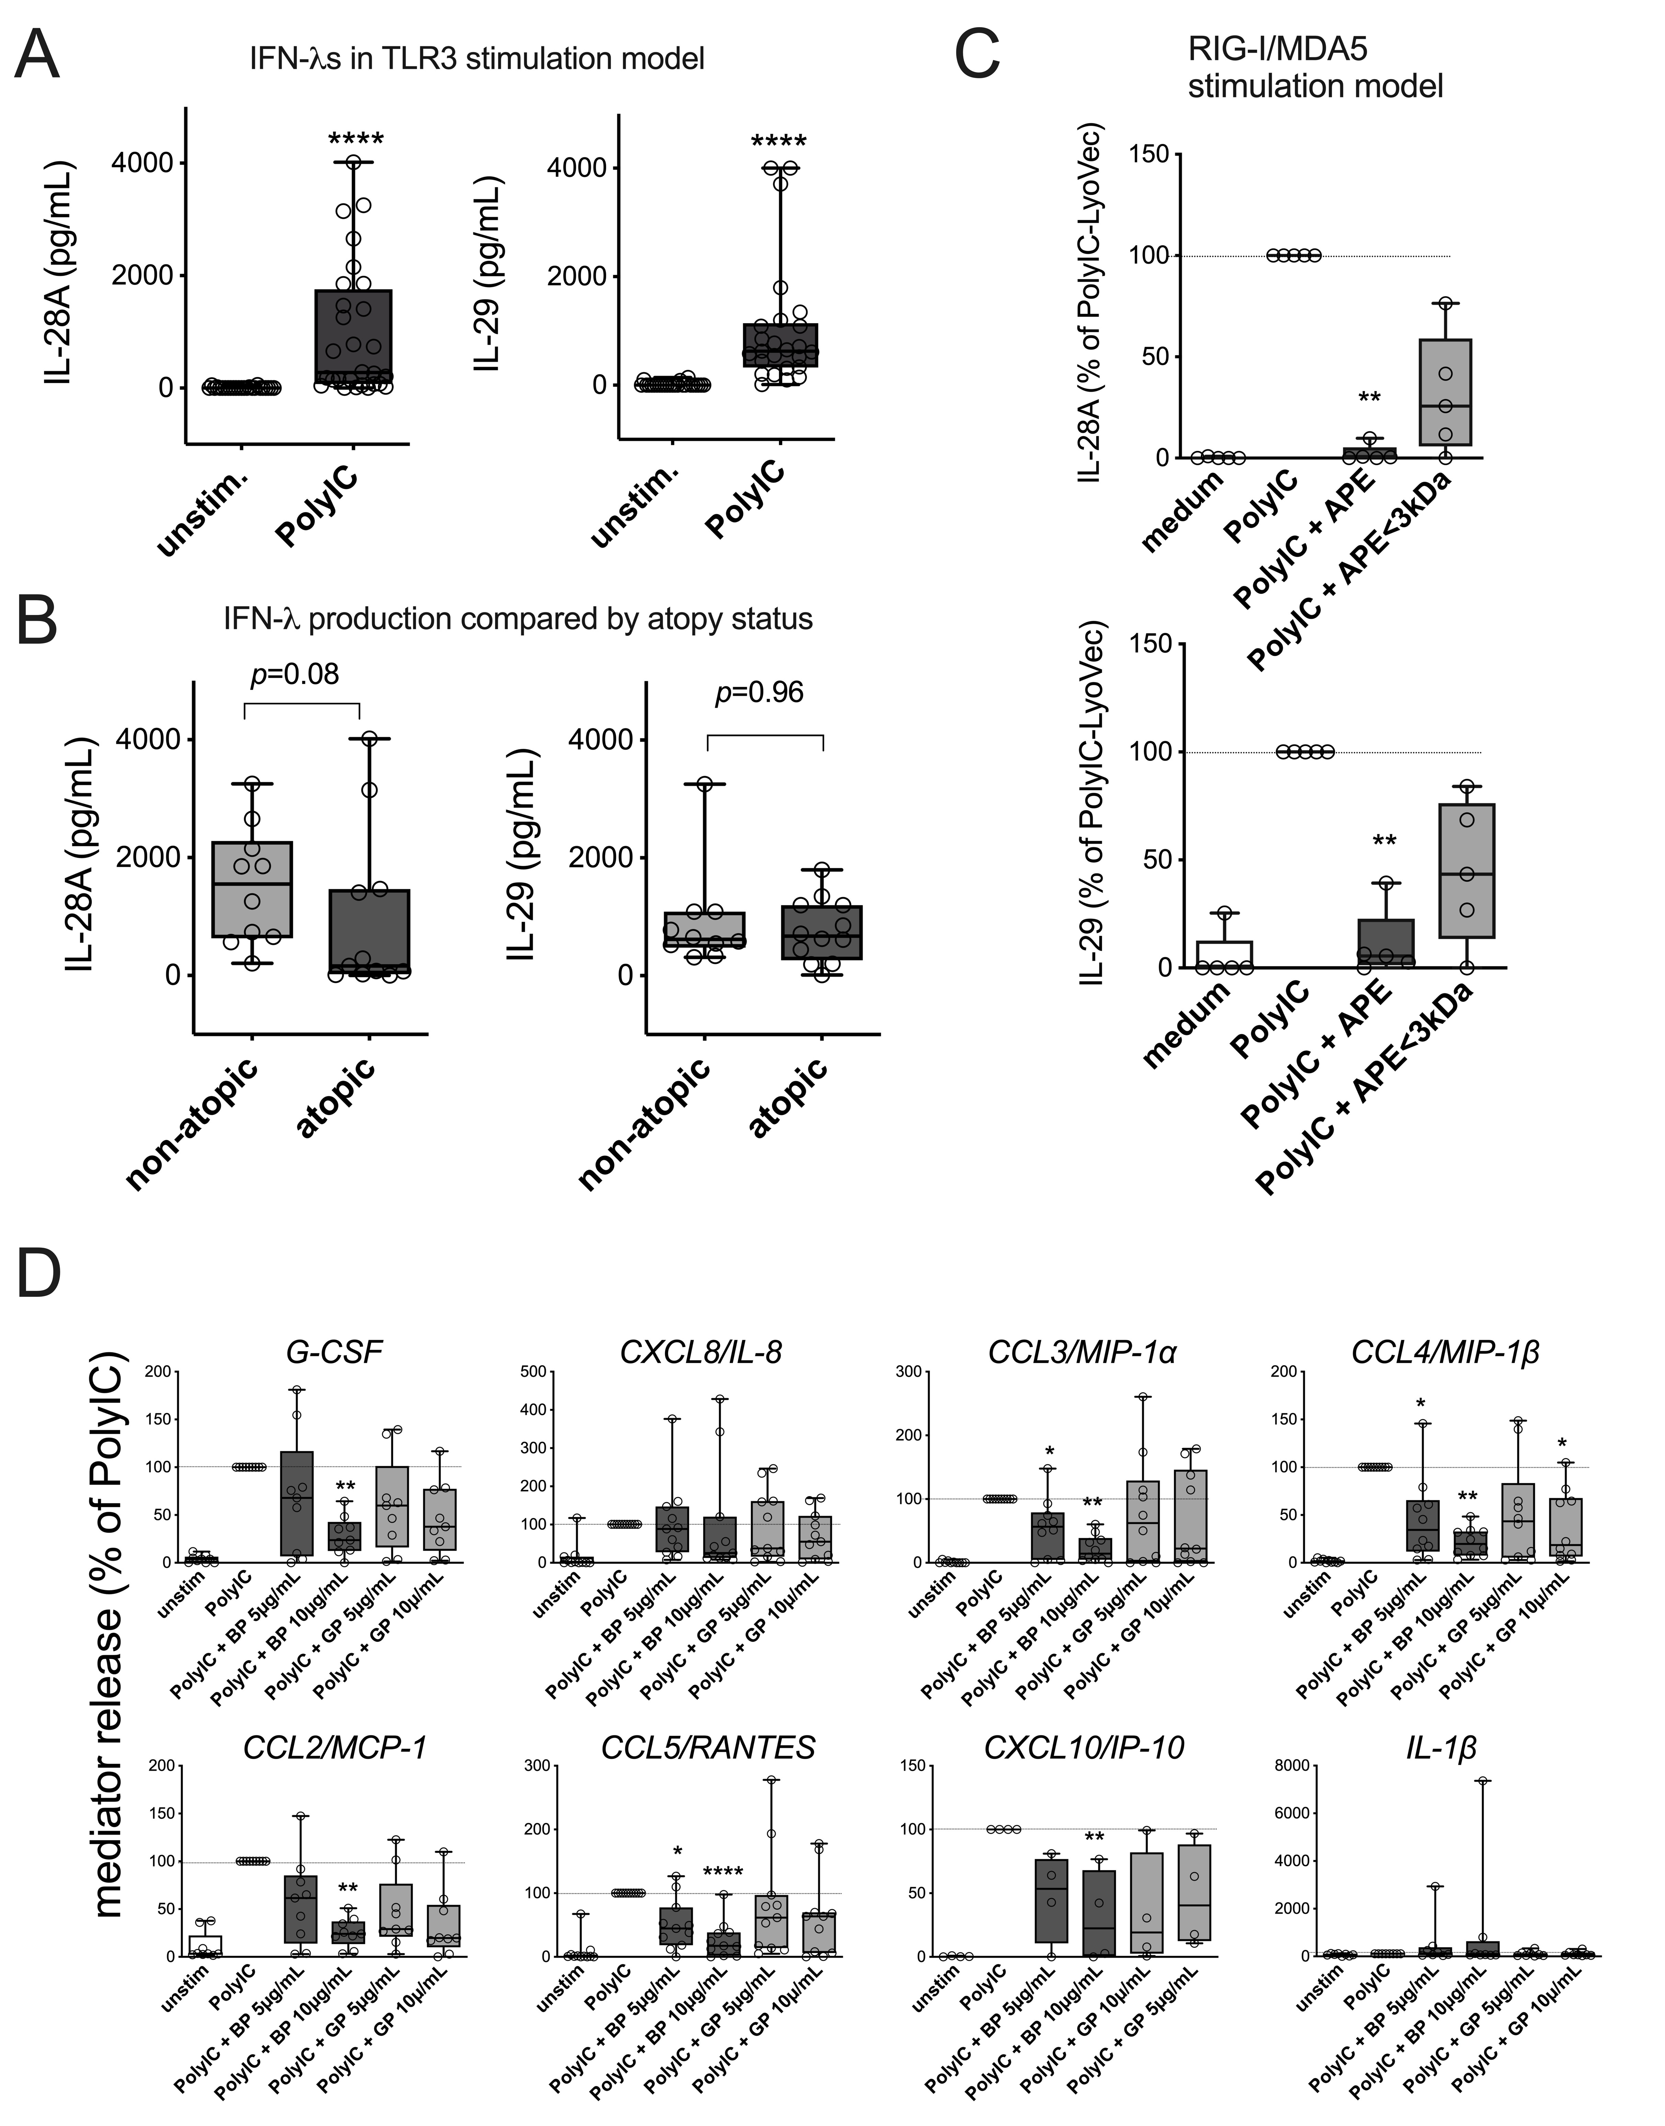

Figure S3: Antiviral response in primary human nasal epithelial cells stimulated with viral mimics.
A: Induction of IFN-λs after PolyIC stimulation. ****: p<0.001; n=28. B: Comparison of IFN-λ levels between HNECs of non-atopic (n=10) and atopic donors (n=11) stimulated with PolyIC. C: IFN- λ response in cells transfected with PolyIC-LyoVec, for RIG-I and MDA-5 stimulation, in the absence and presence of aqueous birch pollen extract (APE) and or low a molecular weight fraction thereof (APE<3kDa). **: p<0.01; n=5. D: Chemokine and cytokine response of HNECs treated with PolyIC in the absence or presence of whole pollen grains of birch (BP) and timothy grass (GP). The concentration of pollen grains in the cell culture corresponded to 5 and 10µg/mL total protein as contained in aqueous pollen extract. *: p<0.05; **: p<0.01; ****: p<0.001; n=7-14. All experiments were carried out with cells of independent donors.

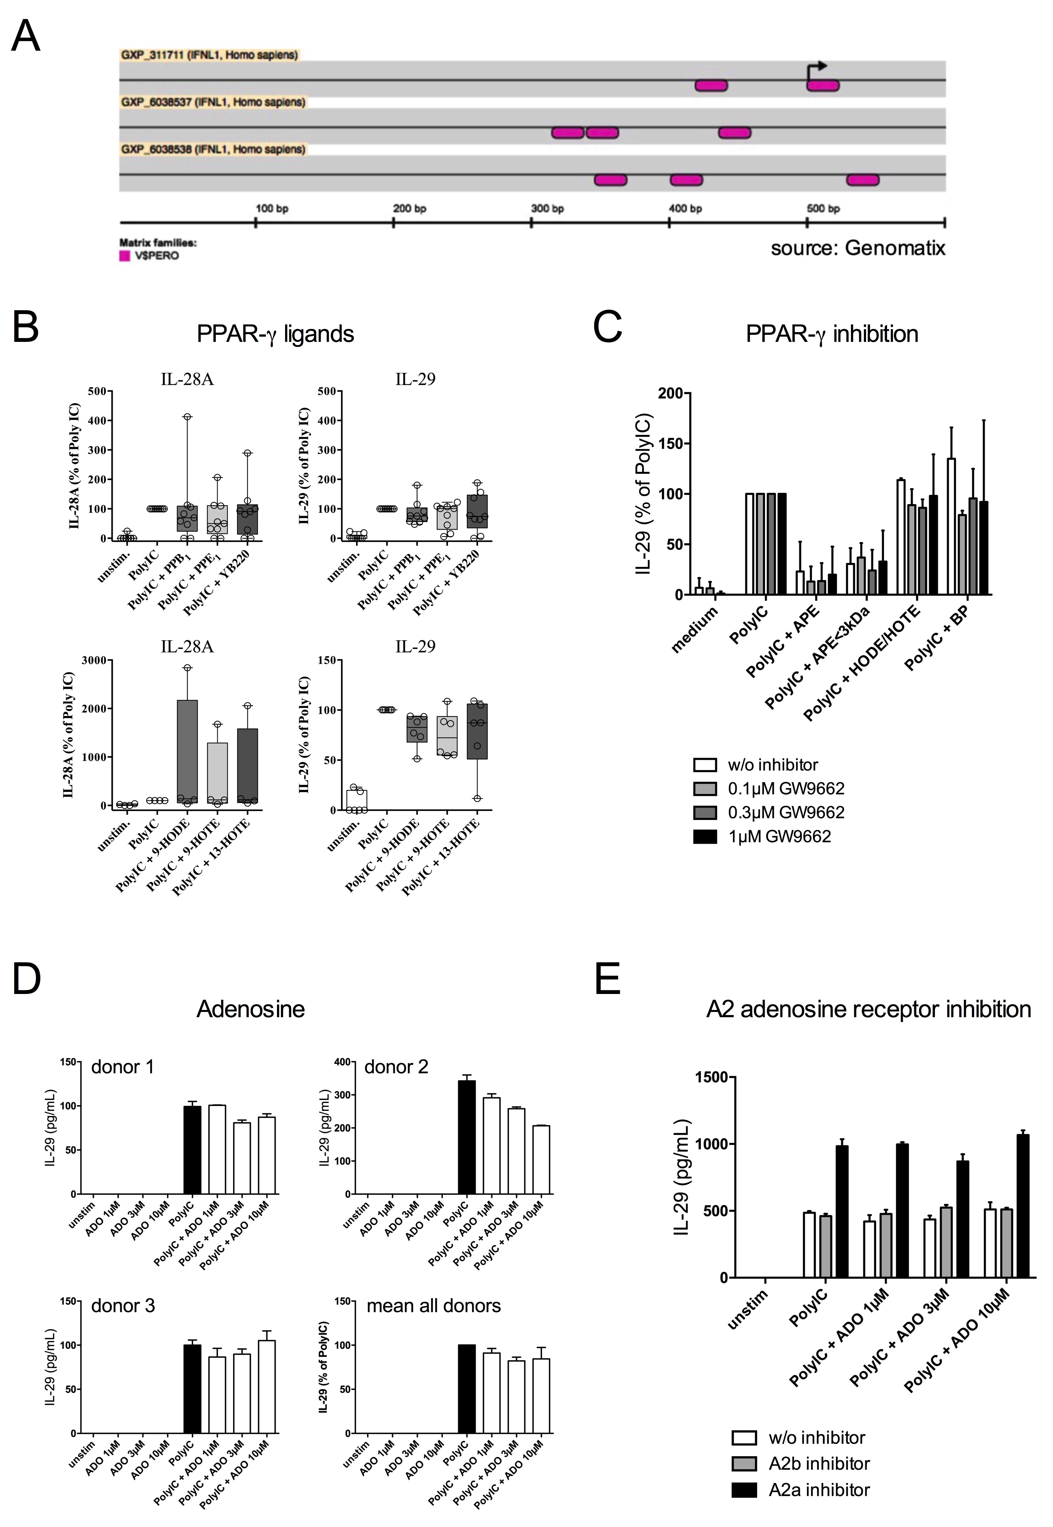
Figure S4: Effects of known candidate compounds from pollen on the PolyIC-stimulated IFN-λ response of HNECs.
A: Localization of consensus PPAR-γ binding sequence elements (depicted in pink) in the putative core promoter region of the human IFNL1 gene, coding for the IL-29 protein. The promoter analysis was performed using an online promoter analysis tool (Genomatix Suite, release 3.0; www.genomatix.com), using three different genebank reference sequences for the IFNL1 core promoter. B: IFN-λ response of HNECs to PolyIC (10µg/mL) and co-stimulated with pollen-associated lipid mediators (1µmol/L each). n=4-9. PPB₁: equimolar mixture of type-I and type-II B₁-phytoprostanes; PPE₁: equimolar mixture of type-I and type-II E₁-phytoprostanes; YB220: 15-E_{2t}-Isoprostane; HODE: Hydroxy-octodecadienoic acid; HOTE: Hydroxy-oxtodecatrienoic acid. C: IL-29 response of HNECs treated with PolyIC in combination with aqueous birch pollen extract (APE), a low molecular-weight fraction (APE<3kDa), birch pollen grains (BP) or HODE/HOTE. Cells were pre-incubated for 1h with or without a PPAR-γ inhibitor, GW9662 (0.1-3µmol/L). Mean + SEM; n=3. D: IFN-λ response in PolyIC treated nasal epithelial cells co-stimulated with adenosine (ADO; 1-10µmol/L). E: IFN-λ response of HNECs stimulated with PolyIC (10µg/mL) and adenosine (ADO; 1-10µmol/L) in the absence or presence of inhibitors for A2a (SCH-442416; 1µmol/L) and A2b (MRS-1754; 1µmol/L). Mean + SEM; n=2. Except for indicated single donor results in (D), all results are shown as averages of experiments carried out with cells of independent donors.

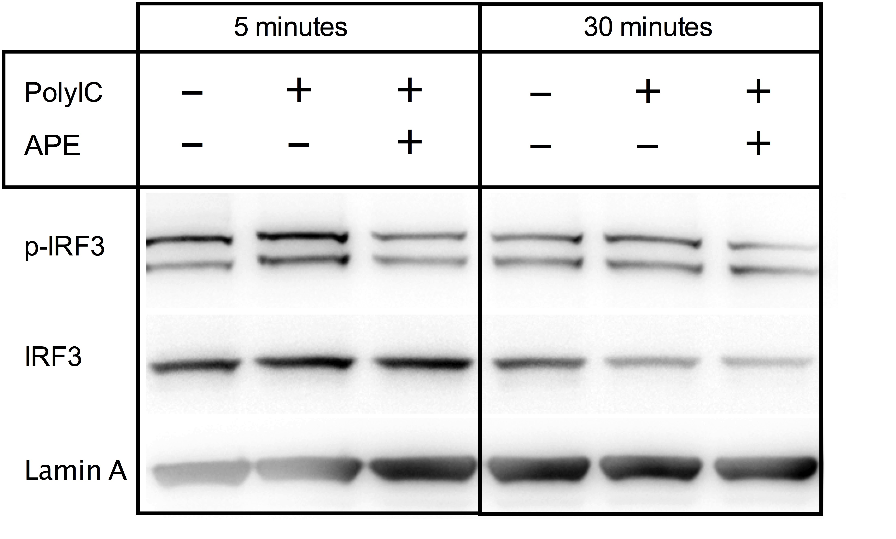
Figure S5: Phosphorylated and total IRF-3 in nuclear extracts of human nasal epithelial cells after co-stimulation of PolyIC and aqueous birch pollen extract.
HNEC submerged monolayer cultures were incubated for 5 and 30 minutes with medium, PolyIC (10µg/mL) or PolyIC plus aqueous birch pollen extract (100µg/mL; APE). Nuclear extracts were subjected to Western blotting and blots were probed with antibodies against phosphorylated total IRF-3. Lamin A served as loading control.
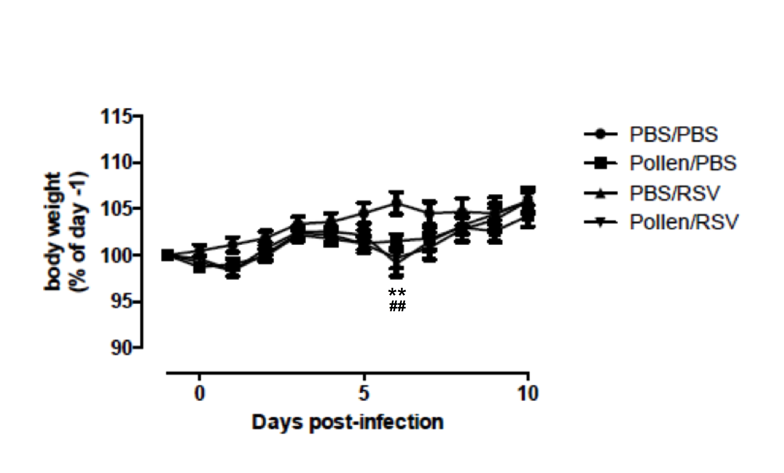
Figure S6: Body weight of animals in the RSV infection experiment. Body weight gain was slowed down in all treatment groups with exception of the PBS/PBS group. The effect was most pronounced at day 6 post infection. **: p<0.01 (PBS/RSV vs. PBS/PBS); ##: p<0.01 (Pollen/RSV vs. PBS/PBS); One-way ANOVA for repeated measures; n=6 mice per group.

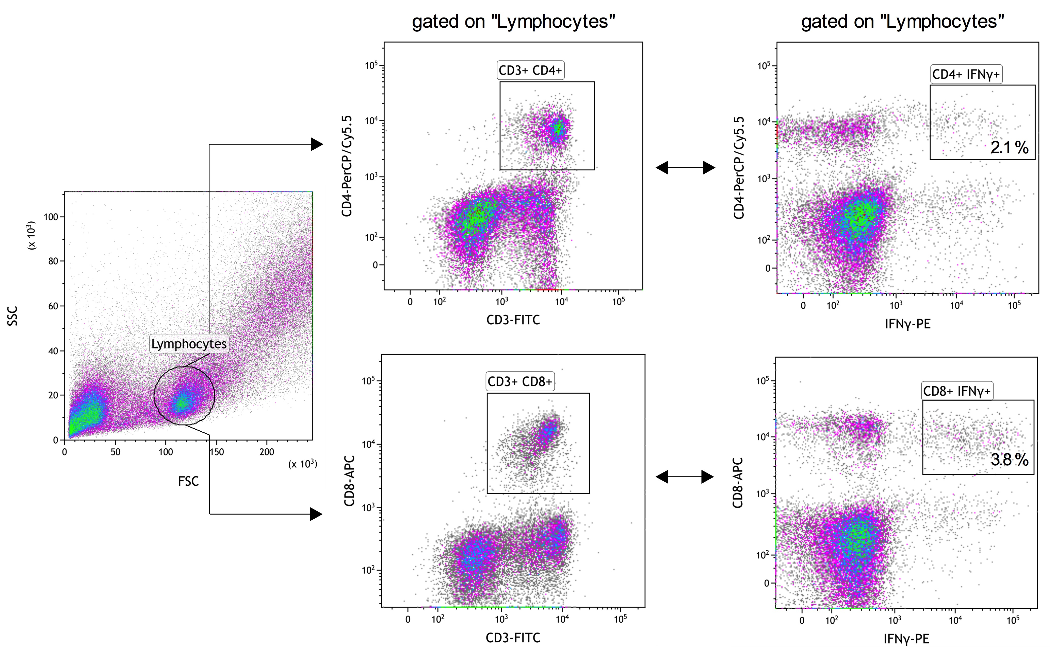
Figure S7: FACS plot depicting the gating strategy for the experiment plotted in fig. 4, H-I. Lung infiltrating cells were re-stimulated with RSV-infected D1 cells. Plotted are IFN-γ⁺ CD4⁺ and CD8⁺T cells as percentages of all lymphocytes.
References

1. Obersteiner, A., et al. Pollen-Associated Microbiome Correlates with Pollution Parameters and the Allergenicity of Pollen. PLoS One 11, e0149545 (2016).
2. Gilles, S., et al. Pollen metabolome analysis reveals adenosine as a major regulator of dendritic cell-primed T(H) cell responses. J Allergy Clin Immunol 127, 454-461 e451-459 (2011).
3. Calven, J., et al. Viral stimuli trigger exaggerated thymic stromal lymphopoietin expression by chronic obstructive pulmonary disease epithelium: role of endosomal TLR3 and cytosolic RIG-I-like helicases. J Innate Immun 4, 86-99 (2012).
4. Zhao, W., et al. Peroxisome proliferator-activated receptor gamma negatively regulates IFN-beta production in Toll-like receptor (TLR) 3- and TLR4-stimulated macrophages by preventing interferon regulatory factor 3 binding to the IFN-beta promoter. J Biol Chem 286, 5519-5528 (2011).
5. van de Pol, A.C., et al. Molecular quantification of respiratory syncytial virus in respiratory samples: reliable detection during the initial phase of infection. J Clin Microbiol 48, 3569-3574 (2010).
6. Winzler, C., et al. Maturation stages of mouse dendritic cells in growth factor-dependent long-term cultures. J Exp Med 185, 317-328 (1997).
7. Foti, M., et al. Upon dendritic cell (DC) activation chemokines and chemokine receptor expression are rapidly regulated for recruitment and maintenance of DC at the inflammatory site. Int Immunol 11, 979-986 (1999).
8. Galan, C., et al. Pollen monitoring: minimum requirements and reproducibility of analysis. Aerobiologia 30, 385-395 (2014).
9. Nilsson, S., Persson, S. Tree pollen spectra in the stockholm region (sweden), 1973-1980. Gana 20, 179-182 (1981).
10. Gilles, S., et al. Pollen-derived E1-phytoprostanes signal via PPAR-gamma and NF-kappaB-dependent mechanisms. J Immunol 182, 6653-6658 (2009).

