SUPPLEMENTAL INFORMATION

Antibodies conjugated with viral antigens elicit a cytotoxic T cell response

against primary CLL *ex vivo*

Viktor Schneidt1-4, Marta Ilecka1,3,4, Peter Dreger5, Dwain G. van Zyl1-4, Susanne Fink1,3,4,6, Josef Mautner7-9, and Henri-Jacques Delecluse1-4

1German Cancer Research Center (DKFZ), Unit F100, 69120 Heidelberg, Germany;

2Heidelberg University, Faculty of Biosciences, 69120 Heidelberg, Germany;

3Institut National de la Santé et de la Recherche Médicale (INSERM) Unit U1074, DKFZ, 69120 Heidelberg, Germany;

4German Center for Infection Research (DZIF), 69120 Heidelberg, Germany;

5Heidelberg University Hospital, Department of Internal Medicine V, 69120 Heidelberg, Germany;

6Nierenzentrum Heidelberg, 69120 Heidelberg, Germany;

7Helmholtz Zentrum München, Research Unit Gene Vectors, 81377 Munich, Germany;

8Children’s Hospital Technische Universität München, 80804 Munich, Germany;

9DZIF, 81377 Munich, Germany.

**Corresponding author:** Henri-Jacques Delecluse, Department of Pathogenesis of Virus-Associated Tumors, DKFZ, Im Neuenheimer Feld 242, 69120 Heidelberg, Germany; phone: +49 6221 42 4870, fax: +49 6221 42 4852, e-mail: h.delecluse@dkfz.de.

**Supplemental Methods**

**Construction of EBNA3C-AgAbs**

DNA sequences encoding anti-human CD19-, CD21-, CD22- (1), and CD20-specific antibodies were previously cloned and described (2). The EBNA3C-AgAbs were constructed through seamless in frame fusion of one of three overlapping EBNA3C segments (amino acids 1 to 341, 322 to 672, 653 to 992) to the C-terminus of the respective antibody heavy chain. We inserted a stop codon at the C-terminal region of the antigen. This yielded the EBNA3C-#1-, -#2- and -#3-AgAbs.

**Recombinant expression of antibodies and quantification**

Recombinant expression of AgAbs and native mAbs was performed in the human embryonic kidney (HEK293) cell line by transient transfection of plasmid DNA using polyethylenimine (PEI) (Sigma-Aldrich, St. Louis, MO, USA). Heavy and light chain-expressing plasmids were transfected at a ratio of 2:1. Briefly, 5x106 HEK293 cells were seeded in 10 mL RPMI Medium 1640 (Gibco, Grand Island, NY, USA) supplemented with 2 % fetal calf serum (FCS) (Sigma-Aldrich) onto a 60 cm2 tissue culture plate. On the next day, the medium was replaced with 10 mL of RPMI Medium 1640 without FCS. 22.5 μg plasmid DNA (11.25 μg of heavy and light chain antibody-containing plasmid, respectively) and 3.4 μL of 10 mg/mL PEI transfection agent were mixed in 750 μL Opti-MEM® I (Gibco) and incubated for 20 min at room temperature. The transfection mix was gently added to the cells followed by incubation for 5 h at 37 °C. The medium was replaced with FreeStyleTM 293 Expression Medium (Gibco). After 72 h at 37 °C, the antibody-containing supernatant was harvested, centrifuged and filtered through a 0.22 µm pore size filter (Merck Millipore, Molsheim, France). Vivaspin® 20 MWCO 10,000 Dalton centrifugal filters (Sartorius AG, Goettingen, Germany) were used to concentrate the antibody-containing supernatant. The final product was sterile-filtered with Ultrafree®-CL centrifugal devices (Merck Millipore).

**Quantification of mouse IgG2a anti-human mAbs and AgAbs**

Quantificationof antibodies was performed with human IgG2a ELISA assays. Corning EIA/RIA 1x8 StripwellTM 96 well plates (Sigma-Aldrich) were coated with 50 μL of the capture antibody (AffiniPure Goat Anti-Mouse IgG + IgM (H + L)) (Jackson ImmunoResearch, West Grove, PA, USA) (5 μg/mL) per well. Blocking was performed with 300 μL PBS containing 2 % FCS. Wells were washed 3 times at every step with 300 μL of PBS containing 0.05 % Tween-20 (Sigma-Aldrich). As IgG standard, a commercial mouse IgG2a antibody (anti-human CD21 THB-5) (Santa Cruz Biotechnology, Dallas, TX, USA) was diluted to 4000, 2000, 1000, 500, 250, 125, 62.5, and 0 pg/mL, and added together with the test samples to the plate for 45 min. For detection, 50 µL of 0.5 μg/mL anti-mouse IgG-HRP conjugate (Promega, Madison, WI, USA) were added to each well for 45 min. Finally, 50 µL of mixed Substrate Reagent A and B (2:1) of the BD OptEIATM TMB substrate reagent set (BD, Franklin Lakes, NJ, USA) were given to each well. The reaction was stopped with 50 µL of stop solution (2 N H2SO4). The absorbance was measured at 450 nm (wavelength correction at 540 nm) using a microplate photometer (Multiskan Ex) (Thermo Fisher Scientific, Waltham, MA, USA).

**Peripheral blood mononuclear cell (PBMC) isolation**

PBMCs were purified from blood buffy coats by density gradient centrifugation. PBMCs were cryopreserved and thawed at time of analysis or T cell stimulation. To prevent clumping of PBMCs typically observed after thawing, RNase-free DNase I (10 Units) (Thermo Fisher Scientific) was added to 5x106 PBMC/mL for 1 h at 37 °C.

**LCL generation**

B cells were isolated from PBMCs by magnetic CD19 beads (DynabeadsTM CD19 Pan B / DETACHaBEADTM CD19) (Thermo Fisher Scientific) according to the manufacturer’s instructions. LCLs were generated by transformation of 2x105 B cells from healthy donors, and 5x106 B cells from CLL patients with the B95.8 strain of EBV at multiplicity of infection of 5 and 2 viruses per cell, respectively. LCLs were grown in RPMI Medium 1640 supplemented with 10 % human serum (HS).

**IL-4 release assays**

Test cell samples were treated as described in T cell activation assays (Materials and Methods). Interleukin-4 (IL-4) released into the supernatants was quantiﬁed using ELISA (Mabtech, Nacka Strand, Sweden). Means and standard deviations are displayed in bar charts.

**Flow cytometry analysis**

5x105 target cells were resuspended in 100 μL FACS buffer (PBS with 1 % bovine serum albumin (BSA) (Sigma-Aldrich)) and incubated with fluorochrome-conjugated antibodies. Unbound antibodies were removed by two washes using the same buffer. The suspension was filtered through a 5 mL polystyrene round-bottom tube with cell-strainer cap (12x75 mm style) (Corning, Corning, NY, USA), and the fluorescence distribution was analyzed on BD FACSCaliburTM. Spectral overlap during multicolor flow cytometry was corrected with compensation through single fluorochrome-stained cell samples. 10,000 events of gated viable lymphocytes were collected and recorded per sample with the CellQuest software. The FlowJo V.10.1 software was used for analysis of the flow cytometry data.Primary antibodies were directed against CD19 (CD19 FITC clone LT19) (Miltenyi Biotec, Bergisch Gladbach, Germany), CD5 (CD5 PE clone UCHT2) (Thermo Fisher Scientific), CD3 (CD3 FITC clone BW264/56) (Miltenyi Biotech), CD4 (CD4 PE-Cy5 or APC clone RPA-T4) (Thermo Fisher Scientific), CD8a (CD8a PE clone SK1) (BioLegend, San Diego, CA, USA), CD28 (CD28 PE clone CD28.2) (BioLegend), CD69 (CD69 PE clone FN50) (BioLegend), CD80 (CD80 PE clone L307.4) (BD Biosciences, San Jose, CA, USA), CD86 (CD86 PE clone 2331 (FUN-1)) (BD Biosciences), CD107a (CD107a FITC clone eBioH4A3) (Thermo Fisher Scientific), Foxp3 (Foxp3 APC clone PCH101) (Thermo Fisher Scientific), HLA class II molecules (HLA-DP, DQ, DR FITC clone Tu39) (BD Biosciences). For target receptor binding analyses, antibodies against CD19, CD20, CD21, and CD22 were produced in HEK293 cells (isotype: mouse IgG2a, 250 ng). We used an anti-mouse IgG2a antibody conjugated with PE (clone m2-15F8) (Thermo Fisher Scientific) as secondary antibody.

**CD107a expression**

2x105 target cells were incubated with RPMI 1640 containing unmodified antibodies or EBNA3C-AgAbs (200 ng) for 16 h at 37°C. Effector T cells were added at E:T = 3:1. Anti-CD107a coupled to FITC was added immediately to the cells. The cell suspension was centrifuged, resuspended in FACS buffer containing anti-CD4 PE-Cy5 or APC, incubated for 30 min on ice and analyzed by flow cytometry. In some assays, additional staining was performed using CD28 PE, CD69 PE, and Foxp3 APC antibodies.

**Calcein release**

The ability of effector T cells to kill target cells was determined in a calcein-AM assay, as previously described (24). All steps were performed in RPMI Medium 1640 without phenol red (Gibco). Target cells (5x104 per test) were treated with antibodies (50 ng) for 16 hours and labeled with 5 μM calcein-AM (Thermo Fisher Scientific, Waltham, MA, US) for 30 min. In some assays, T cells were pretreated with 50 nM concanamycin A (CMA) (Santa Cruz Biotechnology, Dallas, TX, USA) for 90 min (25). Effector T cells were added at E:T ratios ranging from 1:1 to 30:1 in a round U-bottom well plate. Supernatants were harvested after 3 h and measured by Victor3 Multilabel Counter (PerkinElmer, Waltham, MA, US). Specific lysis was determined as follows: specific lysis (%) = (experimental calcein release – spontaneous calcein release) / (maximum calcein release – spontaneous calcein release) x 100 %. The assays were performed in triplicates. One representative result out of at least two independent experiments performed on each patient’s sample in triplicates is shown. Means and standard deviations are displayed in line charts.

**T cell activation assay with Bcl-2 inhibitor venetoclax**

Primary target CLL cells (5x104 per test) were labeled with 5μM calcein-AM for 30 min, washed and incubated with increasing amounts of venetoclax (0.1 to 10 nM) in the presence or absence of EBNA3C-specific AgAbs (50ng per sample) and EBNA3C-specific CD4+ T cells at 37°C for 16h or left untreated. EBNA3C-specific T cells were added at effector: target (E:T) ratio of 10:1. Supernatants were harvested after 3 hours of incubation at 37°C. Calcein release was measured and specific lysis was calculated as described previously.

**Statistical analysis**

Analysis of variance (ANOVA) with two-sided *t*-tests used for post-hoc analyses were performed for the assay shown in Figure S7.

**Supplemental Results**

**EBNA3C-AgAbs elicit a potent immune response in healthy individuals**

We first tested the ability of EBNA3C-AgAbs to bind B cells and found that these chimeric proteins recognized them with the same efficiency as unconjugated antibodies (Figure S1). We then tested the ability of EBNA3C-AgAb-treated target cells to present their antigen moiety to specific CD4+ T cell clones by performing IFN-γ release assays (Figure S2A). To this end, an EBNA3C-specific CD4+ T cell clone from a healthy volunteer (H1) restricted to EBV epitope ENP was co-cultured with a lymphoblastoid cell line (LCL), i.e. autologous B cells transformed by EBV. These potent APCs were either pulsed with anti-CD22 EBNA3C-#1, -#2, -#3, control native antibody, or ENP peptide. The ENP-specific CD4+ T cells exclusively recognized autologous LCLs loaded with anti-CD22 EBNA3C-#1- or -#2-AgAbs that include the ENP epitope sequence. Exposure to 1 pg of EBNA3C-#2 delivered stronger signals than 100 pg of ENP peptide. As expected, LCLs treated with the native anti-CD22 antibody control, or with the anti-CD22 EBNA3C-#3-AgAb that does not contain ENP, did not show any detectable IFN-γ signal. This demonstrates that EBNA3C-AgAbs efficiently vehicle large EBNA3C segments into B cells that are subsequently recognized by T cells. We obtained similar results with AgAbs specific to CD19 or CD21 (Figure S2B). We then expanded T cells from another healthy individual (H2) through sequential stimulation using PBMCs loaded with EBNA3C-AgAbs (Figure S2C). This CD4+ T cell line showed intense IFN-γ release upon exposure to EBNA3C-#2-AgAbs after six rounds of stimulation, but not after exposure to the controls (Figure S2D). The same T cells showed a potent cytotoxic response against autologous LCLs, which was inhibited by prior treatment with CMA that blocks perforin secretion (Figure S2E). We conclude that the EBNA3C-AgAbs can expand fully functional EBNA3C-specific CD4+ CTLs from healthy individuals.

**EBNA3C-AgAbs specific for CD19, CD20, CD21, or CD22 induce target CLL cell killing with similar efficacy**

We monitored killing kinetics induced by EBNA3C#2-AgAbs directed against CD19, CD20, CD21, or CD22 (Fig. S6). We performed an ANOVA at different E:T ratios (1:1 vs. 3:1 vs. 10:1 vs. 30:1). Two-sided *t*-tests were used for post-hoc analyses. These tests revealed no difference in the efficacy of killing between the different AgAbs, except that AgAbs directed against CD20 led to significantly lower killing values at E:T ratio 10:1, *t*(4) = 3.96, *p* = .017, relative to CD21. No other post-hoc *t*-tests reached significance (all *p*s > .05).

**Supplemental Figures**

**Table S1: CD4+ T cell epitopes identified in the EBNA3C protein**. aa: amino acid; *: peptides used in this study.

|  |  |  |  |
| --- | --- | --- | --- |
| **EBNA3C segment** | **Epitope coordinates** | **Epitope sequence** | **Peptide acronym** |
| -#1  (aa 1 - 341) | 66-80 | NRGWMQRIRRRRRR (3) | NRG |
| 100-119 | PHDITYPYTARNIRDAACRAV (4) | PHD |
| 141-155 | ILCFVMAARQRLQDI (3) | ILC |
| -#1/-#2 | 325-339 | ENPYHARRGIKEHVI (2) | ENP* |
| -#2  (aa 322 - 672) | 386-400 | SDDELPYIDPNMEPV (3) | SDD* |
| 401-415 | QQRPVMFVSRVPAKK (3) | QQR |
| 546-560 | QKRAAPPTVSPSDTG (3) | QKR |
| 586-600 | PPAAGPPAAGPRILA (3) | PPA |
| 626-640 | PPVVRMFMRERQLPQ (3) | PPV* |
| -#2/-#3 | 649-660 | PQCFWEMRAGREITQ (3) | PQC |
| -#3  (aa 653 - 992) | 741-760 | PAPQAPYQGYQEPPAPQAPY (5) | PAP |
| 916-930 | PSMPFASDYSQGAFT (3) | PSM |
| 961-986 | AQEILSDNSEISVFPK (3) | AQE* |

**Table S2: Expression profile of CD80 and CD86 on CLL cells and patient-derived LCLs.**

|  |  |  |  |  |
| --- | --- | --- | --- | --- |
| **CLL subject** | **CD80, %** | | **CD86, %** | |
| CLL | LCL | CLL | LCL |
| P1 | 2.7 | 99.8 | 40.9 | 99.9 |
| P2 | 50.1 | 99.7 | 52.7 | 98.8 |
| P3 | 4.3 | 99.6 | 21.6 | 99.3 |
| P4 | 15.7 | 99.6 | 9.9 | 96.7 |
| P6 | 1.1 | 100.0 | 8.0 | 93.0 |
| P7 | 14.8 | 97.0 | 28.4 | 98.6 |
| P8 | 2.1 | 99.5 | 7.2 | 87.6 |
| P10 | 1.5 | 99.9 | 38.5 | 90.7 |
| P11 | 3.9 | 99.1 | 39.9 | 97.9 |
| P12 | 47.7 | 98.4 | 14.7 | 89.0 |

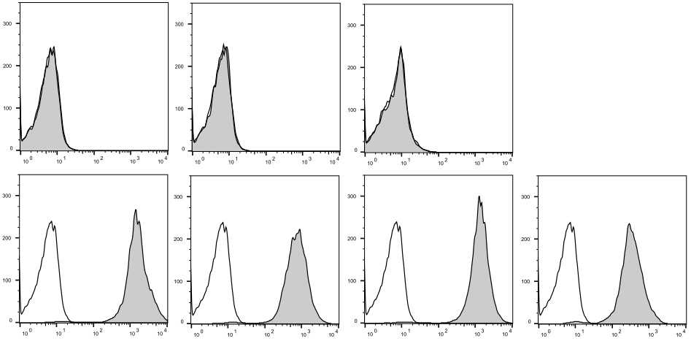

IgG2a isotype anti-mouse CD22

control (commercial ) +EBNA3C-#2

secondary mAb

test

**(A) (B)**

Counts

**(C)**

**(C)**



anti-human CD20 anti-human CD20 anti-human CD20 anti-human CD20

+EBNA3C-#1 +EBNA3C-#2 +EBNA3C-#3

IgG2a

**Figure S1. Binding characteristics of EBNA3C-AgAbs.** Primary B cells were incubated with (A) commercial mouse IgG2a isotype control, (B) IgG2a AgAb isotype control (anti-mouse CD22+EBNA3C-#2), or (C) anti-human CD20 antibodies without or with conjugation of EBNA3C segments. Binding was assessed by flow cytometry after incubation with a secondary anti-mouse IgG2a PE antibody.

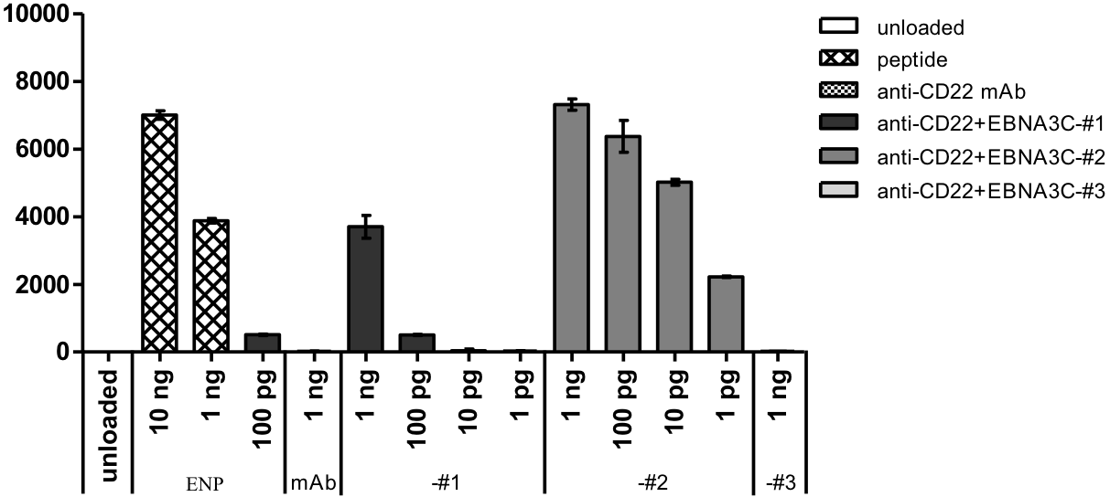

IFN-γ (pg/mL)

**(A)**

**H1**: ENP CD4+ T cell clone

LCL

**(B)** **(C)**

**H1**: ENP CD4+ T cell clone

LCL

IFN-γ (pg/mL)

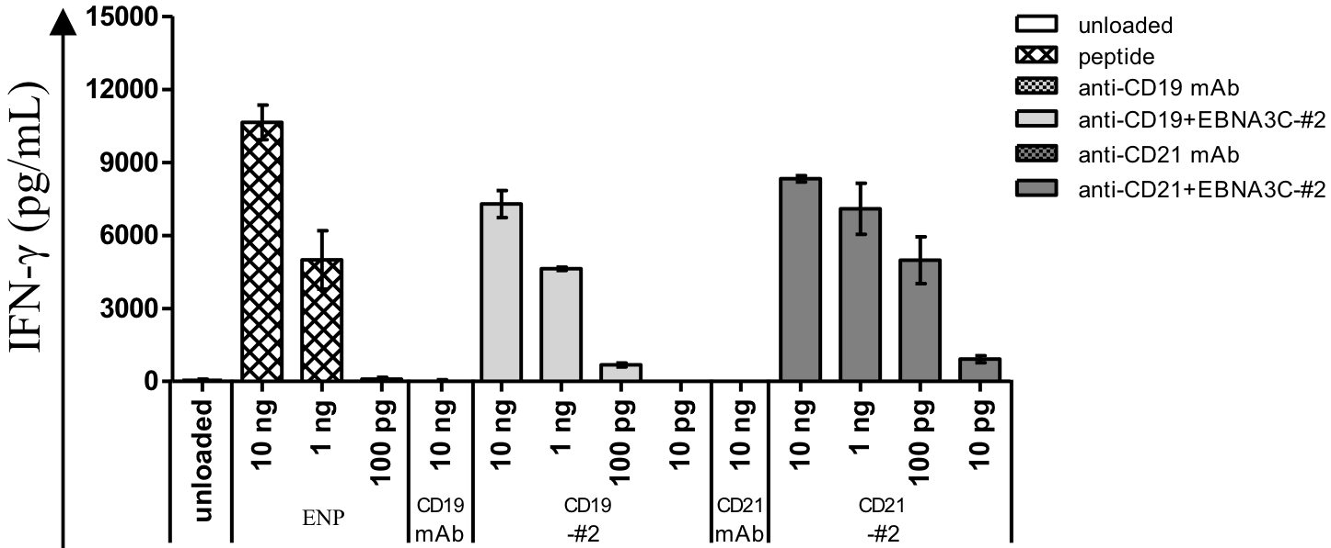

**H2**: EBNA3C CD4+ T cell line

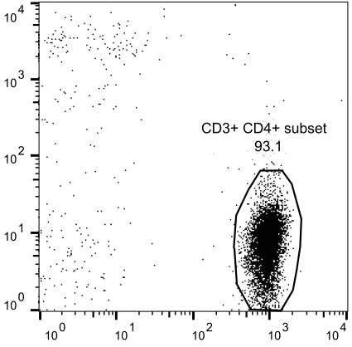

CD8

**(D)**

**H2**: EBNA3C CD4+ T cell line

LCL

**(E)**

**H2**: EBNA3C CD4+ T cell line

LCL

CD4



IFN-γ (pg/mL)

Lysis (%)

E:T

**Figure S2: EBNA3C-AgAbs stimulate proliferation, activation and cytotoxicity of EBV-specific CD4+ T cells.** (A) An IFN-γ release assay was performed at E:T = 2:1 with a CD4+ T cell clone specific for ENP derived from healthy subject H1 that was co-cultured with an autologous LCL exposed to various amounts of ENP peptide or EBNA3C-AgAbs. Unconjugated anti-CD22 antibodies and medium only served as negative controls. (B) Same as in (A) but with CD19 or CD21-specific AgAbs. (C-E) AgAbs induced the proliferation of EBV-specific CD4+ cytotoxic T cells from a healthy individual (H2). (C) PBMCs from H2 were repeatedly stimulated with EBNA3C-AgAbs. A FACS staining with CD4-specific antibodies after 6 rounds of stimulation showed that the outgrowing T cells were mainly CD4-positive. (D) We performed an IFN-γ release assay under the conditions described in (A). (E) This figure shows the results of cytotoxicity assays performed with 5x104 autologous LCL cells pulsed with 50 ng of EBNA3C-AgAbs for 16 h in the presence or absence of CMA. Non-conjugated antibodies, an AgAb isotype control or medium only served as negative controls. Cells were stained with calcein-AM (5 μM) and autologous EBNA3C-specific CD4+ T cells from H2 were added at increasing E:T ratios (1:1; 3:1; 10:1; 30:1). Calcein released into the medium was measured by spectrophotometry to determine the degree of lysis.



IFN-γ (pg/mL)

**P9**  **P1 P8**

LCL LCL LCL

**(A) (B) (C)**

PPV

**Figure S3: CD4+ cells *ex vivo* expanded by exposure to AgAbs recognize autologous LCLs.** We performed IFN-γ release assays at E:T = 5:1 with EBNA3C-specific CD4+ T cells and LCLs from three different CLL subjects that were pulsed with increasing amounts of EBNA3C-AgAbs, or with the EBNA3C epitopes PPV or AQE. Non-conjugated antibodies and unloaded cells were used as negative controls. (A) T cell assay performed with LCLs from patient P9 exposed to EBNA3C-AgAbs. (B) T cell assay performed with LCLs from subject P1 exposed to EBNA3C-AgAbs or to PPV peptide. (C) T cell assay performed with LCLs from subject P8 exposed to EBNA3C-AgAbs or to AQE peptide. We quantified IFN-γ release into the medium by ELISA upon co-culture with autologous EBNA3C-specific CD4+ T cells for 16 h.



**P5**

PBMC

IFN-γ (pg/mL)

**Figure S4: T cells expanded with AgAbs do not recognize antigens from CLL lysates.** We performed IFN-γ release assays at E:T = 5:1 with EBNA3C-specific CD4+ T cells from CLL patient P5. 5x104 CLL cells per test were pulsed with increasing amounts of anti-CD20 antibodies conjugated with EBNA3C-#1, -#2, or -#3, or with the lysate generated from 4x104 PBMCs of P5. Non-conjugated antibodies and medium only were used as negative controls. We quantified IFN-γ release into the medium by ELISA upon co-culture with autologous EBNA3C-specific CD4+ T cells for 16 h.

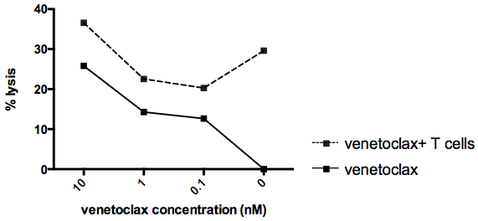

**Figure S5: T cells potentiate the pro- apoptotic effect of venetoclax.**  A primary CLL sample labeled with calcein was incubated with an increasing concentration of venetoclax, ranging from 0 to 10 nM, for 3 hours. In parallel, cells from the same patient treated under the same conditions but that had been additionally pulsed with EBNA3C-specific AgAbs overnight were exposed to EBNA3-specific T cells. The graph shows the percentage of lysed cells as assessed by a calcein release assay.



Lysis (%)

**(A) (B) (C)**

**P1**  **P7 P6**

LCL LCL LCL

E:T

**Figure S6: EBNA3C-specific CD4+ T cells kill LCLs derived from patients with CLL upon exposure to EBNA3C-AgAbs.** This figure shows the results of cytotoxicity assays performed with autologous LCLs from three patients. 5x104 cells were pulsed with 50 ng of EBNA3C-AgAbs for 16 h. Non-conjugated antibodies or medium only served as negative controls. Cells were stained with calcein-AM (5 μM), and autologous EBNA3C-specific CD4+ T cells were added at increasing E:T ratios (1:1; 3:1; 10:1; 30:1). Calcein released into the medium was quantified by spectrophotometry to determine the degree of lysis. Assays were performed in triplicates with means and standard deviations displayed in line graphs. (A-C) The line graphs show the results of killing assays performed with LCLs used as APCs.



**P3**

PBMC

Lysis (%)

E:T

**Figure S7: EBNA3C-AgAbs specific for CD19, CD20, CD21, and CD22 kill target CLL cells with similar efficacy**. A calcein-AM assay was performed with PBMCs from CLL patient P3. 5x104 cells were pulsed with 50 ng of EBNA3C-AgAbs for 16 h. Medium only served as a negative control. Cells were stained with calcein-AM (5 μM), and autologous EBNA3C-specific CD4+ T cells were added at increasing E:T ratios (1:1; 3:1; 10:1; 30:1). Calcein released into the medium was quantified by spectrophotometry to determine the degree of lysis.



Lysis (%)

IFN-γ (pg/mL)

**(A) (B)**

**P1 P1**

PBMC PBMC

T cell activation CTL function

**Figure S8: CD8+ T cells *ex vivo* expanded by the treatment with AgAbs do not specifically recognize autologous CLL cells treated with EBNA3C-AgAbs.** Purified CD4+ and CD8+ T cell populations were individually tested in an IFN-γ release assay and in a calcein-AM assay. (A) IFN-γ release assay was performed at E:T = 5:1 with autologous PBMCs that were pulsed with 50 ng of EBN3C-#1-, -#2-, or -#3-AgAbs or unconjugated antibodies, or with medium only for 8 h. IFN-γ released into the medium was measured by ELISA after co-culture with autologous CD4+ or CD8+ T cells. (B) PBMCs were treated as in (A) but for 16 h and subjected to a 3 h calcein release assay at an E:T ratio of 30:1.

**P8**

PBMC

anti-CD20

+EBNA3C-#3

anti-CD20

+EBNA3C-#2

anti-CD20

+EBNA3C-#1

anti-CD20

mAb

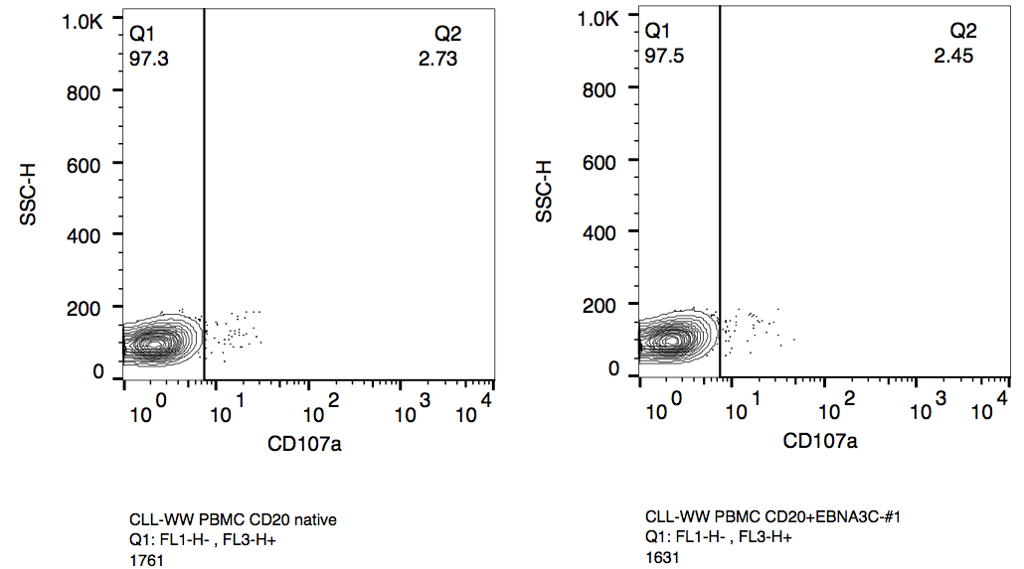

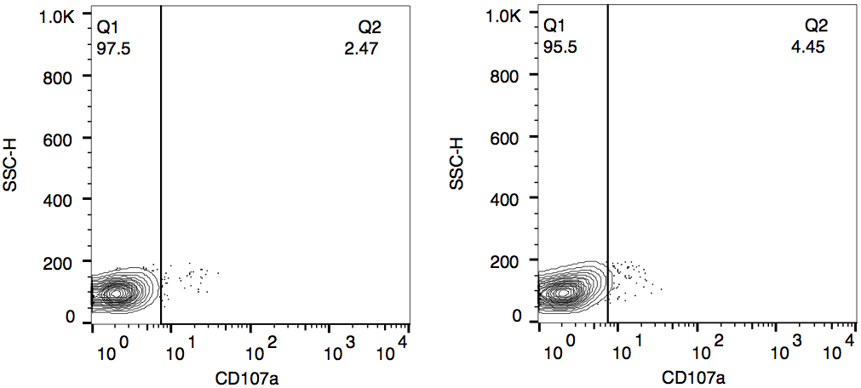

SSC-H

CD107a

**Figure S9: CD107a-positive EBNA3C-specific memory CD4+ T cells can be detected in CLL patients *in vivo*.** 50 ng of native antibody or AgAb were admixed with 5x104 PBMCs from CLL patient P8 for 16 h. Cells were stained for CD4 and CD107a, and a total of 60,000 events was counted. The contour plots with outliers show the expression of CD107a on CD4+ cells (approx. 1,500 events). CD107a-expressing CD4+ T cells are shown in the right quadrant.

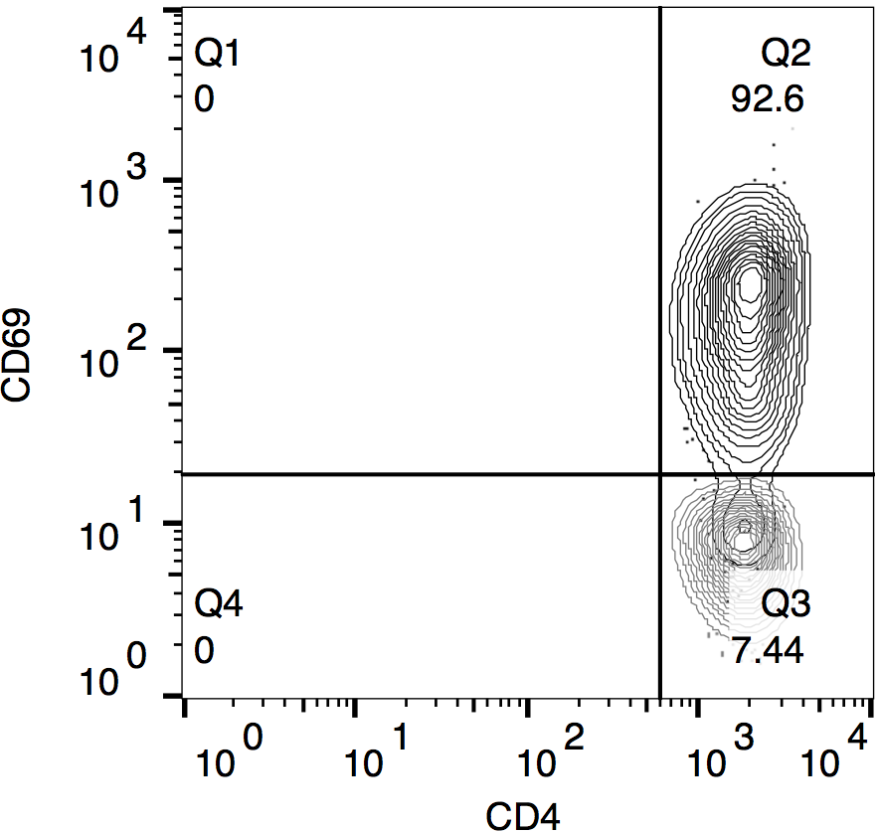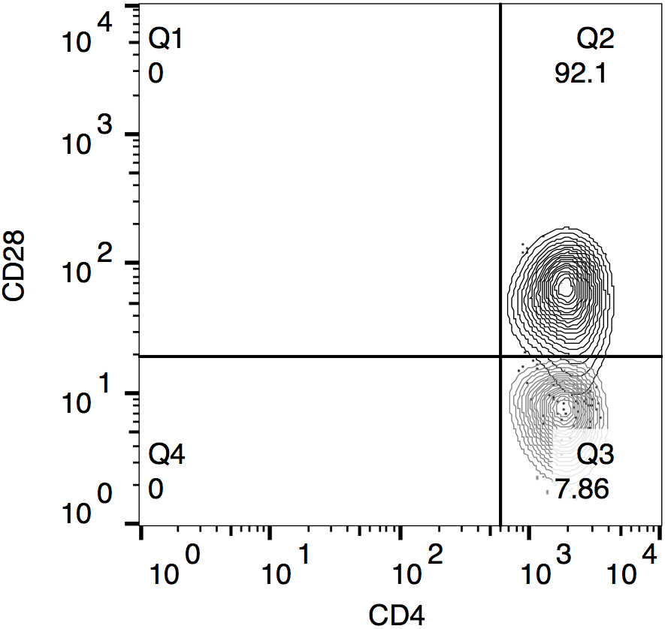

**P7**

LCL

anti-CD20+EBNA3C-#3

**P6**

LCL

anti-CD20+EBNA3C-#3

**P3**

LCL

anti-CD20+EBNA3C-#2

CD69

CD28

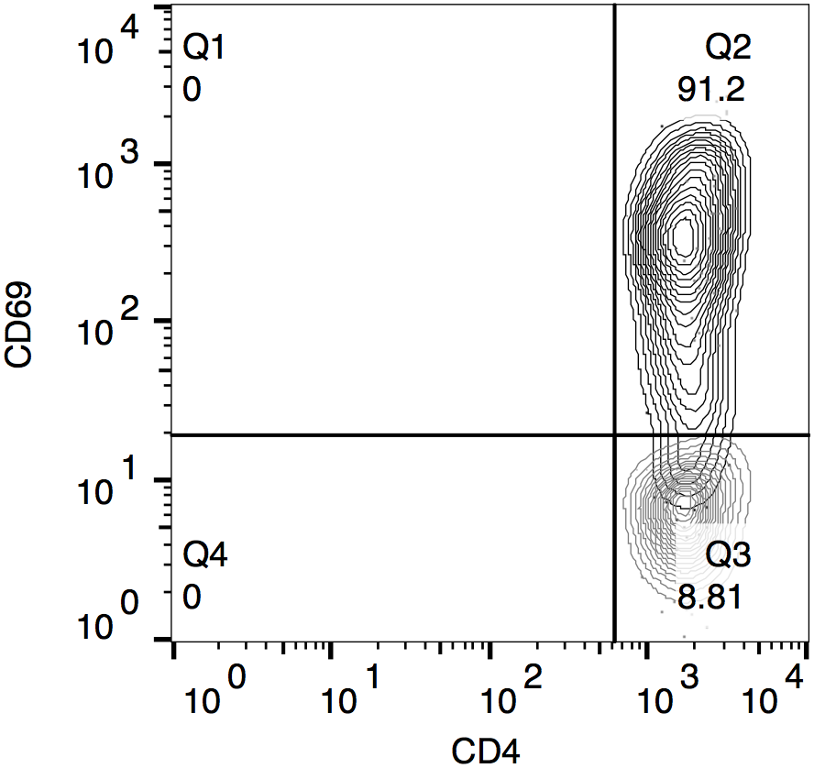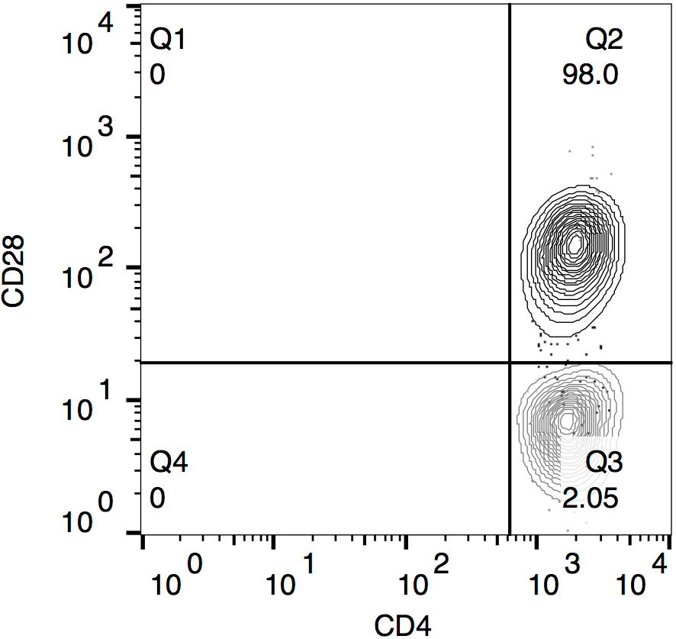

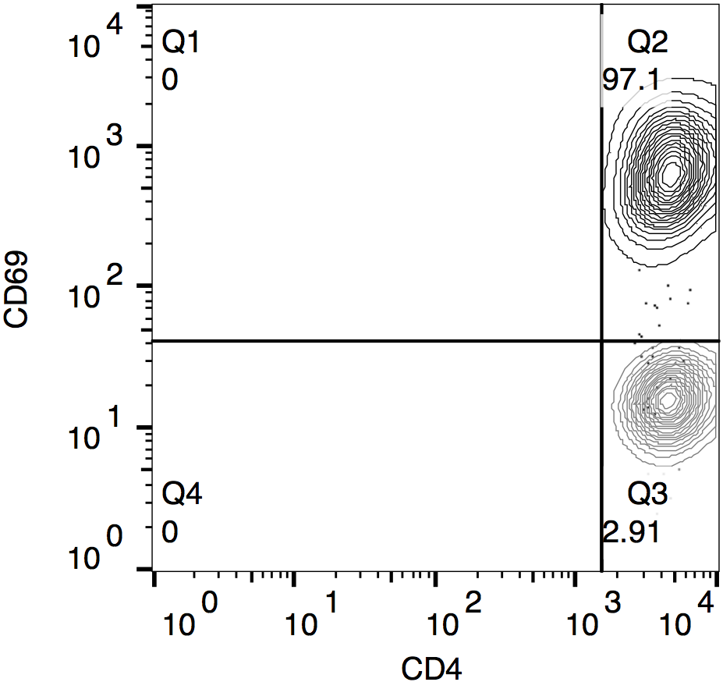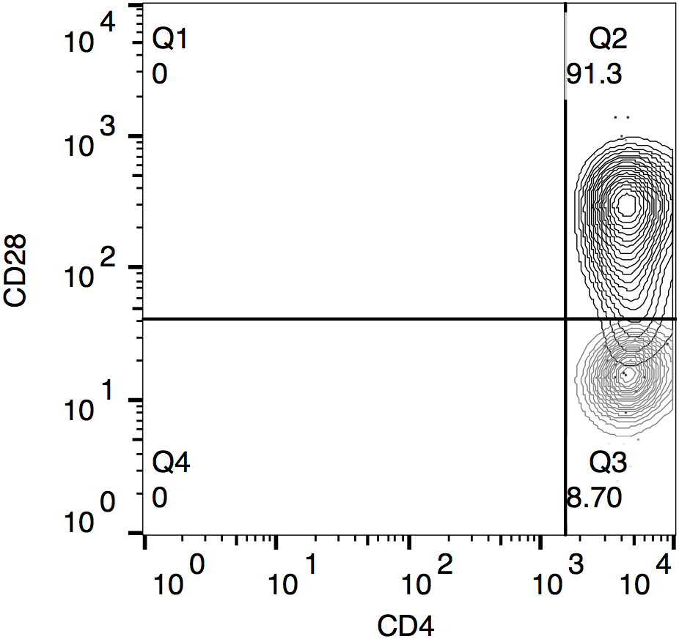

CD107a-negative CD4+ T cells

**Figure S10: CD107a-negative CD4+ T cells from CLL patients express CD28 and CD69 upon AgAb stimulation.** 50 ng of native antibody or AgAb were admixed per 5x104 PBMCs from CLL patients. Expression of CD107a, CD28, and CD69 on CD4+ T cells was analyzed after 16 h. The contour plots with outliers show CD28 and CD69 expression on CD107a-negative CD4+ T cells. The percentage of CD107a-negative CD4+ T cells expressing the marker of interest is shown in the upper right quadrant.



**(A) (B) (C)**

**P12**

LCL

**P5**

PBMC

**P9**

LCL



**P10**

LCL

**P2**

LCL

**P3**

LCL

**(D) (E) (F)**



IL-4 (pg/mL)

**P7**

LCL

**(G) (H) (I)**



**P4**

LCL

**P6**

LCL

**Figure S11. Treatment with AgAbs activates IL-4 release by EBV-specific CD4+ T cells**. We performed IL-4 release assays at E:T = 5:1 with EBNA3C-specific CD4+ T cells expanded *ex vivo* from CLL patients. We used 5x104 LCLs or CLL cells per test. Target cells of nine different patients (A) P9, (B) P5, (C) P12, (D) P3, (E) P2, (F) P10, (G) P6, (H) P4, and (I) P7 were pulsed with increasing amounts of anti-CD20 antibodies conjugated with EBNA3C-#1, -#2, or -#3. APCs incubated with non-conjugated antibodies or medium only served as negative controls. We quantified IL-4 release into the medium by ELISA upon co-culture with autologous EBNA3C-specific CD4+ T cells for 16 h.

**P9**

PBMC

**(A) (B)**



**P11**

PBMC

GrB (pg/mL)

**(C) (D)**



**P10 P4**

PBMC PBMC

**Figure S12. Treatment with AgAbs activates GrB release by EBV-specific CD4+ T cells**. We performed GrB release assays at E:T = 5:1 with EBNA3C-specific CD4+ T cells *ex vivo* expanded from CLL patients. PBMCs (5x104 CLL cells per test) from four different patients, (A) P9, (B) P11, (C) P10, and (D) P4, were pulsed with increasing amounts of anti-CD20 antibodies with conjugation of EBNA3C-#1, -#2, or -#3. APCs incubated with non-conjugated antibodies or medium only served as negative controls. We quantified GrB release into the medium by ELISA upon co-culture with autologous EBNA3C-specific CD4+ T cells for 16 h.

**Supplemental References**

1. Busse C, Feederle R, Schnolzer M, Behrends U, Mautner J, Delecluse HJ. Epstein-Barr Viruses That Express a CD21 Antibody Provide Evidence that gp350's Functions Extend beyond B-Cell Surface Binding. *Journal of Virology* 2010 Jan 15; **84**(2)**:** 1139-1147.

2. Yu X, Ilecka M, Bartlett EJ, Schneidt V, Bhat R, Mautner J*, et al.* Antigen-armed antibodies targeting B lymphoma cells effectively activate antigen-specific CD4+ T cells. *Blood* 2015 Mar 5; **125**(10)**:** 1601-1610.

3. Leen A, Meij P, Redchenko I, Middeldorp R, Bloemena E, Rickinson A*, et al.* Differential immunogenicity of Epstein-Barr virus latent-cycle proteins for human CD4(+) T-helper 1 responses. *Journal of Virology* 2001 Sep; **75**(18)**:** 8649-8659.

4. Landais E, Saulquin X, Scotet E, Trautmann L, Peyrat MA, Yates JL*, et al.* Direct killing of Epstein-Barr virus (EBV)-infected B cells by CD4 T cells directed against the EBV lytic protein BHRF1. *Blood* 2004 Feb 15; **103**(4)**:** 1408-1416.

5. Rajnavolgyi E, Nagy N, Thuresson B, Dosztanyi Z, Simon A, Simon I*, et al.* A repetitive sequence of Epstein-Barr virus nuclear antigen 6 comprises overlapping T cell epitopes which induce HLA-DR-restricted CD4(+) T lymphocytes. *Int Immunol* 2000 Mar; **12**(3)**:** 281-293.