**Utilization and determinants of use of non-pharmacological interventions in COPD: results of the COSYCONET cohort**

Johanna I Luttera,*, Marco Lukasa,b,c, Larissa Schwarzkopfa,d, Rudolf A Jörrese, Michael Studnickaf, Kathrin Kahnertg, Stefan Karrasche,h,Burkhard Bewigi, Claus F Vogelmeierj, Rolf Hollea,c for the COSYCONET Study Group.

Affiliations:

a Institute of Health Economics and Health Care Management, Helmholtz Zentrum München, GmbH – German Research Center for Environmental Health, Comprehensive Pneumology Center Munich (CPC-M), Member of the German Center for Lung Research, Ingolstaedter Landstr. 1, 85764 Neuherberg, Germany

b Pettenkofer School of Public Health, Marchioninistr. 15, 81377 Munich, Germany

c Institute for Medical Information Processing, Biometry and Epidemiology (IBE), Ludwig-Maximilians-University Munich (LMU), Marchioninistr. 15, 81377 Munich, Germany

d IFT-Institut für Therapieforschung, Leopoldsstr. 175, 80804 Munich, Germany

e Institute and Outpatient Clinic for Occupational, Social and Environmental Medicine, University Hospital, LMU Munich, Comprehensive Pneumology Center Munich (CPC-M), Member of the German Center for Lung Research (DZL), Ziemssenstr. 1, 80336 Munich Germany

f Department of Pneumology, Paracelsus Medical University Salzburg, Universitätsklinikum Salzburg, Müllner Hauptstrasse 48, 5020 Salzburg, Austria

g Department of Internal Medicine V, University of Munich (LMU), Comprehensive Pneumology Center, Member of the German Center for Lung Research, Ziemssenstr. 1, 80336 Munich, Germany

h Institute of Epidemiology, Helmholtz Zentrum München (GmbH) – German Research Center for Environmental Health, Comprehensive Pneumology Center Munich (CPC-M), Member of the German Center for Lung Research (DZL), Ingolstaedter Landstr. 1, 85764 Neuherberg, Germany

i University Hospital of Schleswig-Holstein, Campus Kiel, Arnold-Heller-Straße 3, 24105 Kiel, Germany

j Department of Medicine, Pulmonary and Critical Care Medicine, University Medical Center Giessen and Marburg, Philipps-University Marburg, Member of the German Center for Lung Research (DZL), Baldingerstrasse, 35043 Marburg, Germany

* Corresponding author:

Johanna I Lutter  
Institute of Health Economics and Healthcare Management, Helmholtz Zentrum München (GmbH) - German Research Center for Environmental Health, Ingolstädter Landstraße 1, 85764 Neuherberg, Germany.   
E-Mail: johanna.lutter@helmholtz-muenchen.de   
Phone: +49 89 3187 49314

Word count: abstract: 247 / manuscript: 3138

# **Abstract**

**Background**

Guidelines for chronic obstructive pulmonary disease (COPD) recommend supplementing pharmacotherapy with non-pharmacological interventions. Little is known about the use of such interventions by patients. We analyzed the utilization of a number of non-pharmacological interventions and identified potential determinants of use.

**Methods**

Based on self-reports, use of interventions (smoking cessation, influenza vaccination, physiotherapy, sports program, patient education, pulmonary rehabilitation) and recommendation to use were assessed in 1410 patients with COPD. The utilization was analyzed according to sex and severity of disease. Potential determinants of utilization included demographic variables and disease characteristics and were analyzed using logistic regression models.

**Results**

Influenza vaccination in the previous autumn/winter was reported by 73% of patients. About 19% were currently participating in a reimbursed sports program, 10% received physiotherapy, 38% were enrolled in an educational program, and 34% had ever participated in an outpatient or inpatient pulmonary rehabilitation program. Out of 553 current or former smokers, 24% had participated in a smoking cessation program. While reports of having received a recommendation to use mainly did not differ according to sex, women showed significantly (p<0.05) higher utilization rates than men for all interventions except influenza vaccination. Smoking was a predictor for not having received a recommendation for utilization and also significantly associated with a reduced odds of utilization. We found a correlation between recommendation to use and utilization.

**Conclusions**

Utilization of non-pharmacological interventions was lower in men and smokers. A recommendation or offer to use by the physician could help to increase uptake.

**Keywords** treatment guidelines; non-pharmacological intervention; gender differences; vaccination; smoking cessation

**Introduction**

Chronic obstructive pulmonary disease (COPD) carries a high burden and is currently the third leading cause of death worldwide [1, 2]. The prevalence of COPD in Germany is estimated at 13% in the adult population aged 40 years and older [3]. Current international and national COPD guidelines recommend non-pharmacological interventions – with different levels of evidence – to improve symptoms (cough, sputum production, and dyspnea), prevent exacerbations, enhance self-management behavior and optimize daily activity levels [1, 4]. These include preventive measures, such as smoking cessation and vaccination, interventions to promote physical activity and self-management (i.e. pulmonary rehabilitation, lung sports programs, patient education), together with oxygen therapy, ventilator support, and surgical interventions. Smoking cessation is the most effective intervention in the management of COPD, with positive effects on survival and the deceleration of lung function decline [5].

There is evidence for sex-specific differences in the diagnosis, phenotype and therapeutic response of COPD [6, 7]. With regard to non-pharmacological interventions, a Swedish register study found that women had higher utilization rates for education programs and contact with a physiotherapist or dietician [8]. Furthermore, Watson et al. reported, that women were more likely to receive smoking cessation advice [9].

In Germany, data on the pharmacological treatment of COPD [10] as well on the utilization of general healthcare services independent from COPD (e.g. doctor visits, hospital stays, rehabilitation measures) has been investigated [11, 12]. However, data on the uptake of specific guideline-recommended non-pharmacological interventions is lacking. The present analysis aimed to provide data on the use of recommended, COPD-specific, non-pharmacological interventions according to sex and GOLD groups A-D. A secondary aim was to identify determinants of utilization and to explore the association between recommendation by a physician and utilization of interventions.

# **Material and methods**

## **Study population and assessment of non-pharmacological interventions**

We used data from the baseline visit and 36-month follow-up of the COSYCONET cohort (German COPD and Systemic Consequences – Comorbidities Network). In this prospective, observational, multicenter cohort study, 2,741 patients were included at baseline between 2010 and 2013 across Germany and reexamined after 6, 18, and 36 months, with ongoing follow-up visits. Subjects were included if they were ≥40 years and had physician-diagnosed COPD. A standard operating procedure (SOP) was developed to ensure comparability of the scheduled assessments and tests between all study centers. Furthermore, instruments including devices for lung function testing were homogeneous across study sites and clinical investigators participated in regular training. Detailed information on the recruitment process, the standardized data collection, and quality control measures is available elsewhere [13].

The flow-diagram (Figure 1) shows the inclusion criteria and study sample of the present analysis.

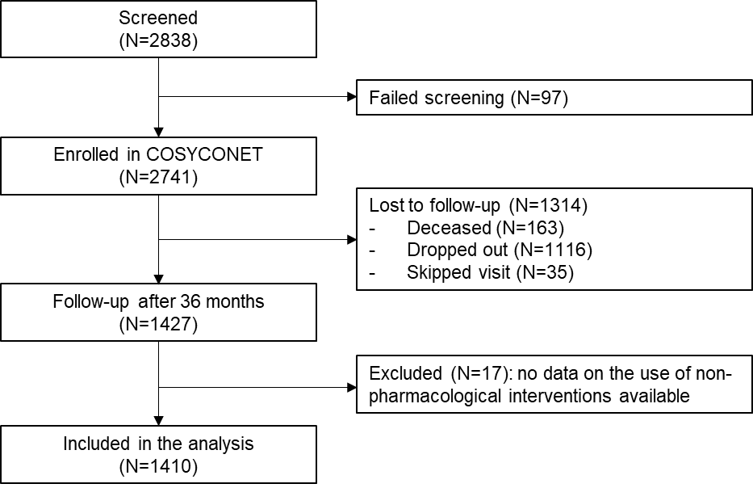

**Figure 1 Overview of the study population**

At the 36-month follow-up, 1,427 patients (47.9% of baseline participants) were re-examined, with questions designed to assess the utilization of non-pharmacological interventions incorporated into the assessments for the first time. Questions were binary (yes/no) and covered different time frames. In detail, this included the following specifically for COPD (“[…] we ask you a number of questions about medical treatment and care for your COPD. However, they refer explicitly only to your COPD.”): influenza vaccination (previous autumn or winter), physiotherapy (currently), sports program that is reimbursed by your health insurance company (currently), patient educational program (ever), inpatient or outpatient pulmonary rehabilitation (ever), and smoking cessation (ever; only for current smokers or patients who quit smoking within the previous 10 years). Oxygen therapy, ventilator support and surgical intervention were not included in the present analysis. Additionally, we assessed whether patients reported to have ever received a recommendation for the use of influenza vaccination and educational program, or an offer to participate in a smoking cessation program expressed by their physician or insurance company.

## **Assessment of covariables**

Assessment of covariables was based on data of the baseline visit of the study. GOLD groups were defined according to ABCD scheme. Low/no symptom patients were classified as groups A and C (modified Medical Research Council dyspnea scale [mMRC] 0‑1). Highly symptomatic patients were assigned to groups B and D (mMRC ≥2). Based on exacerbations of all severities within the previous 12 months, patients were classified as group A or B (0 to 1 exacerbation), and as group C or D (>=1 inpatient (severe) or > 2 non-hospitalized exacerbations) [4].

Lung function was characterized by FEV1 expressed as percent predicted according to the Global Lung Function Initiative (FEV1%pred). The values were determined in a standardized post-bronchodilator spirometry following the standard operating procedures of COSYCONET, which align with established guidelines [13]. Information on age, sex, smoking status, body mass index, and level of education (basic education duration ≤9 years, secondary education 10-11 years, higher education >11 years) was assessed via standardized interviews, questionnaires, and examinations. Exacerbation history was assessed as the highest severity level of exacerbation that occurred in the 12 months prior to the examination. The severity levels were defined according to GOLD (acute respiratory worsening for several days and the need for specific measures; mild: self-managed, moderate: patient visited primary care physician, severe: led to hospital admission).

Information about the specialization of the patients’ main attending physician was collected at the 36-month follow-up by asking “What is the specialty of the physician who has treated you for the most part for your COPD in the last 12 months?”.

## **Statistical analysis**

Baseline characteristics of participants were summarized using unadjusted means and standard deviations (SD) for continuous variables and percentages for categorical variables. Analysis of variance (ANOVA) for continuous variables and chi2-tests for categorical variables were used to compare characteristics between participant groups. Descriptive measures were used to present utilization rates of non-pharmacological interventions. Results were stratified by sex and by GOLD groups A-D, and differences were assessed by chi2-tests. To identify determinants of recommendation and utilization of non-pharmacological interventions, multiple logistic regression models were used to generate odds ratios (OR) and 95% confidence intervals (CI). The models included FEV1%pred, age, sex, education, smoking status, BMI, exacerbation history, presence of dyspnea, time since COPD diagnosis, all assessed at the baseline visit of the study. The specialty of the attending physician was included only for the interventions with current use.

Since we analyzed data from a follow-up visit of COSYCONET, a substantial proportion of patients had already left the cohort. To assess differences between the cohort at baseline and at the 36-month follow-up, descriptive analyses were undertaken to compare the baseline characteristics of participants included and those lost to follow-up.

Statistical analyses were performed using SAS software (SAS Institute Inc., Cary, NC, USA, version 9.4), and p-values of 0.05 or less were considered to be statistically significant.

# **Results**

The baseline characteristics of the study population are given in table 1. The majority of participants was male (59 %), with a mean age of 64.5 years at baseline. Current smoking was reported by 20 % of male and 26 % of female participants. Whereas lung function values and GOLD groups did not differ between sexes, females reported significantly higher levels of dyspnea (mMRC ≥2) and were more likely to have experienced an exacerbation in the preceding 12 months.

## **Utilization of non-pharmacological interventions**

Figure 2 displays the percentages of unadjusted utilization of non-pharmacological interventions. Overall, utilization rates of >50% were found only for influenza vaccination in the previous autumn or winter. Females showed significantly higher utilization rates for every intervention compared to males with the exception of influenza vaccination (male 73.3% vs female 71.6%, p=0.48). The biggest difference with regard to proportions was found for smoking cessation programs (19.0% vs. 30.0%, p=0.0025).

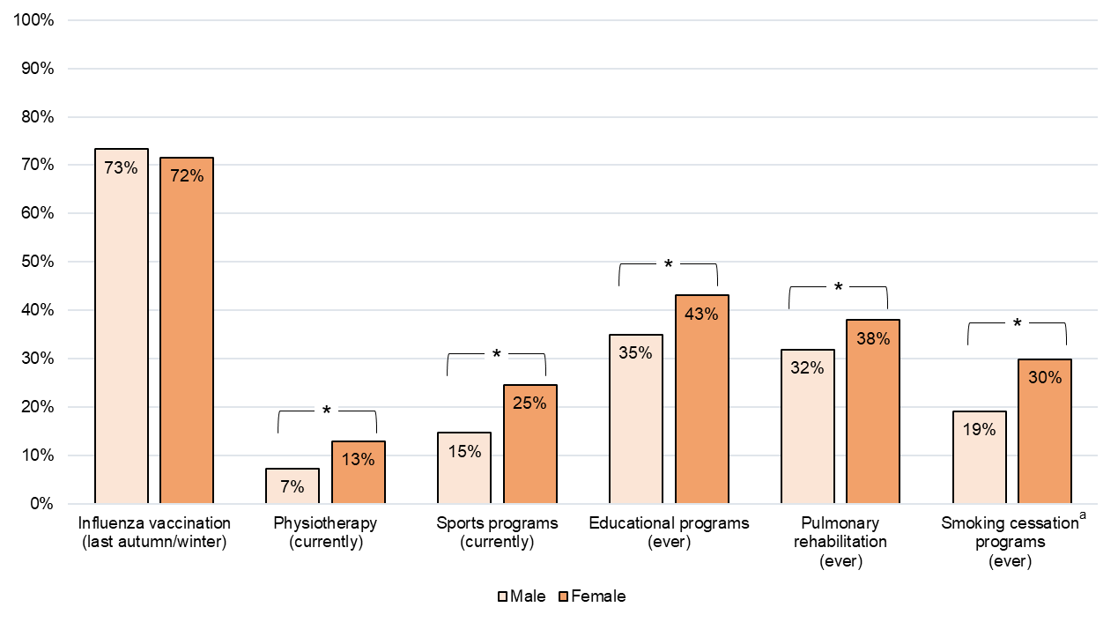

**Figure 2 Utilization of non-pharmacological interventions, stratified by gender**

* Significantly different according to Chi2-tests (p <0.01)

a only for n=553 current smokers or patients who quit smoking ≤ 10 years ago

The utilization of non-pharmacological interventions across GOLD groups A-D can be found in Figure 3. Patients in GOLD group A were the least likely to have received all interventions while utilization was found highest for GOLD D.

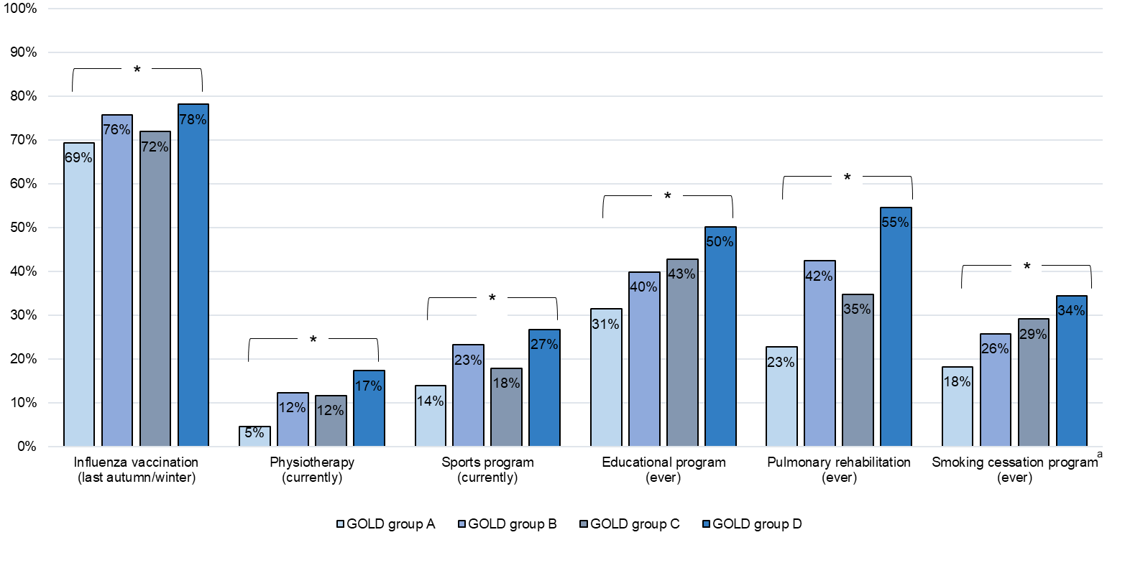

**Figure 3 Utilization of non-pharmacological interventions, stratified by GOLD groups A-D (mMRC)**

* Significantly different according to Chi2-tests (p <0.01)

a only for n=553 current smokers or patients who quit smoking ≤ 10 years ago

## **Association between healthcare resource utilization and recommendation to use**

Figure 4 shows the utilization rates of non-pharmacological interventions for patients who had been given a recommendation to use by their physician or insurance company compared to patients who had not received a recommendation. For all three interventions, a recommendation to use or offer to participate (smoking cessation) was associated with higher utilization rates. For example, 89 % of patients who indicated that a doctor recommended taking part in an educational program, reported utilization of such a program, while 13 % reported utilization without a previous recommendation.

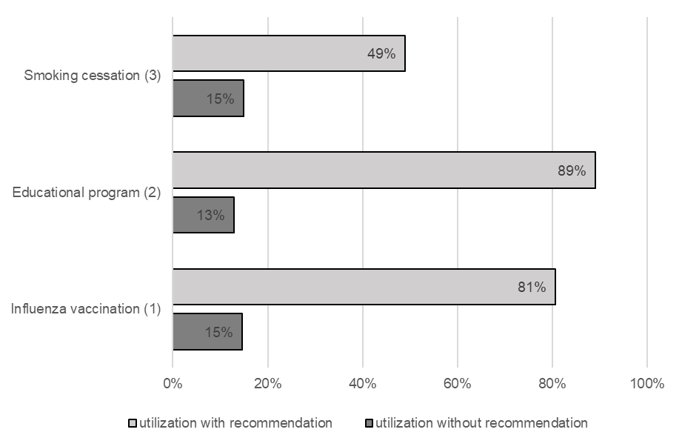

**Figure 4 Association between utilization of non-pharmacological interventions and recommendation of use**

(1) Has your doctor ever recommended you to be vaccinated against influenza? (Yes: 88 %)

(2) Has your doctor ever recommended taking part in a patient educational program for your COPD? (Yes: 33 %)

(3) Has your doctor or health insurance company ever offered you to take part in a smoking cessation program? (Yes: 25 %)

## **Determinants of utilization and recommendation to use**

Determinants of utilization of non-pharmacological interventions are shown in Table 2. Values of FEV1%pred ≤ 50% (vs >80%) were a significant predictor of utilization regarding all interventions except smoking cessation. Moreover, patients aged ≥65 years (vs <55) were more likely to have received influenza vaccination, while on the other hand older age was associated with a lower probability of currently seeing a physiotherapist or having had pulmonary rehabilitation.

Consistent with the unadjusted results, females had significantly higher odds of utilization for every intervention except influenza vaccination and pulmonary rehabilitation.

Regarding the patient’s smoking status, being a current smoker (vs never smoker) was associated with a significantly reduced probability of utilization of influenza vaccination, sports program, educational program, and pulmonary rehabilitation. Obesity was also significantly associated with a reduced probability of utilization of some interventions.

A history of moderate or severe exacerbations in the 12 months before the baseline study visit and mMRC ≥2 was significantly associated with higher probabilities of utilization for the majority of outcomes.

With regard to determinants of previous recommendations by physicians, current smoking was significantly associated with a reduced odds of having received a recommendation for influenza vaccination or participation in an educational program. Female sex, on the other hand, was associated with a higher probability of having received a recommendation for influence vaccination.

## **Comparison between the study sample and the cohort at baseline**

At the 36-month follow-up, 1116 patients were still alive but no longer available. Compared to our study sample (n=1410 participants), these patients were older, had poorer lung function and reported higher levels of dyspnea (mMRC) at baseline. This was also reflected in greater proportions of patients in GOLD groups B and D (Table S1).

# **Discussion**

In this study, we analyzed the utilization of non-pharmacological interventions for COPD and identified its determinants based on data from the established German COPD cohort COSYCONET. First, with the exception of influenza vaccination, fewer than half of the patients participated in the recommended panel of non-pharmacological interventions. Second, utilization was higher with increasing severity of COPD as determined by GOLD groups, and for female patients, while current smoking was associated with a reduced utilization. Third, current smoking was also significantly associated with a reduced probability of having received a recommendation to use by a physician.

When stratified by sex, our analysis demonstrated that female patients participated to a higher degree in all non-pharmacological interventions, except influenza vaccination, which showed already high levels for men and women. Similar results have been published in previous reports, which showed that women tend to communicate more frequently with healthcare providers and utilize more healthcare resources than men [14-16]. This was also found in other chronic diseases such as diabetes [17, 18]. Similarly, Henoch et al. found higher participation rates for educational programs and physiotherapy for women compared to men and also higher vaccination rates [8]. Logistic regression models confirmed that female sex was a significant determinant of utilization by increasing the odds of participation in non-pharmacological interventions. Interestingly, female sex was not significantly associated with having received a recommendation for smoking cessation or educational program. This is in contrast to Watson et al., who found women to be more likely to get smoking cessation advice [9].

Smoking cessation is the most effective and cost-effective intervention in the management of COPD. In our study, not even a quarter of current or previous smokers had ever participated in a smoking cessation program. This is a concern, as smoking cessation fundamentally influences the course of COPD by attenuating the decline of lung function and improving survival [1, 19, 20]. Even within COPD, non-smoking patients tend to have less airflow limitation and gas exchange abnormalities and fewer symptoms than current smokers [21, 22]. In comparison, a Swiss study by Kaufmann et al. reported rates of 52 % for smoking cessation programs in 50 smokers with COPD in the outpatient setting [23] and according to a Swedish register study, 34 % of patients participated in a smoking cessation program [8]. Our data indicated, that smoking was also associated with reduced probabilities of participation in all other non-pharmacological interventions, which could lead to two different considerations: smokers with COPD in the cohort refuse to utilize the non-pharmacological therapy options as a somewhat non-compliant behavior. However, the participation in the cohort over several years might be an argument against a general rejection and non-adherence. On the other hand, smoking was also a predictor for not having received a recommendation for two interventions. This could indicate that a physician might be less likely to offer other non-pharmacological options if a patient continues smoking. An alternative explanation could also be that smokers forget about or pay less attention to recommendations they had been given. However, recall bias among smokers seems unlikely, as 98 % of all current smokers report that they had ever been advised by a physician to quit smoking.

Nearly three quarters of patients had received influenza vaccination in the previous autumn or winter. This is an important achievement, as influenza vaccination lowers the likelihood of respiratory infections and can reduce exacerbation rates [1, 24, 25]. Thus the result obtained for Germany can be considered acceptable, especially when compared to other reported vaccination rates in patients with COPD, such as 49 % in Swiss patients, or 34 % in population-based and 71 % in hospital-based patients in Norway [23, 26].

Structured education programs for outpatients include information on risk factors and their reduction or elimination, and in particular emphasize the importance of smoking cessation and have shown to improve inhalation technique, increase self-control of disease, reduce the frequency of acute exacerbations, and reduce costs while improving quality of life [4, 27, 28]. Consistent with this, use of other non-pharmacological interventions, especially smoking cessation, could be improved by higher participation rates in educational programs. In particular, participation in a patient education program is considered an important step towards behavioral change and improved self-management [1, 4, 29, 30]. According to a Swedish register study, the utilization rate of any patient education program was 22 %. In our study, forty percent of all patients had participated in an educational program while a third reported utilization of pulmonary rehabilitation. There might be an overlap between these two interventions, since pulmonary rehabilitation often includes aspects of patient education [31]. Progression of the disease, indicated by lower FEV1%pred, worse dyspnea, and severe exacerbations, was associated with utilization.

Convincing evidence is available for measures promoting physical activity and its benefits in COPD patients including improving strength, endurance, agility and coordination [1, 4]. Utilization rates of physiotherapy (9.5 %) and participation in sports programs (18.5 %) were rather low and might be explained by the shorter time horizon in the respective question compared to those referring to the other interventions (“currently” vs “ever”). Furthermore, it is important to note that the questionnaire specifically assessed participation in a reimbursed sports program and therefore, conclusions regarding daily activity levels of patient are not supported by our data.

Our results are consistent with previous publications, in that therapy options requiring a high degree of behavioral change (such as smoking cessation or physical activity) are recognized as difficult for patients to adopt [32, 33]. Physician`s advice or offer to utilize non-pharmacological options was found to be significantly associated with utilization. One should also keep in mind, that a physician`s recommendation could be an indicator for access to certain interventions, especially with regard to smoking cessation and educational programs, which could explain part of the positive correlation.

We found a trend towards higher participation in guideline-recommended non-pharmacological interventions, if patients reported pulmonologists vs GPs as attending physicians. This was adjusted for pulmonary function and symptoms.. Our finding is consistent with that reported by Garcia-Aymerich et al., showing that COPD patients treated by a pulmonologist were more likely to receive pharmacological and non-pharmacological treatments and were more likely to perform inhalation maneuvers correctly [34]. Pothirat et al. [35] compared the management of patients with COPD by pulmonologists vs internists and also found higher guideline adherence by pulmonologists as well as significantly lower rates and frequencies of severe adverse events in patients managed by them. Other studies, however, did not observe differences in resource utilization intensity or patient survival [36, 37]. Nevertheless, the overall results suggest that in order to maximize treatment efficiency it might be beneficial to integrate specialists early into the treatment process [38].

Potential limitations of our study should be kept in mind when interpreting the findings. First, selection bias is likely as there was a substantial dropout of nearly 50 % between baseline and the 36-month follow-up visit. Patients who did not attend the follow-up visit were older and more severely ill, thus the study population demonstrates healthy participation bias during follow-up. This was also confirmed in previous longitudinal analyses [[12](#_ENREF_12" \o "Byng, 2019 #68), [39](#_ENREF_39" \o "Lutter, 2020 #44)]. We might therefore underestimate the utilization in the general population of patients with COPD. On the other hand, patients who continuously participate in a cohort study over four visits might be more interested in the management of their chronic condition and the available treatment options, leading to higher utilization compared to the general COPD population. Second, the utilization data was collected at the 36-month follow-up visit with different monitoring periods. Although we temporally separated the assessment of outcomes from the independent variables by using baseline variables for the characterization of patients, causal relationships cannot be drawn based on the analyzed dataset, especially, when referring to the time frame “ever”. Third, there is a chance for recall bias when surveying self-reported information on healthcare utilization tending towards underestimation of utilization [40]. However, it is unlikely that binary questions (yes/no) about whether patients participated in interventions are markedly susceptible to recall bias. Finally, there is a lack of standardization of non-pharmacological interventions within our study and in comparison to other studies. To avoid different interpretations within the data assessment, additional descriptions were included in the questionnaire.

The main strength of our study is the large and well-characterized patient sample, which included a panel of determinants and subgroups of different severity. The high number of female patients provided enough power to investigate differences from men regarding the utilization of non-pharmacological interventions.

# **Conclusions**

With the exception of influenza vaccination, our findings indicate relatively low levels of use of guideline-recommended, non-pharmacological interventions for COPD in Germany. Women demonstrated higher participation rates than men, while active smoking was associated with reduced utilization. Recommendations or offers to use non-pharmacological interventions by the physician might help to increase uptake, especially in men and smokers. Future efforts could explore cost-efficient ways to inform and encourage patients to undertake guideline-recommended, non-pharmacological interventions for COPD.

**DECLARATIONS**

**Ethics approval and consent to participate**

The COSYCONET study complies with the Declaration of Helsinki and Good Clinical Practice Guidelines and has been approved by the ethics committee of the medical faculty of the Philipps-Universität Marburg, the local ethics committees of the participating centers (a list of all participating study centers can be found here: http://www.asconet.net/html/cosyconet/studzent) and by the concerned data security authority (data security agency of the federal states of Hesse, Baden-Württemberg, Lower-Saxony, and Saarland). This approval covered the subsequent data analyses as performed here. All cohort participants gave their written informed consent.

**Availability of data and materials**

Data may be obtained from a third party and are not publicly available. The full dataset supporting the conclusions of this article is available upon request and application from the Competence Network Asthma and COPD (ASCONET, http://www.asconet.net/html/cosyconet/projects).

**Funding**

This work was supported by the German Centre for Lung Research (DZL) [grant number 82DZLI05A2 (COSYCONET)], the BMBF [grant number FKZ 01GI0881], and is furthermore supported by unrestricted grants from AstraZeneca GmbH, Boehringer Ingelheim Pharma GmbH & Co. KG, GlaxoSmithKline, Grifols Deutschland GmbH, Novartis Deutschland GmbH. The funding body had no involvement in the design of the study, or the collection, analysis or interpretation of the data.

**Acknowledgements**

The authors thank all participants of COSYCONET, and the COSYCONET Study-Group: Andreas, Stefan (Lungenfachklinik, Immenhausen); Bals, Robert Universitätsklinikum des Saarlandes); Behr, Jürgen and Kahnert, Kathrin (Klinikum der Ludwig-Maximilians-Universität München); Bewig, Burkhard (Universitätsklinikum Schleswig Holstein); Buhl, Roland (Universitätsmedizin der Johannes-Gutenberg-Universität Mainz); Ewert, Ralf and Stubbe, Beate (Universitätsmedizin Greifswald); Ficker, Joachim H. (Klinikum Nürnberg, Paracelsus Medizinische Privatuniversität Nürnberg); Gogol, Manfred (Institut für Gerontologie, Universität Heidelberg); Grohé, Christian (Ev. Lungenklinik Berlin); Hauck, Rainer (Kliniken Südostbayern AG, Kreisklinik Bad Reichenhall); Held, Matthias and Jany, Berthold (Klinikum Würzburg Mitte gGmbH, Standort Missioklinik); Henke, Markus (Asklepios Fachkliniken München-Gauting);Herth, Felix (Thoraxklinik Heidelberg gGmbH); Höffken, Gerd (Fachkrankenhaus Coswig GmbH); Katus, Hugo A. (Universitätsklinikum Heidelberg); Kirsten, Anne-Marie and Watz, Henrik (Pneumologisches Forschungsinstitut an der Lungenclinic Grosshansdorf GmbH); Koczulla, Rembert and Kenn, Klaus (Schön Klinik Berchtesgadener Land); Kronsbein, Juliane (Berufsgenossenschaftliches Universitätsklinikum Bergmannsheil, Bochum); Kropf-Sanchen, Cornelia (Universitätsklinikum Ulm); Lange, Christoph and Zabel, Peter (Forschungszentrum Borstel); Pfeifer, Michael (Klinik Donaustauf); Randerath, Winfried J. (Wissenschaftliches Institut Bethanien e. V., Solingen); Seeger, Werner (Justus-Liebig-Universität Gießen); Studnicka, Michael (Uniklinikum Salzburg); Taube, Christian and Teschler, Helmut (Ruhrlandklinik gGmbH Essen); Timmermann, Hartmut (Hamburger Institut für Therapieforschung GmbH); Virchow, J. Christian (Universitätsklinikum Rostock); Vogelmeier, Claus (Universitätsklinikum Gießen und Marburg GmbH, Standort Marburg); Wagner, Ulrich (Klinik Löwenstein gGmbH); Welte, Tobias (Medizinische Hochschule Hannover); Wirtz, Hubert (Universitätsklinikum Leipzig). Finally, they thank David Young of Young Medical Communications and Consulting Ltd for his critical review of the manuscript. This was funded by the German Federal Ministry of Education and Research (BMBF) Competence Network Asthma and COPD (ASCONET).

# **References**

1. **Global Initiative for Chronic Obstructive Lung Disease. Global Strategy for the Diagnosis, Management, and Prevention of COPD: Update 2019** [<https://goldcopd.org/wp-content/uploads/2018/11/GOLD-2019-v1.7-FINAL-14Nov2018-WMS.pdf>]

2. Mathers CD, Loncar D: **Projections of Global Mortality and Burden of Disease from 2002 to 2030.** *PLOS Medicine* 2006, **3:**e442.

3. Geldmacher H, Biller H, Herbst A, Urbanski K, Allison M, Buist AS, Hohlfeld JM, Welte T: **[The prevalence of chronic obstructive pulmonary disease (COPD) in Germany. Results of the BOLD study].** *Dtsch Med Wochenschr* 2008, **133:**2609-2614.

4. Vogelmeier C, Buhl R, Burghuber O, Criée C-P, Ewig S, Godnic-Cvar J, Hartl S, Herth F, Kardos P, Kenn K: **Leitlinie zur Diagnostik und Therapie von Patienten mit chronisch obstruktiver Bronchitis und Lungenemphysem (COPD).** *Pneumologie* 2018, **72:**253-308.

5. Godtfredsen NS, Lam TH, Hansel TT, Leon M, Gray N, Dresler C, Burns D, Prescott E, Vestbo J: **COPD-related morbidity and mortality after smoking cessation: status of the evidence.** *European Respiratory Journal* 2008, **32:**844-853.

6. Aryal S, Diaz-Guzman E, Mannino DM: **COPD and gender differences: an update.** *Translational research : the journal of laboratory and clinical medicine* 2013, **162:**208–218.

7. Aryal S, Diaz-Guzman E, Mannino DM: **Influence of sex on chronic obstructive pulmonary disease risk and treatment outcomes.** *International journal of chronic obstructive pulmonary disease* 2014, **9:**1145–1154.

8. Henoch I, Strang S, Löfdahl C-G, Ekberg-Jansson A: **Management of COPD, equal treatment across age, gender, and social situation? A register study.** *International journal of chronic obstructive pulmonary disease* 2016, **11:**2681.

9. Watson L, Vestbo J, Postma DS, Decramer M, Rennard S, Kiri VA, Vermeire PA, Soriano JB: **Gender differences in the management and experience of chronic obstructive pulmonary disease.** *Respiratory medicine* 2004, **98:**1207-1213.

10. Graf J, A. Jörres R, Lucke T, Nowak D, F. Vogelmeier C, H. Ficker J: **Medical Treatment of COPD: An Analysis of Guideline-Adherent Prescribing in a Large National Cohort (COSYCONET).** *Deutsches Ärzteblatt International* 2018, **115:**599–605.

11. Wacker ME, Jörres RA, Schulz H, Heinrich J, Karrasch S, Karch A, Koch A, Peters A, Leidl R, Vogelmeier C, Holle R: **Direct and indirect costs of COPD and its comorbidities: Results from the German COSYCONET study.** *Respiratory medicine* 2016, **111:**39–46.

12. Byng D, Lutter JI, Wacker ME, Jörres RA, Liu X, Karrasch S, Schulz H, Vogelmeier C, Holle R: **Determinants of healthcare utilization and costs in COPD patients: first longitudinal results from the German COPD cohort COSYCONET.** *Int J Chron Obstruct Pulmon Dis* 2019, **14:**1423-1439.

13. Karch A, Vogelmeier C, Welte T, Bals R, Kauczor H-U, Biederer J, Heinrich J, Schulz H, Gläser S, Holle R, et al: **The German COPD cohort COSYCONET: Aims, methods and descriptive analysis of the study population at baseline.** *Respiratory medicine* 2016, **114:**27–37.

14. Rahmanian SD, Diaz PT, Wewers ME: **Tobacco use and cessation among women: research and treatment-related issues.** *Journal of women's health (2002)* 2011, **20:**349–357.

15. Ekström MP, Jogréus C, Ström KE: **Comorbidity and sex-related differences in mortality in oxygen-dependent chronic obstructive pulmonary disease.** *PloS one* 2012, **7:**e35806.

16. Ferrari R, Tanni SE, Lucheta PA, Faganello MM, do Amaral RAF, Godoy I: **Gender differences in predictors of health status in patients with COPD.** *Jornal brasileiro de pneumologia : publicacao oficial da Sociedade Brasileira de Pneumologia e Tisilogia* 2010, **36:**37–43.

17. Krämer HU, Rüter G, Schöttker B, Rothenbacher D, Rosemann T, Szecsenyi J, Brenner H, Raum E: **Gender differences in healthcare utilization of patients with diabetes.** *The American journal of managed care* 2012, **18:**362-369.

18. Shalev V, Chodick G, Heymann AD, Kokia E: **Gender differences in healthcare utilization and medical indicators among patients with diabetes.** *Public Health* 2005, **119:**45-49.

19. Stead LF, Buitrago D, Preciado N, Sanchez G, Hartmann-Boyce J, Lancaster T: **Physician advice for smoking cessation.** *Cochrane Database Syst Rev* 2008**:**CD000165.

20. Wu J, Sin DD: **Improved patient outcome with smoking cessation: when is it too late?** *International journal of chronic obstructive pulmonary disease* 2011, **6:**259–267.

21. Zhang J, Lin X-f, Bai C-x: **Comparison of clinical features between non-smokers with COPD and smokers with COPD: a retrospective observational study.** *International journal of chronic obstructive pulmonary disease* 2014, **9:**57–63.

22. Thomsen M, Nordestgaard BG, Vestbo J, Lange P: **Characteristics and outcomes of chronic obstructive pulmonary disease in never smokers in Denmark: a prospective population study.** *The Lancet Respiratory Medicine* 2013, **1:**543–550.

23. Kaufmann C, Markun S, Hasler S, Dalla Lana K, Rosemann T, Senn O, Steurer-Stey C: **Performance Measures in the Management of Chronic Obstructive Pulmonary Disease in Primary Care--A Retrospective Analysis.** *Praxis* 2015, **104:**897–907.

24. Woodhead M, Blasi F, Ewig S, Huchon G, Ieven M, Leven M, Ortqvist A, Schaberg T, Torres A, van der Heijden G, Verheij TJM: **Guidelines for the management of adult lower respiratory tract infections.** *The European respiratory journal* 2005, **26:**1138–1180.

25. Poole PJ, Chacko E, Wood-Baker RW, Cates CJ: **Influenza vaccine for patients with chronic obstructive pulmonary disease.** *Cochrane Database Syst Rev* 2006**:**CD002733.

26. Jouleh B, Erdal M, Eagan TM, Bakke P, Gulsvik A, Nielsen R: **Guideline adherence in hospital recruited and population based COPD patients.** *BMC pulmonary medicine* 2018, **18:**195.

27. Dhein Y, Münks-Lederer C, Worth H: **Evaluation eines ambulanten strukturierten Schulungsprogramms für Patienten mit COPD--eine Pilotstudie.** *Pneumologie (Stuttgart, Germany)* 2003, **57:**591–597.

28. Pleguezuelos E, Pérez ME, Guirao L, Samitier B, Costea M, Ortega P, González MV, Del Carmen VA, Ovejero L, Moreno E, Miravitlles M: **Effects of whole body vibration training in patients with severe chronic obstructive pulmonary disease.** *Respirology (Carlton, Vic)* 2013, **18:**1028–1034.

29. Fromer L, Barnes T, Garvey C, Ortiz G, Saver DF, Yawn B: **Innovations to achieve excellence in COPD diagnosis and treatment in primary care.** *Postgraduate medicine* 2010, **122:**150–164.

30. Lange P, Rasmussen FV, Borgeskov H, Dollerup J, Jensen MS, Roslind K, Nielsen LM: **The quality of COPD care in general practice in Denmark: the KVASIMODO study.** *Primary care respiratory journal : journal of the General Practice Airways Group* 2007, **16:**174–181.

31. Nici L, Donner C, Wouters E, Zuwallack R, Ambrosino N, Bourbeau J, Carone M, Celli B, Engelen M, Fahy B: **American thoracic society/European respiratory society statement on pulmonary rehabilitation.** *American journal of respiratory and critical care medicine* 2006, **173:**1390-1413.

32. Johnston K, Grimmer-Somers K, Young M, Antic R, Frith P: **Which chronic obstructive pulmonary disease care recommendations have low implementation and why? A pilot study.** *BMC research notes* 2012, **5:**652.

33. Johnston KN, Young M, Grimmer-Somers KA, Antic R, Frith PA: **Why are some evidence-based care recommendations in chronic obstructive pulmonary disease better implemented than others? Perspectives of medical practitioners.** *International journal of chronic obstructive pulmonary disease* 2011, **6:**659–667.

34. Garcia-Aymerich J, Escarrabill J, Marrades RM, Monsó E, Barreiro E, Antó JM: **Differences in COPD care among doctors who control the disease: general practitioner vs. pneumologist.** *Respiratory medicine* 2006, **100:**332–339.

35. Pothirat C, Liwsrisakun C, Bumroongkit C, Deesomchok A, Theerakittikul T, Limsukon A: **Comparative study on health care utilization and hospital outcomes of severe acute exacerbation of chronic obstructive pulmonary disease managed by pulmonologists vs internists.** *International journal of chronic obstructive pulmonary disease* 2015, **10:**759–766.

36. Strauss MJ, Conrad D, LoGerfo JP, Hudson LD, Bergner M: **Cost and outcome of care for patients with chronic obstructive lung disease. Analysis by physician specialty.** *Medical care* 1986, **24:**915–924.

37. Regueiro C, Hamel M, Davis R, Desbiens N, Connors Jr A, Phillips R, Investigators S: **A comparison of generalist and pulmonologist care for patients hospitalized with severe chronic obstructive pulmonary disease: resource intensity, hospital costs, and survival.** *The American journal of medicine* 1998, **105:**366-372.

38. Glaab T, Vogelmeier C, Hellmann A, Buhl R: **Guideline-based survey of outpatient COPD management by pulmonary specialists in Germany.** *International journal of chronic obstructive pulmonary disease* 2012, **7:**101–108.

39. Lutter JI, Jörres RA, Kahnert K, Schwarzkopf L, Studnicka M, Karrasch S, Schulz H, Vogelmeier CF, Holle R: **Health-related quality of life associates with change in FEV(1) in COPD: results from the COSYCONET cohort.** *BMC Pulm Med* 2020, **20:**148.

40. Evans C, Crawford B: **Patient Self-Reports in Pharmacoeconomic Studies.** *PharmacoEconomics* 1999, **15:**241–256.

## **Artwork and Tables**

## **Preference for color: online only**

Table 1: Baseline characteristics of the study population, stratified by sex

|  |  |  |  |  |  |  |
| --- | --- | --- | --- | --- | --- | --- |
|  | |  | Male  (n= 833) | Female  (n= 577) | Total  (n= 1410) | p-value |
| Age (years) | Mean age | | 65.3 (8.2) | 63.4 (8.5) | 64.5 (8.4) | <0.0001 a |
| Spirometry | FEV1%pred | | 60.0 (20.3) | 61.1 (20.5) | 60.5 (20.3) | 0.3100 a |
|  | FVC%pred | | 81.8 (18.4) | 81.8 (17.2) | 81.8 (17.9) | 0.9943 a |
| GOLD group (mMRC) | A | | 405 (48.9) | 242 (42.1) | 647 (46.1) | 0.0896 b |
|  | B | | 173 (20.9) | 133 (23.1) | 306 (21.8) |  |
|  | C | | 118 (14.2) | 90 (15.7) | 208 (14.8) |  |
|  | D | | 133 (16.0) | 110 (19.1) | 243 (17.3) |  |
| Smoking status | Current smoker | | 170 (20.4) | 147 (25.5) | 317 (22.5) | <0.0001 b |
|  | Former smoker | | 614 (73.7) | 361 (62.6) | 975 (69.2) |  |
|  | Never smoker | | 49 (5.9) | 69 (12.0) | 118 (8.4) |
| BMI (kg/m2) | Mean BMI | | 27.7 (4.7) | 26.5 (5.6) | 27.3 (5.1) | < 0.0001 a |
|  | Normal weight  (18.5≤BMI<25) | | 237 (28.5) | 232 (40.2) | 469 (33.3) | < 0.0001 b |
|  | Overweight  (25≤BMI<30) | | 358 (43.0) | 189 (32.8) | 547 (38.8) |  |
|  | Obese  (BMI≥30) | | 230 (27.6) | 135 (23.4) | 365 (25.9) |
|  | Underweight  (BMI<18.5) | | 8 (1.0) | 21 (3.6) | 29 (2.1) |
| Education | Basic education | | 439 (52.7) | 301 (52.2) | 740 (52.5) | <0.0001 b |
|  | Secondary education | | 203 (24.4) | 195 (33.8) | 398 (28.2) |  |
|  | Higher education | | 191 (22.9) | 81 (14.0) | 272 (19.3) |
| Exacerbation historyc | None/ Mild | | 484 (58.1) | 277 (48.0) | 761 (54.0) | 0.0002b |
|  | Moderate/ Severe | | 349 (41.9) | 300 (52.0) | 649 (46.0) |
| mMRC | mMRC ≥2 | | 306 (36.9) | 243 (42.3) | 549 (39.1) | 0.0434 b |
| Years since COPD diagnosis |  | | 8.1 (7.3) | 7.2 (6.4) | 7.7 (6.9) | 0.0152 a |

Notes: Data are mean (SD) or n (percentage).

a p-value based on ANOVA b p-value based on Chi2-Test  
c Previous 12 months before study visit

Table 2: Determinants of healthcare resource utilization of non-pharmacological interventions in COPD

|  |  |  |  |  |  |  |  |
| --- | --- | --- | --- | --- | --- | --- | --- |
|  |  | Influenza vaccination | Physiotherapy | Sports program | Educational program | Pulmonary rehabilitation | Smoking cessation |
| Covariate |  | *OR*  *[95% KI]* | *OR*  *[95% KI]* | *OR*  *[95% KI]* | *OR*  *[95% KI]* | *OR*  *[95% KI]* | *OR*  *[95% KI]* |
| FEV1%pred | >80% | *ref.* | *ref.* | *ref.* | *ref.* | *ref.* | *ref.* |
|  | 50-80% | 1.02  [0.74-1.41] | 1.77  [0.86-3.65] | 1.17  [0.76-1.81] | 1.30  [0.95-1.79] | 1.43  [1.00-2.04] | 0.67  [0.38-1.18] |
|  | 30-50% | **1.57**  **[1.06-2.32]** | **2.83**  **[2.36-5.89]** | **2.09**  **[1.31-3.32]** | **1.96**  **[1.37-2.81]** | **2.60**  **[1.77-3.84]** | 1.13  [0.60-2.13] |
|  | <30% | **2.87**  **[1.29-6.36]** | **2.64**  **[1.03-6.73]** | 1.53  [0.74-3.15] | **3.35**  **[1.85-6.05]** | **3.04**  **[1.63-5.64]** | 1.18  [0.37-3.79] |
| Age (years) | <55 | *ref.* | *ref.* | *ref.* | *ref.* | *ref.* | *ref.* |
|  | 55–64 | 1.40  [0.94.2.07] | 0.70  [0.40-1.25] | 1.63  [0.96-2.77] | 1.32  [0.90-1.93] | 0.97  [0.65-1.46] | 0.65  [0.38-1.14] |
|  | 65–74 | **1.94**  **[1.30-2.90]** | **0.47**  **[0.26-0.87]** | **1.77**  **[1.04-3.02]** | 1.31  [0.89-1.92] | 0.67  [0.44-1.00] | 0.94  [0.52-1.72] |
|  | >74 | **1.91**  **[1.11-3.30]** | 0.44  [0.18-1.07] | 1.55  [0.79-3.06] | 1.01  [0.61-1.68] | **0.50**  **[0.29-0.86]** | 1.56  [0.45-5.37] |
| Sex | male | *ref.* | *ref.* | *ref.* | *ref.* | *ref.* | *ref.* |
|  | female | 1.08  [0.83-1.40] | **1.84**  **[1.24-2.75]** | **1.99**  **[1.47-2.68]** | **1.36**  **[1.07-1.73]** | 1.28  [0.99-1.66] | **1.75**  **[1.13-2.71]** |
| Education | basic | *ref.* | *ref.* | *ref.* | *ref.* | *ref.* | *ref.* |
|  | secondary | 1.14  [0.84-1.53] | 0.96  [0.61-1.52] | 0.96  [0.69-1.35] | **1.49**  **[1.14-1.94]** | 0.88  [0.66-1.18] | 0.99  [0.62-1.59] |
|  | higher | 1.12  [0.80-1.57] | 1.28  [0.77-2.14] | 0.81  [0.54-1.21] | 0.94  [0.69-1.29] | 1.09  [0.78-1.51] | 0.81  [0.44-1.50] |
| Smoking status | never smoker | *ref.* | *ref.* | *ref.* | *ref.* | *ref.* |  |
|  | Current smoker | **0.54**  **[0.32-0.90]** | 0.48  [0.20-1.16] | **0.40**  **[0.22-0.74]** | **0.44**  **[0.28-0.71]** | **0.31**  **[0.18-0.52]** | 0.65  [0.42-1.01] |
|  | former smoker | 1.01  [0.62-1.64] | 1.32  [0.67-2.60] | 0.89  [0.55-1.46] | **0.64**  **[0.42-0.97]** | 0.91  [0.59-1.42] | *ref.* |
| Weight (BMI) | normal | *ref.* | *ref.* | *ref.* | *ref.* | *ref.* | *ref.* |
|  | overweight | 0.94  [0.69-1.26] | 0.89  [0.58-1.37] | 1.14  [0.82-1.58] | 0.93  [0.71-1.22] | 1.03  [0.77-1.38] | 0.97  [0.59-1.61] |
|  | obese | 1.12  [0.80-1.58] | **0.39**  **[0.21-0.72]** | **0.61**  **[0.40-0.93]** | 0.99  [0.73-1.34] | **0.70**  **[0.50-0.98]** | 1.03  [0.59-1.80] |
|  | underweight | 0.46  [0.20-1.06] | 1.98  [0.74-5.34] | 0.72  [0.25-2.06] | 0.63  [0.28-1.44] | 1.33  [0.56-3.19] | 1.23  [0.39-3.86] |
| Exacerbation history | None/mild | *ref.* | *ref.* | *ref.* | *ref.* | *ref.* | *ref.* |
|  | Moderate/severe | 1.22  [0.94-1.59] | **1.75**  **[1.15-2.65]** | 1.19  [0.88-1.61] | **1.35**  **[1.07-1.70]** | **1.64**  **[1.28-2.11]** | **1.60**  **[1.04-2.48]** |
| mMRC >= 2 |  | 1.10  [0.83-1.46] | **1.91**  **[1.26-2.90]** | **1.46**  **[1.07-1.99]** | 1.11  [0.86-1.42] | **1.94**  **[1.49-2.52]** | 1.44  [0.91-2.27] |
| Years since COPD diagnosis | Per 5 years | 1.03  [0.93-1.13] | **1.17**  **[1.02-1.33]** | 0.98  [0.88-1.09] | 1.07  [0.98-1.16] | 1.06  [0.97-1.16] | **1.33**  **[1.10-1.59]** |
| Attending physician | General practitioner | *ref.* | *ref.* | *ref.* |  |  |  |
|  | Internal specialist | 0.77  [0.45-1.31] | 1.00  [0.38-2.67] | 1.03  [0.50-2.12] |  |  |  |
|  | Pulmonologist | 1.29  [0.95-1.75] | 1.52  [0.86-2.67] | **1.52**  **[1.01-2.28]** |  |  |  |

Numbers of patients with missing information for the independent variables: influenza vaccination (n=4), physiotherapy (n=10), sports programs (n=9), educational programs (n=3), pulmonary rehabilitation (n=12), and smoking cessation programs (n=4)

Table 3: Determinants of recommendations for the use of non-pharmacological interventions in COPD

|  |  |  |  |  |
| --- | --- | --- | --- | --- |
|  |  | Recommendation for Influenza vaccination | Recommendation to participate in an Educational program | Offer to participate in a Smoking cessation program |
| Covariate |  | *OR*  *[95% KI]* | *OR*  *[95% KI]* | *OR*  *[95% KI]* |
| FEV1%pred | >80% | *ref.* | *ref.* | *ref.* |
|  | 50-80% | **1.62**  **[1.08-2.42]** | 1.36  [0.98-1.88] | 1.25  [0.71-2.19] |
|  | 30-50% | **2.80**  **[1.65-4.75]** | **1.61**  **[1.11-2.31]** | 1.37  [0.72-2.61] |
|  | <30% | **3.41**  **[1.23-9.47]** | **2.85**  **[1.59-5.10]** | 1.07  [0.35-3.29] |
| Age (years) | <55 | *ref.* | *ref.* | *ref.* |
|  | 55–64 | 1.01  [0.61-1.68] | 1.08  [0.74-1.57] | 0.85  [0.50-1.43] |
|  | 65–74 | 1.54  [0.90-2.63] | 0.99  [0.68-1.45] | 0.67  [0.37-1.21] |
|  | >74 | 1.32  [0.64-2.72] | 0.94  [0.57-1.57] | 2.02  [0.67-6.13] |
| Sex | male | *ref.* | *ref.* | *ref.* |
|  | female | **1.48**  **[1.03-2.13]** | 1.26  [0.99-1.60] | 1.11  [0.73-1.68] |
| Education | basic | *ref.* | *ref.* | *ref.* |
|  | secondary | 1.04  [0.70-1.53] | 1.23  [0.94-1.61] | 0.81  [0.51-1.28] |
|  | higher | 1.38  [0.86-2.21] | 0.80  [0.58-1.11] | 0.77  [0.43-1.38] |
| Smoking status | never smoker | *ref.* | *ref.* |  |
|  | Current smoker | **0.45**  **[0.22-0.94]** | **0.51**  **[0.32-0.81]** | -- |
|  | former smoker | 0.95  [0.47-1.92] | **0.57**  **[0.38-0.86]** | -- |
| Weight (BMI) | normal | *ref.* | *ref.* | *ref.* |
|  | overweight | 0.88  [0.59-1.32] | 1.06  [0.80-1.40] | 1.19  [0.73-1.93] |
|  | obese | 1.26  [0.78-2.02] | 1.16  [0.85-1.58] | 1.25  [0.73-2.13] |
|  | underweight | 0.49  [0.18-1.31] | 1.05  [0.47-2.32] | 1.02  [0.31-3.37] |
| Exacerbation history | None/mild | *ref.* | *ref.* | *ref.* |
|  | Moderate/severe | 1.16  [0.82-1.65] | 1.16  [0.92-1.47] | **1.57**  **[1.04-2.39]** |
| mMRC >= 2 |  | 0.87  [0.59-1.26] | 1.00  [0.78-1.29] | 0.97  [0.62-1.52] |
| Years since COPD diagnosis | Per 5 years | 1.04  [0.91-1.18] | 1.02  [0.94-1.12] | 1.17  [0.98-1.39] |

Numbers of patients with missing information for the independent variables: Recommendation for Influenza vaccination (n=4), Recommendation to participate in an Educational program (n=1), Offer to participate in a Smoking cessation program (n=7)