**Light sheet fluorescence microscopy guided MALDI-imaging mass spectrometry of cleared tissue samples**

AndreasBlutke1, Na Sun1, Zhihao Xu1, Achim Buck1, Luke Harrison2,3,4,5, Sonja C. Schriever2,3,4, Paul T. Pfluger2,3,4, David Wiles6, Thomas Kunzke1, Katharina Huber1, Jürgen Schlegel7, Michaela Aichler1, Annette Feuchtinger1*, Kaspar Matiasek8, Stefanie M. Hauck9, and Axel Walch1

1Research Unit Analytical Pathology, Helmholtz Zentrum München, 8576 Neuherberg, Germany

2Research Unit Neurobiology of Diabetes, Helmholtz Zentrum München, 85764 Neuherberg, Germany

3Institute for Diabetes and Obesity, Helmholtz Zentrum München, 85764 Neuherberg, Germany

4German Center for Diabetes Research (DZD), 85764 Neuherberg, Germany

5Division of Metabolic Diseases, Technische Universität München, 80333 Munich, Germany

6arivis AG, 80636 München, Germany

7Institute for Pathology, Department of Neuropathology, Technische Universität München, 80333 Munich, Germany.

8Institute for Veterinary Pathology at the Centre for Clinical Veterinary Medicine, Ludwig-Maximilians-Universität München, 80539 Munich, Germany

9Research Unit for Protein Science, Helmholtz Zentrum München, 85764 Neuherberg, Germany

*Corresponding author. Email: annette.feuchtinger@helmholtz-muenchen.de

**Supplemental data**

**Supplemental Figure 1.** **Schematic experimental design and work-flow of Experiment N°1 and Experiment N°2.**

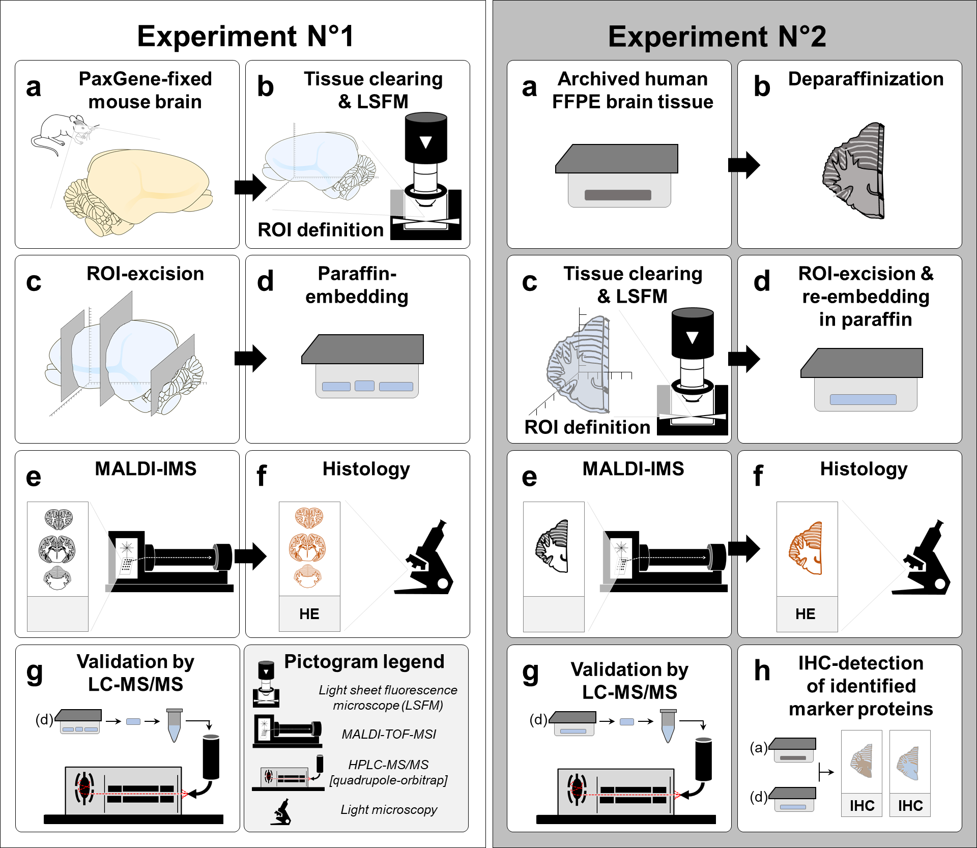

**Supplemental Figure 1.** **Schematic experimental designs and work-flows.** To demonstrate the feasibility of MALDI-MSI on paraffin sections of optically cleared tissue samples, two experiments were performed. In **Experiment N°1**, a freshly dissected mouse brain was fixed in formaldehyde-free fixation solution (PaxGene) (**a**), optically cleared (3DISCO) and subjected to light sheet fluorescence microscopy (LSFM) (**b**). Regions of interest (ROIs) defined by LSFM were dissected from the cleared tissue (**c**), and embedded in paraffin (**d**). Paraffin sections were subjected to MALDI-MSI (**e**) and subsequent HE-staining (**f**).For validation of MALDI-MSI data, proteomic LC-MS/MS analysis was performed onadditional samples of paraffin-embedded mouse brain tissue (**g**). For **Experiment N°2**,FFPE human brain tissue (archive material, **a**) was deparaffinized, (**b**) optically cleared (3DISCO) and subjected to LSFM (**c**). Regions of interest were defined by LSFM and dissected from the cleared tissue, and re-embedded in paraffin (**d**). Paraffin sections of the re-embedded tissue were subjected to MALDI-MSI (**e**) and subsequent HE-staining (**f**). For validation of MALDI-MSI data, proteomic LC-MS/MS analysis was performed on additional samples of paraffin-embedded human brain tissue (**g**) and the spatial abundance patterns of MALDI-MSI detected tryptic peptides of different established nerve tissue marker proteins were confirmed by immunohistochemistry (**h**).

**Supplemental Figure 2**

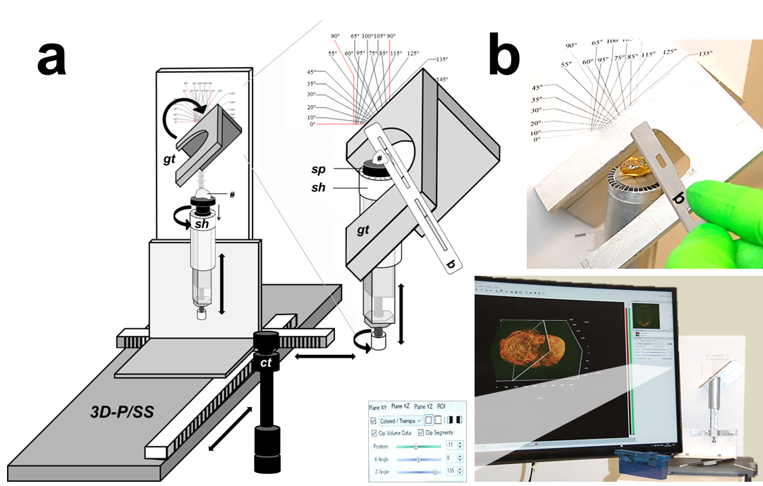

**Supplemental Figure 2. Excision of a LSFM-determined ROI from the cleared tissue sample.**

Within the cleared tissue, ROI(s) for subsequent MALDI-MSI are defined by LSFM and subsequently excised from the sample. For reasonably sized organ samples, such as complete mouse brains, with abundant distinctive anatomical details, the use of a positioning and sectioning device is dispensable and sections can be straightforwardly excised by hand, with adequate precision. However, for cutting of small-sized tissue samples, or for preparation of oblique sections through cleared samples with indistinct, uniform external shapes, the aid of a three-dimensional sample positioning device (**3D-P/SS**) with a blade guiding track (***gt***), is advantageous. Here, a self-constructed positioning and cutting-device, built from a microscope cross-table (***ct***) and few standard hardware store components is shown. **a**: Construction scheme. **b:** Gross image and detail enlargement. For accurate positioning of the sample (#) and the section plane(s), the x-, y-, and z-position of the sample holder (***sh***) can be precisely be adjusted, the sample-plate (***sp***) and the blade guiding track can be rotated by 360°. To precisely replicate the orientation of LSFM optical section plane(s), the sample plate with the tissue sample (***#***) is removed from the sample chamber of the LSFM and directly transferred to the sample plate holder of the 3D-positioning/cutting device. The sample-positioning data and the section plane angle(s) of the LSFM-viewer software are correspondingly transferred to the gadget, and the cleared tissue sample is sectioned, using a microtome blade (***b***). Care should be taken to place the physical section plane through the cleared tissue sample approximately 0.5 mm parallel to the optical LSFM-section plane, to avoid cutting directly through the structure of interest. In the present example, the positioning of a cleared mouse brain for preparation of an 135° oblique frontal section through the cerebrum and the diencephalon is shown (the presented example intends to illustrate the sectioning process, it does not show the same ROI-section plane orientation examined in the MALDI-MSI experiment). Note that the described method of tissue-sectioning works well only for solid, shape-retaining optically cleared tissue samples, but not for soft/gelatinous samples.

**Supplemental Figure 3**

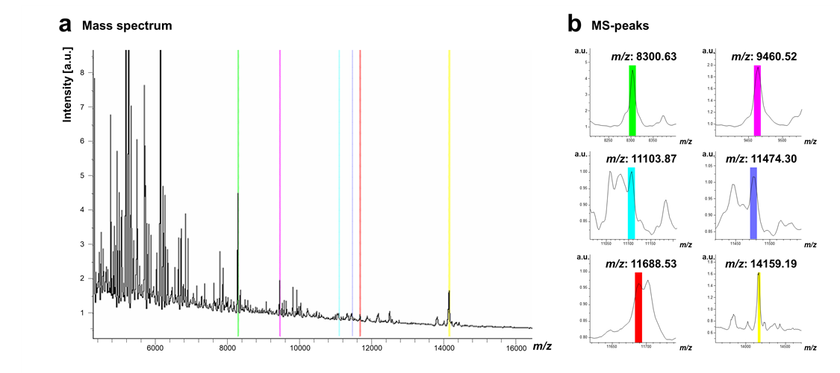

|  |  |  |  |  |  |  |
| --- | --- | --- | --- | --- | --- | --- |
| **c**  **Protein** | **Protein accession numbers** | **Protein molecular weight (Da)** | **Protein identification probability** | **Exclusive unique peptide count** | **Sequence coverage (%)** | **Corresponding MALDI-MSI Peak (*m/z*)** |
| GNG3 | P63216|GBG3_MOUSE | 8304.90 | 100.00% | 2 | 60.00% | 8300.63 |
| RPS27 | Q6ZWU9|RS27_MOUSE | 9460.90 | 100.00% | 2 | 28.60% | 9460.52 |
| MRPS36 | Q9CQX8|RT36_MOUSE | 11101.10 | 100.00% | 4 | 57.80% | 11103.87 |
| RPLP1 | P47955|RLA1_MOUSE | 11475.00 | 100.00% | 2 | 51.80% | 11474.30 |
| NDUFB3 | Q9CQZ6|NDUB3_MOUSE | 11692.30 | 99.10% | 2 | 14.40% | 11688.53 |
| SCOC | Q78YZ6|SCOC_MOUSE | 14155.00 | 100.00% | 2 | 35.20% | 14159.19 |

**Supplemental Figure 3. MS-spectra of MALDI-IMS and identified proteins validated by LC-MS/MS analysis in experiment N°1 (PaxGene-fixed, 3DISCO-cleared, paraffin-embedded mouse brain tissue).** **a**: MALDI-mass spectrum from 4-16 kDa. MS-protein peaks of six identified masses are highlighted in different colors. **b**: Detail enlargements of these mass spectra peaks with corresponding *m/z* values. The six featured mass spectra correspond to ions of the same LC-MS/MS-confirmed proteins shown in Figure 1. *m/z*: 8300.63: GNG3 (guanine nucleotide-binding protein subunit gamma-3); *m/z*: 9460.52: RPS27 (40S ribosomal protein S27); *m/z*: 11103.87: MRPS36 (28S ribosomal protein S36, mitochondrial); *m/z*: 11474.30: RPLP1 (60S acidic ribosomal protein P1); *m/z*: 11688.53: NDUFB3 (NADH dehydrogenase [ubiquinone] 1 beta subcomplex subunit 3); *m/z*: 14159.19: SCOC (Short coiled-coil protein). Relevant parameters of the LC-MS/MS protein identification are provided in table c.

**Supplemental Figure 4**

**a**

**GFAP (*m/z* 1208.83, EAASYQEALAR + H+)**

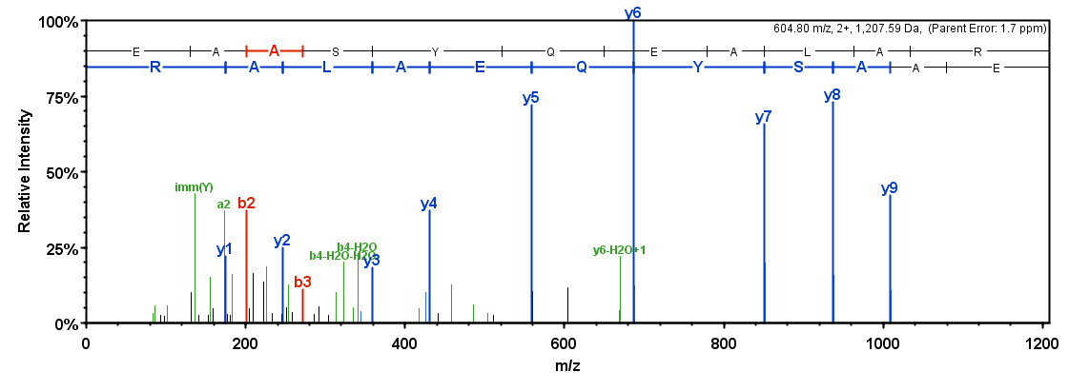

**MAP2 (*m/z* 1506.91, TTAAGGESALAPSVFK + H+)**

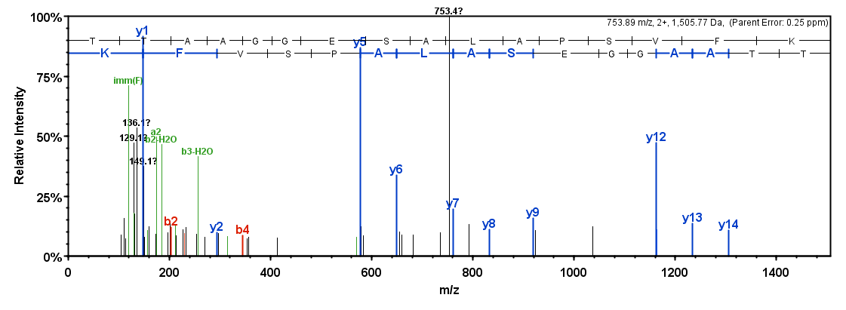

**MBP (*m/z* 975.63, GVDAQGTLSK + H+)**

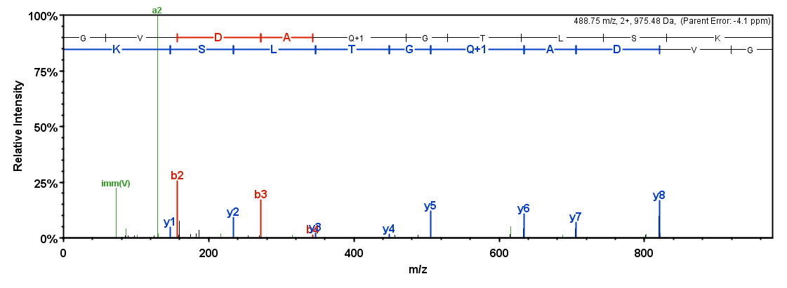

**b**

|  |  |  |  |  |  |  |  |
| --- | --- | --- | --- | --- | --- | --- | --- |
| Protein | Protein accession numbers | Protein molecular weight (Da) | Protein identification probability | Unique peptide count | Peptide sequence | Peptide identification probability | Calculated +1H Peptide Mass |
| GFAP | P14136|GFAP_HUMAN | 49881.40 | 100.00% | 48 | EAASYQEALAR | 99.70% | 1208.59 |
| MAP2 | P11137|MTAP2_HUMAN | 199527.90 | 100.00% | 34 | TTAAGGESALAPSVFK | 99.70% | 1506.78 |
| MBP | P02686|MBP_HUMAN | 33117.70 | 100.00% | 4 | GVDAQGTLSK | 99.70% | 975.5107 |

**Supplementary Figure 4. MS/MS-spectra of tryptic peptides detected by MALDI-IMS and validated by LC-MS/MS analysis in experiment N°2 (FFPE, 3DISCO-cleared, and paraffin-(re)embedded human brain tissue samples).** The MS/MS-spectra shown in (a) correspond to ions of tryptic peptides of the same established neural tissue marker proteins also detected by MALDI-MSI and confirmed by immunohistochemistry (refer to Figure 2). Tryptic peptide EAASYQEALAR+H+ (*m/z* 1208.83) corresponds to glial fibrillary acidic protein (GFAP), an astrocyte-marker. Tryptic peptide TTAAGGESALAPSVFK+H+ (*m/z* 1506.91) corresponds to microtubule-associated protein 2 (MAP2), a neuronal differentiation marker.Tryptic peptide GVDAQGTLSK+H+ (*m/z* 975.63) corresponds to myelin basic protein (MBP), a marker of myelinating glia, highly abundant in the white matter. Relevant parameters of the LC-MS/MS peptide 3 identification are provided in table b.

**Supplemetal Video 1. LSFM guided MALDI-MSI** **and integration of 2D MALDI-MS images with 3D-LSFM reconstructions of organ morphology.** The video shows the 3D reconstruction of a PaxGene-fixed, optically cleared (3DISCO) mouse brain from a previous study1. Blood vessels are visualized in gray color (tagged by fluorescent labeled lectin) [0:00-0:06 sec]. The positions and orientations of the section planes of the tissue regions of interest (ROI N°1-3) selected for excision and MALDI-MSI are superimposed with MALDI-MS images subsequently acquired in paraffin sections of the corresponding locations [0:09-0:34 sec], showing the spatial distributions and intensities of guanine nucleotide-binding protein subunit gamma-3 (Gng3, *m/z*: 8300.63). Signal intensities are visualized by different colors; minimal intensities are shown in black-to blue, maximal intensities are indicated by red color (compare to the intensity-color scales shown in Fig. 1 and Fig. 2).

1. Harrison, L., et al., Fluorescent blood-brain barrier tracing shows intact leptin transport in obese mice. Int J Obes (Lond), 2018.