**Supplementary Material**

Long-term exposure to air pollution and mortality from dementia, psychiatric disorders, and suicide in a large pooled European cohort: ELAPSE study

**Table of Contents**

**Supplementary Tables**

Table S1. Study characteristic of each sub-cohort with dementia, psychiatric disorders and suicide mortality rates. 3

Table S2. Pearson correlations between air pollutants for year 2010 exposure in the pooled cohort and sub-cohorts. 6

Table S3. Associations between long-term air pollution exposure and mortality from dementia, psychiatric disorders, and suicide by various cut-off values in Model 3. 11

Table S4. Effect modification on the association between year 2010 exposure (Model 3) and mortality from dementia and suicide by baseline characteristics. 14

Table S5. Associations between year 2010 exposure and back-extrapolated baseline year exposure and dementia, psychiatric disorder and suicide mortality in Model 3 (N=271,695). 18

Table S6. Associations between time-varying annual exposure and dementia, psychiatric disorders and suicide mortality in three cohorts (CEANS, EPIC-NL, and VHM&PP; N=132,952) with available information based on Model 3. 19

Table S7. Results for sensitivity analysis of associations between year 2010 exposure and dementia, psychiatric disorders and suicide mortality in Model 3. 20

Table S8. Associations between long-term exposure to air pollutants and dementia, psychiatric disorder and suicide mortality in Model 3 with (N=271,695) and without (N=324,674) the multiple imputation 22

Table S9. Associations between long-term exposure to air pollutants and dementia, psychiatric disorder and suicide mortality in Model 3 with and without consideration of competing risk events (N=271,695) 23

Table S10. Exposure distribution of PM2.5 composition in the pooled cohort 24

Table S11. Pearson correlations between PM2.5 compositions and PM2.5 mass in the pooled cohort. 25

Table S12. Pearson correlations between PM2.5 compositions and NO2 in the pooled cohort. 26

**Supplementary Figures**

Figure S1. Seven cohorts included in the study (N=271,720). 4

Figure S2. Description of air pollutants by cohorts and sub-cohorts for the year 2010 and the baseline years (N=271,720). 5

Figure S3. Survival probability of mortality from (A) dementia and (B) psychiatric disorders by seven cohorts 7

Figure S4. Concentration-response curves for the associations between long-term exposure to air pollution and dementia mortality. 8

Figure S5. Concentration-response curves for the associations between long-term exposure to air pollution and psychiatric disorder mortality. 9

Figure S6. Concentration-response curves for the associations between long-term exposure to air pollution and suicide mortality. 10

Figure S7. Comparing the results of different approaches for adjusting the heterogeneity between sub-cohorts based on the association with psychiatric disorder mortality in Model 3. 17

Figure S8. Pearson correlations between air pollutants composition estimated from supervised linear regression model in the pooled cohort. 27

Figure S9. Pearson correlations between air pollutants composition estimated from random forest model in the pooled cohort. 28

Figure S10. Associations of PM2.5 composition with psychiatric disorders mortality in single-pollutant and two-pollutant models in Supervised Linear Regression and Random Forest analyses. (N= 271,003; Psychiatric disorder mortality= 239) 29

Figure S11. Associations of PM2.5 composition with dementia mortality in single-pollutant and two-pollutant models in Supervised Linear Regression and Random Forest analyses. (N= 271,003; dementia mortality= 898) 30

Figure S12. Associations of PM2.5 composition with suicide mortality in single-pollutant and two-pollutant models in Supervised Linear Regression and Random Forest analyses. (N= 271,003; suicide mortality= 161) 31

Table S1. Study characteristic of each sub-cohort with dementia, psychiatric disorders and suicide mortality rates.

|  |  |  |  |  |  |  |  |  |  |  |
| --- | --- | --- | --- | --- | --- | --- | --- | --- | --- | --- |
| **Cohort/sub-cohort** | **Population size\*** | **N**# | **Enrolment**  **year** | **End of follow-up** | **Mean age at baseline**  **(years)** | **Mean age at end of follow-up**  **(years)** | **Deaths, N (rate)**φ | | | **Study area** |
| **Dementia** | **Psychiatric** | **Suicide** |
| **Pooled Cohort** | 324,728 | 271,720 | / | / | 47.1 | 66.9 | 900 (16.8) | 241 (4.5) | 164 (3.1) | Seven cohorts in six countries |
| **CEANS** | 21,987 | 20,702 | / | / | 56.3 | 69.3 | 159 (59.1) | 10 (3.7) | 37 (13.8) | Stockholm county, Sweden |
| SDPP | 7,835 | 7,727 | 1992-1998 | 2011 | 47.1 | 63 | 4 (3.3) | 5 (4.1) | 12 (9.8) |
| SIXTY | 4,180 | 3,969 | 1997-1999 | 2014 | 60 | 75.5 | 7 (11.4) | 0 (0.0) | 9 (14.7) |
| SALT | 6,724 | 6,176 | 1998-2002 | 2011 | 57.8 | 68.2 | 58 (90.4) | 2 (3.1) | 11 (17.2) |
| SNAC-K | 3,248 | 2,830 | 2001-2004 | 2011 | 72.9 | 80.3 | 90 (429.2) | 3 (14.3) | 5 (23.8) |
| **DNC** | 28,433 | 25,171 | / | / | 53.5 | 70.8 | 187 (42.9) | 37 (8.5) | 66 (15.1) | Denmark-wide |
| 1993 | 19,664 | 17,043 | 1993 | 2013 | 56.2 | 74.9 | 180 (56.5) | 31 (9.7) | 52 (16.3) |
| 1999 | 8,769 | 8,128 | 1999 | 2013 | 47.9 | 62.4 | 7 (6.0) | 6 (5.1) | 14 (11.9) |
| **E3N** | 53,521 | 39,006 | 1989-1991 | 2011 | 53 | 69.7 | 71 (10.9) | 18 (2.8) | 33 (5.1) | France-wide |
| **EPIC-NL** | 36,905 | 32,872 | / | / | 49.5 | 66.1 | 111 (20.3) | 8 (1.5) | 28 (5.1) | Four cities, the Netherlands |
| Morgen | 20,711 | 18,302 | 1993-1997 | 2013 | 42.9 | 59.8 | 13 (4.2) | 5 (1.6) | 18 (5.8) |
| Prospect | 16,194 | 14,570 | 1993-1997 | 2013 | 57.7 | 74.1 | 98 (40.9) | 3 (1.3) | 10 (4.2) |
| **HNR** | 4,809 | 4,733 | 2000-2003 | 2015 | 59.7 | 71.7 | 8 (14.1) | 3 (5.3) | 0 (0.0) | Ruhr area, Germany |
| **KORA** | 8,823 | 4,853 | / | / | 49.4 | 63.7 | 9 (12.9) | 8 (11.5) | 0 (0.0) | Augsburg area, Germany |
| S3 | 4,566 | 2,572 | 1994-1995 | 2011 | 49.4 | 65 | 5 (12.5) | 6 (15.0) | 0 (0.0) |
| S4 | 4,257 | 2,281 | 1999-2001 | 2014 | 49.3 | 62.3 | 4 (13.5) | 2 (6.8) | 0 (0.0) |
| **VHM&PP** | 170,250 | 144,383 | 1985-2005 | 2014 | 42.1 | 65.2 | 355 (10.6) | 157 (4.7) | 0 (0.0) | Vorarlberg region, Austria |

*: Population size is the number of participants for which information was transferred to Utrecht University for construction of the pooled cohort.

#: N indicates the number participants included in our model analysis.

φ: Rate is crude mortality rate for the pooled cohort during the follow-up period, expressed in units of deaths per 100,000 participants per year.

Figure S1. Seven cohorts included in the study (N=271,720).

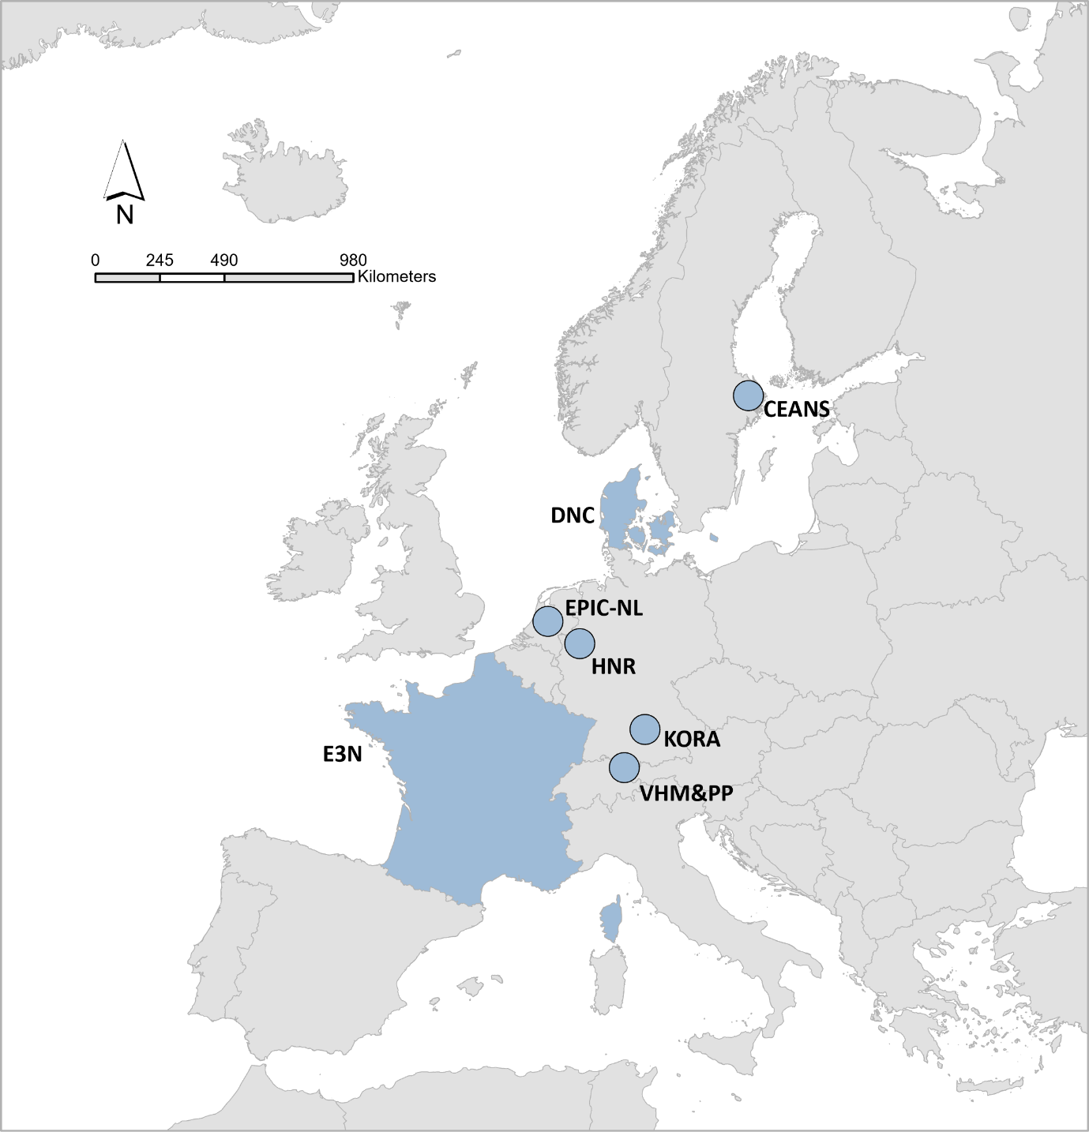

Figure S2. Description of air pollutants by cohorts and sub-cohorts for the year 2010 and the baseline years (N=271,720).

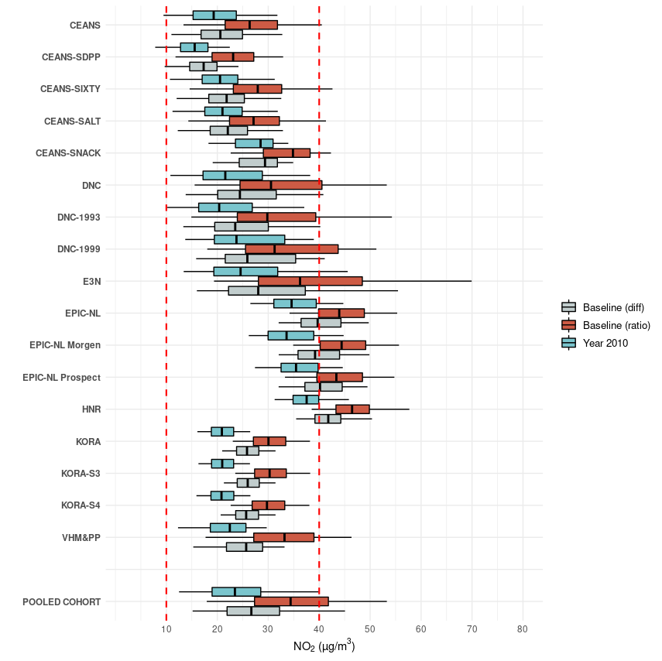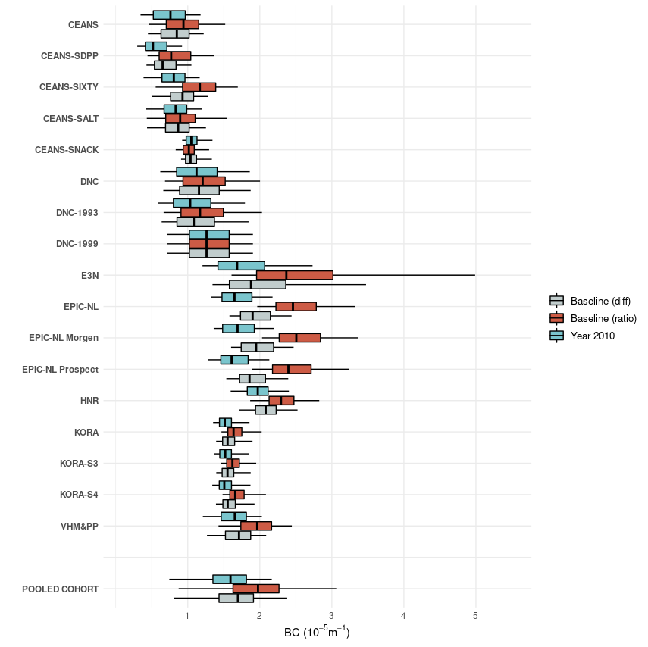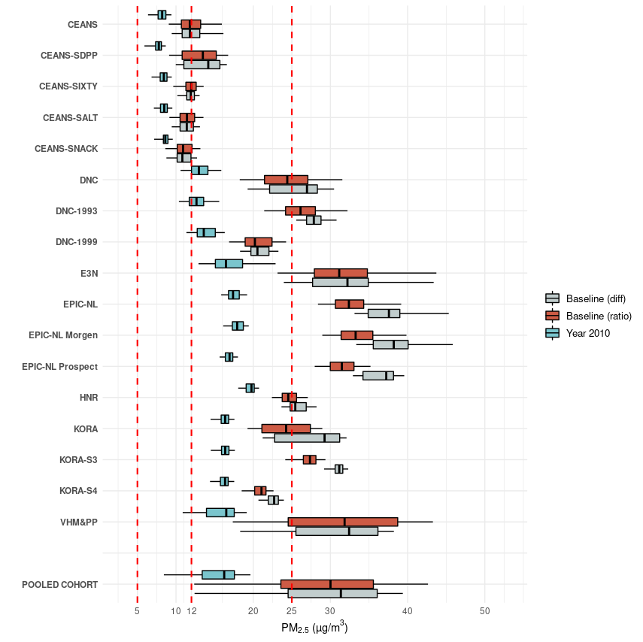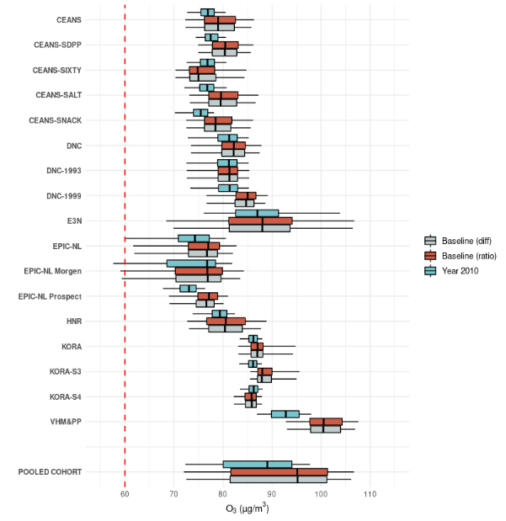

The bold lines in the middle of the box indicate the median values (the 50th percentiles). The lower and upper hinges correspond to the 25th and 75th percentiles. The lower and upper whiskers extend to the 5th and 95th percentiles. Red dotted dash lines represent different limited/guideline values in EU, U.S., and WHO guidelines (2021 version).

The number of participants for available baseline exposures, which were back-extrapolated using ratio and difference methods, was 271,720. For comparison, we restricted the same participants for 2010 exposure in this graph.

Definition of abbreviation: PM2.5, particulate matter with aerodynamic diameters of less than 2.5 μm; NO2, nitrogen dioxide; BC, black carbon; O3, ozone.

Table S2. Pearson correlations between air pollutants for year 2010 exposure in the pooled cohort and sub-cohorts.

|  |  |  |  |  |  |  |  |  |  |  |
| --- | --- | --- | --- | --- | --- | --- | --- | --- | --- | --- |
| **Pollutants** | **Cohort** | **NO2** | **PM2.5** | **BC** | **O3** | **Cohort** | **NO2** | **PM2.5** | **BC** | **O3** |
|  | **Pooled cohort** |  |  |  |  | **CEANS-SALT** |  |  |  |  |
| NO2 | 1 |  |  |  | 1 |  |  |  |
| PM2.5 | 0.59 | 1 |  |  | 0.67 | 1 |  |  |
| BC | 0.71 | 0.82 | 1 |  | 0.84 | 0.55 | 1 |  |
| O3 | -0.6 | -0.04 | 0 | 1 | -0.74 | -0.47 | -0.76 | 1 |
|  | **CEANS-SDPP** |  |  |  |  | **CEANS-SIXTY** |  |  |  |  |
| NO2 | 1 |  |  |  | 1 |  |  |  |
| PM2.5 | 0.6 | 1 |  |  | 0.69 | 1 |  |  |
| BC | 0.67 | 0.49 | 1 |  | 0.84 | 0.59 | 1 |  |
| O3 | -0.7 | -0.18 | -0.33 | 1 | -0.71 | -0.44 | -0.71 | 1 |
|  | **CEANS-**  **SNAC-K** |  |  |  |  | **DNC-1999** |  |  |  |  |
| NO2 | 1 |  |  |  | 1 |  |  |  |
| PM2.5 | 0.75 | 1 |  |  | 0.61 | 1 |  |  |
| BC | 0.43 | 0.29 | 1 |  | 0.93 | 0.64 | 1 |  |
| O3 | -0.66 | -0.5 | -0.74 | 1 | -0.21 | -0.16 | -0.2 | 1 |
|  | **DNC-1993** |  |  |  |  | **EPIC-NL-Morgen** |  |  |  |  |
| NO2 | 1 |  |  |  | 1 |  |  |  |
| PM2.5 | 0.64 | 1 |  |  | 0.22 | 1 |  |  |
| BC | 0.92 | 0.7 | 1 |  | 0.84 | 0.41 | 1 |  |
| O3 | -0.42 | -0.32 | -0.42 | 1 | -0.78 | 0.15 | -0.55 | 1 |
|  | **E3N** |  |  |  |  | **HNR** |  |  |  |  |
| NO2 | 1 |  |  |  | 1 |  |  |  |
| PM2.5 | 0.81 | 1 |  |  | 0.65 | 1 |  |  |
| BC | 0.92 | 0.74 | 1 |  | 0.88 | 0.64 | 1 |  |
| O3 | -0.5 | -0.49 | -0.38 | 1 | -0.83 | -0.66 | -0.81 | 1 |
|  | **EPIC-NL-Prospect** |  |  |  |  | **KORA-S4** |  |  |  |  |
| NO2 | 1 |  |  |  | 1 |  |  |  |
| PM2.5 | 0.48 | 1 |  |  | 0.58 | 1 |  |  |
| BC | 0.91 | 0.41 | 1 |  | 0.73 | 0.54 | 1 |  |
| O3 | -0.86 | -0.43 | -0.84 | 1 | -0.73 | -0.37 | -0.71 | 1 |
|  | **KORA-S3** |  |  |  |  | **VHM&PP** |  |  |  |  |
| NO2 | 1 |  |  |  | 1 |  |  |  |
| PM2.5 | 0.52 | 1 |  |  | 0.65 | 1 |  |  |
| BC | 0.78 | 0.46 | 1 |  | 0.91 | 0.76 | 1 |  |
| O3 | -0.75 | -0.38 | -0.77 | 1 | -0.83 | -0.69 | -0.88 | 1 |

Definition of abbreviation: PM2.5, particulate matter with aerodynamic diameters of less than 2.5 μm; NO2, nitrogen dioxide; BC, black carbon; O3, ozone.

Figure S3. Survival probability of mortality from (A) dementia and (B) psychiatric disorders by seven cohorts

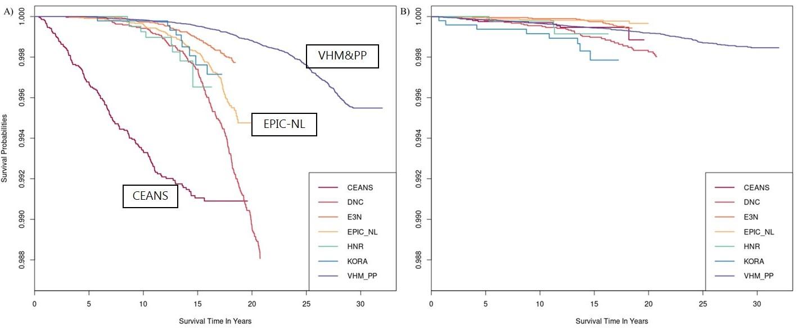

Figure S4. Concentration-response curves for the associations between long-term exposure to air pollution and dementia mortality.

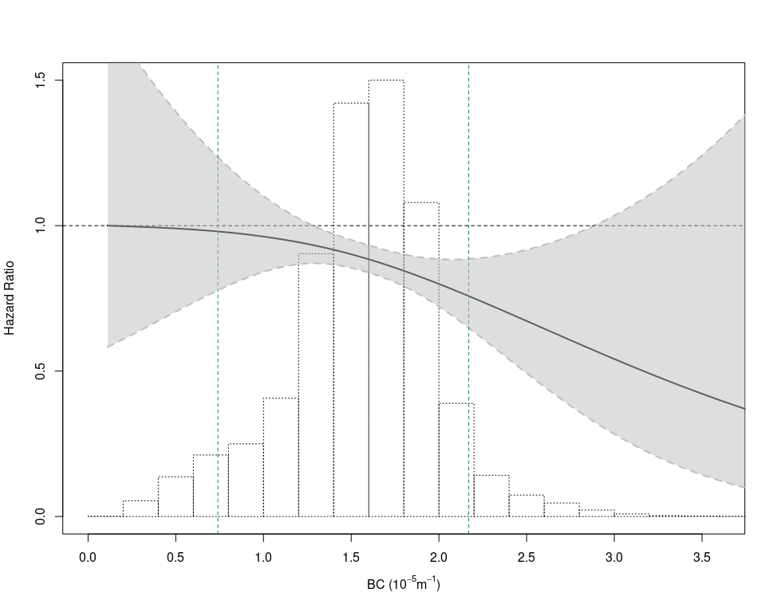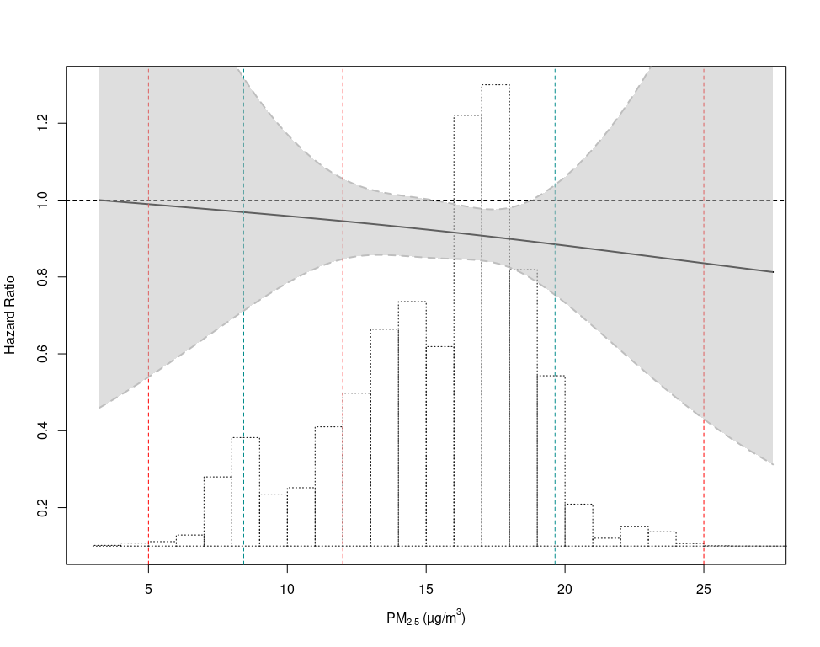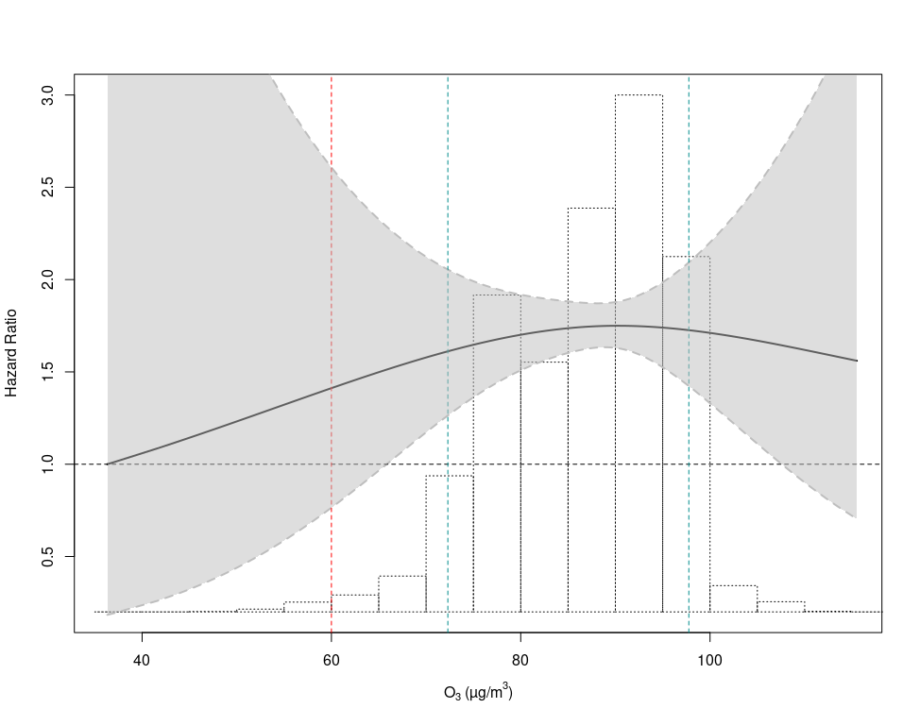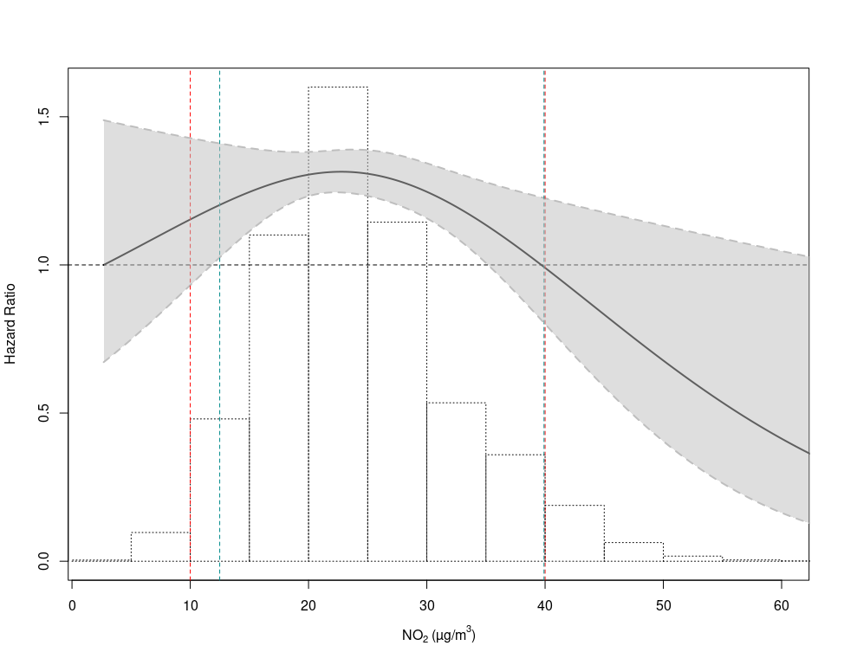

Natural cubic splines with two degrees of freedom were fit for air pollutants based on Model 3, where the hazard ratios equal to one were for minimum pollutant exposures. P-values for the linearity test for the associations of particulate matter with aerodynamic diameters of less than 2.5 μm (PM2.5), nitrogen dioxide (NO2), black carbon (BC), and ozone (O3) with dementia mortality were 0.96, 0.03, 0.48, and 0.60, respectively.

Solid black lines indicate hazard ratio values and black dashed lines indicate their 95% confidence intervals. Green dotted lines indicate the 5th and 95th percentiles of air pollutants’ concentrations. Red dotted dash lines represent different limited values in EU, U.S., and WHO guidelines (2021 version). The histograms show the distributions of exposures in 2010.

Figure S5. Concentration-response curves for the associations between long-term exposure to air pollution and psychiatric disorder mortality.

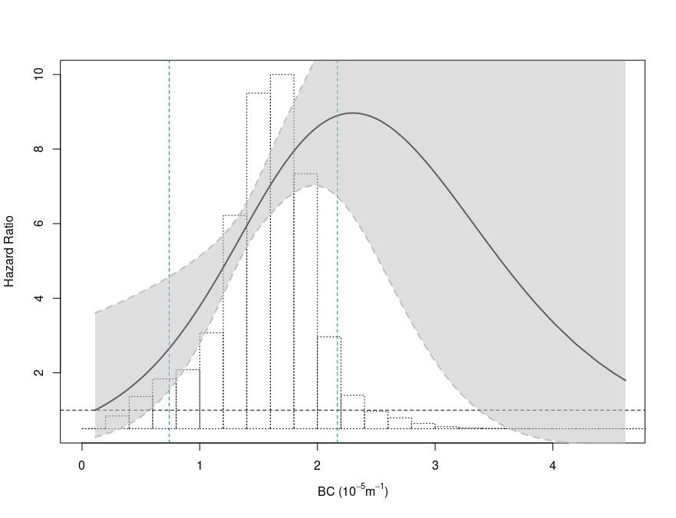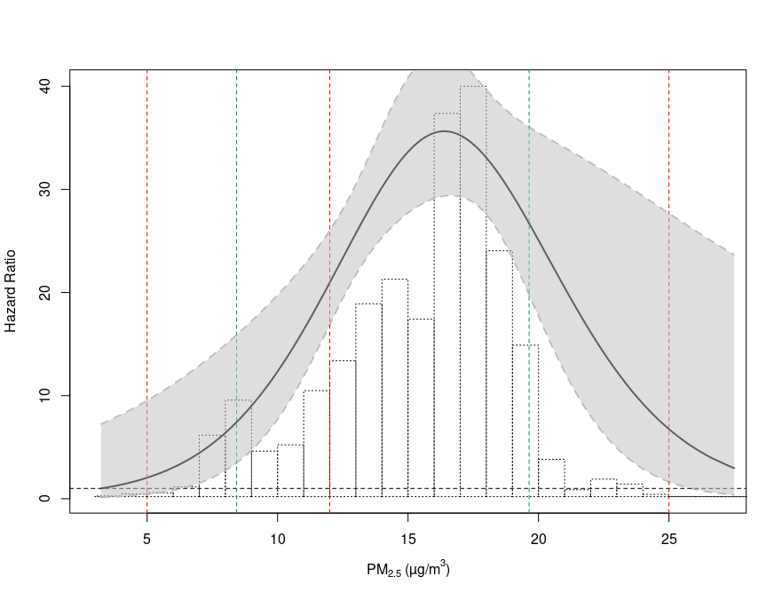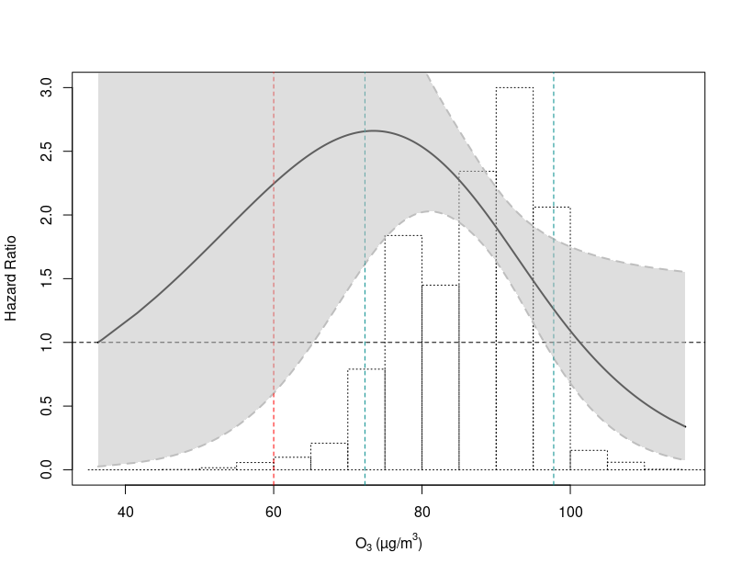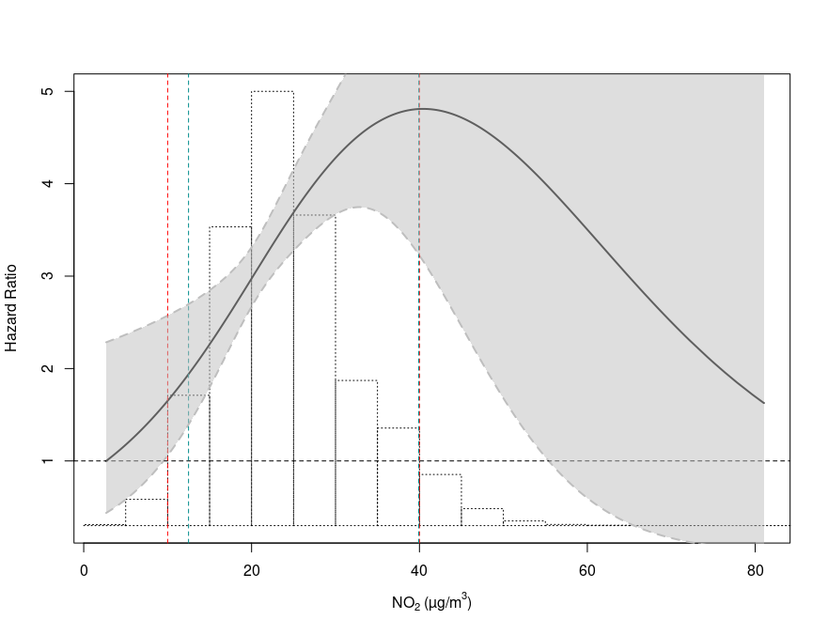

Natural cubic splines with two degrees of freedom were fit for air pollutants based on Model 3, where the hazard ratios equal to one were for minimum pollutant exposures. P-values for the linearity test for the associations of particulate matter with aerodynamic diameters of less than 2.5 μm (PM2.5), nitrogen dioxide (NO2), black carbon (BC), and ozone (O3) with dementia mortality were <0.01, 0.14, 0.09, and 0.16, respectively.

Solid black lines indicate hazard ratio values and black dashed lines indicate their 95% confidence intervals. Green dotted lines indicate the 5th and 95th percentiles of air pollutants’ concentrations. Red dotted dash lines represent different limited values in EU, U.S., and WHO guidelines (2021 version). The histograms show the distributions of exposures in 2010.

Figure S6. Concentration-response curves for the associations between long-term exposure to air pollution and suicide mortality.

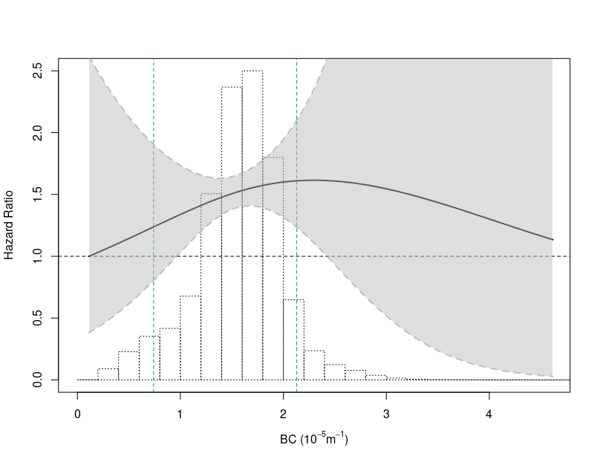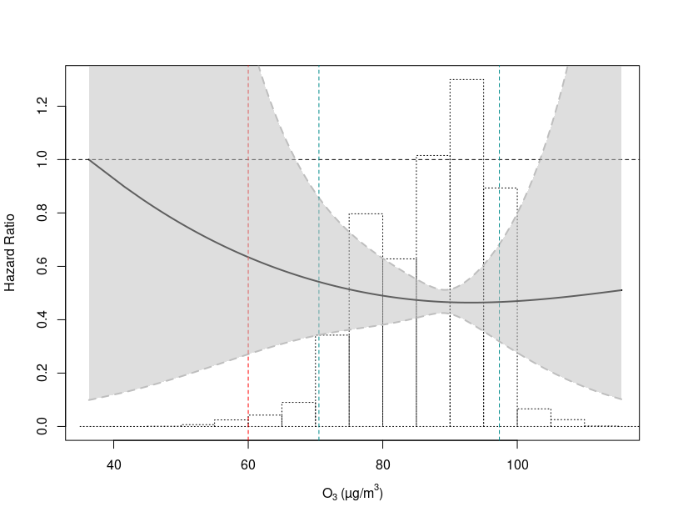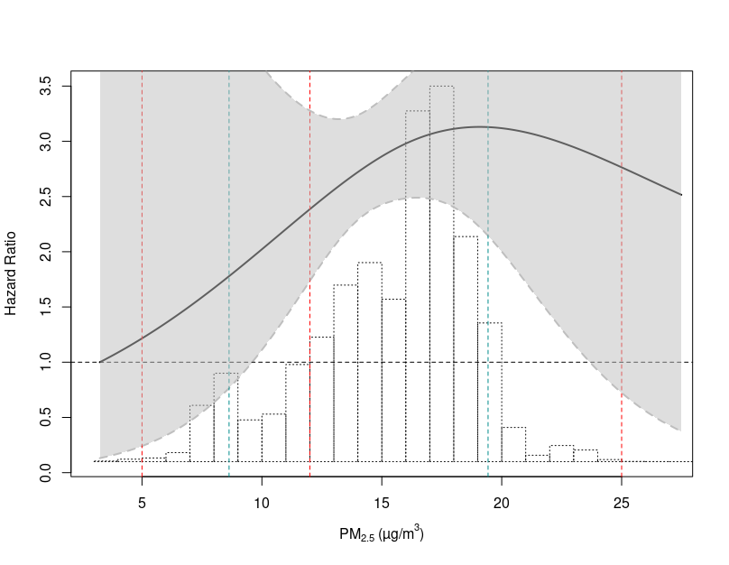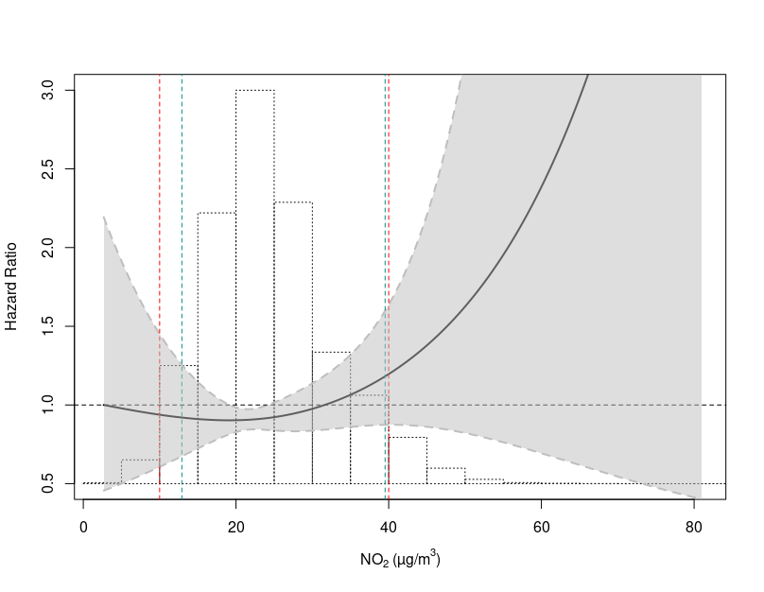

Natural cubic splines with two degrees of freedom were fit for air pollutants based on Model 3, where the hazard ratios equal to one were for minimum pollutant exposures. P-values for the linearity test for the associations of particulate matter with aerodynamic diameters of less than 2.5 μm (PM2.5), nitrogen dioxide (NO2), black carbon (BC), and ozone (O3) with dementia mortality were 0.50, 0.38, 0.65, and 0.71, respectively.

Solid black lines indicate hazard ratio values and black dashed lines indicate their 95% confidence intervals. Green dotted lines indicate the 5th and 95th percentiles of air pollutants’ concentrations. Red dotted dash lines represent different limited values in EU, U.S., and WHO guidelines (2021 version). The histograms show the distributions of exposures in 2010.

Table S3. Associations between long-term air pollution exposure and mortality from dementia, psychiatric disorders, and suicide by various cut-off values in Model 3.

|  |  |  |  |  |
| --- | --- | --- | --- | --- |
| **Pollutants** | **Cut-off levels** | **Number of participants** | **Number of deaths** | **HR (95%CI)** |
| **Dementia** |  |  |  |  |
| **NO2** |  |  |  |  |
|  | All levels | 271,720 | 900 | 0.96 (0.82, 1.13) |
|  | < 40 µg/m3 | 258,344 | 860 | 0.94 (0.83, 1.06) |
|  | < 30 µg/m3 | 214,921 | 697 | 1.07 (0.91, 1.26) |
|  | < 20 µg/m3 | 81,681 | 236 | 0.97 (0.63, 1.48) |
| **PM2.5** |  |  |  |  |
|  | All levels | 271,720 | 900 | 0.94 (0.85, 1.05) |
|  | < 25 µg/m3 | 271,692 | 900 | 0.96 (0.82, 1.13) |
|  | < 20 µg/m3 | 262,893 | 882 | 0.94 (0.79, 1.11) |
|  | < 15 µg/m3 | 106,014 | 494 | 1.02 (0.71, 1.47) |
| **BC** |  |  |  |  |
|  | All levels | 271,720 | 900 | 0.91 (0.81, 1.01) |
|  | < 3 × 10-5/m | 271,115 | 900 | 0.92 (0.82, 1.03) |
|  | < 2.5 × 10-5/m | 267,060 | 890 | 0.90 (0.80, 1.02) |
|  | < 2 × 10-5/m | 243,603 | 845 | 0.94 (0.82, 1.08) |
| **O3** |  |  |  |  |
|  | All levels | 271,720 | 900 | 1.03 (0.88, 1.20) |
|  | < 120 µg/m3 | 271,720 | 900 | 1.03 (0.88, 1.20) |
|  | < 100 µg/m3 | 266,875 | 888 | 1.03 (0.87, 1.22) |
|  | < 80 µg/m3 | 67,713 | 357 | 1.01 (0.73, 1.41) |
| **Psychiatric disorders** |  |  |  |  |
| **NO2** |  |  |  |  |
|  | All levels | 271,720 | 241 | 1.38 (1.13, 1.70) |
|  | < 40 µg/m3 | 258,344 | 232 | 1.49 (1.18, 1.88) |
|  | < 30 µg/m3 | 214,921 | 201 | 1.57 (1.14, 2.16) |
|  | < 20 µg/m3 | 81,681 | 61 | 2.18 (0.87, 5.43) |
| **PM2.5** |  |  |  |  |
|  | All levels | 271,720 | 241 | 1.29 (0.98, 1.71) |
|  | < 25 µg/m3 | 271,692 | 241 | 1.29 (0.98, 1.71) |
|  | < 20 µg/m3 | 262,893 | 237 | 1.38 (1.02, 1.86) |
|  | < 15 µg/m3 | 106,014 | 97 | 4.25 (1.78, 10.14) |
| **BC** |  |  |  |  |
|  | All levels | 271,720 | 241 | 1.37 (1.11, 1.69) |
|  | < 3 × 10-5/m | 271,115 | 240 | 1.37 (1.10, 1.70) |
|  | < 2.5 × 10-5/m | 267,060 | 238 | 1.43 (1.13, 1.80) |
|  | < 2 × 10-5/m | 243,603 | 217 | 1.67 (1.26, 2.22) |
| **O3** |  |  |  |  |
|  | All levels | 271,720 | 241 | 0.74 (0.55, 0.99) |
|  | < 120 µg/m3 | 271,720 | 241 | 0.74 (0.55, 0.99) |
|  | < 100 µg/m3 | 266,875 | 238 | 0.71 (0.52, 0.97) |
|  | < 80 µg/m3 | 67,713 | 39 | 0.78 (0.37, 1.66) |
| **Suicide** |  |  |  |  |
| **NO2** |  |  |  |  |
|  | All levels | 271,720 | 164 | 1.19 (0.76, 1.87) |
|  | < 40 µg/m3 | 258,344 | 147 | 1.07 (0.84, 1.38) |
|  | < 30 µg/m3 | 214,921 | 109 | 0.99 (0.67, 1.46) |
|  | < 20 µg/m3 | 81,681 | 58 | 1.06 (0.48, 2.33) |
| **PM2.5** |  |  |  |  |
|  | All levels | 271,720 | 164 | 1.13 (0.92, 1.38) |
|  | < 25 µg/m3 | 271,692 | 164 | 1.20 (0.76, 1.88) |
|  | < 20 µg/m3 | 262,893 | 160 | 1.51 (0.87, 2.64) |
|  | < 15 µg/m3 | 106,014 | 98 | 1.49 (0.59, 3.79) |
| **BC** |  |  |  |  |
|  | All levels | 271,720 | 164 | 1.08 (0.87, 1.35) |
|  | < 3 × 10-5/m | 271,115 | 164 | 1.11 (0.89, 1.39) |
|  | < 2.5 × 10-5/m | 267,060 | 161 | 1.14 (0.89, 1.45) |
|  | < 2 × 10-5/m | 243,603 | 147 | 1.15 (0.87, 1.53) |
| **O3** |  |  |  |  |
|  | All levels | 271,720 | 164 | 0.93 (0.70, 1.24) |
|  | < 120 µg/m3 | 271,720 | 164 | 0.93 (0.70, 1.24) |
|  | < 100 µg/m3 | 266,875 | 161 | 0.95 (0.69, 1.31) |
|  | < 80 µg/m3 | 67,713 | 92 | 0.78 (0.50, 1.24) |

Model 3 adjusted for age (time axis), sex (strata), sub-cohort (strata), calendar year of baseline, smoking (status, duration, intensity, and intensity2), body mass index (category), marital status, employment status, and area-level mean year income.

Results are presented as hazard ratio and 95% confidence interval [HR (95%CI)] for the following increases: 10 µg/m3 for nitrogen dioxide (NO2), 5 µg/m3 for particulate matter with aerodynamic diameters of less than 2.5 μm (PM2.5), 0.5 × 10-5/m for black carbon (BC), and 10 µg/m3 for ozone (O3).

Table S4. Effect modification on the association between year 2010 exposure (Model 3) and mortality from dementia and suicide by baseline characteristics.

|  |  |  |  |  |  |  |  |
| --- | --- | --- | --- | --- | --- | --- | --- |
| Baseline characteristics | N | Deaths, N | HR (95% CI) | | | | P values* |
|  |  |  | NO2 | PM2.5 | BC | O3 |  |
| **Dementia** |  |  |  |  |  |  |  |
| Age, years |  |  |  |  |  |  | NO2: 0.73; PM2.5: 0.69; BC: 0.99; O3: 0.17 |
| < 65 | 245,488 | 383 | 0.93 (0.80, 1.09) | 0.95 (0.77, 1.16) | 0.92 (0.78, 1.07) | 1.09 (0.90, 1.32) |
| ≥ 65 | 26,232 | 517 | 0.96 (0.85, 1.10) | 1.00 (0.80, 1.25) | 0.92 (0.80, 1.06) | 0.95 (0.79, 1.14) |
| Sex |  |  |  |  |  |  | NO2: 0.43; PM2.5: 0.79; BC: 0.40; O3: 0.14 |
| Female | 186,766 | 718 | 0.93 (0.83, 1.04) | 0.97 (0.82, 1.15) | 0.92 (0.81, 1.03) | 1.05 (0.90, 1.23) |
| Male | 84,954 | 182 | 1.03 (0.80, 1.31) | 0.94 (0.75, 1.18) | 0.84 (0.67, 1.04) | 0.90 (0.71, 1.14) |
| Overweight |  |  |  |  |  |  | NO2: 0.93; PM2.5: 0.48; BC: 0.36; O3: 0.49 |
| No | 160,976 | 500 | 0.94 (0.83, 1.06) | 0.93 (0.77, 1.12) | 0.88 (0.77, 1.00) | 1.01 (0.85, 1.19) |
| Yes | 110,744 | 400 | 0.95 (0.82, 1.09) | 1.00 (0.82, 1.20) | 0.95 (0.82, 1.10) | 1.06 (0.88, 1.28) |
| Smoking status |  |  |  |  |  |  | NO2: 0.83; PM2.5: 0.20; BC: 0.91; O3: 0.93 |
| Current smoker | 59,125 | 113 | 0.89 (0.71, 1.12) | 0.86 (0.62, 1.20) | 0.87 (0.69, 1.09) | 1.04 (0.77, 1.41) |
| Former smoker | 44,529 | 200 | 0.93 (0.78, 1.11) | 0.81 (0.62, 1.05) | 0.90 (0.76, 1.08) | 0.99 (0.79, 1.25) |
| Never smoker | 168,066 | 587 | 0.96 (0.85, 1.09) | 1.00 (0.84, 1.18) | 0.92 (0.80, 1.04) | 1.04 (0.87, 1.23) |
| Employment status |  |  |  |  |  |  | NO2: 0.34; PM2.5: 0.33; BC: 0.62; O3: 0.06 |
| Employed | 185,768 | 153 | 0.87 (0.71, 1.06) | 1.08 (0.81, 1.45) | 0.95 (0.77, 1.17) | 1.21 (0.96, 1.53) |
| Others | 85,952 | 747 | 0.96 (0.86, 1.07) | 0.93 (0.79, 1.11) | 0.90 (0.79, 1.01) | 1.00 (0.85, 1.17) |
| Baseline characteristics | N | Deaths, N | HR (95% CI) | | | | P values* |
|  |  |  | NO2 | PM2.5 | BC | O3 |  |
| **Suicide** |  |  |  |  |  |  |  |
| Age, years |  |  |  |  |  |  | NO2: 0.71;  PM2.5: 0.07; BC: 0.16; O3: 0.63 |
| < 65 | 245,488 | 146 | 1.14 (0.92, 1.41) | 1.30 (0.82, 2.04) | 1.13 (0.90, 1.42) | 0.94 (0.70, 1.27) |
| ≥ 65 | 26,232 | 18 | 1.01 (0.56, 1.82) | 0.40 (0.11, 1.46) | 0.70 (0.37, 1.34) | 0.76 (0.33, 1.78) |
| Sex |  |  |  |  |  |  | NO2: 0.85;  PM2.5: 0.22; BC: 0.50; O3: 0.57 |
| Female | 186,766 | 135 | 1.13 (0.92, 1.40) | 1.22 (0.78, 1.90) | 1.10 (0.88, 1.37) | 0.96 (0.70, 1.31) |
| Male | 84,954 | 29 | 1.08 (0.66, 1.76) | 0.85 (0.42, 1.72) | 0.94 (0.58, 1.52) | 0.79 (0.43, 1.47) |
| Overweight |  |  |  |  |  |  | NO2: 0.81;  PM2.5: 0.19; BC: 0.54; O3: 0.67 |
| No | 160,976 | 119 | 1.14 (0.91, 1.42) | 1.26 (0.80, 1.99) | 1.11 (0.88, 1.40) | 0.90 (0.66, 1.23) |
| Yes | 110,744 | 45 | 1.09 (0.77, 1.54) | 0.93 (0.52, 1.67) | 1.00 (0.71, 1.41) | 1.00 (0.62, 1.62) |
| Smoking status |  |  |  |  |  |  | NO2: 0.83;  PM2.5: 0.84; BC: 0.69; O3: 0.60 |
| Current smoker | 59,125 | 72 | 1.12 (0.85, 1.48) | 1.27 (0.76, 2.12) | 1.16 (0.89, 1.52) | 0.98 (0.67, 1.44) |
| Former smoker | 44,529 | 38 | 1.23 (0.86, 1.75) | 1.09 (0.60, 1.95) | 1.03 (0.73, 1.46) | 0.74 (0.44, 1.25) |
| Never smoker | 168,066 | 54 | 1.07 (0.79, 1.46) | 1.18 (0.70, 1.98) | 1.02 (0.75, 1.38) | 0.98 (0.66, 1.45) |
| Employment status |  |  |  |  |  |  | NO2: 0.93;  PM2.5: 0.53; BC: 0.79; O3: 0.49 |
| Employed | 185,768 | 97 | 1.13 (0.89, 1.45) | 1.26 (0.78, 2.03) | 1.10 (0.86, 1.41) | 1.00 (0.70, 1.41) |
| Others | 85,952 | 67 | 1.12 (0.83, 1.50) | 1.09 (0.64, 1.86) | 1.06 (0.79, 1.42) | 0.85 (0.59, 1.24) |

Model 3 adjusted for age (time axis), sex (strata), sub-cohort (strata), calendar year of baseline, smoking (status, duration, intensity, and intensity2), body mass index (category), marital status, employment status, and area-level mean year income.

Results are presented as hazard ratio and 95% confidence interval [HR (95%CI)] for the following increases: 10 µg/m3 for nitrogen dioxide (NO2), 5 µg/m3 for particulate matter with aerodynamic diameters of less than 2.5 μm (PM2.5), 0.5 × 10-5/m for black carbon (BC), and 10 µg/m3 for ozone (O3).

Effect modification analyses were conducted based on Model 3 and evaluated by introducing interaction terms. *P* values for whether there were statistical differences between strata were tested by the Wald test.

*: A statistically significant *P* value (at 5% level) for effect modification analyses.

#: Body mass index ≥ 25 kg/m2 indicates overweight according to WHO categories.

φ: Employed status includes employed and self-employed.

Figure S7. Comparing the results of different approaches for adjusting the heterogeneity between sub-cohorts based on the association with psychiatric disorder mortality in Model 3.

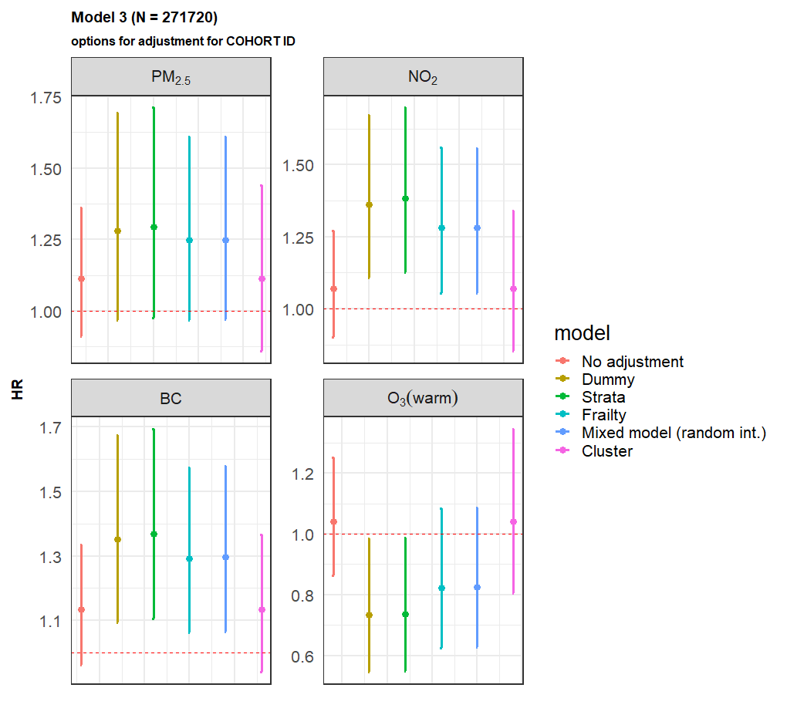

The green error bars are our main result in Models adjusted for sub-cohort with strata.

Results are presented as hazard ratio and 95% confidence interval [HR (95%CI)] for the following increases: 10 µg/m3 for nitrogen dioxide (NO2), 5 µg/m3 for particulate matter with aerodynamic diameters of less than 2.5 μm (PM2.5), 0.5 × 10-5/m for black carbon (BC), and 10 µg/m3 for ozone (O3).

The Akaike Information Criteria values for different approaches in models with NO2 exposure were 4839.71 for no adjustment, 4808.49 for dummy variables, 4282.34 for strata, 4806.73 for a frailty term, 4807.24 for a random intercept, and 4839.71 for a cluster term.

Table S5. Associations between year 2010 exposure and back-extrapolated baseline year exposure and dementia, psychiatric disorder and suicide mortality in Model 3 (N=271,695).

|  |  |  |  |
| --- | --- | --- | --- |
|  | **Year 2010 exposure** | **Baseline year exposure** | |
| **(N=271,695)** | **Ratio method** | **Difference method** |
| **Dementia (900 deaths)** | | |  |
| NO2 | 0.94 (0.85, 1.05) | 0.97 (0.90, 1.04) | 0.95 (0.86, 1.05) |
| PM2.5 | 0.96 (0.82, 1.13) | 0.97 (0.90, 1.04) | 0.99 (0.88, 1.11) |
| BC | 0.91 (0.81, 1.01) | 0.94 (0.87, 1.02) | 0.92 (0.83, 1.03) |
| O3 | 1.03 (0.88, 1.20) | 1.03 (0.91, 1.17) | 1.03 (0.90, 1.18) |
| **Psychiatric disorders (241 deaths)** | | |  |
| NO2 | 1.38 (1.13, 1.70) | 1.25 (1.09, 1.44) | 1.35 (1.11, 1.64) |
| PM2.5 | 1.29 (0.98, 1.71) | 1.14 (1.01, 1.30) | 1.24 (1.02, 1.50) |
| BC | 1.37 (1.11, 1.69) | 1.16 (1.01, 1.33) | 1.29 (1.06, 1.56) |
| O3 | 0.74 (0.55, 0.99) | 0.81 (0.63, 1.03) | 0.81 (0.63, 1.04) |
| **Suicide (164 deaths)** | | |  |
| NO2 | 1.13 (0.92, 1.38) | 1.07 (0.93, 1.23) | 1.10 (0.91, 1.33) |
| PM2.5 | 1.19 (0.76, 1.87) | 1.15 (0.92, 1.43) | 1.15 (0.90, 1.49) |
| BC | 1.08 (0.87, 1.35) | 1.06 (0.92, 1.21) | 1.07 (0.88, 1.29) |
| O3 | 0.93 (0.70, 1.24) | 0.92 (0.73, 1.17) | 0.92 (0.72, 1.17) |

Results are presented as hazard ratio and 95% confidence interval [HR (95%CI)] for the following increments: 10 µg/m3 for nitrogen dioxide (NO2), 5 µg/m3 for particulate matter with aerodynamic diameters of less than 2.5 μm (PM2.5), 0.5 × 10-5/m for black carbon (BC), and 10 µg/m3 for ozone (O3)

Table S6. Associations between time-varying annual exposure and dementia, psychiatric disorders and suicide mortality in three cohorts (CEANS, EPIC-NL, and VHM&PP; N=132,952) with available information based on Model 3.

|  |  |  |  |
| --- | --- | --- | --- |
|  | **Year 2010 exposure** | **Time-varying exposure\*** | |
| **(N=132,952)** | **Ratio method** | **Difference method** |
| **Dementia (534 deaths)** | | |  |
| NO2 | 1.08 (0.92, 1.26) | 1.20 (1.02, 1.41) | 1.20 (1.02, 1.41) |
| PM2.5 | 1.03 (0.83, 1.28) | 1.08 (0.87, 1.34) | 1.08 (0.87, 1.35) |
| BC | 1.03 (0.86, 1.22) | 1.09 (0.91, 1.31) | 1.09 (0.92, 1.30) |
| O3 | 0.98 (0.76, 1.27) | 0.85 (0.75, 0.96) | 0.85 (0.75, 0.96) |
| **Psychiatric disorders (90 deaths)** | | |  |
| NO2 | 1.25 (0.82, 1.89) | 1.47 (0.98, 2.19) | 1.50 (0.99, 2.28) |
| PM2.5 | 1.07 (0.69, 1.65) | 1.06 (0.71, 1.58) | 1.09 (0.70, 1.68) |
| BC | 1.21 (0.79, 1.87) | 1.45 (0.95, 2.22) | 1.44 (0.94, 2.21) |
| O3 | 0.64 (0.38, 1.08) | 0.76 (0.59, 0.99) | 0.76 (0.59, 0.99) |
| **Suicide (65 deaths)** | | |  |
| NO2 | 1.31 (0.85, 2.02) | 1.09 (0.75, 1.58) | 1.13 (0.74, 1.73) |
| PM2.5 | 0.70 (0.19, 2.56) | 0.63 (0.23, 1.72) | 0.65 (0.19, 2.25) |
| BC | 1.29 (0.81, 2.07) | 1.16 (0.75, 1.80) | 1.20 (0.75, 1.92) |
| O3 | 0.80 (0.49, 1.31) | 0.95 (0.72, 1.25) | 0.94 (0.71, 1.24) |

*: Time-varying analyses were additionally adjusted for calendar year of follow-up (strata one year) based on Model 3 to account for secular time trend in psychiatric and suicide mortality and air pollution.

Results are presented as hazard ratio and 95% confidence interval for the following increments: 10 µg/m3 for nitrogen dioxide (NO2), 5 µg/m3 for particulate matter with aerodynamic diameters of less than 2.5 μm (PM2.5), 0.5 × 10-5/m for black carbon (BC), and 10 µg/m3 for ozone (O3).

Table S7. Results for sensitivity analysis of associations between year 2010 exposure and dementia, psychiatric disorders and suicide mortality in Model 3.

|  |  |  |  |  |  |  |
| --- | --- | --- | --- | --- | --- | --- |
|  | **Number of participants** | **Number of deaths** | **HR (95%CI)** | | | |
| **NO2** | **PM2.5** | **BC** | **O3** |
| **Dementia** | | |  |  |  |  |
| All cohorts | 271,720 | 900 | 0.94 (0.85, 1.05) | 0.96 (0.82, 1.13) | 0.91 (0.81, 1.01) | 1.03 (0.88, 1.20) |
| Exclude CEANS | 251,018 | 741 | 0.91 (0.81, 1.03) | 0.93 (0.79, 1.09) | 0.87 (0.77, 0.99) | 1.06 (0.90, 1.25) |
| Exclude DNC | 246,549 | 713 | 1.02 (0.90, 1.16) | 1.03 (0.87, 1.23) | 0.94 (0.82, 1.08) | 1.07 (0.89, 1.28) |
| Exclude E3N | 232,714 | 829 | 0.96 (0.85, 1.07) | 0.94 (0.79, 1.12) | 0.94 (0.83, 1.06) | 0.97 (0.80, 1.16) |
| Exclude EPIC-NL | 238,848 | 789 | 0.94 (0.84, 1.06) | 0.95 (0.81, 1.12) | 0.92 (0.81, 1.04) | 1.00 (0.85, 1.18) |
| Exclude HNR | 266,987 | 892 | 0.94 (0.85, 1.05) | 0.96 (0.81, 1.13) | 0.91 (0.81, 1.02) | 1.03 (0.88, 1.20) |
| Exclude KORA | 266,867 | 891 | 0.94 (0.85, 1.05) | 0.96 (0.82, 1.13) | 0.91 (0.82, 1.02) | 1.02 (0.87, 1.20) |
| Exclude VHM&PP | 127,337 | 545 | 0.84 (0.74, 0.96) | 0.88 (0.65, 1.17) | 0.82 (0.71, 0.94) | 1.09 (0.90, 1.31) |
| **Psychiatric disorder** | | |  |  |  |  |
| All cohorts | 271,720 | 241 | 1.38 (1.13, 1.70) | 1.29 (0.98, 1.71) | 1.37 (1.11, 1.69) | 0.74 (0.55, 0.99) |
| Exclude CEANS | 251,018 | 231 | 1.36 (1.10, 1.68) | 1.27 (0.96, 1.68) | 1.38 (1.11, 1.71) | 0.76 (0.56, 1.02) |
| Exclude DNC | 246,549 | 204 | 1.28 (1.00, 1.63) | 1.19 (0.89, 1.59) | 1.23 (0.96, 1.58) | 0.68 (0.49, 0.95) |
| Exclude E3N | 232,714 | 223 | 1.50 (1.19, 1.90) | 1.41 (1.04, 1.92) | 1.47 (1.16, 1.87) | 0.68 (0.49, 0.95) |
| Exclude EPIC-NL | 238,848 | 233 | 1.42 (1.16, 1.75) | 1.34 (1.01, 1.78) | 1.41 (1.13, 1.75) | 0.70 (0.51, 0.95) |
| Exclude HNR | 266,987 | 238 | 1.40 (1.14, 1.73) | 1.30 (0.98, 1.72) | 1.39 (1.12, 1.72) | 0.73 (0.54, 0.98) |
| Exclude KORA | 266,867 | 233 | 1.37 (1.11, 1.69) | 1.30 (0.98, 1.72) | 1.36 (1.10, 1.69) | 0.74 (0.55, 0.99) |
| Exclude VHM&PP | 127,337 | 84 | 1.37 (1.04, 1.80) | 1.19 (0.66, 2.16) | 1.36 (1.02, 1.81) | 0.93 (0.62, 1.39) |
| **Suicide** | | |  |  |  |  |
| All cohorts | 271,720 | 164 | 1.13 (0.92, 1.38) | 1.19 (0.76, 1.87) | 1.08 (0.87, 1.35) | 0.93 (0.70, 1.24) |
| Exclude CEANS | 251,018 | 127 | 1.11 (0.89, 1.38) | 1.17 (0.73, 1.86) | 1.03 (0.82, 1.31) | 0.96 (0.71, 1.28) |
| Exclude DNC | 246,549 | 98 | 1.10 (0.83, 1.45) | 1.01 (0.58, 1.76) | 1.03 (0.77, 1.39) | 0.91 (0.65, 1.26) |
| Exclude E3N | 232,714 | 131 | 1.21 (0.95, 1.55) | 1.41 (0.71, 2.80) | 1.21 (0.92, 1.58) | 0.88 (0.60, 1.28) |
| Exclude EPIC-NL | 238,848 | 136 | 1.09 (0.88, 1.36) | 1.27 (0.80, 2.01) | 1.07 (0.85, 1.36) | 0.96 (0.69, 1.34) |
| Exclude HNR | 266,987 | 164 | 1.13 (0.92, 1.38) | 1.19 (0.76, 1.87) | 1.08 (0.87, 1.35) | 0.93 (0.70, 1.24) |
| Exclude KORA | 266,867 | 164 | 1.13 (0.92, 1.38) | 1.19 (0.76, 1.87) | 1.08 (0.87, 1.35) | 0.93 (0.70, 1.24) |
| Exclude VHM&PP | 127,337 | 164 | 1.13 (0.92, 1.38) | 1.19 (0.76, 1.87) | 1.08 (0.87, 1.35) | 0.93 (0.70, 1.24) |

Results are presented as hazard ratio and 95% confidence interval [HR (95%CI)] for the following increments: 10 µg/m3 for nitrogen dioxide (NO2), 5 µg/m3 for particulate matter with aerodynamic diameters of less than 2.5 μm (PM2.5), 0.5 × 10-5/m for black carbon (BC), and 10 µg/m3 for ozone (O3).

Table S8. Associations between long-term exposure to air pollutants and dementia, psychiatric disorder and suicide mortality in Model 3 with (N=271,695) and without (N=324,674) the multiple imputation

|  |  |  |  |
| --- | --- | --- | --- |
|  |  | **Sensitivity analysis results**  **(*With* the multiple imputation)** | **Main results**  **(*Without* the multiple imputation)** |
|  | **(N=324,674)** | **(N=271,695)** |
| **Dementia (900 deaths)** | |  |  |
| NO2 |  | 0.95 (0.87, 1.05) | 0.94 (0.85, 1.05) |
| PM2.5 |  | 0.97 (0.84, 1.13) | 0.96 (0.82, 1.13) |
| BC |  | 0.91 (0.82, 1.01) | 0.91 (0.81, 1.01) |
| O3 |  | 1.02 (0.89, 1.17) | 1.03 (0.88, 1.20) |
| **Psychiatric disorders (241 deaths)** | |  |  |
| NO2 |  | 1.35 (1.13, 1.62) | 1.38 (1.13, 1.70) |
| PM2.5 |  | 1.25 (0.98, 1.59) | 1.29 (0.98, 1.71) |
| BC |  | 1.32 (1.09, 1.59) | 1.37 (1.11, 1.69) |
| O3 |  | 0.76 (0.58, 0.99) | 0.74 (0.55, 0.99) |
| **Suicide (164 deaths)** | |  |  |
| NO2 |  | 1.01 (0.84, 1.21) | 1.13 (0.92, 1.38) |
| PM2.5 |  | 0.86 (0.58, 1.27) | 1.19 (0.76, 1.87) |
| BC |  | 1.02 (0.84, 1.25) | 1.08 (0.87, 1.35) |
| O3 |  | 1.09 (0.85, 1.39) | 0.93 (0.70, 1.24) |

Results are presented as hazard ratio and 95% confidence interval [HR (95%CI)] for the following increments: 10 µg/m3 for nitrogen dioxide (NO2), 5 µg/m3 for particulate matter with aerodynamic diameters of less than 2.5 μm (PM2.5), 0.5 × 10-5/m for black carbon (BC), and 10 µg/m3 for ozone (O3)

Table S9. Associations between long-term exposure to air pollutants and dementia, psychiatric disorder and suicide mortality in Model 3 with and without consideration of competing risk events (N=271,695)

|  |  |  |  |  |
| --- | --- | --- | --- | --- |
| **Health outcomes and exposure to pollutants** |  | Model 3 | Competing risk events | |
| **Number of deaths** | Cardiovascular mortality | Other natural mortality |
| **Dementia** | 900 |  |  |  |
| NO2 |  | 1.38 (1.13, 1.70) | 1.37 (1.12, 1.68) | 1.36 (1.10, 1.66) |
| PM2.5 |  | 1.29 (0.98, 1.71) | 1.28 (0.97, 1.70) | 1.26 (0.95, 1.67) |
| BC |  | 1.37 (1.11, 1.69) | 1.36 (1.10, 1.68) | 1.35 (1.09, 1.66) |
| O3 |  | 0.74 (0.55, 0.99) | 0.74 (0.55, 0.99) | 0.75 (0.56, 1.00) |
| **Psychiatric disorders** | 241 |  |  |  |
| NO2 |  | 0.94 (0.85, 1.05) | 0.94 (0.85, 1.05) | 0.94 (0.84, 1.05) |
| PM2.5 |  | 0.96 (0.82, 1.13) | 0.94 (0.80, 1.11) | 0.92 (0.78, 1.09) |
| BC |  | 0.91 (0.81, 1.01) | 0.90 (0.81, 1.01) | 0.90 (0.81, 1.01) |
| O3 |  | 1.03 (0.88, 1.20) | 1.03 (0.88, 1.21) | 1.02 (0.87, 1.20) |
| **Suicide** | 164 |  |  |  |
| NO2 |  | 1.13 (0.92, 1.38) | 1.13 (0.92, 1.38) | 1.12 (0.92, 1.38) |
| PM2.5 |  | 1.19 (0.76, 1.87) | 1.19 (0.76, 1.87) | 1.18 (0.76, 1.85) |
| BC |  | 1.08 (0.87, 1.35) | 1.09 (0.87, 1.35) | 1.08 (0.87, 1.35) |
| O3 |  | 0.93 (0.70, 1.24) | 0.93 (0.69, 1.23) | 0.93 (0.70, 1.24) |

Results are presented as hazard ratio and 95% confidence interval [HR (95%CI)] for the following increments: 10 µg/m3 for nitrogen dioxide (NO2), 5 µg/m3 for particulate matter with aerodynamic diameters of less than 2.5 μm (PM2.5), 0.5 × 10-5/m for black carbon (BC), and 10 µg/m3 for ozone (O3)

Table S10. Exposure distribution of PM2.5 composition in the pooled cohort

|  |  |  |  |  |  |  |  |  |  |  |  |
| --- | --- | --- | --- | --- | --- | --- | --- | --- | --- | --- | --- |
| PM2.5 composition | Exposure Model | Mean | SD | IQR | Min | P5 | P25 | Median | P75 | P95 | Max |
| Cu | SLR | 3.7 | 2.7 | 3.8 | 0.0 | 0.0 | 1.5 | 3.7 | 5.3 | 7.6 | 42.4 |
| RF | 4.0 | 1.7 | 1.9 | 0.9 | 1.9 | 2.7 | 4.0 | 4.6 | 6.9 | 19.2 |
| Fe | SLR | 89.0 | 47.0 | 56.7 | 0.0 | 20.5 | 57.8 | 85.7 | 114.4 | 162.6 | 453.9 |
| RF | 83.7 | 34.5 | 31.2 | 21.0 | 44.0 | 62.6 | 74.3 | 93.8 | 158.7 | 311.8 |
| K | SLR | 176.9 | 51.0 | 69.4 | 31.8 | 87.5 | 141.3 | 177.9 | 210.7 | 257.0 | 321.4 |
| RF | 233.3 | 98.1 | 201.3 | 74.4 | 98.4 | 118.5 | 268.1 | 319.9 | 375.8 | 480.6 |
| Ni | SLR | 0.7 | 0.7 | 0.7 | 0.0 | 0.0 | 0.3 | 0.5 | 1.0 | 1.9 | 12.7 |
| RF | 0.8 | 0.6 | 0.9 | 0.1 | 0.2 | 0.3 | 0.5 | 1.1 | 1.9 | 3.8 |
| S | SLR | 644.0 | 146.5 | 226.2 | 299.0 | 430.9 | 537.2 | 619.3 | 763.4 | 897.4 | 1251.9 |
| RF | 684.7 | 144.1 | 180.1 | 484.2 | 524.2 | 607.4 | 632.9 | 787.5 | 935.0 | 1314.1 |
| Si | SLR | 95.5 | 20.6 | 22.7 | 37.5 | 68.6 | 81.9 | 93.0 | 104.6 | 133.0 | 255.3 |
| RF | 86.9 | 25.4 | 22.9 | 38.1 | 62.5 | 71.9 | 78.9 | 94.7 | 134.7 | 299.7 |
| V | SLR | 1.2 | 1.3 | 1.6 | 0.0 | 0.0 | 0.3 | 0.7 | 1.9 | 3.2 | 17.8 |
| RF | 1.1 | 1.1 | 1.3 | 0.3 | 0.3 | 0.3 | 0.4 | 1.6 | 3.5 | 7.3 |
| Zn | SLR | 16.9 | 11.8 | 11.2 | 0.0 | 3.1 | 10.5 | 15.4 | 21.7 | 32.5 | 145.4 |
| RF | 20.8 | 7.4 | 8.1 | 9.5 | 11.3 | 15.4 | 21.3 | 23.6 | 32.6 | 73.9 |

PM2.5, particulate matter with aerodynamic diameters of less than 2.5 μm; Cu, copper; Fe, iron; K, potassium; Ni, nickel; S, sulfur; Si, silicon; V, vanadium; Zn, zinc; SLR, Supervised Linear Regression model; RF, Random Forest model; SD, standard deviation; IQR, interquartile range; P5 to P95 are percentiles.

Unit for pollutants: ng/m3

Table S11. Pearson correlations between PM2.5 compositions and PM2.5 mass in the pooled cohort.

|  |  |  |  |  |  |  |  |  |  |  |  |  |  |  |  |  |  |  |
| --- | --- | --- | --- | --- | --- | --- | --- | --- | --- | --- | --- | --- | --- | --- | --- | --- | --- | --- |
| Cohort/Sub-cohort | Cu | | Fe | | K | | Ni | | S | | Si | | | V | | | Zn | |
| SLR | RF | SLR | RF | SLR | RF | SLR | RF | SLR | RF | SLR | RF | SLR | | RF | SLR | | RF |
| Mean* | 0.41 | 0.45 | 0.45 | 0.41 | 0.28 | 0.43 | 0.24 | 0.12 | 0.46 | 0.31 | 0.37 | 0.20 | 0.17 | | -0.02 | 0.36 | | 0.39 |
| CEANS-SDPP | 0.10 | 0.53 | 0.29 | 0.31 | 0.22 | 0.47 | -0.06 | 0.07 | 0.39 | 0.16 | 0.25 | 0.01 | -0.09 | | 0.14 | -0.08 | | 0.40 |
| CEANS-SIXTY | 0.43 | 0.51 | 0.53 | 0.49 | 0.19 | 0.63 | 0.31 | 0.33 | 0.45 | 0.04 | 0.45 | 0.35 | 0.03 | | 0.03 | 0.40 | | 0.46 |
| CEANS-SALT | 0.46 | 0.49 | 0.52 | 0.49 | 0.15 | 0.57 | 0.28 | 0.33 | 0.43 | 0.03 | 0.44 | 0.37 | 0.06 | | 0.11 | 0.37 | | 0.43 |
| CEANS-SNAC-K | 0.46 | 0.46 | 0.49 | 0.51 | 0.31 | 0.43 | -0.01 | 0.41 | 0.38 | 0.14 | 0.43 | 0.26 | 0.38 | | -0.02 | 0.36 | | 0.48 |
| DNC-1993 | 0.42 | 0.42 | 0.42 | 0.38 | 0.17 | 0.41 | 0.32 | 0.29 | 0.43 | 0.44 | 0.38 | 0.23 | 0.23 | | 0.27 | 0.46 | | 0.26 |
| DNC-1999 | 0.33 | 0.33 | 0.31 | 0.27 | 0.11 | 0.37 | 0.23 | 0.18 | 0.31 | 0.37 | 0.23 | 0.14 | 0.12 | | 0.19 | 0.36 | | 0.14 |
| EPIC-NL-Morgen | 0.19 | 0.25 | 0.25 | 0.25 | 0.38 | 0.41 | 0.05 | -0.04 | 0.45 | 0.46 | 0.25 | 0.43 | -0.06 | | -0.41 | 0.38 | | 0.55 |
| EPIC-NL-Prospect | 0.41 | 0.34 | 0.39 | 0.34 | 0.55 | 0.46 | 0.06 | 0.37 | 0.62 | 0.58 | 0.34 | 0.25 | 0.27 | | 0.21 | 0.34 | | 0.30 |
| HNR | 0.47 | 0.47 | 0.49 | 0.63 | -0.22 | 0.49 | 0.33 | 0.48 | 0.49 | 0.28 | 0.39 | 0.32 | 0.30 | | 0.39 | 0.24 | | 0.57 |
| E3N | 0.70 | 0.62 | 0.74 | 0.56 | 0.26 | -0.22 | 0.50 | 0.07 | 0.43 | 0.40 | 0.54 | -0.01 | 0.29 | | 0.06 | 0.46 | | 0.57 |
| KORA-S3 | 0.30 | 0.29 | 0.38 | 0.33 | 0.44 | 0.47 | 0.19 | -0.30 | 0.36 | 0.27 | 0.27 | 0.23 | 0.07 | | -0.49 | 0.29 | | 0.13 |
| KORA-S4 | 0.36 | 0.46 | 0.44 | 0.45 | 0.35 | 0.45 | 0.32 | -0.24 | 0.38 | 0.27 | 0.40 | 0.37 | 0.00 | | -0.51 | 0.37 | | 0.17 |
| VHM&PP | 0.73 | 0.66 | 0.64 | 0.36 | 0.78 | 0.67 | 0.55 | -0.42 | 0.82 | 0.55 | 0.42 | -0.30 | 0.65 | | -0.27 | 0.71 | | 0.62 |

PM2.5, particulate matter with aerodynamic diameters of less than 2.5 μm; Cu, copper; Fe, iron; K, potassium; Ni, nickel; S, sulfur; Si, silicon; V, vanadium; Zn, zinc

*Mean of cohort-specific correlation.

Table S12. Pearson correlations between PM2.5 compositions and NO2 in the pooled cohort.

|  |  |  |  |  |  |  |  |  |  |  |  |  |  |  |  |  |  |  |
| --- | --- | --- | --- | --- | --- | --- | --- | --- | --- | --- | --- | --- | --- | --- | --- | --- | --- | --- |
| Cohort/Sub-cohort | Cu | | Fe | | K | | Ni | | S | | Si | | | V | | | Zn | |
| SLR | RF | SLR | RF | SLR | RF | SLR | RF | SLR | RF | SLR | RF | SLR | | RF | SLR | | RF |
| Mean* | 0.72 | 0.77 | 0.80 | 0.75 | 0.10 | 0.37 | 0.43 | 0.28 | 0.45 | 0.20 | 0.69 | 0.40 | 0.31 | | 0.04 | 0.47 | | 0.52 |
| CEANS-SDPP | 0.23 | 0.79 | 0.83 | 0.66 | 0.16 | 0.8 | 0.22 | 0.12 | 0.2 | -0.34 | 0.73 | -0.01 | 0.04 | | -0.04 | 0.37 | | 0.62 |
| CEANS-SIXTY | 0.82 | 0.85 | 0.91 | 0.87 | -0.16 | 0.74 | 0.55 | 0.61 | 0.46 | -0.04 | 0.81 | 0.71 | 0.07 | | -0.04 | 0.63 | | 0.69 |
| CEANS-SALT | 0.84 | 0.85 | 0.91 | 0.88 | -0.23 | 0.71 | 0.51 | 0.63 | 0.46 | -0.03 | 0.81 | 0.73 | 0.08 | | 0.03 | 0.59 | | 0.68 |
| CEANS-SNAC-K | 0.79 | 0.83 | 0.82 | 0.87 | 0.27 | 0.7 | 0.06 | 0.65 | 0.44 | 0.33 | 0.73 | 0.55 | 0.61 | | -0.05 | 0.57 | | 0.72 |
| DNC-1993 | 0.61 | 0.61 | 0.62 | 0.54 | -0.12 | 0.41 | 0.39 | 0.27 | 0.37 | 0.24 | 0.49 | 0.21 | 0.24 | | 0.23 | 0.44 | | 0.38 |
| DNC-1999 | 0.41 | 0.4 | 0.4 | 0.33 | -0.11 | 0.29 | 0.24 | 0.13 | 0.21 | 0.17 | 0.28 | 0.12 | 0.11 | | 0.12 | 0.29 | | 0.22 |
| EPIC-NL-Morgen | 0.9 | 0.91 | 0.89 | 0.88 | -0.61 | -0.57 | 0.67 | 0.73 | 0.29 | -0.43 | 0.73 | 0.5 | 0.6 | | 0.54 | -0.01 | | -0.08 |
| EPIC-NL-Prospect | 0.86 | 0.89 | 0.89 | 0.89 | 0.02 | 0.64 | 0.37 | 0.16 | 0.43 | 0.53 | 0.83 | 0.75 | 0.32 | | -0.16 | 0.61 | | 0.7 |
| HNR | 0.8 | 0.79 | 0.82 | 0.77 | -0.05 | 0.26 | 0.19 | 0.53 | 0.47 | 0.34 | 0.56 | 0.41 | 0.22 | | 0.34 | 0.14 | | 0.49 |
| E3N | 0.84 | 0.79 | 0.87 | 0.78 | 0.24 | -0.23 | 0.6 | 0.24 | 0.54 | 0.47 | 0.74 | 0.23 | 0.42 | | 0.17 | 0.5 | | 0.59 |
| KORA-S3 | 0.76 | 0.73 | 0.78 | 0.74 | 0.61 | 0.31 | 0.56 | 0.09 | 0.63 | 0.39 | 0.69 | 0.59 | 0.31 | | -0.36 | 0.63 | | 0.48 |
| KORA-S4 | 0.71 | 0.74 | 0.78 | 0.76 | 0.61 | 0.09 | 0.56 | 0.1 | 0.66 | 0.35 | 0.72 | 0.61 | 0.29 | | -0.17 | 0.65 | | 0.57 |
| VHM&PP | 0.84 | 0.81 | 0.89 | 0.77 | 0.69 | 0.68 | 0.63 | -0.57 | 0.73 | 0.65 | 0.81 | -0.23 | 0.7 | | -0.14 | 0.76 | | 0.69 |

PM2.5, particulate matter with aerodynamic diameters of less than 2.5 μm; NO2, nitrogen dioxide; Cu, copper; Fe, iron; K, potassium; Ni, nickel; S, sulfur; Si, silicon; V, vanadium; Zn, zinc

*Mean of cohort-specific correlation

Figure S8. Pearson correlations between air pollutants composition estimated from supervised linear regression model in the pooled cohort.

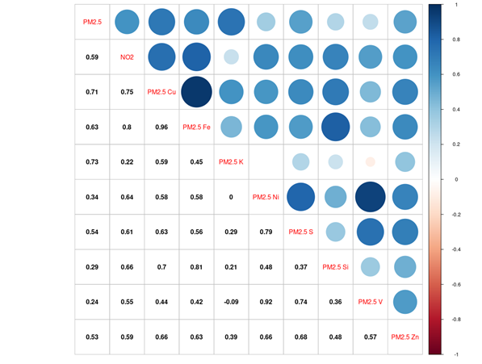

PM2.5, particulate matter with aerodynamic diameters of less than 2.5 μm; NO2, nitrogen dioxide; Cu, copper; Fe, iron; K, potassium; Ni, nickel; S, sulfur; Si, silicon; V, vanadium; Zn, zinc.

Figure S9. Pearson correlations between air pollutants composition estimated from random forest model in the pooled cohort.

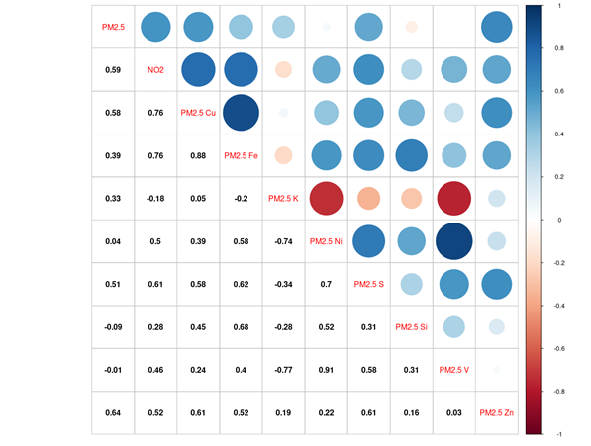

PM2.5, particulate matter with aerodynamic diameters of less than 2.5 μm; NO2, nitrogen dioxide; Cu, copper; Fe, iron; K, potassium; Ni, nickel; S, sulfur; Si, silicon; V, vanadium; Zn, zinc.

Figure S10. Associations of PM2.5 composition with psychiatric disorders mortality in single-pollutant and two-pollutant models in Supervised Linear Regression and Random Forest analyses. (N= 271,003; Psychiatric disorder mortality= 239)

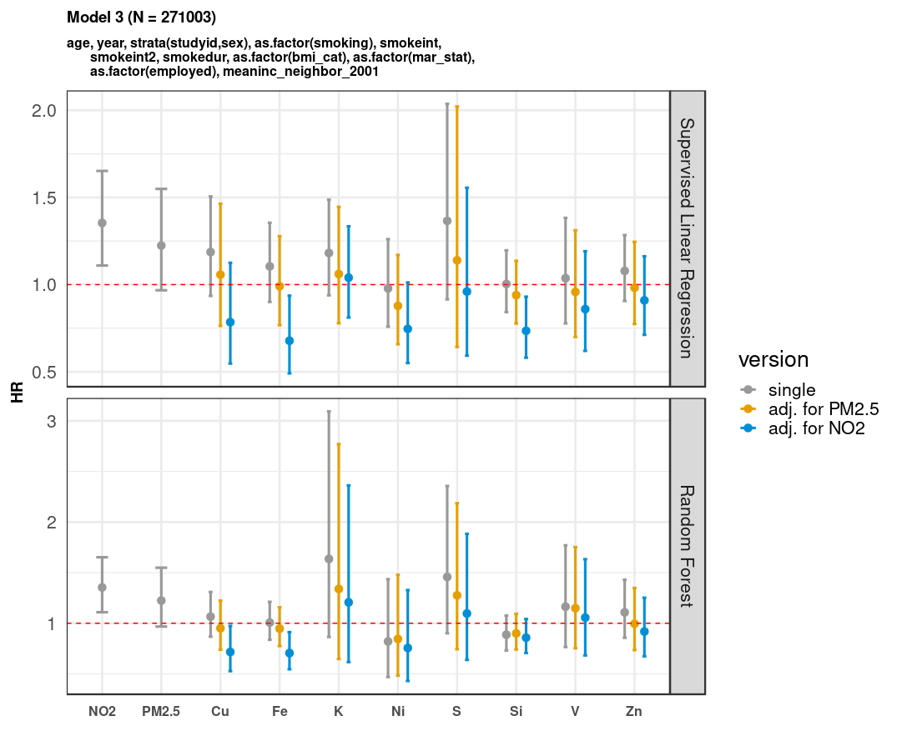

Results are presented as hazard ratio and 95% confidence interval [HR (95%CI)] for the following increments: 10 µg/m3 for nitrogen dioxide (NO2) and 5 µg/m3 for particulate matter with aerodynamic diameters of less than 2.5 μm (PM2.5), and interquartile range increments for each composition. The main model was adjusted for sub-cohort identification, age, sex, year of enrollment, smoking (status, duration, intensity, and intensity2), body mass index categories, marital status, employment status, and 2001 neighborhood-level mean income. In two-pollutant models, PM2.5 and NO2 exposures were estimated using the land-use regression models.

Note: Cu, copper; Fe, iron; K, potassium; Ni, nickel; S, sulfur; Si, silicon; V, vanadium; Zn, zinc.

Figure S11. Associations of PM2.5 composition with dementia mortality in single-pollutant and two-pollutant models in Supervised Linear Regression and Random Forest analyses. (N= 271,003; dementia mortality= 898)

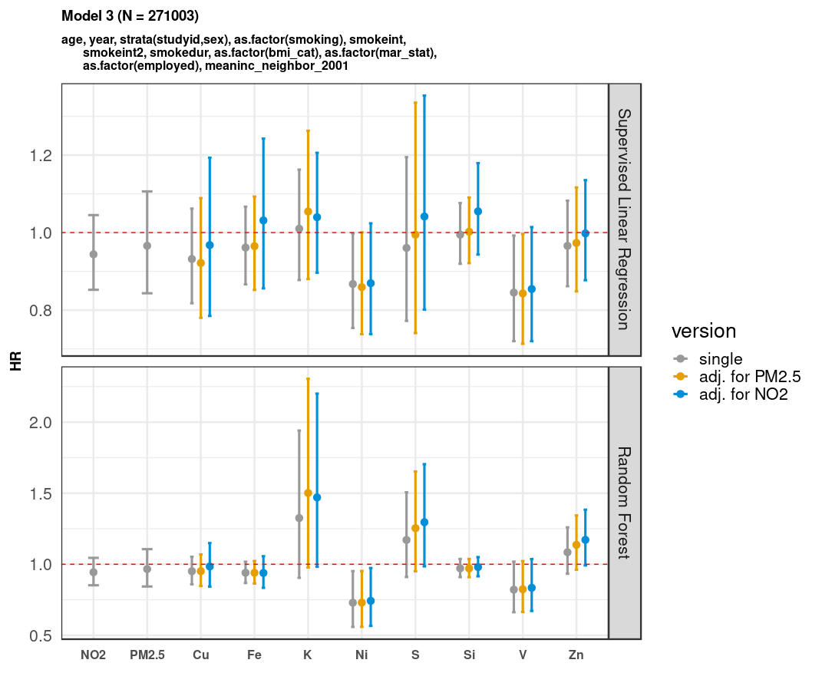Results are presented as hazard ratio and 95% confidence interval [HR (95% CI)] for the following increments: 10 µg/m3 for nitrogen dioxide (NO2) and 5 µg/m3 for particulate matter with aerodynamic diameters of less than 2.5 μm (PM2.5), and interquartile range increments for each composition.

The main model was adjusted for sub-cohort identification, age, sex, year of enrollment, smoking (status, duration, intensity, and intensity2), body mass index categories, marital status, employment status, and 2001 neighborhood-level mean income. In two-pollutant models, PM2.5 and NO2 exposures were estimated using the land-use regression models.

Note: Cu, copper; Fe, iron; HR, hazard ratio; K, potassium; Ni, nickel; S, sulfur; Si, silicon; V, vanadium; Zn, zinc.

Figure S12. Associations of PM2.5 composition with suicide mortality in single-pollutant and two-pollutant models in Supervised Linear Regression and Random Forest analyses. (N= 271,003; suicide mortality= 161)

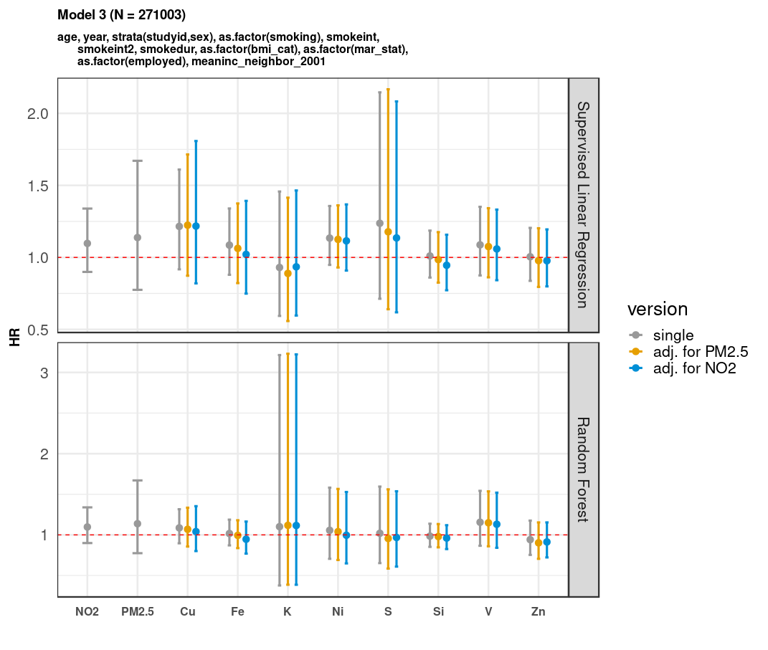

Results are presented as hazard ratio and 95% confidence interval [HR (95%CI)] for the following increments: 10 µg/m3 for nitrogen dioxide (NO2) and 5 µg/m3 for particulate matter with aerodynamic diameters of less than 2.5 μm (PM2.5), and interquartile range increments for each composition.

The main model was adjusted for sub-cohort identification, age, sex, year of enrollment, smoking (status, duration, intensity, and intensity2), body mass index categories, marital status, employment status, and 2001 neighborhood-level mean income. In two-pollutant models, PM2.5 and NO2 exposures were estimated using land-use regression models.

Note: Cu, copper; Fe, iron; HR, hazard ratio; K, potassium; Ni, nickel; S, sulfur; Si, silicon; V, vanadium; Zn, zinc.