Supplementary Material

Identification of Disease-Causing Variants by Comprehensive Genetic Testing with Exome Sequencing in Adults with Suspicion of Hereditary FSGS

Matthias Christoph Braunisch^{1,2}, Korbinian Maria Riedhammer^{1,2}, Pierre-Maurice Herr², Sarah Draut², Roman Günthner^{1,2}, Matias Wagner^{2,3,4}, Marc Weidenbusch⁵, Adrian Lungu⁶, Bader Alhaddad², Lutz Renders¹, Tim M Strom^{2,3}, Uwe Heemann¹, Thomas Meitinger^{2,3}, Christoph Schmaderer¹, and Julia Hoefele²

Table of Contents
Pedigree and segregation F9, COL4A3 (NM_000091.4) 2
Pedigree and segregation F26, COQ8B (NM_024876.4) 2
Pedigree and segregation F27, INF2 (NM_022489.3) 3
Pedigree and segregation F103, INF2 (NM_022489.3) 4
Pedigree and segregation F274, COL4A5 (NM_000495.3) 5
Pedigree and segregation F332, MUC1 (NM_001204285.1) 5
Pedigree and segregation F520, WT1 (NM_024426.4) 6

Pedigree and segregation F9, COL4A3 (NM_000091.4)
c.[2126-1G>C];[4421T>C], p.[?];[Leu1474Pro]

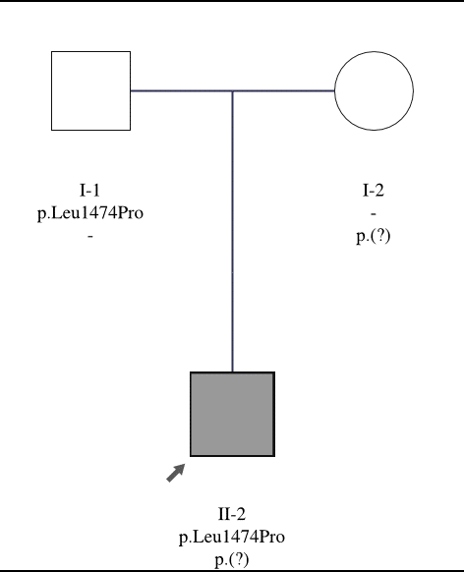

Pedigree and segregation F26, COQ8B (NM_024876.4)
c.1447G>T(;)(1447G>T), p.Glu483*(;)(Glu483*)

Pedigree and segregation F27, INF2 (NM_022489.3)
c.[529C>T];[=], p.[Arg177Cys];[=]

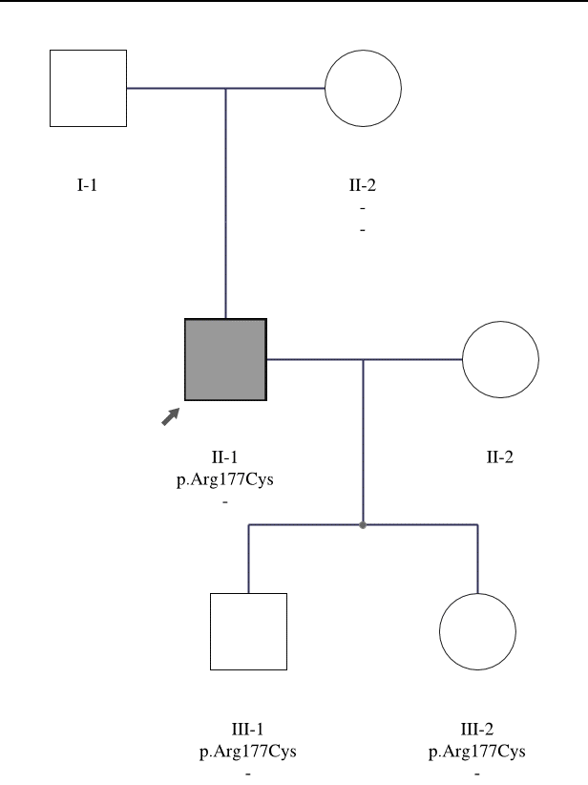
Note: Predictive testing was performed in the two asymptomatic children III-1 and III-2. III-1 is presently 9 years old and III-2 is presently 6 years old. Disease-causing variants are typically associated with a late-onset phenotype ¹.

Pedigree and segregation F103, INF2 (NM_022489.3)
c.[490G>C];[=], p.[Ala164Pro];[=]

Note: No DNA and phenotype information were available from III-16. Also, no DNA was available from IV-9.

Pedigree and segregation F274, COL4A5 (NM_000495.3)
c.[2359G>A];[=], p.[Gly787Arg];[=]

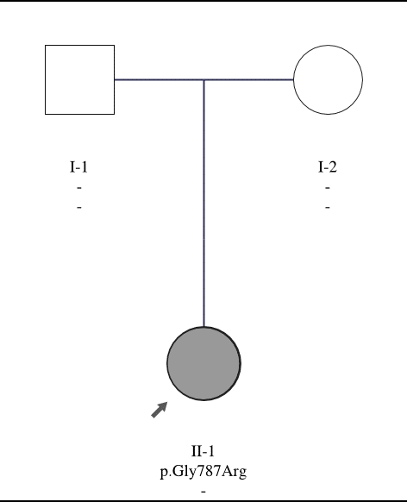

Pedigree and segregation F332, MUC1 (NM_001204285.1)
c.[103_564insG];[=], p.[?];[=]

Pedigree and segregation F520, WT1 (NM_024426.4)
c.[1432+4C>T];[=], p.[?];[=]

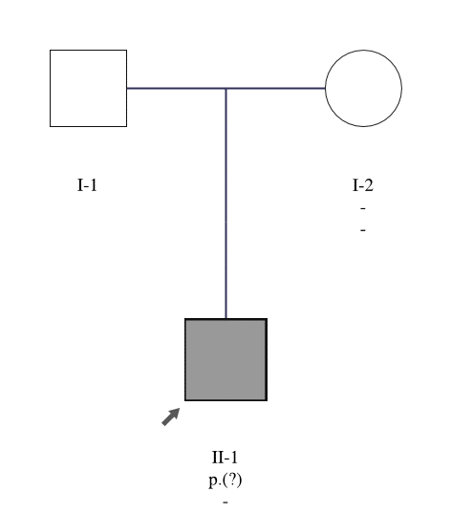

References
1. Brown EJ, Schlondorff JS, Becker DJ, Tsukaguchi H, Tonna SJ, Uscinski AL et al: Mutations in the formin gene INF2 cause focal segmental glomerulosclerosis. Nat Genet 2010; 42: 72-76.

