**Hypotaurine reduces glucose-mediated vascular calcification**

**Supplementary figures**

**Supplementary Figure 1**

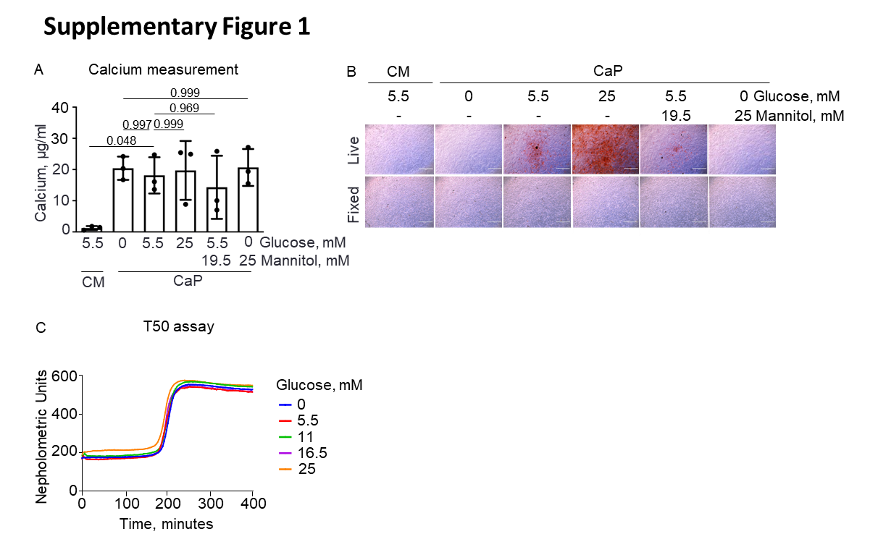

**Supplementary Figure 1.** **Glucose did not affect calcium/phosphate (CaP) complex building. A)** Calcium content was measured in control (CM; 5.5 mM glucose) and CaP media with varying glucose (0 mM, 5.5 mM and 25 mM) and its corresponding mannitol concentrations after 7 days of incubation in the absence of cells. Mean ± SD. N = 3. One-way ANOVA with Sidak’s post hoc test. **B)** Representative images of extracellular matrix mineral using Alizarin Red staining for live and 4 % paraformaldehyde-fixed primary human coronary artery smooth muscle cells treated with glucose and mannitol in CaP for 7 days. Scale bars: 1000 µm. N = 3. **C)** T50 values in response to different glucose concentrations. Based on a turbidity test, T50 assay measures the half-maximum transformation time of primary calciproteins into secondary calciproteins. Glucose was diluted in 140 mM NaCl solution to a final concentration of 0, 5, 25 and 25 mM. Data are presented as mean of two independent experiments in duplicates.

**Supplementary Figure 2**

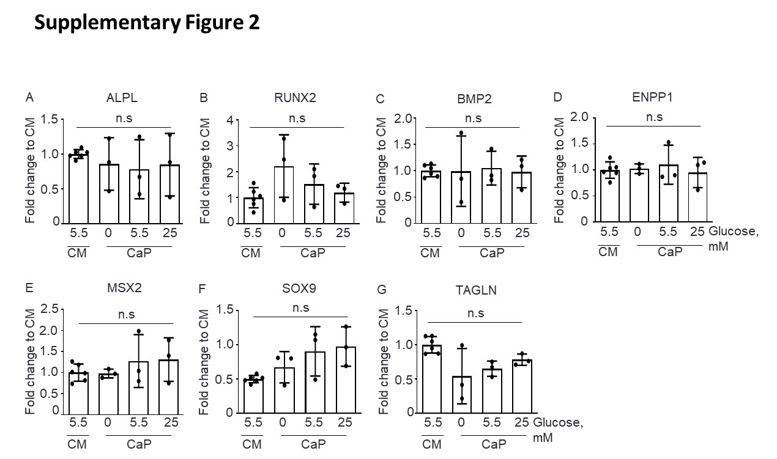

**Supplementary Figure 2.** **Calcium/phosphate (CaP) treatment and glucose did not alter the mRNA expression of the classic osteogenic, chondrogenic, and smooth muscle cell markers.** Primary human coronary artery smooth muscle cells (pSMC) were cultured in control (CM; 5.5 mM glucose) or CaP-enriched media with 0, 5.5, or 25 mM glucose for 7 days. mRNA levels were quantified by qPCR. **A)** tissue-nonspecific alkaline phosphatase (ALPL), **B)** Runt-related transcription factor (RUNX2), **C)** Bone morphogenetic protein 2 (BMP2), **D)** Ectonucleotide pyrophosphatase / phosphodiesterase family 1 (ENPP1), **E)** Homeobox protein MSX2 (MSX2), **F)** Transcription factor SOX9 (SOX9), and **G)** Transgelin (TAGLN). N = 3, each n represents an independent pSMC donor. Mean ± SD. One-way ANOVA with Sidak’s post hoc test, n.s; not significant.

**Supplementary Figure 3**

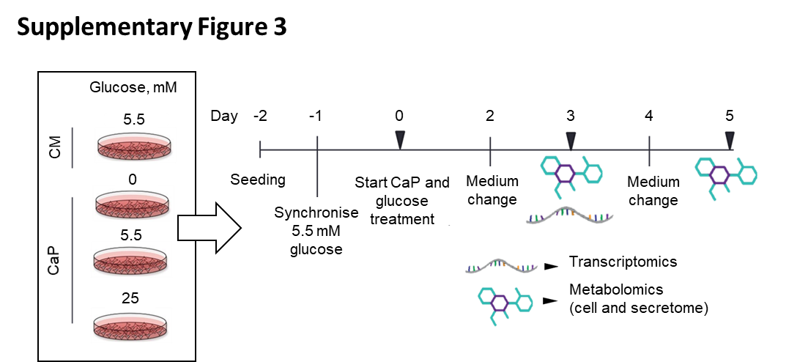

**Supplementary Figure 3.** **Experimental design for the multi-omics approach.** Three independent primary human coronary artery smooth muscle cell donors were cultured for up to 5 days in control (CM; 5.5 mM glucose) and calcium/phosphate (CaP) medium with 0, 5.5, and 25 mM glucose. Transcriptomics was performed on day 3. Metabolomics from cells and supernatant were performed on days 3 and 5.

**Supplementary Figure 4**

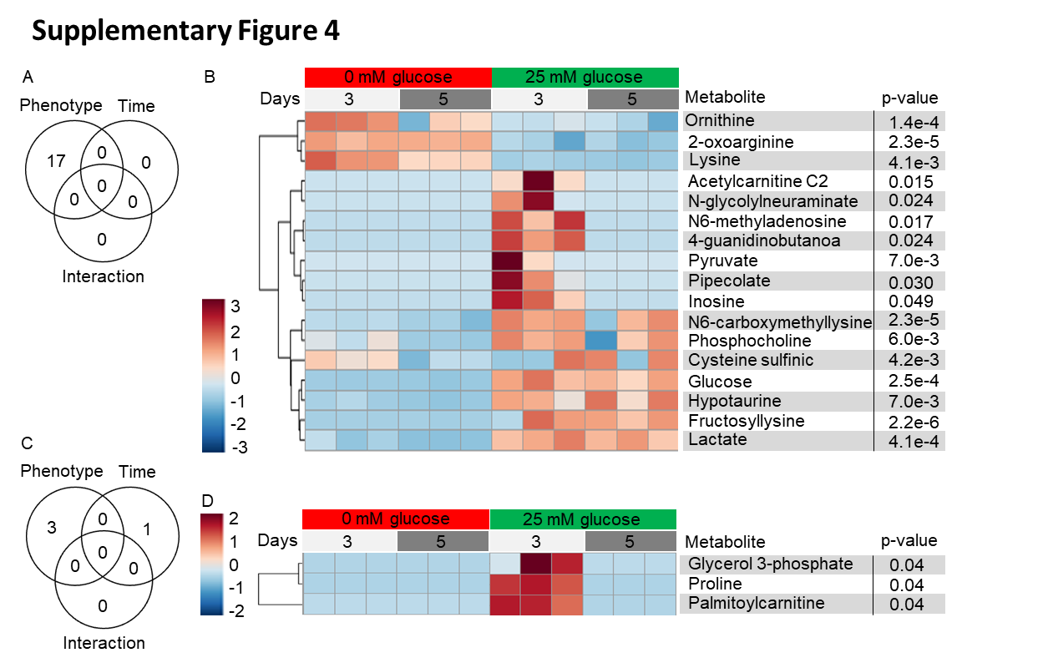

**Supplementary Figure 4. Two-way ANOVA analysis evaluated the metabolomic changes associated with the phenotype (0 and 25 mM glucose) and time (3 and 5 days) in calcifying primary human coronary artery smooth muscle cells cultured in 0 or 25 mM glucose.** Venn diagram for the number of metabolites that had a significant p-value (< 0.05) regarding the phenotype, time, or the interaction of both factors for **A)** supernatant and **C)** cells.Heatmap of the abundance of the metabolites identified as significant for phenotype analysis in the **B)** supernatant and **D)** cells. Metabolites in the heatmap are sorted by clusters. Fold change ±1.2.

**Supplementary Figure 5**

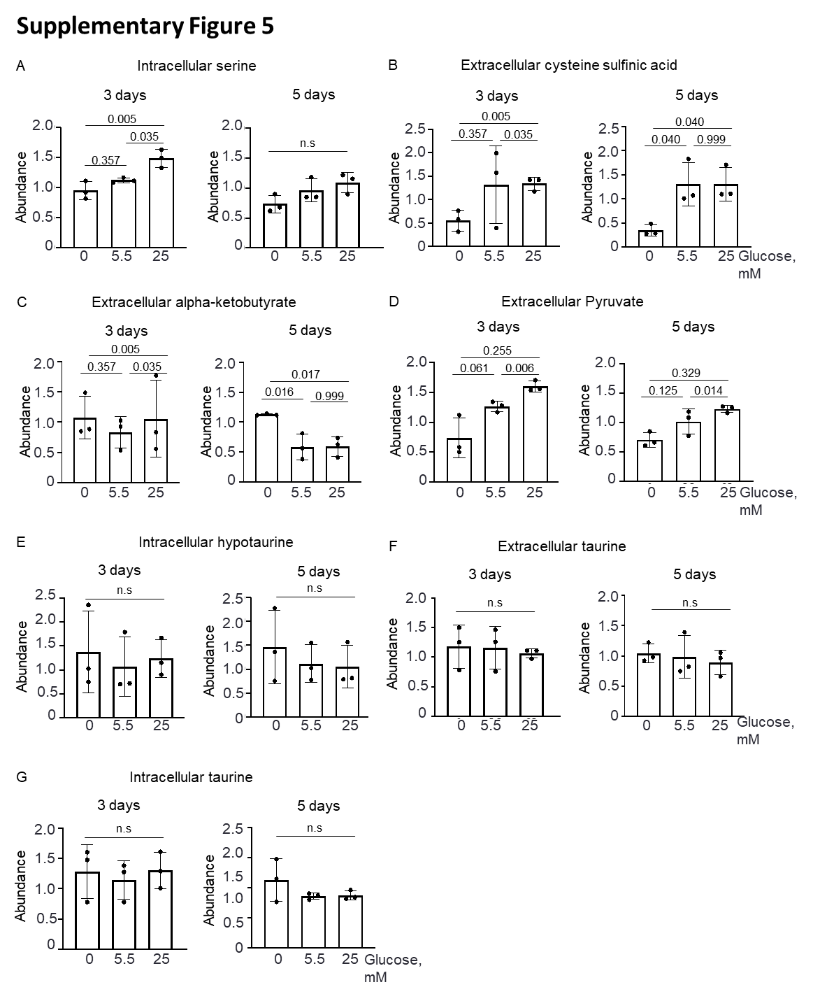

**Supplementary Figure 5. The abundance of metabolites from the hypotaurine/taurine pathway based on an untargeted metabolomics approach of calcifying primary human coronary smooth muscle cells (pSMC).** pSMC were cultured in calcium/phosphate (CaP)-enriched media with 0, 5.5, or 25 mM glucose for 3 and 5 days. The abundance of **A)** intracellular serine, **B)** extracellular cysteine sulfinic acid, **C)** extracellular alpha-ketobutyrate, **D)** extracellular pyruvate, **E)** intracellular hypotaurine, **F)** extracellular taurine, and **G)** intracellular taurine according to time. N = 3, each n represents an independent pSMC cell donor. Mean ± SD. One-way ANOVA with Turkey’s post hoc test, n.s; not significant.

**Supplementary Figure 6**

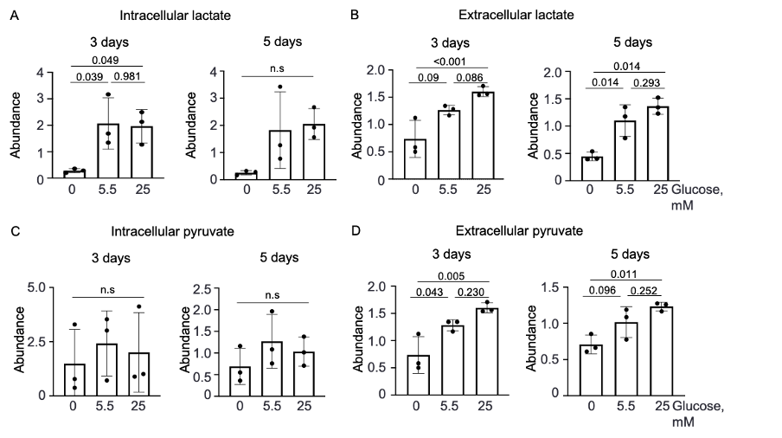

**Supplementary Figure 6. The abundance of intracellular and extracellular lactate based on an untargeted metabolomics approach of calcifying primary human coronary smooth muscle cells (pSMC).** pSMC were cultured in calcium/phosphate (CaP)-enriched media with 0, 5.5, or 25 mM glucose for 3 and 5 days. The abundance of **A)** intracellular lactate, **B)** extracellular lactate. N = 3, each n represents an independent pSMC cell donor. Mean ± SD. One-way ANOVA with Turkey’s post hoc test, n.s; not significant.

**Supplementary Figure 7**

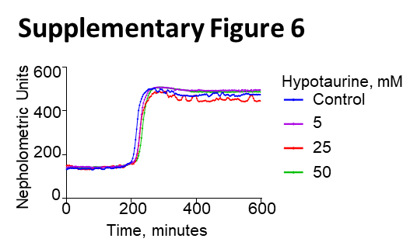

**Supplementary Figure 7.** **Hypotaurine did not affect calcium/phosphate (CaP) complex building based on T50 turbidity test.** Hypotaurine was diluted in 140 mM NaCl solution to a final concentration of 5, 25 and 50 mM. Data are presented as mean of two independent experiments in duplicates.

**Supplementary Figure 8**

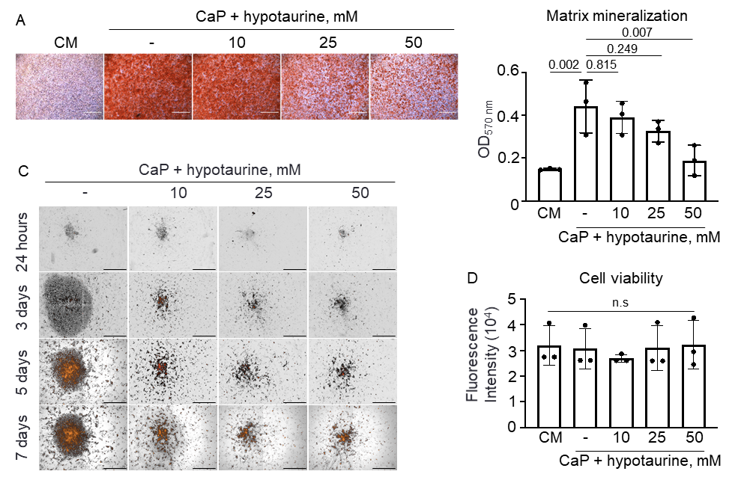

**Supplementary Figure 8.** **Hypotaurine reduced ECM calcification in calcifying hyperglycemic human ventral smooth muscle cells.** Cells were cultured in 25 mM glucose under calcium/phosphate (CaP) media with or without hypotaurine (10, 25, 50 mM). Mineralization was visualized using live-time fluorescence imaging using Alexa Fluor®-546-tagged fetuin-A (orange) as a calcification sensor merged to phase contrast (gray/black). Representative images from n = 3 independent human ventral smooth muscle cell donors (in duplicates). Scale bar: 1000 μm.

**Supplementary Figure 9**

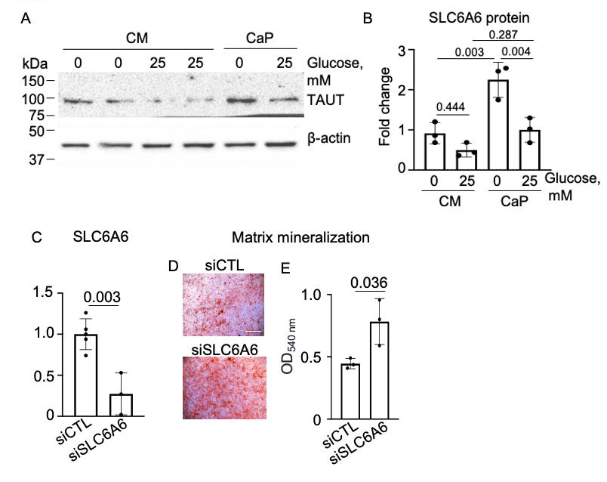  
**Supplementary Figure 9.** **Silencing of SLC6A6 promoted extracellular matrix calcification in calcifying hyperglycemic immortalized vascular smooth muscle cells (imSMC).** Human vascular immortalized smooth muscle cells (imSMCs) were cultured in 0 mM or 25 mM glucose under control (CM) and calcium/phosphate (CaP) conditions for 7 days. A) Protein expression of the taurine/hypotaurine receptor (TAUT; *SLC6A6*) was accessed by western blot and B) quantified. C) *SLC6A6* was silenced, and the mRNA expression was quantified by qPCR. D) The alizarin red staining visualized extracellular matrix mineralization and E) eluted for quantification. Mean ± SD. Fold increase to 0 mM glucose CM. n = 3-4 in duplicates, each n represents an independent experiment. One-way ANOVA with Sidak’s post hoc test.