Crystal structure of a biliverdin-bound phycobiliprotein: interdependence of oligomerization and chromophorylation

Juan Pablo Fuenzalida-Wernera+, Robert Janowskib+, Kanuj Mishraa, Ina Weidenfelda, Dierk Niessingb,d, Vasilis Ntziachristosa,e,f and Andre C. Stiela

a) Institute of Biological and Medical Imaging (IBMI), Helmholtz Zentrum München, Neuherberg, Germany

b) Intracellular Transport and RNA Biology Group, Institute of Structural Biology, Helmholtz Zentrum München, Neuherberg, Germany

d) Institute of Pharmaceutical Biotechnology, Ulm University, Ulm, Germany

e) Chair of Biological Imaging, Technische Universität München, Munich, Germany

f) Center for Translational Cancer Research (TranslaTUM), Technische Universität München, Munich, Germany

+) J.P. F.-W. and R.J. contributed equally

ABSTRACT: Small, ultra-red fluorescence protein (smURFP) introduces the non-native biliverdin (BV) chromophore to phycobiliproteins (PBPs), allowing them to be used as transgenic labels for *in vivo* mammalian imaging. Presently, no structural information exists for PBPs bound to the non-native BV chromophore, which limits the further development of smURFP and related proteins as imaging labels or indicators. Here we describe the first crystal structure of a PBP bound to BV. The structures of smURFP-Y56R with BV and smURFP-Y56F without BV reveal unique oligomerization interfaces different from those in wild-type PBPs bound to native chromophores. Our structures suggest that the oligomerization interface affects the BV binding site, creating a link between oligomerization and chromophorylation that we confirmed through site-directed mutagenesis and that may help guide efforts to improve the notorious chromophorylation of smURFP and other PBPs engineered to bind BV.

1. Introduction

Far-red absorbing transgene labels are a prerequisite for *in vivo* mammalian imaging, allowing deeper penetration by evading the abundant endogenous absorber hemoglobin (Rodriguez et al., 2017; Shcherbakova et al., 2018). Phycobiliproteins (PBPs) are, apart from bacteriophytochromes (BphPs), the only class of natively far‑red absorbing proteins (Oliinyk et al., 2017). These proteins, naturally found as light-harvesting complexes in photosynthetic bacteria, can contain several tetrapyrrole-based chromophores with high absorption coefficients (> 100,000 M-1 cm-1) and photostability. The basic structural building block is a heterodimer of two highly structurally homologous globin folds that nevertheless share relatively low sequence identity (Watanabe and Ikeuchi, 2013). Recently the laboratory of the late Roger Tsien replaced the natural phycocyanobilin (PCB) chromophore of *Trichodesmium erythraeum* allophycocyanin with biliverdin (BV), a product of the heme degradation pathway that, unlike native PBP chromophores, is readily available in mammalian cells. The result was a small, ultra-red fluorescent protein (smURFP) showing absorption at 642 nm and emission  at 670 nm (Rodriguez et al., 2016). More recently, Zhao and coworkers reported another PBP with BV binding capability, termed biliprotein derived fluorescent protein (BDFP), which absorbs around 680 nm (Ding et al., 2017). BDFP binds BV more efficiently than smURFP does, but it shows approximately 50% lower absorptivity. Both smURFP and BDFP can be expressed in functional form in mammalian cell lines. However, in contrast to BphPs efficient chromophorylation continues to be a challenge for PBPs, curtailing their potential (Shemetov et al., 2017), among other things possibly due to native PBPs frequently relying on lyases for chromophore attachment (Scheer and Zhao, 2008).

Presently, structural information is missing on smURFP or any other PBP bound to the non‑native chromophore BV stalling further engineering efforts (Miyawaki, 2016). Here, we elucidated structures of smURFP with and without BV to provide insights into chromophore binding and oligomerization. Given the strong structure homology among PBPs, the results may help guide the engineering of BV-binding PBPs as mammalian imaging labels

1. Results and discussion

Several attempts to crystallize wild-type smURFP failed, and we reasoned that this may be due to heterogeneity in the protein sample because of low chromophorylation. Consequently, we probed positions in the vicinity of the expected chromophore position for an influence on chromophorylation. We noticed that all substitutions at position 56 resulted in a slight increase in chromophorylation; Y56R, which occurs only in few PBPs (Coll et al., 1978), stood out by leading to 5 times better chromophorylation (Supplemental Table 1). Crystallization of smURFP‑Y56R yielded brilliant blue crystals, indicative of bound chromophore, providing us with a 2.5 Å resolution structure showing a homodimer in the asymmetric unit exhibiting an interface unique among PBPs (Figure 1A and 2A). The canonical interface in native PBPs is formed by strong symmetric interactions between helices X and Y (Figure 1C and 2C). However, with these helices absent from smURFP, we instead observe a symmetric interface formed by helices A, E and F; with helices E and F being part of the chromophore binding side. A single BV chromophore per dimer is stabilized by canonical interactions, similar to those in the nearest homologous crystal structure, allophycocyanin B from *Synechocystis* PCC 6803 complexed with its native chromophore PCB (4po5) (Peng et al., 2014): R54 interacts with the ring-C carboxyl, D55 interacts with the nitrogens of rings B and C (Figure 3A), and S100 and S89 form hydrogen bonds with carbonyl groups of the chromophore. However, in contrast to stabilization of the canonical chromophore, S77 of the second chain forms a hydrogen bond with the carboxyl of ring C and carbonyl of ring D (Figure 3A), suggesting that the chromophore additionally stabilizes this dimer interface. Chromophore binding destroys the total symmetry, as can be observed by placing a theoretical second chromophore in the binding pocket of chain B (Figure 3B): in this case, S77 of chain A interacts not with the chromophore but instead with H61 of chain B. This further stabilizes the interface but likely precludes binding of a second chromophore. Comparison of the binding region with and without chromophore (chain A vs. chain B) shows that the chromophore tightens the binding pocket by tilting helices G and E slightly towards the chromophore. Likely this is due to the interaction between R56 with the catalytic C52, which lie approximately ~3 Å apart. This interaction, together with the positive charge of R56, likely promotes attachment of the negatively charged BV. This may help explain why we were able to crystallize this mutant but not the wild-type protein.

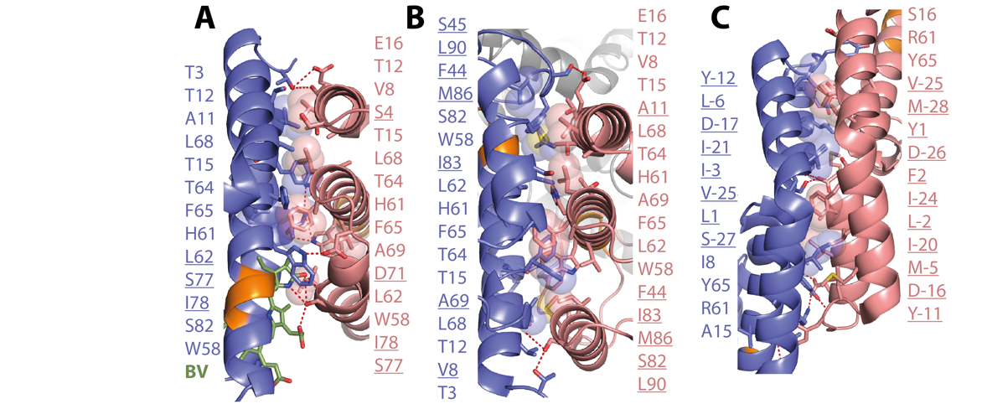

**Figure 2.** Dimer interfaces with contributing residues for **(A)** Structure of smURFP-Y56R bound to the BV chromophore, **(B)** smURFP-Y56F without chromophore and **(C)** a canonical PBP (4po5) bound to the native PCB chromophore. Residues that are unique for the given interface are underlined. All numbers are given for smURFP nomenclature.

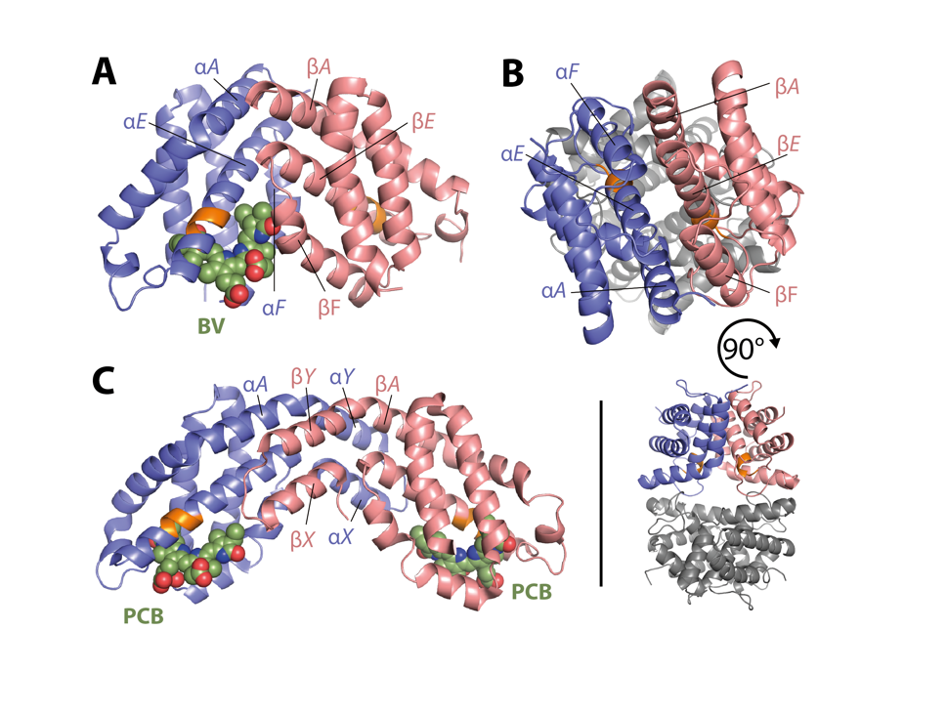

**Figure 1. (A)** Structure of smURFP-Y56R bound to the BV chromophore, **(B)** smURFP-Y56F without chromophore and **(C)** a canonical PBP (4po5) bound to the native PCB chromophore. Structural overview with helices contributing to the interface annotated.

Since our work is the first PBP structure with a BV chromophore, we can only compare to another class of bacterial photoreceptor; BphPs frequently bear BV chromophores and several structures exists. The chromophore in smURFP-Y56R shows higher planarity than two exemplary engineered BphPs (Supplementary Table S3). However, in comparison to those the high planarity of smURFP-Y56R is not associated with a redshift (Peng et al., 2014; Sjöqvist et al., 2014). This discrepancy is most likely due to the less shielded environment of the chromophore in PBPs compared to BphPs (Supplementary Figure S2). E.g. in our structure 24 residues can be found in a 5 Å radius around the BV while this number range from 31 (PDB: 5VIK) to 42 (PDB: 3S7Q) in BphPs.

To obtain more insight into BV binding to smURFP, we determined the structure of the protein without the chromophore. Efforts to crystallize the wild-type and Y56R proteins failed, presumably due to various oligomerization states (see below) and flexibility in the stretch upstream of the CLRD motif (Supplementary Figure S1). We succeeded in crystallizing smURFP‑Y56F and determined the structure at 2.3 Å resolution, revealing a tetramer in the asymmetric unit. Comparison of this structure with the chromophorylated smURFP-Y56R structure (Figure 1B and 2B) described above revealed that the dimer interface in the absence of BV is still formed by helices A, E and F, but rotated by 180° relative to the interface in the BV-bound structure. Since position 56 is not part of either interface, we reasoned that the binding of the chromophore is resulting in the different interfaces. With -13 kcal/mol (based on PISA interface energy calculation (Krissinel and Henrick, 2007)) and an additionally ‑3 kcal/mol from the chromophore-to-S77 interaction the BV-bound interface is less energetically favorable compared to the interface observed in the structure without BV (‑24 kcal/mol), which may explain why smURFP does not efficiently chromophorylate (Shemetov et al., 2017).

Accordingly, the interface promiscuity of smURFP suggests, that mutations that alter the oligomerization interface should influence chromophorylation. Indeed, disrupting interactions that were observed in the BV-free smURFP-Y56F but not in the BV-bound smURFP-Y56R improved chromophorylation as we could show by analytical size exclusion chromatography and judging chromophorylation by the Soret/A280 ratio (smURFP-F44A+S45A, Figure 4A4 and 4B4 and Supplementary Table S1, Supplementary Figure S3). Mutations that stabilize helix E and promote the interface observed in the BV-bound structure increased chromophorylation (smURFP-G57S, Figure 4B5). Disrupting hydrophobic protein-protein interactions that stabilize the oligomerization interface in smURFP-Y56R converted the normally dimeric protein into a monomer, which was accompanied by complete loss of chromophorylation (smURFP-F65A+I81R+I83A and smURFP-F65K+I81R+I83A Figure 4A6-7 and 4B6-7). These results suggest that an appropriate dimer interface is crucial for BV attachment, perhaps because chromophore binding is unfavorable without additional interactions provided by the second chain (e.g. residue S77). Similarly, in BDFP chromophorylation appears to be substantially higher for the dimer (Ding et al., 2017). Further, the effect of the mutations in the wildtype background suggest that the interfaces in wildtype are similar to the ones observed in our crystal structures and have comparable effects. We observed that in typical preparations of wild-type smURFP in our hands, a small proportion was tetrameric, and this population showed a higher degree of chromophorylation than the dimeric population (Figure 4A1). These results together with the tetrameric structure of non-chromophorylated smURFP-Y56F, imply that higher-order oligomers of smURFP do form and may further influence chromophorylation.

1. Conclusion

In summary, engineered PBPs with BV chromophores are highly promising for a new generation of labels due to their strong far-red absorbance, fluorescence and high chromophore-to-protein ratio. Here we report the first structures of this protein class with the BV chromophore essential for *in vivo* mammalian imaging. The structure shows a unique oligomerization interface and its involvement in chromophorylation. These results will enable further engineering to improve *in vivo* chromophorylation, generate variants that are farther red-shifted and implement PBPs in transgene indicator strategies analogous to those used so successfully for green fluorescent proteins.

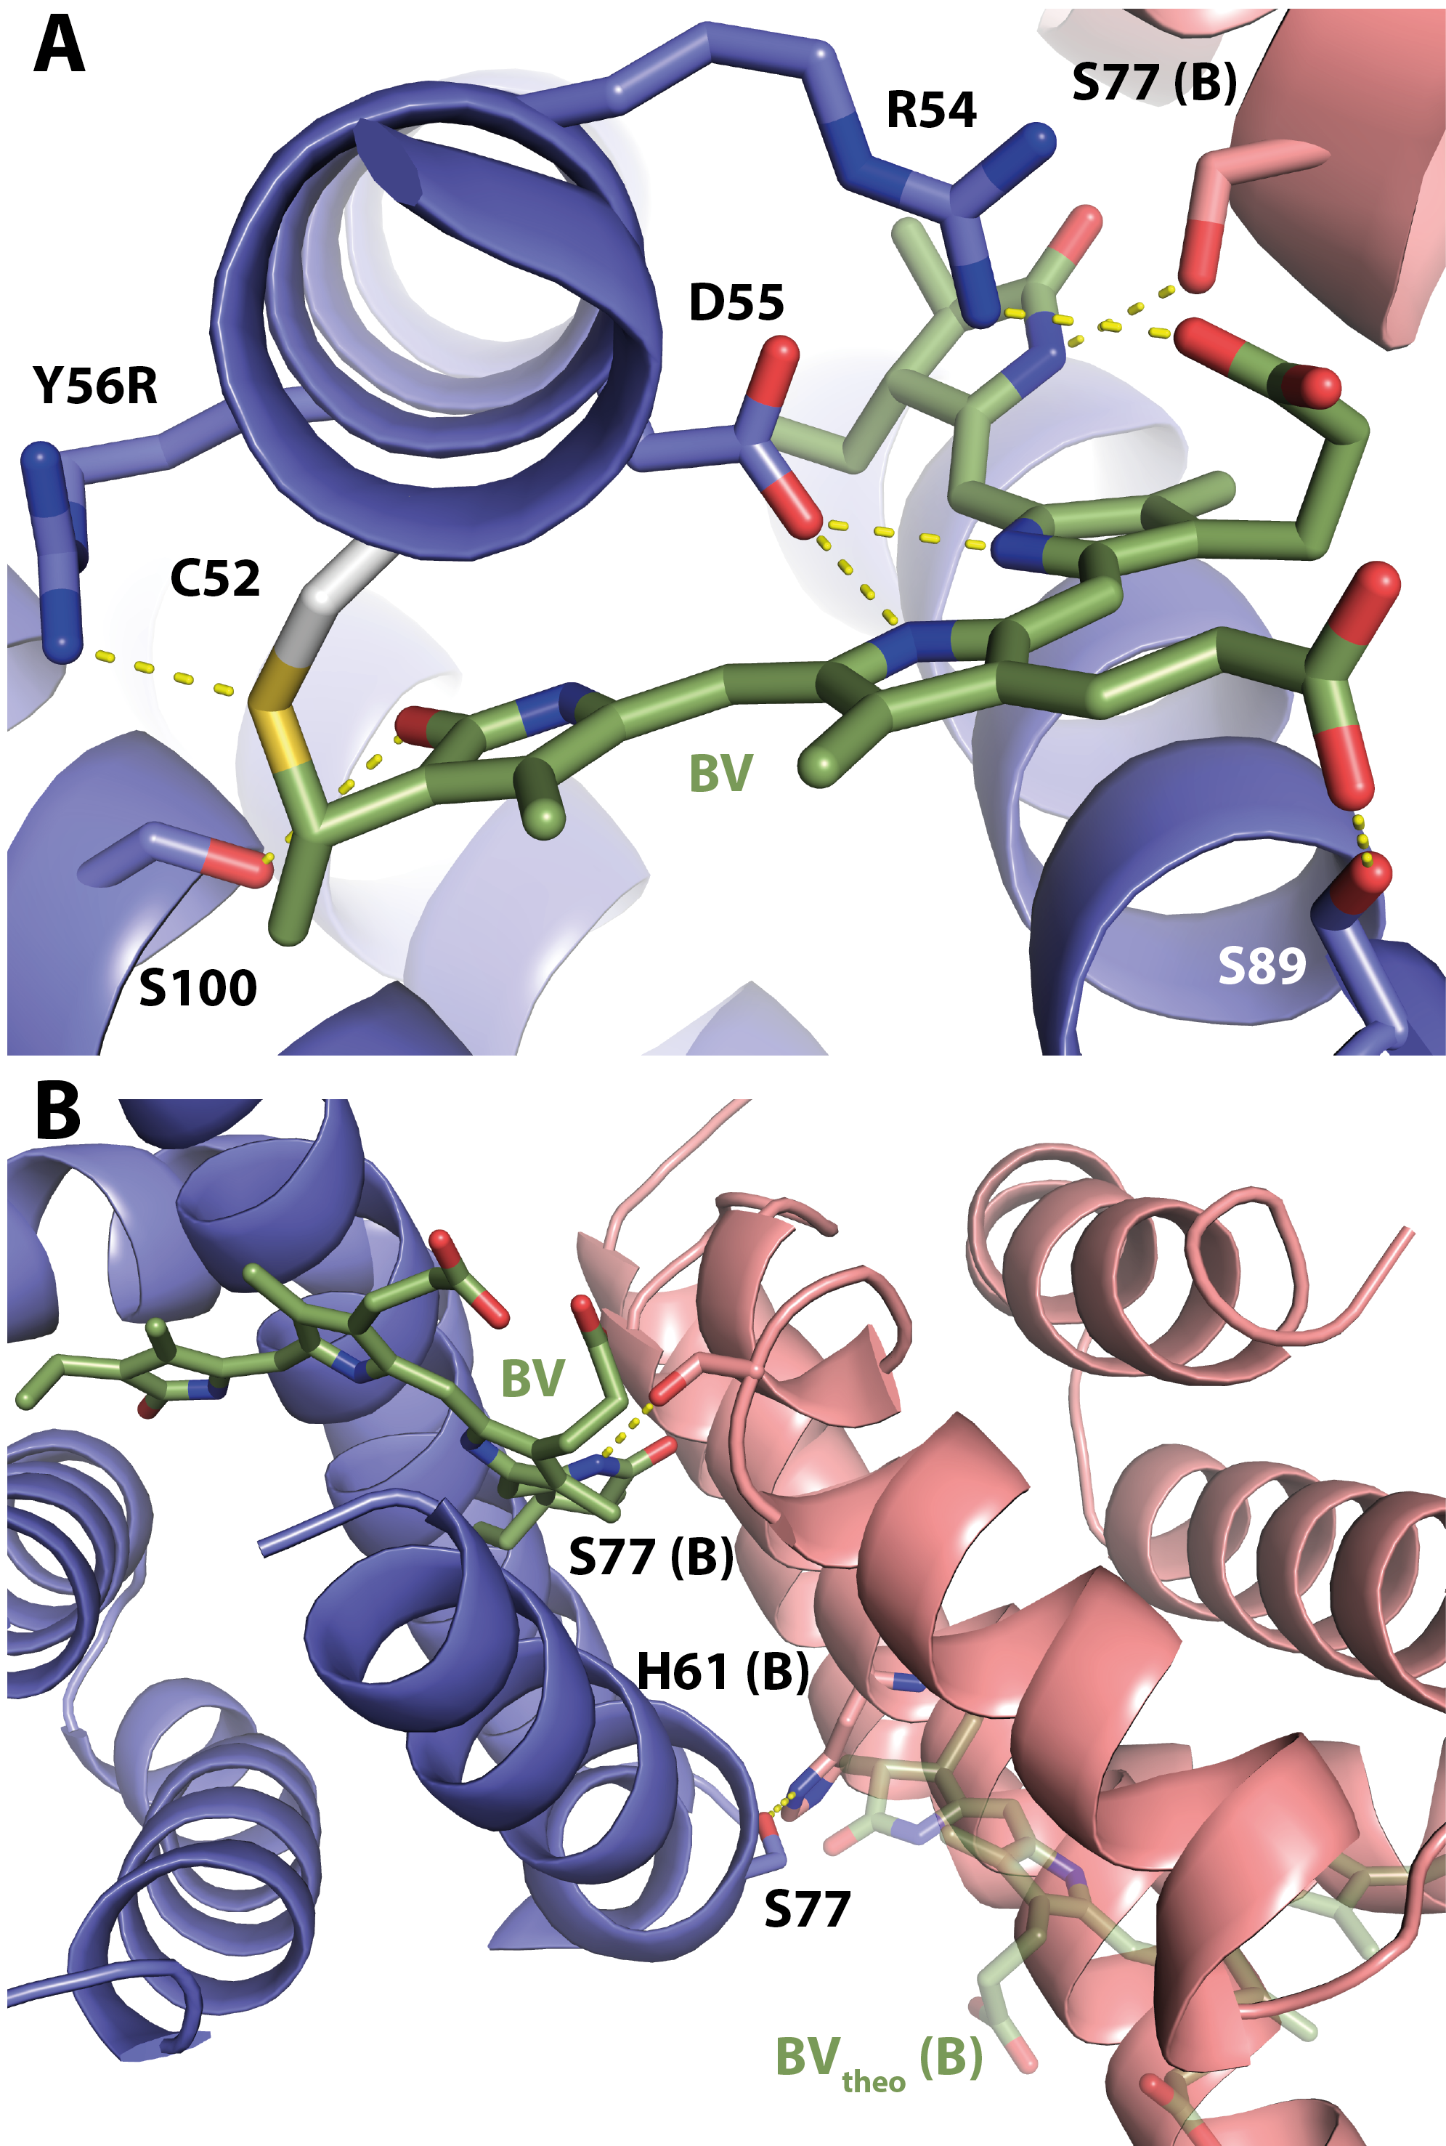

**Figure 3.** smURFP-Y56R **(A)** Binding pocket with the BV chromophore covalently attached to C52 and **(B)** dimer interface with the interaction between the chromophore and S77 as well as a second theoretical chromophore binding pocket, where the chromophore cannot form this interaction. Thus, no chromophore can be identified in this pocket.

ASSOCIATED CONTENT

**Supporting Information**.

Supporting information file contains tabular data for each variant, further structure visualization, data collection and refinement statistics as well as experimental details.

AUTHOR INFORMATION

Corresponding Author

A.C.S. andre.stiel@helmholtz-muenchen.de

Author Contributions

J.P.F-W. and A.C.S. conceived experiments, analyzed all data and wrote the manuscript. J.P.F‑W. and K.M. conducted molecular biology and protein purification and spectroscopy. R.J. conducted x-ray crystallography work and elucidated the structures. I.M.W. helped testing smURFP variants. D.N. and V.N. contributed to the manuscript.

Funding Sources

No competing financial interests have been declared.

A.C.S. and K.M. received support from the Deutsche Forschungsgemeinschaft (STI 656/1-1).

ACKNOWLEDGMENT

The authors wish to thank R. Hillermann for technical assistance, and A.C. Rodríguez for discussions on the manuscript.

REFERENCES

Auldridge, M.E., Satyshur, K.A., Anstrom, D.M., Forest, K.T., 2012. Structure-guided Engineering Enhances a Phytochrome-based Infrared Fluorescent Protein * □ 287, 7000–7009. https://doi.org/10.1074/jbc.M111.295121

Coll, R. Mac, Edwards, M.R., Haaksma, C., 1978. Some properties of allophycocyanin from a thermophilic blue-green alga. Biophys. Chem. 8, 369–376. https://doi.org/10.1016/0301-4622(78)80018-0

Ding, W., Miao, D., Hou, Y., Jiang, S., Zhao, B., Zhou, M., Scheer, H., Zhao, K., 2017. Small monomeric and highly stable near-infrared fl uorescent markers derived from the thermophilic phycobiliprotein , ApcF2. BBA - Mol. Cell Res. 1864, 1877–1886. https://doi.org/10.1016/j.bbamcr.2017.08.002

Feliks, M., Lafaye, C., Shu, X., Royant, A., Field, M., 2016. Structural Determinants of Improved Fluorescence in a Family of Bacteriophytochrome-Based Infrared Fluorescent Proteins: Insights from Continuum Electrostatic Calculations and Molecular Dynamics Simulations. Biochemistry 55, 4263–74. https://doi.org/10.1021/acs.biochem.6b00295

Krissinel, E., Henrick, K., 2007. Inference of macromolecular assemblies from crystalline state. J. Mol. Biol. 372, 774–97. https://doi.org/10.1016/j.jmb.2007.05.022

Miyawaki, A., 2016. Exploiting the cyanobacterial light-harvesting 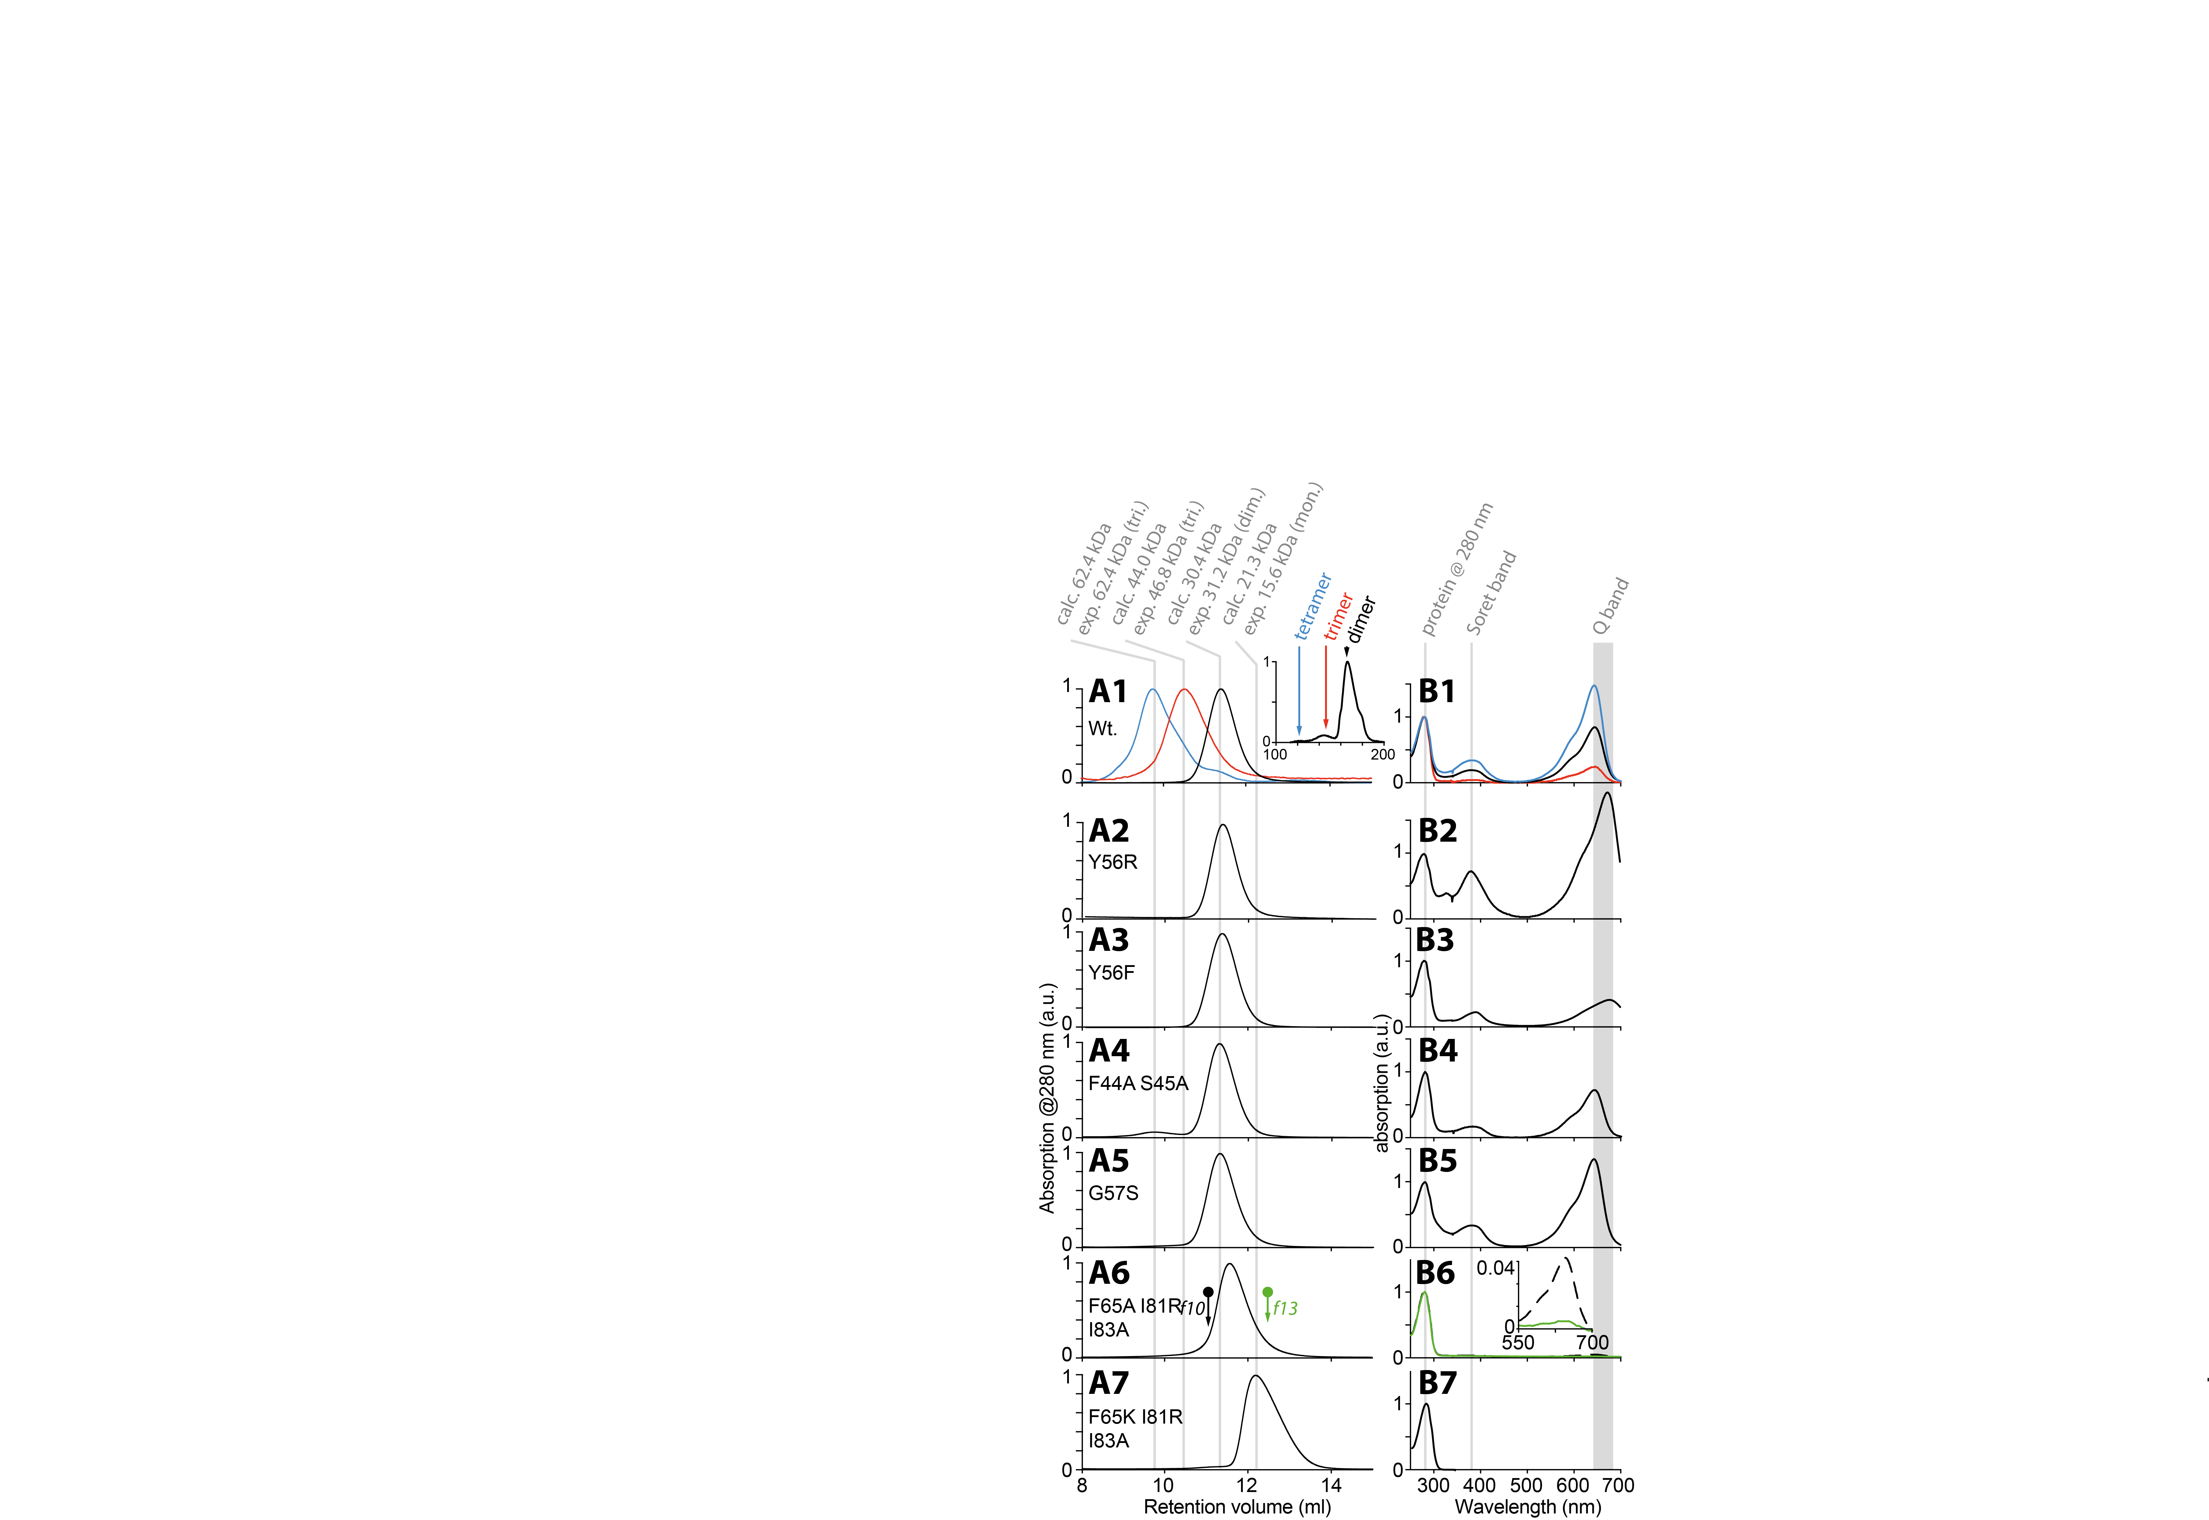machinery for developing fluorescent probes. Nat. Methods 13, 729–730. https://doi.org/10.1038/nmeth.3983

Oliinyk, O.S., Chernov, K.G., Verkhusha, V. V, 2017. Bacterial Phytochromes, Cyanobacteriochromes and Allophycocyanins as a Source of Near-Infrared Fluorescent Probes. Int. J. Mol. Sci. 18. https://doi.org/10.3390/ijms18081691

Peng, P.-P., Dong, L.-L., Sun, Y.-F., Zeng, X.-L., Ding, W.-L., Scheer, H., Yang, X., Zhao, K.-H., 2014. The structure of allophycocyanin B from {\it Synechocystis} PCC 6803 reveals the structural basis for the extreme redshift of the terminal emitter in phycobilisomes. Acta Crystallogr. Sect. D 70, 2558–2569. https://doi.org/10.1107/S1399004714015776

Rodriguez, E.A., Campbell, R.E., Lin, J.Y., Lin, M.Z., Miyawaki, A., Palmer, A.E., Shu, X., Zhang, J., Tsien, R.Y., 2017. The Growing and Glowing Toolbox of Fluorescent and Photoactive Proteins. Trends Biochem. Sci. 42, 111–129. https://doi.org/10.1016/j.tibs.2016.09.010

Rodriguez, E.A., Tran, G.N., Gross, L.A., Crisp, J.L., Shu, X., Lin, J.Y., Tsien, R.Y., 2016. A far-red fluorescent protein evolved from a cyanobacterial phycobiliprotein. Nat. Methods 13, 763–9. https://doi.org/10.1038/nmeth.3935

Scheer, H., Zhao, K.-H.H., 2008. Biliprotein maturation: The chromophore attachment. Mol. Microbiol. 68, 263–276. https://doi.org/10.1111/j.1365-2958.2008.06160.x

Shcherbakova, D.M., Stepanenko, O. V, Turoverov, K.K., Verkhusha, V. V, 2018. Near-Infrared Fluorescent Proteins: Multiplexing and Optogenetics across Scales. Trends Biotechnol. https://doi.org/10.1016/j.tibtech.2018.06.011

Shemetov, A.A., Oliinyk, O.S., Verkhusha, V. V, 2017. How to Increase Brightness of Near-Infrared Fluorescent Proteins in Mammalian Cells. Cell Chem. Biol. 24, 758–766.e3. https://doi.org/10.1016/j.chembiol.2017.05.018

Sjöqvist, J., Maria, J., Simon, R.A., Linares, M., Norman, P., Nilsson, K.P.R., Lindgren, M., 2014. Toward a Molecular Understanding of the Detection of Amyloid Proteins with Flexible Conjugated Oligothiophenes. J. Phys. Chem. A 118, 9820–9827. https://doi.org/10.1021/jp506797j

Watanabe, M., Ikeuchi, M., 2013. Phycobilisome : architecture of a light-harvesting supercomplex 265–276. https://doi.org/10.1007/s11120-013-9905-3

**Figure 4.** Oligomerization state as indicated by (**A**) analytical size exclusion chromatography (SEC) as well as (**B**) absorption spectra for smURFP and variants. Chromatograms are normalized to the protein peaks; Absorbance spectra are normalized to the protein absorbance at 280 nm. For wildtype (Wt.) the preparative SEC is given as inset to demonstrate contribution of the different oligomeric states. f10 and f13 in A6 denote fractions of this peak representing a mixture of monomer and dimer. Accordingly, the spectra for both fractions are shown in B6 as green and black dashed line. For B the Q band maxima is given as a range due to the shift of this band in different mutants.

**Figure 3.** Oligomerization state as indicated by (**A**) analytical size exclusion chromatography (SEC) as well as (**B**) absorption spectra for smURFP and variants. Chromatography is normalized to one maximum value and spectroscopy is normalized to the intensity of the protein band at 280 nm. For wildtype (Wt.) the preparative SEC is given as inset to demonstrate contribution of the different oligomeric states.