A B

C

|  |  |  |
| --- | --- | --- |
| Undifferentiated | Differentiation medium | Browning medium |

|  |
| --- |
| **Supp. Fig. 1: Differentiation potential of DFAT.** (A, B) qPCR analysis of indicated genes in DFAT after 1 and 2 weeks in maintenance medium (Undiff), preadipocyte differentiation medium (Diff) or browning medium (Brown). Gene expression is shown as ∆CT. (C) Representative pictures of lipid accumulation after two weeks of differentiation of various culture conditions using NileRed (green). Nucleus stained with DAPI (blue). n=4-6. |

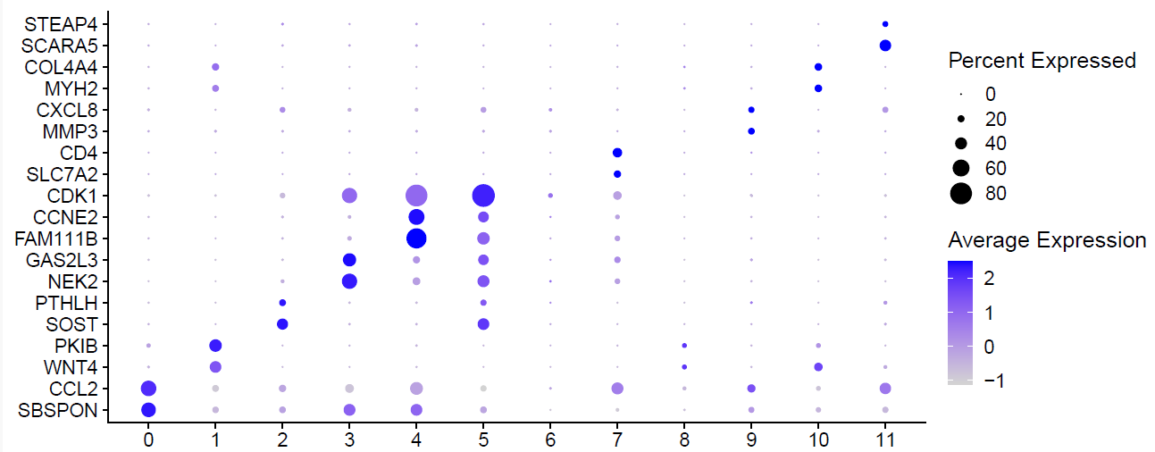

|  |
| --- |
| **Supp. Fig. 2: Examples of specific markers genes for each cluster.** Dot plot of cluster-specific marker gene expression in each of the 12 clusters. Dots depict average normalized expression (colour) and percentage of expressing cells of specified genes (size) in each cluster. n=4 |

|  |
| --- |
| **Supp. Fig. 3:** Expression of browning markers in different clusters. n=4. |



|  |
| --- |
| **Supp. Fig. 4: OCR in C7* compared to control cells and non-sorted DFAT**. Undifferentiated (left) and differentiated (right) DFAT from a donor different than Fig 2 D. n=4. |

|  |
| --- |
| **Supp. Fig. 5: Bulk sequencing analysis of C7* vs. control cells cultured in 2D and 3D.** (A) Principal component analysis illustrates the differential gene expression between C7* and control DFAT cells in 2D and 3D culture, before and after differentiation. (B) Quantification of genes significantly downregulated (red) and upregulated (green) under the specified conditions. (C) Expression of adipocyte related genes in C7* and control cells under different cell culture conditions. Statistically significant differences (limma moderated t test, Benjamini-Hochberg adjusted) between C7* and control cells are indicated by * Padj<0.05, ** Padj<0.01, *** Padj<0.001. |

|  |
| --- |
| **Supp. Fig. 6: Gene regulation under different conditions in C7* DFAT cells.** Expression of genes involved in mitochondrial function (A), oxidative phosphorylation (B) and citric acid cycle (C), in C7* and control DFAT cells under the specified conditions. Statistically significant differences (limma moderated t test, Benjamini-Hochberg adjusted) between C7* and control cells are indicated by * Padj<0.05, ** Padj<0.01, *** Padj<0.001. |

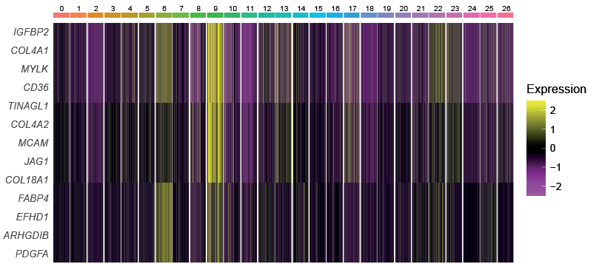

**Supp. Fig. 7: Expression of C7 marker genes in cluster#9.** Heat map showing enrichment of C7 marker gene expression in one cluster (#9) of endothelial and fibroblast cells

|  |
| --- |
| **Supp. Fig. 8: Gating strategy for FACS sorting.** (A)Side scatter area (SSC-A) vs. forward scattered light area (FSC-A) and AF647 vs. BV421 of isotype control cells displaying the gating strategy. (B) SSC-A vs. FSC-A and AF647 vs. BV421 for the same cells and the same gates shown in (A), but incubated with the CD36 and CD146 antibodies, as specified in the methods section. Q3-1 contains the CD36-CD146- cells and Q2-1 the CD36+CD146+ cells. |

**Supp. Table 1.** Output of enrichGO analysis for cluster 7



**Supp. Table 2.** List of genes significantly regulated in the scRNA-seq for cluster 7 of DFAT which reappeared in the bulk sequencing of C7* DFAT cells differentiated as spheroids.

|  |  |  |
| --- | --- | --- |
| Gene | Name | Trend |
| COL4A1 | Collagen alpha-1(IV) | Upregulated |
| PPP1R14A | Protein phosphatase 1 regulatory subunit 14A | Upregulated |
| COL4A2 | Collagen alpha-2(IV) | Upregulated |
| CD36 | Cluster differentiation 36 | Upregulated |
| MCAM | Melanoma cell adhesion molecule (CD146) | Upregulated |
| FABP4 | Fatty acid binding protein 4 | Upregulated |
| CARMN | Cardiac Mesoderm Enhancer-Associated Non-Coding RNA | Upregulated |
| CAV2 | Caveolin 2 | Upregulated |
| TFPI2 | Tissue Factor Pathway Inhibitor 2 | Downregulated |
| GREM2 | Gremlin 2 | Downregulated |
| DKK1 | Dickkopf WNT Signaling Pathway Inhibitor 1 | Downregulated |