**Supplementary material:**

**Supplementary Figure 1**: Growth charts of the reported patient.

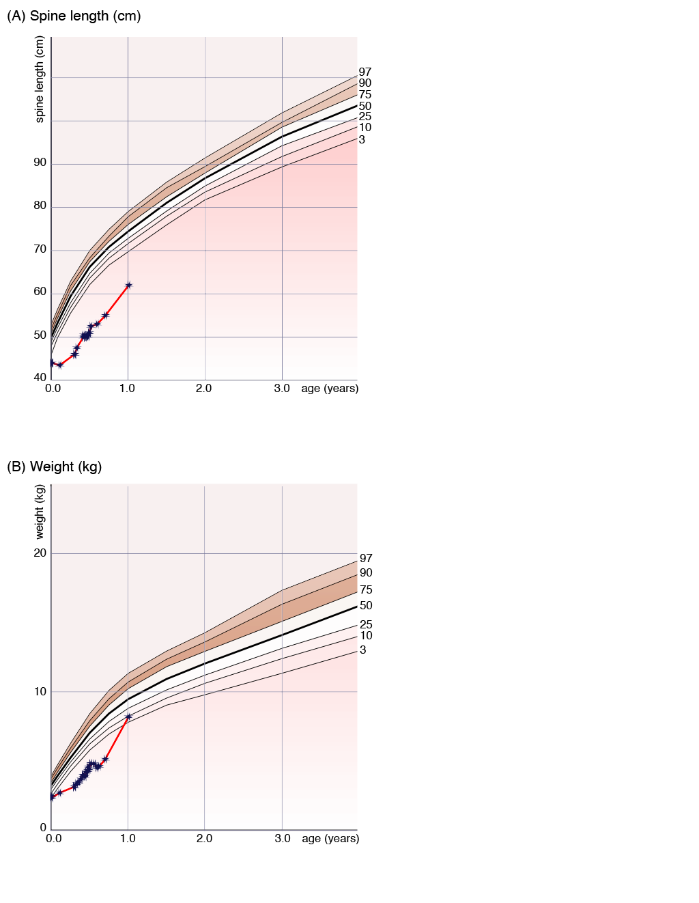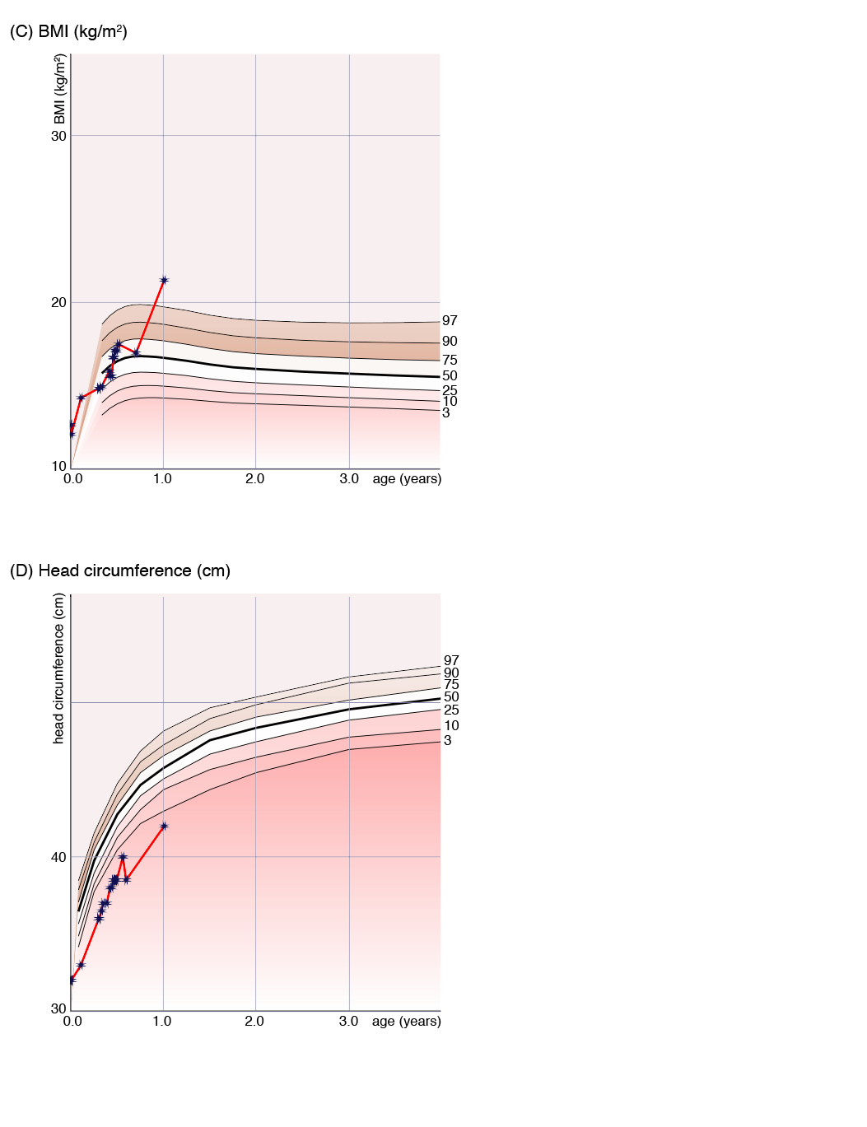

**Supplementary Table 1:** Listing of the clinical details of the reported patent with a homozygous loss-of-function variant in *CCDC186* in comparison to the previously reported patient by Monies et al. (2017).

|  |  |  |  |
| --- | --- | --- | --- |
|  |  | **reported patient** | **Monies et al. (2017)**  **(16W-0208)** |
| **Age at last follow-up** |  | 15 months | 4 years |
| **Gender** |  | female | male |
| **Homozygous variants in *CCDC186* (NM_018017.2)** |  | c.767C>G; p.(Ser256Ter) | c.610C>T; p.(Glu204Ter) |
| **Origin** |  | Senegal | Saudi Arabia |
| **Consanguinity** |  | yes | yes |
| **Growth** | **IUGR** | yes (birth weight: 2450g) | NA |
|  | **Failure to thrive** | yes | yes |
|  | **Microcephaly** | yes | NA |
| **Development** | **Developmental delay** | yes (severe) | yes (fine and gross motor delay, intellectual disability) |
|  | **Speech delay** | yes (no speech) | yes |
| **Neurological findings** | **Muscular hypotonia** | yes | yes |
|  | **Seizures** | yes | NA |
| **Congenital anomalies** |  | infundibular pulmonary stenosis | NA |
| **Gastrointestinal findings** |  | yes (vomiting, obstipation, exocrine pancreas insufficiency) | NA |
| **Endocrinologic findings** |  | yes (hypothyreosis, suspected endocrine pancreas insufficiency) | NA |
| **Urogenital findings** |  | no | yes (undescended testis, micropenis) |
| **Ophthalmologic findings** |  | yes (lack of fixation) | yes (poor vision) |
| **Auditory findings** |  | yes (hyperacusis, left side) | NA |
| **Craniofacial features** |  | no distinctive facial features | NA |
| **MRI findings** |  | frontotemporal atrophy | brain atrophy |

**Supplementary Table 2**: Identified homozygous loss of function variants by exome sequencing. Listing of all identified homozygous loss of function variants applying a filter of maximum allele frequency of 0.1% according to the in-house database after removal of incorrectly called variants and intronic variants.

|  |  |  |  |  |  |  |  |  |  |  |  |  |  |  |  |
| --- | --- | --- | --- | --- | --- | --- | --- | --- | --- | --- | --- | --- | --- | --- | --- |
| **Chromosome** | **Gene** | **Transcript** | **cDNA variant** | **Protein variant** | **Omim** | **Class** | **Function** | **Variant alleles** | **SNV Qual** | **Map Qual** | **Depth** | **Percent Var** | **ClinVar** | **gnomAD ea** | **gnomAD aa** |
| chr10:115910972-115910972 | CCDC186/ 10orf118 | NM_018017.2 | c.767C>G | p.Ser256Ter | NA | snp | nonsense,noncoding | 2 | 159 | 60 | 44 | 100 |  | NA | NA |
| chr11:5221439-5221442 | OR51V1 | NM_001004760.2 | c.489_492delCTTT | p.Phe163LeufsTer9 | NA | indel | frameshift | 2 | 164 | 50 | 43 | 100 |  | 64115--31--0 | 9577--2542--176 |
| chr12:10569265-10569265 | KLRC3 | NM_002261.2 | c.587+1G>T | ? | NA | snp | splice | 2 | 223 | 49 | 65 | 100 |  | 64304--38--0 | 10166--2172--126 |
| chr12:31256907-31256907 | DDX11 | NM_001257144.1 | c.2853C>A | p.Cys951Ter | 601150 | snp | nonsense,3utr,noncoding | 2 | 282 | 37 | 206 | 99 |  | 47295--17--0 | 8497--565--6 |
| chr12:55945585-55945588 | OR6C4 | NM_001005494.1 | c.575_578delTCTT | p.Leu192GlnfsTer3 | NA | indel | frameshift | 2 | 290 | 55 | 118 | 100 |  | 64202--127--0 | 8383--3714--368 |
| chr13:111335483-111335484 | CARS2 | NM_024537.2 | c.572-3_572-2delCA |  | 612800 | indel | splice | 2 | 207 | 60 | 57 | 100 | Benign | 60450--2--0 | 10959--689--13 |
| chr17:33772713-33772713 | SLFN13 | NM_144682.5 | c.-13-1G>T |  | NA | snp | splice,5utr | 2 | 193 | 60 | 55 | 100 |  | 57331--9--0 | 11396--311--5 |
| chr22:36556768-36556768 | APOL3 | NM_145640.2 | c.172C>T | p.Gln58Ter | NA | snp | nonsense,5utr | 2 | 208 | 59 | 60 | 100 |  | 64525--37--0 | 7609--4229--640 |
| chr2:108443529-108443529 | RGPD4 | NM_182588.2: | c.60delG | p.Ser21ArgfsTer69 | NA | indel | frameshift | 2 | 290 | 48 | 87 | 100 |  | 53336--8--1 | 9668--298--3 |
| chr2:74730314-74730315 | LBX2-AS1 | NM_001009812.1 | c.-329dupG |  | NA | indel | frameshift,5utr,regulation | 2 | 290 | 60 | 89 | 100 |  | 7698--5--0 | 3171--1093--85 |
| chr4:88235097-88235097 | HSD17B13 | NM_001136230.1 | c.465delC | p.Ala156LeufsTer8 | NA | indel | frameshift | 2 | 237 | 59 | 67 | 100 |  | 57303--45--0 | 7171--3456--401 |
| chr8:125568183-125568183 | NDUFB9 | NM_014751.4 | c.1405-38delC |  | 601445 | indel | frameshift,intronic | 2 | 290 | 60 | 210 | 100 |  | 55425--1692--22 | 8396--2317--162 |
| chrX:154290120-154290120 | CMC4 | NM_001018024.2 | c.205T>C | p.Ter69GlnextTer13 | NA | snp | stoploss | 2 | 280 | 60 | 84 | 100 |  | 45293--0--0 | 9332--71--0 |

**Supplementary Table 3:** Frequency of heterozygous loss-of-function variants in healthy controls and assessed minimal lifetime risk of *CCDC186*-associated disease. The table shows all reported loss-of-function variants in *CCDC186* and the respective allele frequency in the gnomAD v2.1.1 dataset.

|  |  |  |  |  |  |  |  |  |  |  |  |
| --- | --- | --- | --- | --- | --- | --- | --- | --- | --- | --- | --- |
| **Chromo-some** | **Position** | **rsID** | **Reference** | **Alternate** | **Consequence** | **Protein Consequence** | **Transcript Consequence** | **Annotation** | **Allele Count** | **Allele Number** | **Allele Frequency** |
| 10 | 115884906 | rs778829812 | GT | G | p.Thr898ProfsTer17 | p.Thr898ProfsTer17 | c.2692delA | frameshift_variant | 4 | 241146 | 1,6587E-05 |
| 10 | 115884963 | rs756548615 | G | A | p.Gln435Ter | p.Gln435Ter | c.1301C>T | stop_gained | 1 | 248728 | 4,0205E-06 |
| 10 | 115885678 | rs1171341409 | C | CA | p.Leu860PhefsTer27 | p.Leu860PhefsTer27 | c.2579dupT | frameshift_variant | 1 | 251146 | 3,9817E-06 |
| 10 | 115885698 | rs1340695419 | G | A | p.Arg854Ter | p.Arg854Ter | c.2560C>T | stop_gained | 2 | 251178 | 7,9625E-06 |
| 10 | 115885794 | rs1236126404 | CTT | C | p.Lys821SerfsTer5 | p.Lys821SerfsTer5 | c.2462_2463delAA | frameshift_variant | 1 | 251116 | 3,9822E-06 |
| 10 | 115887353 | rs746517320 | GAA | G | p.Phe753SerfsTer5 | p.Phe753SerfsTer5 | c.2258_2259delTT | frameshift_variant | 1 | 251074 | 3,9829E-06 |
| 10 | 115887398 | rs767520724 | G | A | p.Arg739Ter | p.Arg739Ter | c.2215C>T | stop_gained | 1 | 250968 | 3,9846E-06 |
| 10 | 115889649 | rs1421818558 | C | T | c.2182+1G>A | | c.2182+1G>A | splice_donor_variant | 1 | 250920 | 3,9853E-06 |
| 10 | 115889728 | rs753516890 | G | A | p.Arg702Ter | p.Arg702Ter | c.2104C>T | stop_gained | 2 | 281766 | 7,0981E-06 |
| 10 | 115891065 | rs199821888 | G | A | p.Arg648Ter | p.Arg648Ter | c.1942C>T | stop_gained | 1 | 228274 | 4,3807E-06 |
| 10 | 115894670 | rs1361963132 | A | G | c.1655+2T>C |  | c.1655+2T>C | splice_donor_variant | 1 | 240854 | 4,1519E-06 |
| 10 | 115894775 | rs758001809 | C | A | p.Glu518Ter | p.Glu518Ter | c.1552G>T | stop_gained | 1 | 248372 | 4,0262E-06 |
| 10 | 115894793 | rs776927562 | G | A | p.Arg512Ter | p.Arg512Ter | c.1534C>T | stop_gained | 1 | 244868 | 4,0838E-06 |
| 10 | 115894810 | rs1376612258 | T | TTC | p.Lys506ArgfsTer4 | p.Lys506ArgfsTer4 | c.1515_1516dupGA | frameshift_variant | 1 | 242078 | 4,1309E-06 |
| 10 | 115895905 | rs761037441 | A | T | c.1425+2T>A |  | c.1425+2T>A | splice_donor_variant | 2 | 250202 | 7,9935E-06 |
| 10 | 115895936 | rs1419473942 | G | A | p.Gln466Ter | p.Gln466Ter | c.1396C>T | stop_gained | 1 | 250558 | 3,9911E-06 |
| 10 | 115896006 | rs1466763519 | C | A | c.1327-1G>T |  | c.1327-1G>T | splice_acceptor_variant | 1 | 245720 | 4,0697E-06 |
| 10 | 115896007 | rs755392771 | T | C | c.1327-2A>G |  | c.1327-2A>G | splice_acceptor_variant | 1 | 245574 | 4,0721E-06 |
| 10 | 115896980 | rs781536227 | G | A | p.Arg431Ter | p.Arg431Ter | c.1291C>T | stop_gained | 1 | 251026 | 3,9837E-06 |
| 10 | 115904306 | rs750455162 | T | A | p.Lys391Ter | p.Lys391Ter | c.1171A>T | stop_gained | 1 | 251158 | 3,9816E-06 |
| 10 | 115910864 | rs760354548 | T | TG | p.Gln292ProfsTer11 | p.Gln292ProfsTer11 | c.874dupC | frameshift_variant | 1 | 250548 | 3,9913E-06 |
| 10 | 115910936 |  | GAAGCTTTAACTTCTTTATTAAGTTCTTCTATTCTTGATTCTAACTGTAAAGAAAATTATTTCCAAATTATTTTTATAGCTAT | G | c.760-39_802delATAGCTATAAAAATAATTTGGAAATAATTTTCTTTACAGTTAGAATCAAGAATAGAAGAACTTAATAAAGAAGTTAAAGCTT | | c.760-39_802delATAGCTATAAAAATAATTTGGAAATAATTTTCTTTACAGTTAGAATCAAGAATAGAAGAACTTAATAAAGAAGTTAAAGCTT | splice_acceptor_variant | 2 | 250516 | 7,9835E-06 |
| 10 | 115917316 | rs759642671 | TTTAA | T | p.Ile251AsnfsTer3 | p.Ile251AsnfsTer3 | c.752_755delTTAA | frameshift_variant | 2 | 238150 | 8,3981E-06 |
| 10 | 115922394 | rs763932967 | ACT | A | c.632_632+1delAG | | c.632_632+1delAG | splice_donor_variant | 1 | 195750 | 5,1086E-06 |
| 10 | 115922493 | rs765734254 | G | A | p.Arg179Ter | p.Arg179Ter | c.535C>T | stop_gained | 2 | 251098 | 7,9650E-06 |
| 10 | 115922660 | rs781063741 | C | CTTAA | p.Arg123IlefsTer11 | p.Arg123IlefsTer11 | c.364_367dupTTAA | frameshift_variant | 4 | 282046 | 1,4182E-05 |
| 10 | 115922695 | rs1436133199 | TGTTTC | T | p.Glu110ArgfsTer21 | p.Glu110ArgfsTer21 | c.328_332delGAAAC | frameshift_variant | 1 | 249506 | 4,0079E-06 |
| 10 | 115922958 |  | CCTTT | C | p.Glu24ThrfsTer14 | p.Glu24ThrfsTer14 | c.66_69delAAAG | frameshift_variant | 1 | 251158 | 3,9816E-06 |
|  |  |  |  |  |  |  |  |  | **Combined minor allele frequency** | | 1,60E-04 |
|  |  |  |  |  |  |  |  |  | **minimal lifetime risk** | | 2,5622E-08 |

**Supplementary Figure Legends:**

**Supplementary Figure 1:** Growth charts of the reported patient. Black asterisks connected by a red line mark measurements of the reported patient. Percentile curves (3rd/10th/25th/50th/75th/90th/97th percentiles) show the age dependent distribution of the respective body measurement. (A): Spine length measured in cm. (B): Body weight measured in kg. (C): BMI (kg/m2). (D): Head circumference measured in cm.

**Supplementary Table 1:** Listing of the clinical details of the reported patient with a homozygous loss-of-function variant in *CCDC186* in comparison to the previously reported patient by Monies et al. (2017). IUGR: intrauterine growth retardation; MRI: magnetic resonance imaging; NA: not applicable.

**Supplementary Table 2:** Listing of all identified homozygous loss-of-function variants by exome sequencing applying a filter of maximum allele frequency of 0.1% according to the in-house database after removal of incorrectly called variants and intronic variants.

**Supplementary Table 3:** Frequency of heterozygous loss-of-function variants in healthy controls and assessed minimal lifetime risk of *CCDC186*-associated disease. The table shows all reported loss-of-function variants in *CCDC186* and the respective allele frequency in the gnomAD v2.1.1 dataset.