High spatial resolution LA-ICP-MS demonstrates massive liver copper depletion in Wilson disease rats upon Methanobactin treatment

Jennifer-Christin Müllerª, Josef Lichtmannegger^{b}, Hans Zischka^{b,c}, Michael Sperling^{a,d}, and Uwe Karst^{a,}*

ª University of Münster, Institute of Inorganic and Analytical Chemistry, Corrensstraße 30, 48149 Münster, Germany
^{b} Institute of Molecular Toxicology and Pharmacology, Helmholtz Center Munich, German Research Center for Environmental Health, 85764 Neuherberg, Germany
^{c} Institute of Toxicology and Environmental Hygiene, Technical University Munich, 80802 Munich, Germany
^{d} European Virtual Institute for Speciation Analysis (EVISA), Mendelstraße 11, 48149 Münster, Germany

* Corresponding author: Uwe Karst, uk@uni-muenster.de, phone +49 251/83-33141, fax +49 251/83-36013

Abbreviations
d-PA, D-penicillamin; ICP-OES, inductively coupled plasma-optical emission spectroscopy; LA-ICP-MS, laser ablation-inductively coupled plasma-mass spectrometry; MB, Methanobactin; WD, Wilson disease
Abstract
Wilson disease (WD) is a rare genetic disorder of the copper metabolism leading to systemic copper accumulation, predominantly in the liver. The therapeutic approach in WD patients is the generation of a negative copper balance and the maintenance of copper homeostasis, currently by the use of copper chelators such as d-penicillamine (D-PA). However, in circumstances of delayed diagnosis, poor treatment compliance, or treatment failure, mortality is almost certain without hepatic transplantation. Moreover, even after years of D-PA treatment, high liver copper levels are present in WD patients.
We have recently suggested the use of the bacterial peptide Methanobactin (MB), which has an outstanding binding affinity for copper, as potentially efficient and patient-friendly remedy against copper damage in WD. Here we substantiate these findings considerably, by demonstrating a significant removal of copper from liver samples of WD rats upon short, one week only, MB treatments. Using laser ablation-inductively coupled plasma-mass spectrometry with a spatial resolution down to 4 µm, we demonstrate that only small copper hotspots remain in MB treated animal livers. We further demonstrate in WD rat livers, seven weeks after the stopped MB treatment, a lower liver copper concentration as compared to untreated control animals. Thus, MB highly efficiently depletes liver copper overload with a sustained therapeutic effect.
Keywords
Elemental bioimaging
Laser ablation-inductively coupled plasma-mass spectrometry (LA-ICP-MS)
Wilson disease
Methanobactin
Chelation therapy
Copper

Highlights
- Spatial resolution of 4 µm was achieved with LA-ICP-MS for liver tissue.
- LA-ICP-MS shows the copper removal capacity of Methanobactin treatment.
- Small copper hotspots were observed after the treatment.
- Copper reaccumulation takes place after seven weeks of treatment stop.
Introduction
Copper is an essential trace element for humans and animals, which is needed as cofactor for enzymes, taking part in cell metabolism or blood coagulation for example.[1] Especially in mitochondria, copper is used to control oxidative stress and for oxygen utilization.[2] In the autosomal-recessive disorder Wilson disease (WD), the copper metabolism is impaired leading to copper accumulation, especially in liver and brain. Patients with WD show various mutations of the gene Atp7b. The disease leads to a wide variety of symptoms, including neurologic, psychologic and hepatic abnormalities.[3] WD affects between one in 30,000 and one in 100,000 patients and ends fatal without treatment.[4]
The treatment of WD is based on an increase of copper excretion by administration of copper chelators, such as d-penicillamin (d-PA) or trientine. In addition to that, zinc therapy can be used to reduce the absorption of copper from food.[5] However, these clinically used drugs have severe side effects. These include bone marrow and nephron toxicity as well as triggering of autoimmune diseases. In addition, d-PA treatment may lead to deterioration of neurological symptoms in 10-20% of patients with initial neurological manifestation.[6] Moreover, even after years of d-PA administration, WD livers contain a massive copper load due to an insufficient capacity of d-PA to deplete the excess copper.[7] Finally, acute liver failure in WD patients cannot be treated using the established drugs and liver transplantation is the only option to avoid death.[8]
To overcome these disadvantages, new therapeutic approaches are urgently needed. One alternative to the aforementioned drugs may be Methanobactin (MB), a peptide isolated from bacteria.[9] In recent studies, MB was able to reverse acute liver failure in LPP rats, a WD animal model that mirrors the liver phenotype in WD patients.[10] As shown previously, laser ablation-inductively coupled plasma-mass spectrometry (LA-ICP-MS) is a useful imaging tool to analyze the copper concentration and distribution, as well as the distribution of other trace elements, in WD liver tissue.[11–13] Especially information about the elemental distribution in addition to the information about the concentration can help to understand the effect mechanism of MB in more detail. In this paper, the copper removal efficiency of the new drug MB is investigated with a spatial resolution down to 4 µm.
Materials and methods
Chemicals
All chemicals were used in the highest purity available. Gelatin was purchased from Grüssing (Filsum, Germany). Iron(II) sulfate heptahydrate was obtained from VWR Chemicals (Haasrode, Belgium). Zinc(II) chloride was purchased from Alfa Aesar (Karlsruhe, Germany). Nitric acid (65%, Suprapur), multi-element standard IV (1000 mg/l), copper(II) sulfate pentahydrate, ethanol and xylene were obtained from Merck (Darmstadt, Germany). Rhodium (1000 mg/l) ICP standard solution was purchased from SCP Science (Baie D’Urfé, Canada). Doubly distilled water was prepared using an Aquatron Water Still purification system model A4000D (Barloworld Scientific, Nemours Cedex, France).
Animals
The LPP rat strain was provided by Jimo Borjigin, University of Michigan, Ann Arbor, USA.[14] Rats were maintained ad lib on standard diet with a copper content of 13 mg/kg (Altromin Spezialfutter GmbH, Seelenkamp, Germany) and tap water. All animals were treated under the guidelines for the care and use of laboratory animals of the Helmholtz Center Munich. Animal experiments were approved by the government authorities of the Regierung von Oberbayern, Munich, Germany.
Animal treatments
LPP Atp7b^{-/-} rats were treated either for five weeks with Methanobactin OB3b (MB, kindly provided by Prof. Alan A Dispirito, Iowa State University, USA) by i.p. injections at a dose of 62.5 mg/kg bodyweight three times per week (16 treatments in total), or by twice daily MB i.p. injections for eight consecutive days at a dose of 150 mg/kg bodyweight. One LPP Atp7b^{-/-} rat was subjected to two treatment cycles, each consisting of three daily MB injections (i.p.) for five days with an intermediate non-treatment period of three weeks and a subsequent observation period (“drug holiday”) of seven weeks.
Metal content determination
The copper content in liver homogenate was analyzed by ICP-OES (Ciros Vision, SPECTRO Analytical Instruments GmbH, Kleve, Germany) after wet ashing of samples with 65% nitric acid.[15]
Liver sample preparation
For laser ablation-inductively coupled plasma-mass spectrometry (LA-ICP-MS) analysis, tissue sections of LPP rat liver samples embedded in paraffin were prepared with a thickness of 5 µm using a microtome HM 355S (Thermo Scientific, Bremen Germany). The tissue samples were deparaffinated by washing with xylene, ethanol and water. Afterwards, bright field microscopic images were captured with a BZ-9000 microscope (Keyence, Osaka, Japan).
Preparation of matrix-matched standards
To quantify the copper, iron and zinc concentration in the tissue samples, external calibration with matrix-matched standards was applied. Calibration standards based on 10% gelatin (w/w) were prepared by spiking gelatin with aqueous solutions of copper(II) sulfate pentahydrate, iron(II) sulfate heptahydrate and zinc(II) chloride, respectively. The mixtures were then homogenized at 40 °C. Copper and iron standards in a concentration range from 10 to 1000 µg/g and zinc standards with concentrations between 10 and 500 µg/g were used. Standards for different elements were prepared separately to avoid degradation of the gelatin and to ensure a homogeneous distribution. Sections with a thickness of 5 µm were prepared using a cryomicrotome (Cryostar NX70, Thermo Scientific) to match the thickness of the liver samples. The standards were analyzed via LA-ICP-MS using the same measurement parameters as for the tissue samples. To validate the standard concentrations, bulk analysis after digestion with nitric acid was used. Therefore, 1 ml nitric acid was added to precisely 100 mg standard and the mixture was filled to 50 ml with doubly distilled water. Further dilution was carried out using nitric acid (2%(w/v)) to obtain an identical matrix for all samples. As internal standard, a rhodium solution was used. 100 µl of a rhodium ICP standard was added to the gelatin sample before digestion, resulting in a final concentration of 1 ng/g for the internal standard in each sample. The copper, iron and zinc concentrations in the sample were determined using an external calibration in a concentration range from 1 to 25 µg/g with a multi-elemental standard solution.
LA-ICP-MS instrumentation
A laser ablation system LSX-213 G2⁺ (Teledyne CETAC Technologies, Omaha, USA) was used for the LA-ICP-MS measurements. The system was equipped with a Nd-YAG laser operating at a wavelength of 213 nm and a HelEx Active 2-Volume Cell (Teledyne CETAC Technologies). ICP-MS detection was carried out with a quadrupole-based iCAP TQ (Thermo Fisher Scientific). The laser ablation and ICP-MS were connected with Tygon tubing. The samples were completely ablated line-by-line. For overview images, a laser spot size of 25 µm and a scan rate of 50 µm/s were chosen to achieve a compromise between spatial resolution and analysis time. For a more detailed analysis, a laser spot size of 4 µm with a scan rate of 8 µm/s was used. The laser was operated with a frequency of 20 Hz and the ablation chamber was flushed with a helium gas flow of 0.8 l/min. After the ablation chamber, an additional argon gas flow (~ 0.9 l/min, daily tuned) was added to the aerosol stream via T-piece. For sample introduction, a quartz injector pipe with an inner diameter of 3.5 mm was used. The ICP-MS was operated with nickel sampler and skimmer cones in the single quadrupole kinetic energy discrimination mode (SQ-KED) with helium as collision gas. The isotopes ³¹P, ⁵⁷Fe, ⁶³Cu, ⁶⁵Cu and ⁶⁶Zn were monitored with a dwell time of 0.1 s each. The following ICP-MS parameters were applied for all measurements: rf power, 1550 W; cool gas flow, 14 l/min; auxiliary gas flow, 0.8 l/min.
The determination of the bulk copper, iron and zinc concentration in the gelatin standards was carried out using an iCAP Q ICP-MS instrument (Thermo Fisher Scientific) and an ASX-560 autosampler (Teledyne CETAC Technologies). Again, the instrument was operated in the KED mode and the isotopes ⁵⁷Fe, ⁶³Cu, ⁶⁵Cu, ⁶⁶Zn and ¹⁰³Rh were monitored with a dwell time of 0.1 s each. All other parameters were kept the same.
Data analysis
An in-house developed software was used to convert the LA-ICP-MS data into two-dimensional images. To obtain even better signal-to-noise ratios for copper and to account for variations in the natural isotopic ratios, the sum images of the two copper isotopes ⁶³Cu and ⁶⁵Cu are shown. To determine average concentrations for the ablated areas, only data points with a phosphorus signal higher than the phosphorus background intensity were used. Therefore, data points, which do not represent the tissue, such as blood vessels, were excluded from the calculation. The copper, iron and zinc concentrations were calculated using a linear calibration function derived from the average signal intensities for each standard using Microsoft Excel 2016 (Microsoft Corp, Redmond, USA). Statistical comparison of copper hotspots was performed using two-tailed, unpaired t-test.
3. Results and discussion
3.1 Calibration by means of matrix-matched standards
To quantify the copper, iron and zinc concentration in the liver tissue samples, gelatin-based standards for the three elements were used. Iron standards could be prepared in concentrations above 500 µg/g without denaturation of the gelatin by using iron(II) sulfate instead of iron(III) chloride, as described previously.[11] With this calibration approach, the tissue matrix is sufficiently simulated with respect to potential matrix effects influencing the ablation or atomization behavior. The calibration shows low relative standard deviations and a good linearity over a wide concentration range, which is required for analyzing positive as well as negative control samples. Limits of detection and limits of quantification for analysis with a laser spot size of 25 µm of approximately 25 ng/g and 83 ng/g for ⁶³Cu, 13 ng/g and 44 ng/g for ⁶⁵Cu, 200 ng/g and 600 ng/g for ⁵⁷Fe, as well as 50 ng/g and 167 ng/g for ⁶⁶Zn were achieved.
3.2 Total copper content of liver samples
To analyze the copper removal efficiency of MB, non-affected heterozygous Atp7b^{+/-} controls and affected Atp7b^{-/-} LPP rats were used as model animals for WD. The study includes Atp7b^{-/-} animals treated with two different MB doses of 62.5 mg/kg bodyweight (low dose) and 150 mg/kg bodyweight (high dose). In addition to the continuous treatment, one animal experienced a so-called drug holiday phase, a drug free phase after treatment periods. The rat was treated with the higher dose of MB for 5 days, followed by a drug free phase of three weeks, again five days of MB treatment and a seven-week drug free re-accumulation period. Untreated non-affected heterozygous Atp7b^{+/-} and affected Atp7b^{-/-} LPP rats were used as further controls. Table 1 summarizes the total copper concentrations in the liver of all shown samples, as determined by ICP-OES.
Table 1: Treatment and total copper content of analyzed liver samples determined using ICP-OES.
Sample number age of sacrifice / days treatment copper concentration/µg∙g⁻¹
1a 91 Atp7b^{+/-} healthy control 7.3
1b 84 Atp7b^{+/-} healthy control 7.0
2a 94 Atp7b^{-/-} diseased control 411
2b 94 Atp7b^{-/-} diseased control 454
3a 121 Atp7b^{-/-} low MB dose 181
3b 120 Atp7b^{-/-} low MB dose 204
4a 89 Atp7b^{-/-} high MB dose 188
5a 166 Atp7b^{-/-} drug holiday 351

The bulk liver analysis shows a highly increased copper concentration for the Atp7b^{-/-} animals in comparison to Atp7b^{+/-} rats, as expected from the disturbed copper metabolism of the diseased Atp7b^{-/-} animals. The MB treatment of eight consecutive days leads to a decrease in the copper content with concentrations less than half of those of untreated rats, as overserved before by Lichtmannegger et al.[10]
3.3 Bioimaging of Cu, Fe and Zn in rat liver tissue
Whereas the chelation and excretion of copper is the desired therapeutic activity of the chelation therapy, the homeostasis of other elements should not be affected by the WD treatment. To observe the influence of the MB treatment on other trace elements present in the liver, the elements iron and zinc were quantified as well. In the following, the results of single sections for samples 1-5a are shown: The other analyzed sections and the images of samples 1-3b showed similar results and are summarized in appendix A in the supplementary material.
To obtain an estimate of the copper, iron and zinc distribution in the liver samples, LA-ICP-MS analysis with a laser spot size of 25 µm was carried out. This spot size provides a satisfactory compromise between spatial resolution and analysis time. Because of the destructive nature of this imaging technique, only one half of each sample was ablated with the larger spot size. The other sample half was used for analysis with a higher spatial resolution of 4 µm.
Figure 1 shows the iron, copper and zinc distribution of a healthy Atp7b^{+/-} control liver (sample 1a) as well as an untreated, diseased Atp7b^{-/-} sample (sample 2a). The copper distribution for the healthy control is very homogenous with an average concentration of 14 µg/g. For the diseased animal, the average copper concentration is 702 µg/g with many hotspots all over the tissue sample. WD is typically diagnosed in humans, if a liver copper content above 250 µg/g is found. Copper concentrations below 55 µg/g are considered normal.[4] Therefore, both control animals can be classified correctly as healthy and diseased, respectively, which demonstrates the applicability of the developed LA-ICP-MS method for the analysis of WD tissue samples.
For the healthy Atp7b^{+/-} control, iron concentrations up to 500 µg/g can be found with higher concentrations next to blood vessels. This finding may be explained by remaining blood cells containing hemoglobin in these areas. In contrast, an elevated liver iron level of the untreated, diseased Atp7b^{-/-} animal with concentrations up to 1000 µg/g was observed.
The zinc images show a uniform distribution for both control samples, but lower concentrations around the edges of the tissue samples can be found. This indicates a possible washout effect of this element during sample preparation steps in these edge areas. However, this phenomenon was not observed with respect to the iron and copper distributions. A plausible explanation may be a possible binding of iron and copper ions to insoluble proteins, whereas zinc could be either present as free ion or bound in water- or alcohol-soluble complexes. To avoid the washout of zinc, cryo samples instead of paraffinated samples could be used.
Figure 2 shows the comparison of the iron, copper and zinc distributions for the animals treated with different MB concentration as well as the drug holiday animal. For all three samples, the iron and zinc distributions look similar to the untreated Atp7b^{-/-} control samples and the concentrations are in the same range up to 1000 µg/g for iron and up to 75 µg/g for zinc. The washout effect observed before is differently pronounced, but observable in the high MB dose and the drug holiday sample. These results show that the MB treatment does not affect the iron and zinc concentration and distribution in the liver. For the animal treated with the lower MB dose of 62.5 mg/kg bodyweight, copper concentrations up to 600 µg/g with an average concentration of 318 µg/g can be found, which is a significant decrease in comparison to the untreated Atp7b^{-/-} animal. Interestingly, a non-homogenous copper distribution was observed in the MB treated livers with various small copper hotspots. A similar observation can be made for the animal treated with the higher MB dose of 150 mg/kg bodyweight. Copper concentrations up to 300 µg/g with an average of 98 µg/g were found for this tissue sample, demonstrating an even more profound copper depletion as compared to the lower MB dose treated animal liver. The observed copper distribution is inhomogeneous here as well with the lowest concentrations directly next to blood vessels, possibly indicating a copper extraction effect through MB containing blood. This phenomenon was already observed for the treatment with the established drug d-PA.[12] Importantly, in comparison to the established treatment with d-PA, which led to an average copper concentration between 170 and 190 µg/g, a lower liver copper concentration after the high dose treatment was found. This increased MB induced decoppering was observed despite the fact that the d-PA treatment of Atp7b^{-/-} rats lasted 36 and 37 days,[12] respectively, whereas the high dose MB treatment period was only eight days. Therefore, both drugs remove copper from liver tissue, but, with a 4.5 times lower treatment duration, MB does so with an unmet efficiency.
In order to study the perdurability of the MB induced liver copper depletion, a so-called drug holiday animal, which had two drug free periods of three and seven weeks after two treatment periods with the higher MB dose of 150 mg/kg bodyweight, was analyzed (Figure 2c). For this sample, copper concentrations up to 600 µg/g with an average concentration of 245 µg/g were observed, similar to values of animals treated with the lower MB dose. Thus, copper re-accumulation up to levels of untreated animals was not reached by a seven week lasting treatment stop. This demonstrates the sustained therapeutic effect of the MB treatment. Furthermore, an inhomogeneous copper distribution can be observed showing no correlation with blood vessels or other elements measured here.
3.4 High spatial resolution imaging of rat liver tissue
To further investigate the copper hotspots observed in the samples treated with MB, sections of the same samples were analyzed with a laser spot size of 4 µm to obtain a better spatial resolution. Again, copper, iron and zinc were quantified, but the iron and zinc distributions did not lead to any further information. Therefore, only the images of the copper distribution are shown here. Figure 3 shows the copper distribution for both, the healthy Atp7b^{+/-} and the untreated Atp7b^{-/-} animal. Both images have the same concentration scale with concentrations up to 1000 µg/g to better visualize the differences. The copper distribution for the healthy animal is low and very homogenous, whereas the diseased animal shows many hotspots with concentrations above 1000 µg/g and high copper levels all over the tissue sample. The liver samples of the MB treated animals are also shown in Figure 3. In contrast to the measurements with a laser spot size of 25 µm, the concentration range shown here is up to 1000 µg/g. This can be explained with a lower averaging effect when a smaller spot size is used. Nevertheless, the calculated average concentrations for both samples remain very similar. With the spatial resolution of 4 µm, the removal of copper near blood vessels can be seen for both samples. Moreover, the inhomogeneous copper distribution becomes excellently visible for both MB doses.
The advantages of the high spatial resolution of 4 vs. 25 µm can be demonstrated by a more profound analysis of the observed copper hotspots. Figure 4 illustrates the concentration differences between the hotspots and the MB extracted regions for the animal treated with the lower MB dose of 62.5 mg/kg bodyweight. For better visualization of the copper concentration, the image for the sample treated with the lower MB dose is depicted with a monochromatic concentration scale in the same concentration range as shown before. Thereby, the copper hotspots can be seen as white pixels. Three hotspot regions (green circles), three areas directly next to blood vessels (blue circles) as well as three reference areas (grey circles) were selected to demonstrate the concentration differences. With the in-house developed imaging software, the average concentration for 15 pixels in each selected area was calculated. The bar chart on the right hand side shows the mean concentrations for the three hotspots, the three areas near blood vessels, as well as the average concentration of the reference areas and the overall concentration determined by ICP-OES as summarized in Table 1. The copper concentration in the hotspots is around 3.5 times higher than in the average tissue sample, whereas the concentration near the blood vessels is only half as high. The two tailed, unpaired t-test results in p<0.001 for the copper hotspots in comparison to the reference areas and p<0.02 for the areas near blood vessels compared to the reference areas (n=4), indicating a significant difference between those areas.
In addition to that, two high spatial resolution areas for the diseased Atp7b^{-/-} control animal and the animal treated with the lower MB dose of 62.5 mg/kg bodyweight were analyzed regarding the observed copper hotspots. Figure 5 visualizes the effects of the MB treatment on those regions of interest. The LA-ICP-MS images with the modified concentration scales, in which all pixels with copper concentrations below 750 µg/g are depicted in grey scales, emphasizes the drastic decrease in the number of hotspots after the treatment with the lower MB dose. For the diseased control animal, 12% of the pixels in the ablated area show copper concentrations of 750 µg/g or higher, whereas only 0.5% of the pixels for the MB treated animal have such high copper concentrations. For the untreated animal, 54 hotspots were identified in an ablated area of around 5 mm², while only 12 hotspots were identified in the same area of the treated animal. The box plot diagram in Figure 4c illustrates the size difference of the hotspots in both samples. The average sizes of the individual copper accumulations for the diseased and the MB treated animal are 230 µm² and 123 µm², respectively. In addition to that, the average copper concentrations for the identified hotspots in each selected area was calculated with an in-house developed imaging software. The extrapolated concentrations are significantly different with an average of approx. 1428 µg/g for the diseased and 1031 µg/g for the treated animal (Figure 4d). The two tailed, unpaired t-test results in p<0.002 for the comparison of the copper concentration in hotspots for both samples. Therefore, the number of hotspots per area as well as the average hotspot size and the copper concentration in the hotspots decreases significantly by the MB treatment, which can only be analyzed with the high spatial resolution of 4 µm.
These findings demonstrate that a highly spatially resolved analysis of the copper concentration in WD tissue samples is very useful when evaluating the copper removal efficiency of novel therapeutic approaches. Bulk liver analysis of the copper content is not able to account for the hotspots observed with LA-ICP-MS, which should be recognized to evaluate the treatment success. It could be shown that the short MB treatment is superior to the significantly longer D-PA treatment, which led to equal results regarding the copper removal efficiency.
The high spatial resolution images of the drug holiday animal can be found in Figure A.6. In this animal liver, the copper distribution is very inhomogeneous. As illustrated by the LA-ICP-MS with a laser spot size of 25 µm, the copper is re-accumulated in some areas in the liver, whereas other regions are not loaded with copper. Because of the high resolution used here, only small areas of the sample were investigated. Therefore, some measured areas show average concentrations of 235 µg/g (Figure A.6a) and 260 µg/g (Figure A.6b), while the copper concentration in other areas is up to 890 µg/g (Figure A.6c). Furthermore, no defined copper hotspots can be observed, which is in accordance to the images with a spot size of 25 µm. The re-accumulated copper seems to be located in broader tissue regions compared to the copper accumulated in the untreated Atp7b^{-/-} rats, where smaller, high concentration hotspots can be found. This phenomenon could be explained by a redistribution of copper over time and could influence the accessibility of the copper in subsequent treatment periods. However, more samples with different treatment-free periods should be analyzed to confirm this hypothesis.
Conclusion
It is demonstrated here that LA-ICP-MS is a highly informative method to investigate the copper removal efficiency of novel therapies for the treatment of WD. The drug MB was investigated with a spatial resolution down to 4 µm, revealing an unmet copper removal efficiency in a reduced treatment period of only 8 days. The remaining copper hotspots in the liver tissue after the MB treatment are smaller, much less frequent and have lower average copper concentrations compared to the hotspots observed in the untreated control sample.
Moreover, a copper reaccumulation after a drug free phase of seven weeks was observed, but the copper content in the liver of untreated animals was not reached. Thus, the MB induced copper depletion did present with a sustainable therapeutic effect. In addition, a possible redistribution of copper over time was observed, when comparing the high spatial resolution images of the animal that experienced a drug-free phase with the untreated animal.
The iron concentration and distribution was not significantly affected by the MB treatment. It was not possible to draw a final conclusion regarding the concentration and distribution of zinc in the liver tissue, due to the observed washout effects during the sample preparation steps. However, no immense alterations were observed after the treatment. This is in accordance with the binding selectivity of MB as investigated by McCabe et al.[16]
Conflict of interest
All authors declare that there are no conflicts of interest associated with this manuscript.
Acknowledgements
The authors would like to thank Robin Schmid for development of and support with the image processing software. We would especially like to thank Alan A Dispirito (Iowa State University, USA) for the kind provision of Methanobactin.
References
[1] B.-E. Kim, T. Nevitt, D.J. Thiele, Mechanisms for copper acquisition, distribution and regulation., Nat. Chem. Biol. 4 (2008) 176–185. doi:10.1038/nchembio.72.
[2] S.C. Leary, D.R. Winge, P.A. Cobine, “Pulling the plug” on cellular copper: The role of mitochondria in copper export, Biochim. Biophys. Acta. 1793 (2009) 146–153. doi:10.1016/j.bbamcr.2008.05.002.
[3] P. de Bie, P. Muller, C. Wijmenga, L.W.J. Klomp, Molecular pathogenesis of Wilson and Menkes disease: correlation of mutations with molecular defects and disease phenotypes., J. Med. Genet. 44 (2007) 673–688. doi:10.1136/jmg.2007.052746.
[4] A. Ala, A.P. Walker, K. Ashkan, J.S. Dooley, M.L. Schilsky, Wilson’s disease, Lancet. 369 (2007) 397–408. doi:10.1016/S0140-6736(07)60196-2.
[5] R. Purchase, The treatment of Wilson’s disease, a rare genetic disorder of copper metabolism, Sci. Prog. 96 (2013) 19–32. doi:10.3184/003685013X13587771579987.
[6] E.A. Roberts, M.L. Schilsky, Diagnosis and treatment of Wilson disease: An update, Hepatology. 47 (2008) 2089–2111. doi:10.1002/hep.22261.
[7] I.H. Scheinberg, I. Sternlieb, M. Schilsky, R.J. Stockert, Penicillamine may detoxify copper in Wilson’s disease, Lancet. 330 (1987) 95. doi:10.1016/S0140-6736(87)92753-X.
[8] S. Emre, E.O. Atillasoy, S. Ozdemir, M. Schilsky, C. V Rathna Varma, S.N. Thung, I. Sternlieb, S.R. Guy, P.A. Sheiner, M.E. Schwartz, C.M. Miller, Orthotopic liver transplantation for Wilson’s disease: a single-center experience., Transplantation. 72 (2001) 1232–1236. doi:0041-1337/01/7207-1232/0.
[9] G.E. Kenney, A.C. Rosenzweig, Methanobactins: maintaining copper homeostasis in methanotrophs and beyond, J. Biol. Chem. (2018) jbc.TM117.000185. doi:10.1074/jbc.TM117.000185.
[10] J. Lichtmannegger, C. Leitzinger, R. Wimmer, S. Schmitt, S. Schulz, Y. Kabiri, C. Eberhagen, T. Rieder, D. Janik, F. Neff, B.K. Straub, P. Schirmacher, A.A. Di Spirito, N. Bandow, B.S. Baral, A. Flatley, E. Kremmer, G. Denk, F.P. Reiter, S. Hohenester, F. Eckardt-Schupp, N.A. Dencher, J. Adamski, V. Sauer, C. Niemietz, H.H.J. Schmidt, U. Merle, D.N. Gotthardt, G. Kroemer, K.H. Weiss, H. Zischka, Methanobactin reverses acute liver failure in a rat model of Wilson disease, J. Clin. Invest. 126 (2016) 2721–2735. doi:10.1172/JCI85226.
[11] O. Hachmöller, M. Aichler, K. Schwamborn, L. Lutz, M. Werner, M. Sperling, A. Walch, U. Karst, Element bioimaging of liver needle biopsy specimens from patients with Wilson’s disease by laser ablation-inductively coupled plasma-mass spectrometry, J. Trace Elem. Med. Biol. 35 (2016) 97–102. doi:10.1016/j.jtemb.2016.02.001.
[12] O. Hachmöller, A. Zibert, H. Zischka, M. Sperling, S. Reinartz Groba, I. Grünewald, E. Wardelmann, H.H.J. Schmidt, U. Karst, Spatial investigation of the elemental distribution in Wilson’s disease liver after D-penicillamine treatment by LA-ICP-MS, J. Trace Elem. Med. Biol. 44 (2017) 26–31. doi:10.1016/j.jtemb.2017.05.008.
[13] O. Hachmöller, M. Aichler, K. Schwamborn, L. Lutz, M. Werner, M. Sperling, A. Walch, U. Karst, Investigating the influence of standard staining procedures on the copper distribution and concentration in Wilson’s disease liver samples by laser ablation-inductively coupled plasma-mass spectrometry, J. Trace Elem. Med. Biol. 44 (2017) 71–75. doi:10.1016/j.jtemb.2017.06.002.
[14] S. Ahmed, J. Deng, J. Borjigin, A new strain of rat for functional analysis of PINA, Mol. Brain Res. 137 (2005) 63–69. doi:10.1016/j.molbrainres.2005.02.025.
[15] H. Zischka, J. Lichtmannegger, S. Schmitt, N. Jägemann, S. Schulz, D. Wartini, L. Jennen, C. Rust, N. Larochette, L. Galluzzi, V. Chajes, N. Bandow, V.S. Gilles, A.A. DiSpirito, I. Esposito, M. Goettlicher, K.H. Summer, G. Kroemer, Liver mitochondrial membrane crosslinking and destruction in a rat model of Wilson disease, J. Clin. Invest. 121 (2011) 1508–1518. doi:10.1172/JCI45401.
[16] J.W. McCabe, R. Vangala, L.A. Angel, Binding Selectivity of Methanobactin from Methylosinus trichosporium OB3b for Copper(I), Silver(I), Zinc(II), Nickel(II), Cobalt(II), Manganese(II), Lead(II), and Iron(II), J. Am. Soc. Mass Spectrom. 28 (2017) 2588–2601. doi:10.1007/s13361-017-1778-9.
Figure captions
Figure 1: Comparison of a) a healthy and b) a diseased control rat liver sample. The bright field microscopic images (left) as well as the iron, copper and zinc distributions obtained by LA-ICP-MS analysis with a laser spot size of 25 µm are shown.
Figure 2: Comparison of the liver tissue of a) an animal treated with the lower MB dose of 62.5 mg/kg bodyweight, b) an animal treated with the higher MB dose of 150 mg/kg bodyweight and c) an animal, which experienced two drug-free phases after two treatment periods. The bright field microscopic images (left) as well as the LA-ICP-MS images (25 µm laser spot size) of iron, copper and zinc are shown.
Figure 3: Bright field microscopic images (upper row) and high spatial resolution LA-ICP-MS images (4 µm laser spot size, lower row) of Cu. The images for a) the healthy control liver tissue, b) the diseased control liver tissue, c) the animal treated with the lower MB dose of 62.5 mg/kg bodyweight and d) the animal treated with the higher MB dose of 150 mg/kg bodyweight are shown. The copper concentration scale refers to all images; the white scale bar indicates 100 µm.
Figure 4: Monochromatic LA-ICP-MS image (4 µm laser spot size) of the Cu distribution of the animal treated with the lower MB dose of 62.5 mg/kg bodyweight as shown in Figure 4 (sample 3a). The average copper concentrations of three hotspots (green circles), three areas near blood vessels (blue circles) and three reference areas (grey circles) are plotted on the right side (n=3). The average copper concentration in the tissue was determined by means of ICP-OES.
Figure 5: Cu distribution maps (LA-ICP-MS, 4 µm spot size) with modified concentration scale to visualize the hotspot regions for a) the diseased control sample and b) the sample treated with the lower MB dose of 62.5 mg/kg bodyweight (see also Figure 3). Diagram c) shows the size distributions of the hotspots in the ablated areas of the diseased control sample (n=54) and the MB treated animal (n=12), d) shows the corresponding copper concentration in the hotspots.

Figure A.1: Additional bright field microscopic images (upper row) and high spatial resolution LA-ICP-MS images (4 µm laser spot size, lower row) of Cu for a) the healthy control sample 1a and b) the healthy control sample 1b (two sections). The copper concentration scale refers to all images; the white scale bar indicates 100 µm.
Figure A.2: Additional bright field microscopic images (upper row) and high spatial resolution LA-ICP-MS images (4 µm laser spot size, lower row) of Cu for a) the diseased control sample 2a and b) the diseased control sample 2b. The copper concentration scale refers to all images; the white scale bar indicates 100 µm.
Figure A.3: Additional bright field microscopic images (upper row) and high spatial resolution LA-ICP-MS images (4 µm laser spot size, lower row) of Cu for a) sample 3a, b) sample 3b, both treated with the lower MB dose of 62.5 mg/kg bodyweight and c) sample 4a treated with the higher MB dose of 150 mg/kg bodyweight. The copper concentration scale refers to all images; the white scale bar indicates 100 µm.
Figure A.4: Additional bright field microscopic images (upper row) and LA-ICP-MS images (25 µm laser spot size, lower row) of Cu for the drug holiday sample 5a. The copper concentration scale refers to both images.
Figure A.5: Bright field microscopic images (upper row) and high spatial resolution LA-ICP-MS images (4 µm laser spot size, lower row) of Cu from different regions (a, b and c) of the drug holiday sample 5a. The copper concentration scale refers to all images; the white scale bar indicates 100 µm.
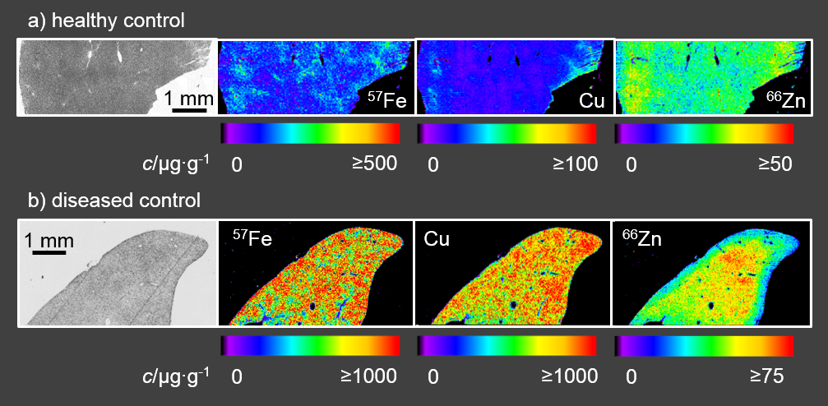Figures

Figure 1
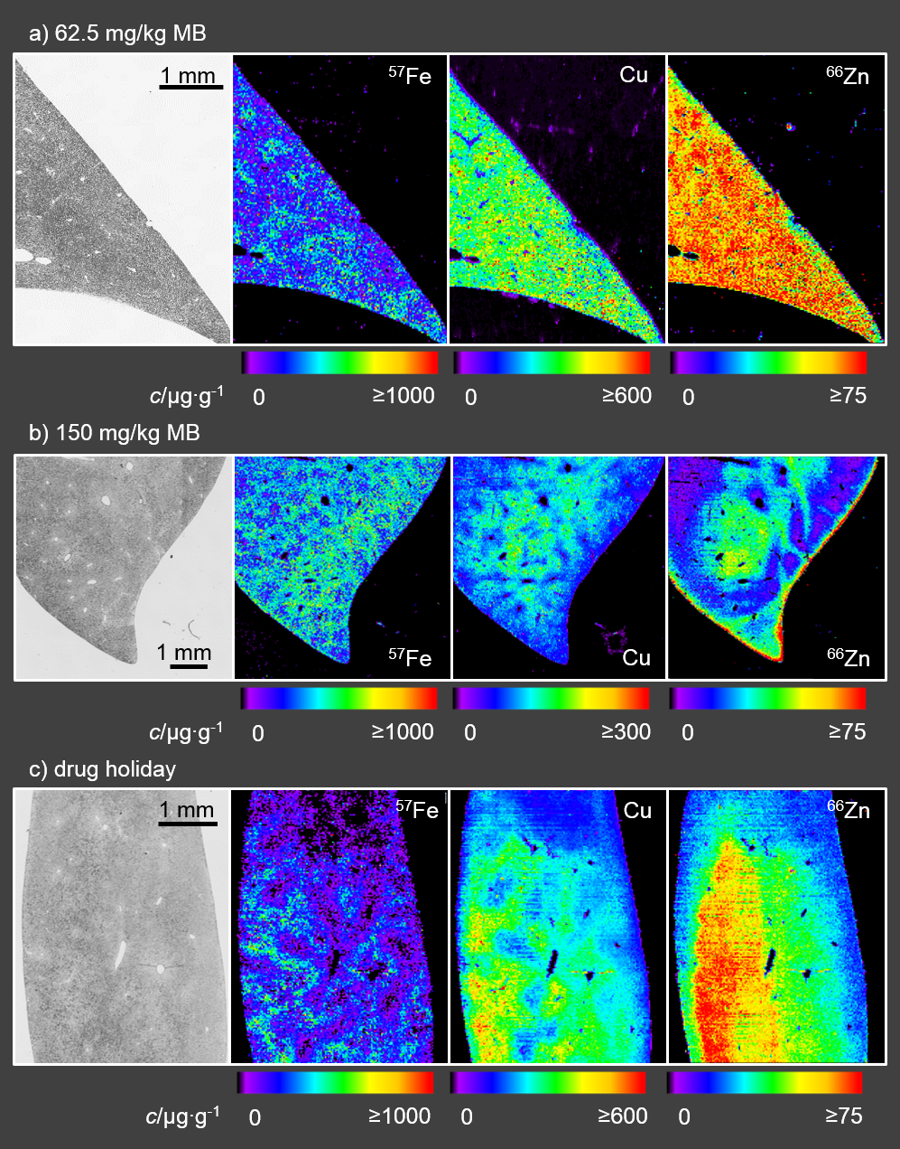
Figure 2
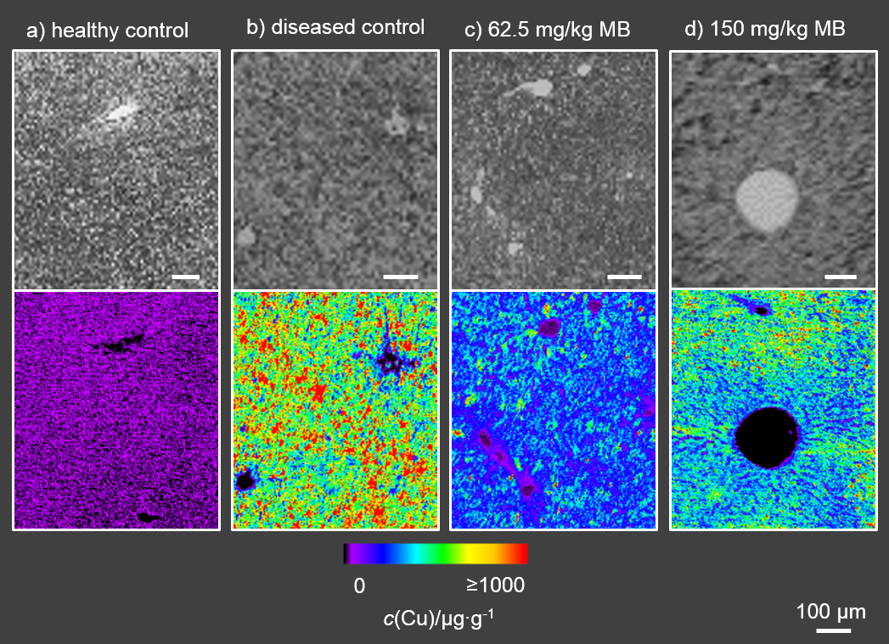
Figure 3
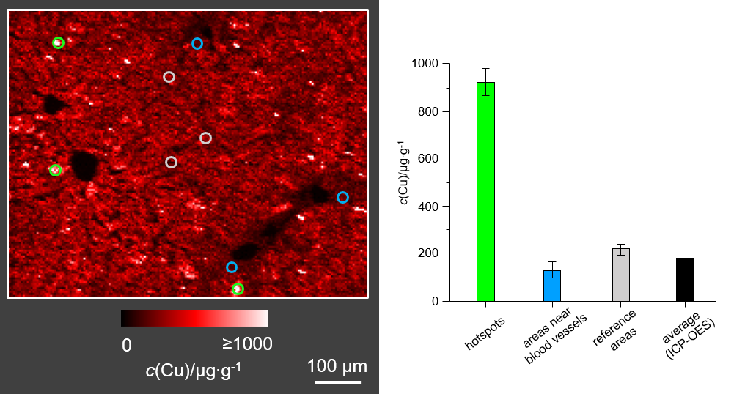
Figure 4
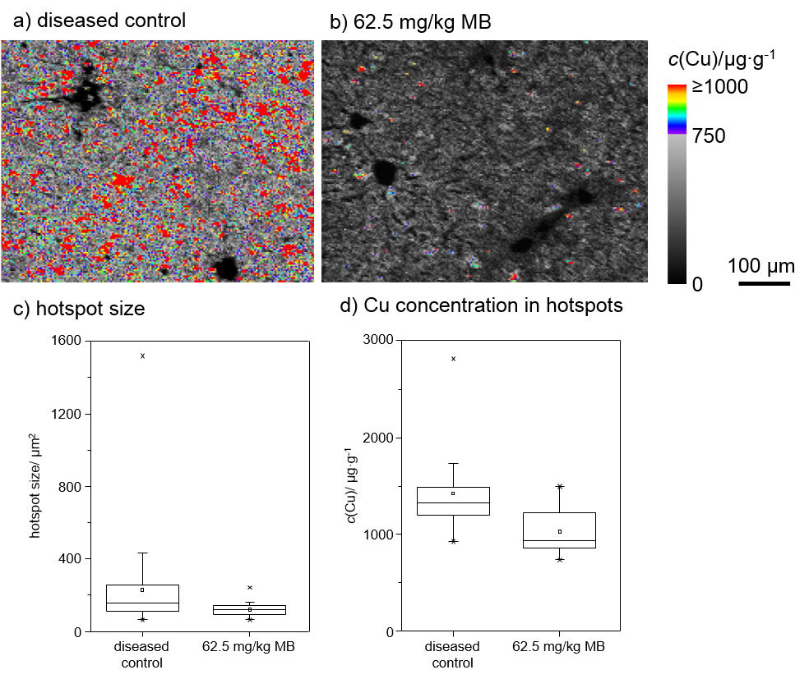
Figure 5
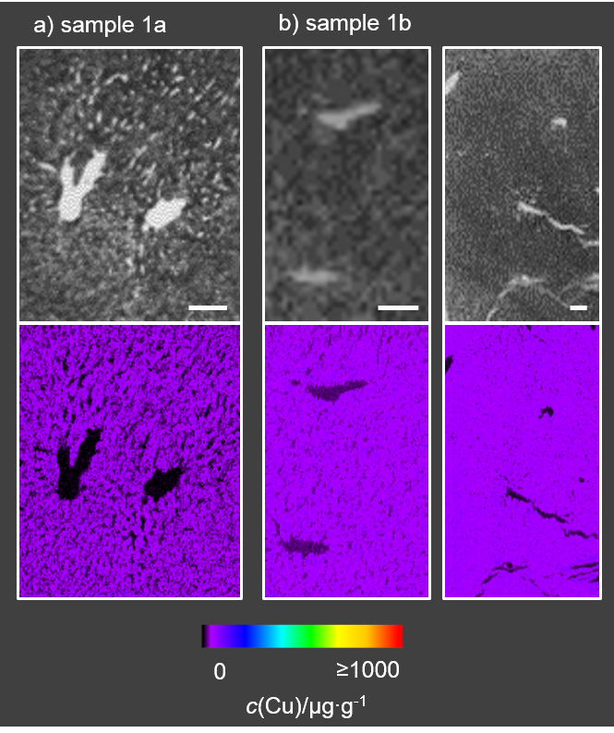Supplementary material

Figure A.1
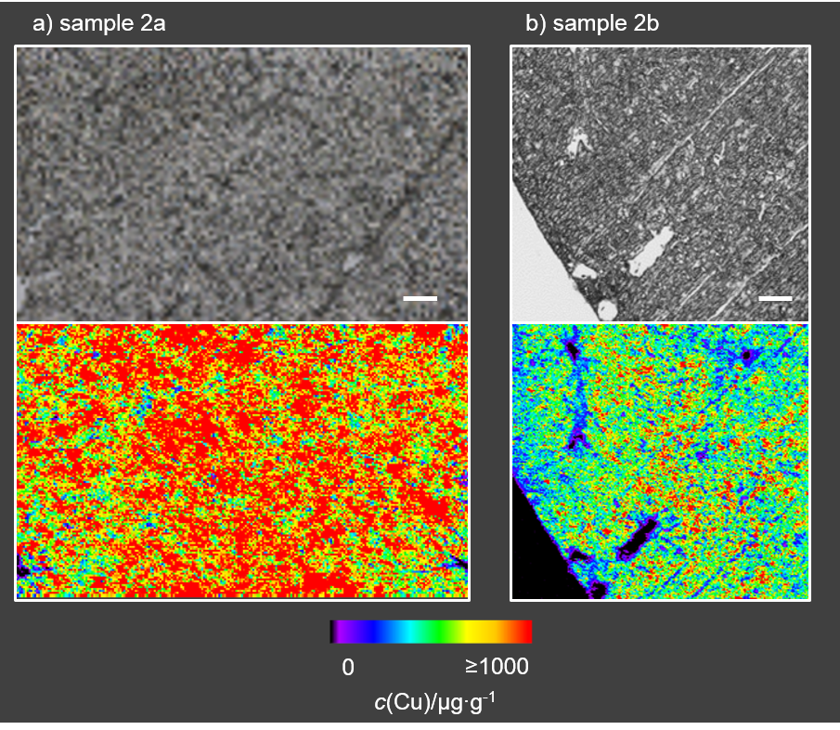
Figure A.2
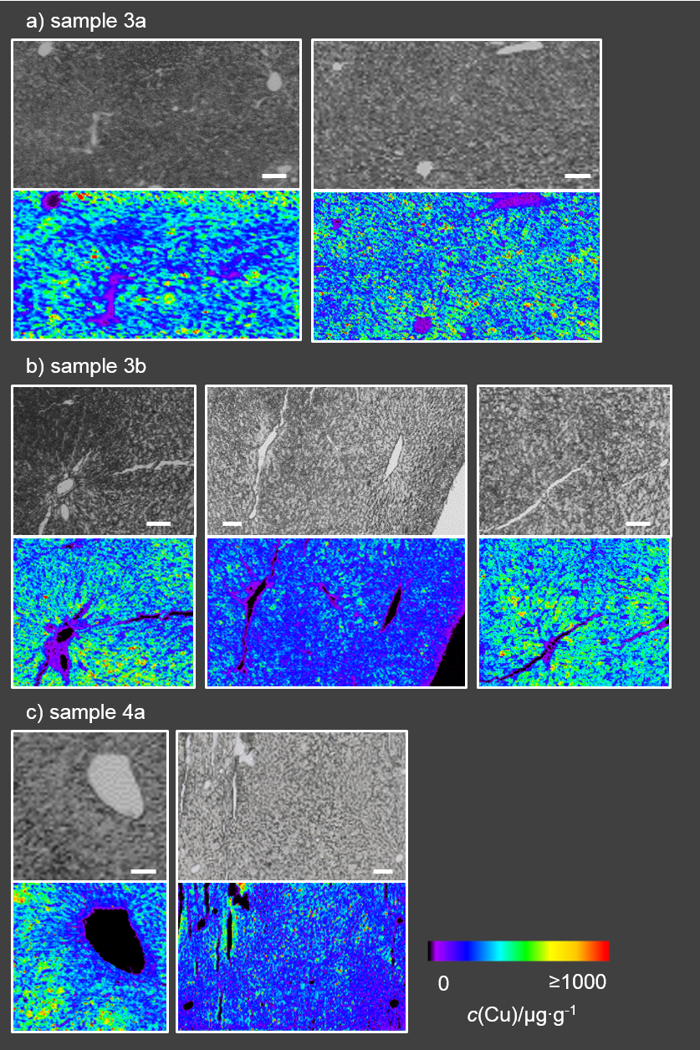
Figure A.3
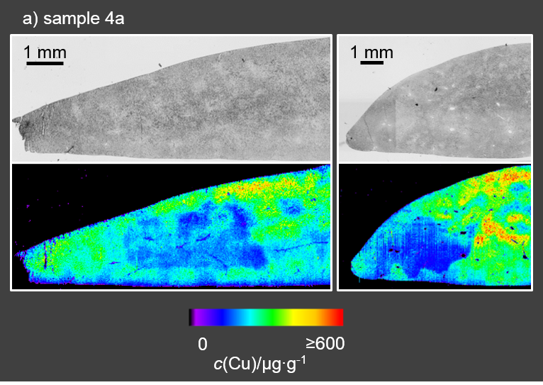
Figure A.4
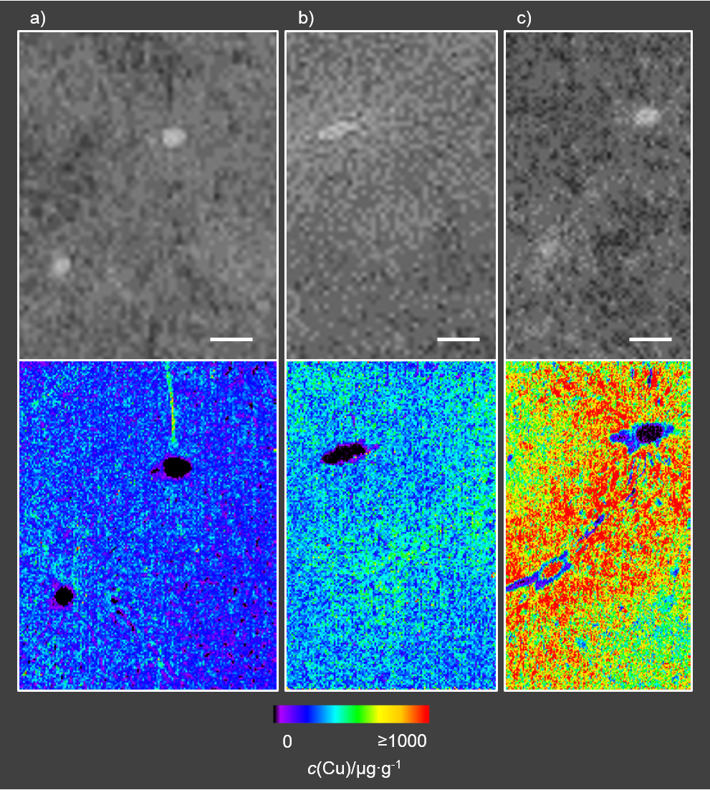
Figure A.5

