**Infections in early life and development of type 1 diabetes**

Andreas Beyerlein1, PhD; Ewan Donnachie2, MSc; Sibille Jergens1, MSc; Anette-Gabriele Ziegler1, MD

1Institute of Diabetes Research, Helmholtz Zentrum München, Munich, Germany

2Kassenärztliche Vereinigung Bayern, Munich, Germany

Corresponding author:

Prof. Dr. Anette-G. Ziegler, MD

Institute of Diabetes Research

Helmholtz Zentrum München

Ingolstädter Landstraße 1

85764 Neuherberg, Germany

Phone +49(0)89 3187-2836

Fax +49(0)89 3081-733

E-mail: anette-g.ziegler@helmholtz-muenchen.de

Running title: Infections and type 1 diabetes

Key words: Respiratory infections, Type 1 diabetes mellitus, Viral infections

Date of revision: 21 December 2015

Word count: 650

**Introduction**

Viral infections in early life have been hypothesized to cause type 1 diabetes (T1D) 1, particularly enteroviruses 2, which are major agents of respiratory infections 3. Recent studies suggest that respiratory infections are associated with increased T1D risk if they are encountered within the first 6 months of life 4. We explored associations between infection types and T1D during the first 2 years of life in a population-based cohort and the association between respiratory infections in the first 6 months and T1D.

**Methods**

The Bavarian association of statutory health insurance physicians (Kassenärztliche Vereinigung Bayern) processes claims data for all statutorily insured patients in Bavaria, Germany (approximately 85% of the total population of Bavaria). Infants born between 2005 and 2007 and followed until March 2015 or last contact with a physician were included. Diagnoses of infection and T1D were obtained using ICD-10 codes recorded in quarterly intervals. Infections were categorized by symptoms (respiratory, gastrointestinal, dermal, eye, fever, and other) and causes (viral, bacterial, mycoses, allergies, parasites, or unknown). We calculated hazard ratios (HRs) and 95% confidence intervals (CIs) of time from occurrence of each category of infectious events (binary variables) in quarterly intervals to T1D diagnosis during the first 2 years of life using Cox’s proportional hazard regression model, adjusted for sex and calendar month of birth. We also calculated the cumulative risk of T1D in the first 6 months by quarterly intervals with any or viral respiratory infections using Kaplan-Meier plots and the log-rank test. Statistical analyses were done using SAS 9.3 and R 3.0.3. Statistical significance was determined on a level of 5% (two-sided). As we performed secondary analyses of observational data, no IRB approval or informed consent of patients was necessary.

**Results**

Of 295,420 infants included (162,448 (55%) male), 720 were diagnosed with T1D over a median (interquartile range) of 8.5 (7.5-9.25) years, for an incidence rate of 20-40/100,000 after the first year of life. At least 1 infectious event was reported during the first 2 years of life in 93% (n=275,245) of all children, and in 97% (n=696) of children with T1D. Most children experienced respiratory (87%) and viral (83%) infections. Parasite infections were infrequent (1%).

Most infections in the first 2 years were not associated with increased T1D risk, except for respiratory infections (observed in 100,970 children (34%), HR 1.18, 95% CI 1.05-1.34) and viral infections (observed in 87,000 children (29%), HR 1.25, 95% CI 1.09-1.43) before 6 months (Figure 1).

In the first 6 months, having respiratory infections in both age periods (0-2.9 and 3-5.9 months) was associated with an increased T1D risk, compared with having infections in 1 or 0 quarter (cumulative 5-year risk: 206/100,000 compared to 142/100,000 and 118/100,000, respectively, p=0.01), particularly if the infections were caused by viruses (cumulative 5-year risk: 269/100,000 compared to 145/100,000 and 120/100,000, respectively, p<0.001, Figure 2). Repeated respiratory infections in the first 6 months were reported for 8% (n=56) of all T1D cases.

**Discussion**

Respiratory infections during infancy were associated with T1D development in a general population setting. A similar study from Taiwan found that enterovirus infections were associated with increased T1D risk, but was unable to investigate critical time windows for infection exposure 5. It is unknown whether the association with early infections reflects increased exposure to virus or an impairment of the immune system response to early infection. We consider it likely that genetic susceptibility may matter in this context, as for T1D in general. As a limitation, we were unable to adjust for potential confounding factors such as family history of T1D as these were unavailable in the present dataset. Further, we investigated several infection types with different exposure ages, potentially introducing multiple testing errors. However, the association of respiratory infections in the first 6 months with T1D is in line with earlier studies4,6 suggesting that the first half year of life is crucial for the development of the immune system and autoreactivity.

**Acknowledgements**

The work was supported by grants from the Kompetenznetz Diabetes mellitus (Competence Network for Diabetes mellitus), funded by the Federal Ministry of Education and Research (FKZ 01GI0805-07, FKZ 01GI0805), the Deutsche Forschungsgemeinschaft (DFG ZI-310/14-1 to -4), the JDRF (JDRF-No 17-2012-16), funding from the German Federal Ministry of Education and Research (BMBF) to the German Center for Diabetes Research (DZD e.V.), and by iMed–the Helmholtz Initiative on Personalized Medicine. We thank Ezio Bonifacio, PhD (Technische Universität Dresden, Germany), for critically reviewing the manuscript without receiving compensation.

The funders had no impact design and conduct of the study; collection, management, analysis, and interpretation of the data; preparation, review, or approval of the manuscript; and decision to submit the manuscript for publication.

The authors’ responsibilities were as follows: ED conducted data extraction and data management. SJ contributed to categorization of infection diagnoses. AB performed statistical analyses and wrote the first and subsequent drafts of the paper together with ED, SJ and AGZ. AB and ED had full access to all of the data in the study and take responsibility for the integrity of the data and the accuracy of the data analysis.

The authors had no conflicts of interest.

**References**

**1.** von Herrath M. Diabetes: A virus-gene collaboration. *Nature.* May 28 2009;459(7246):518-519.

**2.** Yeung WC, Rawlinson WD, Craig ME. Enterovirus infection and type 1 diabetes mellitus: systematic review and meta-analysis of observational molecular studies. *Bmj.* 2011;342:d35.

**3.** Monto AS. Epidemiology of viral respiratory infections. *The American journal of medicine.* Apr 22 2002;112 Suppl 6A:4S-12S.

**4.** Beyerlein A, Wehweck F, Ziegler AG, Pflueger M. Respiratory infections in early life and the development of islet autoimmunity in children at increased type 1 diabetes risk: evidence from the BABYDIET study. *JAMA pediatrics.* Sep 2013;167(9):800-807.

**5.** Lin HC, Wang CH, Tsai FJ, et al. Enterovirus infection is associated with an increased risk of childhood type 1 diabetes in Taiwan: a nationwide population-based cohort study. *Diabetologia.* Jan 2015;58(1):79-86.

**6.** Ziegler AG, Schmid S, Huber D, Hummel M, Bonifacio E. Early infant feeding and risk of developing type 1 diabetes-associated autoantibodies. *JAMA : the journal of the American Medical Association.* Oct 1 2003;290(13):1721-1728.

**Figure 1.** Hazard ratios (dots) and 95% confidence intervals for type 1 diabetes development by the major infection types, adjusted for sex and month of birth.

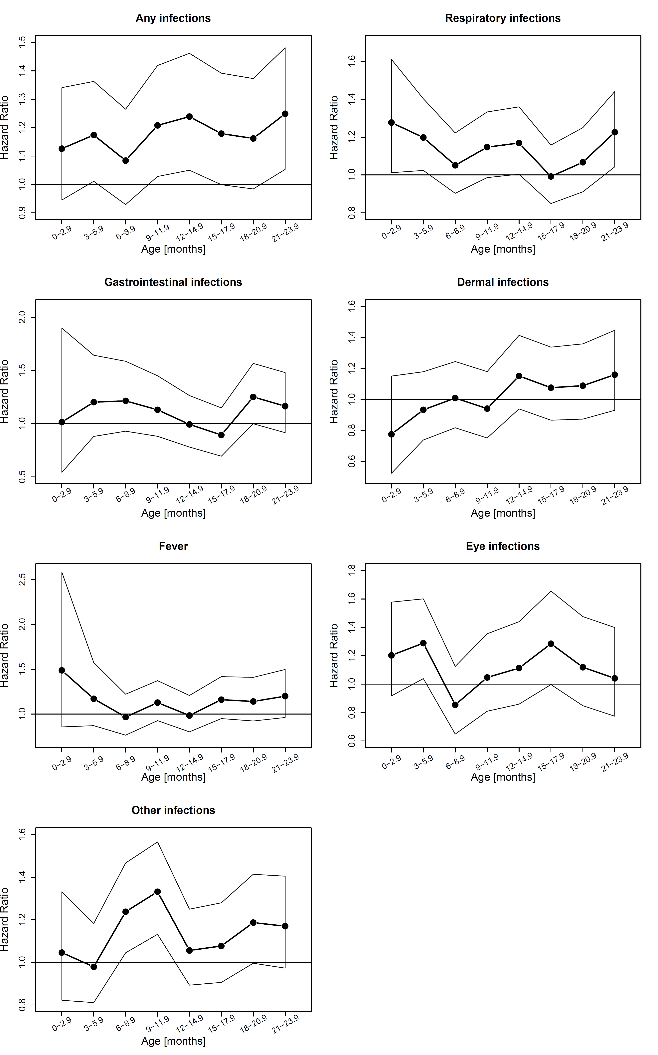

**Figure 2.** Cumulative risk of type 1 diabetes development by number of quarterly intervals with a documented respiratory infection (any / viral) during the first 6 months of life.

