**Supplementary information**

**Improving the intestinal lipidome coverage in a gnotobiotic mouse model using UHPLC-MS-based approach through optimization of mobile phase modifiers and column selection**

Habiba Selmi**a**, Alesia Walker**a\***, Laurent Debarbieux**b**, Philippe Schmitt-Kopplin**a,c**

aResearch Unit Analytical BioGeoChemistry, Helmholtz Zentrum München, Neuherberg, Germany

bInstitut Pasteur, Université Paris Cité, CNRS UMR6047, Bacteriophage Bacterium Host, Paris, France

cChair of Analytical Food Chemistry, Technical University of Munich, Freising, Germany

*Corresponding author:

E-mail: alesia.walker@helmholtz-munich.de

HelmholtzZentrum München

Deutsches Forschungszentrum für Gesundheit und Umwelt

Department of Environmental Sciences

Analytical BioGeoChemistry

Ingolstaedter Landstrasse 1

85764 Neuherberg

Germany

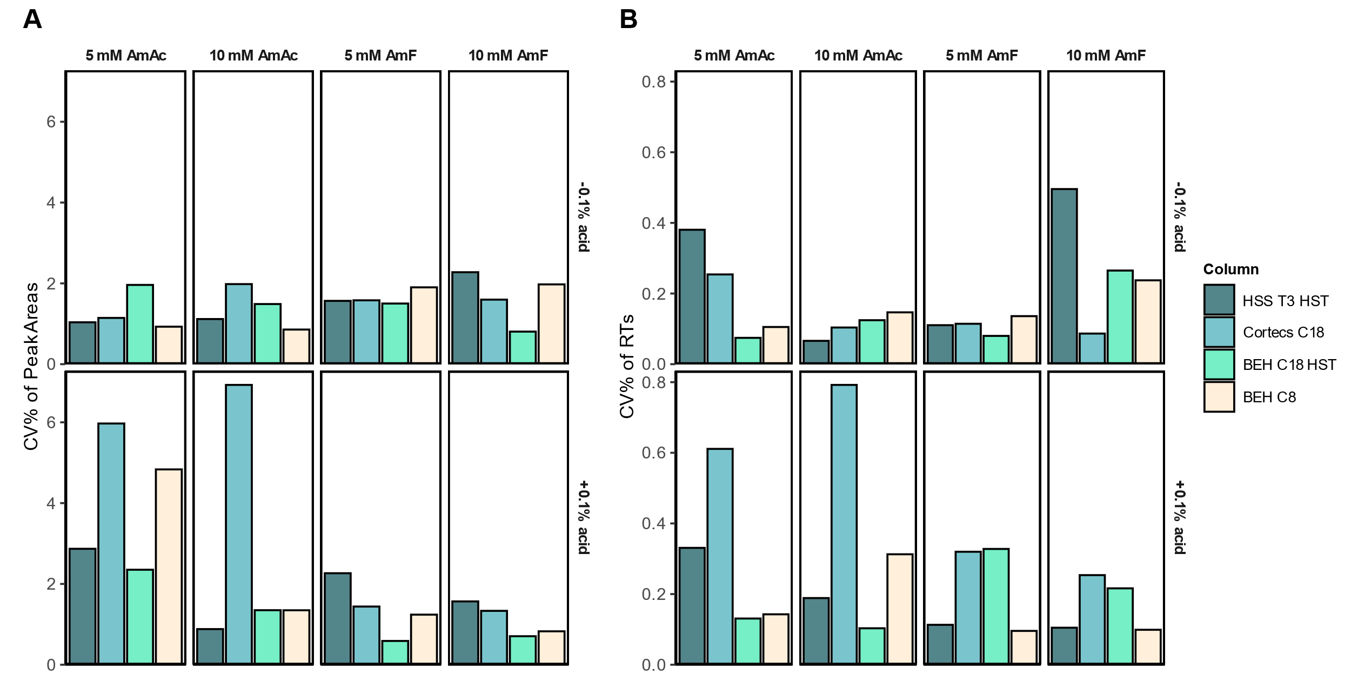

**Fig. S1.** Precision of peak areas (A) and retention times (B) of four deuterated lipids (1-acetyl-d3-L-carnitine, decanoyl-L-carnitine-d3, 1-pentadecanoyl-2-oleoyl(d7)-sn-glycero-3 phosphocholine and 1-pentadecanoyl-2-oleoyl(d7)-sn-glycero-3-phosphoethanolamine) spiked in blanks and derived from replicate injections measured in ESI(+) RPLC-MS/MS, expressed as average of CV% and analyzed with four columns.

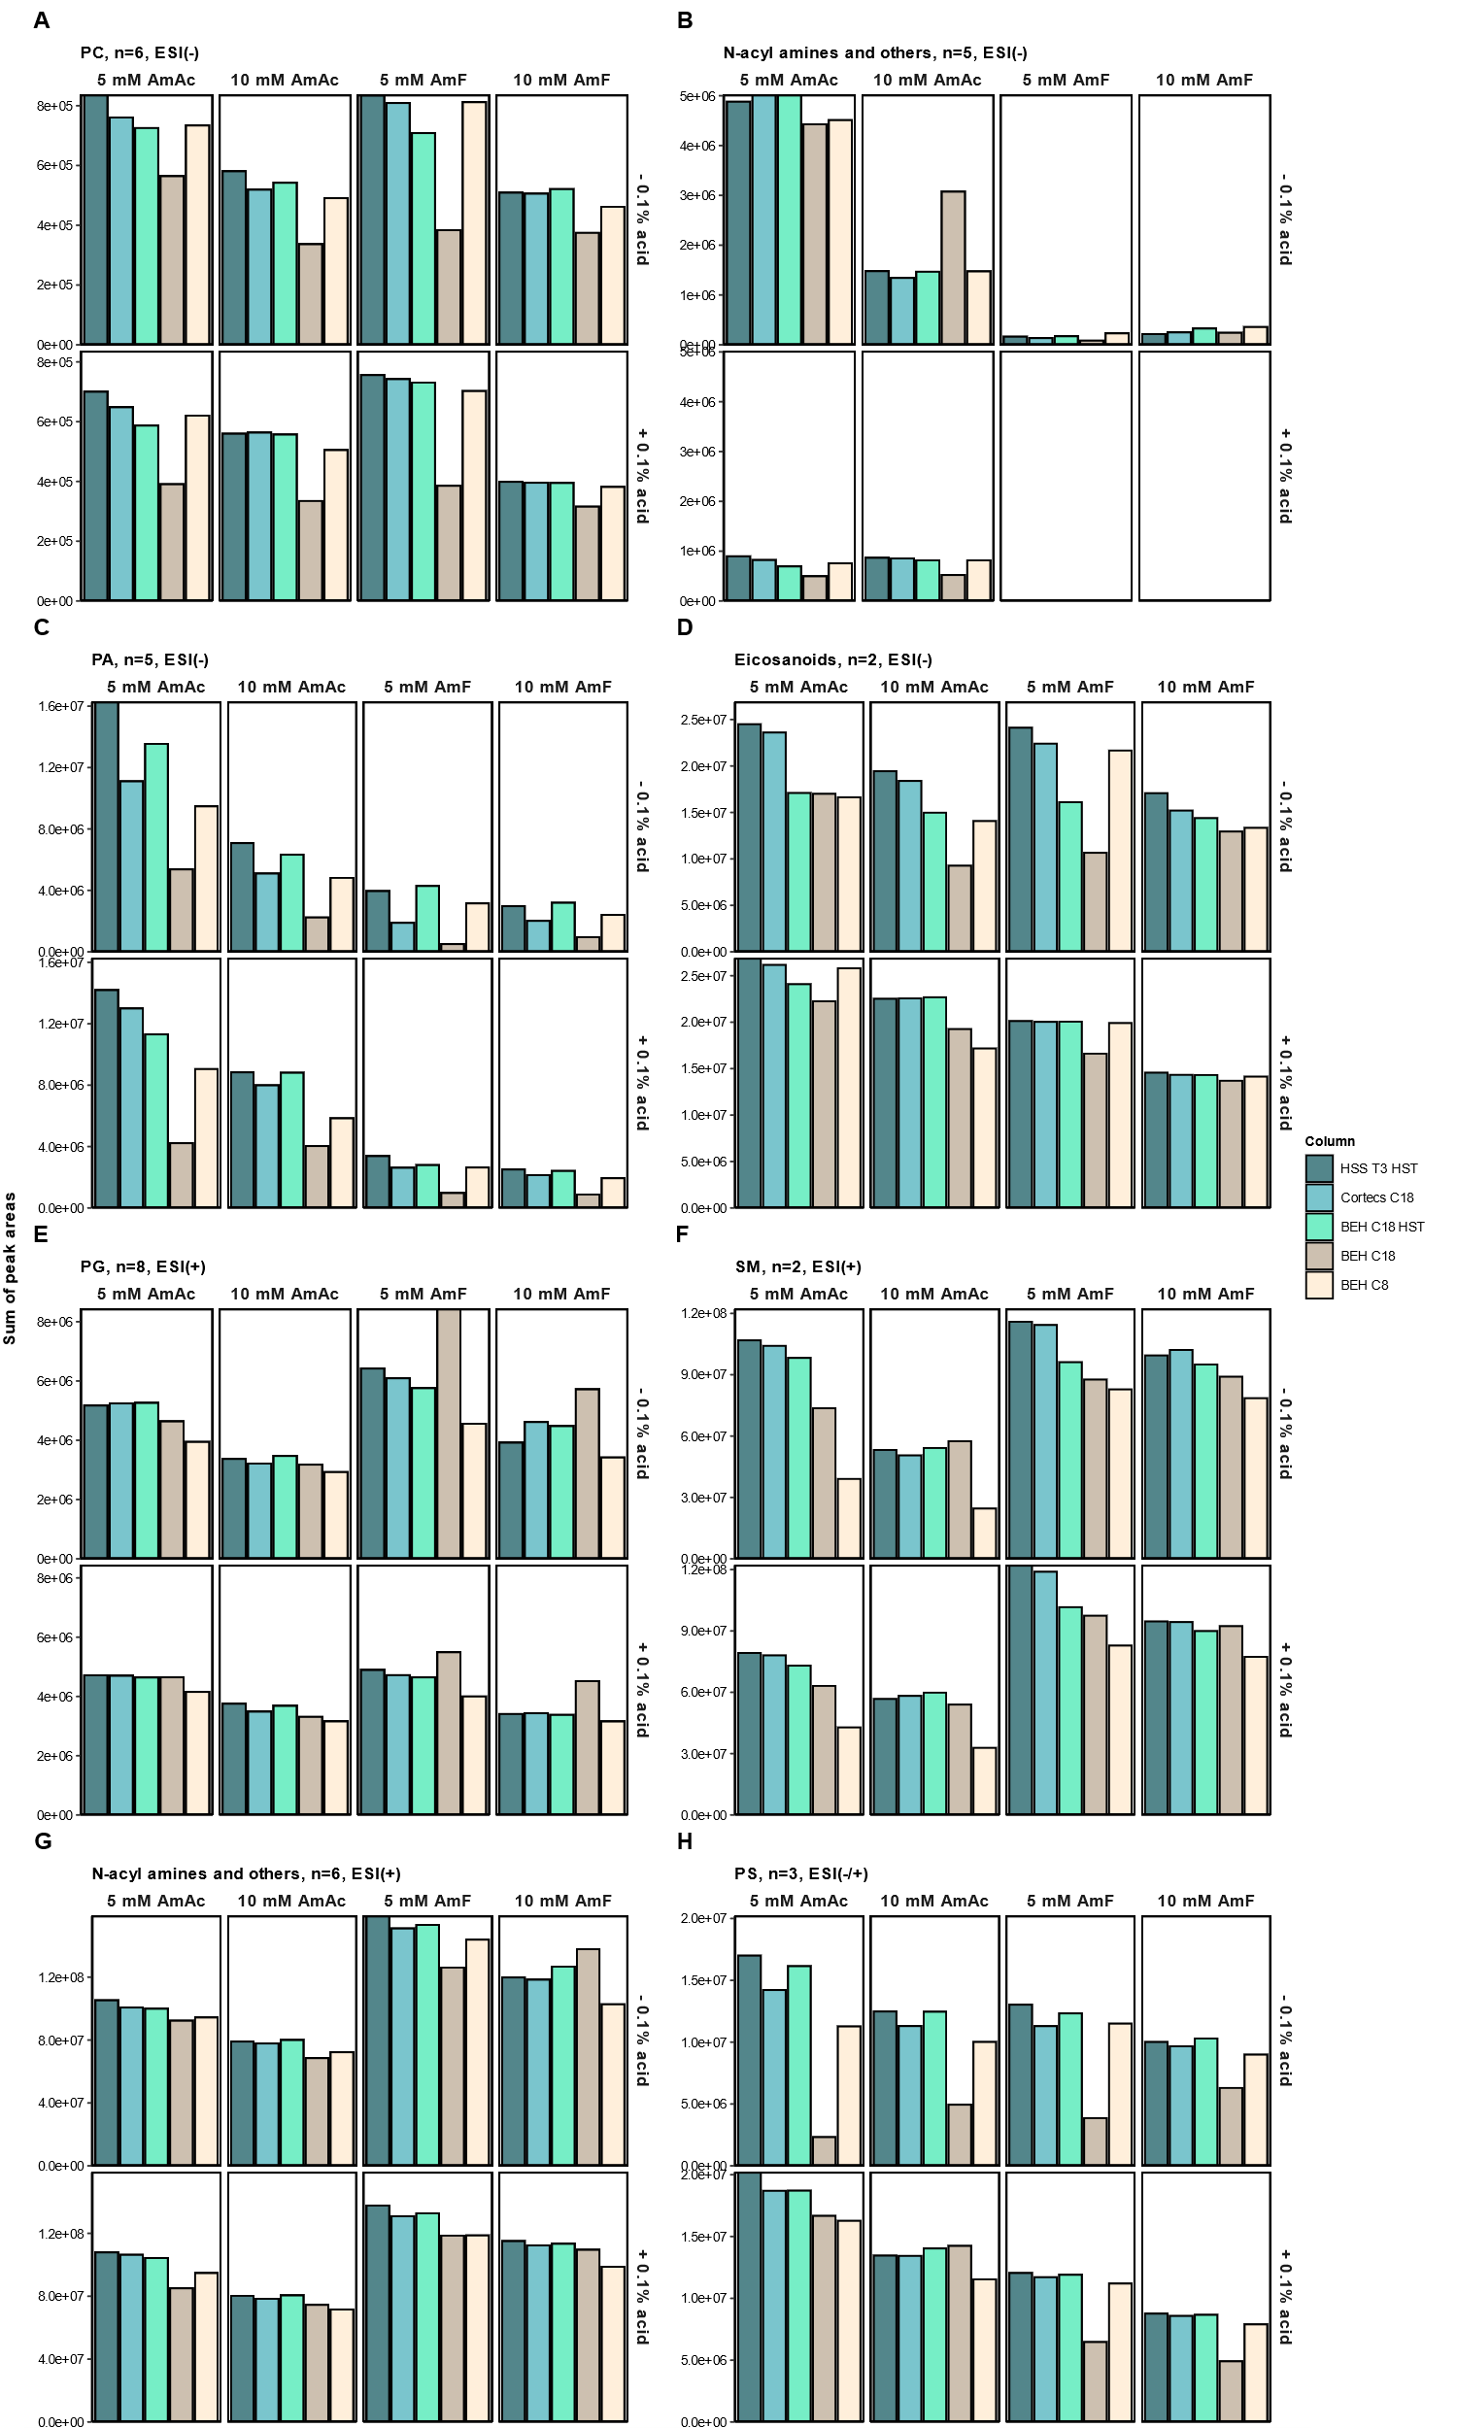

**Fig. S2.** The impact of two ammonium-based buffers (AmAc and AmF) at 5 and 10 mM and mobile phase acidification (+/-) 0.1% acid on ionization efficiency expressed by summed peak areas per condition of selected lipid standards. Lipid classes including PC (n=6), N-acyl amines and others (n=5), PA (n=5) and eicosanoids (n=2) in ESI(-) (**A-D**), PG (n=8), SM (n=2) and N-acyl amines and others (n=6) in ESI(+) (**E-G**) or PS (n=3) in both modes (ESI(-/+) (**H**) were analyzed with five columns. Legend: AmAc: ammonium acetate and AmF: ammonium formate. Acetic acid (0.1%) was added to 5 or 10 mM AmAc while formic acid (0.1%) was used with 5 or 10 mM AmF.





**Fig. S3.** Extracted ion chromatograms of lipid standards in both ESI(+/-). (**A**) Palmitoleic acid analyzed with the BEH C18 HST using 5 mM AmAc and AmF without acidification both in ESI(-) and (**B**) PC(15:0/15:0) with 5 mM AmAc and AmF with acidification in ESI(+). (**C**) SM(18:1;2O/18:0) analyzed with five different columns incorporating HST, conventional and core-shell technology, using 5 mM AmAc without acidification in ESI(+). Tailing factors and peak width values were displayed for each column. (**D**) PS(16:0;2O/18:1) analyzed with the BEH C18 HST and BEH C18 in ESI(-).

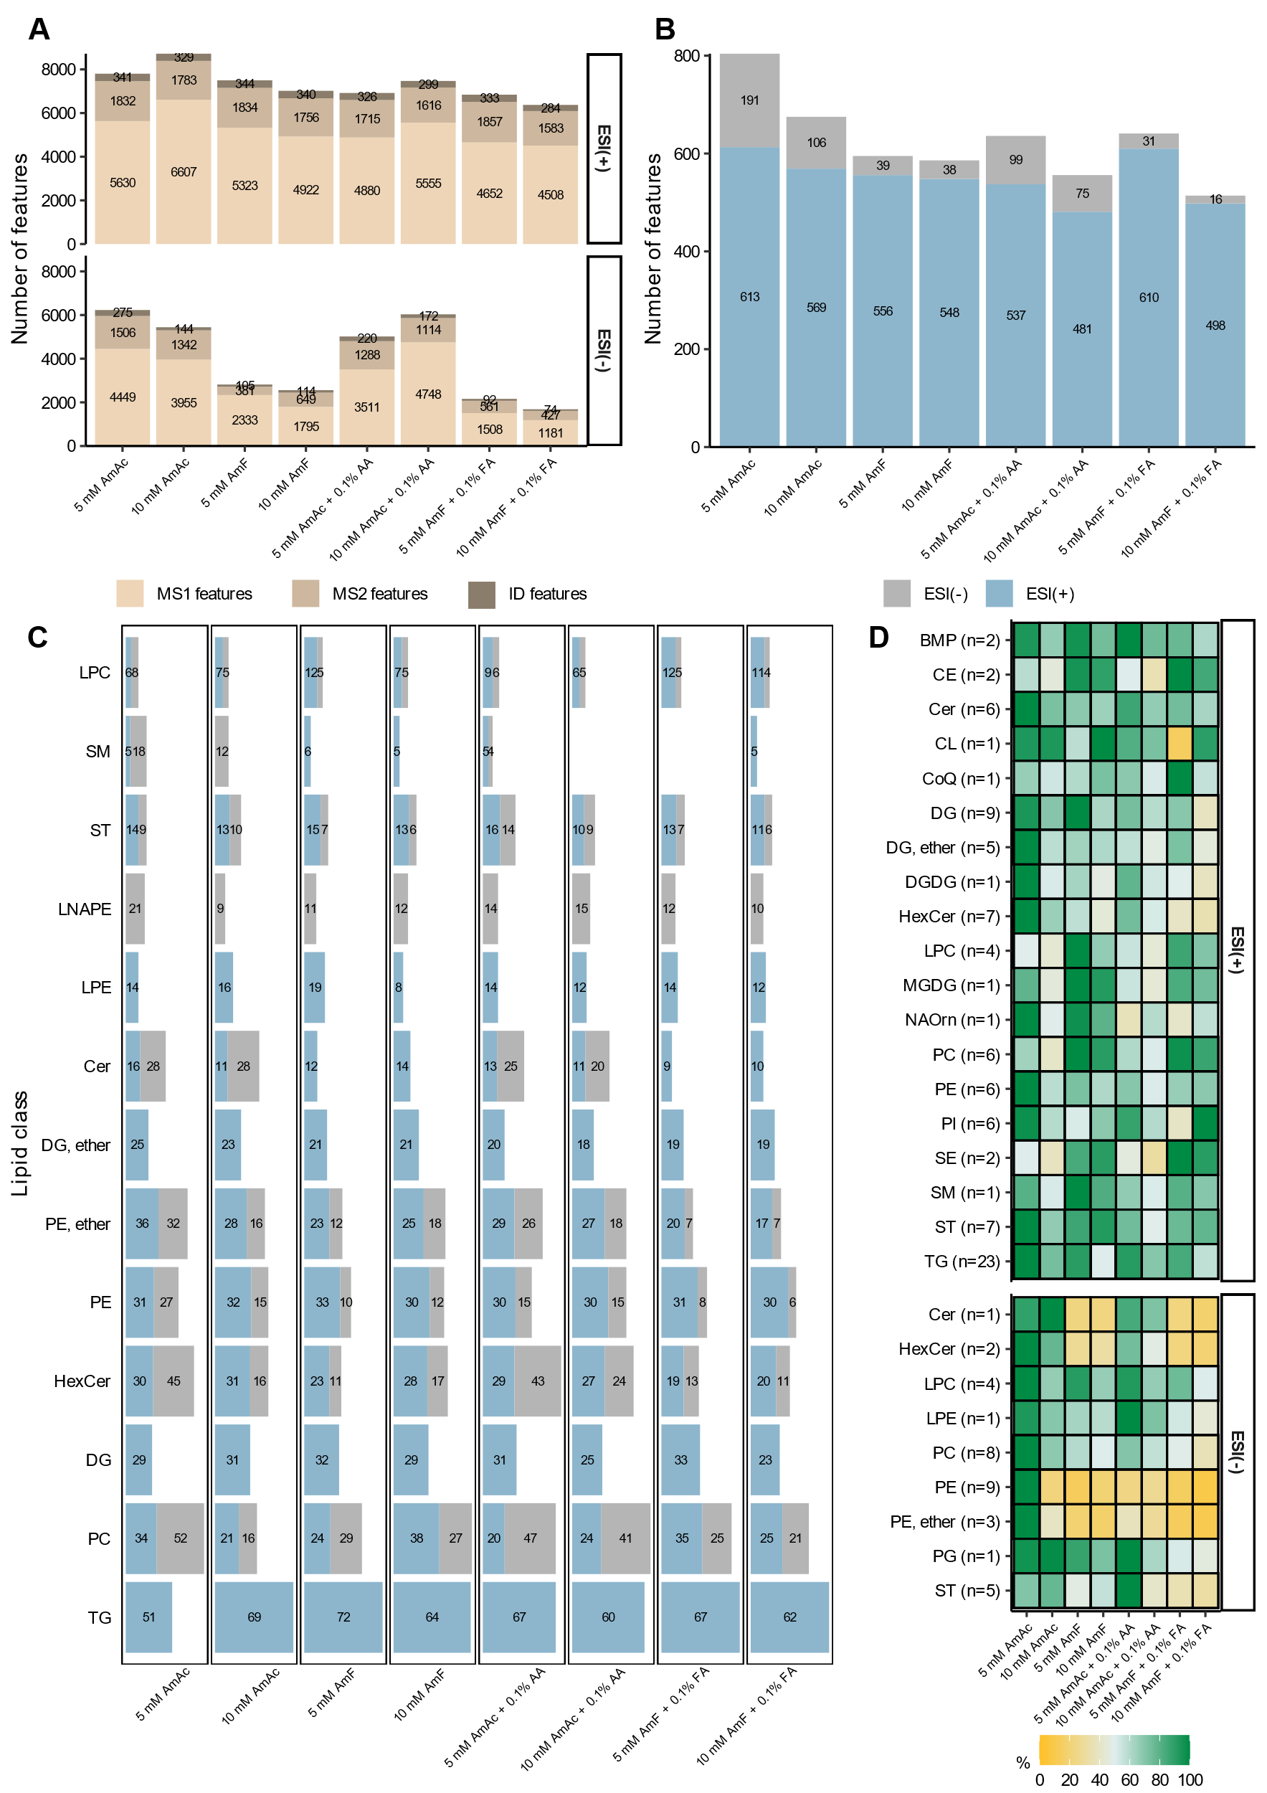

**Fig. S4.** The impact of various mobile phase modifiers on feature coverage, lipid classification and the ionization efficiency in a pooled ileum sample analyzed with LC-MS/MS in ESI(+/-). Intestinal lipids were separated using the BEH C18 HST column. (**A**) Bar plots showing the total number of detected features (MS1), features with MS2 and features annotated by the MS-DIAL library (ID). (**B**) Bar plots representing the total count of classified features (probability over 0.6) by CANOPUS. (**C**) Bar plots showing the individual count of common lipid classes among different buffer additives. (**D**) Heatmap showing the percentage of relative peak intensities, for lipid classes detected under all eight buffer conditions in ESI(+/-). The percentages of each lipid species were defined to the highest peak intensity set to 100%, observed for each common lipid species across the eight buffer conditions. Peak intensities of lipid classes were categorized as follows: moderate poor (<50%), sufficient (≥50%), and excellent (≥80%). Legend: AmAc: ammonium acetate; AmF: ammonium formate, AmAc + 0.1% AA: ammonium acetate and 0.1% acetic acid; AmF + 0.1% FA: ammonium formate and 0.1% formic acid.

**Table S1:** Detailed information on analyzed lipids

|  |  |  |  |
| --- | --- | --- | --- |
| **Name** | **Producer** | **Order Number** | **CAS** |
| [(3R)-3-Hydroxydodecanoyl]-L-carnitine | Sigma-Aldrich | 49853 | 1469900-99-9 |
| [(3R)-3-Hydroxyhexadecanoyl]-L-carnitine | Sigma-Aldrich | 52096 | 1469901-03-8 |
| 1,2-Diarachidoyl-sn-glycero-3-phosphocholine, powder | Cayman Chemical | 850368P | 61596-53-0 |
| 1,2-Dibehenoyl-sn-glycero-3-phosphocholine, powder | Avanti Polar Lipids | 850371P | 37070-48-7 |
| 1,2-Diheptadecanoyl-sn-glycero-3-phosphate (sodium salt) | Avanti Polar Lipids | 830856 | 154804-54-3 |
| 1,2-Diheptadecanoyl-sn-glycero-3-phospho-(1'-rac-glycerol) (sodium salt) | Avanti Polar Lipids | 830456 | 799268-52-3 |
| 1,2-Diheptadecanoyl-sn-glycero-3-phosphocholine, powder | Avanti Polar Lipids | 850360P | 70897-27-7 |
| 1,2-Diheptadecanoyl-sn-glycero-3-phosphoethanolamine | Avanti Polar Lipids | 830756 | 140219-78-9 |
| 1,2-Dimyristoyl-sn-glycero-3-phosphate (sodium salt) | Avanti Polar Lipids | 830845 | 80724-31-8 |
| 1,2-Dimyristoyl-sn-glycero-3-phospho-(1'-rac-glycerol) (sodium salt) | Avanti Polar Lipids | 840445 | 200880-40-6 |
| 1,2-Dimyristoyl-sn-glycero-3-phosphocholine | Avanti Polar Lipids | 850345 | 18194-24-6 |
| 1,2-Dimyristoyl-sn-glycero-3-phosphoethanolamine | Avanti Polar Lipids | 850745 | 998-07-2 |
| 1,2-Dipalmitoyl-sn-glycero-3-phosphate (sodium salt) | Avanti Polar Lipids | 830855 | 169051-60-9 |
| 1,2-Dipalmitoyl-sn-glycero-3-phospho-(1'-rac-glycerol) (sodium salt) | Avanti Polar Lipids | 840455 | 200880-41-7 |
| 1,2-Dipalmitoyl-sn-glycero-3-phosphoethanolamine | Avanti Polar Lipids | 850705 | 923-61-5 |
| 1,2-Dipalmitoyl-sn-glycero-3-phospho-L-serine (sodium salt) | Avanti Polar Lipids | 840037 | 145849-32-7 |
| 1,2-Dipentadecanoyl-sn-glycero-3-phospho-(1′-rac-glycerol) (sodium salt), powder | Avanti Polar Lipids | 840446P | 322647-32-5 |
| 1,2-Dipentadecanoyl-sn-glycero-3-phosphoethanolamine, powder | Avanti Polar Lipids | 850704P | 109032-52-2 |
| 1,2-Distearoyl-sn-glycero-3-phosphate (sodium salt) | Avanti Polar Lipids | 830865 | 108321-18-2 |
| 1,2-Distearoyl-sn-glycero-3-phospho-(1'-rac-glycerol) (sodium salt) | Avanti Polar Lipids | 840465 | 200880-42-8 |
| 1,2-Distearoyl-sn-glycero-3-phosphoethanolamine | Avanti Polar Lipids | 850715 | 1069-79-0 |
| 1,3-dipentadecanoyl-2-oleyol(d7)-glycerol | Avanti Polar Lipids | 791648 | 2097561-17-4 |
| 1.2-Didecanoyl-sn-glycero-3-phosphocholine | Avanti Polar Lipids | 850325 | 3436-44-0 |
| 1.2-Dilauroyl-sn-glycero-3-Phospho-L-Serine | Avanti Polar Lipids | 840038P | 208757-51-1 |
| 1.2-Dioleoyl-sn-glycero-3-phosphoethanolamine | Avanti Polar Lipids | 880130 | 474922-90-2 |
| 12-Methyltetradecanoic acid | Sigma-Aldrich | M3664 | 5502-94-3 |
| 13-Methylmyristic acid | Sigma-Aldrich | M7031 | 2485-71-4 |
| 1-Heptadecanoyl-2-hydroxy-sn-glycero-3-phosphocholine | Avanti Polar Lipids | 855676 | 50930-23-9 |
| 1-Myristoyl-2-hydroxy-sn-glycero-3-phosphocholine | Avanti Polar Lipids | 855575 | 20559-16-4 |
| 1-Oleoyl-2-hydroxy-sn-glycero-3-phosphoethanolamine | Avanti Polar Lipids | 846725 | 89576-29-4 |
| 1-Palmitoyl-2-arachidonoyl-sn-glycero-3-phospho-(1′-rac-glycerol) (sodium salt), chloroform | Avanti Polar Lipids | 840499C | 322647-47-2 |
| 1-Palmitoyl-2-arachidonoyl-sn-glycero-3-phosphocholine | Avanti Polar Lipids | 850459 | 35418-58-7 |
| 1-Palmitoyl-2-docosahexaenoyl-sn-glycero-3-phosphate (sodium salt) | Avanti Polar Lipids | 840860 | 474943-28-7 |
| 1-Palmitoyl-2-docosahexaenoyl-sn-glycero-3-phospho-(1′-rac-glycerol) (sodium salt), chloroform | Avanti Polar Lipids | 840500C | 384833-22-1 |
| 1-Palmitoyl-2-docosahexaenoyl-sn-glycero-3-phosphocholine | Avanti Polar Lipids | 850461 | 59403-54-2 |
| 1-Palmitoyl-2-docosahexaenoyl-sn-glycero-3-phosphoethanolamine | Avanti Polar Lipids | 850801 | 96998-00-4 |
| 1-Palmitoyl-2-glutaryl-sn-glycero-3-phosphocholine | Avanti Polar Lipids | 870602 | 89947-79-5 |
| 1-Palmitoyl-2-hydroxy-sn-glycero-3-phosphocholine | Avanti Polar Lipids | 855675 | 17364-16-8 |
| 1-Palmitoyl-2-linoleoyl-sn-glycero-3-phospho-(1′-rac-glycerol) (sodium salt), chloroform | Avanti Polar Lipids | 840497C | 322647-44-9 |
| 1-Palmitoyl-2-linoleoyl-sn-glycero-3-phosphocholine | Avanti Polar Lipids | 850458 | 159701-21-0 |
| 1-Palmitoyl-2-linoleoyl-sn-glycero-3-phosphoethanolamine | Avanti Polar Lipids | 850756 | 26662-95-3 |
| 1-Palmitoyl-2-linoleoyl-sn-glycero-3-phospho-L-serine (sodium salt) | Avanti Polar Lipids | 840060 | 384833-20-9 |
| 1-Palmitoyl-2-oleoyl-glycero-3-phosphocholine | Avanti Polar Lipids | 850457 | 26853-31-6 |
| 1-Palmitoyl-2-oleoyl-sn-glycero-3-phosphate (sodium salt) | Avanti Polar Lipids | 840857 | 169437-35-8 |
| 1-Palmitoyl-2-oleoyl-sn-glycero-3-phospho-(1'-rac-glycerol) (sodium salt) | Avanti Polar Lipids | 840457 | 268550-95-4 |
| 1-Palmitoyl-2-oleoyl-sn-glycero-3-phosphoethanolamine | Avanti Polar Lipids | 850757 | 26662-94-2 |
| 1-Palmitoyl-2-oleoyl-sn-glycero-3-phospho-L-serine (sodium salt) | Avanti Polar Lipids | 840034 | 321863-21-2 |
| 1-Palmitoyl-2-stearoyl-sn-glycero-3-phosphocholine | Avanti Polar Lipids | 850456 | 59403-51-9 |
| 1-Pentadecanoyl-2-hydroxy-sn-glycero-3-phosphocholine | Avanti Polar Lipids | 855576P | 108273-89-8 |
| 1-Stearoyl-2-arachidonoyl-sn-glycero-3-phosphocholine | Avanti Polar Lipids | 850469 | 35418-59-8 |
| 1-Stearoyl-2-arachidonoyl-sn-glycero-3-phosphoethanolamine | Avanti Polar Lipids | 850804 | 61216-62-4 |
| 1-Stearoyl-2-docosahexaenoyl-sn-glycero-3-phosphoethanolamine | Avanti Polar Lipids | 850806 | 96998-01-5 |
| 1-Stearoyl-2-hydroxy-sn-glycero-3-phosphocholine | Avanti Polar Lipids | 855775 | 19420-57-6 |
| 1-Stearoyl-2-hydroxy-sn-glycero-3-phosphoethanolamine | Avanti Polar Lipids | 856715 | 69747-55-3 |
| 1-Stearoyl-2-linoleoyl-sn-glycero-3-phosphocholine | Avanti Polar Lipids | 850468 | 27098-24-4 |
| 1-Stearoyl-2-linoleoyl-sn-glycero-3-phosphoethanolamine | Avanti Polar Lipids | 850802 | 7266-53-7 |
| 1-Stearoyl-2-oleoyl-sn-glycero-3-phosphoethanolamine | Avanti Polar Lipids | 850758 | 6418-95-7 |
| 1-Stearoyl-2-palmitoyl-sn-glycero-3-phosphocholine | Avanti Polar Lipids | 850465 | 59403-53-1 |
| 1-Tridecanoyl-2-hydroxy-sn-glycero-3-phosphocholine, powder | Avanti Polar Lipids | 855476P | 20559-17-5 |
| 2-Methylbutyryl-L-carnitine | Sigma-Aldrich | 50405 | 256928-75-3 |
| 3-Hydroxybutyrylcarnitine chloride | Sigma-Aldrich | 90941 | 918639-76-6 |
| 3-Methylglutaryl carnitine | Sigma-Aldrich | 738816 | 102673-95-0 |
| 3-sn-Lysophosphatidylethanolamine | Sigma-Aldrich | L4754 |  |
| Acetyl-d3-L-carnitine hydrochloride | Sigma-Aldrich | 617466 | 362049-62-5 |
| Acetyl-L-carnitine | Cayman Chemical | 16948 | 5080-50-2 |
| Adipoyl-L-carnitine | Sigma-Aldrich | 91926 | 102636-83-9 |
| Arachidonic acid, sodium salt | Cayman Chemical | 100006607 | 6610-25-9 |
| Arachidonoyl ethanolamide | Cayman Chemical | 10005765 | 94421-69-9 |
| Arachidonyl-L-carnitine | Sigma-Aldrich | 30172 | 36816-11-2 |
| Butyryl-L-carnitine | Sigma-Aldrich | 42623 | 25576-40-3 |
| C16 lactosyl(β) ceramides (d18:1/16:0) | Avanti Polar Lipids | 860576P | 4201-62-1 |
| C18 Glucosyl(ß) ceramide (d18:1/18:0) | Avanti Polar Lipids | 860547 | 95119-86-1 |
| Caprylic acid (C8:0) | Sigma-Aldrich | O3907 | 124-07-2 |
| Ceramide mixture | Cayman Chemical | 22853 | 100403-19-8 |
| Cholesterol | Sigma-Aldrich | C8667 | 57-88-5 |
| Cis, cis-9,12-octadecadienoyl-L-carnitine | Sigma-Aldrich | 76771 | 36816-10-1 |
| Decanoyl-L-carnitine | Sigma-Aldrich | 50637 | 3992-45-8 |
| Decanoyl-L-carnitine-d3 (chloride) | Cayman Chemical | 6568 | 2483831-87-2 |
| D-galactosyl-ß-1,1' N-palmitoyl-D-erythro-sphingosine | Avanti Polar Lipids | 860521P | 34324-89-5 |
| D-ribo-phytosphingosine | Avanti Polar Lipids | 860499 | 388566-94-7 |
| D-sphingosine | Avanti Polar Lipids | 860490 | 123-78-4 |
| Glutaryl-L-carnitine lithium salt | Sigma-Aldrich | 72715 | 102636-82-8 |
| Hexanoyl-L-carnitine | Sigma-Aldrich | 7439 | 22671-29-0 |
| Isobutyryl-L-carnitine | Sigma-Aldrich | 51085 | 25518-49-4 |
| Isovaleryl-L-carnitine | Sigma-Aldrich | 51371 | 31023-24-2 |
| Lauroyl-L-carnitine | Sigma-Aldrich | 91432 | 25518-54-1 |
| L-carnitine hydrochloride | Sigma-Aldrich | C0283 | 6645-46-1 |
| Malonyl-L-carnitine | Sigma-Aldrich | 92998 | 910825-21-7 |
| Methyl stearate | Sigma-Aldrich | S5376 | 112-61-8 |
| Myristoyl-L-carnitine | Sigma-Aldrich | 61367 | 25597-07-3 |
| N-(2-hydroxyethyl)-heptadecanamide | Cayman Chemical | 17567 | 5450-40-8 |
| N-heptadecanoyl-D-erythro-sphingosine | Avanti Polar Lipids | 860517 | 67492-16-4 |
| N-palmitoyl-D-erythro-sphingosylphosphorylcholine | Avanti Polar Lipids | 860584 | 6254-89-3 |
| N-stearoyl-D-erythro-sphingosine | Avanti Polar Lipids | 860518 | 2304-81-6 |
| N-stearoyl-D-erythro-sphingosylphosphorylcholine | Avanti Polar Lipids | 860586 | 58909-84-5 |
| N-stearoyl-Taurine | Cayman Chemical | 10005610 | 63155-80-6 |
| Octanoyl-L-carnitine | Sigma-Aldrich | 50892 | 25243-95-2 |
| Oleic acid | Sigma-Aldrich | O1008 | 112-80-1 |
| Oleoyl Ethanolamide | Sigma-Aldrich | O0383 | 111-58-0 |
| Oleoyl-L-carnitine | Sigma-Aldrich | 597562 | 31062-78-9 |
| O-succinyl-L-carnitine lithium salt | Sigma-Aldrich | 4609 |  |
| 1,2-dipentadecanoyl-sn-glycero-3-phosphocholine | Avanti Polar Lipids | 850350C | 3355-27-9 |
| Palmitoyl-L-carnitine | Sigma-Aldrich | 61251 | 2364-67-2 |
| Pentadecanoic acid | Sigma-Aldrich | P6125 | 1002-84-2 |
| Pentadecanoyl Ethanolamide | Cayman Chemical | 9001740 | 53832-58-9 |
| Propionyl-L-carnitine | Sigma-Aldrich | 52941 | 203806-01-3 |
| Prostaglandin E₂ | Sigma-Aldrich | P0409 | 363-24-6 |
| Prostaglandin F1α | Sigma-Aldrich | P5765 | 745-62-0 |
| Prostaglandin F2α | Avanti Polar Lipids | 900121O | 38562-01-5 |
| Stearoyl-L-carnitine | Sigma-Aldrich | 61229 | 25597-09-5 |
| Sulfatides | Avanti Polar Lipids | 131305 | 383906-24-9 |
| Tetradecanoyl-L-carnitine | Sigma-Aldrich | 730939 | 25597-07-3 |
| Tigloyl-L-carnitine | Sigma-Aldrich | 39588 | 64681-36-3 |
| Trans-2-Dodecenoyl-L-carnitine | Sigma-Aldrich | 74023 | 1631992-06-7 |
| Trans-2-Octenoyl-L-carnitine | Sigma-Aldrich | 55184 | 152064-94-3 |
| Trans-2-Tetradecenoyl-L-carnitine | Sigma-Aldrich | 40733 |  |
| Valeryl-L-carnitine | Sigma-Aldrich | 4265 | 40225-14-7 |
| α-linolenic acid | Cayman Chemical | 90210 | 463-40-1 |
| 1-pentadecanoyl-2-oleoyl(d7)-sn-glycero-3-phosphocholine | Avanti Polar Lipids | 791637 | 2097561-16-3 |
| 1-pentadecanoyl-2-oleoyl(d7)-sn-glycero-3-phosphoethanolamine | Avanti Polar Lipids | 791638 | 2097561-15-2 |
| Palmitoleic acid | Sigma-Aldrich | [76169](https://www.sigmaaldrich.com/DE/de/product/sial/76169) | [373-49-9](https://www.sigmaaldrich.com/DE/de/search/373-49-9?focus=products&page=1&perpage=30&sort=relevance&term=373-49-9&type=cas_number) |
| Palmitoleoyl Ethanolamide | Cayman Chemical | 10965 | 94421-67-7 |

**Table S2:** Mass spectrometric settings of lipidomics method

|  |  |  |
| --- | --- | --- |
| **Parameter** | **Value** | **Information** |
| Method duration | 25 min | Source and gas parameters |
| Total scan time | 0.412 s |
| Estimated cycles | 3643 |
| Ion source gas 1 | 45 psi |
| Ion source gas 2 | 45 psi |
| Curtain gas | 30 psi |
| CAD gas | 7 |
| Temperature | 500 °C |
| TOF start mass | 100 Da | TOF MS parameters |
| TOF stop mass | 1500 Da |
| Spray voltage | (+/-) 4500 V |
| Accumulation time | 0.1 s |
| Declustering potential | (+/-) 50 V |
| DP spread | 0 V |
| Collision energy | (+/-) 5 V |
| CE spread | 0 V |
| Maximum candidate ions | 10 |
| Intensity threshold exceeds | 1000 cps |
| TOF MS/MS start mass | 65 | TOF MS/MS parameters |
| TOF MS/MS stop mass | 1500 |
| Declustering potential | (+/-) 80 |
| Collision energy | (+/-) 35 V |
| CE spread | 15 V |
| DP spread | 0 |
| Accumulation time | 0.025 s |

|  |  |  |
| --- | --- | --- |
| **Table S3:** Lipid standards used for the RPLC targeted analysis | | |
| **ESI(+)** | | |
| **Lipid class** | **Lipid** | **Name** |
| PC | PC(15:0/15:0) | 1,2-dipentadecanoyl-sn-glycero-3-phosphocholine |
| PC | PC(10:0/10:0) | 1.2-Didecanoyl-sn-glycero-3-phosphocholine |
| PC | PC(18:0/20:4) | 1-Stearoyl-2-arachidonoyl-sn-glycero-3-phosphocholine |
| PC | PC(14:0/0:0) | 1-Myristoyl-2-hydroxy-sn-glycero-3-phosphocholine |
| PC | PC(16:0/18:1(9Z)) | 1-Palmitoyl-2-oleoyl-glycero-3-phosphocholine |
| PG | PG(14:0/14:0 | 1,2-Dimyristoyl-sn-glycero-3-phospho-(1'-rac-glycerol) |
| PG | PG(16:0/20:4) | 1-Palmitoyl-2-arachidonoyl-sn-glycero-3-phospho-(1′-rac-glycerol) |
| PG | PG(16:0/18:1) | 1-Palmitoyl-2-oleoyl-sn-glycero-3-phospho-(1'-rac-glycerol) |
| PG | PG(15:0/15:0) | 1,2-Dipentadecanoyl-sn-glycero-3-phospho-(1′-rac-glycerol) |
| PG | PG(16:0/16:0) | 1,2-Dipalmitoyl-sn-glycero-3-phospho-(1'-rac-glycerol) |
| PG | PG(17:0/17:0) | 1,2-Diheptadecanoyl-sn-glycero-3-phospho-(1'-rac-glycerol) |
| PG | PG(18:0/18:0) | 1,2-Distearoyl-sn-glycero-3-phospho-(1'-rac-glycerol) |
| PG | PG(16:0/18:2) | 1-Palmitoyl-2-linoleoyl-sn-glycero-3-phospho-(1′-rac-glycerol) |
| SM | SM(18:1;2O/16:0) | N-palmitoyl-D-erythro-sphingosylphosphorylcholine |
| SM | SM(18:1;2O/18:0) | N-stearoyl-D-erythro-sphingosylphosphorylcholine |
| N-acyl amines and others | Arachidoyl Ethanolamide | Arachidonoyl ethanolamide |
| N-acyl amines and others | D-Sphingosine | D-sphingosine |
| N-acyl amines and others | Heptadecanoyl Ethanolamide | N-(2-hydroxyethyl)-heptadecanamide |
| N-acyl amines and others | Oleoyl Ethanolamide | Oleoyl Ethanolamide |
| N-acyl amines and others | Palmitoleoyl Ethanolamide | Palmitoleoyl Ethanolamide |
| N-acyl amines and others | Pentadecanoyl Ethanolamide | Pentadecanoyl Ethanolamide |
| Fatty Acyls | Decanoyl-L-carnitine | Decanoyl-L-carnitine |
| Fatty Acyls | Hexanoyl-L-carnitine | Hexanoyl-L-carnitine |
| Fatty Acyls | Myristoyl-L-carnitine | Myristoyl-L-carnitine |
| Fatty Acyls | Octanoyl-L-carnitine | Octanoyl-L-carnitine |
| Fatty Acyls | Palmitoyl-L-carnitine | Palmitoyl-L-carnitine |
| Fatty Acyls | Stearoyl-L-carnitine | Stearoyl-L-carnitine |
| Fatty Acyls | Tetradecanoyl-L-carnitine | Tetradecanoyl-L-carnitine |
| **ESI(–)** | | |
| Eicosanoids | Prostaglandine E2 | Prostaglandin E₂ |
| Eicosanoids | Prostaglandine F2 alpha | Prostaglandin F2α |
| Fatty Acids | 12-Methyltetradecanoic acid | 12-Methyltetradecanoic acid |
| Fatty Acids | Arachidonic acid | Arachidonic acid, Porcine liver sodium salt |
| Fatty Acids | Oleic acid | Oleic acid |
| Fatty Acids | Palmitoleic acid | Palmitoleic acid |
| Fatty Acids | 13-Methylmyristic acid | 13-Methylmyristic acid |
| Fatty Acids | Pentadecanoic acid | Pentadecanoic acid |
| N-acyl amines and others | Oleoyl Ethanolamide | Oleoyl Ethanolamide |
| N-acyl amines and others | Palmitoleoyl Ethanolamide | Palmitoleoyl Ethanolamide |
| N-acyl amines and others | Heptadecanoyl Ethanolamide | N-(2-hydroxyethyl)-heptadecanamide |
| N-acyl amines and others | Pentadecanoyl Ethanolamide | Pentadecanoyl Ethanolamide |
| N-acyl amines and others | Arachidoyl Ethanolamide | Arachidonoyl ethanolamide |
| PA | PA(16:0/16:0) | 1,2-Dipalmitoyl-sn-glycero-3-phosphate |
| PA | PA(16:0/22:6) | 1-Palmitoyl-2-docosahexaenoyl-sn-glycero-3-phosphate |
| PA | PA(16:0/18:1(9Z)) | 1-Palmitoyl-2-oleoyl-sn-glycero-3-phosphate |
| PA | PA(17:0/17:0) | 1,2-Diheptadecanoyl-sn-glycero-3-phosphate |
| PA | PA(14:0/14:0) | 1,2-Dimyristoyl-sn-glycero-3-phosphate |
| PC | PC(18:0/20:4) | 1-Stearoyl-2-arachidonoyl-sn-glycero-3-phosphocholine |
| PC | PC(16:0/0:0) | 1-Palmitoyl-2-hydroxy-sn-glycero-3-phosphocholine |
| PC | PC(17:0/0:0) | 1-Heptadecanoyl-2-hydroxy-sn-glycero-3-phosphocholine |
| PC | PC(15:0/0:0) | 1-Pentadecanoyl-2-hydroxy-sn-glycero-3-phosphocholine |
| PC | PC(13:0/0:0) | 1-Tridecanoyl-2-hydroxy-sn-glycero-3-phosphocholine |
| PC | PGPC | 1-Palmitoyl-2-glutaryl-sn-glycero-3-phosphocholine |
| PG | PG(16:0/18:1) | 1-Palmitoyl-2-oleoyl-sn-glycero-3-phospho-(1'-rac-glycerol) |
| PG | PG(16:0/20:4) | 1-Palmitoyl-2-arachidonoyl-sn-glycero-3-phospho-(1′-rac-glycerol) |
| PG | PG(17:0/17:0) | 1,2-Diheptadecanoyl-sn-glycero-3-phospho-(1'-rac-glycerol) |
| PG | PG(18:0/18:0) | 1,2-Distearoyl-sn-glycero-3-phospho-(1'-rac-glycerol) |
| PG | PG(16:0/16:0) | 1,2-Dipalmitoyl-sn-glycero-3-phospho-(1'-rac-glycerol) |
| PG | PG(16:0/18:2) | 1-Palmitoyl-2-linoleoyl-sn-glycero-3-phospho-(1′-rac-glycerol) |
| PG | PG(16:0/22:6) | 1-Palmitoyl-2-docosahexaenoyl-sn-glycero-3-phospho-(1′-rac-glycerol) |
| PG | PG(14:0/14:0) | 1,2-Dimyristoyl-sn-glycero-3-phospho-(1'-rac-glycerol) |
| **ESI(–/+)** | | |
| Ceramides | C16 lactosyl(beta) Ceramides (d18:1/16:0) | C16 lactosyl(β) ceramides (d18:1/16:0) |
| Ceramides | Cer(d18:1/25:1) | Ceramide mixture |
| Ceramides | C18 Glucosyl(beta) Ceramide (d18:1/18:0) | C18 Glucosyl(ß) ceramide (d18:1/18:0) |
| Ceramides | Cer(d18:1/26:1) | Ceramide mixture |
| Ceramides | Cer(d18:1/16:0(2OH)) | Ceramide mixture |
| Ceramides | Cer(d18:1/17:0) | Ceramide mixture |
| Ceramides | Cer(d18:1/18:0(2OH)) | Ceramide mixture |
| Ceramides | Cer(d18:1/18:0) | Ceramide mixture |
| Ceramides | Cer(d18:1/22:0(2OH)) | Ceramide mixture |
| Ceramides | Cer(d18:1/22:0) | Ceramide mixture |
| Ceramides | Cer(d18:1/23:0(2OH)) | Ceramide mixture |
| Ceramides | Cer(d18:1/24:0(2OH)) | Ceramide mixture |
| Ceramides | Cer(d18:1/24:0) | Ceramide mixture |
| Ceramides | Cer(d18:1/24:1) | Ceramide mixture |
| Ceramides | Galactosylceramide (d18:1/16:0) | Ceramide mixture |
| Ceramides | Cer(d18:1/20:0) | Ceramide mixture |
| Ceramides | Cer(d18:1/25:0(2OH)) | Ceramide mixture |
| Ceramides | Cer(d18:1/25:0) | Ceramide mixture |
| Ceramides | Cer(d18:1/26:0) | Ceramide mixture |
| Ceramides | Cer(d18:1/27:1) | Ceramide mixture |
| PE | PE(18:0/0:0) | 1-Stearoyl-2-hydroxy-sn-glycero-3-phosphoethanolamine |
| PE | PE(18:1/0:0) | 1-Oleoyl-2-hydroxy-sn-glycero-3-phosphoethanolamine |
| PE | PE(14:0/14:0) | 1,2-Dimyristoyl-sn-glycero-3-phosphoethanolamine |
| PE | PE(15:0/15:0) | 1,2-Dipentadecanoyl-sn-glycero-3-phosphoethanolamine, powder |
| PE | PE(15:0/18:1)-d7 | 1-pentadecanoyl-2-oleoyl(d7)-sn-glycero-3-phosphoethanolamine |
| PE | PE(16:0/16:0) | 1,2-Dipalmitoyl-sn-glycero-3-phosphoethanolamine |
| PE | PE(16:0/18:1) | 1-Palmitoyl-2-oleoyl-sn-glycero-3-phosphoethanolamine |
| PE | PE(16:0/18:2) | 1-Palmitoyl-2-linoleoyl-sn-glycero-3-phosphoethanolamine |
| PE | PE(16:0/22:6) | 1-Palmitoyl-2-docosahexaenoyl-sn-glycero-3-phosphoethanolamine |
| PE | PE(17:0/17:0) | 1,2-Diheptadecanoyl-sn-glycero-3-phosphoethanolamine |
| PE | PE(18:0/18:0) | 1,2-Distearoyl-sn-glycero-3-phosphoethanolamine |
| PE | PE(18:0/18:1) | 1-Stearoyl-2-oleoyl-sn-glycero-3-phosphoethanolamine |
| PE | PE(18:0/18:2) | 1-Stearoyl-2-linoleoyl-sn-glycero-3-phosphoethanolamine |
| PE | PE(18:0/20:4) | 1-Stearoyl-2-arachidonoyl-sn-glycero-3-phosphoethanolamine |
| PE | PE(18:0/22:6) | 1-Stearoyl-2-docosahexaenoyl-sn-glycero-3-phosphoethanolamine |
| PE | PE(18:1/18:1) | 1.2-Dioleoyl-sn-glycero-3-phosphoethanolamine |
| PS | PS(16:0/18:1) | 1-Palmitoyl-2-oleoyl-sn-glycero-3-phospho-L-serine |
| PS | PS(12:0/12:0) | 1.2-Dilauroyl-sn-glycero-3-Phospho-L-Serine |
| PS | PS(16:0/16:0) | 1,2-Dipalmitoyl-sn-glycero-3-phospho-L-serine |