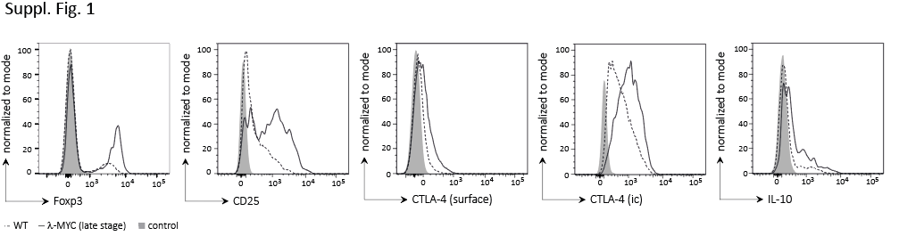

**Supplemental Fig. 1.** Typical histograms showing the alterations of Foxp3, CD25, CTLA-4 and IL-10 expressed by Foxp3+ Tregs from -Myc late stage tumors (solid lines) compared to cells from wt animals (dotted lines). Shaded curves: isotype control.