Title: N-acetylcysteine modulates markers of oxidation, inflammation and infection in tuberculosis: Supplemental appendix
Short title: NAC biomarkers in TB supplement
Authors: Daniel Adon Mapamba^{1,2}, Issa Sabi¹, Julieth Lalashowi¹, Elingarami Sauli², Joram Buza², Willyhelmina Olomi¹, Bariki Mtafya¹, Michael Kibona¹, Abhishek Bakhuli³, Andrea Rachow^{3,4,5}, Kavindhran Velen⁷, Michael Hoelscher^{3,4,5,6}, Nyanda E Ntinginya², Salome Charalambous^{7,8}, Gavin Churchyard^{7,9,10}, Robert S. Wallis^{7,8,9}, and the TB SEQUEL consortium
Affiliations: ¹ National Institute for Medical Research-Mbeya Medical Research Center, Mbeya, Tanzania; ² The Nelson Mandela African Institution of Science and Technology, Arusha, Tanzania; ³ Division of Infectious Diseases and Tropical Medicine, Medical Centre of the University of Munich (LMU), Munich, Germany; ⁴ German Center for Infection Research (DZIF), Partner Site Munich, Munich, Germany; ⁵ Unit Global Health, Helmholtz Zentrum München, German Research Center for Environmental Health (HMGU), Neuherberg, Germany; ⁶ Fraunhofer Institute for Translational Medicine and Pharmacology ITMP; Immunology, Infection and Pandemic Research, Munich, Germany; ⁷ The Aurum Institute, Johannesburg, South Africa; ⁸ Case Western Reserve University, Cleveland USA; ⁹ Department of Medicine, Vanderbilt University, Nashville USA; ¹⁰ School of Public Health, University of Witwatersrand, Johannesburg, South Africa
Correspondence: dmapamba@nimr-mmrc.org
Funding: German Ministry for Education and Research (BMBF) grant 01KA1613 for TB SEQUEL

Table of contents
Table s1. Participant demographic and baseline data 3
Figure s1. Screening and eligibility 4

Parameter |  | Patients with tuberculosis |  | Healthy
 |  | Control arm | NAC arm | Volunteers
 |  | n=70 | n=69 | n=82
Sex | male | 54 (77%) | 50 (72%) | 43 (53.4%)
 | Female | 16 (23%) | 19 (28%) | 39 (47.6%)
Age median (IQR) | years | 35 (29, 40) | 34 (29, 41) | 30 (25,38)
BMI mean (SD) | kg/m² | 19.71 (3.46) | 19.69 (2.83) | -
HIV-1 status | positive | 23 (32.9%) | 19 (27.5%) | -
 | Negative | 47 (67.1%) | 50 (72.5%) | -
CD4+ T cells  (if HIV+) | <200/ul | 3 (13.0%) | 3 (15.8%) | -
 | ≥200/ul | 20 (87.0%) | 16 (84.2%) | -
Radiographic extent of disease | far advanced | 33 (47%) | 32 (46%) | -
 | moderate | 37 (53%) | 37 (54%) | -
Spirometry | FEV1% | 60.4 (18.5) | 62.3 (14.7) | -
 | FVC% | 65.6 (17.4) | 68.3 (12.9) | -
 | Performed | 44 (62.9%) | 41 (59.4%)
 | ND/NS | 26 (37.1%) | 28 (40.6%) | -
Sputum AFB smear n (%) | Negative | 1 (1.4%) | 4 (5.8%) | -
 | Scanty | 2 (2.9%) | 2 (2.9%) | -
 | 1+ | 2 (2.9%) | 4 (5.8%) | -
 | 2+ | 4 (5.7%) | 6 (8.7%) | -
 | 3+ | 61 (87%) | 53 (77%) | -
MGIT culture | Positive for MTB | 70 (100%) | 69 (100%) | -
 | TTP days median (IQR) | 3.60 (2.96, 4.17) | 3.67 (2.99, 5.15) | -
Glutathione | Total uM/l | 653.3±145.7 | 643.1±177.6 | 1345.9±480.8
CRP | mg/dl | 97.04±56.35 | 85.55±51.73
Hemoglobin | g/dl | 12.03±2.07 | 12.38±2.03
TNF | log pg/mL | 3.09±0.36 | 2.98±0.33 | -
IL-10 | log pg/mL | 2.31±0.44 | 2.31±0.57 | -

Table s1. Participant demographic and baseline data of the modified intention to treat (mITT) patient population and healthy controls. Values are mean±SD unless otherwise indicated.

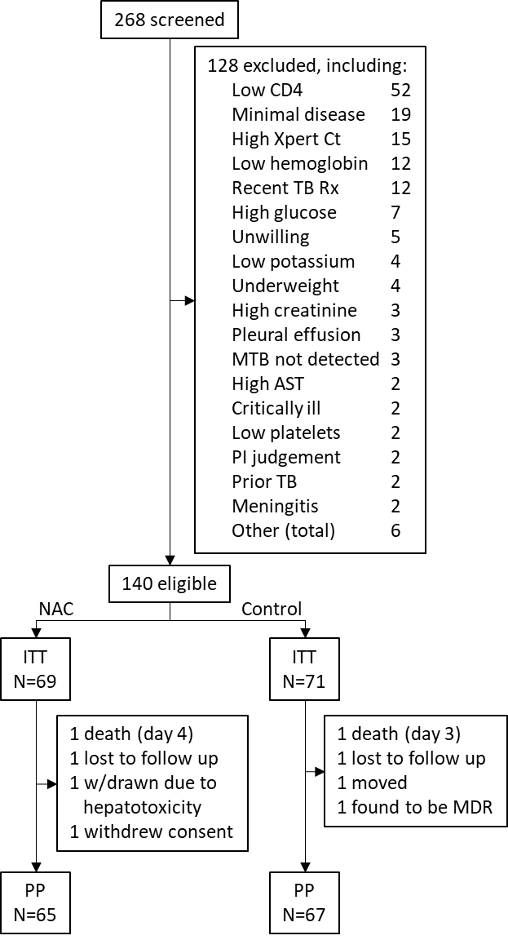
Figure s1. Screening and eligibility. Ct=Xpert cycle threshold. ITT=intention to treat. PP=per protocol. MDR=multidrug resistant.

